Name of Journal: World Journal of Clinical Cases
Manuscript NO: 68886
Manuscript Type: CASE REPORT

Crouzon syndrome in a fraternal twin: A case report and review of the literature

Li XJ et al. CS of a fraternal twin

Xiao-Jing Li, Ji-Mei Su, Xiao-Wei Ye

Xiao-Jing Li, Ji-Mei Su, Xiao-Wei Ye, Department of Stomatology, The Children’s Hospital, Zhejiang University School of Medicine, National Clinical Research Center for Child Health, Hangzhou 310052, Zhejiang Province, China

Author contributions: Li XJ and Su JM performed the initial review and data collection, reviewed the literature and contributed to the manuscript drafting and revision; Ye XW analyzed and interpreted the imaging findings; all authors issued final approval for the version to be submitted.

Corresponding author: Jimei Su, MD, Chief Doctor, Department of Stomatology, The Children’s Hospital, Zhejiang University School of Medicine, National Clinical Research Center for Child Health, No. 3333 Binsheng Road , Hangzhou 310052, Zhejiang Province, China. 6198003@zju.edu.cn

Received: December 13, 2021
Revised: January 21, 2022
Accepted: April 2, 2022
Published online:

Abstract
BACKGROUND
Crouzon syndrome (CS; OMIM 123500) is an autosomal dominant inherited craniofacial disorder caused by mutations in the fibroblast growth factor receptor 2 (FGFR2) gene. CS is characterized by craniofacial dysostosis, exophthalmos, and facial anomalies with hypoplastic maxilla and relative mandibular prognathism.

CASE SUMMARY
Our report involves a 6-year-old fraternal twin boy with many caries in the oral cavity who presented with characteristic features of CS based on clinical and radiographic examinations along with Sanger sequencing. The fraternal girl did not show any abnormalities indicating CS. Carious teeth and poor oral hygiene were managed promptly through administering appropriate behavior guidance, orthodontic treatment was planned, and preventive procedures were described.

CONCLUSION
CS could occur in a fraternal twin caused by a de novo mutation of the FGFR2 gene. Oral hygiene instruction, preventive programs on oral hygiene, orthodontic treatment, and maxillary osteotomy were required for treatment.

Key Words: Crouzon syndrome; Craniosynostosis; Fibroblast growth factor receptor 2; Mutation; Fraternal twin; Case report

Li XJ, Su JM, Ye XW. Crouzon syndrome in a fraternal twin: A case report and review of the literature. World J Clin Cases 2022; In press

Core Tip: Crouzon syndrome (CS) is an autosomal dominant inherited craniofacial disorder caused by mutations in fibroblast growth factor receptor 2, but approximately 50% of cases result from de novo mutations. This syndrome has been rarely seen and evaluated in fraternal twins, only one of whom has CS. We presented a 6-year-old fraternal twin boy diagnosed with CS who had many caries and enamel hypomineralization in the oral cavity. The boy’s parents and his fraternal twin sister did not show any abnormalities indicating CS, so we hypothesize that the fraternal twin boy’s gene mutation arose from a de novo mutation.

INTRODUCTION
Crouzon syndrome (CS) is an autosomal dominant inherited disorder and characterized by calvarial deformities with craniofacial dysostosis, exophthalmos, and facial anomalies^{[1,2]}. In 1912, the French physician Louis Edouard Octave Crouzon first reported this syndrome and identified a mother and her son with craniosynostosis that resulted in skull and facial deformities^{[3]}. This syndrome is described as the mildest type of many craniosynostosis syndromes^{[3,4]}. The birth incidence of CS is approximately 1:25000^{[4]}. It is proven to be the most common craniosynostosis syndrome, as it accounts for nearly 4.8% of all craniosynostosis cases at birth^{[1,5]}. It is more common in males than females (3:1)^{[6]}. Mutations in the fibroblast growth factor receptor 2 (FGFR2) gene on chromosome locus 10q25.3-q26 are related to CS^{[7]}. Families with CS commonly suggest an autosomal dominant inheritance pattern^{[8,9]}. The syndrome presents incomplete penetrance and variable expressivity leading to phenotypical characteristics varying from mild to severe^{[7,10]}. About 50% of cases result from de novo mutations of the FGFR2 gene^{[11]}.
CS is commonly observed at birth owing to characteristic facial and cranial deformities and a positive family history. The prominent manifestations of these patients can be detected upon physical examination. Brachycephaly, hypertelorism, proptosis, flattened forehead, beaked noses, and maxillary/midface hypoplasia are the most common features^{[3,12-14]}. Hearing loss, strabismus (misaligned eyes), a cleft lip and palate, and dental problems can be also seen from these patients^{[12,15,16]}. However, Crouzon syndrome patients have normal hands and feet in contrast to Apert syndrome patients and other craniosynostosis syndromes^{[17,18]}. The different characteristics of the more common syndromic craniosynostosis syndromes are shown in Table 1^{[17,19-22]}.
The most common dental problems in craniosynostosis are supernumerary teeth, hypodontia, delayed eruption, and macrodontia^{[23,24]}. We report a 6-year-old fraternal twin boy with CS who had many caries and enamel hypomineralization in the oral cavity. The boy’s parents and his fraternal twin sister did not show any abnormalities indicating CS. Therefore, we hypothesize that the twin boy’s gene mutation arose from a de novo mutation.

CASE PRESENTATION
Chief complaints
A 6-year-old Chinese boy was referred to the stomatology department of the Children’s Hospital, Zhejiang University School of Medicine, with a chief complaint of dental caries.

History of present illness
Dental caries were observed since the patient was 4-years-old and gradually became progressively larger.

History of past illness
The patient underwent intracranial decompression surgery at the age of 1 due to hydrocephalus. Posterior cranial vault distraction was performed when he was 2-years-old. The patient underwent a ventriculoperitoneal shunt operation for hydrocephalus at the age of 3. One year later, the patient had cranial vault remodeling as a result of craniofacial dysostosis.

Personal and family history
His medical and developmental history showed that he was born at full-term by cesarean delivery after an uneventful pregnancy with a 48 cm height and 2.35 kg weight, along with his fraternal twin sister with a 48 cm height and 1.8 kg weight. The family history of going back for three generations was negative for similar conditions, and his fraternal twin sister had no medical issues.

Physical examination
Physical examination showed normal height (108 cm) and weight (20.4 kg) compared with that of children of the same age. Clinically normal hands and feet were found. Extraoral examination revealed a prominent forehead, eyelid ptosis, ocular proptosis, shallow eye sockets, hypertelorism, midface hypoplasia, and a retrusive upper lip and protrusive lower lip (Figure 1).
Intraoral examination showed that the patient was in early mixed dentition, with all deciduous canines and molar teeth present in the maxillary and mandibular arch. The chronology of eruption and eruption status was in accordance with the child’s age (Figure 1). The oral hygiene of the child was poor with scattered pigmentation on the teeth, and permanent teeth 36 and 46 and deciduous teeth 54, 55, 65, 74, 75, and 85 were mostly decayed. The eruptive permanent teeth, including 11, 21, 36, and 46, showed enamel hypomineralization. The maxillary arch was constricted, and the anterior cross bite and open bite are shown.

Laboratory examinations
Sanger sequencing showed that the pathogenic variant c.1026C > G (p.Cys342Trp) was present on the FGFR2 gene for the patient. The mutation was not present in any of the family members.

Imaging examinations
The panoramic radiograph showed that there were no supernumerary teeth or normal permanent tooth germ development. Deciduous carious teeth 55, 64, 65, 75, and 85 had once been restored and displayed further second caries at the time of the study. Permanent teeth 36 and 46 and deciduous teeth 54 and 74 were decayed (Figure 2A).
Based on the lateral cephalometric analysis, a severe skeletal Class III relationship was diagnosed with Sella-Nasion-A point angle: 63.8°, Sella-Nasion-B point angle: 71.6° and A point-Nasion-B point angle: -7.8° (Figure 2B). A hypodivergent facial pattern was shown with Sella-Nasion/Gonion-Gnathion: 35.1°. The cephalometric analysis also revealed the maxillary skeletal size (condylion to point A) was diminished. The upper central incisors leaned toward the lip (U1/Sella-Nasion: 112.8°).

FINAL DIAGNOSIS
The final diagnosis of the presented case was CS, caries, and enamel hypomineralization.

TREATMENT
A comprehensive treatment plan was made. The initial treatment involved improving the patient’s oral hygiene and restoring his carious teeth. The dental caries in teeth 54, 55, 64, 65, 74, 75, 85, 36, and 46 were treated with resin-based restorations. Topical fluoride was regularly applied to enamel hypomineralization in teeth 11, 21, 36, and 46 to promote enamel remineralization. The Skeletal Class III malocclusion was treated by orthodontic treatment and orthognathic surgery. Multidisciplinary approaches involving pediatric dentists, dental surgeons, oral and maxillofacial surgeons, and orthodontists were indispensable for this treatment.
At the first dental visit, the patient was nervous and fearful and was unwilling to open his mouth. Appropriately administered behavior management and guidance^{[25,26]}, including show-and-tell tactics, positive reinforcement, sound communication, and modeling, were used to manage the patient’s anxieties. Oral examination, radiographic assessment, oral prophylaxis, and polishing of the teeth with the rubber cup were performed during the first dental appointment. For the latter dental appointments, carious restoration was successfully completed utilizing show-and-tell tactics, positive reinforcement, and distracting the patient by showing movies during the procedure. After the procedure, the patient was praised and given a post-visit sticker, and he was agreeable for a future visit.

OUTCOME AND FOLLOW-UP
Three months later, the oral hygiene of the patient was good, and topical fluoride was applied in teeth 11, 21, 36, and 46 to promote enamel remineralization.

DISCUSSION
Craniosynostosis results from the premature fusion of one or multiple cranial sutures, resulting in restricted growth of the skull, brain, face, and central nervous system development^{[4]}. CS is the most common syndromic craniosynostosis and is caused by the mutation of FGFR2^{[17]}. FGFR2 belongs to a family of four FGFRs. The FGFR family plays a primary role in the growth and differentiation of mesenchymal and neuroectodermal cells by binding to FGF and initiating signal transduction. Additionally, the FGFR family regulates cranial suture fusion on a macroscopic level^{[7]}.
For our patient the c.1026 C > G (p.Cys342Trp) mutation on the FGFR2 gene caused a cysteine-to-tryptophan substitution at amino acid 342. Mutations at amino acid 342 can cause CS and Pfeiffer syndrome. Normal hands and feet can be observed with CS, which differentiates it from Pfeiffer syndrome. The loss of this cysteine residue is one of the most common mutations in CS patients and has previously been reported in a Chinese family, a Japanese sporadic case, and 4 Caucasian cases^{[9,27-29]}. The Chinese family and 1 Caucasian family with CS have a dominant inherited amino acid 342 mutation^{[9,27]}. The Japanese case and the German patients with CS were sporadic^{[28,29]}. Since the fraternal twin sister and the parents did not present gene mutations and similar presentations, our patient’s mutation was considered to be a de novo mutation. In 11 of the 21 families with CS who underwent tracing to determine the origin of the mutation by analyzing parents and the other family members, FGFR2 mutations arose de novo, representing a high mutation rate for FGFR2^{[29]}.
This case report describes a patient with CS, who presented with a high forehead, ocular proptosis, shallow eye sockets, hypertelorism, palpebral ptosis, and a skeletal Class III relationship. The carious teeth were fully restored, and oral hygiene instruction was performed in the clinic under behavior management and guidance. The child was advised to follow-up regularly with preventive care for teeth. The boy was satisfied with his good oral hygiene. Interceptive orthodontics was contemplated. Midfacial advancement with a Le Fort III, Le Fort II plus zygomatic repositioning, monobloc, or facial bipartition is required for midface retrusion^{[30]}. The appropriate time of surgery is deemed at 8 years of age^{[31]}. He has been referred to the Department of Oral and Maxillofacial Surgery for orthognathic surgical procedures in the next few years. He has also been referred to the Departments of Neurosurgery, Ophthalmology, Otolaryngology, and Psychology to prevent complications.

CONCLUSION
In summary, CS could occur in a fraternal twin caused by a de novo mutation of the FGFR2 gene and is characterized by craniosynostosis, a prominent forehead, midface hypoplasia, and proptosis. Oral hygiene instruction and preventive programs on oral hygiene should be performed regularly. A multidisciplinary approach involving oral and maxillofacial surgeons and orthodontists was necessary for the treatment of midface hypoplasia.

ACKNOWLEDGEMENTS
We sincerely thank the patient and his parents for their participation and permission to publish this paper.

REFERENCES
1 Bowling EL, Burstein FD. Crouzon syndrome. Optometry 2006; 77: 217-222 [PMID: 16651211 DOI: 10.1016/j.optm.2006.03.005]
2 Khandelwal R, Agrawal P, Majumdar MR. Crouzon syndrome. BMJ Case Rep 2012; 2012 [PMID: 22605842 DOI: 10.1136/bcr.05.2011.4196]
3 Padmanabhan V, Hegde AM, Rai K. Crouzon's syndrome: A review of literature and case report. Contemp Clin Dent 2011; 2: 211-214 [PMID: 22215936 DOI: 10.4103/0976-237X.86464]
4 Aviv RI, Rodger E, Hall CM. Craniosynostosis. Clin Radiol 2002; 57: 93-102 [PMID: 11977940 DOI: 10.1053/crad.2001.0836]
5 Wang JC, Nagy L, Demke JC. Syndromic Craniosynostosis. Facial Plast Surg Clin North Am 2016; 24: 531-543 [PMID: 27712819 DOI: 10.1016/j.fsc.2016.06.008]
6 Gothwal S, Nayan S, Kumar J. Crouzon syndrome with bony upper airway obstruction: case report and review literature. Fetal Pediatr Pathol 2014; 33: 199-201 [PMID: 24828762 DOI: 10.3109/15513815.2014.913747]
7 Al-Namnam NM, Hariri F, Thong MK, Rahman ZA. Crouzon syndrome: Genetic and intervention review. J Oral Biol Craniofac Res 2019; 9: 37-39 [PMID: 30202723 DOI: 10.1016/j.jobcr.2018.08.007]
8 Lin Y, Gao H, Ai S, Eswarakumar JVP, Zhu Y, Chen C, Li T, Liu B, Jiang H, Liu Y, Li Y, Wu Q, Li H, Liang X, Jin C, Huang X, Lu L. FGFR2 mutations and associated clinical observations in two Chinese patients with Crouzon syndrome. Mol Med Rep 2017; 16: 5841-5846 [PMID: 28901406 DOI: 10.3892/mmr.2017.7397]
9 Li ZL, Chen X, Zhuang WJ, Zhao W, Liu YN, Zhang FX, Ha RS, Wu JH, Zhao C, Sheng XL. FGFR2 mutation in a Chinese family with unusual Crouzon syndrome. Int J Ophthalmol 2016; 9: 1403-1408 [PMID: 27803855 DOI: 10.18240/ijo.2016.10.06]
10 Lu X, Forte AJ, Fan F, Zhang Z, Teng L, Yang B, Alperovich M, Steinbacher DM, Alonso N, Persing JA. Racial disparity of Crouzon syndrome in maxilla and mandible. Int J Oral Maxillofac Surg 2020; 49: 1566-1575 [PMID: 32362538 DOI: 10.1016/j.ijom.2020.04.005]
11 Pal US, Gupta C, Chellappa AA. Crouzon syndrome with primary optic nerve atrophy and normal brain functions: A case report. J Oral Biol Craniofac Res 2012; 2: 116-118 [PMID: 25737846 DOI: 10.1016/j.jobcr.2012.03.011]
12 Torun GS, Akbulut A. Crouzon syndrome with multiple supernumerary teeth. Niger J Clin Pract 2017; 20: 261-263 [PMID: 28091449 DOI: 10.4103/1119-3077.187332]
13 Forte AJ, Lu X, Hashim PW, Steinbacher DM, Alperovich M, Persing JA, Alonso N. Analysis of Airway and Midface in Crouzon Syndromes. Ann Plast Surg 2019; 82: 686-691 [PMID: 30633021 DOI: 10.1097/SAP.0000000000001740]
14 Quintero-Rivera F, Martinez-Agosto JA. Bilateral exophthalmos: Report of a case and review of a fibroblast growth factor receptor 2 mutation associated with non-penetrant Crouzon syndrome. J Paediatr Child Health 2010; 46: 693-695 [PMID: 20163525 DOI: 10.1111/j.1440-1754.2009.01692.x]
15 Stavropoulos D, Bartzela T, Tarnow P, Mohlin B, Kahnberg KE, Hagberg C. Dental agenesis patterns in Crouzon syndrome. Swed Dent J 2011; 35: 195-201 [PMID: 22372307]
16 Reitsma JH, Balk-Leurs IH, Ongkosuwito EM, Wattel E, Prahl-Andersen B. Dental maturation in children with the syndrome of crouzon and apert. Cleft Palate Craniofac J 2014; 51: 639-644 [PMID: 24021057 DOI: 10.1597/13-071]
17 Ko JM. Genetic Syndromes Associated with Craniosynostosis. J Korean Neurosurg Soc 2016; 59: 187-191 [PMID: 27226847 DOI: 10.3340/jkns.2016.59.3.187]
18 Elmi P, Reitsma JH, Buschang PH, Wolvius EB, Ongkosuwito EM. Mandibular asymmetry in patients with the crouzon or apert syndrome. Cleft Palate Craniofac J 2015; 52: 327-335 [PMID: 24878346 DOI: 10.1597/13-143]
19 Agochukwu NB, Solomon BD, Doherty ES, Muenke M. Palatal and oral manifestations of Muenke syndrome (FGFR3-related craniosynostosis). J Craniofac Surg 2012; 23: 664-668 [PMID: 22565872 DOI: 10.1097/SCS.0b013e31824db8bb]
20 Hassona Y, Al-Hadidi A, Ghlassi TA, Dali HE, Scully C. Pfeiffer syndrome: oral healthcare management and description of new dental findings in a craniosynostosis. Spec Care Dentist 2017; 37: 258-262 [PMID: 28845899 DOI: 10.1111/scd.12236]
21 López-Estudillo AS, Rosales-Bérber MA, Ruiz-Rodríguez S, Pozos-Guillén A, Noyola-Frías MÁ, Garrocho-Rangel A. Dental approach for Apert syndrome in children: a systematic review. Med Oral Patol Oral Cir Bucal 2017; 22: e660-e668 [PMID: 29053644 DOI: 10.4317/medoral.21628]
22 Lu X, Sawh-Martinez R, Forte AJ, Wu R, Cabrejo R, Wilson A, Steinbacher DM, Alperovich M, Alonso N, Persing JA. Mandibular Spatial Reorientation and Morphological Alteration of Crouzon and Apert Syndrome. Ann Plast Surg 2019; 83: 568-582 [PMID: 31008788 DOI: 10.1097/SAP.0000000000001811]
23 Ye X, Attaie AB. Genetic Basis of Nonsyndromic and Syndromic Tooth Agenesis. J Pediatr Genet 2016; 5: 198-208 [PMID: 27895972 DOI: 10.1055/s-0036-1592421]
24 Khominsky A, Yong R, Ranjitkar S, Townsend G, Anderson PJ. Extensive phenotyping of the orofacial and dental complex in Crouzon syndrome. Arch Oral Biol 2018; 86: 123-130 [PMID: 29223639 DOI: 10.1016/j.archoralbio.2017.10.022]
25 Nelson T. The continuum of behavior guidance. Dent Clin North Am 2013; 57: 129-143 [PMID: 23174614 DOI: 10.1016/j.cden.2012.09.006]
26 Karekar P, Bijle MN, Walimbe H. Effect of Three Behavior Guidance Techniques on Anxiety Indicators of Children Undergoing Diagnosis and Preventive Dental Care. J Clin Pediatr Dent 2019; 43: 167-172 [PMID: 30964721 DOI: 10.17796/1053-4625-43.3.4]
27 Ma HW, Lajeunie E, Le Merrer M, de Parseval N, Serville F, Weissenbach J, Munnich A, Renier D. No evidence of genetic heterogeneity in Crouzon craniofacial dysostosis. Hum Genet 1995; 96: 731-735 [PMID: 8522336 DOI: 10.1007/BF00210308]
28 Nagase T, Nagase M, Hirose S, Ohmori K. Mutations in fibroblast growth factor receptor 2 gene and craniosynostotic syndromes in Japanese children. J Craniofac Surg 1998; 9: 162-170 [PMID: 9586546 DOI: 10.1097/00001665-199803000-00015]
29 Kress W, Collmann H, Büsse M, Halliger-Keller B, Mueller CR. Clustering of FGFR2 gene mutations inpatients with Pfeiffer and Crouzon syndromes (FGFR2-associated craniosynostoses). Cytogenet Cell Genet 2000; 91: 134-137 [PMID: 11173845 DOI: 10.1159/000056833]
30 Taylor JA, Bartlett SP. What's New in Syndromic Craniosynostosis Surgery? Plast Reconstr Surg 2017; 140: 82e-93e [PMID: 28654610 DOI: 10.1097/PRS.0000000000003524]
31 Lloyd MS, Trost JG, Khechoyan DY, Hollier LH Jr, Buchanan EP. Identical Twins with Crouzon Syndrome: Eight-Year Follow-up, Genetic Considerations, and Operative Management. Craniomaxillofac Trauma Reconstr 2017; 10: 286-291 [PMID: 29109840 DOI: 10.1055/s-0036-1592091]

Footnotes
Informed consent statement: Informed written consent was obtained from the patient for the publication of this report and any accompanying images.

Conflict-of-interest statement: The authors declare that they have no conflict of interest.

CARE Checklist (2016) statement: The authors have read the CARE Checklist (2016), and the manuscript was prepared and revised according to the CARE Checklist (2016).

Open-Access: This article is an open-access article that was selected by an in-house editor and fully peer-reviewed by external reviewers. It is distributed in accordance with the Creative Commons Attribution NonCommercial (CC BY-NC 4.0) license, which permits others to distribute, remix, adapt, build upon this work non-commercially, and license their derivative works on different terms, provided the original work is properly cited and the use is non-commercial. See: https://creativecommons.org/Licenses/by-nc/4.0/

Provenance and peer review: Unsolicited article; Externally peer reviewed.
Peer-review model: Single blind

Peer-review started: December 13, 2021
First decision: January 12, 2022
Article in press:

Specialty type: Dentistry, oral surgery and medicine
Country/Territory of origin: China
Peer-review report’s scientific quality classification
Grade A (Excellent): 0
Grade B (Very good): B
Grade C (Good): C
Grade D (Fair): 0
Grade E (Poor): 0

P-Reviewer: Malekzadegan A, Iran; Tsou HK, Taiwan S-Editor: Chen YL L-Editor: Filipodia P-Editor: Chen YL

Figure Legends
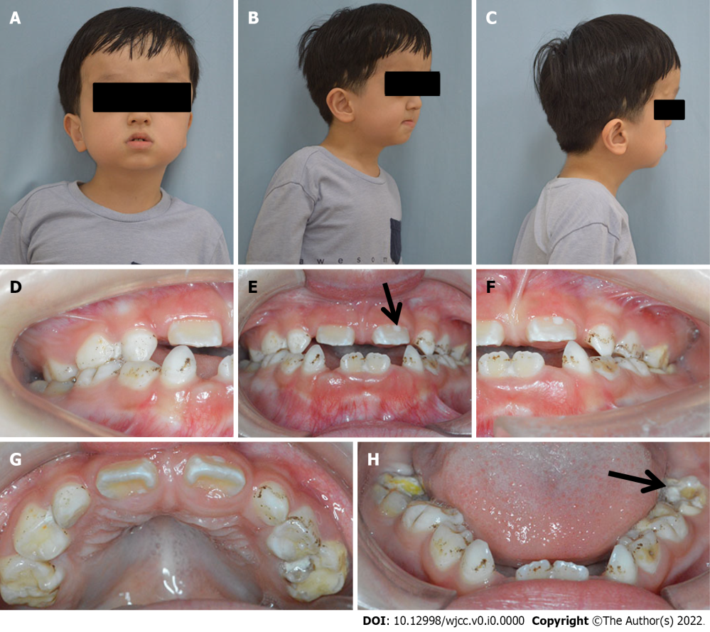
Figure 1 Extraoral and intraoral presentations of the patient. A-C: Extraoral photos showed a prominent forehead, ocular proptosis, midface hypoplasia, retrusive upper lip, and protrusive lower lip; D-H: The intraoral photos showed that oral hygiene was poor with scattered pigmentation on the teeth. Teeth 36, 46, 54, 55, 65, 74, 75, and 85 were decayed, and teeth 11, 21, 36, and 46 showed hypomineralization (black arrows).
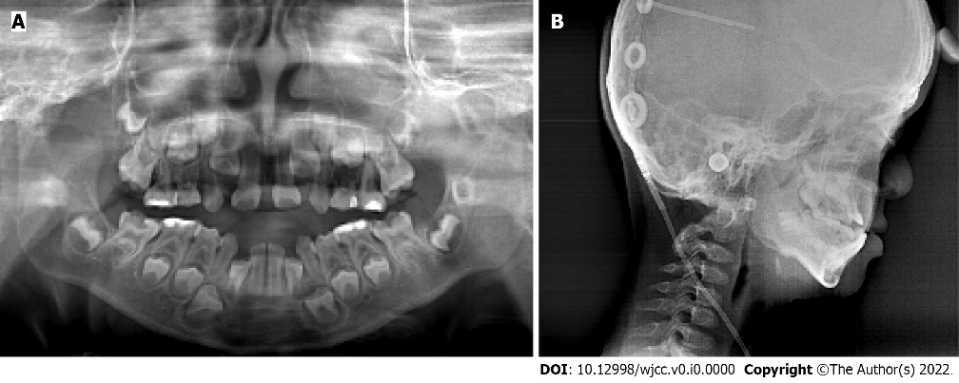
Figure 2 Panoramic and lateral cephalometric radiograph of the patient. A: The panoramic radiograph showed normal permanent tooth germ development; B: The lateral cephalometric radiograph showed a skeletal Class III relationship.

Table 1 Clinical characteristics of the most common syndromic craniosynostosis syndromes
 | Crouzon | Apert | Pfeiffer | Muenke | Saethre-Chotzen
Gene | FGFR2 | FGFR2 | FGFR1/ FGFR2 | FGFR3 | TWIST1
Craniofacial phenotype | Brachycephaly; shallow orbits; ocular proptosis; midface hypoplasia | Turribrachycephaly; large anterior fontanelle with bitemporal widening and occipital flattening; shallow orbits with ocular proptosis and horizontal grooves above supraorbital ridges; mild hypertelorism and down-slanting palpebral fissures; “parrot beak” nasal deformity | Turribrachycephaly; midface hypoplasia; proptosis; hypertelorism; strabismus; down-slanting palpebral fissures; beaked nasal deformity | Craniosynostosis of coronal sutures; uncommon to have midface hypoplasia | Brachycephaly or acrocephaly or anterior plagiocephaly; low frontal hairline; eyelid ptosis; facial asymmetry; deviated nasal septum; ear deformities; parietal foramina
Oral and dental phenotype | Constricted, high-arched palate; anterior open bite; Missing teeth; supernumerary; delayed tooth eruption | High arched or cleft palate; severe midface hypoplasia; anterior open bite; tooth agenesis; supernumerary teeth; dental fusion; delayed tooth eruption | Anterior open bit and bilateral posterior cross-bites; hypodontia; microdontia; dilacerations; radicular dentin dysplasia | High arched palate; the lowest incidence of cleft palate | Cleft palate
Limb phenotype | Normal hands and feet | Severe syndactyly (mitten hand); poor joint mobility | Broad thumbs; broad great toes; variable feature, partial soft-tissue syndactyly of the hands; ankylosed elbows; hydrocephalus | Thimble-like middle phalanges | Brachydactyly; syndactyly; radioulnar synostosis; Hallux valgus
Other phenotype |  | Low-set ears | Hearing loss; visceral anomalies | Hearing loss | Hearing loss; congenital heart malformation; short stature
Cognition | Normal | Intellectual disability | Normal or nearly normal |  | Normal
FGFR: Fibroblast growth factor receptor.

