Name of Journal: World Journal of Clinical Cases
Manuscript NO: 65443
Manuscript Type: ORIGINAL ARTICLE

Retrospective Study
Primary needle-knife fistulotomy for preventing post-endoscopic retrograde cholangiopancreatography pancreatitis: Importance of the endoscopist’s expertise level

Han SY et al. Safety and efficacy of primary NKF

Sung Yong Han, Dong Hoon Baek, Dong Uk Kim, Chang Joon Park, Young Joo Park, Moon Won Lee, Geun Am Song

Sung Yong Han, Dong Hoon Baek, Dong Uk Kim, Chang Joon Park, Young Joo Park, Moon Won Lee, Geun Am Song, Division of Gastroenterology and Hepatology, Internal Medicine and Biomedical Research Institute, Pusan National University Hospital, Busan 49241, South Korea

Author contributions: Kim DU and Song GA contributed study concept and design; Park CJ and Park YJ contributed data acquisition; Han SY and Lee MW contributed data analysis and interpretation; Han SY and Baek DH contributed drafting of the manuscript; Kim DU and Song GA contributed critical revision of the manuscript.

Supported by Korea Medical Device Development Fund Grant Funded by the Korea Government the Ministry of Trade, Industry and Energy (Project Number: 9991007196), No. KMDF_PR_20200901_0066.

Corresponding author: Dong Uk Kim, MD, PhD, Associate Professor, Division of Gastroenterology and Hepatology, Internal Medicine and Biomedical Research Institute, Pusan National University Hospital, 179 Gudeok-ro, Seo-gu, Busan 49241, South Korea. amlm³@hanmail.net

Received: March 8, 2021
Revised: April 5, 2021
Accepted: April 20, 2021
Published online:

Abstract
BACKGROUND
Needle-knife fistulotomy (NKF) is used as a rescue technique for difficult cannulation. However, the data are limited regarding the use of NKF for primary biliary cannulation, especially when performed by beginners.

AIM
To assess the effectiveness and safety of primary NKF for biliary cannulation, and the role of the endoscopist’s expertise level (beginner vs expert).

METHODS
We retrospectively evaluated the records of 542 patients with naïve prominent bulging papilla and no history of pancreatitis, who underwent bile duct cannulation at a tertiary referral center. The patients were categorized according to the endoscopist’s expertise level and the technique used for bile duct cannulation. We assessed the rates of successful cannulation and adverse events.

RESULTS
The baseline characteristics did not differ between the experienced and less-experienced endoscopists. The incidence rate of post-endoscopic retrograde cholangiopancreatography (ERCP) pancreatitis (PEP) was significantly affected by the endoscopist’s expertise level in patients who received conventional cannulation with sphincterotomy (8.9% vs 3.4% for beginner vs expert, P = 0.039), but not in those who received NKF. In the multivariable analysis, a lower expertise level of the biliary endoscopist (P = 0.037) and longer total procedure time (P = 0.026) were significant risk factor of PEP in patients who received conventional cannulation with sphincterotomy but only total procedure time (P = 0.004) was significant risk factor of PEP in those who received NKF.

CONCLUSION
Primary NKF was effective and safe in patients with prominent and bulging ampulla, even when performed by less-experienced endoscopist. We need to confirm which level of endoscopist’s experience is needed for primary NKF through prospective randomized study.

Key Words: Needle-knife fistulotomy; Primary biliary cannulation; Endoscopic retrograde cholangiopancreatography; Expertise levels; Pancreatitis

Han SY, Baek DH, Kim DU, Park CJ, Park YJ, Lee MW, Song GA. Primary needle-knife fistulotomy for preventing post-endoscopic retrograde cholangiopancreatography pancreatitis: Importance of the endoscopist’s expertise level. World J Clin Cases 2021; In press

Core Tip: Needle-knife fistulotomy (NKF) is used as a rescue technique for difficult cannulation. However, the data are limited regarding the use of NKF for primary biliary cannulation, especially when performed by beginners. Our retrospective study aims to assess the effectiveness and safety of primary NKF for biliary cannulation, and the role of the endoscopist’s expertise. The incidence rate of post-endoscopic retrograde cholangiopancreatography pancreatitis was significantly affected by the endoscopist’s expertise level in patients who received conventional cannulation with sphincterotomy, but not in those who received NKF. Primary NKF may be effective and safe in achieving ductal access in patients with naïve papilla, regardless of experience.
INTRODUCTION
Needle-knife fistulotomy (NKF) is used as a rescue technique when cannulation is difficult^{[1]}. Many studies have reported the effectiveness and safety of early precut NKF for preventing post-endoscopic retrograde cholangiopancreatography (ERCP) pancreatitis (PEP). In particular, precut NKF was reported to be associated with a higher rate of successful cannulation and lower incidence of PEP than conventional cannulation techniques^{[2-6]}. Recently, randomized controlled trial study on NKF has been published, proved the safety and efficacy of primary NKF in high-risk cohort of PEP^{[7]}. Despite these encouraging reports, NKF has not been adopted as a primary cannulation technique because most endoscopists believe that a high level of experience is required in order to achieve a sufficiently high rate of successful cannulation and an acceptable rate of adverse events with a use of primary NKF in patients with naïve papilla. Several previous studies on the effectiveness and safety of early NKF reported that NKF procedures performed by less experienced or experienced endoscopists provided comparable rates of adverse events^{[8,9]}. However, there are no published data regarding the level of expertise that is needed for achieving the effectiveness and safety of NKF for primary biliary cannulation.
It is of utmost importance to minimize the risk of PEP, which is difficult to control and potentially lethal even in cases handled by expert biliary endoscopists. Other life-threatening adverse events related to NKF, such as perforation and bleeding, have become relatively manageable due to the continuous developments in instrumentation (especially covered metallic stent, endoclips and absorbable hemostatic powder) and radiologic interventions (e.g., angiographic embolization). However, there are only few study about that the safety of primary NKF for achieving bile duct access in patients with naïve papilla^{[10]}. Furthermore, it is necessary to compare how many manageable adverse events occur between beginners and experts when performed NKF vs conventional cannulation for primary biliary cannulation in patients with naïve papilla.
We aimed to assess the effectiveness and safety of primary NKF according to expertise level of endoscopists in patients with naïve papilla undergoing bile duct cannulation.

MATERIALS AND METHODS
Patient selection and stratification
Among the patients who received ERCP at our hospital, we identified 568 patients who were managed by an expert (over 3000 ERCP procedures) as well as 693 patients managed by a beginner (over 500 ERCP observations with an assistance and then over 300 ERCP procedures with supervision of an expert) between April 2014 and March 2016. The beginner was trained by the expert for a year prior to dispatch. We retrospectively reviewed the medical records of candidates and excluded patients who underwent previous ERCP or presented with biliary pancreatitis at admission. Patients who did not change to altered method even in difficult cannulation were also excluded. And we also excluded patients with non-prominent ampulla, because, they were not suitable for NKF. Finally, 542 patients with naïve papilla (expert, 237; beginner, 305) were enrolled in this study to analyze the effectiveness and safety of primary biliary cannulation, as well as to clarify the role of the endoscopist’s expertise level (Figure 1). This study was conducted in accordance with the ethical guidelines of the Declaration of Helsinki (revised in 2013) and the study protocol was approved by the institutional review board of our Hospital (H-1805-023-067).
The patients were stratified according to the endoscopist’s expertise level (beginner vs expert) and according to the primary cannulation technique employed (conventional cannulation vs NKF). Among the 237 patients managed by the expert, 147 underwent conventional cannulation using a guidewire-assisted technique, while 90 underwent NKF. Among the 305 patients managed by the beginner, 228 received conventional cannulation and 77 received NKF.

Procedures
Conventional cannulation was conducted by using a guidewire-assisted technique with various guidewires (Jagwire from Boston scientific, MA, United States; Terumo from Olympus Co., Tokyo, Japan; and Visiglide from Olympus Co.). The catheter impacts in the papilla before attempting to advance the guidewire for cannulation. If the ampullary orifice was probed > 5 times or > 5 min had passed without achieving biliary access; more than one unintended pancreatic duct cannulation or opacification, we switched to another technique such as pancreatic guidewire-assisted biliary cannulation, pancreatic duct stent placement followed by precut sphincterotomy, or NKF. However, as the study was retrospective in design, the time taken to change to the rescue method was not exactly equal in all cases but was constant. Prophylactic pancreatic stenting was attempted when there was pancreatic duct contrast injection or over twice of pancreatic duct cannulations. Sphincterotomy was performed in all patients. Patients who were performed ERCP without sphincterotomy were not enrolled. In precut sphincterotomy, the needle-knife (Boston scientific, MA, United States) was initially placed at the orifice of the ampulla and the incision was made in an upward direction between the 11 and 12 o'clock positions. In precut NKF, the orifice of the ampulla of Vater remained without contact. The needle-knife as used to initially make a mucosal incision at the maximal bulging point of the papillary roof of the ampulla and then cut the oral side of papillary muscle at the 11-12 o’clock position^{[12]} (Figure 2). In order to reduce the risk of perforation, the needle was kept short with minimal incision of whitish papillary muscles until the red mucosa of bile duct or bile was visualized. After biliary cannulations, additional sphincterotomy was not required for biliary stenting after biopsy or small stone removal, but additional sphincterotomy or endoscopic balloon dilatation was required to remove large stones.

Outcome measures
We evaluated the initial and final cannulation success rates, cannulation time, total procedure time, and ERCP-related adverse events in each group (expert vs beginner; conventional cannulation with sphincterotomy vs NKF). The effectiveness and safety of NKF for primary biliary cannulation were established based on the outcomes noted in patients managed by the expert.
Procedural success was defined as selective cannulation in a single ERCP session. Cannulation time was calculated from the first probing of the ampullary orifice until selective bile duct cannulation. Total procedure time was calculated from the first probing of the ampullary orifice until the end of the procedure. Our institution has some rules that during the ERCP procedure, we must capture the photo (confirmation of ampulla, after succeeding of cannulation, end of procedure). These pictures can be used to estimate cannulation time and total procedure time.
We monitored for PEP by measuring serum amylase and lipase levels before and at 24 h after the procedure. Abdominal radiography was performed to check for perforation 4 h after the procedure in patients with abdominal pain after procedure. ERCP-related adverse events were defined as bleeding, PEP, and perforation, the severity of which was classified according to the Cotton criteria^{[11]}. Hyperamylasemia was defined as high amylase levels without abdominal pain or signs of pancreatitis.
Non-prominent ampulla was defined as a small papilla without marked oral protrusion. And bulging of the ampulla was defined as a marked swelling from the bulge in the papillary roof to the oral ridge of the duodenal wall^{[12]}. The information that was including procedure method, outcome parameter were retrospectively reviewed by a third biliary endoscopist.

Statistical analysis
Statistical analysis was performed using IBM SPSS statistical software, version 21.0 (IBM Corp, Armonk, NY, United States). Baseline characteristics, procedural characteristics, and outcomes were compared between the groups that were defined based on the endoscopist’s expertise level (expert vs beginner) and cannulation technique (conventional cannulation vs NKF). Univariate and multivariate analyses were conducted to identify the predictors of PEP. In multivariable analysis, logistic regression analysis was used to identify factors predicting PEP. Factors with P values < 0.2 on univariate analysis were included in multivariate analysis, along with clinically meaningful variables. Descriptive statistics are presented as frequencies and percentages for categorical variables and as means ± SD for continuous variables. Two-sample comparisons were performed using the χ² test or Fisher’s exact test. For proportions, Student’s t-tests were used for normally distributed variables. A two-sided P value of < 0.05 was used to indicate statistical significance in all analyses.

RESULTS
Baseline characteristics
The demographic and clinical characteristics of the 542 patients included in the study are summarized in Table 1 (ampulla configurations^{[12]} were shown in Figure 3). The two groups defined based on the endoscopist’s expertise level did not differ significantly in terms of age, sex, ampullary morphology (e.g., periampullary diverticulum, ampulla configurations), or disease entity. The mean age of the patients was 67.8 ± 13.4 years, with a male predominance (56.6%). With respect to the ampullary morphology, 163 patients (30.1%) had a periampullary diverticulum. In total, 200 patients underwent ERCP due to malignant biliary obstruction (36.9%), of them underwent biliary drainage. Among the patients managed by the expert, those who underwent NKF were younger and frequently with periampullary diverticulum. (66.6 ± 14.2 years vs 68.7 ± 12.6 years, P = 0.070; 34.2% vs 26.9%, P = 0.067; respectively). And Table 2 shows baseline characteristics in patient according to expertise level and cannulations methods. There were no significantly difference each group, except ratio of patients with periampullary diverticulum between expertized levels in primary NKF group (32.2% vs 18.2%, P = 0.039).

Relationship between expertise level and outcomes of different techniques
The results of the comparison between the groups defined according to the endoscopist’s expertise level are summarized in Table 3. Among the patients who underwent NKF, the expertise level was not associated with any significant differences in outcomes, including PEP incidence rate, procedural success rate, except cannulation time (4.2 min vs 5.5 min, P=0.010). However, among patients who underwent conventional cannulation with sphincterotomy, the PEP rate was significantly lower in patients managed by the expert than in those managed by the beginner (3.4% vs 8.9%, P = 0.039). Generally, the incidence rate of adverse events (PEP, hyperamylasemia, bleeding and perforation) was lower among patients managed by the expert.

Clinical factors associated with PEP incidence
Among the 542 patients with naïve papilla who underwent ERCP and presented with no pancreatitis at admission, a total of 29 developed PEP. In the univariate analysis, the endoscopist’s expertise level and total procedure time were significantly associated with PEP incidence in patients who underwent conventional cannulation, whereas the cannulation time and total procedure time were significantly associated with PEP incidence in patients who underwent NKF. In the multivariate analysis, the endoscopist’s expertise level (P = 0.037) and total procedure time (P = 0.026) were the independent predictor significantly associated with PEP incidence in patients who underwent conventional cannulation, whereas a longer total procedure time (P = 0.004) was associated with PEP occurrence in patients who underwent NKF (Table 4).

DISCUSSION
Early NKF has been confirmed as a highly successful rescue procedure in cases with difficult bile duct access, being associated with low PEP incidence^{[9,13-15]}. Furthermore, it has been observed that the incidence rates of severe bleeding and perforation are similar between NKF and conventional cannulation with sphincterotomy. However, primary NKF continues to be considered a high-risk procedure in patients with naïve papilla.
In our study, the incidence rate of PEP was significantly higher in patients managed by the beginner than in those managed by the expert endoscopist, although there was no significant difference in the final rate of successful cannulation (Supplementary Table 1). However, the endoscopist’s expertise level did not influence the PEP rate in patients who received NKF. Few studies have been published regarding the impact of the endoscopist’s experience level on NKF outcomes. Lee et al^{[9]} reported that an endoscopist with experience of > 100 ERCPs, including > 10 precut procedures, can perform NKF efficiently and safely. In our study, the beginner had observed and assisted > 500 ERCP procedures, and then performed > 300 ERCP procedures with the supervision of an expert. Based on the European guidelines regarding papillary cannulation^{[16]}, NKF should be performed only by endoscopists who achieve successful biliary cannulation in > 80% of cases. A single-operator learning curve analysis for biliary cannulation suggested that procedural success rates of > 80% can be obtained after > 350 supervised ERCP procedures^{[17]}. Taken together, these previous findings and our present results suggest that it is acceptable to perform NKF after > 500 ERCP observations with an assistance and then > 300 ERCP procedures with the supervision of an expert.
In our study, the incidence rates of PEP (8.3% vs 2.4%, P = 0.010) and hyperamylasemia (15.6% vs 8.4%, P = 0.023) was significantly lower in patients who received NKF than in those who received conventional cannulation, even though the rates of other serious adverse events did not differ. A recent study reported that in comparison to delayed NKF, early NKF was associated with a significantly lower PEP incidence^{[1]}. When cannulation is difficult, PEP probably occurs due to injury to the ductal orifice rather than due to the delayed NKF itself^{[18]}, thus suggesting that early NKF helps minimize interaction with the pancreatic duct. However, the same recent study^{[1]} concluded that primary precut NKF is not recommended in ERCP practice because conventional cannulation is highly successful in accessing the common bile duct. NKF has been criticized as potentially unsafe to be used as a primary cannulation technique. Nevertheless, we could not determine any specific situation in which PEP might occur. Many studies have confirmed that NKF is as safe as conventional cannulation techniques^{[9,13-15]}. Moreover, NKF helps minimize interaction with the pancreatic duct, whereas conventional techniques may cause PEP due to pancreatic duct irritation. A previous study reported that primary NKF was not associated with PEP^{[8]}. However, when a deep incision is made through the needle, the pancreatic duct may be damaged. Moreover, some patients have long common channel of pancreatico-biliary junction that are covered with ampullary muscle. In such cases, the pancreatic duct may be damaged by primary NKF. Therefore, PEP may occur in some patients despite undergoing primary NKF. In case of pancreatic duct cannulation via primary NKF, a pancreatic duct stent was not used, which may be a potential cause of PEP in primary NKF. However, the PEP rate was significantly lower in NKF despite the level of the endoscopist’s expertise. Finally, we did not find any other serious adverse events in patients who received NKF. Therefore, we recommend primary NKF as a good alternative technique for preventing PEP occurrence.
We had no standard criteria for the selection of the cannulation technique. However, the morphology of the infundibulum was an important factor in the decision to try primary NKF. Specifically, if the infundibulum is large and covers the papilla, it is difficult to approach the ampullary orifice, and thus, NKF is expected to provide better results because it facilitates access to the bile duct at a site distinct from the ampullary orifice. The expert frequently performed primary NKF procedures in patients who had large infundibula. If the patients had a small ampulla without an infundibulum, primary NKF was not performed. If the infundibulum extended beyond the field of view, a catheter was used to remove the air from the duodenum and probe the duodenal wall in order to evaluate the extent of the infundibulum. If a retracted ampulla or small ampulla was identified, conventional methods were used instead of NKF. In such ampulla, NKF is not considered suitable due to complications such as perforation. Primary NKF was preferred in patients with PEP risk factors such as non-dilated bile duct (< 9 mm)^{[18]}, low serum levels of total bilirubin, and young age, which is why the age was lower in patients who received NKF than in those who received conventional cannulation.
Our study has several limitations. First, this was a retrospective study, and the effect of selection bias could not be excluded. Second, the number of NKF procedures performed by the beginner was not uniformly distributed along the study period. Moreover, the PEP incidence was higher in the first half of the study period, when the beginner performed mostly conventional cannulation with sphincterotomy. Third, there was no definitive criteria for primary NKF. On the other hand, the present study enrolled a relatively large cohort of patients who received primary NKF. Furthermore, to the best of our knowledge, this is the first study to analyze the outcomes of primary NKF according to the endoscopist’s expertise level.

CONCLUSION
Our findings suggest that PEP risk is not associated with the endoscopist’s expertise level in cases of primary NKF. Therefore, we recommend primary NKF as an effective and safe method for achieving ductal access in patients with prominent and bulging infundibulum, and may be especially useful for beginners because, compared to conventional cannulation with sphincterotomy, NKF is less likely to induce PEP due to insufficient expertise of the endoscopist. Further prospective studies are warranted to validate our present results.

ARTICLE HIGHLIGHTS
Research background
Needle-knife fistulotomy (NKF) is used as a rescue technique for difficult cannulation.

Research motivation
However, the data are limited regarding the use of NKF for primary biliary cannulation, especially when performed by beginners.

Research objectives
To assess the effectiveness and safety of primary NKF for biliary cannulation, and the role of the endoscopist’s expertise.

Research methods
To evaluate the records of 542 patients with naïve prominent bulging papilla and no history of pancreatitis, who underwent bile duct cannulation at a tertiary referral center.

Research results
The incidence rate of post-endoscopic retrograde cholangiopancreatography pancreatitis was significantly affected by the endoscopist’s expertise level in patients who received conventional cannulation with sphincterotomy, but not in those who received NKF.

Research conclusions
Primary NKF may be effective and safe in achieving ductal access in patients with naïve papilla, regardless of experience.

Research perspectives
Primary NKF as an effective and safe method for achieving ductal access in patients with prominent and bulging infundibulum, and may be especially useful for beginners.

REFERENCES
1 Mariani A, Di Leo M, Giardullo N, Giussani A, Marini M, Buffoli F, Cipolletta L, Radaelli F, Ravelli P, Lombardi G, D'Onofrio V, Macchiarelli R, Iiritano E, Le Grazie M, Pantaleo G, Testoni PA. Early precut sphincterotomy for difficult biliary access to reduce post-ERCP pancreatitis: a randomized trial. Endoscopy 2016; 48: 530-535 [PMID: 26990509 DOI: 10.1055/s-0042-102250]
2 Chen J, Wan JH, Wu DY, Shu WQ, Xia L, Lu NH. Assessing Quality of Precut Sphincterotomy in Patients With Difficult Biliary Access: An Updated Meta-analysis of Randomized Controlled Trials. J Clin Gastroenterol 2018; 52: 573-578 [PMID: 29912752 DOI: 10.1097/MCG.0000000000001077]
3 Tang Z, Yang Y, Yang Z, Meng W, Li X. Early precut sphincterotomy does not increase the risk of adverse events for patients with difficult biliary access: A systematic review of randomized clinical trials with meta-analysis and trial sequential analysis. Medicine (Baltimore) 2018; 97: e12213 [PMID: 30200135 DOI: 10.1097/MD.0000000000012213]
4 Sundaralingam P, Masson P, Bourke MJ. Early Precut Sphincterotomy Does Not Increase Risk During Endoscopic Retrograde Cholangiopancreatography in Patients With Difficult Biliary Access: A Meta-analysis of Randomized Controlled Trials. Clin Gastroenterol Hepatol 2015; 13: 1722-1729.e2 [PMID: 26144018 DOI: 10.1016/j.cgh.2015.06.035]
5 Navaneethan U, Konjeti R, Venkatesh PG, Sanaka MR, Parsi MA. Early precut sphincterotomy and the risk of endoscopic retrograde cholangiopancreatography related complications: An updated meta-analysis. World J Gastrointest Endosc 2014; 6: 200-208 [PMID: 24891933 DOI: 10.4253/wjge.v6.i5.200]
6 Cennamo V, Fuccio L, Zagari RM, Eusebi LH, Ceroni L, Laterza L, Fabbri C, Bazzoli F. Can early precut implementation reduce endoscopic retrograde cholangiopancreatography-related complication risk? Meta-analysis of randomized controlled trials. Endoscopy 2010; 42: 381-388 [PMID: 20306386 DOI: 10.1055/s-0029-1243992]
7 Jang SI, Kim DU, Cho JH, Jeong S, Park JS, Lee DH, Kwon CI, Koh DH, Park SW, Lee TH, Lee HS. Primary Needle-Knife Fistulotomy Versus Conventional Cannulation Method in a High-Risk Cohort of Post-Endoscopic Retrograde Cholangiopancreatography Pancreatitis. Am J Gastroenterol 2020; 115: 616-624 [PMID: 31913191 DOI: 10.14309/ajg.0000000000000480]
8 Jin YJ, Jeong S, Lee DH. Utility of needle-knife fistulotomy as an initial method of biliary cannulation to prevent post-ERCP pancreatitis in a highly selected at-risk group: a single-arm prospective feasibility study. Gastrointest Endosc 2016; 84: 808-813 [PMID: 27102829 DOI: 10.1016/j.gie.2016.04.011]
9 Lee TH, Bang BW, Park SH, Jeong S, Lee DH, Kim SJ. Precut fistulotomy for difficult biliary cannulation: is it a risky preference in relation to the experience of an endoscopist? Dig Dis Sci 2011; 56: 1896-1903 [PMID: 21082346 DOI: 10.1007/s10620-010-1483-z]
10 Khatibian M, Sotoudehmanesh R, Ali-Asgari A, Movahedi Z, Kolahdoozan S. Needle-knife fistulotomy vs standard method for cannulation of common bile duct: a randomized controlled trial. Arch Iran Med 2008; 11: 16-20 [PMID: 18154417]
11 Cotton PB, Lehman G, Vennes J, Geenen JE, Russell RC, Meyers WC, Liguory C, Nickl N. Endoscopic sphincterotomy complications and their management: an attempt at consensus. Gastrointest Endosc 1991; 37: 383-393 [PMID: 2070995 DOI: 10.1016/s0016-5107(91)70740-2]
12 Lee TH, Park SH, Yang JK, Han SJ, Park S, Choi HJ, Lee YN, Cha SW, Moon JH, Cho YD. Is the Isolated-Tip Needle-Knife Precut as Effective as Conventional Precut Fistulotomy in Difficult Biliary Cannulation? Gut Liver 2018; 12: 597-605 [PMID: 29730907 DOI: 10.5009/gnl17572]
13 Freeman ML, Guda NM. ERCP cannulation: a review of reported techniques. Gastrointest Endosc 2005; 61: 112-125 [PMID: 15672074 DOI: 10.1016/s0016-5107(04)02463-0]
14 Gong B, Hao L, Bie L, Sun B, Wang M. Does precut technique improve selective bile duct cannulation or increase post-ERCP pancreatitis rate? A meta-analysis of randomized controlled trials. Surg Endosc 2010; 24: 2670-2680 [PMID: 20414680 DOI: 10.1007/s00464-010-1033-y]
15 Kaffes AJ, Sriram PV, Rao GV, Santosh D, Reddy DN. Early institution of pre-cutting for difficult biliary cannulation: a prospective study comparing conventional vs. a modified technique. Gastrointest Endosc 2005; 62: 669-674 [PMID: 16246677 DOI: 10.1016/j.gie.2005.05.022]
16 Testoni PA, Mariani A, Aabakken L, Arvanitakis M, Bories E, Costamagna G, Devière J, Dinis-Ribeiro M, Dumonceau JM, Giovannini M, Gyokeres T, Hafner M, Halttunen J, Hassan C, Lopes L, Papanikolaou IS, Tham TC, Tringali A, van Hooft J, Williams EJ. Papillary cannulation and sphincterotomy techniques at ERCP: European Society of Gastrointestinal Endoscopy (ESGE) Clinical Guideline. Endoscopy 2016; 48: 657-683 [PMID: 27299638 DOI: 10.1055/s-0042-108641]
17 Verma D, Gostout CJ, Petersen BT, Levy MJ, Baron TH, Adler DG. Establishing a true assessment of endoscopic competence in ERCP during training and beyond: a single-operator learning curve for deep biliary cannulation in patients with native papillary anatomy. Gastrointest Endosc 2007; 65: 394-400 [PMID: 17321237 DOI: 10.1016/j.gie.2006.03.933]
18 Dumonceau JM, Andriulli A, Elmunzer BJ, Mariani A, Meister T, Deviere J, Marek T, Baron TH, Hassan C, Testoni PA, Kapral C; European Society of Gastrointestinal Endoscopy. Prophylaxis of post-ERCP pancreatitis: European Society of Gastrointestinal Endoscopy (ESGE) Guideline - updated June 2014. Endoscopy 2014; 46: 799-815 [PMID: 25148137 DOI: 10.1055/s-0034-1377875]

Footnotes
Institutional review board statement: The study protocol was approved by the Institutional Review Board of the Pusan National University (approval No. H-1805-023-067).

Informed consent statement: Signed informed consent forms were waived by the Institutional Review Board of the Pusan National University.

Conflict-of-interest statement: Authors declare no conflict of interests for this article.

Data sharing statement: No additional data are available.

Open-Access: This article is an open-access article that was selected by an in-house editor and fully peer-reviewed by external reviewers. It is distributed in accordance with the Creative Commons Attribution NonCommercial (CC BY-NC 4.0) license, which permits others to distribute, remix, adapt, build upon this work non-commercially, and license their derivative works on different terms, provided the original work is properly cited and the use is non-commercial. See: http://creativecommons.org/Licenses/by-nc/4.0/

Manuscript source: Unsolicited manuscript

Peer-review started: March 8, 2021
First decision: March 27, 2021
Article in press:

Specialty type: Medicine, research and experimental
Country/Territory of origin: South Korea
Peer-review report’s scientific quality classification
Grade A (Excellent): 0
Grade B (Very good): 0
Grade C (Good): C, C
Grade D (Fair): 0
Grade E (Poor): 0

P-Reviewer: Matsubara S S-Editor: Gao CC L-Editor: P-Editor:

Figure Legends
A
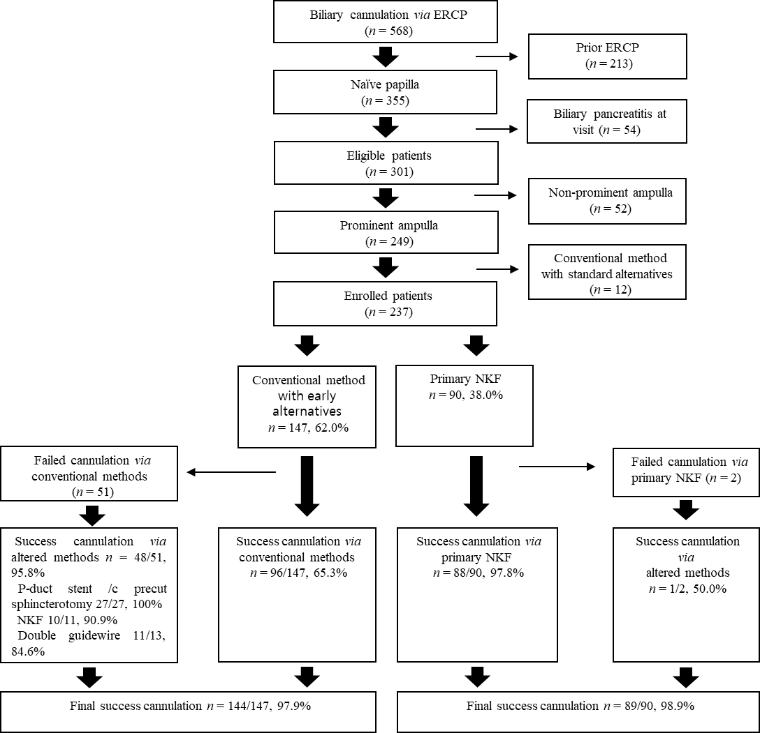
B
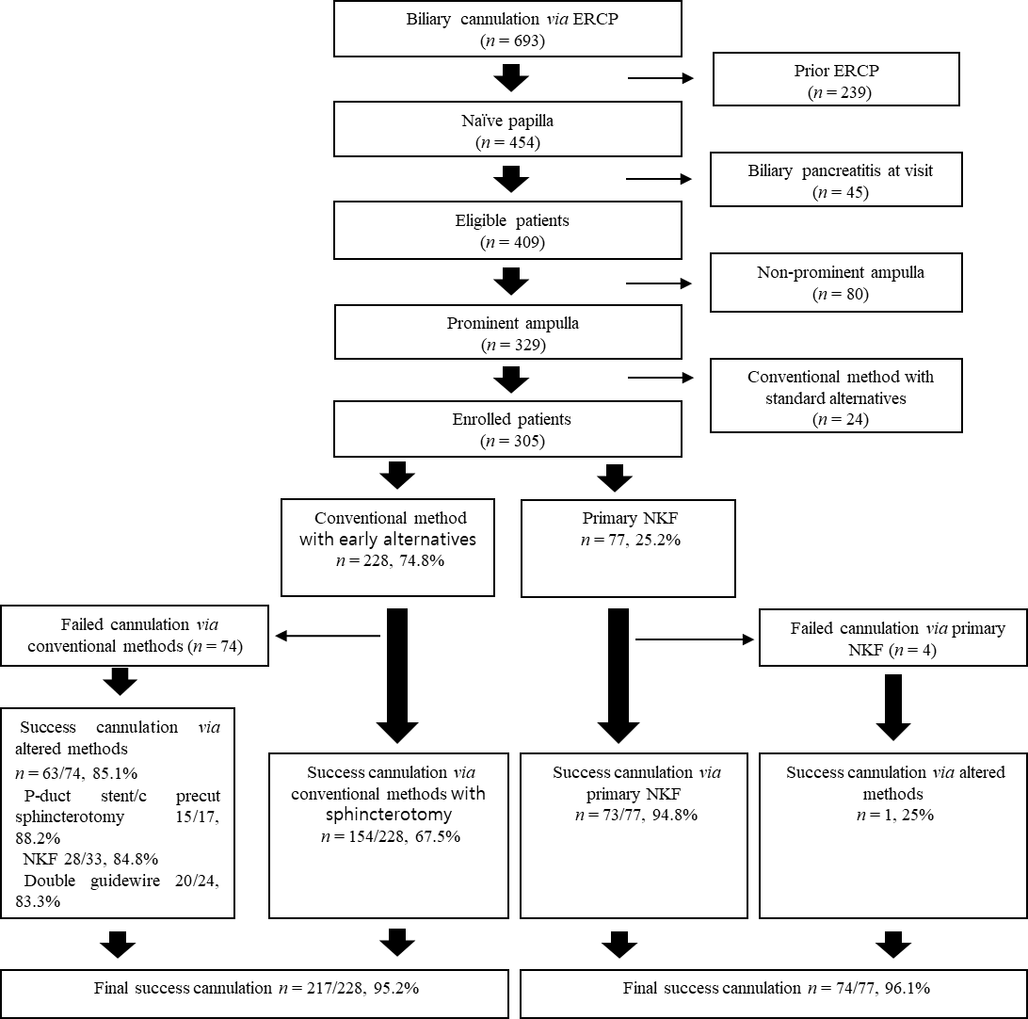
Figure 1 Study flow chart. A: Experienced endoscopist; B: Less experienced endoscopist. ERCP: Endoscopic retrograde cholangiopancreatography; NKF: Needle-knife fistulotomy.
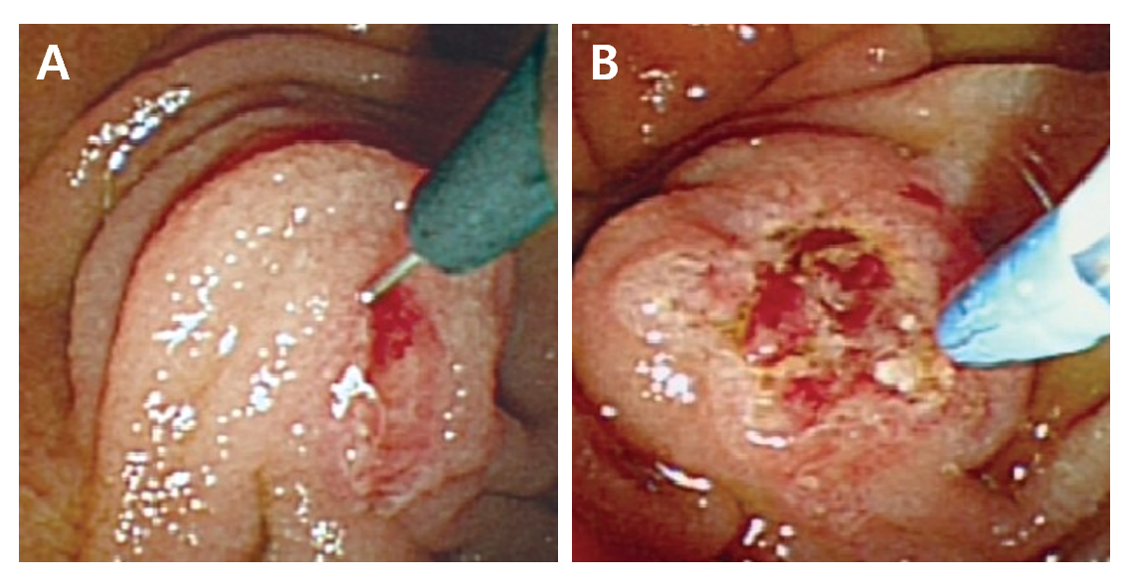
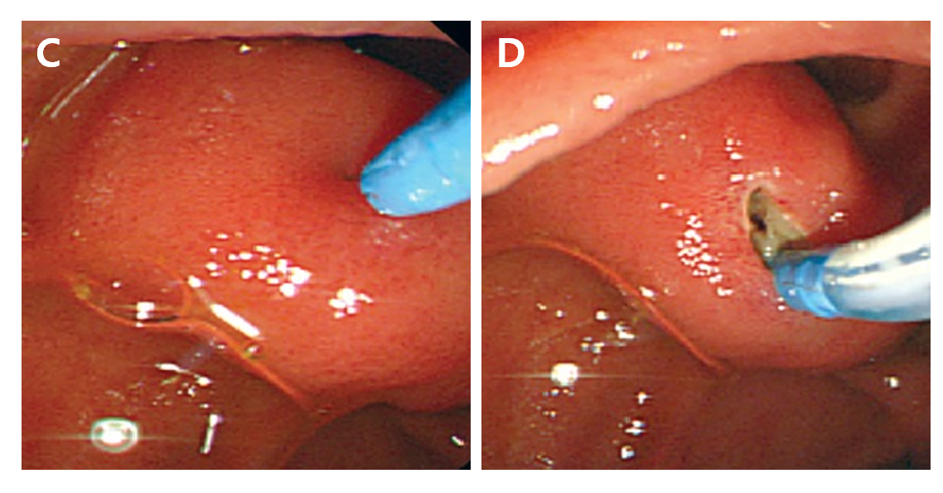
Figure 2 Comparison of precut sphincterotomy and needle-knife fistulotomy. A: Precut sphincterotomy. The needle is placed at the orifice of the ampulla; B: Precut sphincterotomy. Precutting was performed with slight upward tension; C: Needle knife fistulotomy. Mucosal incision at the maximal bulging point of the papillary roof of the ampulla; D: Needle knife fistulotomy. Incision at the oral side of the bile duct at the 11-12 o’clock position relative to the ampulla of Vater.
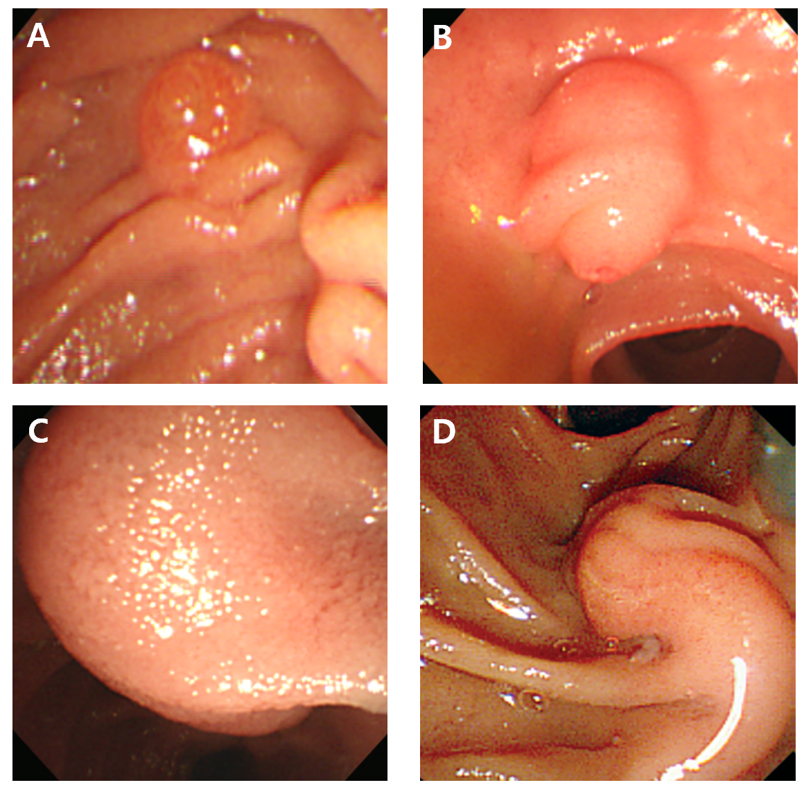
Figure 3 Ampulla configurations. A: Non-prominent; B: Bulging; C: Hook-shape, ampulla of Vater orifice was not shown due to huge bulging; D: Distorted.
Table 1 Baseline characteristics between the experienced and less experienced endoscopists
 | Total, n = 542, (%) | Experienced, n = 237, (%) | Less-experienced, n = 305, (%) | P value
Age (yr) | 67.8 ± 13.4 | 66.6 ± 14.2 | 68.7 ± 12.6 | 0.070
Male (%) | 307 (56.6) | 129 (54.4) | 178 (58.4) | 0.361
Periampullary diverticulum | 163 (30.1) | 81 (34.2) | 82 (26.9) | 0.067
Ampulla configurations |  |  |  | 0.224
Non-prominent | 0 (0) | 0 (0) | 0 (0)
Prominent | 455 (83.9) | 205 (86.5) | 250 (82.0)
Bulging | 65 (12.0) | 25 (10.5) | 0 (13.1)
Distorted | 15 (2.8) | 3 (1.3) | 12 (3.9)
Hook-nose shape | 7 (1.3) | 4 (1.7) | 3 (1.0)
Malignancy | 200 (36.9) | 91 (38.4) | 109 (35.7) | 0.525
Benign diseases | 342 (63.1) | 146 (61.6) | 196 (64.3)

Table 2 Baseline characteristics between the conventional technique with sphincterotomy and needle-knife fistulotomy groups
 | Conventional technique with sphincterotomy, n = 375, (%) |  |  | Primary NKF less-experienced, n = 167, (%)
 | Experienced, n = 147, (%) | Less-experienced, n = 228, (%) | P value | Experienced, n = 90, (%) | Less-experienced, n = 77, (%) | P value
Age (yr) | 68.8 ± 12.9 | 68.7 ± 12.1 | 0.964 | 63.1 ± 15.6 | 68.7 ± 14.3
Male | 75 (51.0) | 130 (57.0) | 0.256 | 54 (60.0) | 48 (62.3) | 0.759
Periampullary diverticulum | 52 (35.4) | 68 (29.8) | 0.262 | 29 (32.2) | 14 (18.2) | 0.039ª
Ampulla configurations |  |  | 0.625 |  |  | 0.265
Non-prominent | 0 (0) | 0 (0) |  | 0 (0) | 0 (0)
Prominent | 136 (92.5) | 205 (89.9) |  | 69 (76.7) | 54 (70.1)
Bulging | 8 (5.4) | 19 (8.3) |  | 17 (18.9) | 16 (20.8)
Distorted | 2 (1.4) | 3 (1.3) |  | 1 (1.1) | 5 (6.50)
Hook-nose shape | 1 (0.7) | 1 (0.4) |  | 3 (3.3) | 2 (2.6)
Malignancy | 58 (39.5) | 80 (35.1) | 0.393 | 33 (36.7) | 29 (37.7) | 0.895
Benign diseases | 89 (60.5) | 148 (64.9) |  | 57 (63.3) | 48 (62.3)
ªP < 0.05. NKF: Needle-knife fistulotomy.
Table 3 Compared results between the experienced and less-experienced endoscopists in each primary cannulation technique
 | Conventional technique with sphincterotomy |  |  | NKF
 | Experienced (n = 147) (%) | Less-experienced (n = 228) (%) | P value | Experienced (n = 90) (%) | Less-experienced (n = 77) (%) | P value
Success rate | 361/375 (96.3) |  |  | 161/167 (96.4) |  | 0.936
 | 144/147 (98.0) | 217/228 (95.2) | 0.166 | 88/90 (97.8) | 73/77 (94.8) | 0.306
Cannulation time (min) | 4.8 ± 3.5 |  |  | 4.8 ± 3.2 |  | 0.951
 | 5.1 ± 3.5 | 4.6 ± 3.6 | 0.200 | 4.2 ± 3.1 | 5.5 ± 3.1 | 0.010ª
Total procedure time (min) | 17.2 ± 9.2 |  |  | 15.2 ± 8.2 |  | 0.019ª
 | 17.6 ± 9.6 | 16.9 ± 8.9 | 0.490 | 14.9 ± 8.4 | 15.6 ± 8.0 | 0.598
Post-ERCP pancreatitis | 25 (6.7) |  |  | 4 (2.4) |  | 0.040ª
 | 5 (3.4) | 20 (8.9) | 0.039ª | 1 (1.1) | 3 (3.9) | 0.243
Hyperamylasemia | 52 (14.0) |  |  | 13 (7.8) |  | 0.041ª
 | 15 (10.2) | 37 (16.4) | 0.090 | 5 (5.6) | 9 (11.7) | 0.156
Bleeding | 10 (2.7) |  |  | 6 (3.6) |  | 0.568
 | 2 (1.4) | 8 (3.6) | 0.202 | 2 (2.2) | 4 (5.2) | 0.306
Perforation | 1 (0.3) |  |  | 0 (0) |  | 0.505
 | 0 (0) | 1 (0.4) | 0.423 | 0 (0) | 0 (0) | NA
ªP < 0.05. NKF: Needle-knife fistulotomy; ERCP: Endoscopic retrograde cholangiopancreatography; NA: Not available.

Table 4 Clinical factors associated with post endoscopic retrograde cholangiopancreatography pancreatitis in conventional technique with sphincterotomy and needle-knife fistulotomy group
 | Conventional technique with sphincterotomy |  |  |  |  |  |  | NKF
 | Total | With PEP | Without PEP | P value |  |  | Odd ratio (95%CI) | Total | With PEP | Without PEP | P value |  | Odd ratio (95%CI)
 | n = 375, (%) | n = 25, (%) | n = 350, (%) | Uni- | Multi- |  |  | n = 167, (%) | n = 4, (%) | n = 163, (%) | Uni- | Multi-
Age (yr) | 68.7 ± 12.4 | 65.6 ± 12.5 | 69.0 ± 12.4 | 0.194 | 0.126 |  | 0.98  (0.94-1.01) | 65.7 ± 15.3 | 69.8 ± 11.9 | 65.6 ± 15.3 | 0.593 | -
Male (%) | 205 (54.7) | 12 (48.0) | 193 (55.1) | 0.490 |  |  |  | 102 (61.1) | 2 (50.0) | 100 (61.3) | 0.648 | -
Periampullary diverticulum | 120 (32.0) | 8 (32.0) | 112 (32.0) | 0.999 |  |  |  | 43 (25.7) | 1 (25.0) | 42 (25.8) | 0.973 | -
Malignancy | 138 (36.8) | 9 (36.0) | 129 (36.9) | 0.932 |  |  |  | 62 (37.1) | 3 (75.0) | 59 (36.2) | 0.114 | 0.165 | 4.74  (0.41-54.8)
Benign diseases | 237 (63.2) | 16 (64.0) | 221 (63.1) | - |  |  |  | 105 (62.9) | 1 (25.0) | 104 (63.8) | - | -
Less-experienced endoscopist | 228 (60.8) | 20 (80.0) | 208 (59.4) | 0.044ª | 0.037ª |  | 2.94  (1.07-8.10) | 77 (46.1) | 3 (75.0) | 74 (45.4) | 0.243 | 0.110 | 6.40 (0.45-90.6)
Pancreatic duct stent | 72 (19.2) | 4 (16.0) | 68 (19.4) | 0.675 |  |  |  | 0 (0.0) | 0 (0.0) | 0 (0.0) | - | -
Cannulation time (min) | 4.8 ± 3.5 | 5.3 ± 3.5 | 4.7 ± 3.5 | 0.431 |  |  |  | 4.8 ± 3.2 | 8.8 ± 1.7 | 4.7 ± 3.1 | 0.010ª | 0.945 | 0.99 (0.75-1.31)
Total procedure time (min) | 17.2 ± 9.2 | 21.0 ± 8.8 | 16.9 ± 9.2 | 0.031ª | 0.026ª |  | 1.04 (1.01-1.08) | 15.2 ± 8.2 | 30.0 ± 9.3 | 14.8 ± 7.9 | 0.000ª | 0.004ª | 1.14 (1.04-1.25)
ªP < 0.05. NKF: Needle-knife fistulotomy; PEP: Post-endoscopic retrograde cholangiopancreatography pancreatitis; CI: Confidence interval.

