Name of journal: World Journal of Stem Cells
ESPS Manuscript NO: 12947
Columns: Review

Role of nanotopography in the development of tissue engineered 3D organs and tissues using mesenchymal stem cells

Salmasi S et al. Role of nanotopography in the development of tissue

Shima Salmasi, Deepak M Kalaskar, Wai-Weng Yoon, Gordon W Blunn, Alexander M Seifalian

Shima Salmasi, Deepak M Kalaskar, Alexander M Seifalian, University College London, Centre for Nanotechnology and Regenerative Medicine, UCL Division of Surgery and Interventional Science, NW3 2PF London, United Kingdom

Wai W Yoon, Royal National Orthopaedic Hospital, Stanmore, HA7 4LP Middlesex, United Kingdom

Gordon W Blunn, Institute of Orthopaedics and Musculo-Skeletal Science, University College London, WC1E 6BT London, United Kingdom

Gordon W Blunn, Institute of Orthopaedics and Musculo-Skeletal Science, Royal National Orthopaedic Hospital, Stanmore, HA7 4LP Middlesex, United Kingdom

Author contributions All authors contributed equally to the manuscript in terms of writing the paper.

Conflict-of-interest: Authors confirm that no conflict of interest exists regarding this manuscript.

Open-Access: This article is an open-access article which selected by an in-house editor and fully peer-reviewed by external reviewers. It distributed in accordance with the Creative Commons Attribution Non Commercial (CC BY-NC 4.0) license, which permits others to distribute, remix, adapt, build upon this work non-commercially, and license their derivative works on different terms, provided the original work is properly cited and the use is non-commercial. See: http://creativecommons.org/licenses/by-nc/4.0/

Correspondence to: Alexander M Seifalian, Professor, University College London, Centre for Nanotechnology and Regenerative Medicine, UCL Division of Surgery and Interventional Science, 9th Floor, Royal Free Campus, Rowland Hill Street, NW3 2PF London, United Kingdom. a.seifalian@ucl.ac.uk

Telephone: +44-020-77940500 Fax: +44-020-74726444

Received: July 29, 2014
Peer-review started: July 30, 2014
First decision: September 29, 2014
Revised: November 7, 2014
Accepted: December 3, 2014
Article in press:
Published online:

Abstract
Recent regenerative medicine and tissue engineering strategies (using cells, scaffolds, medical devices and gene therapy) have led to fascinating progress of translation of basic research towards clinical applications. In the past decade, great deal of research has focused on developing various 3D organs, such as bone, skin, liver, kidney and ear, using such strategies in order to replace or regenerate damaged organs for the purpose of maintaining or restoring organs’ functions that may have been lost due to aging, accident or disease. The surface properties of a material or a device are key aspects in determining the success of the implant in biomedicine, as the majority of biological reactions in human body occur on surfaces or interfaces. Furthermore, it has been established in the literature that cell adhesion and proliferation are, to a great extent, influenced by the micro- and nano-surface characteristics of biomaterials and devices. In addition, it has been shown that the functions of stem cells, mesenchymal stem cells in particular, could be regulated through physical interaction with specific nanotopographical cues. Therefore, guided stem cell proliferation, differentiation and function are of great importance in the regeneration of 3D tissues and organs using tissue engineering strategies. This review will provide an update on the impact of nanotopography on mesenchymal stem cells for the purpose of developing laboratory-based 3D organs and tissues, as well as the most recent research and case studies on this topic.

© 2014 Baishideng Publishing Group Inc. All rights reserved.

Key words: Nanotopography; Nanotechnology; Mesenchymal stem cells; Tissue engineering; 3D organs/tissues; Scaffolds

Core tip: Tissue engineering and nanotechnology are both exciting fields that have enormous potentials to revolutionise medicine as we know it today. Use of nanotechnology is an attractive and effective way to control and direct biological events at cellular levels. Nanoscale architecture plays a pivotal role directing cellular activities. Here, the use of nanotopography for the purpose of 3D organ/tissue regeneration using mesenchymal stem cells (i.e., their proliferation, differentiation and function), is reviewed by investigating the most recent, innovative, and effective studies in this field.

Salmasi S, Kalaskar DM, Yoon WW, Blunn GW, Seifalian AM. Role of nanotopography in the development of tissue engineered 3D organs and tissues using mesenchymal stem cells. World J Stem Cells 2014; In press

INTRODUCTION
It is becoming progressively evident that with an ever increasingly older population and high costs associated with meeting the healthcare demands^{[1]} as well as the shortage of organs and effective therapeutic methods^{[2]}, the field of medicine has to move towards cutting edge, laboratory engineered techniques and devices if, we are to avoid a drastic world-wide healthcare collapse in the near future. To this end, the fields of nanotechnology, regenerative medicine and tissue engineering (TE) are expanding at a rapid pace. Recent regenerative medicine and TE strategies (using cells, scaffolds, medical devices and gene therapy) have led to fascinating progress of translation of basic research towards clinical applications^{[1,3]}. In the past decade, great deal of research has focused on developing various 3D organs, such as bone^{[4]}, skin^{[5]}, liver^{[6]}, kidney^{[7]}, and ear^{[8]}, using such strategies in order to replace or regenerate damaged organs for the purpose of maintaining or restoring organs’ functions.
Human organs are responsible for various important functions of the body including, but not limited to, digesting food, serving as a barrier against infections, recognising and coordinating the body’s response to its internal and external environmental changes, and providing oxygen (to be used for cellular respiration) as well as removing excess carbon dioxide. They are also responsible for maintaining homeostasis, transmission of information and generating force^{[3]}. In cases when one or a few of the organs are severely damaged, to an extent that they are no longer capable of reconstructing or regenerating themselves, tissue engineering and nanotechnology based strategies, using previously established knowledge on cellular behaviour^{[9,10]}, could be employed to develop and construct tailored therapies, devices, or even whole organs. To this end, nanostructured, bio-inspired, or biological materials have attracted a great deal of attention as they poses unique chemical, mechanical and surface characteristics that could prove useful for organ or tissue TE.
The surface properties of a material or a device are key aspects in determining the success of the implant in biomedicine, as the majority of biological reactions in human body occur on surfaces or interfaces^{[11]}. Furthermore, it has been established in the literature that cell adhesion and proliferation are, to a great extent, influenced by the micro- and nano-surface characteristics of biomaterials and devices^{[12,13]}. In addition, it has been shown that the stem cells’, mesenchymal stem cells (MSCs) in particular, functions can be regulated through physical interaction with specific nanotopographical cues^{[3,14]}, further indicating the importance of surface characteristics at nanometre length scale. Therefore, guided stem cell proliferation, differentiation and function are of great importance in the regeneration of 3D organs and tissues using TE strategies.
This review will provide an update on the impact of nanotopography on MSCs for the purpose of developing laboratory-based 3D organs, as well as the most recent research and case studies on this topic.

NANOFABRICATION OF 3D SCAFFOLDS WITH STEM CELLS
Previously, most research and investigations focused on growing cells in a petri dish (two dimensional, 2D). However, in nature cells use 3D template of extracellular matrix (ECM) to shape functional tissues^{[15]}. Micro- and nano-scale chemical and physical cues from the ECM environment control and direct various key cell behaviours including their adhesion, proliferation, migration and differentiation^{[16-18]}. Therefore, the construction of a synthetic system that mimics the natural ECM and its component has become a field of topical interest^{[19]}.
Recent investigations have shown rapid success in TE of sophisticated and complex nanoenvironments suitable for 3D growth of stem cells for the purpose of organ and tissue regeneration^{[19-22]}. So far, various biofabrication techniques have been developed and employed to design an ideal 3D synthetic ECM-mimetic system that resembles the architecture and mechanical properties of the natural ECM^{[3]}. Natural or synthetic polymers are used as scaffold materials and, depending on their nature, suitable biofabrication techniques are used to create a 3D environment with nanotopographical cues that can lead to controlled and directed growth and differentiation of stem cells toward a specific or organ regeneration. Numerous studies have covered the currently available fabrication techniques for natural or synthetic polymers^{[15,23-27]}. In general, the available fabrication techniques can be classified into different categories based on their energy source, i.e. thermal, optical, physical, chemical or electrical (Table 1). It is beyond the scope of this paper to review the different available techniques in each of these categories, however, a review conducted by Kim et al^{[3]} could be referred to for further and in detail information on this topic.

CHARACTERISTICS OF MSCs AND THEIR APPLICATION IN TE OF 3D ORGANS
An extensive number of studies have demonstrated the great potentials of using MSCs for TE approaches^{[28-33]}. Among many advantageous characteristics of MSCs the fact that these cells can be isolated from several tissues and that they have the potential to be expanded in culture and exhibit multilineage differentiation (Figure 1) make MSCs a highly interesting stem cell source for TE and regenerative medicine research^{[31]}. Other interesting properties of MSCs include; their ability to self-renew, modulate immune responses, and their availability (they can be obtained from a small scale aspirate of bone marrow or adipose tissues)^{[34-36]}. Furthermore, MSCs can be isolated from adults, therefore, allogeneic transplant of these cells would eliminate raising ethical issues in regards to their use in TE and regenerative medicine^{[36]}.
Among most potential characteristics of MSCs, it is probably their ability of multilineage differentiation that is mostly exploited for TE and regenerative medicine purposes. The differentiation of MSCs is controlled by some regulatory genes and induction chemicals that lead to the specific differentiation of these progenitor cells^{[37,38]}. In addition to growth factors and induction chemicals, various biomaterials (i.e. natural and synthetic polymers) are used to provide appropriate scaffolding for the proliferation and differentiation of MSCs for the purpose of reconstruction of several hard and soft tissues and organs, such as bone, cartilage, tendons, and skin^{[39,40]} (Figure 2).

THE ROLE OF NANOTOPOGRAPHY ON THE GROWTH AND PROLIFIRATION OF MSCS
As mentioned earlier, surface nanotopography of biomaterials can evoke specific cellular responses. Materials with unique nanotopographical characteristics offer properties, similar to growth factors, which can be used to induce specific biological performances of safe and cost effective manners in the human body^{[41]}. Previous studies show that various nanotopographical cues can potentially impact the adhesion^{[42,43]}, orientation^{[44]}, and cytoskeletal organisation^{[45]} of MSCs as well as their self-renewal^{[46]}, proliferation and differentiation^{[41]}. Furthermore, nanotopographical cues could influence morphology, migratory capacity, gene expression and subsequently the fate of MSCs^{[47,48]}.
It has been shown that nanofeatures including nanopits, nanogratings and nanoprotruisons have the potentials to influence the cell morphology, proliferation and differentiation of MSCs^{[49,50]} (Figure 3). For instants, it has been shown that homogenously nanopatterned and chemically modified surfaces can have direct effect on cellular responses of MSCs, including their self-renewal abilities, control over their initial cell interactions and subsequently their cell phenotype, by creating arrays of nanodots using dip pen nanolithography (DPN)^{[51]} (Figure 4). Furthermore, differentiation and proliferation of human MSCs (hMSCs) were investigated on nanogratings of 350nm width combined with biochemical cues such as retinoic acid, and it was shown that synthetic nanostructures can induce hMSCs to differentiate into neuronal lineage^{[52]}. This study, conducted by Yim et al^{[52]}, also confirmed the significance of nanotopography as it revealed that retinoic acid alone on unpatterned surfaces did not lead to strong neuronal marker expression as it was shown on surfaces with nanogratings. Other nanopatterned structures, such as grooves, ridges, and pores as well as holes, nods, or rods are of other commonly techniques currently employed to change unpatterned surfaces for MSCs to grow on and to direct their cellular responses^{[53]}. Such nanostructures have great applications to all areas of TE. For instance, Andersen et al^{[54]} investigated adhering nanoparticles containing different small-interfering RNAs (siRNAs) into nanostructured scaffolds consisting of nanopores and reported of spatial retention of the RNAs within nanopores seeded with MSCs, which resulted in enhanced osteogenic and adipogenic differentiation of MSCs^{[54]}. This is an exciting finding as the ability of directing a single type of differentiation plays a crucial role in developing specific 3D organs. In another study, Watari et al^{[55]} used topographically-patterned substrates containing anisotropically ordered ridges and grooves to modulate osteogenic differentiation in hMSCs^{[55]}. They reported that hMSCs cultured on 1400 or 4000 nm pitches, compared to those seeded on 400 nm pitch or planer control, exhibit better elongation and alignment, while they showed a significant decrease in Runt-related transcription factor 2 (RUNX2) and bone gamma-carboxyglutamic acid-containing protein (BGLAP) expression. Their data also revealed that 400 nm pitch increased extracellular calcium deposition. Watari et al^{[55]} concluded that specific size scale of topographic cues could directly influence the osteogenic differentiation of hMSCs both with and without osteogenic agents. This is another important finding that could enable one to manipulate and develop nanostructures that could lead to controlled and directed differentiation of stem cells for the purpose of TE of 3D organs. Very recently, the effect of topographical design, in the form of nano-pillar, nano-hole and nano-grill, on hMSCs were investigated by Wu et al^{[56]} in which these nanotopographies were applied onto a polycaprolactone surface using thermal nanoimprinting^{[56]}. Their findings revealed that nanotopographical patterns trigger changes in the morphology and cytoskeletal structure of hMSCs. They also found that, compared to non-patterned surfaces, nano-pillar and nano-hole topography determined MSCs chondrogenesis, resulting in specific cartilage formation. Furthermore, Kilian et al^{[57]} showed that geometric nanotopography cues, that increase actomyosin contractility, could influence and direct the osteogenesis of bone marrow-derived hMSCs^{[57]}. Such geometric cues direct and control mechanochemical signals and paracrine/autocrine factors necessary for specific differentiation of MSCs, also observed during the in vivo investigation of the microenvironment of the differentiated cells.

CASE STUDIES ON THE APPLICATION OF NANOTOPOGRAPHY GUIDED TE OF 3D ORGANS/TISSUES USING MSCS

Bone
Reconstruction of large bone defects caused by surgery, trauma or tumours are common deficiencies, which present a significant medical challenge^{[58]}. Autologous bone grafting is the gold standard for treating bone defects, but obstacles such as limited sources of tissue, and bone resorption before bone healing, have raised interests in synthetic materials as potential bone substitutes^{[59]}. Furthermore, bone grafting has proven challenging for large bone defects reconstruction^{[60]}. This is mainly due to difficulties in harvesting enough bone grafts from a healthy bone, potential postoperative pain, risk of infection, risk of hypersensitivity, risk of paresthesia, and time constraints^{[61,62]}. TE, using stem cells, provides the opportunity to avoid the established drawbacks of bone graft materials for the purpose of reconstructing or regenerating bone defects at variety of scales. MSCs, because of their interesting properties, have been demonstrated as an attractive cell source for bone TE applications^{[63]}. Controlled and directed differentiation of MSCs into osteoblasts (bone cells) is therefore a key aspect of this process. As mentioned above, nanotopographical cues could be used to influence MSCs cell behaviour and differentiation toward specific lineages. For instance, in a very recent study, McCafferty et al^{[64]} demonstrated the use of nanotopography to induce osteogenic differentiation of human bone marrow derived MSCs^{[64]}. They sputter deposited thin films of bioactive calcium phosphate onto a polycrystalline titanium nanostructured surface. These sputter deposited surfaces supported high levels of bone marrow–derived hMSCs proliferation and adhesion, determined by DNA quantification. Moreover, they were also able to directly promote significant levels of osteogenic differentiation. In this study, gene expression, alkaline phosphatase activity and immunocytochemical localisation of key osteogenic markers showed that the nanostructured titanium surfaces and the bioactive calcium phosphate coatings could direct differentiation towards an osteogenic lineage. The addition of the calcium phosphate chemistry to the topographical profile of the titanium was found to induce increased bone marrow–derived hMSCs differentiation compared to that observed for either the titanium or calcium phosphate coating without an underlying nanostructure. Therefore, the results presented a clear benefit from a surface engineering strategy that combines a defined nanoscale surface topography with a conformal bioactive chemistry. In another study by de Peppo et al^{[65]} osteogenic response of hMSCs to titanium-coated hemisphere-like topographic nanostructures of 50, 100, and 200 nm was assessed^{[65]}. Their aim was to look at the influence of different sizes of nanoscale topographies on the morphology, proliferation, and osteogenic differentiation of hMSCs in vitro. Here, the nanostructuring was fabricated using colloidal lithography and the desired structure sizes were achieved by etching the original 200 nm polymeric particles (polystyrene particles) and further heat-treating them above the transition temperature of polystyrene (118 °C), to create semispheroidal nanoparticles to increase their surface attachment abilities. Their results showed that there is a direct relationship between the proliferation and osteogenic differentiation of hMSCs and the size of the underlying structures, demonstrating that by varying the scale of the nanotopographic features at nanoscale, one can control the osteogenic behaviour of hMSCs. de Peppo et al^{[65]} concluded that colloidal lithography in combination with coating technologies can enable structuring well defined nanoscale topographies to control and direct hMSCs growth and differentiation. Dalby et al^{[66]} also investigated the osteogenitor response of hMSCs to semi-ordered and random nanotopographies performed by colloidal lithography and polymer demixing on silicon and showed that hMSCs react robustly to nanotopographic features down to 10 nm in size with a low aspect ratio^{[66]}. In this study, scanning electron microscopy of primary hMSCs on flat controls and scaffolds with nanotopographic structures showed that hMSCs exhibited strong reaction to nanofeatures as their filopodia extended and curled around these features (Figure 5). Dalby et al^{[66]} concluded that their recorded osteogenic response of hMSCs to nanotopographies could be employed to construct and design scaffolds with an appropriate osteogenic “environment” instead of planar control structures in order to direct and control MSCs growth and differentiation.
Furthermore, Rosa et al^{[67]} examined the osteoinductive potential of titanium (Ti) surfaces with nanotopographic features, yield by chemically treating polished Ti discs with H₂SO₄/H₂O₂, and cultured them with rat MSCs under osteogenic and non-osteogenic conditions^{[67]}. Untreated polished Ti surfaces were used as controls. Their findings revealed that Ti surfaces with nanotopography boosted cell proliferation and alkaline phosphatase (Alp) activity of rat MSCs under both osteogenic and non-osteogenic conditions (Figure 6). They also demonstrated that nanotopography upregulated the gene expression of major bone markers under both of the test conditions. Interestingly, they noticed that obtustatin, an α1β1 integrin inhibitor, was able to reduce higher gene expression of key bone markers and Alkaline Phosphatase (ALP) activity on Ti Scaffolds with nanotopographic features. Therefore, suggesting that obtustatin signalling pathway plays a crucial role in determining the osteoinductive effect of nanotopography on MSCs, a finding that can be exploited as a novel mechanism of accelerating and/or enhancing MSCs osseointegration for the purpose of TE of complex organs or tissues in the future.

Cartilage
Cartilage defects, caused by osteoarthritis, trauma or sport, are considered serious clinical problems. So far, TE of cartilage has proven to be much more difficult than many other organs or tissues, due to cartilage’s inherently poor regenerative ability^{[68]}. Therefore, developing a functional TE system, capable of improving the regenerative ability of this tissue, would be of great interest. Most research on this field have been focused on using polymeric scaffolds with stem cells, in particular MSCs^{[8,68-70]}. MSCs are considered the “gold standard” of stem cell source for cartilage TE as their differentiation to chondrocytes can be easily controlled and directed using various techniques, in particular nanotopography^{[8,56]}.
Previous studies have shown that a more rounded, spheroidal cell shape can enhance the rate of chondrogenesis, through increasing the expression of chondrocyte-related genes, markers, and proteins^{[71,72]}. Based on this, Zhong et al^{[73]} attempted to create a microenvironment suitable for MSCs fibrochondrogenesis using simultaneously integrated nanotopography and flow stimulus^{[73]}. They developed a biomimetic microfluidic device consisting of aligned nanofibers of poly lactic-co-glycolic acid (PLGA), and micorchambers of different angles. The micorchambers were used to enable flow direction to create different angles with PLGA nanofibers. Their findings showed that the combination of fluid flow, nanotopography-induced cues, and the direction of flow in relation to the aligned nanofibers contributed towards the round shape morphology of MSCs, associated with fibrochondrogenesis during chondrogenic differentiation of these cells.
Although, most studies have shown positive contributions of various nanotopographical cues on MSCs growth and differentiation, a few studies have concluded that certain types of nanotopography could have adverse effect on the differentiation of MSCs into chondrocytes for the purpose of repairing or regenerating cartilage. The study by Wu et al^{[56]} is a good example on this statement as their findings revealed that MSCs experienced delayed chondrogenesis on samples with nano-grill topography^{[56]}. They observed radically different morphological, proliferation and chondrogenesis changes as well as significantly higher upregulation of type II collagen on nano-pillar and nano-hole surfaces compared to nano-grill surfaces, where the expression of collagen I marker was drastically higher (Figure 7). Similarly, Trujillo et al^{[74]} reported of decreased chondrogenic differentiation of adipose-derived MSCs on nanowire surfaces^{[74]}. They used sintering and solvent-free nanotemplating to fabricate polycaprolactone (PCL, as control) and nanowire (NW) samples. After 4 and 7 d of culturing the samples with adipose-derived MSCs, both groups demonstrated positive support for cell attachment and proliferation. Once chondrogenic differentiation media was supplemented to the cultures, alcian blue staining was used to confirm the presence of acidic polysaccharides, such as sulphated glycosaminoglycans, normally found in articular and hyaline cartilage tissue. At 3 wk, it was evident that there had been significantly higher production of polysaccharides on PCL compared to NW. The authors also investigated PCL and NW samples under adipogenic differentiation conditions and found the results to be reversed, i.e., there was increased adipogenic differentiation of adipose-derived MSCs on the NW samples. These findings indicate that nanotopography can have bias and in some cases unexpected effects on the differentiation of MSCs towards a particular lineage. However, further research is required on this particular topic in the future, in order to better understand the underlying mechanism of such adverse events.

Skin
Millions of burn injuries occur worldwide that cause serious harm to skin and subsequently to the general health of patients, as the first line of a patient’s defence is compromised. In cases where the injuries are too severe for the natural repair process to take place, skin TE is considered. Skin, with a surface area of 1.8 m², is the largest organ in the body, which consists of two layers: the outer protective epidermis and inner corium or dermis. Currently the main obstacle in front of skin TE is in vitro culture time required to grow epithelial sheets large enough to be used for severe cases. This is particularly dangerous as the longer the wound takes to heal, the patient is at higher risks of acquiring infection^{[75]}. Another issue is that epithelial cells are very sensitive and adhering them to the burned surfaces is very difficult^{[76]}.
Like in other diseases, stem cells can help improve the healing and regenerating process of skin. Previously, bone marrow-derived MSCs have been shown to differentiate into epithelial cells of skin^{[77]}, and promising results have been achieved in treating skin wounds, especially chronic ones^{[78,79]}. Wounds treated using bone marrow-derived MSCs have shown accelerated wound closure with rapid re-epithelisation, cellularity and angiogenesis^{[80]}. Incorporation of these cells into a suitable scaffold, which closely mimics the native micro- and nanotopographical characteristics of the ECM of the skin, may offer improved opportunity to repair or regenerate skin^{[81]}. For this to happen, two events should take place; (1) MSCs should be directed to the sites of injury and (2) they should differentiate into cells of skin lineage. This is achievable by designing scaffolds with specific nanotopographical features^{[82]}.
Based on the highly oriented nanogrooved structures of natural ECMs in human body, Kim et al^{[83]} designed nanotopographically variable grooved matrices, using UV assisted capillary force lithography, with curable polyurethane acrylate (PUA) polymer^{[83]}. The PUA nanogrooved matrices were then gelatine coated prior to cell culturing with hMSCs. In this study, the effect of nanotopographical density was investigated on hMSCs migration and proliferation for wound healing purposes. It was shown that hMSCs migrate into the target area (the wounded, cell free area) and that the hMSCs on nanogrooved matrices exhibited a significantly higher speed of cell migration than those on the flat controls. They also investigated various densities of nanogrooves and found that as the density of the nanogrooved matrices increases, the speed of hMSCs migration increases proportionally. Their analysis of hMSC proliferation on nanogrooved matrices, compared to flat ones, revealed no significant differences, hence concluding that proliferation of hMSCs may not be influenced by nanogrooves.
Recently, great deal of attention has been focused on electrospun nanofibrous for skin regeneration^{[75,81,84,85]}. Using various nanotopographical designs, highly porous meshes of ultrafine fibers could be fabricated that closely resemble the nanotopography of the natural ECM of human skin^{[84]}. Jin et al^{[86]} investigated the in vitro differentiation potentials of bone marrow-derived MSCs to epidermal cells on electrospun collagen/poly (_{L}-lactic acid)-copoly (3-caprolactone) (Coll/PLLCL) nanofibrous scaffolds^{[86]}. To further mimic the structure of the natural ECM of human skin, they incorporated Coll/PLLCL nanofibrous scaffolds with collagen, at a ratio of 30:70, respectively. Their findings demonstrated that electrospun Coll/PLLCL nanofibers enhanced the level of MSC and scaffold interaction and that the electrospun scaffolds could mimic the native skin ECM. Furthermore, their results showed controlled and directed differentiation of MSCs along the epidermal lineage on Coll/PLLCL nanofibrous scaffolds (Figure 8), suggesting their potential use in skin TE applications.

POTENTIAL ADVERS EFFECTS OF ERODED NANOPARTICLES ON MSCS
Based on the evidence presented in this review, it is clear that nanotopography of a surface can have a great influence on the various cellular behaviours of MSCs including; their attachment, proliferation and most importantly their differentiation towards a specific lineage. However, based on the literature, there have been various reports of the adverse effects of nanoparticles on the cellular behaviour of MSCs as the result of implant erosion over-time^{[87-89]}. This is especially a concern of biodegradable materials as they have been specifically designed to be deteriorated once implanted in their host. In long-term clinical application, the physiochemical properties of implants are influenced by their constant chemical, mechanical, and biological interactions with their host tissue and its surrounding environment^{[90]}. These factors cause the degradation of the implant and subsequently to the release microscale and/or nanoscale wear particles in their immediate vicinity. These released particles no longer exhibit any of the nanotopographical characteristic of the implant surface, prior to implantation.
Released nanoparticles, once exposed to tissues and bodily fluids, tend to absorb macromolecules in their vicinity and depending on the surface characteristics of the nanoparticles (e.g., their surface chemistry and surface energy), these macromolecules become attached onto the surface of the nanoparticles, leading to potential modification or functionalization of the surface of the nanoparticles^{[91,92]}. Attachment of such macromolecules could change the affinity of a nanoparticle to bind with a specific protein, on the surface of a particular type of cells, which in return could have serious unaccounted for or adverse toxic effects on the proliferation and/or differentiation of cells^{[93]}. For instance, there has been a report on serious DNA damage caused to MSCs when cultured with metallic silver nanoparticles, even at lower concentrations^{[88]}. Calcium phosphate nanoparticles, very commonly used for bone tissue engineering applications, have also shown to affect MSC proliferation in a size-dependent manner, with larger particles causing more serious harm^{[87]}. Furthermore, studies conducted by Hu et al^{[94]} and Liu et al^{[89]} showed that calcium phosphate nanoparticles could also affect MSC differentiation depending on their concentration and form of appearance^{[89,94]}. They reported that increasing the concentration of calcium phosphate nanoparticles, especially in the form of amorphous particles, rather than crystals, could negatively affect the osteogenic cell differentiation and matrix mineralisation of MSCs.
Other types of nanoparticles such as metallic ones are also of great concerns, as their release could lead to serious nanotoxicity in biomaterials and different cell lines. Various groups have investigated adverse systematic effects of titanium nanoparticles on different cell lines such as endothelial^{[95]}, lymphoblastoid^{[96]}, and fibroblasts^{[97]} cells and reported of inflammatory reactions, DNA damage, and induction of apoptosis, respectively. However, until a year ago, there was no concise report on the adverse effect of titanium nanoparticles on the cellular behaviour of bone marrow-derived MSCs, despite titanium implants majorly being used for medical applications, such as in bone TE. As the result, very recently, Hou et al^{[98]} investigated the effects of titanium nanoparticles on adhesion, migration, proliferation and differentiation of MSCs and reported of serious negative effects of the nanoparticles on MSC migration as particle size increased^{[98]}. They also demonstrated that exposure of MSCs to titanium nanoparticles negatively affected their osteogenic differentiation^{[98]}.

DISCUSSION AND FUTURE PROSPECTIVE
In this review, the role of nanotopography on controlling and directing cellular behaviour of various types of MSCs, with respect to specific tissues and organs, has been described. Based on the studies presented here, it can be established that various nanofabrication methods can be employed to design and fabricate nanostructured scaffolds with distinct nanotopographical cues to control and direct various cellular behaviours of MSCs including; their attachment, proliferation and most importantly their differentiation towards a specific lineage (Table 2). Therefore, incorporating nanotopography on the design of scaffolds would open doors to new generation of TE strategies for the development of functional organs and tissues.
The review of the literature demonstrated that most studies on this topic have been focused on bone TE applications. In most of these studies, such strategy seemed to improve the proliferation and differentiation of MSCs for repair or regeneration of bone. In most cases, authors have reported of controlled and directed osteogenesis of these cells on various polymeric based composite or nanocomposite scaffolds. However, there seems to be a clear lack of investigation into the potentials of using nanotopography for the development of more complex organs or tissues such as heart, kidney, or bladder. This is despite of the fact that some studies have confirmed the abilities of MSCs to differentiate into various other cell types; including muscle cells, stromal cells and fibroblast cells. Therefore, in the future, TE and regenerative medicine could greatly benefit from research focused on developing more complex organs or tissues using nanotopography guided differentiation of MSCs, while at the same time, there needs to be a more comprehensive investigation on the potential adverse effect of various types of nanoparticles, released from eroded nanotopographical surfaces, on the cellular behaviour of MSCs.

REFERENCES
1 Messenger MP, Tomlins PE. Regenerative medicine: a snapshot of the current regulatory environment and standards. Adv Mater 2011; 23: H10-H17 [PMID: 21433095 DOI: 10.1002/adma.201100254]
2 Hopley EL, Salmasi S, Kalaskar DM, Seifalian AM. Carbon nanotubes leading the way forward in new generation 3D tissue engineering. Biotechnol Adv 2014; 32: 1000-1014 [PMID: 24858314 DOI: 10.1016/j.biotechadv]
3 Kim HN, Jiao A, Hwang NS, Kim MS, Kang do H, Kim DH, Suh KY. Nanotopography-guided tissue engineering and regenerative medicine. Adv Drug Deliv Rev 2013; 65: 536-558 [PMID: 22921841 DOI: 10.1016/j.addr.2012.07.014]
4 Oryan A, Alidadi S, Moshiri A, Maffulli N. Bone regenerative medicine: classic options, novel strategies, and future directions. J Orthop Surg Res 2014; 9: 18 [PMID: 24628910 DOI: 10.1186/1749-799X9-18]
5 Catalano E, Cochis A, Varoni E, Rimondini L, Azzimonti B. Tissue-engineered skin substitutes: an overview. J Artif Organs 2013; 16: 397-403 [PMID: 24096542 DOI: 10.1007/s10047-013-0734-0]
6 Li YS, Harn HJ, Hsieh DK, Wen TC, Subeq YM, Sun LY, Lin SZ, Chiou TW. Cells and materials for liver tissue engineering. Cell Transplant 2013; 22: 685-700 [PMID: 23127824 DOI: 10.3727/096368912X655163]
7 Martovetsky G, Nigam SK. Cellular and developmental strategies aimed at kidney tissue engineering. Nephron Exp Nephrol 2014; 126: 101 [PMID: 24854650 DOI: 10.1159/000360680]
8 Nayyer L, Birchall M, Seifalian AM, Jell G. Design and development of nanocomposite scaffolds for auricular reconstruction. Nanomedicine 2014; 10: 235-246 [PMID: 23792331 DOI: 10.1016/j.nano.2013.06.006]
9 Zhao M, Song B, Pu J, Wada T, Reid B, Tai G, Wang F, Guo A, Walczysko P, Gu Y, Sasaki T, Suzuki A, Forrester JV, Bourne HR, Devreotes PN, McCaig CD, Penninger JM. Electrical signals control wound healing through phosphatidylinositol-3-OH kinase-gamma and PTEN. Nature 2006; 442: 457-460 [PMID: 16871217 DOI: 10.1038/nature04925]
10 Petrie RJ, Doyle AD, Yamada KM. Random versus directionally persistent cell migration. Nat Rev Mol Cell Biol 2009; 10: 538-549 [PMID: 19603038 DOI: 10.1038/nrm2729]
11 Stylianou A, Yova D, and Alexandratou E. Nanotopography of collagen thin films in correlation with fibroblast response. J of Nanophotonics 2013; 7: 073590 [DOI: 10.1117/1.JNP.7.073590]
12 Tay CY, Irvine SA, Boey FY, Tan LP, Venkatraman S. Micro-/nano-engineered cellular responses for soft tissue engineering and biomedical applications. Small 2011; 7: 1361-1378 [PMID: 21538867 DOI: 10.1002/smll.201100046]
13 Phong HQ, Wang SL, Wang MJ. Cell behaviors on micro-patterned porous thin films. Mat Sci Eng: B 2010; 169: 94-100 [DOI: 10.1016/j.mseb.2010.01.009]
14 Kim J, Kim HN, Lim KT, Kim Y, Pandey S, Garg P, Choung YH, Choung PH, Suh KY, Chung JH. Synergistic effects of nanotopography and co-culture with endothelial cells on osteogenesis of mesenchymal stem cells. Biomaterials 2013; 34: 7257-7268 [PMID: 23834896 DOI: 10.1016/j.biomaterials.2013.06.029]
15 Shapira A, Kim DH, Dvir T. Advanced micro- and nanofabrication technologies for tissue engineering. Biofabrication 2014; 6: 020301 [PMID: 24876336 DOI: 10.1088/1758-5082/6/2/02030]
16 Guvendiren M, Burdick JA. The control of stem cell morphology and differentiation by hydrogel surface wrinkles. Biomaterials 2010; 31: 6511-6518 [PMID: 20541257 DOI: 10.1016/j.biomaterials.2010.05.037]
17 Ayala R, Zhang C, Yang D, Hwang Y, Aung A, Shroff SS, Arce FT, Lal R, Arya G, Varghese S. Engineering the cell-material interface for controlling stem cell adhesion, migration, and differentiation. Biomaterials 2011; 32: 3700-3711 [PMID: 21396708 DOI: 10.1016/j.biomaterials.2011.02.004]
18 Zouani OF, Chanseau C, Brouillaud B, Bareille R, Deliane F, Foulc MP, Mehdi A, Durrieu MC. Altered nanofeature size dictates stem cell differentiation. J Cell Sci 2012; 125: 1217-1224 [PMID: 22302989 DOI: 10.1242/jcs.093229]
19 Das RK, Zouani OF. A review of the effects of the cell environment physicochemical nanoarchitecture on stem cell commitment. Biomaterials 2014; 35: 5278-5293 [PMID: 24720880 DOI: 10.1016/j.biomaterials.2014.03.044]
20 Discher DE, Janmey P, Wang YL. Tissue cells feel and respond to the stiffness of their substrate. Science 2005; 310: 1139-1143 [PMID: 16293750 DOI: 10.1126/science.1116995]
21 Discher DE, Mooney DJ, Zandstra PW. Growth factors, matrices, and forces combine and control stem cells. Science 2009; 324: 1673-1677 [PMID: 19556500 DOI: 10.1126/science.1171643]
22 Baker BM, Chen CS. Deconstructing the third dimension: how 3D culture microenvironments alter cellular cues. J Cell Sci 2012; 125: 3015-3024 [PMID: 22797912 DOI: 10.1242/jcs.079509]
23 Liang L, Liu J, Windisch Jr CF, Exarhos GJ, Lin Y. Direct assembly of large arrays of oriented conducting polymer nanowires. Angew Chem Int Ed Engl 2002; 41: 3665-368, 3520 [PMID: 12370924]
24 Tsai IY, Kimura M, Stockton R, Green JA, Puig R, Jacobson B, Russell TP. Fibroblast adhesion to micro- and nano-heterogeneous topography using diblock copolymers and homopolymers. J Biomed Mater Res A 2004; 71: 462-469 [PMID: 15484209 DOI: 10.1002/jbm.a.30183]
25 Tsang VL, Bhatia SN. Three-dimensional tissue fabrication. Adv Drug Deliv Rev 2004; 56: 1635-1647 [PMID: 15350293 DOI: 10.1016/j.addr.2004.05.001]
26 Zhu X, Mills KL, Peters PR, Bahng JH, Liu EH, Shim J, Naruse K, Csete ME, Thouless MD, Takayama S. Fabrication of reconfigurable protein matrices by cracking. Nat Mater 2005; 4: 403-406 [PMID: 15834415 DOI: 10.1038/nmat1365]
27 Guo LJ. Nanoimprint lithography: methods and material requirements. Adv Mat 2007; 19: 495-513 [DOI: 10.1002/adma.200600882]
28 Bianco P, Robey PG, Simmons PJ. Mesenchymal stem cells: revisiting history, concepts, and assays. Cell Stem Cell 2008; 2: 313-319 [PMID: 18397751 DOI: 10.1016/j.stem.2008.03.002]
29 Prockop DJ. Repair of tissues by adult stem/progenitor cells (MSCs): controversies, myths, and changing paradigms. Mol Ther 2009; 17: 939-946 [PMID: 19337235 DOI: 10.1038/mt.2009.62]
30 Prockop DJ, Kota DJ, Bazhanov N, Reger RL. Evolving paradigms for repair of tissues by adult stem/progenitor cells (MSCs). J Cell Mol Med 2010; 14: 2190-2199 [PMID: 20716123 DOI: 10.1111/j.15824934.2010.01151.x]
31 Santos JL, Pandita D, Rodrigues J, Pêgo AP, Granja PL, Tomás H. Non-viral gene delivery to mesenchymal stem cells: methods, strategies and application in bone tissue engineering and regeneration. Curr Gene Ther 2011; 11: 46-57 [PMID: 21182464 DOI: 10.2174/156652311794520102]
32 Ahmed TA, Hincke MT. Mesenchymal stem cell-based tissue engineering strategies for repair of articular cartilage. Histol Histopathol 2014; 29: 669-689 [PMID: 24452855]
33 Serakinci N, Fahrioglu U, Christensen R. Mesenchymal stem cells, cancer challenges and new directions. Eur J Cancer 2014; 50: 1522-1530 [PMID: 24613620 DOI: 10.1016/j.ejca.2014.02.011]
34 Porada CD, Zanjani ED, Almeida-Porad G. Adult mesenchymal stem cells: a pluripotent population with multiple applications. Curr Stem Cell Res Ther 2006; 1: 365-369 [PMID: 18220880 DOI: 10.2174/157488806778226821]
35 Parekkadan B, Milwid JM. Mesenchymal stem cells as therapeutics. Annu Rev Biomed Eng 2010; 12: 87-117 [PMID: 20415588 DOI: 10.1146/annurev-bioeng-070909-105309]
36 Patel DM, Shah J, Srivastava AS. Therapeutic potential of mesenchymal stem cells in regenerative medicine. Stem Cells Int 2013; 2013: 496218 [PMID: 23577036 DOI: 10.1155/2013/496218]
37 Hoogduijn MJ, Dor FJ. Mesenchymal stem cells in transplantation and tissue regeneration. Front Immunol 2011; 2: 84 [PMID: 22566873]
38 Yokoo T, Matsumoto K, Yokote S. Potential use of stem cells for kidney regeneration. Int J Nephrol 2011; 2011: 591731 [PMID: 21603103 DOI: 10.4061/2011/591731]
39 Zippel N, Schulze M, Tobiasch E. Biomaterials and mesenchymal stem cells for regenerative medicine. Recent Pat Biotechnol 2010; 4: 1-22 [PMID: 20201799 DOI: 10.2174/187220810790069497]
40 Ding DC, Shyu WC, Lin SZ. Mesenchymal stem cells. Cell Transplant 2011; 20: 5-14 [PMID: 21396235 DOI: 10.3727/096368910X]
41 Unadkat HV, Hulsman M, Cornelissen K, Papenburg BJ, Truckenmüller RK, Carpenter AE, Wessling M, Post GF, Uetz M, Reinders MJ, Stamatialis D, van Blitterswijk CA, de Boer J. An algorithm-based topographical biomaterials library to instruct cell fate. Proc Natl Acad Sci U S A 2011; 108: 16565-16570 [PMID: 21949368 DOI: 10.1073/pnas.1109861108]
42 Biggs MJ, Richards RG, Gadegaard N, Wilkinson CD, Oreffo RO, Dalby MJ. The use of nanoscale topography to modulate the dynamics of adhesion formation in primary osteoblasts and ERK/MAPK signalling in STRO-1+ enriched skeletal stem cells. Biomaterials 2009; 30: 5094-5103 [PMID: 19539986 DOI: 10.1016/j.biomaterials.2009.05.049]
43 Altrock E, Muth CA, Klein G, Spatz JP, Lee-Thedieck C. The significance of integrin ligand nanopatterning on lipid raft clustering in hematopoietic stem cells. Biomaterials 2012; 33: 3107-3118 [PMID: 22269650 DOI: 10.1016/j.biomaterials.2012.01.002]
44 Charest JL, García AJ, King WP. Myoblast alignment and differentiation on cell culture substrates with microscale topography and model chemistries. Biomaterials 2007; 28: 2202-2210 [PMID: 17267031 DOI: 10.1016/j.biomaterials.2007.01.020]
45 Dalby MJ, Childs S, Riehle MO, Johnstone HJ, Affrossman S, Curtis AS. Fibroblast reaction to island topography: changes in cytoskeleton and morphology with time. Biomaterials 2003; 24: 927-935 [PMID: 12504513 DOI: 10.1016/S0142-9612(02)00427-1]
46 McMurray RJ, Gadegaard N, Tsimbouri PM, Burgess KV, McNamara LE, Tare R, Murawski K, Kingham E, Oreffo RO, Dalby MJ. Nanoscale surfaces for the long-term maintenance of mesenchymal stem cell phenotype and multipotency. Nat Mater 2011; 10: 637-644 [PMID: 21765399 DOI: 10.1038/nmat3058]
47 Curtis A, Wilkinson C. Topographical control of cells. Biomaterials 1997; 18: 1573-1583 [PMID: 9613804 DOI: 10.1016/S0142-9612(97)00144-0]
48 Stevens MM, George JH. Exploring and engineering the cell surface interface. Science 2005; 310: 1135-1138 [PMID: 16293749 DOI: 10.1126/science.1106587]
49 Nava MM, Raimondi MT, Pietrabissa R. Controlling self-renewal and differentiation of stem cells via mechanical cues. J Biomed Biotechnol 2012; 2012: 797410 [PMID: 23091358]
50 Dalby MJ, Gadegaard N, Tare R, Andar A, Riehle MO, Herzyk P, Wilkinson CD, Oreffo RO. The control of human mesenchymal cell differentiation using nanoscale symmetry and disorder. Nat Mater 2007; 6: 997-1003 [PMID: 17891143 DOI: 10.1038/nmat2013]
51 Curran JM, Stokes R, Irvine E, Graham D, Amro NA, Sanedrin RG, Jamil H, Hunt JA. Introducing dip pen nanolithography as a tool for controlling stem cell behaviour: unlocking the potential of the next generation of smart materials in regenerative medicine. Lab Chip 2010; 10: 1662-1670 [PMID: 20390207 DOI: 10.1039/c004149a]
52 Yim EK, Pang SW, Leong KW. Synthetic nanostructures inducing differentiation of human mesenchymal stem cells into neuronal lineage. Exp Cell Res 2007; 313: 1820-1829 [PMID: 17428465 DOI: 10.1016/j.yexcr.2007.02.031]
53 Guduru D, Niepel M, Vogel J, Groth T. Nanostructured material surfaces--preparation, effect on cellular behavior, and potential biomedical applications: a review. Int J Artif Organs 2011; 34: 963-985 [PMID: 22161281 DOI: 10.5301/IJAO.5000012]
54 Andersen MØ, Nygaard JV, Burns JS, Raarup MK, Nyengaard JR, Bünger C, Besenbacher F, Howard KA, Kassem M, Kjems J. siRNA nanoparticle functionalization of nanostructured scaffolds enables controlled multilineage differentiation of stem cells. Mol Ther 2010; 18: 2018-2027 [PMID: 20808289 DOI: 10.1038/mt.2010.166]
55 Watari S, Hayashi K, Wood JA, Russell P, Nealey PF, Murphy CJ, Genetos DC. Modulation of osteogenic differentiation in hMSCs cells by submicron topographically-patterned ridges and grooves. Biomaterials 2012; 33: 128-136 [PMID: 21982295 DOI: 10.1016/j.biomaterials.2011.09.058]
56 Wu YN, Law JB, He AY, Low HY, Hui JH, Lim CT, Yang Z, Lee EH. Substrate topography determines the fate of chondrogenesis from human mesenchymal stem cells resulting in specific cartilage phenotype formation. Nanomedicine 2014; 10: 1507-1516 [PMID: 24768908 DOI: 10.1016/j.nano.2014.04.002]
57 Kilian KA, Bugarija B, Lahn BT, Mrksich M. Geometric cues for directing the differentiation of mesenchymal stem cells. Proc Natl Acad Sci U S A 2010; 107: 4872-4877 [PMID: 20194780 DOI: 10.1073/pnas.0903269107]
58 Hu J, Zhou Y, Huang L, Liu J, Lu H. Effect of nano-hydroxyapatite coating on the osteoinductivity of porous biphasic calcium phosphate ceramics. BMC Musculoskelet Disord 2014; 15: 114 [PMID: 24690170 DOI: 10.1186/1471-2474-15-114]
59 Deng M, James R, Laurencin CT, Kumbar SG. Nanostructured polymeric scaffolds for orthopaedic regenerative engineering. IEEE Trans Nanobioscience 2012; 11: 3-14 [PMID: 22275722 DOI: 10.1109/TNB.2011.2179554]
60 Yamada Y, Nakamura S, Ito K, Umemura E, Hara K, Nagasaka T, Abe A, Baba S, Furuichi Y, Izumi Y, Klein OD, Wakabayashi T. Injectable bone tissue engineering using expanded mesenchymal stem cells. Stem Cells 2013; 31: 572-580 [PMID: 23225744 DOI: 10.1002/stem.1300]
61 Joshi A, Kostakis GC. An investigation of post-operative morbidity following iliac crest graft harvesting. Br Dent J 2004; 196: 167-71; discussion 155 [PMID: 14963443 DOI: 10.1038/sj.bdj.4810945]
62 Chatterjea A, Meijer G, van Blitterswijk C, de Boer J. Clinical application of human mesenchymal stromal cells for bone tissue engineering. Stem Cells Int 2010; 2010: 215625 [PMID: 21113294 DOI: 10.4061/2010/215625]
63 Mauney JR, Volloch V, Kaplan DL. Role of adult mesenchymal stem cells in bone tissue engineering applications: current status and future prospects. Tissue Eng 2005; 11: 787-802 [PMID: 15998219 DOI: 10.1089/ten.2005.11.787]
64 McCafferty MM, Burke GA, Meenan BJ. Calcium phosphate thin films enhance the response of human mesenchymal stem cells to nanostructured titanium surfaces. J Tissue Eng 2014; 5: 2041731414537513 [PMID: 24904730 DOI: 10.1177/2041731414537513]
65 de Peppo GM, Agheli H, Karlsson C, Ekström K, Brisby H, Lennerås M, Gustafsson S, Sjövall P, Johansson A, Olsson E, Lausmaa J, Thomsen P, Petronis S. Osteogenic response of human mesenchymal stem cells to well-defined nanoscale topography in vitro. Int J Nanomedicine 2014; 9: 2499-2515 [PMID: 24904210 DOI: 10.2147/IJN.S58805]
66 Dalby MJ, McCloy D, Robertson M, Agheli H, Sutherland D, Affrossman S, Oreffo RO. Osteoprogenitor response to semi-ordered and random nanotopographies. Biomaterials 2006; 27: 2980-2987 [PMID: 16443268 DOI: 10.1016/j.biomaterials.2006.01.010]
67 Rosa AL, Kato RB, Castro Raucci LM, Teixeira LN, de Oliveira FS, Bellesini LS, de Oliveira PT, Hassan MQ, Beloti MM. Nanotopography drives stem cell fate toward osteoblast differentiation through α1β1 integrin signaling pathway. J Cell Biochem 2014; 115: 540-548 [PMID: 24122940 DOI: 10.1002/jcb.24688]
68 Childs A, Hemraz UD, Castro NJ, Fenniri H, Zhang LG. Novel biologically-inspired rosette nanotube PLLA scaffolds for improving human mesenchymal stem cell chondrogenic differentiation. Biomed Mater 2013; 8: 065003 [PMID: 24225196 DOI: 10.1088/1748-6041/8/6/065003]
69 Patel KH, Nayyer L, Seifalian AM. Chondrogenic potential of bone marrow-derived mesenchymal stem cells on a novel, auricular-shaped, nanocomposite scaffold. J Tissue Eng 2013; 4: 2041731413516782 [PMID: 24555012 DOI: 10.1177/2041731413516782]
70 Jung H, Park JS, Yeom J, Selvapalam N, Park KM, Oh K, Yang JA, Park KH, Hahn SK, Kim K. 3D tissue engineered supramolecular hydrogels for controlled chondrogenesis of human mesenchymal stem cells. Biomacromolecules 2014; 15: 707-714 [PMID: 24605794 DOI: 10.1021/bm401123m]
71 McBride SH, Knothe Tate ML. Modulation of stem cell shape and fate A: the role of density and seeding protocol on nucleus shape and gene expression. Tissue Eng Part A 2008; 14: 1561-1572 [PMID: 18774910 DOI: 10.1089/ten.tea.2008.0112]
72 Gao L, McBeath R, Chen CS. Stem cell shape regulates a chondrogenic versus myogenic fate through Rac1 and N-cadherin. Stem Cells 2010; 28: 564-572 [PMID: 20082286 DOI: 10.1002/stem.308]
73 Zhong W, Zhang W, Wang S, Qin J. Regulation of fibrochondrogenesis of mesenchymal stem cells in an integrated microfluidic platform embedded with biomimetic nanofibrous scaffolds. PLoS One 2013; 8: e61283 [PMID: 23637803 DOI: 10.1371/journal.pone.0061283]
74 Trujillo NA, Popat KC. Increased adipogenic and decreased chondrogenic differentiation of adipose derived stem cells on nanowire surfaces. Materials 2014; 7: 2605-2630 [DOI: 10.3390/ma7042605]
75 Prabhakaran MP, Venugopal J, Ghasemi-Mobarakeh L, Kai D, Jin G, Ramakrishna S. Stem cells and nanostructures for advanced tissue regeneration. Biomed App of Polymeric Nanofibers 2012; 246: 21-62 [DOI: 10.1007/12_2011_113]
76 Zhang CP, Fu XB. Therapeutic potential of stem cells in skin repair and regeneration. Chin J Traumatol 2008; 11: 209-221 [PMID: 18667118 DOI: 10.1016/S1008-1275(08)60045-0]
77 Krause DS, Theise ND, Collector MI, Henegariu O, Hwang S, Gardner R, Neutzel S, Sharkis SJ. Multi-organ, multi-lineage engraftment by a single bone marrow-derived stem cell. Cell 2001; 105: 369-377 [PMID: 11348593 DOI: 10.1016/S0092-8674(01)00328-2]
78 Badiavas EV, Falanga V. Treatment of chronic wounds with bone marrow-derived cells. Arch Dermatol 2003; 139: 510-516 [PMID: 12707099 DOI: doi: 10.1001/archderm.139.4.510]
79 Dabiri G, Heiner D, Falanga V. The emerging use of bone marrow-derived mesenchymal stem cells in the treatment of human chronic wounds. Expert Opin Emerg Drugs 2013; 18: 405-419 [PMID: 24004161 DOI: 10.1517/14728214.2013.833184]
80 Wu Y, Chen L, Scott PG, Tredget EE. Mesenchymal stem cells enhance wound healing through differentiation and angiogenesis. Stem Cells 2007; 25: 2648-2659 [PMID: 17615264 DOI: 10.1634/stemcells.2007-0226]
81 Sundaramurthi D, Krishnan UM, Sethuraman S. Electrospun nanofibers as scaffolds for Skin tissue engineering. Polymer Reviews 2014; 54: 348-76 [DOI: 10.1080/15583724.2014.881374]
82 Ma K, Liao S, He L, Lu J, Ramakrishna S, Chan CK. Effects of nanofiber/stem cell composite on wound healing in acute full-thickness skin wounds. Tissue Eng Part A 2011; 17: 1413-1424 [PMID: 21247260 DOI: 10.1089/ten.TEA.2010.0373]
83 Kim J, Kim HN, Lim KT, Kim Y, Seonwoo H, Park SH, Lim HJ, Kim DH, Suh KY, Choung PH, Choung YH, Chung JH. Designing nanotopographical density of extracellular matrix for controlled morphology and function of human mesenchymal stem cells. Sci Rep 2013; 3: 3552 [PMID: 24352057 DOI: 10.1038/srep03552]
84 Lim SH, Liu XY, Song H, Yarema KJ, Mao HQ. The effect of nanofiber-guided cell alignment on the preferential differentiation of neural stem cells. Biomaterials 2010; 31: 9031-9039 [PMID: 20797783 DOI: 10.1016/j.biomaterials]
85 Subramanian A, Krishnan UM, Sethuraman S. 14 - Skin tissue regeneration. Electrospinning for Tissue Regeneration. Bosworth LA, Downes S, Editors. Woodhead Publishing, 2011: 298-316
86 Jin G, Prabhakaran MP, Ramakrishna S. Stem cell differentiation to epidermal lineages on electrospun nanofibrous substrates for skin tissue engineering. Acta Biomater 2011; 7: 3113-3122 [PMID: 21550425 DOI: 10.1016/j.actbio.2011.04.017]
87 Cai Y, Liu Y, Yan W, Hu Q, Tao J, Zhang M, Shi Z, Tang R. Role of hydroxyapatite nanoparticle size in bone cell proliferation. J Mater Chem 2007; 17: 3780-87 [DOI: 10.1039/B705129H]
88 Hutmacher DW, Schantz T, Zein I, Ng KW, Teoh SH, Tan KC. Mechanical properties and cell cultural response of polycaprolactone scaffolds designed and fabricated via fused deposition modeling. J Biomed Mater Res 2001; 55: 203-216 [PMID: 11255172 DOI: 10.1002/1097-4636(200105)55: 2<203: : AID-JBM1007>3.0.CO; 2-7]
89 Liu Y, Wang G, Cai Y, Ji H, Zhou G, Zhao X, Tang R, Zhang M. In vitro effects of nanophase hydroxyapatite particles on proliferation and osteogenic differentiation of bone marrow-derived mesenchymal stem cells. J Biomed Mater Res A 2009; 90: 1083-1091 [PMID: 18671263 DOI: 10.1002/jbm.a.32192]
90 Azevedo HS, Reis RL. Understanding the enzymatic degradation of biodegradable polymers and strategies to control their degradation rate. Biodegradable systems in tissue engineering and regenerative medicine. Boca Raton, FL: CRC Press 2005: 177-201 [DOI: 10.1201/9780203491232.ch12]
91 Schellenberger EA, Reynolds F, Weissleder R, Josephson L. Surface-functionalized nanoparticle library yields probes for apoptotic cells. Chembiochem 2004; 5: 275-279 [PMID: 14997519 DOI: 10.1002/cbic.200300713]
92 Sperling RA, Parak WJ. Surface modification, functionalization and bioconjugation of colloidal inorganic nanoparticles. Philos Trans A Math Phys Eng Sci 2010; 368: 1333-1383 [PMID: 20156828 DOI: 10.1098/rsta.2009.0273]
93 Tautzenberger A, Kovtun A, Ignatius A. Nanoparticles and their potential for application in bone. Int J Nanomedicine 2012; 7: 4545-4557 [PMID: 22923992 DOI: 10.2147/IJN.S34127]
94 Hu Q, Tan Z, Liu Y, Tao J, Cai Y, Zhang M, Pan H, Xu X, Tang R. Effect of crystallinity of calcium phosphate nanoparticles on adhesion, proliferation, and differentiation of bone marrow mesenchymal stem cells. J Mater Chem 2007; 17: 4690-98 [DOI: 10.1039/B710936A]
95 Peters K, Unger RE, Kirkpatrick CJ, Gatti AM, Monari E. Effects of nano-scaled particles on endothelial cell function in vitro: studies on viability, proliferation and inflammation. J Mater Sci Mater Med 2004; 15: 321-325 [PMID: 15332593 DOI: 10.1023/B: JMSM.0000021095.36878.1b]
96 Wang JJ, Sanderson BJ, Wang H. Cyto- and genotoxicity of ultrafine TiO2 particles in cultured human lymphoblastoid cells. Mutat Res 2007; 628: 99-106 [PMID: 17223607 DOI: 10.1016/j.mrgentox.2006.12.003]
97 Rahman Q, Lohani M, Dopp E, Pemsel H, Jonas L, Weiss DG, Schiffmann D. Evidence that ultrafine titanium dioxide induces micronuclei and apoptosis in Syrian hamster embryo fibroblasts. Environ Health Perspect 2002; 110: 797-800 [PMID: 12153761]
98 Hou Y, Cai K, Li J, Chen X, Lai M, Hu Y, Luo Z, Ding X, Xu D. Effects of titanium nanoparticles on adhesion, migration, proliferation, and differentiation of mesenchymal stem cells. Int J Nanomedicine 2013; 8: 3619-3630 [PMID: 24101871 DOI: 10.2147/IJN.S38992]

P-Reviewer: Kim SY S-Editor: Ji FF L-Editor: E-Editor:

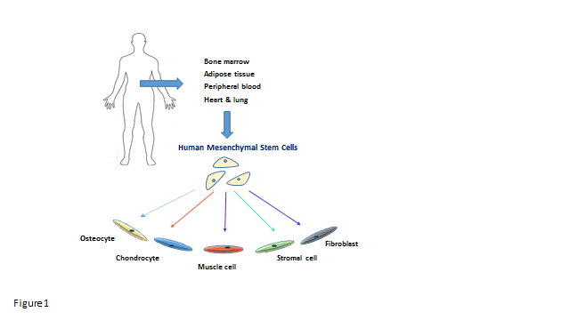
Figure 1 Potentials and sources of mesenchymal stem cells. Mesenchymal stem cells can be collected from various sources within human body and have the ability to differentiate into a variety of lineages.
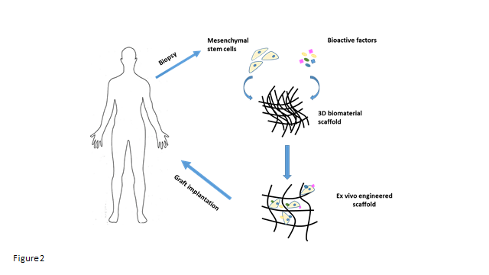
Figure 2 Overview of tissue engineering strategy of incorporating scaffolds with mesenchymal stem cells. Mesenchymal stem cells (derived directly from the patient) are expanded in the laboratory, whereby the necessary environment for their growth has been prepared. These cells are then seeded onto a scaffold and either allowed to differentiate ex vivo pre-implantation or the scaffold is immediately implanted.
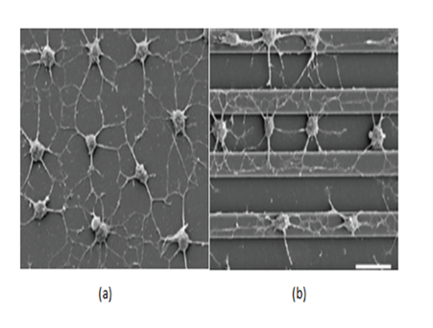
Figure 3 Comparison of different topography strategies employed to investigate the effects of anisotropic versus isotropic cytoskeletal tension on cultured mesenchymal stem cells. (A) nonpatterned substrates caused randomly oriented cell protrusions to be formed, while (B) alignment of elaborated processes in the direction of the grooves were induced by micropatterned surfaces, mimicing the native structure and orientation of the natural extracellular matrix proteins^{[52]}.
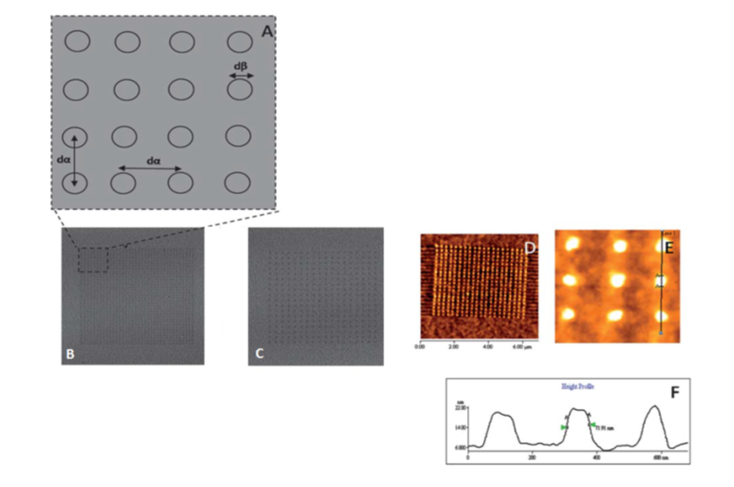
Figure 4 Nanopatterned gold surfaces examination for the effect of both the nanotopography and terminating chemical functionality. (A) Nanopatterned surfaces used for mesenchymal stem cell control and differentiation exhibiting dot to dot pitch (dα) and dot diameter (dβ), (B) Lateral Force Microscopy (LFM) image of small area 280 nm pitch array, (C) LFM image of 140 nm pitch array. (D–F) Atomic force microscopy (AFM) topographical image of an alkanethiol resist array fabricated on gold surface following chemical etching. An average diameter feature (dβ) of 70 nm was shown on the cursor profile^{[53]}.
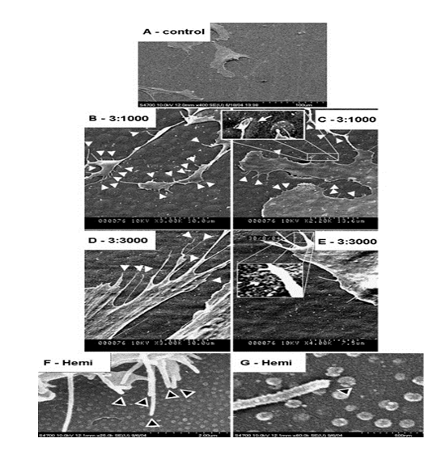
Figure 5 Scanning electron micrographs of human mesenchymal stem cells cultured on control and test materials. (A) on planar control materials cells showed normal morphologies, (B, C) Filopodial of the human mesenchymal stem cells (hMSCs) interacts with the 3:1000 substrates (arrowheads) (C) hMSC filopodia are curving around an island, (D, E) filopodial interactions with the 3:3000 substrates (arrowheads) (E) a filopodia curving around an island is clearly observed, (F) filopodial interactions with the hemi substrates (arrowheads) and (G) filopodia curving around a hemisphere (arrowhead)^{[66]}.
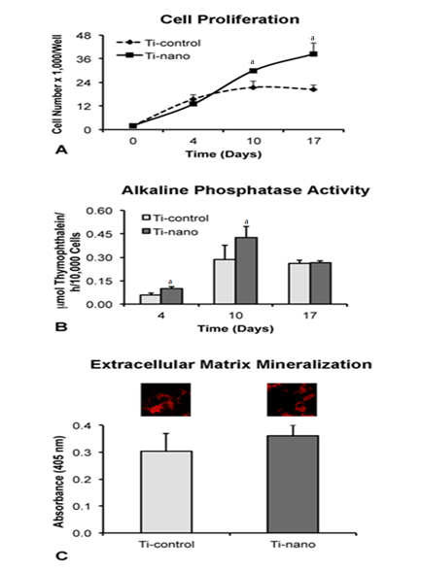
Figure 6 Investigation of the effects of nanotopography on proliferation. (A), alkaline phosphatase (Alp) activity (B), and extracellular matrix mineralization (C) of mesenchymal stem cells differentiated into osteoblasts and cultured on nanotopography in an osteogenic medium compared to control Ti surfaces. A: The number of cells was significantly increased on Ti with nanotopography on days 10 (P = 0.07) and 17 (P = 0.03); B: Higher Alp activity was supported by Ti surface with nanotopography supported on days 4 (P = 0.01) and 10 (P = 0.04); C: The difference in the level of calcium mineralisation in the matrix (insets) was not statistically significant (P = 0.13) by comparing both surfaces. The data are presented as mean ± standard deviation (n = 4). ªIndicates statistically significant difference^{[67]}.
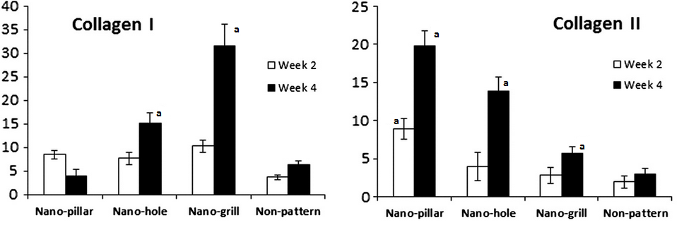
Figure 7 The effect of nano-patterned surfaces on the expression of cartilaginous genes. Real time PCR was used to analyse mRNA expression levels of cartilaginous genes at week 2, 4 or 6 of chondrogenic differentiation, which was normalised to their respective GAPDH expression and expressed as fold changes relative to undifferentiated MSCs. n = 3 per group, mean ± SD. ªP < 0.05 which was considered statistically significant compared to non-patterned surface^{[56]}.
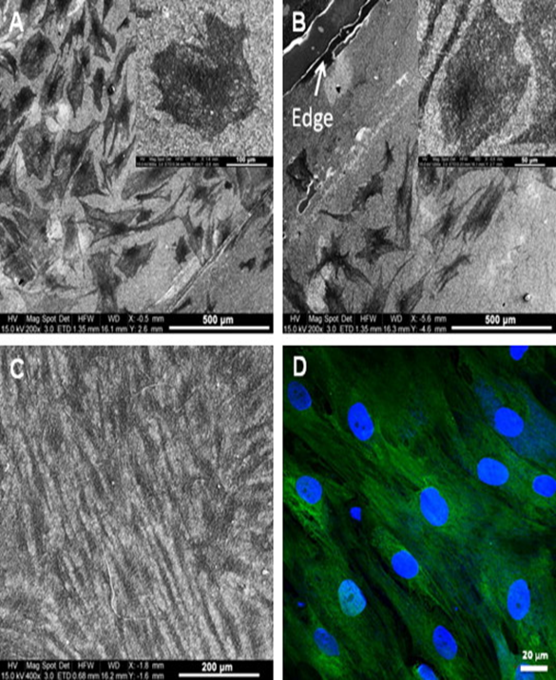
Figure 8 Electron microscopy images of differentiated and undifferentiated mesenchymal stem cells on Coll/PLLCL nanostructured nanofibrers. (A) mesenchymal stem cell (MSC) directed to differentiate along the epidermal lineage when cultured in epidermal induction medium and (B) epidermally differentiated MSC on the edge of a Coll/PLLCL scaffold (as shown by arrow), (C) electrospun Coll/PLLCL nanofibers seeded with undifferentiated MSC cultured in normal growth medium, (D) MSC grown in normal growth medium on Coll/PLLCL nanofibers stained with Ker 10, after 15 d cell culture, imaged using laser scanning confocal microscope^{[86]}.

Table 1 Classification of various types of nanotopography (nanofabrication) methods
Energy source | Method | Mechanism and final outcome | Processable polymers
Thermal | Replica modelling | Creating negative shape of the mold by thermal cross-linking of cavity-filled pre-polymer | Thermocurable polymers  e.g., poly(dimethyl siloxane)
 | Nanoimprint lithography | Creating negative shape of the mold by plastic deformation of polymer above Tg | Thermoplastic e.g.,  polystyrene, poly(lactic acid), and conductive polymers e.g., polyaniline  and polypyrrole
 | Block copolymer lithography | Creating nanoscale hole, line and lamellar structures by microphase separation of two immiscible polymers | Block copolymer e.g., polystyrene-block-  poly(methyl methacrylate), styrenebutadiene-styrene
Optical | Photolithography | Depending on mask design and selective UV exposure, solubility is changed | Photo curable polymers e.g., photoresist, polyurethane-based
 | E-beam lithography | Formation of arbitrary patterns using different electron beam pathways and selective irradiation of focused electron beams to change solubility | E-beam sensitive polymers e.g., polymethyl methacrylate

 | Direct laser writing | Formation of arbitrary patterns by selective cross-linking of the polymer by laser irradiation | Photo-curable polymers
Chemical | Microcontact printing | Creating extruded patterns of elastomeric stamp using relative surface energy difference needed for transferring materials | Proteins and self-assembled monolayers
 | Dip-pen lithography | Formation of arbitrary patterns by direct writing of molecules with a sharp tip | Self-assembled monolayers
 | Salt leaching/gas foaming | Formation of a block of polymer with voids by dissolution of salt particles (salt leaching) and/or bubble formation in the polymer block (gas foaming) | Solvent soluble polymers e.g., thermoplastic and conductive ones
Electrical | Electrochemical deposition | Forming negatively shaped molds by electrochemical reduction of the polymer | Conductive Polymers
 | Electrospinning | Drawing a three dimensional nanofibrous mesh from the polymer solution using an electric field | Solvent soluble polymers
Physical | Capillary force lithography | Formation of partially filed negative shape of the mold by capillary rise of thermoplastic polymer above Tg | Thermoplastic and solvent soluble polymers
 | Micromolding in capillaries | Creating a negative shape of the mold by capillary-driven microchannel filling | Solvent soluble polymers
 | Wrinkle | Formation of random or aligned micro- or nanolines using mechanical buckling Mechanical buckling between elastic substrate and rigid film | Elastomeric polymers e.g.,  Polydimethylsiloxane
 | Crack | Formation of aligned or inter-crossing line patterns by mechanical fracturing of the stiff film adhered onto elastic substrate | Elastomeric polymers

Adapted from Kim et al^{[3]}.

Table 2 Significant studies on nanotopography and mesenchymal stem cells for developing 3D bone, cartilage and skin
Tissue/Organ | Nanotopographical Cues | Description | Outcome | Ref.
Bone | Nano-ridges, and nanogrooves nanotopography surfaces | The effect of nanotopographic ridges and grooves on MSCs morphology, proliferation and differentiation to osteoblast cells were investigated | Osteogenic differentiation can be controlled and directed using specific size scale of topographic cues with or without osteogenic agents | Watari et al^{[55]}
 | Implementing  nanostructures of different sizes | The effect of titanium-coated hemisphere-like topographic nanostructures of various sizes (50, 100, and 200 nm) on hMSCs cellular behaviour towards osteoblast lineage was investigated | Osteogenic differentiation of hMSCs is dependent on the size of the underlying nanotopographical structures. Colloidal lithography combined with coating technologies can have great potentials for fabricating nanoscale topography on scaffolds | de Peppo et al^{[65]}
 | Bioactive calcium phosphate thin films sputter deposited onto a polycrystalline titanium nanostructured surface | Calcium phosphate thin films were used to study the cellular response of hMSCs to nanostructured titanium surfaces with the aim of directing them towards osteogenic differentiation | Various in vitro studies revealed that the use of nanostructured titanium surfaces and the bioactive calcium phosphate coatings could allow for directed and controlled differentiation of hMSCs towards osteogenic lineage. The combination of the two materials together showed higher rate of osteogenic differentiation compared to that of each of these materials on their own | McCafferty et al^{[64]}

 | Polished Ti surfaces chemically treated with H₂SO₄/H₂O₂ to create nanotopography | Chemically treated Ti surfaces with nanotopography and seeded with rat MSCs were used to investigate their osteoinductive potentials compared to untreated surfaces. Signalling pathways responsible for osteoinductive effect of nanotopography on MSCs were also investigated | Ti surfaces with nanotopography exhibited increased cell proliferation and alkaline phosphate activity. Gene expression of key bone markers was upregulated on nanotopography surfaces, under non-osteogenic conditions, compared to control | Rosa et al^{[67]}
Cartilage | A biomimetic microfluidic device embedded with aligned nanofibers consisting of microchambers of different angle | A device was developed to create a microenvironment that integrates nanotopography and flow stimulus of the ECM of natural cartilage for the purpose of investigating the effect of microfluidic and nanotopography on the cellular behaviour and fibrochondrogenesis of MSCs | The angle of flow direction, in relation to the aligned nanofibers, affects MSCs behaviour. Fibrochondrogenesis of MSCs was evident when the flow direction was perpendicular to the aligned nanofibers | Zhang et al^{[76]}
 | Nanowire  nanotopographic surfaces | Polycaprolactone nanowires surfaces were fabricated using a solvent-free gravimetric template technique to investigate their nanotopographical effects on the adhesion, proliferation, differentiation and ECM synthesis of adipose-derived MSCs | The results demonstrated that adhesion and proliferation of adipose-derived MSCs were enhanced on nanowire surfaces compared to the control. Nanowires also effected the morphology of these cells Interestingly, it was shown that nanowires supported adipogenic differentiation of these cells rather than chondrogenic differentiation | Trujillo et al^{[74]}
 | Nano-pillar, nano-hole and nano-grill nanotopography surfaces | Nano-pillar, nano-hole and nano-grill structures were formed on polycaprolactone surface using thermal nanoimprinting to investigate their effect on chondrogenic differentiation of hMSCs | Nanotopographical patterns have the ability to induce changes in MSC morphology and cytoskeletal structure towards a specific lineage, in this case chondrocyte cells. Delayed chondrogenesis was observed on nanogrill topography compared to nano-pillar and nano-hole topography, which enhance MSC chondrogenesis | Wu et al^{[56]}
Skin | Electrospun nanofibrous scaffolds | Electrospun  Coll/PLLCL and PLLCL nanofibrous scaffolds were prepared to investigate the proliferation and differentiation of MSCs to epidermal lineages | Cell proliferation was significantly higher on Coll/PLLCL nanofibrous scaffolds compared to PLLCL scaffolds. MSC morphology was also different on Coll/PLLCL nanofibrous scaffolds compared to control. Electrospun Coll/PLLCL exhibited similar properties to the native skin ECM | Jin et al^{[86]}
 | Nanotopographically variable grooved matrices | Nanotopographically variable grooved matrices, using UV assisted capillary force lithography, with curable PUA polymer were fabricated and then coated with gelatine to investigate the effect of nanotopographical density on hMSC migration and proliferation for wound healing purposes | As the density of the nanogrooved matrices increased, the speed of hMSCs migration increased proportionally. It was shown that hMSC proliferation was not significantly different on nanogrooved matrices, compared to flat control. Therefore, suggesting that proliferation of hMSCs may not be influenced by the nanogrooves | Kim et al^{[83]}
PUA: Polyurethane acrylate; Coll/PLLCL: Collagen/poly(llactic acid)-co-poly(3-
caprolactone); Ti: Titanium; hMSCs: Human mesenchymal stem cells.

