Name of journal: World Journal of Clinical Cases
ESPS Manuscript NO: 4649
Columns: CASE REPORT

Cytomegalovirus enteritis with jejunal perforation in a patient with endometrial adenocarcinoma

Jun YJ et al. Cytomegalovirus enteritis with jejunal perforation

Young Jin Jun, Jongmin Sim, Hye In Ahn, Hulin Han, Hyunsung Kim, Kijong Yi, Abdul Rehman, Se Min Jang, Ki-Seok Jang, Seung Sam Paik

Young Jin Jun, Jongmin Sim, Hye In Ahn, Hulin Han, Hyunsung Kim, Kijong Yi, Abdul Rehman, Se Min Jang, Ki-Seok Jang, Seung Sam Paik, Department of Pathology, College of Medicine, Hanyang University, Seoul 133-792, South Korea

Author contributions: Jun YJ and Sim J designed research; Han H and Ahn HI performed research; Kim H and Yi K contributed new reagents or analytic tools; Rehman A, Jang SM and Jang K analyzed data; Jun YJ and Paik SS wrote the paper.

Correspondence to: Seung Sam Paik, MD, Department of Pathology, College of Medicine, Hanyang University, 222 Wangsimni-ro, Seongdong-gu, Seoul 133-792, South Korea. sspaik@hanyang.ac.kr

Telephone: +82-2-22908252 Fax: +82-2-22967502
Received: July 12, 2013 Revised: August 15, 2013
Accepted: August 20, 2013

Published online:

Abstract

Cytomegalovirus (CMV) infection of the gastrointestinal tract has been reported most frequently in the setting of immunodeficiency. The whole gastrointestinal tract can be affected, however, the small bowel is rarely affected. We report a case of CMV enteritis with jejunal perforation in a 53-year-old-woman with a history of chemo-radiation therapy for endometrial cancer 8 years ago. At follow-up evaluation, lower abdominal pain, diarrhea and vomiting appeared. Abdominal computed tomography showed an intra-abdominal free air in the subphrenic space and portahepatis. The jejunal segment revealed serosal purulent exudates with a perforation. The resected jejunal segment showed a large geographic ulcerative mucosal lesion. The microscopic findings revealed a diffuse ulcerative mucosal change with a prominent granulation tissue formation and many large atypical vascular endothelial cells and stromal fibroblasts with intranuclear or intracytoplasmic inclusion bodies. These cells were positive for CMV antibody. The final diagnosis was CMV-associated jejunitis with a jejunal perforation.

© 2013 Baishideng. All rights reserved.

Key words: Cytomegalovirus; Enteritis; Jejunum; Perforation

Core tip: Small bowel involvement by gastrointestinal cytomegalovirus (CMV) infection is very rare. However, CMV enteritis should be included in the differential diagnosis of the ulcerative lesion of small bowel segment when abdominal pain, vomiting, diarrhea and perforation develop in patients with a history of cancer.

Jun YJ, Sim J, Ahn HI, Han H, KimH, Yi K, Rehman A, Jang SM, Jang KS, Paik SS. Cytomegalovirus enteritis with jejunal perforation in a patient with endometrial adenocarcinoma. World J Clin Cases 2013;
Available from: URL: http://www.wjgnet.com/esps/

DOI: http://dx.doi.org/1012998/wjcc.v1.i0.0000

INTRODUCTION

Cytomegalovirus (CMV) infection is commonly developed in immunocompromised patients and is a major cause of morbidity and mortality^{[1]}. Most cases occur in patients of human immunodeficiency virus infection, undergoing cancer chemotherapy, receiving long-term corticosteroids treatment, and organ transplant recipients^{[2,3]}. It may affect the gastrointestinal tract anywhere from the mouth to the anus. The site most commonly affected is the colon, followed by duodenum, stomach, esophagus, and small intestine^{[4,5]}. The esophagitis, gastritis, duodenitis, and enterocolitis are induced by CMV infection in the gastrointestinal tract. However, the intestinal perforation is relatively rare^{[6]}. The most common site of perforation with CMV infection of gastrointestinal tract is the colon, followed by the ileum and appendix^{[7]}. The jejunal perforation due to gastrointestinal CMV infection is extremely rare. Only five cases have been reported in the English literature^{[8-12]}. Here we report a case of CMV enteritis with a jejunal perforation in a patient with endometrial adenocarcinoma.

CASE REPORT

A 53-year-old woman with a history of endometrial cancer surgery visited the emergency room with left lower abdominal pain. She had a history of diarrhea and vomiting one week ago. She had undergone an extended abdominal hysterectomy with bilateral salphingo-oophorectomy and pelvic lymph node dissection for endometrial adenocarcinoma and received chemotherapy and radiation therapy 8 years ago. On physical examination, she complaint of abdominal distension and generalized abdominal tenderness with muscle guarding. Clinically the generalized peritonitis was suspected. Simple x-ray and computed tomography of the abdomen demonstrated a free intraperitoneal air in the right subphrenic space and portahepatis (Figure 1). Radiologically, the possibility of intestinal perforation was suspected. She underwent an emergency laparotomy and a perforation was found in a segment of the jejunum with serosal grayish white exudative covering. The affected jejunal segment was resected.

The resected jejunal segment measured 10 cm in length and 7 cm in circumference. The outer surface showed a perforation site with serosal purulent exudates. The mucosal surface of jejunal segment revealed a diffuse geographic ulcerative lesion which measured 9.5 cm × 3.5 cm in size. The ulcerative lesion showed an irregular, dirty mucosal surface and a perforation site was noted (Figure 2). Microscopically, the jejunal wall showed a diffuse ulceration with exuberant granulation tissue formation and heavy inflammatory cell infiltration. Many large atypical vascular endothelial cells and stromal fibroblasts with intranuclear or intracytoplasmic inclusion bodies were found in the granulation tissue area (Figure 3). The features of vasculitis were combined. The immunohistochemical staining using monoclonal anti-CMV antibody revealed many positive nuclear reactions of large atypical cells with or without intranuclear inclusion bodies (Figure 3, inset).

DISCUSSION

In this report, we have described a rare case of CMV enteritis with a jejunal perforation in a patient with a history of endometrial cancer surgery and chemo-radiation therapy. To the best of our knowledge, only five cases of CMV enteritis with a jejunal perforation have been reported^{[8-12]}. The reported five cases are summarized in Table 1. Four cases were male and one case was female. The mean age was 42.4 years (range: 28 to 60 years). The clinical presentations were lower abdominal pain, diarrhea, fever, nausea, loss of appetite, intermittent epigastralgia and emesis. The underlying diseases were acquired immunodeficiency syndrome (AIDS) in three patients, adult T-cell leukemia-lymphoma in a patient and no underlying disease in a patient. Our case was a 53-years-old woman with clinical presentation of left lower abdominal pain, diarrhea and vomiting and had a history of endometrial adenocarcinoma.

Cytomegalovirus infection is a well-known opportunistic viral infection that frequently occurs in immunocompromised patients, including patients with AIDS, those who have received bone marrow or organ transplants, those who received long-term corticosteroids treatment and those who have received chemotherapy or radiation therapy^{[2,6]}. CMV belongs to a member of the herpes viral group and is a DNA virus. More than 90% of healthy adults are seropositive for CMV^{[3,6]}. Pulmonary infection is the most frequently recognized type of CMV infection. However, CMV infection of the gastrointestinal tract is also common^{[13]}. It can affect the gastrointestinal tract anywhere from the mouth to the anus. In CMV infection of the gastrointestinal tract, the site most commonly affected is the colon (47%), followed by the duodenum (21.7%), stomach (17.4%), esophagus (8.7%), and small bowel (4.3%)^{[4]}. The intestinal perforation as a complication of gastrointestinal CMV infection is a rare finding. The most common site of perforation is the colon (53%), followed by the ileum (40%) and appendix (7%)^{[7]}. The jejunum, as a perforation site in gastrointestinal CMV infection is an extremely rare location. In our case, the patient presented with a gastrointestinal CMV infection manifested as jejunitis and led to a jejunal perforation.

The CMV-related enteritis appears to be related in part to up-regulation of the production of local pro-inflammatory cytokines, potentially by altering resident intestinal macrophages to express human immunodeficiency virus proteins^{[14]}. The CMV-induced ulceration is thought to involve ischemic mucosal injury secondary to the infection of the vascular endothelial cells^{[5,15]}. CMV may infect various gastrointestinal cells. The most commonly affected cells are the vascular endothelial cells and stromal fibroblasts. CMV infection into the vascular endothelial cells leads to abnormal cellular swelling and enlargement, vascular luminal compromise, fibrin thrombus formation, local vasculitis and tissue damage in the intestinal segment supplied by the affected vessels^{[3,15]}. Finally the intestinal ulceration is developed in the infected intestinal segment. Our case showed a large geographic ulceration with exuberant granulation tissue formation. CMV infection was frequently found in the vascular endothelial cells and stromal fibroblasts which is supportive of the reported pathophysiology of CMV-induced ulceration.

In conclusion, the small bowel is a rare site of involvement by gastrointestinal CMV infection and the CMV enteritis with jejunal perforation is extremely rare. However, CMV enteritis should be considered as a possible diagnosis in the ulcerative lesion of small bowel segment when abdominal pain, vomiting, diarrhea and perforation develop in patients with a history of endometrial cancer.

REFERENCES
1 Fernandes B, Brunton J, Koven I. Ileal perforation due to cytomegaloviral enteritis. Can J Surg 1986; 29: 453-456 [PMID: 3022902]
2 Drew WL. Cytomegalovirus infection in patients with AIDS. Clin Infect Dis 1992; 14: 608-615 [PMID: 1313313 DOI: 10.1093/clinids/14.2.608]
3 Bang S, Park YB, Kang BS, Park MC, Hwang MH, Kim HK, Lee SK. CMV enteritis causing ileal perforation in underlying lupus enteritis. Clin Rheumatol 2004; 23: 69-72 [PMID: 14749990 DOI: 10.1007/s10067-003-0825-z]
4 Hinnant KL, Rotterdam HZ, Bell ET, Tapper ML. Cytomegalovirus infection of the alimentary tract: a clinicopathological correlation. Am J Gastroenterol 1986; 81: 944-950 [PMID: 3020973]
5 Goodgame RW. Gastrointestinal cytomegalovirus disease. Ann Intern Med 1993; 119: 924-935 [PMID: 8215005 DOI: 10.7326/0003-4819-119-9-199311010-00010]
6 Kawate S, Ohwada S, Sano T, Kawashima Y, Kishikawa I, Tomizawa N, Takeyoshi I, Watanuki F, Morishita Y. Ileal perforation caused by cytomegalovirus infection in a patient with recurrent gastric cancer: report of a case. Surg Today 2002; 32: 1088-1090 [PMID: 12541029 DOI: 10.1007/s005950200220]
7 Kram HB, Shoemaker WC. Intestinal perforation due to cytomegalovirus infection in patients with AIDS. Dis Colon Rectum 1990; 33: 1037-1040 [PMID: 2173658]
8 Shah SK, Kreiner LA, Walker PA, Klein KL, Bajwa KS, Robinson EK, Millas SG, Souchon EA, Wray CJ. Cytomegalovirus enteritis manifesting as recurrent bowel obstruction and jejunal perforation in patient with acquired immunodeficiency syndrome: rare report of survival and review of the literature. Surg Infect (Larchmt) 2012; 13: 121-124 [PMID: 22439782 DOI: 10.1089/sur.2010.098]
9 Nabeshima K, Sakaguchi E, Inoue S, Eizuru Y, Minamishima Y, Koono M. Jejunal perforation associated with cytomegalovirus infection in a patient with adult T-cell leukemia-lymphoma. Acta Pathol Jpn 1992; 42: 267-271 [PMID: 1319102]
10 Houin HP, Gruenberg JC, Fisher EJ, Mezger E. Multiple small bowel perforations secondary to cytomegalovirus in a patient with acquired immunodeficiency syndrome. Henry Ford Hosp Med J 1987; 35: 17-19 [PMID: 2824406]
11 DeRiso AJ, Kemeny MM, Torres RA, Oliver JM. Multiple jejunal perforations secondary to cytomegalovirus in a patient with acquired immune deficiency syndrome. Case report and review. Dig Dis Sci 1989; 34: 623-629 [PMID: 2539285]
12 Petrogiannopoulos CL, Kalogeropoulos SG, Dandakis DC, Hartzoulakis GA, Karahalios GN, Flevaris CP, Zacharof AK. Cytomegalovirus enteritis in an immunocompetent host. Chemotherapy 2004; 50: 276-278 [PMID: 15608442 DOI: 10.1159/000082625]
13 Rosen P, Armstrong D, Rice N. Gastrontestinal cytomegalovirus infection. Arch Intern Med 1973; 132: 274-276 [PMID: 4352550 DOI: 10.1001/archinte.1973.03650080118023]
14 Maheshwari A, Smythies LE, Wu X, Novak L, Clements R, Eckhoff D, Lazenby AJ, Britt WJ, Smith PD. Cytomegalovirus blocks intestinal stroma-induced down-regulation of macrophage HIV-1 infection. J Leukoc Biol 2006; 80: 1111-1117 [PMID: 17056764 DOI: 10.1189/jlb.0306230]
15 Golden MP, Hammer SM, Wanke CA, Albrecht MA. Cytomegalovirus vasculitis. Case reports and review of the literature. Medicine (Baltimore) 1994; 73: 246-255 [PMID: 7934809]

P-Reviewer Yokoyama Y S-Editor Gou SX L-Editor E-Editor

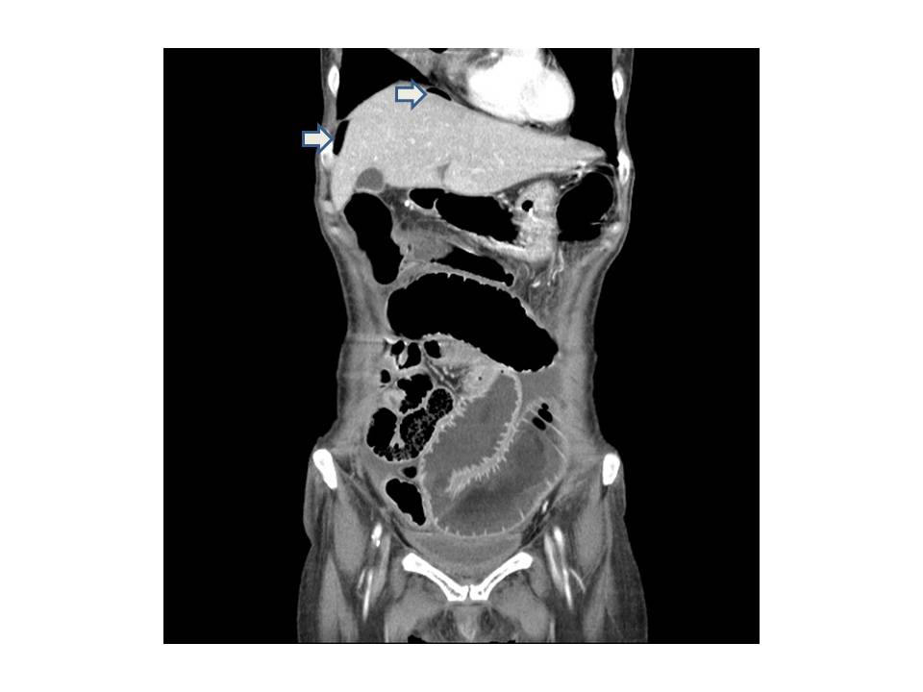

Figure 1 Abdominal computed tomography revealed an intra-abdominal free air in the right subphrenic space (arrows).

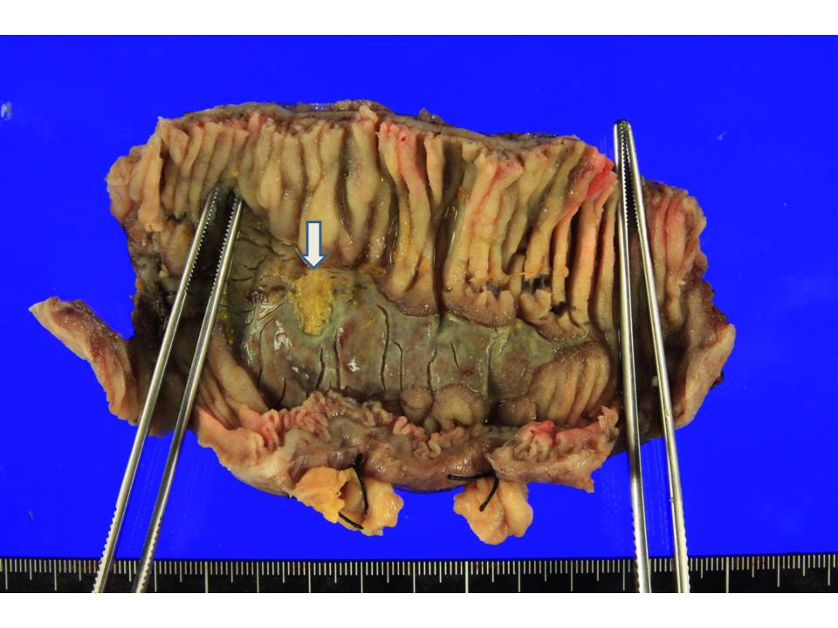

Figure 2 The resected jejunal segment showed a large geographic ulceration with a perforation site (arrow).

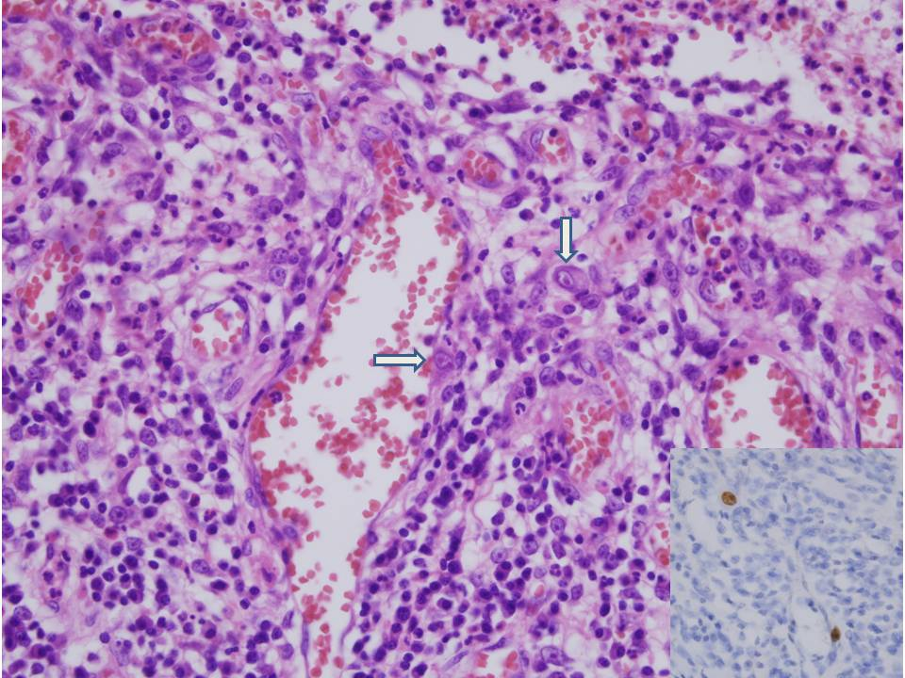

Figure 3 The ulcer bed was composed of granulation tissue with abundant vascular proliferation. Many large atypical endothelial cells and stromal fibroblasts with the formation of intranuclear inclusion bodies were noted (arrows). These cells were positive for cytomegalovirus antibody (Inset).

Table 1 Summary of reported five cases of cytomegalovirus enteritis with jejunal perforation.
Cases | Sex | Age | Perforation sites | Clinical presentation | Underlying disease | Ref.
1 | M | 50 | Jejunum | Lower abdominal pain, nausea, emesis, diarrhea | AIDS | [7]
2 | M | 34 | Jejunum and ileum | Loss of appetite, intermittent epigastralgia | Adult T-cell leukemia-lymphoma | [8]
3 | M | 28 | Jejunum and ileum | Chronic diarrhea, fever, abdominal pain | AIDS | [9]
4 | M | 40 | Jejunum | Lower abdominal pain, fever | AIDS | [10]
5 | F | 60 | Jejunum | Diarrhea, fever | None | [11]
Our case | F | 53 | Jejunum | Left lower abdominal pain, diarrhea, vomiting | Endometrial adenocarcinoma

M: Male; F: Female; AIDS: Acquired immunodeficiency syndrome; Ref.: Reference number.

