Name of Journal: World Journal of Gastroenterology
Manuscript NO: 81348
Manuscript Type: ORIGINAL ARTICLE

Case Control Study
Can visceral fat parameters based on computed tomography be used to predict occult peritoneal metastasis in gastric cancer?

Li LM et al. Prediction of occult peritoneal metastasis

Li-Ming Li, Lei-Yu Feng, Chen-Chen Liu, Wen-Peng Huang, Yang Yu, Peng-Yun Cheng, Jian-Bo Gao

Li-Ming Li, Jian-Bo Gao, Department of Radiology, Henan Key Laboratory of Imaging Diagnosis and Treatment for Digestive system Tumor, The First Affiliated Hospital of Zhengzhou University, Zhengzhou 450052, Henan Province, China

Lei-Yu Feng, Department of Cardiology, The First Affiliated Hospital of Zhengzhou University, Zhengzhou 450052, Henan Province, China

Chen-Chen Liu, Department of Radiology, The First Affiliated Hospital of Zhengzhou University, Zhengzhou 450052, Henan Province, China

Wen-Peng Huang, Department of Nuclear Medicine, Peking University First Hospital, Beijing 100034, China

Yang Yu, Peng-Yun Cheng, Beijing Branch, Siemens Healthineers Ltd., Shenyang 110011, Liaoning Province, China

Author contributions: Li LM, Huang WP, and Gao JB designed the research study; Huang WP, Li LM, and Gao JB performed the research; Yu Y and Cheng PY contributed analytic tools; Li LM, Feng LY, and Liu CC analyzed the data and wrote the manuscript; all authors have read and approved the final manuscript.

Supported by Henan Province 2023 Scientific Research Projects Focused on Higher Education Project, China, No. 23A320059

Corresponding author: Jian-Bo Gao, Doctor, Professor, Department of Radiology, Henan Key Laboratory of Imaging Diagnosis and Treatment for Digestive system Tumor, The First Affiliated Hospital of Zhengzhou University, No. 1, East Jianshe Road, Zhengzhou 450052, Henan Province, China. jianbogaochina@163.com

Received: November 4, 2022
Revised: January 21, 2023
Accepted: March 20, 2023
Published online:

Abstract
BACKGROUND
The preoperative prediction of peritoneal metastasis (PM) in gastric cancer would prevent unnecessary surgery and promptly indicate an appropriate treatment plan.

AIM
To explore the predictive value of visceral fat (VF) parameters obtained from preoperative computed tomography (CT) images for occult PM and to develop an individualized model for predicting occult PM in patients with gastric carcinoma (GC).

METHODS
A total of 128 confirmed GC cases (84 male and 44 female patients) that underwent CT scans were analyzed and categorized into PM-positive (n = 43) and PM-negative (n = 85) groups. The clinical characteristics and VF parameters of two regions of interest (ROIs) were collected. Univariate and stratified analyses based on VF volume were performed to screen for predictive characteristics for occult PM. Prediction models with and without VF parameters were established by multivariable logistic regression analysis.

RESULTS
The mean attenuations of VF_{ROI 1} and VF_{ROI 2} varied significantly between the PM-positive and PM-negative groups (P = 0.044 and 0.001, respectively). The areas under the receiver operating characteristic curves (AUCs) of VF_{ROI 1} and VF_{ROI 2} were 0.599 and 0.657, respectively. The mean attenuation of VF_{ROI 2} was included in the final prediction combined model, but not an independent risk factor of PM (P = 0.068). No significant difference was observed between the models with and without mean attenuation of VF (AUC: 0.749 vs 0.730, P = 0.339).

CONCLUSION
The mean attenuation of VF is a potential auxiliary parameter for predicting occult PM in patients with GC.

Key Words: Gastric carcinoma; Peritoneal metastasis; Visceral fat; Tomography; X-ray computed; Prediction; Individualized model

Li LM, Feng LY, Liu CC, Huang WP, Yu Y, Cheng PY, Gao JB. Can visceral fat parameters based on computed tomography be used to predict occult peritoneal metastasis in gastric cancer? World J Gastroenterol 2023; In press

Core Tip: The preoperative prediction of peritoneal metastasis (PM) in gastric cancer would prevent unnecessary surgery and promptly indicate an appropriate treatment plan. We therefore aimed to explore the predictive value of visceral fat (VF) parameters obtained from preoperative computed tomography images for occult PM and to develop an individualized model for predicting occult PM in patients with gastric carcinoma (GC). Consequently, mean attenuation of VF is a potential auxiliary parameter to predict occult PM in patients with GC.

INTRODUCTION
Peritoneal metastasis (PM) is the major cause of postoperative distant metastasis and occurs in more than 10% of patients with newly diagnosed gastric cancer^{[1]}. Gastric carcinoma (GC) is the third leading cause of cancer-related deaths worldwide. In gastric cancer with PM, the survival time is only a few months^{[2]}. Many recent studies^{[3]} have shown that the combination of complete cell reduction and intraperitoneal thermal perfusion chemotherapy can significantly prolong the median survival time in gastric cancer with PM. Thus, the preoperative prediction of PM in gastric cancer would prevent unnecessary surgery and promptly indicate an appropriate treatment plan. For example, laparoscopic exploration may be the preferred choice. Additionally, intraperitoneal hyperthermic chemotherapy may be prepared, and open exploration may be the final choice for a patient with occult PM.
Traditional preoperative imaging methods, such as computed tomography (CT) and magnetic resonance imaging, demonstrate high specificity and low sensitivity in the detection of PM^{[4]}. Therefore, occult PM has attracted extensive attention; it refers to metastasis not indicated on preoperative CT imaging but detected during surgery and pathologic examination^{[5]}. In the last few years, many studies have demonstrated the great potential of radiomics in the prediction of occult PM in gastric cancer^{[6]}. However, most studies have used manual delineation of regions of interest (ROIs) in PM, which reduces repeatability and increases subjective dependence. Therefore, the urgent exploration for new parameters for predicting occult PM is warranted.
Tumor infiltration of the peritoneum alters the characteristics of the surrounding visceral fat (VF) on CT, and these changes have been investigated in previous radiomics studies^{[7]}. In addition, the feature referred to as “smudge-like ground-glass opacity” in the abdominal cavity, which presents an increased CT attenuation of VF, is a common but easily overlooked sign of early-stage omental metastasis^{[8]}. In addition, the adipose microenvironment has a subtle relationship with tumor progression^{[9]}.
We therefore aimed to explore the predictive value of VF parameters based on preoperative CT imaging for occult PM in GC and to develop an individualized model for predicting occult PM preoperatively.

MATERIALS AND METHODS
Patients
This retrospective study was approved by the local institutional review board, and the requirement for informed consent was waived.
Patients at our hospital who met the inclusion/exclusion criteria were consecutively enrolled between July 2012 and July 2021. The inclusion criteria were as follows: (1) Diagnosis of gastric cancer by endoscopy and biopsy, with complete biopsy information; (2) Diagnosis of cT3 and cT4 gastric cancer by CT without obvious PM characteristics; and (3) PM status confirmed by exploratory surgery and pathological biopsy. The exclusion criteria were follows: (1) A history of abdominal tumors, cirrhosis, or other inflammatory diseases; (2) A history of abdominal surgery; (3) An interval between CT and surgical exploration longer than 2 wk; and (4) The presence of artifacts that affect the evaluation of VF parameters.
Clinical patient data (e.g., sex and age), blood test information [e.g., carcinoembryonic antigen (CEA), carbohydrate antigen 199 (CA199), and carbohydrate antigen 125 (CA125)], and biopsy information (e.g., pathological type and differentiation) were collected for further analysis.

CT examination
CT examinations were performed using SOMATOM Definition Flash CT or SOMATOM Force (Siemens, Germany). All patients fasted for 6 h, and drank 800-1000 mL water 5-15 min before CT examination. Following an unenhanced scan, dual-phase enhanced CT images were obtained at 30- and 70-s delays. Approximately 1.3 mL/kg iodinated contrast agent (Ultravist 370, Bayer Schering Pharma) was injected intravenously at a rate of 3.0 mL/s. The parameters of the unenhanced scan were as follows: 120 kV tube voltage, 250–350 mAs, and 5 mm slice thickness and slice interval. The parameters of the enhanced scan were as follows: 120 kV tube voltage, automatic tube current modulation techniques, and 5- or 1.25-mm slice thickness and slice interval.

Fat assessment
The volume and mean CT attenuation of VF and subcutaneous fat (SF) were measured using unenhanced scan CT images on a workstation (MM Research Frontier SyngoVia, VB2.0, Siemens Healthineers, Forchheim, Germany). VF was defined as fat within the abdominal cavity, whereas SF was defined as fat below the skin. ROIs were manually drawn by tracing the medial edge of the abdominal muscle using a semiautomated technique, starting from the maximal axial section of the tumor and extending 15 mm (ROI 1) and 25 mm (ROI 2) downward. The contour of each layer can be adjusted manually as necessary. A primary radiologist (with 6 years of experience) was responsible for outlining, while another senior radiologist (with 25 years of experience) was responsible for supervising each operation (Figure 1). Twenty cases were randomly chosen for outlining by another radiologist (with 3 years of experience) to verify the consistency.
CT attenuation between −150 and −50 Hounsfield units (HU) was performed to evaluate voxels containing adipose tissue^{[10]}. Adipose tissue volume was measured in cubic centimeters (cm³), while mean CT attenuation was measured in HU. The mean CT attenuation and volume of VF were obtained directly on the workstation simultaneously with a table including the CT attenuation of each voxel. The 10th, 30th, 50th, 70th, 90th, 25th, and 75th percentiles of CT attenuation were obtained during postprocessing and calculation.

Analysis of CT images
Two radiologists blinded to the pathologic data analyzed the CT characteristics. When disagreements occurred, a senior radiologist made the final decision. The cT and cN stages were analyzed according to the 8th American Joint Committee staging classification^{[11,12]}. Mild ascites refers to ascites that could not be clearly determined to be caused by metastasis^{[5]}. The GC thickness was measured at the maximal axial section^{[13]}.

Statistical analysis
Statistical analyses were conducted using SPSS software (version 22.0) and MedCalc software (version 15.2). Interobserver reliability was assessed using the intraclass correlation coefficient (ICC), where ICC ≥ 0.80 is excellent, 0.61-0.80 is good, and < 0.60 is the difference. The discrimination capability of various VF characteristics was evaluated using the receiver operating characteristic (ROC) curve and compared using Delong’s test. The relationship between volume and mean attenuation was evaluated using Pearson correlation analysis. Stratified analysis based on VF volume was performed. The differences in continuous variables were compared using the two-tailed t test, Mann–Whitney U test, Kruskal-Wallis H test, and one-way ANOVA. The differences in categorical variables were compared using the χ² test. Significant variables were analyzed using multifactorial logistic regression analysis (backward: Conditional). P < 0.05 was considered to suggest a statistically significant difference.

RESULTS
Patient characteristics
A total of 43 PM-positive patients were included in the study, and 85 PM-negative patients treated between January 2021 and July 2021 were included as control subjects. Significant differences in age, CA125, tumor location, thickness, mild ascites, and cT (P < 0.05 for all) were found between the PM-positive and PM-negative groups (Table 1). No significant differences were found for sex, pathological type, differentiation, CEA, CA199, or cN stage (P > 0.05 for all).

VF characteristics
Significant differences in the mean attenuations of VF_{ROI 1} and VF_{ROI 2} (P = 0.044 and 0.001, respectively) were found between the PM-positive and PM-negative groups (Table 2). No significant differences were found for the mean attenuations of SF_{ROI 1} and SF_{ROI 2}, the volumes of VF_{ROI 1,} VF_{ROI 2}, SF_{ROI 1}, and SF_{ROI 2}, or the volume ratio VF/SF (P > 0.05 for all).
The areas under the receiver operating characteristic curves (AUCs) of VF_{ROI 1} and VF_{ROI 2} for predicting PM in GC were 0.599 [95% confidence interval (CI): 0.509-0.685] and 0.657 (95%CI: 0.568-0.738), respectively (Figure 2A). The comparison of the ROC curves of the VF characteristics suggested that VF_{ROI 2} significantly outperformed VF_{ROI 1} (P = 0.002). Most of the interobserver agreements between the two operators were excellent (Table 2).
Significant differences in the 30th, 50th, 70th, 25th, and 75th percentiles of CT attenuation of VF_{ROI 2} were found between the PM-positive and PM-negative groups (Supplementary Table 1). The AUCs of the 10th, 30th, 50th, 70th, 90th, 25th, and 75th percentiles of CT attenuation for predicting PM in GC were 0.612, 0.642, 0.641, 0.619, 0.608, 0.629, and 0.619, respectively. The comparison of ROC curves suggested no significant difference between the 30th percentile and the mean CT attenuation of VF_{ROI 2} (P = 0.664) (Supplementary Figure 1).

Relationship between VF and clinical characteristics
Significant differences in the mean attenuation of VF_{ROI 2} were observed between the different cN and cT stage classifications (P = 0.030 and 0.003, respectively). The mean attenuation of VF_{ROI 2} in patients with elevated CA125, elevated CA199, and mild ascites was significantly higher than that in normal conditions (P = 0.002, 0.039, and 0.001, respectively) (Table 3).

Stratified analysis
The mean attenuation was negatively correlated with the volume of VF_{ROI 2} (Pearson correlation coefficient = -0.688; P = 0.001) (Supplementary Figure 2). Patients were divided into two groups according to the median volume of VF _{ROI 2} (median = 141.58 cm³). Stratified analysis suggested that the mean attenuation of VF _{ROI 2} was more effective in predicting occult PM in the high-volume group than in the low-volume group (Table 4, Figure 3).

Risk factors for occult PM
Multiple logistic regression analysis based on clinical characteristics showed that mild ascites and cT stage (≥ T4) were independent risk factors for occult PM (P = 0.003 and 0.010, respectively) (Table 5). The Hosmer-Lemeshow test revealed that the model had a good fit (P = 0.977). Furthermore, the clinical model showed a moderate prediction performance (AUC = 0.730, 95%CI: 0.644-0.804).
Multiple logistic regression analyses of both clinical characteristics and VF parameters showed that the mean attenuation of VF_{ROI 2}, mild ascites, and cT stage (≥ T₄) were included in the final prediction combined model, but the mean attenuation of VF_{ROI 2} was not an independent risk factor for PM (P = 0.068) (Table 5). The Hosmer-Lemeshow test indicated that the model had a good fit (P = 0.523). The combined model showed a moderate prediction performance (AUC = 0.749, 95%CI: 0.665-0.821). No significant difference was found between the prediction performance of the two models (P = 0.339) (Figure 2B).

DISCUSSION
We explored the value of VF parameters in predicting occult PM in GC and subsequently developed a preoperative prediction model based on clinical features and VF parameters. A significant difference in the mean attenuation of VF was found between the PM-positive and PM-negative groups. The mean attenuation of VF was included in the final prediction combined model but was not an independent predictor of occult PM in GC.
Previous studies on VF have mostly focused on the effect of volume or area on postoperative prognosis, and few studies have investigated the CT attenuation of VF^{[14,15]}. CT attenuation of pericoronary adipose tissue has been shown to be strongly correlated with cardiovascular disease^{[16]}. Xiang et al^{[9]} investigated the relationship between adipocytes and gastric cancer cells and found that adipocytes may promote cancer cell invasion through a specific signaling pathway. CT attenuation is an index reflecting changes in the VF microenvironment, and its increase may be closely related to tumor progression^{[17]}. Given all of that, we believe that certain changes occur in VF with PM. The indicators used to quantify such changes in our study included the mean attenuation, volume, and volume ratio. Previous studies^{[5,18]} have suggested that the radiomics features of the adjacent peritoneum are helpful in predicting PM in GC. Therefore, two nearby ROIs that delineated from the maximal axial section of the tumor were adopted in our study, and these ROIs were considered to be the most likely sites of metastasis.
The regression analysis indicated that the mean attenuation of VF_{ROI 2} was not an independent risk factor for PM, and it had a lower predictive ability than ascites and cT stage. The changes in the adipose microenvironment and the increase in the mean attenuation of VF may be mainly concentrated around the tumor, and the ROI of VF on the whole axial level may dilute this change and reduce the predictive sensitivity. However, the results confirmed that the mean attenuation of VF was significantly different between the PM-positive and PM-negative groups in both ROI 1 and ROI 2. The 30th, 50th, 70th, 25th, and 75th percentiles of attenuation of VF_{ROI 2} were also significantly different between the two groups. Moreover, the mean attenuation of VF was related to clinical features representing tumor invasiveness. Therefore, we have reasons to believe that the mean attenuation of VF is a potential auxiliary parameter for predicting occult PM in patients with GC, especially for those with only nonenhanced CT images or upper abdominal CT images.
The mean attenuation was negatively correlated with the volume of VF; however, noticeably, no significant difference in the VF volume was found between the PM-positive and PM-negative groups. Considering the relationship between the mean attenuation and volume of VF, volume-stratified analysis was applied to minimize the deviations in volume variation. The mean attenuation of VF_{ROI 2} showed a higher predictive potential in the high-volume group than in the low-volume group. This result suggests that patients with high-volume VF may have more hypoxic or disordered adipocytes that secrete proinflammatory cytokines and angiogenic factors and promote tumor metastasis than patients with low-volume VF^{[19]}. The attenuation of VF was significantly correlated with cT stage, cN stage, CA125, and CA199, indicating that increased VF attenuation is highly correlated with tumor progression.
Mild ascites and cT stage are independent predictive factors for occult PM. Liu et al^{[7]} reported that cT stage was significantly correlated with occult PM, which reflects tumor aggressiveness. Mild ascites was also incorporated into a clinical model for predicting occult PM in a multicenter study^{[5]}. Significant differences were observed in the mean attenuations of VF between the different ascites statuses and cT stages.
Compared with previous radiomics studies, the extraction of VF parameters in our study was based on unenhanced CT images through semiautomated sketching technology, which would reduce the selection differences between operators. The consistency between the operators of VF parameters was excellent. The ROIs in the peritoneum used in most previous studies on occult PM were manually sketched^{[5,18]}. Thus, evaluating the consistency among different operators in defining the location and area of ROIs selected was difficult. In addition, three-dimensional ROIs were defined in our study, which remain applicable in patients with lesser VF.
This study has certain limitations. First, the VF parameters were measured using data obtained from a single center with a small sample size, and multicenter studies with a large sample size are thus needed to validate the results. Second, the parameters used to quantify VF changes were obtained only from unenhanced CT images, which warrants the need to consider more parameters from multiphase enhanced images.

CONCLUSION
In conclusion, our study demonstrates the great potential of VF parameters in predicting occult PM in GC and presents a noninvasive preoperative model that combines the mean attenuation of VF and clinical factors for predicting occult PM in GC.

ARTICLE HIGHLIGHTS
Research background
The preoperative prediction of peritoneal metastasis (PM) in gastric cancer (GC) would prevent unnecessary surgery and promptly indicate an appropriate treatment plan.

Research motivation
Tumor infiltration of the peritoneum alters the characteristics of the surrounding VF on computed tomography (CT), and these changes have been investigated in previous studies.

Research objectives
We therefore aimed to explore the predictive value of VF parameters obtained from preoperative CT images for occult PM and to develop an individualized model for predicting occult PM in patients with GC.

Research methods
A total of 128 confirmed GC cases that underwent CT scans were analyzed and categorized into PM-positive and PM-negative groups. The clinical characteristics and VF parameters of two regions of interest (ROIs) were collected. Univariate and stratified analyses based on VF volume were performed to screen for predictive characteristics for occult PM. Prediction models with and without VF parameters were established by multivariable logistic regression analysis.

Research results
The mean attenuations of VF_{ROI 1} and VF_{ROI 2} varied significantly between the PM-positive and PM-negative groups (P = 0.044 and 0.001, respectively). The mean attenuation of VF_{ROI 2} was included in the final prediction combined model, but not an independent risk factor of PM (P = 0.068). No significant difference was observed between the models with and without mean attenuation of VF (area under the curve: 0.749 vs 0.730, P = 0.339).

Research conclusions
The mean attenuation of VF is a potential auxiliary parameter for predicting occult PM in patients with GC.

Research perspectives
Our study demonstrates the great potential of VF parameters in predicting occult PM in GC and presents a noninvasive preoperative model that combines the mean attenuation of VF and clinical factors for predicting occult PM in GC.

REFERENCES
1 Maehara Y, Hasuda S, Koga T, Tokunaga E, Kakeji Y, Sugimachi K. Postoperative outcome and sites of recurrence in patients following curative resection of gastric cancer. Br J Surg 2000; 87: 353-357 [PMID: 10718807 DOI: 10.1046/j.1365-2168.2000.01358.x]
2 GLOBOCAN 2012: Stomach cancer: estimated incidence, mortality and prevalence worldwide in 2012. [Internet] [accessed 5 November 2021]. Available from:: http://globocan.iarc.fr/old/FactSheets/cancers/stomach-new.asp
3 Rau B, Brandl A, Piso P, Pelz J, Busch P, Demtröder C, Schüle S, Schlitt HJ, Roitman M, Tepel J, Sulkowski U, Uzunoglu F, Hünerbein M, Hörbelt R, Ströhlein M, Beckert S, Königsrainer I, Königsrainer A; Peritoneum Surface Oncology Group and members of the StuDoQ|Peritoneum Registry of the German Society for General and Visceral Surgery (DGAV). Peritoneal metastasis in gastric cancer: results from the German database. Gastric Cancer 2020; 23: 11-22 [PMID: 31228044 DOI: 10.1007/s10120-019-00978-0]
4 Kim SJ, Kim HH, Kim YH, Hwang SH, Lee HS, Park DJ, Kim SY, Lee KH. Peritoneal metastasis: detection with 16- or 64-detector row CT in patients undergoing surgery for gastric cancer. Radiology 2009; 253: 407-415 [PMID: 19789243 DOI: 10.1148/radiol.2532082272]
5 Dong D, Tang L, Li ZY, Fang MJ, Gao JB, Shan XH, Ying XJ, Sun YS, Fu J, Wang XX, Li LM, Li ZH, Zhang DF, Zhang Y, Li ZM, Shan F, Bu ZD, Tian J, Ji JF. Development and validation of an individualized nomogram to identify occult peritoneal metastasis in patients with advanced gastric cancer. Ann Oncol 2019; 30: 431-438 [PMID: 30689702 DOI: 10.1093/annonc/mdz001]
6 Huang W, Zhou K, Jiang Y, Chen C, Yuan Q, Han Z, Xie J, Yu S, Sun Z, Hu Y, Yu J, Liu H, Xiao R, Xu Y, Zhou Z, Li G. Radiomics Nomogram for Prediction of Peritoneal Metastasis in Patients With Gastric Cancer. Front Oncol 2020; 10: 1416 [PMID: 32974149 DOI: 10.3389/fonc.2020.01416]
7 Liu S, He J, Liu S, Ji C, Guan W, Chen L, Guan Y, Yang X, Zhou Z. Radiomics analysis using contrast-enhanced CT for preoperative prediction of occult peritoneal metastasis in advanced gastric cancer. Eur Radiol 2020; 30: 239-246 [PMID: 31385045 DOI: 10.1007/s00330-019-06368-5]
8 Li ZY, Tang L, Li ZM, Li YL, Fu J, Zhang Y, Li XT, Ying XJ, Ji JF. Four-Point Computed Tomography Scores for Evaluation of Occult Peritoneal Metastasis in Patients with Gastric Cancer: A Region-to-Region Comparison with Staging Laparoscopy. Ann Surg Oncol 2020; 27: 1103-1109 [PMID: 31965376 DOI: 10.1245/s10434-019-07812-y]
9 Xiang F, Wu K, Liu Y, Shi L, Wang D, Li G, Tao K, Wang G. Omental adipocytes enhance the invasiveness of gastric cancer cells by oleic acid-induced activation of the PI3K-Akt signaling pathway. Int J Biochem Cell Biol 2017; 84: 14-21 [PMID: 27956048 DOI: 10.1016/j.biocel.2016.12.002]
10 Chen Y, Xi W, Yao W, Wang L, Xu Z, Wels M, Yuan F, Yan C, Zhang H. Dual-Energy Computed Tomography-Based Radiomics to Predict Peritoneal Metastasis in Gastric Cancer. Front Oncol 2021; 11: 659981 [PMID: 34055627 DOI: 10.3389/fonc.2021.659981]
11 Tsoukalas N, Tsapakidis K, Kamposioras K. AJCC-8 TNM Staging System for Gastric Cancer. Is There a Scope for Improvement? J Invest Surg 2020; 33: 939-940 [PMID: 30892116 DOI: 10.1080/08941939.2019.1579280]
12 Marano L, D'Ignazio A, Cammillini F, Angotti R, Messina M, Marrelli D, Roviello F. Comparison between 7th and 8th edition of AJCC TNM staging system for gastric cancer: old problems and new perspectives. Transl Gastroenterol Hepatol 2019; 4: 22 [PMID: 31143843 DOI: 10.21037/tgh.2019.03.09]
13 Li J, Fang M, Wang R, Dong D, Tian J, Liang P, Liu J, Gao J. Diagnostic accuracy of dual-energy CT-based nomograms to predict lymph node metastasis in gastric cancer. Eur Radiol 2018; 28: 5241-5249 [PMID: 29869176 DOI: 10.1007/s00330-018-5483-2]
14 Lin YC, Lin G, Yeh TS. Visceral-to-subcutaneous fat ratio independently predicts the prognosis of locally advanced gastric cancer----- highlighting the role of adiponectin receptors and PPARα, β/ δ, ɤ. Eur J Surg Oncol 2021; 47: 3064-3073 [PMID: 33941417 DOI: 10.1016/j.ejso.2021.04.028]
15 Taniguchi Y, Kurokawa Y, Takahashi T, Saito T, Yamashita K, Tanaka K, Makino T, Yamasaki M, Nakajima K, Eguchi H, Doki Y. Impacts of Preoperative Psoas Muscle Mass and Visceral Fat Area on Postoperative Short- and Long-Term Outcomes in Patients with Gastric Cancer. World J Surg 2021; 45: 815-821 [PMID: 33179125 DOI: 10.1007/s00268-020-05857-9]
16 Ichikawa K, Miyoshi T, Osawa K, Nakashima M, Miki T, Nishihara T, Toda H, Yoshida M, Ito H. High pericoronary adipose tissue attenuation on computed tomography angiography predicts cardiovascular events in patients with type 2 diabetes mellitus: post-hoc analysis from a prospective cohort study. Cardiovasc Diabetol 2022; 21: 44 [PMID: 35303857 DOI: 10.1186/s12933-022-01478-9]
17 Lee JW, Son MW, Chung IK, Cho YS, Lee MS, Lee SM. Significance of CT attenuation and F-18 fluorodeoxyglucose uptake of visceral adipose tissue for predicting survival in gastric cancer patients after curative surgical resection. Gastric Cancer 2020; 23: 273-284 [PMID: 31485803 DOI: 10.1007/s10120-019-01001-2]
18 Kim HY, Kim YH, Yun G, Chang W, Lee YJ, Kim B. Could texture features from preoperative CT image be used for predicting occult peritoneal carcinomatosis in patients with advanced gastric cancer? PLoS One 2018; 13: e0194755 [PMID: 29596522 DOI: 10.1371/journal.pone.0194755]
19 Divella R, De Luca R, Abbate I, Naglieri E, Daniele A. Obesity and cancer: the role of adipose tissue and adipo-cytokines-induced chronic inflammation. J Cancer 2016; 7: 2346-2359 [PMID: 27994674 DOI: 10.7150/jca.16884]

Footnotes
Institutional review board statement: The study was reviewed and approved by the First Affiliated Hospital of Zhengzhou University Institutional Review Board (Approval No. 2021-KY-1070-002).

Informed consent statement: Patients were not required to give informed consent to the study because the analysis used anonymous clinical data that were obtained after each patient agreed to treatment by written consent.

Conflict-of-interest statement: All the authors report no relevant conflicts of interest for this article.

Data sharing statement: Dataset available from the corresponding author at jianbogaochina@163.com.

Open-Access: This article is an open-access article that was selected by an in-house editor and fully peer-reviewed by external reviewers. It is distributed in accordance with the Creative Commons Attribution NonCommercial (CC BY-NC 4.0) license, which permits others to distribute, remix, adapt, build upon this work non-commercially, and license their derivative works on different terms, provided the original work is properly cited and the use is non-commercial. See: https://creativecommons.org/Licenses/by-nc/4.0/

Provenance and peer review: Unsolicited article; Externally peer reviewed.

Peer-review model: Single blind

Peer-review started: November 4, 2022
First decision: January 3, 2023
Article in press: January 21, 2023

Specialty type: Gastroenterology and hepatology
Country/Territory of origin: China
Peer-review report’s scientific quality classification
Grade A (Excellent): 0
Grade B (Very good): B, B
Grade C (Good): C
Grade D (Fair): D
Grade E (Poor): 0

P-Reviewer: Hori T, Japan; koganti SB, United States; Sun D, China; Tanabe H, Japan S-Editor: Liu GL L-Editor: Wang TQ P-Editor: Liu GL
Figure Legends
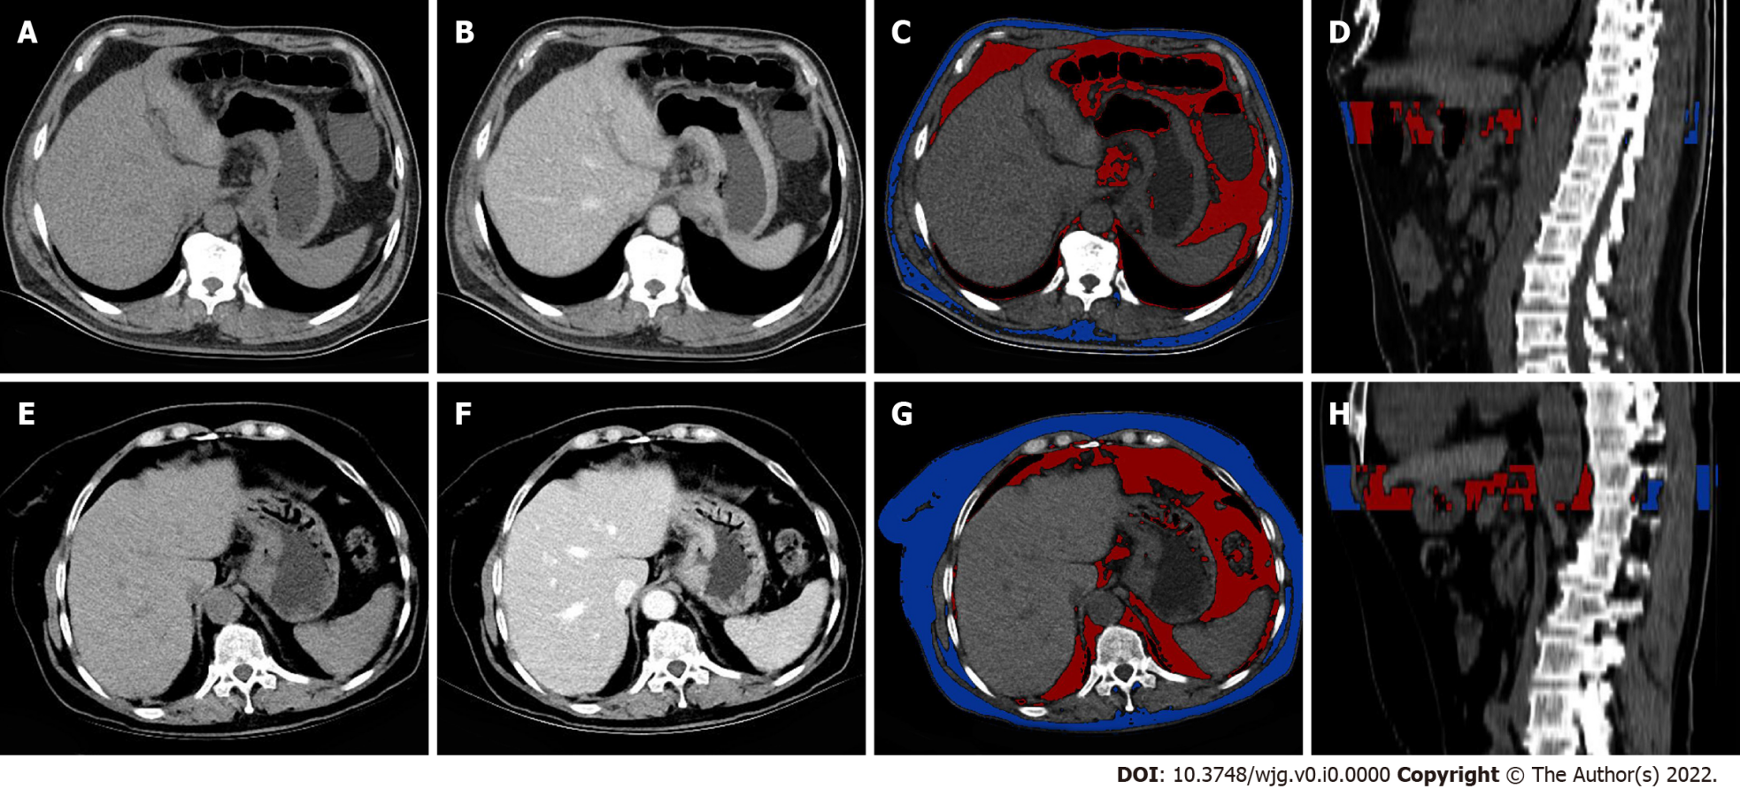
Figure 1 Determination of visceral fat parameters. A-D: Detection of visceral fat (VF) parameters in a 54-year-old male patient with gastric cancer with peritoneal metastasis (PM); A and B: Axial unenhanced and venous computed tomography (CT) images showing wall thickening in the cardia and the lesser and greater curvatures of the stomach; C: Regions of interest (ROI) were drawn using a semiautomated technique. The red area represents VF, while the blue area represents subcutaneous fat (SF); D: Sagittal image showing a three-dimensional (3D) ROI, delineated starting from the maximal axial section of the tumor and extending 25 mm; E-H: Determination of VF parameters in a 66-year-old female patient with gastric cancer without PM; E and F: Axial unenhanced and venous CT images showing irregular wall thickening and a mass in the cardia of the stomach; G and H: A 3D ROI drawn with a 25-mm height using a semiautomated technique. The red area represents VF, while the blue area represents SF.

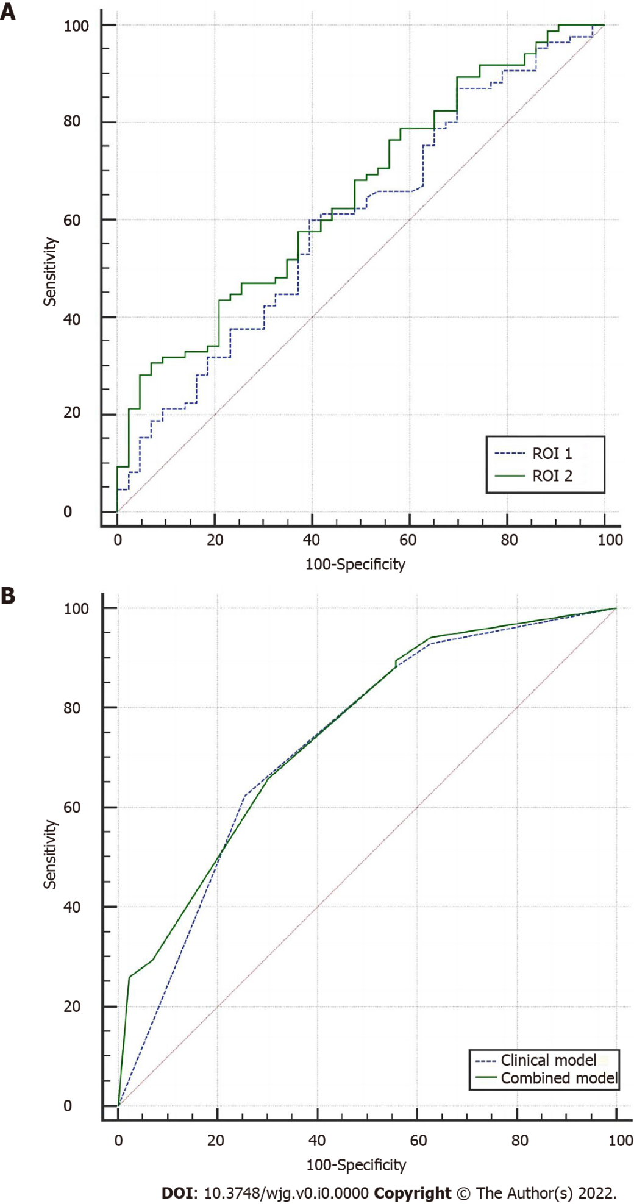
Figure 2 Predictive performance of computed tomography attenuations for visceral fat in two regions of interest and two models for predicting peritoneal metastasis in gastric cancer. A: Receiving operator characteristic (ROC) curves of the visceral fat (VF) computed tomography (CT) attenuations on ROIs 1 and 2. The VF CT attenuations on ROI 2 [area under the curve (AUC): 0.657, sensitivity 93.0%, specificity 30.6%] showed a better predictive performance than those on ROI 1 (AUC: 0.599, sensitivity 60.0%, specificity 60.0%); B: ROC curves of the clinical and combined models. The two models showed comparable predictive performance for peritoneal metastasis in gastric cancer (AUC: 0.730 vs 0.749, P = 0.399)

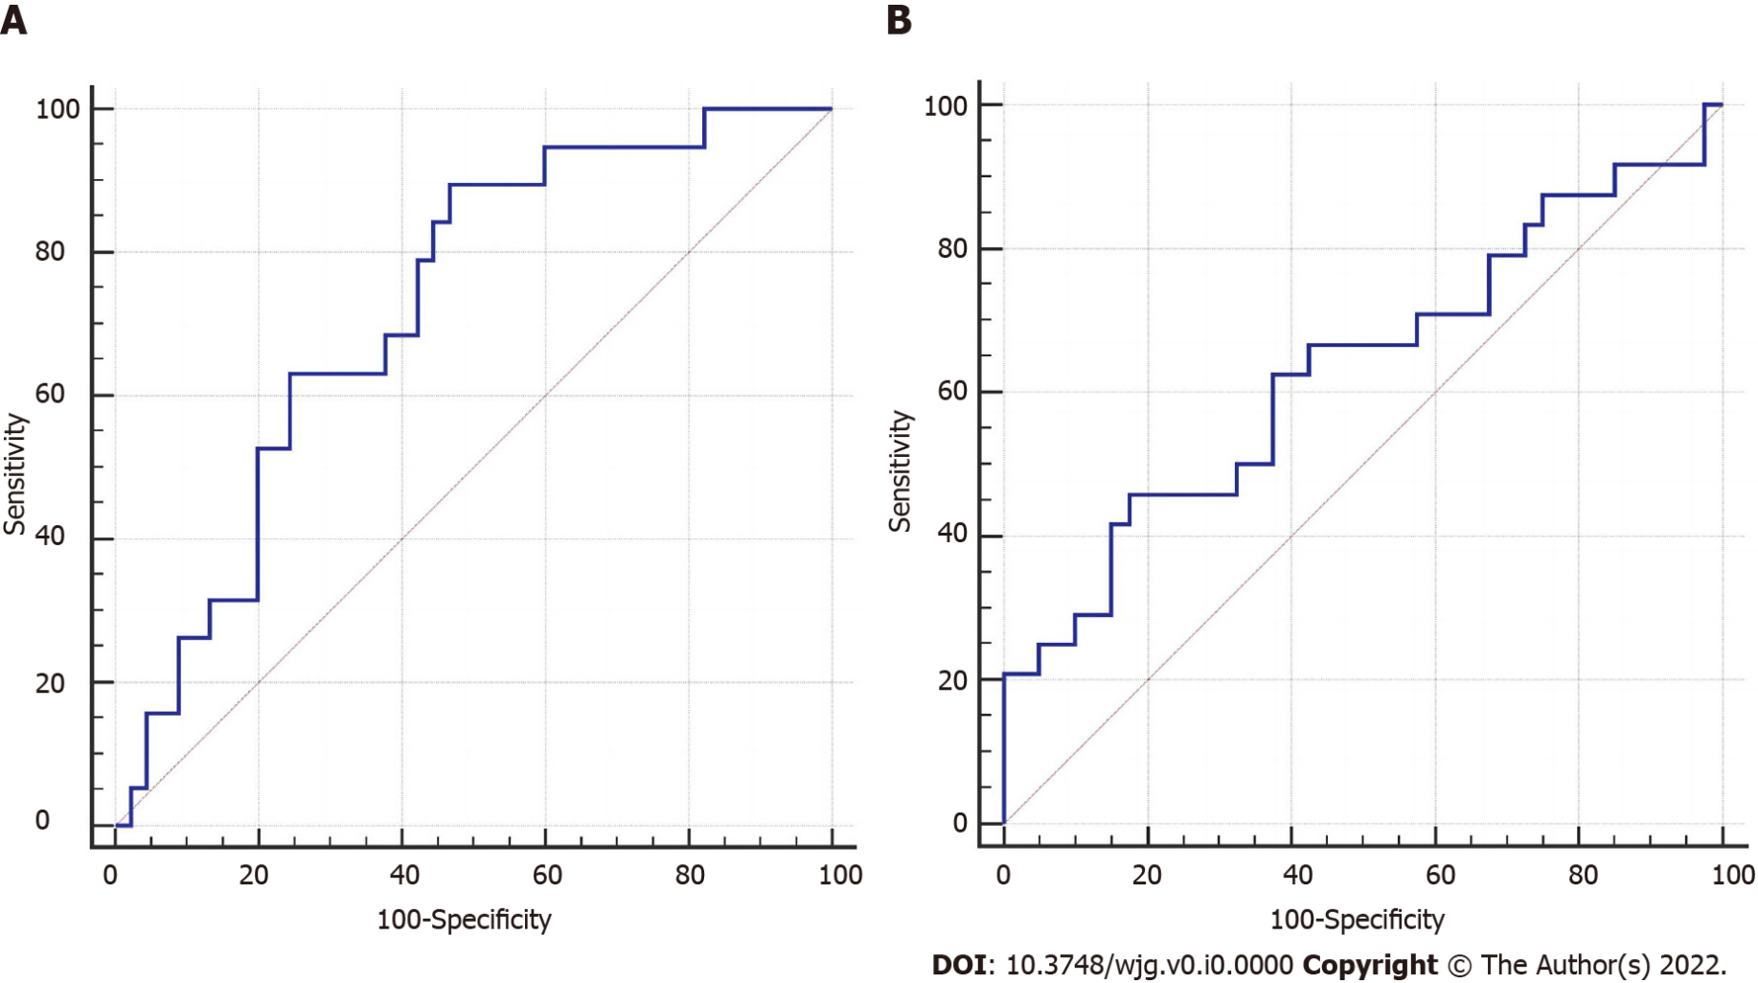
Figure 3 Performance of computed tomography attenuations for visceral fat in predicting peritoneal metastasis in gastric cancer. A: High-volume group; B: Low-volume group.

Table 1 Comparison of clinical and computed tomography characteristics between two groups, n (%)
Variable |  | PM (-) (n = 85) | PM (+) (n = 43) | P value
Sex | Male | 60 (70.6) | 24 (55.8) | 0.096
 | Female | 25 (29.4) | 19 (44.2)
Age (yr)  (mean ± SD) |  | 56.44±12.63 | 61.25±11.11 | 0.029¹
Pathological type | Adenocarcinoma | 83 (97.6) | 38 (88.4) | 0.077
 | Non-adenocarcinoma | 2 (2.4) | 5 (11.6)
Differentiation | Poorly differentiated | 50 (58.8) | 30 (69.8) | 0.227
 | Moderately and well differentiated | 35 (41.2) | 13 (30.2)
CEA | Normal | 74 (87.1) | 37 (86.0) | 0.873
 | Elevated | 11 (12.9) | 6 (14.0)
CA199 | Normal | 74 (87.1) | 32 (74.4) | 0.073
 | Elevated | 11 (12.9) | 11 (25.6)
CA125 | Normal | 83 (97.6) | 37 (86.0) | 0.030¹
 | Elevated | 2 (2.4) | 6 (14.0)
Location | Cardia | 44 (51.8) | 7 (16.3) | 0.001¹
 | Body | 12 (14.1) | 14 (32.6)
 | Antrum | 20 (23.5) | 13 (30.2)
 | ≥ 2 parts | 9 (10.6) | 9 (20.9)
Mild ascites | (-) | 75 (88.2) | 24 (55.8) | 0.001¹
 | (+) | 10 (11.8) | 29 (44.2)
cN stage | N0 | 26 (30.6) | 11 (25.6) | 0.150
 | N1-2 | 41 (48.2) | 16 (37.2)
 | N3-4 | 18 (21.2) | 16 (37.2)
cT stage | ≤ T3 | 57 (67.1) | 14 (32.6) | 0.001¹
 | ≥ T4 | 28 (32.9) | 29 (67.4)
Thickness (mm),  median (IQR) |  | 15.11 (13.02, 18.85) | 13.43 (11.28, 17.83) | 0.023¹
¹P < 0.05.
PM: Peritoneal metastasis; CEA: Carcinoembryonic antigen; CA199: Carbohydrate antigen 199; CA125: Carbohydrate antigen 199; IQR: Interquartile range.

Table 2 Comparison of visceral fat characteristics between the two lesions
Variable | PM (+) (n = 43) | PM (-) (n = 85) | P value | ICC
VF_{ROI 1}
Volume (cc) | 84.45 (36.70, 161.04) | 87.92 (49.89, 160.75) | 0.412 | 0.913
Mean attenuation (HU) | -82.07 ± 6.06 | -85.33 ± 5.89 | 0.044¹ | 0.810
SD attenuation (HU) | 18.82 (17.78, 21.25) | 19.51 (18.63, 21.11) | 0.133 | 0.926
SF_{ROI 1}
Volume (cc) | 108.79 (55.10, 170.90) | 115.96 (62.70, 178.72) | 0.760 | 0.979
Mean attenuation (HU) | -85.33 ± 5.89 | -86.05 ± 8.23 | 0.934 | 0.955
SD attenuation (HU) | 17.94 (16.60, 19.37) | 18.58 (17.27, 20.16) | 0.180 | 0.981
VF_{ROI 2}
Volume (cc) | 132.63 (58.85, 273.65) | 145.48 (82.58, 277.42) | 0.302 | 0.932
Mean attenuation (HU) | -82.19 ± 5.35 | -85.70 ± 5.65 | 0.001¹ | 0.974
SD attenuation (HU) | 19.86 (17.58, 20.46) | 19.13 (18.47, 20.66) | 0.317 | 0.950
SF_{ROI 2}
Volume (cc) | 163.24 (82.57, 261.17) | 175.86 (97.86, 267.52) | 0.76 | 0.991
Mean attenuation (HU) | -86.28 ± 8.61 | -86.41 ± 8.08 | 0.938 | 0.980
SD attenuation (HU) | 17.80 (16.42, 19.33) | 18.45 (17.29, 19.91) | 0.124 | 0.993
Volume ratio
VF/SF_{ROI 1} | 0.92 (0.44, 1.50) | 1.00 (0.61, 1.65) | 0.317 | 0.804
VF/SF_{ROI 2} | 0.98 (0.47, 1.41) | 1.00 (0.63, 1.68) | 0.279 | 0.884
¹P < 0.05.
PM: Peritoneal metastasis; ICC: Intraclass correlation coefficient; VF: Visceral fat; SF: Subcutaneous fat; SD: Standard deviation; ROI: Region of interest; HU: Hounsfield units; ROIs 1 and 2: Regions of interest starting at the largest axial level of the tumor and extending down 15 mm and 25 mm, respectively.

Table 3 Comparison of attenuations of visceral fat between different clinical characteristic classifications
Variable |  | Mean attenuation of VF ROI 2 | P value
Sex | Male | -84.90 ± 6.19 | 0.306
 | Female | -83.83 ± 4.88
Age (yr) | ≤ 61 | -84.48 ± 5.11 | 0.937
 | > 61 | -84.46 ± 5.14
Pathological type | Adenocarcinoma | -84.64 ± 5.81 | 0.339
 | Non-adenocarcinoma | -82.49 ± 4.99
Differentiation | Poorly differentiated | -84.18 ± 5.91 | 0.377
 | Moderately and well differentiated | -85.11 ± 5.56
CEA | Normal | -84.64 ± 5.92 | 0.583
 | Elevated | -83.81 ± 4.86
CA199 | Normal | -85.04 ± 6.04 | 0.002¹
 | Elevated | -82.07 ± 3.40
CA125 | Normal | -84.80 ± 5.81 | 0.039¹
 | Elevated | -80.46 ± 3.41
Location | Cardia/Body/Antrum | -84.93 ± 5.86 | 0.049¹
 | ≥ 2 parts | -82.05 ± 4.67
Mild ascites | (-) | -85.41 ± 5.79 | 0.001¹
 | (+) | -81.52 ± 4.69
cN stage | N0 | -85.48 (-89.85, -82.95) | 0.030¹
 | N1-2 | -83.08 (-86.68, -79.43)
 | N3-4 | -84.54 (-87.51, -80.60)
cT stage | ≤ T3 | -85.88 ± 5.83 | 0.003¹
 | ≥ T4 | -82.84 ± 5.29
Thickness (mm) | ≤ 14.5 | -84.82 ± 6.36 | 0.517
 | > 14.5 | -84.15 ± 4.98
¹P < 0.05.
CEA: Carcinoembryonic antigen; CA199: Carbohydrate antigen 199; CA125: Carbohydrate antigen 199; VF: Visceral fat; ROI 2: Regions of interest starting at the largest axial level of the tumor and extending down 25 mm.

Table 4 Stratified analysis of volume
 | PM (-) | PM (+) | P value | AUC (95%CI)
Volume > median
No | 45 | 19
Mean attenuation (HU) | -89.08 ± 5.31 | -85.44 ± 3.93 | 0.009¹ | 0.726 (0.59-0.854)
Volume ≤ median
No | 40 | 24
Mean attenuation (HU) | -81.92 ± 3.01 | -79.61 ± 4.94 | 0.046¹ | 0.639 (0.490-0.787)
¹P < 0.05.
PM: Peritoneal metastasis; No: Number; AUC: Area under the curve; HU: Hounsfield units.

Table 5 Variables and coefficients of multiple regression logistic analysis
Variable | OR | 95%CI | P value
Based on all characteristics
Mild ascites (+ vs -) | 3.552 | (1.375-9.175) | 0.009¹
Mean attenuations of VF_{ROI 2} | 3.437 | (0.914-12.914) | 0.068
cT stage (≥ T4 vs ≤ T3) | 2.631 | (1.126-6.144) | 0.025¹
Intercept | 0.009 |  | 0.001¹
Based on clinical characteristics
Mild ascites (+ vs -) | 4.188 | (1.636-10.722) | 0.003¹
cT stage (≥ T4 vs ≤ T3) | 2.992 | (1.301-6.881) | 0.010¹
Intercept | 0.068 |  | 0.001¹
¹P < 0.05.
VF: Visceral fat; ROI: Region of interest; OR: Odds ratio; CI: Confidence interval.

