Name of Journal: World Journal of Clinical Cases
Manuscript NO: 90036
Manuscript Type: CASE REPORT

Perforated gastric ulcer causing mediastinal emphysema: A case report

Dai ZC et al. Perforated gastric ulcer causing mediastinal emphysema

Zhi-Cheng Dai, Xun-Wu Gui, Feng-He Yang, Hao-Yuan Zhang, Wen-Feng Zhang

Zhi-Cheng Dai, Xun-Wu Gui, Feng-He Yang, Wen-Feng Zhang, Department of General Surgery, Mengcheng County First People's Hospital, Mengcheng 233500, Anhui Province, China

Hao-Yuan Zhang, Department of Medical Imaging, Mengcheng County First People's Hospital, Mengcheng 233500, Anhui Province, China

Author contributions: Dai ZC, Yang FH, and Gui XW compiled the literature and data; Dai ZC and Zhang HY drafted the paper and prepared the figures; Dai ZC and Zhang WF reviewed and revised the final version of the paper.

Corresponding author: Wen-Feng Zhang, MD, Chief Physician, Department of General Surgery, Mengcheng County First People's Hospital, No. 282 Shangcheng East Road, Mengcheng 233500, Anhui Province, China. zwf197801@163.com

Received: December 3, 2023
Revised: December 14, 2023
Accepted: January 8, 2024
Published online: February 6, 2024

Abstract
BACKGROUND
Mediastinal emphysema is a condition in which air enters the mediastinum between the connective tissue spaces within the pleura for a variety of reasons. It can be spontaneous or secondary to chest trauma, esophageal perforation, medically induced factors, etc. Its common symptoms are chest pain, tightness in the chest, and respiratory distress. Most mediastinal emphysema patients have mild symptoms, but severe mediastinal emphysema can cause respiratory and circulatory failure, resulting in serious consequences.

CASE SUMMARY
A 75-year-old man, living alone, presented with sudden onset of severe epigastric pain with chest tightness after drinking alcohol. Due to the remoteness of his residence and lack of neighbors, the patient was found by his nephew and brought to the hospital the next morning after the disease onset. Computed tomography (CT) showed free gas in the abdominal cavity, mediastinal emphysema, and subcutaneous pneumothorax. Upper gastrointestinal angiography showed that the esophageal mucosa was intact and the gastric antrum was perforated. Therefore, we chose to perform open gastric perforation repair on the patient under thoracic epidural anesthesia combined with intravenous anesthesia. An operative incision of the muscle layer of the patient's abdominal wall was made, and a large amount of subperitoneal gas was revealed. And a continued incision of the peritoneum revealed the presence of a perforation of approximately 0.5 cm in the gastric antrum, which we repaired after pathological examination. Postoperatively, the patient received high-flow oxygen and cough exercises. Chest CT was performed on the first and sixth postoperative days, and the mediastinal and subcutaneous gas was gradually reduced.

CONCLUSION
After gastric perforation, a large amount of free gas in the abdominal cavity can reach the mediastinum through the loose connective tissue at the esophageal hiatus of the diaphragm, and upper gastrointestinal angiography can clarify the site of perforation. In patients with mediastinal emphysema, open surgery avoids the elevation of the diaphragm caused by pneumoperitoneum compared to laparoscopic surgery and avoids increasing the mediastinal pressure. In addition, thoracic epidural anesthesia combined with intravenous anesthesia also avoids pressure on the mediastinum from mechanical ventilation.

Key Words: Gastric ulcer; Perforated; Mediastinal emphysema; Case report

©The Author(s) 2024. Published by Baishideng Publishing Group Inc. All rights reserved.

Citation: Dai ZC, Gui XW, Yang FH, Zhang HY, Zhang WF. Perforated gastric ulcer causing mediastinal emphysema: A case report. World J Clin Cases 2024; 12(4): 859-864
URL: https://www.wjgnet.com/2307-8960/full/v12/i4/859.htm
DOI: https://dx.doi.org/10.12998/wjcc.v12.i4.859

Core Tip: Abdominal free gas from a perforated gastric ulcer may pass through the lax esophageal hiatus into the mediastinum and then travel up to the neck and chest wall. This condition should be differentiated from esophageal perforation, and upper gastrointestinal angiography can clarify the diagnosis. In such patients, the pneumoperitoneum for laparoscopic surgery increases the pressure in the abdominal cavity, not only causing elevation of the diaphragm but also allowing more gas to enter the mediastinum through the esophageal hiatus. Open surgery may be preferred. Thoracic epidural anesthesia combined with intravenous anesthesia can prevent the effect of mechanical ventilation on the mediastinum.

INTRODUCTION
The term mediastinum is used for the general name for the right and left mediastinal pleura and the organs, structures, and connective tissue contained within them. The mediastinum includes the heart, large blood vessels that enter and leave the heart, esophagus, trachea, thymus, nerves, lymphatic tissue, etc^{[1]}. The normal mediastinum is free of gas, and mediastinal emphysema is a pathological condition in which gas accumulates in the mediastinum for a variety of reasons. Common causes of mediastinal emphysema include: (1) Alveolar rupture, where gas accumulates in the interlobular septa and diffuses into the mediastinum along the bronchial vascular sheaths; (2) tracheal and esophageal injuries, where air enters the mediastinum; and (3) after neck surgery, gas diffuses into the mediastinum along the cervical fascia space. Mediastinal emphysema due to gastric perforation has rarely been reported^{[2,3]}. Here, we report a case of mediastinal emphysema due to gastric perforation and describe the treatment for this condition.

CASE PRESENTATION
Chief complaints
Epigastric pain with chest tightness after drinking alcohol for 7 h.

History of present illness
A 75-year-old man had a sudden onset of severe epigastric pain for 7 h after drinking alcohol, in addition to chest tightness and shortness of breath.

History of past illness
The patient suffered from chronic obstructive pulmonary disease (COPD) for 15 years.

Personal and family history
There was no family history of gastric malignancy or lung malignancy. The patient had smoked for more than 30 years (20 cigarettes/d) and drank alcohol for more than 20 years (50% alcohol, 200 mL/d).

Physical examination
The patient had a painful facial appearance, abdominal distension, full abdominal tenderness, rebound pain, board-like rigidity, and drumming sounds upon percussion in the epigastrium. A palpable crepitus sensation could be observed under the skin of the chest wall. His oxygen saturation measured by finger oximetry (with high-flow oxygen) was 95%.

Laboratory examinations
The patient's liver and kidney function parameters were normal. Blood analysis revealed leukocytosis (13.69 × 10⁹/L) and elevated inflammatory markers, including C-reactive protein (325.9 mg/L), procalcitonin (33.63 ng/mL), and neutrophil percentage (97.4%). The arterial blood gas measurements were as follows: pH = 7.30, PaCO2 = 33 mmHg, PaO2 = 108 mmHg, lactic acid = 3.8 mmol/L, and bicarbonate = 16.8 mmol/L.

Imaging examinations
The patient's upper gastrointestinal angiography (contrast medium: Iohexol injection) showed an intact esophageal mucosa and perforation of the gastric antrum (Figure 1). Computed tomography (CT) showed free gas in the abdominal cavity, mediastinal emphysema, and subcutaneous pneumothorax (Figure 2A).

FINAL DIAGNOSIS
Based on imaging findings and clinical symptoms and signs, we could definitively diagnose the patient as having mediastinal and subcutaneous emphysema caused by abdominal free gas from the gastric perforation.

TREATMENT
We performed open gastric perforation repair under thoracic epidural anesthesia combined with intravenous anesthesia, after which the patient was prohibited from eating and drinking, left with a gastric tube, and received high-flow oxygen. Also, we encouraged the patient to cough. In addition, the patient received acid-suppressing medication (omeprazole sodium 40 mg/12 h) and antibiotics, including cefoperazone sodium and sulbactam sodium 3 g/12 h and metronidazole 0.5 g/12 h.

OUTCOME AND FOLLOW-UP
On the first postoperative day, we performed another chest CT scan and found that the patient's mediastinal and subcutaneous air volume was significantly reduced (Figure 2B). On the third postoperative day, the patient's chest wall twisting sensation was significantly diminished, and his blood parameters also stabilized, including leukocytes (9.69 × 10⁹/L), C-reactive protein (40.9 mg/L), procalcitonin (0.63 ng/mL), and neutrophil percentage (72.4%). The patient underwent another CT examination on the sixth postoperative day, which revealed that the mediastinal emphysema had almost disappeared (Figure 2C). We removed the patient's gastric tube. On the ninth postoperative day, the patient was successfully discharged from the hospital. Postoperative pathology revealed gastric ulcer inflammation. One month later, the patient returned to the hospital for gastroscopy, which showed chronic superficial gastritis and frosted ulcers in the antrum area.

DISCUSSION
Acute gastric perforation is a common acute abdominal disease in general surgery and is characterized by rapid onset, rapid progression, and severe conditions. If not treated in time, the acidic gastric contents will flow into the abdominal cavity after perforation, and the peritoneum will be stimulated to produce severe abdominal pain. As early as a century ago, gastrointestinal perforation was recognized to cause mediastinal and subcutaneous emphysema. Oetting et al^{[4]} noted that the three most important underlying factors in the pathogenesis of subcutaneous or mediastinal emphysema of gastrointestinal origin are intestinal (or gastric) perforation, an adequate pressure gradient between the intestinal lumen and the tissues where the gas ultimately accumulates, and the anatomical site of the perforation. In addition, bacterial infections caused by gastrointestinal perforation may produce some amount of gas and contribute to the development of mediastinal emphysema to varying degrees^{[5]}.
In this case, the patient had an acute perforation of a gastric ulcer caused by alcohol consumption; the patient moaned with severe pain and inhaled a large amount of gas into the stomach, and the peristalsis of the stomach prompted the digestive juices and gases in the gastric lumen to pass through the site of the perforation into the abdominal cavity. The abdominal muscles contract violently in response to the stimulation of the digestive juices, thus increasing the pressure in the abdominal cavity and creating a certain pressure gradient within the mediastinum. Elderly people tend to experience widening of the esophageal hiatus and relaxation of the diaphragmatic esophageal membrane. Gas passes through the pressure gradient through the lax part of the esophageal hiatus into the mediastinum, leading to mediastinal emphysema. In addition, the gas in the mediastinum will continue to travel into the neck and chest wall.
A small number of mediastinal emphysema cases can be resolved with conservative treatment, and some of these patients do not even require any management. However, large amounts of mediastinal emphysema in a short period of time can significantly increase the mediastinal pressure, leading to circulatory or respiratory failure, and rapid decompression can be effective at relieving mediastinal pressure^{[6]}. Kiefer et al^{[7]} reported a case in which a patient with a duodenal perforation underwent endoscopy, resulting in a large amount of gas entering the abdominal cavity. Gas entered the mediastinum and subcutaneous tissues through a pressure gradient, and this stagnant air increased the resistance to lung filling and decreased venous return. To relieve pressure on the mediastinum, surgeons used an incision in the clavicle to allow gas to escape, thus restoring normal cardiopulmonary function. Interestingly, this procedure is similar to creating "gills" on the human body. In addition, Herlan et al^{[8]} described four patients with respiratory compromise due to subcutaneous emphysema, in whom respiratory function was normalized by decompression of the subcutaneous emphysema through skin incisions made bilaterally under the clavicle.
Currently, scholars generally agree that laparoscopic surgery is a safe option for the treatment of gastrointestinal perforation. Compared to open surgery, laparoscopic surgery is associated with less postoperative morbidity, a lower incidence of wound infection, and shorter hospital stays^{[9]}. However, the creation of pneumoperitoneum for laparoscopic surgery increases the pressure in the abdominal cavity, which can compress the diaphragm and displace it into the thoracic cavity, causing narrowing of the mediastinal cavity, increasing the mediastinal pressure, decreasing blood flow, and restricting circulation^{[10]}. Upon admission, the patient's oxygen saturation measured by finger oximetry (with high-flow oxygen) was 95%, and the patient was confirmed to have gastric perforation by imaging. Therefore, we chose to perform open surgery under thoracic epidural anesthesia combined with intravenous anesthesia to relieve the abdominal pressure and break the pressure difference between the abdominal cavity and the mediastinum. During the procedure, when we incised the muscular layer of the abdominal wall, the pressure in the abdominal cavity encourages the peritoneum to expand through the incision. After continuing to incise the peritoneum, a large amount of gas was observed to escape. This confirmed that the peritoneal gas was under high pressure.
An increase in thoracic pressure during mechanical ventilation further exacerbates mediastinal pressure and increases the resistance of venous blood return, leading to a decrease in the amount of venous blood returned to the heart and even causing circulatory failure^{[11]}. In addition, long-term smoking or COPD can make respiratory failure difficult to correct and resolve, resulting in withdrawal difficulties in mechanical ventilation patients. In this case, we chose thoracic epidural anesthesia combined with intravenous anesthesia, and during the operation, the patient experienced autonomous breathing, which prevented the effect of mechanical ventilation on mediastinal pressure and reduced the occurrence of lung injury caused by mechanical ventilation. In addition, the analgesic effect of epidural anesthesia lasts for a long time, which helps patients cough up sputum during the postoperative period, promotes alveolar expansion, and accelerates the expulsion of gases from the mediastinum.

CONCLUSION
In this case, a hasty choice of laparoscopic surgery would have further increased the volume of mediastinal pneumomediastinum, enhanced the pressure in the mediastinal cavity, and jeopardized the patient’s life. Therefore, emergency physicians must be aware that gastric perforation can cause mediastinal emphysema, and such patients can be treated by open surgery under thoracic epidural anesthesia combined with intravenous anesthesia.

REFERENCES
1 Ugalde PA, Pereira ST, Araujo C, Irion KL. Correlative anatomy for the mediastinum. Thorac Surg Clin 2011; 21: 251-272, ix [PMID: 21477775 DOI: 10.1016/j.thorsurg.2010.12.008]
2 Rizvi S, Wehrle CJ, Law MA. Anatomy, Thorax, Mediastinum Superior and Great Vessels. 2023 Jul 24. In: StatPearls [Internet]. Treasure Island (FL): StatPearls Publishing; 2023 [PMID: 30137860]
3 Weissberg D, Weissberg D. Spontaneous mediastinal emphysema. Eur J Cardiothorac Surg 2004; 26: 885-888 [PMID: 15519176 DOI: 10.1016/j.ejcts.2004.05.050]
4 Oetting HK, Kramer NE, Branch WE. Subcutaneous emphysema of gastrointestinal origin. Am J Med 1955; 19: 872-886 [PMID: 13275483 DOI: 10.1016/0002-9343(55)90155-8]
5 Vonheimburg RL, Alexander SJ, Sauer WG, Bernatz PE. Subcutaneous emphysema from perforated gastric ulcer: Case report and review of literature. Ann Surg 1963; 158: 1-5 [PMID: 14042629 DOI: 10.1097/00000658-196307000-00001]
6 Smith BA, Ferguson DB. Disposition of spontaneous pneumomediastinum. Am J Emerg Med 1991; 9: 256-259 [PMID: 2018598 DOI: 10.1016/0735-6757(91)90090-7]
7 Kiefer MV, Feeney CM. Management of subcutaneous emphysema with "gills": case report and review of the literature. J Emerg Med 2013; 45: 666-669 [PMID: 23993942 DOI: 10.1016/j.jemermed.2013.04.052]
8 Herlan DB, Landreneau RJ, Ferson PF. Massive spontaneous subcutaneous emphysema. Acute management with infraclavicular "blow holes". Chest 1992; 102: 503-505 [PMID: 1340766 DOI: 10.1378/chest.102.2.503]
9 Quah GS, Eslick GD, Cox MR. Laparoscopic Repair for Perforated Peptic Ulcer Disease Has Better Outcomes Than Open Repair. J Gastrointest Surg 2019; 23: 618-625 [PMID: 30465190 DOI: 10.1007/s11605-018-4047-8]
10 Atkinson TM, Giraud GD, Togioka BM, Jones DB, Cigarroa JE. Cardiovascular and Ventilatory Consequences of Laparoscopic Surgery. Circulation 2017; 135: 700-710 [PMID: 28193800 DOI: 10.1161/CIRCULATIONAHA.116.023262]
11 Singer BD, Corbridge TC. Basic invasive mechanical ventilation. South Med J 2009; 102: 1238-1245 [PMID: 20016432 DOI: 10.1097/SMJ.0b013e3181bfac4f]

Footnotes
Informed consent statement: Informed written consent was obtained from the patient for publication of this report and any accompanying images.

Conflict-of-interest statement: All the authors declare that they have no conflict of interest to disclose.

CARE Checklist (2016) statement: The authors have read the CARE Checklist (2016), and the manuscript was prepared and revised according to the CARE Checklist (2016).

Open-Access: This article is an open-access article that was selected by an in-house editor and fully peer-reviewed by external reviewers. It is distributed in accordance with the Creative Commons Attribution NonCommercial (CC BY-NC 4.0) license, which permits others to distribute, remix, adapt, build upon this work non-commercially, and license their derivative works on different terms, provided the original work is properly cited and the use is non-commercial. See: https://creativecommons.org/Licenses/by-nc/4.0/

Provenance and peer review: Unsolicited article; Externally peer reviewed.
Peer-review model: Single blind

Peer-review started: December 3, 2023
First decision: December 12, 2023
Article in press: January 8, 2024

Specialty type: Gastroenterology & hepatology
Country/Territory of origin: China
Peer-review report’s scientific quality classification
Grade A (Excellent): 0
Grade B (Very good): 0
Grade C (Good): C
Grade D (Fair): 0
Grade E (Poor): 0

P-Reviewer: Vyshka G, Albania S-Editor: Liu JH L-Editor: Wang TQ P-Editor: Zhang YL
Figure Legends
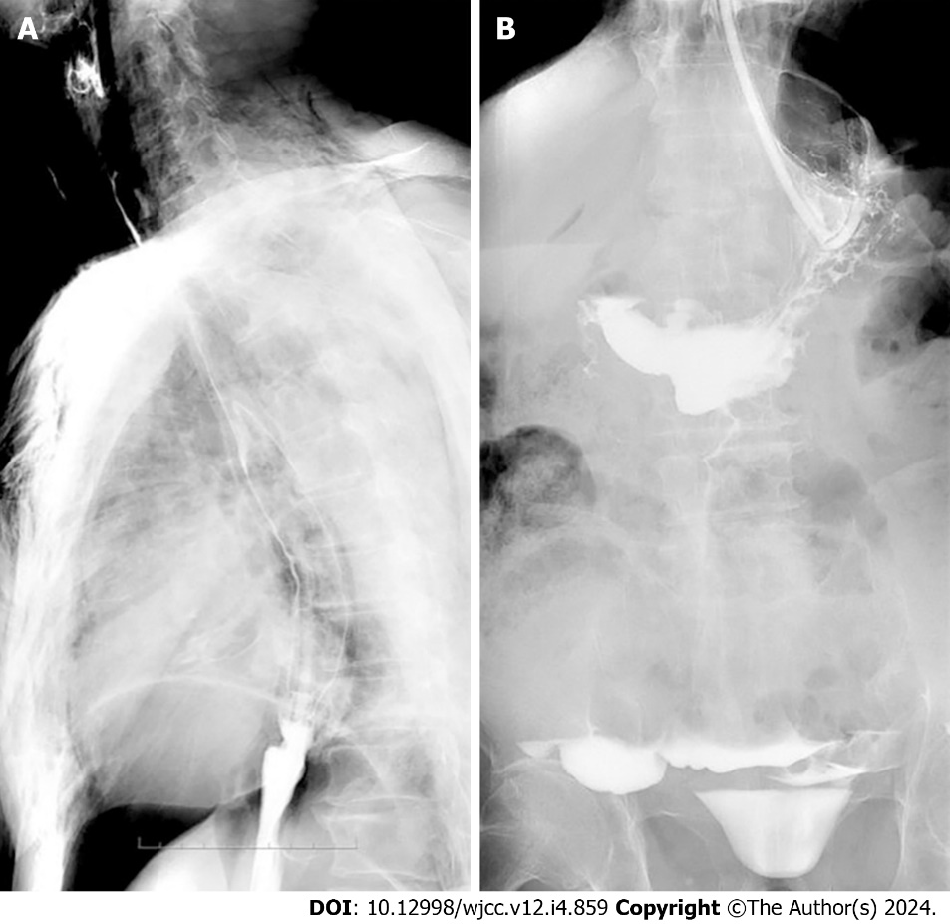
Figure 1 Upper gastrointestinal imaging. A: Smooth esophageal wall, large amount of free gas visible in the abdominal cavity, and gas visible around the esophagus; B: Gastric perforation with flow of contrast into the pelvis.
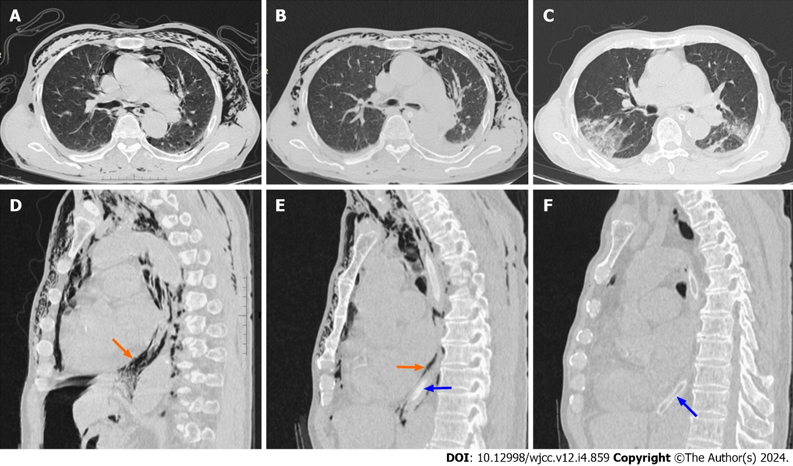
Figure 2 Computed tomography. A-I and A-II: Preoperative computed tomography (CT) showed striated and cast areas without lung texture along the fascial space in the mediastinum and both chest walls. Gas is visible around the esophagus (red arrow). The blue arrow indicates the gastric tube; B-I and B-II: CT on the first postoperative day showed significant reduction of original mediastinal emphysema and chest wall emphysema after surgical treatment; C-I and C-II: CT on the sixth postoperative day showed that original mediastinal emphysema and chest wall emphysema largely disappeared.

Published by Baishideng Publishing Group Inc
7041 Koll Center Parkway, Suite 160, Pleasanton, CA 94566, USA
Telephone: +1-925-3991568
E-mail: office@baishideng.com
Help Desk: https://www.f6publishing.com/helpdesk
https://www.wjgnet.com

© 2024 Baishideng Publishing Group Inc. All rights reserved.

