Name of Journal: World Journal of Clinical Cases
Manuscript NO: 70671
Manuscript Type: ORIGINAL ARTICLE

Retrospective Study
machine learning approach to predict acute kidney injury after liver surgery

Dong JF et al. Machine learning models to predict AKI

Jun-Feng Dong, Qiang Xue, Ting Chen, Yuan-Yu Zhao, Hong Fu, Wen-Yuan Guo, Jun-Song Ji

Jun-Feng Dong, Yuan-Yu Zhao, Hong Fu, Wen-Yuan Guo, Jun-Song Ji, Department of Organ Transplantation, Changzheng Hospital, Navy Medical University, Shanghai 200003, China

Qiang Xue, Department of Neurosurgery, Eastern Hepatobiliary Surgery Hospital, Navy Medical University, Shanghai 200082, China

Ting Chen, Department of Intensive Rehabilitation, Zhabei Central Hospital, Shanghai 200070, China

Author contributions: Dong JF, Xue Q, and Chen T contributed equally to this work; Guo WY and Ji JS should be considered co-corresponding authors; Dong JF, Xue Q, and Chen T were responsible for conceptualization, data curation, methodology, and wrote the original draft; Zhao YY and Fu H were responsible for visualization and software; Guo WY and Ji JS were responsible for validation, supervision, reviewing and editing the manuscript; all authors approved the final submission.

Corresponding author: Jun-Song Ji, MM, PhD, Associate Professor, Department of Organ Transplantation, Changzheng Hospital, Navy Medical University, No. 415 Fengyang Road, Huangpu District, Shanghai 200003, China. 974938677@qq.com

Received: August 10, 2021
Revised: September 15, 2021
Accepted: November 3, 2021
Published online: December 26, 2021

Abstract
BACKGROUND
Acute kidney injury (AKI) after surgery appears to increase the risk of death in patients with liver cancer. In recent years, machine learning algorithms have been shown to offer higher discriminative efficiency than classical statistical analysis.

AIM
to develop prediction models for AKI after liver cancer resection using machine learning techniques.

METHODS
We screened a total of 2450 patients who had undergone primary hepatocellular carcinoma resection at Changzheng Hospital, Shanghai City, China, from January 1, 2015 to August 31, 2020. The AKI definition used was consistent with the Kidney Disease: Improving Global Outcomes. We included in our analysis preoperative data such as demographic characteristics, laboratory findings, comorbidities, and medication, as well as perioperative data such as duration of surgery. Computerized algorithms used for model development included logistic regression (LR), support vector machine (SVM), random forest (RF), extreme gradient boosting (XGboost), and decision tree (DT). Feature importance was also ranked according to its contribution to model development.

RESULTS
AKI events occurred in 296 patients (12.1%) within 7 d after surgery. Among the original models based on machine learning techniques, the RF algorithm had optimal discrimination with an area under the curve value of 0.92, compared to 0.87 for XGBoost, 0.90 for DT, 0.90 for SVM, and 0.85 for LR. The RF algorithm also had the highest concordance-index (0.86) and the lowest Brier score (0.076). The variable that contributed the most in the RF algorithm was age, followed by cholesterol, and surgery time.

CONCLUSION
Machine learning algorithms are highly effective in discriminating patients at high risk of developing AKI. The successful application of machine learning models may help guide clinical decisions and help improve the long-term prognosis of patients.

Key Words: Machine learning; Liver cancer; Surgery; Acute kidney injury; Prediction

©The Author(s) 2021. Published by Baishideng Publishing Group Inc. All rights reserved.

Citation: Dong JF, Xue Q, Chen T, Zhao YY, Fu H, Guo WY, Ji JS. machine learning approach to predict acute kidney injury after liver surgery. World J Clin Cases 2021; 9(36): 11255-11264
URL: https://www.wjgnet.com/2307-8960/full/v9/i36/11255.htm
DOI: https://dx.doi.org/10.12998/wjcc.v9.i36.11255

Core Tip: Acute kidney injury (AKI) is a relatively common complication after liver surgery and has a negative impact on long-term patient prognosis. Early detection and timely intervention are key in order to minimize the negative impact of AKI. Machine learning has become increasingly better integrated with clinical medicine. In our retrospective study, we established a real-time prediction model based on machine learning algorithms. The final models showed high power to discriminate AKI events.

INTRODUCTION
Liver surgery associated acute kidney injury (LSA-AKI) is a relatively common postoperative complication in patients with liver cancer. LSA-AKI has a negative impact on the postoperative recovery and increases long-term patient mortality^{[1]}. The incidence of AKI has been reported to be between 15% and 50% in patients with liver cancer that undergo surgery^{[2]}. However, in clinical practice, AKI events are often underdiagnosed^{[3]}. Many studies have investigated AKI-associated risk factors, and several classical scoring systems for AKI have emerged^{[4,5]}. Nevertheless, the potential non-linear relationship between variables and variable-outcome can compromise the predictive performance of the model. Moreover, the traditional multiple linear analysis methods limit the number of relevant variables that may be clinically significant^{[6]}. In contrast, machine learning techniques are not limited to linear relationships nor to the number of variables included in the analysis, and therefore may offer a better predictive performance.
Machine learning includes computer algorithm-based technology that can efficiently process clinical data to solve classification or regression problems^{[7,8]}. With the continuous expansion of artificial intelligence (AI) techniques, machine learning and clinical medicine are gradually overlapping, as illustrated by numerous studies performed on both^{[9]}. In clinical medicine, machine learning has demonstrated its value in analyzing postoperative complications and long-term outcomes due to its powerful data processing capabilities^{[10-13]}. For example, in contrast to traditional regression models, machine learning performed better at screening patients at high-risk of sepsis^{[14]}. Moreover, in prior prospective evaluations of the AKI events, the machine-learning-based AKI predictor outperformed physician predictive performance^{[15]}.
Machine learning has also made progress in critical care medicine^{[16]}, and was shown to be valuable in the emergency department^{[17]}, and iconography^{[18]}. In the era of big data, the combination of machine learning and electronic medical records can provide more advanced technical support for clinical management of AKI patients^{[19]}. AKI predictive models based on big data and artificial intelligence are potentially reliable tools to individually and prospectively monitor the condition of each patient and help support clinical decisions accordingly^{[20,21]}. In our research, machine learning algorithms were used to develop the LSA-AKI models, with appropriate validation and evaluation of the model’s performance.

MATERIALS AND METHODS
Study population
A total of 2450 patients who had undergone primary hepatocellular carcinoma resection at Changzheng Hospital, Shanghai City, China, from January 1, 2015 to August 31, 2020 were screened (Figure 1). The study was approved by the Ethics Committee of Navy Medical University, with an exemption from the informed consent.

Data collection
The AKI standard used was the 2012 KDIGO criteria, which is defined as: (1) an increase in serum creatinine of more than 50% within 7 d after surgery; and (2) an increase in serum creatinine of more than 0.3 mg/dL within 48 h after surgery. The preoperative serum creatinine was measured as a baseline value.
We included in our analysis preoperative data such as demographic characteristics, laboratory findings, comorbidities, and medication, as well as perioperative data such as duration of surgery. The baseline characteristics included age, gender, and dyslipidemia. Data on tumor characteristics such as alpha-fetoprotein (AFP) and tumor size were also collected. Laboratory measurements included hemoglobin, serum creatinine, and cholesterol. Perioperative variables included the use of blood products and surgery duration.

Statistical analysis
Python version 3.6 and Scikit-learn package (https://github.com/scikit-learn/scikit-learn) were used for development of the model. Patients were randomly assigned to the training and the test sets at a ratio of 7:3. The training set was used for model development and optimization, while the test set was used for model validation and evaluation.

Machine learning techniques
We used several mature machine learning algorithms for modelling: the logistic regression (LR), the support vector machine (SVM), the random forest (RF), the extreme gradient propulsion (XGBoost), and the decision tree (DT). The operating principle of the LR model is to calculate the regression coefficient through the maximum likelihood ratio, and therefore to calculate the occurrence probability of the observing endpoint. The DT, RF, and XGBoost techniques adopted the tree-based algorithm, which is a tree-like modelling which can synthesize the analysis to reach the best prediction decision (Figure 2). Feature importance was ranked according to the mean decrease in the Gini index^{[22]}. SVM, a binary program introduced by Vapnik^{[23]}, was able to place the tagged targets to their belonged hyperplane partitions according to the inputted variable characteristics^{[24]}. In this study, we used the five machine learning algorithms described above to predict whether a patient developed AKI within 7 d after liver cancer resection.

Performance evaluation
The area under the curve (AUC) in the receiver operating characteristic curve was applied to show the RF model performance. The greater the AUC, the better the predictive performance. Additionally, the concordance index (C-index)^{[25]} and the Brier score (BS)^{[26]} were measured to gauge the model’s discriminatory ability. A high C-index and a low BS suggest superior predictive performance. The optimal hyperparameters were identified in a 10-fold cross-validation to avoid the overfitting pitfall during model development.

RESULTS
Patient characteristics
A total of 2450 cases were included in our analysis. The age of the population was 54 ± 10.5 (mean ± SD). The majority were men, accounting for 81.3% (1992/2450) of the population. Tumor-associated information included: the tumor size (ranging from 0.8 cm to 8.3 cm); specific tumor markers of liver cancer (AFP fluctuated between 483 and 43203). 23.9% (586/2450) of the patients had dyslipidemia, 7.8% (190/2450) had diabetes mellitus, 48.4% (92/190) of which were currently receiving insulin. 13.2% (324/2450) of the patients had been prescribed oral beta blockers, and 8.1% (198/2450) were on aspirin. Table 1 shows the baseline characteristics in the training and the test sets, and confirms that there were no statistically significant differences between the two sets.

AKI morbidity
Serum creatinine fluctuations were continuously monitored after the operation, and were compared with the preoperative baseline values. Our results indicate that a LSA-AKI event occurred in 296 patients (12.1%) within 7 days after surgery. The incidence of AKI in the training set and test set was 11.5% (198/1715) and 13.3% (98/735), respectively.

Measures of effectiveness
The LR, SVM, RF, XGboost, and DT models were developed to predict postoperative AKI events. Table 2 and Figure 3 show the performance of the five machine learning models used. The RF technique had the largest evaluated AUC (0.92) in contrast to the LR technique which had the minimum evaluated AUC (0.85). Table 2 shows the C-index and the BS of the five models. The models developed from machine learning were, as expected, shown to have a great C-index and small BS for the interest outcomes of AKI. In particular, the RF model performed better than the other prediction models with a higher C-index and lower BS (C-index: 0.86, BS: 0.076).

Tree structure
Figure 2 depicts a tree-like algorithm processing variables to classify the sample. Each variable flowed through the tree and showed the importance of its value. Samples in the training set continue to branch out according to the classification results. Variables were given an entropy value and Gini index in the decision tree. In the random forest, the final prediction result was determined according to the majority votes of the final decision trees, with the importance of each variable ranked according to the Gini index.

Importance rank
The ranked variable value of the RF algorithm is shown in Figure 4, revealing the 18 foremost variables. Variables were ranked according to the mean decreases in the Gini index. The top five contributing variables to the model were age, cholesterol, surgery time, serum creatinine, and platelet counts.

DISCUSSION
Early detection and timely intervention are key to efficient treatment of AKI events^{[27]}. Therefore, it is a clinical priority to develop risk assessment systems to screen the high-risk population so that timely and effective interventions can be conducted. However, due to the multifactorial nature and the multilinear relationships of LSA-AKI, previous risk scores have been inefficient in predicting AKI episodes^{[28]}. In addition, development of such risk scores commonly used a small set of preoperative clinical variables. Nevertheless, other factors, including intraoperative events such as surgery duration and body fluid loss may also actively impact the development of LSA-AKI.
With the advent of big data, machine learning holds great potential in the field of AKI research due to its unparalleled ability in data processing^{[19]}. Therefore, machine learning models may be powerful tools for AKI risk stratification and prediction^{[20]}. A clinical decision support system based on the machine learning technique has many advantages, such as helping save clinicians' time and energy, increasing the efficiency of diagnosis and treatment, and improving real-time monitoring of patients' conditions^{[29]}. In this retrospective study, we developed, validated, and evaluated several LSA-AKI machine learning models based on preoperative and intraoperative features. It is important to note that we included intraoperative variables to construct the models to offer a better simulation of the real physiological conditions during liver surgery. The existent risk scores in predicting AKI events after liver surgery included the Kalisvaart Score^{[30]} and the Park Score^{[31]}. These risk scoring systems were developed from traditional regression analysis methods, with AUC values ranging from 0.70 to 0.85. In our study, the prediction models established by a machine learning approach had a high discriminatory power with AUC values ranging from 0.85 to 0.92. The RF classifier had the largest evaluated AUC (0.92), in contrast to the LR classifier which had the minimum evaluated AUC (0.85). These models, derived from machine learning algorithms, showed an apparent improvement in LSA-AKI discrimination ability compared with that of the Kalisvaart and the Park Scores.
The first report of machine learning on LSA-AKI indicated that XGBoost had a high obtained AUC score for predicting LSA-AKI events [0.90, 95% confidence interval (CI): 0.86-0.93], whereas the AUC of LR analysis was 0.61 (95%CI: 0.56-0.66)^{[6]}. These results suggest that the traditional regression model does not perform better than machine learning models in predictive analysis, which may result from its linear assumption during data analysis^{[6]}.
Figure 4 lists the factors involved in the development of the RF model and the contribution ranking of the related variables. These ranked variables may be potential risk factors for the development of LSA-AKI events. It is worth noting that the rank of the relevant variables did not include some previously known risk factors, such as intraoperative urine output. In addition, several factors previously thought to be unrelated to AKI development, such AFP, appear to be relevant. These findings might prompt new research ideas and better understanding of AKI events.
There are also some limitations in our study. First, this was a single-center retrospective study. Due to the relatively small sample size and the lack of external validation, our results may not be generalizable. Second, including all variables in the process of data collection is a very challenging task, and therefore some potentially relevant factors may have been ignored. Finally, most of the inputted features were implemented manually. We are still working on developing a real-time automated electronic health record algorithm that could collect perioperative patient information from a variety of data sources. With these new technologies, predictive models based on machine learning may have the potential to change clinical practice.

CONCLUSION
LSA-AKI is a postoperative complication with high incidence in patients with liver cancer. LSA-AKI has a negative impact on the postoperative recovery of patients and results in increased long-term mortality. As LSA-AKI is associated with a variety of factors, and given the complex nonlinear relationship among variables and outcomes, it is challenging for traditional regression analysis to predict its occurrence. In recent years, the intersection of machine learning and clinical medicine has allowed early detection of AKI. Our model, based on machine learning approaches, may be helpful for screening patients at high risk of AKI, ultimately helping to guide clinical decisions and facilitate prospective interventions for high-risk individuals. Future research should attempt to further improve the predictive performance of LSA-AKI by combining AKI biomarkers such as IL-18, NGAL and KIM1^{[32]} with machine learning.

ARTICLE HIGHLIGHTS
Research background
Recently, machine learning has proven helpful in the interpretation of medical results and has potential for helping guide diagnosis and treatment, ultimately improving patient outcomes.

Research motivation
Machine learning methods to predict acute kidney injury (AKI) events remain largely unexplored.

Research objectives
We aimed to develop prediction models for AKI after liver cancer resection based on machine learning techniques.

Research methods
A total of 2450 patients who had undergone primary hepatocellular carcinoma resection at Changzheng Hospital, Shanghai City, China, from January 1, 2015 to August 31, 2020 were screened. Patients were randomly assigned to the training and the test sets at a ratio of 7:3. The training set was used for model development and optimization, while the test set was used for model validation and evaluation.

Research results
AKI events occurred in 296 patients (12.1%) after surgery. Among the original models based on machine learning techniques, the random forest (RF) algorithm had optimal discrimination with an area under the curve value of 0.92, compared to 0.87 for extreme gradient boosting, 0.90 for decision tree, 0.90 for support vector machine, and 0.85 for logistic regression. The RF algorithm also had the highest concordance-index (0.86) and the lowest Brier score (0.076). The variables that contributed the most in the RF algorithm were age, cholesterol, and surgery time.

Research conclusions
Machine learning technology can accurately predict AKI after hepatectomy.

Research perspectives
In the era of personalized medicine, our model based on machine learning can discriminate patients at high risk for AKI, thus helping guide clinical decisions and facilitating prospective interventions for high-risk individuals.

REFERENCES
1 Joliat GR, Labgaa I, Demartines N, Halkic N. Acute kidney injury after liver surgery: does postoperative urine output correlate with postoperative serum creatinine? HPB (Oxford) 2020; 22: 144-150 [PMID: 31431415 DOI: 10.1016/j.hpb.2019.06.016]
2 Tang IY, Murray PT. Prevention of perioperative acute renal failure: what works? Best Pract Res Clin Anaesthesiol 2004; 18: 91-111 [PMID: 14760876 DOI: 10.1016/j.bpa.2003.09.006]
3 Moore EM, Simpson JA, Tobin A, Santamaria J. Preoperative estimated glomerular filtration rate and RIFLE-classified postoperative acute kidney injury predict length of stay post-coronary bypass surgery in an Australian setting. Anaesth Intensive Care 2010; 38: 113-121 [PMID: 20191786 DOI: 10.1177/0310057X1003800119]
4 Chen J, Singhapricha T, Hu KQ, Hong JC, Steadman RH, Busuttil RW, Xia VW. Postliver transplant acute renal injury and failure by the RIFLE criteria in patients with normal pretransplant serum creatinine concentrations: a matched study. Transplantation 2011; 91: 348-353 [PMID: 21127462 DOI: 10.1097/TP.0b013e31820437da]
5 Pannu N, Graham M, Klarenbach S, Meyer S, Kieser T, Hemmelgarn B, Ye F, James M; APPROACH Investigators and the Alberta Kidney Disease Network. A new model to predict acute kidney injury requiring renal replacement therapy after cardiac surgery. CMAJ 2016; 188: 1076-1083 [PMID: 27297813 DOI: 10.1503/cmaj.151447]
6 Lee HC, Yoon SB, Yang SM, Kim WH, Ryu HG, Jung CW, Suh KS, Lee KH. Prediction of Acute Kidney Injury after Liver Transplantation: Machine Learning Approaches vs. Logistic Regression Model. J Clin Med 2018; 7 [PMID: 30413107 DOI: 10.3390/jcm7110428]
7 Hashimoto DA, Witkowski E, Gao L, Meireles O, Rosman G. Artificial Intelligence in Anesthesiology: Current Techniques, Clinical Applications, and Limitations. Anesthesiology 2020; 132: 379-394 [PMID: 31939856 DOI: 10.1097/ALN.0000000000002960]
8 Nevin L; PLOS Medicine Editors. Advancing the beneficial use of machine learning in health care and medicine: Toward a community understanding. PLoS Med 2018; 15: e1002708 [PMID: 30500811 DOI: 10.1371/journal.pmed.1002708]
9 Rajkomar A, Dean J, Kohane I. Machine Learning in Medicine. N Engl J Med 2019; 380: 1347-1358 [PMID: 30943338 DOI: 10.1056/NEJMra1814259]
10 Huang C, Murugiah K, Mahajan S, Li SX, Dhruva SS, Haimovich JS, Wang Y, Schulz WL, Testani JM, Wilson FP, Mena CI, Masoudi FA, Rumsfeld JS, Spertus JA, Mortazavi BJ, Krumholz HM. Enhancing the prediction of acute kidney injury risk after percutaneous coronary intervention using machine learning techniques: A retrospective cohort study. PLoS Med 2018; 15: e1002703 [PMID: 30481186 DOI: 10.1371/journal.pmed.1002703]
11 Lee HC, Yoon HK, Nam K, Cho YJ, Kim TK, Kim WH, Bahk JH. Derivation and Validation of Machine Learning Approaches to Predict Acute Kidney Injury after Cardiac Surgery. J Clin Med 2018; 7 [PMID: 30282956 DOI: 10.3390/jcm7100322]
12 Motwani M, Dey D, Berman DS, Germano G, Achenbach S, Al-Mallah MH, Andreini D, Budoff MJ, Cademartiri F, Callister TQ, Chang HJ, Chinnaiyan K, Chow BJ, Cury RC, Delago A, Gomez M, Gransar H, Hadamitzky M, Hausleiter J, Hindoyan N, Feuchtner G, Kaufmann PA, Kim YJ, Leipsic J, Lin FY, Maffei E, Marques H, Pontone G, Raff G, Rubinshtein R, Shaw LJ, Stehli J, Villines TC, Dunning A, Min JK, Slomka PJ. Machine learning for prediction of all-cause mortality in patients with suspected coronary artery disease: a 5-year multicentre prospective registry analysis. Eur Heart J 2017; 38: 500-507 [PMID: 27252451 DOI: 10.1093/eurheartj/ehw188]
13 Xu FB, Cheng H, Yue T, Ye N, Zhang HJ, Chen YP. Derivation and validation of a prediction score for acute kidney injury secondary to acute myocardial infarction in Chinese patients. BMC Nephrol 2019; 20: 195 [PMID: 31146701 DOI: 10.1186/s12882-019-1379-x]
14 Lin K, Hu Y, Kong G. Predicting in-hospital mortality of patients with acute kidney injury in the ICU using random forest model. Int J Med Inform 2019; 125: 55-61 [PMID: 30914181 DOI: 10.1016/j.ijmedinf.2019.02.002]
15 Rank N, Pfahringer B, Kempfert J, Stamm C, Kühne T, Schoenrath F, Falk V, Eickhoff C, Meyer A. Deep-learning-based real-time prediction of acute kidney injury outperforms human predictive performance. NPJ Digit Med 2020; 3: 139 [PMID: 33134556 DOI: 10.1038/s41746-020-00346-8]
16 Hever G, Cohen L, O'Connor MF, Matot I, Lerner B, Bitan Y. Machine learning applied to multi-sensor information to reduce false alarm rate in the ICU. J Clin Monit Comput 2020; 34: 339-352 [PMID: 30955160 DOI: 10.1007/s10877-019-00307-x]
17 Lee S, Mohr NM, Street WN, Nadkarni P. Machine Learning in Relation to Emergency Medicine Clinical and Operational Scenarios: An Overview. West J Emerg Med 2019; 20: 219-227 [PMID: 30881539 DOI: 10.5811/westjem.2019.1.41244]
18 Abraham A, Pedregosa F, Eickenberg M, Gervais P, Mueller A, Kossaifi J, Gramfort A, Thirion B, Varoquaux G. Machine learning for neuroimaging with scikit-learn. Front Neuroinform 2014; 8: 14 [PMID: 24600388 DOI: 10.3389/fninf.2014.00014]
19 Cheungpasitporn W, Kashani K. Electronic Data Systems and Acute Kidney Injury. Contrib Nephrol 2016; 187: 73-83 [PMID: 26882100 DOI: 10.1159/000442367]
20 Sutherland SM, Goldstein SL, Bagshaw SM. Acute Kidney Injury and Big Data. Contrib Nephrol 2018; 193: 55-67 [PMID: 29393191 DOI: 10.1159/000484963]
21 Laszczyńska O, Severo M, Azevedo A. Electronic Medical Record-Based Predictive Model for Acute Kidney Injury in an Acute Care Hospital. Stud Health Technol Inform 2016; 228: 810-812 [PMID: 27577501]
22 Ambale-Venkatesh B, Yang X, Wu CO, Liu K, Hundley WG, McClelland R, Gomes AS, Folsom AR, Shea S, Guallar E, Bluemke DA, Lima JAC. Cardiovascular Event Prediction by Machine Learning: The Multi-Ethnic Study of Atherosclerosis. Circ Res 2017; 121: 1092-1101 [PMID: 28794054 DOI: 10.1161/CIRCRESAHA.117.311312]
23 Vapnik VN. An overview of statistical learning theory. IEEE Trans Neural Netw 1999; 10: 988-999 [PMID: 18252602 DOI: 10.1109/72.788640]
24 Zhu ZH, Sun BY, Ma Y, Shao JY, Long H, Zhang X, Fu JH, Zhang LJ, Su XD, Wu QL, Ling P, Chen M, Xie ZM, Hu Y, Rong TH. Three immunomarker support vector machines-based prognostic classifiers for stage IB non-small-cell lung cancer. J Clin Oncol 2009; 27: 1091-1099 [PMID: 19188679 DOI: 10.1200/JCO.2008.16.6991]
25 Malayeri AA, Natori S, Bahrami H, Bertoni AG, Kronmal R, Lima JA, Bluemke DA. Relation of aortic wall thickness and distensibility to cardiovascular risk factors (from the Multi-Ethnic Study of Atherosclerosis [MESA]). Am J Cardiol 2008; 102: 491-496 [PMID: 18678312 DOI: 10.1016/j.amjcard.2008.04.010]
26 Redheuil A, Yu WC, Wu CO, Mousseaux E, de Cesare A, Yan R, Kachenoura N, Bluemke D, Lima JA. Reduced ascending aortic strain and distensibility: earliest manifestations of vascular aging in humans. Hypertension 2010; 55: 319-326 [PMID: 20065154 DOI: 10.1161/HYPERTENSIONAHA.109.141275]
27 Thongprayoon C, Hansrivijit P, Kovvuru K, Kanduri SR, Torres-Ortiz A, Acharya P, Gonzalez-Suarez ML, Kaewput W, Bathini T, Cheungpasitporn W. Diagnostics, Risk Factors, Treatment and Outcomes of Acute Kidney Injury in a New Paradigm. J Clin Med 2020; 9 [PMID: 32294894 DOI: 10.3390/jcm9041104]
28 Thakar CV, Arrigain S, Worley S, Yared JP, Paganini EP. A clinical score to predict acute renal failure after cardiac surgery. J Am Soc Nephrol 2005; 16: 162-168 [PMID: 15563569 DOI: 10.1681/ASN.2004040331]
29 Molitoris BA. Beyond Biomarkers: Machine Learning in Diagnosing Acute Kidney Injury. Mayo Clin Proc 2019; 94: 748-750 [PMID: 31054601 DOI: 10.1016/j.mayocp.2019.03.017]
30 Kalisvaart M, Schlegel A, Umbro I, de Haan JE, Polak WG, IJzermans JN, Mirza DF, Perera MTP, Isaac JR, Ferguson J, Mitterhofer AP, de Jonge J, Muiesan P. The AKI Prediction Score: a new prediction model for acute kidney injury after liver transplantation. HPB (Oxford) 2019; 21: 1707-1717 [PMID: 31153834 DOI: 10.1016/j.hpb.2019.04.008]
31 Park MH, Shim HS, Kim WH, Kim HJ, Kim DJ, Lee SH, Kim CS, Gwak MS, Kim GS. Clinical Risk Scoring Models for Prediction of Acute Kidney Injury after Living Donor Liver Transplantation: A Retrospective Observational Study. PLoS One 2015; 10: e0136230 [PMID: 26302370 DOI: 10.1371/journal.pone.0136230]
32 Koyner JL, Vaidya VS, Bennett MR, Ma Q, Worcester E, Akhter SA, Raman J, Jeevanandam V, O'Connor MF, Devarajan P, Bonventre JV, Murray PT. Urinary biomarkers in the clinical prognosis and early detection of acute kidney injury. Clin J Am Soc Nephrol 2010; 5: 2154-2165 [PMID: 20798258 DOI: 10.2215/CJN.00740110]

Footnotes
Institutional review board statement: This study was approved by the Ethics Committee of Navy Medical University.

Informed consent statement: The data were not involved in the patients’ privacy information, so the informed consent was waived by the Ethics Committee of Navy Medical University.

Conflict-of-interest statement: The authors have no related conflicts of interest to disclose.

Data sharing statement: No additional data are available.

Open-Access: This article is an open-access article that was selected by an in-house editor and fully peer-reviewed by external reviewers. It is distributed in accordance with the Creative Commons Attribution NonCommercial (CC BY-NC 4.0) license, which permits others to distribute, remix, adapt, build upon this work non-commercially, and license their derivative works on different terms, provided the original work is properly cited and the use is non-commercial. See: http://creativecommons.org/Licenses/by-nc/4.0/

Provenance and peer review: Unsolicited article; Externally peer reviewed.
Peer-review model: Single blind

Peer-review started: August 10, 2021
First decision: September 2, 2021
Article in press: November 3, 2021

Specialty type: Urology and nephrology
Country/Territory of origin: China
Peer-review report’s scientific quality classification
Grade A (Excellent): 0
Grade B (Very good): 0
Grade C (Good): C
Grade D (Fair): 0
Grade E (Poor): 0

P-Reviewer: Veelken R S-Editor: Gong ZM L-Editor: Webster JR P-Editor: Gong ZM

Figure Legends
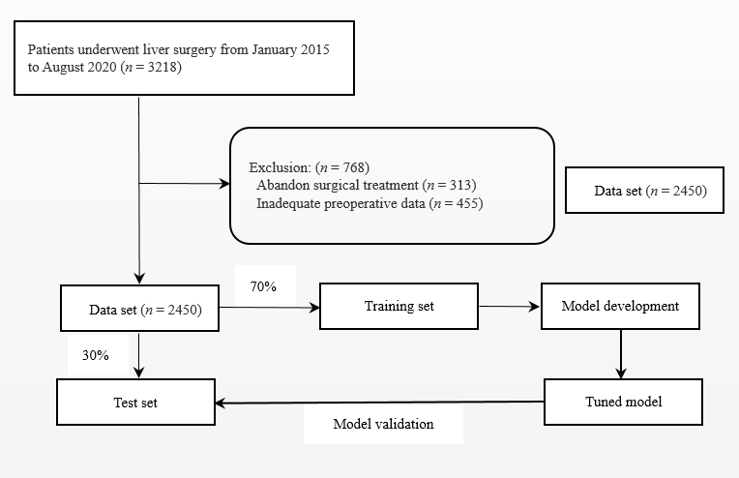
Figure 1 Patient selection and analysis. The 3218 patients who underwent liver cancer resection were initially included. 768 patients were excluded based on exclusion criteria, and a total of 2450 patients were included in the study (data set). The data set was divided into a training set and test set. First, the model was applied to the training set for the modeling process and the parameters were debugged. Then, the model was validated in the test set.
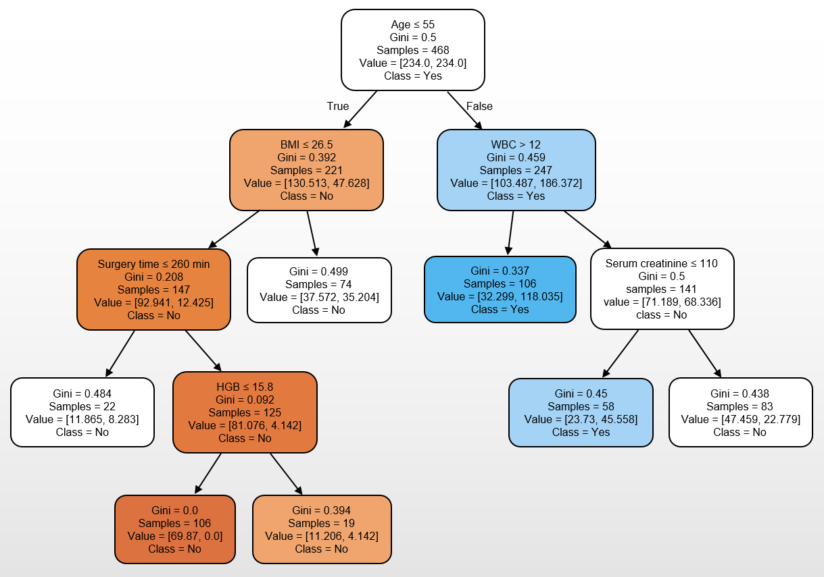
Figure 2 Tree-like algorithm. Tree-like modelling can help analysis to reach the best prediction decision. Classification results for acute kidney injury (AKI) and non-AKI are shown in blue and orange, respectively. The smaller the Gini index, the darker the color. BMI: body mass index; WBC: white blood cell; HGB: hemoglobin.
Figure 3 Areas under the receiver operating characteristic curve. LR: logistic regression; SVM: support vector machine; RF: random forest; XGboost: extreme gradient boosting; DT: decision tree.
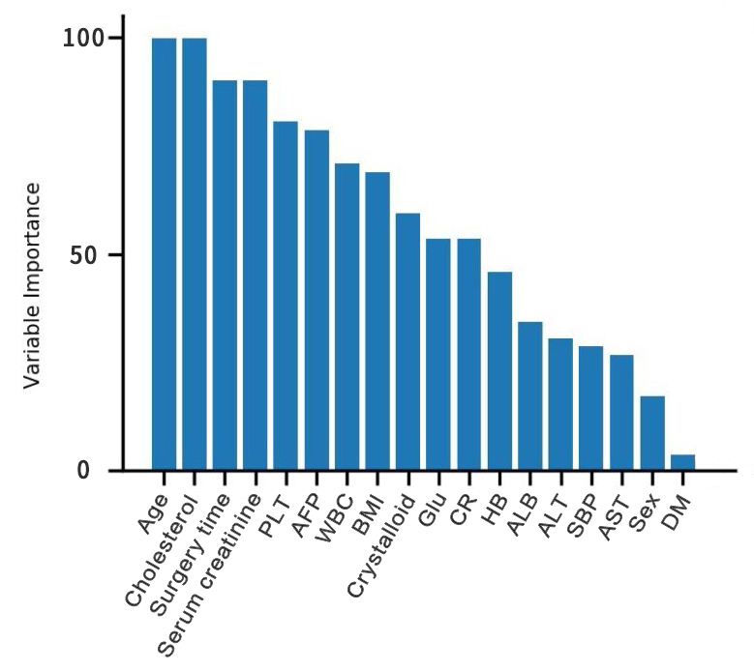
Figure 4 Ranked variable values of the random forest algorithm. PLT: platelet; AFP: alpha-fetoprotein; WBC: white blood cell; BMI: body mass index; CR: creatinine clearance; HB: hemoglobin; ALB: albumin; ALT: alanine aminotransferase; AST: aspartate aminotransferase; SBP: Systolic blood pressure; DM: diabetes mellitus.
Table 1 Patient characteristics
Variables | Training set | Test set | p value
Patient population, n | 1715 | 735
Age (yr) | 55 (45-65) | 54 (44-66) | 0.323
Male, n (%) | 1390 (81.0) | 602 (81.9) | 0.307
BMI (kg/m²) | 24.6 (17.1-29.8) | 24.9 (17.3-28.9) | 0.956
Tumor size (cm) | 4.5 (0.9-7.8) | 4.8 (0.8-8.3) | 0.283
AFP | 8301 (489-35203) | 8842 (503-43203) | 0.058
WBC (× 10³/µL) | 7.3 (3.5-13.8) | 7.5 (3.3-15.8) | 0.128
Hemoglobin (mg/dL) | 13.0 (10.8-15.6) | 12.7 (10.5-16.5) | 0.460
PLT (× 10³/µL) | 168 (102-245) | 175 (113-260) | 0.156
Creatinine (mg/dL) | 0.92 (0.71-1.16) | 0.90 (0.70-1.15) | 0.128
ALB (g/dL) | 3.8 (3.3-4.4) | 3.7 (3.2-4.3) | 0.603
AST (IU/L) | 36.1 (6.3-163.5) | 42.4 (5.8-173.4) | 0.096
Diabetes mellitus, n (%) | 109 (6.4) | 81 (11.0) | 0.098
Dyslipidemia, n (%) | 395 (23.0) | 191 (26.0) | 0.063
ALT (IU/L) | 39.8 (8.3-178.5) | 42.3 (6.5-169.8) | 0.132
Glucose (mg/dL) | 11.8 (5.8-18.3) | 12.5 (6.3-19.8) | 0.285
Cholesterol (mg/dL) | 162.2 (135.8-198.3) | 168.0 (130.0-198.3) | 0.323
PRBC (units) | 0.5 (0.0-3.0) | 0.8 (0.0-3.0) | 0.112
Crystalloid (mL) | 2318.8 (1500-3500) | 2218 (1500-4000) | 0.994
Surgery time (min) | 278 (198-363) | 285 (202-387) | 0.856
Beta blockers, n (%) | 257 (15.0) | 67 (9.1) | 0.155
Aspirin, n (%) | 152 (8.9) | 46 (6.3) | 0.183
RAAS blocker, n (%) | 91 (5.3) | 61 (8.3) | 0.360
Insulin, n (%) | 48 (2.8) | 44 (6.0) | 0.059
systolic blood pressure | 113 (88-154.8) | 118 (95-165.5) | 0.658
diastolic blood pressure | 75 (55-84） | 77 (58-89) | 0.537
mean arterial pressure | 93 (71-119) | 108 (68-121) | 0.437
PLT: platelet; AFP: alpha-fetoprotein; WBC: white blood cell; BMI: body mass index; ALB: albumin; ALT: alanine aminotransferase; AST: aspartate aminotransferase; PRBC: Packed red blood cell; RAAS: Renin-angiotensin-aldosterone system.

Table 2 Model performance (Concordance-index, Brier score, and area under the curve)
Machine learning models | Concordance-index | Brier score | AUC
Logistic regression | 0.84 | 0.078 | 0.85
Support vector machine | 0.86 | 0.083 | 0.90
Random forest | 0.86 | 0.076 | 0.92
Extreme gradient boosting | 0.80 | 0.083 | 0.87
Decision tree | 0.83 | 0.085 | 0.90
AUC: area under the curve.

Published by Baishideng Publishing Group Inc
7041 Koll Center Parkway, Suite 160, Pleasanton, CA 94566, USA
Telephone: +1-925-3991568
E-mail: bpgoffice@wjgnet.com
Help Desk: https://www.f6publishing.com/helpdesk
https://www.wjgnet.com

© 2021 Baishideng Publishing Group Inc. All rights reserved.

