Name of Journal: World Journal of Gastroenterology
Manuscript NO: 39337
Manuscript Type: ORIGINAL ARTICLES

Basic Study
Stomach wall structure and vessels imaging by acoustic resolution photoacoustic microscopy

Wang C et al. Stomach wall structure and vessels imaging

Cheng Wang, Yu-Fei Lu, Chun-Miao Cai, Hua-Zhong Xiang, Gang Zheng

Cheng Wang, Yu-Fei Lu, Hua-Zhong Xiang, Gang Zheng, Institute of Biomedical Optics and Optometry, School of Medical Instrument and Food Engineering, University of Shanghai for Science and Technology, Shanghai 200093, China

Chun-Miao Cai, Department of Pathology, Shanghai Tenth People's Hospital Affiliated to Tongji University, Shanghai 200093, China

ORCID number: Cheng Wang (0000-0002-6293-1607); Yu-Fei Lu (0000-0002-1446-0070); Chun-Miao Cai (0000-0003-3692-5120); Hua-Zhong Xiang (0000-0002-2544-4850); Gang Zheng (0000-0002-6818-0509).

Author contributions: Wang C designed and performed the research; Wang C and Lu Y F wrote the paper; Cai CM harvested experimental samples and provided the pathology images; Wang C, Lu YF, Xiang HZ and Gang Z performed the photoacoustic imaging experiment and processed the experiment data.

Supported by the National Nature Science Foundation of China, No. 61378060.

Institutional review board statement: This study was approved by the Laboratory Animal Ethics Committee of Shanghai Tenth People’ Hospital .The design is reasonable, in line with the animal requirement. The ethics committee agreed to carry out a formal experiment.

Conflict-of-interest statement: To the best of our knowledge, no conflict of interest exists.

Data sharing statement: No additional data are available.

Open-Access: This article is an open-access article which was selected by an in-house editor and fully peer-reviewed by external reviewers. It is distributed in accordance with the Creative Commons Attribution Non Commercial (CC BY-NC 4.0) license, which permits others to distribute, remix, adapt, build upon this work non-commercially, and license their derivative works on different terms, provided the original work is properly cited and the use is non-commercial. See: http://creativecommons.org/licenses/by-nc/4.0/

Manuscript source: Unsolicited manuscript

Correspondence to: Cheng Wang, PhD, Associate Professor, Institute of Biomedical Optics and Optometry, School of Medical Instrument and Food Engineering, University of Shanghai for Science and Technology, No. 516 Jungong Road, Shanghai 200093, China. c.wang@usst.edu.cn
Telephone: +86-21-55271165
Fax: +86-21-55271200

Received: April 12, 2018
Peer-review started: April 13, 2018
First decision: May 17, 2018
Revised: May 26, 2018
Accepted: June 27, 2018
Article in press:
Published online:

Abstract
AIM
To realize layer-by-layer and blood vessels imaging in layered tissue, for example, stomach wall.

METHODS
We built up the acoustic resolution photoacoustic microscopy (AR-PAM) system for imaging layered tissues, such as stomach wall. A tunable dye laser system was coupled a fiber bundle, the fiber bundle were placed in nine directions with incident angle of 45° around a high-frequency ultrasound transducer attached with the acoustic lens. This structure formed a dark field on the tissue surface under the acoustic lens and the nine light beams from the fibers to be combined near the focal point of the acoustic lens. The sample piece was cut from a part of the porcine stomach into a petri dish. In order to realize photoacoustic depth imaging of tumor, we designed tumor model based on indocyanine green (ICG) dye, which the ICG solution with concentration of 129 μm/mL mixed into molten gel, and then a gel mixture of ICG concentration of 12.9 μm/mL would be injected into stomach submucosal 2-3 mm position, the injection quantity would be controlled in 0.1 mL to make a small tumor model.

RESULTS
An acoustic resolution photoacoustic microscopy based on fiber illumination was established and an axial resolution of 25 μm and a lateral resolution of 50 μm in its focal zone range of 500 μm has been accomplished, respectively. We tuned the laser wavelength to 600 nm, the photoacoustic probe was driven to do B-scan imaging in tissue thickness direction with step size of 200 μm. The photoacoustic micro-image of mucosa and submucosa of the tissue have been obtained and compared with pathological photograph of the tissue stained by hematoxylin-eosin staining. We have observed more detailed internal structure of the tissue. We also utilized this photoacoustic microscopy to image blood vessels inside submucosa. Using ICG dye as absorption enhancing tumor model in submucosa, the tumor model imaging under 2400 μm depth with very high contrast was obtained, too.

CONCLUSION
This AR-PAM is able to image layer-by-layer construction and some blood vessels under mucosa in stomach wall without any contrast agents.

Key words: Photoacoustic imaging; Stomach; Layered tissue; Acoustic resolution; Fiber

© The Author(s) 2018. Published by Baishideng Publishing Group Inc. All rights reserved.

Core tip: In order to realize layer-by-layer and blood vessels imaging in layered tissue, acoustic resolution photoacoustic microscopy based on fiber illumination was established and an axial resolution of 25 μm and a lateral resolution of 50 μm in its focal zone range of 500 μm can be accomplished, respectively. Layer-by-layer imaging of stomach tissue and blood vessels under stomach mucosa have been obtained, respectively. Using indocyanine green dye as absorption enhancing tumor model in submucosa, the tumor model imaging under 2400 μm depth with very high contrast was obtained, too.

Wang C, Lu YF, Cai CM, Xiang HZ, Zheng G. Stomach wall structure and vessels imaging by acoustic resolution photoacoustic microscopy. World J Gastroenterol 2018; In press

INTRODUCTION
Stomach submucosal tumors (SMT) are any intramural growth underneath the mucosa of gastrointestinal tract^{[1]}, those tumors are very hard to find because of usually asymptomatic and therefore most often discovered as accidental findings during surgery, autopsy and so on. When examining submucosal tumors, standard optical stomach endoscopy, capsule optical endoscopy and push-and-pull enteroscopy together with barium contrast X-ray do not alone provide sufficient information. Endoscopic ultrasound (EUS), computed tomography (CT) and magnetic resonance imaging (MRI) are recommended as supplementary tools^{[2]}, because CT and MRI often lack either sufficient spatial resolution of satisfactory contrast (or both) to be effective for early-stage tumor imaging^{[3]}. Optimal EUS imaging of an SMT needs submersion of the tumor under water. However, benign SMTs, for example the submucosal inflammation, cannot be distinguished endosonographically^{[4]}. Therefore, Early-phase tumor detection or in situ characterization of sick tissue is challenging for EUS. Because mechanism of EUS imaging is ultrasound imaging, this is based on tissue bulk mechanical properties. Tumor tissue boundaries and blood vessels structure are clinically relevant and provide necessary information for assessing disease stage or progress and planning treatment therapies.
Optical endoscopic imaging modalities have been developed recently, like narrow band imaging endoscopy^{[5]}, endoscopic optical coherent tomography^{[6]} and confocal laser endomicroscopy^{[7]}, can detect tissue or tissue changes with high sensitivity and high spatial resolution. Because of the strong optical scattering properties of tissue, these techniques are unable to image targets beyond a 1-2 mm depth. Photoacoustic imaging has a lot of advantages, such as, endogenous optical chromophore contrast enables label-free imaigng of the microvasculature with a high resolution^{[8]}; in vivo blood vessels photoacoustic imaging can cover the length scale from a superficial capillary^{[9]} to an abdominal aorta^{[10]}, demonstrating the potential of photoacoustic imaging to bridge the resolution and penetration gaps between microvascular microscopy and clinical angiography and so on^{[11,12]}. This paper’s aim is to demonstrate that photoacoustic imaging is able to image the constraction with layer by layer and blood vessels under the surface in the tissue. In future, we can design and develop an photoacoustic endoscopic imaging system to image deeper tissue imaging with higher resolution for diagnosis and treatment.

MATERIALS AND METHODS
AR-PAM system
The acoustic resolution photoacoustic microscopy (AR-PAM) system for stomach wall was shown in Figure 1A. A tunable dye laser system pumped by an Q-switch Nd:YAG laser (ND6000, continuum) is used to provide laser pulse with a pulse repetition of 10 Hz and a pulse width of 5.5 ns. The tunable range of the laser light from 415 nm to 940 nm. A pair of concave and convex lenses expanded and collimated the light beam to approximately 5 mm in diameter, and then coupling to a fiber bundle that was composed by nine optical fibers (FT400UMT, Thorlabs) which have a 400 μm core diameter and numerical aperture of 0.39 were placed in nine directions (40° interval in 360°) around a high-frequency (50-MHz, bandwidth of 30MHz) ultrasound transducer attached with the acoustic lens (the f/# is 1.3 and focal length is 4 mm). The cross angle between the fibers with the transducer axis direction were set to 45°, so that formed a dark field on the tissue surface under the acoustic lens and the nine light beams from the fibers to be combined near the focal point of the acoustic lens, i.e. It is then weakly focused into the tissue with the focal region coaxially overlapping the ultrasonic focus inside the tissue. In an optically transparent medium, the optical focus is about 2 mm in diameter, which is much wider than the ultrasonic focus. The focal acoustic transducer and output end of the fibers were fastened with a holder made by 3D printer. We can refer as it to photoacoustic probe, photograph of the probe is shown Figure 1B. According to the parameters of the ultrasonic transducer, an axial resolution of 25 μm and a lateral resolution of 50 μm in its focal zone range of 500 μm can be accomplished, respectively. The photoacoustic probe is translated in water bath. A window at the bottom of the water container is sealed with an optically and ultrasonically transparent disposable polyethylene membrane (thickness: 0.04 mm). After commercial ultrasound gel is applied to the region of interest on the sample for acoustic coupling, the sample is placed between the sample supporter and the water container for imaging. The photoacoustic wave is recorded at each location of the ultrasonic transducer and subsequently converted into a one-dimensional (1D) depth-resolved image (A-scan) based on the sound velocity in soft tissue (1.54 mm/us). Images were generated by one dimension (B-Scan) in X or Y direction or two-dimensional (C-Scan) raster scanning of the photoacoustic probe in the X-Y plane with a step size of 30 μm. In addition to, we can also scan in Z direction with a step of 200 μm for producing an imaging of the deeper tissue by utilizing deeply penetrable diffused light to excite photoacoustic signals. At each scanning position, signals were recorded by 8 bits digitizer card (DP1400, Agilent Tech, USA) after it was amplified by preamplifier(AU-2A-0150-BNC, MTEQ, USA) and then amplified and filtered (high pass 1 MHz) by pulser/receiver (5073PR,Olympus, Japan). No signal averaging is performed. As shown in Figure 2. photoacoustic imaging of a hair with about diameter of 80 μm were obtained with this photoacoustic system for verifying the imaging ability. Figure 2A was a B-scan imaging and Figure 2B was a C-scan imaging for this hair.

Preparing a porcine stomach wall sample
A porcine stomach was received the day after the animal was sacrificed for an unrelated study. The sample piece was cut from a part of the porcine stomach into a petri dish with a diameter of 140 mm and a thickness of 22 mm. In order to realize photoacoustic depth imaging of tumor, we designed tumor model based on indocyanine green (ICG) dye, which the ICG solution with concentration of 129 μm/mL mixed into molten gel, and then a gel mixture of ICG concentration of 12.9 μm/mL would be injected into stomach submucosal 2-3 mm position, the injection quantity would be controlled in 0.1ml to make a small tumor model.

RESULTS
In order to verify photoacoustic imaging can also be used to implement stratified imaging of stomach wall, we tuned the laser wavelength to 600 nm, the photoacoustic probe was driven to do many times B-scan imaging in tissue thickness direction with step size of 200 μm. And then, all of B-scan images were combined to complete an imaging of layered structure of stomach wall, as shown Figure 3. A particle with the diameter of 300 μm was placed on the surface of stomach tissue, in order to indicate the surface position of the tissue. As shown in Figure 4, the photoacoustic micro-image of mucosa and submucosa of the tissue have been obtained and compared with pathological photograph of the tissue stained by hematoxylin-eosin staining. We have observed more detailed internal structure of the tissue.
In addition, we also utilized this photoacoustic microscopy to image blood vessels inside submucosa as shown in Figure 5. Figure 5A has shown the photograph of the dissected stomach wall after imaging by photoacoustic microscopy, and Figure 5B has shown photoacoustic imaging of vessels under submucosa. We very clearly saw the artery vessels and vein vessels.
In order to realize photoacoustic depth imaging of tumor, we designed a labeled tumor model based on ICG dye, which the 0.1 mL ICG gelatin solution with concentration of 129 μm/mL be injected into stomach submucosal 2-3 mm depth position. After the ICG-gel mixture was injected to tissue and coagulated for 20 min, the C-scan imaging in different depth would be implemented. When doing the scanning, the output wavelength of laser was tuned to 700 nm, because of this wavelength is an absorption peak of ICG dye with molar extinction coefficient of 1.1×10⁵cm-1/M in water, this will improve signal-noise rate of the image. The specific imaging results have been shown in Figure 6. Figure 6A has shown some diffusion phenomena of ICG resolution at mucosal site of 400 μm, this reason may be the ICG dye combined with blood in the vessels, so some likely tubular structures were observed. Although, in the depth of 2400 μm, the image of contrast of ICG labeled tumor model still didn’t be decreased, it has been shown in Figure 6B. This indicated that we can achieve deeper detection ability.

DISCUSSION
Ultrasound uses high-frequency sound waves to produce images of the organs and structures inside the body such as ovaries, uterus, liver, gallbladder, pancreas, or aorta. EUS combines endoscopy and ultrasound in order to obtain images and information about the digestive tract and the surrounding tissue and organs. EUS can obtain information about the layers of the intestinal wall as well as adjacent areas such as lymph nodes and the blood vessels. EUS provides your doctor with more information than other imaging tests by providing detailed images of your digestive tract. Although contrast-enhanced ultrasonic techniques^{[13,14]} such as Doppler ultrasound^{[15]} are able to image blood vessels, these imaging techniques’ resolutions are all much lower than that of PAM, which has recently achieved the lateral resolution up to 15 mm^{[16]}. Additionally, photoacoustic imaging provides functional information with endogenous contrast and with the aid of an exogenous contrast agent. Therefore, photoacoustic endoscopy based on photoacoustic tomography and EUS which has achieved spatially coincident photoacoustic and ultrasonic imaging provides unprecedented information and promotes morphologic and functional understanding of the gastrointestinal tract imaging have been published^{[17]}. But the research on tissue structure based on photoacoustic imaging technique has not been published yet. This paper reported that utilizing AR-PAM to image layer-by-layer construction and blood vessels under mucosa in stomach wall tissue without any contrast agents. In next step, this acoustic resolution photoacoustic microscopy will combine with endoscopy and minimize the photoacoustic probe to make a micro-photoacoustic endoscopy for obtaining tissue morphologic and functional information with higher resolution and deeper depth in vivo.
In conclusions, we have presented a fiber illumination based acoustic resolution photoacoustic microscopy. We have realized an axial resolution of 25 μm and a lateral resolution of 50 μm in its focal zone range of 500 μm. This system was utilized to image layer-by-layer construction and blood vessels under mucosa in stomach wall tissue without any contrast agents. Using ICG dye as absorption enhancing tumor model, the tumor model imaging under 2400 μm tissue with very high contrast was obtained. This proved this photoacoustic microscopy have enough ability to accomplish layered tissue and deeper target imaging with high resolution and high contrast.

ARTICLE HIGHLIGHTS
Research background
When checking submucosal tumors, traditional methods (such as standard optical stomach endoscopy, capsule optical endoscopy and push-and-pull enteroscopy together with barium contrast X-ray) can’t provide accurate information. Computed tomography and magnetic resonance imaging often lower in resolution and contrast. Optimal endoscopic ultrasound (EUS) imaging of stomach submucosal tumors (SMT) needs submersion of the tumor under water. However, benign SMTs, for example the submucosal inflammation, cannot be distinguished endosonographically. Therefore, it is still a challenging for EUS to detect early-phase tumor in situ. Our team aim to demonstrate that photoacoustic imaging is able to image the structure with layer by layer and blood vessels under the surface in the tissue. In future, we can design and develop a photoacoustic endoscopic imaging system to image deeper tissue imaging with higher resolution for diagnosis and treatment.

Research motivation
Our team devoted to realize layer-by-layer and blood vessels imaging in layered tissue.

Research objectives
Our aim is to demonstrate that photoacoustic imaging can detect the structure of layers and blood vessels beneath the surface of the tissue.

Research methods
Our team established the acoustic resolution photoacoustic microscopy (AR-PAM) system for stomach wall structure imaging. Photoacoustic micro-imaging of stomach wall structure compared with pathology imaging for verifying the layered structure and compared with an anatomy picture for looking vessels and vessels direction.

Research results
As a result, we have established a fiber illumination based acoustic resolution photoacoustic microscopy. We have realized imaging ability with an axial resolution of 25 μm and a lateral resolution of 50 μm in its focal zone range of 500 μm. We have observed more detailed internal structure of the tissue from AR-PAM imaging. We also utilized this photoacoustic microscopy to image blood vessels inside submucosa. By using ICG dye as absorption enhancing tumor model in submucosa, the tumor model imaging under 2400 μm depth with very high contrast was obtained.

Research conclusions
In this study, we have established a fiber illumination based acoustic resolution photoacoustic microscopy and realized an axial resolution of 25 μm and a lateral resolution of 50 μm in its focal zone range of 500 μm. Layer-by-layer imaging of stomach tissue and blood vessels under stomach mucosa have been obtained, respectively. By using ICG dye as absorption enhancing tumor model, the tumor model imaging under 2400 μm tissue with very high contrast was obtained. This proved this photoacoustic microscopy have enough ability to accomplish layered tissue and deeper target imaging with high resolution and high contrast. In the near future, after minimized photoacoustic probe, this technique combining with endoscopy will supply a simple tool for doctor to see difference layer feature and functional imaging of tumor angiogenesis in submucosa.

Research perspectives
In the near future, after minimized photoacoustic probe, this technique combining with endoscopy will supply a simple tool for doctor to see difference layer feature and functional imaging of tumor angiogenesis in submucosa. Scientific research should aim at solving practical problems in clinical practice. Innovative scientific research is demonstrated in the ability to effectively solve the difficult problems doctors encounter in clinical practice. Therefore, we should strengthen cooperation with doctors.

REFERENCES
1 Chak A. EUS in submucosal tumors. Gastrointest Endosc 2002; 56: S43-S48 [PMID: 12297748 DOI: 10.1016/S0016-5107(02)70085-0]
2 Hsu CC, Chen JJ, Changchien CS. Endoscopic features of metastatic tumors in the upper gastrointestinal tract. Endoscopy 1996; 28: 249-253 [PMID: 8739742 DOI: 10.1055/s-2007-1005437]
3 Hu S, Wang LV. Photoacoustic imaging and characterization of the microvasculature. J Biomed Opt 2010; 15: 011101 [PMID: 20210427 DOI: 10.1117/1.3281673]
4 Shim CS, Jung IS. Endoscopic removal of submucosal tumors: preprocedure diagnosis, technical options, and results. Endoscopy 2005; 37: 646-654 [PMID: 16010609 DOI: 10.1055/s-2005-861477]
5 Han S, Hsu A, Wassef WY. An update in the endoscopic management of gastric cancer. Curr Opin Gastroenterol 2016; 32: 492-500 [PMID: 27662061 DOI: 10.1097/MOG.0000000000000318]
6 Ding Z, Qiu J, Shen Y, Chen Z, Bao W. Lens-free all-fiber probe with an optimized output beam for optical coherence tomography. Opt Lett 2017; 42: 2814-2817 [PMID: 28708176 DOI: 10.1364/OL.42.002814]
7 Karia K, Kahaleh M. A Review of Probe-Based Confocal Laser Endomicroscopy for Pancreaticobiliary Disease. Clin Endosc 2016; 49: 462-466 [PMID: 27642847 DOI: 10.5946/ce.2016.086]
8 Zhang HF, Maslov K, Stoica G, Wang LV. Functional photoacoustic microscopy for high-resolution and noninvasive in vivo imaging. Nat Biotechnol 2006; 24: 848-851 [PMID: 16823374 DOI: 10.1038/nbt1220]
9 Maslov K, Zhang HF, Hu S, Wang LV. Optical-resolution photoacoustic microscopy for in vivo imaging of single capillaries. Opt Lett 2008; 33: 929-931 [PMID: 18451942 DOI: 10.1364/OL.33.000929]
10 Brecht HP, Su R, Fronheiser M, Ermilov SA, Conjusteau A, Liopo A, Motamedi M, Oraevsky AA. Optoacoustic 3D whole-body tomography: experiments in nude mice. Proc SPIE 2009; 7177: 71770E [DOI: 10.1117/12.812319]
11 Wang X, Xie X, Ku G, Wang LV, Stoica G. Noninvasive imaging of hemoglobin concentration and oxygenation in the rat brain using high-resolution photoacoustic tomography. J Biomed Opt 2006; 11: 024015 [PMID: 16674205 DOI: 10.1117/1.2192804]
12 Wang Y, Hu S, Maslov K, Zhang Y, Xia Y, Wang LV. In vivo integrated photoacoustic and confocal microscopy of hemoglobin oxygen saturation and oxygen partial pressure. Opt Lett 2011; 36: 1029-1031 [PMID: 21478972 DOI: 10.1364/OL.36.001029]
13 Ignee A, Jenssen C, Hocke M, Dong Y, Wang WP, Cui XW, Woenckhaus M, Iordache S, Saftoiu A, Schuessler G, Dietrich CF. Contrast-enhanced (endoscopic) ultrasound and endoscopic ultrasound elastography in gastrointestinal stromal tumors. Endosc Ultrasound 2017; 6: 55-60 [PMID: 28218202 DOI: 10.4103/2303-9027.200216]
14 Dong Y, Wang WP, Mao F, Ji ZB, Huang BJ. Application of imaging fusion combining contrast-enhanced ultrasound and magnetic resonance imaging in detection of hepatic cellular carcinomas undetectable by conventional ultrasound. J Gastroenterol Hepatol 2016; 31: 822-828 [PMID: 26480287 DOI: 10.1111/jgh.13202]
15 Xuan JW, Bygrave M, Jiang H, Valiyeva F, Dunmore-Buyze J, Holdsworth DW, Izawa JI, Bauman G, Moussa M, Winter SF, Greenberg NM, Chin JL, Drangova M, Fenster A, Lacefield JC. Functional neoangiogenesis imaging of genetically engineered mouse prostate cancer using three-dimensional power Doppler ultrasound. Cancer Res 2007; 67: 2830-2839 [PMID: 17363606 DOI: 10.1158/0008-5472.CAN-06-3944]
16 Xing W, Wang L, Maslov K, Wang LV. Integrated optical- and acoustic-resolution photoacoustic microscopy based on an optical fiber bundle. Opt Lett 2013; 38: 52-54 [PMID: 23282835 DOI: 10.1364/OL.38.000052]
17 Yang JM, Favazza C, Chen R, Yao J, Cai X, Maslov K, Zhou Q, Shung KK, Wang LV. Simultaneous functional photoacoustic and ultrasonic endoscopy of internal organs in vivo. Nat Med 2012; 18: 1297-1302 [PMID: 22797808 DOI: 10.1038/nm.2823]
P-Reviewer: Goral V S-Editor: Wang JL
L-Editor: E-Editor:
Specialty type: Gastroenterology and hepatology
Country of origin: China
Peer-review report classification
Grade A (Excellent): 0
Grade B (Very good): B
Grade C (Good): 0
Grade D (Fair): 0
Grade E (Poor): 0

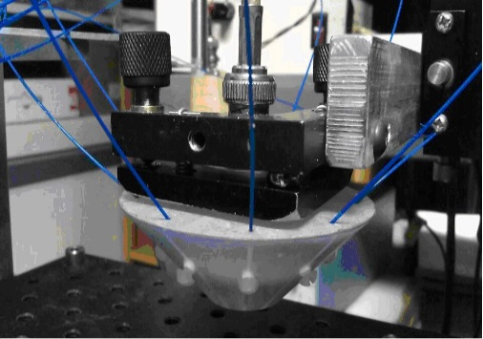
B
A

Figure 1 Schematic of the acoustic resolution photoacoustic microscopical system (A) and photograph of the photoacoustic probe (B). P/R: Pulser/ receiver; A: Preamplifier; T: Transducer, PC: Personal computer.

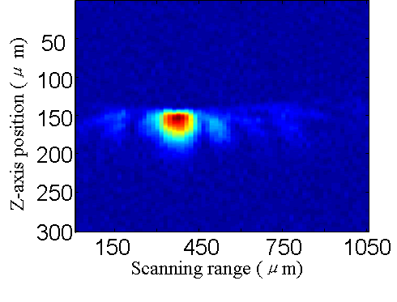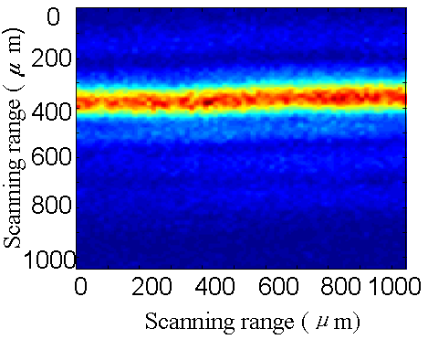
A B
Figure 2 Photoacoustic image of a hair with about diameter of 80 μm. A: B-scan imaging; B: C-scan imaging.

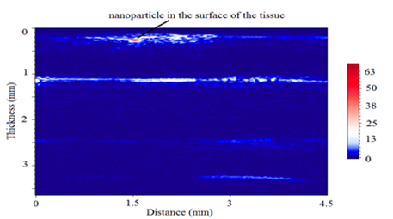
Figure 3 Imaging of layer-by-layer structure of stomach wall.

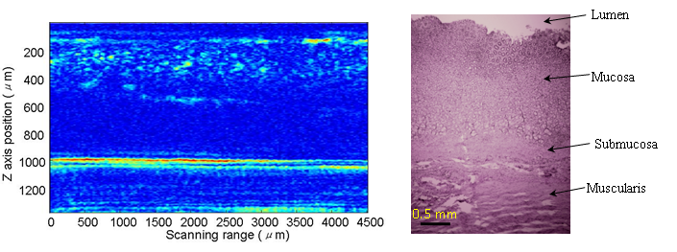
Figure 4 Compared photoacoustic image with pathological photograph stained by hematoxylin-eosin staining for mucosa and submucosa of the tissue.

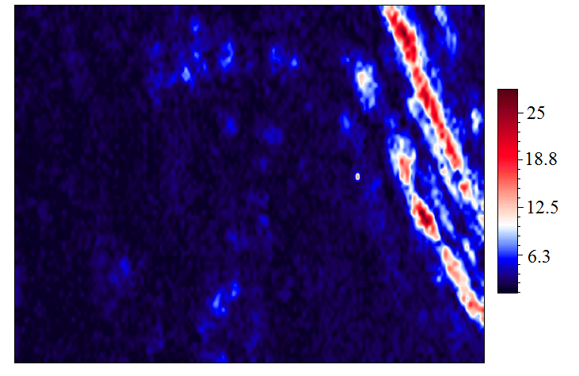
1mm
1 mm
A
B
Veins
Arteries

Figure 5 Photograph of the dissected stomach wall after imaging by photoacoustic microscopy (A) and photoacoustic imaging under surface of the tissue of 500 µm (The red arrow directs vessels, B).

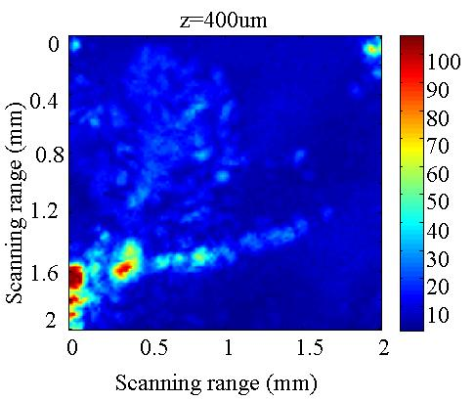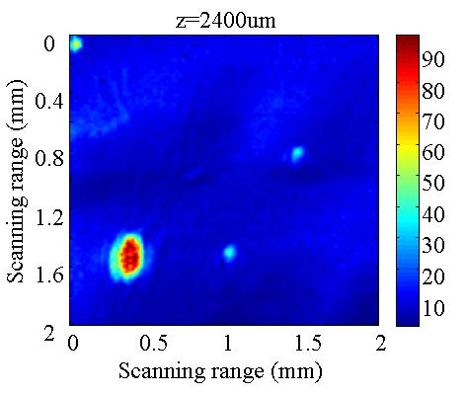
A B
Figure 6 Photoacoustic imaging with laser wavelength of 700 nm for contrast agent with concentration of 12.9 μm/mL in depth of 400 μm (A) and 2400 μm (B), respectively.

