Name of Journal: World Journal of Virology
Manuscript NO: 89104
Manuscript Type: ORIGINAL ARTICLE

Observational Study
Chronic hepatitis B and occult infection in chemotherapy patients - evaluation in oncology and hemato-oncology settings: The CHOICE study

Sudevan N et al. CHB and occult infection in oncology and hemato-oncology settings

Nayana Sudevan, Manish Manrai, T V S V G K Tilak, Harshit Khurana, Harikrishnan Premdeep

Nayana Sudevan, Harikrishnan Premdeep, Department of Internal Medicine, Armed Forces Medical College, Pune 411040, India

Manish Manrai, Department of Gastroenterology, Command Hospital Cantonment Rd, Sadar Bazaar, Cantonment, Lucknow, Uttar Pradesh, India 226002

T V S V G K Tilak, Department of Internal Medicine, Command Hospital, Bangalore 560007, India

Harshit Khurana, Department of Geriatric Medicine, Armed Forces Medical College, Pune 411040, India

Author contributions: Manrai M conceptualized and supervised the study and was involved with obtaining resources, data collection, editing, and validation; Sudevan N conducted the study and was involved in writing the manuscript; Tilak TVSVGK and Khurana H were involved with obtaining resources and data curation, Premdeep H was involved with data curation and editing.

Corresponding author: Manish Manrai, FRCPE, MBBS, MD, Professor, Department of Gastroenterology, Command Hospital Cantonment Rd, Sadar Bazaar, Cantonment, 226002 Lucknow, Uttar Pradesh, India. manishmanrai75@yahoo.com

Received: October 20, 2023
Revised: December 27, 2023
Accepted: January 24, 2024
Published online: March 25, 2024

Abstract
BACKGROUND
Reactivation of hepatitis B virus (HBV) infection is a well-known risk that can occur spontaneously or following immunosuppressive therapies, including cancer chemotherapy. HBV reactivation can cause significant morbidity and even mortality, which are preventable if at-risk individuals are identified through screening and started on antiviral prophylaxis.

AIM
To determine the prevalence of chronic HBV (CHB) and occult HBV infection (OBI) among oncology and hematology-oncology patients undergoing chemotherapy.

METHODS
In this observational study, the prevalence of CHB and OBI was assessed among patients receiving chemotherapy. Serological markers of HBV infection [hepatitis B surface antigen (HBsAg)/anti-hepatitis B core antigen (HBc)] were evaluated for all patients. HBV DNA levels were assessed in those who tested negative for HBsAg but positive for total anti-HBc.

RESULTS
The prevalence of CHB in the study cohort was determined to be 2.3% [95% confidence interval (95%CI): 1.0-4.2]. Additionally, the prevalence of OBI among the study participants was found to be 0.8% (95%CI: 0.2-2.3).

CONCLUSION
The findings of this study highlight the importance of screening for hepatitis B infection in oncology and hematology-oncology patients undergoing chemotherapy. Identifying individuals with CHB and OBI is crucial for implementing appropriate antiviral prophylaxis to prevent the reactivation of HBV infection, which can lead to increased morbidity and mortality.

Key Words: Hepatitis B virus; Chronic hepatitis B; Occult B infection; Oncology; Hepatitis B reactivation; Hematology-oncology

©The Author(s) 2024. Published by Baishideng Publishing Group Inc. All rights reserved.

Citation: Sudevan N, Manrai M, Tilak TVSVGK, Khurana H, Premdeep H. Chronic hepatitis B and occult infection in chemotherapy patients - evaluation in oncology and hemato-oncology settings: The CHOICE study. World J Virol 2024; 13(1): 89104
URL: https://www.wjgnet.com/2220-3249/full/v13/i1/89104.htm
DOI: https://dx.doi.org/10.5501/wjv.v13.i1.89104

Core Tip: Hepatitis B virus (HBV) reactivation, a significant risk for individuals undergoing immunosuppressive therapy such as cancer chemotherapy, can lead to preventable morbidity and mortality. Our observational study determined the prevalence of chronic HBV (CHB) infection and occult HBV infection (OBI) in oncology and hematology-oncology patients receiving chemotherapy. Our results showed a 2.3% prevalence of CHB and 0.8% prevalence of OBI in our study cohort, underscoring the critical importance of routinely screening oncology and hematology-oncology patients for HBV infection. Identifying those with CHB and OBI is vital for promptly initiating antiviral prophylaxis, which can prevent the reactivation of HBV infection.

INTRODUCTION
Reactivation of hepatitis B virus (HBV) infection is a well-known risk that can occur spontaneously or following immunosuppressive therapies, including cancer chemotherapy^{[1]}. This reactivation causes significant morbidity and mortality, which is preventable if at-risk individuals are identified through screening and started on antiviral prophylaxis^{[1]}. The prevalence of chronic hepatitis B (CHB) infection and occult hepatitis B infection (OBI) among oncology and hemato-oncology patients receiving chemotherapy is an important area of study. CHB refers to persistent HBV infection characterized by the presence of hepatitis B surface antigen (HBsAg) for more than 6 months. OBI, on the other hand, is defined as the presence of HBV DNA in the absence of detectable HBsAg^{[2]}. Understanding the prevalence of CHB and OBI in this patient population is crucial for implementing appropriate preventive measures and antiviral prophylaxis to prevent HBV reactivation (HBVr). Previous studies have reported varying prevalence rates of CHB and OBI among cancer patients undergoing chemotherapy, highlighting the need for further investigation^{[3-5]}. By determining the prevalence of CHB and OBI in this specific patient population, this study will contribute to the existing knowledge on HBV infection in the context of cancer chemotherapy. The findings will provide valuable insights into the need for routine screening, antiviral prophylaxis, and infection control measures to prevent HBVr and associated complications in oncology and hematology-oncology patients undergoing chemotherapy.

MATERIALS AND METHODS
Study design and population
This observational study estimated the prevalence of CHB and OBI in newly diagnosed oncological and hematology-oncology patients before starting chemotherapy. The study population included both male and female patients from urban and rural areas, aged 18 years or older, who were seeking treatment at a tertiary care oncology center. Patients with solid organ cancer, leukemia, and lymphoma, as well as those planning to undergo chemotherapy (standard chemotherapy protocols as per the cancer type) and hematopoietic stem cell transplant, were included in the study. Patients with a history of previous chemotherapy or immunosuppressive therapy, pre-existing CHB or chronic hepatitis C virus infection, or contraindications for antiviral therapy for CHB were excluded.

Data collection
Data were collected from a total of 400 patients over 2 years. All patients underwent screening for HBsAg and total anti-HBc. Patients who tested positive for either of these markers were further tested for HBV DNA quantification using polymerase chain reaction. All patients who were identified as CHB or OBI were started on antiviral prophylaxis with entecavir or tenofovir and followed up at 6 and 12 months with HBV DNA and liver function tests. The data collected from the patients were recorded on an Excel spreadsheet for further analysis.

Statistical analysis
The collected data were analyzed using appropriate statistical methods. Descriptive statistics were used to summarize the demographic and clinical characteristics of the study population. The prevalence of CHB and OBI was estimated based on the number of patients testing positive for HBsAg, total anti-HBc, and HBV DNA. The statistical analysis determined the prevalence rates and associated confidence intervals (CIs) for CHB and OBI in the study population.

Ethical considerations
The study protocol was reviewed and approved by the relevant ethical committee. Informed consent was obtained from all participants before their inclusion in the study. Confidentiality and privacy of patient information were strictly maintained throughout the study.

RESULTS
In this observational study, we investigated the prevalence of CHB and OBI in a cohort of 400 patients visiting the oncology and hematology departments with different types of malignancies (Figure 1). Among the 400 subjects studied, 129 (32.3%) were females and 271 (67.8%) were males. The mean age of the study group was 51.34 years (95%CI: 49.83-52.85). Most of the participants were oncology patients (339, 84.8%), with only (61, 15.3%) patients with hematolymphoid malignancies (Figure 2).
A total of 9 patients (2.3%) tested positive for HBsAg (Figure 3) of whom 7 were above the age of 50 years and 2 were below 50 years (Figure 4). The distribution of cancer types among these patients included 5 with hepatocellular carcinoma, 2 with colon cancer, 1 with acute lymphoblastic leukemia, and 1 with pancreatic cancer. Five patients among them had a history of jaundice, of whom 3 were documented to have acute hepatitis B infection (Table 1). Only 2 of them had elevated liver enzymes. Two patients had high HBV DNA levels, which were undetectable at the 6- and 12-month follow-ups (Table 2). Among all HBsAg-negative cases, 3 patients tested positive for total anti-HBc. Among these patients, 1 had acute myeloid leukemia, 1 had a non-seminomatous germ cell tumor, and 1 had colon cancer (Table 3). Two of these patients had a history of jaundice in the past. None of the patients with OBI had detectable HBV DNA levels, and their liver enzymes were within the normal range (Table 4). All patients with CHB and OBI were started on antiviral prophylaxis (tenofovir or entecavir) and were followed up at 6 and 12 months. On follow-up, there was clearance of viral load and normalization of liver enzymes (Table 2).

DISCUSSION
This study identified a prevalence of CHB of 2.3% (95%CI: 1.0-4.2) and OBI of 0.8% (95%CI: 0.2-2.3) within the study group. Two patients in the CHB subgroup had high HBV-DNA levels with deranged liver enzymes wherein none of these patients knew their HBV status before our study. This reiterates the importance of such screening tests before immunosuppressive therapies. Anti-viral prophylaxis was initiated in both the CHB and OBI (moderate to severe risk) patients. These patients were followed up at 6 and 12 months, but no reactivation was noted. For those who had high viral load, 6 and 12-months follow-up revealed clearance of viral load.
These results provide valuable insights into the burden of hepatitis B infection in this specific patient population and have important implications for clinical management and preventive strategies. The prevalence of CHB in the study cohort is consistent with previous studies reporting a wide range of prevalence rates among cancer patients undergoing chemotherapy^{[3]}. Furthermore, the prevalence of OBI in the study group was estimated to be 0.8%. Although OBI is often considered a low-level infection, it can still pose a risk of transmission, especially in immunocompromised individuals^{[5]}. Identifying OBI in this patient population underscores the importance of infection control measures to prevent HBV transmission in healthcare settings. Among the patients who tested positive for HBsAg, the majority were above the age of 50 years. This is in line with previous studies that have shown an increased risk of CHB infection with advancing age^{[6]}. It is noteworthy that none of the patients with OBI had detectable HBV DNA levels, and their liver function tests were within the normal range. This suggests that these patients may have resolved their HBV infection or have very low-level viral replication. However, it is important to monitor these individuals closely, as OBI can still pose a risk of reactivation under immunosuppressive conditions. Loss of immune control over HBV is a crucial event in HBVr, leading to an increase in HBV DNA levels among individuals previously exposed to HBV^{[7]}. The immune system plays a role in partially controlling viral replication in these individuals, and this control can be disrupted by exposure to immunosuppressive therapy^{[8]}. HBVr can occur due to the ability of HBV to remain latent in the liver as covalently closed circular DNA and its capacity to alter the immune system of infected individuals^{[9]}. Weakening of cellular immune responses during immunosuppressive therapy or chemotherapy can increase HBV replication, leading to HBVr^{[10]}. In a study from Hong Kong, among 104 patients with diffuse large B-cell lymphoma undergoing treatment 46 were found to be HBsAg-negative and anti-HBc-positive. Twenty-one of these patients were treated with R-CHOP and twenty-five were treated with CHOP alone. Of patients treated with R-CHOP, 5 (25%) developed HBVr. None of the patients treated with CHOP therapy developed HBVr^{[11]}.
In another study, 115 patients with non-Hodgkin’s Lymphoma (NHL) who were receiving at least one dose of rituximab were examined for the risk of HBVr. Fifteen of these patients were HBsAg-positive, and ten of them did not receive antiviral prophylaxis during treatment. In all, 80% of patients who were HBsAg-positive and received rituximab therapy without antiviral prophylaxis experienced HBV-related hepatitis. Of the 95 patients with NHL who were HBsAg-negative, 4 developed HBV-related hepatitis of whom 2 died due to fulminant hepatic failure^{[12]}.

CONCLUSION
The findings of this study have important clinical implications. Routine screening for hepatitis B infection should be considered in oncology and hematology patients before initiating chemotherapy or immunosuppressive therapies. Identifying individuals with CHB and OBI allows for appropriate management strategies, including antiviral prophylaxis, to prevent reactivation and associated complications. Additionally, strict adherence to infection control measures is crucial to prevent HBV transmission in healthcare settings. A notable limitation of our study was that some patients (20 of 400) were lost to follow-up, potentially introducing bias and impacting prevalence estimates and while the study population of 400 patients was substantial, its single-center nature might limit its application to other healthcare settings, although the data support the existing guidelines and perhaps gives way to more work in this interesting clinical setting.

ARTICLE HIGHLIGHTS
Research background
The issue of reactivation of hepatitis B virus (HBV) infection is often missed due to inadequate evaluation, especially for occult HBV infection (OBI). This reactivation following immunosuppression can lead to liver dysfunction, which in turn either impacts the continuation of therapy and/or increases the morbidity and mortality in an already immunocompromised patient. We attempted to study the same to know the current status of evaluation protocols and the prevalence of HBV infection as well as reactivation.

Research motivation
The protocols for the evaluation of patients with malignancy need to include checking for OBI as it carries risk of reactivation following chemotherapy during treatment. The presence of pre-existing HBV infection always involves a gastroenterology or hepatology consult regarding the consideration of antiviral therapy. On the other hand, OBI is not considered routinely in pretreatment evaluation and therefore any possible prophylaxis is delayed. More data are required in these specific situations to formulate better protocols for the future.

Research objectives
Our primary objective was to determine the prevalence of chronic HBV (CHB) and OBI among oncology and hematology-oncology patients undergoing chemotherapy. We followed up with patients for reactivation and initiated treatment/prophylaxis as and when indicated.

Research methods
In this observational study, the prevalence of CHB and OBI was assessed among patients receiving chemotherapy. Serological markers of HBV infection [hepatitis B surface antigen (HBsAg)/anti-hepatitis B core antigen (HBc)/anti-hepatitis B surface antibody] were evaluated for all participants. Those who tested negative for HBsAg but positive for total anti-HBc were tested for HBV DNA levels. Due ethical clearance was taken and data of 400 patients were collected over 2 years. Appropriate statistics were applied for analysis in this observational study.

Research results
In our study, the prevalence of CHB within the study cohort was determined to be 2.3% [95% confidence interval (95%CI): 1.0-4.2]. Additionally, the prevalence of OBI among the study participants was found to be 0.8% (95%CI: 0.2-2.3). Although the prevalence seems low, on consideration of the people affected by malignancy worldwide, the numbers may be significant.

Research conclusions
The findings of this study highlight the importance of screening for hepatitis B infection in oncology and hematology-oncology patients undergoing chemotherapy. Identifying individuals with CHB and OBI is crucial for implementing appropriate antiviral prophylaxis to prevent the reactivation of HBV infection, which can lead to increased morbidity and mortality.

Research perspectives
The direction of future research should be to actively look for OBI.

REFERENCES
1 Lok AS, McMahon BJ. Chronic hepatitis B: update 2009. Hepatology 2009; 50: 661-662 [PMID: 19714720 DOI: 10.1002/hep.23190]
2 Franz C, Perez Rde M, Zalis MG, Zalona AC, Rocha PT, Gonçalves RT, Nabuco LC, Villela-Nogueira CA. Prevalence of occult hepatitis B virus infection in kidney transplant recipients. Mem Inst Oswaldo Cruz 2013; 108: 657-660 [PMID: 23903984 DOI: 10.1590/0074-0276108052013019]
3 Yeo W, Chan PK, Zhong S, Ho WM, Steinberg JL, Tam JS, Hui P, Leung NW, Zee B, Johnson PJ. Frequency of hepatitis B virus reactivation in cancer patients undergoing cytotoxic chemotherapy: a prospective study of 626 patients with identification of risk factors. J Med Virol 2000; 62: 299-307 [PMID: 11055239 DOI: 10.1002/1096-9071(200011)62:3<299::aid-jmv1>3.0.co;2-0]
4 Ferlay J, Soerjomataram I, Dikshit R, Eser S, Mathers C, Rebelo M, Parkin DM, Forman D, Bray F. Cancer incidence and mortality worldwide: sources, methods and major patterns in GLOBOCAN 2012. Int J Cancer 2015; 136: E359-E386 [PMID: 25220842 DOI: 10.1002/ijc.29210]
5 Hwang JP, Lok AS. Management of patients with hepatitis B who require immunosuppressive therapy. Nat Rev Gastroenterol Hepatol 2014; 11: 209-219 [PMID: 24247262 DOI: 10.1038/nrgastro.2013.216]
6 Kao JH, Chen DS. Global control of hepatitis B virus infection. Lancet Infect Dis 2002; 2: 395-403 [PMID: 12127351 DOI: 10.1016/s1473-3099(02)00315-8]
7 Cornberg M, Wong VW, Locarnini S, Brunetto M, Janssen HLA, Chan HL. The role of quantitative hepatitis B surface antigen revisited. J Hepatol 2017; 66: 398-411 [PMID: 27575311 DOI: 10.1016/j.jhep.2016.08.009]
8 Perrillo RP, Gish R, Falck-Ytter YT. American Gastroenterological Association Institute technical review on prevention and treatment of hepatitis B virus reactivation during immunosuppressive drug therapy. Gastroenterology 2015; 148: 221-244.e3 [PMID: 25447852 DOI: 10.1053/j.gastro.2014.10.038]
9 Gentile G, Antonelli G. HBV Reactivation in Patients Undergoing Hematopoietic Stem Cell Transplantation: A Narrative Review. Viruses 2019; 11 [PMID: 31717647 DOI: 10.3390/v11111049]
10 Tavakolpour S, Alavian SM, Sali S. Hepatitis B Reactivation During Immunosuppressive Therapy or Cancer Chemotherapy, Management, and Prevention: A Comprehensive Review-Screened. Hepat Mon 2016; 16: e35810 [PMID: 27257429 DOI: 10.5812/hepatmon.35810]
11 Yeo W, Chan TC, Leung NW, Lam WY, Mo FK, Chu MT, Chan HL, Hui EP, Lei KI, Mok TS, Chan PK. Hepatitis B virus reactivation in lymphoma patients with prior resolved hepatitis B undergoing anticancer therapy with or without rituximab. J Clin Oncol 2009; 27: 605-611 [PMID: 19075267 DOI: 10.1200/JCO.2008.18.0182]
12 Smalls DJ, Kiger RE, Norris LB, Bennett CL, Love BL. Hepatitis B Virus Reactivation: Risk Factors and Current Management Strategies. Pharmacotherapy 2019; 39: 1190-1203 [PMID: 31596963 DOI: 10.1002/phar.2340]

Footnotes
Institutional review board statement: The study protocol was reviewed and approved by the relevant ethical committee of Armed Forces Medical College, Pune, Maharashtra, India. Informed consent was obtained from all participants before their inclusion in the study. Confidentiality and privacy of patient information were strictly maintained throughout the study.

Informed consent statement: All study participants, or their legal guardian, provided informed written consent prior to study enrolment.

Conflict-of-interest statement: The authors have no conflicts of interest to declare.

Data sharing statement: Informed consent was obtained from all participants before their inclusion in the study. Confidentiality and privacy of patient information were strictly maintained throughout the study.

STROBE statement: The authors have read the STROBE Statement—checklist of items, and the manuscript was prepared and revised according to the STROBE Statement—checklist of items.

Open-Access: This article is an open-access article that was selected by an in-house editor and fully peer-reviewed by external reviewers. It is distributed in accordance with the Creative Commons Attribution NonCommercial (CC BY-NC 4.0) license, which permits others to distribute, remix, adapt, build upon this work non-commercially, and license their derivative works on different terms, provided the original work is properly cited and the use is non-commercial. See: https://creativecommons.org/Licenses/by-nc/4.0/

Provenance and peer review: Invited article; Externally peer reviewed.
Peer-review model: Single blind
Corresponding Author's Membership in Professional Societies: American Gastroenterological Association, 1050754; American College of Gastroenterology, 51519; American Society for Gastrointestinal Endoscopy, 151100.

Peer-review started: October 20, 2023
First decision: November 21, 2023
Article in press: January 24, 2024

Specialty type: Gastroenterology and hepatology
Country/Territory of origin: India
Peer-review report’s scientific quality classification
Grade A (Excellent): 0
Grade B (Very good): 0
Grade C (Good): C
Grade D (Fair): 0
Grade E (Poor): 0

P-Reviewer: Shahid M, Pakistan S-Editor: Liu JH L-Editor: Filipodia P-Editor: Zheng XM
Figure Legends

Figure 1 Types of malignancies in the study population.
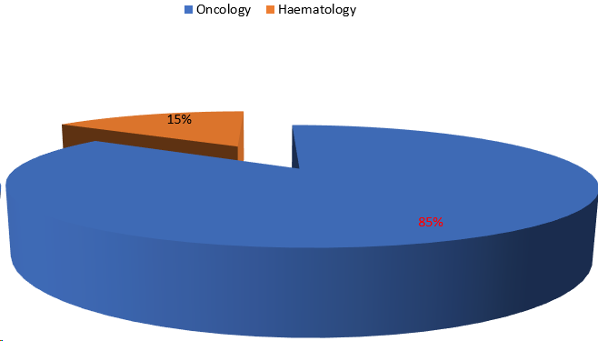
Figure 2 Pie chart depicting the distribution of malignancy among hematology and solid organ malignancy.

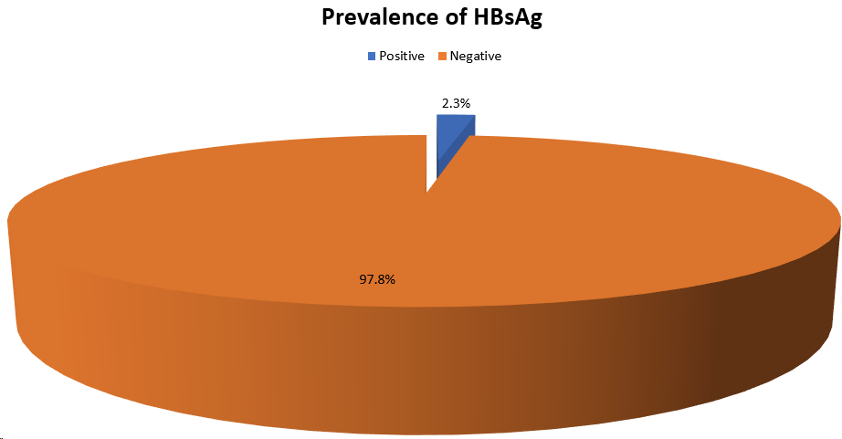 Figure 3 Prevalence of hepatitis B surface antigen in oncology and hemato-oncology patients. HBsAg: Hepatitis B surface antigen.

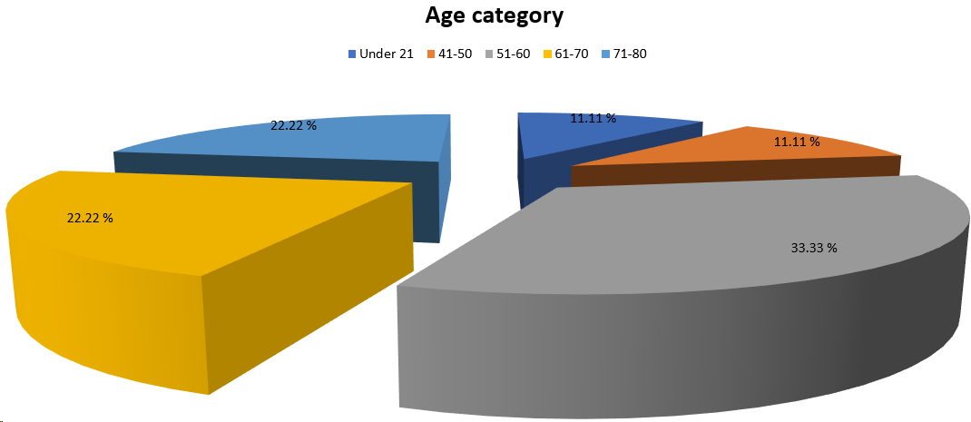
Figure 4 Age distribution of the chronic hepatitis subgroup.
Table 1 Patient demographics of the chronic hepatitis group
Patient demographics |  | Number of patients | Percentage
Sex | Female | 1 | 11.1
 | Male | 8 | 88.9
Malignancy | ALL | 1 | 11.1
 | Colon | 2 | 22.2
 | HCC | 5 | 55.6
 | Pancreas | 1 | 11.1
USG | Coarse liver | 5 | 55.6
 | Normal | 4 | 44.4
Past history of jaundice | No | 4 | 44.4
 | Yes | 5 | 55.6
Positive family history | No | 8 | 88.9
 | Yes | 1 | 11.1
Past history of surgeries | No | 8 | 88.9
 | Yes | 1 | 11.1
History of transfusion in the past | No | 8 | 88.9
 | Yes | 1 | 11.1
History of acute hepatitis B in the past | No | 6 | 66.6
 | Yes | 3 | 33.3
ALL: Acute lymphoblastic leukemia; HCC: Hepatocellular carcinoma; USG: Ultrasound sonography.

Table 2 Baseline hepatitis B virus DNA levels of the chronic hepatitis with follow-up at 6 and 12 months after the introduction of prophylaxis (tenofovir or entecavir)
Patient | 0 months |  | 6th months |  | 12TH months
 | HBV DNA | Liver enzymes | HBV DNA | Liver enzymes | HBV DNA | Liver enzymes
1 | TND | Normal | TND | Normal | TND | Normal
2 | TND | Normal | TND | Normal | TND | Normal
3 | TND | Normal | TND | Normal | TND | Normal
4 | TND | Normal | TND | Normal | TND | Normal
5 | TND | Normal | TND | Normal | TND | Normal
6 | TND | Normal | TND | Normal | TND | Normal
7 | TND | Normal | TND | Normal | TND | Normal
8 | HIGH | Elevated > 2X UNL | TND | Normal | TND | Normal
9 | HIGH | Elevated > 2X UNL | TND | Normal | TND | Normal
HBV: Hepatitis B virus; TND: Target not detected; UNL: Upper limit of normal.

Table 3 Patient demographics of the occult hepatitis B infection group
Patient demographics |  | No. of patients | Percentage
Age | 52 yr | 1 | 33.3
 | 75 yr | 1 | 33.3
 | 78 yr | 1 | 33.3
Sex | Female | 1 | 33.3
 | Male | 2 | 66.7
Malignancy | AML | 1 | 33.3
 | Colon | 1 | 33.3
 | NSGCT | 1 | 33.3
USG | Normal | 1 | 33.3
 | Coarse liver | 2 | 66.7
History of Jaundice | Yes | 2 | 66.7
 | No | 1 | 33.3
History of blood transfusion in the past | Yes | 1 | 33.3
 | No | 2 | 66.7
History of surgery in the past | Yes | 1 | 33.3
 | No | 2 | 66.7
Family history | Yes | 0 | 0.0
 | No | 3 | 100.0
AML: Acute myeloid leukemia; NSGCT: Non-seminomatous germ cell tumor; USG: Ultrasound sonography.

Table 4 Baseline hepatitis B virus DNA levels of occult hepatitis B infection group and follow-up at 6 and 12 months after the introduction of prophylaxis (tenofovir or entecavir)
Patient | 0 months |  | 6th months |  | 12th months
 | HBV DNA | Liver enzymes | HBV DNA | Liver enzymes | HBV DNA | Liver enzymes
1 | TND | Normal | TND | Normal | TND | Normal
2 | TND | Normal | TND | Normal | TND | Normal
3 | TND | Normal | TND | Normal | TND | Normal
HBV: Hepatitis B virus; TND: Target not detected.

Published by Baishideng Publishing Group Inc
7041 Koll Center Parkway, Suite 160, Pleasanton, CA 94566, USA
Telephone: +1-925-3991568
E-mail: office@baishideng.com
Help Desk: https://www.f6publishing.com/helpdesk
https://www.wjgnet.com

© 2024 Baishideng Publishing Group Inc. All rights reserved.

