Name of Journal: World Journal of Clinical Cases
Manuscript NO: 56274
Manuscript Type: CASE REPORT

Application of ozonated water for treatment of gastro-thoracic fistula after comprehensive esophageal squamous cell carcinoma therapy: A case report

Wu DD et al. Gastro-thoracic fistula treated with ozonated water

De-Di Wu, Ke-Nan Hao, Xiao-Jing Chen, Xin-Min Li, Xiao-Feng He

De-Di Wu, Ke-Nan Hao, Xiao-Jing Chen, Xin-Min Li, Xiao-Feng He, Division of Vascular and Interventional Radiology, Department of General Surgery, Nanfang Hospital, Southern Medical University, Guangzhou 510515, Guangdong Province, China

Author contributions: Wu DD wrote the paper and collected the patient’s clinical data; Hao KN and Chen Xj administrated and followed the patient; Li XM performed the operation and approved the publication of the paper; He XF made critical revisions to the paper and designed the operation.

Supported by Foundation of President of Nanfang hospital, Southern Medical University.

Corresponding author: Xiao-Feng He, MD, Chief Doctor, Professor, Division of Vascular and Interventional Radiology, Department of General Surgery, Nanfang Hospital, Southern Medical University, No. 1838, Guangzhou Avenue North, Guangzhou 510515, Guangdong Province, China. ozonetherapy@126.com

Received: May 9, 2020
Revised: May 28, 2020
Accepted: August 25, 2020
Published online:

Abstract
BACKGROUND
Gastro-thoracic fistula is a serious complication after radical surgery for esophageal cancer, and a conservative approach or endoscopic intervention is commonly applied to treat most cases.

CASE SUMMARY
Here we describe the case of a patient with a gastro-thoracic fistula which could not be closed during gastroscopy after receiving postoperative radiotherapy, together with severe multiple drug-resistant bacterial infection and chest wall fistula. The abscess was drained and local irrigation applied with ozonated water, together with oral ozonated water, which achieved a good effect and highlighted a new way to cure fistula in such patients.

CONCLUSION
Patients with gastro-thoracic fistula that cannot be closed and severe infection can be treated by drainage and flushing with ozonated water.

Key words: Esophageal squamous cell carcinoma; Ozonated water; Radiotherapy; Gastro-thoracic fistula; Drug-resistant bacterial infection; Case report

Wu DD, Hao KN, Chen XJ, Li XM, He XF. Application of ozonated water for treatment of gastro-thoracic fistula after comprehensive esophageal squamous cell carcinoma therapy: A case report. World J Clin Cases 2020; In press

Core tip: We report a patient whose gastro-thoracic fistula could not be closed surgically following radiotherapy, and who also presented with severe multiple drug-resistance bacterial infection and chest wall fistula. The patient was successfully treated by draining the abscess and applying local irrigation, as well as administering ozonated water orally. This case demonstrates that adequate local drainage and anti-infection treatment can be used to cure patients with severe infection and gastro-thoracic fistula which cannot be closed under endoscopy. As a supplement to conventional therapy, treatment using local irrigation with ozonated water to control infection can heal patients with this condition.

INTRODUCTION
The incidence and mortality of esophageal cancer are high in China. Radical surgery is often the first-line treatment option for the majority of patients^{[1,2]}. One type of life-threatening postoperative complication is gastro-thoracic fistula with an incidence of 14.1% worldwide^{[3,4]}, which may be associated with body mass index^{[5]}. Effective anti-infection treatment is the key to reducing mortality and improving patient quality of life.
Long-term clinical trials have proven that ozone can both effectively control infections caused by various bacteria, fungi, and viruses^{[6,7]}, and promote tissue repair^{[8]}. Here, we report a case of gastro-thoracic fistula after comprehensive treatment for esophageal cancer, complicated by severe thoracic infection, and successfully treated using ozone.

CASE PRESENTATION
Chief complaints
A 50-year-old woman developed an open wound in a surgical incision scar and was readmitted to our hospital on July 31, 2019 because the wound in her left chest wall had reopened.

History of present illness
Following radical esophagectomy in June 2016 to treat esophageal squamous cell carcinoma, in May 2019, the patient developed an open wound in the surgical incision scar on her left chest wall (Figure 1).

History of past illness
The patient was diagnosed with moderately differentiated esophageal squamous cell carcinoma in 2016. During the 3 years following surgery, the patient received repeated radiotherapy to metastatic tumor of the left lung (40 Gy/4 F), anastomotic site and lymph nodes (60 Gy/30 F), metastatic tumor of the right lung (50 Gy/5 F), metastatic tumors of both lungs (48 Gy/6 F), and sternal metastases (45 Gy/15 F) with time sequence (Figure 2).

Physical examination
When the patient was readmitted to our hospital on July 31, 2019, she was pale and dehydrated on physical examination, and the wound in her left chest wall had reopened, was approximately 2 cm × 3 cm, and had malodorous purulent secretion emanating from it.

Laboratory examinations
Bacterial culture and drug sensitivity testing of the pleural drainage fluid on August 8, 2019 revealed positivity for methicillin-resistant Staphylococcus aureus and Candida albicans. Regular bacterial culture of the pleural abscess drainage fluid indicated that Pseudomonas aeruginosa (August 29) and Klebsiella ozaena (September 30) were present.

Imaging examinations
When the patient presented in May 2019, whole body positron emission tomography (PET-CT) indicated the formation of a gastro-thoracic fistula, with lesions involving the lateral chest wall (Figure 3A and B) and active malignancies in the left lung, inferior segment sternotomy, and right lobe of the liver. A gastro-thoracic fistula of approximately 5 cm, located in the greater curvature of the stomach, was confirmed on endoscopy (Figure 3C and D). Poor drainage of the abscess by the drainage tube applied was detected on computed tomography (CT) examination in September 2019.

Personal and family history
The patient did not smoke or consume alcohol. Her mother and brother both died of esophageal cancer.

MULTIDISCIPLINARY EXPERT CONSULTATION
Rui-jun Cai, Deputy Chief Physician, Department of Thoracic Surgery, Nanfang Hospital, Southern Medical University
Gastro-thoracic fistula was diagnosed clearly and the fistula is too large to perform reoperation or endoscopic treatment.

Hao Zhou, Deputy Chief Physician, Department of Infection Control, Nanfang Hospital, Southern Medical University
The images of PET-CT showed that the gastro-thoracic fistula was complicated with severe infection that was not controlled.

FINAL DIAGNOSIS
The final diagnosis was gastro-thoracic fistula following comprehensive treatment for squamous cell esophageal carcinoma.

TREATMENT
Following detection of the fistula in May 2019, her oral intake was restricted and she received gastrointestinal decompression therapy and nose-jejunum nutrition support at our hospital until the open wound was sealed.
On readmission on July 31, she received intravenous administration of imipenem and fosfomycin to treat the infection and a gastric tube was placed to irrigate the wound. She was also administered metronidazole, enteral nutrition support, and intravenous nutrition supplementation. The open wound at the site of her surgical scar was treated with local empyema and disinfection, and the dressing changed. A jejunal nutrition tube and gastric-thoracic fistula drainage tube were placed on August 7 and saline used to flush the fistula following surgery. Following detection of methicillin-resistant Staphylococcus aureus and Candida albicans on August 8, sulfamethoxazole combined with fluconazole was administered intravenously to control the infection. Next, we began application of 15 µg/ml ozonated water to rinse the fistula once per day (500 ml each time) and administered 12 µg/ml ozonated water orally (500 ml per day) from August 10. Subsequently, following detection of Pseudomonas aeruginosa (August 29) and Klebsiella ozaena (September 30), intravenous antibiotics were adjusted to piperacillin sodium and tazobactam sodium injection (September 4), in addition to amikacin combined with ciprofloxacin (September 30), according to the results of drug sensitivity testing.
Leukocyte number and the proportion of neutrophils were found to have continued to increase on September 3 (Figure 4A and B), indicating that the infection was unsatisfactorily controlled. On detection of poor abscess drainage, we applied closed thoracic drainage under the guidance of CT on September 10, resulting in drainage of thick, dark red liquid.
The patient then received 2 mo of adequate drainage and rinsing with ozonated water.

OUTCOME AND FOLLOW-UP
The patient’s infection was satisfactorily controlled, leukocyte number and the proportion of neutrophils were subsequently decreased gradually after closed thoracic drainage (Figure 4A and B). Procalcitonin also declined, indicating that related symptoms, including severe bacterial infection and sepsis, were gradually improving (Figure 4C). C-reactive protein levels fluctuated, related to the changes in the underlying disease of the patient, including obstructive pneumonia (Figure 4D).
CT examinations during treatment revealed that the wall of the gastro-thoracic fistula gradually thickened (Figure 5A-F). Three-dimensional stereograms of the fistula were reconstructed from CT images using Interactive Medical Image Control System 21 software (Materialise, Belgium). Fistula volumes were measured based on the sum of the voxel volume for the fistula, using ITK-SNAP 3.8.0 (Yushkevich, University of Pennsylvania and Gerig, University of Utah), and were 131, 144, 155, 162, 98, and 96 ml on August 20, August 26, August 30, September 2, September 17, and October 8, respectively (Figure 5A’-F’).
The open wound on her left chest wall was sealed on September 20. She did not complain of chills, fever, or other types of discomfort.

DISCUSSION
First line treatments for patients with gastro-thoracic fistula generally comprise conservative approaches^{[9]}, including restriction of oral intake, infection control, thoracic drainage, and nutritional support. Patients with severe symptoms may also require endoscopic intervention, such as endoscopic clips, fibrin glue, sutures, stents, or a combination of two or more techniques^{[10,11]}; however, due to severe infection and poor physical condition, it is challenging to conduct endoscopic clipping or re-operation for these patients^{[12,13]}. Then, we can use the ozonated water, which has not been reported to be applied in esophageal carcinoma patients with fistula before.
In the case presented here, the gastro-thoracic fistula was located in the greater curvature of the stomach with high tension, combined with brittle local tissue, as a consequence of repeated radiotherapy; hence, endoscopic intervention would have been technically challenging. Furthermore, other conventional conservative approaches, including antibiotic administration, oral intake, and parenteral nutrition, had minimal effect, due to the poor physical condition and severe infection of the patient, which left us with more effective anti-infection therapy and adequate drainage as the crucial options. During treatment of this patient, a thoracic drainage tube was placed in the lowest position in the purulent cavity, rather than through the original higher chest wall fistula, and together with daily flushing with ozonated water, the rupture of the chest wall gradually healed and the chest infection was satisfactorily controlled.

CONCLUSION
In conclusion, adequate local drainage and anti-infection treatment are likely the best choice to aid survival of patients with gastro-thoracic fistula which cannot be closed under endoscopy and is complicated with severe infection, as in our case. Combined with conventional conservative treatments, the application of local ozonated water irrigation to control infection can promote the healing of a chest wall fistula and improve patient quality of life.

ACKNOWLEDGEMENTS
Thanks to Dr. Wang YY for her valuable comments on the logic and writing of the paper, and to Dr. Sun JY and Dr. Cao CH for their assistance in checking and verifying the radiotherapy plan and radiation dose.

REFERENCES
1 Uzunoglu FG, Reeh M, Kutup A, Izbicki JR. Surgery of esophageal cancer. Langenbecks Arch Surg 2013; 398: 189-193 [PMID: 23354360 DOI: 10.1007/s00423-013-1052-y]
2 Lu D, Liu X, Li M, Feng S, Dong X, Yu X, Wu H, Xiong G, Cai R, Li G, Cai K. Three-port mediastino-laparoscopic esophagectomy (TPMLE) for an 81-year-old female with early-staged esophageal cancer: a case report of combining single-port mediastinoscopic esophagectomy and reduced port laparoscopic surgery. J Thorac Dis 2018; 10: E378-E382 [PMID: 29997998 DOI: 10.21037/jtd.2018.05.52]
3 Turkyilmaz A, Eroglu A, Aydin Y, Tekinbas C, Muharrem Erol M, Karaoglanoglu N. The management of esophagogastric anastomotic leak after esophagectomy for esophageal carcinoma. Dis Esophagus 2009; 22: 119-126 [PMID: 18847447 DOI: 10.1111/j.1442-2050.2008.00866.x]
4 Birla R, Hoara P, Dinu D, Rosianu C, Constantinoiu S. Postoperative Esophageal Leaks in Malignant Pathology - Optimal Management: A Systematic Review. Chirurgia (Bucur) 2019; 114: 429-436 [PMID: 31511128 DOI: 10.21614/chirurgia.114.4.429]
5 Zhang SS, Yang H, Luo KJ, Huang QY, Chen JY, Yang F, Cai XL, Xie X, Liu QW, Bella AE, Hu RG, Wen J, Hu Y, Fu JH. The impact of body mass index on complication and survival in resected oesophageal cancer: a clinical-based cohort and meta-analysis. Br J Cancer 2013; 109: 2894-2903 [PMID: 24201750 DOI: 10.1038/bjc.2013.666]
6 Souza YM, Fontes B, Martins JO, Sannomiya P, Brito GS, Younes RN, Rasslan S. Evaluation of the effects of ozone therapy in the treatment of intra-abdominal infection in rats. Clinics (Sao Paulo) 2010; 65: 195-202 [PMID: 20186304 DOI: 10.1590/S1807-59322010000200012]
7 Song M, Zeng Q, Xiang Y, Gao L, Huang J, Huang J, Wu K, Lu J. The antibacterial effect of topical ozone on the treatment of MRSA skin infection. Mol Med Rep 2018; 17: 2449-2455 [PMID: 29207120 DOI: 10.3892/mmr.2017.8148]
8 Hao K, Li Y, Feng J, Zhang W, Zhang Y, Ma N, Zeng Q, Pang H, Wang C, Xiao L, He X. Ozone promotes regeneration by regulating the inflammatory response in zebrafish. Int Immunopharmacol 2015; 28: 369-375 [PMID: 26033494 DOI: 10.1016/j.intimp.2015.05.026]
9 Dehn TC, Menon K. Diagnosis and conservative management of intrathoracic leakage after oesophagectomy. Br J Surg 1999; 86: 427 [PMID: 10201794 DOI: 10.1046/j.1365-2168.1999.1055e.x]
10 Shen SS, Zhang XQ, Li ZL, Zou XP, Ling TS. Over-the-scope clip to close a gastrocutaneous fistula after esophagectomy. World J Gastroenterol 2015; 21: 13396-13399 [PMID: 26715825 DOI: 10.3748/wjg.v21.i47.13396]
11 Kumar N, Thompson CC. Endoscopic therapy for postoperative leaks and fistulae. Gastrointest Endosc Clin N Am 2013; 23: 123-136 [PMID: 23168123 DOI: 10.1016/j.giec.2012.10.002]
12 Guo J, Chu X, Liu Y, Zhou N, Ma Y, Liang C. Choice of therapeutic strategies in intrathoracic anastomotic leak following esophagectomy. World J Surg Oncol 2014; 12: 402 [PMID: 25547979 DOI: 10.1186/1477-7819-12-402]
13 Lee DH, Kim HR, Kim SR, Kim YH, Kim DK, Park SI. Comparison of clinical outcomes after conservative and surgical treatment of isolated anastomotic leaks after esophagectomy for esophageal cancer. Dis Esophagus 2013; 26: 609-615 [PMID: 23237428 DOI: 10.1111/dote.12011]

Footnotes
Informed consent statement: Informed consent was obtained from the patient.

Conflict-of-interest statement: There are no conflicts of interest to disclose.

CARE Checklist (2016) statement: The authors have read the CARE Checklist (2016), and the manuscript was prepared and revised according to the CARE Checklist (2016).

Open-Access: This article is an open-access article that was selected by an in-house editor and fully peer-reviewed by external reviewers. It is distributed in accordance with the Creative Commons Attribution NonCommercial (CC BY-NC 4.0) license, which permits others to distribute, remix, adapt, build upon this work non-commercially, and license their derivative works on different terms, provided the original work is properly cited and the use is non-commercial. See: http://creativecommons.org/licenses/by-nc/4.0/

Manuscript source: Unsolicited manuscript

Corresponding Author's Membership in Professional Societies: World Federation of Ozone Therapy.

Peer-review started: May 9, 2020
First decision: May 15, 2020
Article in press:

Specialty type: Gastroenterology and hepatology
Country/Territory of origin: China
Peer-review report’s scientific quality classification
Grade A (Excellent): 0
Grade B (Very good): 0
Grade C (Good): C
Grade D (Fair): 0
Grade E (Poor): 0

P-Reviewer: Chien CR S-Editor: Gong ZM L-Editor: Wang TQ E-Editor:

Figure Legends
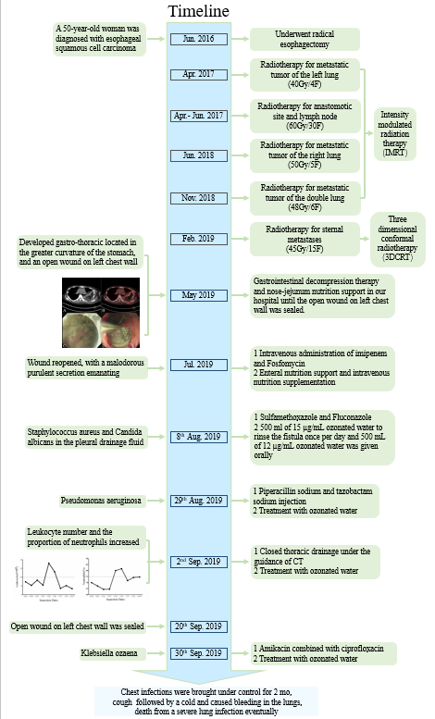
Figure 1 Timeline.
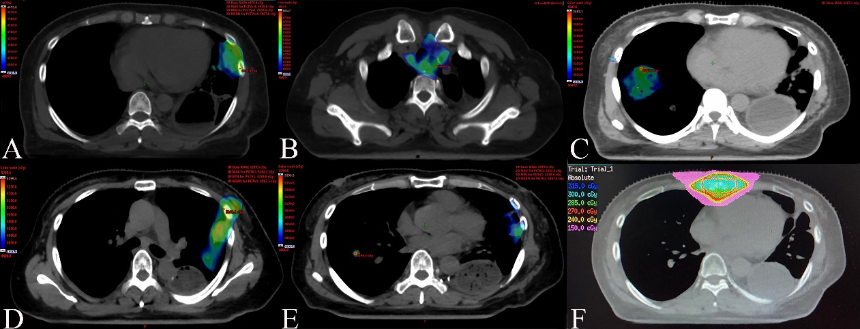
Figure 2 Cumulative isodose distribution. A: Radiotherapy for metastatic tumor of the left lung (40 Gy/4 F) in April 2017; B: Radiotherapy for anastomotic site and lymph nodes (60 Gy/30 F) from April to June 2017; C: Radiotherapy for metastatic tumor of the right lung (50 Gy/5 F) in June 2018; D and E: Radiotherapy for metastatic tumors of both lungs (48 Gy/6 F) in November 2018; F: Radiotherapy for sternal metastases (45 Gy/15 F) in February 2019.
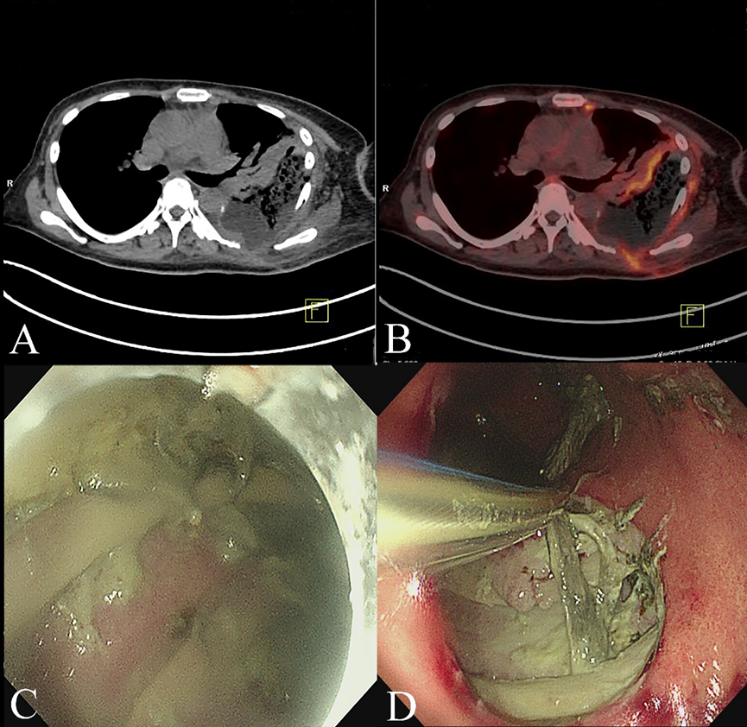
Figure 3 positron emission tomography-computed tomography and endoscopy examination images of a 50-year-old woman with gastro-thoracic fistula after esophagectomy taken before treatment. A and B: computed tomography (CT) and fused CT images showing the formation of a gastro-thoracic fistula, with lesions involving the lateral chest wall; C and D: Endoscopic images showing the purulent gastric contents and local necrosis.
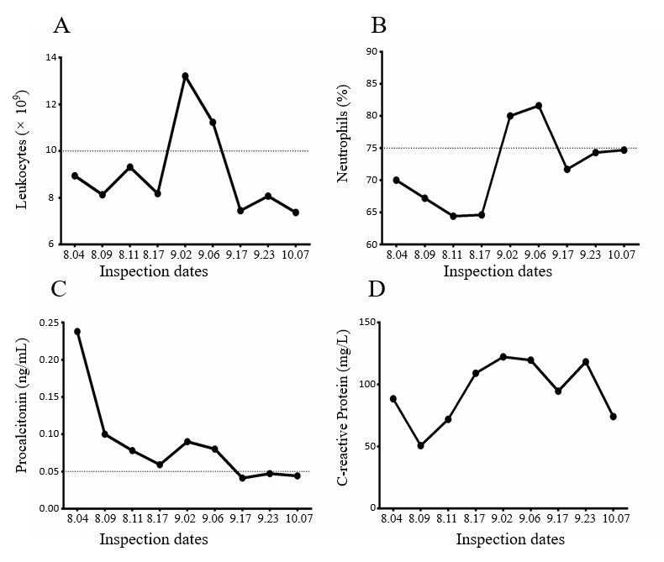
Figure 4 Infection indices of the patient during the course of treatment. A and B: Leukocyte number and neutrophil proportion continued to rise in early September because of obstruction of the drainage tube and decreased gradually after the position of the drainage tube was changed; C: Procalcitonin was also declining, indicating that related symptoms, including severe bacterial infection and sepsis, were gradually improving; D: C-reactive protein levels fluctuated, related to the changes in the underlying disease of the patient, including obstructive pneumonia.
Figure 5 Computed tomography images and 3D stereograms of the gastro-thoracic fistula (★) during the course of treatment. A-F: computed tomography examination of the patient on August 20, August 26, August 30, September 2, September 17, and October 8, 2019, respectively, showing that the wall of the thoracic abscess gradually thickened after 2 mo of adequate drainage, together with ozonated water rinse; A’-F’: Three-dimensional stereograms confirming that the volume of the fistula cavity was reduced markedly in late September.

