Name of Journal: World Journal of Clinical Cases
Manuscript NO: 85411
Manuscript Type: CASE REPORT

Early esophageal carcinomas in achalasia patient after endoscopic submucosal dissection combined with peroral endoscopic myotomy: A case report

An BQ et al. Case of combined ESD and POEM

Bai-Quan An, Chun-Xiao Wang, Hai-Yan Zhang, Jin-Dong Fu

Bai-Quan An, Hai-Yan Zhang, Jin-Dong Fu, Department of Gastroenterology, People’s Hospital of Rizhao, Rizhao 276800, Shandong Province, China

Chun-Xiao Wang, Department of Hematology, People’s Hospital of Rizhao, Rizhao 276800, Shandong Province, China

Author contributions: An BQ collected the data and drafted the manuscript; Wang CX participated in collecting the clinical data; Fu JD and Zhang HY designed the study; and all authors approved the submitted manuscript.

Corresponding author: Jin-Dong Fu, MM, Doctor, Department of Gastroenterology, People’s Hospital of Rizhao, No. 126 Taian Road, Rizhao 276800, Shandong Province, China. 36943087@qq.com

Received: May 21, 2023
Revised: June 27, 2023
Accepted: July 17, 2023
Published online:

Abstract
BACKGROUND
Achalasia is associated with high risk of esophageal carcinoma. However, the optimal endoscopic surgery for patients with early esophageal carcinoma concomitant with achalasia remains unclear.

CASE SUMMARY
A combination of concurrent endoscopic submucosal dissection (ESD) and modified peroral endoscopic myotomy (POEM) was performed on a 62-year-old male, who presented with multiple early esophageal carcinomas concomitant with achalasia. The patient exhibited an improvement in feeding obstruction, and presented no evidence of disease during the 3-year follow-up.

CONCLUSION
The combination of ESD and POEM is a feasible treatment modality for patients with early esophageal carcinoma concomitant with achalasia.

Key Words: Achalasia; Early esophageal carcinoma; Endoscopic submucosal dissection; Modified peroral endoscopic myotomy; Case report

An BQ, Wang CX, Zhang HY, Fu JD. Early esophageal carcinomas in achalasia patient after endoscopic submucosal dissection combined with peroral endoscopic myotomy: A case report. World J Clin Cases 2023; In press

Core Tip: The present findings suggest that the combination of endoscopic submucosal dissection and peroral endoscopic myotomy is a feasible and effective treatment modality for patients with early esophageal carcinoma. Clinicians should be cautious on the occurrence of early esophageal carcinoma in achalasia patients.

INTRODUCTION
Achalasia is a primary disorder of the esophageal sphincter secondary to the degeneration of Auerbach’s plexus^{[1]}, which manifests as the absence of esophageal peristalsis, high pressure of the lower esophageal sphincter, and reduced relaxation response to swallowing^{[2]}. The increase in esophageal carcinoma risk has been associated with prolonged achalasia^{[3]}. Endoscopic submucosal dissection (ESD) and peroral endoscopic myotomy (POEM) are the main endoscopic therapeutic methods adopted for early esophageal carcinoma and achalasia, respectively. The present case illustrates the safety and efficacy of the combination of ESD and POEM for the treatment of achalasia patients with early esophageal carcinoma.

CASE PRESENTATION
Chief complaints
A 62-year-old male with achalasia, who was diagnosed with multiple early esophageal carcinomas a week ago, presented to our hospital.

History of present illness
The patient had progressive dysphagia and regurgitation for 14 years, but did not receive standard treatment or endoscopic intervention.

History of past illness
The patient denied any previous medical history.

Personal and family history
The patient denied a family history achalasia.

Physical examination
The physical examination results were normal.

Laboratory examinations
The laboratory examination results revealed no abnormalities.

Imaging examinations
The chest computed tomography revealed a massively dilated esophagus from the proximal to the gastroesophageal junction (Figure 1). The esophageal manometry indicated the absence of peristalsis of the esophageal body. The average residual pressure of the lower esophageal sphincter was 24.3 mmHg, which was higher than the normal pressure of 15 mmHg (Figure 2).

FINAL DIAGNOSIS
The patient was diagnosed with achalasia and multiple early esophageal carcinomas.

TREATMENT
A combination of ESD and POEM was performed for the patient. ESD was conducted in accordance to the following procedure. First, the extent of the lesions was marked using a dual knife. Then, a solution that contained methylene blue and epinephrine was injected into the mucosa to mark the periphery of the lesions. Next, the lesions were successfully removed while ensuring that no active bleeding occurred. Meanwhile, POEM was performed on the opposite side of the lesions. After the incision of the lower esophagus circular muscles, the endoscope could easily pass through the cardia. The entrance was closed with titanium clips following the completion of hemostasis in the tunnel (Figure 3). The patient fasted for 48 h, after which drugs for acid suppression and mucosal protection were administered.

OUTCOME AND FOLLOW-UP
The pathological findings of the excised specimen revealed a moderately differentiated squamous cell carcinoma located in the mucosa (Figure 4). The patient was discharged a week later without any complications. The patient reported feeling well during the 3-year follow-up.

DISCUSSION
Achalasia has been associated with a high risk of esophageal carcinoma. For patients with achalasia, food retention is common, which in turn, causes repeated injury to the esophageal epithelium. Chronic stimulation of inflammation eventually triggers the malignant transformation of the esophageal epithelium^{[4]}. However, esophageal carcinoma is usually diagnosed at the advanced stage, because neoplasm symptoms are often hidden by the achalasia-induced dysphagia. Therefore, surveillance endoscopy is recommended for patients with achalasia, especially for patients with specific risks and a history of esophageal carcinoma^{[5]}. Ohkura et al^{[6]} reported that ESD for early esophageal carcinoma with achalasia is a safe and curative procedure, due to esophageal dilatation and wall thickening. However, ESD on the POEM line is impaired by fibrosis^{[5]}. Therefore, when compared to a staging operation, a one-off operation can reduce the risk of fibrosis-induced surgical complications. For the present patient, POEM was immediately performed after ESD, which reduced the chances of unfavorable complications and additional hospital expenses.

CONCLUSION
In summary, the present findings suggest that the combination of ESD and POEM is a feasible and effective treatment modality for patients with early esophageal carcinoma. Clinicians should be cautious on the occurrence of early esophageal carcinoma in achalasia patients.

REFERENCES
1 Park W, Vaezi MF. Etiology and pathogenesis of achalasia: the current understanding. Am J Gastroenterol 2005; 100: 1404-1414 [PMID: 15929777 DOI: 10.1111/j.1572-0241.2005.41775.x]
2 Pohl D, Tutuian R. Achalasia: an overview of diagnosis and treatment. J Gastrointestin Liver Dis 2007; 16: 297-303 [PMID: 17925926]
3 Tustumi F, Bernardo WM, da Rocha JRM, Szachnowicz S, Seguro FC, Bianchi ET, Sallum RAA, Cecconello I. Esophageal achalasia: a risk factor for carcinoma. A systematic review and meta-analysis. Dis Esophagus 2017; 30: 1-8 [PMID: 28859394 DOI: 10.1093/dote/dox072]
4 Boeckxstaens GE, Zaninotto G, Richter JE. Achalasia. Lancet 2014; 383: 83-93 [PMID: 23871090 DOI: 10.1016/S0140-6736(13)60651-0]
5 Sato H, Nishikawa Y, Abe H, Shiwaku H, Shiota J, Sato C, Sakae H, Ominami M, Hata Y, Fukuda H, Ogawa R, Nakamura J, Tatsuta T, Ikebuchi Y, Yokomichi H, Terai S, Inoue H. Esophageal carcinoma in achalasia patients managed with endoscopic submucosal dissection and peroral endoscopic myotomy: Japan Achalasia Multicenter Study. Dig Endosc 2022; 34: 965-973 [PMID: 34787940 DOI: 10.1111/den.14197]
6 Ohkura Y, Iizuka T, Kikuchi D, Yamashita S, Nakamura M, Matsui A, Mitani T, Hoteya S, Kaise M, Yahagi N. Endoscopic submucosal dissection for early esophageal cancer associated with achalasia. Turk J Gastroenterol 2013; 24: 161-166 [PMID: 23934464 DOI: 10.4318/tjg.2013.0522]

Footnotes
Informed consent statement: The participant provided an informed written consent prior to study enrollment.

Conflict-of-interest statement: All the authors report no relevant conflicts of interest for this article.

CARE Checklist (2016) statement: The authors have read the CARE Checklist (2016), and the manuscript was prepared and revised according to the CARE checklist (2016).

Open-Access: This article is an open-access article that was selected by an in-house editor and fully peer-reviewed by external reviewers. It is distributed in accordance with the Creative Commons Attribution NonCommercial (CC BY-NC 4.0) license, which permits others to distribute, remix, adapt, build upon this work non-commercially, and license their derivative works on different terms, provided the original work is properly cited and the use is non-commercial. See: https://creativecommons.org/Licenses/by-nc/4.0/

Provenance and peer review: Unsolicited article; Externally peer reviewed.
Peer-review model: Single blind

Peer-review started: May 21, 2023
First decision: June 15, 2023
Article in press:

Specialty type: Medicine, research and experimental
Country/Territory of origin: China
Peer-review report’s scientific quality classification
Grade A (Excellent): A
Grade B (Very good): 0
Grade C (Good): C
Grade D (Fair): 0
Grade E (Poor): 0

P-Reviewer: Srpcic M, Slovenia; Suresh Kumar VC, United States S-Editor: Wang JJ L-Editor: A P-Editor: Wang JJ

Figure Legends
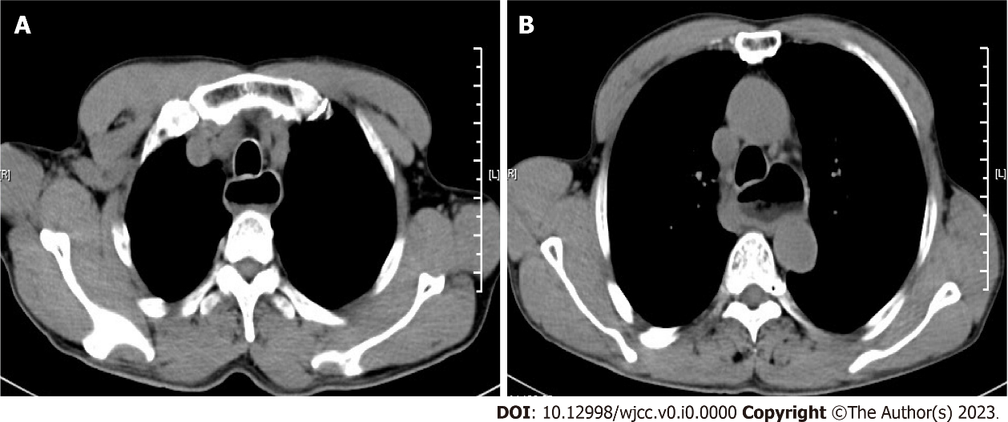
Figure 1 Computed tomography images. A and B: The chest computed tomography examination revealed evident dilatation of the esophagus proximal to the gastroesophageal junction.

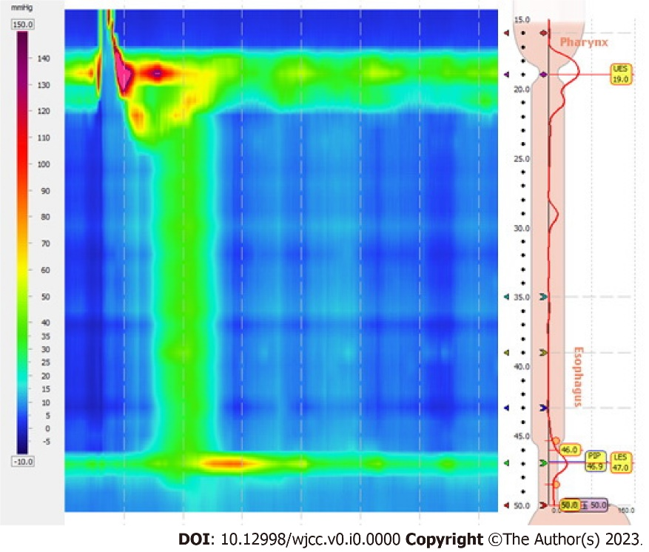
Figure 2 The esophageal manometric view revealed the outflow obstruction of the gastroesophageal junction and the absence of peristalsis in the esophageal body.
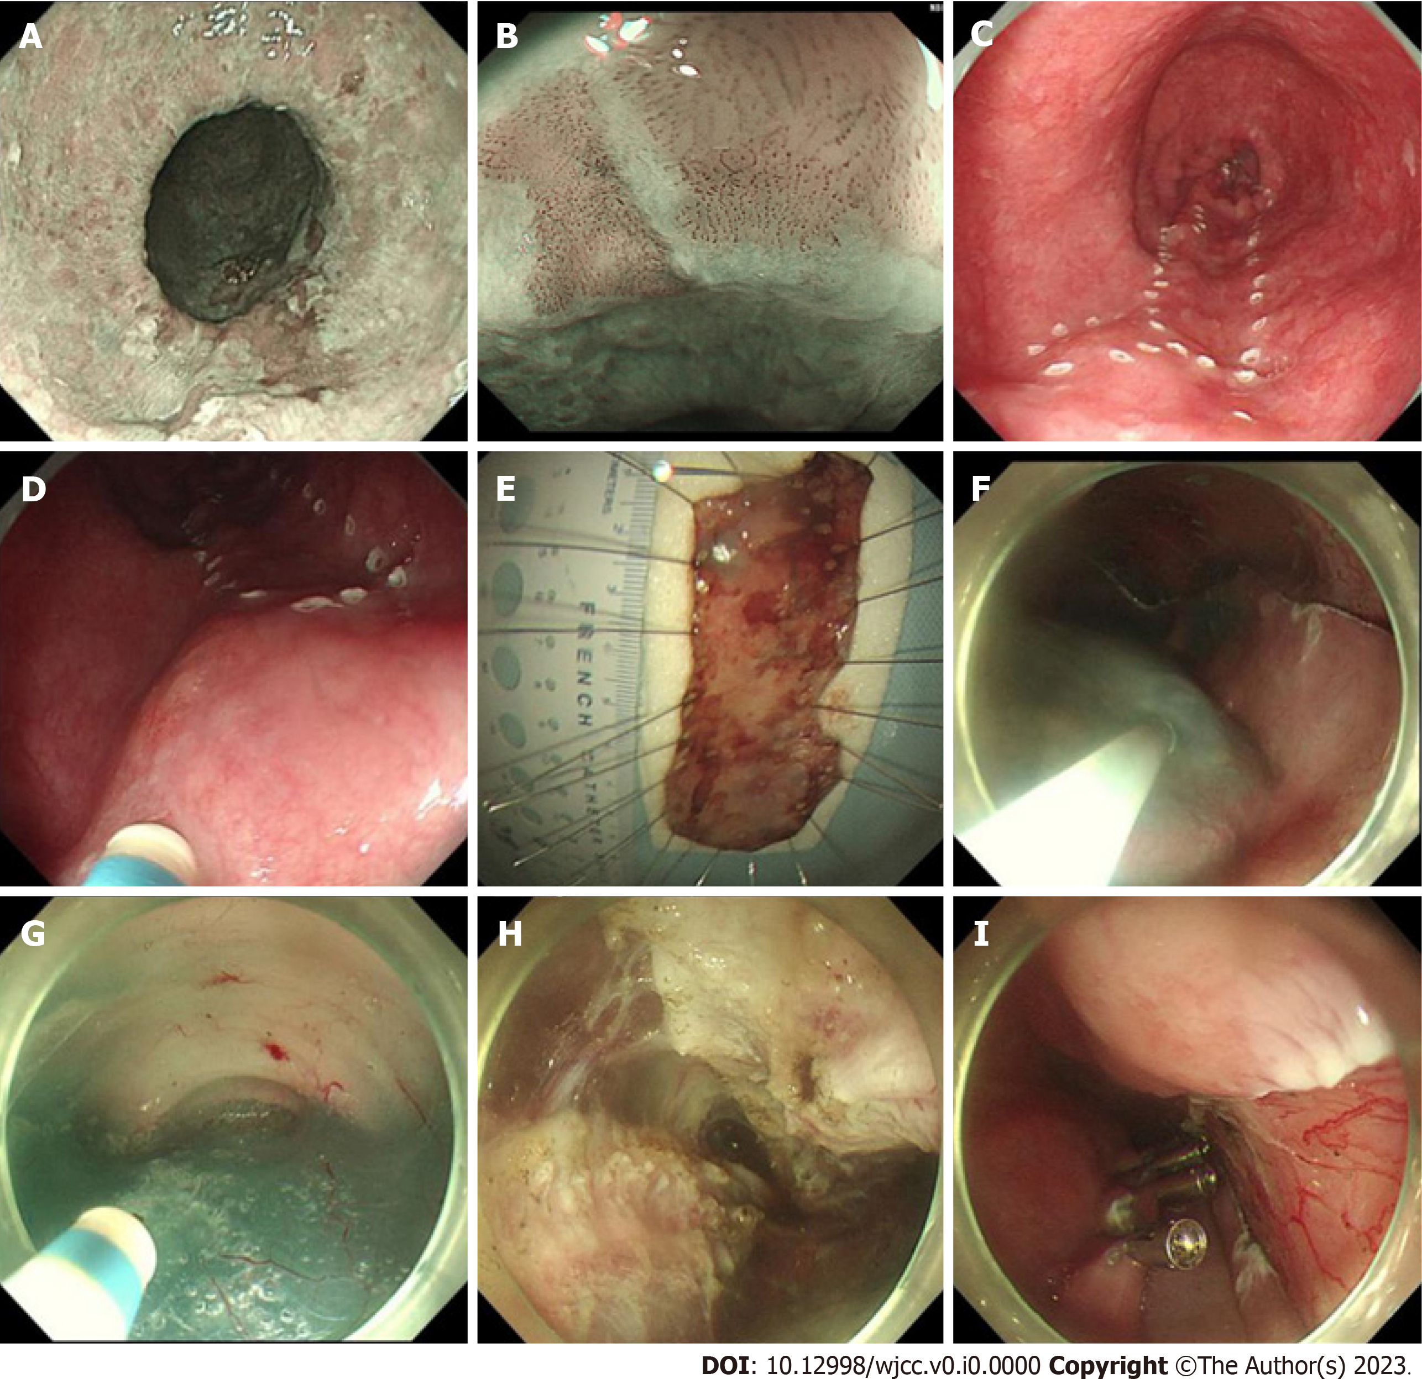
Figure 3 The entrance was closed with titanium clips following the completion of hemostasis in the tunnel. A: The narrow-band image (NBI) shows brownish areas at 27-34 cm away from the incisor; B: The magnified NBI clearly shows the type B1 vessels; C and D: The extent of the lesions was determined using a dual knife; E: The resected lesion; F: Submucosal injection for the mucosal incision; G: Submucosal dissection and tunneling; H: Myotomy; I: Closure of the longitudinal mucosal incision with clips.
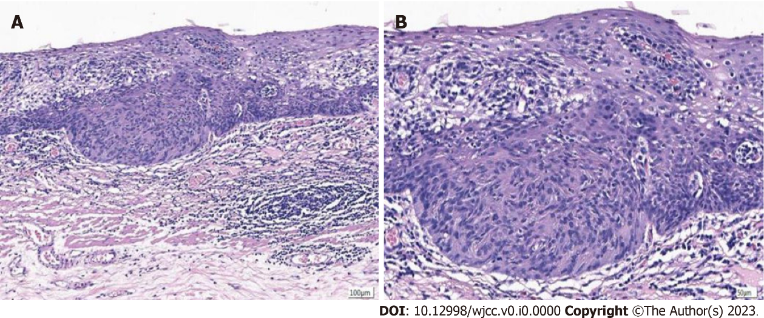
Figure 4 Pathological findings of a moderately differentiated squamous cell carcinoma located in the mucosa. A: × 100; B: × 200.

