Name of Journal: World Journal of Gastrointestinal Oncology
Manuscript NO: 70252
Manuscript Type: ORIGINAL ARTICLE

Basic Study
O⁶-methylguanine DNA methyltransferase is upregulated in malignant transformation of gastric epithelial cells via its gene promoter DNA hypomethylation

Chen YX et al. NOCs-induced MGMT gene hypomethylation

Yue-Xia Chen, Lu-Lu He, Xue-Ping Xiang, Jing Shen, Hong-Yan Qi

Yue-Xia Chen, Lu-Lu He, Hong-Yan Qi, Department of Pathology and Pathophysiology and Department of Radiation Oncology of the Second Affiliated Hospital, University School of Medicine, Zhejiang University, Hangzhou 310058, Zhejiang Province, China

Yue-Xia Chen, Department of Pathology, Third Hospital of Nanchang, Nanchang 330000, Jiangxi Province, China

Xue-Ping Xiang, Department of Pathology, the Second Affiliated Hospital, Zhejiang University, Hangzhou 310058, Zhejiang Province, China

Jing Shen, Department of Pathology and Pathophysiology and Department of Medical Oncology of the Second Affiliated Hospital, Zhejiang University School of Medicine, Zhejiang University, Hangzhou 310058, Zhejiang Province, China

Author contributions: Chen YX and Lulu He contributed to the acquisition and analyses of the data; Xiang XP contributed to the collection and immunostaining of clinical samples; Shen J and Qi HY designed the study and made the critical revisions of the manuscript.

Supported by National Natural Science Foundation of China, No. 81472543 and No. 81772919; Zhejiang Provincial Natural Science Foundation of China, No. LY18H160024 and No. LY20H160040.

Corresponding author: Hong-Yan Qi, PhD, Associate Professor, Department of Pathology and Pathophysiology and Department of Radiation Oncology of the Second Affiliated Hospital, University School of Medicine, Zhejiang University, No. 866 Yuhangtang Road, Hangzhou 310058, Zhejiang Province, China. qihongyan@zju.edu.cn

Received: July 27, 2021
Revised: November 10, 2021
Accepted: February 10, 2022
Published online: March 15, 2022

Abstract
BACKGROUND
O⁶-methylguanine-DNA methyltransferase (MGMT) is a suicide enzyme that repairs the mispairing base O⁶-methyl-guanine induced by environmental and experimental carcinogens. It can transfer the alkyl group to a cysteine residue in its active site and became inactive. The chemical carcinogen N-nitroso compounds (NOCs) can directly bind to the DNA and induce the O⁶-methylguanine adducts, which is an important cause of gene mutation and tumorigenesis. However, the underlying regulatory mechanism of MGMT involved in NOCs-induced tumorigenesis, especially in the initiation phase, remains largely unclear.

AIM
To investigate the molecular regulatory mechanism of MGMT in NOCs-induced gastric cell malignant transformation and tumorigenesis.

METHODS
We established a gastric epithelial cell malignant transformation model induced by N-methyl-N’-nitro-N-nitrosoguanidine (MNNG) or N-methyl-N-nitroso-urea (MNU) treatment. Cell proliferation, colony formation, soft agar, cell migration, and xenograft assays were used to verify the malignant phenotype. By using quantitative real-time polymerase chain reaction (qPCR) and Western blot analysis, we detected the MGMT expression in malignant transformed cells. We also confirmed the MGMT expression in early stage gastric tumor tissues by qPCR and immunohistochemistry. MGMT gene promoter DNA methylation level was analyzed by methylation-specific PCR and bisulfite sequencing PCR. The role of MGMT in cell malignant transformation was analyzed by colony formation and soft agar assays.

RESULTS
We observed a constant increase in MGMT mRNA and protein expression in gastric epithelial cell malignant transformation induced by MNNG or MNU treatment. Moreover, we found a reduction of MGMT gene promoter methylation level by methylation-specific PCR and bisulfite sequencing PCR in MNNG/MNU-treated cells. Inhibition of the MGMT expression by O⁶-benzylguanine promoted the MNNG/MNU-induced malignant phenotypes. Overexpression of MGMT partially reversed the cell malignant transformation process induced by MNNG/MNU. Clinical gastric tissue analysis showed that MGMT was upregulated in the precancerous lesions and metaplasia tissues, but downregulated in the gastric cancer tissues.

CONCLUSION
Our finding indicated that MGMT upregulation is induced via its DNA promoter hypomethylation. The highly expressed MGMT prevents the NOCs-induced cell malignant transformation and tumorigenesis, which suggests a potential novel approach for chemical carcinogenesis intervention by regulating aberrant epigenetic mechanisms.

Key Words: O⁶-methylguanine-DNA methyltransferase; DNA methylation; Malignant transformation; Gastric carcinogenesis; Epigenetic regulation

©The Author(s) 2022. Published by Baishideng Publishing Group Inc. All rights reserved.

Citation: Chen YX, He LL, Xiang XP, Shen J, Qi HY. O⁶-methylguanine DNA methyltransferase is upregulated in malignant transformation of gastric epithelial cells via its gene promoter DNA hypomethylation. World J Gastrointest Oncol 2022; 14(3): 664-677
URL: https://www.wjgnet.com/1948-5204/full/v14/i3/664.htm
DOI: https://dx.doi.org/10.4251/wjgo.v14.i3.664

Core Tip: This study revealed a molecular regulatory mechanism of O⁶-methylguanine-DNA methyltransferase (MGMT) gene upregulation in the early stage of tumor development, and improved the understanding of the dynamic change of MGMT expression in different stages of tumor development, providing a new entry point for further study of the expression mechanism of key regulatory genes in the process of chemical carcinogenesis.

INTRODUCTION
Gastric cancer (GC) is currently the fifth most frequently diagnosed and the third leading cause of cancer death worldwide with a high prevalence in many Asia countries, particularly in China, Japan, and South Korea^{[1,2]}. Previous studies have reported that epigenetic alterations are widely recognized to be involved in the initiation and progression of gastric tumorigenesis^{[3,4]}. DNA methylation is a common significant epigenetic modification and plays an important role in the development and prognosis of GC^{[5-8]}.
O⁶-methylguanine-DNA methyltransferase (MGMT) is a suicide enzyme that efficiently removes alkylating lesions at the O⁶ position of guanine induced by DNA alkylating agents^{[9]}. Following the transfer of the alkyl group to itself, MGMT becomes inactive and it is ubiquitinated and targeted for proteasomal degradation. MGMT is frequently regulated by epigenetic silencing mediated Fits gene promoter DNA methylation in gliomas^{[10,11]}. The abnormal modifications of histone and aberrant expression of transcriptional activators and repressors, also contribute to the regulation of MGMT expression in different tumors^{[11]}. O⁶-methylguanine is a potent mutagenic lesion that leads to base mismatching and double-strand breaks, promoting gene mutagenesis and tumor initiation. MGMT can restore this type of DNA damage and play an important role in maintaining genomic stability^{[12]}. Inhibiting MGMT function can induce G:C to A:T mutation of the onco-suppressors p53 and PTEN to promote human carcinogenesis^{[13]}. In the TCGA database, the probability of point mutation of p53 and PTEN was higher in MGMT promoter methylated tissues than in non-methylated tissues of glioma. In colon cancer, lung cancer, and GC, the reduction of MGMT expression induced by DNA methylation in its promoter regions was also observed^{[14-17]}. Yet, MGMT expression can be increased by chemotherapy with alkylating agents, such as temozolomide, which contributes to the chemotherapy resistance^{[18]}. However, the role of MGMT in the early stage of tumorigenesis remains unclear.
The monofunctional alkylating agent N-methyl-N’-nitro-N-nitrosoguanidine (MNNG) and N-methyl-N-nitroso-urea (MNU) are widely accepted model chemical carcinogens for studying the mechanisms of mutagenesis and carcinogenesis induced by N-nitroso compounds (NOCs). They generate adducts with DNA and protein, such as O⁶-methylguanine, which lead to point mutations, chromosomal aberrations, initiation and promotion of various cancer, specially increasing the risk of gastrointestinal cancers^{[19,20]}. Our previously studies showed that MNNG and MNU treatments can stimulate multiple cellular responses, including epigenetic events^{[21,22]}. We revealed a dysregulation of histone modifications and DNA methylation, which contributed to numerous cancer-related gene expression changes promoting cell malignant transformation upon NOCs treatment^{[21,22]}. These findings prompted us to speculate that the abnormal epigenetic regulation could be the critical molecular mechanism of chemical carcinogens-induced gastric carcinogenesis.
In the present study, we investigated the epigenetic changes of MGMT in NOCs-induced human gastric cell malignant transformation. And we demonstrated that DNA methylation level of MGMT promoter was strongly decreased, which resulted the inhibition of MGMT expression, contributing the malignant phenotypes during the cell malignant transformation process.

MATERIALS AND METHODS
Patient samples
A total of 93 clinical gastric tissue samples collected by endoscopic biopsy at the Second Affiliated Hospital of Zhejiang University were used in this study, including 25 cases of gastritis, 18 cases of gastric metaplasia (used as precancerous lesion), 50 pairs of GC and adjacent normal tissues (early stage, 19 cases; advanced stage, 31 cases). The study was approved by the ethics committee of Zhejiang University School of Medicine (No. 2017026). The tissue samples were formalin-fixed and paraffin-embedded for immunohistochemistry or used for mRNA isolation to detect gene expression.

Cell culture
The human gastric normal epithelium cell line GES-1 (Cell Bank of the Chinese Academy of Science, Xiangya, China) was cultured in DMEM (Gibco, Grand Island, NY, United States) supplemented with 10% fetal bovine serum (FBS; Gibco), streptomycin (100 g/mL), and penicillin (100 U/mL) at 37 °C in an atmosphere containing 5% CO₂. And GC cell lines, including AGS, MKN45, SGC7901, KATOIII, and NCI-N87 (Cell Bank of the Chinese Academy of Science, Shanghai, China), were cultured in DMEM or PRIM-1640 supplemented with 10% FBS, streptomycin, and penicillin. The authenticity of cell lines used in this study had been verified by short tandem repeat profiling.

Cell transformation assays
Cells were exposed to MNNG or MNU as described in a previous study to establish the cell transformation model^{[22]}. Briefly, cells were exposed to MNU (TRC, Toronto, Canada) or MNNG (Sigma, St. Louis, MO, United States) for 2 h in serum free medium. Then, the medium was removed and cells were recovered in fresh medium at 37 °C. MNU and MNNG exposure was repeated once a week for 4 wk. After 4 wk of treatment and 4 wk of restoration, characteristics related to malignant phenotype were measured.

Scratch test
Cells were plated in 6-well plates and allowed to reach 90% confluence. The monolayer was scratched with a 10-mL sterile pipette tip. Images of the scratches were taken using an inverted microscope at × 10 magnification at 0, 24, and 48 h of incubation. ImageJ software was used to analyze the percentage of wound closure.

Cell proliferation analysis
Cells (1.2 × 10⁴ cells/well) were seeded in 24-well plates and cultured for 24, 48, 72, 96, and 120 h. Cells were digested by trypsin every 24 h and then re-suspended in fresh medium and counted.

Soft agar and colony formation assays
For soft agar assay, cells (1000 cells/well) were suspended in a culture medium containing 0.4% agarose (A9045-5G) (Sigma) and seeded onto a base layer of 0.7% agar bed in 12-well plates. The culture medium was changed every 3 d. After 2 wk, colonies were stained with crystal violet and photographed. Colonies ≥ 0.05 mm in diameter were counted.
For colony formation assay, cells (1000 cells/well) were seeded in 6-well plates and cultured. The culture medium was changed every 3 d. After 2 wk, colonies were stained with crystal violet and photographed. Colonies ≥ 0.05 mm in diameter were counted.

Dual-luciferase reporter assay
The MGMT promoter sequence (-954/+24) was amplified from the extracted genomic DNA and cloned into pGL3-promoter vector (Promega, Madison, WI, United States). After seeding MNNG/MNU-transformed cells for 24 h, the cells were co-transfected with 0.5 μg of pGL3-MGMT-promoter and 0.02 μg of pRL-SV40 renilla luciferase reporter plasmid using X-treme GENE HP (Roche, Basel, Switzerland). Dual-Luciferase Reporter Assay System was used for testing relative luciferase activity after transfection for 24 h (Promega).

DNA methylation specific polymerase chain reaction and bisulfite genomic sequence assay
Total DNA (5 × 10⁶ cells) was isolated from the MNNG/MNU-transformed cells with the Qiagen DNA Isolation Kit. Then, bisulfite conversion was performed with 500 ng of genomic DNA using the EZ DNA Methylation Kit (Zymo Research, Irvine, CA, United States). The converted DNA was eluted in 100 mL of nuclease-free water. Methylation specific polymerase chain reaction (PCR) (MSP) analysis was performed in a 25-μL reaction system that consisted of 50 ng of sodium bisulfite-treated DNA, 12.5 μL of 2 × Master Mix (Qiagen, Germany), ddH2O, and 3 μL of isometric mixture of MGMT gene methylated and un-methylated primers. MGMT methylated and un-methylated primers used are: Forward 5’-TTTCGACGTTCGTAGGTTTTCGC-3’ and reverse, 5’-GCACTCTTCCGAAAACGAAACG-3’; forward, 5’-TTTGTGTTTTGATGTTTGTAGGTTTTTGT-3’ and reverse, 5’-ACTCCACACTCTTCCAAAAACAAAACA-3’. Bisulfite genomic sequence (BSP) analysis was performed by Xiangyin Biological Corporation. Bisulfite treatments of the genomic DNA samples were carried out with the Qiagen EpiTect kit according to the manufacturer’s instructions, followed by the PCR amplification procedure (30 cycles of 94 °C for 30 s, 55 °C for 30 s, and 72 °C for 60 s; 72 °C for 30 min; and held at 4 °C) using KAPA2G Fast Multiplex Mix and KAPA 2G Robust HS. The PCR products were identified by electrophoresis and gel-purified with the Gel and PCR Clean-up System (Promega). The purified PCR products were inserted into PMD-18T Vector and sequenced by Sanger sequencing.

Chromatin immunoprecipitation assay
For chromatin immunoprecipitation (ChIP) assay, the malignant transformed cells were cross-linked with 1% formaldehyde for 10 min at 37 °C. Then, cells were isolated and lysed for preparation of sheared chromatin. The cell lysates were sonicated for 1 min and repeated ten times at 1-min intervals. After centrifugation at 13000 g at 4 °C for 30 min, the cell lysates were diluted with IP buffer and incubated with anti-DNMT1, anti-H3K9Me3, and anti-H3K4Me2 antibodies (CST, Massachusetts, United States) overnight, respectively. For collecting the bound DNA, the coated beads were added in the samples and incubated for 4 h at 4 °C. The beads were collected, washed, and eluted with elution buffer. Then, the bound DNA was extracted with a DNA extraction kit (Qiagen) for quantification by qPCR. Primers used for detecting the binding sites in MGMT promoter are: Forward, 5’-GCCCCTAGAACGCTTTGC-3’ and reverse, 5’-CAACACCTGGGAGGCACTT-3’.

Immunohistochemistry
Immunohistochemistry was performed using an Envision Detection System (DAKO, Carpinteria, CA, United States) according to the manufacturer's instructions. Mouse monoclonal anti-human MGMT antibody (dilution, 1:150) was purchased from Santa Cruz Biotechnology (Santa Cruz, CA, United States) and used for immunohistochemistry. The staining results were assessed and confirmed by two independent investigators blinded to the clinical data.

qPCR
Total RNA was extracted from cell lines and tissue samples with TRIzol reagent (Invitrogen). For gene expression, mRNA was reverse transcribed using a Prime-Script RT reagent Kit (TaKaRa). qPCR was carried out with SYBR Premix Ex Taq (TaKaRa). Experiments were performed in triplicate and values were normalized to glyceraldehyde-3-phosphate dehydrogenase (GAPDH) using the 2^{−ΔΔCt} method for gene expression analysis. The primers used for MGMT and GAPDH amplification are: Forward, 5’-AACGCTGCCCTTGCTCTATT-3’ and reverse, 5’-AGCTTTCTAGTGTGGACGGC-3’ for MGMT; forward, 5’-ATGGGGAAGGTGAAGGTCGGAGT-3’ and reverse, 5’-TGACAAGCTTCCCGTTCTCAGCC-3’ for GAPDH.

Immunoblot analysis
Cells were lysed with RIPA buffer, and the total protein was quantified by Bradford assay. Cell lysates (50 mg) were separated on a 10% SDS-PAGE gel and then transferred onto a nitrocellulose membrane (Whatman, Maidstone, United Kingdom). The membrane was blocked with 5% skim milk solution for 2 h and incubated overnight with diluted primary antibody at 4 °C. Then, the membrane was incubated with IRDye 800- or IRDye 680-conjugated secondary antibody (LI-COR Biosciences, Lincoln, NE, United States) and detected with an Odyssey infrared imaging system. Mouse monoclonal anti-human MGMT antibody (dilution, 1:1000) and mouse monoclonal anti-human GADPH antibody (dilution, 1:2000) were purchased from Santa Cruz Biotechnology.

Xenograft assay
Balb/c nude mice (4 wk) were purchased from Shanghai Slac Laboratory Animal Co. LTD. Thirty-six Balb/c nude mice were randomly divided into three groups: Control group, MNNG-induced subclone injected group, and MNU-induced subclone injected group. The mice were subcutaneously injected with 1 × 10⁶ MNNG/MNU-transformed cells (100 μL). Three days after injection, the long diameter (a) and short diameter (b) of the tumors were measured, after which the volume (V) was calculated using the formula V = 1/2 × a × b². Mice were sacrificed, and the tumor tissues were obtained and weighed. The animal experiments were conducted in accordance with the NIH Guidelines for the Care and Use of Laboratory Animals. The Committee on the Use of Animals of Zhejiang University, China approved the study protocol of our experiments.

Cell transfection and RNA interference
The MGMT protein coding sequences was subcloned into PCDNA3.1 vector. The transformed cells were transfected with the MGMT overexpression plasmid and PCDNA3.1 empty vector (EV), respectively. Then, the proliferative activity of cells was analyzed by colony formation and soft agar assays.
SiRNAs targeting human MGMT (GenePharma, Shanghai, China) were transfected into cells using Lipofectamine RNAiMAX (Invitrogen) according to the manufacturer's instructions. A siRNA negative control (siRNA NC) was also used.

Statistical analysis
The two-tailed Student's t test and one-way analysis of variance were used for statistical analyses. The data are expressed as the mean ± SD from three separate experiments. P ≤ 0.05 was considered statistically significant.

RESULTS
MGMT expression is upregulated in early stage GC
To study the role of MGMT in GC development, especially in the early events and tumor initiation, we detected the expression of MGMT in 19 clinical early stage GC tissues. The immunohistochemistry analysis showed that MGMT expression was increased in early stage cancer tissues compared with the normal tissue, though there was an individual difference (Figure 1A). qPCR analysis of endoscopic biopsy samples confirmed the upregulation of MGMT mRNA expression in early stage cancer tissues compared with adjacent normal tissues (Figure 1B). Moreover, MGMT expression was also enhanced in the GC cell lines at both the mRNA and protein levels (Figure 1C). Collectively, these results suggest that MGMT expression is upregulated in early stage GC.

MGMT is upregulated in NOCs-induced gastric epithelial cell malignant transformation
To investigate the molecular mechanism of MGMT upregulation, we established a gastric epithelial cell (GES-1) malignant transformation model following MNNG and MNU exposure. MNNG/MNU-treated cells showed an increase of cell proliferation, anchorage-independent growth capability, and colony formation ability, as demonstrated by cell proliferative assay, soft agar assay, and colony formation assays, respectively (Figure 2A-C). We also observed that the cell migration was enhanced upon MNNG/MNU treatment by wound healing assay (Figure 2D). Xenograft assay showed that MNNG/MNU-induced transformed cells demonstrated increased tumor growth (Figure 2E and F), further confirming the malignant phenotypes of NOCs-induced transformed GES-1 cells. Then, we detected the MGMT expression in MNNG/MNU-transformed cells. MGMT expression was persistently increased during the malignant transformation process (Figure 3A and B). But the extent of MGMT upregulation was decreased after removal of MNNG/MNU exposure for 12 wk (data not shown), suggesting that MGMT expression demonstrated a dynamic change in MNNG/MNU-induced cell malignant transformation process. In particular, the augmentation of MGMT expression was negatively correlated with the colony-forming ability of the MNNG/MNU-transformed cell subclones (Figure 3C), but it was positively correlated with the anti-apoptotic effect of malignant transformed cell subclones (Figure 3D).

DNA hypomethylation is responsible for MGMT upregulation in cell malignant transformation
To further investigate the regulatory mechanism underlying the MGMT upregulation upon MNNG/MNU treatment, we constructed a MGMT gene promoter luciferase reporter. We did not find an increase of the MGMT gene promoter in MNNG/MNU-induced cells by dual-luciferase reporter assay. We used p53 and JunD as the positive controls, since it was reported that they are the transcriptional activators of the MGMT promoter (Figure 4A). It is known that MGMT expression was closely related with its promoter DNA methylation in different cancers. We preformed MSP to detect the DNA methylation level in the MGMT promoter, which showed that in MNNG/MNU-transformed subcolones, unmethylated DNA was accumulated, indicating a reduction of DNA methylation level in the MGMT gene promoter (Figure 4B). Since it is known that HeLa cells exhibit high expression of MGMT with a low DNA methylation level in the promoter region, they were used as a positive control. M. SssI (CpG methyltransferase) treated cell was used as a negative control. As shown by BSP analysis, MNNG/MNU-transformed subcolones showed few DNA methylation sites compared with the controls, confirming the reduction of DNA methylation level in the MGMT gene promoter (Figure 4C). Furthermore, we used 5-aza, a DNMT specific inhibitor, to treat CES-1 cells. After 48 and 72 h, MGMT expression was increased upon 5-aza treatment (Supplementary Figure 1). Moreover, based on the CCLE database, we found that MGMT expression was negatively related with DNA methylation levels (Figure 4D), indicating that the DNA methylation level is involved in the upregulation of MGMT.
Next, we preformed ChIP-PCR with anti-DNMT1 and anti-H3K9Met3 and anti-H3K4Met2 (against specific methylation sites) antibodies. H3K9Met3 was known as a transcriptional inhibition signal and H3K4Met2 was reported as a transcriptional activation signal. The results showed that the DMNT1 recruitment was significantly decreased to the promoter region of MGMT. We also detected the reduction of H3K9Met3 and the augment of H3K4Met2 located in the promoter region of MGMT, as well as a reduction of DNMT1 binding to the MGMT promoter (Figure 4E). The results suggested that the upregulation of MGMT expression was dependent on the DNA hypomethylation in its promoter. Interestingly, after removal of NOCs exposure for 12 wk, the binding of DNMT1 to the MGMT gene promoter returned to the baseline level. The same changes of H3K9Met3 and H3K4Met2 levels in the MGMT gene promoter were also observed. These data suggest that the binding of DNMT1 to the MGMT gene promoter changes dynamically, which could help us to understand the dynamic changes of MGMT expression regulated by DNA methylation in NOCs-induced malignant transformation.

Inhibition of MGMT contributes to the NOCs-induced cell malignant phenotype
To evaluate the role of MGMT in NOCs-induced cell malignant transformation, we used O⁶-benzylguanine (O⁶-BG), a specific inhibitor of MGMT, to inhibit the activity of MGMT. After treatment with O⁶-BG at different concentrations, we found a reduction of MGMT expression (Supplementary Figure 1). MTT assay showed that treatment with O⁶-BG at low doses did not induce a decrease of cell viability (Supplementary Figure 1). Therefore, we used 2 μM O⁶-BG in the subsequent experiments. O⁶-BG exposure increased the proliferative activity and anchorage-independent growth capability of MNNG/MNU-induced cells (Figure 5A and B). Knock-down of MGMT in MNNG/MNU-transformed cells also resulted in the increase of cell reproductive activity (Figure 5C and D). Moreover, overexpressed MGMT resulted in the decrease of cell proliferative activity in MNNG/MNU-transformed cells (Figure 5E and F). In addition, MGMT was upregulated in precancerous lesions (gastric metaplasia) and early stage GC compared with non-cancerous lesions (gastritis), but the MGMT level was reduced in the advanced GC tissues compared with the precancerous lesion and early tumor tissues (Figure 5G), indicating a protective role of MGMT in GC progression.

DISCUSSION
By causing DNA damages and activating downstream pathways that promote cancer initiation and development, NOCs can directly induce cell malignant transformation, thus contributing to gastric carcinogenesis^{[23,24]}. The formation of DNA adducts induced by NOCs has been studied in different studies^{[19,20,25,26]}. The present study focused on early events and the molecular mechanisms of MGMT gene dysregulation in cell malignant transformation and gastric tumorigenesis following MNNG/MNU exposure. Our data showed persistent upregulation of MGMT expression in gastric epithelial cell malignant transformation induced by NOCs. The reduction of MGMT gene promoter DNA methylation level was responsible for the increase of MGMT expression in MNNG/MNU-treated cells. Inhibited MGMT expression promoted the MNNG/MNU-induced malignant phenotype, while overexpression of MGMT partially reversed the cell malignant transformation phenotype, suggesting that stable MGMT upregulation induced by its promoter DNA hypomethylation prevented the NOCs-induced cell malignant transformation and tumorigenesis.
Studies have reported that NOCs can directly act on DNA, mainly cause O⁶-methylguanine damage, and subsequently induce DNA mutation and double strand breaks, participating in cancer formation and progression^{[19,20]}. The administration of MNNG can cause the destruction of pyloric mucosal structure and the occurrence of gastric adenocarcinoma in rats^{[24]}. MNNG exposure can also induce the mutation and amplification of oncogenes participating in the occurrence of GC^{[26]}. Moreover, the chromatin-based epigenetics regulation induced by NOCs, especially DNA methylation and histone modifications, has an essential role in cancer biology^{[27]}. In the current study, we demonstrated that MGMT gene expression was rapidly increased after MNNG/MNU exposure, and the upregulation was continuously maintained during the early phase of cell malignant transformation. However, the extent of increased MGMT expression level was reduced progressively, leading us to speculate that the dynamic changes of MGMT expression could be involved in different steps of chemical carcinogens-induced gastric cell malignant transformation and tumorigenesis.
MGMT can remove O⁶-guanosine alkylation adducts caused by alkylation agents from DNA sequence in one-step reaction that restores the O⁶-guanosine residue to itself, consequently forming an inactive form^{[28]}. Hence, the expression level of MGMT is fundamental for accurate DNA repair. It has been known that the transcriptional mechanism and epigenetic regulation are important to regulate the MGMT expression^{[1,29]}. Hypoxia inducible factor 1-α can upregulate the expression level of MGMT and increase the drug resistance of glioma stem cells to temozolomide^{[30]}. In addition, microRNAs can also bind to the 3'-untranslated region of MGMT, reduce the stability of the mRNA, and affect protein translation^{[31,32]}. Moreover, MGMT gene promoter region lacks TATA box and CAAT box, but has rich GC sequence, which is prone to be methylated and closely related to transcriptional regulation^{[33]}. DNA methylation in the MGMT gene has been reported in various human cancers, which can increase the sensitivity to alkylating agents in chemotherapy, influencing the tumor prognosis. However, the high level of gene methylation is usually associated with the low expression of protein level. Inhibition of MGMT protein level decreases its ability of removing O⁶-guanosine from the damaged DNA sites, resulting in an increase of mutation frequency and easily leading to the occurrence of tumor^{[34-36]}. We found that MGMT upregulation was regulated by DNA hypomethylation in its gene promoter. And the subclones with high a level of MGMT showed a weak malignant proliferative activity, but with a strong anti-apoptotic effect upon exposure to DNA damage agents. This result suggested a protective effect of MGMT against NOCs-induced cell malignant transformation. Using O⁶-BG and by knocking MGMT down with siRNA, we showed an increased malignant proliferative ability of the transformed cells. Overexpressed MGMT decreased this effect, confirming the protected role of MGMT following chemical carcinogen exposure. In particular, the ChIP assay showed that DNMT1 was responsible for the MGMT gene promoter methylation. After 12 wk of cell transformation, the MGMT expression level was restored by recovering DNMT1 binding to the MGMT promoter region. This result suggested dynamic changes of MGMT expression, which is regulated by DNA methylation. Analysis of clinical gastric tissue samples also confirmed the dynamic changes of MGMT expression in gastric carcinogenesis. Taken together, we hypothesize that MGMT expression shows dynamic changes in gastric tumorigenesis induced by chemical carcinogens. It can be upregulated in the initiation phase for repairing the DNA damage and helping cells survive upon NOCs exposure; but in the progressive stage, it can be restored to the normal level to facilitate GC development. Hence, revealing the molecular mechanism of dynamic regulation of MGMT expression is important to help us understand the role of MGMT in GC formation and progression. However, the exact regulatory mechanisms of the dynamic changes on MGMT expression in different stages of cancer progression need to be further investigated (Supplementary Table 1).

CONCLUSION
In summary, our current study revealed the molecular mechanism of MGMT upregulation mediated by DNA hypomethylation of its gene promoter in NOCs-induced gastric cell malignant transformation, and showed the dual effects of MGMT by regulating its expression level in chemical carcinogen-induced tumorigenesis. Our findings provide a dynamic regulatory mechanism by which MGMT is implicated in cell malignant transformation and tumorigenesis induced by NOCs, and shed new light on MGMT as a potential diagnostic and therapeutic target for gastric carcinogenesis intervention by regulating aberrant epigenetic mechanisms.

ARTICLE HIGHLIGHTS
Research background
O⁶-methylguanine-DNA methyltransferase (MGMT) is a specific enzyme that repairs the mispairing base O⁶-methyl-guanine induced by methylating environmental and experimental carcinogens. The N-nitroso compounds (NOCs) N-methyl-N’-nitro-N-nitrosoguanidine (MNNG) and N-methyl-N-nitroso-urea (MNU) are monofunctional alkylating agents which can directly bind to the DNA and induce the formation of O⁶-methylguanine adducts to promote gene mutation and tumorigenesis. They are widely accepted chemical carcinogens for studying the mechanisms of mutagenesis and carcinogenesis induced by NOCs.

Research motivation
The underlying regulatory mechanism of MGMT involved in NOCs-induced tumorigenesis, especially in the initiation phase, remains largely unclear.

Research objectives
To investigate the molecular regulatory mechanism of MGMT in NOCs-induced gastric cell malignant transformation and tumorigenesis.

Research methods
We established a gastric epithelial cell malignant transformation model induced by MNNG or MNU treatment. Cell proliferation, colony formation, soft agar, cell migration, and xenograft assays were used to verify the malignant phenotype. By using quantitative real-time polymerase chain reaction (qPCR) and Western blot analysis, we detected the MGMT expression in malignant transformed cells. We also confirmed the MGMT expression in clinical early stage gastric tumor tissues by qPCR and immunohistochemistry. MGMT gene promoter DNA methylation level was analyzed by methylation-specific PCR and bisulfite sequencing PCR. The effect of MGMT in cell malignant transformation was analyzed by colony formation and soft agar assays.

Research results
MGMT expression was upregulated in NOCs-induced gastric cell malignant transformation and in clinical early stage gastric cancer tissues. The upregulation of MGMT was regulated by the hypomethylation of its DNA promoter.

Research conclusions
The upregulation of MGMT expression is mediated by the hypomethylation of its DNA promoter in NOCs-induced gastric cell malignant transformation.

Research perspectives
The findings provide a dynamic regulatory mechanism of MGMT expression in cell malignant transformation and tumorigenesis induced by NOCs, supporting that MGMT might be a potential diagnostic and therapeutic target for gastric carcinogenesis.

REFERENCES
1 Bray F, Ferlay J, Soerjomataram I, Siegel RL, Torre LA, Jemal A. Global cancer statistics 2018: GLOBOCAN estimates of incidence and mortality worldwide for 36 cancers in 185 countries. CA Cancer J Clin 2018; 68: 394-424 [PMID: 30207593 DOI: 10.3322/caac.21492]
2 Chen W, Zheng R, Baade PD, Zhang S, Zeng H, Bray F, Jemal A, Yu XQ, He J. Cancer statistics in China, 2015. CA Cancer J Clin 2016; 66: 115-132 [PMID: 26808342 DOI: 10.3322/caac.21338]
3 Padmanabhan N, Ushijima T, Tan P. How to stomach an epigenetic insult: the gastric cancer epigenome. Nat Rev Gastroenterol Hepatol 2017; 14: 467-478 [PMID: 28513632 DOI: 10.1038/nrgastro.2017.53]
4 Yamashita S, Kishino T, Takahashi T, Shimazu T, Charvat H, Kakugawa Y, Nakajima T, Lee YC, Iida N, Maeda M, Hattori N, Takeshima H, Nagano R, Oda I, Tsugane S, Wu MS, Ushijima T. Genetic and epigenetic alterations in normal tissues have differential impacts on cancer risk among tissues. Proc Natl Acad Sci U S A 2018; 115: 1328-1333 [PMID: 29358395 DOI: 10.1073/pnas.1717340115]
5 Tie J, Zhang X, Fan D. Epigenetic roles in the malignant transformation of gastric mucosal cells. Cell Mol Life Sci 2016; 73: 4599-4610 [PMID: 27464701 DOI: 10.1007/s00018-016-2308-9]
6 Klutstein M, Nejman D, Greenfield R, Cedar H. DNA Methylation in Cancer and Aging. Cancer Res 2016; 76: 3446-3450 [PMID: 27256564 DOI: 10.1158/0008-5472.CAN-15-3278]
7 Takeshima H, Ushijima T. Accumulation of genetic and epigenetic alterations in normal cells and cancer risk. NPJ Precis Oncol 2019; 3: 7 [PMID: 30854468 DOI: 10.1038/s41698-019-0079-0]
8 Zheng SC, Widschwendter M, Teschendorff AE. Epigenetic drift, epigenetic clocks and cancer risk. Epigenomics 2016; 8: 705-719 [PMID: 27104983 DOI: 10.2217/epi-2015-0017]
9 Christmann M, Verbeek B, Roos WP, Kaina B. O(6)-Methylguanine-DNA methyltransferase (MGMT) in normal tissues and tumors: enzyme activity, promoter methylation and immunohistochemistry. Biochim Biophys Acta 2011; 1816: 179-190 [PMID: 21745538 DOI: 10.1016/j.bbcan.2011.06.002]
10 Mur P, Rodríguez de Lope Á, Díaz-Crespo FJ, Hernández-Iglesias T, Ribalta T, Fiaño C, García JF, Rey JA, Mollejo M, Meléndez B. Impact on prognosis of the regional distribution of MGMT methylation with respect to the CpG island methylator phenotype and age in glioma patients. J Neurooncol 2015; 122: 441-450 [PMID: 25682093 DOI: 10.1007/s11060-015-1738-9]
11 Wick W, Platten M. Understanding and targeting alkylator resistance in glioblastoma. Cancer Discov 2014; 4: 1120-1122 [PMID: 25274683 DOI: 10.1158/2159-8290.CD-14-0918]
12 Gerson SL. MGMT: its role in cancer aetiology and cancer therapeutics. Nat Rev Cancer 2004; 4: 296-307 [PMID: 15057289 DOI: 10.1038/nrc1319]
13 Soejima H, Zhao W, Mukai T. Epigenetic silencing of the MGMT gene in cancer. Biochem Cell Biol 2005; 83: 429-437 [PMID: 16094446 DOI: 10.1139/o05-140]
14 Fornaro L, Vivaldi C, Caparello C, Musettini G, Baldini E, Masi G, Falcone A. Pharmacoepigenetics in gastrointestinal tumors: MGMT methylation and beyond. Front Biosci (Elite Ed) 2016; 8: 170-180 [PMID: 26709653]
15 Alizadeh Naini M, Kavousipour S, Hasanzarini M, Nasrollah A, Monabati A, Mokarram P. O6-Methyguanine-DNA Methyl Transferase (MGMT) Promoter Methylation in Serum DNA of Iranian Patients with Colorectal Cancer. Asian Pac J Cancer Prev 2018; 19: 1223-1227 [PMID: 29801405 DOI: 10.22034/APJCP.2018.19.5.1223]
16 Gu C, Lu J, Cui T, Lu C, Shi H, Xu W, Yuan X, Yang X, Huang Y, Lu M. Association between MGMT promoter methylation and non-small cell lung cancer: a meta-analysis. PLoS One 2013; 8: e72633 [PMID: 24086261 DOI: 10.1371/journal.pone.0072633]
17 Yousuf A, Bhat MY, Pandith AA, Afroze D, Khan NP, Alam K, Shah P, Shah MA, Mudassar S. MGMT gene silencing by promoter hypermethylation in gastric cancer in a high incidence area. Cell Oncol (Dordr) 2014; 37: 245-252 [PMID: 25008999 DOI: 10.1007/s13402-014-0179-3]
18 Oldrini B, Vaquero-Siguero N, Mu Q, Kroon P, Zhang Y, Galán-Ganga M, Bao Z, Wang Z, Liu H, Sa JK, Zhao J, Kim H, Rodriguez-Perales S, Nam DH, Verhaak RGW, Rabadan R, Jiang T, Wang J, Squatrito M. MGMT genomic rearrangements contribute to chemotherapy resistance in gliomas. Nat Commun 2020; 11: 3883 [PMID: 32753598 DOI: 10.1038/s41467-020-17717-0]
19 Mirvish SS. Role of N-nitroso compounds (NOC) and N-nitrosation in etiology of gastric, esophageal, nasopharyngeal and bladder cancer and contribution to cancer of known exposures to NOC. Cancer Lett 1995; 93: 17-48 [PMID: 7600541 DOI: 10.1016/0304-3835(95)03786-V]
20 Loh YH, Jakszyn P, Luben RN, Mulligan AA, Mitrou PN, Khaw KT. N-Nitroso compounds and cancer incidence: the European Prospective Investigation into Cancer and Nutrition (EPIC)-Norfolk Study. Am J Clin Nutr 2011; 93: 1053-1061 [PMID: 21430112 DOI: 10.3945/ajcn.111.012377]
21 Chen K, Zhang S, Ke X, Qi H, Shao J, Shen J. Biphasic reduction of histone H3 phosphorylation in response to N-nitroso compounds induced DNA damage. Biochim Biophys Acta 2016; 1860: 1836-1844 [PMID: 27233451 DOI: 10.1016/j.bbagen.2016.05.028]
22 Qi H, Yang Z, Dai C, Wang R, Ke X, Zhang S, Xiang X, Chen K, Li C, Luo J, Shao J, Shen J. STAT3 activates MSK1-mediated histone H3 phosphorylation to promote NFAT signaling in gastric carcinogenesis. Oncogenesis 2020; 9: 15 [PMID: 32041943 DOI: 10.1038/s41389-020-0195-2]
23 Higginson J, DeVita VT Jr. IARC monographs on the evaluation of carcinogenic risk of chemicals to humans. Am Ind Hyg Assoc J 1980; 41: A26, A28, A30 passim [PMID: 6998267]
24 Sugimura T, Fujimura S. Tumour production in glandular stomach of rat by N-methyl-N'-nitro-N-nitrosoguanidine. Nature 1967; 216: 943-944 [PMID: 6074981 DOI: 10.1038/216943a0]
25 Kwak H, Lee M, Cho M. Interrelationship of apoptosis, mutation, and cell proliferation in N-methyl-N'-nitro-N-nitrosoguanidine (MNNG)-induced medaka carcinogenesis model. Aquat Toxicol 2000; 50: 317-329 [PMID: 10967394 DOI: 10.1016/s0166-445x(00)00093-x]
26 Arber N, Hibshoosh H, Moss SF, Sutter T, Zhang Y, Begg M, Wang S, Weinstein IB, Holt PR. Increased expression of cyclin D1 is an early event in multistage colorectal carcinogenesis. Gastroenterology 1996; 110: 669-674 [PMID: 8608874 DOI: 10.1053/gast.1996.v110.pm8608874]
27 Baccarelli A, Bollati V. Epigenetics and environmental chemicals. Curr Opin Pediatr 2009; 21: 243-251 [PMID: 19663042 DOI: 10.1097/mop.0b013e32832925cc]
28 Iyama T, Wilson DM 3rd. DNA repair mechanisms in dividing and non-dividing cells. DNA Repair (Amst) 2013; 12: 620-636 [PMID: 23684800 DOI: 10.1016/j.dnarep.2013.04.015]
29 Bocangel D, Sengupta S, Mitra S, Bhakat KK. p53-Mediated down-regulation of the human DNA repair gene O6-methylguanine-DNA methyltransferase (MGMT) via interaction with Sp1 transcription factor. Anticancer Res 2009; 29: 3741-3750 [PMID: 19846904]
30 Pistollato F, Abbadi S, Rampazzo E, Persano L, Della Puppa A, Frasson C, Sarto E, Scienza R, D'avella D, Basso G. Intratumoral hypoxic gradient drives stem cells distribution and MGMT expression in glioblastoma. Stem Cells 2010; 28: 851-862 [PMID: 20309962 DOI: 10.1002/stem.415]
31 Wang J, Sai K, Chen FR, Chen ZP. miR-181b modulates glioma cell sensitivity to temozolomide by targeting MEK1. Cancer Chemother Pharmacol 2013; 72: 147-158 [PMID: 23645289 DOI: 10.1007/s00280-013-2180-3]
32 Jesionek-Kupnicka D, Braun M, Trąbska-Kluch B, Czech J, Szybka M, Szymańska B, Kulczycka-Wojdala D, Bieńkowski M, Kordek R, Zawlik I. MiR-21, miR-34a, miR-125b, miR-181d and miR-648 Levels inversely correlate with MGMT and TP53 expression in primary glioblastoma patients. Arch Med Sci 2019; 15: 504-512 [PMID: 30899304 DOI: 10.5114/aoms.2017.69374]
33 Malley DS, Hamoudi RA, Kocialkowski S, Pearson DM, Collins VP, Ichimura K. A distinct region of the MGMT CpG island critical for transcriptional regulation is preferentially methylated in glioblastoma cells and xenografts. Acta Neuropathol 2011; 121: 651-661 [PMID: 21287394 DOI: 10.1007/s00401-011-0803-5]
34 Butler M, Pongor L, Su YT, Xi L, Raffeld M, Quezado M, Trepel J, Aldape K, Pommier Y, Wu J. MGMT Status as a Clinical Biomarker in Glioblastoma. Trends Cancer 2020; 6: 380-391 [PMID: 32348734 DOI: 10.1016/j.trecan.2020.02.010]
35 Yu W, Zhang L, Wei Q, Shao A. O⁶-Methylguanine-DNA Methyltransferase (MGMT): Challenges and New Opportunities in Glioma Chemotherapy. Front Oncol 2019; 9: 1547 [PMID: 32010632 DOI: 10.3389/fonc.2019.01547]
36 Bouras E, Karakioulaki M, Bougioukas KI, Aivaliotis M, Tzimagiorgis G, Chourdakis M. Gene promoter methylation and cancer: An umbrella review. Gene 2019; 710: 333-340 [PMID: 31202904 DOI: 10.1016/j.gene.2019.06.023]

Footnotes
Institutional review board statement: The study was approved by the ethics committee of Zhejiang University School of Medicine (No. 2017026).

Institutional animal care and use committee statement: The work described herein was approved by the Laboratory Animals Welfare Ethics Review Committee of Zhejiang University (No. ZJU20170522).

Conflict-of-interest statement: The authors declare no conflicts of interest for this article.

Data sharing statement: No additional data are available.

ARRIVE guidelines statement: The authors have read the ARRIVE guidelines, and the manuscript was prepared and revised according to the ARRIVE guidelines.

Open-Access: This article is an open-access article that was selected by an in-house editor and fully peer-reviewed by external reviewers. It is distributed in accordance with the Creative Commons Attribution NonCommercial (CC BY-NC 4.0) license, which permits others to distribute, remix, adapt, build upon this work non-commercially, and license their derivative works on different terms, provided the original work is properly cited and the use is non-commercial. See: https://creativecommons.org/Licenses/by-nc/4.0/

Provenance and peer review: Invited article; Externally peer reviewed.
Peer-review model: Single blind

Peer-review started: July 27, 2021
First decision: October 3, 2021
Article in press: February 10, 2022

Specialty type: Oncology
Country/Territory of origin: China
Peer-review report’s scientific quality classification
Grade A (Excellent): 0
Grade B (Very good): 0
Grade C (Good): C
Grade D (Fair): D
Grade E (Poor): 0

P-Reviewer: Bai G, Batool SN S-Editor: Fan JR L-Editor: Wang TQ P-Editor: Yuan YY

Figure Legends
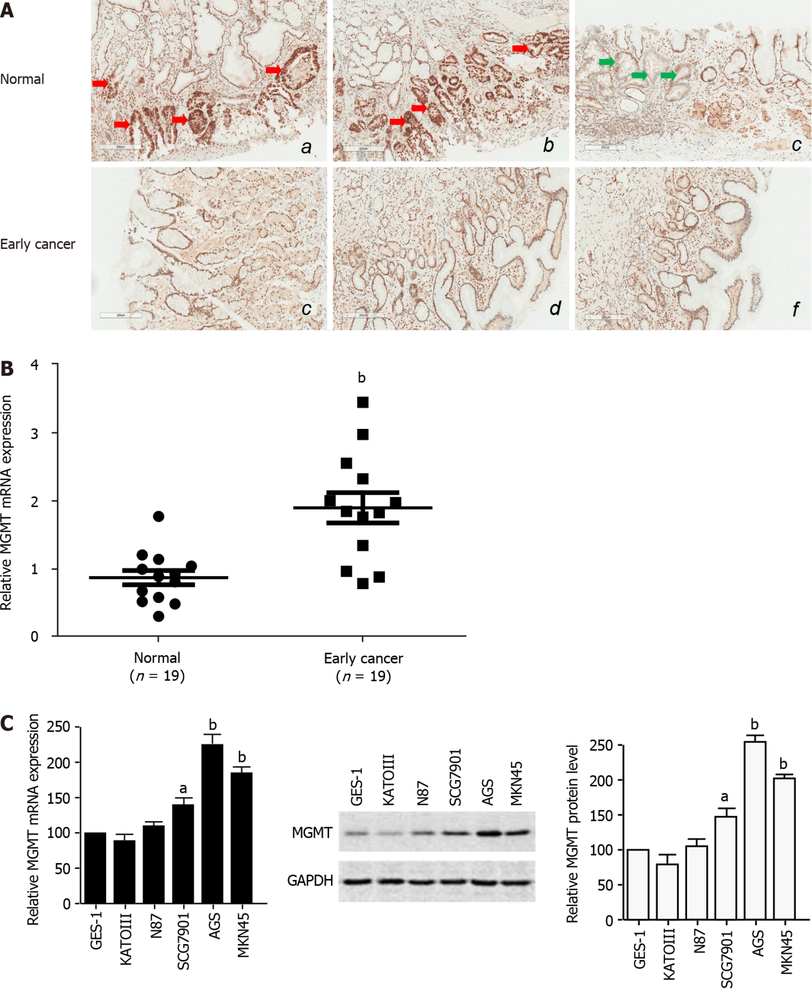
Figure 1 O⁶-methylguanine-DNA methyltransferase expression is enhanced in early stage gastric cancer. A: Representative images of immunohistochemistry staining for O⁶-methylguanine-DNA methyltransferase (MGMT) in early stage gastric tumor and normal tissues (n = 19); B: The mRNA level of MGMT in early stage gastric tumor and adjacent normal tissues (n = 19). The mRNA expression was normalized by glyceraldehyde-3-phosphate dehydrogenase (GAPDH); C: MGMT mRNA and protein expression in normal gastric epithelial cells and cancer cells by quantitative real-time polymerase chain reaction and immunoblot assays. GAPDH was used to normalize MGMT expression. The analyses were repeated three times, and the results are expressed as the mean ± SD. ªP < 0.05; ^{b}P < 0.01. MG-C: MNNG-induced malignant transformed cell; MU-C: MNU-induced malignant transformed cell; GAPDH: Glyceraldehyde-3-phosphate dehydrogenase.

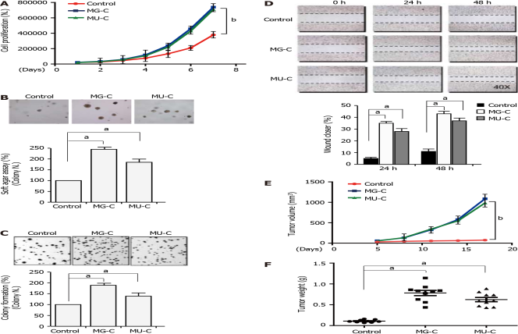
Figure 2 N-nitroso compound treatment induces gastric epithelial cell malignant transformation. A: Cell proliferation monitored by cell counting in N-methyl-N’-nitro-N-nitrosoguanidine (MNNG)/N-methyl-N-nitroso-urea (MNU)-treated and control cells; B and C: Cell anchorage-independent growth on soft agar and cell colony formation. Top, representative images; bottom, quantitative results of cell colony per field; D: Wound healing assay. Top, representative images of wound healing assay; right, relative percentage of wound closure after treatment; E and F: Tumor growth curve and tumor weight in nude mice injected subcutaneously with the transformed cells induced by MNNG/MNU and control cells. The analyses were repeated three times, and the results are expressed as the mean ± SD. ªP < 0.05; ^{b}P < 0.01.
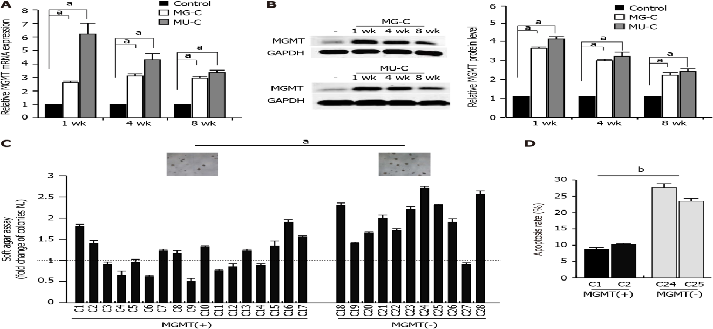
Figure 3 O⁶-methylguanine-DNA methyltransferase is downregulated in N-nitroso compound-induced gastric epithelial cell malignant transformation. A and B: O⁶-methylguanine-DNA methyltransferase (MGMT) mRNA and protein expression in transformed gastric epithelial cells induced by N-methyl-N’-nitro-N-nitrosoguanidine (MNNG)/N-methyl-N-nitroso-urea (MNU) for 1, 4, and 8 wk; C: Cell anchorage-independent growth on soft agar for subcolones of MNNG/MNU-induced cells. C1-28: Different subcolones of MNNG/MNU-induced cells; MGMT(+): MGMT expression is upregulated in these subcolones; MGMT(-): MGMT expression is downregulated or no-changed in these subcolones; D: Apoptosis assay of MNNG/MNU-transformed subcolones after doxycycline treatment. The analyses were repeated three times, and the results are expressed as the mean ± SD. ªP < 0.05; ^{b}P < 0.01. GAPDH: Glyceraldehyde-3-phosphate dehydrogenase.
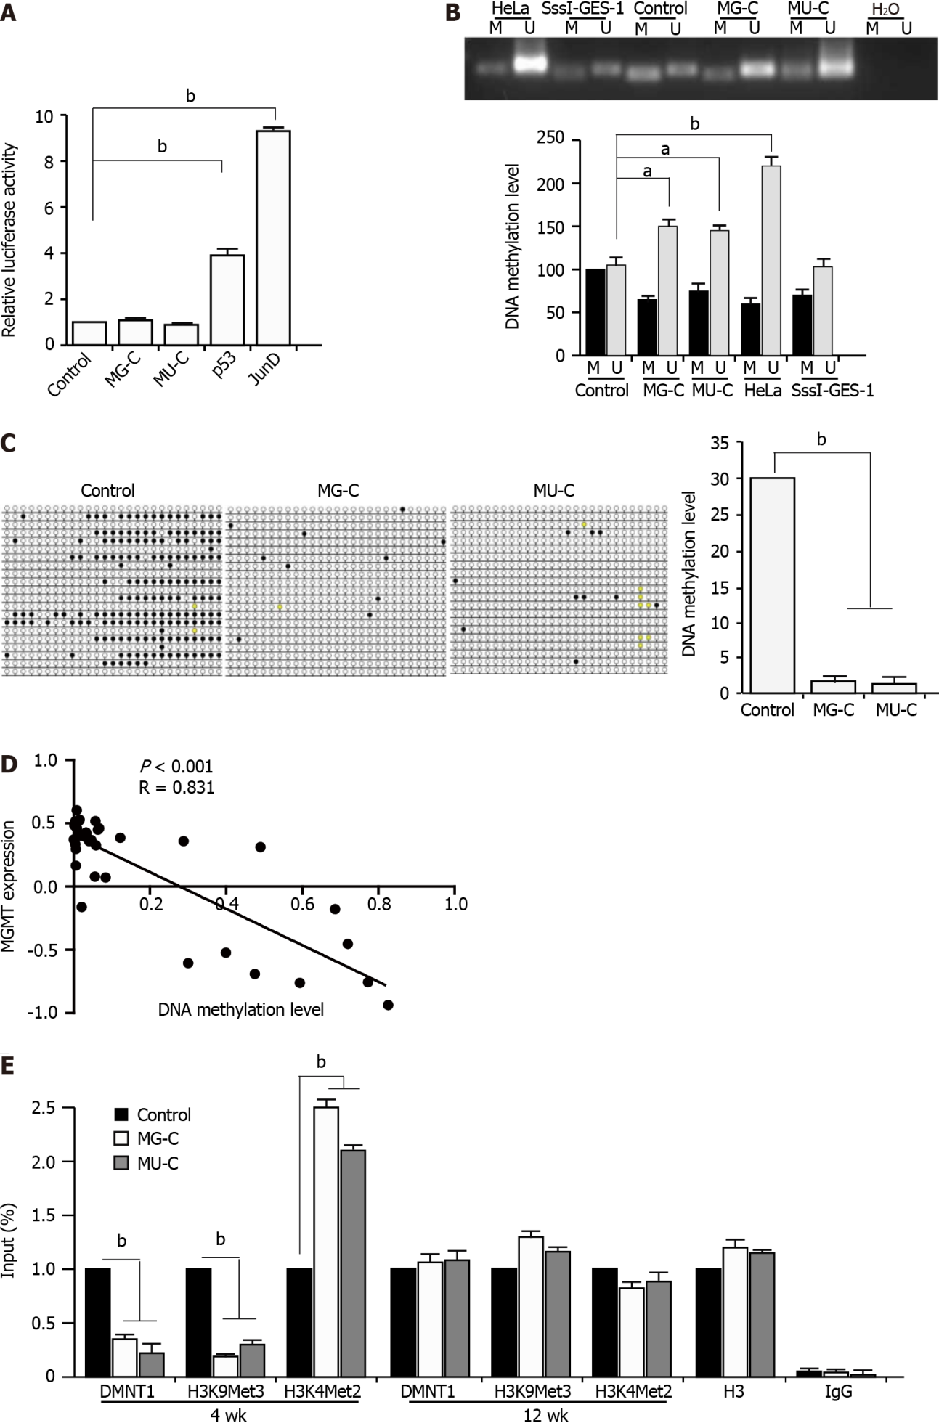
Figure 4 DNA hypomethylation contributes to O⁶-methylguanine-DNA methyltransferase upregulation in cell malignant transformation. A: Luciferase reporter assay in control and N-nitroso compound-transformed cells using PGL3-O⁶-methylguanine-DNA methyltransferase (MGMT) promoter; B and C: Methylation specific polymerase chain reaction and bisulfite genomic sequence analysis of the DNA methylation level of N-methyl-N’-nitro-N-nitrosoguanidine/N-methyl-N-nitroso-urea-induced transformed cells compared with control cells; D: Correlation of MGMT expression and DNA methylation level of MGMT promoter based on the CCLE database; E: ChIP assay with anti-DNMT1 and anti-H3K9Me3 and H3K4Me2 antibodies for analyzing the DNMT1 binding to the MGMT promoter and the H3K9Me3 and H3K4Me2 levels in the MGMT promoter. The analyses were repeated three times, and the results are expressed as the mean ± SD. ªP < 0.05; ^{b}P < 0.01. M: Methylated; U: Unmethylated; IgG: Immunoglobulin G.
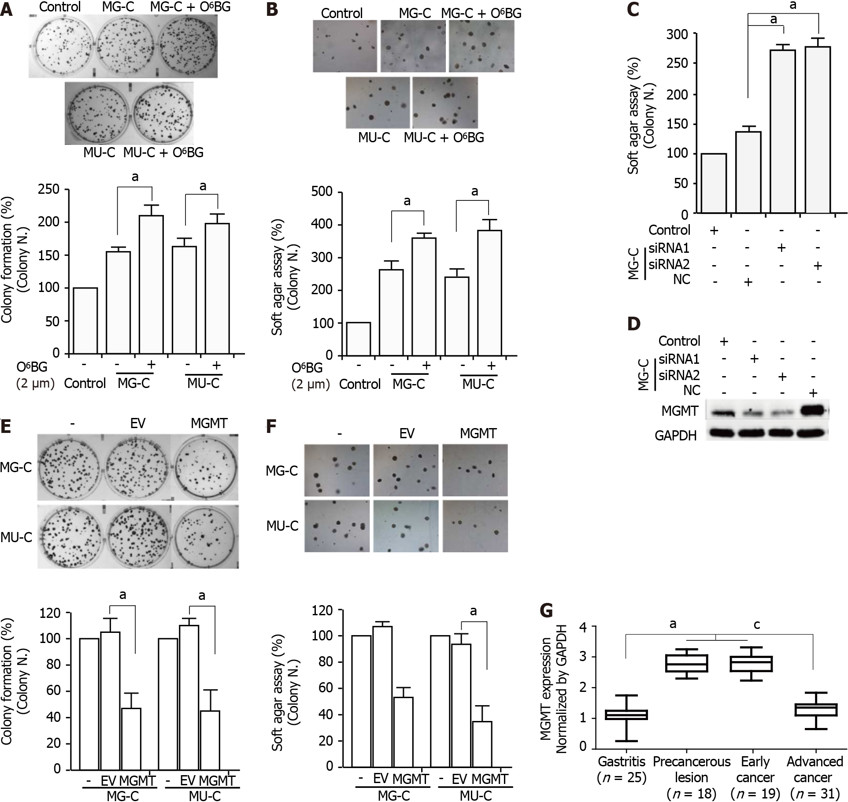
Figure 5 Inhibition of O⁶-methylguanine-DNA methyltransferase contributes to the N-nitroso compound-induced cell malignant phenotype. A and B: Cell anchorage-independent growth on soft agar and cell colony formation of N-methyl-N’-nitro-N-nitrosoguanidine/N-methyl-N-nitroso-urea-induced cells after O⁶-BG treatment; C: Cell anchorage-independent growth on soft agar of cells with O⁶-methylguanine-DNA methyltransferase (MGMT) knock-down; D: Knock-down efficiency of MGMT detected by Western blot; E and F: Cell anchorage-independent growth on soft agar and cell colony formation of MGMT overexpressing cells; G: The mRNA expression of MGMT in gastric endoscopic biopsy samples. The analyses were repeated three times, and the results are expressed as the mean ± SD. ^{a,c}P < 0.05. ^{c}P < 0.05, precancerous lesion and early cancer vs advanced cancer. EV: Empty vector; MGMT: MGMT overexpression; MGMT: O⁶-methylguanine-DNA methyltransferase.

Published by Baishideng Publishing Group Inc
7041 Koll Center Parkway, Suite 160, Pleasanton, CA 94566, USA
Telephone: +1-925-3991568
E-mail: bpgoffice@wjgnet.com
Help Desk: https://www.f6publishing.com/helpdesk
https://www.wjgnet.com

© 2022 Baishideng Publishing Group Inc. All rights reserved.

