Name of journal: World Journal of Gastroenterology
ESPS Manuscript NO: 24907
Columns: CASE REPORT

Idiopathic abdominal cocoon syndrome with unilateral abdominal cryptorchidism and greater omentum hypoplasia in a young case of small bowel obstruction

Fei X et al. Abdominal cocoon with cryptorchidism and omentum hypoplasia

Xiang Fei, Hai-Rui Yang, Peng-Fei Yu, Hai-Bo Sheng, Guo-Li Gu

Xiang Fei, Hai-Rui Yang, Peng-Fei Yu, Guo-Li Gu, Department of General Surgery, the Air Force General Hospital, Chinese PLA, Beijing 100142, China

Hai-Bo Sheng, Department of Urinary Surgery, the Air Force General Hospital, Chinese PLA, Beijing 100142, China

Author contributions: Gu GL designed the research; Gu GL, Yang HR, Sheng HB and Fei X performed the research; Fei X and Yu PF collected and analyzed the data; Gu GL and Fei X wrote the paper; and Gu GL revised the paper.

Supported by Major Projects of Chinese PLA "13th Five-Year Plan" Logistics Research Subject, No. AKJ15J003.

Institutional review board statement: This work has been carried out in accordance with the Declaration of Helsinki (2000) of the World Medical Association. This study was approved ethically by Ethics Committee of the Air Force General Hospital, PLA.

Informed consent statement: The patient involved in this study gave his written informed consent authorizing use and disclosure of his protected health information.

Conflict-of-interest statement: All the authors have no conflicts of interests to declare.

Open-Access: This article is an open-access article which was selected by an in-house editor and fully peer-reviewed by external reviewers. It is distributed in accordance with the Creative Commons Attribution Non Commercial (CC BY-NC 4.0) license, which permits others to distribute, remix, adapt, build upon this work non-commercially, and license their derivative works on different terms, provided the original work is properly cited and the use is non-commercial. See: http://creativecommons.org/licenses/by-nc/4.0/

Correspondence to: Guo-Li Gu, Associate Professor, Deputy Director, Department of General Surgery, the Air Force General Hospital, Chinese PLA, No.30, Fucheng Road, Haidian District, Beijing 100142, China. kzggl@163.com
Telephone: +86-10-66928303
Fax: +86-10-66928303

Received: February 12, 2016
Peer-review started: February 14, 2016
First decision: March 7, 2016
Revised: March 14, 2016
Accepted: April 7, 2016
Article in press:
Published online:
Abstract
Abdominal cocoon syndrome (ACS) is a rare cause of intestinal obstruction due to total or partial encapsulation of the small intestine by a fibrocollagenous membrane. Idiopathic ACS with abdominal cryptorchidism and greater omentum hypoplasia is rarer in clinic. We successfully treated with a 26-year-old male case of small bowel obstruction with acute peritonitis. He was finally diagnosed as idiopathic ACS with unilateral abdominal cryptorchidism and greater omentum hypoplasia during exploratory laparotomy; and then he underwent enterolysis, cryptorchidectomy and appendectomy. He gradually recovered from operations and early postoperative inflammatory ileus. And the intestinal obstruction doesn’t recurrence since operation, and he is still in follow-up. We analyzed his clinical data and reviewed literatures retrospectively, it maybe be helpful to improve the clinical capability of diagnosis and treatment on ACS.

Key words: Abdominal cocoon syndrome; Abdominal cryptorchidism; Intestinal obstruction; Diagnosis; Treatment.

© The Author(s) 2016. Published by Baishideng Publishing Group Inc. All rights reserved.

Core tip: Abdominal cocoon syndrome (ACS) is a rare abdominal disease with portion or all abdominal organs wrapped in dense membrane-like fibrous tissue. Intestinal obstruction is the main clinical manifestations of ACS. Because of its rare and lacking characteristic symptoms, so ACS is fairly difficult to get diagnosis before the operation. Surgeons should vigilantly remember this disease when they face with a case of intestinal obstruction whose abdominal radiography shows intestinal loop aggregation into cluster. And then when surgeons face with a suspected case of ACS, they must be alert to the possibilities of accompanying cryptorchidism, and then make carefully physical examination and operative exploration for undescended testicle. As to the patients with ACS, postoperative care and dietary guidance are very important to their rehabilitation. The postoperative re-adhesion and EPII are easy to occur after extensively dissection of enterolysis.

Fei X, Yang HR, Yu PF, Sheng HB, Gu GL. Idiopathic abdominal cocoon syndrome with unilateral abdominal cryptorchidism and greater omentum hypoplasia in a young case of small bowel obstruction. World J Gastroenterol 2016; In press

INTRODUCTION
Abdominal cocoon syndrome (ACS) is a rare abdominal disease with portion or all abdominal organs wrapped in dense membrane-like fibrous tissue. It was first reported in 1978 and also known as idiopathic sclerosing peritonitis, primary sclerosing peritonitis and sclerosing encapsulating peritonitis^{[1,2]}. The etiology and epidemiological characteristics of idiopathic ACS is still unknown. Intestinal obstruction is the main clinical manifestations of ACS. Usually the ACS is chanced upon during abdominal operation. Because of its rare and lacking characteristic symptoms, so ACS is fairly difficult to get diagnosis before the operation.
We successfully treated a young male case of intestinal obstruction that was secondary to idiopathic ACS with unilateral abdominal cryptorchidism and greater omentum hypoplasia.

CASE REPORT
A 26-year-old male patient was admitted to the emergency department with complaints of abdominal pain, nausea and vomiting for about 10 hours on November 25 2014. Moreover, this patient had a history of overeating before hospitalization, but he did not have history of chronic systemic disease or abdominal trauma. Upon physical examination, there was asymmetrical distension and general tenderness with heightened intestinal sounds, especially prominent in right middle abdomen. Right testicle can’t be touched in scrotum. The laboratory examinations showed peripheral leukocyte counts were normal (7.98 × 10⁹/L), however, the ratio of neutrophils slightly increased to 75.1%. Abdominal radiography detected the dilated intestine with air-fluid levels was prominent in the right middle abdomen (Figure 1). The abdominal computerized tomography detected dilated small intestinal loops containing air-fluid levels clustered in the middle abdomen and surrounded by a thick and saclike membrane (Figures 2). The widespread adhesions between the peritoneum and small intestine were found during exploratory laparotomy. Following with further exploration, a cocoon-like fibrous structure was identified in the middle abdomen which surrounded the majority of small intestinal (Figure 3). The right undescended testicle had softened and adhered tightly to fibrous membrane near appendix. And the greater omentum was hypoplastic. When the cocoon-like fibrous membrane was opened, the small intestinal segments were dilated due to obstruction but otherwise normal in structure. The obstruction was caused by fibrous bands of irregular thickness inside the cocoon-like fibrous membrane. The operation was completed after total excision of the fibrous membrane and removal of the adhesions. The released small intestinal were rearranged and coated sodium hyaluronate. At the same time, the right undescended testicle and appendix were resected. Postoperative pathologic examination showed the testis with interstitial fibrosis has no spermatogonium, primary spermatocyte, secondary spermatocyte, spermatid and spermatozoon found in seminiferous tubules (Figure 4).
This patient recovered well postoperative first week, but he suffered early postoperative inflammatory ileus (EPII) performance with intermittent abdominal pain and vomiting in the postoperative 12th day. After a serial of symptomatic treatment for about 5 days, including fasting, gastrointestinal decompression, inhibiting secretion of digestive juices by octreotide, nutritional support and keeping balance of electrolytes; he recovered gradually and discharged on December 20 2014. The intestinal obstruction doesn’t recurrence and he is still in follow-up now.

DISCUSSION
According to whether its etiology is explicit or not, ACS can be divided into two subtype: primary (idiopathic) and secondary^{[3]}. Usually the secondary ACS results in chronic asymptomatic peritonitis, such endometriosis, retrograde menstruation, peritoneal dialysis and abdominal tuberculosis, etc. ^{[4]}. Although idiopathic ACS is rare in clinic, the patient with idiopathic ACS often accompanied with greater omentum absent and cryptorchidism. So it suggests that genetic factors maybe also play a role in the etiology of idiopathic ACS. Our case developed intestinal obstruction and peritonitis without any other known risk factors; the typical fibrous membrane surrounding small intestinal with greater omentum hypoplastic and undescended testicle make sure the diagnosis of idiopathic ACS is right.
Although ACS is a rare cause of intestinal obstruction, we should vigilantly remember this disease when we face with a case of intestinal obstruction whose abdominal radiography shows intestinal loop aggregation into cluster ^{[5, 6]}. And then when we face with a suspected case of ACS, we must be alert to the possibilities of accompanying cryptorchidism, and then make carefully physical examination and operative exploration for undescended testicle. There still has controversial point on how to deal with the undescended testicle^{[7,8]}. Because surgical options of the undescended testicle involved with patient’s fertility and high risk of seminoma, so it is necessary to fully communicate with patient about it before operation performed. As to appendix, we think appendectomy maybe a good choice for patients with ACS, because the occurrence of postoperative abdominal adhesion is inevitable, it will be very difficult to perform appendectomy to these postoperative patients with appendicitis or other appendical diseases^{[9]}. The surgeon should pay attention to reserve the vital intestine and ileocecal valve possibly, and avoid resecting the “cocoon” as tumor result in short bowel syndrome.
As to the patients with ACS, postoperative care and dietary guidance are very important to their rehabilitation. The postoperative re-adhesion and EPII are easy to occur after extensively dissection of enterolysis^{[10]}. So we should encourage patients to get out of bed early in order to promote intestinal peristalsis recovery and avoid recurrence of intestinal obstruction. The patients’ diet should gradually restore since his gastrointestinal function get recovery manifested as exhaust and defecation. The whole process of diet restoring maybe take about 10 d to 2 wk beginning from liquid diet, semi-liquid diet, soft diet, final to general diet. Our case’s discharge time delayed for about 7 d by EPII just because improper self-eating.

COMMENTS
Case characteristics
Patient was admitted to the emergency department with complaints of abdominal pain, nausea and vomiting for about 10 h.

Clinical diagnosis
Upon physical examination, there was asymmetrical distension and general tenderness with heightened intestinal sounds, especially prominent in right middle abdomen.

Differential diagnosis
The abdominal computerized tomography detected dilated small intestinal loops containing air-fluid levels clustered in the middle abdomen and surrounded by a thick and saclike membrane.

Laboratory diagnosis
During exploratory surgery, a cocoon-like fibrous structure was identified in the middle abdomen which surrounded the majority of small intestinal.

Imaging diagnosis
The abdominal computerized tomography detected dilated small intestinal loops containing air-fluid levels clustered in the middle abdomen and surrounded by a thick and saclike membrane.

Pathological diagnosis
Pathologic examination showed the testis with interstitial fibrosis has no spermatogonium, primary spermatocyte, secondary spermatocyte, spermatid and spermatozoon found in seminiferous tubules.

Treatment
He underwent a series of operations, firstly exploratory laparotomy, and then enterolysis, cryptorchidectomy and appendectomy.

Term explanation
Abdominal cocoon syndrome (ACS) is a rare cause of intestinal obstruction due to total or partial encapsulation of the small intestine by a fibrocollagenous membrane.

Experiences and lessons
When you face with a suspected case of ACS, you must be alert to the possibilities of accompanying cryptorchidism, and then make carefully physical examination and operative exploration for undescended testicle. The postoperative care and dietary guidance are very important to their rehabilitation.

Peer-review
This manuscript is very interesting, and the case is rare. In this manuscript, the authors reported a case of small bowel obstruction with acute peritonitis. Abdominal cocoon syndrome is a rare disease with portion or all abdominal organs wrapped in dense membrane-like fibrous tissue.

REFERENCES
1 Uzunoglu Y, Altintoprak F, Yalkin O, Gunduz Y, Cakmak G, Ozkan OV, Celebi F. Rare etiology of mechanical intestinal obstruction: Abdominal cocoon syndrome. World J Clin Cases 2014; 2: 728-731 [PMID: 25405199 DOI: 10.12998/wjcc.v2.i11.728]
2 Akbulut S. Accurate definition and management of idiopathic sclerosing encapsulating peritonitis. World J Gastroenterol 2015; 21: 675-687 [PMID: 25593498 DOI: 10.3748/wjg.v21.i2.675]
3 Sohail MZ, Hasan S, Dala-Ali B, Ali S, Hashmi MA. Multiple abdominal cocoons: an unusual presentation of intestinal obstruction and a diagnostic dilemma. Case Rep Surg 2015; 2015: 282368 [PMID: 25893128 DOI: 10.1155/2015/282368]
4 Kaur S, Doley RP, Chabbhra M, Kapoor R, Wig J. Post trauma abdominal cocoon. Int J Surg Case Rep 2015; 7C: 64-65 [PMID: 25590647 DOI: 10.1016/j.ijscr.2014.10.081]
5 Karan A, Özdemir M, Bostancı MT, Bostancı EB. Idiopathic abdominal cocoon syndrome: Preoperative diagnosis with computed tomography. Turk J Gastroenterol 2015; 26: 193-194 [PMID: 25835123 DOI: 10.5152/tjg.2015.7312]
6 Frost JH, Price EE. Abdominal cocoon: idiopathic sclerosing encapsulating peritonitis. BMJ Case Rep 2015; 2015: [PMID: 25612756 DOI: 10.1136/bcr-2014-207524]
7 Solmaz A, Tokoçin M, Arıcı S, Yiğitbaş H, Yavuz E, Gülçiçek OB, Erçetin C, Çelebi F. Abdominal cocoon syndrome is a rare cause of mechanical intestinal obstructions: a report of two cases. Am J Case Rep 2015; 16: 77-80 [PMID: 25671606 DOI: 10.12659/AJCR.892658]
8 Awe JA. Abdominal cocoon syndrome (idiopathic sclerosing encapsulating peritonitis): how easy is its diagnosis preoperatively? A case report. Case Rep Surg 2013; 2013: 604061 [PMID: 23738183 DOI: 10.1155/2013/604061]
9 Acar T, Kokulu İ, Acar N, Tavusbay C, Hacıyanlı M. Idiopathic encapsulating sclerosing peritonitis. Ulus Cerrahi Derg 2015; 31: 241-243 [PMID: 26668535 DOI: 10.5152/UCD.2015.2786]
10 Jayant M, Kaushik R. Abdominal cocoon in a young man. World J Emerg Med 2014; 5: 234-236 [PMID: 25225591 DOI: 10.5847/wjem.j.1920-8642.2014.03.014]

P-Reviewer: Peters JH, Yamada A S-Editor: Qi Y L-Editor: E-Editor:

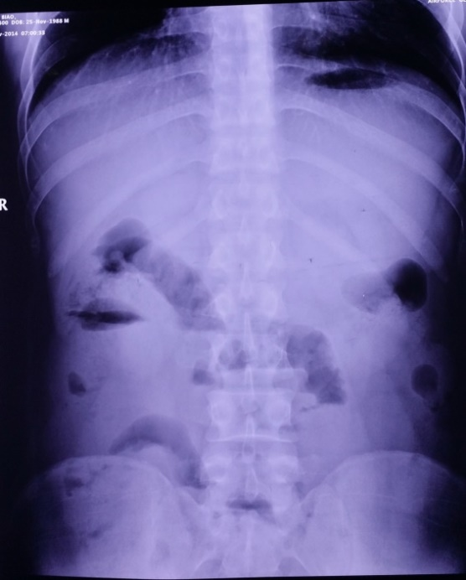
Figure 1 Abdominal Radiography. The dilated intestine with air-fluid levels was prominent in the right middle abdomen.

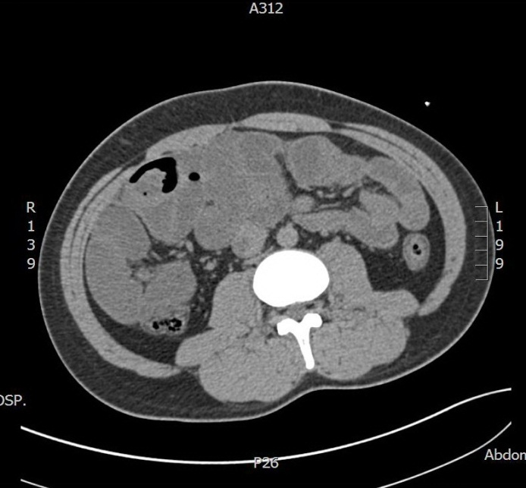 | 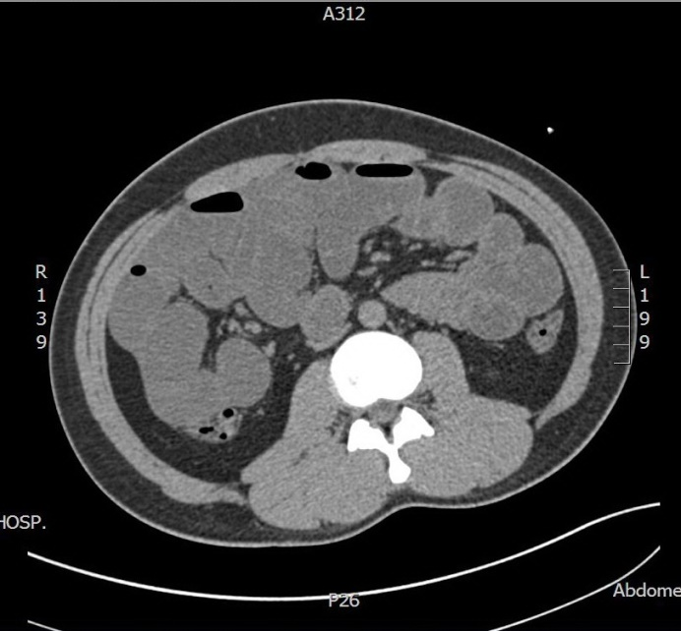
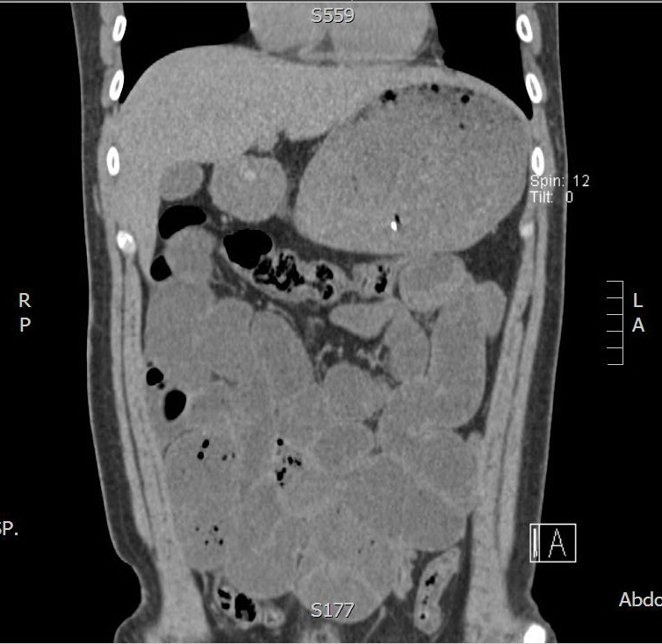 | 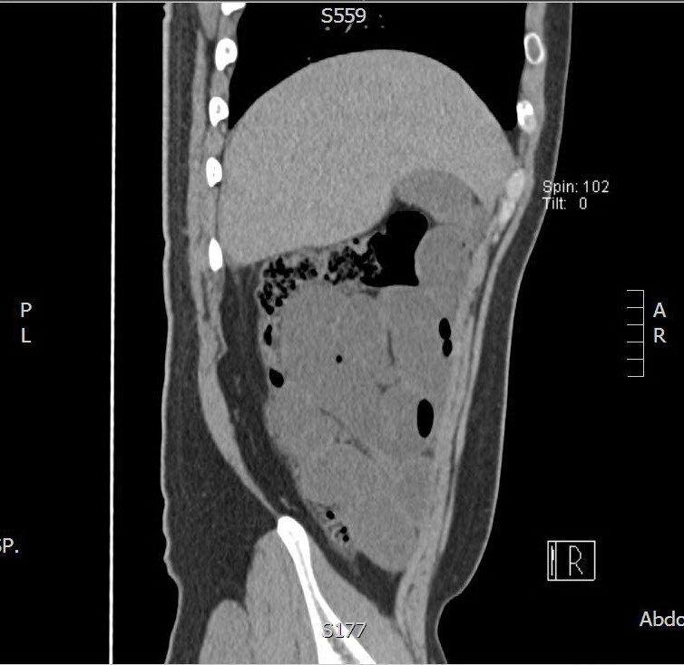
Figure 2 Abdominal computed tomography scans. Dilated small intestinal loops containing air-fluid levels clustered in the right middle abdomen and surrounded by a saclike membrane.
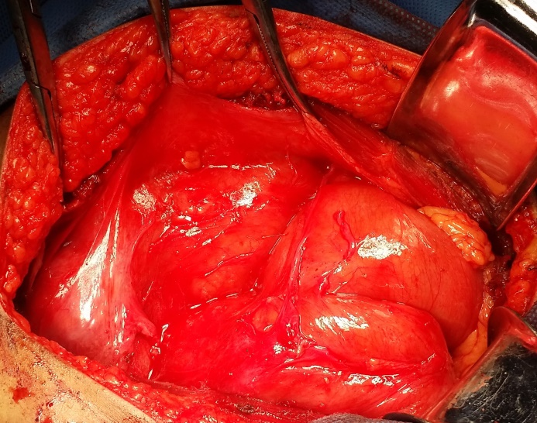
Figure 3 Intraoperative findings. Dilated small intestine was surrounded by a capsular structure in right middle abdomen which had a regular surface composed by natural fibrous membranes.

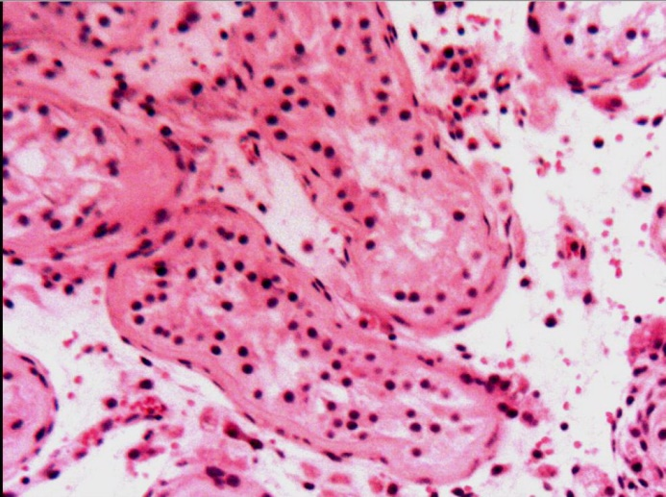

Figure 4 Pathologic examination (HE × 200). The testis with interstitial fibrosis has no spermatogonium, primary spermatocyte, secondary spermatocyte, spermatid and spermatozoon found in seminiferous tubules.

