Name of Journal: World Journal of Clinical Cases

Manuscript NO: 40722

Manuscript Type: META-ANALYSIS

Photodynamic therapy for middle-advanced stage upper gastrointestinal carcinomas: A systematic review and meta-analysis

Chen B et al. PDT for upper gastrointestinal carcinomas

Bo Chen, Li Xiong, Wei-Dong Chen, Xiao-Hua Zhao, Jun He, Yan-Wen Zheng, Fan-Hua Kong, Xi Liu, Zi-Jian Zhang, Xiong-Ying Miao

Bo Chen, Li Xiong, Wei-Dong Chen, Xiao-Hua Zhao, Jun He, Yan-Wen Zheng, Fan-Hua Kong, Xi Liu, Zi-Jian Zhang, Xiong-Ying Miao, Department of General Surgery, The Second Xiangya Hospital, Central South University, Changsha 410011, Hunan Province, China

ORCID number: Bo Chen (0000-0002-6692-8552); Li Xiong (0000-0002-5570-0229); Wei-Dong Chen (0000-0002-0058-0880); Xiao-Hua Zhao (0000-0002-1256-3244); Jun He (0000-0001-5309-0765); Yan-Wen Zheng (0000-0002-2704-5001); Fan-Hua Kong (0000-0003-3126-2508); Xi Liu (0000-0001-7349-8792); Zi-Jian Zhang (0000-0003-4041-9263); Xiong-Ying Miao (0000-0002-3793-2966).

Author contributions: Miao XY and Xiong L designed the research; Chen B, Chen WD, and Zhao XH performed the research; He J and Zheng YW contributed to analytic tools; Kong FH and Liu X analyzed data; Chen B and Zhang ZJ wrote the paper; Chen B and Xiong L participated in revisions of the manuscript.

Supported by the National Natural Science Foundation of China, No. 81372628, No. 81773293 and No.31660266; the Natural Science Foundation of Hunan Province, No. 12JJ5048; and the Science and Technology Plan Fund in Hunan Province, P.R. China, No. 2018JJ3758, No. 2017WK2063, No. 2017DK2011, No. 2015GK3117 and No. 2014WK2016.

Conﬂict-of-interest statement: No potential conﬂicts of interest relevant to this article were reported.

PRISMA 2009 Checklist statement: The manuscript was prepared and revised according to the PRISMA 2009 Checklist.

Open-Access: This is an open-access article that was selected by an in-house editor and fully peer-reviewed by external reviewers. It is distributed in accordance with the Creative Commons Attribution Non Commercial (CC BY-NC 4.0) license, which permits others to distribute, remix, adapt, build upon this work non-commercially, and license their derivative works on different terms, provided the original work is properly cited and the use is non-commercial. See: http://creativecommons.org/licenses/by-nc/4.0/

Manuscript source: Unsolicited manuscript

Correspondence to: Xiong-Ying Miao, MD, Professor, Department of General Surgery, The Second Xiangya Hospital, Central South University, No.139 Middle Renmin Road, Changsha 410011, Hunan Province, China. miaoxiongying3016@csu.edu.cn
Telephone: +86-731-88836045
Fax: +86-731-84895199

Received: July 19, 2018

Peer-review started: July 19, 2018

First decision: August 25, 2018
Revised: September 13, 2018

Accepted: October 12, 2018

Article in press:

Published online:

Abstract

AIM
To determine the effect of photodynamic therapy (PDT) for middle-advanced stage upper gastrointestinal carcinomas.

METHODS
We searched PubMed, EMBASE, the Cochrane Library, China National Knowledge Infrastructure, China Science and Technology Journal Database and Wanfang Database from inception to April 2018 for randomized controlled studies. These studies compared PDT with other palliative therapies (radiotherapy, chemotherapy or Nd:YAG) and compared PDT, radiotherapy or chemotherapy alone with PDT combined with chemotherapy/radiotherapy. In our meta-analysis, both fixed and random effects models were used to estimate the risk ratio (RR) for dichotomous outcomes (the response rate and one-year survival rate).

RESULTS
Ten random controlled clinical studies with 953 patients were included in the analysis. The effective rate for PDT was better than that of radiotherapy or Nd:YAG for the treatment of middle-advanced upper gastrointestinal cancers [RR = 1.36; 95% confidence interval (CI):1.13–1.65; P = 0.001]. In addition, PDT combined with chemotherapy had significantly better efficacy and a higher one-year survival rate than did PDT or chemotherapy alone (the significant remission rate, RR = 1.62; 95%CI: 1.34–1.97; P < 0.00001; one-year survival rate, RR = 1.81; 95%CI: 1.13–2.89; P = 0.01).

CONCLUSION
PDT is a useful method for the treatment of middle-advanced stage upper gastrointestinal cancers. PDT combined with chemotherapy or radiotherapy can enhance its efficacy and prolong survival time.

Key words: Photodynamic therapy; Radiotherapy; Chemotherapy; Nd:YAG laser; Gastrointestinal neoplasm; Upper gastrointestinal tract; Gastrointestinal diseases; Meta-analysis

© The Author(s) 2018. Published by Baishideng Publishing Group Inc. All rights reserved.

Core tip: Photodynamic therapy (PDT) is minimally invasive compared with chemotherapy and radiotherapy for the treatment of cancers. Limited data exist regarding the efficacy of PDT alone or combined with radiotherapy and chemotherapy for the treatment of middle-advanced stage upper gastrointestinal carcinomas. Therefore, we performed a systematic review and meta-analysis of ten available randomized controlled clinical trials that addressed the efficacy of PDT alone or combined with radiotherapy and chemotherapy in patients with middle-advanced stage upper gastrointestinal carcinomas. Our analysis showed PDT may be suitable for single or combined treatment of middle-advanced stage upper gastrointestinal carcinomas, especially for elderly patients, those with severe diseases, those with severe complications and those unwilling to undergo surgery.

Chen B, Xiong L, Chen WD, Zhao XH, He J, Zheng YW, Kong FH, Liu X, Zhang ZJ, Miao XY. Photodynamic therapy for middle-advanced stage upper gastrointestinal carcinomas: A systematic review and meta-analysis. World J Clin Cases 2018; In press

INTRODUCTION
Upper gastrointestinal carcinomas, including esophageal and gastric cancer, constitute major health problems worldwide^{[1]}. Gastric cancer is the fifth most
common malignancy and is the third leading cause of cancer death. In 2012,
there were approximately 95200 new cases of in the world. Esophageal carcinoma is the eighth most common cancer worldwide. In 2012, the number of new cases of esophageal cancer was approximately 456000, and the number of deaths was approximately 400000. The five-year survival rate ranged between 13% and 18%^{[2]}.
At present, the standard treatment of upper gastrointestinal cancers is surgical resection. However, many patients are diagnosed in middle-advanced stage or are elderly, and most of them have lost their best chance of surgery. These patients can undergo palliative treatments only to relieve esophageal obstruction symptoms to improve their quality of life^{[3]}. Palliatively, the principal regimens for middle-advanced stage upper gastrointestinal cancers include chemotherapy, radiotherapy and endoscopic ablation^{[4]}. Specially, endoscopic ablation treatment includes photodynamic therapy (PDT)^{[5]}, Nd:YAG laser^{[6]}, radiofrequency ablation^{[7]} and argon plasma coagulation^{[8]}.
Chemotherapy and radiotherapy are curative treatment options for upper gastrointestinal cancers. Chemotherapy has a mitigating effect on a small group of patients whose disease is in the advanced stage. However, low response rates, severe toxic side-effects and drug resistance have limited further use of chemotherapy^{[9]}. Radiotherapy can cause extensive damage to adjacent organs, thereby reducing its clinical value^{[10]}. Therefore, it is urgent to develop new antitumor treatments to overcome these limitations.
In recent decades, PDT has become an alternative to radiotherapy and chemotherapy for a variety of diseases including cancer because of its minimally invasive nature^{[11]}. It utilizes a specific light wavelength to activate a photosensitizer in cells, thereby generating reactive oxygen species to damage cancer cells^{[12]}. By virtue of the fact that PDT is noninvasive, highly selective and low-toxicity, it can reduce damage to surrounding tissues of the intestine and decrease the risk of intestinal leakage. In addition, it has high patient acceptance/compliance and is a relatively simple procedure ^{[13]}. Therefore, PDT has played an increasingly important role in the treatment of upper gastrointestinal tumors and precancerous diseases. PDT can also be used in combination with chemotherapy or radiation to improve efficacy and reduce side-effects^{[14]}.
Recently, several randomized controlled trials (RCTs) have verified the efficacy of PDT alone or PDT combined with radiotherapy/chemotherapy for treatment of middle-advanced stage upper gastrointestinal carcinomas. Therefore, we undertook a systematic review and meta-analysis of RCTs regarding the combination of PDT with chemotherapy or radiotherapy for the treatment of middle-advanced stage upper gastrointestinal carcinomas, with particular reference to survival rate and tumor response rate (the significant remission rate and effective rate).

MATERIALS AND METHODS

Literature search
PRISMA statement guidelines were followed for the calculation and reporting of meta-analysis data^{[15]}. A literature retrieval was carried out in PubMed, EMBASE, the Cochrane Library, China National Knowledge Infrastructure, China Science and Technology Journal Database and Wanfang Database from inception to May 2018 using the following key words: "upper gastrointestinal carcinomaʺ, "gastric carcinomaʺ, "stomach cancerʺ, "cardia carcinomaʺ, "esophageal carcinomaʺ, "esophagocardiac carcinomaʺ, "photodynamic therapyʺ, "endoscopic therapyʺ, "ablationʺ, "radiotherapyʺ, "brachytherapyʺ, "irradiationʺ, "brachyradiotherapyʺ, "chemotherapyʺ, "randomized controlled trialʺ and "clinical studiesʺ. All analyses were based on previous published studies. Therefore, no ethics approval or patient consents were required.

Inclusion and exclusion criteria
Studies that met the following criteria were included: adults with middle-advanced stage upper gastrointestinal carcinomas confirmed by endoscopy or pathologic diagnosis; the intervention arm was PDT alone or PDT combined with chemotherapy/radiotherapy; and the control arm was palliative treatment (radiotherapy, chemotherapy or Nd:YAG laser). RCTs had access to the full text. The following studies were excluded: those with no control group; those in which the study outcomes did not include complete or available efficacy data; case reports, abstracts, letters, comments, reviews without original data; and studies that presented insufficient data.

Study selection and data extraction
Two reviewers read the structured table to extract data from relevant articles. Any disagreement between the two reviewers was resolved by discussion with a third reviewer. For duplicated articles, we extracted relevant data from the most recent article. We extracted first author, publication year, study design, participant number, average age, proportion of men and women, type of upper gastrointestinal carcinomas, intervention methods and primary outcomes.

Quality assessment and publication bias
The Cochrane System Evaluation Manual Intervention was used to assess the quality of random controlled clinical studies. Funnel plots were constructed to assess the risk of publication bias.

Statistical analysis
Tumor response rate (the significant remission rate and effective rate) was evaluated one month after PDT. The criteria for PDT established at the national conference held in 1984 were as follows: complete remission (CR)-tumor disappearance; no histologic examination of cancer cells for at least one month; partial remission (PR)-extensive tumor necrosis, and tumor volume reduced for at least 1 mo; Mild remission (MR)-the tumor volume decreased less than 50% for at least one month; No remission (NR)-no obvious necrosis, tumor volume decreased slightly or even increased. The significant remission rate included CR and PR. The effective rate included CR, PR and MR. The meta-analysis was performed using Review Manager (version 5.3.0) software. We calculated risk ratio (RR) and 95% confidence interval (CI) values for binary variables. In addition, a P-value < 0.05 was considered significant. Heterogeneity tests used the chi-square statistic (P-value < 0.10 considered significant) and I² tests. If P < 0.10 or I² > 50%, indicating the heterogeneity was large, a random effect model was used. If P > 0.10 or I² < 50%, indicating the heterogeneity was small, a fixed effect model was used.

RESULTS

Characteristics of the included studies
A flow chart of the study selection process and exclusion criteria is shown in Figure 1. A total of 501 studies were identified based on the search criteria. We filtered by title, abstract and full text. Eventually, ten studies met the inclusion and exclusion criteria^{[16-25]}. The total number of patients was 953; of these patients, 523 underwent PDT alone or PDT combined with other palliative therapies (radiotherapy, chemotherapy), and 430 were in the control group. The characteristics of all included studies are shown in Table 1.

Evaluation for equality of studies
We used the standards of the Cochrane System Evaluation Manual Intervention for this assessment^{[26]}. For the included RCTs, assessment of the bias risk involved the following parameters: sequence generation, allocation concealment, blinding, incomplete outcome data, selective reporting bias and other potential sources of bias. Detailed results of the assessments are shown in Figures 2 and 3.

Risk of publication bias
Potential publication bias was assessed by visual inspection of the funnel plots (Figure 4), which suggested no obvious evidence of publication bias.

The significant remission rate of PDT and other palliative treatments
Two studies reported the significant remission rate of PDT and other palliative treatments (Nd:YAG or radiotherapy). The result of meta-analysis showed that the value of the significant remission rate (CR + PR) increased with PDT therapy (RR = 1.36; 95%CI:1.09-1.69; P = 0.007; I² = 0%). Therefore, we used a fixed model (Figure 5A).

The effective rate of PDT and other palliative treatments
Three studies reported the effective rate of PDT and other palliative treatments (Nd:YAG or radiotherapy). The result of meta-analysis showed that the value of the effective rate (CR + PR + MR) increased with PDT therapy (RR = 1.36; 95%CI: 1.13-1.65; P = 0.001; I² = 0%). Therefore, we used a fixed model (Figure 5B).

The significant remission rate of PDT combined with chemotherapy/ radiotherapy vs PDT/ chemotherapy/radiotherapy
Seven included studies reported the significant remission rate of PDT combined with chemotherapy/radiotherapy and PDT/chemotherapy/ radiotherapy alone. The result of meta-analysis showed that the value of the significant remission rate increased in PDT combined with chemotherapy or radiotherapy (RR = 1.62; 95%CI: 1.34-1.97; P < 0.00001; I² = 29%). Therefore, we used a fixed model (Figure 5C).

The effective rate of PDT combined with chemotherapy vs PDT/chemotherapy
Six included studies reported the effective rate between PDT combined with chemotherapy/radiotherapy and PDT/chemotherapy/radiotherapy alone. The result of meta-analysis showed that the value of the effective rate increased with PDT combined with chemotherapy (RR = 1.09; 95%CI: 1.00-1.19; P = 0.04; I² = 42%). Therefore, we used a fixed model (Figure 5D).

One-year survival rate for PDT combined with chemotherapy vs PDT/ chemotherapy
Four included studies reported one-year survival rate for PDT combined with chemotherapy and PDT or chemotherapy alone. The results of meta-analysis showed that the value of the one-year survival rate increased with PDT combined with chemotherapy (RR = 1.81; 95%CI:1.13-2.89; P = 0.01; I² = 58%). Therefore, we used a random model (Figure 5E).

DISCUSSION
Upper gastrointestinal carcinomas are the most common malignant tumors of the digestive tract. Because the early symptoms of patients are atypical, most of these diseases are already in the middle-advanced stage at diagnosis^{[27]}. Currently, the primary method for radical treatment of upper gastrointestinal cancers is surgical resection. However, due to complicated patient conditions, old age and high surgical risk, many patients are reluctant to undergo surgery^{[28]}. In recent years, increasing numbers of domestic and foreign scholars have used PDT alone or in combination with other palliative therapies to treat middle-advanced stage upper gastrointestinal cancers. Although the total number of cases is small, the treatment of cancer has achieved positive results.
Lightdale et al^{[19]} reported that PDT was an effective method for treating esophageal cancer and that its efficacy was superior to that of Nd:YAG laser. Furthermore, this treatment can prolong the survival time of patients. The PDT procedure is also simple and more accepted by patients. Li et al^{[24]} reported that PDT alleviated the dysphagia associated with esophageal cancer. Dysphagia improved significantly during this period and the curative effect was better than that of local radiotherapy. Our study showed that PDT was suitable for middle-advanced stage upper gastrointestinal cancers, and that it increased the significant remission rate (CR + PR) and the effective rate (CR + PR + MR) over that of Nd:YAG or radiotherapy alone, which is in agreement with results from studies by Lightdale and Li^{[19,24]}.
PDT has several potential advantages over traditional palliative treatments. Unlike chemotherapy and radiotherapy, neither tumor DNA nor rapidly dividing tumor cells are targeted by PDT, therefore, PDT rarely induces secondary tumorigenesis. PDT can also be reused in the same location without increasing its toxicity^{[29]}. Unlike Nd:YAG lasers, PDT selectively kills cancer cells without damaging the surrounding tissue, extending the healing time of wounds and increasing the formation of scars after treatment, thereby reducing the possibility of posttreatment obstruction^{[30]}.
However, due to the limited ability of the laser to penetrate tissue, PDT has little effect on deep invasive lesions^{[31]}. PDT combined with chemotherapy or radiotherapy can improve overall efficacy. Zhang et al^{[21]} reported that PDT combined with local chemotherapy was a safe and effective way to treat advanced esophageal cancer. Local administration of 5-FU improved PDT efficacy and prolonged survival time. Qin et al^{[20]} reported that PDT combined with local radiotherapy was an effective treatment for advanced esophageal cancer. Local radiotherapy also improved radiological outcomes and extended survival time. Our study showed that PDT combined with radiotherapy or chemotherapy significantly improved the significant remission rate, the effective rate and the one-year survival rate for middle-advanced stage upper gastrointestinal cancers over rates achieved with single therapy, consistent with the work of Zhang and Qin.
The primary mechanisms of the coordinated effect of PDT and chemotherapy are the following: First, PDT and chemotherapeutic drugs act on tumor cells in different cell cycles; second, chemotherapeutic drugs increase the uptake of photosensitizers by increasing the permeability of cell membranes to photosensitizers; third, chemotherapeutic drugs damage the repair function of cells, thereby enhancing photodynamic killing capacity^{[32,33]}. The synergistic mechanism of PDT combined with radiotherapy is mainly because some anti-PDT tumor cells are sensitive to radiotherapy, and some antiradiotherapy tumor cells are sensitive to PDT. In addition, it has been reported that some photosensitizers can also be used as radiosensitizers^{[34,35]}.
To the best of our knowledge, this study is the first systematic review and meta-analysis of RCTs to analyze the effect of PDT alone or PDT combined with chemotherapy or radiotherapy for the treatment of middle-advanced stage upper gastrointestinal cancers. Nevertheless, there were some deficiencies in the current meta-analysis. First, the number of studies included in this analysis was relatively small, and most of the studies were published a long time ago. Second, the evaluation of literature indicated that the quality of the literature was generally low. Third, RCTs were conducted in different ways, including tumor characteristics, PDT treatment options, differences in chemotherapy or radiotherapy and outcome assessment. These differences may lead to heterogeneity and may have an impact on our results. Therefore, it is necessary to carry out more and better RCTs to provide more rigorous evidence for the therapeutic effects of various interventions and to guide clinical practice.
In summary, the results of this meta-analysis provide evidence that PDT is an effective treatment for middle-advanced stage upper gastrointestinal cancers. Other palliative treatments (chemotherapy/radiotherapy/Nd:YAG laser) were less effective than was PDT. Compared with PDT/radiotherapy/ chemotherapy alone, PDT combined with radiotherapy/chemotherapy gave significantly better tumor response rates and a higher one-year survival rate. Our results suggest that PDT may be suitable for single or combined treatment of middle-advanced stage upper gastrointestinal cancers, especially for elderly patients, those with severe diseases, those with severe complications and those unwilling to undergo surgery.

ARTICLE HIGHLIGHTS

Research background
The standard treatment of upper gastrointestinal cancers is surgical resection. However, many patients are diagnosed in middle-advanced stage or are elderly, and most of them have lost their best chance of surgery. These patients can only receive palliative treatments to relieve esophageal obstruction symptoms. Photodynamic therapy (PDT) can significantly improve the symptoms of patients with middle-advanced stage upper gastrointestinal cancers. PDT can also be used in combination with chemotherapy or radiation to improve efficacy and reduce side-effects.

Research motivation
The main aim of the present study was to clarify the effect of PDT alone or in combination with radiotherapy/chemotherapy for the treatment of middle-advanced stage upper gastrointestinal carcinomas.

Research objectives
This was the first comprehensive article on this topic to take into account all the available evidence. We quantified the effect of PDT in addition to radiotherapy/chemotherapy for middle-advanced stage upper gastrointestinal carcinomas.

Research methods
A meta-analysis was performed according to the guidelines of the PRISMA protocol. PubMed, Cochrane Library, EMBASE, Cochrane Library, China National Knowledge Infrastructure, and China Science and Technology Journal Database databases were comprehensively searched for studies analyzing the effect of PDT alone or combined with radiotherapy/chemotherapy for middle-advanced stage upper gastrointestinal carcinomas. The risks of bias and quality of the individual studies were assessed using funnel plots and the Cochrane System Evaluation Manual Intervention. Both fixed and random effects models were used to estimate the risk ratios for dichotomous outcomes.

Research results
The statistical analysis involved 953 patients with middle-advanced stage upper gastrointestinal carcinomas. The results showed that the effective rate of PDT was better than that of radiotherapy or Nd:YAG for the treatment of middle-advanced stage upper gastrointestinal cancers. Furthermore, PDT combined with chemotherapy gave significantly better efficacy and higher one-year survival rates than did PDT or chemotherapy alone.

Research conclusions
PDT may be suitable for single or combined treatment of middle-advanced stage upper gastrointestinal cancers, especially for patients in old age, with severe diseases, severe complications or who are unwilling to undergo surgery.

Research perspectives
Further research would be essential to understand the effect of PDT alone or combined with radiotherapy/chemotherapy in the treatment of middle-advanced stage upper gastrointestinal cancers. A multicenter, double-blind, randomized controlled trial could provide a better answer.

REFERENCES
1 Ferlay J, Shin HR, Bray F, Forman D, Mathers C, Parkin DM. Estimates of worldwide burden of cancer in 2008: GLOBOCAN 2008. Int J Cancer 2010; 127: 2893-2917 [PMID: 21351269 DOI: 10.1002/ijc.25516]
2 Ferlay J, Soerjomataram I, Ervik M, Dikshit R, Eser S, Mathers C, Rebelo M, Parkin DM, Forman D, Bray F. Cancer Incidence and Mortality Worldwide: IARC Cancer Base No.11. Int J Cancer 2014; 136: E359–E386
3 Reed CE, Marsh WH, Carlson LS, Seymore CH, Kratz JM. Prospective, randomized trial of palliative treatment for unresectable cancer of the esophagus. Ann Thorac Surg 1991; 51: 552-5; discussion 556 [PMID: 1707255 DOI: 10.1016/0003-4975(91)90309-E]
4 Lambert R. Palliation of carcinoma of the esophagus: is there a hope for cure? Am J Gastroenterol 1994; 89: S27-S40 [PMID: 7519392]
5 Gossner L, May A, Sroka R, Stolte M, Hahn EG, Ell C. Photodynamic destruction of high grade dysplasia and early carcinoma of the esophagus after the oral administration of 5-aminolevulinic acid. Cancer 1999; 86: 1921-1928 [PMID: 10570414]
6 Swain CP, Bown SG, Edwards DA, Kirkham JS, Salmon PR, Clark CG. Laser recanalization of obstructing foregut cancer. Br J Surg 1984; 71: 112-115 [PMID: 6692101 DOI: 10.1002/bjs.1800710211]
7 Sharma V, Mahantshetty U, Dinshaw KA, Deshpande R, Sharma S. Palliation of advanced/recurrent esophageal carcinoma with high-dose-rate brachytherapy. Int J Radiat Oncol Biol Phys 2002; 52: 310-315 [PMID: 11872275]
8 Akhtar K, Byrne JP, Bancewicz J, Attwood SE. Argon beam plasma coagulation in the management of cancers of the esophagus and stomach. Surg Endosc 2000; 14: 1127-1130 [PMID: 11148781 DOI: 10.1007/s004640000266]
9 Chabner BA, Roberts TG Jr. Timeline: Chemotherapy and the war on cancer. Nat Rev Cancer 2005; 5: 65-72 [PMID: 15630416 DOI: 10.1038/nrc1529]
10 Thorsen LB, Thomsen MS, Berg M, Jensen I, Josipovic M, Overgaard M, Overgaard J, Skogholt P, Offersen BV; Danish Breast Cancer Cooperative Group Radiotherapy committee. CT-planned internal mammary node radiotherapy in the DBCG-IMN study: benefit versus potentially harmful effects. Acta Oncol 2014; 53: 1027-1034 [PMID: 24957557 DOI: 10.3109/0284186X.2014.925579]
11 Moan J, Peng Q. An outline of the hundred-year history of PDT. Anticancer Res 2003; 23: 3591-3600 [PMID: 14666654]
12 Dougherty TJ. Photodynamic therapy. Clin Chest Med 1985; 6: 219-236 [PMID: 3161682]
13 Brown SB, Brown EA, Walker I. The present and future role of photodynamic therapy in cancer treatment. Lancet Oncol 2004; 5: 497-508 [PMID: 15288239 DOI: 10.1016/S1470-2045(04)01529-3]
14 Dolmans DE, Fukumura D, Jain RK. Photodynamic therapy for cancer. Nat Rev Cancer 2003; 3: 380-387 [PMID: 12724736 DOI: 10.1038/]
15 Liberati A, Altman DG, Tetzlaff J, Mulrow C, Gøtzsche PC, Ioannidis JP, Clarke M, Devereaux PJ, Kleijnen J, Moher D. The PRISMA statement for reporting systematic reviews and meta-analyses of studies that evaluate healthcare interventions: explanation and elaboration. BMJ 2009; 339: b2700 [PMID: 19622552 DOI: 10.1136/bmj.b2700]
16 Jin ML, Yang BQ, Zhang W, Ren P. Combined treatment with photodynamic therapy and chemotherapy for advanced cardiac cancers. J Photochem Photobiol B 1992; 12: 101-106 [PMID: 1531855 DOI: 10.1016/1011-1344(92)85021-L]
17 Zhang NZ, Li JH. Photodynamic therapy combined with local chemotherapy for upper gastrointestinal tumors. Zhongguo Jiguang Yixue Zazhi 1994; 3: 91-93 [DOI: 10.13480/j.issn1003-9430.1994.02.007]
18 Heier SK, Rothman KA, Heier LM, Rosenthal WS. Photodynamic therapy for obstructing esophageal cancer: light dosimetry and randomized comparison with Nd:YAG laser therapy. Gastroenterology 1995; 109: 63-72 [PMID: 7541003 DOI: 10.1016/0016-5085(95)90269-4]
19 Lightdale CJ, Heier SK, Marcon NE, McCaughan JS Jr, Gerdes H, Overholt BF, Sivak MV Jr, Stiegmann GV, Nava HR. Photodynamic therapy with porfimer sodium versus thermal ablation therapy with Nd:YAG laser for palliation of esophageal cancer: a multicenter randomized trial. Gastrointest Endosc 1995; 42: 507-512 [PMID: 8674919 DOI: 10.1016/S0016-5107(95)70002-1]
20 Qin YC, Han DS. Short-term efficacy of photodynamic therapy combined with radiotherapy for esophageal cancer. Shiyong Zhongliu Zazhi 1997; 109-111
21 Zhang NZ, Zhu Y, Pan W, Ma WQ, Shao AL. Photodynamic therapy combined with local chemotherapy for the treatment of advanced esophagocardiac carcinoma. Photodiagnosis Photodyn Ther 2007; 4: 60-64 [PMID: 25047193 DOI: 10.1016/j.pdpdt.2006.12.002]
22 Zhu L. Efficacy of endoscopic photodynamic therapy combined with local chemotherapy for esophageal and cardiac carcinoma. Zhongguo Shequ Yisheng 2012; 14: 29-29 [DOI: 10.3969/j.issn.1007-614x.2012.03.023]
23 Li Q, Wang KS. Efficacy and adverse reactions of photodynamic therapy combined with S-1 for elderly patients with gastric cancer. Zhongguo Zhongliu Linchuang Yu Kangfu 2015; 959-961 [DOI: 10.13455/j.cnki.cjcor.2015.08.21]
24 Li JS, Zeng QX. Efficacy of endoscopic photodynamic therapy for esophageal cancer. Taishan Yixueyuan Xuebao 2016; 37: 1415-1416 [DOI: 10.3969/j.issn.1004-7115.2016.12.038]
25 Jin Y, Kang C, Guo ZL, Chen XW, Liu J. Efficacy of photodynamic therapy combined with nedaplatin and 5-Fu in the treatment of patients with cisplatin-resistant advanced esophageal cancer. Yixue Linchuang Yanjiu 2018; 35: 155-157 [DOI: 10.3969/j.issn.1671-7171.2018.01.053]
26 Higgins J, Cochrane handbook for systematic reviews of interventions. Version 5.1.0 [updated March 2011]. The Cochrane Collaboration 2011; 5: S38
27 Shao LF, Gao ZG, Yang NP, Wei GQ, Wang YD, Cheng CP. Results of surgical treatment in 6,123 cases of carcinoma of the esophagus and gastric cardia. J Surg Oncol 1989; 42: 170-174 [PMID: 2811381 DOI: 10.1002/jso.2930420308]
28 Savage AP, Baigrie RJ, Cobb RA, Barr H, Kettlewell MG. Palliation of malignant dysphagia by laser therapy. Dis Esophagus 1997; 10: 243-246 [PMID: 9455650 DOI: 10.1093/dote/10.4.243]
29 Simone CB, Busch TM, Cengel KA. Radiotherapy and Photodynamic Therapy for Malignant Pleural Mesothelioma. In: Testa JR. Asbestos and Mesothelioma. Springer International Publishing AG 2017; 295-312 [DOI:10.1007/978-3-319-53560-9_14]
30 Wang H, Xu Y, Shi J, Gao X, Geng L. Photodynamic therapy in the treatment of basal cell carcinoma: a systematic review and meta-analysis. Photodermatol Photoimmunol Photomed 2015; 31: 44-53 [PMID: 25377432 DOI: 10.1111/phpp.12148]
31 Moghissi K, Dixon K. Photodynamic therapy (PDT) in esophageal cancer: a surgical view of its indications based on 14 years experience. Technol Cancer Res Treat 2003; 2: 319-326 [PMID: 12892514 DOI: 10.1177/153303460300200406]
32 Harbord M, Dawes RF, Barr H, Giovannini M, Viens P, Eysselein V, Mishra L, Orenberg EK, Bown SG. Palliation of patients with dysphagia due to advanced esophageal cancer by endoscopic injection of cisplatin/epinephrine injectable gel. Gastrointest Endosc 2002; 56: 644-651 [PMID: 12397270 DOI: 10.1067/mge.2002.129212]
33 Edell ES, Cortese DA. Combined effects of hematoporphyrin derivative phototherapy and adriamycin in a murine tumor model. Lasers Surg Med 1988; 8: 413-417 [PMID: 2971847]
34 Berg K, Luksiene Z, Moan J, Ma L. Combined treatment of ionizing radiation and photosensitization by 5-aminolevulinic acid-induced protoporphyrin IX. Radiat Res 1995; 142: 340-346 [PMID: 7761584 DOI: 10.2307/3579143]
35 Luksiene Z, Berg K, Moan J. Combination of photodynamic therapy and x-irradiation: a study on 5-aminolevulinic acid (ALA) radiomodifying properties. Proc. SPIE 1995; 2325: 306-311 [DOI: 10.1117/12.199159]

P-Reviewer: Aseni P, Einama T
S-Editor: Ma RY L-Editor: E-Editor:
Specialty type: Medicine, research and experimental
Country of origin: China
Peer-review report classification
Grade A (Excellent): 0
Grade B (Very good): B, B
Grade C (Good): 0
Grade D (Fair): 0
Grade E (Poor): 0

Records identified through databases: PubMed, Cochrane,
Embase, CNKI, VIP, WF:
N= 501

Literature obtained through
other sources:
N = 0
Records after duplicates were
removed by EndNote:
N = 345
Full-text articles assessed for eligibility: N = 31
Records screened out after reading titles and abstracts: non-randomized control trials, case reports, reviews, animal studies, mechanism studies, protocol: N=314
Final inclusion articles in quantitative synthesis
(meta-analysis): N=10
Full-text articles do not fully fulfill the inclusion criteria or were duplications: N=21
Identification
Screening
Eligibility
Inclusion
Figure 1 Flow diagram of included studies in the meta-analysis (up to April 2018). CNKI: China National Knowledge Infrastructure; VIP: China Science and Technology Journal Database; WF: Wanfang Database.
Figure 1:Flow diagram of included studies in the meta-analysis(up to April 2018)
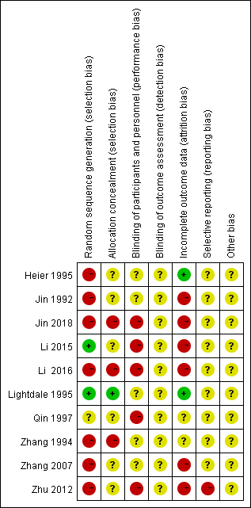
Figure 2 Risk of bias summary: review authors’ judgements regarding risk of bias item for each included study.

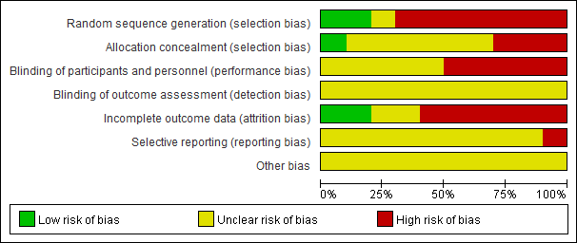
Figure 3 Risk of bias graph: review authors’ judgements regarding risk of bias items presented as percentages across all included studies.

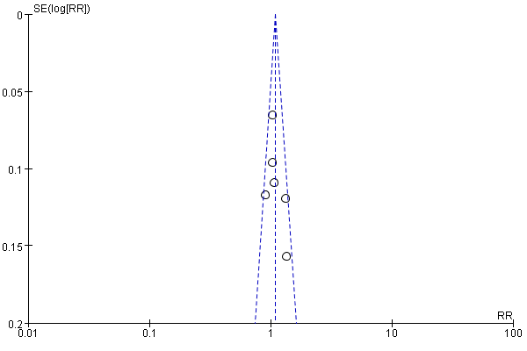
Figure 4 The funnel plot of the significant remission rate between photodynamic therapy combined with chemotherapy and photodynamic therapy/Chemotherapy discussion in middle-advanced upper gastrointestinal carcinoma. RR: Risk ratio.

A
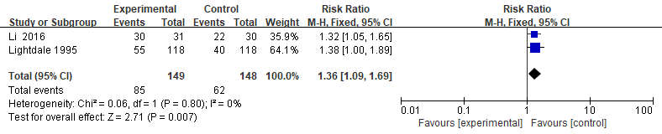

B

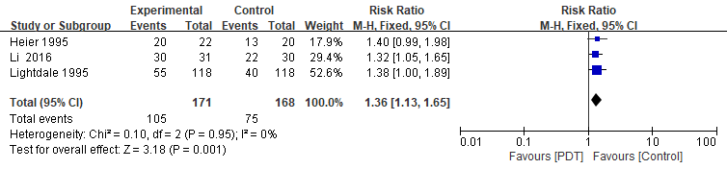

C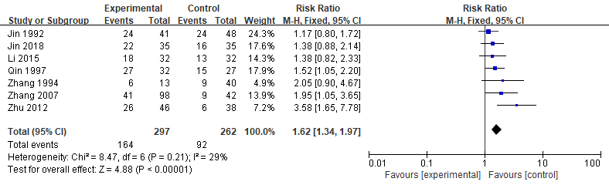

D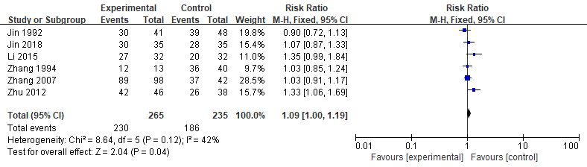
E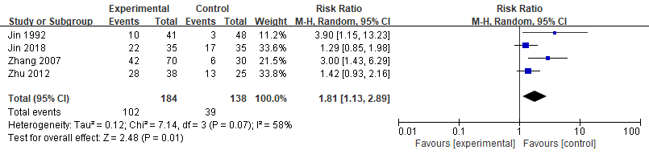

Figure 5 Forest plot of the risk ratio. A: Significant remission rate associated with middle-advanced stage upper gastrointestinal carcinomas; B: Effective rate associated with middle-advanced stage upper gastrointestinal carcinomas; C: Significant remission rate associated with middle-advanced stage upper gastrointestinal carcinomas; D: Effective rate associated with middle-advanced stage upper gastrointestinal carcinomas; E: One-year survival rate associated with middle-advanced stage upper gastrointestinal carcinomas. The box represents the RR point estimate of each study, and its area is proportional to the weight of the estimate. Horizontal lines represent the 95%CI. RR: Risk ratio; CI: Confidence interval.

Table 1 From inception to April 2018, 31 potential abstracts were obtained of which 10 randomized controlled trials studies met the criteria for the meta-analysis
Study | Study design | Time of cases  Included | Cancer type | Age (yr) | Gender  (M/F) | Sample  Size (E/C) |  | Intervention |  |  |  | Main outcomes
 |  |  |  |  |  |  |  | Experiment | Control
Jin et al^{[16]} | RCT | 1982.9-1990.7 | Advanced cardiac cancer | (34-91) | 139/5 | 144 (96/48) | PDT¹+CHT² |  |  |  | CHT² | SR, ER, MST, OSR
Zhang et al^{[17]} | RCT | 1990-1994 | Advanced upper gastrointestinal cancer | 56.8 (29-77） | 42/41 | 53 (13/40) |  | PDT¹+CHT³ |  | PDT¹ |  | SR, ER, MST
Heier et al^{[18]} | RCT | NA | Esophageal cancer | 69 (42-87) | 26/16 | 42 (22/20) |  | PDT⁴ |  | Nd:YAG⁵ |  | ER, AEs, KPS, EG
Lightdale et al^{[19]} | RCT | 1988.9-1992.8 | Esophageal cancer | 70 | 169/67 | 236 (118/118) |  | PDT⁶ |  | Nd:YAG⁷ |  | SR, ER, AEs, SP
Qin et al^{[20]} | RCT | 1993.6-1995.5 | Middle-advanced stage esophageal cancer | 58.6 (43-73) | 44/15 | 59 (32/27) |  | PDT⁸+RAT⁹ |  | RAT⁹ |  | SR
Zhang et al^{[21]} | RCT | NA | Advanced esophagocardiac cancer | 60.8 (40-81) | 111/29 | 140 (98/42) |  | PDT¹⁰+CHT³ |  | PDT¹⁰ |  | SR, ER, OSR
Zhou et al^{[22]} | RCT | 2007.12-2009.6 | Middle-advanced stage cardiac cancer | 59.5 (38-82) | 63/21 | 84 (46/38) |  | PDT¹¹+  CHT¹² |  | CHT¹² |  | SR, ER, OSR
Li et al^{[23]} | RCT | 2013.1-2014.10 | Middle-advanced stage  gastric cancer | NA | 45/19 | 64 (32/32） |  | PDT¹+CHT¹³ |  | PDT¹ |  | SR, ER, AEs
Li et al^{[24]} | RCT | 2013.2-2014.2 | Advanced  esophageal cancer | (53-83) | 40/22 | 61 (31/30） |  | PDT¹ |  | RAT¹⁴ |  | SR, ER, AEs
Jin et al^{[25]} | RCT | 2014.9-2015.9 | Advanced  esophageal cancer | (47-76) | 41/29 | 70 (35/35） |  | PDT¹+CHT¹⁵ |  | CHT¹⁵ |  | SR, ER, AEs, OSR
¹Haematoporphyrin derivative (5 mg/kg); ²UFTM (UFT 450 mg/d and mitomycin C 8-10 mg/wk); ³5-FU (250-500 mg/time); ⁴Photomedica (2 mg/kg); ⁵90 W; ⁶Porfimer sodium (2 mg/kg); ⁷15-90 W; ⁸PsD-007 (5 mg/kg); ⁹D_{T} 55 -70 Gy; ¹⁰PsD-007 (3-5 mg/kg); ¹¹PsD-007 (3-5 mg/kg); ¹²5-Fu (250-500 mg/time) + Bleomycin (15 mg/time); ¹³S-1 (40 mg/m²); ¹⁴D_{T} 40-50 Gy; ¹⁵NDP (80-100 mg/m²) + 5-FU (500-750 mg/m²). RCT: Randomized controlled trial; RAT: Radiotherapy; CHT: Chemotherapy; PDT: Photodynamic therapy; NA: Not available; M/F: Male/female; E/C: Experiment group/control group; AEs: Adverse events; SR: Significant remission rate; ER: Effective rate; MST: Mean survival time; OSR: One year survival rate; EG: Esophageal grade; SP: Symptom palliation.

