Name of Journal: World Journal of Radiology
Manuscript NO: 54747
Manuscript Type: Minireviews

Diagnostic problems in two-dimensional shear wave elastography of the liver

Naganuma H et al. Diagnostic problems in 2D-SWE

Hiroko Naganuma, Hideaki Ishida, Atsushi Uno, Hiroshi Nagai, Hidekatsu Kuroda, Masahiro Ogawa

Hiroko Naganuma, Department of Gastroenterology, Yokote Municipal Hospital, Yokote 0138602, Akita, Japan

Hideaki Ishida, Department of Gastroenterology, Akita Red Cross Hospital, Kamikitatesaruta 0101495, Akita, Japan

Atsushi Uno, Department of Gastroenterology, Oomori Municipal Hospital, Yokote 0130525, Akita, Japan

Hiroshi Nagai, New Generation Imaging Laboratory, Tokyo 1680065, Japan

Hidekatsu Kuroda, Division of Gastroenterology and Hepatology, Iwate Medical University, Morioka 0200023, Iwate, Japan

Masahiro Ogawa, Department of Gastroenterology and Hepatology, Nihon University Hospital, Chiyoda 1018309, Tokyo, Japan

Author contributions: Naganuma H designed the report, collected the patient’s clinical data, and generated the figures; Ishida H designed the report and wrote the paper; Uno A performed the computer simulation; Nagai H generated the figures; Kuroda H and Ogawa M collected the patient’s clinical data.

Corresponding author: Hiroko Naganuma, MD, PhD, Doctor, Department of Gastroenterology, Yokote Municipal Hospital, 5-31 Negishi-cho, Yokote 0138602, Akita, Japan. hiron@vesta.ocn.ne.jp

Received: February 25, 2020
Revised: April 19, 2020
Accepted: May 12, 2020
Published online: May 28, 2020

Abstract
Two-dimensional shear wave elastography (2D-SWE) is used in the clinical setting for observation of the liver. Unfortunately, a wide spectrum of artifactual images are frequently encountered in 2D-SWE, the precise mechanisms of which remain incompletely understood. This review was designed to present many of the artifactual images seen in 2D-SWE of the liver and to analyze them by computer simulation models that support clinical observations. Our computer simulations yielded the following suggestions: (1) When performing 2D-SWE in patients with chronic hepatic disease, especially liver cirrhosis, it is recommended to measure shear wave values through the least irregular hepatic surface; (2) The most useful 2D-SWE in patients with focal lesion will detect lesions that are poorly visible on B-mode ultrasound and will differentiate true tumors from pseudo-tumors (e.g., irregular fatty change); and (3) Measurement of shear wave values in the area posterior to a focal lesion must be avoided.

Key words: Two-dimensional shear wave elastography; Ultrasound; Artifacts; Liver cirrhosis; Liver tumor; Computer simulation model

Naganuma H, Ishida H, Uno A, Nagai H, Kuroda H, Ogawa M. Diagnostic problems in two-dimensional shear wave elastography of the liver. World J Radiol 2020; 12(5): 76-86
URL: https://www.wjgnet.com/1949-8470/full/v12/i5/76.htm
DOI: https://dx.doi.org/10.4329/wjr.v12.i5.76

Core tip: Two-dimensional shear wave elastography is the most widely used diagnostic tool for liver but has many ultrasound artifact-related problems. Our computer simulation model suggests the following ways to minimize them: (1) In patients with chronic hepatic disease, especially liver cirrhosis, measure shear wave values through the least irregular hepatic surface; (2) The most useful application in patients with focal lesions is detecting lesions poorly visible on B-mode ultrasound and differentiating true tumors from pseudo-tumors (e.g., irregular fatty change); and (3) Measurement of shear wave values in the area posterior to a focal lesion must be avoided.

INTRODUCTION
Although liver biopsy has long been the standard method for diagnosing chronic liver disease, it is associated with many problems, such as postbiopsy complications^{[1]}, sampling error^{[2]}, and interobserver variability^{[3]}. In a positive aspect, these problems motivated the development of noninvasive techniques to assess liver fibrosis, including magnetic resonance elastography^{[4-6]} and ultrasound (US)-based elastography^{[7-10]}. The latter has attained preferential use because of its lower cost and easier manipulation of the instrument^{[7-10]}. Currently, there are four kinds of US-based elastography, namely strain elastography^{[11]}, transient elastography^{[12]}, point shear wave elastography^{[13]}, and two-dimensional shear wave elastography (2D-SWE)^{[9,14,15]}. Among these methods, 2D-SWE has emerged as the most frequently used diagnostic US tool for hepatic fibrosis quantification; this is due to its ability to sample a large area in the liver, changing the sampling area quickly under B-mode observation and displaying a color mapping of shear wave (SW) values over the B-mode image^{[9,15]}. Measurement of SW values can be easily performed but it is also well known that the obtained SW values change according to the instrument itself and the level of expertise of the operator; as such, the certitude of those SW results is not always satisfactory^{[6,9,15]}. The other reasons for this instability have not been clarified.
This review reexamines the variability, using a method that is different from those in the commonly reported studies. US artifacts are routinely encountered in clinical practice and include refraction artifacts^{[16-18]}, attenuation artifacts^{[16,19,20]}, reflection artifact^{[16,21]}, reverberation artifacts^{[22]} and others^{[16,23,24]}. As use of 2D-SWE becomes more widespread, the problems related to US artifacts in it will be more important^{[25-27]}. The aim of this review was, thus, to present a wide spectrum of US artifacts in hepatic 2D-SWE and to provide the simplest way to minimize the effects of such.

THEORETICAL BASIS OF two-dimensional shear wave elastography
The push-pulse produces small tissue movements in the plane of the push-pulse. These tissue movements, in turn, produce SWs that propagate and produce other minimal tissue movements in the horizontal plane of the push-pulse. These movements in the horizontal plane further propagate through the tissue in a sideway direction, away from the push-pulse. These SW movements (strictly speaking, tissue movements produced by SWs) are tracked by the regular-interval tracking US pulses, which are used to measure the arrival time of SWs. The simple formula is arrival time of SW/distance from the push-pulse, used to determine the speed of SWs. Such a measurement is possible because the speed of SWs is very slow (< 1-10 m/s) compared to the speed of US pulses (around 1540 m/s) (Table 1)^{[28,29]}. There are two ways to quantify the relative tissue stiffness: SW speed expressed as m/s; and, kilopascal (kPa). Mostly, the SW speed is converted automatically to kPa, using the equation 1 kPa = 3 × P × (SW speed m/s)², with the assumption that the examined tissue is always homogeneous, and where P is the tissue density and defined as 1.00 kg/m³.
The 2D-SWE method uses emission of multiple acoustic push-pulse to generate SWs from multiple lines in the tissue (Figure 1). As the SWs propagate, they cause tissue displacement, and this very minimal displacement is tracked by conventional pulse-echo US beams^{[6,30,31]}. The US machine measures the propagation speed of SWs as they travel in tissue, and the measured SW speed at each point is displayed in color^{[6,32]}. The reconstructed 2D color mapping of SWs is called “2D-SWE” and facilitates recognition of global distribution of tissue elasticity of the area.

FACTORS THAT DEGRADE QUALITY OF two-dimensional shear wave elastography IMAGES
For all, these US artifact-related problems are more clearly shown upon use of propagation mode, which can determine the causal artifact.

Reverberation artifact
Acoustic reverberation of the push-pulse at the liver capsule results in a false increase in SW speed. Reverberation artifacts arise when the US signals reflects repeatedly between two interfaces of largely different acoustic impedance, resulting in delayed echoes returning to the transducer at regular intervals. This can lead to reverberation artifacts on grayscale US image^{[33]}. The same phenomenon of the push pulse is considered to occur between the liver capsule and the transducer. This phenomenon usually appears in the upper part of the cursor, presenting as a band of red (i.e. very increased SW speeds) (Figure 2). Thus, it is highly recommended to avoid this area when measuring SW values with SWE; if not, the results will be overestimated.

Attenuation artifact
Attenuation frequently occurs in a clinical setting and most commonly in obese or overweight patients. In these patients, a strongly attenuated push-pulse passing through the tissue results in poor creation of SWs at depth. This phenomenon usually appears at the distal part of the cursor, presenting as a colorless area (i.e. poor acquisition of SW data) (Figure 3). Thus, it is highly recommended to avoid this area when measuring SW values in obese or overweight patients.

Probe compression artifact
Excessive probe compression during image acquisition causes artificial compression of tissues just under the probe. This phenomenon is seen clearly when the liver is evaluated through subcostal scanning (Figure 4). SW measurement in the compressed area leads to a false elevation in SW values. A probe compression artifact appears near the probe, presenting as a reddish band. Thus, it is recommended not to compress the liver too much. The simplest way to avoid this artifact is to perform measurements through intercostal spaces only, where the liver tissue is less likely to be compressed by the probe.

Motion artifact
This phenomenon is seen clearly when the patient is unable to hold his/her breath or to change position quickly. Besides these extreme conditions, a motion artifact is usually seen when observing the left lobe of the liver, due to cardiac motion. Motion artifacts give rise to the characteristic image of a colorless area or a reddish area in the cursor, suggesting that SW values cannot be measured accurately in this area (Figure 5; see also, the section on tracking US beam-related problems below).

mechanisms underlying ultrasound artifact-related problems in two-dimensional shear wave elastography determined by a computer simulation model
US scanners reconstruct US images on the assumption that sound passes through all parts of the human body in a straight line and at a constant velocity, and apply this assumption to all scanning planes. Actually, however, these sound velocity in the human body varies with the composition of the tissue scanned. When a plane containing tissues with different velocities is scanned, sound refraction occurs at the interface of the tissues, according to Snell’s law (see later in “Discussion”). Computer simulation analysis helps understand the global images of refraction in the plane, measuring the degree of refraction at each point of the interface, not only in grayscale US image but also in 2D-SWE image.

2D-SWE in diffuse liver disease
2D-SWE has been reported as useful for assessing liver fibrosis with high accuracy^{[8,9,34-36]}. It is generally reported that SW speed increases as fibrosis advances^{[15, 37-39]}; thus, heterogeneous distribution of different degrees of fibrosis will create a heterogeneous color mapping in 2D-SWE. Measurement of liver stiffness is based on the following assumptions: (1) all push-pulses emitted from the transducer advance directly without deviation, at an even distance from each other; and (2) all SWs created from these push-pulses propagate horizontally at the same distance from the transducer. However, in reality, like conventional US beams, push-pulses refract at the liver surface (according to Snell’s law) because there is a large difference between the liver and the surrounding tissue and the hepatic surface is irregular.
Figure 6 shows the mode of propagation of push-pulses in the liver. As a result, SWs propagate in unassumed directions. This computer simulation model clearly teaches us an important lesson about measurement of SW speeds in liver cirrhosis. Furthermore, this speculation is in accordance with the findings from some studies with 2D-SWE measurements of healthy volunteers in whom the liver surface was smooth^{[40,41]}. In those studies, measurements by novice operators were not significantly different from those of experienced operators^{[31,40,42]}. Our computer simulation model shows that studies of normal liver do not contribute to resolving the problem of significant variability of SW values in liver cirrhosis. Although the measuring error is minimal, it is recommended to measure SW values through the least deformed hepatic surface possible.

2D-SWE in liver tumors
2D-SWE findings have been reported as useful for predicting tissue characterization of liver tumor, with markedly contradictory results^{[43-47]}. The most widely accepted method for diagnosing liver tumors by 2D-SWE is measurement of maximal or median SW values within the lesion^{[46-49]}. This method has long been performed but, as is shown in Figure 7, this idea is compromised by a combination of US refraction and reflection. The reported SW measurement of tumor stiffness is based on the following assumptions: (1) all SWs created from the push-pulses advance directly, without deviation, from the surrounding tissue toward the tumor and within the tumor; and (2) no reflection occurs at the interface between the surrounding tissue and liver tumor.
However, in reality, like conventional US beams, SWs refract at the interface (again, according to Snell’s law) because there is a large difference in propagation speed between the liver tumor and the surrounding tissue (Figure 7). Furthermore, the degree of refraction is thought to be more accentuated in 2D-SWE (1-10 m/s) than in conventional US (around 1540 m/s) (Figure 7B and C). The degree of reflection at the surrounding tissue-liver tumor interface is more accentuated in 2D-SWE, for the same reason. It is the deviation from the two above-mentioned assumptions that leads to the conclusion that accurate stiffness measurement of liver tumors is not possible by 2D-SWE, in most cases. This idea is in accordance with the American Institute of Ultrasound in Medicine recommendation that evaluation of liver tumor stiffness by 2D-SWE must be done with caution. Although, the SW value measurement inside the tumor is not highly accurate, this measurement is still valuable for judgement of relative stiffness of tumor and surrounding liver. However, conversely, this phenomenon helps in the detection of a liver tumor that is otherwise poorly visualized on B-mode (Figure 8) and in the differentiation of a pseudo-liver tumor (i.e., focal fatty infiltration^{[43]} or chronic hepatic porphyria^{[50]}) from a true liver tumor.

Tracking US beam-related problems
Finally, we would like to briefly mention refraction of tracking US beams. We mentioned earlier the influence of US artifacts on 2D-SWE, on the assumption that the tracking US pulses occur at regular intervals and advance straight from the transducer through the tissue. However, they deviate in some instances. Figure 9 shows such a case. US beams deviate twice when passing through a focal lesion, with one at the upper surrounding tissue-focal lesion interface and the other at the lower focal lesion-surrounding tissue interface. As a result, US beams propagating in tissue posterior to the focal lesion deviate; however, the US machine calculates SW values on the assumption that there is no deviation of US beams. Thus, this phenomenon suggests that SW measurements must be done in a plane that does not contain focal lesions.

DISCUSSION
In many reported studies, 2D-SWE has been shown to have a sufficient level of sensitivity in evaluating the degree of hepatic fibrosis^{[7-9,36]} but with significant heterogeneity of results. This heterogeneity has been considered due to variations among patient populations, study design, and devices used^{[49]}. Some of these studies have pointed to technical flaws in earlier studies but recent studies also show some instable results^{[45,46,51]}. These studies have brought into question whether they included the influence of US artifacts.
This review has an important strength in that it is a theoretical analysis not found in similar trials reported in the literature. Computer simulation model yields a purely theoretical analysis. In the case of gray-scale US images, the sound refraction produces artifactual images, because the US scanner displays each point at the appropriate distance determined by the time taken for the echo to return to the transducer in the direction in which the transducer is pointing at the time, even when the US beam is refracted. In the case of 2D-SWE as well, the US scanner reconstructs 2D-SWE images on the assumption that SW passes horizontally in a straight line, without deviation, and the US scanner displays SW velocity mapping on the basis of data measured by tracking pulses (determined by the time/distance). Computer simulation model enables us to calculate accurately and automatically the degree of refraction at each point, and understand the global image of refraction in the plane. This method is especially useful for understanding the global mode of refraction at the curved interface (tumor-surrounding tissue interface or surrounding tissue-irregular hepatic surface interface) (Figure10)^{[52-54]}. In short, it ensures that unfavorable factors, such as technical errors, differences in US machines used and different levels of 2D-SWE experience, or influence biased by additional clinical data, do not interfere in this analysis. It also maintains a high quality of interpretation. The SWE diagnosis is usually the so-called “final report” of the clinician and explains that it is necessarily correct. Our simulation model can be considered the basic thought of what the clinicians conclude. It is recommended, therefore, that as more practitioners are trained in 2D-SWE, our basic thought is used in clinical practice.

CONCLUSION
Two-dimensional shear wave elastography artifacts, although seen very frequently in a clinical setting, are poorly recognized. Our review emphasizes that interpretation of 2D-SWE images must incorporate knowledge of US artifacts.

REFERENCES
1 Midia M, Odedra D, Shuster A, Midia R, Muir J. Predictors of bleeding complications following percutaneous image-guided liver biopsy: a scoping review. Diagn Interv Radiol 2019; 25: 71-80 [PMID: 30644369 DOI: 10.5152/dir.2018.17525]
2 Rockey DC, Caldwell SH, Goodman ZD, Nelson RC, Smith AD; American Association for the Study of Liver Diseases. Liver biopsy. Hepatology 2009; 49: 1017-1044 [PMID: 19243014 DOI: 10.1002/hep.22742]
3 The French METAVIR Cooperative Study Group. Intraobserver and interobserver variations in liver biopsy interpretation in patients with chronic hepatitis C. Hepatology 1994; 20: 15-20 [PMID: 8020885 DOI: 10.1002/hep.1840200104]
4 Serai SD, Obuchowski NA, Venkatesh SK, Sirlin CB, Miller FH, Ashton E, Cole PE, Ehman RL. Repeatability of MR Elastography of Liver: A Meta-Analysis. Radiology 2017; 285: 92-100 [PMID: 28530847 DOI: 10.1148/radiol.2017161398]
5 Yin M, Venkatesh SK. Ultrasound or MR elastography of liver: which one shall I use? Abdom Radiol (NY) 2018; 43: 1546-1551 [PMID: 28988274 DOI: 10.1007/s00261-017-1340-z]
6 Kennedy P, Wagner M, Castéra L, Hong CW, Johnson CL, Sirlin CB, Taouli B. Quantitative Elastography Methods in Liver Disease: Current Evidence and Future Directions. Radiology 2018; 286: 738-763 [PMID: 29461949 DOI: 10.1148/radiol.2018170601]
7 Barr RG. Shear wave liver elastography. Abdom Radiol (NY) 2018; 43: 800-807 [PMID: 29116341 DOI: 10.1007/s00261-017-1375-1]
8 Ferraioli G, Wong VW, Castera L, Berzigotti A, Sporea I, Dietrich CF, Choi BI, Wilson SR, Kudo M, Barr RG. Liver Ultrasound Elastography: An Update to the World Federation for Ultrasound in Medicine and Biology Guidelines and Recommendations. Ultrasound Med Biol 2018; 44: 2419-2440 [PMID: 30209008 DOI: 10.1016/j.ultrasmedbio.2018.07.008]
9 Dietrich CF, Bamber J, Berzigotti A, Bota S, Cantisani V, Castera L, Cosgrove D, Ferraioli G, Friedrich-Rust M, Gilja OH, Goertz RS, Karlas T, de Knegt R, de Ledinghen V, Piscaglia F, Procopet B, Saftoiu A, Sidhu PS, Sporea I, Thiele M. EFSUMB Guidelines and Recommendations on the Clinical Use of Liver Ultrasound Elastography, Update 2017 (Long Version). Ultraschall Med 2017; 38: e16-e47 [PMID: 28407655 DOI: 10.1055/s-0043-103952]
10 Nadebaum DP, Nicoll AJ, Sood S, Gorelik A, Gibson RN. Variability of Liver Shear Wave Measurements Using a New Ultrasound Elastographic Technique. J Ultrasound Med 2018; 37: 647-656 [PMID: 28960385 DOI: 10.1002/jum.14375]
11 Frulio N, Trillaud H. Ultrasound elastography in liver. Diagn Interv Imaging 2013; 94: 515-534 [PMID: 23623211 DOI: 10.1016/j.diii.2013.02.005]
12 Castera L, Forns X, Alberti A. Non-invasive evaluation of liver fibrosis using transient elastography. J Hepatol 2008; 48: 835-847 [PMID: 18334275 DOI: 10.1016/j.jhep.2008.02.008]
13 Ferraioli G, Tinelli C, Lissandrin R, Zicchetti M, Bernuzzi S, Salvaneschi L, Filice C; Elastography Study Group. Ultrasound point shear wave elastography assessment of liver and spleen stiffness: effect of training on repeatability of measurements. Eur Radiol 2014; 24: 1283-1289 [PMID: 24643497 DOI: 10.1007/s00330-014-3140-y]
14 Yoo J, Lee JM, Joo I, Yoon JH. Assessment of liver fibrosis using 2-dimensional shear wave elastography: a prospective study of intra- and inter-observer repeatability and comparison with point shear wave elastography. Ultrasonography 2020; 39: 52-59 [PMID: 31623416 DOI: 10.14366/usg.19013]
15 Zheng J, Guo H, Zeng J, Huang Z, Zheng B, Ren J, Xu E, Li K, Zheng R. Two-dimensional shear-wave elastography and conventional US: the optimal evaluation of liver fibrosis and cirrhosis. Radiology 2015; 275: 290-300 [PMID: 25575116 DOI: 10.1148/radiol.14140828]
16 Quien MM, Saric M. Ultrasound imaging artifacts: How to recognize them and how to avoid them. Echocardiography 2018; 35: 1388-1401 [PMID: 30079966 DOI: 10.1111/echo.14116]
17 Konno K, Ishida H, Komatsuda T, Naganuma H, Sato M, Hamashima Y, Watanabe S. Image distortion in US-guided liver tumor puncture with curved linear array. Eur Radiol 2003; 13: 1291-1296 [PMID: 12764644 DOI: 10.1007/s00330-002-1711-9]
18 Sato M, Ishida H, Konno K, Komatsuda T, Furukawa K, Yamada M, Yagisawa H, Yoshida Y, Watanabe S. Analysis of refractive artifacts by reconstructed three-dimensional ultrasound imaging. J Med Ultrason (2001) 2006; 33: 11-16 [PMID: 27277613 DOI: 10.1007/s10396-005-0072-9]
19 Sato M, Ishida H, Konno K, Komatsuda T, Furukawa K, Yamada M, Yagisawa H, Yoshida Y, Watanabe S. Analysis of posterior echoes using reconstructed vertical ultrasound images. J Med Ultrason (2001) 2006; 33: 85-90 [PMID: 27277726 DOI: 10.1007/s10396-005-0078-3]
20 Konno K, Ishida H, Sato M, Komatsuda T, Ishida J, Naganuma H, Hamashima Y, Watanabe S. Liver tumors in fatty liver: difficulty in ultrasonographic interpretation. Abdom Imaging 2001; 26: 487-491 [PMID: 11503085 DOI: 10.1007/s00261-001-0005-z]
21 Ishida H, Konno K, Ishida J, Naganuma H, Komatsuda T, Sato M, Watanabe S. Splenic lymphoma: differentiation from splenic cyst with ultrasonography. Abdom Imaging 2001; 26: 529-532 [PMID: 11503094 DOI: 10.1007/s00261-001-0006-y]
22 Franquet T, Bescos JM, Barberena J, Montes M. Acoustic artifacts and reverberation shadows in gallbladder sonograms: their cause and clinical implications. Gastrointest Radiol 1990; 15: 223-228 [PMID: 2187731 DOI: 10.1007/bf01888781]
23 Naganuma H, Ishida H, Funaoka M, Fujimori S, Okuyama A, Odashima M, Takeuchi S, Hanaoka A. Mobile echoes in liver cysts: a form of range-ambiguity artifact. J Clin Ultrasound 2010; 38: 475-479 [PMID: 20848575 DOI: 10.1002/jcu.20746]
24 Naganuma H, Ishida H, Nagai H, Ogawa M, Ohyama Y. Range-ambiguity artifact in abdominal ultrasound. J Med Ultrason (2001) 2019; 46: 317-324 [PMID: 30888535 DOI: 10.1007/s10396-019-00938-2]
25 Dubinsky TJ, Shah HU, Erpelding TN, Sannananja B, Sonneborn R, Zhang M. Propagation Imaging in the Demonstration of Common Shear Wave Artifacts. J Ultrasound Med 2019; 38: 1611-1616 [PMID: 30380161 DOI: 10.1002/jum.14840]
26 Lin CY, Chen PY, Shau YW, Wang CL. An Artifact in Supersonic Shear Wave Elastography. Ultrasound Med Biol 2017; 43: 517-530 [PMID: 27793363 DOI: 10.1016/j.ultrasmedbio.2016.09.018]
27 Franchi-Abella S, Elie C, Correas JM. Ultrasound elastography: advantages, limitations and artefacts of the different techniques from a study on a phantom. Diagn Interv Imaging 2013; 94: 497-501 [PMID: 23567179 DOI: 10.1016/j.diii.2013.01.024]
28 Itoh K, Yasuda Y, Suzuki O, Itoh H, Itoh T, Tsao JW, Konishi T, Koyano A. Studies on frequency-dependent attenuation in the normal liver and spleen and in liver diseases, using the spectral-shift zero-crossing method. J Clin Ultrasound 1988; 16: 553-562 [PMID: 3152399 DOI: 10.1002/jcu.1870160804]
29 Goss SA, Johnston RL, Dunn F. Comprehensive compilation of empirical ultrasonic properties of mammalian tissues. J Acoust Soc Am 1978; 64: 423-457 [PMID: 361793 DOI: 10.1121/1.382016]
30 Bouchet P, Gennisson JL, Podda A, Alilet M, Carrié M, Aubry S. Artifacts and Technical Restrictions in 2D Shear Wave Elastography. Ultraschall Med 2018 [PMID: 30577047 DOI: 10.1055/a-0805-1099]
31 O'Hara S, Zelesco M, Rocke K, Stevenson G, Sun Z. Reliability Indicators for 2-Dimensional Shear Wave Elastography. J Ultrasound Med 2019; 38: 3065-3071 [PMID: 30887548 DOI: 10.1002/jum.14984]
32 Lee ES, Lee JB, Park HR, Yoo J, Choi JI, Lee HW, Kim HJ, Choi BI, Park HJ, Park SB. Shear Wave Liver Elastography with a Propagation Map: Diagnostic Performance and Inter-Observer Correlation for Hepatic Fibrosis in Chronic Hepatitis. Ultrasound Med Biol 2017; 43: 1355-1363 [PMID: 28431795 DOI: 10.1016/j.ultrasmedbio.2017.02.010]
33 Kremkau FW. Imaging and Doppler artifacts. In: Hagen-Ansert SL. Diagnostic sonography. St Louis: Elsevier, 2018: 119-137
34 Jian ZC, Long JF, Liu YJ, Hu XD, Liu JB, Shi XQ, Li WS, Qian LX. Diagnostic value of two dimensional shear wave elastography combined with texture analysis in early liver fibrosis. World J Clin Cases 2019; 7: 1122-1132 [PMID: 31183343 DOI: 10.12998/wjcc.v7.i10.1122]
35 Park HS, Choe WH, Han HS, Yu MH, Kim YJ, Jung SI, Kim JH, Kwon SY. Assessing significant fibrosis using imaging-based elastography in chronic hepatitis B patients: Pilot study. World J Gastroenterol 2019; 25: 3256-3267 [PMID: 31333316 DOI: 10.3748/wjg.v25.i25.3256]
36 Abe T, Kuroda H, Fujiwara Y, Yoshida Y, Miyasaka A, Kamiyama N, Takikawa Y. Accuracy of 2D shear wave elastography in the diagnosis of liver fibrosis in patients with chronic hepatitis C. J Clin Ultrasound 2018; 46: 319-327 [PMID: 29624693 DOI: 10.1002/jcu.22592]
37 Ferraioli G, Tinelli C, Dal Bello B, Zicchetti M, Filice G, Filice C; Liver Fibrosis Study Group. Accuracy of real-time shear wave elastography for assessing liver fibrosis in chronic hepatitis C: a pilot study. Hepatology 2012; 56: 2125-2133 [PMID: 22767302 DOI: 10.1002/hep.25936]
38 Leung VY, Shen J, Wong VW, Abrigo J, Wong GL, Chim AM, Chu SH, Chan AW, Choi PC, Ahuja AT, Chan HL, Chu WC. Quantitative elastography of liver fibrosis and spleen stiffness in chronic hepatitis B carriers: comparison of shear-wave elastography and transient elastography with liver biopsy correlation. Radiology 2013; 269: 910-918 [PMID: 23912619 DOI: 10.1148/radiol.13130128]
39 Herrmann E, de Lédinghen V, Cassinotto C, Chu WC, Leung VY, Ferraioli G, Filice C, Castera L, Vilgrain V, Ronot M, Dumortier J, Guibal A, Pol S, Trebicka J, Jansen C, Strassburg C, Zheng R, Zheng J, Francque S, Vanwolleghem T, Vonghia L, Manesis EK, Zoumpoulis P, Sporea I, Thiele M, Krag A, Cohen-Bacrie C, Criton A, Gay J, Deffieux T, Friedrich-Rust M. Assessment of biopsy-proven liver fibrosis by two-dimensional shear wave elastography: An individual patient data-based meta-analysis. Hepatology 2018; 67: 260-272 [PMID: 28370257 DOI: 10.1002/hep.29179]
40 Bende F, Mulabecirovic A, Sporea I, Popescu A, Sirli R, Gilja OH, Vesterhus M, Havre RF. Assessing Liver Stiffness by 2-D Shear Wave Elastography in a Healthy Cohort. Ultrasound Med Biol 2018; 44: 332-341 [PMID: 29249457 DOI: 10.1016/j.ultrasmedbio.2017.10.013]
41 Petzold G, Hofer J, Ellenrieder V, Neesse A, Kunsch S. Liver Stiffness Measured by 2-Dimensional Shear Wave Elastography: Prospective Evaluation of Healthy Volunteers and Patients With Liver Cirrhosis. J Ultrasound Med 2019; 38: 1769-1777 [PMID: 30536601 DOI: 10.1002/jum.14866]
42 Kim DW, Suh CH, Kim KW, Pyo J, Park C, Jung SC. Technical Performance of Two-Dimensional Shear Wave Elastography for Measuring Liver Stiffness: A Systematic Review and Meta-Analysis. Korean J Radiol 2019; 20: 880-893 [PMID: 31132814 DOI: 10.3348/kjr.2018.0812]
43 Qiu T, Ling W, Li J, Lu Q, Lu C, Li X, Zhu C, Luo Y. Can ultrasound elastography identify mass-like focal fatty change (FFC) from liver mass? Medicine (Baltimore) 2017; 96: e8088 [PMID: 28953628 DOI: 10.1097/MD.0000000000008088]
44 Praktiknjo M, Krabbe V, Pohlmann A, Sampels M, Jansen C, Meyer C, Strassburg CP, Trebicka J, Gonzalez Carmona MA. Evolution of nodule stiffness might predict response to local ablative therapy: A series of patients with hepatocellular carcinoma. PLoS One 2018; 13: e0192897 [PMID: 29444164 DOI: 10.1371/journal.pone.0192897]
45 Wang Y, Jia L, Wang X, Fu L, Liu J, Qian L. Diagnostic Performance of 2-D Shear Wave Elastography for Differentiation of Hepatoblastoma and Hepatic Hemangioma in Children under 3 Years of Age. Ultrasound Med Biol 2019; 45: 1397-1406 [PMID: 30979592 DOI: 10.1016/j.ultrasmedbio.2019.02.007]
46 Hu X, Huang X, Chen H, Zhang T, Hou J, Song A, Ding L, Liu W, Wu H, Meng F. Diagnostic effect of shear wave elastography imaging for differentiation of malignant liver lesions: a meta-analysis. BMC Gastroenterol 2019; 19: 60 [PMID: 31023234 DOI: 10.1186/s12876-019-0976-2]
47 Gerber L, Fitting D, Srikantharajah K, Weiler N, Kyriakidou G, Bojunga J, Schulze F, Bon D, Zeuzem S, Friedrich-Rust M. Evaluation of 2D- Shear Wave Elastography for Characterisation of Focal Liver Lesions. J Gastrointestin Liver Dis 2017; 26: 283-290 [PMID: 28922441 DOI: 10.15403/jgld.2014.1121.263.dsh]
48 Yoon K, Jeong WK, Kim Y, Kim MY, Kim TY, Sohn JH. 2-dimensional shear wave elastography: Interobserver agreement and factors related to interobserver discrepancy. PLoS One 2017; 12: e0175747 [PMID: 28414822 DOI: 10.1371/journal.pone.0175747]
49 Ryu H, Ahn SJ, Yoon JH, Lee JM. Reproducibility of liver stiffness measurements made with two different 2-dimensional shear wave elastography systems using the comb-push technique. Ultrasonography 2019; 38: 246-254 [PMID: 30744303 DOI: 10.14366/usg.18046]
50 Naganuma H, Ishida H, Yoshida M, Funaoka M, Ito S, Ohyama Y. Multinodular fatty change in the liver in three patients with chronic hepatic porphyria: Contribution of sonography to the diagnosis. J Clin Ultrasound 2019; 47: 165-168 [PMID: 30378127 DOI: 10.1002/jcu.22660]
51 Ferraioli G. Review of Liver Elastography Guidelines. J Ultrasound Med 2019; 38: 9-14 [PMID: 30444274 DOI: 10.1002/jum.14856]
52 Ishida H, Yagisawa H, Naganuma H, Konno K, Ohnami Y, Uno A, Masamune O. Rotation of the diaphragmatic echo behind the liver tumor. Clinical significance and computer analysis. Eur J Ultrasound 1996; 3: 267-275 [doi: 10.1016/0929-8266(95)00159-O]
53 Uno A, Ishida H, Konno K, Hamashima Y, Naganuma H, Komatsuda T, Sato M, Shindoh K, Oyake J, Watanabe S. Errors in measuring blood flow velocity behind hepatic mass lesions using color doppler sonography. J Med Ultrason (2001) 2003; 30: 133-140 [PMID: 27278303 DOI: 10.1007/BF02481218]
54 Konno K, Ishida H, Uno A, Naganuma H, Ohnami Y, Hamashima Y, Masamune O. Accuracy of liver puncture under US guidance: re-evaluation by microcomputer simulation model. J Clin Ultrasound 1997; 25: 127-132 [PMID: 9058261 DOI: 10.1002/(sici)1097-0096(199703)25:3<127::aid-jcu5>3.0.co;2-i]

Footnotes
Conflict-of-interest statement: The authors declare no conflicts of interest.

Open-Access: This article is an open-access article that was selected by an in-house editor and fully peer-reviewed by external reviewers. It is distributed in accordance with the Creative Commons Attribution NonCommercial (CC BY-NC 4.0) license, which permits others to distribute, remix, adapt, build upon this work non-commercially, and license their derivative works on different terms, provided the original work is properly cited and the use is non-commercial. See: http://creativecommons.org/licenses/by-nc/4.0/

Manuscript source: Invited manuscript

Peer-review started: February 25, 2020
First decision: April 7, 2020
Article in press: May 12, 2020

Specialty type: Radiology, nuclear medicine and medical imaging
Country/Territory of origin: Japan
Peer-review report’s scientific quality classification
Grade A (Excellent): 0
Grade B (Very good): 0
Grade C (Good): C, C
Grade D (Fair): 0
Grade E (Poor): 0

P- Reviewer: Lu Q, Shim J S- Editor: Zhang L L- Editor: A E- Editor: Liu MY

Figure Legends
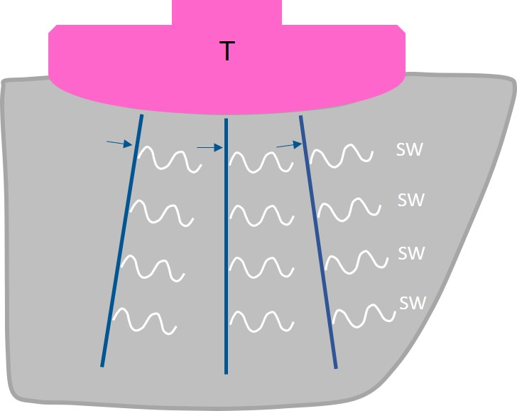
Figure 1 Schematic drawing of two-dimensional shear wave elastography in a healthy individual. Multiple push-pulses (arrows) are emitted from the transducer to create shear waves. T: Transducer; SW: Shear wave.

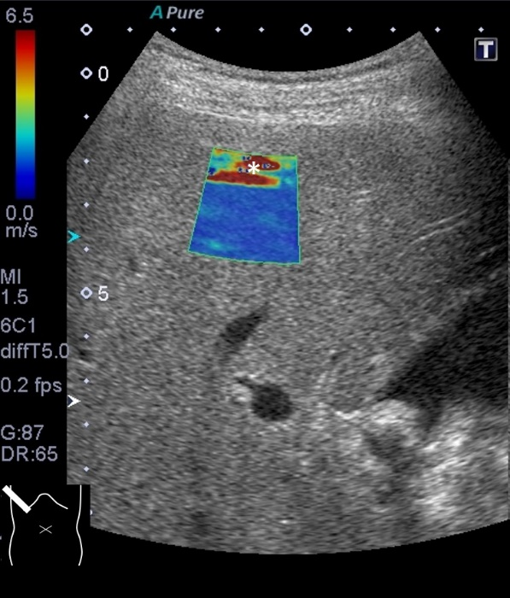
Figure 2 Reverberation artifact. The cursor contains a red (falsely increased shear wave) area (asterisk) at the top.

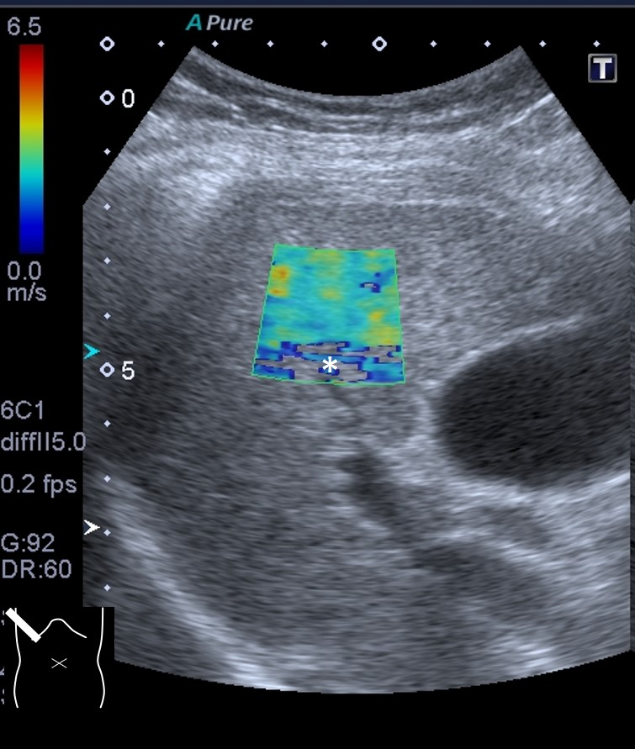
Figure 3 Attenuation artifact. The cursor includes a colorless area (asterisk indicating poor acquisition of shear wave data) at the bottom.

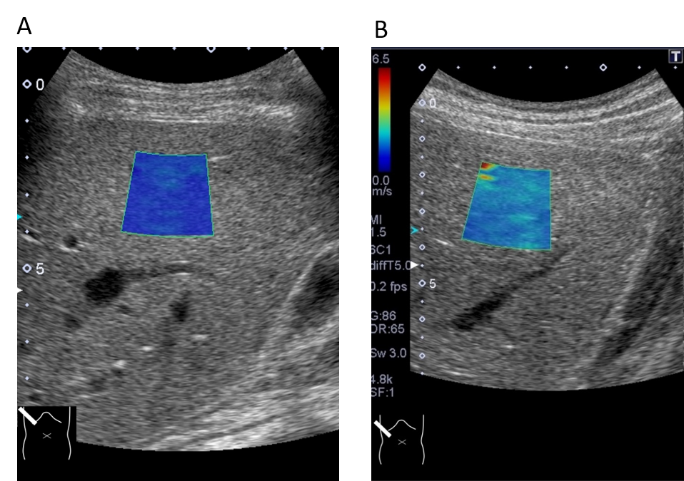
Figure 4 Probe compression artifact. Excessive probe compression gives rise to falsely increased shear wave values. A: Note that shear wave speed is 1.2 ± 0.06 m/s measured through an intercostal space; B: Changes to 2.0 ± 0.13 m/s through subcostal scanning under probe compression.

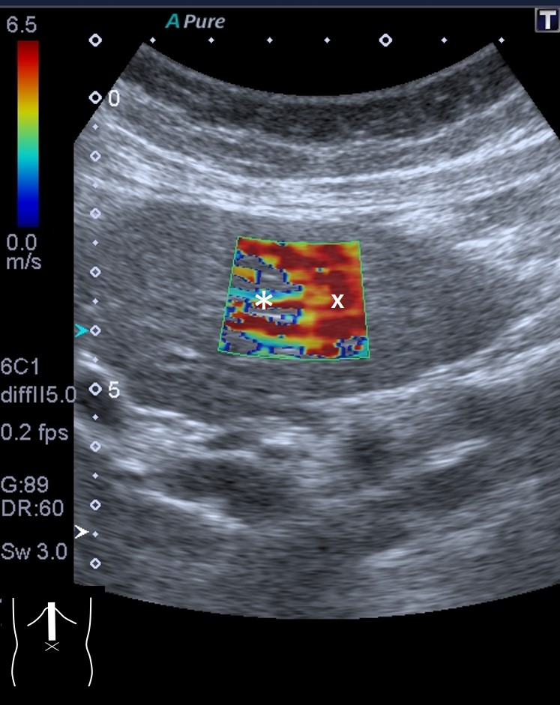
Figure 5 Motion artifact. Two-dimensional shear wave elastography of the liver left lobe shows this characteristic finding of a colorless area (asterisk), suggesting inaccurate measurement of shear wave values. The reddish part (×) of the cursor is also unreliable.

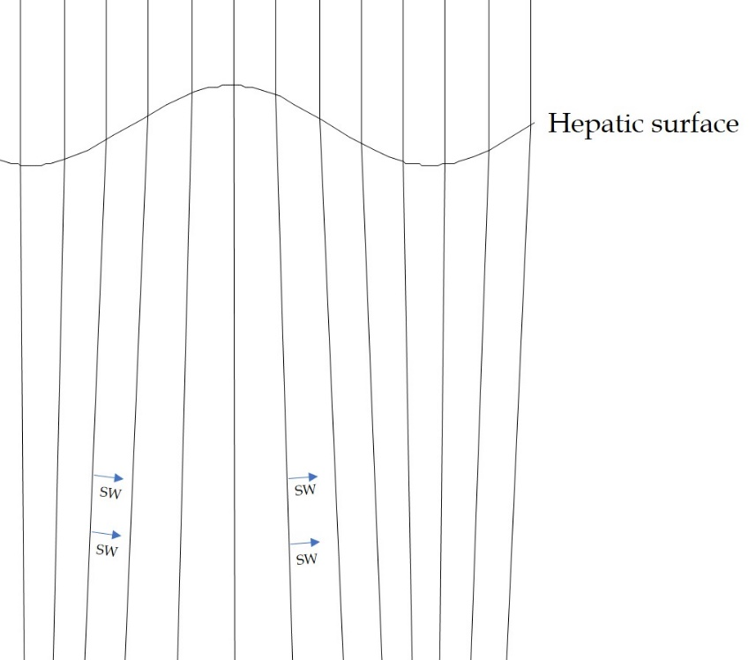
Figure 6 Computer simulation model of push-pulses in a cirrhotic patient. Push-pulses change direction at the irregular hepatic surface, according to Snell’s law. Shear wave (arrow). SW: Shear wave.
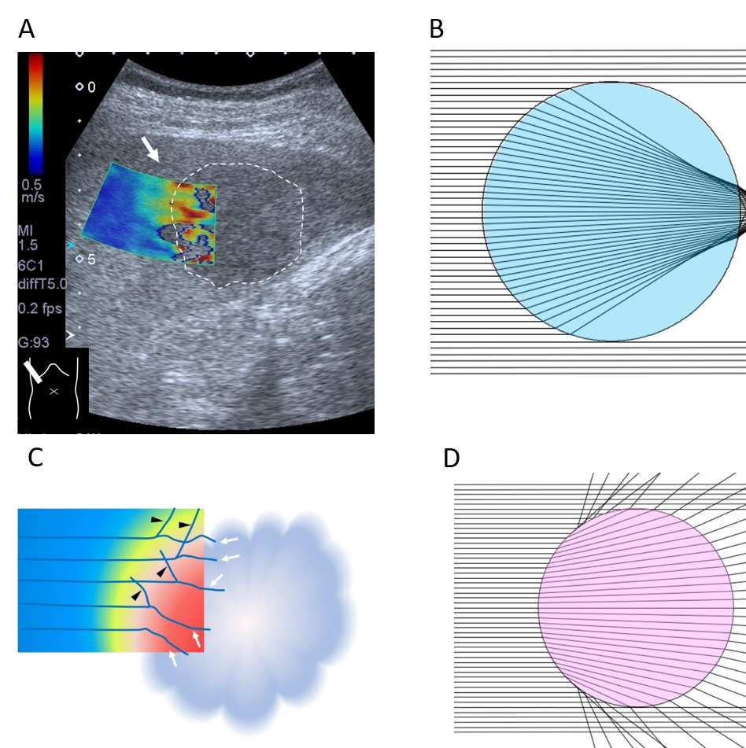
Figure 7 Two-dimensional shear wave elastography of liver tumor. A: Two-dimensional SW elastography of a liver tumor (encircled area) shows an irregular-shaped round area consisting of multiple layers of different colors (arrows); B: When the tumor has a lesser SW value than the surrounding tissue. Computer simulation model shows that all SWs deviate largely at the surrounding tissue (in this case, SW velocity 1.5 m/s) -liver tumor (in this case, SW velocity 1.0 m/s) interface; C: When the tumor has a greater SW value than the surrounding tissue. Computer simulation model shows that all SWs deviate largely at the surrounding tissue (in this case, SW velocity 1.5 m/s) -liver tumor (in this case, SW velocity 2.0 m/s) interface; D: Schematic drawing of mode of SWs around the surrounding tissue-liver tumor interface (arrows: deviated SWs; arrow heads: reflected SWs). SW: Shear wave.

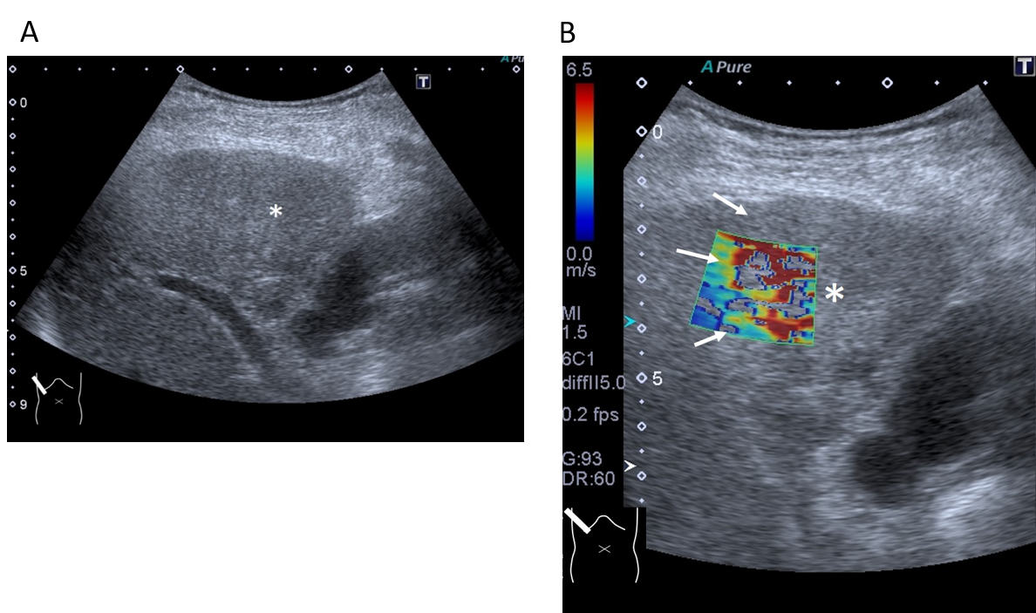
Figure 8 Representative case: intrahepatic cholangiocellular carcinoma. A and B: The lesion (asterisk) is poorly visible on B-mode (A) but it is well demarcated on two-dimensional shear wave elastography (B, arrow).

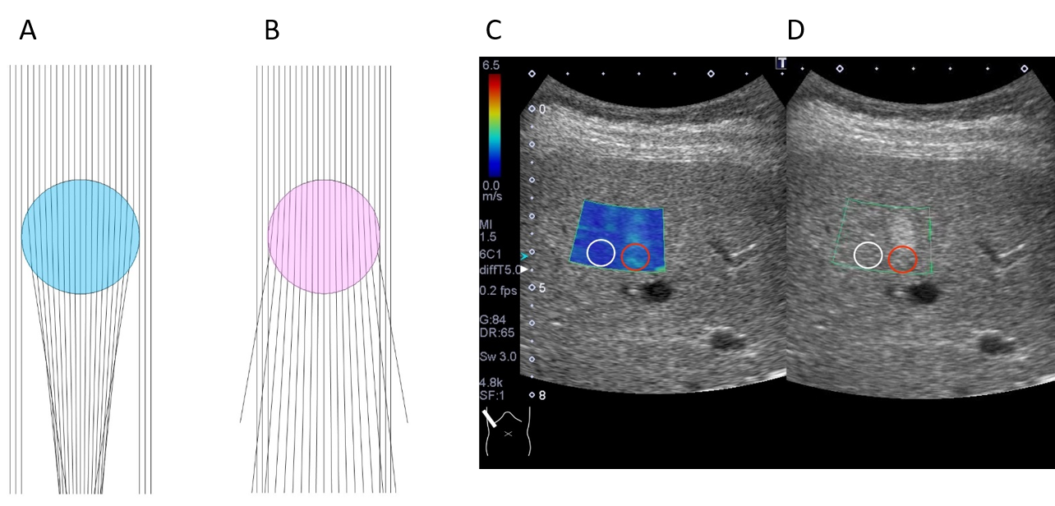
Figure 9 Computer simulation model of deviated push-pulses. A: Surrounding tissue acoustic speed is 1540 m/s and that of tumor (blue) is 1480 m/s; B: Surrounding tissue acoustic speed is 1540 m/s and that of tumor (pink) is 1600 m/s [A and B — the push-pulses change direction twice at two interfaces (upper and lower) of the surface of the lesion]; C: Two-dimensional shear wave elastography shows the posterior zone behind the lesion (red circle) to have a greater shear wave velocity (1.67 ± 0.19 m/s) than the surrounding hepatic tissue (1.07 ± 0.08 m/s) (white circle); D: Hepatic ultrasound reveals a 2 cm × 2 cm echogenic mass (hemangioma) in segment 5.

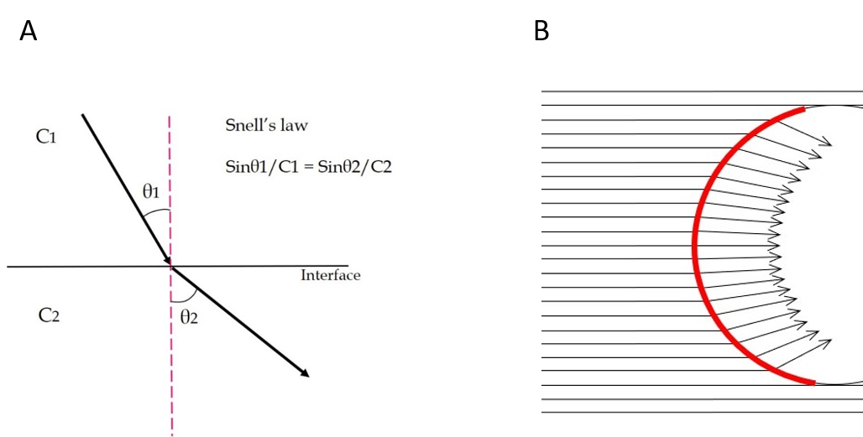
Figure 10 Sound refraction at the interface. A: Sound (or shear wave) refraction occurs at the straight interface between two structures of different acoustic (or shear wave) velocities, depending on Snell’s law. The degree of refraction is always the same. θ1: angle of incidence, θ2: angle of refraction, C1: sound (or shear wave) velocity in tissue 1, C2: sound (or shear wave) velocity in tissue 2; B: Sound (or shear wave) refraction at the curved interface. As the tumor (or cirrhotic liver surface) has a curved interface, the angle of incidence changes according to the incidental point. Thus, the angle of refraction changes also according to the incidental point. Red line: Curved interface.

Table 1 Acoustic characteristics of human tissues^{[28,29]}
Tissue | Sound velocity (m/s) | Acoustic impedance (× 10⁶ kg/m²・s) | Density (× 10³ kg/m³)
Liver | 1555 | 1.65 | 0.001
Fat | 1460 | 1.38 | 0.0009
Muscle | 1600 | 1.70 | 0.001
Water | 1480 | 1.48 | 0.007
Cited from references 28 and 29, with minimal modification.

