Name of Journal: World Journal of Clinical Cases

Manuscript NO: 41903

Manuscript Type: CASE REPORT

Psoriatic fasciitis in a pediatric patient: A case report

Otar Yener G et al. JPsA with fasciitis

Gulcin Otar Yener, Zahide Ekici Tekin, Selcuk Yuksel

Gulcin Otar Yener, Zahide Ekici Tekin, Selcuk Yuksel, Department of Pediatric of Rheumatology, Pamukkale University School of Medicine, Denizli 20070, Turkey

ORCID number: Gulcin Otar Yener (0000-0003-2575-6309); Zahide Ekici Tekin (0000-0002-5446-667X); Selcuk Yuksel (0000-0001-9415-1640).

Author contributions: Otar Yener G and Yuksel S designed the report; Otar Yener G, Ekici Tekin Z and Yuksel S collected the patient’s clinical data; Otar Yener G and Yuksel S analyzed the data and wrote the paper.

Informed consent statement: Consent was obtained from relatives of the patient for publication of this report and any accompanying images.

Conflict-of-interest statement: The authors declare that they have no conflicts of interest.

CARE Checklist (2016) statement: The manuscript was prepared and revised according to the guidelines of the CARE Checklist (2016).

Open-Access: This is an open-access article that was selected by an in-house editor and fully peer-reviewed by external reviewers. It is distributed in accordance with the Creative Commons Attribution Non Commercial (CC BY-NC 4.0) license, which permits others to distribute, remix, adapt, build upon this work non-commercially, and license their derivative works on different terms, provided the original work is properly cited and the use is non-commercial. See: http://creativecommons.org/licenses/by-nc/4.0/

Manuscript source: Invited manuscript

Corresponding author: Selcuk Yuksel, MD, Professor, Department of Pediatric Rheumatology, Pamukkale University School of Medicine, Pamukkale, Denizli 20070, Turkey. selcuky@pau.edu.tr
Telephone: +90-258-2965410
Fax: +90-258-2966001

Received: September 3, 2018

Peer-review started: September 3, 2018

First decision: November 1, 2018
Revised: November 26, 2018

Accepted: December 12, 2018

Article in press: December 12, 2018

Published online: January 6, 2019

Abstract

BACKGROUND
Diffuse fasciitis with psoriatic arthritis on magnetic resonance imaging (MRI) has not been previously described in childhood. Here we present the first case report of a pediatric patient developing fasciitis, beyond plantar fasciitis, with psoriatic arthritis.

CASE SUMMARY
An 11-year-old female was admitted with the complaints of psoriatic rash on the body associated with severe pain in the lower extremities and arthritis in the right knee. Psoriasis was confirmed by skin biopsy, she diagnosed with juvenile psoriatic arthritis. Diagnostic tests did not indicate any pathology except MRI. MRI of the femur and tibia revealed that high-signal inflammatory changes in the subdermal fascia. These findings led to a diagnosis of psoriatic fasciitis. Methotrexate was given for 3 mo but the patient showed no response to therapy; therefore, etanercept was added. However, there was no response to treatment. Etanercept was switched to adalimumab at the sixth month of therapy. Clinical improvement started with therapy of adalimumab within one month. Fasciitis finding in MRI disappeared at seventh months on adalimumab therapy. She has no complaint for two years with adalimumab.

CONCLUSION
The most effective imaging method is MRI and adalimumab may be the best choice of treatment for psoriatic fasciitis.

Key words: Case report; Fasciitis; Psoriasis; Childhood; Arthritis

© The Author(s) 2019. Published by Baishideng Publishing Group Inc. All rights reserved.

Core tip: Plantar fasciitis may be observed on magnetic resonance imaging (MRI) in patients with psoriatic arthritis. However, to our knowledge, MRI findings of diffuse fasciitis associated with psoriatic arthritis have not been previously described in a pediatric patient. Fasciitis should be considered in patients with psoriatic arthritis, especially with unresolved extremity pain. MRI seems to be the most effective imaging method and adalimumab may be the best choice of treatment for psoriatic fasciitis.

Citation: Otar Yener G, Ekici Tekin Z, Yuksel S. Psoriatic fasciitis in a pediatric patient: A case report. World J Clin Cases 2019; 7(1): 69-72
URL: https://www.wjgnet.com/2307-8960/full/v7/i1/69.htm
DOI: https://dx.doi.org/10.12998/wjcc.v7.i1.69

INTRODUCTION
Juvenile psoriatic arthritis (JPsA) is a rare disease characterized by psoriasis and arthritis in childhood. According to the International League of Associations for Rheumatology (ILAR) criteria, children with arthritis and psoriasis can be diagnosed with JPsA, as well as children presenting with arthritis and at least two of three features: dactylitis, nail changes, or psoriasis in a first-degree relative^{[1]}.
Plantar fasciitis may be observed on magnetic resonance imaging (MRI) in patients with psoriatic arthritis^{[2]}. However, to our knowledge, MRI findings of diffuse fasciitis associated with psoriatic arthritis have not been previously described in a pediatric patient.

CASE PRESENTATION

Chief complaints
An 11-year-old female patient presented with psoriatic rash on the body associated with severe pain in the lower extremities and arthritis in the right knee.

History of present illness
She reported worsening pain in the legs for the past 6 mo that did not improve despite taking nonsteroidal anti-inflammatory drugs.

History of past illness
She had 1-year history of cutaneous rash on her extremities. Skin biopsy confirmed psoriasis and she was under treatment with topical steroids.

Personal and family history
Her medical history was unremarkable except for psoriasis. There was no consanguineous marriage or family history of significant disease.

Physical examination upon admission
On physical examination, psoriatic rashes were observed on the extensor surfaces of the patient’s arms and legs. She had arthritis of the right knee and also, she reported myalgia associated with psoriatic rash in the lower extremities. Her vital signs were normal but weight was in the 90th-97th percentile range. Her vital signs were normal but weight was in the 90th-97th percentile range. Respiratory, cardiovascular, and gastrointestinal system examinations were normal. Eye examination performed by an ophthalmologist revealed no pathologies such as uveitis.

Laboratory examinations
Laboratory results for complete blood account, complete urinalysis, acute-phase reactants, liver and renal function tests, serum complement (C3, C4), muscle enzymes (creatine kinase, lactate dehydrogenase, aspartate amino transferase), and antistreptolysin O were normal. All viral serological (Epstein–Barr virus, cytomegalovirus, hepatitis B and C, Toxoplasmosis, rubella, human immunodeficiency virus) and bacterial (Brucella, syphilis, Borrelia burgdorferi) tests were negative. Rheumatologic serological investigations investigations (ANA, HLA B27, Anti CCP and rheumatoid factor) were also negative. Genetic testing for autoinflammatory diseases revealed no pathology (MEFV, MVK, NLRP3, NLRC4, CASP10, CASP3, PSMB8, SLC29A3, CASP1, TNFRSF1A, PSTPIP1, PYCARD, NOD2, PLCG2, NLRP1, CARD8, NLRP12 genes were tested). Chest X-ray, echocardiography, abdominal ultrasound, and electroneuromyography were normal. A muscle biopsy revealed normal findings. In the absence of signs of other conditions included in the differential diagnosis, such as infection, malignancy, and autoinflammatory diseases, a diagnosis of JPsA was considered.

Imaging examinations
MRI was performed due to the patient’s severe lower extremity pain. T2-weighted images of the femur and tibia revealed high-signal inflammatory changes in the subdermal fascia (Figure 1).

FINAL DIAGNOSIS
The patient with arthritis and psoriasis was diagnosed with JPsA. All of these findings led to a final diagnosis of psoriatic fasciitis.

TREATMENT
For treatment methotrexate (15 mg/wk) was given for 3 mo but the patient showed no response to therapy; therefore, etanercept (0.8 mg/kg per week) was added. However, there was no response to treatment. After 3 mo of etanercept treatment, the patient’s pain and skin eruptions persisted, so treatment was switched to adalimumab (40 mg every second week).

OUTCOME AND FOLLOW-UP
Clinical improvement started with therapy of adalimumab within one month. Significant clinical improvement was seen, with regression of the cutaneous lesions and resolution of the MRI findings after 7 months of the adalimumab treatment. After the therapy, she had no pain or rash in any of her extremities during the 2-year follow-up period.

DISCUSSION
Psoriasis is a common chronic inflammatory skin disease characterized by the development of erythematous skin and scar plaques. Children presenting with both arthritis and psoriasis or other psoriatic criteria may be diagnosed with JPsA^{[1]}. Inflammation may involve a single joint or multiple joints, with or without involvement of the sacroiliac joints, the spinal column, or peripheral entheses. Dactylitis is a common manifestation in younger children, whereas axial arthritis and enthesitis are more common in older children^{[3]}. And also, a current a report from GRAPPA emphasized that JPsA was usually presented with peripheral arthritis in early childhood, and late-onset JPsA was usually presented with enthesitis and axial arthritis features. Identification of these differences in classification is important to provide that late onset JPsA are successfully transferred from pediatric to adult care^{[4]}.
To our knowledge, this is the first report of a pediatric patient developing diffuse fasciitis with psoriatic arthritis. Bains et al^{[5]} reported a 26-year-old adult patient with psoriatic arthritis who underwent fluorodeoxyglucose positron emission tomography-computed tomography imaging, which showed an uncommon imaging pattern with muscle and fascial involvement. In addition, two patients with psoriatic arthritis who had biopsy-proven eosinophilic fasciitis have been reported^{[6,7]}. However, there was no peripheral eosinophilia in our patient and her muscle biopsy was normal.
Autoinflammatory disease with fasciitis, such as tumor necrosis factor receptor-associated periodic syndrome (TRAPS), has also been reported. Hull et al^{[8]} presented a case of TRAPS associated with monocytic fasciitis in MRI examinations performed due to diffuse skin sensitivity and localized myalgia, similar to the clinical presentation of our case. They detected edematous changes in the muscle compartments and surrounding soft tissues of the left femur on MRI. Their pathologic examination revealed inflammation of the fascia and tendon comprising lymphocytes and macrophages along with tissue destruction, dissolution, and necrosis, while myofibers and endomysium were normal. The authors attributed their patient’s myalgia and rash to the distribution of inflammation throughout the fascial planes. Similarly, in our patient MRI revealed fasciitis corresponding to the region of arthralgia and muscle pain in the right knee. Our patient’s myalgia was due to fasciitis, but the biopsy showed no alterations in the muscle tissue.

CONCLUSION
In conclusion, psoriatic fasciitis presents its exceptionally unusual occurrence in a patient with JPsA. Fasciitis should be considered in patients with psoriatic arthritis, especially those with unresolved extremity pain. MRI seems to be the most effective imaging method and adalimumab may be the best choice of treatment.

REFERENCES
1 Petty RE, Southwood TR, Manners P, Baum J, Glass DN, Goldenberg J, He X, Maldonado-Cocco J, Orozco-Alcala J, Prieur AM, Suarez-Almazor ME, Woo P; International League of Associations for Rheumatology. International League of Associations for Rheumatology classification of juvenile idiopathic arthritis: second revision, Edmonton, 2001. J Rheumatol 2004; 31: 390-392 [PMID: 14760812]
2 Erdem CZ, Tekin NS, Sarikaya S, Erdem LO, Gulec S. MR imaging features of foot involvement in patients with psoriasis. Eur J Radiol 2008; 67: 521-525 [PMID: 17997068 DOI: 10.1016/j.ejrad.2007.08.005]
3 Stoll ML, Zurakowski D, Nigrovic LE, Nichols DP, Sundel RP, Nigrovic PA. Patients with juvenile psoriatic arthritis comprise two distinct populations. Arthritis Rheum 2006; 54: 3564-3572 [PMID: 17075862 DOI: 10.1002/art.22173]
4 Zisman D, Stoll ML, Butbul Aviel Y, Mellins ED. Juvenile Psoriatic Arthritis: A Report from the GRAPPA 2017 Annual Meeting. J Rheumatol Suppl 2018; 94: 11-16 [PMID: 29858347 DOI: 10.3899/jrheum.180131]
5 Bains S, Reimert M, Win AZ, Khan S, Aparici CM. A Patient with Psoriatic Arthritis Imaged with FDG-PET/CT Demonstrated an Unusual Imaging Pattern with Muscle and Fascia Involvement: A Case Report. Nucl Med Mol Imaging 2012; 46: 138-143 [PMID: 24900049 DOI: 10.1007/s13139-012-0137-9]
6 Hariman R, Patel P, Strouse J, Collins MP, Rosenthal A. Development of Eosinophilic Fasciitis during Infliximab Therapy for Psoriatic Arthritis. Case Rep Rheumatol 2016; 2016: 7906013 [PMID: 27293946 DOI: 10.1155/2016/7906013]
7 Wright GD, Thornton C, Keegan DA, Bell AL. Eosinophilic fasciitis presenting as psoriatic arthropathy. Ulster Med J 1992; 61: 112-115 [PMID: 1621293]
8 Hull KM, Wong K, Wood GM, Chu WS, Kastner DL. Monocytic fasciitis: a newly recognized clinical feature of tumor necrosis factor receptor dysfunction. Arthritis Rheum 2002; 46: 2189-2194 [PMID: 12209524 DOI: 10.1002/art.10448]

P-Reviewer: Palmirotta R S-Editor: Ma RY L-Editor: A E-Editor: Bian YN
Specialty type: Medicine, research and experimental
Country of origin: Turkey
Peer-review report classification
Grade A (Excellent): 0
Grade B (Very good): 0
Grade C (Good): C
Grade D (Fair): 0
Grade E (Poor): 0

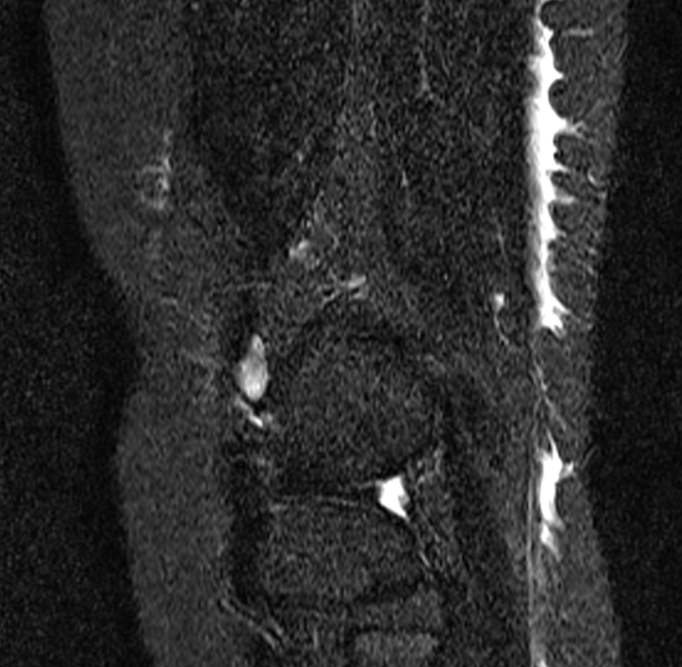
Figure 1 Magnetic resonance imaging of the femur and tibia. High signal inflammatory change in the subdermal fascia.

