Name of Journal: World Journal of Clinical Cases
Manuscript NO: 70161
Manuscript Type: CASE REPORT

Unusual glomus tumor of the lower leg: A case report

Wang HY et al. A case report of glomus tumor

Han-Yu Wang, Ping Duan, Hui Chen, Zhen-Yu Pan

Han-Yu Wang, Ping Duan, Hui Chen, Zhen-Yu Pan, Department of Orthopedics, Zhongnan Hospital of Wuhan University, Wuhan 430000, Hubei Province, China

Author contributions: Pan ZY completed the operation and completed the revision of the manuscript; Wang HY and Duan P completed the follow-up and wrote the manuscript; and Chen H collected the data; all authors read and approved the final manuscript.

Corresponding author: Zhen-Yu Pan, MD, PhD, Chief Physician, Professor, Department of Orthopedics, Zhongnan Hospital of Wuhan University, No. 169 Donghu Road, Wuchang District, Wuhan 430000, Hubei Province, China. soloistp@126.com

Received: July 25, 2021
Revised: November 4, 2021
Accepted: February 27, 2022
Published online: April 16, 2022

Abstract
BACKGROUND
Glomus tumors are rare neoplasms, usually found on the fingers or toes. Glomus tumours that occur in the lower leg are even rarer and is likely to be misdiagnosed or underdiagnosed. This article will document the diagnosis, treatment, and follow-up of a rare glomus tumor of the lower leg, which had been misdiagnosed for up to 15 years.

CASE SUMMARY
The patient was a A 36-year-old woman who had suffered from localized pain in her left lower leg for 15 years. After a complete physical examination, a glomus tumor on her lower leg was considered and removed surgically. The specimen was pathologically diagnosed as a glomus tumor. There was no relapse at a 4-year follow-up.

CONCLUSION
Correct diagnosis and complete removal of the glomus tumor is important.

Key Words: Glomus tumor; Pain; Lower leg; Case report

©The Author(s) 2022. Published by Baishideng Publishing Group Inc. All rights reserved.

Citation: Wang HY, Duan P, Chen H, Pan ZY. Unusual glomus tumor of the lower leg: A case report. World J Clin Cases 2022; 10(11): 3485-3489
URL: https://www.wjgnet.com/2307-8960/full/v10/i11/3485.htm
DOI: https://dx.doi.org/10.12998/wjcc.v10.i11.3485

Core Tip: A 36-year-old woman who had suffered from localized pain in her left lower leg had been misdiagnosed for up to 15 years. She was eventually diagnosed with glomus tumor and underwent surgical treatment. The patient recovered well with no recurrence observed at a 4-year follow-up.

INTRODUCTION
Glomus tumor (GT), a rare neoplasm caused by degenerated smooth muscle cells in a neuro-arterial adenoma, regulates body temperature through arteriovenous shunting of blood^{[1,2]}. Most GTs are benign, with few malignant cases reported^{[3,4]}. The characteristic clinical manifestations of GT are spontaneous lancinating pain, extreme pain with the slightest touch, and intolerance to temperature changes^{[5]}. It usually presents as a well-defined, blue or red nodule, often located on the fingers or toes, especially in the nail bed, and uncommon elsewhere^{[6]}. Individual literatures have reported GTs occurring in rare sites such as sinonasal location, but more evidences are needed to verify this^{[7]}. We reviewed the literature and found that GT was infrequently reported in the lower leg, thus, it is likely to be misdiagnosed or underdiagnosed. In this article, we report the diagnosis, treatment and follow-up of a rare case of GT of the lower leg, which was misdiagnosed for up to 15 years because of its small number of favored sites and size. The tumor was removed surgically and the patient had complete remission after surgery. This case can enhance our understanding of the rare location of GTs to decrease misdiagnosis and missed diagnosis.

CASE PRESENTATION
Chief complaints
A 36-year-old Asian woman was admitted to our hospital on April 25, 2016 with localized pain in the left anterior tibial region for 15 years.

History of present illness
The patient had visited several hospitals in the past 15 years but was diagnosed with venous thrombosis, which did not improve with conservative treatment such as analgetics. Over the past three years, the patient's pain had progressively worsened, and was exacerbated by touch, temperature changes and mood swings. In addition, the patient often had a poor sleep at night because of the pain.

History of past illness
No special history of past illness.

Personal and family history
There was no personal history of GT or any other family medical history.

Physical examination
Physical examination revealed mildly localized swelling on the on left leg along with tenderness in a 50 mm × 30 mm area of skin on the anterior medial aspect of her left lower extremity, with no ulceration or warmth.

Laboratory examinations
No obvious abnormality was found in laboratory examination.

FINAL DIAGNOSIS
After careful consideration of the patient's medical history and physical examination findings, including spontaneous tingling, minimal tenderness and intolerance to temperature changes, we made a tentative diagnosis of GT.

TREATMENT
After a thorough preoperative examination and confirming no surgical contraindications, the patient underwent soft tissue lesion resection, biopsy and flap transposition on April 27, 2016 (Figure 1A). Intra-operative examination showed an oval tumor with a light red colour, firm texture, intact envelope and clear contours under the skin of her lower leg.
We completely removed the tumor and the surrounding normal soft tissue, which was approximately 10 mm in thickness and 50 mm × 30 mm in size, for pathological diagnosis (Figure 1B). Because of the skin and soft-tissue defect, we designed a lateral gastrocnemius nutrition flap of the left lower limb to cover it (Figure 1C).

OUTCOME AND FOLLOW-UP
The pathological examination at our hospital showed a spindle cell tumor (Figure 1D). The results of immunohistochemistry were as follows: Ki-67 (3%, partially up to 10%), Caldesmon(+), CK(-), P63(-), S-100(-), SMA(part+), VIMENTIN(+), GFAP(-), CD31(-), CD34(-), HMB45(-). The examination results at two other tertiary hospitals confirmed it to be a GT. Suturing was performed two weeks after surgery. The wound healed well, and the survival of the skin flap was satisfactory (Figure 1E). There was no abnormality in blood flow, sensation and movement of her left lower limb. At the one-month follow up, the wound was well healed and patient was pain free. No recurrence of pain was observed during a 4-year follow-up (Figure 1F).

DISCUSSION
GTs were firstly reported by Wood in 1812 as "painful subcutaneous tubercle"^{[8]}. It was not until 1924 that Masson et al named it GT after pathological analysis^{[5]}. GTs are most commonly encountered on the fingers^{[9]}. It has been reported to be very rare, accounting for 1% to 2% of all soft tissue tumors, most of which are benign^{[3,4,10]}. The characteristic clinical manifestations of GTs are subcutaneous blue or red nodules, firm and smooth, usually no more than 10 mm in diameter. Pain is the most obvious symptom of the disease, usually presenting as spontaneous tingling, extreme pain with the slightest touch, and intolerance to temperature changes^{[5,11]}. In addition to these obvious symptoms, uncommon presentations such as tumor-induced osteomalacia were also reported, but more evidences are needed to support this discovery^{[12]}. The disease diagnosis depends on clinical tests such as the Love test (point tenderness) and Hildreth's sign (decreased pain on exsanguination of the limb and application of a tourniquet)^{[13]}. In addition to qualitative diagnosis, characteristic pain can also be used to localize the lesion. Magnetic resonance imaging (MRI) is occasionally helpful, and hyperenhanced lesions on T2 weighted and short time inversion recovery sequence imaging may illustrate the vascular appearance of GT. Other imaging examinations may include plain radiography, computed tomography and colour Doppler ultrasonography. However, all of the above may be negative and exploration of the painful location should be considered if a GT is suspected even if the MRI findings are negative^{[14]}.
In the present case, the tumor was located in the left anterior tibial region, which is relatively rare, so it had been misdiagnosed as venous thrombosis or sciatica resulting in chronic pain for up to 15 years. On the one hand, the initial symptom was pain, which would be easily confused with skin disease, thrombotic diseases, etc., when the disease is located in the lower leg. On the other hand, the huge size of this tumor is extremely rare in this disease. A study of 138 cases suggested that the median size of superficial GT was 8 mm, with none exceeding 45 mm^{[1]}, while the size of the tumor in our case was up to 50 mm in size.
Once diagnosed, surgical resection is an effective method for the treatment of GT. It should still be noted that recurrence may occur due to incomplete resection. We should therefore remove the tumor completely during surgery via avoiding residuals and expanding the resection area when conditions permit^{[15]}. In previous case reports, a simple excisional approach has generally been used. In our case, we used an innovative combination of extended tumor resection and flap transposition due to the large volume of the tumor to avoid soft tissue defects while resecting the tumor completely. The patient recovered well after the surgery with no recurrence observed during the 4 years of follow-up. The patient was satisfied with the surgery and recovered well.

CONCLUSION
The patient with glomus tumor had visited many specialists and underwent numerous examinations before receiving a correct diagnosis. Correct diagnosis and surgical treatment eventually healed her. Remaining alert to rare diseases can be an effective way to avoid them.

REFERENCES
1 Mravic M, LaChaud G, Nguyen A, Scott MA, Dry SM, James AW. Clinical and histopathological diagnosis of glomus tumor: an institutional experience of 138 cases. Int J Surg Pathol 2015; 23: 181-188 [PMID: 25614464 DOI: 10.1177/1066896914567330]
2 Singh D, Garg RS, Vikas, Garg Y, Arora V. Glomus Tumor - A Rarity; M.R.I- A big help in early Diagnosis. J Orthop Case Rep 2016; 6: 38-39 [PMID: 28116265 DOI: 10.13107/jocr.2250-0685.494]
3 McDermott EM, Weiss AP. Glomus tumors. J Hand Surg Am 2006; 31: 1397-1400 [PMID: 17027805 DOI: 10.1016/j.jhsa.2006.05.018]
4 Folpe AL, Fanburg-Smith JC, Miettinen M, Weiss SW. Atypical and malignant glomus tumors: analysis of 52 cases, with a proposal for the reclassification of glomus tumors. Am J Surg Pathol 2001; 25: 1-12 [PMID: 11145243 DOI: 10.1097/00000478-200101000-00001]
5 Abou Jaoude JF, Roula Farah A, Sargi Z, Khairallah S, Fakih C. Glomus tumors: report on eleven cases and a review of the literature. Chir Main 2000; 19: 243-252 [PMID: 11079182 DOI: 10.1016/s1297-3203(00)73487-1]
6 Gombos Z, Zhang PJ. Glomus tumor. Arch Pathol Lab Med 2008; 132: 1448-1452 [PMID: 18788860 DOI: 10.5858/2008-132-1448-GT]
7 Raj R, Hasanzadeh S, Dashtizadeh M, Kalantarhormozi M, Vahdat K, Dabbaghmanesh MH, Nabipour I, Ravanbod M, Assadi M, Hashemi B, Asadipooya K. Oncogenic osteomalacia secondary to glomus tumor. Endocrinol Diabetes Metab Case Rep 2021; 2021 [PMID: 34196273 DOI: 10.1530/EDM-20-0202]
8 Gombos Z, Fogt F, Zhang PJ. Intraosseous glomus tumor of the great toe: a case report with review of the literature. J Foot Ankle Surg 2008; 47: 299-301 [PMID: 18590892 DOI: 10.1053/j.jfas.2008.04.003]
9 Takase K. Intraosseous glomus tumour in the distal phalanx of the index finger. J Hand Surg Eur Vol 2011; 36: 74-76 [PMID: 21169304 DOI: 10.1177/1753193410381035]
10 Tuncali D, Yilmaz AC, Terzioglu A, Aslan G. Multiple occurrences of different histologic types of the glomus tumor. J Hand Surg Am 2005; 30: 161-164 [PMID: 15680574 DOI: 10.1016/j.jhsa.2004.09.008]
11 Heys SD, Brittenden J, Atkinson P, Eremin O. Glomus tumour: an analysis of 43 patients and review of the literature. Br J Surg 1992; 79: 345-347 [PMID: 1315603 DOI: 10.1002/bjs.1800790423]
12 Dehghani M, Dabbaghmanesh MH, Khalafi-Nezhad A, Riazmontazer N, Dehghanian A, Vojdani R, Sasani M. Glomus tumor as a cause of oncogenic osteomalacia. Clin Cases Miner Bone Metab 2017; 14: 359-362 [PMID: 29354168 DOI: 10.11138/ccmbm/2017.14.3.359]
13 Giele H. Hildreth's test is a reliable clinical sign for the diagnosis of glomus tumours. J Hand Surg Br 2002; 27: 157-158 [PMID: 12027491 DOI: 10.1054/jhsb.2001.0724]
14 Al-Qattan MM, Al-Namla A, Al-Thunayan A, Al-Subhi F, El-Shayeb AF. Magnetic resonance imaging in the diagnosis of glomus tumours of the hand. J Hand Surg Br 2005; 30: 535-540 [PMID: 16085343 DOI: 10.1016/j.jhsb.2005.06.009]
15 Giugale JM, Fowler JR. Glomus Tumors: A Review of Preoperative Magnetic Resonance Imaging to Detect Satellite Lesions. Orthopedics 2015; 38: e888-e890 [PMID: 26488783 DOI: 10.3928/01477447-20151002-55]

Footnotes
Informed consent statement: The patient agreed the doctors could use and publish her disease related article with personal information deleted.

Conflict-of-interest statement: The authors declare no conflict of interests.

CARE Checklist (2016) statement: The authors have read the CARE Checklist (2016), and the manuscript was prepared and revised according to the CARE Checklist (2016).

Open-Access: This article is an open-access article that was selected by an in-house editor and fully peer-reviewed by external reviewers. It is distributed in accordance with the Creative Commons Attribution NonCommercial (CC BY-NC 4.0) license, which permits others to distribute, remix, adapt, build upon this work non-commercially, and license their derivative works on different terms, provided the original work is properly cited and the use is non-commercial. See: https://creativecommons.org/Licenses/by-nc/4.0/

Provenance and peer review: Unsolicited article; Externally peer reviewed.
Peer-review model: Single blind

Peer-review started: July 25, 2021
First decision: October 25, 2021
Article in press: February 27, 2022

Specialty type: Peripheral vascular disease
Country/Territory of origin: China
Peer-review report’s scientific quality classification
Grade A (Excellent): 0
Grade B (Very good): B, B
Grade C (Good): 0
Grade D (Fair): 0
Grade E (Poor): 0

P-Reviewer: Ghannam WM, Egypt; Raj R, United States S-Editor: Xing YX L-Editor: A P-Editor: Xing YX

Figure Legends
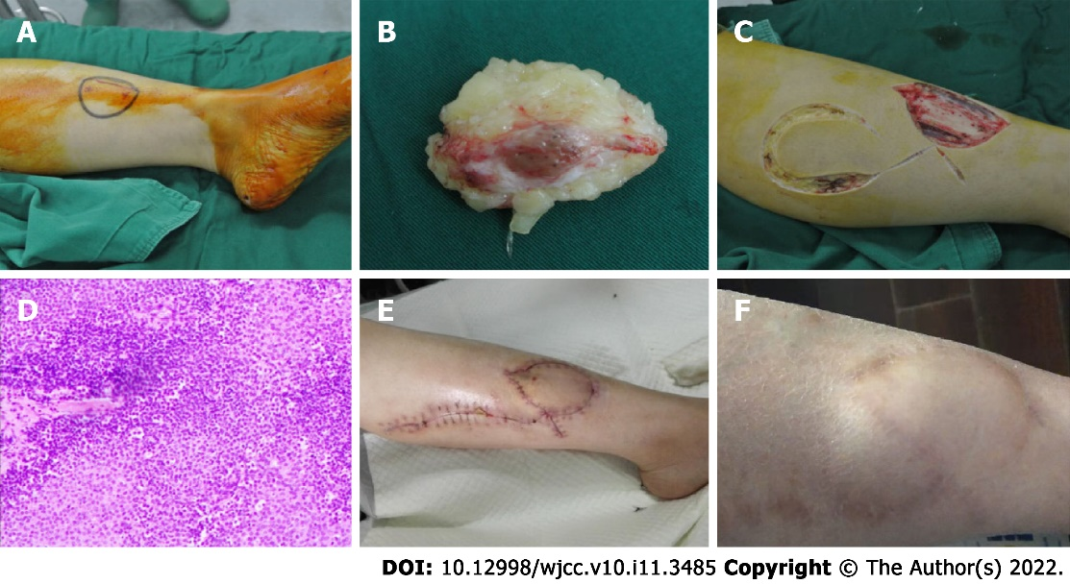
Figure 1 The imaging of case. A: Surgical field: The appearance of the medial left lower leg; B: The appearance of excised tissue in operation. Ellipsoid red soft tissue be covered with adipose tissue, about 50 mm × 30 mm ×10 mm in size; C: Designing and harvesting the lateral gastrocnemius nutrition flap of the left lower leg to cover the tumor's resection site during the surgery; D: Pathologic examination shows a glomus tumor with chronic inflammatory cell infiltrates; E: The appearance of the anteromedial incision of the left lower leg two weeks after the surgery. The incision suture had been removed. The flap survived well, and the incision recovered well with no infection; F: The anteromedial appearance of the left lower leg four years after the surgery. The pain did not relapse.

Published by Baishideng Publishing Group Inc
7041 Koll Center Parkway, Suite 160, Pleasanton, CA 94566, USA
Telephone: +1-925-3991568
E-mail: bpgoffice@wjgnet.com
Help Desk: https://www.f6publishing.com/helpdesk
https://www.wjgnet.com

© 2022 Baishideng Publishing Group Inc. All rights reserved.

