Name of journal: World Journal of Gastrointestinal Endoscopy
ESPS Manuscript NO: 13980
Columns: Review

Advances in endoscopic retrograde cholangiopancreatography for the treatment of cholangiocarcinoma

Uppal DS et al. Advances in ERCP for cholangiocarcinoma

Dushant S Uppal, Andrew Y Wang

Dushant S Uppal, Andrew Y Wang, Division of Gastroenterology and Hepatology, University of Virginia Health System, Charlottesville, VA 22908, United States

Author contributions: Uppal DS and Wang AY contributed equally to this manuscript.

Conflict-of-interest: The authors have no conflicts of interest, financial or otherwise, to report with respect to this manuscript.

Open-Access: This article is an open-access article which was selected by an in-house editor and fully peer-reviewed by external reviewers. It is distributed in accordance with the Creative Commons Attribution Non Commercial (CC BY-NC 4.0) license, which permits others to distribute, remix, adapt, build upon this work non-commercially, and license their derivative works on different terms, provided the original work is properly cited and the use is non-commercial. See: http://creativecommons.org/licenses/by-nc/4.0/

Correspondence to: Andrew Y Wang, MD, FACG, FASGE, Associate Professor of Medicine, Co-Medical Director of Endoscopy, Division of Gastroenterology and Hepatology, University of Virginia Health System, Box 800708, Charlottesville, VA 22908, United States. ayw7d@virginia.edu

Telephone: +1-434-9241653
Fax: +1-434-2447590

Received: September 11, 2014
Peer-review started: September 11, 2014
First decision: December 17, 2014
Revised: January 22, 2015
Accepted: February 9, 2015
Article in press:
Published online:

Abstract
Cholangiocarcinoma (CCA) is a malignancy of the bile ducts that carries high morbidity and mortality. Patients with CCA typically present with obstructive jaundice, and associated complications of CCA include cholangitis and biliary sepsis. Endoscopic retrograde cholangiopancreatography (ERCP) is a valuable treatment modality for patients with CCA, as it enables internal drainage of blocked bile ducts and hepatic segments by using plastic or metal stents. While there remains debate as to if bilateral (or multi-segmental) hepatic drainage is required and/or superior to unilateral drainage, the underlying tenant of draining any persistently opacified bile ducts is paramount to good ERCP practice and good clinical outcomes. Endoscopic therapy for malignant biliary strictures from CCA has advanced to include ablative therapies via ERCP-directed photodynamic therapy (PDT) or radiofrequency ablation (RFA). While ERCP techniques cannot cure CCA, advancements in the field of ERCP have enabled us to improve upon the quality of life of patients with inoperable and incurable disease. ERCP-directed PDT has been used in lieu of brachytherapy to provide neoadjuvant local tumor control in patients with CCA who are awaiting liver transplantation. Lastly, mounting evidence suggests that palliative ERCP-directed PDT, and probably ERCP-directed RFA as well, offer a survival advantage to patients with this difficult-to-treat malignancy.

Key words: Endoscopic retrograde cholangiopancreatography; Cholangiocarcinoma; Stents; Self-expandable metal stents; Photodynamic therapy; Photodynamic therapy; Radiofrequency ablation; Radiofrequency ablation

© The Author(s) 2015. Published by Baishideng Publishing Group Inc. All rights reserved.

Core tip: Endoscopic retrograde cholangiopancreatography (ERCP) is a valuable treatment modality for patients with cholangiocarcinoma (CCA), as it enables luminal drainage of blocked bile ducts and hepatic segments by using plastic or metal stents. While there remains some debate as to if bilateral hepatic drainage is required and/or superior to unilateral drainage, the underlying tenant of draining any persistently opacified bile ducts is paramount to good ERCP practice. Although ERCP interventions cannot cure CCA, advancements in the field of ERCP, including ERCP-directed photodynamic therapy and radiofrequency ablation, likely confer a survival advantage and improve upon the quality of life of patients with incurable disease.

Uppal DS, Wang AY. Advances in endoscopic retrograde cholangiopancreatography for the treatment of cholangiocarcinoma. World J Gastrointest Endosc 2015; In press

INTRODUCTION
Cholangiocarcinoma (CCA) is the second most common primary neoplasm of the liver^{[1]}. It arises from malignant transformation of cholangiocytes, which are the epithelial cells that line the biliary tree. CCA may be classified based on location as intrahepatic, perihilar, or extrahepatic^{[1]}. Perihilar lesions are further sub-classified depending on their proximal tumor extension according to the classification proposed by Bismuth^{[2]}. Seventy percent of tumors present with bilateral hilar involvement-termed “Klatskin tumors”-and are unresectable cancers^{[2]}. Although CCA is a rare malignancy with 3500 to 5000 cases diagnosed annually in the United States^{[3]}, mortality from this cancer is high due to a typically late presentation and limited curative therapies^{[3]}.
In patients with inoperable, incurable CCA, initial management usually involves drainage of malignant biliary obstruction and palliation of jaundice. Nevertheless, systemic or locoregional therapies do exist that offer the potential for tumor control, in part to mitigate the complications of further biliary obstruction. Chemotherapeutic agents and radiation therapies have been utilized to achieve this end, although their efficacy is limited, with partial response rates with chemotherapy demonstrated to be 35.9%, and with a stable disease rate of only 26.9%^{[4]}.
Over the past two to three decades, the management of CCA has evolved. While surgery remains a curative option for early disease, most cases of CCA are unresectable at the time of presentation. The typical presenting sign of CCA is jaundice. As such, decompressive biliary drainage techniques can help bridge symptomatic patients to surgery, and they can also be used for palliation by treating jaundice and pruritus and by reducing the risk of cholangitis. Various strategies have been employed for biliary drainage, including surgical drainage, percutaneous drainage, and endoscopic decompression via nasobiliary drainage or internal biliary stenting. Other mainly palliative modalities for treatment of CCA involve chemoradiation, transarterial chemoembolization, and ablative therapies such as brachytherapy, photodynamic therapy (PDT), and radiofrequency ablation (RFA), which can be applied intraoperatively, percutaneously, or endoscopically^{[5]}. Herein, we will focus on endobiliary therapies for the treatment of CCA and its complications, and the majority of this review will pertain to interventions delivered via endoscopic retrograde cholangiopancreatography (ERCP).

BILIARY DECOMPRESSION
While surgical resection is the only treatment that offers curative intent to patients with CCA, the morbidity and mortality associated with liver resection is significantly higher in patients with obstructive jaundice than in patients with normal liver function^{[6]}. Therefore, pre-operative biliary drainage is routinely performed to reverse cholestatic liver dysfunction and reduce mortality after selective hepatectomy^{[7]}.
Historically, surgical bypass (hepaticojejunostomy or choledochojejunostomy) was the primary modality of biliary drainage prior to percutaneous and endoscopic advancements^{[8-11]}. With advances in endoscopic therapy, particularly the development and refinement of ERCP, endoscopic decompression of obstructive jaundice due to malignant biliary stricturing from CCA should be considered the standard of care^{[12-16]}. While adverse events are influenced by the clinical scenario, the risks associated with ERCP are well documented and uncommon. An American Society for Gastrointestinal Endoscopy guideline on “Complications of ERCP” reports a post-ERCP pancreatitis rate of about 3.5% (range 1.6%-15.7%), a rate of hemorrhage of 1.3%, and a perforation rate of 0.1%-0.6%^{[17]}. Typically, the rate of post-ERCP cholangitis is 1% or less, but this risk does increase in situations of ERCP for drainage of malignant biliary obstruction^{[17]}.
In circumstances where biliary decompression is not possible or is incomplete by ERCP, percutaneous transhepatic biliary drainage (PTBD) can be an effective adjunctive therapy. However, PTBD is also associated with its own risks, including intra-procedural death in 1.7% of cases^{[18]}.
Many variables must be considered when endoscopic biliary drainage is pursued in patients with obstructive jaundice from CCA. Decisions include whether to use plastic stents (PS) vs self-expandable metal stents (SEMS) and whether to pursue unilateral vs bilateral biliary stenting.

UNILATERAL VS BILATERAL BILIARY DRAINAGE
In patients with Bismuth I perihilar cholangiocarcinoma, which involves the extrahepatic bile duct but not the biliary confluence, a single stent that crosses the malignant stricture is usually adequate^{[12]}. However, when considering patients with obstructive jaundice from more advanced CCAs that might involve the biliary confluence but not the second-order radicals (Bismuth II), or for those that involve the right (Bismuth IIIA), left (Bismuth IIIB), or bilateral (Bismuth IV) hepatic ducts and higher-order branches, it has been suggested that drainage of as little as 25% of the liver can result in resolution of jaundice^{[19]}. Thus, placement of a single stent into one lobe of the liver can result in sufficient biliary decompression in many cases. In some circumstances, segments of the liver that are inaccessible may be atrophied due to chronic involvement of tumor, making additional stenting unnecessary. However, in cases of Bismuth type II, III, or IV CCA, the question of location and number of stents remains controversial and has been addressed by a number of studies^{[12-16,20-31]}.
Deviere et al^{[12]} demonstrated in 1988 that bilateral biliary stenting was associated with significantly improved survival and decreased development of cholangitis compared to unilateral stenting. However, in that study, contrast was injected into both lobes of the liver in all patients making the need for bilateral stenting more critical. In instances where one or more segments of the liver are injected with contrast, cholangitis may develop if adequate drainage is not achieved. This concept underscores an important point that—given the advancements in radiographic imaging-whenever possible, a thinly-sliced computed tomography (CT) scan performed on a multidetector scanner or a contrasted magnetic resonance imaging scan with magnetic resonance cholangiopancreatogram (MRCP) should be obtained prior to ERCP. High resolution cross-sectional imaging can identify areas of obstruction that can be selectively targeted for biliary decompression during ERCP, thereby avoiding over-opacification of the intrahepatic bile ducts^{[32,33]}.
In 1998, Chang et al^{[20]} reviewed fluoroscopic images from ERCPs conducted for biliary decompression in 141 patients with hilar CCA. Those patients who had either a single lobe opacified and drained (unilateral stenting) or both lobes opacified and drained (bilateral stenting) had a significantly lower incidence of cholangitis and mortality compared with those patients who had both lobes of the liver opacified and only one side drained. These findings highlight that the decision to pursue unilateral vs bilateral stenting is greatly influenced by procedure-related issues, such as the extent of intrahepatic biliary opacification as well as the ease/difficulty of cannulating and subsequently draining various intrahepatic segments.
Other reports have suggested that drainage of more than 50% of the liver volume is associated with improved survival^{[34]}. In a large retrospective review of 480 patients receiving endoscopic biliary drainage for hilar CCA, bilateral stenting (with either SEMS or PS) resulted in significantly longer overall stent patency compared with unilateral stenting [18 wk vs 17 wk for PS (P = 0.0004) and 27 wk vs 20 wk for SEMS (P < 0.0001)]^{[26]}. This finding had previously been reported in a smaller retrospective review of 46 consecutive patients undergoing palliative endoscopic biliary stent placement for malignant hilar obstruction. In a subgroup with hilar CCA, significantly greater overall stent patency was found in the group receiving bilateral stenting compared to the unilateral stenting group (P = 0.009)^{[27]}.
In 2001, De Palma et al^{[21]} randomized patients in Italy with malignant hilar obstruction (about 57% from CCA) to unilateral or bilateral stenting for biliary decompression following a diagnostic cholangiogram. On intention-to-treat (ITT) analysis, patients who received unilateral 10-French (Fr) PS had significantly greater rates of successful stent insertion and drainage and also significantly lower rates of cholangitis (8.8% vs 16.6%, P = 0.013) compared to those who got bilateral PS. There were no significant differences between the two groups with respect to 30-d mortality, late complications, and median survival. It is important to note that successful stent insertion was significantly lower in the group randomized to bilateral PS (76.9%) as compared to the unilateral PS group (88.6%, P = 0.041). Bilateral stenting of complex hilar strictures from CCA is challenging and often requires significant device manipulation and repeated opacification of the biliary tree in order to access undrained hepatic segments using a guidewire. In fact, on per-protocol analysis (when only patients with successful unilateral and bilateral drainage were included) there was no difference in outcomes between these two groups, but this secondary analysis was underpowered to detect significant differences.
In considering these somewhat disparate data, it is probably best to be guided by the central tenet of endoscopic retrograde cholangiography, that drainage of any opacified large bile ducts or hepatic segments that do not drain spontaneously should be pursued. In a patient with complex perihilar stricturing, use of cross-sectional imaging to guide ERCP and limit contrast opacification can reduce the risk of cholangitis and other procedure-related complications. Planning an ERCP using cross-sectional imaging can also help one avoid opacifying atrophic segments that are less likely to be functional, which might also be more difficult to access and completely drain. When ERCP is performed using this type of a planned and deliberate approach, unilateral biliary stenting might be sufficient to relieve jaundice from a malignant hilar obstruction.
Lastly, effective treatment of patients with CCA requires multidisciplinary consultation. In patients with potentially resectable disease, the choice of which lobe or segments to drain may not be as simple as going after the largest volume of obstructed liver on cross-sectional imaging. Indeed, presurgical biliary drainage of the lobe or segments of the liver that will remain after operative resection is key to avoiding atrophy of the liver remnant. If the bile ducts of the designated remnant liver are obstructed and not accessible by ERCP, drainage via PTBD should be pursued. In these situations, drainage of the portion of the liver targeted for resection might not be required, as atrophy of these segments is desired (and sometimes pursued by selective portal vein embolization) so as to cause hypertrophy of the future liver remnant, which reduces the risk of post-resection hepatic decompensation^{[35,36]}.

PLASTIC VS. SELF-EXPANDABLE METAL STENTS
The issue of the most appropriate means of biliary decompression is further complicated by the decision to utilize either PS or SEMS. Plastic stents are smaller in caliber and tend to form biofilms, resulting in earlier obstruction than SEMS. On average, PS need to be exchanged at least every 3 mo, while SEMS may remain patent for 6 to 12 mo or longer. Raju et al^{[37]} demonstrated median SEMS patency of 5.6 mo compared with 1.9 mo for PS, and they found SEMS to be more cost effective because of reduced need for re-intervention^{[37]}. The advantage of PS is that they are removable, and thus their use may be more attractive in patients with good functional status who might outlive a palliative SEMS. Metal stents are available in uncovered, partially-covered, or fully-covered versions. While fully-covered SEMS are potentially removable, their use across a perihilar stricture can be problematic as they can inadvertently obstruct other intersecting normal bile ducts due to their coating. Covered SEMS are also more prone to migration. Uncovered SEMS are less likely to migrate as tumor ingrowth keeps these stents in place, although tumor ingrowth can also lead to stent occlusion. In clinical practice, many interventional endoscopists tend to favor plastic biliary stenting in situations where the diagnosis remains in question, when surgery might still be possible, and in those patients who are likely to outlive the patency of permanent uncovered SEMS.
Multiple non-randomized and randomized trials have demonstrated greater patency with use of SEMS in patients with inoperable CCA, as compared to plastic stenting^{[13-16,23,25-30,38-40]}. Peters et al^{[16]} conducted a small prospective pilot study in 1997 to assess the efficacy of SEMS for palliation of jaundice in patients with malignant hilar strictures. Of the 17 patients included, 11 had CCA, and 9 demonstrated adequate drainage following SEMS placement as reflected by a significant decrease in bilirubin. The 2 patients who did not obtain relief from jaundice had extensive intrahepatic disease. Median stent patency was 12 mo with median survival of 10 mo. While these authors concluded that SEMS appeared to provide durable palliation for high-grade malignant biliary strictures, they cautioned against direct comparison with PS until a controlled trial comparing the two modalities had been completed.
In 2003, Kaassis et al^{[13]} published a randomized study that found no significant survival difference in patients with malignant common bile duct strictures who underwent SEMS placement compared with patients who underwent PS placement. However, time to the first episode of biliary obstruction was significantly longer in the group receiving SEMS (P = 0.007). Metal stenting was also noted to be more cost-effective in patients without hepatic metastases, who had longer survival (5.3 mo vs 2.7 mo in patients with metastases). These authors recommended that plastic stenting was more appropriate in patients with advanced disease, signified by metastases, due to their shorter expected survival^{[13]}.
A large retrospective review of 480 patients who received endoscopic biliary drainage in the setting of hilar CCA over a 15-year period demonstrated greater functional success (defined by a decrease in bilirubin to less than 75% of pre-treatment level) with SEMS placement (97.9%) compared with PS placement (84.8%, P < 0.001)^{[26]}. Furthermore, there were significantly greater rates of early complications (8.3% vs 2.0%) and late complications (56.4% vs 24.4%) in the group that received PS compared to the group that received SEMS. Interestingly, multivariate analysis using Poisson regression showed that SEMS placement (P < 0.01) and bilateral deployment (P < 0.01) were the only independent prognostic factors associated with stent patency^{[26]}.
In 2012, Sangchan et al^{[30]} conducted an open-label randomized controlled trial in Thailand that compared PS to SEMS placement for unresectable hilar CCA. 180 patients underwent ERCP with randomization to unilateral placement of a 10-mm-wide SEMS vs a 7-Fr or 10-Fr PS into the hepatic duct with the largest area of obstruction based on pre-procedural CT or MRCP. On ITT analysis, the rate of successful drainage in the SEMS group was significantly greater than in the PS group (70.4% vs 46.3%, P = 0.011)^{[30]}. Median survival time for the SEMS group (126 d) was also significantly longer compared with the PS group (49 d, P = 0.0021).
In 2013, a randomized controlled trial conducted in Japan compared SEMS to PS for drainage of malignant biliary strictures^{[15]}. This study found the 6-month stent patency in the SEMS group was significantly greater (81%) compared with the PS group (20%, P = 0.0012). Kaplan-Meir analysis demonstrated a 50% patency rate of 359 d in the SEMS group as compared to 112 d in the PS group (P = 0.0002). Furthermore, the mean number of interventions for stent failure was significantly lower in the SEMS group (0.63 times/patient) compared to the PS group (1.80 times/patient, P = 0.0008). Lastly, the overall total cost for the treatment was significantly lower in the SEMS group than in the PS group (P = 0.0222).
Overall, these studies support the use of SEMS over PS for long-term palliation of patients with malignant biliary obstruction, including from unresectable CCA. Typically, uncovered SEMS should be used for palliation when strictures are found across the biliary confluence, and these SEMS likely have even greater utility and cost-effectiveness when expected survival exceeds 3 mo, such as in those patients without metastatic disease. However, with the advent of ERCP-directed ablative therapies for unresectable CCA, a substantial proportion of patients might now expect to outlive even the patency of SEMS. In these patients, a strategy of repeated ERCP for plastic stent revision and possibly repeated ERCP-directed ablation for locoregional tumor control is reasonable, particularly while they maintain good functional status and quality of life.

PERCUTANEOUS TRANSHEPATIC BILIARY DECOMPRESSION
Biliary decompression and stent placement for malignant biliary strictures can also be achieved by a percutaneous approach. In most centers, PTBD is performed by interventional radiologists. Decompression tubes may be inserted into dilated proximal biliary radicals to facilitate drainage of static bile above the level of obstruction. Alternatively, stenting across a malignant stricture can also be achieved by PTBD, which then allows for bile drainage internally into the duodenum. However, several studies have evaluated the use of PTBD with mixed results^{[14]}. Complications associated with PTBD include vascular injury, risk for tumor seeding, and discomfort at the external drain site^{[28]}. Additionally, PTBD has reported intraprocedural hemorrhage and sepsis rates of 2.5% and a death rate of 1.7%^{[18]}.
Hamy et al^{[23]} evaluated 35 patients with malignant hilar obstruction (most had CCA) who received a palliative SEMS via a percutaneous-transhepatic route. They found a 97% rate of adequate biliary drainage with a median survival of 182 d and a 25% rate of recurrent jaundice after 180 d. These results were corroborated by a large retrospective multicenter study of 84 patients that compared the efficacy of percutaneous-transhepatic to endoscopic SEMS placement for initial malignant biliary decompression^{[28]}. In this study, the rate of successful initial biliary decompression was higher in the percutaneous group (92.7%) as compared with the endoscopically-placed SEMS group (77.3%)^{[28]}. However, overall stent patency and survival-once decompression was achieved-were similar between the groups, suggesting that a well-placed stent, irrespective of how it was placed, is the key to durable biliary decompression and improved survival in patients with malignant biliary obstruction.
Oftentimes, the decision to pursue biliary drainage via ERCP or PTBD is determined by clinical reasons, such as in patients with surgically altered gastroduodenal anatomy in whom PTBD might offer easier or more reliable access for therapeutic biliary interventions, or by local expertise. PTBD can be a valuable adjunctive therapy to drain obstructed bile ducts not accessible by ERCP, particularly in patients who might be surgical candidates and require drainage of the future liver remnant so as to prevent atrophy. In our experience, most patients favor endoscopic biliary drainage whenever possible, as it obviates the need for an external catheter for drainage or access. In general, if an experienced biliary endoscopist is available who can perform complex ERCP (as treatment of a hilar tumor is considered a level-3-complexity ERCP by American Society for Gastrointestinal Endoscopy guidelines^{[41]}), we suggest attempting biliary decompression via ERCP. If adequate biliary drainage by ERCP is not achieved, then PTBD is an important adjunctive therapy in this patient population that should be pursued. Furthermore, once a PTBD track is mature (which typically requires 3-4 wk), a rendezvous-ERCP procedure can be performed to internalize biliary drainage of a previously inaccessible segment, after which the PTBD catheter can be removed.

ERCP-DIRECTED PHOTODYNAMIC THERAPY
PDT is a well-studied ablative therapy that induces tumor necrosis and apoptosis in treated portions of the biliary tree. The intravenous photosensitizer used in the United States (US) is porfimer sodium (Photofrin, Pinnacle Biologics, Bannockburn, IL). While use of this drug for PDT in patients with CCA is done so off-label in the US, Medicare and most private insurers in the US do cover this procedure for palliation of unresectable CCA^{[42]}. Porfimer sodium is typically administered intravenously, at 2 mg/kg, ideally 48 h (but possibly up to 72 h) before ERCP. At the time of ERCP, a 10-Fr bougie catheter (SBDC-10, Cook Medical, Bloomington, IL) or a choledochoscope (SpyGlass, Boston Scientific, Natick, MA) is advanced over a wire to the level of the malignant stricture and used to pass a laser fiber. This laser fiber (Figure 1 and 2) is then used to deliver activating light (at 630 nm for 750 s, with a light dose of 180 J/cm²)^{[43]}. When the photosensitizer is activated, oxygen free radicals are released that result in local tissue destruction. Since its first description for biliary tumor ablation in 1991^{[44]}, multiple studies have demonstrated that PDT can enable local tumor control and also can result in improved quality of life in this difficult-to-treat patient population^{[42,45-61]}. Metal stent patency has also been shown to be significantly greater with PDT applied immediately prior to stent placement vs. metal stent placement alone (median time of 244 d vs 177 d, respectively, P = 0.002)^{[49]}.
In 2003, Ortner et al^{[52]} conducted a prospective, open-label, randomized, multicenter study of patients with unresectable CCA that compared PDT (using porfimer sodium) in addition to endoscopic or percutaneous stenting by using two 10-Fr endoprostheses vs stenting alone and demonstrated significant improvement in survival times (median 493 d vs 98 d, respectively, P < 0.0001)^{[52]}. Improvement in cholestasis and quality of life indices were also reported. Another randomized controlled trial by Zoepf et al^{[60]} in 2005 compared PDT (using Photosan-3, SeeLab, Wesselburenerkoog, Germany) and stenting vs stenting alone in patients with unresectable CCA. These investigators demonstrated significantly improved survival in the group that received PDT (21 mo) compared to the group that received only stents (7 mo, P = 0.0109). In this study, PDT was delivered via ERCP (transpapillary) or by percutaneous biliary access.
The survival benefit associated with PDT in patients with unresectable CCA has also been demonstrated by multiple heterogeneous cohort studies, which were mostly retrospective in nature^{[45,47,54,62,63]}. In 2012, Leggett et al^{[50]} conducted a meta-analysis that included six studies that contributed 170 patients with unresectable CCA who received PDT and biliary stenting vs 157 patients with CCA who underwent stenting alone. This meta-analysis found that PDT was associated with a statistically significant survival advantage (weighted mean difference of 265 d, P = 0.01) and significantly improved quality of life as reflected by improvement in Karnofsky score (weighted mean difference of 7.74, P = 0.01). While there appears to be sufficient data to support that at least one round of PDT offers a survival advantage to patients with incurable CCA, it is not clear if multiple rounds of PDT (done every few months) adds to the survival advantage^{[62]}; nor is it clear if bilateral PDT is superior to unilateral PDT in the case of Bismuth IV tumors.
The merits of PDT are tempered somewhat by its potential side-effects. Although a study evaluating the safety and long-term efficacy of PDT using porfimer sodium reported no treatment-related mortality or grade-4 toxicity, complications including photosensitivity resulting in burns (Figure 3) and to a lesser extent bleeding, stenosis, and bile leak have been reported^{[46]}. Cholangitis is usually the most commonly encountered problem that arises in patients with CCA who have undergone biliary intervention, and as expected cholangitis following PDT does occur. A major drawback with ERCP-directed PDT is the need for patients to avoid direct or indirect sunlight for 4-6 wk, which may significantly affect their quality of life. Efforts to limit light toxicity have also resulted in use of a newer photosensitizer meta-tetra(hydroxyphenyl)chlorin (Foscan, Biolitec AG, Jena, Germany) that has demonstrated efficacy in a small study while potentially removing the detrimental side-effects of prolonged skin photosensitivity^{[48]}. Another major drawback of PDT is that the cost of a single-dose of porfimer sodium in a 75 kg patient is about USD $37208, which can be prohibitively high^{[43]}.
Nevertheless, PDT has several advantages including: (1) porfimer sodium preferentially accumulates in malignant cells, potentially reducing damage to non-malignant epithelium; and (2) laser light can refract through bile, which can transmit the PDT effect to malignant strictures that are not directly adjacent to (and might be inaccessible to) the laser fiber^{[43]}. Because PDT is dependent on the transmittance of laser light, and does not require the laser fiber to directly make contact with tumor tissue, successful delivery of PDT through metal stents has been reported with appropriate adjustment of the light dose^{[64]}.

ERCP-DIRECTED RADIOFREQUENCY ABLATION
Percutaneously- and intraoperatively-directed RFA have been demonstrated by several studies to be efficacious for local tumor control in patients with inoperable CCA^{[65-70]}, including as an adjunct to surgery^{[71-73]}. RFA has been used for local control of tumor recurrence following surgery in patients who may no longer be good operative candidates or for whom no other surgical intervention is possible^{[68,72]}, including those who have already undergone protocol liver transplantation for CCA^{[74]}. However, complications following the percutaneous delivery of RFA are not trivial and have included gastrohepatic fistula^{[75]}, hemorrhage necessitating transarterial embolization^{[76]}, hepatic vein pseudoaneurysm^{[77]}, acute liver failure or abscess formation^{[78]}, and needle-tract seeding of tumor^{[79]}.
ERCP-directed RFA was developed to enable endoscopists to treat malignant biliary strictures via a mechanism of coagulative necrosis induced by thermal energy that is delivered via contact using a bipolar catheter^{[43]}. One commercially available RFA catheter (Figure 1) is an 8-Fr device with two electrodes spaced 8 mm apart at the end of the catheter that can be passed over a guidewire (Habib EndoHPB; EMcision, London, United Kingdom)^{[80]}. This device passed US Food and Drug Administration 510[k] premarketing clearance in 2009. This RFA catheter can be passed through the accessory channel of a duodenoscope and into the bile duct (Figure 4). Fluoroscopic guidance is used to center the two sets of bipolar rings across a malignant stricture for RFA treatment (Figure 5 and 6).
In 2011, Steel et al^{[81]} conducted a single-center open-label pilot study that demonstrated that ERCP-directed RFA could be performed safely and efficaciously in patients with malignant biliary strictures from unresectable pancreas cancer or CCA. In this initial study, all but one of 21 patients who had RFA followed by SEMS placement maintained stent patency at 30 d. One patient had asymptomatic biochemical pancreatitis, 2 patients required percutaneous gallbladder drainage, and 1 patient developed rigors. At 90-d follow-up, 3 patients had occluded biliary stents. Subsequently, in a retrospective series of 12 patients (9 with CCA) with malignant intraductal or perihilar biliary strictures, Tal et al^{[80]} performed 19 successful RFA applications via ERCP followed by PS placement. These investigators used a setting of 8 W for treatment of intrahepatic and perihilar biliary strictures and 10 W for extrahepatic bile duct strictures using an ERBE electrosurgical generator (VIO 200D, ERBE Elektromedizin, Tübingen, Germany). However, biliary bleeding was observed at 4-6 wk in 3 patients (2 of whom died of hemorrhagic shock), and cholangitis developed in 4 patients, which was amenable to stent exchange. Finally, Figueroa-Barojas et al^{[82]} reported on the use of ERCP-directed RFA in 25 patients with malignant biliary structures (11 patients had CCA). Procedures were performed using a RITA 1500X RF generator (Angiodynamics, Latham, NY) set at 7–10 watts for a time period of 2 min. These investigators reported a resultant significant increase in mean bile duct diameter of 3.5 mm (P < 0.0001)^{[82]}. In this series, 5 patients presented with pain after the procedure, one patient developed mild post-ERCP pancreatitis, and one patient developed cholecystitis following endobiliary RFA.
In 2014, Sharaiha et al^{[83]} published a retrospective series of 66 patients with malignant biliary strictures (36 with CCA) who underwent either SEMS placement alone or RFA followed by SEMS placement. They reported 100% technical success in both groups. While these investigators found that rates of stent patency were similar between the two groups, on multivariate analysis, RFA was found to be an independent predictor of survival (HR of 0.29, 95%CI: 0.11-0.76, P = 0.012). Finally RFA has been described as a means of treating tumor ingrowth of uncovered SEMS in the bile duct^{[84]}. Typically, the RFA catheter can be passed into a blocked stent and used under fluoroscopic guidance to ablate any tumor ingrowth, which is then removed by retrieval balloon sweep. This ablation may be followed by placement of an indwelling plastic stent or a second uncovered SEMS, in appropriate situations (Figure 6).
When compared to PDT, the advantages of endobiliary RFA include being able to provide ablative treatment without the patient having to come in 2 d in advance for infusion of a photosensitizer, easier delivery of the RFA catheter that can be done over a guidewire, and no requirement to avoid sunlight for several weeks to prevent photosensitivity. However, RFA requires direct contact with neoplastic tissue for ablation, thus it does not offer the “field effect” conferred by the laser light used in PDT, which can refract through bile to treat inaccessible blocked bile ducts.
In 2014, Strand et al^{[43]} demonstrated comparable survival following ERCP-directed RFA vs ERCP-directed PDT. In this retrospective cohort study, 48 patients with unresectable CCA underwent RFA (n = 16) or PDT (n = 32) followed by plastic or metal biliary stenting. Overall median survival in both treatment groups was not statistically different (9.6 mo following RFA and 7.5 mo following PDT, P = 0.799). Furthermore, patients who underwent RFA had a lower mean number of plastic stents placed per month (0.45 vs 1.10, P = 0.001) but also had more episodes of stent occlusion (0.06 vs 0.02, P = 0.008) and cholangitis (0.13 vs 0.05, P = 0.008) per month, as compared to patients who received PDT.
In addition to the differing advantages and disadvantages of RFA vs PDT that were mentioned earlier, a major discriminating factor between these two ablative technologies is cost. Strand et al^{[43]} noted that because both procedures required ERCP with sent exchange, the true cost differential is the difference between the cost of a dose of porfimer sodium (USD $37208) and the cost of the RFA catheter (USD $1295), which is $35913^{[43]}. In the current environment of falling reimbursements and the need for cost-containment, this is a significant difference that favors ERCP-directed RFA.

ERCP-DIRECTED NEOADJUVANT ABLATIVE THERAPY FOR CCA PRIOR TO LIVER TRANSPLANTATION
Experience with liver transplantation (LT) for unresectable CCA had previously been disappointing due to frequent cancer recurrence and poor 5-year survival rates^{[3]}. To improve outcomes following LT for CCA, a protocol for neoadjuvant chemotherapy followed by LT was first developed at the University of Nebraska and then at the Mayo Clinic^{[3,85]}. Patients who met the following criteria were included in this LT protocol: (1) perihilar location of suspected CCA; (2) a malignant-appearing stricture on cholangiography with malignant endoluminal brushing or biopsy, carbohydrate antigen 19-9 level > 100 U/mL (in the absence of cholangitis), mass on cross-sectional imaging, and/or polysomy on fluorescence in situ hybridization; (3) unresectable disease or disease arising in primary sclerosing cholangitis; (4) completion of neoadjuvant therapy before LT; and (5) medical suitability for LT^{[85]}. Neoadjuvant therapy from the early “Mayo” protocol included administration of external beam radiation therapy (XBRT) and 5-fluorouracil, followed by brachytherapy^{[85-87]}. Use of intraluminal brachytherapy and XBRT in patients with unresectable CCA has been reported for palliation of jaundice and as a treatment to temporarily obviate the need for biliary stenting^{[88,89]}. Furthermore, a retrospective study by Darwish Murad et al^{[85]} of 287 patients, 75% of whom received brachytherapy as part of neoadjuvant therapy prior to LT, demonstrated a 5-year ITT survival rate of 53% and post-transplant recurrence-free survival of 65%^{[85]}. In this large series of patients, recurrence-free survival for patients who had received brachytherapy was similar to those who had not (HR 1.05; 95%CI, 0.60–1.85)^{[85]}. Other studies have also shown no mortality benefit from the addition of brachytherapy^{[90,91]}. In an effort to mitigate side-effects associated with brachytherapy and the complexities associated with delivery of radioactive ribbons in the endoscopy or radiology suite, other endobiliary therapies for neoadjuvant locoregional CCA tumor control prior to LT have been adopted.
In particular, PDT, as mentioned previously, has been demonstrated to be a safe and potentially efficacious modality for locoregional control of perihilar CCA in palliative patients. In a proof-of-concept study performed at our institution, Cosgrove et al^{[42]} reported on 4 patients with unresectable CCA who had undergone protocol-driven neoadjuvant chemoradiation followed by ERCP-directed PDT to provide endobiliary and local tumor control in patients who were awaiting LT^{[42]}. Although the sample size of this study was small, none of the patients receiving PDT had progressive locoregional disease or distant metastases during the pre-transplant period, and all patients underwent successful LT. ITT disease-free survival was 75% at a mean follow-up of 28.1 mo. Based on these data regarding PDT, as well as our comparable experience with RFA for patients with incurable CCA^{[43]}, our institution’s protocol allows for the use of either PDT or RFA as an alternative to brachytherapy for locoregional tumor control in patients with inoperable CCA who are awaiting LT. Prospective trials to study these ERCP-directed neoadjuvant modalities for locoregional control in patients with CCA are indicated.

CONCLUSION
CCA is a malignancy with high morbidity and mortality due to its typically late presentation with obstructive jaundice, and its associated complications of cholangitis and biliary sepsis. ERCP is a valuable treatment modality for patients with CCA, as it enables internal luminal drainage of blocked bile ducts and hepatic segments by using plastic or metal stents. While there remains debate as to if bilateral (or multi-segmental) hepatic drainage is required and/or superior to unilateral drainage, the underlying tenant of draining any persistently opacified bile ducts is paramount to good ERCP practice and good clinical outcomes. Endoscopic therapy for malignant biliary strictures from CCA has advanced to include ablative therapies via ERCP-directed PDT or RFA. As chemoradiation is of limited efficacy in providing tumor control for this cancer, these endoscopic modalities, which offer the potential for locoregional control and hopefully more durable biliary drainage, are a much needed addition to our therapeutic endobiliary armamentarium. While ERCP techniques cannot cure CCA, advancements in the field of ERCP have enabled us to improve upon the quality of life of patients with incurable disease. ERCP-directed PDT has been used in lieu of brachytherapy to provide neoadjuvant local tumor control in patients with CCA who are awaiting LT. Lastly, mounting evidence suggests that palliative ERCP-directed PDT, and probably ERCP-directed RFA as well, can offer a survival advantage to patients with this difficult-to-treat malignancy.

REFERENCES
1 Blechacz B, Komuta M, Roskams T, Gores GJ. Clinical diagnosis and staging of cholangiocarcinoma. Nat Rev Gastroenterol Hepatol 2011; 8: 512-522 [PMID: 21808282 DOI: 10.1038/nrgastro.2011.131]
2 Sainani NI, Catalano OA, Holalkere NS, Zhu AX, Hahn PF, Sahani DV. Cholangiocarcinoma: current and novel imaging techniques. Radiographics 2008; 28: 1263-1287 [PMID: 18794305 DOI: 10.1148/rg.285075183]
3 Masuoka HC, Rosen CB. Transplantation for cholangiocarcinoma. Clin Liver Dis 2011; 15: 699-715 [PMID: 22032524 DOI: 10.1016/j.cld.2011.08.004]
4 Pracht M, Le Roux G, Sulpice L, Mesbah H, Manfredi S, Audrain O, Boudjema K, Raoul JL, Boucher E. Chemotherapy for inoperable advanced or metastatic cholangiocarcinoma: retrospective analysis of 78 cases in a single center over four years. Chemotherapy 2012; 58: 134-141 [PMID: 22572213 DOI: 10.1159/000337289]
5 Skipworth JR, Olde Damink SW, Imber C, Bridgewater J, Pereira SP, Malagó M. Review article: surgical, neo-adjuvant and adjuvant management strategies in biliary tract cancer. Aliment Pharmacol Ther 2011; 34: 1063-1078 [PMID: 21933219 DOI: 10.1111/j.1365-2036.2011.04851.x]
6 Belghiti J, Hiramatsu K, Benoist S, Massault P, Sauvanet A, Farges O. Seven hundred forty-seven hepatectomies in the 1990s: an update to evaluate the actual risk of liver resection. J Am Coll Surg 2000; 191: 38-46 [PMID: 10898182]
7 Farges O, Regimbeau JM, Fuks D, Le Treut YP, Cherqui D, Bachellier P, Mabrut JY, Adham M, Pruvot FR, Gigot JF. Multicentre European study of preoperative biliary drainage for hilar cholangiocarcinoma. Br J Surg 2013; 100: 274-283 [PMID: 23124720 DOI: 10.1002/bjs.8950]
8 Andersen JR, Sørensen SM, Kruse A, Rokkjaer M, Matzen P. Randomised trial of endoscopic endoprosthesis versus operative bypass in malignant obstructive jaundice. Gut 1989; 30: 1132-1135 [PMID: 2475392 DOI: 10.1136/gut.30.8.1132]
9 Lai EC, Chu KM, Lo CY, Fan ST, Lo CM, Wong J. Choice of palliation for malignant hilar biliary obstruction. Am J Surg 1992; 163: 208-212 [PMID: 1371206 DOI: 10.1016/0002-9610(92)90102-W]
10 Shepherd HA, Royle G, Ross AP, Diba A, Arthur M, Colin-Jones D. Endoscopic biliary endoprosthesis in the palliation of malignant obstruction of the distal common bile duct: a randomized trial. Br J Surg 1988; 75: 1166-1168 [PMID: 2466520 DOI: 10.1002/bjs.1800751207]
11 Smith AC, Dowsett JF, Russell RC, Hatfield AR, Cotton PB. Randomised trial of endoscopic stenting versus surgical bypass in malignant low bileduct obstruction. Lancet 1994; 344: 1655-1660 [PMID: 7996958 DOI: 10.1016/S0140-6736(94)90455-3]
12 Deviere J, Baize M, de Toeuf J, Cremer M. Long-term follow-up of patients with hilar malignant stricture treated by endoscopic internal biliary drainage. Gastrointest Endosc 1988; 34: 95-101 [PMID: 2835282 DOI: 10.1016/S0016-5107(88)71271-7]
13 Kaassis M, Boyer J, Dumas R, Ponchon T, Coumaros D, Delcenserie R, Canard JM, Fritsch J, Rey JF, Burtin P. Plastic or metal stents for malignant stricture of the common bile duct? Results of a randomized prospective study. Gastrointest Endosc 2003; 57: 178-182 [PMID: 12556780 DOI: 10.1067/mge.2003.66]
14 Lee SH, Park JK, Yoon WJ, Lee JK, Ryu JK, Yoon YB, Kim YT. Optimal biliary drainage for inoperable Klatskin's tumor based on Bismuth type. World J Gastroenterol 2007; 13: 3948-3955 [PMID: 17663508]
15 Mukai T, Yasuda I, Nakashima M, Doi S, Iwashita T, Iwata K, Kato T, Tomita E, Moriwaki H. Metallic stents are more efficacious than plastic stents in unresectable malignant hilar biliary strictures: a randomized controlled trial. J Hepatobiliary Pancreat Sci 2013; 20: 214-222 [PMID: 22415652 DOI: 10.1007/s00534-012-0508-8]
16 Peters RA, Williams SG, Lombard M, Karani J, Westaby D. The management of high-grade hilar strictures by endoscopic insertion of self-expanding metal endoprostheses. Endoscopy 1997; 29: 10-16 [PMID: 9083730 DOI: 10.1055/s-2007-1004054]
17 Anderson MA, Fisher L, Jain R, Evans JA, Appalaneni V, Ben-Menachem T, Cash BD, Decker GA, Early DS, Fanelli RD, Fisher DA, Fukami N, Hwang JH, Ikenberry SO, Jue TL, Khan KM, Krinsky ML, Malpas PM, Maple JT, Sharaf RN, Shergill AK, Dominitz JA. Complications of ERCP. Gastrointest Endosc 2012; 75: 467-473 [PMID: 22341094 DOI: 10.1016/j.gie.2011.07.010]
18 Saad WE, Wallace MJ, Wojak JC, Kundu S, Cardella JF. Quality improvement guidelines for percutaneous transhepatic cholangiography, biliary drainage, and percutaneous cholecystostomy. J Vasc Interv Radiol 2010; 21: 789-795 [PMID: 20307987 DOI: 10.1016/j.jvir.2010.01.012]
19 Dowsett JF, Vaira D, Hatfield AR, Cairns SR, Polydorou A, Frost R, Croker J, Cotton PB, Russell RC, Mason RR. Endoscopic biliary therapy using the combined percutaneous and endoscopic technique. Gastroenterology 1989; 96: 1180-1186 [PMID: 2925062]
20 Chang WH, Kortan P, Haber GB. Outcome in patients with bifurcation tumors who undergo unilateral versus bilateral hepatic duct drainage. Gastrointest Endosc 1998; 47: 354-362 [PMID: 9609426]
21 De Palma GD, Galloro G, Siciliano S, Iovino P, Catanzano C. Unilateral versus bilateral endoscopic hepatic duct drainage in patients with malignant hilar biliary obstruction: results of a prospective, randomized, and controlled study. Gastrointest Endosc 2001; 53: 547-553 [PMID: 11323577]
22 Gerhardt T, Rings D, Höblinger A, Heller J, Sauerbruch T, Schepke M. Combination of bilateral metal stenting and trans-stent photodynamic therapy for palliative treatment of hilar cholangiocarcinoma. Z Gastroenterol 2010; 48: 28-32 [PMID: 20072993 DOI: 10.1055/s-0028-1109983]
23 Hamy A, d'Alincourt A, Paineau J, Lerat F, Gibaud H, Leborgne J, Visset J. Percutaneous self-expandable metallic stents and malignant biliary strictures. Eur J Surg Oncol 1997; 23: 403-408 [PMID: 9393567]
24 Kato H, Tsutsumi K, Harada R, Okada H, Yamamoto K. Endoscopic bilateral deployment of multiple metallic stents for malignant hilar biliary strictures. Dig Endosc 2013; 25 Suppl 2: 75-80 [PMID: 23617654 DOI: 10.1111/den.12061]
25 Lee JH, Krishna SG, Singh A, Ladha HS, Slack RS, Ramireddy S, Raju GS, Davila M, Ross WA. Comparison of the utility of covered metal stents versus uncovered metal stents in the management of malignant biliary strictures in 749 patients. Gastrointest Endosc 2013; 78: 312-324 [PMID: 23591331 DOI: 10.1016/j.gie.2013.02.032]
26 Liberato MJ, Canena JM. Endoscopic stenting for hilar cholangiocarcinoma: efficacy of unilateral and bilateral placement of plastic and metal stents in a retrospective review of 480 patients. BMC Gastroenterol 2012; 12: 103 [PMID: 22873816 DOI: 10.1186/1471-230X-12-103]
27 Naitoh I, Ohara H, Nakazawa T, Ando T, Hayashi K, Okumura F, Okayama Y, Sano H, Kitajima Y, Hirai M, Ban T, Miyabe K, Ueno K, Yamashita H, Joh T. Unilateral versus bilateral endoscopic metal stenting for malignant hilar biliary obstruction. J Gastroenterol Hepatol 2009; 24: 552-557 [PMID: 19220678 DOI: 10.1111/j.1440-1746.2008.05750.x]
28 Paik WH, Park YS, Hwang JH, Lee SH, Yoon CJ, Kang SG, Lee JK, Ryu JK, Kim YT, Yoon YB. Palliative treatment with self-expandable metallic stents in patients with advanced type III or IV hilar cholangiocarcinoma: a percutaneous versus endoscopic approach. Gastrointest Endosc 2009; 69: 55-62 [PMID: 18657806 DOI: 10.1016/j.gie.2008.04.005]
29 Prat F, Chapat O, Ducot B, Ponchon T, Pelletier G, Fritsch J, Choury AD, Buffet C. A randomized trial of endoscopic drainage methods for inoperable malignant strictures of the common bile duct. Gastrointest Endosc 1998; 47: 1-7 [PMID: 9468416]
30 Sangchan A, Kongkasame W, Pugkhem A, Jenwitheesuk K, Mairiang P. Efficacy of metal and plastic stents in unresectable complex hilar cholangiocarcinoma: a randomized controlled trial. Gastrointest Endosc 2012; 76: 93-99 [PMID: 22595446 DOI: 10.1016/j.gie.2012.02.048]
31 Yasuda I, Mukai T, Moriwaki H. Unilateral versus bilateral endoscopic biliary stenting for malignant hilar biliary strictures. Dig Endosc 2013; 25 Suppl 2: 81-85 [PMID: 23617655 DOI: 10.1111/den.12060]
32 Freeman ML, Overby C. Selective MRCP and CT-targeted drainage of malignant hilar biliary obstruction with self-expanding metallic stents. Gastrointest Endosc 2003; 58: 41-49 [PMID: 12838219 DOI: 10.1067/mge.2003.292]
33 Hintze RE, Abou-Rebyeh H, Adler A, Veltzke-Schlieker W, Felix R, Wiedenmann B. Magnetic resonance cholangiopancreatography-guided unilateral endoscopic stent placement for Klatskin tumors. Gastrointest Endosc 2001; 53: 40-46 [PMID: 11154487 DOI: 10.1067/mge.2001.111388]
34 Vienne A, Hobeika E, Gouya H, Lapidus N, Fritsch J, Choury AD, Chryssostalis A, Gaudric M, Pelletier G, Buffet C, Chaussade S, Prat F. Prediction of drainage effectiveness during endoscopic stenting of malignant hilar strictures: the role of liver volume assessment. Gastrointest Endosc 2010; 72: 728-735 [PMID: 20883850 DOI: 10.1016/j.gie.2010.06.040]
35 Hemming AW, Reed AI, Howard RJ, Fujita S, Hochwald SN, Caridi JG, Hawkins IF, Vauthey JN. Preoperative portal vein embolization for extended hepatectomy. Ann Surg 2003; 237: 686-691; discussion 691-693 [PMID: 12724635 DOI: 10.1097/01.SLA.0000065265.16728.C0]
36 Higuchi R, Yamamoto M. Indications for portal vein embolization in perihilar cholangiocarcinoma. J Hepatobiliary Pancreat Sci 2014; 21: 542-549 [PMID: 24520045 DOI: 10.1002/jhbp.77]
37 Raju RP, Jaganmohan SR, Ross WA, Davila ML, Javle M, Raju GS, Lee JH. Optimum palliation of inoperable hilar cholangiocarcinoma: comparative assessment of the efficacy of plastic and self-expanding metal stents. Dig Dis Sci 2011; 56: 1557-1564 [PMID: 21222156 DOI: 10.1007/s10620-010-1550-5]
38 Elwir S, Sharzehi K, Veith J, Moyer MT, Dye C, McGarrity T, Mathew A. Biliary stenting in patients with malignant biliary obstruction: comparison of double layer, plastic and metal stents. Dig Dis Sci 2013; 58: 2088-2092 [PMID: 23456505 DOI: 10.1007/s10620-013-2607-z]
39 Lee DH, Yu JS, Hwang JC, Kim KH. Percutaneous placement of self-expandable metallic biliary stents in malignant extrahepatic strictures: indications of transpapillary and suprapapillary methods. Korean J Radiol 2000; 1: 65-72 [PMID: 11752932]
40 Park YJ, Kang DH. Endoscopic drainage in patients with inoperable hilar cholangiocarcinoma. Korean J Intern Med 2013; 28: 8-18 [PMID: 23345990 DOI: 10.3904/kjim.2013.28.1.8]
41 Cotton PB, Eisen G, Romagnuolo J, Vargo J, Baron T, Tarnasky P, Schutz S, Jacobson B, Bott C, Petersen B. Grading the complexity of endoscopic procedures: results of an ASGE working party. Gastrointest Endosc 2011; 73: 868-874 [PMID: 21377673 DOI: 10.1016/j.gie.2010.12.036]
42 Cosgrove ND, Al-Osaimi AM, Sanoff HK, Morris MM, Read PW, Cox DG, Mann JA, Argo CK, Berg CL, Pelletier SJ, Maluf DG, Wang AY. Photodynamic therapy provides local control of cholangiocarcinoma in patients awaiting liver transplantation. Am J Transplant 2014; 14: 466-471 [PMID: 24373228 DOI: 10.1111/ajt.12597]
43 Strand DS, Cosgrove ND, Patrie JT, Cox DG, Bauer TW, Adams RB, Mann JA, Sauer BG, Shami VM, Wang AY. ERCP-directed radiofrequency ablation and photodynamic therapy are associated with comparable survival in the treatment of unresectable cholangiocarcinoma. Gastrointest Endosc 2014; 80: 794-804 [PMID: 24836747 DOI: 10.1016/j.gie.2014.02.1030]
44 McCaughan JS, Mertens BF, Cho C, Barabash RD, Payton HW. Photodynamic therapy to treat tumors of the extrahepatic biliary ducts. A case report. Arch Surg 1991; 126: 111-113 [PMID: 1824676]
45 Cheon YK, Lee TY, Lee SM, Yoon JY, Shim CS. Longterm outcome of photodynamic therapy compared with biliary stenting alone in patients with advanced hilar cholangiocarcinoma. HPB (Oxford) 2012; 14: 185-193 [PMID: 22321037 DOI: 10.1111/j.1477-2574.2011.00424.x]
46 Gao F, Bai Y, Ma SR, Liu F, Li ZS. Systematic review: photodynamic therapy for unresectable cholangiocarcinoma. J Hepatobiliary Pancreat Sci 2010; 17: 125-131 [PMID: 19455276 DOI: 10.1007/s00534-009-0109-3]
47 Kahaleh M, Mishra R, Shami VM, Northup PG, Berg CL, Bashlor P, Jones P, Ellen K, Weiss GR, Brenin CM, Kurth BE, Rich TA, Adams RB, Yeaton P. Unresectable cholangiocarcinoma: comparison of survival in biliary stenting alone versus stenting with photodynamic therapy. Clin Gastroenterol Hepatol 2008; 6: 290-297 [PMID: 18255347 DOI: 10.1016/j.cgh.2007.12.004]
48 Kniebühler G, Pongratz T, Betz CS, Göke B, Sroka R, Stepp H, Schirra J. Photodynamic therapy for cholangiocarcinoma using low dose mTHPC (Foscan(®)). Photodiagnosis Photodyn Ther 2013; 10: 220-228 [PMID: 23993847 DOI: 10.1016/j.pdpdt.2012.12.005]
49 Lee TY, Cheon YK, Shim CS, Cho YD. Photodynamic therapy prolongs metal stent patency in patients with unresectable hilar cholangiocarcinoma. World J Gastroenterol 2012; 18: 5589-5594 [PMID: 23112552 DOI: 10.3748/wjg.v18.i39.5589]
50 Leggett CL, Gorospe EC, Murad MH, Montori VM, Baron TH, Wang KK. Photodynamic therapy for unresectable cholangiocarcinoma: a comparative effectiveness systematic review and meta-analyses. Photodiagnosis Photodyn Ther 2012; 9: 189-195 [PMID: 22959798 DOI: 10.1016/j.pdpdt.2012.03.002]
51 Nanashima A, Yamaguchi H, Shibasaki S, Ide N, Sawai T, Tsuji T, Hidaka S, Sumida Y, Nakagoe T, Nagayasu T. Adjuvant photodynamic therapy for bile duct carcinoma after surgery: a preliminary study. J Gastroenterol 2004; 39: 1095-1101 [PMID: 15580404 DOI: 10.1007/s00535-004-1449-z]
52 Ortner ME, Caca K, Berr F, Liebetruth J, Mansmann U, Huster D, Voderholzer W, Schachschal G, Mössner J, Lochs H. Successful photodynamic therapy for nonresectable cholangiocarcinoma: a randomized prospective study. Gastroenterology 2003; 125: 1355-1363 [PMID: 14598251]
53 Pereira SP, Aithal GP, Ragunath K, Devlin J, Owen F, Meadows H. Safety and long term efficacy of porfimer sodium photodynamic therapy in locally advanced biliary tract carcinoma. Photodiagnosis Photodyn Ther 2012; 9: 287-292 [PMID: 23200007 DOI: 10.1016/j.pdpdt.2012.03.005]
54 Prasad GA, Wang KK, Baron TH, Buttar NS, Wongkeesong LM, Roberts LR, LeRoy AJ, Lutzke LS, Borkenhagen LS. Factors associated with increased survival after photodynamic therapy for cholangiocarcinoma. Clin Gastroenterol Hepatol 2007; 5: 743-748 [PMID: 17545000 DOI: 10.1016/j.cgh.2007.02.021]
55 Quyn AJ, Ziyaie D, Polignano FM, Tait IS. Photodynamic therapy is associated with an improvement in survival in patients with irresectable hilar cholangiocarcinoma. HPB (Oxford) 2009; 11: 570-577 [PMID: 20495709 DOI: 10.1111/j.1477-2574.2009.00102.x]
56 Rumalla A, Baron TH, Wang KK, Gores GJ, Stadheim LM, de Groen PC. Endoscopic application of photodynamic therapy for cholangiocarcinoma. Gastrointest Endosc 2001; 53: 500-504 [PMID: 11275896 DOI: 10.1067/mge.2001.113386]
57 Shim CS, Cheon YK, Cha SW, Bhandari S, Moon JH, Cho YD, Kim YS, Lee LS, Lee MS, Kim BS. Prospective study of the effectiveness of percutaneous transhepatic photodynamic therapy for advanced bile duct cancer and the role of intraductal ultrasonography in response assessment. Endoscopy 2005; 37: 425-433 [PMID: 15844020 DOI: 10.1055/s-2005-861294]
58 Talreja JP, DeGaetani M, Sauer BG, Kahaleh M. Photodynamic therapy for unresectable cholangiocarcinoma: contribution of single operator cholangioscopy for targeted treatment. Photochem Photobiol Sci 2011; 10: 1233-1238 [PMID: 21512706 DOI: 10.1039/c0pp00259c]
59 Wiedmann M, Berr F, Schiefke I, Witzigmann H, Kohlhaw K, Mössner J, Caca K. Photodynamic therapy in patients with non-resectable hilar cholangiocarcinoma: 5-year follow-up of a prospective phase II study. Gastrointest Endosc 2004; 60: 68-75 [PMID: 15229428]
60 Zoepf T, Jakobs R, Arnold JC, Apel D, Riemann JF. Palliation of nonresectable bile duct cancer: improved survival after photodynamic therapy. Am J Gastroenterol 2005; 100: 2426-2430 [PMID: 16279895 DOI: 10.1111/j.1572-0241.2005.00318.x]
61 Dumoulin FL, Gerhardt T, Fuchs S, Scheurlen C, Neubrand M, Layer G, Sauerbruch T. Phase II study of photodynamic therapy and metal stent as palliative treatment for nonresectable hilar cholangiocarcinoma. Gastrointest Endosc 2003; 57: 860-867 [PMID: 12776033 DOI: 10.1067/mge.2003.250]
62 Harewood GC, Baron TH, Rumalla A, Wang KK, Gores GJ, Stadheim LM, de Groen PC. Pilot study to assess patient outcomes following endoscopic application of photodynamic therapy for advanced cholangiocarcinoma. J Gastroenterol Hepatol 2005; 20: 415-420 [PMID: 15740486 DOI: 10.1111/j.1440-1746.2005.03582.x]
63 Witzigmann H, Berr F, Ringel U, Caca K, Uhlmann D, Schoppmeyer K, Tannapfel A, Wittekind C, Mossner J, Hauss J, Wiedmann M. Surgical and palliative management and outcome in 184 patients with hilar cholangiocarcinoma: palliative photodynamic therapy plus stenting is comparable to r1/r2 resection. Ann Surg 2006; 244: 230-239 [PMID: 16858185 DOI: 10.1097/01.sla.0000217639.10331.47]
64 Wang LW, Li LB, Li ZS, Chen YK, Hetzel FW, Huang Z. Self-expandable metal stents and trans-stent light delivery: are metal stents and photodynamic therapy compatible? Lasers Surg Med 2008; 40: 651-659 [PMID: 18951422 DOI: 10.1002/lsm.20680]
65 Butros SR, Shenoy-Bhangle A, Mueller PR, Arellano RS. Radiofrequency ablation of intrahepatic cholangiocarcinoma: feasability, local tumor control, and long-term outcome. Clin Imaging 2014; 38: 490-494 [PMID: 24637151 DOI: 10.1016/j.clinimag.2014.01.013]
66 Carrafiello G, Laganà D, Cotta E, Mangini M, Fontana F, Bandiera F, Fugazzola C. Radiofrequency ablation of intrahepatic cholangiocarcinoma: preliminary experience. Cardiovasc Intervent Radiol 2010; 33: 835-839 [PMID: 20411389 DOI: 10.1007/s00270-010-9849-3]
67 Fan WJ, Wu PH, Zhang L, Huang JH, Zhang FJ, Gu YK, Zhao M, Huang XL, Guo CY. Radiofrequency ablation as a treatment for hilar cholangiocarcinoma. World J Gastroenterol 2008; 14: 4540-4545 [PMID: 18680236]
68 Fu Y, Yang W, Wu W, Yan K, Xing BC, Chen MH. Radiofrequency ablation for postoperative recurrences of intrahepatic cholangiocarcinoma. Chin J Cancer Res 2011; 23: 295-300 [PMID: 23359754 DOI: 10.1007/s11670-011-0295-9]
69 Haidu M, Dobrozemsky G, Schullian P, Widmann G, Klaus A, Weiss H, Margreiter R, Bale R. Stereotactic radiofrequency ablation of unresectable intrahepatic cholangiocarcinomas: a retrospective study. Cardiovasc Intervent Radiol 2012; 35: 1074-1082 [PMID: 22006031 DOI: 10.1007/s00270-011-0288-6]
70 Jiang K, Su M, Zhang W, Zhao X, Wang J, Dong J, Huang Z. Complete radiofrequency ablation of hepatolithiasis-associated cholangiocarcinoma and successful management of post-ablation bronchobiliary fistula. Cell Biochem Biophys 2014; 68: 555-559 [PMID: 23979984 DOI: 10.1007/s12013-013-9737-y]
71 Kamphues C, Seehofer D, Eisele RM, Denecke T, Pratschke J, Neumann UP, Neuhaus P. Recurrent intrahepatic cholangiocarcinoma: single-center experience using repeated hepatectomy and radiofrequency ablation. J Hepatobiliary Pancreat Sci 2010; 17: 509-515 [PMID: 20714840 DOI: 10.1007/s00534-009-0256-6]
72 Kim JH, Won HJ, Shin YM, Kim PN, Lee SG, Hwang S. Radiofrequency ablation for recurrent intrahepatic cholangiocarcinoma after curative resection. Eur J Radiol 2011; 80: e221-e225 [PMID: 20950977 DOI: 10.1016/j.ejrad.2010.09.019]
73 Qiu J, Chen S, Wu H. Long-term outcomes after hepatic resection combined with radiofrequency ablation for initially unresectable multiple and bilobar liver malignancies. J Surg Res 2014; 188: 14-20 [PMID: 24387841 DOI: 10.1016/j.jss.2013.11.1120]
74 Rai R, Manas D, Rose J. Radiofrequency ablation of recurrent cholangiocarcinoma after orthotopic liver transplantation -- a case report. World J Gastroenterol 2005; 11: 612-613 [PMID: 15641158]
75 Brown C, Chen C, Cha C. Gastrohepatic fistula as a complication of laparoscopic radiofrequency liver ablation in a patient with intrahepatic cholangiocarcinoma. J Clin Gastroenterol 2014; 48: 563-564 [PMID: 24440942 DOI: 10.1097/mcg.0000000000000047]
76 Carrafiello G, Laganà D, Ianniello A, Craparo G, Recaldini C, Lumia D, Dionigi G, Cuffari S, Fugazzola C. Bleeding after percutaneous radiofrequency ablation: Successful treatment with transcatheter embolization. Eur J Radiol 2007; 61: 351-355 [PMID: 17097255 DOI: 10.1016/j.ejrad.2006.10.001]
77 Park HS, Kim YJ, Park SW, Lee MW, Yu NC, Chang SH, Jeon HJ. Hepatic vein pseudoaneurysm after radiofrequency ablation of recurrent intrahepatic cholangiocarcinoma managed with stent-graft placement. J Vasc Interv Radiol 2010; 21: 306-307 [PMID: 20036150 DOI: 10.1016/j.jvir.2009.10.018]
78 Giorgio A, Tarantino L, de Stefano G, Coppola C, Ferraioli G. Complications after percutaneous saline-enhanced radiofrequency ablation of liver tumors: 3-year experience with 336 patients at a single center. AJR Am J Roentgenol 2005; 184: 207-211 [PMID: 15615976 DOI: 10.2214/ajr.184.1.01840207]
79 Jaskolka JD, Asch MR, Kachura JR, Ho CS, Ossip M, Wong F, Sherman M, Grant DR, Greig PD, Gallinger S. Needle tract seeding after radiofrequency ablation of hepatic tumors. J Vasc Interv Radiol 2005; 16: 485-491 [PMID: 15802448 DOI: 10.1097/01.rvi.0000151141.09597.5f]
80 Tal AO, Vermehren J, Friedrich-Rust M, Bojunga J, Sarrazin C, Zeuzem S, Trojan J, Albert JG. Intraductal endoscopic radiofrequency ablation for the treatment of hilar non-resectable malignant bile duct obstruction. World J Gastrointest Endosc 2014; 6: 13-19 [PMID: 24527176 DOI: 10.4253/wjge.v6.i1.13]
81 Steel AW, Postgate AJ, Khorsandi S, Nicholls J, Jiao L, Vlavianos P, Habib N, Westaby D. Endoscopically applied radiofrequency ablation appears to be safe in the treatment of malignant biliary obstruction. Gastrointest Endosc 2011; 73: 149-153 [PMID: 21184881 DOI: 10.1016/j.gie.2010.09.031]
82 Figueroa-Barojas P, Bakhru MR, Habib NA, Ellen K, Millman J, Jamal-Kabani A, Gaidhane M, Kahaleh M. Safety and efficacy of radiofrequency ablation in the management of unresectable bile duct and pancreatic cancer: a novel palliation technique. J Oncol 2013; 2013: 910897 [PMID: 23690775 DOI: 10.1155/2013/910897]
83 Sharaiha RZ, Natov N, Glockenberg KS, Widmer J, Gaidhane M, Kahaleh M. Comparison of metal stenting with radiofrequency ablation versus stenting alone for treating malignant biliary strictures: is there an added benefit? Dig Dis Sci 2014; 59: 3099-3102 [PMID: 25033929 DOI: 10.1007/s10620-014-3264-6]
84 Lui KL, Li KK. Intraductal radiofrequency ablation of tumour ingrowth into an uncovered metal stent used for inoperable cholangiocarcinoma. Hong Kong Med J 2013; 19: 539-541 [PMID: 24310661 DOI: 10.12809/hkmj133867]
85 Darwish Murad S, Kim WR, Harnois DM, Douglas DD, Burton J, Kulik LM, Botha JF, Mezrich JD, Chapman WC, Schwartz JJ, Hong JC, Emond JC, Jeon H, Rosen CB, Gores GJ, Heimbach JK. Efficacy of neoadjuvant chemoradiation, followed by liver transplantation, for perihilar cholangiocarcinoma at 12 US centers. Gastroenterology 2012; 143: 88-98.e3; quiz e14 [PMID: 22504095 DOI: 10.1053/j.gastro.2012.04.008]
86 Gores GJ, Nagorney DM, Rosen CB. Cholangiocarcinoma: is transplantation an option? For whom? J Hepatol 2007; 47: 455-459 [PMID: 17697722 DOI: 10.1016/j.jhep.2007.07.003]
87 Kaya M, de Groen PC, Angulo P, Nagorney DM, Gunderson LL, Gores GJ, Haddock MG, Lindor KD. Treatment of cholangiocarcinoma complicating primary sclerosing cholangitis: the Mayo Clinic experience. Am J Gastroenterol 2001; 96: 1164-1169 [PMID: 11316165 DOI: 10.1111/j.1572-0241.2001.03696.x]
88 Chan SY, Poon RT, Ng KK, Liu CL, Chan RT, Fan ST. Long-term survival after intraluminal brachytherapy for inoperable hilar cholangiocarcinoma: a case report. World J Gastroenterol 2005; 11: 3161-3164 [PMID: 15918211]
89 Ishii H, Furuse J, Nagase M, Kawashima M, Ikeda H, Yoshino M. Relief of jaundice by external beam radiotherapy and intraluminal brachytherapy in patients with extrahepatic cholangiocarcinoma: results without stenting. Hepatogastroenterology 2004; 51: 954-957 [PMID: 15239222]
90 Chen Y, Wang XL, Yan ZP, Cheng JM, Wang JH, Gong GQ, Qian S, Luo JJ, Liu QX. HDR-192Ir intraluminal brachytherapy in treatment of malignant obstructive jaundice. World J Gastroenterol 2004; 10: 3506-3510 [PMID: 15526374]
91 Isayama H, Tsujino T, Nakai Y, Sasaki T, Nakagawa K, Yamashita H, Aoki T, Koike K. Clinical benefit of radiation therapy and metallic stenting for unresectable hilar cholangiocarcinoma. World J Gastroenterol 2012; 18: 2364-2370 [PMID: 22654427 DOI: 10.3748/wjg.v18.i19.2364]

P- Reviewer: Ramia J, Schmeding M S- Editor: Gong XM
L- Editor: E- Editor:

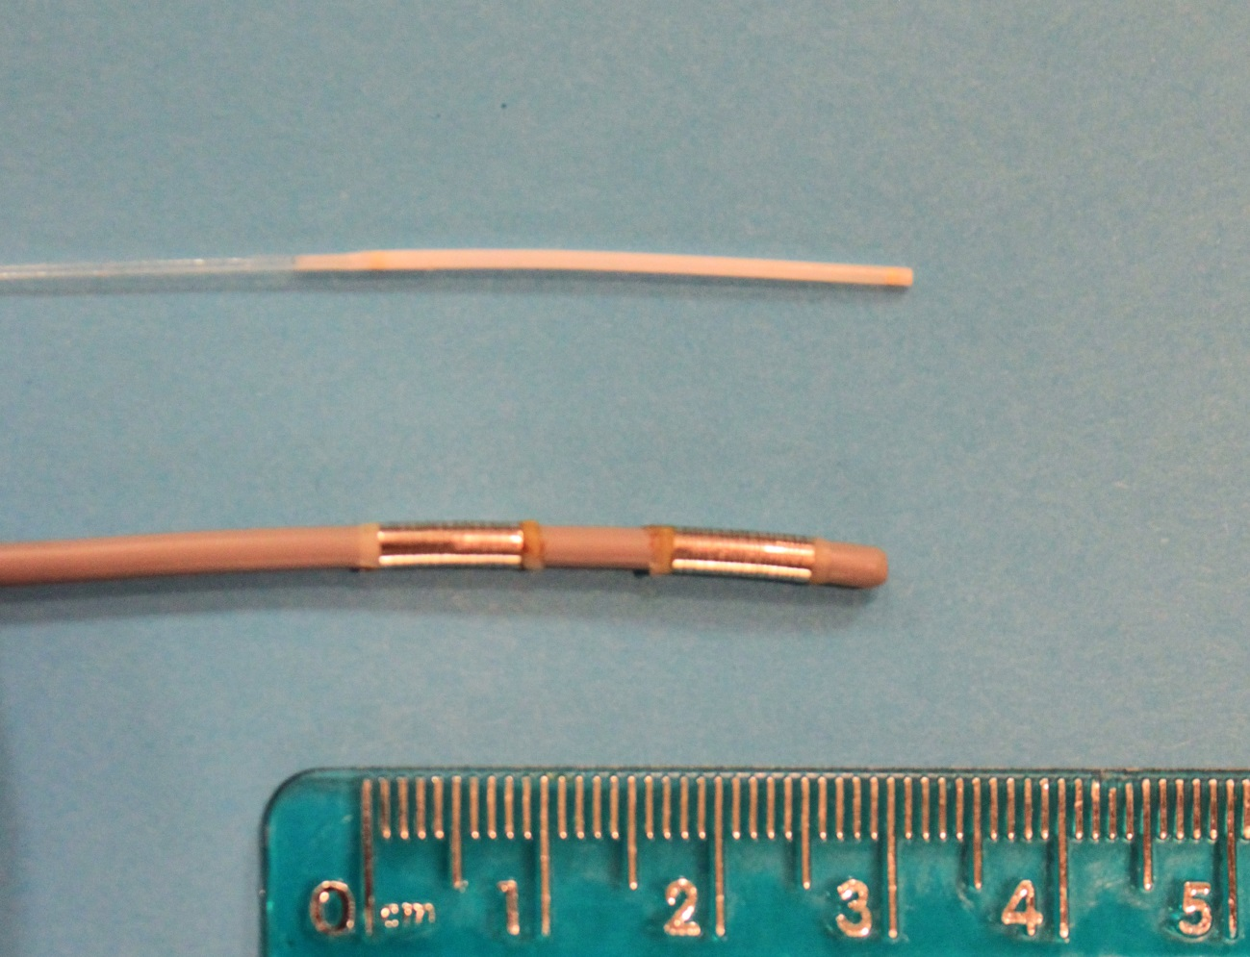
Figure 1 Endoscopic retrograde cholangiopancreatography-directed ablative therapies. Photodynamic therapy is applied via a laser fiber (above), whereas radiofrequency ablation is delivered using an 8-Fr catheter with two sets of bipolar rings (below).

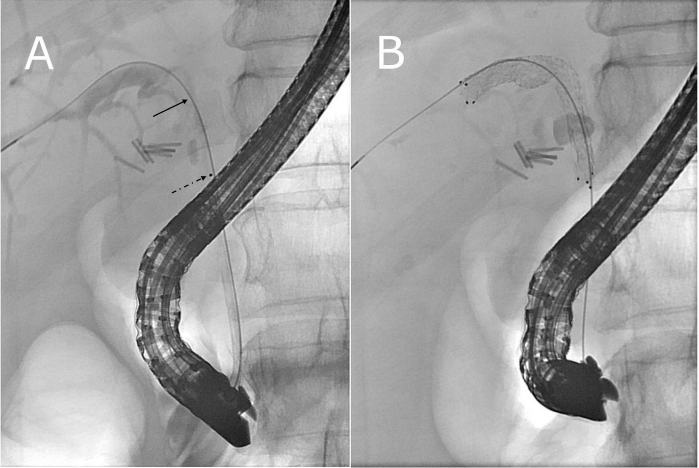
Figure 2 Endoscopic retrograde cholangiopancreatography-directed photodynamic therapy followed by unilateral metal stenting. A: Fluoroscopic view of a photodynamic therapy laser fiber delivered through a 10 Fr-bougie catheter during endoscopic retrograde cholangiopancreatography. The portion of the fiber that emits laser light is demarcated by the black dot (dashed arrow). The proximal-most tip of the fiber is not visible fluoroscopically (solid arrow) but is located near the biliary confluence; B: An 8 mm x 6 cm uncovered self-expandable metal stent was placed across a malignant stricture that involved the right hepatic duct and common hepatic duct.

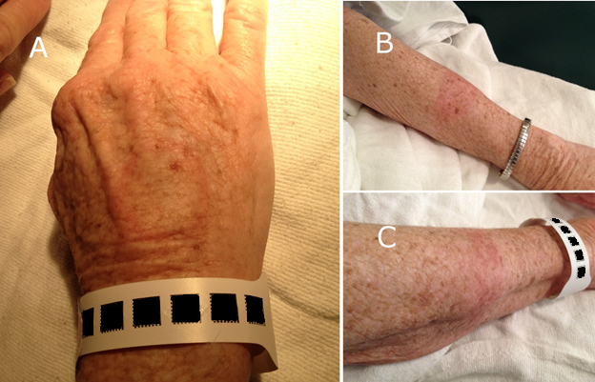
Figure 3 Photosensitivity following photodynamic therapy. A patient with unresectable cholangiocarcinoma was treated with photodynamic therapy. After 4 wk, a test dose of 10 min of exposure to direct sunlight on small areas of uncovered skin resulted in moderate burns on hands (A) and forearms (B, C). Two additional weeks of avoidance to even indirect sunlight was required.

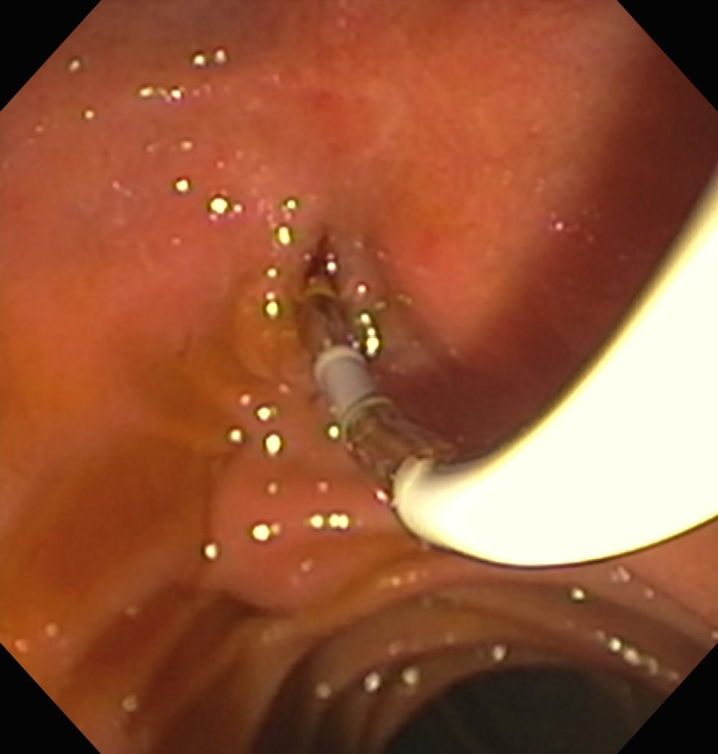
Figure 4 Endoscopic view of a radiofrequency ablation catheter being inserted into the bile duct by using a duodenoscope. A biliary sphincterotomy had been performed during a prior endoscopic retrograde cholangiopancreatography procedure in this patient with an unresectable cholangiocarcinoma to enable easier access to the bile duct. Note: this is not a depiction of radiofrequency ablation (RFA) actively being performed, as RFA is not typically applied with the bipolar coils exposed in the duodenal lumen, in order to avoid thermal injury to the duodenal wall.

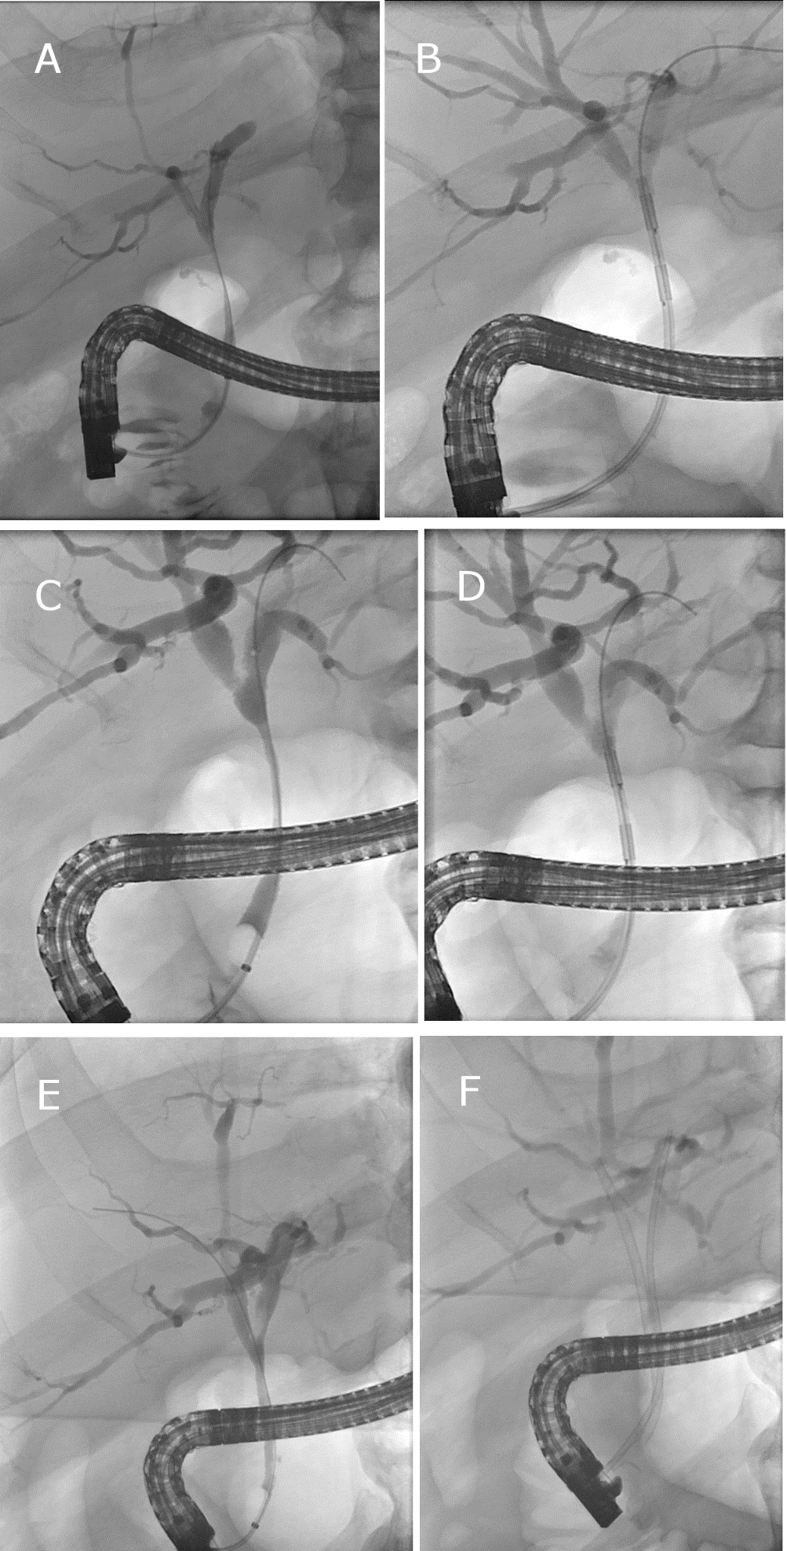
Figure 5 Effect of repeated endoscopic retrograde cholangiopancreatography-directed radiofrequency ablation on a malignant extrahepatic biliary stricture in a patient with unresectable cholangiocarcinoma. A long perihilar stricture is seen involving the extrahepatic duct (A) in a patient who had exploratory laparotomy that showed locally advanced and unresectable Bismuth I cholangiocarcinoma. A cholecystectomy had been performed at the time of laparotomy. Endoscopic retrograde cholangiopancreatography (ERCP)-directed radiofrequency ablation (RFA) was applied to this malignant stricture (B) followed by biliary stenting (not shown). Following two rounds of RFA done at about 3 mo intervals, a third ERCP showed moderate improvement in the stricture diameter (C). Repeat ERCP-directed RFA was performed (D). After 4 rounds of RFA therapy, an ERCP 1 year later showed marked improvement of the extrahepatic bile duct with no high-grade stricture seen (E), and RFA was not repeated during this procedure. A 10-Fr plastic stent was placed into the right hepatic duct and a 7-Fr plastic stent was placed into the left hepatic duct for more durable biliary drainage (F), as this was an otherwise healthy patient with excellent functional status who would likely outlive metal stenting. While patients with Bismuth I cholangiocarcinoma often do well with a single extrahpeatic biliary stent, this patient had previously had premature stent failure and cholangitis with a single plastic stent, thus two biliary stents were required.

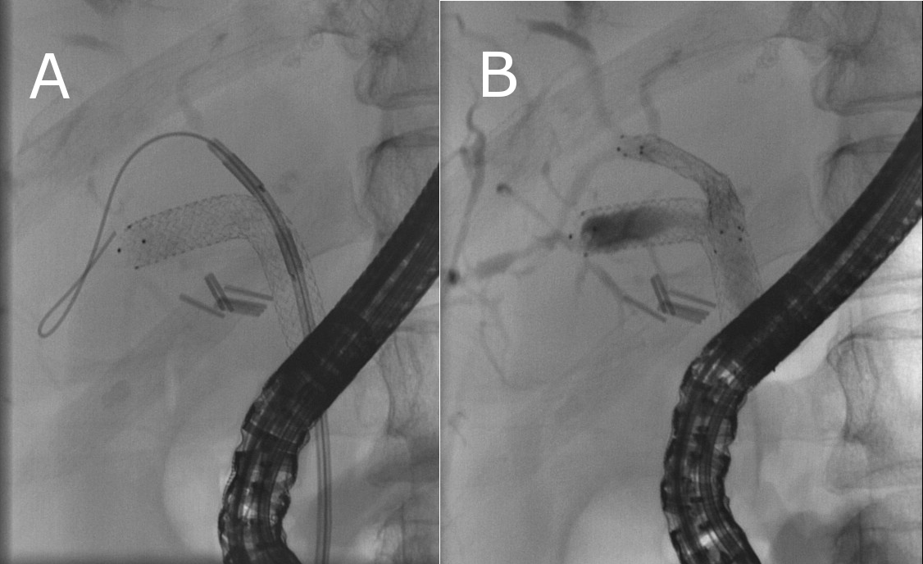
Figure 6 A patient with unresectable cholangiocarcinoma was previously treated with photodynamic therapy followed by placement of an uncovered metal stent (see Figure 2). For persistent symptomatic biliary obstruction due to undrained segments in the right liver, a wire passed into the previously undrained segments which allowed for 6-Fr bougie dilation followed by 4-mm balloon dilation across the lattices of the existing large-cell uncovered self-expandable metal stent (SEMS) (not shown). After dilation, the 8-Fr radiofrequency ablation (RFA) catheter was deployed over the wire and through the SEMS, and RFA was applied to a malignant stricture that was obstructing drainage (A). Lastly an 8-mm uncovered SEMS was deployed through the previously placed 8-mm uncovered SEMS (B) enabling durable drainage of more of the right liver.

