Name of Journal: World Journal of Gastroenterology
Manuscript NO: 70327
Manuscript Type: LETTER TO THE EDITOR

Prognostic role of expression of angiogenesis markers in hepatocellular carcinoma: A bioinformatics analysis

Miao YD et al. Angiogenesis markers in HCC

Yan-Dong Miao, Xiao-Long Tang, Jiang-Tao Wang, Deng-Hai Mi

Yan-Dong Miao, Xiao-Long Tang, Jiang-Tao Wang, Deng-Hai Mi, The First Clinical Medical College, Lanzhou University, Lanzhou 730000, Gansu Province, China

Yan-Dong Miao, Jiang-Tao Wang, Yantai Affiliated Hospital of Binzhou Medical University, The Second Clinical Medical College of Binzhou Medical University, Yantai 264000, Shandong Province, China

Deng-Hai Mi, Dean’s Office, Gansu Academy of Traditional Chinese Medicine, Lanzhou 730000, Gansu Province, China

Author contributions: Mi DH and Miao YD designed the research; Miao YD wrote this comment; Miao YD and Tang XL performed data analysis and prepared the tables and figures; Wang JT downloaded the data; Mi DH reviewed the manuscript; Miao YD and Tang XL contributed equally to this work; and all authors approved the final manuscript.

Supported by the Special Plan for Condition Construction of Gansu Provincial Scientific Research Institutes, No. 20JR10RA432.

Corresponding author: Deng-Hai Mi, MD, Chief Doctor, Dean, Dean’s Office, Gansu Academy of Traditional Chinese Medicine, No. 418 Guazhou Road, Qilihe District, Lanzhou 730000, Gansu Province, China. mi.dh@outlook.com

Received: July 30, 2021
Revised: August 22, 2021
Accepted: July 18, 2022
Published online:

Abstract
The expression of angiopoietin (ANGPT) 1, ANGPT2, vascular endothelial growth factor (VEGF) A, VEGFB, VEGFC, VEGFD, and placental growth factor (PGF) is significantly higher in tumor tissues than in normal tissues in both unpaired and paired hepatocellular carcinoma (HCC) samples. ANGPT2, VEGFB, VEGFC, and PGF are primarily involved in regulating the activation of the epithelial-mesenchymal transition pathway; ANGPT1 is primarily involved in regulating the activation of the RAS/mitogen-activated protein kinase and receptor tyrosine kinase (RTK) pathways; VEGFA is engaged in regulating the RTK activation pathway; and VEGFD is mainly involved in regulating the activation of the tuberous sclerosis protein/mammalian target of rapamycin pathway. There is a significant difference in overall survival between HCC patients with high and low expression of ANGPT2, PGF, VEGFA, and VEGFD. Disease free survival (DFS) is significantly shorter in HCC patients with high ANGPT2, PGF, and VEGFA expression than in those with low ANGPT2, PGF, and VEGFA expression.

Key Words: Hepatocellular carcinoma; Angiogenesis; Marker; Bioinformatics analysis; Pathway

Miao YD, Tang XL, Wang JT, Mi DH. Prognostic role of expression of angiogenesis markers in hepatocellular carcinoma: A bioinformatics analysis. World J Gastroenterol 2022; In press

Core Tip: We found that the expression of angiogenesis markers was significantly higher in tumor tissues than in normal tissues in both unpaired and paired hepatocellular carcinoma (HCC) samples. These angiogenesis markers are mainly involved in regulating the activation of the EMT pathway, the RAS/mitogen-activated protein kinase and receptor tyrosine kinase pathways, and the tuberous sclerosis protein/mammalian target of rapamycin pathway. In addition, there was a significant difference in overall survival between HCC patients with high and low expression of angiopoietin-2 (ANGPT2), placental growth factor (PGF), vascular endothelial growth factor A (VEGFA), and VEGFD. Disease free survival was significantly shorter in HCC patients with high ANGPT2, PGF, and VEGFA expression than in those with low ANGPT2, PGF, and VEGFA expression.

TO THE EDITOR
We read with read interest the article by Choi et al^{[1]}, in which they initially evaluated plasma levels of angiogenesis biomarkers in hepatocellular carcinoma (HCC) patients, and then assessed their roles in forecasting overall survival (OS) and progression-free survival (PFS), indicating that the plasma level of angiopoietin (ANGPT) 2 was related to tumor stage, liver function, and cancer invasiveness, and that ANGPT2 performed better in predicting OS and PFS than alpha-fetoprotein (AFP), ANGPT1, and vascular endothelial growth factor (VEGF).
We appreciate the authors’ unique perspective in exploring the prognostic role of plasma levels of ANGPT1, ANGPT2, and VEGF in HCC. However, there are some errors in the original text that may cause confusion for readers. For example, the survival curve in figure 3B in the original article should have represented the survival curve between the high and low ANGPT2 expression subgroups, which the authors incorrectly labeled as ANGPT1. Second, it is well known that the VEGF family includes VEGFA, VEGFB, VEGFC, VEGFD, VEGFE, and placental growth factor (PGF)^{[2,3]}, so to which VEGF do the authors refer in the text? Usually, VEGF refers to VEGFA, but the authors should have clarified it in the text.
Moreover, it might make the results more significant if the authors could improve the outcome by demonstrating the differential expression of ANGPT1, ANGPT2, and VEGF in normal tissues and HCC tissues as a whole, for example, the analysis of HCC samples in the Cancer Genome Atlas database using bioinformatics. We found that the expression of ANGPT1, ANGPT2, VEGFA, VEGFB, VEGFC, VEGFD, and PGF was significantly higher in cancer samples than in corresponding normal samples in both unpaired and paired HCC samples (Figures 1A and 1B). Detailed statistical results are reported in Tables 1 and 2.
We also found that ANGPT2, VEGFB, VEGFC, and PGF are mainly involved in regulating the activation of the EMT pathway; ANGPT1 is prominently involved in regulating the activation of the RAS/mitogen-activated protein kinase and receptor tyrosine kinase (RTK) pathways; VEGFA is engaged in regulating the activation of the RTK pathway; and VEGFD is mainly involved in regulating the activation of the tuberous sclerosis protein/mammalian target of rapamycin pathway (Figure 1C). These results are consistent with those of previously reported studies^{[4-7]}. Our findings could be a supplement to Choi et al’s study^{[1]}. In the future, the roles of ANGPT1, ANGPT2, and VEGF in the development of HCC should be further explored.
Choi et al^{[1]} found that OS was significantly shorter in the high ANGPT2 and high AFP subgroups than in the low ANGPT2 and AFP subgroups, respectively, though the differences in OS rates were not significant between the high and low ANGPT1 subgroups or between the high and low VEGF subgroups. Our study found that OS was significantly shorter in patients with high ANGPT2, PGF, VEGFA, or VEGFD expression than in those with low expression, respectively (Figures 2A-D; P < 0.05). However, there was no significant difference in survival time between patients with high and low expression of ANGPT1, VEGFB, VEGFC, and AFP (Figures 2E-H; P > 0.05). Prognostic data for HCC came from Liu et al^{[8]}.
In addition, we also analyzed the differences in disease free survival (DFS) between patients with high and low angiogenesis marker expression. We found that DFS was significantly shorter in the high ANGPT2, PGF, and VEGFA groups than in the low ANGPT2, PGF, and VEGFA groups, respectively (Figures 3A, 3B and 3C; P < 0.05). However, there was no significantly difference in DFS between groups with high and low expression of AFP, ANGPT1, VEGFB, VEGFC, and VEGFD (Figures 3D-H; P > 0.05). The above results confirm that the study performed by Choi et al^{[1]} is of great value and that our discovery could be a supplement to their research.

Statistical analysis
We utilized R (version 4.0.3) to perform statistical analyses and display the results. The differential expression analysis of angiogenesis markers between HCC tissues and corresponding normal tissues was performed using the Wilcoxon rank-sum test, and the results are presented by using R-package “ggplot2”^{[9]}. Survival analysis was completed through log-rank test and COX regression. Pathway analysis was performed based on the online database GSCALite (http://bioinfo.life.hust.edu.cn/web/GSCALite/)^{[10]}.

ACKNOWLEDGEMENTS
We are grateful to the professors at the School of Foreign Languages of Lanzhou University for their help in the language polish of this manuscript.

REFERENCES
1 Choi GH, Jang ES, Kim JW, Jeong SH. Prognostic role of plasma level of angiopoietin-1, angiopoietin-2, and vascular endothelial growth factor in hepatocellular carcinoma. World J Gastroenterol 2021; 27: 4453-4467 [PMID: 34366616 DOI: 10.3748/wjg.v27.i27.4453]
2 Heloterä H, Alitalo K. The VEGF family, the inside story. Cell 2007; 130: 591-592 [PMID: 17719536 DOI: 10.1016/j.cell.2007.08.012]
3 Thomas JL, Eichmann A. The power of VEGF (vascular endothelial growth factor) family molecules. Cell Mol Life Sci 2013; 70: 1673-1674 [PMID: 23475064 DOI: 10.1007/s00018-013-1276-6]
4 Kong D, Zhou H, Neelakantan D, Hughes CJ, Hsu JY, Srinivasan RR, Lewis MT, Ford HL. VEGF-C mediates tumor growth and metastasis through promoting EMT-epithelial breast cancer cell crosstalk. Oncogene 2021; 40: 964-979 [PMID: 33299122 DOI: 10.1038/s41388-020-01539-x]
5 Wang X, Xing Z, Xu H, Yang H, Xing T. Development and validation of epithelial mesenchymal transition-related prognostic model for hepatocellular carcinoma. Aging (Albany NY) 2021; 13: 13822-13845 [PMID: 33929972 DOI: 10.18632/aging.202976]
6 Bi X, Niu J, Ding W, Zhang M, Yang M, Gu Y. Angiopoietin-1 attenuates angiotensin II-induced ER stress in glomerular endothelial cells via a Tie2 receptor/ERK1/2-p38 MAPK-dependent mechanism. Mol Cell Endocrinol 2016; 428: 118-132 [PMID: 27033326 DOI: 10.1016/j.mce.2016.03.027]
7 Chen H, Guan R, Lei Y, Chen J, Ge Q, Zhang X, Dou R, Chen H, Liu H, Qi X, Zhou X, Chen C. Lymphangiogenesis in gastric cancer regulated through Akt/mTOR-VEGF-C/VEGF-D axis. BMC Cancer 2015; 15: 103 [PMID: 25884175 DOI: 10.1186/s12885-015-1109-0]
8 Liu J, Lichtenberg T, Hoadley KA, Poisson LM, Lazar AJ, Cherniack AD, Kovatich AJ, Benz CC, Levine DA, Lee AV, Omberg L, Wolf DM, Shriver CD, Thorsson V; Cancer Genome Atlas Research Network, Hu H. An Integrated TCGA Pan-Cancer Clinical Data Resource to Drive High-Quality Survival Outcome Analytics. Cell 2018; 173: 400-416.e11 [PMID: 29625055 DOI: 10.1016/j.cell.2018.02.052]
9 Walter W, Sánchez-Cabo F, Ricote M. GOplot: an R package for visually combining expression data with functional analysis. Bioinformatics 2015; 31: 2912-2914 [PMID: 25964631 DOI: 10.1093/bioinformatics/btv300]
10 Liu CJ, Hu FF, Xia MX, Han L, Zhang Q, Guo AY. GSCALite: a web server for gene set cancer analysis. Bioinformatics 2018; 34: 3771-3772 [PMID: 29790900 DOI: 10.1093/bioinformatics/bty411]
11 Vivian J, Rao AA, Nothaft FA, Ketchum C, Armstrong J, Novak A, Pfeil J, Narkizian J, Deran AD, Musselman-Brown A, Schmidt H, Amstutz P, Craft B, Goldman M, Rosenbloom K, Cline M, O'Connor B, Hanna M, Birger C, Kent WJ, Patterson DA, Joseph AD, Zhu J, Zaranek S, Getz G, Haussler D, Paten B. Toil enables reproducible, open source, big biomedical data analyses. Nat Biotechnol 2017; 35: 314-316 [PMID: 28398314 DOI: 10.1038/nbt.3772]

Footnotes
Conflict-of-interest statement: All the authors report no relevant conflicts of interest for this article.

Open-Access: This article is an open-access article that was selected by an in-house editor and fully peer-reviewed by external reviewers. It is distributed in accordance with the Creative Commons Attribution NonCommercial (CC BY-NC 4.0) license, which permits others to distribute, remix, adapt, build upon this work non-commercially, and license their derivative works on different terms, provided the original work is properly cited and the use is non-commercial. See: https://creativecommons.org/Licenses/by-nc/4.0/

Provenance and peer review: Invited article; Externally peer reviewed
Peer-review model: Single blind

Peer-review started: July 30, 2021
First decision: August 19, 2021
Article in press:

Specialty type: Gastroenterology and hepatology
Country/Territory of origin: China
Peer-review report’s scientific quality classification
Grade A (Excellent): 0
Grade B (Very good): 0
Grade C (Good): C
Grade D (Fair): 0
Grade E (Poor): 0

P-Reviewer: Zhong C, China S-Editor: Wang JJ L-Editor: Wang TQ P-Editor:

Figure Legends
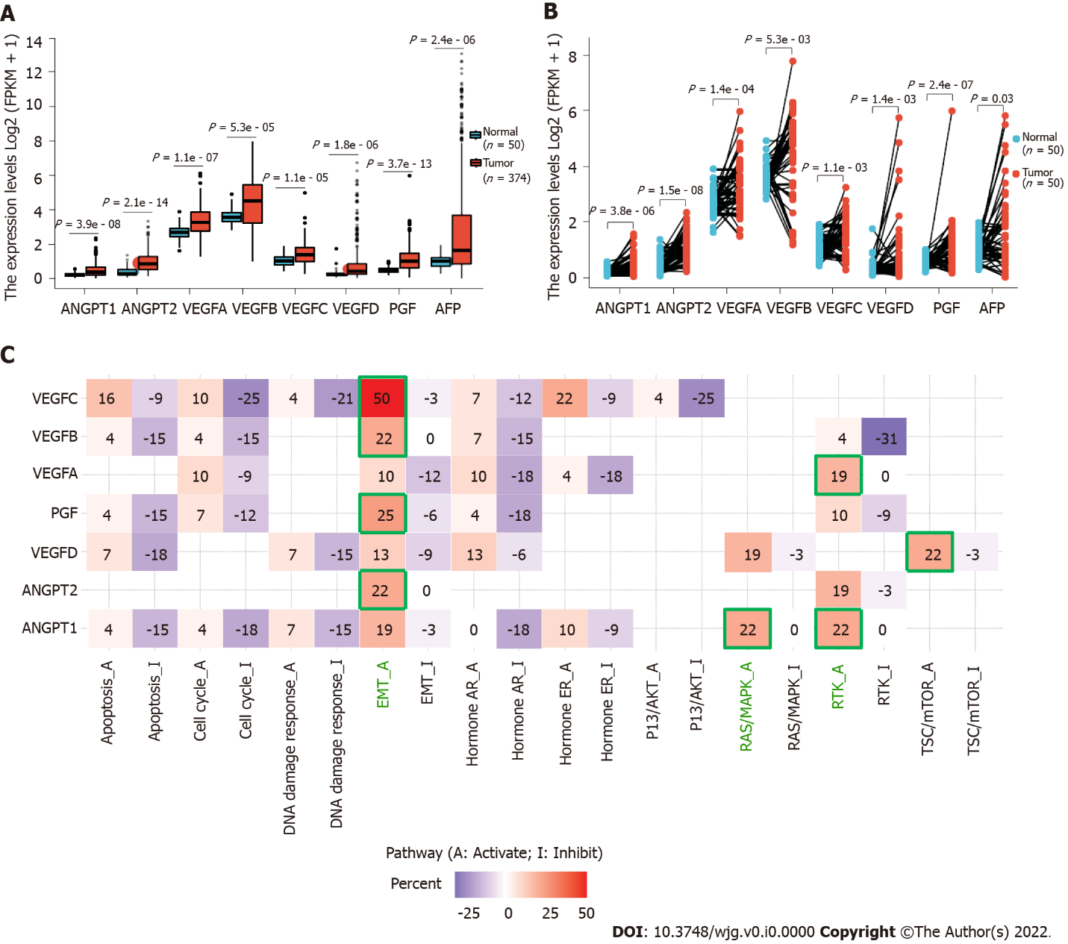
Figure 1 Roles of angiopoietins 1 and 2, vascular endothelial growth factors A-D, and placental growth factor in development of hepatocellular carcinoma. Data source: UCSC XENA (https://xenabrowser.net/datapages/) mRNA-Seq data of TPM format for GTEx and TCGA processed uniformly via the Toil process^{[11]}. Liver hepatocellular carcinoma tissue data from TCGA and corresponding normal tissue data from GTEx were used. A: Differential expression of angiopoietin (ANGPT) 1, ANGPT2, vascular endothelial growth factor (VEGF) A, VEGFB, VEGFC, VEGFD, and placental growth factor (PGF) in hepatocellular carcinoma (HCC) and normal tissue samples; B: Differential expression of ANGPT1, ANGPT2, VEGFA, VEGFB, VEGFC, VEGFD, and PGF in paired HCC and normal samples. The expression in cancer tissues is represented in orange, and that in normal tissues is displayed in blue; C: Pathway analysis for ANGPT1, ANGPT2, VEGFA, VEGFB, VEGFC, VEGFD, and PGF in HCC. ANGPT: Angiopoietin; PGF: Placental growth factor; VEGF: Vascular endothelial growth factor; AFP: Alpha-fetoprotein; EMT: Epithelial-mesenchymal transition; AR: Androgen receptor; ER: Estrogen receptor; P13K/AKT: Phosphatidylinositol 3 kinase/AKT; RAS/MAPK: RAS/mitogen-activated protein kinase; RTK: Receptor tyrosine kinase; TSC/mTOR: TSC/mammalian target of rapamycin.

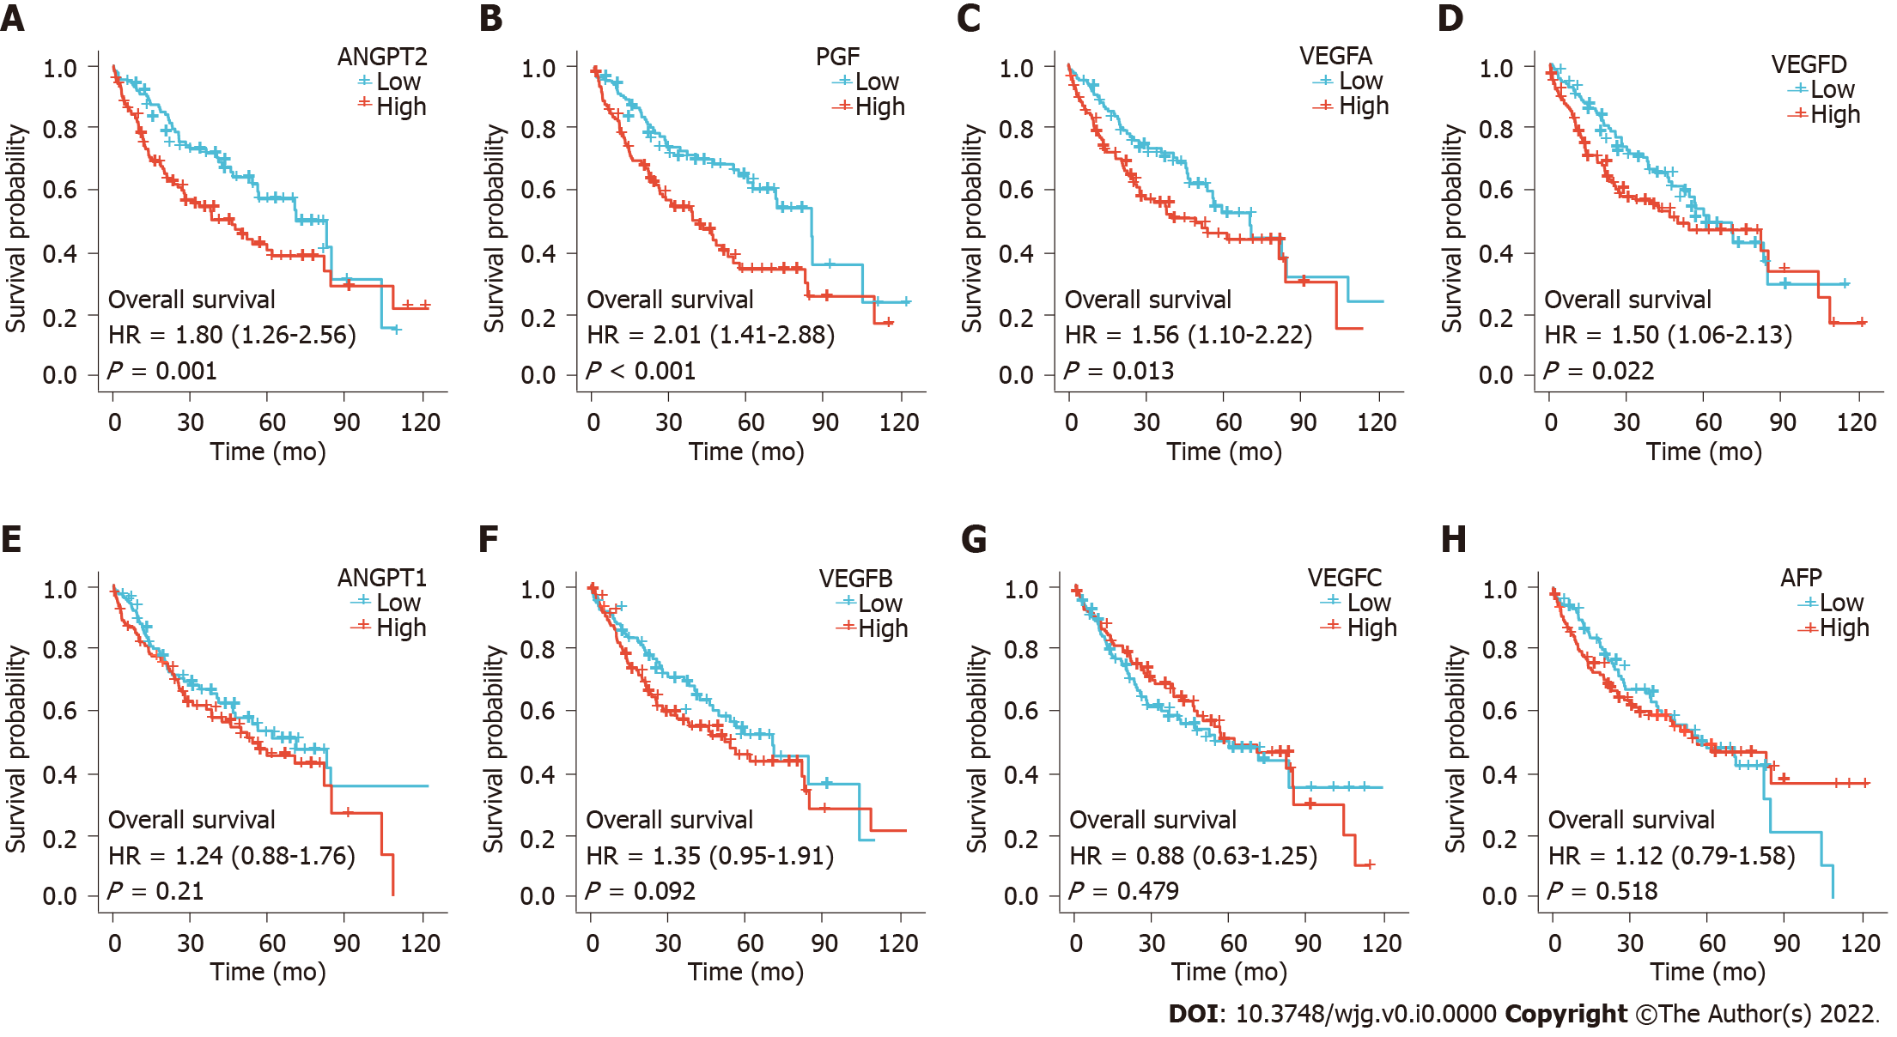
Figure 2 Overall survival by angiogenesis marker expression in hepatocellular carcinoma. A: Angiopoietin (ANGPT) 2; B: Placental growth factor; C: Vascular endothelial growth factor (VEGF) A; D: VEGFD; E: ANGPT1; F: VEGFB; G: VEGFC; H: Alpha-fetoprotein. The red and blue lines indicate the survival curves of the high and low angiogenesis marker expression groups, respectively. ANGPT: Angiopoietin; PGF: Placental growth factor; VEGF: Vascular endothelial growth factor; AFP: Alpha-fetoprotein; HR: Hazard ratio.

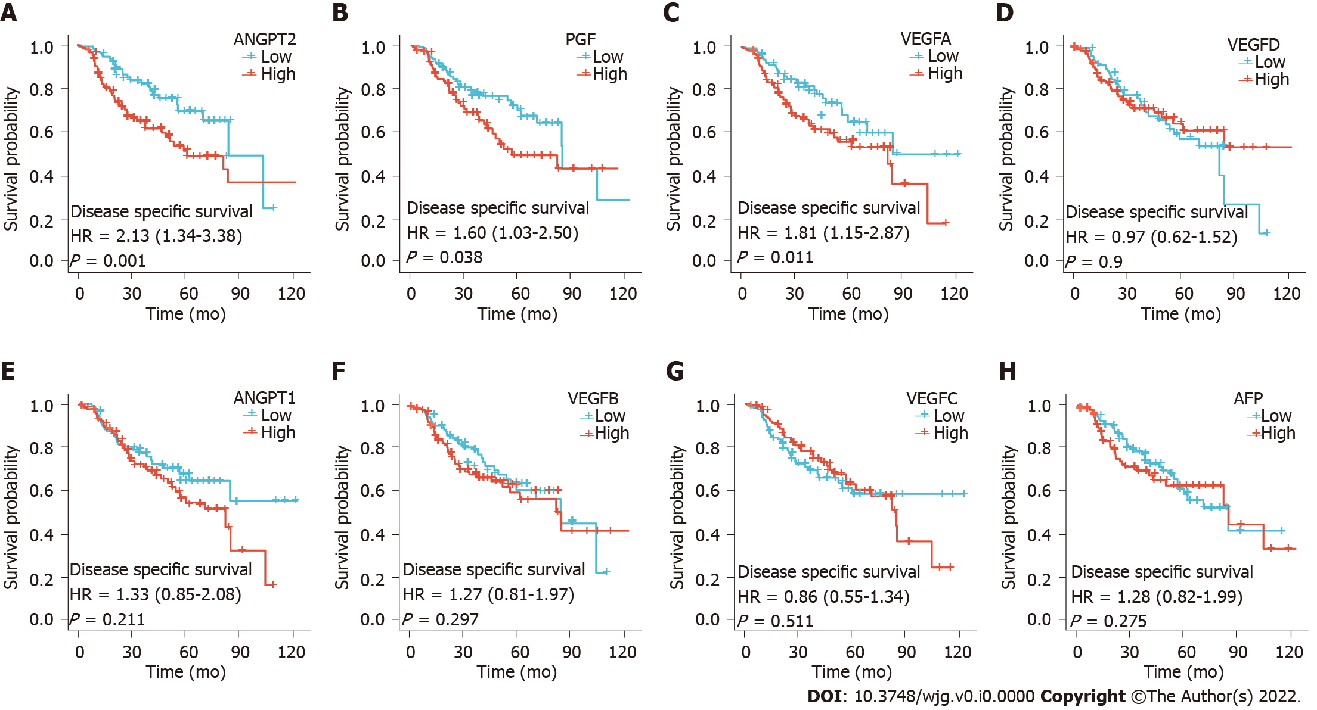
Figure 3 Disease free survival by angiogenesis marker expression in hepatocellular carcinoma. A: Angiopoietin (ANGPT) 2; B: Placental growth factor; C: Vascular endothelial growth factor (VEGF) A; D: Alpha-fetoprotein; E: ANGPT1; F: VEGFB; G: VEGFC; H: VEGFD. The red and blue lines indicate the survival curves of the high and low angiogenesis marker expression groups, respectively. ANGPT: Angiopoietin; PGF: Placental growth factor; VEGF: Vascular endothelial growth factor; AFP: Alpha-fetoprotein; HR: Hazard ratio.

Table 1 Detailed statistical results of differential expression analysis of angiogenesis markers in hepatocellular carcinoma
Gene | Group | Number | Minimum | Maximum | Median | IQR | Lower quartile | Upper quartile | Mean | SD | SE
ANGPT1 | Normal | 50 | 0.029 | 0.552 | 0.188 | 0.132 | 0.138 | 0.27 | 0.206 | 0.106 | 0.015
ANGPT1 | Tumor | 374 | 0 | 2.351 | 0.373 | 0.464 | 0.2 | 0.664 | 0.485 | 0.391 | 0.02
ANGPT2 | Normal | 50 | 0.043 | 1.351 | 0.278 | 0.33 | 0.195 | 0.525 | 0.394 | 0.289 | 0.041
ANGPT2 | Tumor | 374 | 0.116 | 3.339 | 0.848 | 0.769 | 0.513 | 1.282 | 0.963 | 0.581 | 0.03
VEGFA | Normal | 50 | 1.616 | 3.901 | 2.687 | 0.473 | 2.439 | 2.911 | 2.717 | 0.445 | 0.063
VEGFA | Tumor | 374 | 1.258 | 6.138 | 3.268 | 1.103 | 2.769 | 3.871 | 3.291 | 0.809 | 0.042
VEGFB | Normal | 50 | 2.816 | 4.919 | 3.568 | 0.523 | 3.325 | 3.848 | 3.636 | 0.444 | 0.063
VEGFB | Tumor | 374 | 0.978 | 8.003 | 4.532 | 2.234 | 3.223 | 5.458 | 4.292 | 1.521 | 0.079
VEGFC | Normal | 50 | 0.408 | 1.901 | 1.019 | 0.453 | 0.787 | 1.239 | 1.057 | 0.355 | 0.05
VEGFC | Tumor | 374 | 0.253 | 4.988 | 1.376 | 0.816 | 0.978 | 1.795 | 1.436 | 0.62 | 0.032
VEGFD | Normal | 50 | 0.054 | 1.74 | 0.236 | 0.151 | 0.164 | 0.316 | 0.307 | 0.28 | 0.04
VEGFD | Tumor | 374 | 0.014 | 6.756 | 0.422 | 0.622 | 0.241 | 0.863 | 0.838 | 1.14 | 0.059
PGF | Normal | 50 | 0.182 | 0.992 | 0.471 | 0.204 | 0.37 | 0.575 | 0.501 | 0.188 | 0.027
PGF | Tumor | 374 | 0.061 | 5.991 | 1.007 | 0.855 | 0.613 | 1.467 | 1.104 | 0.675 | 0.035
AFP | Normal | 50 | 0.266 | 1.969 | 1.016 | 0.507 | 0.714 | 1.221 | 0.992 | 0.416 | 0.059
AFP | Tumor | 374 | 0 | 13.118 | 1.644 | 2.855 | 0.844 | 3.699 | 2.965 | 3.15 | 0.163
ANGPT: Angiopoietin; VEGFA: Vascular endothelial growth factor; PGF: Placental growth factor; AFP: Alpha-fetoprotein; IQR: Interquartile range; SD: Standard deviation, SE: Standard error.

Table 2 Detailed statistical results of differential expression analysis of angiogenesis markers in paired samples of hepatocellular carcinoma
Gene | Group | Number | Minimum | Maximum | Median | IQR | Lower quartile | Upper quartile | Mean | SD | SE
ANGPT1 | Normal | 50 | 0.029 | 0.552 | 0.188 | 0.132 | 0.138 | 0.27 | 0.206 | 0.106 | 0.015
ANGPT1 | Tumor | 50 | 0.014 | 1.557 | 0.463 | 0.56 | 0.228 | 0.788 | 0.507 | 0.363 | 0.051
ANGPT2 | Normal | 50 | 0.043 | 1.351 | 0.278 | 0.33 | 0.195 | 0.525 | 0.394 | 0.289 | 0.041
ANGPT2 | Tumor | 50 | 0.193 | 2.324 | 1.056 | 0.77 | 0.747 | 1.517 | 1.111 | 0.517 | 0.073
VEGFA | Normal | 50 | 1.616 | 3.901 | 2.687 | 0.473 | 2.439 | 2.911 | 2.717 | 0.445 | 0.063
VEGFA | Tumor | 50 | 1.471 | 5.974 | 3.102 | 1.087 | 2.801 | 3.888 | 3.287 | 0.902 | 0.128
VEGFB | Normal | 50 | 2.816 | 4.919 | 3.568 | 0.523 | 3.325 | 3.848 | 3.636 | 0.444 | 0.063
VEGFB | Tumor | 50 | 1.164 | 7.789 | 4.833 | 1.993 | 3.323 | 5.317 | 4.328 | 1.575 | 0.223
VEGFC | Normal | 50 | 0.408 | 1.901 | 1.019 | 0.453 | 0.787 | 1.239 | 1.057 | 0.355 | 0.05
VEGFC | Tumor | 50 | 0.261 | 3.233 | 1.398 | 0.819 | 1.013 | 1.831 | 1.459 | 0.633 | 0.09
VEGFD | Normal | 50 | 0.054 | 1.74 | 0.236 | 0.151 | 0.164 | 0.316 | 0.307 | 0.28 | 0.04
VEGFD | Tumor | 50 | 0.014 | 5.746 | 0.367 | 0.562 | 0.231 | 0.793 | 0.832 | 1.207 | 0.171
PGF | Normal | 50 | 0.182 | 0.992 | 0.471 | 0.204 | 0.37 | 0.575 | 0.501 | 0.188 | 0.027
PGF | Tumor | 50 | 0.144 | 5.991 | 1.072 | 0.833 | 0.67 | 1.503 | 1.16 | 0.859 | 0.121
AFP | Normal | 50 | 0.266 | 1.969 | 1.016 | 0.507 | 0.714 | 1.221 | 0.992 | 0.416 | 0.059
AFP | Tumor | 50 | 0 | 5.824 | 1.033 | 1.31 | 0.725 | 2.036 | 1.62 | 1.383 | 0.196
ANGPT: Angiopoietin; VEGFA: Vascular endothelial growth factor; PGF: Placental growth factor; AFP: Alpha-fetoprotein; IQR: Interquartile range; SD: Standard deviation, SE: Standard error.

