Name of Journal: World Journal of Gastroenterology
Manuscript NO: 32495
Manuscript Type: Letter to the Editor

Is tremor related to celiac disease?

Ameghino L et al. Is tremor related to CD?

Lucia Ameghino, Malco Damian Rossi, Daniel Cerquetti, Marcelo Merello

Lucia Ameghino, Malco Damian Rossi, Daniel Cerquetti, Marcelo Merello, Movement Disorders Section, Neuroscience Department, Raul Carrea Institute for Neurological Research, Buenos Aires C1428AQK, Argentina

Author contributions: All authors equally contributed to this paper.

Conflict-of-interest statement: The author reports no conflict of interest.

Open-Access: This article is an open-access article which was selected by an in-house editor and fully peer-reviewed by external reviewers. It is distributed in accordance with the Creative Commons Attribution Non Commercial (CC BY-NC 4.0) license, which permits others to distribute, remix, adapt, build upon this work non-commercially, and license their derivative works on different terms, provided the original work is properly cited and the use is non-commercial. See: http://creativecommons.org/licenses/by-nc/4.0/

Manuscript source: Unsolicited manuscript

Correspondence to: Marcelo Merello, MD, PhD, Movement Disorders Section, Neuroscience Department, Raul Carrea Institute for Neurological Research, Montañeses 2325, Buenos Aires C1428AQK, Argentina. mmerello@fleni.org.ar
Telephone: +54-11-57773200
Received: January 10, 2017
Peer-review started: January 11, 2017
First decision: February 9, 2017
Revised: April 3, 2017
Accepted: May 9, 2017
Article in press:
Published online:

Abstract
Neurological features in celiac disease (CD) are not rare (5%-36%), but tremor is scarcely described. Subjects with CD and healthy controls completed an online survey using WHIGET tremor rating scale. 1512 subjects completed the survey, finally 674 CD patients and 290 healthy subjects were included. A higher prevalence of tremor in CD patients was observed in comparison to controls (28% vs 14%, p < 0.001). Frequency of family history of tremor in CD patients with and without tremor was 25% and 20% (p = 0.2), while in the control group it was 41% and 10% (p < 0.001). Controls with tremor showed a higher frequency of family history of tremor when compared to CD patients with tremor (41.5% vs 24.6%, p = 0.03). The results suggested that tremor in CD might be more frequent and possibly related to the disease itself and not due to associated essential tremor.

Key words: Tremor; Celiac disease; Gluten; Gluten-free diet; Movement disorders

© The Author(s) 2017. Published by Baishideng Publishing Group Inc. All rights reserved.

Core tip: We performed an online inquest, completed by 1512 subjects, 674 had celiac disease and 290 controls. We observed a higher (double) prevalence of tremor in celiac patients in comparison to healthy controls (28% vs 14%, p < 0.001). The frequency of a family history of tremor was higher in controls with tremor, but not in Celiac disease (CD) patients with tremor, suggesting that tremor in CD might be might be more frequent than controls and possibly related to the disease process itself and not due to essential tremor.

Ameghino L, Rossi MD, Cerquetti D, Merello M. Is tremor related to celiac disease? World J Gastroenterol 2017; In press

To the editor
Celiac disease (CD) is a systemic autoimmune disease that mainly affects small intestine. Neurological features are not rare in CD and the physiopathology of the nervous system compromise is still controversial. However, it is believed that a cross antibodies reaction due to molecular mimicry occurs, mainly exerted by the celiac panel antibodies against the Purkinje cells in the cerebellum. With an overall frequency of 5%-36%, ataxia, myoclonus, chorea, peripheral neuropathy, headache and seizures are the most frequent neurological symptoms of CD^{[1,2]}. Tremor was scarcely described^{[3,4]} and its prevalence and clinical correlates were not established. Therefore, in this pilot study we aimed to prospectively evaluate tremor features in CD patients.
In a prospective way, an online inquest using the tremor scale Washington Heights-Inwood Genetic Study of Essential Tremor (WHIGET)^{[5]} was published in the Argentinean Celiac Association website from June through July 2015. Subjects with CD that reported bowel biopsy confirmation of villous atrophy (Marsh score 3) were asked to complete the WHIGET scale. A case of tremor was considered when subjects rated one or more points. Demographic data, medications, CD antibodies and gluten-free diet (GFD) compliance were registered. Non-blood relatives served as age- and gender-matched controls. Individuals under 18 years or with known functional or structural bowel disorders were excluded. The local IRB approved the protocol and participants signed written informed consent in accordance to Helsinki Declaration principles. Descriptive data are shown as mean ± standard error of the mean or proportions. Chi-square test was used to compare categorical data and analysis of variance (ANOVA) was employed for numerical variables.
A total of 1512 subjects [mean age, 38.5 ±12.8 years; 1335 (88%) females] completed the survey, of which 964 (64%) met inclusion criteria (Figure 1). Among the included participants, 674 (70%) had CD [mean age, 37.9 ±12.7 years; 622 (92%) females] and 290 (30%) were healthy controls [mean age, 37.7 ± 12.4 years; 237 (82%) females]. No age differences were observed between both groups (p = 0.5). The overall prevalence of tremor was 28% in CD patients and 14% en controls (p <0.001). A 25% of CD patients with tremor had a positive family history of tremor in comparison to a 20% of CD patients without tremor (p = 0.2). Frequency of family history of tremor in controls with tremor was 41% compared with 10% of controls without tremor (p < 0.001). A lower frequency of family history of tremor was found in CD patients with tremor in comparison to controls with tremor (25% vs 41%, p = 0.03). Comparison of CD patients with and without tremor revealed no statistically significant differences in family history of CD (29% vs 24%, respectively; p = 0.2), disease duration (5.3 ± 5.5 vs 6.5 ± 8.1, respectively; p = 0.07), positive CD antibodies (26.2% vs 26.4, respectively; p = 0.9), GFD compliance (83% vs 82%, respectively; p = 0.7) and treatment (thyroid hormone and β2 adrenergic agonist).
In a large sample, a double prevalence of tremor in the CD group was found compared to healthy individuals. We consider that tremor in CD might be possibly secondary to the disease process itself and not due to essential tremor as the frequency of a family history of tremor was lower in CD patients with tremor than in controls presenting with tremor. Tremor in CD was independent from demographics and CD characteristics, like disease duration, CD antibodies or GFD compliance. However, we might have failed to find any relationship between tremor and CD antibodies or GFD compliance, as symptoms may improve with gluten-free diet along with the disappearance of the CD-specific antibodies. Bürk and colleagues reported neurological features in a series of 72 patients with CD, of which 3% (2 patients) of them had intention tremor. Tremor features or its association with CD characteristics were not described^{[3]}. Kheder and colleagues reported a patient with positive antigliadin antibodies and progressive ataxia and palatal tremor that obtained improvement in his symptoms after two years of GFD^{[4]}.
Limitations of this study include the absence of a physical examination of CD patients with tremor, the absence of IgA deficiency exclusion, and that possible vitamin E, vitamin B12 or Mg deficiencies due to malabsorption, that may cause tremor secondary to a sensory neuropathy was not ruled out. Finally, a population bias may have occurred as an online inquest may have included mostly young subjects with Internet access. Further confirmatory studies are required to confirm the exact frequency of tremor in CD and the associated clinical correlates.

Acknowledgments
We thank the Argentinean Celiac Association for all their collaboration.

REFERENCES
1 Baizabal-Carvallo JF, Jankovic J. Movement disorders in autoimmune diseases. Mov Disord 2012; 27: 935-946 [PMID: 22555904 DOI: 10.1002/mds.25011]
2 Jackson JR, Eaton WW, Cascella NG, Fasano A, Kelly DL. Neurologic and psychiatric manifestations of celiac disease and gluten sensitivity. Psychiatr Q 2012; 83: 91-102 [PMID: 21877216 DOI: 10.1007/s11126-011-9186-y]
3 Bürk K, Farecki ML, Lamprecht G, Roth G, Decker P, Weller M, Rammensee HG, Oertel W. Neurological symptoms in patients with biopsy proven celiac disease. Mov Disord 2009; 24: 2358-2362 [PMID: 19845007 DOI: 10.1002/mds.22821]
4 Kheder A, Currie S, Romanowski C, Hadjivassiliou M. Progressive ataxia with palatal tremor due to gluten sensitivity. Mov Disord 2012; 27: 62-63 [PMID: 22252893 DOI: 10.1002/mds.23987]
5 Louis ED, Ottman R, Ford B, Pullman S, Martinez M, Fahn S, Hauser WA. The Washington Heights-Inwood Genetic Study of Essential Tremor: methodologic issues in essential-tremor research. Neuroepidemiology 1997; 16: 124-133 [PMID: 9159767]

P-Reviewer: Abenavoli L, Garcia-Olmo D, Kreisel W S-Editor: Ma YJ L-Editor: E-Editor:

Specialty type: Gastroenterology and hepatology
Country of origin: Argentina
Peer-review report classification
Grade A (Excellent): A
Grade B (Very good): 0
Grade C (Good): C, C
Grade D (Fair): 0
Grade E (Poor): 0

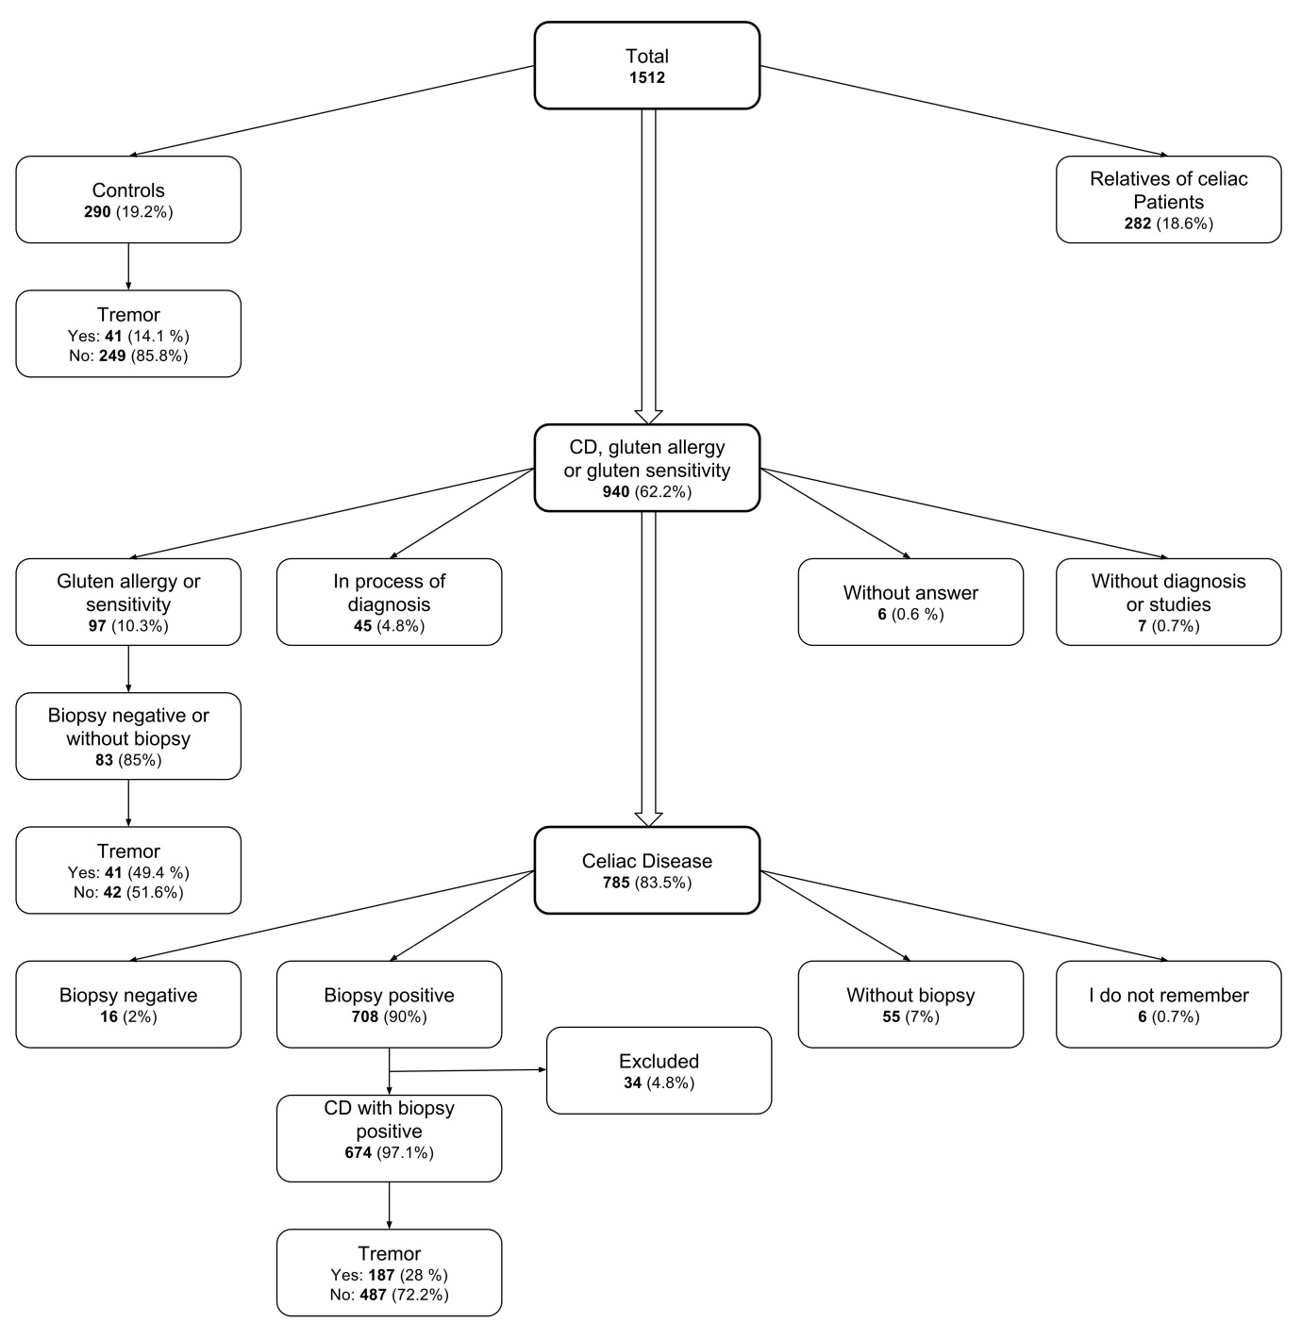

Figure 1 Flow chart of the study selection process.

