Name of journal: World Journal of Hepatology
ESPS Manuscript NO: 12366
Columns: Review

Liver cirrhosis in hepatic vena cava syndrome (or membranous obstruction of inferior vena cava)

Shrestha SM et al. Cirrhosis in developing countries

Santosh Man Shrestha

Santosh Man Shrestha, Liver Foundation Nepal, Sitapaela Height, Kathmandu, Nepal

Author contributions: The author solely contributed to this work.

Conflict-of-interest: The author has no conflict of interest.

Open-Access: This article is an open-access article which was selected by an in-house editor and fully peer-reviewed by external reviewers. It is distributed in accordance with the Creative Commons Attribution Non Commercial (CC BY-NC 4.0) license, which permits others to distribute, remix, adapt, build upon this work non-commercially, and license their derivative works on different terms, provided the original work is properly cited and the use is non-commercial. See: http://creativecommons.org/licenses/by-nc/4.0/

Correspondence to: Santosh Man Shrestha, MBBS, DTM&H, MRCP, FRCPE, Liver Foundation Nepal, Sitapaela Height, Ward No 2, Kathmandu, Nepal. smshrestha1938@gmail.com

Telephone: +977-1-4033275

Received: July 4, 2014
Peer-review started: July 11, 2014
First decision: August 28, 2014
Revised: December 30, 2014
Accepted: Janurary 15, 2015
Article in press:
Published online:

Abstract
Hepatic vena cava syndrome (HVCS) also known as membranous obstruction of inferior vena cava reported mainly from Asia and Africa is an important cause of hepatic venous outflow obstruction (HVOO) that is complicated by high incidence of liver cirrhosis (LC) and moderate to high incidence of hepatocellular carcinoma (HCC). In the past the disease was considered congenital and was included under Budd-Chiari syndrome (BCS). HVCS is a chronic disease common in developing countries, the onset of which is related to poor hygienic living condition. The initial lesion in the disease is a bacterial infection induced localized thrombophlebitis in hepatic portion of inferior vena cava at the site where hepatic veins open which on resolution transforms into stenosis, membrane or thick obstruction, and is followed by development of cavo-caval collateral anastomosis. The disease is characterized by long asymptomatic period and recurrent acute exacerbations (AE) precipitated by clinical or subclinical bacterial infection. AE is managed with prolonged oral antibiotic. Development of LC and HCC in HVCS is related to the severity and frequency of AEs and not to the duration of the disease or the type or severity of the caval obstruction. HVOO that develops during severe acute stage or AE is a pre-cirrhotic condition. Primary BCS on the other hand is a rare disease related to prothrombotic disorders reported mainly among Caucasians that clinically manifest as acute, subacute disease or as fulminant hepatic failure; and is managed with life-long anticoagulation, porto-systemic shunt/endovascular angioplasty and stent or liver transplantation. As epidemiology, etiology and natural history of HVCS are different from classical BCS, it is here, recognized as a separate disease entity, a third primary cause of HVOO after sinusoidal obstruction syndrome and BCS. Understanding of the natural history has made early diagnosis of HVCS possible. This paper describes epidemiology, natural history and diagnosis of HVCS and discusses the pathogenesis of LC in the disease and mentions distinctive clinical features of HVCS related LC.

Key words: Hepatic venous outflow obstruction; Budd-Chiari syndrome; Hepatic inferior vena cava disease; Bacterial infection; Hepatocellular carcinoma

© The Author(s) 2015. Published by Baishideng Publishing Group Inc. All rights reserved.

Core tip: Previously considered congenital and diagnosed late hepatic vena cava syndrome (HVCS) is a dynamic life-long disease related to bacterial infection that begins insidiously often in childhood and leads to development of cirrhosis and hepatocellular carcinoma. Localized stenosis, the sequel of the initial lesion persists life-long makes it vulnerable to subsequent bacterial infection which is followed by thrombosis in inferior vena cava (IVC) and intra-hepatic veins resulting in recurrent ischemic liver damage. As it frequently occurs as a co-morbid condition in patients with chronic hepatitis B or C infection or alcohol use, patients with cirrhosis in developing countries should be assessed for presence of HVCS by ultrasonography of IVC.

Shrestha SM. Liver cirrhosis in hepatic vena cava syndrome (or membranous obstruction of inferior vena cava). World J Hepatol 2015; In press

INTRODUCTION
Cirrhosis develops in liver diseases where recurrent loss of hepatocytes is followed by fibrosis and formation of regenerative nodules. The process distorts the architecture of the liver, and results in porto-systemic shunting of blood and impairment of hepatic function. Alcoholic liver disease and chronic hepatitis B and hepatitis C viral infections are common causes of cirrhosis in the world. These diseases cause veno-portal type of cirrhosis where bridging fibrosis develop between hepatic veins (HV) and portal tract (PT). Hepatic venous outflow obstruction (HVOO) is an interesting condition associated with a distinctive type
of liver cirrhosis (LC) where fibrous bridges develop between terminal hepatic veins, with minimal fibrosis between HV and PT called reversed lobulation or non-portal or veno-centric cirrhosis^{[1,2]}. Both veno-centric and veno-portal cirrhosis occur in HVOO but veno-centric cirrhosis is not seen in other conditions^{[2]}. Three primary diseases of HVOO are sinusoidal obstruction syndrome (SOS), caused by toxic damage of sinusoids by pyrrolizidine alkaloid or myeloablative therapy^{[3]}; Budd-Chiari syndrome (BCS) caused by thrombosis of HV related to prothrombotic disorders^{[4]}; and bacterial infection initiated primary disease of the hepatic portion of the inferior vena cava (IVC) the hepatic vena cava syndrome (HVCS)^{[5]}.
SOS was previously called veno-occlusive disease^{[1]}. Till 1950s before the advent of chemotherapy the only cause of SOS was pyrrolizidine alkaloid ingestion as herbal tea or food contaminated with seeds of plants like Senecio, Crotalaria and Heliotropium. The disease then occurred in developing countries as sporadic cases and as outbreaks^{[6,7]}. The disease is now rare and is seen in persons with myeloablative therapy^{[3]}. BCS is also a rare disease, often occurs as acute or fulminant type^{[8]} reported mainly from the West with a prevalence of 1:10000^{[4]} that occurs predominantly in young Caucasian female. HVCS is an important cause of HVOO in Asia and Africa^{[9-25]} and is associated with high incidence of LC and moderate to high incidence of hepatocellular carcinoma (HCC).
HVCS at present is diagnosed late after development of complete obstruction of the IVC or after development of LC or HCC^{[12-14]}. Understanding of the natural history of the disease and use of ultrasonography and color Doppler (USG) examination of IVC and liver in people with bacterial infection has helped to recognize the disease at early stage^{[26]}. The disease is endemic in Nepal^{[22]}, and may also be common in other developing countries. The aim of this article is to draw attention to this under-diagnosed bacterial infection induced disease that is complicated by LC and HCC. Pathogenesis of LC and its distinctive features in HVCS are described, and difference between classical BCS and HVCS are mentioned.

HEPATIC VENA CAVA SYNDROME AND BUDD-CHIARI SYNDROME ARE TWO DIFFERENT DISEASES
HVCS is often described under BCS or under various names as membranous obstruction of inferior vena cava (MOVC), hepatic vena cava disease, or coarctation of inferior vena cava or hepatocavopathy. The popularly used term MOVC is a misnomer as the lesion in the chronic disease reported from Asia and Africa had either thick localized stenosis or thick obstruction^{[12,24,27]}.
BCS reported from the West is caused by prothrombotic disorders^{[28]} where thrombosis occurs predominantly in hepatic veins. Some prothrombotic conditions like factor V Leiden cause thrombosis at the supra-hepatic portion of the IVC that transformed into a thin membrane on resolution^{[29]}. The natural history of BCS is different from HVCS. Classical BCS manifest clinically as acute and subacute disease or as fulminant hepatic failure^{[4,8]} and is managed with life-long anticoagulation, porto-systemic shunt/endovascular angioplasty and stent or liver transplantation^{[30,31]}. Its inclusion under BCS^{[32,33]} has caused much confusion and led to adoption of treatment of BCS in HVCS^{[15]}.
HVCS is not related to prothrombotic disorders^{[15,34]}. The disease occurs in people living in poor hygienic condition^{[17,22,26]} and affects both sexes of all age groups including children^{[23,35-37]}. It is a chronic disease characterized by insidious onset, long asymptomatic period, recurrent acute exacerbations (AE) and development of cavo-caval collaterals. Thrombolytic or anticoagulant therapy is not effective in HVCS^{[38,39]}. Acute disease and AEs are managed with prolonged high dose oral antibiotic with diuretics where necessary. Developments of extensive collaterals in chronic patients results in establishment of circulatory equilibrium making surgery or endovascular procedure to correct obstructive lesion in the IVC superfluous. The etiology, natural history and management of HVCS are thus different from BCS. Okuda et al^{[40]} in 1998 proposed to separate it from BCS. It is here recognized as a third primary disease causing HVOO, after SOS and BCS under the name “HVCS”.

EPIDEMIOLOGY OF HVCS
The incidence of congestive cirrhosis due to HVCS in autopsied cases of HCC in Japan in 1921 was 8.1% (9 out of 110 cases)^{[41]}, which in 1986-1987 dropped to 0.1% among 2982 cases^{[42]}. An epidemiological survey conducted in Japan in 1989 by a national study group detected 300 cases in the whole country, with 21 new cases occurring annually^{[42]}. These studies indicated to occurrence of the disease in Japan, whose prevalence had declined recently. An epidemiological survey of the disease carried out in Dongping county of Shandong province in China in 1980s showed the prevalence of the disease to be 6.5 per 100000^{[43]}. And large series of surgically operated cases in China^{[16,17]} till recently showed that IVC disease (94.4%) predominated in that country compared to hepatic vein obstruction (5.5%). In South Africa the frequency of HVCS diagnosed indirectly from liver biopsy was 7.1% among black patients with liver disease^{[24]}. HVCS is endemic in Nepal, where it is a common cause of ascites^{[44]} and LC^{[45,37]}. Liver biopsies performed in 430 patients in 1990 to 1997 showed evidence of HVCS in 158 (36.7 %), 126 had congestive changes and 32 had congestive cirrhosis^{[34]}. Okuda observed that the prevalence of HVCS in different countries was inversely related to the standard of hygiene^{[46]} and suggested that the causative factor of the disease perhaps lay in opportunity for frequent bacterial infection^{[27]}. In India besides HVCS, recently BCS related to prothrombotic disorders had been described^{[47,48]}.
PATHOGENESIS OF HVCS
HVCS was previously considered a congenital disease^{[12,15,19,25,49]}. Much discussion ensued on the subject and consensus had developed on the acquired nature of the disease^{[5,34,40,50,51]}. Observation of transformation of thrombosis in IVC into a membrane led Okuda et al^{[40]} to propose thrombosis theory. Thrombosis was considered idiopathic, as it was not related to prothrombotic disorders^{[40,52]}. Later recognition of acute stage of the disease associated with bacteremia or bacterial infection^{[34]} and transformation of acute localized thrombosis formed during bacterial infection into stenosis and complete obstruction^{[5]}, and high prevalence of the disease among people living in poor hygienic conditions in China and Nepal^{[17,22]} led to suggestion that the initial lesion probably was bacterial infection induced thrombophlebitis^{[5]}. Occurrence of fever chills and bacteremia within a few hours after cavogram, absence of thrombo-embolic phenomenon^{[53]}; and past autopsy studies that detected bacteria in the thrombus in IVC^{[35,54]} and the histology of the lesion in IVC that showed features of thrombophlebitis^{[55]}, all supported the hypothesis.
The initial localized thrombophlebitis in IVC occurred typically at the site where hepatic veins open^{[5,34]}. Subsequent resolution transformed the lesion into stenosis or complete obstruction (1A-1D). An important feature of the disease is the occurrence of recurrent AE^{[10,22,54-56]} precipitated by clinical or subclinical bacterial infection^{[53,54]}. During AE fresh thrombus is deposited at the site of the lesion in IVC (Figure 2A-2E)^{[10,45]}. AE may be subclinical or when thrombus so formed obstructs the hepatic orifices it manifests as HVOO with hepatomegaly and ascites (Figure 2D). Resolutions of thrombosis formed during recurrent AEs eventually convert the segment of the IVC into a thick obliteration of various types^{[12,51,57]}. During AE thrombus is also deposited in intra-hepatic veins, resolution of which leads to development of intimal thickening, segmental stenosis or membrane within the vein and at orifices of big veins. These changes that had been described in autopsy studies^{[51,52]} are also observed in USG examination of the patients (Figure 3A-3B). The obliterative lesion in the IVC and HV is followed by development collaterals anastomosis. Deep cavo-caval collaterals like dilated ascending lumbar, azygos and hemiazygos veins are most constant and are better outlined by cavogram^{[57]}. Superficial cava-caval collaterals are seen as dilated superficial veins in the body trunk with upward flow. It is observed only in about 25% of the patients. Collaterals also develop between obstructed and patent intra-hepatic veins and veins around the liver (Figure 4A-4C).

NATURAL HISTORY OF HVCS
The acute stage of the disease is frequently unrecognized or misdiagnosed. The disease becomes chronic with long asymptomatic period and recurrent AE. Intermittent upper abdomen discomfort usually after food or exertion or intermittent mild ankle edema is common. The disease is usually diagnosed following fortuitous detection of hepatomegaly or splenomegaly or dilated superficial veins in the body trunk, or during AE^{[58,59]}. Features of AE include fever, mild jaundice or mild alanine transaminase (ALT) elevation. Severe AE is characterized by prolonged fever or jaundice followed by ascites (due to HVOO), edema legs, or pleural effusion^{[60]} or puffy face or variceal bleeding (due to transient portal hypertension). Ascites in HVCS is associated with bacterial peritonitis^{[44]}. In between AEs patients remain well with normal or minimal elevation of bilirubin or ALT.
Patients with long standing disease may develop varicose veins or signs of poor circulation in legs like increase pigmentation or poorly healing ulcer in sheen. Other features of the chronic disease include proteinurea, sterility or failure to sustain pregnancy to full term^{[10, 17]}. Clinical manifestation of the HVCS is thus protean and its diagnosis depends on the detection of the localized lesion in hepatic portion of the IVC.
The disease is compatible with long survival^{[9, 37]}. Death in early stage is from AE related septicemia, renal failure or bleeding from esophageal varices and in later stage is from HCC or natural cause^{[9,11,26]}. HVCS is complicated by high incidence (70%) of liver cirrhosis (Table 1) and moderate (about 10%) to high (> 20%) incidence of HCC^{[9,24,45,46]}. HVCS thus is a lifelong disease with a potential to develop recurrent ascites, portal hypertension and LC or HCC. In endemic areas HVCS occurs as co-morbid conditions with other acute and chronic liver diseases as chronic hepatitis B, chronic hepatitis C and alcoholic liver disease^{[14,61]}.

DIAGNOSIS OF HVCS
Diagnosis is made by identification of the obliterative lesion in the hepatic portion of the IVC- thrombosis, stenosis or complete obstruction by imaging procedure. Early diagnosis before development of complete IVC obstruction is possible. Ultrasonography and color Doppler is specific and sensitive in the diagnosis of the lesion and is the investigation of first choice. The procedure is not only non-invasive and cost-effective but is easily available in developing countries where the disease is common. It yields better result when used by the clinician himself as a part of initial and follow-up clinical examination. Detection of intra-hepatic veins thrombosis and its sequel intimal thickening, stenosis or membrane (Figure 3A-3B) and collaterals in and around the liver (Figure 4A-4C), and detection of cava-caval collaterals supports the diagnosis.
Inferior vena cavogram (cavogram) and other imaging procedures as MRI; or liver biopsy are used to confirm the diagnosis. Cavogram may miss the diagnosis in patients with minimal stenosis or in advanced stage when contrast medium rapidly runs off into large collaterals and fails to outline the caval obstruction^{[24]}. Liver biopsy during AE may show acute centrilobular congestion. Biopsy findings vary greatly depending on the phase of the disease. It varies from normal or minimal changes like sinusoidal dilatation, central vein dilatation or fibrosis or obstruction; to thrombosis or endophlebitis of sublobular vein; or congestive fibrosis or cirrhosis^{[36,51,52,58]}.
Recognition of AE is important. USG is sensitive in the diagnosis of AE. Detection of ‘recent’ thrombus in the IVC at the site of old lesion indicates AE (Figure 2A). Presence of old organized thrombi of different ages along posterior wall of the IVC just distal to the initial lesion indicates to occurrence of recurrent AE (Figure 2A-2E ). Severe AE is recognized in USG by presence of ascites, hepatomegaly and recent thrombus in IVC obstructing hepatic vein orifices (Figure 2D). Ascitic fluid has high protein content, high serum ascitic albumin gradient and evidence of bacterial peritonitis^{[44]}. Neutrophil leukocytosis, increased level of C-reactive protein and bacteremia occur during severe AE. Severe AE is a pre-cirrhotic condition. Severe AE is followed by development of LC within 6 mo^{[45]}. Recognition and early treatment of severe AE is thus important.

CIRRHOSIS IN HVCS
Clinical features of cirrhosis are determined by three vectors: (1) portal hypertension (PH); (2) extent of parenchymal failure; and (3) features of the original disease that had caused cirrhosis. Relative importance of these three vectors differs in different diseases causing cirrhosis and in the stage of the cirrhosis. In alcoholic cirrhosis, symptoms of parenchymal failure or PH dominate the clinical picture. Vascular spiders, gynaecomastia and coagulopathy are common. In LC due to chronic viral infection ascites, jaundice and bacterial infection develop late and their presence often indicates presence of severe hepatocellular damage and an indication for liver transplantation^{[62,63]}. In HVCS related LC vascular spiders, palmer erythema, coagulopathy are uncommon. Hepatomegaly is seen in 75% and splenomegaly in 25% of the cases. Symptoms of AE dominate the clinical picture. Recurrent jaundice, ascites with bacterial peritonitis and pleural effusion is common and occur early. These are related to AE and not to severity of hepatocellular damage, and responds to medical treatment. Even patients with advanced cirrhosis develop ascites bacterial infection induced AE (Figure 5A) that responds to medical treatment. LC due to HVCS in general has better prognosis with long survival^{[45]} if infection is prevented or AE treated with prolonged high dose oral antibiotic.
HVCS related LC is characterized by a few distinctive USG features that help in its diagnosis. Hepatic veins are frequently dilated (Figure 1C, 5B), whereas in LC due to other causes these appear attenuated. Other distinctive features include presence of echoic intra-hepatic vein wall (Figure 4A-4B), intra-hepatic and extra-hepatic collaterals (Figure 4A-4C), membrane in HVs (Figure 1B), obstruction at the ostia of hepatic veins (Figure 1B-1C), calcified foci in liver (Figure 5C) and presence of thick or thick edematous gall bladder wall and thick visceral and parietal peritoneum (Figure 5D). These signs are related to infection and infection induced vascular obstruction. Thick or thick edematous GB wall had been reported earlier and was labeled as aclalculus cholecystitis^{[8]}. Color Doppler study showed that calcified focus occurred at the wall of the hepatic vein.

CIRRHOSIS IN CHILDREN DUE TO HVCS
Cirrhosis in children is interesting, as alcohol, chronic hepatitis B and C the common causes of the disease in adult are often not the important issue in children. There is a distinct geographical pattern in the etiology of cirrhosis in children. Common cause of cirrhosis in children in 1950s in West Indies was SOS caused by pyrrolizidine alkaloid^{[64]}, and in India in 1950-90s it was Indian childhood cirrhosis^{[65,66]}. Chronic hepatitis and metabolic disorders such as Wilsons’s disease are rare causes of cirrhosis in children the world over^{[67]}. HVCS occurs in children and LC (Figure 6) had been reported among them^{[23,36]}. In Nepal it was a common cause of cirrhosis in children and affected predominantly children of poor socio-economic background or those with history of chronic diarrhea or prolonged intermittent fever^{[37]}.

PATHOGENESIS OF LIVER CIRRHOSIS IN HVCS
Occurrence of LC in HVCS was recognized since 1878^{[57]}. But its pathogenesis was not clearly understood. Okuda assumed that cirrhosis in HVCS is a late event in the course of the disease, and it resulted from prolonged congestion with loss of hepatocyte followed by failure to regeneration because of continued high intra-hepatic venous pressure^{[27]}. Liver damage in HVCS occurs periodically during AE and there is no prolonged continued damage because of development efficient collateral circulation. Development of cirrhosis is not related to the duration of the disease or the type of caval lesion but to the severity and frequency of the AEs (Table 2)^{[45]}. Further, surgical or endovascular procedures to treat caval obstruction did not prevent development of LC or HCC^{[15,36]}.
Severe AE is a pre-cirrhotic condition. Severe AE associated with HVOO and/or thrombosis or endophlebitis of medium-sized intra-hepatic veins are followed by development of cirrhosis within a few months. Two mechanisms (Figure 7) of development cirrhosis in HVCS are described^{[45]}: (1) HVOO: Large thrombosis formed in IVC close to hepatic veins orifices during acute stage or AE results in HVOO (Figure 2D). Severe HVOO causes sudden increases in the sinusoidal pressure that result in sinusoidal congestion and hemorrhage in the space of Disse (Figure 8A). Increase in sinusoidal pressure is followed by reflex reduction of hepatic arterial blood flow. The combined effect of sinusoidal congestion and decrease arterial flow results in ischemic necrosis of hepatocytes around central vein. Apoptosis of the hepatocytes in the congested region is followed by fibrosis (Figure 8B) and regenerative activity in periportal areas which eventually leads to development of venocentric or reversed lobulation cirrhosis within a few months^{[2,45]}; (2) Thrombosis or thrombophlebitis of sublobular or medium-sized hepatic vein (Fig ure 8C) that occurs in AE is associated ischemic necrosis of hepatocytes drained by the vein^{[45,58]}. Extinction of large areas of hepatocytes is followed by development of fibrous septa within a few weeks^{[2,68]}. Obstruction of hepatic vein branch is more injurious. Combined PV and HV obstruction leads to veno-portal cirrhosis. Obstruction of portal vein radicals alone lead to atrophy and secondary nodular hyperplasia but no extinction of hepatocytes as ischemic insult is compensated by arterial flow. This however may lead to development of large regenerative nodules^{[2]}. Development of LC in steatohepatitis and chronic viral infection was also considered to be due to obstruction of small hepatic veins adjacent to hepatic necroinflammation^{[69]}. Mechanism of development of cirrhosis in HVCS thus is more explicit- ischemic necrosis and extinction of hepatic parenchyma secondary to obstruction of hepatic vein and sinusoids by thrombosis or phlebitis during AE.

CONCLUSION
Geo-cultural factors determine the etiology of cirrhosis in a community. In Japan and recently in the West beside alcohol, chronic hepatitis C related to drug abuse that followed social upheaval following 2nd World War or Vietnam War is an important cause of cirrhosis and HCC^{[70]}. In Asia and Africa besides chronic hepatitis B infection, bacterial infection initiated HVCS is an important cause of cirrhosis both in children and adults. Patients with LC and HCC in developing countries may have two or more co-morbid condition like alcohol, hepatitis B or C and HVCS co-existing together^{[14,61]}. Therefore careful assessment of the cause of cirrhosis is mandatory before planning treatment. This is done based on the understanding of the natural history of the etiologic factors. History of recurrent AE with jaundice and ascites and presence of USG features of IVC lesion and the distinctive features of HVCS related cirrhosis mentioned above helps in the diagnosis of LC due to HVCS. Ascites due to HVOO that occur during AE is a pre-cirrhotic condition. Prognosis of LC due to HVCS is improved by prevention or adequate treatment of AE. AE is precipitated by clinical or subclinical bacterial infection and is treated with high dose prolonged antibiotic.
HVCS still remains an underdiagnosed entity in developing countries^{[71]} or is often diagnosed late after development of cirrhosis or HCC^{[12-14]}. Routine examination of IVC and liver by color Doppler ultrasonography in patients with bacterial infection and liver disease in developing countries is expected to provide a better assessment of its prevalence in the community. Recognition of the early stage of the disease provides opportunity for prevention of cirrhosis and HCC in this disease.

REFERENCES
1 Bras G, Jelliffe DB, Stuart KL. Veno-occlusive disease of liver with nonportal type of cirrhosis, occurring in Jamaica. AMA Arch Pathol 1954; 57: 285-300 [PMID: 13147641]
2 Tanaka M, Wanless IR. Pathology of the liver in Budd-Chiari syndrome: portal vein thrombosis and the histogenesis of veno-centric cirrhosis, veno-portal cirrhosis, and large regenerative nodules. Hepatology 1998; 27: 488-496 [PMID: 9462648 DOI: 10.1002/hep.510270224]
3 DeLeve LD, Shulman HM, McDonald GB. Toxic injury to hepatic sinusoids: sinusoidal obstruction syndrome (veno-occlusive disease). Semin Liver Dis 2002; 22: 27-42 [PMID: 11928077 DOI: 10.1055/s-2002-23204]
4 Plessier A, Valla DC. Budd-Chiari syndrome. Semin Liver Dis 2008; 28: 259-269 [PMID: 18814079 DOI: 10.1055/s-0028-1085094]
5 Shrestha SM, Shrestha S. Hepatic vena cava disease: Etiologic relation to bacterial infection. Hepatol Res 2007; 37: 196-204 [PMID: 17362302 DOI: 10.1111/j.1872-034X.2007.00012.x]
6 Mohabbat O, Younos MS, Merzad AA, Srivastava RN, Sediq GG, Aram GN. An outbreak of hepatic veno-occlusive disease in north-western Afghanistan. Lancet 1976; 2: 269-271 [PMID: 59848]
7 Tandon HD, Tandon BN, Tandon R, Nayak NC. A pathological study of the liver in an epidemic outbreak of veno-occlusive disease. Indian J Med Res 1977; 65: 679-684 [PMID: 924565]
8 Powell-Jackson PR, Ede RJ, Williams R. Budd-Chiari syndrome presenting as fulminant hepatic failure. Gut 1986; 27: 1101-1105 [PMID: 3758822 DOI: 10.1136/gut.27.9.1101]
9 Nakamura T, Nakamura S, Aikawa T, Suzuki O, Onodera A, Karoji N. Obstruction of the inferior vena cava in the hepatic portion and the hepatic veins. Report of eight cases and review of the Japanese literature. Angiology 1968; 19: 479-498 [PMID: 5677579 DOI: 10.1177/000331976801900805]
10 Takeuchi J, Takada A, Hasumura Y, Matsuda Y, Ikegami P. Budd-Chiari syndrome associated with obstruction of the inferior vena cava. A report of seven cases. Am J Med 1971; 51: 11-20 [PMID: 5570315 DOI: 10.1016/0002-9343(71)90319-6.]
11 Nakamura S, Takezawa Y. Obstruction of the inferior vena cava in the hepatic portion and hepatocellular carcinoma. Tohoku J Exp Med 1982; 138: 119-120 [PMID: 6293115 DOI: 10.1620/tjem.138.119]
12 Ono J, Sakoda K, Kawada T. Membranous obstruction of the inferior vena cava. Ann Surg 1983; 197: 454-458 [PMID: 6830351]
13 Shin SH, Chung YH, Suh DD, Shin JW, Jang MK, Ryu SH, Park NH, Lee HC, Lee YS, Suh DJ. Characteristic clinical features of hepatocellular carcinoma associated with Budd-Chiari syndrome: evidence of different carcinogenic process from hepatitis B virus-associated hepatocellular carcinoma. Eur J Gastroenterol Hepatol 2004; 16: 319-324 [PMID: 15195897 DOI: 10.1097/00042737-200403000-00012.]
14 Gwon D, Ko GY, Yoon HK, Sung KB, Kim JH, Lee SS, Lee JM, Ohm JY, Shin JH, Song HY. Hepatocellular carcinoma associated with membranous obstruction of the inferior vena cava: incidence, characteristics, and risk factors and clinical efficacy of TACE. Radiology 2010; 254: 617-626 [PMID: 20093533 DOI: 10.1148/radiol.09090738]
15 Lee BB, Villavicencio L, Kim YW, Do YS, Koh KC, Lim HK, Lim JH, Ahn KW. Primary Budd-Chiari syndrome: outcome of endovascular management for suprahepatic venous obstruction. J Vasc Surg 2006; 43: 101-108 [PMID: 16414396 DOI: 10.1016/j.jvs.2005.09.003.]
16 Wang ZG. Management of Budd-Chiari syndrome: experience from 430 cases. Asian J Surg 1996; 19: 23-30
17 Wang ZG, Zhang FJ, Li XQ, Meng QY. Management of Budd-Chiari syndrome: what is the best approach? J Gastroenterol Hepatol 2004; 19: S212-S218 [DOI: 10.1111/j.14001746.2004.03677.x]
18 Datta DV, Saha S, Singh SA, Gupta BB, Aikat BK, Chhuttani PN. Clinical spectrum of Budd-Chiari syndrome in Chandigrah with particular reference to obstruction of intrahepatic portion of inferior vena cava. Indian J Med Res 1972; 60: 385-402 [PMID: 4659918]
19 Victor S, Jayanthi V, Madanagopalan N. Coarctation of the inferior vena cava. Trop Gastroenterol 1987; 8: 127-142 [PMID: 3321651]
20 Dilawari JB, Bambery P, Chawla Y, Kaur U, Bhusnurmath SR, Malhotra HS, Sood GK, Mitra SK, Khanna SK, Walia BS. Hepatic outflow obstruction (Budd-Chiari syndrome). Experience with 177 patients and a review of the literature. Medicine (Baltimore) 1994; 73: 21-36 [PMID: 8309360 DOI: 10.1097/00005792-199401000-00003]
21 Singh V, Sinha SK, Nain CK, Bambery P, Kaur U, Verma S, Chawla YK, Singh K. Budd-Chiari syndrome: our experience of 71 patients. J Gastroenterol Hepatol 2000; 15: 550-554 [PMID: 10847443 DOI: 10.1046/j.1440-1746.2000.02157.x]
22 Shrestha SM, Okuda K, Uchida T, Maharjan KG, Shrestha S, Joshi BL, Larsson S, Vaidya Y. Endemicity and clinical picture of liver disease due to obstruction of the hepatic portion of the inferior vena cava in Nepal. J Gastroenterol Hepatol 1996; 11: 170-179 [PMID: 8672764 DOI: 10.1111/j.1440-1746.tb00056.x]
23 Awwad S. The Budd-Chiari syndrome. J Egypt Med Assoc 1952; 35: 650-669 [PMID: 13035825]
24 Simson IW. Membranous obstruction of the inferior vena cava and hepatocellular carcinoma in South Africa. Gastroenterology 1982; 82: 171-178 [PMID: 6274728]
25 Kew MC, McKnight A, Hodkinson J, Bukofzer S, Esser JD. The role of membranous obstruction of the inferior vena cava in the etiology of hepatocellular carcinoma in Southern African blacks. Hepatology 1989; 9: 121-125 [PMID: 2461892 DOI: 10.1002/hep.1840090121]
26 Shrestha SM. Natural history of hepatic vena cava disease: the liver disease due to obstruction of the hepatic portion of inferior vena cava. Hepatol Int 2009; 3 [DOI 10.1007/s12072-009-9133-2]
27 Okuda K. Inferior vena cava thrombosis at its hepatic portion (obliterative hepatocavopathy). Semin Liver Dis 2002; 22: 15-26 [PMID: 11928076]
28 Moucari R, Rautou PE, Cazals-Hatem D, Geara A, Bureau C, Consigny Y, Francoz C, Denninger MH, Vilgrain V, Belghiti J, Durand F, Valla D, Plessier A. Hepatocellular carcinoma in Budd-Chiari syndrome: characteristics and risk factors. Gut 2008; 57: 828-835 [PMID: 18218675 DOI: 10.1136/gut.2007.139477]
29 Blanshard C, Dodge G, Pasi J, Ormiston M, Dick R, Burroughs AK. Membranous obstruction of the inferior vena cava in a patient with factor V Leiden: evidence for a post-thrombotic aetiology. J Hepatol 1997; 26: 731-735 [PMID: 9075684]
30 Ouwendijk RJ, Koster JC, Wilson JH, Stibbe J, Lameris JS, Visser W, Benhamou JP. Budd-Chiari syndrome in a young patient with anticardiolipin antibodies: need for prolonged anticoagulant treatment. Gut 1994; 35: 1004-1006 [PMID: 8063206 DOI: 10.1136/gut.35.7.1004]
31 Darwish Murad S, Valla DC, de Groen PC, Zeitoun G, Hopmans JA, Haagsma EB, van Hoek B, Hansen BE, Rosendaal FR, Janssen HL. Determinants of survival and the effect of portosystemic shunting in patients with Budd-Chiari syndrome. Hepatology 2004; 39: 500-508 [PMID: 14768004]
32 Janssen HL, Garcia-Pagan JC, Elias E, Mentha G, Hadengue A, Valla DC. Budd-Chiari syndrome: a review by an expert panel. J Hepatol 2003; 38: 364-371 [PMID: 12586305 DOI: 10.1016/S0168-8278(02)00434-8]
33 DeLeve LD, Valla DC, Garcia-Tsao G. Vascular disorders of the liver. Hepatology 2009; 49: 1729-1764 [PMID: 19399912 DOI: 10.1002/hep.22772]
34 Shrestha SM, Joshi BL, Shrestha S, Maharajan KG. Cavographic study of an early stage of obstruction of the hepatic portion of the inferior vena cava. J Gastroenterol Hepatol 2000; 15: 202-210 [PMID: 10735545]
35 Kibel MA, MARSDEN HB. Inferior vena caval and hepatic vein thrombosis: the Chiari syndrome in childhood. Arch Dis Child 1956; 31: 225-228 [PMID: 13328163]
36 Gentil-Kocher S, Bernard O, Brunelle F, Hadchouel M, Maillard JN, Valayer J, Hay JM, Alagille D. Budd-Chiari syndrome in children: report of 22 cases. J Pediatr 1988; 113: 30-38 [PMID: 3290415 DOI: 10.1016/S0022-3476(88)80524-9]
37 Shrestha SM, Shrestha S. Hepatic vena cava syndrome: a common cause of liver cirrhosis in children in Nepal. Trop Gastroenterol 2014; 35: 85-95 [PMID: 25470870 DOI: 10.7869/tg.186]
38 Shrestha SM. Hepatic IVC disease: Non-surgical management. In: Sarin SK, Sharma BC, Kumar M. Hepatology: Postgraduate course and current review. New Delhi: CBS Publishers and Distributers, 2004: 43-49
39 Khuroo MS, Datta DV. Budd-Chiari syndrome following pregnancy. Report of 16 cases, with roentgenologic, hemodynamic and histologic studies of the hepatic outflow tract. Am J Med 1980; 68: 113-121 [PMID: 7350798 DOI: 10.1016/0002-9343(80)90180-1]
40 Okuda K, Kage M, Shrestha SM. Proposal of a new nomenclature for Budd-Chiari syndrome: hepatic vein thrombosis versus thrombosis of the inferior vena cava at its hepatic portion. Hepatology 1998; 28: 1191-1198 [PMID: 9794901]
41 Kika G. Statistical study of 110 cases with primary liver carcinoma at the department of Pathology, Tokyo University School of Medicine (in Japanese). Gann 1927; 23: 341
42 Okuda H, Yamagata H, Obata H, Iwata H, Sasaki R, Imai F, Okudaira M, Ohbu M, Okuda K. Epidemiological and clinical features of Budd-Chiari syndrome in Japan. J Hepatol 1995; 22: 1-9 [PMID: 7751574 DOI: 10.1016/0168-8278(95)80252-5]
43 Wang ZG. Need, genesis, and future of the International Society for the Budd-Chiari syndrome. 3rd International Congress on the Budd-Chiari syndrome. Chennai, India: Programme and Abstract, 1998: 22-23
44 Shrestha S, Shrestha S. Bacterial peritonitis in hepatic inferior vena cava disease: a hypothesis to explain the cause of infection in high protein ascites. Hepatol Res 2002; 24: 42 [PMID: 12243791]
45 Shrestha SM. Liver cirrhosis and hepatocellular carcinoma in hepatic vena cava disease, a liver disease caused by obstruction of inferior vena cava. Hepatol Int 2009; 3: 392-402 [PMID: 19669366 DOI: 10.1007/s12072-009-9122-5]
46 Okuda K. Membranous obstruction of the inferior vena cava: etiology and relation to hepatocellular carcinoma. Gastroenterology 1982; 82: 376-379 [PMID: 6274733]
47 Valla DC. Hepatic venous outflow tract obstruction etiopathogenesis: Asia versus the West. J Gastroenterol Hepatol 2004; 19: S204-S211 [DOI: 10.111/j.1400-1746.2004.03642.x]
48 Ganguli SC, Ramzan NN, McKusick MA, Andrews JC, Phyliky RL, Kamath PS. Budd-Chiari syndrome in patients with hematological disease: a therapeutic challenge. Hepatology 1998; 27: 1157-1161 [PMID: 9537458]
49 Hirooka M. Membranous obstruction of the hepatic portion of the inferior vena cava. Presumtive theory based on developmental abnormality. Acta Hepatologica Japonica 1969; 6: 566-577 [DOI: 10.2957/kanzo.10.566]
50 Takaishi Y, Asada M, Kimura K, Okuda K. Aetiology of membranous obstruction of the inferior vena cava: congenital or acquired. Gastroenterology Int 1990; 3: 70-80
51 Kage M, Arakawa M, Kojiro M, Okuda K. Histopathology of membranous obstruction of the inferior vena cava in the Budd-Chiari syndrome. Gastroenterology 1992; 102: 2081-2090 [PMID: 1587428]
52 Parker RG. Occlusion of the hepatic veins in man. Medicine (Baltimore) 1959; 38: 369-402 [PMID: 14430507]
53 Shrestha SM. Hepatic venous outflow obstruction in Nepal. Trop Gastroenterol 1996; 17: 165-171 [PMID: 8987408]
54 Thompson T, Turnbull HM. Primary occlusion of the ostia of the hepatic veins. Quart. J Med 1912; 5: 277-295
55 Rigdon RH. On the relation between thrombophlebitis of inferior vena cava and occlusion of hepatic veins (Endophlebitis hepatic obliterans). Bull Johns Hopkins Hosp 1933; 53: 162-171
56 Bronte-Stewart B, Goetz RH. Budd-Chiari syndrome: high inferior vena caval obstruction demonstrated by venography. Angiology 1952; 3: 167-178 [DOI: 10.1177/000331975200300203]
57 Osler W. Obliteration of Vena Cava Inferior, with great Stenosis of Orifices of Hepatic Veins. J Anat Physiol 1879; 13: 291-304.1 [PMID: 17231259]
58 Mann JD, Hall IW. Obstruction of inferior vena cava. Edinburgh Med J 1904; 16: 56-62
59 Shrestha SM, Ghimire RK, Basnyat P, Pradhan V, Poudel V. Acute on chronic phenomenon in hepatic IVC obstruction: a case report. Trop Gastroenterol 1999; 20: 182-184 [PMID: 10769609]
60 Shrestha SM. Pleural effusion in hepatic vena cava disease. Kathmandu Univ Med J (KUMJ) 2007; 5: 218-224 [PMID: 18604023]
61 Shrestha SM, Shrestha S, Shrestha A, Tsuda F, Endo K, Takahashi M, Okamoto H. High prevalence of hepatitis B virus infection and inferior vena cava obstruction among patients with liver cirrhosis or hepatocellular carcinoma in Nepal. J Gastroenterol Hepatol 2007; 22: 1921-1928 [PMID: 17914971 DOI: 10.1111/j.1440-1746.2006.04611.x]
62 Wright TL, Boyer TD. Diagnosis and management of cirrhotic ascites. In: Zakim D, Boyer TD Hepatology. New York: WB Saunders Co, 1990: 616-634
63 Arvaniti V, D'Amico G, Fede G, Manousou P, Tsochatzis E, Pleguezuelo M, Burroughs AK. Infections in patients with cirrhosis increase mortality four-fold and should be used in determining prognosis. Gastroenterology 2010; 139: 1246-156, 1246-156, [PMID: 20558165 DOI: 10.1053/j.gastro.2010.06.019]
64 Bras G, Brooks SE, Watler DC. Cirrhosis of the liver in Jamaica. J Pathol Bacteriol 1961; 82: 503-512 [PMID: 13872533 DOI: 10.1002/path.1700820226]
65 Nayak NC. Indian childhood cirrhosis. In: Ahuja MMS. Progress in Clinical Medicine, Second series. India: Arnold–Heinnemann, 1978: 304-314
66 Pandit A. Indian childhood cirrhosis: a reappraisal. In: Tandon BN, Nayak NC, Nundy S. Advances in Liver Diseases. Delhi: Macmillan India Ltd, 1989: 69-74
67 Vajro P, Hadchouel P, Hadchouel M, Bernard O, Alagille D. Incidence of cirrhosis in children with chronic hepatitis. J Pediatr 1990; 117: 392-396 [PMID: 2391593 DOI: 10.1016/S0022-3476(05)81078-9]
68 Wanless IR. Pathogenesis of cirrhosis. J Gastroenterol Hepatol 2004; 19: S369-S371 [DOI: 10.1111/j.1400-1746.2004.03705.x]
69 Wanless IR, Shiota K. The pathogenesis of nonalcoholic steatohepatitis and other fatty liver diseases: a four-step model including the role of lipid release and hepatic venular obstruction in the progression to cirrhosis. Semin Liver Dis 2004; 24: 99-106 [PMID: 15085490 DOI: 10.1055/s-2004-823104]
70 Yoshizawa H. Hepatocellular carcinoma associated with hepatitis C virus infection in Japan: projection to other countries in the foreseeable future. Oncology 2002; 62 Suppl 1: 8-17 [PMID: 11868791 DOI: 10.1159/000048270]
71 Shrestha SM. Membranous obstruction of the hepatic portion of the inferior vena cava: is this an underdiagnosed entity in developing countries? Am J Gastroenterol 1995; 90: 303-306 [PMID: 7847306]

P- Reviewer: Dhiman RK, Vinken M S- Editor: Gong XM
L- Editor: E- Editor:

Table 1 Incidence of liver cirrhosis in hepatic vena cava syndrome

Ref. | Country | Number of patients | LC (%)
Nakamura et al^{[9]} | Japan | 7 | 7 (100%)
Nakamura et al^{[9]} | From Japanese literature | 64 | 64 (100%)
Takeuchi et al^{[10]} | Japan | 7 | 5 (71%)
Nakamura et al^{[11]} | Japan | 13¹ | 13 (100%)
Ono et al^{[12]} | Japan | 18 | 17 (94.0%)²
Gentil-Kocher et al^{[36]} | France | 22 | 22
Kage et al^{[51]} | Japan | 17 | 6 (35.2%)³
Shrestha^{[45]} | Nepal | 56* | 44 (78.5%)
Shrestha^{[37]} | Nepal⁴ | 178 | 49 (27.5%)
¹Long term follow-up cases; ²Of 18 biopsied cases 17 showed LC and 1 congestion;
³Autopsied cases, reminder 4 had congestion and 7 congestive fibrosis; ⁴Children

Table 2 Comparison of frequency of acute exacerbations in hepatic vena cava syndrome: among patients who did and did not develop liver cirrhosis and hepatocellular carcinoma¹
56 patients of HVCS seen in the period 1990-1997
Followed up for 14.8 ± 9 years
LC developed in 44 (78.5%). HCC developed in 6 (10.7%)
 | Incidence of AE | P value
Who did not develop LC/HCC | 3.2 ± 3.2
Patient who developed LC | 6.5 ± 4.5 | 0.017
Patients who developed HCC | 11.5+ 3.0¹ | < 0.001
¹Quarter of the AE in HCC group was severe. Severe AE: Development of ascites due to HVOO. Modified from Shrestha SM^{[55]}. HVCS: Hepatic vena cava syndrome; HCC: Hepatocellular carcinoma; AE: Acute exacerbation; LC: Liver cirrhosis; HVOO: Hepatic venous outflow obstruction.

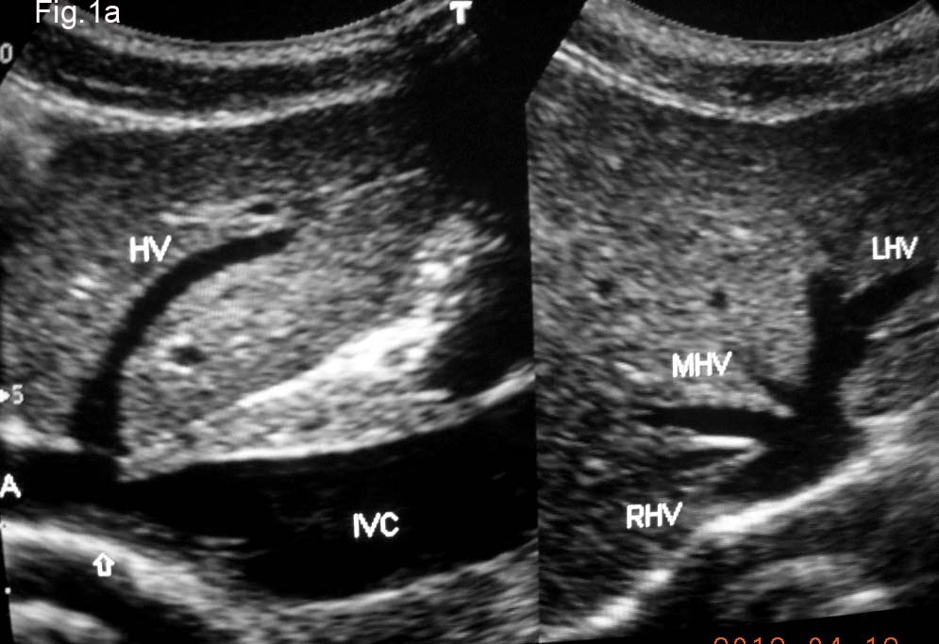

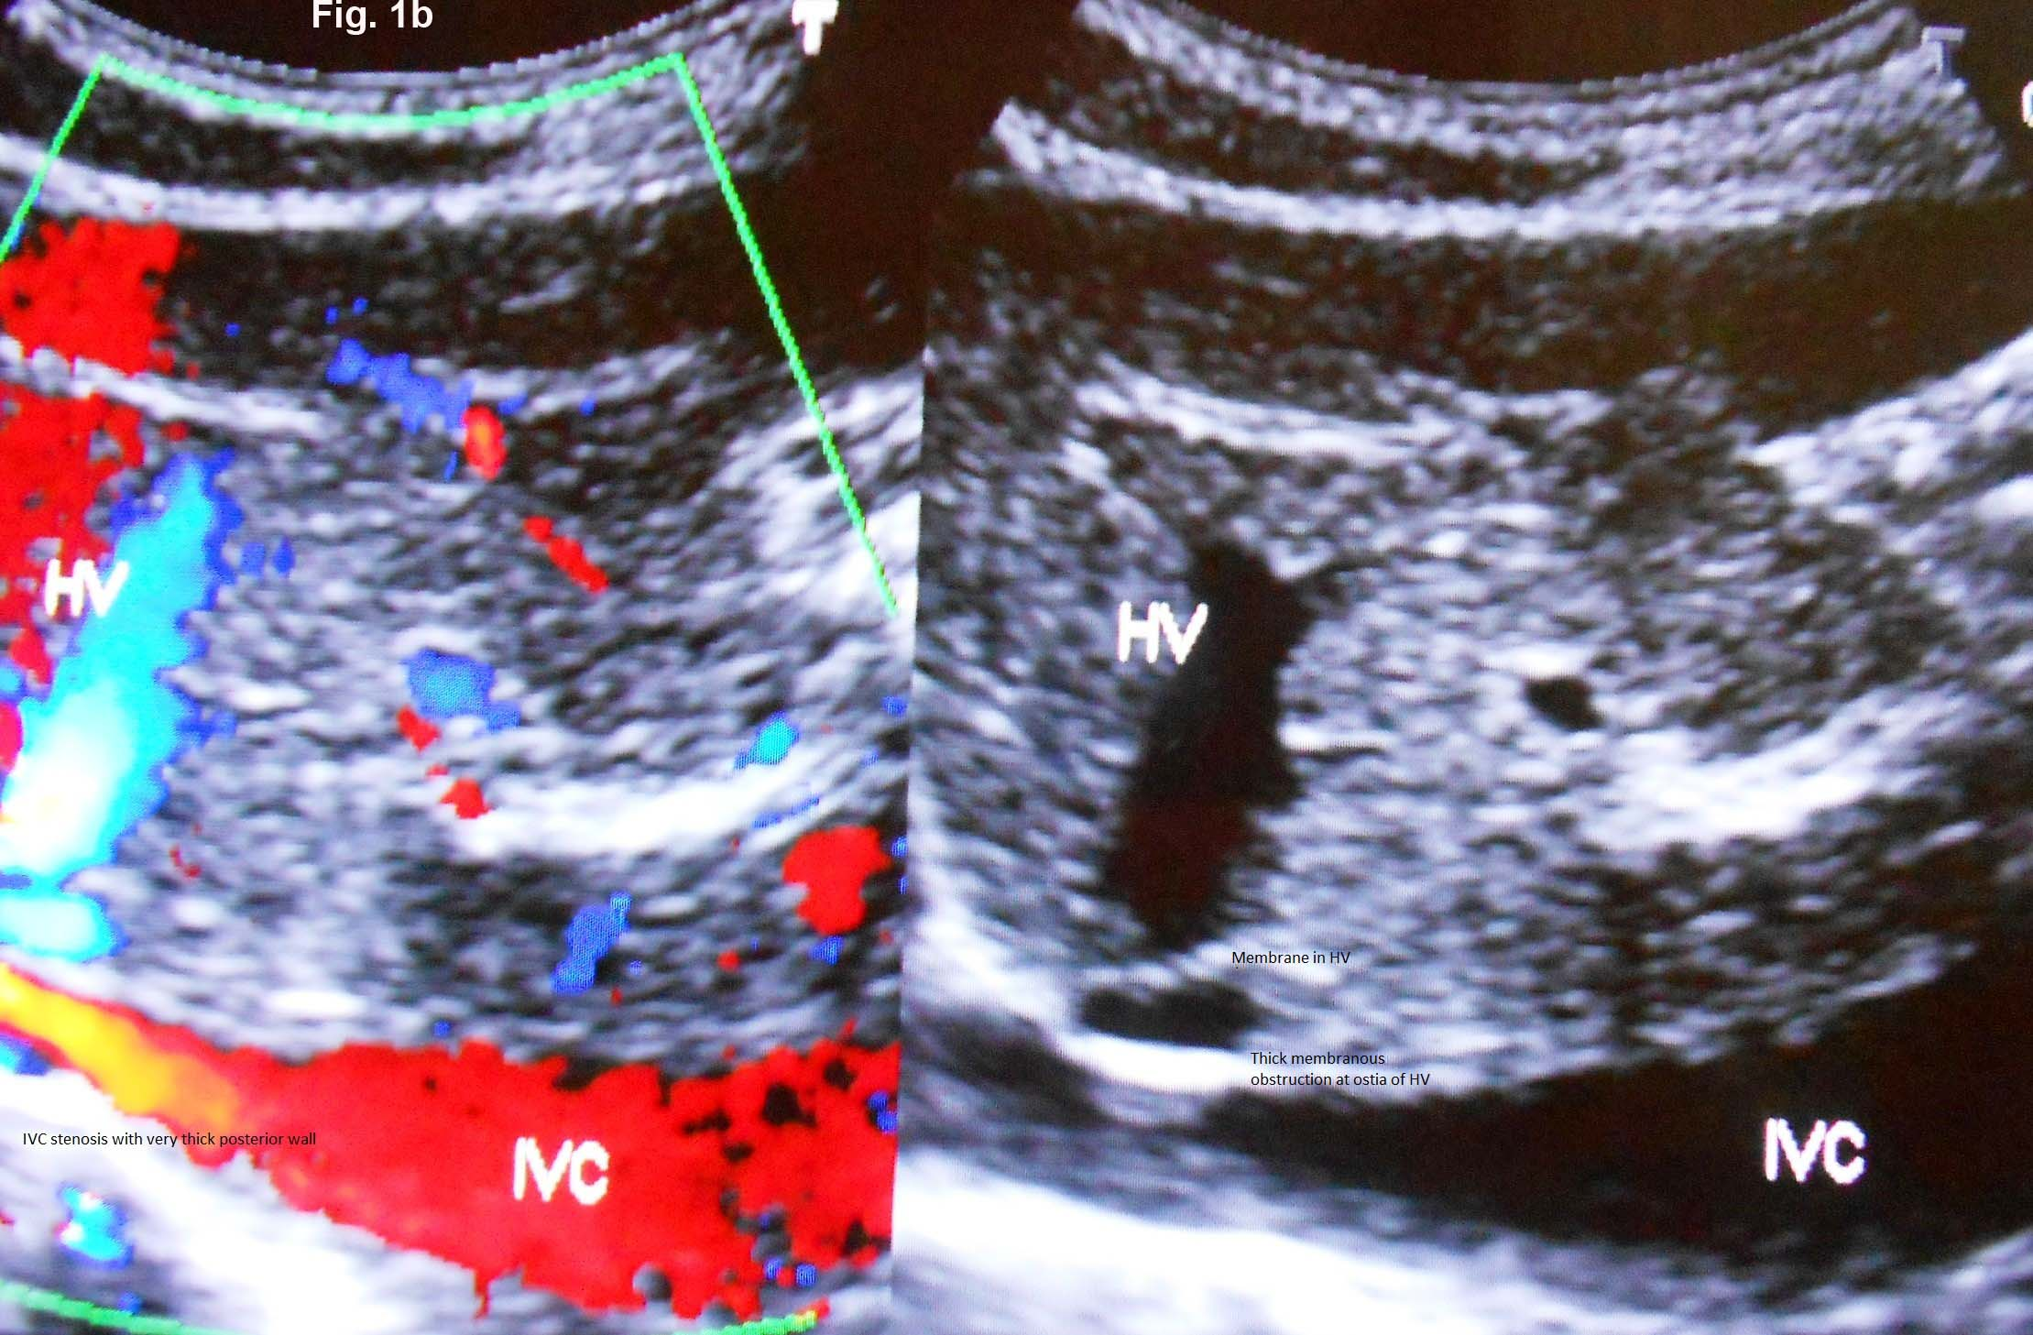

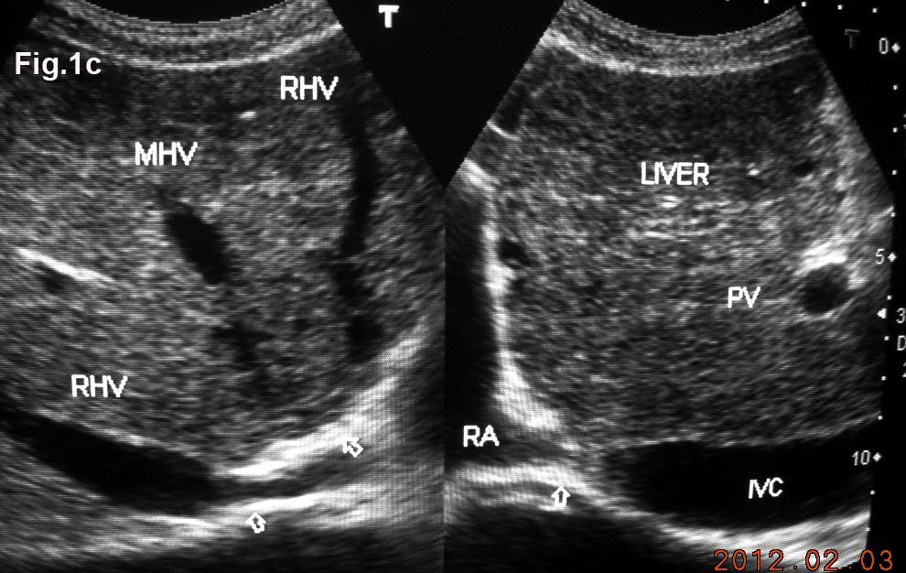
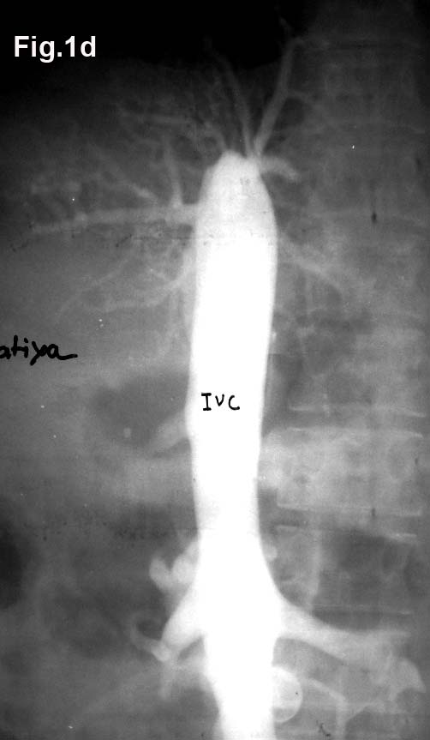
Figure 1 Inferior vena cava obstruction. A: Ultrasonography showing stenosis of inferior vena cava (IVC) at cavo-atrial junction. Note patent orifices hepatic vein (HV)-right HV (RHV), middle HV (MHV) and left HV (LHV); B: Color Doppler ultrasonography of a patient with liver cirrhosis showing IVC stenosis, membranes in HV; C: Ultrasonography of a patient with liver cirrhosis showing complete obstruction of IVC at cavo-atrial junction and obstruction at orifices of MHV and LHV. Note dilated hepatic veins; D: Cavogram showing complete obstruction of the IVC.

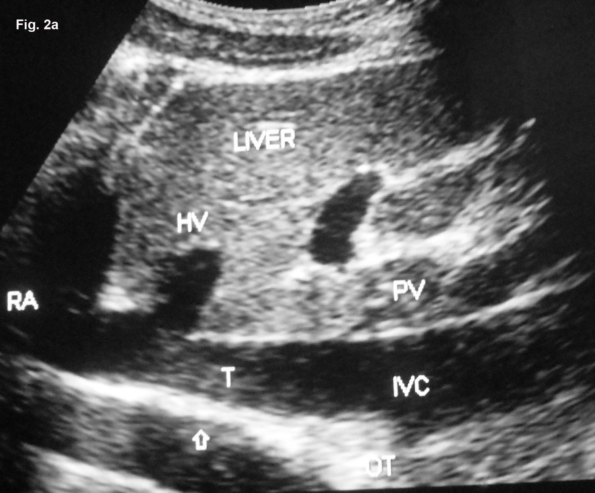

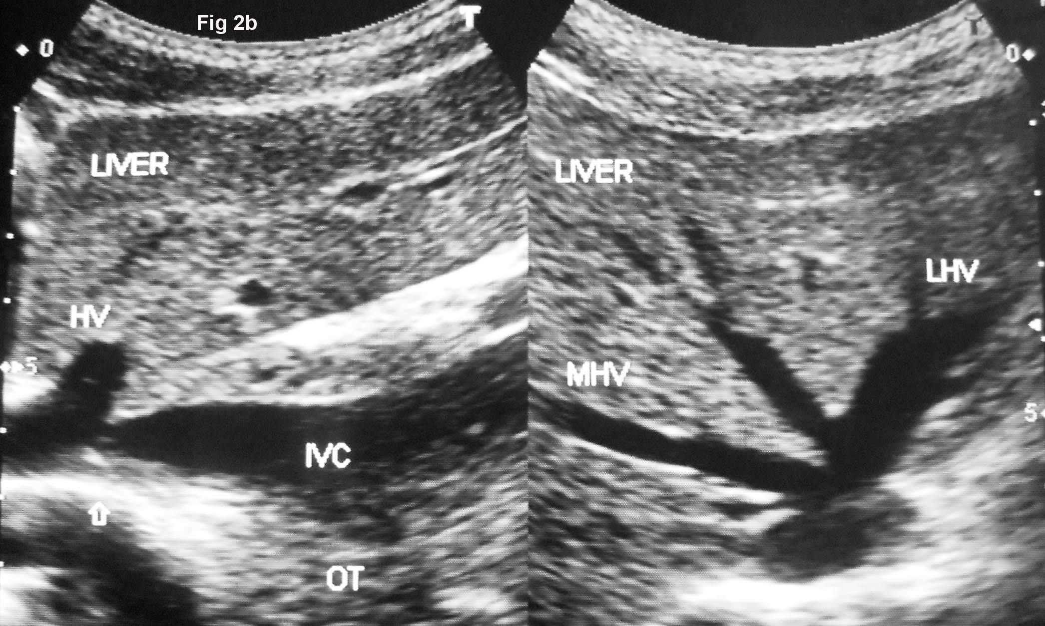

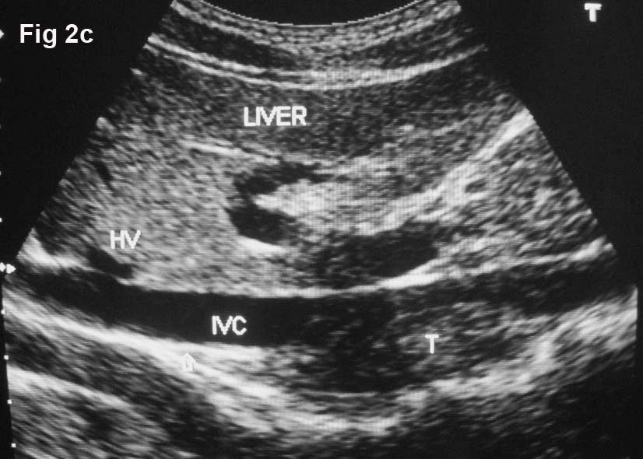

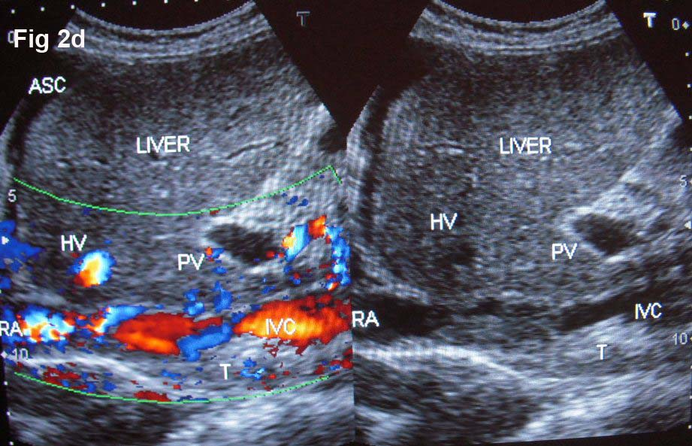

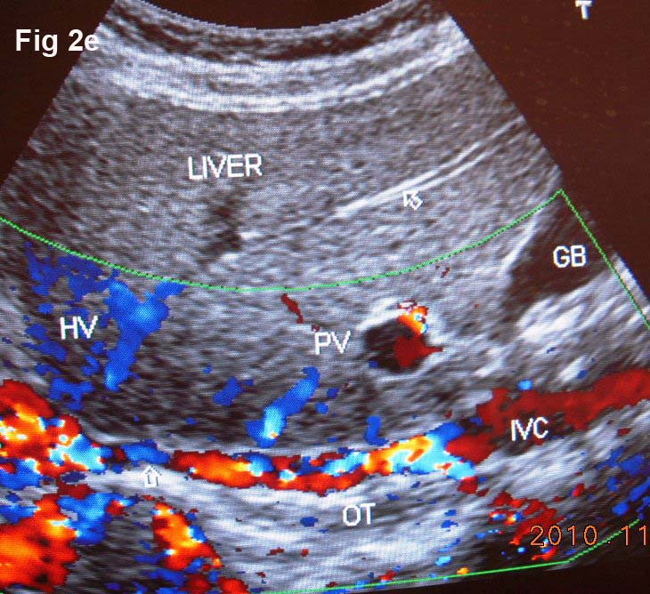
Figure 2 Ultrasonography showing thrombi of different ages in inferior vena cava due to recurrent acute exacerbations. A: Ultrasonography showing mild stenosis of inferior vena cava (IVC) with thick echoic posterior wall at cavo-atrial junction. It shows recent thrombus (T) and old organized thrombus (OT) deposited during recurrent acute exacerbation (AE); B: Ultrasonography showing stenosis of IVC at cavo-atrial junction, with OT along posterior wall just distal to it. Middle (MHV) and left (LHV) hepatic veins are patent; C: Ultrasonography showing mild stenosis of IVC at cavo-atrial junction and T of different ages along the posterior wall of the IVC. Note a thin membrane at the orifice of HV; D: Ultrasonography showing features of HV outflow obstruction-hepatomegaly and ascites in a patient with IVC stenosis near cavo-atrial junction and IVC filled with recent and old organized T; E: Ultrasonographic evidence of recurrent AE; Color Doppler ultrasonography showing layers of linear old OT along posterior wall of the hepatic portion of the IVC narrowing its lumen. Arrow indicates to a segmental stenosis of the HV.

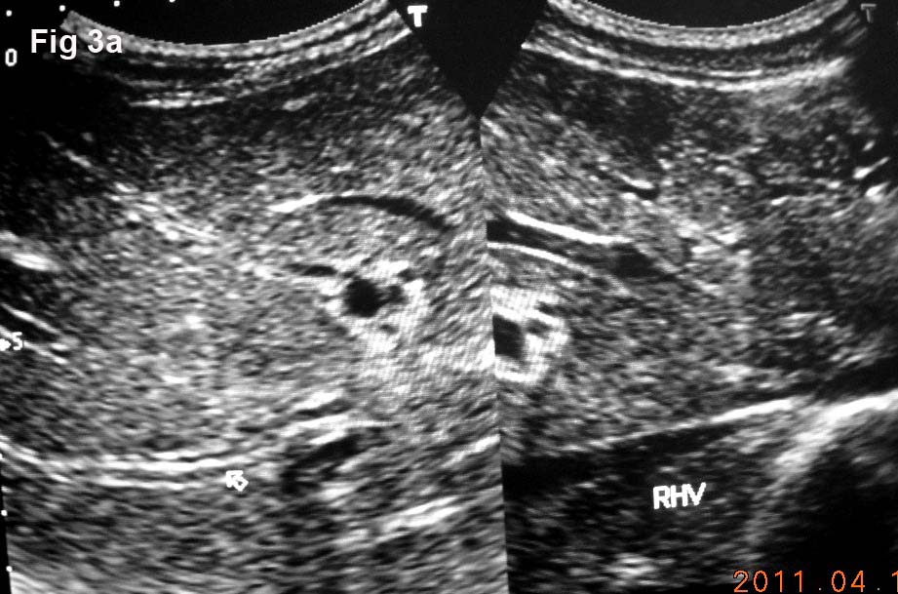
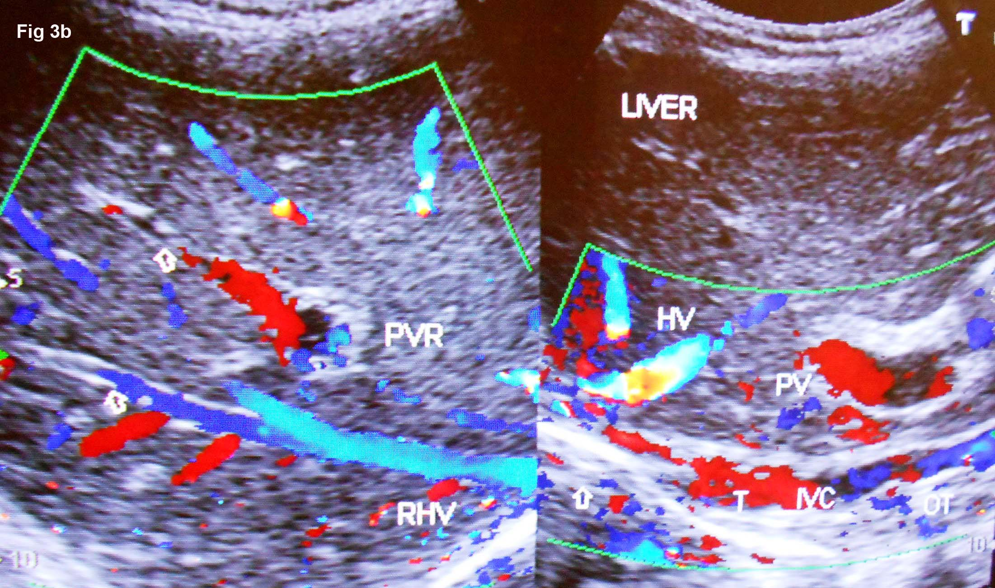
Figure 3 Ultrasonography showing thrombosed intra-hepatic veins. A: Ultrasonography showing diffuse thrombosed and echoic walls of large and medium-sized intra-hepatic veins (one of which is indicated by an arrow) that occurred during acute exacerbation. Right hepatic vein (RHV) orifice is narrowed; B: Color Doppler Ultrasonography of patient with cirrhosis. It shows long segment stenosis of inferior vena cava (IVC) with recent thrombus (T) and old organized thrombi (OT) on thick posterior wall. Arrow shows thrombosed large and medium-sized intra-hepatic veins.

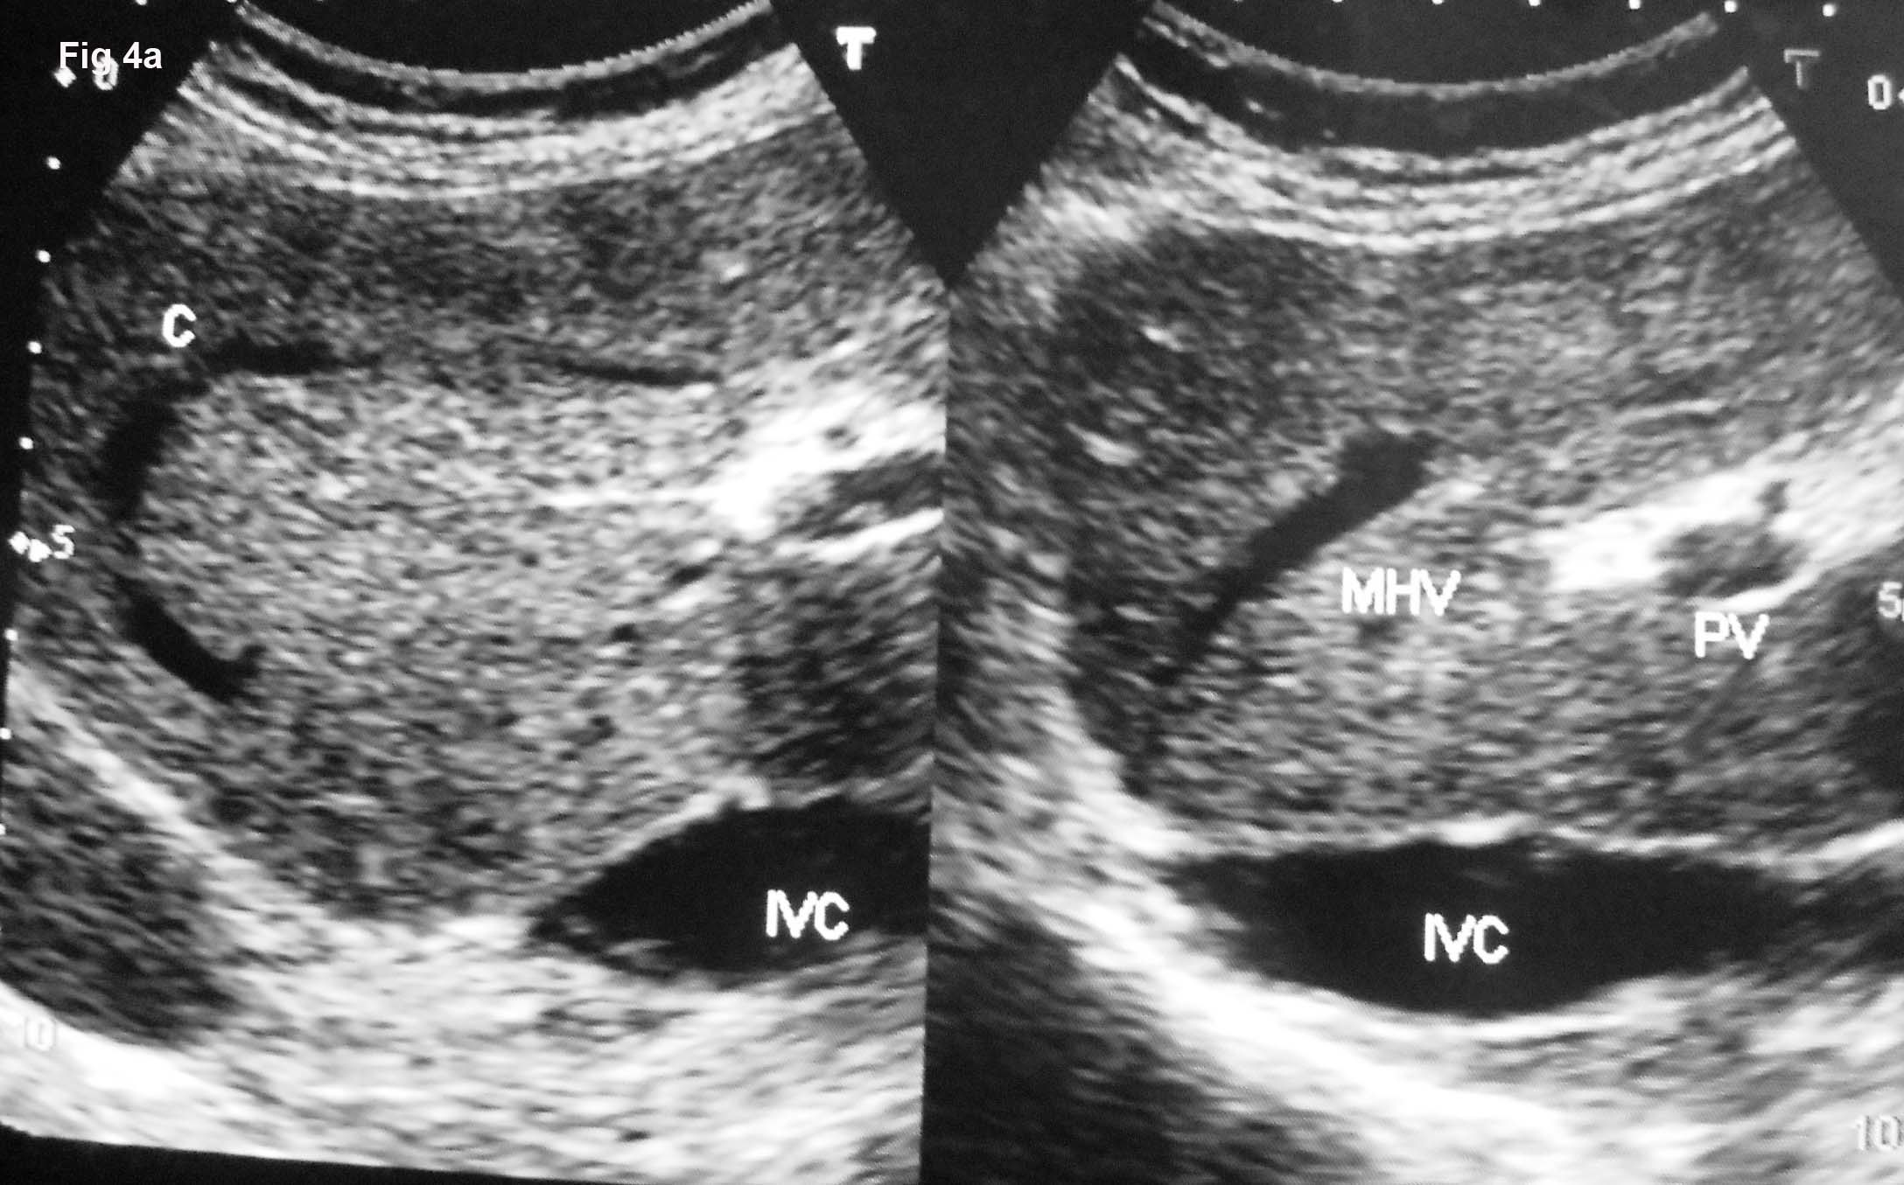

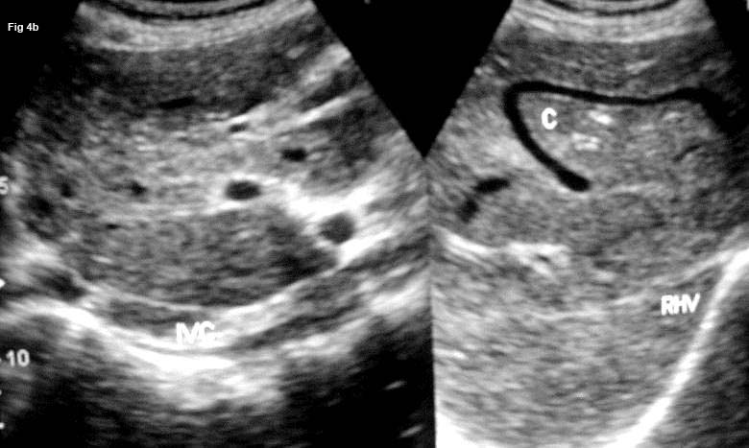

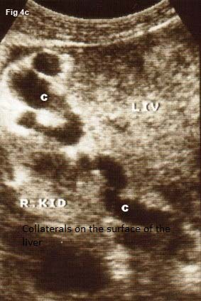
Figure 4 Ultrasonography showing collaterals. A: Ultrasonography of a patient with liver cirrhosis due to complete inferior vena cava (IVC) obstruction at cavo-atrial junction showing obstruction of middle hepatic vein (MHV) and a intra-hepatic collateral (C); B: Ultrasonography of a young girl with liver cirrhosis: IVC is filled with old organized thrombi of different ages, right hepatic vein (RHV) is thrombosed and a large intra-hepatic collateral is seen; Ultrasonography showing dilated C on the surface of liver (LIV) close to right kidney (R KID) in a patient with liver cirrhosis.

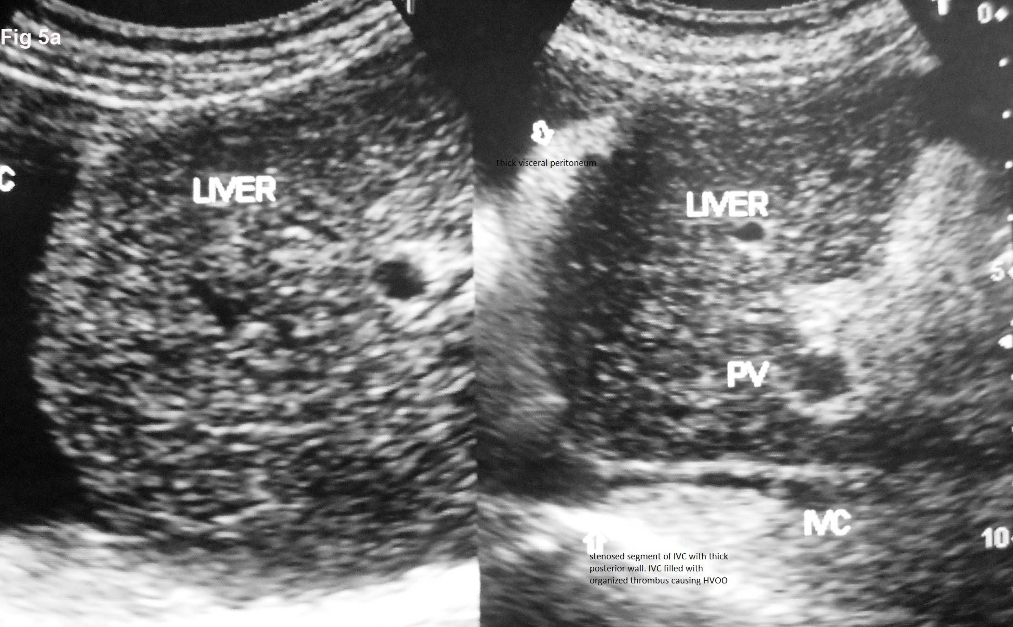

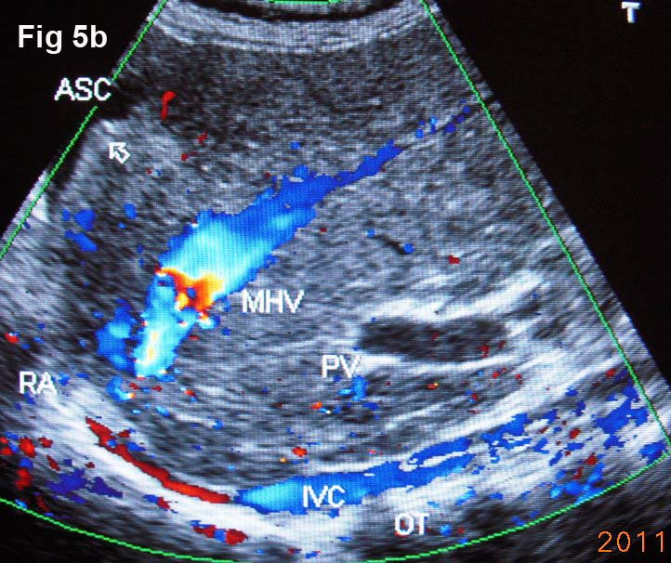

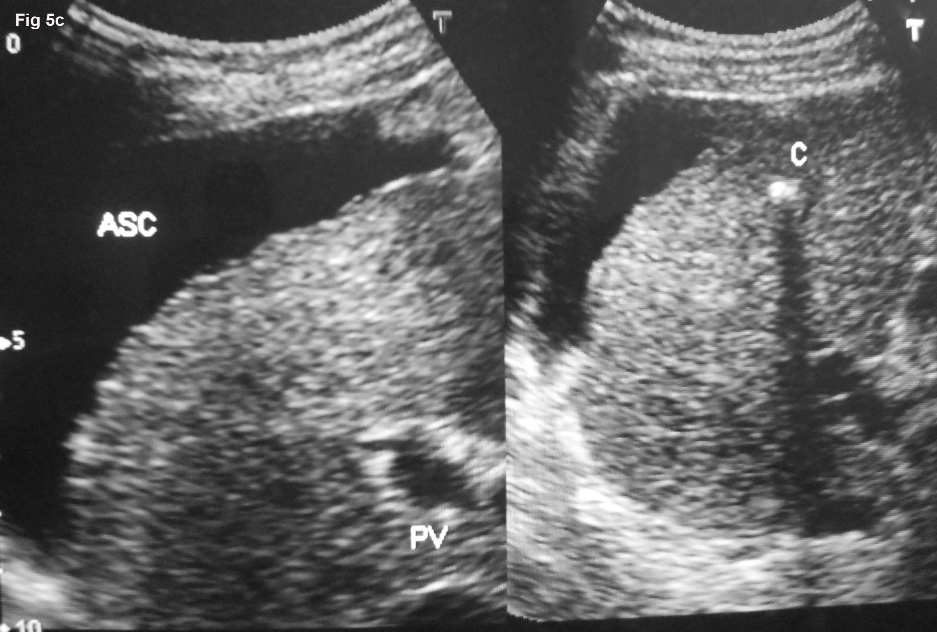

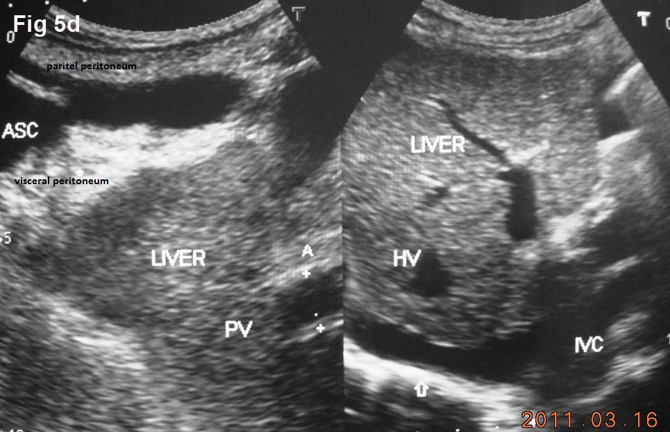
Figure 5 Ultrasonography showing ascites and evidence of chronic peritonitis in a patient with cirrhosis. A: Acute exacerbation in a patient with liver cirrhosis showing hepatic portion of the inferior vena cava (IVC) filled with organizing thrombus and ascites with thick visceral peritoneum-indicating presence of bacterial peritonitis; B: Ultrasonography of a patient with liver cirrhosis due to hepatic vena cava syndrome: showing long segment stenosis of IVC with thick old organized thrombus (OT) along the posterior wall of the hepatic portion of the IVC. Note the presence of ascites (ASC) and irregular margin of the liver indicated by an arrow. Middle hepatic vein (MHV) is obstructed at its orifice and shows distal segmental stenosis; C: Ultrasonography of a patient with liver cirrhosis due to hepatic vena cava syndrome showing inferior vena cava stenosis, a calcified focus (C) in the liver and ascites; D: Ultrasonography of patient with liver cirrhosis due to hepatic vena cava syndrome showing IVC stenosis with organized thrombus on posterior wall and ASC and thick visceral peritoneum, suggestive of chronic bacterial peritonitis. Portal vein (PV) is dilated.

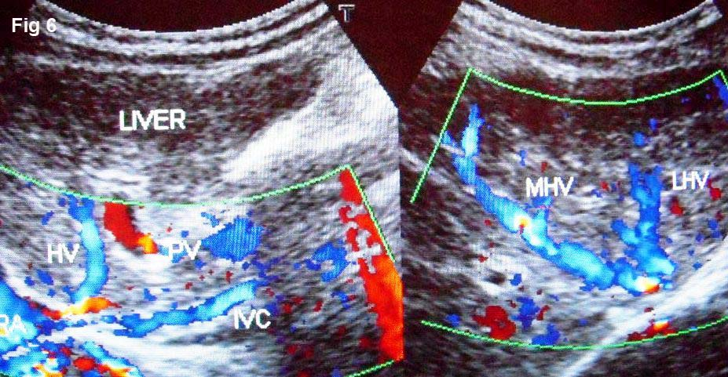
Figure 6 Liver cirrhosis in a young girl due to hepatic vena cava syndrome. Note long segment obstruction of the inferior vena cava (IVC) at cavo-atrial junction and irregular narrowing of its hepatic portion. Middle (MHV) and left (LHV) hepatic veins are dilated with irregular caliber. PV: Portal vein.

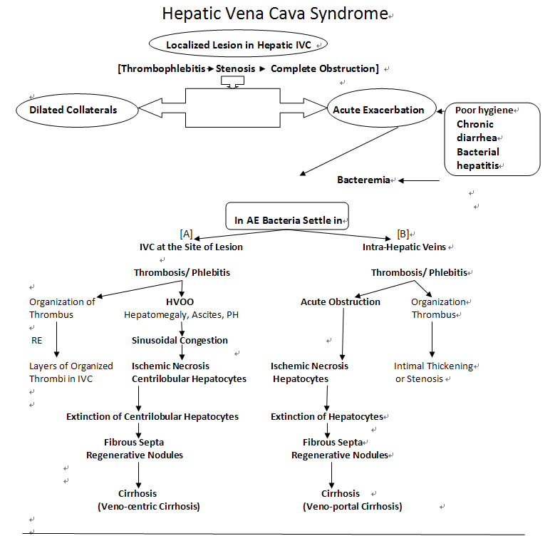
Figure 7 Mechanism of development of cirrhosis in hepatic vena cava syndrome. IVC: Inferior vena cava; HVOO: Hepatic venous outflow obstruction; PH: Portal hypertension; AE: Acute exacerbation; RE: Recurrent AE.

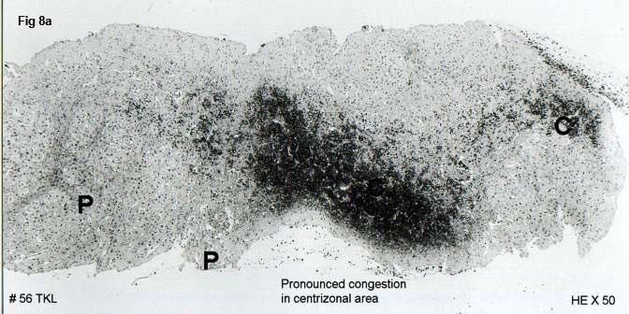
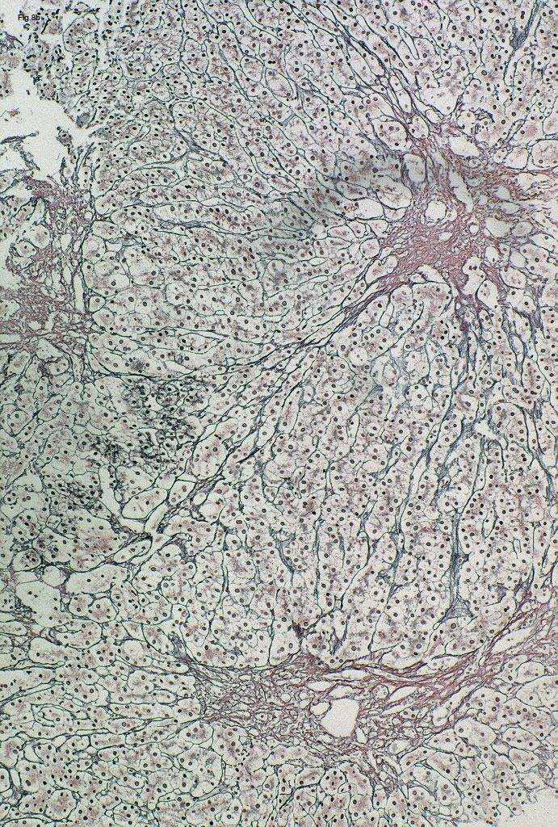
Figure 8 Histology showing fibrosis in centri-lobular areas. A: Histology of liver of a patient with hepatic vena cava syndrome during acute exacerbation showing acute congestive changes around central vein (C) and sparing of liver around portal tract (P) due to hepatic venous outflow obstruction; B: Histology of liver of patient with hepatic vena cava syndrome a few months after development of hepatic venous outflow obstruction during acute exacerbation showing fibrosis around central vein; Histology of liver of a patient with hepatic vena cava syndrome showing the wall of a thrombosed medium sized intra-hepatic vein that occurred during acute exacerbation.

