Name of Journal: World Journal of Clinical Cases
Manuscript NO: 78225
Manuscript Type: CASE REPORT

Malignant giant cell tumors of the tendon sheath of the right hip: A case report

Huang WP et al. MGCTTS of the right hip

Wen-Peng Huang, Ge Gao, Qi Yang, Zhao Chen, Yong-Kang Qiu, Jian-Bo Gao, Lei Kang

Wen-Peng Huang, Qi Yang, Zhao Chen, Yong-Kang Qiu, Lei Kang, Department of Nuclear Medicine, Peking University First Hospital, Beijing 100034, China

Ge Gao, Department of Medical Imaging, Peking University First Hospital, Beijing 100034, China

Jian-Bo Gao, Department of Radiology, The First Affiliated Hospital of Zhengzhou University, Zhengzhou 450052, Henan Province, China

Author contributions: Huang WP and Gao G contributed equally to this work; Huang WP, Gao G, Yang Q, Chen Z, and Qiu YK designed research; Huang WP, Gao G, Kang L and Gao JB performed research; Huang WP, Gao G and Kang L analyzed data; and Huang WP, Gao G and Kang L wrote the paper.

Supported by The Beijing Science Foundation for Distinguished Young Scholars, No. JQ21025.

Corresponding author: Lei Kang, MD, PhD, Department of Nuclear Medicine, Peking University First Hospital, No. 8 Xishiku Street, Xicheng Dist., Beijing 100034, China. kanglei@bjmu.edu.cn

Received: June 14, 2022
Revised: August 9, 2022
Accepted: August 30, 2022
Published online:

Abstract
BACKGROUND
Malignant giant cell tumor of the tendon sheath (MGCTTS) is an extremely rare malignant tumor originating from synovial and tendon sheath tissue with highly aggressive biological behavior and a high rate of local recurrence and distant metastasis which should be considered a highly malignant sarcoma and managed aggressively. How to systemically treat MGCTTS remains a challenge. In this case, a patient with MGCTTS suffered a recurrence after 2 surgical resections received adjuvant chemotherapy and radiation therapy, but the treatment outcome remained poor. More clinical trials and better understanding of the biology and molecular aspects of this subtype of sarcoma are needed while novel medicines should be developed to efficiently target particular pathways.

CASE SUMMARY
A 52-year-old man presented with persistent dull pain in the right groin accompanied by limited right hip motion starting 6 mo ago. Two months before his attending to hospital, the patient's pain worsened, presenting as severe pain when standing or walking, limping, and inability to straighten or move the right lower extremity. Surgical excision was performed and MGCTTS was confirmed by pathology examination. Two recurrences occurred after surgical resection, moreover, the treatment outcome remained poor after adjuvant chemotherapy and radiation therapy. The patient died only 10 mo after the initial diagnosis.

CONCLUSION
MGCTTS is characterized by a joint mass with pain and limited motion. It typically grows along the tendons and infiltrated into the surrounding muscle and bone tissue, with a stubborn tendency to relapse, as well as pulmonary metastasis. Radically surgical resection provides a choice of treatment whereas post-operation care should be taken to preserve the function of the joint. Chemotherapy and radiotherapy can be used as alternative treatments when radical resection cannot be performed.

Key Words: Malignant; Tenosynovial giant cell tumor; Recurrence; Magnetic resonance imaging; Bone scintigraphy; Treatment; X-ray computed tomography; Case report

Huang WP, Gao G, Yang Q, Chen Z, Qiu YK, Gao JB, Kang L. Malignant giant cell tumors of the tendon sheath of the right hip: A case report. World J Clin Cases 2022; In press

Core Tip: This case demonstrates the highly aggressive biological behavior of Malignant giant cell tumor of the tendon sheath (MGCTTS), which mostly appears in Computed tomography (CT) images as a large mass that grows around the joint with poorly defined borders. CT can show details of bone destruction surrounding the lesion caused by extensive invasion. MRI clearly shows the histological features of the tumor and its relationship to the surrounding tissue. There is a stubborn tendency for MGCTTS to relapse and a possibility of pulmonary metastasis. Postoperative follow-up, especially long-term follow-up for evaluating recurrence, is necessary. Meanwhile systemic examination should be undertaken to evaluate distant metastasis.

INTRODUCTION
Giant cell tumor of the tendon sheath (GCTTS) is a benign tumor involving the synovial joints, bursae and tendon sheaths. Based on the 2013 edition of the World Health Organization (WHO) Classification of Tumors of Bone and Soft Tissue, it is classified as a "so-called fibrous histiocytic tumor". It can be further classified as limited, diffuse, intra-articular or extra-articular according to its biological behavior and location respectively^{[1-2]}. GCTTS occurs mostly in young people, especially women, with a median age of 40 years^{[3]}. Limited-type GCTTS usually affects small joints, such as fingers and wrists, and is characterized by a low recurrence rate (10%-20%). Rarely, diffuse GCTTS can become malignant, with a highly aggressive biology, such as regional lymph node and distant organ metastases^{[4]}.
Here, we report the imaging presentation and treatment of a patient with malignant giant cell tumor of the tendon sheath (MGCTTS) of the right hip who suffered recurrence after two surgical resections and a continuous poor treatment outcome after adjuvant chemotherapy and radiation therapy. The survival time was only 10 mo after initial diagnosis.

CASE PRESENTATION
Chief complaints
A 52-year-old male came to see doctors with a complaint of pain in his right hip for 6 mo.

History of present illness
The patient had developed unexplained right hip pain 6 mo ago, presenting as persistent dull pain accompanied by limited movement of the right hip joint without radiating pain or numbness of the lower limbs. The right hip pain worsened 2 mo prior to this visit, manifested as severe pain when standing or walking, limping, and inability to straighten or move the right lower limb. The patient had developed symptoms of anemia 1 wk ago.

History of past illness
No special circumstances.

Personal and family history
The patient had no family history of hereditary diseases.

Physical examination
On admission, the patient suffered normal spinal motion, no pressure or percussion pain in the spinous process, pain in the right hip without radiating, inability to straighten the right lower extremity, limited movement in the angle and range of the right hip, limping, and no erythema found on the skin of the right hip, respectively.

Laboratory examinations
Laboratory tests showed a platelet count of 695 × 10⁹/L (normal range, 125-350 × 10⁹/L); monocyte count of 0.71 × 10⁹/L (normal range, 0.1-0.6 × 10⁹/L); D-dimer of 0.35 mg/L (normal range, 0-0.55 mg/L); C-reactive protein of 176.29 mg/L (normal range, 0-5 mg/L); procalcitonin of 0.25 ng/mL (normal range, 0-0.2 ng/mL); and ESR of 21.00 mm/h (normal range, 0-15 mm/h), respectively.

Imaging examinations
Pelvic radiography showed multiple cystic hypodense shadows in varying sizes, with well-defined borders in the right iliac bone and right upper femur, suggesting osteolytic bone destruction (Figure 1). CT revealed a soft tissue mass with heterogeneous density in the intermuscular space anterior to the right iliopsoas muscle and the right superior femur, with patchy hypodense necrosis within the mass with indistinct borders, at the size of approximately 5.3 cm × 7.5 cm × 21.2 cm (AP × LR × SI). The plain CT attenuation value of the mass was approximately 49 HU and osteolytic bone destruction could be seen in the adjacent iliac bone and acetabulum. The enhanced CT attenuation value of the mass was approximately 55 HU and 58 HU in the arterial and venous phases respectively, representing heterogeneous mild to moderate enhancement (Figure 2). Magnetic resonance imaging (MRI) displayed a mixed-signal mass along the right iliopsoas and the anteromedial muscle gap of the right upper femur, with a heterogeneous low signal on T1-weighted imaging (T1WI), a heterogeneous slightly high signal on fat-saturated T2-weighted imaging (T2WI), a high signal on diffusion weighted image (DWI), and a low signal on apparent diffusion coefficient (ADC) imaging (Figure 3). The patient underwent a whole-body ^{99m}Tc-methylene diphosphonate bone scan, which demonstrated a high radioactive accumulation around the areas in the right ilium, acetabulum, proximal femur, and knee (Figure 4).

FINAL DIAGNOSIS
Postoperative histopathology showed that the tumor was composed of mononuclear synovial-like cells and sarcoma cells with lacunar-like lacunae inside. Moreover, tumor cells showed obvious pleomorphism and heterogeneity with pathological nuclear division and collagen matrix between the cells. Immunohistochemical staining was positive for EMA, CK, CD31, CD34, CD99, Vimentin, INI-1, TLE1, and FLI-1 and negative for S-100, SOX-10, GATA-3, CK5/6, CK7, P63, SMA, Desmin, ERG, HMB45, Melan-A, CD21, CD23, and CD35, corresponding to the phenotypic profile of MGCTTS (Figure 5).

TREATMENT
The patient underwent resection of the right hip mass under general anesthesia. Intraoperatively, the tumor was found to be grayish-yellow in color and soft in texture with an incomplete local capsule and unclear border from the surrounding tissues. The tumor was rich in blood supply with dark-red bloody fluid inside.

OUTCOME AND FOLLOW-UP
Nineteen days after surgery, the patient suffered pain again in his right hip with a palpated mass measuring approximately 8 cm × 5 cm with a hard texture under the surgical scar, which was considered to be a recurrence of the tumor. Surgical resection was performed again. Fifteen days after the 2nd surgery, a follow-up CT imaging revealed a recurrence of MGCTTS in the right hip with a significantly increased size of approximately 7.7 cm × 7.6 cm × 24.3 cm (AP × LR × SI). Instead of surgical resection, the patient received chemotherapy with isocyclophosphamide (2 g per day fromd1 to d4) and epirubicin (50 mg d1 and 40 mg d2). After 2 cycles of treatment, CT re-examination revealed a decreased CT attenuation value of lesion with expanded necrosis range, and increased tumor size. In addition, the patient had multiple small solid nodulars along the pleura of both lungs with the larger lesion at approximately 0.6 cm in diameter (Figure 6A-D). The treatment was then changed to conformal intensity-modulated radiation therapy (50 Gy/25 F). After 21 sessions of radiation therapy, the patient developed a cutaneous fistula on the ventral side of the right hip with persistent bleeding. Then, CT examination revealed a further enlargement of the lesion, with the multiple, lamellar cystic hypodense lesions around with a mild enhancement of the cyst wall, suggesting the presence of infection. A lamellar hypodense infarcted area of the spleen was observed as well as increased number and sizes of small nodules in both lungs (Figure 6E-F). The patient exhibited low albumin levels with poor nutritional status. Nutritional support and oral antidote capsules (1 capsule once a day) was given then and the radiotherapy was discontinued. The patient died 4 mo later.

DISCUSSION
MGCTTS was first reported by Castens et al^{[5]}. The site of onset is mostly in the large joints of the extremities, but it can also occur in the myofascia and fascia of the forearms, thighs, and low back^{[6]}. MGCTTS can be divided into primary and secondary lesions, with primary lesions having the typical pattern of GCTTS at first presentation along with areas of malignant sarcoma and secondary lesions having typical GCTTS at first presentation and a malignant sarcoma component at recurrence^{[4,7]}. This case belongs to a primary MGCTS, occurring in the large joint, which affected large angle and range of motion of the hip, susceptibility to injury and chronic strain. It growed rapidly and aggressively with severe destruction of the surrounding bone.
The histological presentation of MGCTTS is comparable to that of a typical mesenchymal sarcoma, both presenting as grayish-yellow and grayish-red soft-textured masses with infiltrative growth, indistinct borders, and large tumor size^{[6]}. Histomorphologically, MGCTTS originates from synoviocytes or mesenchymal cells differentiated toward synoviocytes and has both benign GCTTS and malignant factors with sarcoma, which is commonly arranged in a villous, pseudoglandular, or lacunar pattern, with a background of more-or-less osteoblastic giant cells, foam cells, lymphoplasmacytic infiltrates, iron-containing heme deposits, and abundant collagenous stroma^{[2]}. Diagnostic features include prominent nuclear schwannomas (> 20 per 10 HPF), enlarged tumor cell nuclei with distinct nucleoli, the presence of spindle-shaped mononuclear-like cells, coagulative necrosis, and mucinous changes, which is sometimes coexist with undifferentiated pleomorphic sarcoma or mucinous fibrous sarcoma^{[2,8]}. However, aggressive growth does not indicate malignant transformation of the tumor, whereas the presence of only one feature above cannot indicate malignant transformation^{[7-8]}.
CT can clearly show the details of bone changes. In CT imaging, MGCTTS mostly appears as a large and irregular mass that grows around a joint, with poorly defined borders. It is accompanied by extensive infiltrative destruction of adjacent bone tissue and shows obvious malignant behavious^{[9-11]}. MRI has better resolution to show soft tissues than CT so that it can accurately demonstrate the histological features of tumors and their relationship with surrounding tissues^{[12-13]}. MGCTTS typically shows heterogeneous signals on MRI images, with a predominantly muscle-like signal, that show a T1WI low signal, a T2WI high signal, or (and) iron-containing heme deposits in T1WI and T2WI low-signal areas due to the existence of necrosis and cystic changes within the tumor^{[4,6,12,14]}. This case presented as a huge mass located in the right side of the proximal iliac, acetabular, and femoral bones, growing long with the tendon and with indistinct borders. It showed isointense with the muscle on CT with lamellar apparent necrosis inside, as well as extensive osteolytic destruction of adjacent bone tissue without periosteal reaction. Moreover, the mass showed a low signal on MRI in T1WI, a slightly high signal in fat-saturated T2WI, and nodular low-signal features in all sequences, suggesting iron-containing heme deposits with inhomogeneous mild enhancement. CT and MRI imaging can reveal the size, shape, location, internal changes such as necrosis and bleeding, and invasion of surrounding muscles and bones^{[15]}. Since MGCTTS has an apparently high metastatic propensity^{[4]}, a whole-body PET/CT examination can play an important role in the evaluation of distant metastases comprehensively, which can help in the staging and early detection of metastases. This type of case should be differentiated from synovial sarcoma, which is mostly seen in young people with predominant in males and appears as a soft tissue mass on CT showing speckled or patchy high-density calcification inside. Meanwhile, when synovial sarcoma invades bone tissue and produces dead bone, more calcification along with the tendency could be shown Besides, for synovial sarcoma, A mixture of intralesional cystic lesions, bleeding and fibrous septa often showed typically T2WI triple signals (high, slightly high, and iso-low signal), meanwhile, rich blood supply in the tumor could show obvious enhancement^{[16-18]}.
The complex biology and clinical characteristics of MGCTTS render it difficult to make a definitive diagnosis and a thorough treatment plan preoperatively. MGCTTS is characterized by a high rate of local recurrence and distant metastasis in lungs and lymph nodes, leading to patient death. Therefore, the tumor should be considered a highly malignant sarcoma and managed aggressively^{[11]}. There has been no standard treatment for MGCTTS so far and radical surgical resection remains the first choice for treatment. Surgery was shown to be able to minimize local recurrence and to decrease the occurence of distant metastases^{[19]}. In soft tissue sarcomas of the extremities, producing a careful balance between local control and functional preservation is critical. However, it is important to remember that systemic therapy for MGCTTS is currently limited^{[11]}. Adjuvant radiation therapy is used as an alternative treatment when complete resection is impossible^{[1,20]}. Unfortunately, there is no evidence that these treatments for MGCTTS is totally effective. Some studies concluded that CSF1 of GCTTS is at a high level^{[21]}. In many case reports and a retrospective series of patients with locally progressed or metastatic TGCTs, imatinib against CSF1R, was proven to be effective^{[22-23]}. The patient in this case received multimodal treatments including surgery, radiation therapy, and chemotherapy. Unfortunately, the prognosis was still poor with an overall survival for only 10 mo.

CONCLUSION
In summary, we report a patient with MGCTTS who experienced recurrence after 2 surgical resections and his treatment outcome remained poor after adjuvant radiotherapy and chemotherapy. The treatment of MGCTTS is still unsatisfied. As a result, MGCTTS remains a difficult illness without enough medical requirements. More clinical trials and better understanding of the biology and molecular aspects of this subtype of sarcoma are needed, as well as the development of new medical treatment that can efficiently target specific pathways. Moreover, CT, MRI, and PET/CT imaging are essential for the staging, management, treatment response assessment, and monitoring of MGCTTS.

REFERENCES
1 Gouin F, Noailles T. Localized and diffuse forms of tenosynovial giant cell tumor (formerly giant cell tumor of the tendon sheath and pigmented villonodular synovitis). Orthop Traumatol Surg Res 2017; 103: S91-S97 [PMID: 28057477 DOI: 10.1016/j.otsr.2016.11.002]
2 Coindre JM. [New WHO classification of tumours of soft tissue and bone]. Ann Pathol 2012; 32: S115-S116 [PMID: 23127926 DOI: 10.1016/j.annpat.2012.07.006.]
3 Brahmi M, Vinceneux A, Cassier PA. Current Systemic Treatment Options for Tenosynovial Giant Cell Tumor/Pigmented Villonodular Synovitis: Targeting the CSF1/CSF1R Axis. Curr Treat Options Oncol 2016; 17: 10 [PMID: 26820289 DOI: 10.1007/s11864-015-0385-x]
4 Kondo R, Akiba J, Hiraoka K, Hisaoka M, Hashimoto H, Kage M, Yano H. Malignant diffuse-type tenosynovial giant cell tumor of the buttock. Pathol Int 2012; 62: 559-564 [PMID: 22827766 DOI: 10.1111/j.1440-1827.2012.02838.x]
5 Castens HP, Howell RS. Maglignant giant cell tumor of tendon sheath. Virchows Arch A Pathol Anat Histol 1979; 382: 237-243 [PMID: 157610 DOI: 10.1007/BF01102878]
6 Li CF, Wang JW, Huang WW, Hou CC, Chou SC, Eng HL, Lin CN, Yu SC, Huang HY. Malignant diffuse-type tenosynovial giant cell tumors: a series of 7 cases comparing with 24 benign lesions with review of the literature. Am J Surg Pathol 2008; 32: 587-599 [PMID: 18301053 DOI: 10.1097/PAS.0b013e318158428f]
7 Fletcher C, Bridge J, Antonescu C. WHO classification of tumours editorial board[J]. WHO Classification of Tumors Soft Tissue and Bone Tumours, 2020: 403-409
8 Fletcher C, Bridge J A, Hogendoorn P C W, Mertens, F. WHO Classification of Tumours of Soft Tissue and Bone: WHO Classification of Tumours, vol. 5[M]. World Health Organization, 2013
9 Bertoni F, Unni KK, Beabout JW, Sim FH. Malignant giant cell tumor of the tendon sheaths and joints (malignant pigmented villonodular synovitis). Am J Surg Pathol 1997; 21: 153-163 [PMID: 9042281 DOI: 10.1097/00000478-199702000-00004]
10 Richman DM, Bresler SC, Rosenthal MH, Howard SA. Malignant tenosynovial giant cell tumor of the leg: a radiologic-pathologic correlation and review of the literature. J Clin Imaging Sci 2015; 5: 13 [PMID: 25861547 DOI: 10.4103/2156-7514.152343]
11 Rebuzzi SE, Grassi M, Catalano F, Buscaglia M, Bertulli R, Satragno C, Belgioia L, Comandini D. Multiple systemic treatment options in a patient with malignant tenosynovial giant cell tumour. Anticancer Drugs 2020; 31: 80-84 [PMID: 31567307 DOI: 10.1097/CAD.0000000000000844]
12 Waldt S, Rechl H, Rummeny EJ, Woertler K. Imaging of benign and malignant soft tissue masses of the foot. Eur Radiol 2003; 13: 1125-1136 [PMID: 12695837 DOI: 10.1007/s00330-002-1604-y]
13 Mastboom MJL, Lips W, van Langevelde K, Mifsud M, Ng C, McCarthy CL, Athanasou NA, Gibbons CLMH, van de Sande MAJ. The effect of Imatinib Mesylate in diffuse-type Tenosynovial Giant Cell Tumours on MR imaging and PET-CT. Surg Oncol 2020; 35: 261-267 [PMID: 32932224 DOI: 10.1016/j.suronc.2020.08.030]
14 Righi A, Gambarotti M, Sbaraglia M, Frisoni T, Donati D, Vanel D, Dei Tos AP. Metastasizing tenosynovial giant cell tumour, diffuse type/pigmented villonodular synovitis. Clin Sarcoma Res 2015; 5: 15 [PMID: 26052431 DOI: 10.1186/s13569-015-0030-2]
15 Li L, Huang W, Xue K, Feng L, Han Y, Wang R, Gao J. Clinical and imaging features of carcinosarcoma of the uterus and cervix. Insights Imaging 2021; 12: 142 [PMID: 34674042 DOI: 10.1186/s13244-021-01084-5]
16 Trassard M, Le Doussal V, Hacène K, Terrier P, Ranchère D, Guillou L, Fiche M, Collin F, Vilain MO, Bertrand G, Jacquemier J, Sastre-Garau X, Bui NB, Bonichon F, Coindre JM. Prognostic factors in localized primary synovial sarcoma: a multicenter study of 128 adult patients. J Clin Oncol 2001; 19: 525-534 [PMID: 11208847 DOI: 10.1200/JCO.2001.19.2.525]
17 Gazendam AM, Popovic S, Munir S, Parasu N, Wilson D, Ghert M. Synovial Sarcoma: A Clinical Review. Curr Oncol 2021; 28: 1909-1920 [PMID: 34069748 DOI: 10.3390/curroncol28030177]
18 Ashikyan O, Bradshaw SB, Dettori NJ, Hwang H, Chhabra A. Conventional and advanced MR imaging insights of synovial sarcoma. Clin Imaging 2021; 76: 149-155 [PMID: 33607418 DOI: 10.1016/j.clinimag.2021.02.010]
19 Gronchi A, Lo Vullo S, Fiore M, Mussi C, Stacchiotti S, Collini P, Lozza L, Pennacchioli E, Mariani L, Casali PG. Aggressive surgical policies in a retrospectively reviewed single-institution case series of retroperitoneal soft tissue sarcoma patients. J Clin Oncol 2009; 27: 24-30 [PMID: 19047283 DOI: 10.1200/JCO.2008.17.8871]
20 Temponi EF, Barros AAG, Paganini VO, Barbosa VAK, Badet R, Carvalho Júnior LH. Diffuse pigmented villonodular synovitis in knee joint: diagnosis and treatment. Rev Bras Ortop 2017;52(4):450-457. [PMID: PMC5582863 DOI: 10.1016/j.rboe.2017.06.008]
21 Cassier PA, Gelderblom H, Stacchiotti S, Thomas D, Maki RG, Kroep JR, van der Graaf WT, Italiano A, Seddon B, Dômont J, Bompas E, Wagner AJ, Blay JY. Efficacy of imatinib mesylate for the treatment of locally advanced and/or metastatic tenosynovial giant cell tumor/pigmented villonodular synovitis. Cancer 2012; 118: 1649-1655 [PMID: 21823110 DOI: 10.1002/cncr.26409]
22 Blay JY, El Sayadi H, Thiesse P, Garret J, Ray-Coquard I. Complete response to imatinib in relapsing pigmented villonodular synovitis/tenosynovial giant cell tumor (PVNS/TGCT). Ann Oncol 2008; 19: 821-822 [PMID: 18296418 DOI: 10.1093/annonc/mdn033]
23 Stacchiotti S, Crippa F, Messina A, Pilotti S, Gronchi A, Blay JY, Casali PG. Response to imatinib in villonodular pigmented synovitis (PVNS) resistant to nilotinib. Clin Sarcoma Res 2013; 3: 8 [PMID: 23668619 DOI: 10.1186/2045-3329-3-8]
Footnotes
Informed consent statement: Written informed consent for publication of clinical details and/or clinical images was obtained from the parents of the participant. A copy of the consent form is available for review by the Editor of the journal.

Conflict-of-interest statement: The authors declare that they have no competing interests.

CARE Checklist (2016) statement: The authors have read the CARE Checklist (2016), and the manuscript was prepared and revised according to the CARE Checklist (2016).

Open-Access: This article is an open-access article that was selected by an in-house editor and fully peer-reviewed by external reviewers. It is distributed in accordance with the Creative Commons Attribution NonCommercial (CC BY-NC 4.0) license, which permits others to distribute, remix, adapt, build upon this work non-commercially, and license their derivative works on different terms, provided the original work is properly cited and the use is non-commercial. See: https://creativecommons.org/Licenses/by-nc/4.0/

Provenance and peer review: Unsolicited article; Externally peer reviewed.
Peer-review model: Single blind

Peer-review started: June 14, 2022
First decision: July 29, 2022
Article in press:

Specialty type: Radiology, nuclear medicine and medical imaging
Country/Territory of origin: China
Peer-review report’s scientific quality classification
Grade A (Excellent): 0
Grade B (Very good): 0
Grade C (Good): C
Grade D (Fair): D
Grade E (Poor): 0

P-Reviewer: Chrcanovic BR, Sweden; Tangsuwanaruk T, Thailand S-Editor: Ma YJ L-Editor: A P-Editor: Ma YJ
Figure Legends
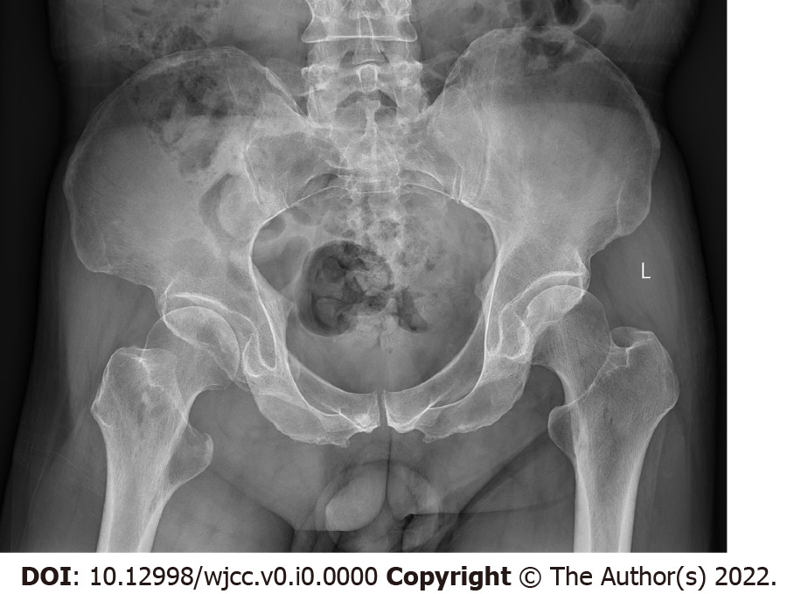
Figure 1 Pelvis radiography. Multiple cystic hypodense lesions with variable sizes and well-defined borders were shown in the right iliac bone and right upper femur, suggesting osteolytic bone destruction.

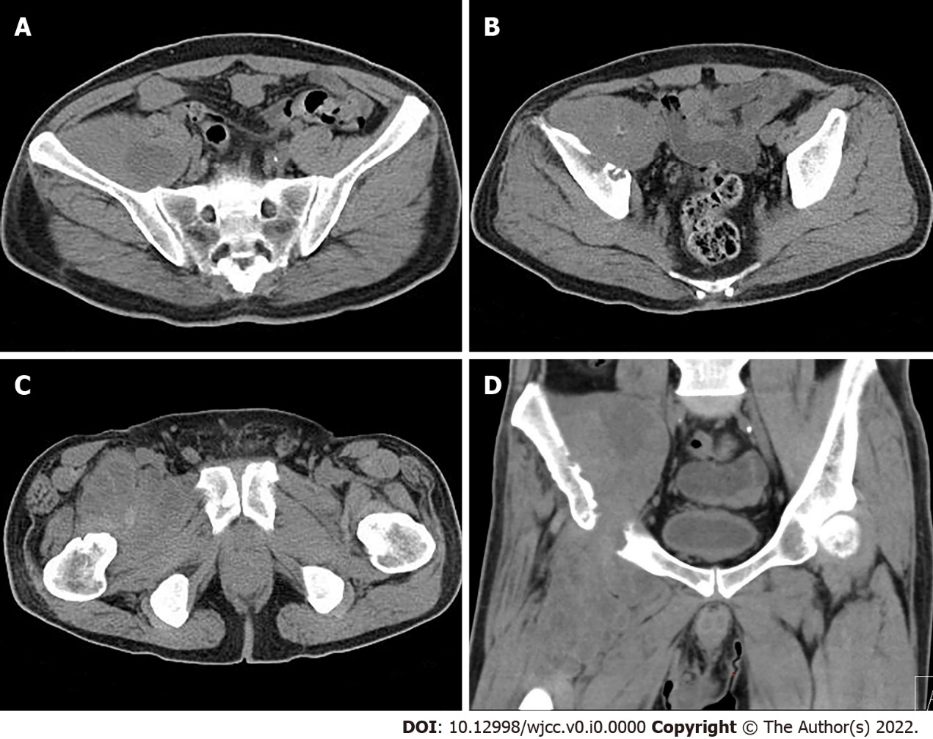
Figure 2 Computed tomography of the pelvis reveals a soft tissue mass in the intermuscular space anterior to the right iliopsoas muscle and the right upper femur. A: The mass showed soft tissue density with lamellar hypodense necrosis inside; B: Osteolytic bone destruction of the right iliac bone was displayed clearly; C: The mass had poorly defined margins; and D: The massive tumor growed along the tendon.
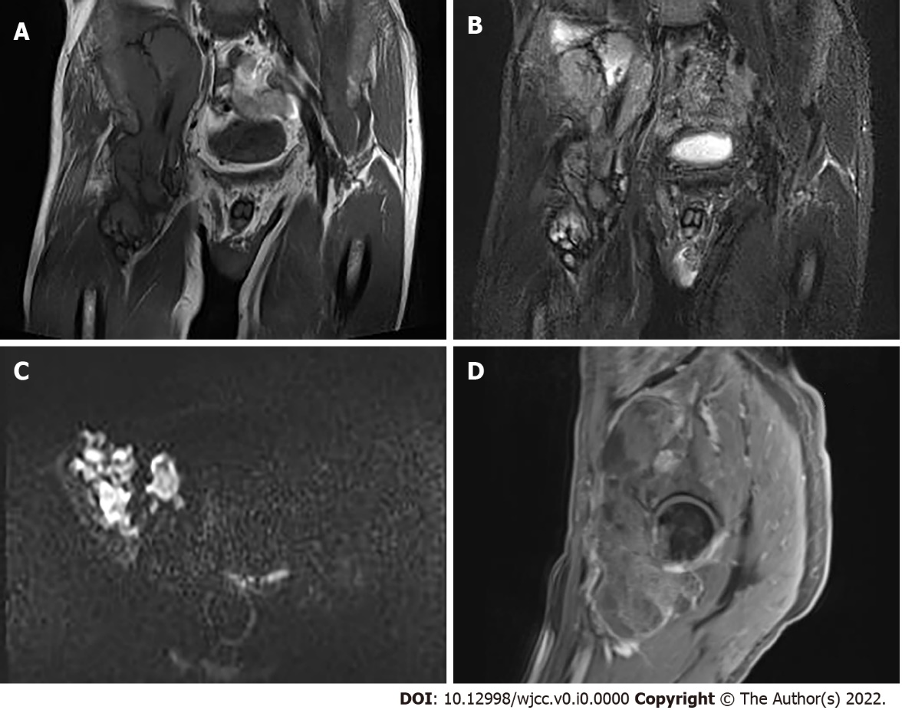
Figure 3 Magnetic resonance imaging of the hip. A: Inhomogeneous moderate hypointensity on coronal T1-weighted images; B: Mixed mild hyperintensity on coronal fat-saturated T2-weighted images; C: Inhomogeneous hyperintensity on axial D-weighted images; and D: Heterogeneous mild ring enhancement of the lesion on sagittal T1-weighted images after contrast administration.
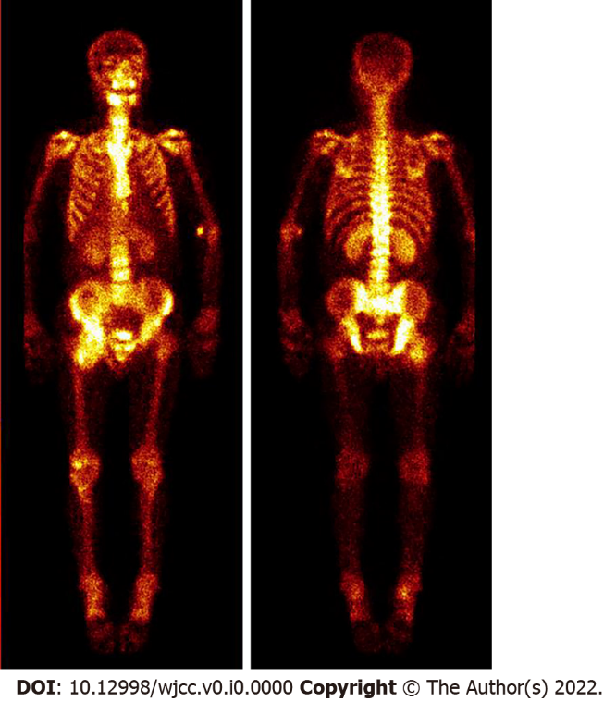
Figure 4 ^{99m}Tc-methylene diphosphonate whole-body bone scan. Multiple high radioactive lesions were demonstrated along the right ilium, acetabulum and proximal femur, which were correlated with computed tomography and magnetic resonance imaging findings.
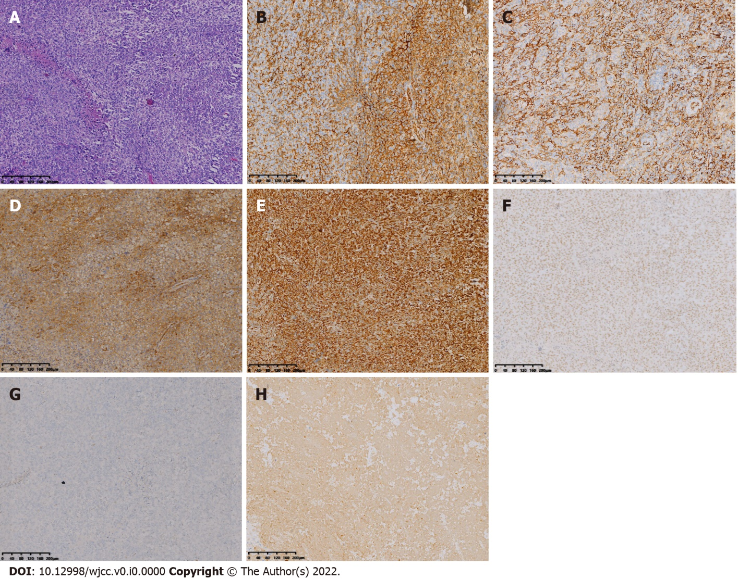
Figure 5 Histopathological images. A: Hematoxylin-eosin (HE) staining showed that the tumor was composed of mononuclear synovial-like cells and sarcoma cells. Lacunar-like lacunae were shown within the tumor cells and pleomorphism and heterogeneity of the tumor cells were obvious. Pathological nuclear division was seen and a collagen matrix was found between the cells (magnification ×100); B: Immunohistochemical staining revealed CD31 positivity (Envision, 100×); C: Immunohistochemical staining revealed CD34 positivity (Envision, 100×); D: Immunohistochemical staining revealed CD99 positivity (Envision, 100×); E: Immunohistochemical staining revealed Vimentin positivity (Envision, 100×); F: Immunohistochemical staining revealed INI-1 positivity (Envision, 100×); G: Immunohistochemical staining revealed TLE1 positivity (Envision, 100×); H: Immunohistochemical staining revealed CK positivity (Envision, 100×).

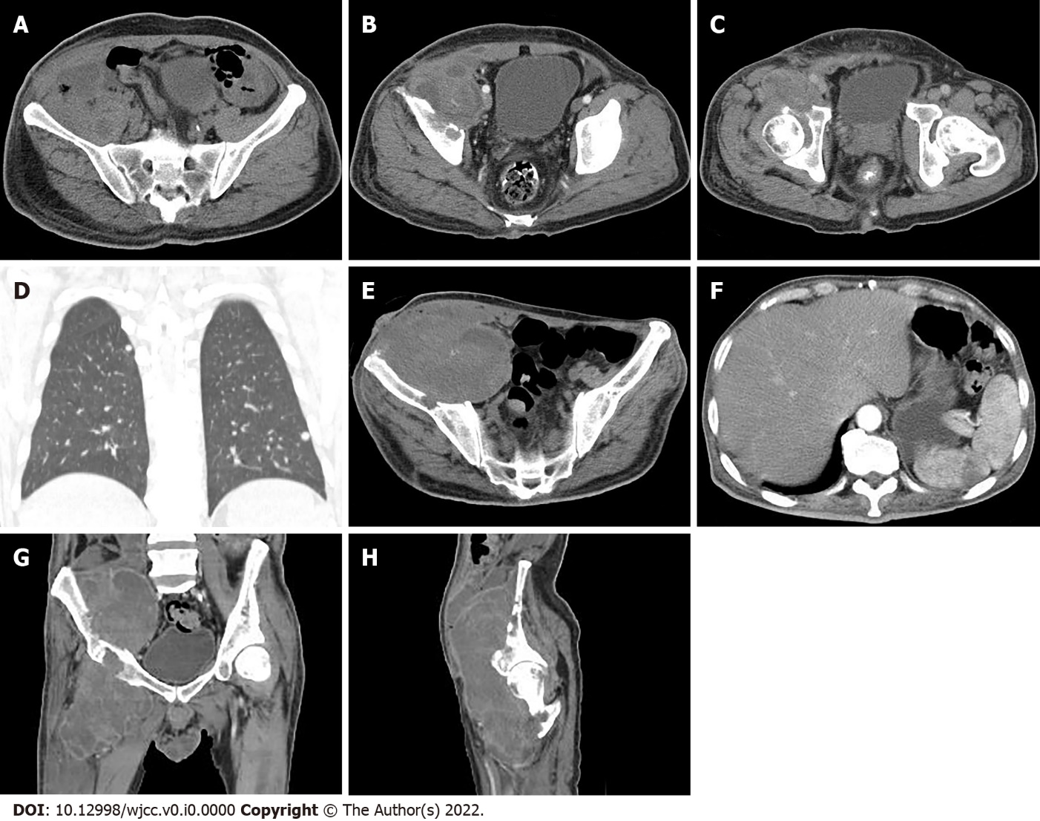
Figure 6 Computed tomography monitoring after chemotherapy. A-D: 1 mo and 7 d after the initial diagnosis; A: The lesion was larger in size than before and the adjacent abdominal wall was unevenly thickened; B: There were an increased amounts of necrosis lesions; C: The lesion invaded the acetabulum; D: Small and round solid nodules were found in both lung lobes; E-F: 5 mo and 20 d after the initial diagnosis; E: Thinning of the right abdominal wall with a skin fistula was caused by the mass; F: A patchy, hypodense infarcted area in the spleen represented a metastatic lesion; G: Further enlargement of the lesion; and H: Multiple osteolytic destruction was shown in the right ilium, acetabulum, and proximal femur.

