Name of Journal: World Journal of Clinical Cases
Manuscript NO: 70037
Manuscript Type: CASE REPORT

Intestinal intussusception caused by intestinal duplication and ectopic pancreas: A case report and review of literature

Wang TL et al. Intestinal intussusception

Tao-Li Wang, Xiao-Song Gong, Jin Wang, Chen-Yan Long

Tao-Li Wang, Department of Pathology, Zhuzhou Hospital Affiliated to Xiangya School of Medicine, Central South University, Zhuzhou 412007, Hunan Province, China

Xiao-Song Gong, Jin Wang, Chen-Yan Long, The Second Department of General Surgery, Zhuzhou Hospital Affiliated to Xiangya School of Medicine, Central South University, Zhuzhou 412007, Hunan Province, China

Author contributions: Wang TL, Gong XS and Wang J contributed equally to this work; Wang TL collected the data of the case and drafted the manuscript; Gong XS and Wang J performed the surgery; Wang J assisted in the revision; and Long CL reviewed the manuscript and provided constructive input; all authors read and approved the final manuscript.

Supported by Zhuzhou Science and Technology Plan Project, No. 2021–005.

Corresponding author: Chen-Yan Long, MD, PhD, Doctor, Surgeon, Surgical Oncologist, The Second Department of General Surgery, Zhuzhou Hospital Affiliated to Xiangya School of Medicine, Central South University, No. 116 Changjiang South Road, Zhuzhou 412007, Hunan Province, China. 85378307@qq.com

Received: July 20, 2021
Revised: September 17, 2021
Accepted: January 22, 2022
Published online: March 6, 2022

Abstract
BACKGROUND
Intestinal intussusception caused by intestinal duplication and ectopic pancreas is extremely rare in the clinic and has not been reported previously.

CASE SUMMARY
A 29-year-old man was admitted to the hospital for chronic abdominal pain and bloating. The preoperative diagnosis was intestinal obstruction and intussusception. Then, laparotomy, partial small intestinal resection and extraintestinal decompression were performed. Postoperative pathology confirmed intestinal duplication and ectopic pancreas. After surgery, the patient recovered well with no complications. No recurrence was observed after more than 5 mo of follow-up.

CONCLUSION
We report a new case of a young male with intussusception caused by intestinal duplication and ectopic pancreas. Surgery is the main treatment for these conditions. This study aimed to raise awareness and provide information to improve the clinical management of this rare yet serious condition.

Key Words: Intestinal intussusception; Ectopic pancreas; Intestinal duplication; Intestinal obstruction; Adult; Case report

©The Author(s) 2022. Published by Baishideng Publishing Group Inc. All rights reserved.

Citation: Wang TL, Gong XS, Wang J, Long CY. Intestinal intussusception caused by intestinal duplication and ectopic pancreas: A case report and review of literature. World J Clin Cases 2022; 10(7): 2261-2267
URL: https://www.wjgnet.com/2307-8960/full/v10/i7/2261.htm
DOI: https://dx.doi.org/10.12998/wjcc.v10.i7.2261

Core Tip: We present a new case of a young man with intussusception caused by intestinal duplication and ectopic pancreas. This case highlights that intestinal duplication and heterotopic pancreas should be considered causes of intestinal obstruction associated with intussusception.

INTRODUCTION
Intestinal intussusception refers to intestinal tube insertion into the connected intestinal lumen, which causes obstruction of the intestinal contents. Adult intussusception only accounts for 5% of the total incidence^{[1]}. The average age of adult patients is 50 years, and the male-to-female ratio is 1:5^{[2]}. Adult intussusception has no specific clinical manifestations and lacks the classic triad of pediatric intussusception symptoms: abdominal pain, vomiting, and jam-like stool. Abdominal computed tomography (CT) is considered the most useful examination, but most specific causes still require intraoperative detection or postoperative pathology for clarification. Ninety percent of adult intussusception is caused by tumors, polyps, diverticulum, etc.^{[3-6]}. Thus, 70% to 90% of adult intussusception requires surgical treatment^{[7]}. However, to date, there are no case reports on intussusception caused by small intestinal duplication and ectopic pancreas.
We report a new case of a young man with intussusception caused by intestinal duplication and ectopic pancreas. Informed consent for the publication of these data was obtained from the patient.

CASE PRESENTATION
Chief complaints
A 29-year-old man was admitted to the hospital for repeated abdominal pain and bloating for more than 2 mo that had been aggravated for 2 d.

History of present illness
The patient had repeated abdominal pain and abdominal distension for 2 mo and had been treated in many hospitals. The symptoms could be relieved by symptomatic treatments, such as rehydration and pain relief. Due to aggravation of the above symptoms for 2 d, the patient was admitted to our hospital to consider the possibility of intestinal obstruction. Since onset, the patient’s anal exhaust and defecation had decreased, with no additional vomiting, chills, fever or other discomfort. A yellow-brown stool was discharged once on the day of admission, and no mucous or blood was present in the stool.

History of past illness
The patient had no relevant previous medical history.

Personal and family history
The patient’s family history was unremarkable.

Physical examination
The physical examination findings were as follows: slight abdominal bulge, no obvious tension of the abdominal muscles, right lower abdominal tenderness, slight rebound pain, negative Murphy sign, and no obvious palpable abdominal mass.

Laboratory examinations
Initial laboratory data revealed a white blood cell count of 8.3 × 10⁹/L, neutrophil count of 6.67 × 10⁹/L, neutrophil percentage of 83.1% and C-reactive protein of 13.9 mg/L. Liver and kidney parameters were normal.
The postoperative pathology results were as follows: Two intestinal canal-like structures were observed in the mesentery-side lumen, measuring approximately 6 cm in length and 2.5 cm in diameter and 2.5 cm in length and 2 cm in diameter. The intestinal canals were observed directly after incision (Figure 1). Microscopically, the intestinal mucosa, submucosa, muscular layer and serosal layer were observed in both intestinal canals. The muscular layer of the short intestinal wall was significantly thickened, and local dysplasia of the external longitudinal muscle was accompanied by disordered growth of the muscular bundle (Figure 2A). The serosal surface of the long intestinal canal showed fatty tissue hyperplasia with ectopic pancreas, and pancreatic acinar and islet tissue and pancreatic duct cells were observed (Figure 2B and C).

Imaging examinations
Abdominal enhanced CT showed an annular bowel shadow in the lower left abdomen, indicating the possibility of intussusception, intestinal wall thickening, and inflammatory edema (Figure 3).

FINAL DIAGNOSIS
The following diagnoses were made: Intestinal obstruction, intestinal duplication and ectopic pancreas, and intussusception.

TREATMENT
The patient underwent emergency exploratory laparotomy, partial small intestinal resection and extraintestinal decompression.
During the operation, the proximal small intestine was found to be inserted into the distal small intestine on the ileum approximately 80 cm away from the ileocecal valve. The lesion length was approximately 20 cm, and the proximal small intestine was dilated to a diameter of approximately 8 cm. The distal small intestine was empty, and the small intestine at the site of intussusception was edematous. Some of the intestinal wall was thickened and hardened, resulting in complete obstruction of the intestinal cavity. Exploration and manual reduction of a mass measuring approximately 3 cm × 2.5 cm at the site of intussusception were difficult. Small intestinal tumors, intestinal intussusception and intestinal obstruction were considered. Partial small intestinal resection and extraintestinal decompression were performed.

OUTCOME AND FOLLOW-UP
The patient recovered well with no complications. No recurrence was found after more than 5 mo of follow-up.

DISCUSSION
Intussusception is a special form of intestinal obstruction, accounting for approximately 1%-5% of cases^{[1]}. The exact cause of approximately 8%-12% of adult intussusception is unclear^{[1,7,8]}. Any intestinal disease that changes the normal peristalsis of the intestine increases the risk of intussusception^{[9]}. Adult intussusception is often secondary to intestinal tumors, polyps, diverticulum, etc. Therefore, for suspected adult intussusception patients, digestive tract radiography, CT, magnetic resonance imaging and other examinations should be actively performed to clarify the etiology, and active surgery is needed to treat the primary disease and relieve the obstruction. For patients with adult intussusception that can be reduced, subsequent resection of the organic lesions remains the preferred treatment.
Intestinal duplication and ectopic pancreas are two independent congenital defects. The incidence of ectopic pancreas according to autopsy reports is 0.5%-13%^{[10]}. The etiology of ectopic pancreas is still unclear. Studies have shown that during embryonic development, pancreatic primordia adhere to or penetrate the intestinal wall of the embryo and continue to develop and form in various abnormal locations with the movement of intestinal transposition^{[11,12]}. Ectopic pancreas is mainly composed of pancreatic duct and acinar tissue and usually lacks islet tissue. There are no anatomical or vascular connections between the ectopic pancreas and normal pancreas^{[13]}. It most commonly occurs in the duodenum but can also appear in the jejunum and, rarely, in the ileum^{[14]}. Ectopic pancreas is generally considered asymptomatic^{[15]}. In a few case reports, intestinal obstruction, abdominal pain and bleeding were also mentioned^{[16,17]}. Due to the diverse locations and lack of specific lesions, early ectopic pancreas diagnosis is difficult, easily leading to misdiagnoses or missed diagnosis. We searched the literature on PubMed for adult intussusception and ectopic pancreas, and the results are summarized in Table 1.
The incidence rate of intestinal duplication is 1 in 10000 newborns, and it is rare in adults^{[18]}. We retrieved the literature on adult intussusception caused by intestinal duplication from PubMed, and the publications are listed in Table 2. The differences between intestinal duplication and Meckel’s diverticulum are as follows: (1) Intestinal duplication shares a blood supply with the surrounding intestine, while diverticulum has an independent blood supply; and (2) well-developed smooth muscle is present in intestinal duplication but not in Meckel’s diverticulum^{[19]}. Studies suggest that there is a direct communication hole between intestinal duplication and the normal intestinal wall for unknown reasons^{[20,21]}. With the closure of the hole, the muscular layer becomes discontinuous, and feces form a mucosal bridge after passing through the hole, which leads to the occurrence of adult intussusception.
Although adult intussusception, ectopic pancreas and intestinal duplication have been reported separately, our case was unique, as intussusception caused by intestinal duplication and heterotopic pancreas has not been reported previously.
In this case, the patient had been treated in many hospitals for repeated abdominal pain and received symptomatic treatments, such as fluid infusion and pain relief. However, because the fundamental cause of the disease was not determined, the symptoms persisted, and intussusception inevitably occurred, leading to complete intestinal obstruction. Therefore, we speculate that due to the abnormal anatomical position, when intestinal duplication is combined with ectopic pancreatic tissue, the ectopic pancreatic tissue is accompanied by the continuous growth of adipose tissue. Because of the compensatory ability of the body, increased intestinal peristalsis occurs, resulting in intussusception and complete intestinal obstruction. Therefore, early correct diagnosis and timely treatment are critical for adult intussusception.

CONCLUSION
This is the first reported case of intestinal intussusception caused by intestinal duplication and ectopic pancreas. Therefore, intestinal duplication and ectopic pancreas should be considered in the differential diagnosis of intussusception. Although modern diagnostic technology has greatly progressed, diagnosis of intestinal duplication and ectopic pancreas remains difficult. Definitive diagnosis usually depends on postoperative pathology.

REFERENCES
1 Azar T, Berger DL. Adult intussusception. Ann Surg 1997; 226: 134-138 [PMID: 9296505 DOI: 10.1097/00000658-199708000-00003]
2 Honjo H, Mike M, Kusanagi H, Kano N. Adult intussusception: a retrospective review. World J Surg 2015; 39: 134-138 [PMID: 25192846 DOI: 10.1007/s00268-014-2759-9]
3 Eisen LK, Cunningham JD, Aufses AH Jr. Intussusception in adults: institutional review. J Am Coll Surg 1999; 188: 390-395 [PMID: 10195723 DOI: 10.1016/s1072-7515(98)00331-7]
4 Weilbaecher D, Bolin JA, Hearn D, Ogden W 2nd. Intussusception in adults. Review of 160 cases. Am J Surg 1971; 121: 531-535 [PMID: 5557762 DOI: 10.1016/0002-9610(71)90133-4]
5 Stubenbord WT, Thorbjarnarson B. Intussusception in adults. Ann Surg 1970; 172: 306-310 [PMID: 5433296 DOI: 10.1097/00000658-197008000-00019]
6 Akçay MN, Polat M, Cadirci M, Gencer B. Tumor-induced ileo-ileal invagination in adults. Am Surg 1994; 60: 980-981 [PMID: 7992979]
7 Begos DG, Sandor A, Modlin IM. The diagnosis and management of adult intussusception. Am J Surg 1997; 173: 88-94 [PMID: 9074370 DOI: 10.1016/S0002-9610(96)00419-9]
8 Erkan N, Haciyanli M, Yildirim M, Sayhan H, Vardar E, Polat AF. Intussusception in adults: an unusual and challenging condition for surgeons. Int J Colorectal Dis 2005; 20: 452-456 [PMID: 15759123 DOI: 10.1007/s00384-004-0713-2]
9 Takeuchi K, Tsuzuki Y, Ando T, Sekihara M, Hara T, Kori T, Kuwano H. The diagnosis and treatment of adult intussusception. J Clin Gastroenterol 2003; 36: 18-21 [PMID: 12488701 DOI: 10.1097/00004836-200301000-00007]
10 Gokhale UA, Nanda A, Pillai R, Al-Layla D. Heterotopic pancreas in the stomach: a case report and a brief review of the literature. JOP 2010; 11: 255-257 [PMID: 20442522]
11 Liu YM, Shen HP, Li X, Gong JP. Heterotopic pancreas: a clinical analysis of nine patients and review of literature. Am Surg 2012; 78: E141-E143 [PMID: 22524740]
12 Heretsch P, Tzagkaroulaki L, Giannis A. Modulators of the hedgehog signaling pathway. Bioorg Med Chem 2010; 18: 6613-6624 [PMID: 20708941 DOI: 10.1016/j.bmc.2010.07.038]
13 Sathyanarayana SA, Deutsch GB, Bajaj J, Friedman B, Bansal R, Molmenti E, Nicastro JM, Coppa GF. Ectopic pancreas: a diagnostic dilemma. Int J Angiol 2012; 21: 177-180 [PMID: 23997566 DOI: 10.1055/s-0032-1325119]
14 Tanaka K, Tsunoda T, Eto T, Yamada M, Tajima Y, Shimogama H, Yamaguchi T, Matsuo S, Izawa K. Diagnosis and management of heterotopic pancreas. Int Surg 1993; 78: 32-35 [PMID: 8473080]
15 Armstrong CP, King PM, Dixon JM, Macleod IB. The clinical significance of heterotopic pancreas in the gastrointestinal tract. Br J Surg 1981; 68: 384-387 [PMID: 7237066 DOI: 10.1002/bjs.1800680606]
16 Serrano JS, Stauffer JA. Ectopic Pancreas in the Wall of the Small Intestine. J Gastrointest Surg 2016; 20: 1407-1408 [PMID: 26892166 DOI: 10.1007/s11605-016-3104-4]
17 Kilius A, Samalavicius NE, Danys D, Zaldokas G, Seinin D. Asymptomatic heterotopic pancreas in Meckel's diverticulum: a case report and review of the literature. J Med Case Rep 2015; 9: 108 [PMID: 25956067 DOI: 10.1186/s13256-015-0576-x]
18 Iyer CP, Mahour GH. Duplications of the alimentary tract in infants and children. J Pediatr Surg 1995; 30: 1267-1270 [PMID: 8523222 DOI: 10.1016/0022-3468(95)90482-4]
19 Huang ZH, Wan ZH, Vikash V, Vikash S, Jiang CQ. Report of a rare case and review of adult intestinal duplication at the opposite side of mesenteric margin. Sao Paulo Med J 2018; 136: 89-93 [PMID: 29236936 DOI: 10.1590/1516-3180.2017.0184030817]
20 Tamvakopoulos GS, Sams V, Preston P, Stebbings WS. Iron-deficiency anaemia caused by an enterolith-filled jejunal duplication cyst. Ann R Coll Surg Engl 2004; 86: W49-W51 [PMID: 16749968 DOI: 10.1308/147870804119]
21 Kimura S, Iida H, Gunji N, Gohongi T, Ogata T. Stool filling of an intestinal duplication cyst at the ileocecal valve triggers colonic intussusception: a case report. Surg Case Rep 2018; 4: 116 [PMID: 30219978 DOI: 10.1186/s40792-018-0527-z]
22 Ganapathi S, Villa F, Perera R, Wan A. Ectopic pancreas, intussusception, and a ruptured mesenteric band: an unusual association. Clin Anat 2011; 24: 128-132 [PMID: 20949486 DOI: 10.1002/ca.21052]
23 Sciannamea A, Vaccari S, Marasco G, Dalla Via B, Lauro A, Marino IR, Vasuri F, Cervellera M, D'Andrea V, Tonini V. Concomitant Heterotopic Pancreas and Endometriosis as a Rare Cause of Ileo-Ileal Intussusception in a Young Woman with Spina Bifida: Case Report and Literature Review. Dig Dis Sci 2020; 65: 2800-2804 [PMID: 32572657 DOI: 10.1007/s10620-020-06410-3]
24 Gold D, Nawass M, Imam R, Pillar N, Appelbaum L, Pikarsky A, Khalaileh A, Imam A. Intussusception in a pregnant patient caused by an ectopic pancreatic mass. Clin J Gastroenterol 2020; 13: 209-213 [PMID: 31364039 DOI: 10.1007/s12328-019-01030-5]
25 Giordano A, Alemanno G, Bergamini C, Prosperi P, Bruscino A, Valeri A. The Role of Laparoscopy in the Management of a Diagnostic Dilemma: Jejunal Ectopic Pancreas Developing into Jejunojejunal Intussusception. Case Rep Surg 2017; 2017: 8452947 [PMID: 28819577 DOI: 10.1155/2017/8452947]
26 Chuang MT, Tsai KB, Ma CJ, Hsieh TJ. Ileoileal intussusception due to ileal ectopic pancreas with abundant fat tissue mimicking lipoma. Am J Surg 2010; 200: e25-e27 [PMID: 20678617 DOI: 10.1016/j.amjsurg.2009.12.027]
27 Abe I, Saito M, Ikeda T, Fukuda R, Tanaka A, Rikiyama T. Ileectomy performed on a case of adult intussusception due to inversion of Meckel's diverticulum. J Surg Case Rep 2020; 2020: rjz367 [PMID: 31976058 DOI: 10.1093/jscr/rjz367]
28 Daniel NE, Rampersad FS, Naraynsingh V, Barrow S, David S. Jejunal Intussusception Due to Heterotopic Pancreas: A Case Report. Cureus 2021; 13: e14586 [PMID: 34036004 DOI: 10.7759/cureus.14586]
29 Ho YC. Total colorectal and terminal ileal duplication presenting as intussusception and intestinal obstruction. World J Gastroenterol 2012; 18: 6338-6340 [PMID: 23180958 DOI: 10.3748/wjg.v18.i43.6338]
30 Li BL, Huang X, Zheng CJ, Zhou JL, Zhao YP. Ileal duplication mimicking intestinal intussusception: a congenital condition rarely reported in adult. World J Gastroenterol 2013; 19: 6500-6504 [PMID: 24151372 DOI: 10.3748/wjg.v19.i38.6500]
31 Al-Qahtani HH. Enteric duplication cyst as a leading point for ileoileal intussusception in an adult: A rare cause of complete small intestinal obstruction. World J Gastrointest Surg 2016; 8: 472-475 [PMID: 27358681 DOI: 10.4240/wjgs.v8.i6.472]
32 Kyo K, Azuma M, Okamoto K, Nishiyama M, Shimamura T, Maema A, Shirakawa M, Nakamura T, Koda K, Yokoyama H. Laparoscopic resection of adult colon duplication causing intussusception. World J Gastroenterol 2016; 22: 2398-2402 [PMID: 26900303 DOI: 10.3748/wjg.v22.i7.2398]
33 Kim HS, Sung JY, Park WS, Kim YW. An ileal duplication cyst manifested as an ileocolic intussusception in an adult. Turk J Gastroenterol 2014; 25 Suppl 1: 196-198 [PMID: 25910304 DOI: 10.5152/tjg.2014.4011]
34 Reiser-Erkan C, Erkan M, Ulbrich E, Nährig J, Kleeff J. Cystic colon duplication causing intussusception in a 25-year-old man: report of a case and review of the literature. BMC Surg 2010; 10: 19 [PMID: 20573256 DOI: 10.1186/1471-2482-10-19]
35 Kusnierz K, Pilch-Kowalczyk J, Gruszczynska K, Baron J, Lucyga M, Lampe P. A duodenal duplication cyst manifested by duodenojejunal intussusception and chronic pancreatitis. Surgery 2014; 156: 742-744 [PMID: 23777586 DOI: 10.1016/j.surg.2013.02.013]
36 Nadatani Y, Watanabe T, Sugawa T, Eguchi S, Shimada S, Otani K, Yamagami H, Tanigawa T, Shiba M, Tominaga K, Fujiwara Y, Arakawa T. Double-balloon endoscopy WAS effective in diagnosing small intestinal duplication: a case report. Springerplus 2016; 5: 1598 [PMID: 27652171 DOI: 10.1186/s40064-016-3256-4]
37 O'Connor PA, McGrath FP, Lane BE. Duodenal intussusception secondary to an internal duodenal duplication. Clin Radiol 1999; 54: 69-70 [PMID: 9915514 DOI: 10.1016/s0009-9260(99)91243-6]

Footnotes
Informed consent statement: Informed written consent was obtained from the patient for publication of this report and any accompanying images.

Conflict-of-interest statement: The authors have no conflicts of interest or uses of previously copyrighted material to disclose.

CARE Checklist (2016) statement: The authors have read the CARE Checklist (2016), and the manuscript was prepared and revised according to the CARE Checklist (2016).

Open-Access: This article is an open-access article that was selected by an in-house editor and fully peer-reviewed by external reviewers. It is distributed in accordance with the Creative Commons Attribution NonCommercial (CC BY-NC 4.0) license, which permits others to distribute, remix, adapt, build upon this work non-commercially, and license their derivative works on different terms, provided the original work is properly cited and the use is non-commercial. See: https://creativecommons.org/Licenses/by-nc/4.0/

Provenance and peer review: Unsolicited article; Externally peer reviewed.
Peer-review model: Single blind

Peer-review started: July 20, 2021
First decision: September 5, 2021
Article in press: January 22, 2022

Specialty type: Gastroenterology and hepatology
Country/Territory of origin: China
Peer-review report’s scientific quality classification
Grade A (Excellent): 0
Grade B (Very good): 0
Grade C (Good): 0
Grade D (Fair): D
Grade E (Poor): 0

P-Reviewer: Limaiem F S-Editor: Yan JP L-Editor: A P-Editor: Yan JP
Figure Legends

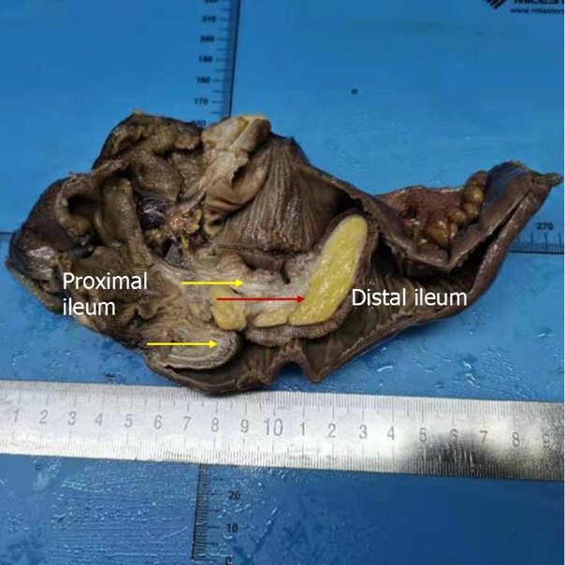
Figure 1 Postoperative gross specimen showing intestinal duplication (yellow arrow) and adipose tissue hyperplasia with ectopic pancreatic tissue (red arrow).

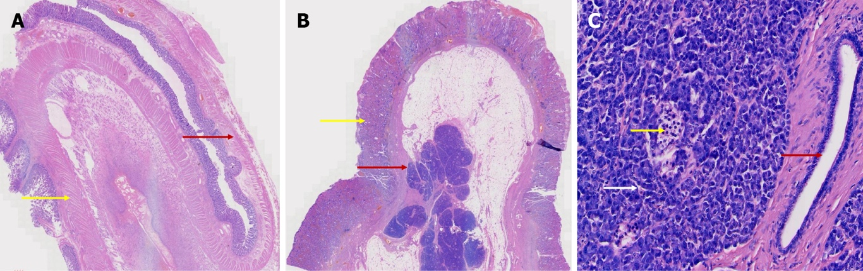

Figure 2 Hematoxylin & eosin staining. A: Microscopic view of the wall of the normal intestine (red arrow) and duplicated intestine (yellow arrow) [hematoxylin & eosin (HE) × 5]; B: Microscopic view of adipose tissue hyperplasia on the serosa surface of the duplicated intestinal wall (yellow arrow) with ectopic pancreas (red arrow) (HE × 5); C: Microscopically, the ectopic pancreatic tissue showed pancreatic islet cells (yellow arrow), pancreatic acinus (white arrow), and the pancreatic duct (red arrow) (HE × 200).

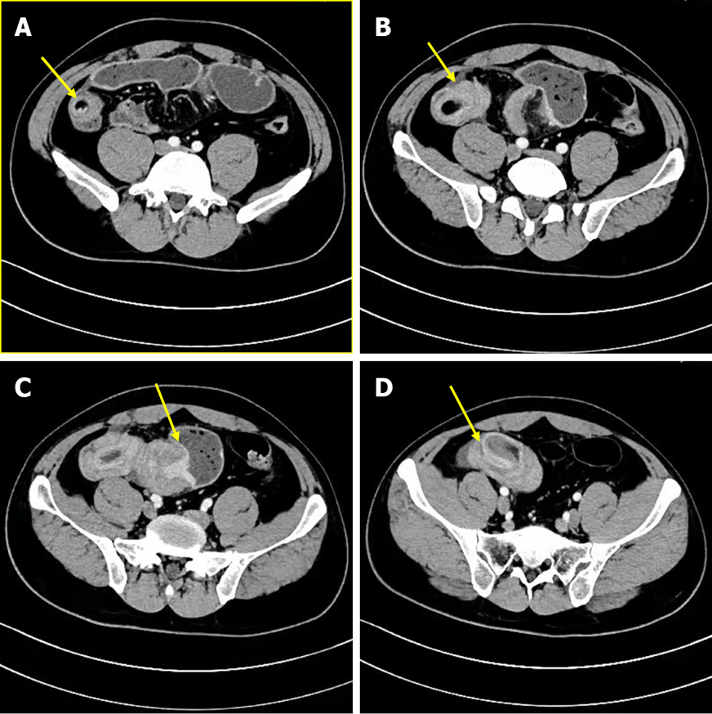

Figure 3 Abdominal enhanced computed tomography showing an annular bowel shadow in the lower left abdomen, indicating the possibility of intussusception and intestinal wall thickening. A: Head of intussusception; B: Distal sheath of intussusception; C: Neck of intussusception; D: Sheath of intussusception.

Table 1 Adult intestinal intussusception and ectopic pancreas
Ref. | Gender | Age | Location
Ganapathi et al^{[22]}, 2011 | Male | 26 | Ileo-ileal
Sciannamea et al^{[23]}, 2020 | Female | 33 | Ileo-ileal
Gold et al^{[24]}, 2020 | Female | 23 | Intestinal
Giordano et al^{[25]}, 2017 | Male | 29 | Jejunojejunal
Chuang et al^{[26]}, 2010 | Female | 26 | Ileo-ileal
Abe et al^{[27]}, 2020 | Female | 43 | Ileo-ileal
Daniel et al^{[28]}, 2021 | Female | 78 | Jejunojejunal

Table 2 Adult intestinal intussusception caused by intestinal duplication
Ref. | Gender | Age | Location
Kimura et al^{[21]}, 2018 | Male | 19 | Colon
Ho^{[29]}, 2012 | Male | 25 | Terminal ileum, appendix, colon and rectum
Li et al^{[30]}, 2013 | Male | 25 | Ileum
Al-Qahtani^{[31]}, 2016 | Female | 32 | Ileum
Kyo et al^{[32]}, 2016 | Male | 20 | Colon
Kim et al^{[33]}, 2014 | Female | 19 | Ileal
Reiser-Erkan et al^{[34]}, 2010 | Male | 25 | Colon
Kusnierz et al^{[35]}, 2014 | Unknown | 31 | Duodenal
Nadatani et al^{[36]}, 2016 | Male | 73 | Ileal
O'Connor et al^{[37]}, 1999 | Female | 32 | Duodenal

Published by Baishideng Publishing Group Inc
7041 Koll Center Parkway, Suite 160, Pleasanton, CA 94566, USA
Telephone: +1-925-3991568
E-mail: bpgoffice@wjgnet.com
Help Desk: https://www.f6publishing.com/helpdesk
https://www.wjgnet.com

© 2022 Baishideng Publishing Group Inc. All rights reserved.

