The ARRIVE Guidelines Checklist

Animal Research: Reporting In Vivo Experiments

Pan-Pan Cen¹, Lin-Xiao Fan², Jie Wang², Jia-Jia Chen² and Lan-Juan Li²

1 Department of Infectious Diseases, Hangzhou First People’s Hospital, Zhejiang University School of Medicine, China，2 State Key Laboratory for Diagnosis and Treatment of Infectious Diseases; National Clinical Research Center for Infectious Diseases; The First Affiliated Hospital, Zhejiang University School of Medicine, China
 |  | ITEM |  | RECOMMENDATION |  |  | Reported on
 |  |  |  |  |  |  | page #
 |  |  |  |  |  |  | 1
 |  |  |  |  |  |  | 3
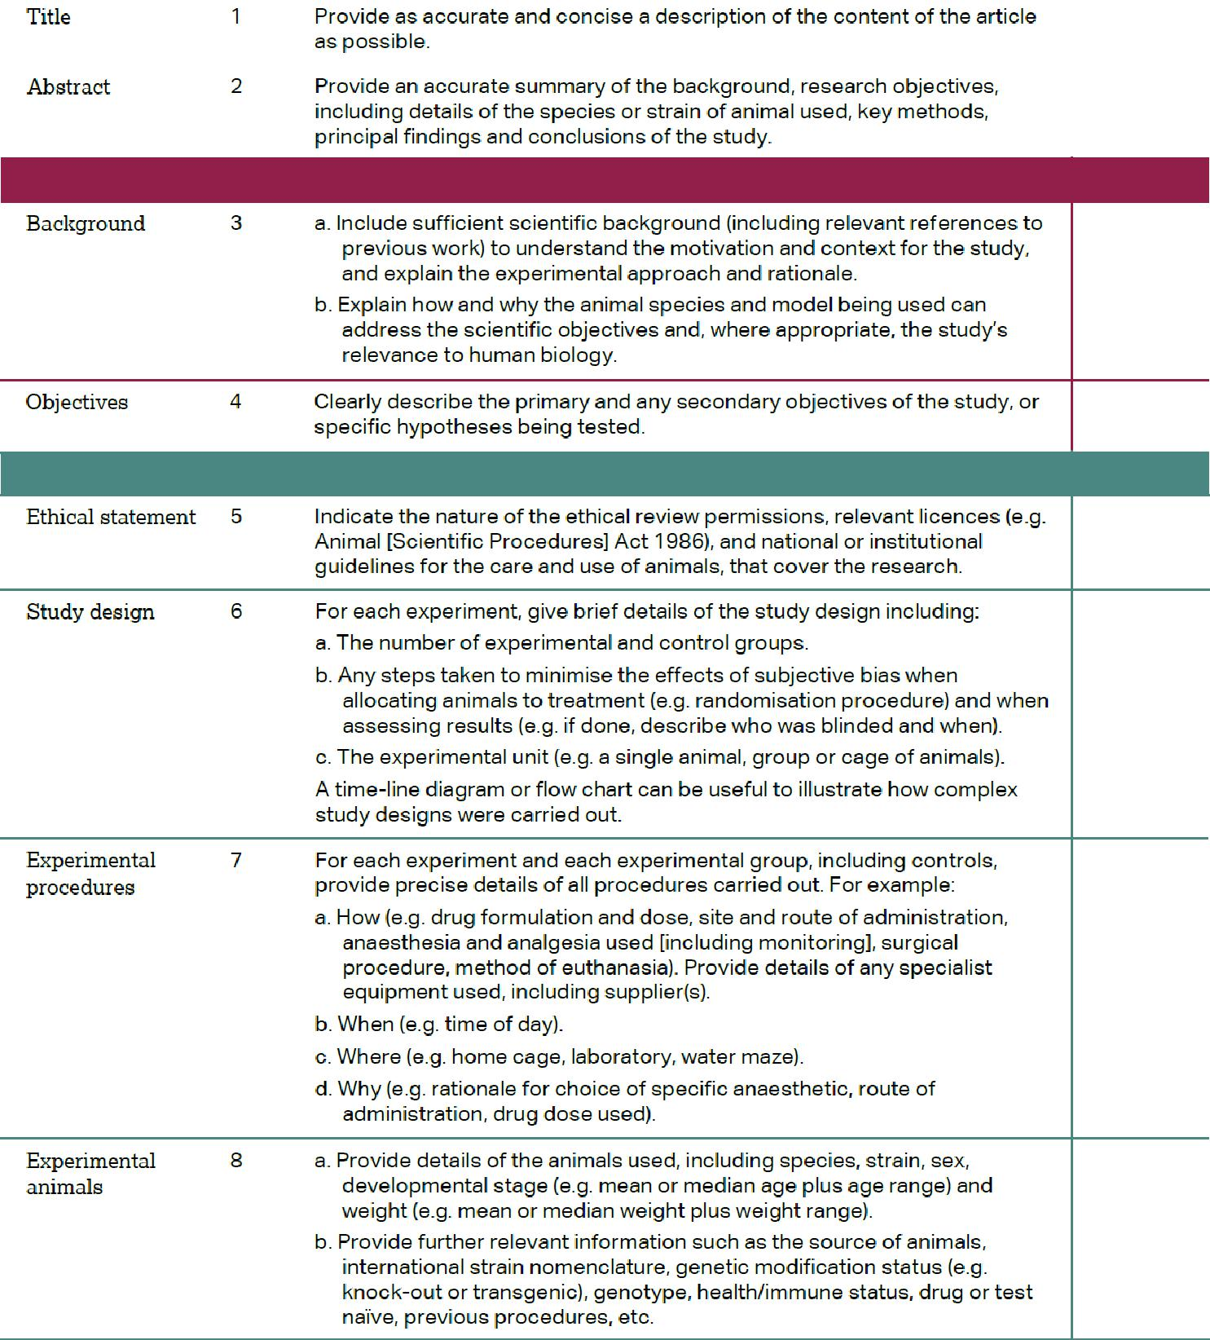

INTRODUCTION

5

6
METHODS

8

8

8

8

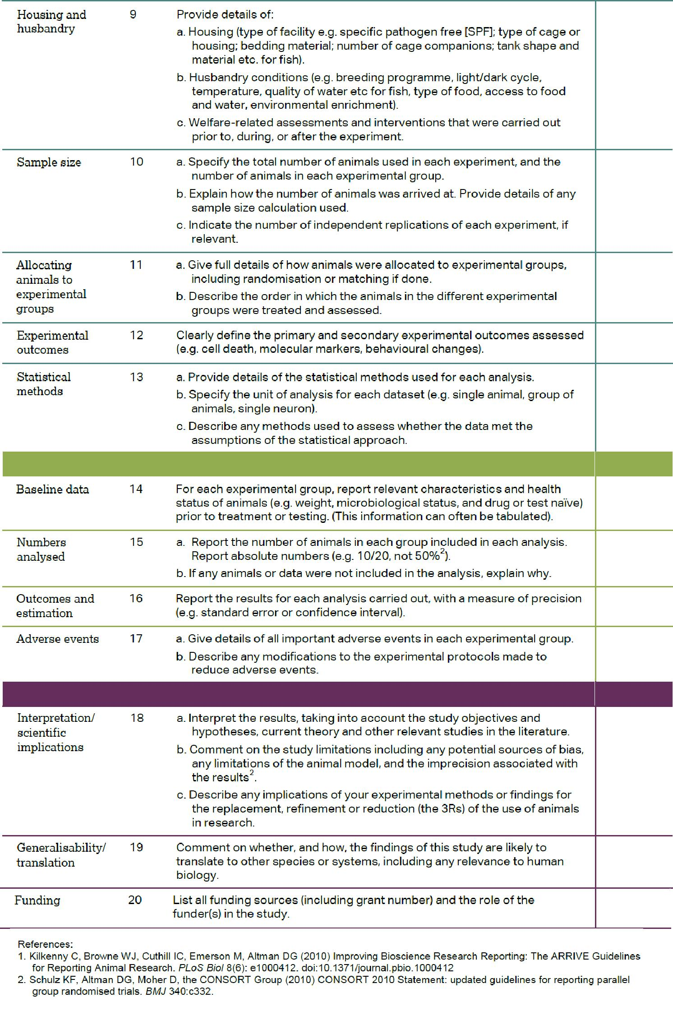

8

8

8

6-7, 9

9
RESULTS

10-11

8

10-11

10

DISCUSSION
1
15
12-15

