Name of Journal: World Journal of Clinical Urology
ESPS Manuscript NO: 29500
Manuscript Type: Case Report

Classical seminoma in a 92-year-old patient

Denning C et al. Classical seminoma in an elderly patient

Catharine Denning, Li June Tay, James Carton, Kaka Hama Attar

Catharine Denning, Li June Tay, James Carton, Kaka Hama Attar, Department of Urology, Chelsea and Westminster Hospital, London SW10 9NH, United Kingdom

Author contributions: The manuscript is original work of all authors; all authors made a significant contribution to this study; all authors have read and approved the final version of the manuscript; the principal author of this report is Denning C; Denning C also collected the majority of patient information and data; Tay LJ helped collect data and reviewed the writing of this case report; Carton J provided his expert histopathological opinion on this case and provided specimen histopathology slide pictures; Attar KH was the consultant in charge of this patient’s case; he provided his expert opinion and was the over-all reviewer and consultant in the writing of this report.

Institutional review board statement: Chelsea and Westminster Review Board.

Informed consent statement: N/A, patient deceased with no next of kin.

Conflict-of-interest statement: The manuscript is being submitted by me, Dr. Catharine Denning on behalf of all the authors. This manuscript has not been submitted for publication; it has not been accepted for publication and has not been published in any other journal. There is no conflict of interest from any author, including but not limited to commercial, personal, political, intellectual, or religious interests.

Open-Access: This is an open-access article that was selected by an in-house editor and fully peer-reviewed by external reviewers. It is distributed in accordance with the Creative Commons Attribution Non Commercial (CC BY-NC 4.0) license, which permits others to distribute, remix, adapt, build upon this work non-commercially, and license their derivative works on different terms, provided the original work is properly cited and the use is non-commercial. See: http://creativecommons.org/licenses/by-nc/4.0/

Manuscript source: Invited manuscript

Correspondence to: Dr. Catharine Denning, Department of Urology, Chelsea and Westminster Hospital, 369 Fulham Road, London SW10 9NH, United Kingdom. drcdenning@gmail.com
Telephone: +44-7795-387870

Received: August 17, 2016
Peer-review started: August 18, 2016
First decision: September 6, 2016
Revised: December 8, 2016
Accepted: December 27, 2016
Article in press:
Published online:

Abstract
Seminoma is a germ cell tumour which primarily affects the testes. Seminomas are treated by orchidectomy with usually excellent outcomes. We report the occurrence of a classical seminoma in a 92-year-old man, who is currently the oldest patient with this histology reported in literature. He presented with a painful, swollen testis. Scrotal ultrasound scan revealed a testicular mass. A left inguinal orchidectomy was carried out and histological examination confirmed the diagnosis of a classical seminoma. Further staging by computerised tomography revealed pulmonary lesions suspicious of metastases. The patient declined further treatment in view of his age and co-morbidities.

Key words: Urology; Seminoma; Medical oncology; Geriatrics

© The Author(s) 2016. Published by Baishideng Publishing Group Inc. All rights reserved.

Core tip: This is the first case in the literature which describes the occurrence of such a tumour in patients over the age of 90 and should raise the index of suspicion for malignant testicular tumours in elderly patients where infectious causes of testicular swellings are by far the most common.

Denning C, Tay LJ, Carton J, Attar KH. Classical seminoma in a 92-year-old patient. World J Clin Urol 2016; In press

INTRODUCTION
We would like to introduce the first case in the literature which describes the occurrence of a testicular seminoma in patients over the age of 90 and we hope that this presentation will educate the future doctors to raise the index of suspicion for malignant testicular tumours in elderly patients where infectious causes of testicular swellings are by far the most common.

CASE REPORT
A 92-year-old man presented with a 4 wk history of a left painful swollen scrotal mass, initially to his General Practitioner (GP), and subsequently to the emergency department. His medical history included alcoholic liver disease, oesophageal varices, chronic obstructive airway disease, and a cardiac pacemaker. Scrotal ultrasound scan showed a 4cm heterogeneous vascular testicular mass. Laboratory tests revealed normal levels of serum alpha feta protein (AFP) (2 kU/L) βhCG (< 2 iU/L) and lactate dehydrodgense (LDH) (59 iU/L). Left inguinal orchidectomy was performed in view of the suspicious findings. Macroscopic histopathological examination revealed a well-circumscribed pale grey mass measuring 6.5 cm with central necrosis. Histological sectioning showed sheets of large polygonal cells (Figure 1) which stained positively for Oct-3/4 (Figure 2) and placental alkaline phosphatase (PLAP). These findings were consistent with a diagnosis of classical seminoma with no evidence of intratubular germ cell neoplasia. The tumour had not breached the tunica vaginalis nor involved the spermatic cord. A staging computerised tomography (CT) scan revealed diffuse pulmonary metastases, a collapse fracture of the 12th thoracic vertebra and severe ascites (secondary to chronic liver disease). The patient declined further intervention including oncological input in view of his age and co-morbidities. He died 6 wk later but a post mortem was not carried out.

DISCUSSION
Testicular cancer is the 16th most common cancer in men in the United Kingdom. It accounts for 1% of all new cases of male cancer. Between 2009 and 2011, 84% of testicular cancer cases were diagnosed in men aged 15-49 years in the United Kingdom; only 6% occurred in patients aged over 60^{[1]}. The incidence of testicular cancer in patients older than 85 is only 2.4 per 100000. Ninety-five percent of testicular tumours are germ cell tumours (GCTs), which includes seminomas (40%-45%) and non-seminomas (55%-60%). GCTs develop from a non-invasive lesion called carcinoma in situ (CIS) of the testis (ITGCN), whose malignant transformation is likely to be influenced by hormones at or after puberty^{[2]}. Seminoma rarely occurs in the adolescent or infant population and the peak age of incidence is between aged 35-39 years with less than 10% being diagnosed after the age of 50^{[3]}. A large study in 2008 revealed an 86-year-old patient with spermatocytic seminoma^{[4]} while a recent case report describes spermatocytic seminoma in a 92-year-old.
Malignant testicular lumps are usually painless, and hence the presentation of seminoma as a painful, swollen testis is unusual^{[5]}. Differential diagnosis in a 92-year-old patient with a painful lump in the testicle would include orchitis, epididymitis, or an abscess, especially if accompanied by symptoms of systemic infection. Testicular torsion is also possible, but this is most common in the second and third decades of life and presents acutely. A persistent processus vaginalis may lead to a hydrocele or an indirect inguinal hernia, and a painful strangulated hernia or hydrocele can present at any age[^{6]}. This is often accompanied by abdominal pain, nausea, and vomiting all of which were absent in this patient.
Serum tumour markers may detect the presence of a testicular seminoma. Serum AFP is not raised in classical seminoma and serum β human Chorionic Gonadotrophin is elevated in only 10%-20%. PLAP is positive in 50% of cases, but has a low sensitivity in smokers, and on its own, has a limited use in the diagnosis of testicular cancer^{[7]}. LDH may be elevated in seminomas and usually has some prognostic value in later stages^{[8]}.
It remains uncertain as to why this gentleman only presented to his GP after four weeks. Perhaps a limited awareness of sinister causes of testicular lumps or apprehension to accessing care may have led to this delay. Patient education is of key importance, not only to highlight symptoms to be aware of but also to reiterate the importance of early presentation.
This is a rare case of classical seminoma in a 92-year-old, which we believe is the oldest patient in the literature. Testicular cancer should remain within the differential diagnoses of an elderly patient presenting with a testicular swelling, even if their symptoms are atypical. Education of the general public should highlight the importance of urgent access to medical care when faced with symptoms of a testicular swelling.

COMMENTS
Case characteristics
Elderly gentleman with a painful, swelling in his left testicle.

Clinical diagnosis
Four centimeter tender, scrotal mass in left testicle.

Differential diagnosis
A combination of ultrasound, blood markers and histopathology following orchidectomy allowed us to exclude orchitis, epididymitis, abscess testicular torsion persistent and processus vaginalis to conclude that the cause of these symptoms was a seminoma.

Laboratory diagnosis
Laboratory tests revealed normal levels of serum alpha feta protein (2 kU/L) βhCG (< 2 iU/L) and lactate dehydrodgense (59 iU/L).

Imaging diagnosis
Scrotal ultrasound scan showed a 4 cm heterogeneous vascular testicular mass alongside a staging computerised tomography scan which revealed diffuse pulmonary metastases, a collapse fracture of the 12th thoracic vertebra and severe.

Pathological diagnosis
Histological sectioning of the mass showed sheets of large polygonal cells which stained positively for Oct-3/4 and placental alkaline phosphatase which was consistent with seminoma.

Treatment
The patient declined treatment following orchidectomy.

Related reports
Please provide other contents related to the case report to help readers better understand the present case.

Experiences and lessons
Testicular cancer should remain within the differential diagnoses of an elderly patient presenting with a testicular swelling, even if their symptoms are atypical. Education of the general public should highlight the importance of urgent access to medical care when faced with symptoms of a testicular swelling.

Peer-review
This is a well written case report on a seminoma in a 92-year-old patient. It is an interesting report, since the vast majority of seminomas occur at a much earlier age.

REFERENCES
1 Office for National Statistics. Testicular incidence by age. [accessed 2014 Oct 10]. Available from: URL: http://www.ons.gov.uk/ons/search/index.html?newquery=cancer registrations
2 Rajpert-De Meyts E, Bartkova J, Samson M, Hoei-Hansen CE, Frydelund-Larsen L, Bartek J, Skakkebaek NE. The emerging phenotype of the testicular carcinoma in situ germ cell. APMIS 2003; 111: 267-278; discussion 278-279 [PMID: 12752272 DOI: 10.1034/j.1600-0463.2003.11101301.x]
3 Townsend JS, Richardson LC, German RR. Incidence of testicular cancer in the United States, 1999-2004. Am J Mens Health 2010; 4: 353-360 [PMID: 20031937 DOI: 10.1177/1557988309356101]
4 Berney DM, Warren AY, Verma M, Kudahetti S, Robson JM, Williams MW, Neal DE, Powles T, Shamash J, Oliver RT. Malignant germ cell tumours in the elderly: a histopathological review of 50 cases in men aged 60 years or over. Mod Pathol 2008; 21: 54-59 [PMID: 17975539 DOI: 10.1038/modpathol.3800978]
5 Horwich A, Shipley J, Huddart R. Testicular germ-cell cancer. Lancet 2006; 367: 754-765 [PMID: 16517276 DOI: 10.1016/S0140-6736(06)68305-0]
6 Kraft BM, Kolb H, Kuckuk B, Haaga S, Leibl BJ, Kraft K, Bittner R. Diagnosis and classification of inguinal hernias. Surg Endosc 2003; 17: 2021-2024 [PMID: 14577028 DOI: 10.1007/s00464-002-9283-y]
7 Doherty AP, Bower M, Christmas TJ. The role of tumour markers in the diagnosis and treatment of testicular germ cell cancers. Br J Urol 1997; 79: 247-252 [PMID: 9052477 DOI: 10.1046/j.1464-410X.1997.27517.x]
8 Mencel PJ, Motzer RJ, Mazumdar M, Vlamis V, Bajorin DF, Bosl GJ. Advanced seminoma: treatment results, survival, and prognostic factors in 142 patients. J Clin Oncol 1994; 12: 120-126 [PMID: 7505805]

P-Reviewer: Crea F, Mehdi I, Romani A S-Editor: Ji FF L-Editor: E-Editor:

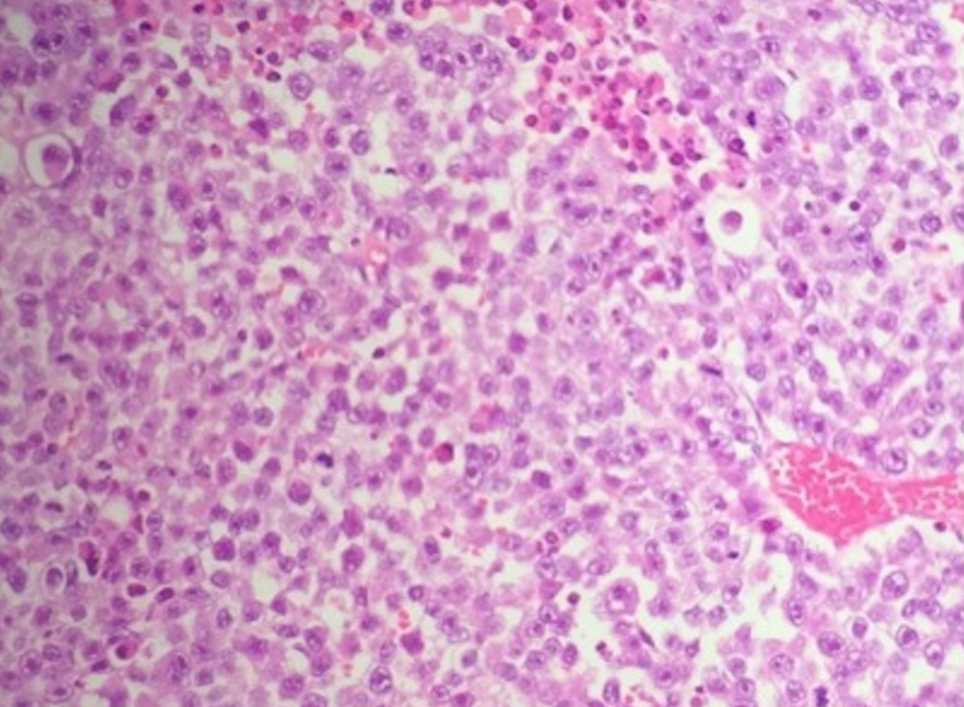
Figure 1 Sheets of seminoma cells with vesicular nuclei containing prominent nucleoli (H and E × 100).

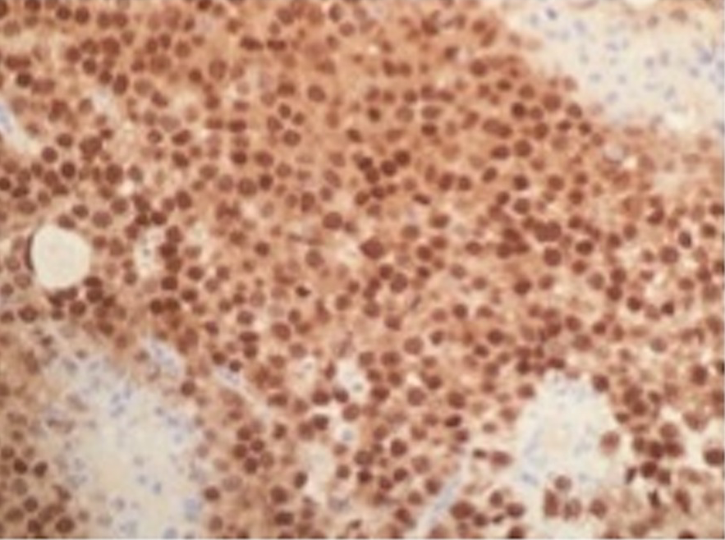
Figure 2 Oct-4 immunohistochemistry showing positive nuclear expression in tumour cells.

