Name of journal: World Journal of Gastroenterology
Manuscript NO: 31194
Manuscript type: ORIGINAL ARTICLE

Observational Study
Detection of metastatic cancer cells in mesentery of colorectal cancer patients

Luo XL et al. Metastasis V in CRC

Xue-Lai Luo, Da-Xing Xie, Jian-Xin Wu, An-Ding Wu, Zong-Qing Ge, Hai-Jie Li, Jun-Bo Hu, Zhi-Xin Cao, Jian-Ping Gong

Xue-Lai Luo, Da-Xing Xie, Jian-Xin Wu, An-Ding Wu, Zong-Qing Ge, Hai-Jie Li, Jun-Bo Hu, Zhi-Xin Cao, Jian-Ping Gong, Tongji Cancer Research Institute, Department of Gastrointestinal Surgery, Tongji Hospital, Tongji Medical College in Huazhong University of Science and Technology, Wuhan 430030, Hubei Province, China

Author contributions: Luo XL and Xie DX contributed equally to this work; Gong JP contributed to study conception and design; Luo XL, Wu JX, Wu AD and Ge ZQ contributed to data acquisition, data analysis and interpretation, Luo XL and Xie DX contributed to writing the article; Li HJ, Hu JB and Cao ZX, contributed to editing, reviewing the article; all authors have reviewed the manuscript.

Supported by National Natural Science Foundation of China, No. 81572861, No. 81302309 and No. 81372324.

Institutional review board statement: All procedures performed in studies were in accordance with the ethical standards of Tongji Hospital Ethics Committee.

Informed consent statement: Informed consent was obtained from all individual participants included in the study.

Conflict-of-interest statement: The authors declare that they have no conflict of interest.

Data sharing statement: No additional data are available.

Open-Access: This article is an open-access article which was selected by an in-house editor and fully peer-reviewed by external reviewers. It is distributed in accordance with the Creative Commons Attribution Non Commercial (CC BY-NC 4.0) license, which permits others to distribute, remix, adapt, build upon this work non-commercially, and license their derivative works on different terms, provided the original work is properly cited and the use is non-commercial. See: http://creativecommons.org/licenses/by-nc/4.0/

Manuscript source: Unsolicited manuscript

Correspondence to: Jian-ping Gong, MD, PhD, Tongji Cancer Research Institute, Department of Gastrointestinal Surgery, Tongji Hospital, Tongji Medical College in Huazhong University of Science and Technology, 1095 Jiefang Av., Wuhan 430030, Hubei Province, China. jpgong@tjh.tjmu.edu.cn
Telephone: +86-27-83665275
Fax: +86-27-83662696

Received: November 2, 2016
Peer-review started: November 4, 2016
First decision: January 19, 2017
Revised: March 21, 2017
Accepted: May 19, 2017
Article in press:
Published online:
Abstract
AIM
To detect the existence of isolated cancer cells in the mesentery of colorectal (named as Metastasis V), and investigate its clinical significance in colorectal cancer patients.

METHODS
Sixty-three colorectal cancer patients who received radical excision between January 2012 and September 2015 were included. All the patients received laparoscopy-assisted radical colorectomy or proctectomy (with CME or TME) with R0 dissections at the Department of Gastrointestinal Surgery, Tongji Hospital, Tongji Medical College in Huazhong University of Science and Technology. The location and size of the primary lesions were recorded immediately after the tumor was removed, with the surrounding mesenterium completely separated along the intestinal wall. Each dissected mesentery sample was analyzed for hematoxylin-eosin staining and immunohistochemistry by using cytokeratin 19 antibody. Image Pro Plus Software 6.0 (Media Cybernetics, CA, United States) was used to semi-quantitatively measure the concentration of the cytokeratin 19 immunohistochemistry. The correlation of metastasis found in mesentery with clinicopathological characteristics was examined. The prognosis of patients was also evaluated by preoperative serum CEA level.

RESULTS
Metastasis V was detected in 14 of 63 (22.2%) colorectal cancer patients who received laparoscopy-assisted radical colorectomy or proctectomy (CME or TME) with R0 dissections in our hospital between January 2012 and September 2015. There was no significant difference of patients with Metastasis V in age, gender, tumor size, and tumor location (P > 0.05). Metastasis V was more likely to occur in poorly differentiated tumor (5/11; 45.5%) rather than moderately (8/46; 17.4%) and well differentiated one (1/6; 16.7%). The incidence of Metastasis V in N2 stage (9/14; 64.3%) was more frequent than in the N0 stage (3/35; 8.6%) or N1 stages (2/14; 14.3%). In addition, Metastasis V was positively related to the tumor invasive depth (T1:0/1, 0%; T2:1/12, 8.3%; T3:7/39, 17.9%; T4:6/11, 54.5%). Furthermore, preoperative serum CEA level in Metastasis V-positive patients was significantly higher than Metastasis V-negative patients (4.27 ng/ml vs 3.00 ng/ml).

CONCLUSION
Metastasis V might be associated with the poor prognosis of colorectal cancer patients.

Key words: Colorectal cancer; Radical surgery; Metastasis V; Colorectal mesentery; serum CEA level

© The Author(s) 2017. Published by Baishideng Publishing Group Inc. All rights reserved.

Core tip: Local–regional recurrence of colorectal cancer is common in patients who received R0 resection. Our previous study proposed a novel type of metastasis designated as “Metastasis V” in gastric cancer. Metastasis V is defined as the appearance of cancer cells in the mesentery in broad sense, and may be a risky factor for the poor prognosis after radical surgery. In this study, we demonstrated that Metastasis V was also detected in the mesentery of colorectum, and it might be associated with the poor prognosis of colorectal cancer.

Luo XL, Xie DX, , Wu JX, Wu AD, Ge ZQ, Li HJ, Hu JB, Cao ZX, Gong JP. Detection of metastatic cancer cells in mesentery of colorectal cancer patients. World J Gastroenterol 2017; In press

INTRODUCTION
Three decades ago, R.J. Heald introduced total mesorectal excision (TME) in the treatment of rectal cancer^{[1]}. Subsequently, complete mesocolic excision (CME) was popularized by W Hoehenbuerg to reduce tumor relapse and improve prognosis in colon cancer^{[2]}. These new approaches greatly contributed to the complete mesentery excisions and improved harvested lymph nodes. Furthermore, with the development of surgical technology, neo-adjuvant chemotherapy and efficient perioperative management, the prognosis of patients with colorectal cancer has been improved. However, local-regional recurrence of colorectal cancer is still often noted in those patients who received radical R0-resection with no lymphatic metastasis^{[3]}.
Direct invasion, lymphatic drainage, hematogenous spread and peritoneal dissemination are the four classical routes through which local-regional recurrence or distant implants of cancer cells can be determined. In addition to these pathways, people have also reported the existence of metastatic cancer cells in the mesentery of colorectum, and this type of metastasis was named as ‘extra-capsular spreads’ or ‘extra-nodal metastasis’^{[4-7]}. In our previous study, we proposed a novel type of tumor metastasis designated as Metastasis V in gastric cancer. Metastasis V is defined as the appearance of cancer cells in the mesogastrium with perigastric adipose tissue, and it may be a risk factor for patient survival after radical surgery^{[8]}. Here, in this study, we further determined whether metastasis V can be detected in the mesocolorectum, and examined its clinic significance.

MATERIALS AND METHODS
Patients, samples, and sectional tissue analysis
Sixty-three patients who underwent surgery for colorectal cancer at the Department of Gastrointestinal Surgery, Tongji Hospital, Tongji Medical College in Huazhong University of Science and Technology between January 2012 and September 2015 were included in this study. The patients consisted of twenty-five female patients and thirty-eight male patients. All of these patients received laparoscopy-assisted radical colorectomy or proctectomy (with CME or TME) with R0 dissections. All participants signed informed written consents in this research. This study was approved by the Tongji Hospital Ethics Committee.
Clinical samples of colorectal cancer were obtained from the resected colorectal tissue. The location and size of the primary lesions were recorded immediately after the tumor was removed, and then the mesenterium was completely separated from the intestinal wall along with the anterior edge. All specimens were fixed in 10% formaldehyde before processing. The lymph nodes were obtained from the mesenterium. Next, the mesentery was cut into strip-shape with a width of 2 cm in an outward-to-inward manner, vertical to the intestinal wall. The strip-shaped samples were cut into cube samples with a mean length of 2 cm. All of the small samples were numbered by numbers from inside (proximal end of the cancer) to outside (Figure 1). These samples were embedding in 10% formaldehyde. Demographic characteristics of the 63 patients were described in Table 1. The clinic-pathological stage was determined by the 7th edition of the AJCC Cancer Staging Manual.

Immunohistochemistry analysis of Metastasis V
Immunohistochemistry was performed using the cytokeratin 19 antibody. Cytokeratin 19 is specifically expressed in intestine epithelia cells and colorectal cancer (CRC) cells^{[9]}. Hence, it has been proven to be a highly sensitive marker for colorectal cancers.
Immunostaining was performed according to the standard streptavidin-biotin method. First, the slices were de-paraffinized and rehydrated. To retrieve antigenicity, the slices were boiled in 0.01 mol/l, pH 6.0 sodium citrate buffer for approximately 15 min. Endogenous peroxidase was restrained with 0.3% hydrogen peroxide for roughly 25 min. After blocking with 3% BSA for 30 min, the anti-cytokeratin 19 monoclonal antibody was now arranged in blocking buffers and the slices were incubated at 4 ℃ overnight. After being washed in pH 7.4 PBS 3 times (5 min each time), the corresponding secondary antibody, retained at room temperature for approximately 50 min and marked by HRP was added. After once more being washed with pH 7.4 PBS for 15 min, the chromogenic reagent DAB was added to the colorate. The slices were counterstained with Harris hematoxylin, dehydrated in a graded alcohol series (75% alcohol for 6 min, 85% alcohol for 6 minutes, absolute ethyl alcohol I for 6 min, and absolute ethyl alcohol II for 6 min), cleared in xylene for 5 min, and mounted. Individual tumor cells in mesenteries, separated from primary lesion and lymph nodes, were identified to be Metastasis V.

Immunohistochemistry image analysis
Image Pro Plus Software 6.0 (Media Cybernetics, CA, United States) was used to semi-quantitatively measure the concentration of the cytokeratin 19 immunohistochemistry. This procedure, was split into six steps: (1) discovering and surveying the section of interest; (2) adjusting of the optical densities; (3) obtaining, transforming and preserving images; (4) amending the background and background staining; (5) configuration of the section of interest to survey the optical density; and (6) surveying optical densities.

Statistical analysis
The Fisher’s exact test, χ² test, and Mann-Whitney U test were used to inspect the significance of the differences between the covariates. We considered a P-value of less than 0.05 statistically significant. Standard statistical analyses were executed by SPSS version 20.0.

RESULTS
Detection of Metastasis V in mesenterium of colorectal cancer patients
Metastasis V was detected in 14 out of the total 63 (22.2%) patients by immunohistochemistry (IHC) staining. These isolated cancer cells separating from the primary lesion and lymph nodes were observed in the same slice (Figure 2). In terms of “T” stage, only one case showed limited muscular layers invasion, seven cases had sub-serosa invaded, and the rest had penetrated the serosa. In these patients, there were three lymph node negative patients with different invasive depths (Table 2).

Correlation between Metastasis V and clinical factors
The demographic characteristics of patients and the pathologic features of tumors with Metastasis V were shown in Table 3. There was no significant difference in age, gender, tumor size, and tumor location (P > 0.05). Metastasis V was more likely to occur in poorly differentiated tumor (5/11; 45.5%) rather than moderately (8/46; 17.4%) and well differentiated one (1/6; 16.7%). The incidence of Metastasis V in N2 stage (9/14; 64.3%) was more frequent than in the N0 stage (3/35; 8.6%) or N1 stages (2/14; 14.3%). In addition, Metastasis V was positively related to the tumor invasive depth (T1:0/1, 0%; T2:1/12, 8.3%; T3:7/39, 17.9%; T4:6/11, 54.5%).

Correlation between Metastasis V and patients preoperative CEA levels
Previous studies have demonstrated the correlation between increased preoperative CEA and the poor prognosis of rectal cancer patients^{[10,11]}. Here, we further determined the correlation between Metastasis V and preoperative CEA levels of patients. Totally forty-two CRC patients who underwent operations in our department were retrospectively studied. Metastasis V was detected in nine patients according to the pathological reports. Six patients were excluded because their preoperative CEA data was missed. The CEA levels were divided into two grades. The CEA levels more than 3 times of normal range (15.00 ng/ml) were classified as high grade, while those less than that were designated as low grade. Our data indicated that preoperative serum CEA levels in Metastasis V-positive patients were significantly higher than Metastasis V-negative patients (4.27 ng/ml vs 3.00 ng/ml) (Table 4).

DISCUSSION
In this study, we have showed metastatic cancer cells can reside in the mesentery of the colorectum of CRC patient. These tumor cells show no directly attachment to the primary lesions, with no involvement of vessel-lymphatic drainage system, and are confined to the fatty tissues enveloped by the fascia proper (Figure 1). In our previous study, we proposed a novel type of tumor metastasis designated as Metastasis V in gastric cancer patients^{[8]}. Thus, we believe that Metastasis V could be detected in the mesenteries of both gastric and colorectal cancer patients. Similar to our previous studies, the incidence of Metastasis V was closely related to the tumor invasion of colorectal cancer patients, which was mainly detected in the T3 and T4 tumors (Table 2). Metastasis V was also correlated with lymphatic metastasis. Lymphatic nodes staging N1-N3 had larger percentages of Metastasis V than N0 (Table 2). Therefore, immunohistochemical analysis of Metastasis V in these patients is strongly recommended in clinical practice.
More interesting, the preoperative serum CEA levels in Metastasis V-positive patients were significantly higher than Metastasis V-negative patients (4.27 ng/ml vs 3.00 ng/ml) (Table 4). These data indicated that the prognosis of the patients with Metastasis V-positive tumors was worse than those with Metastasis V-negative tumors. Due to the limited number of patients in the current study, a larger sample of cohort patients should be enrolled for further analysis.
Little is known about the exact route or mechanism of Metastasis V. It was hypothesized that primary tumor lesions penetrates the intestinal wall, and then the cancer cells could probably scatter into the fatty tissues enveloped by proper fascia. In this way, Metastasis V occurs not only in CRC and gastric cancers, but also in oral head-neck, pancreas and papilla of vater tumors^{[12-20]}.
It has been well known in practice that radical surgery for cancers should include en bloc resections of the primary tumor and neighboring tissues. However, it is difficult to understand the exact boundaries of en bloc resection within gastrointestinal tumors. “TME” or “CME” can reduce the tumor recurrence and increase patient survival, however, the possible reason was still unknown. In our opinion, the mesenteries of colorectum enveloped by the proper fascia not only propose a precise boundary for resection, but also function as pathologic barriers of Metastasis V spreading. Thus, our findings are clinically significant because TME or CME should be the useful choice for surgical excision of Metastasis V. Further studies on the efficiency of Metastasis V excision through TME or CME will be investigated.

ACKNOWLEDGEMENTS
We thank Drs. Chao-ran Yu and Jie Shen for helpful discussion and paper revision work.

COMMENTS
Background
local-regional recurrence of colorectal cancer is still often noted in those patients who received radical R0-resection with no lymphatic metastasis.

Research frontiers
In addition to the classical four metastatic patterns, people have also reported the existence of metastatic cancer cells in the mesentery of colorectal, and this type of metastasis was named as ‘extra-capsular spreads’ or ‘extra-nodal metastasis’. Examination of the clinical and oncological significance of isolated tumor cells found in mesentery of colorectum in colorectal cancer patients is one of the main frontiers in surgical oncology.

Innovations and breakthrough
Metastasis V is defined as the appearance of cancer cells in the mesogastrium, and may be a risky factor for the poor prognosis after radical surgery. In this study, we demonstrated that Metastasis V was also detected in the mesentery of colorectum, and it might be associated with the poor prognosis of colorectal cancer.

Applications
It is clinically useful to be assisted in evaluation of prognosis of colorectal cancer patients.

Peer-review
In this paper, the authors well described an interesting study about isolated cancer cells in the mesentery of colorectum (named as Metastasis V). This is an interesting point, and the issue of metastasis in patients with colorectal cancer is of main importance.

REFERENCES
1 Heald RJ, Husband EM, Ryall RD. The mesorectum in rectal cancer surgery--the clue to pelvic recurrence? Br J Surg 1982; 69: 613-616 [PMID: 6751457 DOI: 10.1002/bjs.1800691019]
2 Hohenberger W, Weber K, Matzel K, Papadopoulos T, Merkel S. Standardized surgery for colonic cancer: complete mesocolic excision and central ligation--technical notes and outcome. Colorectal Dis 2009; 11: 354-64; discussion 364-5 [PMID: 19016817 DOI: 10.1111/j.1463-1318.2008.01735.x]
3 Bouvier AM, Launoy G, Bouvier V, Rollot F, Manfredi S, Faivre J, Cottet V, Jooste V. Incidence and patterns of late recurrences in colon cancer patients. Int J Cancer 2015; 137: 2133-2138 [PMID: 25912489 DOI: 10.1002/ijc.29578]
4 Myers JN, Greenberg JS, Mo V, Roberts D. Extracapsular spread. A significant predictor of treatment failure in patients with squamous cell carcinoma of the tongue. Cancer 2001; 92: 3030-3036 [PMID: 11753980 DOI: 10.1002/1097-0142(20011215)92:12<3030::AID-CNCR10148>3.0.CO;2-P]
5 Nakamura K, Ozaki N, Yamada T, Hata T, Sugimoto S, Hikino H, Kanazawa A, Tokuka A, Nagaoka S. Evaluation of prognostic significance in extracapsular spread of lymph node metastasis in patients with gastric cancer. Surgery 2005; 137: 511-517 [PMID: 15855922 DOI: 10.1016/j.surg.2005.01.007]
6 Etoh T, Sasako M, Ishikawa K, Katai H, Sano T, Shimoda T. Extranodal metastasis is an indicator of poor prognosis in patients with gastric carcinoma. Br J Surg 2006; 93: 369-373 [PMID: 16392106 DOI: 10.1002/bjs.5240]
7 Johnson JT, Barnes EL, Myers EN, Schramm VL, Borochovitz D, Sigler BA. The extracapsular spread of tumors in cervical node metastasis. Arch Otolaryngol 1981; 107: 725-729 [PMID: 7316852 DOI: 10.1001/archotol.1981.00790480001001]
8 Xie D, Osaiweran H, Liu L, Wang X, Yu C, Tong Y, Hu J, Gong J. Mesogastrium: a fifth route of metastasis in gastric cancer? Med Hypotheses 2013; 80: 498-500 [PMID: 23403142 DOI: 10.1016/j.mehy.2012.12.020]
9 Moll R, Franke WW, Schiller DL, Geiger B, Krepler R. The catalog of human cytokeratins: patterns of expression in normal epithelia, tumors and cultured cells. Cell 1982; 31: 11-24 [PMID: 6186379 DOI: 10.1016/0092-8674(82)90400-7]
10 Sisik A, Kaya M, Bas G, Basak F, Alimoglu O. CEA and CA 19-9 are still valuable markers for the prognosis of colorectal and gastric cancer patients. Asian Pac J Cancer Prev 2013; 14: 4289-4294 [PMID: 23991991 DOI: 10.7314/APJCP.2013.14.7.4289]
11 Basbug M, Arikanoglu Z, Bulbuller N, Cetinkaya Z, Aygen E, Akbulut S, Satici O. Prognostic value of preoperative CEA and CA 19-9 levels in patients with colorectal cancer. Hepatogastroenterology ; 58: 400-405 [PMID: 21661403]
12 Alvi A, Johnson JT. Extracapsular spread in the clinically negative neck (N0): implications and outcome. Otolaryngol Head Neck Surg 1996; 114: 65-70 [PMID: 8570253 DOI: 10.1016/S0194-5998(96)70285-1]
13 Woolgar JA, Rogers SN, Lowe D, Brown JS, Vaughan ED. Cervical lymph node metastasis in oral cancer: the importance of even microscopic extracapsular spread. Oral Oncol 2003; 39: 130-137 [PMID: 12509965 DOI: 10.1016/S1368-8375(02)00030-1]
14 Hirabayashi H, Koshii K, Uno K, Ohgaki H, Nakasone Y, Fujisawa T, Syouno N, Hinohara T, Hirabayashi K. Extracapsular spread of squamous cell carcinoma in neck lymph nodes: prognostic factor of laryngeal cancer. Laryngoscope 1991; 101: 502-506 [PMID: 2030629 DOI: 10.1288/00005537-199105000-00010]
15 Veronese N, Luchini C, Nottegar A, Kaneko T, Sergi G, Manzato E, Solmi M, Scarpa A. Prognostic impact of extra-nodal extension in thyroid cancer: A meta-analysis. J Surg Oncol 2015; 112: 828-833 [PMID: 26493240 DOI: 10.1002/jso.24070]
16 Luchini C, Wood LD, Cheng L, Nottegar A, Stubbs B, Solmi M, Capelli P, Pea A, Sergi G, Manzato E, Fassan M, Bagante F, Bollschweiler E, Giacopuzzi S, Kaneko T, de Manzoni G, Barbareschi M, Scarpa A, Veronese N. Extranodal extension of lymph node metastasis is a marker of poor prognosis in oesophageal cancer: a systematic review with meta-analysis. J Clin Pathol 2016; Epub ahead of print [PMID: 27387986 DOI: 10.1136/jclinpath-2016-203830]
17 Veronese N, Fassan M, Wood LD, Stubbs B, Solmi M, Capelli P, Pea A, Nottegar A, Sergi G, Manzato E, Carraro S, Maruzzo M, Cataldo I, Bagante F, Barbareschi M, Cheng L, Bencivenga M, de Manzoni G, Luchini C. Extranodal Extension of Nodal Metastases Is a Poor Prognostic Indicator in Gastric Cancer: a Systematic Review and Meta-analysis. J Gastrointest Surg 2016; 20: 1692-1698 [PMID: 27412320 DOI: 10.1007/s11605-016-3199-7]
18 Veronese N, Nottegar A, Pea A, Solmi M, Stubbs B, Capelli P, Sergi G, Manzato E, Fassan M, Wood LD, Scarpa A, Luchini C. Prognostic impact and implications of extracapsular lymph node involvement in colorectal cancer: a systematic review with meta-analysis. Ann Oncol 2016; 27: 42-48 [PMID: 26483050 DOI: 10.1093/annonc/mdv494]
19 Luchini C, Nottegar A, Pea A, Solmi M, Stubbs B, Capelli P, Sergi G, Manzato E, Fassan M, Wood LD, Scarpa A, Veronese N. Extranodal extension is an important prognostic parameter for both colonic and rectal cancer. Ann Oncol 2016; 27: 955-956 [PMID: 26802150 DOI: 10.1093/annonc/mdw034]
20 Luchini C, Veronese N, Pea A, Sergi G, Manzato E, Nottegar A, Solmi M, Capelli P, Scarpa A. Extranodal extension in N1-adenocarcinoma of the pancreas and papilla of Vater: a systematic review and meta-analysis of its prognostic significance. Eur J Gastroenterol Hepatol 2016; 28: 205-209 [PMID: 26566063]
P-Reviewer: Luchini C, Wittmann T S-Editor: Gong ZM
L-Editor: E-Editor:
Specialty type: Gastroenterology and hepatology
Country of origin: China
Peer-review report classification
Grade A (Excellent): 0
Grade B (Very good): B, B
Grade C (Good): 0
Grade D (Fair): 0
Grade E (Poor): 0

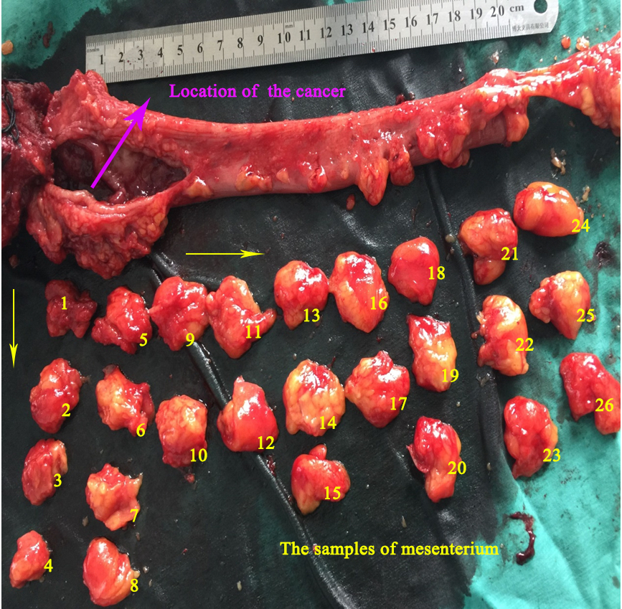
Figure 1 Obtaining samples of mesenterium from colorectal cancer patients. Large cross sectional tissue samples analysis of mesentery of colorectum from surgically resected specimens.

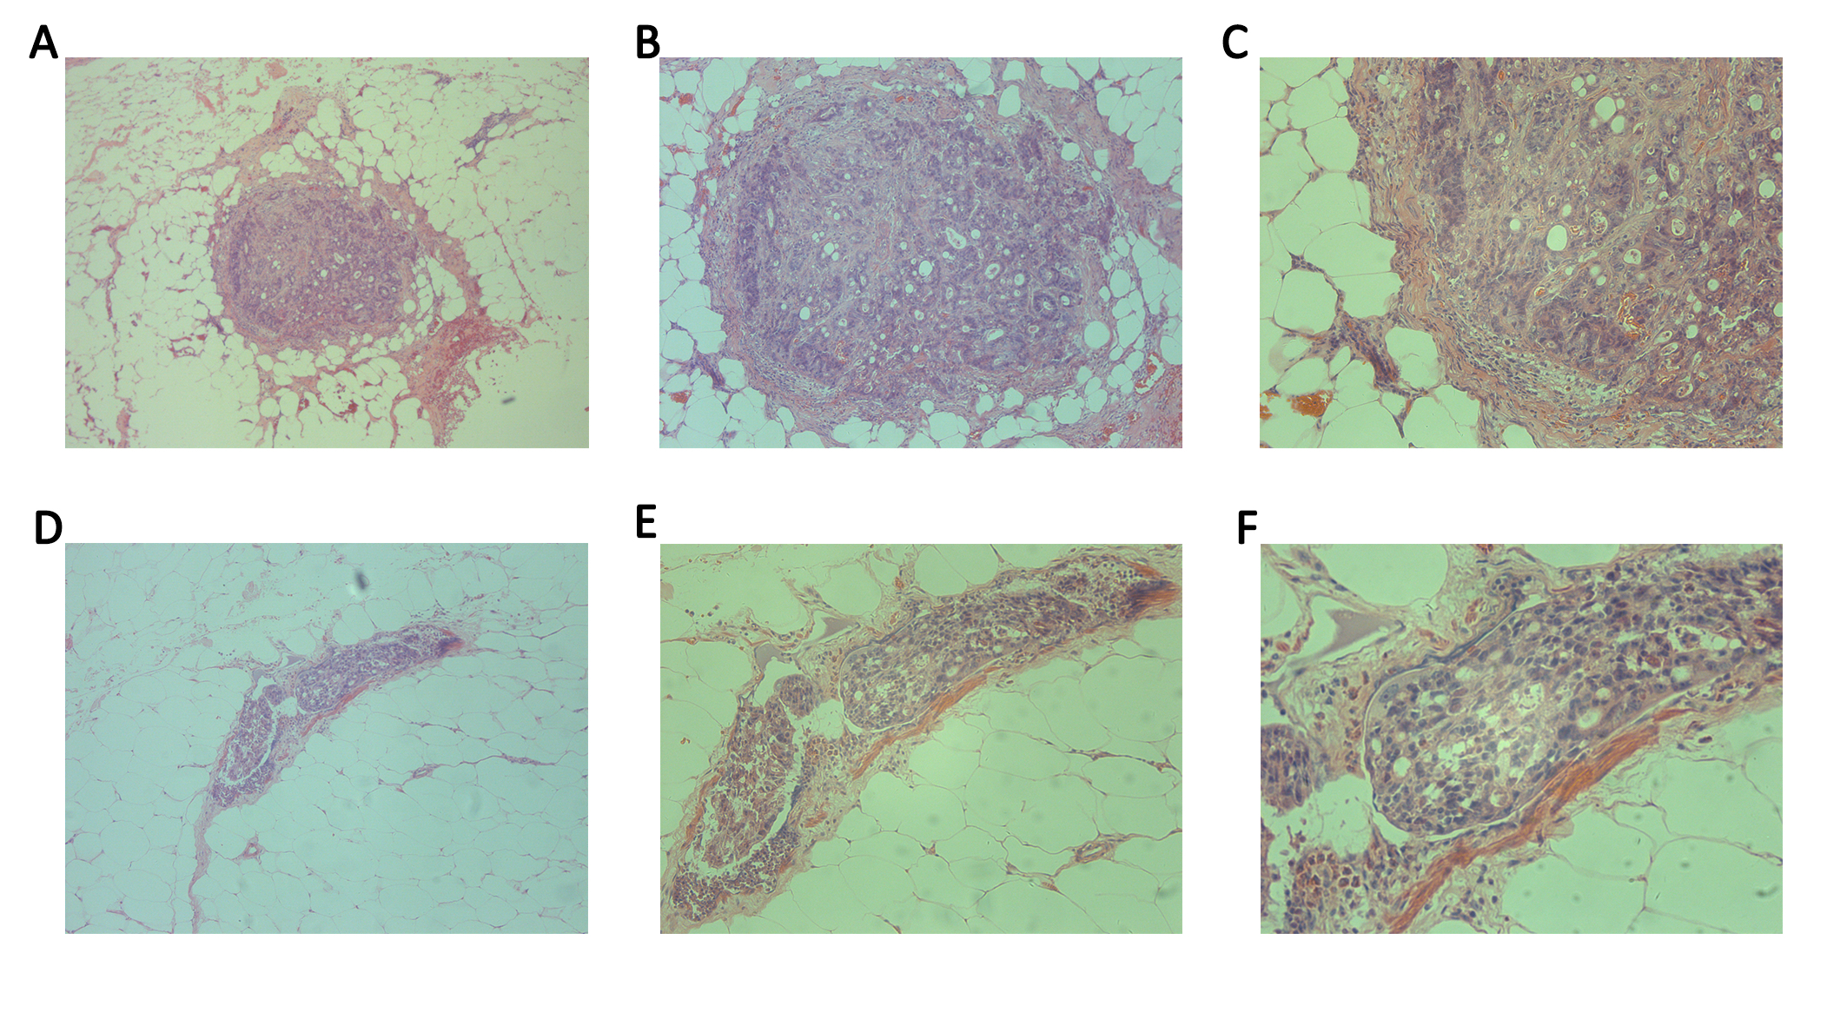
Figure 2 Detection of Metastasis V in colorectal cancer patients. Isolated cancer cells were detected in the mesentery of colorectal by HE staining. A (10 ×), B (20×) and C (40 ×) represent the same slide; D (10 ×), E (20 ×) and F (40 ×) represent the same slide.

Table 1 Data about 63 colorectal cancer patients
Parameters | Results
Gender
Female | 25
Male | 38
Age (yr, mean, range) | 55.5 ( 28-86 )
Location of cancer
Colon | 11
Rectum | 52
Differentiated grade
Well | 6
Moderately | 46
Poorly | 11
Affected lymph nodes
N0 | 35
N1 | 14
N2 | 14
Invasive depth
T1 | 1
T2 | 12
T3 | 39
T4 | 11

Table 2 Data about Metastasis V positive patients
Patients | Sex | Age/yr | Cancer size/cm | Cancer location | Differentiated grade | Invasive depth | Affected lymph nodes | TNM
1 | F | 37 | 2.5 | rectum | poorly | serosal | 8/15 | pT4N2M0
2 | F | 42 | 3 | rectum | Aoderately | subserosal | 5/17 | pT3N2M0
3 | M | 33 | 2 | Rectum | moderately | Serosal | 5/15 | pT4N2M0
4 | M | 48 | 6 | Sigmoid | Well | Serosal | 12/21 | pT4N2M0
5 | F | 63 | 3 | rectum | Poorly | Muscularis | 0/15 | pT2N2M0
6 | F | 45 | 3 | Rectum | Moderately | Serosal | 5/28 | pT4N2M0
7 | M | 58 | 3 | Rectum | Poorly | Subserosal | 8/12 | pT3N2M0
8 | M | 64 | 4 | Rectum | Poorly | Subserosal | 7/15 | pT3N2M1
9 | M | 54 | 6 | Rectum | Moderately | Subserosal | 2/13 | pT3N1M0
10 | F | 60 | 2 | descending colon | moderately | Subserosal | 0/17 | pT3NxM0
11 | M | 54 | 3 | Rectum | Moderately | Serosal | 5/12 | pT4N2M0
12 | M | 58 | 3 | Rectum | Moderately | Subserosal | 0/16 | pT3N0M0
13 | F | 57 | 3 | Rectum | Poorly | Serosal | 2/21 | pT4N1M1
14 | M | 47 | 4 | rectum | moderately | subserosal | 24/32 | pT3N2M0

Table 3 Comparison between Metastasis V positive patients and Metastasis V negative patients
Parameters | Metastasis V |  | P value
 | Negative | Positive
Age (yr) |  |  | NS
< 45 | 8 | 3
≥ 45 and ≤ 59 | 19 | 8
≥ 60 | 22 | 3
Cancer size (cm) |  |  | NS
≤ 3 | 24 | 10
> 3 and < 5 | 14 | 2
≥ 5 | 11 | 2
Gender |  |  | NS
Female | 19 | 6
Male | 30 | 8
Cancer location |  |  | NS
Colon | 9 | 2
Rectum | 40 | 12
Differentiated grade |  |  | NS
Well | 5 | 1
Moderately | 38 | 8
Poorly | 6 | 5
Affected lymph nodes |  |  | < 0.05
N0 | 32 | 3
N1 | 12 | 2
N2 | 5 | 9
Invasive depth |  |  | < 0.05
T1 | 1 | 0
T2 | 11 | 1
T3 | 32 | 7
T4 | 5 | 6

Table 4 Comparison preoperative CEA levels between Metastasis V positive and negative patients
Parameters | Metastasis V |  | P value
 | Negative | Positive
Median (ng/ml) | 3.00 | 4.27 | < 0.05
Grade |  |  | < 0.05
High (> 15.00 ng/ml) | 5 | 5
Low (≤ 15.00 ng/ml) | 73 | 16

