Name of Journal: World Journal of Clinical Cases
Manuscript NO: 59345
Manuscript Type: CASE REPORT

Progressive familial intrahepatic cholestasis — farnesoid X receptor deficiency due to NR1H4 mutation: A case report

Czubkowski P et al. Cholestasis due to FXR deficiency

Piotr Czubkowski, Richard J Thompson, Irena Jankowska, A S Knisely, Milton Finegold, Pamela Parsons, Joanna Cielecka-Kuszyk, Sandra Strautnieks, Joanna Pawłowska, Laura N Bull

Piotr Czubkowski, Irena Jankowska, Joanna Pawłowska, Department of Gastroenterology, Hepatology, Nutritional Disorders and Pediatrics, The Children’s Memorial Health Institute, Warsaw 04-730, Poland

Richard J Thompson, Sandra Strautnieks, Institute of Liver Studies, King's College London Hospital, London SE5 9RS, United Kingdom

A S Knisely, Institut für Pathologie, Medizinische Universität Graz, Graz 8010, Austria

Milton Finegold, Pamela Parsons, Department of Pathology and Immunology, Baylor College of Medicine, Houston, TX 77030, United States

Pamela Parsons, Texas Children’s Hospital, Houston, TX 77030, United States

Joanna Cielecka-Kuszyk, Department of Pathology, The Children’s Memorial Health Institute, Warsaw 04-730, Poland

Laura N Bull, Department of Medicine and Institute for Human Genetics, UCSF Liver Center Laboratory, University of California San Francisco, San Francisco, CA 94143, United States

Author contributions: All authors contributed significantly to the preparation of the manuscript; Czubkowski P, Bull LN, Thompson RJ, Knisely AS, Jankowska I and Pawłowska J contributed to conception and design of the case presentation, acquisition of data and case description; Bull LN, Strautnieks S and Thompson RJ contributed to genetic studies; Knisely AS, Finegold M, Parsons P and Cielecka-Kuszyk J contributed to histopathological assessment; Czubkowski P, Bull LN, Thompson RJ and Knisely AS contributed to drafting the article and making critical revisions related to the content of the manuscript; All authors have read and approve the final manuscript.

Supported by National Institutes of Health, No. R01DK094828; and National Human Genome Research Institute, No. UM1 HG006493 and No. U24 HG008956.

Corresponding author: Piotr Czubkowski, MD, PhD, Associate Professor, Department of Gastroenterology, Hepatology, Nutritional Disorders and Pediatrics, The Children’s Memorial Health Institute, Al. Dzieci Polskich 20, Warsaw 04-730, Poland. p.czubkowski@ipczd.pl

Received: October 17, 2020
Revised: December 16, 2020
Accepted: February 24, 2021
Published online: May 26, 2021

Abstract
BACKGROUND
Functioning farnesoid X receptor (FXR; encoded by NR1H4) is key to normal bile acid homeostasis. Biallelic mutations in NR1H4 are reported in a few children with intrahepatic cholestasis. We describe a boy with progressive familial intrahepatic cholestasis and homozygous mutation in NR1H4.

CASE SUMMARY
A boy had severe neonatal cholestasis with moderate hypercholanemia and persistently elevated alpha-fetoprotein. Despite medical treatment, coagulopathy was uncontrollable prompting liver transplantation at age 8 mo with incidental splenectomy. The patient experienced catch-up growth with good liver function and did not develop allograft steatosis. However, 1 year after transplant, he died from an acute infection, considered secondary to immunosuppression and asplenia. A homozygous protein-truncating mutation, c.547C > T, p.(Arg183Ter), was subsequently identified in NR1H4, and both parents were shown to be heterozygous carriers. Absence of FXR and of bile salt export pump expression was confirmed by immunostaining of explanted liver.

CONCLUSION
Severe cholestasis with persistently high alpha-fetoprotein and modest elevation of serum bile acid levels may suggest FXR deficiency. Some patients with FXR deficiency may not develop allograft steatosis and may respond well to liver transplantation.

Key Words: Neonatal cholestasis; Progressive familial intrahepatic cholestasis; Bile salt export pump; Liver transplantation; Alpha-fetoprotein; Case report

©The Author(s) 2021. Published by Baishideng Publishing Group Inc. All rights reserved.

Citation: Czubkowski P, Thompson RJ, Jankowska I, Knisely AS, Finegold M, Parsons P, Cielecka-Kuszyk J, Strautnieks S, Pawlowska J, Bull LN. Progressive familial intrahepatic cholestasis—farnesoid X receptor deficiency due to NR1H4 mutation: A case report. World J Clin Cases 2021; 9(15): 3631-3636
URL: https://www.wjgnet.com/2307-8960/full/v9/i15/3631.htm
DOI: https://dx.doi.org/10.12998/wjcc.v9.i15.3631

Core Tip: Despite the central role farnesoid X receptor (FXR) plays in bile acid metabolism, only a few children with cholestasis and biallelic FXR deficiency have been reported, and that only recently. Using banked DNA from patients without previous successful genetic diagnosis, we have identified a child with a homozygous mutation predicted to truncate FXR prematurely. We describe his disease course before and after liver transplantation, accompanied by immunohistochemical studies. This report adds meaningfully to the available information regarding disease course and outcomes in patients with severe FXR deficiency. It highlights biochemical findings that may be characteristic of FXR deficiency.
INTRODUCTION
A key function of the farnesoid X receptor (FXR) is maintenance of physiologic bile acid (BA) pool size. FXR activation by BA within terminal-ileum enterocytes triggers production of fibroblast growth factor 19, which in turn suppresses hepatocellular synthesis of BA. In addition, FXR protects against intrahepatocytic BA accumulation by increasing bile salt export pump (BSEP) expression and by suppressing both uptake of BA from plasma via Na⁺-taurocholate cotransporting polypeptide and synthesis of BA via sterol-27 hydroxylase^{[1]}.
NR1H4 encodes FXR. Biallelic mutation in NR1H4 is a rare cause of intrahepatic cholestasis. Eight such children have been reported, three of whom underwent liver transplantation (LT)^{[2-4]}. We describe a patient with FXR deficiency, due to biallelic mutation in NR1H4, who presented with neonatal cholestasis that progressed to end-stage liver disease successfully treated by LT.

CASE PRESENTATION
Chief complaints
Neonate presented with rapidly progressing cholestatic jaundice.

History of present illness
Jaundice was observed from the second postnatal day. Phototherapy was given. At age 5 wk, deepening jaundice and pale stools were noted. He was hospitalized at age 6 wk and transferred to Children’s Memorial Health Institute at age 7 wk.

History of past illness
The patient had an otherwise unremarkable medical history.

Personal and family history
A boy was born at term, weighing 4.1 kg (93rd percentile), to parents without known consanguinity. Pregnancy and spontaneous vaginal delivery were uncomplicated. A brother aged 5 years was healthy; however, two maternal uncles had died as neonates for unknown reasons.

Physical examination
At transfer, he was jaundiced but otherwise well [5.8 kg (77th percentile)]. Motor development was normal. Stools varied from pale to bright yellow. The liver and spleen were palpable, respectively 3 cm and 2 cm below the costal margin. A left iridial coloboma and a right inguinal hernia were found.

Laboratory examinations
Conjugated hyperbilirubinemia accompanied elevated serum transaminase activity (Table 1). Serum BA and alpha-fetoprotein (AFP) levels were elevated. Serum gamma-glutamyl transpeptidase activity was normal. Hypocoagulability did not respond to vitamin K. Persistent hypoglycemia required intravenous glucose. Investigation for metabolic disorders yielded no diagnosis.

Imaging examinations
A normal gallbladder and non-dilated bile ducts were visible on sonography; the left lobe of the liver was enlarged. Splenomegaly was confirmed. After 3 d of phenobarbital, hepatobiliary scintigraphy found decreased and patchy isotope uptake by the liver and substantially decreased, but detectable, excretion into the bowel. A type 2 atrial septal defect (assessed as clinically unimportant) and a butterfly vertebra were noted.

Further diagnostic work-up
Percutaneous liver-biopsy (age 9 wk) found moderate fibrosis, mild inflammation and ductular proliferation; immunostaining for BSEP was unavailable. At age 12 wk, open cholangiography was performed and found a normal biliary tree; wedge liver biopsy revealed changes like those seen previously.

FINAL DIAGNOSIS
Archived patient DNA underwent sequencing of a panel of cholestasis-associated genes (ATP8B1, ABCB11, ABCB4, TJP2, JAG1, NOTCH2, BAAT) with no diagnostic variants found. These results were confirmed when patient DNA then underwent whole-exome sequencing. However, homozygosity was found for c.547C > T, p.(Arg183Ter), a nonsense mutation in NR1H4. Sanger sequencing confirmed homozygosity for this variant in the patient and heterozygosity in each parent. Immunostaining revealed absence of BSEP (Figure 1B) and of nuclear marking for FXR (Figure 1C). Gamma-glutamyl transpeptidase expression was present but very abnormal (Figure 1D).

TREATMENT
Vitamin supplementation and ursodeoxycholic acid (20 mg/kg per d) were initiated. Icterus and hypercholanemia worsened and the patient required repeated intravenous vitamin K. At age 8 mo [8.4 kg (40th percentile)], uncontrollable coagulopathy prompted maternal-donor LT, with splenectomy due to substantial splenomegaly. Histopathologic evaluation revealed marked hepatocellular and canalicular cholestasis with steatosis and micronodular cirrhosis (Figure 1A). Dysplasia and malignancy were not found.

OUTCOME AND FOLLOW-UP
There were no surgical issues after LT. Immunosuppression included tacrolimus and corticosteroids, with trimethoprim/sulfamethoxazole prophylaxis. Vaccination against meningococcus infection was unavailable. His course after LT was unremarkable for 12 mo, apart from transaminitis (cytomegalovirus infection, resolved with ganciclovir). His weight recovered [75th percentile (age 19 mo) 11 mo after LT]. At age 20 mo, vomiting and fever required hospital admission elsewhere. He was assessed as in good condition, but within 12 h he died with disseminated intravascular coagulation and multiorgan failure. No micro-organisms were cultured. Necropsy found hemorrhagic adrenal necrosis. The liver was unremarkable. The heart contained a few foci of remote intramyocardial arterial thrombosis, with dystrophic mineralization.

DISCUSSION
The fundamental role of FXR in BA homeostasis is consistent with the severity of liver disease associated with its absence. Our patient had substantially impaired liver function from presentation at Children’s Memorial Health Institute onward (hypoglycemia; coagulopathy unresponsive to parenteral vitamin K). These disease manifestations overlap with those in the children in whom FXR deficiency was first reported^{[2]}. Coagulopathy is common in cholestasis. Initially, however, it usually responds to vitamin K. In FXR deficiency, vitamin K does not correct the clotting, which seems disproportionate to the severity of liver disease. This may reflect direct involvement of FXR in regulating-clotting factor production^{[5]}. Serum BA elevations in our patient and in one previously described FXR-deficient patient for whom serum BA were reported^{[2]} were modest compared with those in patients with similarly severe cholestasis and BSEP deficiency. This difference may reflect failure of FXR-mediated down-regulation of Na⁺-taurocholate cotransporting polypeptide in FXR deficiency, with consequent unabated hepatocellular uptake of BA^{[6]}.
High AFP levels are found in hepatocellular carcinoma and, during early infancy, in severe early-onset cholestasis. As seen in our patient and others, persistently elevated AFP values in the absence of hepatocellular carcinoma may be a feature of NR1H4 disease^{[2-4]}. This may complicate monitoring for hepatocellular carcinoma development.
Two siblings who underwent LT for FXR deficiency developed mild allograft steatosis, ascribed provisionally to disrupted ileal control of enterohepatic BA homeostasis^{[2]}. The third transplanted patient had stable graft function, and no steatosis in post-transplant liver biopsies in the first 2 years. Our patient had no allograft steatosis, good graft function and no evidence of gastrointestinal disease. These observations suggest heterogeneity in compensation for extrahepatic FXR deficiency. We consider our patient’s death (sepsis, adrenal haemorrhage; predisposed by immunosuppression and lack of spleen) to be independent of NR1H4 mutation.

CONCLUSION
FXR deficiency due to NR1H4 mutation is a rare cause of neonatal cholestasis. Severe cholestasis with persistently high AFP and modestly elevated serum BA levels may suggest FXR deficiency.

REFERENCES
1 Claudel T, Sturm E, Kuipers F, Staels B. The farnesoid X receptor: a novel drug target? Expert Opin Investig Drugs 2004; 13: 1135-1148 [PMID: 15330745 DOI: 10.1517/13543784.13.9.1135]
2 Gomez-Ospina N, Potter CJ, Xiao R, Manickam K, Kim MS, Kim KH, Shneider BL, Picarsic JL, Jacobson TA, Zhang J, He W, Liu P, Knisely AS, Finegold MJ, Muzny DM, Boerwinkle E, Lupski JR, Plon SE, Gibbs RA, Eng CM, Yang Y, Washington GC, Porteus MH, Berquist WE, Kambham N, Singh RJ, Xia F, Enns GM, Moore DD. Mutations in the nuclear bile acid receptor FXR cause progressive familial intrahepatic cholestasis. Nat Commun 2016; 7: 10713 [PMID: 26888176 DOI: 10.1038/ncomms10713]
3 Chen HL, Li HY, Wu JF, Wu SH, Chen HL, Yang YH, Hsu YH, Liou BY, Chang MH, Ni YH. Panel-Based Next-Generation Sequencing for the Diagnosis of Cholestatic Genetic Liver Diseases: Clinical Utility and Challenges. J Pediatr 2019; 205: 153-159.e6 [PMID: 30366773 DOI: 10.1016/j.jpeds.2018.09.028]
4 Himes RW, Mojarrad M, Eslahi A, Finegold MJ, Maroofian R, Moore DD. NR1H4-related Progressive Familial Intrahepatic Cholestasis 5: Further Evidence for Rapidly Progressive Liver Failure. J Pediatr Gastroenterol Nutr 2020; 70: e111-e113 [PMID: 32443034 DOI: 10.1097/MPG.0000000000002670]
5 Zhao A, Lew JL, Huang L, Yu J, Zhang T, Hrywna Y, Thompson JR, de Pedro N, Blevins RA, Peláez F, Wright SD, Cui J. Human kininogen gene is transactivated by the farnesoid X receptor. J Biol Chem 2003; 278: 28765-28770 [PMID: 12761213 DOI: 10.1074/jbc.M304568200]
6 Denson LA, Sturm E, Echevarria W, Zimmerman TL, Makishima M, Mangelsdorf DJ, Karpen SJ. The orphan nuclear receptor, shp, mediates bile acid-induced inhibition of the rat bile acid transporter, ntcp. Gastroenterology 2001; 121: 140-147 [PMID: 11438503 DOI: 10.1053/gast.2001.25503]

Footnotes
Informed consent statement: Parental consent was obtained for hospitalizations and all the procedures described in the manuscript.

Conflict-of-interest statement: Dr. Thompson consults for Albireo, Mirum, GenerationBio, Alnylam, Qing Bile, Horizon, Sana, and Retrophin and has share options in Qing Bile and GenerationBio. Other authors report no conflicts of interest.

CARE Checklist (2016) statement: The authors have read the CARE Checklist (2016) and the manuscript was prepared and revised according to the CARE Checklist (2016).

Open-Access: This article is an open-access article that was selected by an in-house editor and fully peer-reviewed by external reviewers. It is distributed in accordance with the Creative Commons Attribution NonCommercial (CC BY-NC 4.0) license, which permits others to distribute, remix, adapt, build upon this work non-commercially, and license their derivative works on different terms, provided the original work is properly cited and the use is non-commercial. See: http://creativecommons.org/Licenses/by-nc/4.0/

Manuscript source: Unsolicited manuscript

Corresponding Author's Membership in Professional Societies: Polish Society of Gastroenterology.

Peer-review started: October 17, 2020
First decision: November 3, 2020
Article in press: February 24, 2021

Specialty type: Medicine, research and experimental
Country/Territory of origin: Poland
Peer-review report’s scientific quality classification
Grade A (Excellent): 0
Grade B (Very good): 0
Grade C (Good): C, C
Grade D (Fair): 0
Grade E (Poor): 0

P-Reviewer: Mrzljak A S-Editor: Gao CC L-Editor: Filipodia P-Editor: Li JH

Figure Legends
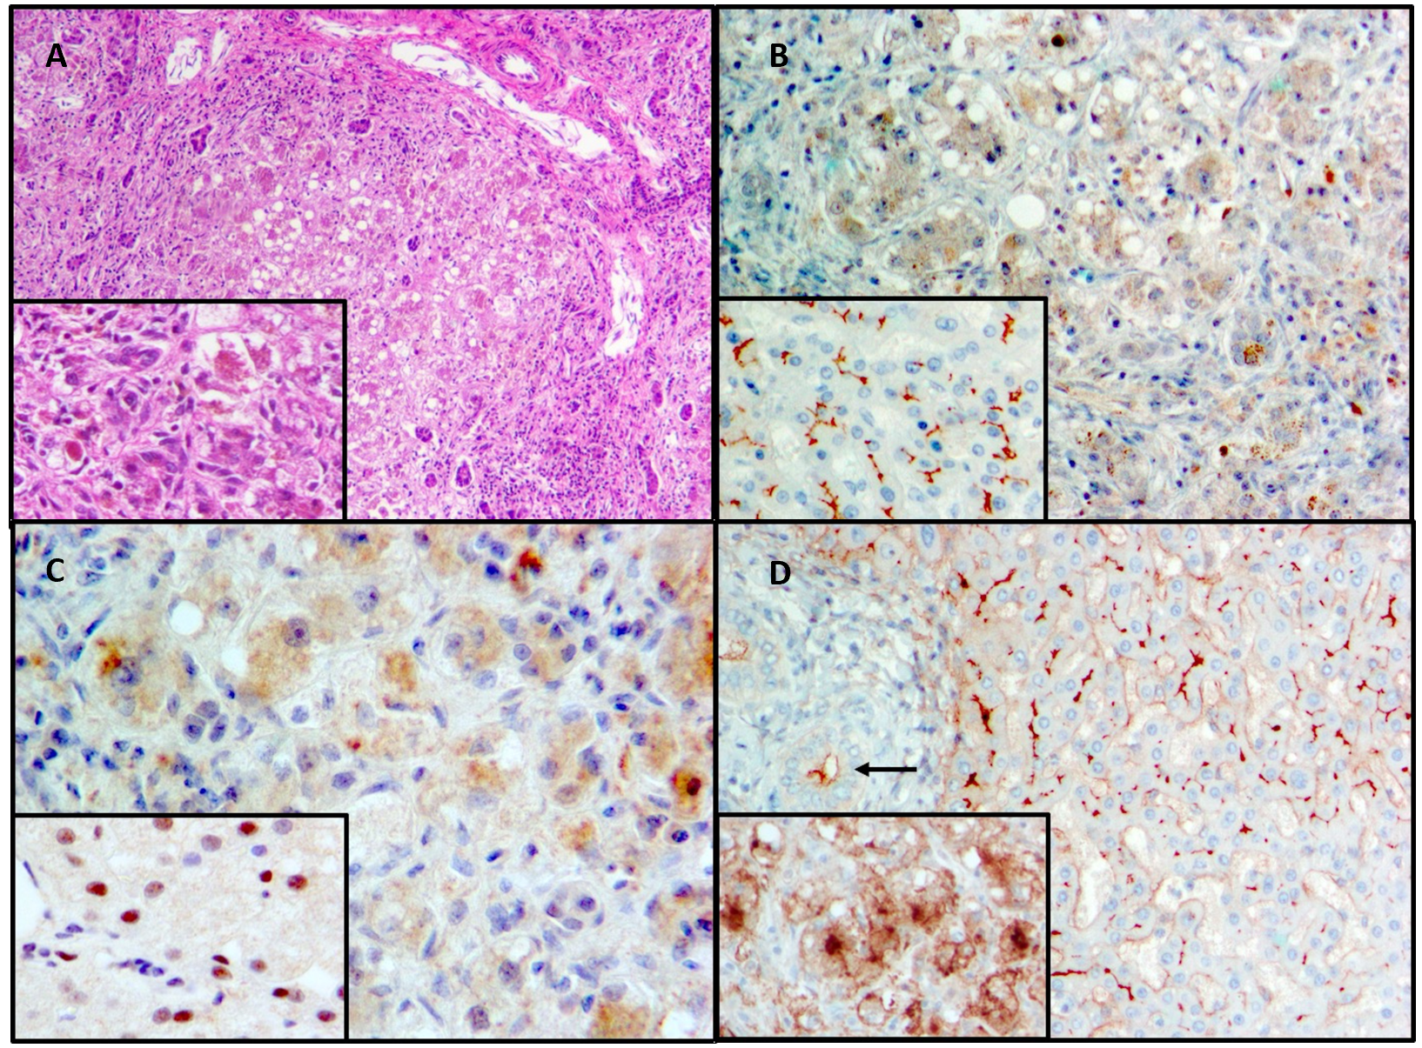
Figure 1 Histopathologic findings, explanted liver and controls. A: Fibrosis and nodularity with steatosis and substantial lobular disarray, explanted liver. Pronounced cholestasis spares portal tracts. Hematoxylin & eosin; main image 100 ×, inset 200 × original magnifications; B: Bile salt export pump expression in normal liver (“control”) and explanted liver. No expression in explanted liver (main image); the pigment seen is bile. Control (inset), crisp expression along an unremarkable bile-canaliculus network. Anti-bile salt export pump antibody (Santa Cruz Biotechnology, Dallas, TX, United States; sc-74500)/hematoxylin; both main image and inset 200 × original magnifications; C: Farnesoid X receptor expression in normal liver (“control”) and explanted liver. No expression in explanted liver (main image); the pigment seen is bile. Control (inset), nuclear expression evident in most hepatocytes. Anti-farnesoid X receptor antibody (Santa Cruz Biotechnology; sc-25309)/hematoxylin; both main image and inset 400 × original magnifications; D: Gamma-glutamyl transpeptidase expression in normal liver (“control”) and explanted liver. Control (main image), crisp expression at apices of cholangiocytes (arrow) and along an unremarkable bile-canaliculus network, with faint perisinusoidal staining. Explanted liver (inset), blurred marking at severely distorted canalicular network with pronounced cytoplasmic and basolateral staining, abnormalities that reflect the extent of hepatocellular injury and disarray. Anti-gamma-glutamyl transpeptidase 1 (Abnova, Taipei, Taiwan; H00002678-M01)/hematoxylin; both main image and inset 200 × original magnifications.
Table 1 Summary of laboratory data
Serum analyte | Reference range | Age 7 wk (presentation) | Age 22 wk (before liver transplantation)
Hematocrit (%) | 33.0-39.0 | 29.2 | 29.6
Hemoglobin (g/dL) | 10.5-13.5 | 10.1 | 10.1
White-cell count (per mm³) | 6.0-17.5 | 9.1 | 11.4
Platelet count (per mm³) | 150-400 | 184 | 154
Total bilirubin (mg/dL) | 0.0-1.0 | 9.4 | 23.8
Direct bilirubin (mg/dL) | 0.0-0.4 | 7.3 | 14.0
ALT (U/L) | 10-55 | 170 | 224
AST (U/L) | 10-55 | 260 | 456
GGT (U/L) | 10-80 | 35 | 41
Alkaline phosphatase (U/L) | 15-350 | 331 | 356
Bile acids (μmol/L) | 0-11 | 69 | 157
Cholesterol (mg/dL) | 80-170 | 228 | 220
Triglycerides (mg/dL) | 50-150 | 136 | 137
Creatine kinase (U/L) | 60-400 | 30
Activated partial-thromboplastin time (s) | 21-33 | 49 | 59
Prothrombin time (s) | 10-13 | 17 | 20
International normalized ratio | < 1.2 | 1.50 | 2.03
D-dimer | < 500 | 138 | 274
Fibrinogen | 150-400 | 200 | 174
Factor V (%) | 70-140 | 70.4 | -
Factor VII (%) | 70-120 | 36.9 | -
Ammonia (μg/dL) | 12-48 | 178 | 243
Glucose (mg%) | 70-110 | 55 | 30
Creatinine (mg/dL) | 0.3-1.0 | 0.2 | 0.2
Protein (g/L) | 60-83 | 45 | 55
Albumin (g/L) | 33-50 | 25 | 34
Globulin (g/L) | 26-41 | 7 | 14
Immunoglobulin G (mg/dL) | 231-1411 | 713 | -
Immunoglobulin A (mg/dL) | 0-83 | 21 | -
Immunoglobulin M (mg/dL) | 0-145 | 79 | -
¹Alpha-fetoprotein (IU/mL) |  | 358000 | 230000
Vitamin A (ng/mL) | 200-800 | 165 | -
Vitamin E (μg/mL) | 3.8-16.0 | 8.4 | -
25OHD₃ (ng/mL) | 11-54 | 26 | -
¹Alpha-fetoprotein normal values according to age: Premature 95000-175000; term newborn 13000-83000; 2 wk-1 mo 20-19000; 3 mo 10-180; 8 mo 0-10.
ALT: Alanine aminotransferase; AST: Aspartate aminotransferase; GGT: Gamma-glutamyl transpeptidase.

Published by Baishideng Publishing Group Inc
7041 Koll Center Parkway, Suite 160, Pleasanton, CA 94566, USA
Telephone: +1-925-3991568
E-mail: bpgoffice@wjgnet.com
Help Desk: https://www.f6publishing.com/helpdesk
https://www.wjgnet.com

© 2021 Baishideng Publishing Group Inc. All rights reserved.

