Name of journal: World Journal of Gastroenterology
Manuscript NO: 33523
Manuscript Type: ORIGINAL ARTICLE

Basic Study
Hepatoprotective effects of Foeniculum vulgare root barks extract on carbon tetrachloride induced-hepatic fibrosis in mice

Zhang C et al. Hepatoprotective effects of Foeniculum vulgare root barks extract

Cai Zhang, Xing Tian, Ke Zhang, Guo-Yu Li, Hang-Yu Wang, Jin-Hui Wang

Cai Zhang, Xing Tian, Ke Zhang, Guo-Yu Li, Hang-Yu Wang, Jin-Hui Wang, School of Pharmacy, Shihezi University, Shihezi 832002, Xinjiang Uygur Autonomous Region China

Author contributions: Zhang C performed the majority of experiments; Tian X made contributions to data interpretation, and wrote the manuscript; Zhang K participated in the establishment of the animal model; Li GY, Wang HY performed data analysis; Wang JH designed the study and revised the manuscript.

Supported by National Key Technology R&D Program, No.2012BAI30B02.

Institutional review board statement: All experiments were reviewed and approved by the Institute Ethnics Committee of Shihezi University and the methods were carried out in accordance with the Animal Management Rules of the Chinese Ministry of Health.

Institutional animal care and use committee statement: The protocol on animal was approved by the Institute Ethnics Committee of Shihezi University.

Conflict-of-interest statement: No potential conflicts of interest relevant to this article were reported.

Data sharing statement: No additional data are available.

Open-Access: This article is an open-access article which was selected by an in-house editor and fully peer-reviewed by external reviewers. It is distributed in accordance with the Creative Commons Attribution Non Commercial (CC BY-NC 4.0) license, which permits others to distribute, remix, adapt, build upon this work non-commercially, and license their derivative works on different terms, provided the original work is properly cited and the use is non-commercial. See: http://creativecommons.org/licenses/by-nc/4.0/

Manuscript source: Unsolicited manuscript

Correspondence to: Xing Tian, PhD, Department of Pharmacy, Shihezi University, Shihezi 832002, Xinjiang Uygur Autonomous Region, China. tianxing2017@shzu.edu.cn

Telephone: +86-993-2310715

Received: February 13, 2017
Peer-review started: February 14, 2017
First decision: April 7, 2017
Revised: May 14, 2017
Accepted: June 9, 2017
Article in press:
Published online:

Abstract
AIM
To investigate hepatoprotective effects of Foeniculum vulgare root barks (FVRBs), a traditional Uyghur medicine, on carbon tetrachloride (CCl₄)-induced hepatic fibrosis in mice.

METHODS
Except for nomal group, the rest group mice were induced by intraperitoneal injection (i.p.) of 0.1% CCl₄-olive oil mixture 10 mL/kg twice a week to build liver fibrosis model. After 4 wk, mice were treated concurrently with the 70% ethanol extract of FVRBs (88 mg/kg, 176 mg/kg, 352 mg/kg and 704 mg/kg, respectively) daily by oral gavage for 4 wk to evaluate its protective effects. Serum aspartate aminotransferase (AST), alanine aminotransferase (ALT), triglyceride (TG), hexadecenoic acid (HA), laminin (LN), glutathione (GSH), superoxide dismutase (SOD), and malondialdehyde (MDA) in liver tissues were measured, respectively. Hematoxylin-eosin (H&E) staining and masson trichrome (MT) examination were performed to assess histopathological changes in the livers. The expression of transforming growth factor β₁ (TGF-β₁), matrix metalloprotein 9 (MMP-9) and metallopeptidase inhibitor 1 (TIMP-1) was observed by immunohistochemical analysis. Additionally, TGF-β₁ and alpha smooth muscle actin (α-SMA) proteins were measured by western blotting.

RESULTS
Significant reduction in serum levels of AST, ALT, TG, HA and LN were observed in the FVRBs treated groups, suggesting that the FVRBs displayed hepatoprotective effects. Also, the depletion of GSH, SOD, and MDA accumulation in liver tissues was suppressed by FVRBs. The expression of TGF-β₁, MMP-9 and TIMP-1 determined by immunohistology was markedly reduced in a dose-dependent manner by FVRBs treatment. Furthermore, protective effects of FVRBs against CCl₄-induced liver injuries were confirmed by histopathological studies. Protein expression of TGF-β₁ and α-SMA was decreased by western blot.

CONCLUSION
Our results indicate that FVRBs may be a promising agent against hepatic fibrosis and its possible mechanisms are inhibiting formation of lipid peroxidation and collagen in liver tissue of liver fibrosis mice.

Key words: Carbon tetrachloride; Hepatic fibrosis; Foeniculum vulgare root barks; Histopathology; TGF-β1

© The Author(s) 2017. Published by Baishideng Publishing Group Inc. All rights reserved.

Core tip: Hepatic fibrosis is a wound-healing pathological process resulted from chronic hepatic injuries. In the present study, hepatoprotective effects of Foeniculum vulgare root barks (FVRBs), a traditional Uyghur medicine, on carbon tetrachloride (CCl₄)-induced hepatic fibrosis in mice was investigated. FVRBs reduced serum levels of aspartate aminotransferase, alanine aminotransferase, triglyceride, hexadecenoic acid and laminin. Further, FVRBs inhibited CCl₄-induced TGF-β₁, MMP-9, TIMP-1 expressions and histopathological changes. Our study indicated that the protective effects of FVRBs are through inhibiting formation of lipid peroxidation and collagen in liver tissue of liver fibrosis mice.

Zhang C, Tian X, Zhang K, Li GY, Wang HY, Wang JH. Hepatoprotective effects of Foeniculum vulgare root barks extract on carbon tetrachloride induced-hepatic fibrosis in mice. World J Gastroenterol 2017; In press

INTRODUCTION
Hepatic fibrosis is a wound-healing pathological process resulted from chronic hepatic injuries characterized by the accumulation of extracellular matrix (ECM)^{[1]}. It occurs during most continuous and chronic liver diseases, driven by inflammatory responses to injury tissues, which ultimately lead to liver cirrhosis. Previous studies indicated that activation of hepatic stellate cells (HSCs) plays an important role in the progress of hepatic fibrosis^{[2,3]}. Activation of HSCs increase cell proliferation, producing large amounts of ECM components including hexadecenoic acid (HA) and laminin (LN)^{[4,5]}. In addition, aberrant activity of transforming growth factor β₁ (TGF-β₁) or members of the platelet derived growth factor family are also the most prominent drivers to activate and transdifferent HSCs into myofibroblast^{[6,7]}. Further, several chemokines that modulate the inflammatory reaction are involved in the progression of HSC activation and the fibrotic insult^{[8,9]}. In response to liver injury, lots of research has demonstrated that the reversion of fibrosis can be carried out，particularly in the early course of the disease. Currently, treatment of liver damage is mainly consists of inhibiting HSCs early activation, proliferation, and collagen fiber growth, promoting HSCs apoptosis and collagen degradation.
Many studies indicated that Foeniculum vulgare root barks (FVRBs), a traditional Uyghur medicine, contain the following chemical constituents, such as saccharides, glycosides, lactone compounds, phenols, tannins, flavonoids, alkaloids, volatile oil, grease, triterpenes and sterols and so on^{[10,11]}. In addition, FVRBs has been traditionally used for the treatment of several pathophysiological states in China, such as dispel cold, warm kidney and stomach, dampness, swelling and pain^{[12-15]}. For the first time, the present study was aimed to investigate the protective role of FVRBs on CCl₄ induced liver injury in vivo and its possible mechanisms.

MATERIALS AND METHODS
Animal
Kunming male mice weighing between 20 ± 2 g were supplied by the Experimental Animal Center of Urumqi (Urumqi, China). Mice were housed at the room temperature under a 12 h light/dark cycle (lights on at 08: 00 h) and were fed a standard diet ad libitum. All animal care and experimental procedures were approved by the Institute Ethnics Committee of Shihezi University.

Drug material
FVRBs were obtained from Uygur pharmaceutical company (Uygur, China). FVRBs were extracted with 70% ethanol by heating reflux method, and steam drying. A voucher specimen (No. 20070820) has been deposited in School of Pharmacy, Shihezi University.

Reagent
CCl₄ were obtained from Tianjin Guangfu science and Technology Development Co. (Tianjin, China). Yiganling pian (batch number 150102044) containing 38.5 mg Silybum marianum each piece were purchased from Shanxi Li jun Chinese Medicine Co. (Shanxi, China). Alanine aminotransferase (ALT) assay kit, Aspartate aminotransferase (AST) determination kit, Triglycerid reagent kit, Malondialdehyde (MDA) assay kit, Reduced glutathione hormone (GSH) determination kit, and Superoxide dismutase (SOD) determination kit were all purchased from Nanjing Jiancheng (Nanjing, China). Hyaluronic acid (HA) and laminin (LN) enzyme-linked immunosorbent analysis kit were obtained from Xitang Co. (Shanghai, China). Rabbit primary antibody against TGF beta 1 (TGF-β₁), alpha smooth muscle actin (α-SMA), matrix metalloprotein 9 (MMP-9), metallopeptidase inhibitor 1 (TIMP-1), and horseradish peroxidase labeled second antibody were purchased from BOSTER (Wuhan, China).

Experimental protocol
Mice were randomly divided into eight groups of twenty animals each (n = 20). The normal group was allowed free access to water and food. In the seven experimental groups, the mice were treated with CCl₄ (10 mL/kg, i.p.) in olive oil (1:1000, v/v), twice in a week for eight weeks. Group b was served as solvent control and mice were given olive oil at 10 mL/kg at the fifth week. Group c was model group which was performed by i.p. 10 mL/kg CCl₄ and olive oil (1:1000 v/v) mixture and mice were given water at 10 mL/kg at the fifth week. Group d, e, f, g was orally administered with FVRBS (88 mg/kg, 176 mg/kg, 352 mg/kg and 704 mg/kg, respectively) once daily at the fifth week and lasted for four weeks. Group h was positive control group and treated with Yiganling pian (200 mg/kg).
Mice were anesthetized with ethyl ether and blood samples were harvested. The blood was centrifuged at 3500 rpm for 10 min under 4℃ to obtain the supernatant serum and stored at 80℃until they were used in biochemical analysis. Liver, spleen and kidney were dissected out and washed immediately with ice cold saline to weight.

Biochemical analysis
Serum was collected as mentioned above. ALT, AST and TG were determined according to the manufacturer’s protocol using a Microplate Reader Thermo 3001. The observation absorbance of ALT and AST reaction were read at 505 nm and the observation absorbance of TG reaction was read at 546 nm. The enzyme activity was calculated as U/L. HA and LN levels were determined by the enzyme-linked immunosorbent assay method using the commercial kits. The absorbance of the reaction was read at 450 nm.

Measurement of MDA, GSH and SOD activities
Liver tissues samples were homogenized in physiological saline to give a 10% (w/v) liver homogenate and then centrifuged at 2500 rpm for 15 min at 4 ℃. The supernatant was used for the measurement of MDA, GSH and SOD activities by the commercial kits following the manufacture’s protocol. Data were expressed as U/mg of protein.

Histopathological evaluation
Liver specimens were fixed in 10% formalin, and then embedded in paraffin. Four-micrometer-thick sections were obtained from paraffin blocks and stained with hematoxylin and eosin (H&E) and Masson’s trichrome (MT) before they were examined under light microscope. The images were randomly taken from ten fields under light microscopy by 200× magnification.

Immunohistological analysis
TGF-β₁, MMP-9, and TIMP-1 expression levels in the liver were measured by immunohistochemistry. The liver tissues were sectioned and incubated with rabbit anti-TGF-β₁ antibody (1:100), rabbit anti-MMP-9 antibody (1:100), and rabbit anti-TIMP-1 antibody (1:100). Then the slides were processed using a DAB colouration immunohistochemical staining kit. Further, the slides were counterstained with hematoxylin and covered with a glycerin gel. In the negative control groups, the primary antibodies were replaced with PBS. The sections were observed under the microscope (Nikon 80i).

Western blotting analysis
The total protein was extracted from the liver tissue and the protein concentration was determination by BCA method. The protein was separated by using SDS-polyacrylamide gel electrophoresis, followed by transferred to PVDF membrane. The membranes were blocked with 5% nonfat milk in TBST buffer for 1 h. Then target proteins were incubated overnight at 4 ℃ with TGF-β₁ and a-SMA primary antibodies (1:1000). After washing 4 times with TBST, the membranes were incubated with HRP-conjugated secondary antibody (1:10000) for 1 h at room temperature. Then the membranes were immersed in an enhanced chemiluminescence detection solution. Protein was analyzed by the gray value of the band, which was expressed by the ratio of the target protein and the β-actin protein.

Statistical analysis
All quantitative data were expressed as mean ± S.E. Data were analyzed with SPSS 13.0 software. Statistical significance between groups was determined by one-way analysis of variance (ANOVA) followed by Tukey’s multiple range post hoc test. P < 0.05 was considered as statistically significant.

RESULTS
Effects of FVRBs on organ index increases induced by CCl₄ treatment
As demonstrated in Fig. 1, organ index including liver, spleen and kidney coefficients were measured in mice. Similar to previous studies^{[16]}, liver and spleen index were significantly increased in mice treated with CCl₄. Compared with the model group, the increase of liver index and spleen index in CCl₄-treated group were reduced by FVRBs and Yiganling pian treatment. However, there were no significant differences in the kidney coefficient between the groups.

Effects of FVRBs on serum AST, ALT and TG activities in mice
As shown in Figure 2, CCl₄ treatment markedly elevated serum AST, ALT and TG activities as compared with the normal group. The AST and ALT activities after CCl₄ treatment were about 5 and 4 times higher than that of normal group, respectively. However, Yiganling pian treatment markedly inhibited the increase of serum AST, ALT and TG after long-term CCl₄ injection in mice (P < 0.05; Figure 2). Similarly, the administration of FVRBs at different dosage significantly decreased AST, and ALT and TG activity (P < 0.05 or P < 0.01; Figure 2).

Effects of FVRBs on MDA, GSH and SOD levels in CCl₄-treated mice
Lipid peroxidation was evaluated by measuring MDA content in liver tissue. In CCl₄ treatment group, the content of MDA was elevated as compared with the normal group. The administration of FVRBs significantly decreased MDA content in a dose-dependent manner. Also, as compared with the normal group, CCl₄ treatment markedly decreased the GSH level and SOD activity in liver tissue. However, treatment with the extract of FVRBs (352 and 704 mg/kg) markedly recovered the CCl₄-induced GSH depletion (P < 0.01; Figure 3). In addition, FVRBs treatment (88, 176, 352 and 704 mg/kg) significantly restored the depletion in SOD activity in a dose-dependent manner (Figure 3). Similarly, Yiganling pian group (200 mg/kg) increased the GSH content and SOD activity as compared with the CCl₄ group (P < 0.01; Figure 3). Further, there was no significant difference in the level of MDA, GSH and SOD between the group of CCl₄ and solvent group.

Effects of FVRBs on serum HA and LN in mice
After CCl₄ administration, the levels of serum HA and LN were significantly increased as compared with that of control group (P < 0.05; Figure 4). Treatment with Yiganling pian (200 mg/kg) significantly decreased the levels of serum HA and LN (P < 0.05; Figure 4). Meanwhile, FVRBs treatment markedly decreased the elevation of serum HA and LN in a dose-dependent manner after long-term CCl₄ injection in mice (P < 0.05; Figure 4).

Effects of FVRBs on histopathological evaluation
As shown in Figure 5A, the liver sections of normal control group exhibited the normal cellular structure with well-preserved cytoplasm, prominent nucleolus and central vein. In contrast, the liver sections of CCl₄-treated group and solvent group exhibited significant pathological changes, such as fibrosis, ballooning degeneration, steatosis, disseminated macrovesicular and microvesicular (Figure 5C and 5B). There was focal necrosis as well as piecemeal necrosis and fibrosis of portal areas. However, the FVRBs and Yiganling pian treatment groups showed a few to milder degree of leukocytes infiltration and necrosis (Figure 5E, F, G, H). In addition, as compared to the normal control, the livers of mice treated with CCl₄ and solvent group exhibited extensive accumulation of connective tissue leading to the formation of continuous fibrotic septa, nodules of regeneration, and noticeable alterations in the central vein (Figure 6A, B and C). However, the FVRBs and Yiganling pian treatment groups significantly attenuated CCl₄-induced alterations (Figure 6E, F, G and H). The severe hepatic fibrosis was reduced by the treatment of FVRBs, which was in good correlation with the results of hepatic antioxidant enzyme activities and the serum aminotransferase activities.

Effects of FVRBs on immunohistochemistry analysis
As shown in Figure 7A, the expression of TGF-β₁ of normal control group was only observed in the portal area and central vein, relatively shallow, narrow range. In Figure 7B and C, the expression of TGF-β₁ in model group was mainly distributed in the portal area and central vein, with fibrous septa and brown granules wide distribution. However, the positive expressions of TGF-β₁ were significantly decreased in FVRBs treatment group (Figure 7D-G). The positive control group also showed a good reduction in the expression of TGF-β₁ (Figure 7H).
Immunohistochemical expression of MMP-9 protein was shown in Figure 8. Tinting in the cytoplasmic and membrane, the protein color was brown or brown granules. The overall color of the normal group was light blue, while the model group was significant difference. Compared with the model group, the positive expression in the treatment group was decreased, especially in the dose group of 704 mg/kg.
The results of TIMP-1 protein expressions were shown in Figure 9. In normal group, there are a few positive expression of TIMP-1 in peripheral blood vessels and bile duct wall of the portal area (Figure 9A). In the solvent group and the model group, the positive staining of TIMP-1 was distributed in the fiber spacing and the central vein, and the brown yellow was obviously visible (Figure 9B, 9C). Compared with the model group, the positive expression of the FVRBs treatment groups was markedly decreased (Figure 9 D-G). Further, there is a small amount of positive staining in Yiganling positive control group (Figure 9H).

Effect of FVRBs on TGF-β₁, α-SMA protein expression
As illustrated in Fig. 10, compared to the normal group, the expression of TGF-β₁ and a-SMA in CCl₄ treatment group was signiﬁcantly increased (P < 0.01). However, FVRBs treatment group markedly decreased TGF-β₁ and a-SMA ratio as compared with the CCl₄ treatment group (P < 0.05 or P < 0.01). Meanwhile, treatment with Yiganling pian positive group also signiﬁcantly attenuated TGF-β₁ and a-SMA ratio (P < 0.01).

DISCUSSION
Liver fibrosis is usually regarded as an outcome of chronic liver injury in the process of long-term wound healing^{[17-19]}. In the present study, CCl₄-induced toxic liver injury, the most commonly used model for hepatic fibrosis^{[20,21]}, has been performed. Simultaneously, we detected the levels of ALT, AST, TG, HA and LN that used to assess liver function and the degree of liver fibrosis. There are evidences that natural substances may have a protective role against CCl₄-induced liver injury^{[22,23]}. Considerable efforts have been made in the study of natural products with hepatoprotective activities^{[24,25]}. Our study has shown that CCl₄ caused significant increases in serum levels of ALT, AST, TG, HA and LN in mice. However, FVRBs treatment significantly attenuated these trends. Its hepatoprotective effect was further confirmed by histopathological observations, for FVRBs attenuated CCl₄ induced necro-inflammatory and fibrogenic effects.
There is growing evidence that oxidative stress contributes to the development of liver fibrosis by activating various signaling pathways involved in fibrogenesis^{[26,27]}. The tissue concentration of MDA, a product of lipid peroxidation during liver fibrogenesis was assayed. Also, the SOD and GSH activities were measured. In the present study, in the CCl₄-treated mice, the MDA level in liver tissue was elevated and the activities of SOD and GSH were decreased. However, reversal of these trends by FVRBs treatment suggests that FVRBs prevented the progression of liver fibrosis by inhibiting oxidative stress in the liver.
The histopathological studies are direct means for assessing the protective effect of FVRBs. HE and Masson results showed that FVRBs could reduce the liver necrosis, significantly inhibit collagen fiber hyperplasia, improve liver tissue structure and reduce fiber tissue. These results further confirmed that FVRBs dose-dependently decreased hepatic histopathological changes.
The activation of HSCs is the central link in the pathogenesis of liver fibrosis^{[28-30]}. In recent years, many studies found that TGF-β₁ is the strongest factor inducing fibrosis, and it is also an important factor to promote the activation of HSCs^{[28,31]}. Our result confirmed that administration of FVRBs reduced the expression of TGF-β₁ protein by immunohistochemistry and western blotting methods. Therefore, the anti-fibrotic effect of FVRBs may be mediated by its inhibition effect on TGF-β₁. In addition, α-SMA expression also increases generation and proliferation of chemotactic factors that capable of recruiting inflammatory cells^{[32,33]}. From the results we know that expression of α-SMA was enhanced by CCl₄ treatment, while the administration of FVRBs prevented the development of fibrosis maybe through the inhibition of α-SMA.
The essential pathological of liver fibrosis is the excessive accumulation of collagen and other extracellular matrix^{[34]}. Under normal circumstances, the synthesis and decomposition of collagen is balanced. Once the synthesis is over than decomposition, it will cause the accumulation of collagen in the liver, lead to format liver fibrosis^{[35]}. Matrix metalloproteinases (MMPs) can promote the degradation of extracellular matrix, which matched with the tissue inhibitors of metalloproteinase (TIMPs) to reduce liver fibrosis severity^{[36, 37]}. Among MMPs family, MMP-9 plays an essential role in fibrosis formation. Many studies have shown that MMP-9 is elevated in patients with liver fibrosis. TIMP-1 can inhibit MMP-9^{[38]}, preventing the degradation of ECM, thereby forming or promoting liver fibrosis. In the present study, the expression of MMP-9 and TIMP-1 protein have shown significant differences between CCl₄ and FVRBs treatment groups, which suggest that MMP-9 and TIMP-1 are related with the protective effects of FVRBs against the formation of hepatic stellate cells.
In conclusion, FVRBs dose-dependently ameliorated hepatic oxidative stress and suppressed inflammation in CCl₄-injured livers. And its mechanisms against liver fibrosis maybe related with inhibiting lipid peroxidation formation in liver tissue of liver fibrosis mice and inhibiting the collagen formation by suppressing protein expressions of TGF-β₁, α-SMA, MMP-9 and TIMP-1. Thus, FVRBs may have potential therapeutic utilities for protecting against liver fibrosis. Further experimental studies to determine the effective constituents of FVRBs are necessary.

COMMENTS
Background
Hepatic fibrosis is a wound-healing pathological process resulted from chronic hepatic injuries characterized by the accumulation of extracellular matrix. It occurs during most continuous and chronic liver diseases, driven by inflammatory responses to injury tissues, which ultimately lead to liver cirrhosis.
Research frontiers
Currently, treatment of liver damage is mainly consists of inhibiting hepatic stellate cells (HSCs) early activation, proliferation, and collagen fiber growth, promoting HSCs apoptosis and collagen degradation. In addition, Foeniculum vulgare root barks (FVRBs), a traditional Uyghur medicine, has been used for the treatment of several pathophysiological states in China, such as dispel cold, warm kidney and stomach, dampness, swelling and pain.

Innovations and breakthroughs
For the first time, the present study was aimed to investigate the protective role of FVRBs on CCl₄ induced liver injury in vivo. And its mechanisms against liver fibrosis maybe related with inhibiting lipid peroxidation formation in liver tissue of liver fibrosis mice and inhibiting the collagen formation by suppressing protein expressions of transforming growth factor β₁, alpha smooth muscle actin, matrix metalloprotein 9 and metallopeptidase inhibitor 1.

Applications
FVRBs dose-dependently ameliorated hepatic oxidative stress and suppressed inflammation in CCl₄-injured livers. Thus, FVRBs may have potential therapeutic utilities for protecting against liver fibrosis.

Terminology
Liver fibrosis is usually regarded as an outcome of chronic liver injury in the process of long-term wound healing.

Peer-review
The authors's aim was to investigate hepatoprotective effects of Foeniculum vulgare root barks on carbon tetrachloride-induced hepatic fibrosis in mice. The methods are appropriate, the results are moderate.
REFERENCES
1 Iwakiri Y, Shah V, Rockey DC. Vascular pathobiology in chronic liver disease and cirrhosis - current status and future directions. J Hepatol 2014; 61: 912-924 [PMID: 24911462 DOI: 10.1016/j.jhep.2014.05.047]
2 Tai CJ, Choong CY, Lin YC, Shi YC, Tai CJ. The anti-hepatic fibrosis activity of ergosterol depended on upregulation of PPARgamma in HSC-T6 cells. Food Funct 2016; 7: 1915-1923 [PMID: 27040153 DOI: 10.1039/c6fo00117c]
3 Zhao J, Tang N, Wu K, Dai W, Ye C, Shi J, Zhang J, Ning B, Zeng X, Lin Y. MiR-21 simultaneously regulates ERK1 signaling in HSC activation and hepatocyte EMT in hepatic fibrosis. PLoS One 2014; 9: e108005 [PMID: 25303175 DOI: 10.1371/journal.pone.0108005]
4 Mòdol T, Brice N, Ruiz de Galarreta M, García Garzón A, Iraburu MJ, Martínez-Irujo JJ, López-Zabalza MJ. Fibronectin peptides as potential regulators of hepatic fibrosis through apoptosis of hepatic stellate cells. J Cell Physiol 2015; 230: 546-553 [PMID: 24976518 DOI: 10.1002/jcp.24714]
5 Thomas RG, Moon MJ, Kim JH, Lee JH, Jeong YY. Effectiveness of Losartan-Loaded Hyaluronic Acid (HA) Micelles for the Reduction of Advanced Hepatic Fibrosis in C3H/HeN Mice Model. PLoS One 2015; 10: e0145512 [PMID: 26714035 DOI: 10.1371/journal.pone.0145512]
6 Peng J, Li X, Feng Q, Chen L, Xu L, Hu Y. Anti-fibrotic effect of Cordyceps sinensis polysaccharide: Inhibiting HSC activation, TGF-β1/Smad signalling, MMPs and TIMPs. Exp Biol Med (Maywood) 2013; 238: 668-677 [PMID: 23918878 DOI: 10.1177/1535370213480741]
7 He Y, Huang C, Sun X, Long XR, Lv XW, Li J. MicroRNA-146a modulates TGF-beta1-induced hepatic stellate cell proliferation by targeting SMAD4. Cell Signal 2012; 24: 1923-1930 [PMID: 22735812 DOI: 10.1016/j.cellsig.2012.06.003]
8 Wasmuth HE, Weiskirchen R. [Pathogenesis of liver fibrosis: modulation of stellate cells by chemokines]. Z Gastroenterol 2010; 48: 38-45 [PMID: 20072995 DOI: 10.1055/s-0028-1109933]
9 Wasmuth HE, Tacke F, Trautwein C. Chemokines in liver inflammation and fibrosis. Semin Liver Dis 2010; 30: 215-225 [PMID: 20665374 DOI: 10.1055/s-0030-1255351]
10 Parejo I, Jauregui O, Sánchez-Rabaneda F, Viladomat F, Bastida J, Codina C. Separation and characterization of phenolic compounds in fennel (Foeniculum vulgare) using liquid chromatography-negative electrospray ionization tandem mass spectrometry. J Agric Food Chem 2004; 52: 3679-3687 [PMID: 15186082 DOI: 10.1021/jf030813h]
11 Badgujar SB, Patel VV, Bandivdekar AH. Foeniculum vulgare Mill: a review of its botany, phytochemistry, pharmacology, contemporary application, and toxicology. Biomed Res Int 2014; 2014: 842674 [PMID: 25162032 DOI: 10.1155/2014/842674]
12 Tripathi P, Tripathi R, Patel RK, Pancholi SS. Investigation of antimutagenic potential of Foeniculum vulgare essential oil on cyclophosphamide induced genotoxicity and oxidative stress in mice. Drug Chem Toxicol 2013; 36: 35-41 [PMID: 22264205 DOI: 10.3109/01480545.2011.648328]
13 Berrington D, Lall N. Anticancer Activity of Certain Herbs and Spices on the Cervical Epithelial Carcinoma (HeLa) Cell Line. Evid Based Complement Alternat Med 2012; 2012: 564927 [PMID: 22649474 DOI: 10.1155/2012/564927]
14 Bogucka-Kocka A, Smolarz HD, Kocki J. Apoptotic activities of ethanol extracts from some Apiaceae on human leukaemia cell lines. Fitoterapia 2008; 79: 487-497 [PMID: 18672039 DOI: 10.1016/j.fitote.2008.07.002]
15 Singh B, Kale RK. Chemomodulatory action of Foeniculum vulgare (Fennel) on skin and forestomach papillomagenesis, enzymes associated with xenobiotic metabolism and antioxidant status in murine model system. Food Chem Toxicol 2008; 46: 3842-3850 [PMID: 18976688 DOI: 10.1016/j.fct.2008.10.008]
16 Tsai CF, Hsu YW, Chen WK, Chang WH, Yen CC, Ho YC, Lu FJ. Hepatoprotective effect of electrolyzed reduced water against carbon tetrachloride-induced liver damage in mice. Food Chem Toxicol 2009; 47: 2031-2036 [PMID: 19477216 DOI: 10.1016/j.fct.2009.05.021]
17 Elpek GÖ. Cellular and molecular mechanisms in the pathogenesis of liver fibrosis: An update. World J Gastroenterol 2014; 20: 7260-7276 [PMID: 24966597 DOI: 10.3748/wjg.v20.i23.7260]
18 Getachew Y, Cusimano FA, Gopal P, Reisman SA, Shay JW. The Synthetic Triterpenoid RTA 405 (CDDO-EA) Halts Progression of Liver Fibrosis and Reduces Hepatocellular Carcinoma Size Resulting in Increased Survival in an Experimental Model of Chronic Liver Injury. Toxicol Sci 2016; 149: 111-120 [PMID: 26443840 DOI: 10.1093/toxsci/kfv213]
19 Melino M, Gadd VL, Alexander KA, Beattie L, Lineburg KE, Martinez M, Teal B, Le Texier L, Irvine KM, Miller GC, Boyle GM, Hill GR, Clouston AD, Powell EE, MacDonald KP. Spatiotemporal Characterization of the Cellular and Molecular Contributors to Liver Fibrosis in a Murine Hepatotoxic-Injury Model. Am J Pathol 2016; 186: 524-538 [PMID: 26762581 DOI: 10.1016/j.ajpath.2015.10.029]
20 Huang SS, Chen DZ, Wu H, Chen RC, Du SJ, Dong JJ, Liang G, Xu LM, Wang XD, Yang YP, Yu ZP, Feng WK, Chen YP. Cannabinoid receptors are involved in the protective effect of a novel curcumin derivative C66 against CCl4-induced liver fibrosis. Eur J Pharmacol 2016; 779: 22-30 [PMID: 26945822 DOI: 10.1016/j.ejphar.2016.02.067]
21 Hafez MM, Hamed SS, El-Khadragy MF, Hassan ZK, Al Rejaie SS, Sayed-Ahmed MM, Al-Harbi NO, Al-Hosaini KA, Al-Harbi MM, Alhoshani AR, Al-Shabanah OA, Alsharari SD. Effect of ginseng extract on the TGF-β1 signaling pathway in CCl4-induced liver fibrosis in rats. BMC Complement Altern Med 2017; 17: 45 [PMID: 28086769 DOI: 10.1186/s12906-016-1507-0]
22 Sun Y, Jia L, Huang Z, Wang J, Lu J, Li J. Hepatoprotective effect against CCl4-induced acute liver damage in mice and High-performance liquid chromatography mass spectrometric method for analysis of the constituents of extract of Rubus crataegifolius. Nat Prod Res 2017; Epub ahead of print [PMID: 28322066 DOI: 10.1080/14786419.2017.1292264]
23 Pareek A, Godavarthi A, Issarani R, Nagori BP. Antioxidant and hepatoprotective activity of Fagonia schweinfurthii (Hadidi) Hadidi extract in carbon tetrachloride induced hepatotoxicity in HepG2 cell line and rats. J Ethnopharmacol 2013; 150: 973-981 [PMID: 24140589 DOI: 10.1016/j.jep.2013.09.048]
24 Vladimir-Knežević S, Cvijanović O, Blažeković B, Kindl M, Štefan MB, Domitrović R. Hepatoprotective effects of Micromeria croatica ethanolic extract against CCl4-induced liver injury in mice. BMC Complement Altern Med 2015; 15: 233 [PMID: 26174335 DOI: 10.1186/s12906-015-0763-8]
25 Wahid A, Hamed AN, Eltahir HM, Abouzied MM. Hepatoprotective activity of ethanolic extract of Salix subserrata against CCl4-induced chronic hepatotoxicity in rats. BMC Complement Altern Med 2016; 16: 263 [PMID: 27473536 DOI: 10.1186/s12906-016-1238-2]
26 Heeba GH, Mahmoud ME. Therapeutic potential of morin against liver fibrosis in rats: modulation of oxidative stress, cytokine production and nuclear factor kappa B. Environ Toxicol Pharmacol 2014; 37: 662-671 [PMID: 24583409 DOI: 10.1016/j.etap.2014.01.026]
27 Domitrović R, Jakovac H, Marchesi VV, Blažeković B. Resolution of liver fibrosis by isoquinoline alkaloid berberine in CCl₄-intoxicated mice is mediated by suppression of oxidative stress and upregulation of MMP-2 expression. J Med Food 2013; 16: 518-528 [PMID: 23734997 DOI: 10.1089/jmf.2012.0175]
28 He YH, Li Z, Ni MM, Zhang XY, Li MF, Meng XM, Huang C, Li J. Cryptolepine derivative-6h inhibits liver fibrosis in TGF-β1-induced HSC-T6 cells by targeting the Shh pathway. Can J Physiol Pharmacol 2016; 94: 987-995 [PMID: 27295431 DOI: 10.1139/cjpp-2016-0157]
29 Wang Q, Dai X, Yang W, Wang H, Zhao H, Yang F, Yang Y, Li J, Lv X. Caffeine protects against alcohol-induced liver fibrosis by dampening the cAMP/PKA/CREB pathway in rat hepatic stellate cells. Int Immunopharmacol 2015; 25: 340-352 [PMID: 25701503 DOI: 10.1016/j.intimp.2015.02.012]
30 Wu T, Chen JM, Xiao TG, Shu XB, Xu HC, Yang LL, Xing LJ, Zheng PY, Ji G. Qinggan Huoxue Recipe suppresses epithelial-to-mesenchymal transition in alcoholic liver fibrosis through TGF-β1/Smad signaling pathway. World J Gastroenterol 2016; 22: 4695-4706 [PMID: 27217701 DOI: 10.3748/wjg.v22.i19.4695]
31 Tang LX, He RH, Yang G, Tan JJ, Zhou L, Meng XM, Huang XR, Lan HY. Asiatic acid inhibits liver fibrosis by blocking TGF-beta/Smad signaling in vivo and in vitro. PLoS One 2012; 7: e31350 [PMID: 22363627 DOI: 10.1371/journal.pone.0031350]
32 Zhou DJ, Mu D, Jiang MD, Zheng SM, Zhang Y, He S, Weng M, Zeng WZ. Hepatoprotective effect of juglone on dimethylnitrosamine-induced liver fibrosis and its effect on hepatic antioxidant defence and the expression levels of α-SMA and collagen III. Mol Med Rep 2015; 12: 4095-4102 [PMID: 26126609 DOI: 10.3892/mmr.2015.3992]
33 Zakaria S, Youssef M, Moussa M, Akl M, El-Ahwany E, El-Raziky M, Mostafa O, Helmy AH, El-Hindawi A. Value of α-smooth muscle actin and glial fibrillary acidic protein in predicting early hepatic fibrosis in chronic hepatitis C virus infection. Arch Med Sci 2010; 6: 356-365 [PMID: 22371771 DOI: 10.5114/aoms.2010.14255]
34 Wu K, Huang R, Wu H, Liu Y, Yang C, Cao S, Hou X, Chen B, DaI J, Wu C. Collagen-binding vascular endothelial growth factor attenuates CCl4-induced liver fibrosis in mice. Mol Med Rep 2016; 14: 4680-4686 [PMID: 27748931 DOI: 10.3892/mmr.2016.5826]
35 Fuchs BC, Wang H, Yang Y, Wei L, Polasek M, Schühle DT, Lauwers GY, Parkar A, Sinskey AJ, Tanabe KK, Caravan P. Molecular MRI of collagen to diagnose and stage liver fibrosis. J Hepatol 2013; 59: 992-998 [PMID: 23838178 DOI: 10.1016/j.jhep.2013.06.026]
36 Cong M, Liu T, Wang P, Fan X, Yang A, Bai Y, Peng Z, Wu P, Tong X, Chen J, Li H, Cong R, Tang S, Wang B, Jia J, You H. Antifibrotic effects of a recombinant adeno-associated virus carrying small interfering RNA targeting TIMP-1 in rat liver fibrosis. Am J Pathol 2013; 182: 1607-1616 [PMID: 23474083 DOI: 10.1016/j.ajpath.2013.01.036]
37 Peng WH, Tien YC, Huang CY, Huang TH, Liao JC, Kuo CL, Lin YC. Fraxinus rhynchophylla ethanol extract attenuates carbon tetrachloride-induced liver fibrosis in rats via down-regulating the expressions of uPA, MMP-2, MMP-9 and TIMP-1. J Ethnopharmacol 2010; 127: 606-613 [PMID: 20035854 DOI: 10.1016/j.jep.2009.12.016]
38 Latronico T, Mascia C, Pati I, Zuccala P, Mengoni F, Marocco R, Tieghi T, Belvisi V, Lichtner M, Vullo V, Mastroianni CM, Liuzzi GM. Liver Fibrosis in HCV Monoinfected and HIV/HCV Coinfected Patients: Dysregulation of Matrix Metalloproteinases (MMPs) and Their Tissue Inhibitors TIMPs and Effect of HCV Protease Inhibitors. Int J Mol Sci 2016; 17: 455 [PMID: 27023536 DOI: 10.3390/ijms17040455]

P-Reviewer: Bacskay I, Lee HC S-Editor: Qi Y L-Editor: E-Editor:
Specialty type: Gastroenterology and hepatology
Country of origin: China
Peer-review report classification
Grade A (Excellent): A
Grade B (Very good): 0
Grade C (Good): C
Grade D (Fair): 0
Grade E (Poor): 0

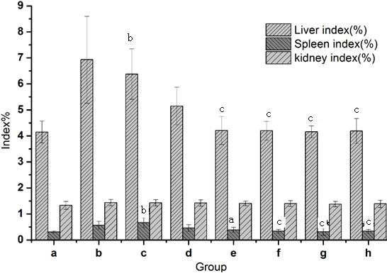
Figure 1 Effect of Foeniculum vulgare root barks organ index in hepatic fibrosis mice. Data is expressed as the mean ± SD (n = 20). ^{b}P < 0.01 vs the normal control group. ^{b}P < 0.05 vs the CCl₄-treated group. ^{c}P < 0.01 vs the CCl₄-treated group. a: Normal group; b: Solvent group + CCl₄; c: CCl₄-treated group; d, e, f and g: are FVRBs treatment group with 88 mg/kg, 176 mg/kg, 352 mg/kg, and 704 mg/kg, respectively; h: Yiganling pian + CCl₄.
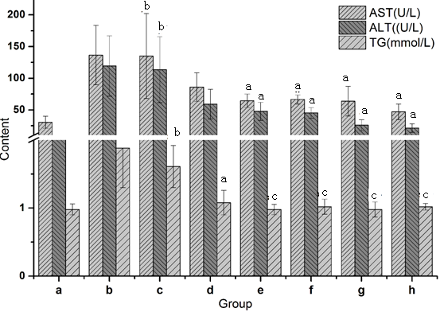
Figure 2 Effect of Foeniculum vulgare root barks on alanine aminotransferase, aspartate aminotransferase and triglyceride activities in CCl₄-treated mice. Data is expressed as the mean ± SD (n = 20). ^{b}P < 0.01 vs the normal control group. ^{b}P < 0.05 vs the CCl₄-treated group. ^{c}P < 0.01 vs the CCl₄-treated group. a: Normal group; b: Solvent group + CCl₄; c: CCl₄-treated group; d, e, f and g: are FVRBs treatment group with 88 mg/kg, 176 mg/kg, 352 mg/kg, and 704 mg/kg, respectively; h: Yiganling pian + CCl₄.

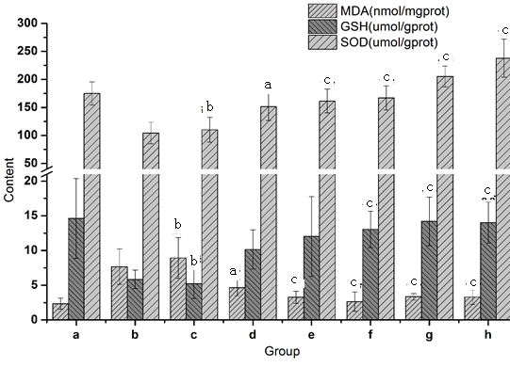
Figure 3 Effect of Foeniculum vulgare root barks on malondialdehyde, glutathione and superoxide dismutase levels in CCl₄-treated mice. Data is expressed as the mean ± SD (n = 20). ^{b}P < 0.01 vs the normal control group. ^{b}P < 0.05 vs the CCl₄-treated group. ^{c}P < 0.01 vs the CCl₄-treated group. a: Normal group; b: Solvent group + CCl₄; c: CCl₄-treated group; d, e, f and g: are FVRBs treatment group with 88 mg/kg, 176 mg/kg, 352 mg/kg, and 704 mg/kg, respectively; h: Yiganling pian + CCl₄.

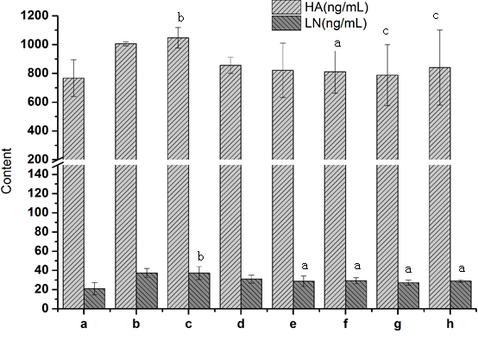
Figure 4 Effect of Foeniculum vulgare root barks on serum hexadecenoic acid, laminin levels in mice. Data is expressed as the mean ± SD (n = 20). ^{b}P < 0.01 vs the normal control group. ^{b}P < 0.05 vs the CCl₄-treated group. ^{c}P < 0.01 vs the CCl₄-treated group. a: Normal group; b: Solvent group + CCl₄; c: CCl₄-treated group; d, e, f and g: are Foeniculum vulgare root barks (FVRBs) treatment group with 88 mg/kg, 176 mg/kg, 352 mg/kg, and 704 mg/kg, respectively; h: Yiganling pian + CCl₄.

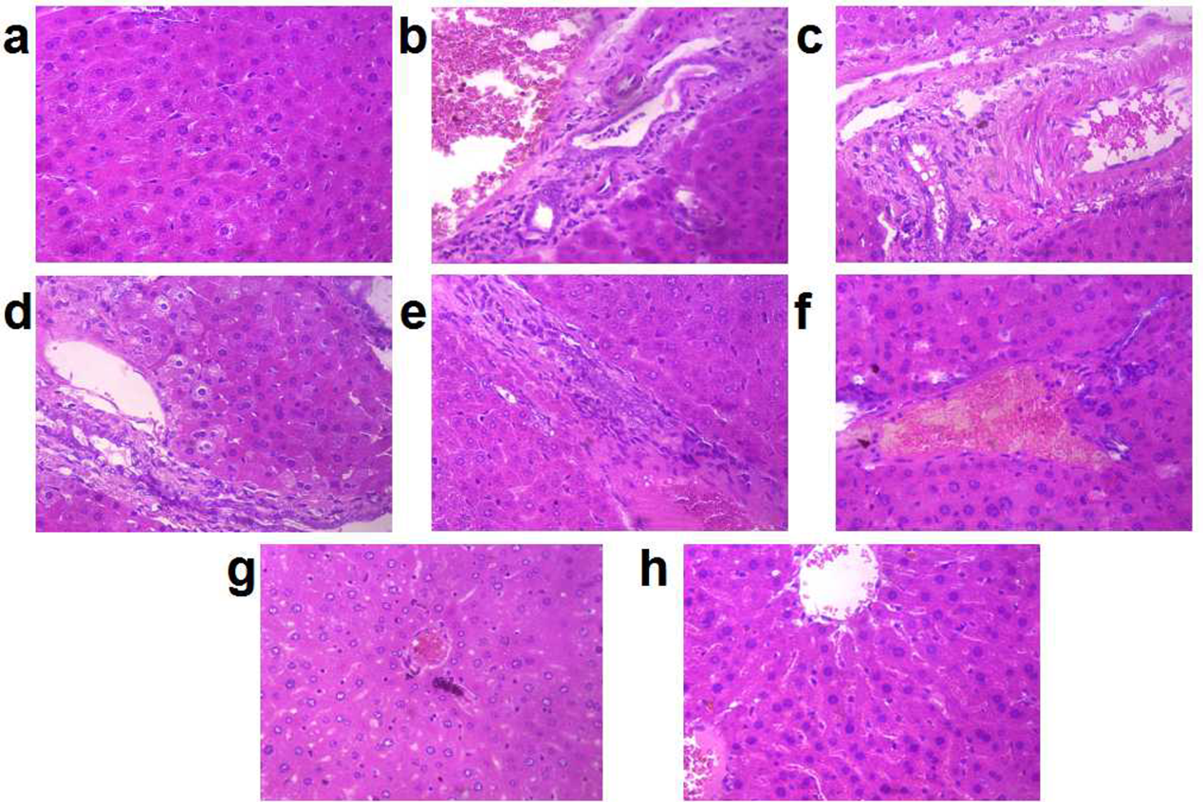
Figure 5 H&E (× 400) of the liver sections in mice. A: Normal group; B: Solvent group + CCl₄; C: CCl₄-treated group; D, E, F And G: are Foeniculum vulgare root barks (FVRBs) treatment group with 88 mg/kg, 176 mg/kg, 352 mg/kg, and 704 mg/kg, respectively; H: Yiganling pian + CCl₄.

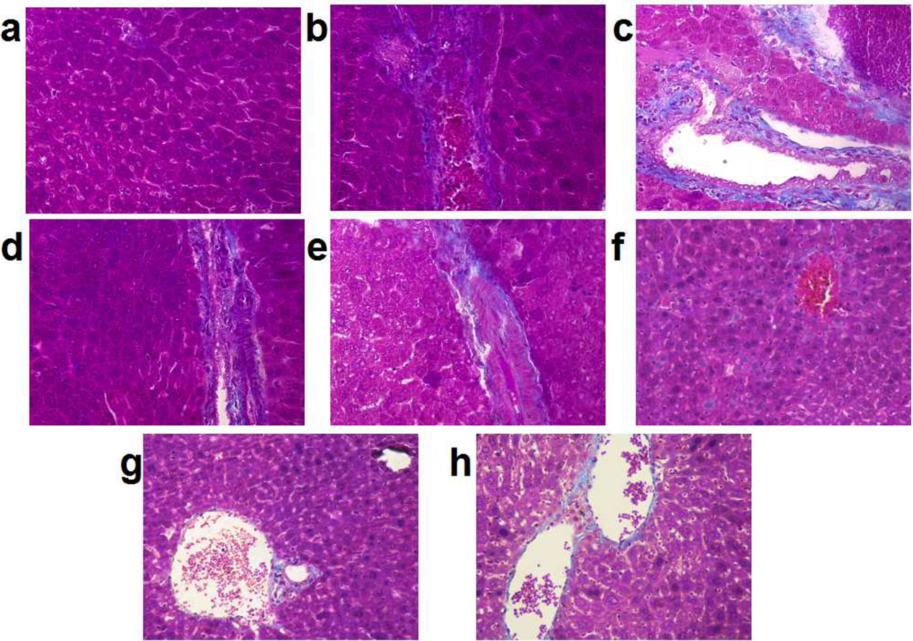
Figure 6 Masson trichrome examinations (× 400) of the liver sections in mice. A: Normal group; B: Solvent group + CCl₄; C: CCl₄-treated group; D, E, F and G: are FVRBs treatment group with 88 mg/kg, 176 mg/kg, 352 mg/kg, and 704 mg/kg, respectively; H: Yiganling pian + CCl₄.

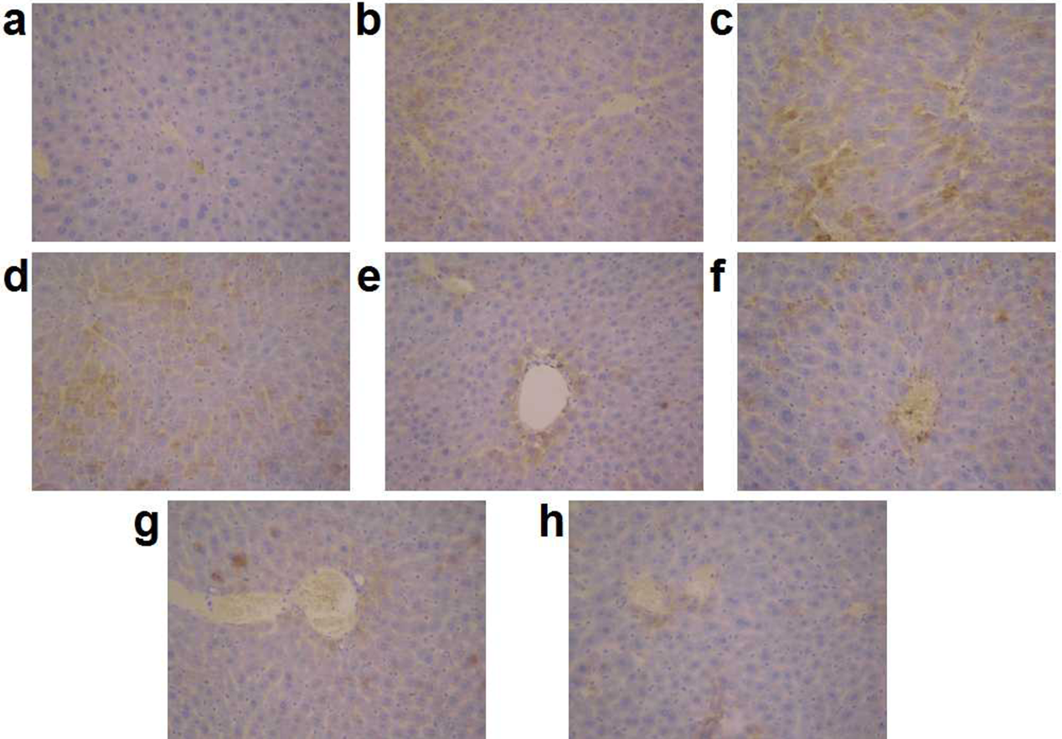
Figure 7 Immunohistochemical examination of transforming growth factor β1 positive cells (x400) of the liver sections in mice. A: Normal group; B: Solvent group + CCl₄; C: CCl₄-treated group; D, E, F and G: are Foeniculum vulgare root barks (FVRBs) treatment group with 88 mg/kg, 176 mg/kg, 352 mg/kg, and 704 mg/kg, respectively; H: Yiganling pian + CCl₄.

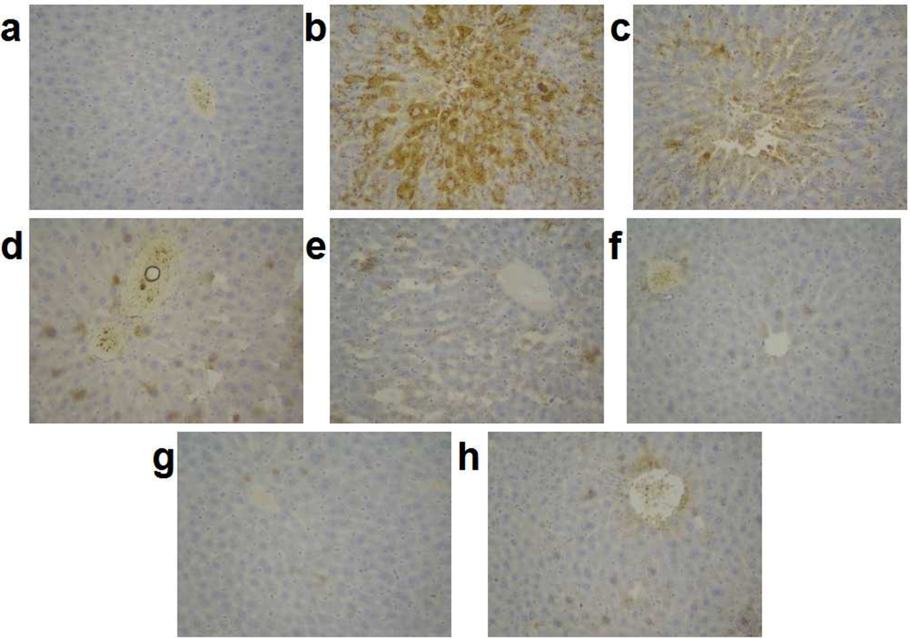
Figure 8 Immunohistochemical examination of matrix metalloprotein 9 positive cells (× 400) of the liver sections in mice. A: Normal group; B: Solvent group + CCl₄; C: CCl₄-treated group; D, E, F And G: are Foeniculum vulgare root barks (FVRBs) treatment group with 88 mg/kg, 176 mg/kg, 352 mg/kg, and 704 mg/kg, respectively; H: Yiganling pian + CCl₄.

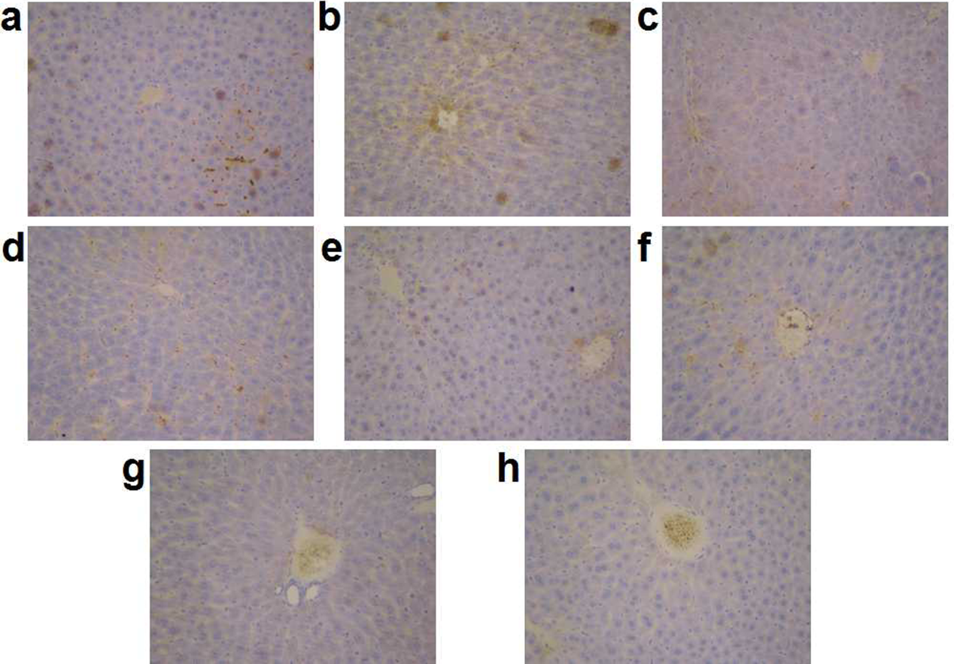
Figure 9 Immunohistochemical examination of metallopeptidase inhibitor 1 positive cells (× 400) of the liver sections in mice. A: Normal group; B: Solvent group + CCl₄; C: CCl₄-treated group; D, E, F And G: are Foeniculum vulgare root barks (FVRBs) treatment group with 88 mg/kg, 176 mg/kg, 352 mg/kg, and 704 mg/kg, respectively; H: Yiganling pian + CCl₄.

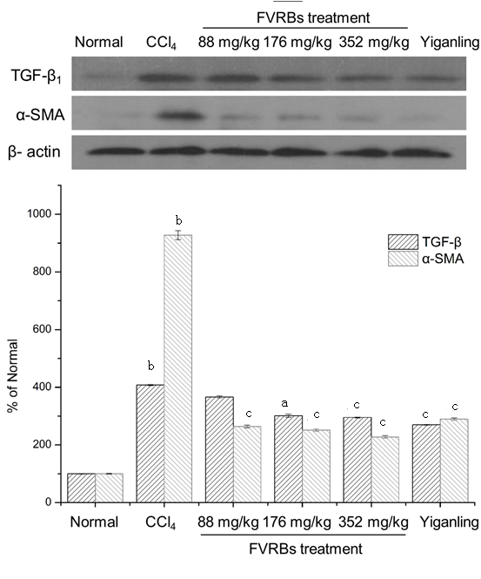
Figure 10 Effect of Foeniculum vulgare root barks on the examination of transforming growth factor β1 and α-SMA Proteins. ^{b}P < 0.01 vs the normal control group. ^{b}P < 0.05 vs the CCl₄-treated group. ^{c}P < 0.01 vs the CCl₄-treated group.

