Name of Journal: World Journal of Hepatology
Manuscript NO: 36026
Manuscript type: case report

Sequential tumor-directed and lobar radioembolization before major hepatectomy for hepatocellular carcinoma

Vouche M et al. Two-steps ⁹⁰Y radioembolization for HCC

Michael Vouche, Thierry Degrez, Fikri Bouazza, Philippe Delatte, Maria Gomez Galdon, Alain Hendlisz, Patrick Flamen, Vincent Donckier

Michael Vouche, Philippe Delatte, Department of Radiology, Institut Jules Bordet, Université Libre de Bruxelles, 1000 Brussels, Belgium

Thierry Degrez, Department of Gastroenterology, CHR Sambre et Meuse, 5000 Namur, Belgium

Fikri Bouazza, Department of Abdominal Surgery, Institut Jules Bordet, Université Libre de Bruxelles, 1000 Brussels, Belgium

Maria Gomez Galdon, Department of Pathology, Institut Jules Bordet, Université Libre de Bruxelles, 1000 Brussels, Belgium

Alain Hendlisz, Department of Digestive Oncology, Institut Jules Bordet, Université Libre de Bruxelles, 1000 Brussels, Belgium

Patrick Flamen, Department of Nuclear Medicine, Institut Jules Bordet, Université Libre de Bruxelles, 1000 Brussels, Belgium

Vincent Donckier, Department of Abdominal Surgery, Institut Jules Bordet, Centre de Chirurgie Hépato-Biliaire de l’ULB (CCHB-ULB), Université Libre de Bruxelles, 1000 Brussels, Belgium

ORCID number: Michael Vouche: (0000-0002-7260-6074); Thierry Degrez (0000-0003-3600-1761); Fikri Bouazza (0000-0002-1636-2888); Philippe Delatte (0000-0003-2757-674X); Maria Gomez Galdon (0000-0001-6943-0402); Alain Hendlisz (0000-0003-2122-1948); Patrick Flamen (0000-0003-2193-6599); Vincent Donckier (0000-0003-1457-2520).

Author contributions: Degrez T, Bouazza F, Delatte P, Gomez Galdon M, Hendlisz A and Flamen P performed research; Vouche M and Donckier V performed research and wrote the paper.

Informed consent statement: An informed consent was obtained from the patient for surgery and potential publication of this case report and any accompanying images.

Conflict-of-interest statement: There is no conflict of interest. None of the authors received any financial support for this work.

Open-Access: This article is an open-access article which was selected by an in-house editor and fully peer-reviewed by external reviewers. It is distributed in accordance with the Creative Commons Attribution Non Commercial (CC BY-NC 4.0) license, which permits others to distribute, remix, adapt, build upon this work non-commercially, and license their derivative works on different terms, provided the original work is properly cited and the use is non-commercial. See: http://creativecommons.org/licenses/by-nc/4.0/

Manuscript source: Unsolicited manuscript

Correspondence to: Vincent Donckier, MD, PhD, Professor of Surgery, Department of Abdominal Surgery, Institut Jules Bordet, Université Libre de Bruxelles, Rue Héger-Bordet, 1, 1000 Brussels, Belgium. vincent.donckier@bordet.be
Telephone: +32-2-5417348
Fax: +32-2-5413141

Received: September 24, 2017
Peer-review started: September 25, 2017
First decision: October 9, 2017
Revised: November 20, 2017
Accepted: December 5, 2017
Article in press:
Published online:

Abstract
Preoperative radioembolization may improve the resectability of liver tumor by inducing tumor shrinkage, atrophy of the embolized liver and compensatory hypertrophy of non-embolized liver. We describe the case of a cirrhotic Child-Pugh A patient with a segment IV hepatocellular carcinoma requiring a left hepatectomy. Preoperative angiography demonstrated 2 separated left hepatic arteries, for segment IV and segments II-III. This anatomic variant allowed sequential radioembolizations, delivering high-dose ⁹⁰Yttrium (160 Gy) to the tumor, followed 28 days later by lower dose (120 Gy) to segments II-III. After 3 months, significant tumor response and atrophy of the future resected liver were obtained, allowing uneventful left hepatectomy. This case illustrates that, when anatomic disposition permits it, sequential radioembolizations, delivering different ⁹⁰Yttrium doses to the tumor and the future resected liver, could represent a new strategy to prepare major hepatectomy in cirrhotic patients, allowing optimal tumoricidal effect while reducing the toxicity of the global procedure.

Key words: Hepatocellular carcinoma; cirrhosis; resectability; radioembolization; sequential; efficacy; safety

© The Author(s) 2017. Published by Baishideng Publishing Group Inc. All rights reserved.

Core tip: Preoperative radioembolization may improve resectability of hepatocellular carcinoma in cirrhotic patient, inducing tumor downsizing, atrophy of radio-embolized sector and regeneration of non-embolized liver. We describe a patient with a segment IV hepatocellular carcinoma where the presence of two separated left hepatic arteries permitted to deliver sequentially high-dose ⁹⁰Yttrium to the tumor and lower dose to future resected liver, allowing uneventful left hepatectomy 3 months later. This observation suggests that, when different arterial accesses exist to tumor and future resected non-tumor liver, sequential radioembolization with different radiation doses could represent a new preoperative strategy, optimizing the tumoricidal effect while minimizing the risk of radiation-induced liver damage.

Vouche M, Degrez T, Bouazza F, Delatte P, Gomez Galdon M, Hendlisz A, Flamen P, Donckier V. Sequential tumor-directed and lobar radioembolization before major hepatectomy for hepatocellular carcinoma. World J Hepatol 2017; In press

Introduction
Partial hepatectomy (PH) and tumor destruction with radiofrequency (RF) are the first therapeutic options in patients with hepatocellular carcinoma (HCC) and compensated cirrhosis who are not candidates for liver transplantation (LT)^{[1,2]}. However, the feasibility and efficacy of these treatments are dramatically limited by underlying liver disease and high tumor recurrence rates. At the present time, no neoadjuvant treatment has been validated for improving the safety and efficacy of PH and RF in this setting. In particular, locoregional treatment with transarterial chemoembolization (TACE) has failed to demonstrate significant long-term benefits when used before PH or RF for HCC^{[3-5]}. Furthermore, when a major resection of 3 or more segments is indicated in cirrhotic livers, preoperative homolateral portal vein embolization (PVE) is recommended to induce an atrophy of the future resected liver and a compensatory hypertrophy of the future liver remnant (FLR)^{[6,7]}. This strategy, however, leaves the tumor untreated while waiting for liver regeneration, exposing the patient to the risk of tumor progression before the surgery^{[8]}.
Selective internal radiotherapy (SIRT), relying on the transarterial embolization of ⁹⁰yttrium-loaded microspheres (⁹⁰Y), has become a new tool for treatment of liver tumors. In HCC, SIRT has been demonstrated to improve survival in patients who are not candidates for curative-intent therapies and to allow tumor control while waiting for LT^{[9-13]}. Furthermore, SIRT can be used preoperatively and the feasibility and safety of post-SIRT surgery has been now assessed^{[14-17]}. The tumoricidal effect of SIRT, leading to tumor downsizing, may significantly modify the extent of surgery or allow the resection of initially unresectable tumors. Moreover, regional intra-arterial hepatic embolization with ⁹⁰Y could also induce the atrophy of the embolized segments and a compensatory hypertrophy of the non-embolized liver^{[18,19]}. This specificity allows for the design of new therapeutic strategies, integrating neoadjuvant SIRT into current surgical approaches to liver tumors, particularly for HCC in cirrhotic patients.
We describe here the case of a patient with centrally-located HCC, treated with sequential intra-tumor and left lobar ⁹⁰Y embolization before a left hepatectomy. This case illustrates the new possibilities offered by the use of SIRT as a preoperative therapy before major liver resection for HCC in cirrhotic patients.

Case report
A 70-year-old man with a past history of alcohol consumption presented with a liver tumor. Contrast-enhanced magnetic resonance imaging (MRI) demonstrated a 40mm mass in segment IV with vascular characteristics of HCC (arterial wash-in and portal wash-out) and features of cirrhosis (Figure 1a and b). Blood tests, including liver function and alpha-fetoprotein, were normal and the patient was classified as Child-Pugh A, with a MELD score of 7. Complete work-up did not demonstrate extra-hepatic metastasis. Accordingly, the tumor corresponded to Okuda stage 1 and BCLC stage A. Due to the patient’s age, the comorbidities, and the patient’s preferences, LT was not recommended during multidisciplinary meeting. Therefore, a left hepatectomy (resection of segments II-III-IV) was proposed and, due to the presence of cirrhosis, preoperative treatment to modulate FLR volume and function was indicated. Analysis of liver volumes on angio-CT scan showed a total liver volume (TLV) of 2339 ml, a tumor volume of 36 ml, a left liver volume (segments II, III, IV) of 812 ml, and an FLR volume (segments I, V, VI, VII, VIII) of 1527 ml, corresponding to an FLR/TLV of 65% and an FLR/body weight ratio of 0.68. On the basis of our previous experience^{[20]} and in relation to the proximity of the tumor to the portal bifurcation that might preclude the chance for resection in case of progression, SIRT was preferred to PVE as preoperative treatment.
Simulation of SIRT with ⁹⁹Tc macroaggregated albumin showed no extra-hepatic deposition and excellent tumor targeting. In addition, the angiography demonstrated a variant hepatic arterial anatomy characterized by a left hepatic artery arising from the right gastric artery, a segment IV artery arising from the gastroduodenal artery and a right hepatic artery arising normally from the celiac trunk. Therefore, 2-step SIRT using different ⁹⁰Y doses was decided upon in order to maximize the dose of ⁹⁰Y selectively delivered to the tumor and to minimize the potential toxicity related to intense radioembolization of a large liver volume. First, ⁹⁰Y hyperselective radioembolization of the segment IV artery to the tumor was performed, allowing the delivery 161 Gy to segment IV (Figure 1c). No side effects related to this procedure were observed. Twenty-eight days later, the left hepatic artery was catheterized and ⁹⁰Y microspheres injected, allowing for the delivery of 120 Gy to segments II and III (Figure 1d). No side effects were observed following this procedure. At day 110 after the second SIRT, contrast-enhanced MRI showed a significant tumor response (size reduction of the tumor diameter from 40 to 34 mm and complete necrosis on arterial phase) (Figure 1d). On the same examination, segments II, III, and IV measured 545 ml, corresponding to a 34% reduction, and FLR measured 1643 ml, corresponding to a minimal increase of 2%. At day 115 after the second SIRT, a left hepatectomy, partially extended to segment V, was performed. Operative exploration confirmed the cirrhosis while the entire left lobe appeared as atrophic and fibrotic (Figure 2a). The surgery proceeded uneventfully. Intraoperative blood losses were 800 ml and no blood transfusions were required. Postoperative course was unremarkable clinically and biologically (minimal values of PT, peak INR, and total bilirubin respectively of 56%, 1.3, and 1.5 mg/dl on day 3 after surgery) and the patient was discharged on day 14. On macroscopic examination of the operative specimen, small foci of cancer cells < 5 mm were observed within a tumor necrotic/fibrotic zone of 55 mm in diameter (Figure 2b). Pathological examination demonstrated a margin-free resection and a major tumor response as indicated by approximately less than 10% of residual cancer cells (Figure 2c and d).

Discussion
PH remains the treatment of choice in patients with large HCC and compensated cirrhosis without significant portal hypertension and who are not candidates for LT^{[1]}. When a major resection is required, preoperative PVE to adapt the FLR is currently considered as the standard procedure. The present case illustrates that neoadjuvant SIRT before surgery may represent now an alternative to this classical sequence. The rationale for considering the use of SIRT before PH for HCC in cirrhotic patients relies on several factors. The first is that SIRT is an effective local treatment for HCC^{[13]}. Thus, if liver surgery would ultimately be found to be infeasible, the patient would still receive an efficient anti-tumor therapy. Secondly, when ⁹⁰Y microspheres are administered both selectively in the tumor and regionally in the future resected liver segments (radiation lobectomy), SIRT has the unique capacity to induce an effective tumoricidal effect together with the atrophy of the future resected liver and a compensatory hypertrophy of the FLR. As compared with preoperative PVE, this may reduce the risk of tumor progression while waiting for functional and volumetric adaptation of the FLR. Finally, and as described for TACE^{[21]}, response to SIRT may potentially serve as a predictive factor both for the safety and the efficacy of the surgery. The feasibility of major liver resection after ⁹⁰Y radiation lobectomy has been assessed. However, particularly in cirrhotic livers, such large liver volume irradiation exposes the patient to the risk of radiation-induced liver disease (RILD)^{[22]}. In the present case, the hepatic arterial anatomy allowed to perform a 2-step SIRT, delivering first high ⁹⁰Y dose to the segment IV tumor, followed by an ablative but safe irradiation dose to left lobe (segments II and III). As a dose-tumor response correlation was demonstrated over 170 Gy^{[23]} and FLR volume modulation was found for doses approximating 120 Gy^{[18]}, such sequential procedures may potentially optimize the neoadjuvant effect of the treatment while reducing the toxicity and the risk of RILD. At 3 months after SIRT, we observed volumetric effects within the embolized regions, as indicated by significant tumor shrinking and left lobe atrophy. In contrast, virtually no increase of the non-embolized FLR was detected, potentially related to the relatively short time period between SIRT and surgery^{[18]}. Despite the absence of significant volumetric regeneration of the right liver, no sign of liver insufficiency has been observed after the left hepatectomy, potentially in relation with favorable initial FLR/TLV ratio. Finally, this case indicates that, despite the so-called ablative ⁹⁰Y dose given to the tumor, a complete pathological response was not obtained, highlighting the need to still resect these irradiated tumors whenever possible.
In conclusion, when distinct arteries to the tumor and to the future resected liver can be selectively catheterized, sequential ⁹⁰Y embolization with modulated doses to the tumor and to the future resected liver could represent a new strategy for improving the safety and the efficacy of neoadjuvant radioembolization before major liver resection in cirrhotic patients. The potential oncological benefit of this therapeutic combination remains to be evaluated.

ARTICLE HIGHLIGHTS
Case characteristics
A seventy years old patient presented with a segment IV liver tumor

Clinical diagnosis
Due to the presence of alcohol-related cirrhosis, a diagnosis of hepatocellular carcinoma was suspected

Differential diagnosis
Differential diagnosis included other solid liver tumors, primary or secondary

Laboratory diagnosis
Laboratory data, including alpha-fetoprotein were not contributive

Imaging diagnosis
Contrast-enhanced magnetic resonance imaging demonstrated a 40mm mass in segment IV of the liver with vascular characteristics of hepatocellular carcinoma, such as arterial phase wash-in and portal phase wash-out and features of cirrhosis. Angiography demonstrated two separated left hepatic arteries, for segment IV and for segments II and III, allowing selective access to the tumor and to the future resected liver.

Pathological diagnosis
On operative specimen, pathology confirmed the diagnosis of hepatocellular carcinoma and a major response to preoperative radioembolization as indicated by less than 10% residual cancer cells

Treatment
Left hepatectomy was preceded by sequential radioembolizations, delivering high-dose radiation to the tumor and then, lower dose to the future resected liver. This 2-steps approach aimed to maximize tumoricidal effect while limiting the risks for radiation-induced liver disease and liver insufficiency.

Related reports
In such cases of hepatocellular carcinoma requiring a major hepatectomy in patients with compensated cirrhosis, resectability is dramatically limited by the risk of postoperative liver insufficiency

Experiences and lessons
This case indicates that, when arterial anatomy allows it, sequential radioembolizations with different radiation doses to the tumor and to the future resected liver could represent a new strategy to maximize the tumoricidal effect while preserving the atrophic effect but reducing the risk of radiation-induced liver injury

Acknowledgements
We acknowledge the contribution of a medical writer, Sandy Field, PhD, for editing of this manuscript.

References
1 European Association For The Study Of The Liver; European Organisation For Research And Treatment Of Cancer. EASL-EORTC clinical practice guidelines: management of hepatocellular carcinoma. J Hepatol 2012; 56: 908-943 [PMID: 22424438 DOI: 10.1016/j.jhep.2011.12.001]
2 Forner A, Gilabert M, Bruix J, Raoul JL. Treatment of intermediate-stage hepatocellular carcinoma. Nat Rev Clin Oncol 2014; 11: 525-535 [PMID: 25091611 DOI: 10.1038/nrclinonc.2014]
3 Zhou WP, Lai EC, Li AJ, Fu SY, Zhou JP, Pan ZY, Lau WY, Wu MC. A prospective, randomized, controlled trial of preoperative transarterial chemoembolization for resectable large hepatocellular carcinoma. Ann Surg 2009; 249: 195-202 [PMID: 19212170 DOI: 10.1097/SLA.0b013e3181961c16]
4 Yoo H, Kim JH, Ko GY, Kim KW, Gwon DI, Lee SG, Hwang S. Sequential transcatheter arterial chemoembolization and portal vein embolization versus portal vein embolization only before major hepatectomy for patients with hepatocellular carcinoma. Ann Surg Oncol 2011; 18: 1251-1257 [PMID: 21069467 DOI: 10.1245/s10434-010-1423-3]
5 Si T, Chen Y, Ma D, Gong X, Yang K, Guan R, Peng C. Preoperative transarterial chemoembolization for resectable hepatocellular carcinoma in Asia area: a meta-analysis of random controlled trials. Scand J Gastroenterol 2016; 51: 1512-1519 [PMID: 27598831 DOI: 10.1080/00365521.2016.1216588]
6 Beppu T, Okabe H, Okuda K, Eguchi S, Kitahara K, Taniai N, Ueno S, Shirabe K, Ohta M, Kondo K, Nanashima A, Noritomi T, Okamoto K, Kikuchi K, Baba H, Fujioka H. Portal Vein Embolization Followed by Right-Side Hemihepatectomy for Hepatocellular Carcinoma Patients: A Japanese Multi-Institutional Study. J Am Coll Surg 2016; 222: 1138-1148.e2 [PMID: 27107976 DOI: 10.1016/j.jamcollsurg.2016.03.023]
7 Glantzounis GK, Tokidis E, Basourakos SP, Ntzani EE, Lianos GD, Pentheroudakis G. The role of portal vein embolization in the surgical management of primary hepatobiliary cancers. A systematic review. Eur J Surg Oncol 2017; 43: 32-41 [PMID: 27283892 DOI: 10.1016/j.ejso.2016.05.026.]
8 Hoekstra LT, van Lienden KP, Doets A, Busch OR, Gouma DJ, van Gulik TM. Tumor progression after preoperative portal vein embolization. Ann Surg 2012; 256: 812-7; discussion 817-8 [PMID: 23095626 DOI: 10.1097/SLA.0b013e3182733f09]
9 Riaz A, Kulik L, Lewandowski RJ, Ryu RK, Giakoumis Spear G, Mulcahy MF, Abecassis M, Baker T, Gates V, Nayar R, Miller FH, Sato KT, Omary RA, Salem R. Radiologic-pathologic correlation of hepatocellular carcinoma treated with internal radiation using yttrium-90 microspheres. Hepatology 2009; 49: 1185-1193 [PMID: 19133645 DOI: 10.1002/hep.22747]
10 Lewandowski RJ, Kulik LM, Riaz A, Senthilnathan S, Mulcahy MF, Ryu RK, Ibrahim SM, Sato KT, Baker T, Miller FH, Omary R, Abecassis M, Salem R. A comparative analysis of transarterial downstaging for hepatocellular carcinoma: chemoembolization versus radioembolization. Am J Transplant 2009; 9: 1920-1928 [PMID: 19552767 DOI: 10.1111/j.1600-6143.2009.02695.x.]
11 Sangro B, Carpanese L, Cianni R, Golfieri R, Gasparini D, Ezziddin S, Paprottka PM, Fiore F, Van Buskirk M, Bilbao JI, Ettorre GM, Salvatori R, Giampalma E, Geatti O, Wilhelm K, Hoffmann RT, Izzo F, Iñarrairaegui M, Maini CL, Urigo C, Cappelli A, Vit A, Ahmadzadehfar H, Jakobs TF, Lastoria S; European Network on Radioembolization with Yttrium-90 Resin Microspheres (ENRY). Survival after yttrium-90 resin microsphere radioembolization of hepatocellular carcinoma across Barcelona clinic liver cancer stages: a European evaluation. Hepatology 2011; 54: 868-878 [PMID: 21618574 DOI: 10.1002/hep.24451]
12 Mazzaferro V, Sposito C, Bhoori S, Romito R, Chiesa C, Morosi C, Maccauro M, Marchianò A, Bongini M, Lanocita R, Civelli E, Bombardieri E, Camerini T, Spreafico C. Yttrium-90 radioembolization for intermediate-advanced hepatocellular carcinoma: a phase 2 study. Hepatology 2013; 57: 1826-1837 [PMID: 22911442 DOI: 10.1002/hep.26014]
13 Salem R, Gordon AC, Mouli S, Hickey R, Kallini J, Gabr A, Mulcahy MF, Baker T, Abecassis M, Miller FH, Yaghmai V, Sato K, Desai K, Thornburg B, Benson AB, Rademaker A, Ganger D, Kulik L, Lewandowski RJ. Y90 Radioembolization Significantly Prolongs Time to Progression Compared With Chemoembolization in Patients With Hepatocellular Carcinoma. Gastroenterology 2016; 151: 1155-1163.e2 [PMID: 27575820 DOI: 10.1053/j.gastro.2016.08.029]
14 Cucchetti A, Cappelli A, Ercolani G, Mosconi C, Cescon M, Golfieri R, Pinna AD. Selective Internal Radiation Therapy (SIRT) as Conversion Therapy for Unresectable Primary Liver Malignancies. Liver Cancer 2016; 5: 303-311 [PMID: 27781202 DOI: 10.1159/000449341]
15 Justinger C, Kouladouros K, Gärtner D, Tatsch K, Reimer P, Rüdiger T, Binnenhei M, Bentz M, Schön MR. Liver resection after selective internal radiotherapy (SIRT): Proof of concept, initial survival, and safety. J Surg Oncol 2015; 112: 436-442 [PMID: 26256832 DOI: 10.1002/jso.24000]
16 Iñarrairaegui M, Pardo F, Bilbao JI, Rotellar F, Benito A, D'Avola D, Herrero JI, Rodriguez M, Martí P, Zozaya G, Dominguez I, Quiroga J, Sangro B. Response to radioembolization with yttrium-90 resin microspheres may allow surgical treatment with curative intent and prolonged survival in previously unresectable hepatocellular carcinoma. Eur J Surg Oncol 2012; 38: 594-601 [PMID: 22440743 DOI: 10.1016/j.ejso.2012.02.189]
17 Pardo F, Sangro B, Lee RC, Manas D, Jeyarajah R, Donckier V, Maleux G, Pinna AD, Bester L, Morris DL, Iannitti D, Chow PK, Stubbs R, Gow PJ, Masi G, Fisher KT, Lau WY, Kouladouros K, Katsanos G, Ercolani G, Rotellar F, Bilbao JI, Schoen M. The Post-SIR-Spheres Surgery Study (P4S): Retrospective Analysis of Safety Following Hepatic Resection or Transplantation in Patients Previously Treated with Selective Internal Radiation Therapy with Yttrium-90 Resin Microspheres. Ann Surg Oncol 2017; 24: 2465-2473 [PMID: 28653161 DOI: 10.1245/s10434-017-5950-z.]
18 Vouche M, Lewandowski RJ, Atassi R, Memon K, Gates VL, Ryu RK, Gaba RC, Mulcahy MF, Baker T, Sato K, Hickey R, Ganger D, Riaz A, Fryer J, Caicedo JC, Abecassis M, Kulik L, Salem R. Radiation lobectomy: time-dependent analysis of future liver remnant volume in unresectable liver cancer as a bridge to resection. J Hepatol 2013; 59: 1029-1036 [PMID: 23811303 DOI: 10.1016/j.jhep.2013.06.015]
19 Garlipp B, de Baere T, Damm R, Irmscher R, van Buskirk M, Stübs P, Deschamps F, Meyer F, Seidensticker R, Mohnike K, Pech M, Amthauer H, Lippert H, Ricke J, Seidensticker M. Left-liver hypertrophy after therapeutic right-liver radioembolization is substantial but less than after portal vein embolization. Hepatology 2014; 59: 1864-1873 [PMID: 24259442 DOI: 10.1002/hep.26947]
20 Bouazza F, Poncelet A, Garcia CA, Delatte P, Engelhom JL, Gomez Galdon M, Deleporte A, Hendlisz A, Vanderlinden B, Flamen P, Donckier V. Radioembolisation and portal vein embolization before resection of large hepatocellular carcinoma. World J Gastroenterol 2015; 21: 9666-9670 [PMID: 26327775 DOI: 10.3748/wjg.v21.i32.9666]
21 Lei JY, Zhong JJ, Yan LN, Zhu JQ, Wang WT, Zeng Y, Li B, Wen TF, Yang JY; - Liver Surgery Group. Response to transarterial chemoembolization as a selection criterion for resection of hepatocellular carcinomas. Br J Surg 2016; 103: 881-890 [PMID: 27027978 DOI: 10.1002/bjs.9864]
22 Gil-Alzugaray B, Chopitea A, Iñarrairaegui M, Bilbao JI, Rodriguez-Fraile M, Rodriguez J, Benito A, Dominguez I, D'Avola D, Herrero JI, Quiroga J, Prieto J, Sangro B. Prognostic factors and prevention of radioembolization-induced liver disease. Hepatology 2013; 57: 1078-1087 [PMID: 23225191 DOI: 10.1002/hep.26191]
23 Vouche M, Habib A, Ward TJ, Kim E, Kulik L, Ganger D, Mulcahy M, Baker T, Abecassis M, Sato KT, Caicedo JC, Fryer J, Hickey R, Hohlastos E, Lewandowski RJ, Salem R. Unresectable solitary hepatocellular carcinoma not amenable to radiofrequency ablation: multicenter radiology-pathology correlation and survival of radiation segmentectomy. Hepatology 2014; 60: 192-201 [PMID: 24691943 DOI: 10.1002/hep.27057]
P-Reviewer: Bramhall S, Hori T, Kai K, Qin JM S-Editor: Gong ZM
L-Editor: E-Editor:
Specialty type: Gastroenterology and hepatology
Country of origin: Belgium
Peer-review report classification
Grade A (Excellent): 0
Grade B (Very good): 0
Grade C (Good): C, C
Grade D (Fair): D, D
Grade E (Poor): 0

A
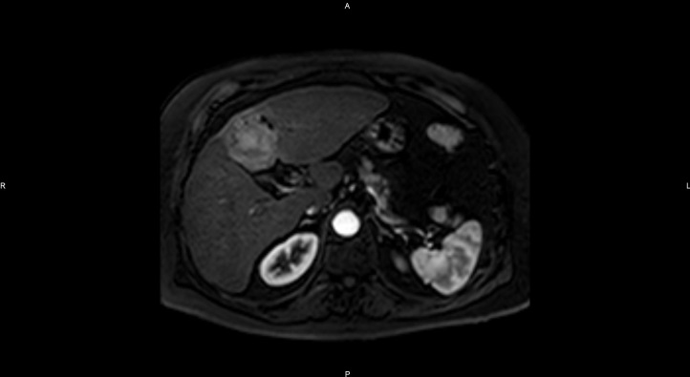
B
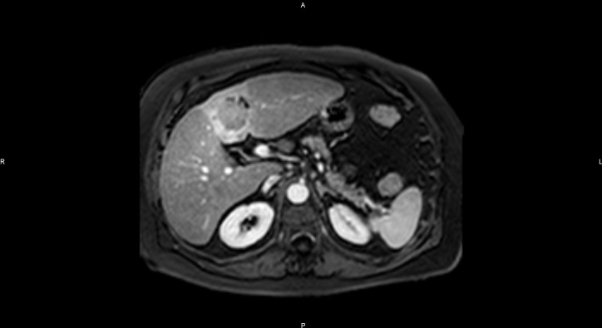
C
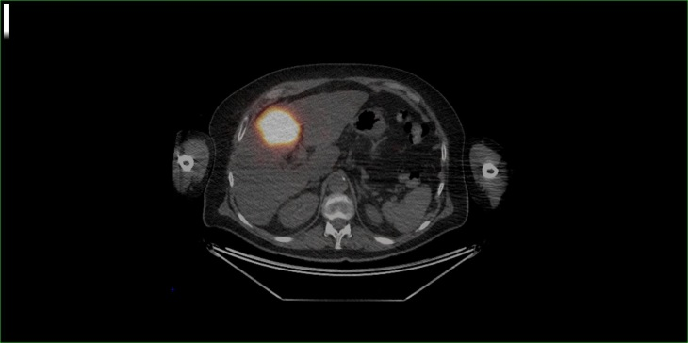
D
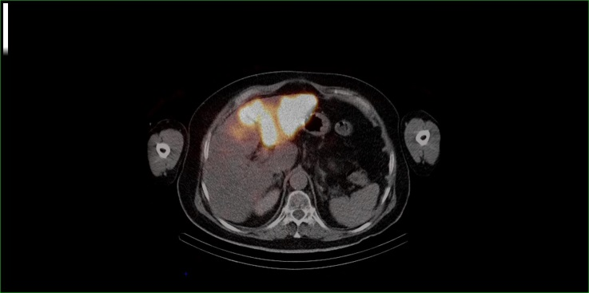
Figure 1 Preoperative imaging. A and B: Baseline contrast-enhanced magnetic resonance imaging (MRI). Contrast-enhanced magnetic resonance imaging (MRI) demonstrated a 40mm mass in segment IV of the liver with arterial wash-in (1A) and wash-out on the portal venous phase (1B) and features of cirrhosis (irregular surface, relative hypertrophy of segment I); C and D: Selective intra-tumor deposition of 90Y microspheres after first SIRT session (1C) and deposition of 90Y microspheres to segments II and III after the second SIRT session.

A B
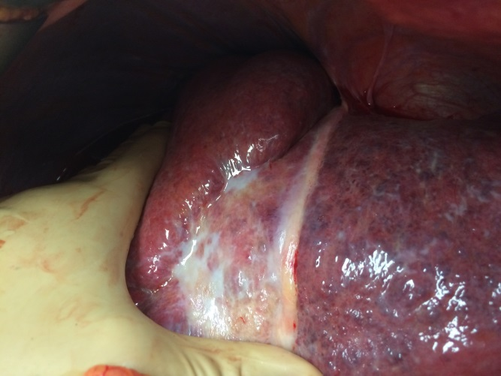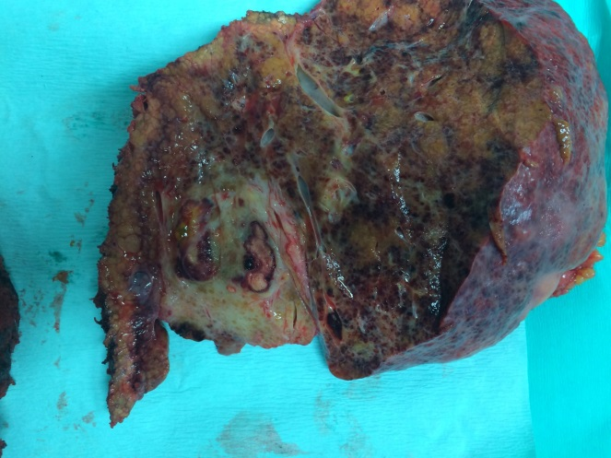
C D
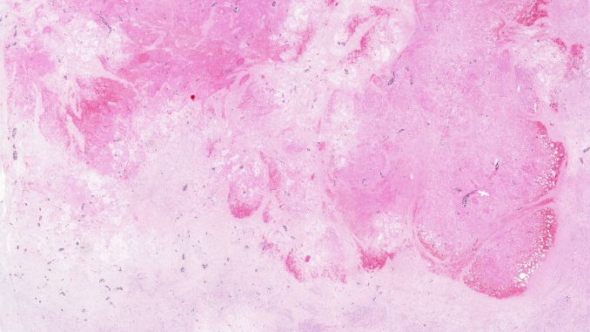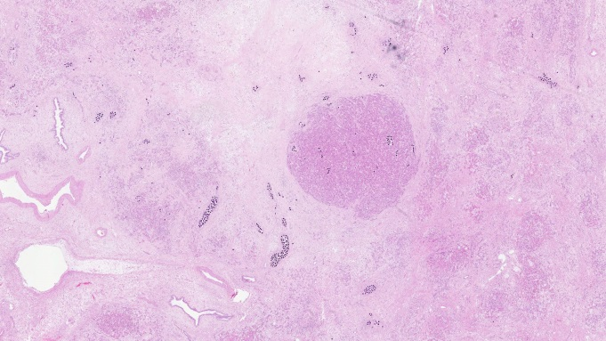
Figure 2 Intra- and postoperative images. A: Intraoperative view showing the cirrhosis and the post-SIRT relative atrophy of the left liver; B: Resected specimen showing small residual cancer cells foci with the necrotic and fibrotic zone targeted by segment IV high-dose SIRT; C: Pathological view showing massive necrosis and fibrosis together with the presence of microspheres; d: Pathological view showing a residual hepatocellular carcinoma focus, surrounded by necrosis and fibrosis together with the presence of microspheres.

