Name of Journal: World Journal of Transplantation
Manuscript NO: 90277
Manuscript Type: MINIREVIEWS

Thrombotic microangiopathy after kidney transplantation: Expanding etiologic and pathogenetic spectra

Mubarak M et al. Etiopathogenesis of posttransplant TMAs

Muhammed Mubarak, Amber Raza, Rahma Rashid, Fnu Sapna, Shaheera Shakeel

Muhammed Mubarak, Rahma Rashid, Department of Pathology, Sindh Institute of Urology and Transplantation, Karachi 74200, Sindh, Pakistan

Amber Raza, Department of Nephrology, Sindh Institute of Urology and Transplantation, Karachi 74200, Sindh, Pakistan

Fnu Sapna, Department of Pathology, Montefiore Medical Center, The University Hospital for Albert Einstein School of Medicine, Bronx, NY 10461, United States

Shaheera Shakeel, Department of Histopathology, Sindh Institute of Urology and Transplantation, Karachi 74200, Sindh, Pakistan

Author contributions: Mubarak M, Raza A, Rashid R, Sapna F, Shakeel S contributed equally to this work; Mubarak M and Raza A designed the research study; Mubarak M, Raza A, Rashid R, Sapna F, Shakeel S performed the research; Mubarak M and Raza A wrote the manuscript; Mubarak M, Raza A, Rashid R, Sapna F, Shakeel S have read and approve the final manuscript.

Corresponding author: Muhammed Mubarak, MD, Professor, Department of Pathology, Sindh Institute of Urology and Transplantation, Chand Bibi Road, Karachi 74200, Sindh, Pakistan. drmubaraksiut@yahoo.com

Received: November 29, 2023
Revised: January 28, 2024
Accepted: March 4, 2024
Published online:

Abstract
Thrombotic microangiopathy (TMA) is an uncommon but serious complication that not only affects native kidneys but also transplanted kidneys. This review is specifically focused on post-transplant TMA (PT-TMA) involving kidney transplant recipients. Its reported prevalence in the latter population varies from 0.8% to 14% with adverse impacts on both graft and patient survival. It has many causes and associations, and the list of etiologic agents and associations is growing constantly. The pathogenesis is equally varied and a variety of pathogenetic pathways lead to the development of microvascular injury as the final common pathway. PT-TMA is categorized in many ways in order to facilitate its management. Ironically, more than one causes are contributory in PT-TMA and it is often difficult to pinpoint one particular cause in an individual case. Pathologically, the hallmark lesions are endothelial cell injury and intravascular thrombi affecting the microvasculature. Early diagnosis and classification of PT-TMA are imperative for optimal outcomes but are challenging for both clinicians and pathologists. The Banff classification has addressed this issue and has developed minimum diagnostic criteria for pathologic diagnosis of PT-TMA in the first phase. Management of the condition is also challenging and still largely empirical. It varies from simple maneuvers, such as plasmapheresis, drug withdrawal or modification, or dose reduction, to lifelong complement blockade, which is very expensive. A thorough understanding of the condition is imperative for an early diagnosis and quick treatment when the treatment is potentially effective. This review aims to increase the awareness of relevant stakeholders regarding this important, potentially treatable but under-recognized cause of kidney allograft dysfunction.

Key Words: Thrombotic microangiopathy; Microvascular injury; Anemia; Thrombocytopenia; Kidney allograft failure

Mubarak M, Raza A, Rashid R, Sapna F, Shakeel S. Thrombotic microangiopathy after kidney transplantation: Expanding etiologic and pathogenetic spectra. World J Transplant 2024; In press

Core Tip: Thrombotic microangiopathy (TMA) is a pattern of microvascular injury characterized by the triad of microangiopathic hemolytic anemia, thrombocytopenia, and multi-organ dysfunction. It is not a specific disease but rather a clinicopathological syndrome associated with numerous causes and conditions. It can also involve kidney allograft and can lead to graft dysfunction and loss. Posttransplant-TMA is distinct from native kidney TMA in certain respects and poses significant diagnostic and therapeutic challenges. A thorough understanding of the condition and the development of consensus-based diagnostic criteria are imperative for an early diagnosis and timely treatment to achieve best patient outcomes.

INTRODUCTION
Thrombotic microangiopathy (TMA) is an uncommon but serious complication that not only affects native kidneys but can also kidney allografts, with resultant graft dysfunction and graft loss. Its reported prevalence in the latter setting varies from 0.8 to 14% of kidney transplant recipients (KTRs) with adverse impacts on both graft and patient survival^{[1,2]}. It is a highly heterogeneous condition with equally heterogeneous outcomes. TMA is not a single disease entity but rather a morphologic pattern of microvascular occlusive injury that can be seen with a variety of disease states and conditions. It has many causes and associations, and the list of these is growing steadily as new cases are being reported^{[3-7]}. The heterogeneous etiology is reflected in a multitude of pathogenetic pathways leading to the final common pathway of occlusive microvascular injury^{[8,9]}. This review is directed at post-transplant TMA (PT-TMA) in KTRs, which is an important cause of kidney allograft injury and loss if not treated promptly and appropriately. The main focus will be on the expanding etiologic and pathogenetic spectra with some description devoted to the pathology and diagnosis of the condition. The management and prognosis will not be dealt with in detail in this review. TMA not only involves the native kidneys but also occurs in the transplanted kidneys. The condition has many similarities as well as some differences in the two settings. This review will be confined mainly to PT-TMA in kidney transplant setting. A thorough understanding of the condition is imperative for an early diagnosis and quick treatment when the treatment is potentially effective. This review aims to increase the awareness of relevant stakeholders regarding this important, potentially treatable but under-recognized cause of kidney allograft dysfunction.

DEFINITION AND CLASSIFICATION
TMA is a clinicopathological syndrome characterized by endothelial injury and the presence of thrombi in the microvasculature (arterioles and capillaries). Thrombus formation in the vascular lumina leads to platelet consumption, damage to the red blood cells, and occlusion of the lumina. The latter phenomenon leads to tissue ischemia and organ dysfunction, typically involving the kidneys but sometimes also other organs^{[10-14]}. It is a potentially life-threatening condition. TMA is broadly categorized into two flagship clinical prototypes: Hemolytic uremic syndrome (HUS) and thrombotic thrombocytopenic purpura (TTP). The former is characterized by severe kidney disease manifested as oliguria and uremia, but few extra-renal manifestations^{[11-13]}. In the second form, TTP, the kidney changes are similar but milder than in HUS. However, widespread systemic manifestations, particularly, central nervous system involvement, are highly prevalent^{[15,16]}. TMA syndromes are an emerging field of research and discoveries in nephrology, hematology, and rheumatology disciplines. Although many developments have taken place, much work remains to be done in genetics, molecular biology, and therapeutics to disentangle the conundrum of the relationships and the apparent differences between the different subclasses of TMA syndromes^{[16-18]}.
The classification of the TMAs is not only challenging but is constantly evolving. Traditionally, these were classified on the basis of clinical findings: TTP for predominant neurologic involvement and HUS for kidney-dominant disease. TMA syndromes can also be classified according to the pathogenetic processes involved in endothelial injury^{[19-21]}. However, the ideal approach to categorize TMA is that of etiology, which, however, may not be identified in each and every case of TMA. Broadly, TMA is labeled as primary when a genetic or acquired defect is identified [as in atypical HUS (aHUS) and TTP] and secondary when it occurs in the setting of another disease process, such as autoimmune disease, malignancy, infection, or drugs (Table 1). This subdivision is also not absolute because underlying genetic defects have been recognized in many cases of secondary TMA as well^{[21,22]}.

PT-TMA
TMA not only involves the native kidneys but also the transplanted kidneys. Kidney transplantation poses a challenging scenario due to multiple potential inciting factors for the development of TMA^{[1,2,23-26]}. PT-TMA has many similarities with native renal TMA as well as some differences necessitating its detailed review. Like native kidney TMA, PT-TMA is caused by endothelial injury in the vast majority of cases and manifests as thrombotic occlusion of the microcirculation resulting in often clinically unexplained allograft dysfunction^{[27]}. The endothelial injury may be caused by a myriad of injurious agents including but not limited to immunologic, genetic, and hematologic disorders and drugs either alone or in various combinations^{[28-30]}. A kidney transplant biopsy is required for a definitive diagnosis^{[31]}. The histopathologic diagnosis of Tx-TMA is based on the subjective interpretation of a large number of histopathologic lesions, whose nature, prevalence, and extent vary from case to case depending on many factors including the duration of the pathologic process. It also depends on the expertise and diagnostic insight of the pathologist^{[31]}. Accurate diagnosis and classification are important for optimal treatment of the condition and favorable patient outcomes. The diagnosis can sometimes be challenging and delayed with consequent delay in the initiation of targeted treatment^{[32]}.
PT-TMA has been categorized in many ways. It can occur in a localized (L-TMA) form, limited to kidney allograft with resulting allograft dysfunction, or in a systemic form, with microangiopathic hemolytic anemia, thrombocytopenia, and renal failure. In native kidneys, TMA is often part of the systemic illness, whereas in PT-TMA, it is often allograft kidney-limited. It can also be classified as recurrent or de novo PT-TMA; the latter being more common. Recurrent PT-TMA is almost invariably complement-mediated, whereas de novo PT-TMA may be complement-mediated or secondary to other inciting factors (Table 2). De novo TMA is reported in 0.8%-14% of KTRs, although the true frequency is unknown, and the incidence of a genetic complement abnormality may be underestimated^{[1,2]}. Differentiating between a primary complement-mediated process and one caused by secondary factors is important to minimize allograft damage since the former is non-responsive to supportive therapy and has a high risk of recurrence. However, distinguishing between the two types can be difficult, given their overlap of clinical, laboratory, and pathological features. TMA syndromes can also be classified according to the pathogenetic processes involved in endothelial injury. However, the ideal approach to categorize TMA is that of etiology, which, however, may not be identified in every case of PT-TMA (Figure 1).

ETIOLOGY OF PT-TMAS
The etiologic spectrum of PT-TMA is expanding and evolving with ever-increasing transplant activity. The etiology of PT-TMA not only includes all those causes that are seen in native kidney disease but also many additional causes unique to the transplant setting (Figure 1). The presence of a causal factor in isolation, such as ADAMTS13 deficiency or a complement mutation (the first hit), may not manifest clinically until a condition, such as an inflammatory disorder, surgery, or pregnancy (the second hit), precipitates an acute TMA episode. In fact, in PT-TMA, often more than one acquired factors are implicated in the causation of the disorder, leading to a proposal by some researchers of three-hit mechanism. It is important to identify all the predisposing factors in order to optimally treat the condition^{[33-38]}. It is, however, often impossible to pinpoint to a single etiologic factor in an individual patient.
The role of immunosuppressant drugs posttransplantation in the development of PT-TMA deserves some attention. The two main groups of immunosuppressants used in all forms of transplantation, i.e., calcineurin inhibitors (CNIs) and mammalian target of rapamycin (mTOR) inhibitors (mTORi) such as sirolimus, can both trigger the development of PT-TMA^{[39,40]}. The etiologic role of CNIs in causing PT-TMA is well established. However, the role of mTOR inhibitors is still largely controversial^{[40]}. In vitro studies have suggested that sirolimus causes endothelial cell (EC) injury only when used in combination with tacrolimus. When used as single-agent, it does not lead to EC injury^{[41]}. In clinical studies too, there is increasing evidence showing that sirolimus and everolimus, either alone or in combination with cyclosporine—can be associated with the pathogenesis of de novo PT-TMA. Some studies suggest that the impact of mTORi may be even higher in the development of TMA than that of CNIs. A USRDS-based study has demonstrated that there is a higher incidence of TMA in patients on initial maintenance therapy with sirolimus (18.1 episodes/1000 person-years) compared with those on CNIs (5.0 episodes/1000 patient- years)^{[42]}. Some other studies have shown that replacing tacrolimus with rapamycin may improve PT-TMA. Thus, the exact mechanisms and roles of immusuppressant drugs are still largely incompletely understood and need further research.

PATHOGENESIS
The pathogenesis of TMA is understandably as diverse as its etiological spectrum. The final common pathway in all forms of injury is endothelial damage with resultant activation of the thrombosis cascade. Within the TMA syndromes, two principal mechanisms participate: (1) Endothelial injury and activation; and (2) excessive platelet aggregation and activation. Among these, the endothelial injuries take precedence in HUS, whereas platelet aggregation and activation appear to be the main driving event in the TTP. Many different etiological precipitating factors have been described for the development of PT-TMA, such as ischemia-reperfusion-injury, use of immunosuppressive drugs, infections, and many more^{[43,44]}.

Endothelial injury
A variable degree of EC injury and activation is the hallmark of all TMA syndromes and in many TMA syndromes, constitutes the final common pathway of microvascular injury. The endothelium is a highly active and dynamic tissue responsible in part for regulating vascular tone, coagulation, and inflammation^{[45,46]}.
All types of TMA are characterized by a common phenotype of activated, prothrombotic ECs. This EC phenotype arises from various distinct types of injurious agents: complement activation, autoimmune diseases, infections, drug toxicity, or malignancy. For most types of TMAs, the exact intracellular mechanisms of EC injury are not well understood.
In typical or classic HUS, the initiating factor for endothelial injury and activation is usually a Shiga-like toxin, whereas, for atypical and inherited forms of HUS, excessive or inappropriate activation of complement is the main triggering event. Many other injurious agents and conditions can sometimes precipitate a HUS-like condition, probably also by damaging the endothelial layer. The EC injury in HUS causes platelet activation, aggregation, and thrombus formation within the lumina of the microvasculature. Previous research has found that reduced production of prostaglandin I₂ and nitric oxide by ECs contributes to intraluminal thrombosis. The reduced production of the above two factors and increased production of EC-derived endothelin also promote vasoconstriction, accentuating the hypoperfusion of organs^{[47-49]}.

Platelet aggregation
This is the second main pathogenetic pathway of thrombus formation in TMA syndromes, manifesting clinically as TTP. In this scenario, endothelial structure and function are relatively intact. In this pathway, the initiating event is the platelet aggregation induced by ultra-large multimers of vWF, which accumulate to a deficiency of ADAMTS13, a plasma protease that degrades vWF multimers into smaller fragments. The deficiency of ADAMTS13 is most often functional caused by autoantibodies that inhibit its function. This form of TTP is referred to as acquired or immune TTP and accounts for 95% of cases. Rarely, an inherited deficiency of ADAMTS13 Leads to a chronic relapsing and remitting form of TTP. This pattern of disease is labeled as inherited or congenital TTP and is rare^{[48-50]}.

PATHOLOGY OF PT-TMAs
A large variety of morphological lesions can be found on kidney allograft biopsies in cases of PT-TMA. The lesions may involve glomeruli, arterioles, and rarely small arteries in variable combinations and with varying degrees of severity (Table 3). Their nature varies according to the duration of the disease process and may be categorized as acute, chronic, or acute-on-chronic^{[51-55]}. The morphological features in various types of TMA syndromes are indistinguishable and vary mainly according to the age of the lesion than the cause of TMA. The glomeruli in active disease may show many non-specific changes such as marked congestion, bloodless appearance, capillary collapse, mild to moderate cellular proliferation, crescent formation, and rarely, complete infarction. Disruption of the mesangial matrix and damage to the mesangial cells may result in mesangiolysis and aneurysmal dilatation of the capillary loops. More specific features include the thickening of the capillary walls by expansion of the subendothelial zones, intraluminal thrombi, and the presence of red cell fragmentation and extravasation into vessel walls (Figure 2). The glomerular lesions vary from case to case and from glomerulus to glomerulus.
The arterioles and small arteries in acute PT-TMA show intraluminal thrombosis and subendothelial edema resulting in marked narrowing of the lumina. Red blood cell fragmentation and extravasation in the walls of arterioles may be observed. Medial necrosis, fibrinoid necrosis, and intramural thrombosis may be seen in severe cases.
Chronic TMA lesions are commonly observed in patients with aHUS and manifest as lesions emanating from continued endothelial injury and attempts at repair. The glomeruli are mildly hypercellular and show thickened capillary walls with double contours or tram-tracking, producing mesangiocapillary pattern of injury. The double contours result from reduplication and formation of neobasement membrane because of persistent injury to the endothelium. In vessels, medial hypertrophy (onion-skining) may be seen in lesions of longer duration. Mucinous intimal thickening with marked narrowing of lumina is characteristically observed in chronic TMA lesions involving the arterioles and small arteries (Figure 3).
Immunoflourescence shows deposits of fibrin in glomeruli and arterioles. There may be weak nonspecific positivity of IgM in the glomeruli and arterioles with less frequent C3 and IgG. Fibrin is invariably present in the fibrin thrombi.
Electron microscopy shows separation of the endothelium from the underlying glomerular basement membrane (GBM) by electron-lucent zone filled with fluffy electron-lucent material during early phase of the disease. Within this space also lie scattered fine fibrils, occasional stands of fibrin, fragments of red blood cells and platelets and cytoplasmic processes of mesangial and endothelial cells. No electron dense deposits are found. A newly formed basement membrane is found below the endothelial layer. Mesangial changes may be marked on ultrastructural level^{[51-55]}.
Till recent past, the diagnostic criteria were not standardized for the clinical or pathological diagnosis of PT-TMA. Moreover, the histopathologic diagnosis is a subjective task. The Banff Working Group (BWG) on TMA was formed in 2016 under the auspices of the Banff Foundation for Allograft Pathology, with the aim of standardizing the diagnostic criteria of TMA and formulating recommendations^{[31]}. A survey conducted in January 2016 among the BWG participants, showed considerable heterogeneity among pathologists, using a variety of known TMA features with imprecise or subjective definitions. Therefore, the first objective of the BWG was to provide the nephropathology community with a standardized set of minimum diagnostic criteria (MDC) for PT-TMA. A secondary objective, identified during the study, was to scrutinize specific lesions that could potentially determine specific etiologies of PT-TMA. Diagnosis of TMA in the renal allograft is not merely a morphologic task; clinical and laboratory information is also critical for diagnosis and needs to be standardized in phase II of the study. The Delphi approach was used by the BWG, for the first time in the Banff classification, to generate consensus, among an expert panel^{[31]}. The group generated consensus on 24 criteria, provided a list of eight differential diagnoses, and identified areas of diagnostic difficulty. According to the authors this work is a starting point in the process of diagnosing PT-TMA in KTRs^{[31]}.

DIAGNOSIS OF PT-TMAS
Overall, there is a lack of international consensus criteria for the diagnosis of PT-TMA. Moreover, the clinical and laboratory features of the condition are non-specific and protean. This is reflected in the wide variation in the reported incidence of PT-TMA. An algorithmic approach to diagnosis, classification and treatment is presented in Figure 4. Recently, the BWG on TMA has published the results of phase I of the consensus process for MDC for the pathologic diagnosis PT-TMA in KTRs. The other main group of PT-TMA relates to patients undergoing hematopoietic stem cell transplantation. Different diagnostic criteria are used in the hematology discipline. There is no uniformity in the approach to diagnosis and investigation in these two broad groups of PT-TMA. There is a clear need for unified, objective, and organ-specific criteria to help in the timely diagnosis of TMA in clinical practice and for use in future clinical trials.

MANAGEMENT AND PROGNOSIS
Management of the condition is challenging and still largely empirical. It varies from simple maneuvers, such as plasmapheresis, drug withdrawal or modification, or dose reduction, to lifelong complement blockade by eculizumab, which is very expensive approach (Figure 5). Careful donor selection and proper recipient preparation, including complete genetic screening, would be a more rational approach. Novel targeted therapies are being actively researched but are still in the experimental phase and are not yet available in clinical practice^{[56-59]}.
The prognosis of de novo or recurrent TMA in kidney allografts is generally guarded and varies according to underlying causes^{[60-68]}. With better understanding and characterization of the disease, the patient and allograft outcomes are improving steadily.

PREVENTIVE/PROPHYLAXIS MEASURES
These measures or strategies can only be applied in cases of aHUS for possible risk of recurrence after kidney transplantation (Figure 5). The risk of recurrence depends on the type of mutation in complement regulatory proteins and can be calculated before transplantation. Recurrence usually occurs very early in the posttransplant period and may be precipitated quickly by an ischemia-reperfusion–induced endothelial injury. However, the time between kidney transplantation and aHUS recurrence varies considerably. Due to the severity of aHUS recurrences and the unpredictable time of onset, the KDIGO workgroup recommends the prophylactic use of eculizumab for KTRs who are at high risk of recurrence based on the patient’s genetic background. Eculizumab has been used both before and after transplantation. An analysis of the Global aHUS Registry showed that pretransplant use of eculizumab resulted in better allograft function than posttransplant initiation. Other preventive measures include pretransplant plasma exchange (PE), use of induction therapy and low doses of CNIs. For some complement regulatory gene mutations, use of liver-kidney transplantation has been used successfully^{[69]}. This procedure is controversial because of potentially severe postoperative complications but the use of PE or a single dose of eculizumab until graft liver function is adequate greatly improved outcomes for the patient. However, this type of transplant should only be performed in centers with proven expertise, after a careful risk-benefit analysis.

CONCLUSION
PT-TMA is an important but underestimated cause of kidney allograft dysfunction and loss. Its etiologic spectrum and associated pathogenetic pathways are expanding steadily. Its early diagnosis and treatment are challenging. Recently attempts have been made to standardize the pathologic diagnostic criteria for its accurate diagnosis so as to optimize treatment approaches. There is a need to adopt a unified and international consensus-based approach across all the relevant specialties involved for standardizing and optimizing TMA diagnosis and management.

REFERENCES
1 Ávila A, Gavela E, Sancho A. Thrombotic Microangiopathy After Kidney Transplantation: An Underdiagnosed and Potentially Reversible Entity. Front Med (Lausanne) 2021; 8: 642864 [PMID: 33898482 DOI: 10.3389/fmed.2021.642864]
2 Cho W, Jo SK, Jung CW, Kim MG. Characteristics and management of thrombotic microangiopathy in kidney transplantation. Korean J Transplant 2023; 37: 11-18 [PMID: 37064766 DOI: 10.4285/kjt.23.0011]
3 Yerigeri K, Kadatane S, Mongan K, Boyer O, Burke LLG, Sethi SK, Licht C, Raina R. Atypical Hemolytic-Uremic Syndrome: Genetic Basis, Clinical Manifestations, and a Multidisciplinary Approach to Management. J Multidiscip Healthc 2023; 16: 2233-2249 [PMID: 37560408 DOI: 10.2147/JMDH.S245620]
4 George JN, Nester CM. Syndromes of thrombotic microangiopathy. N Engl J Med 2014; 371: 654-666 [PMID: 25119611 DOI: 10.1056/NEJMra1312353]
5 Shatzel JJ, Taylor JA. Syndromes of Thrombotic Microangiopathy. Med Clin North Am 2017; 101: 395-415 [PMID: 28189178 DOI: 10.1016/j.mcna.2016.09.010]
6 Kappler S, Ronan-Bentle S, Graham A. Thrombotic Microangiopathies (TTP, HUS, HELLP). Hematol Oncol Clin North Am 2017; 31: 1081-1103 [PMID: 29078925 DOI: 10.1016/j.hoc.2017.08.010]
7 Petr V, Thurman JM. The role of complement in kidney disease. Nat Rev Nephrol 2023; 19: 771-787 [PMID: 37735215 DOI: 10.1038/s41581-023-00766-1]
8 Hanna RM, Henriksen K, Kalantar-Zadeh K, Ferrey A, Burwick R, Jhaveri KD. Thrombotic Microangiopathy Syndromes-Common Ground and Distinct Frontiers. Adv Chronic Kidney Dis 2022; 29: 149-160.e1 [PMID: 35817522 DOI: 10.1053/j.ackd.2021.11.006]
9 Blasco M, Guillén-Olmos E, Diaz-Ricart M, Palomo M. Complement Mediated Endothelial Damage in Thrombotic Microangiopathies. Front Med (Lausanne) 2022; 9: 811504 [PMID: 35547236 DOI: 10.3389/fmed.2022.811504]
10 Michael M, Bagga A, Sartain SE, Smith RJH. Haemolytic uraemic syndrome. Lancet 2022; 400: 1722-1740 [PMID: 36272423 DOI: 10.1016/S0140-6736(22)01202-8]
11 Brocklebank V, Wood KM, Kavanagh D. Thrombotic Microangiopathy and the Kidney. Clin J Am Soc Nephrol 2018; 13: 300-317 [PMID: 29042465 DOI: 10.2215/CJN.00620117]
12 Bayer G, von Tokarski F, Thoreau B, Bauvois A, Barbet C, Cloarec S, Mérieau E, Lachot S, Garot D, Bernard L, Gyan E, Perrotin F, Pouplard C, Maillot F, Gatault P, Sautenet B, Rusch E, Buchler M, Vigneau C, Fakhouri F, Halimi JM. Etiology and Outcomes of Thrombotic Microangiopathies. Clin J Am Soc Nephrol 2019; 14: 557-566 [PMID: 30862697 DOI: 10.2215/CJN.11470918]
13 Fakhouri F, Frémeaux-Bacchi V. Thrombotic microangiopathy in aHUS and beyond: clinical clues from complement genetics. Nat Rev Nephrol 2021; 17: 543-553 [PMID: 33953366 DOI: 10.1038/s41581-021-00424-4]
14 Kömhoff M, Roofthooft MT, Spronsen F. Syndromes of thrombotic microangiopathy. N Engl J Med 2014; 371: 1846-1847 [PMID: 25372106 DOI: 10.1056/NEJMc1410951]
15 Scully M, Cataland S, Coppo P, de la Rubia J, Friedman KD, Kremer Hovinga J, Lämmle B, Matsumoto M, Pavenski K, Sadler E, Sarode R, Wu H; International Working Group for Thrombotic Thrombocytopenic Purpura. Consensus on the standardization of terminology in thrombotic thrombocytopenic purpura and related thrombotic microangiopathies. J Thromb Haemost 2017; 15: 312-322 [PMID: 27868334 DOI: 10.1111/jth.13571]
16 Masias C, Vasu S, Cataland SR. None of the above: thrombotic microangiopathy beyond TTP and HUS. Blood 2017; 129: 2857-2863 [PMID: 28416509 DOI: 10.1182/blood-2016-11-743104]
17 Klein A, Molad Y. Hematological Manifestations among Patients with Rheumatic Diseases. Acta Haematol 2021; 144: 403-412 [PMID: 33221805 DOI: 10.1159/000511759]
18 Kello N, Khoury LE, Marder G, Furie R, Zapantis E, Horowitz DL. Secondary thrombotic microangiopathy in systemic lupus erythematosus and antiphospholipid syndrome, the role of complement and use of eculizumab: Case series and review of literature. Semin Arthritis Rheum 2019; 49: 74-83 [PMID: 30598332 DOI: 10.1016/j.semarthrit.2018.11.005]
19 Kato H, Nangaku M, Okada H, Kagami S. Controversies of the classification of TMA and the terminology of aHUS. Clin Exp Nephrol 2018; 22: 979-980 [PMID: 29282571 DOI: 10.1007/s10157-017-1524-4]
20 Aigner C, Schmidt A, Gaggl M, Sunder-Plassmann G. An updated classification of thrombotic microangiopathies and treatment of complement gene variant-mediated thrombotic microangiopathy. Clin Kidney J 2019; 12: 333-337 [PMID: 31198225 DOI: 10.1093/ckj/sfz040]
21 Coppo P, Veyradier A. Thrombotic microangiopathies: towards a pathophysiology-based classification. Cardiovasc Hematol Disord Drug Targets 2009; 9: 36-50 [PMID: 19275576 DOI: 10.2174/187152909787581318]
22 Dessaix K, Bontoux C, Aubert O, Grünenwald A, Sberro Soussan R, Zuber J, Duong Van Huyen JP, Anglicheau D, Legendre C, Fremeaux Bacchi V, Rabant M. De novo thrombotic microangiopathy after kidney transplantation in adults: Interplay between complement genetics and multiple endothelial injury. Am J Transplant 2024 [PMID: 38320731 DOI: 10.1016/j.ajt.2024.01.029]
23 Garg N, Rennke HG, Pavlakis M, Zandi-Nejad K. De novo thrombotic microangiopathy after kidney transplantation. Transplant Rev (Orlando) 2018; 32: 58-68 [PMID: 29157988 DOI: 10.1016/j.trre.2017.10.001]
24 Imanifard Z, Liguori L, Remuzzi G. TMA in Kidney Transplantation. Transplantation 2023; 107: 2329-2340 [PMID: 36944606 DOI: 10.1097/TP.0000000000004585]
25 Roberts D, Siegman I, Andeen N, Woodland D, Deloughery T, Rueda J, Olyaei A, Rehman S, Norman D, Lockridge J. De novo thrombotic microangiopathy in two kidney transplant recipients from the same deceased donor: A case series. Clin Transplant 2020; 34: e13885 [PMID: 32314417 DOI: 10.1111/ctr.13885]
26 Broecker V, Bardsley V, Torpey N, Perera R, Montero R, Dorling A, Bentall A, Neil D, Willicombe M, Berry M, Roufosse C. Clinical-pathological correlations in post-transplant thrombotic microangiopathy. Histopathology 2019; 75: 88-103 [PMID: 30851188 DOI: 10.1111/his.13855]
27 Abbas F, El Kossi M, Kim JJ, Sharma A, Halawa A. Thrombotic microangiopathy after renal transplantation: Current insights in de novo and recurrent disease. World J Transplant 2018; 8: 122-141 [PMID: 30211021 DOI: 10.5500/wjt.v8.i5.122]
28 Teixeira CM, Tedesco Silva Junior H, Moura LAR, Proença HMS, de Marco R, Gerbase de Lima M, Cristelli MP, Viana LA, Felipe CR, Medina Pestana JO. Clinical and pathological features of thrombotic microangiopathy influencing long-term kidney transplant outcomes. PLoS One 2020; 15: e0227445 [PMID: 31923282 DOI: 10.1371/journal.pone.0227445]
29 Saikumar Doradla LP, Lal H, Kaul A, Bhaduaria D, Jain M, Prasad N, Thammishetti V, Gupta A, Patel M, Sharma RK. Clinical profile and outcomes of De novo posttransplant thrombotic microangiopathy. Saudi J Kidney Dis Transpl 2020; 31: 160-168 [PMID: 32129209 DOI: 10.4103/1319-2442.279936]
30 Ponticelli C, Banfi G. Thrombotic microangiopathy after kidney transplantation. Transpl Int 2006; 19: 789-794 [PMID: 16961769 DOI: 10.1111/j.1432-2277.2006.00354.x]
31 Afrouzian M, Kozakowski N, Liapis H, Broecker V, Truong L, Avila-Casado C, Regele H, Seshan S, Ambruzs JM, Farris AB, Buob D, Chander PN, Cheraghvandi L, Clahsen-van Groningen MC, de Almeida Araujo S, Ertoy Baydar D, Formby M, Galesic Ljubanovic D, Herrera Hernandez L, Honsova E, Mohamed N, Ozluk Y, Rabant M, Royal V, Stevenson HL, Toniolo MF, Taheri D. Thrombotic Microangiopathy in the Renal Allograft: Results of the TMA Banff Working Group Consensus on Pathologic Diagnostic Criteria. Transpl Int 2023; 36: 11590 [PMID: 37680648 DOI: 10.3389/ti.2023.11590]
32 Nadasdy T. Thrombotic microangiopathy in renal allografts: the diagnostic challenge. Curr Opin Organ Transplant 2014; 19: 283-292 [PMID: 24811438 DOI: 10.1097/MOT.0000000000000074]
33 Vanikar AV, Kanodia KV, Suthar KS, Nigam LA, Patel RD, Thakkar UG, Mehta AH. Thrombotic microangiopathy in a renal allograft: Single-center five-year experience. Saudi J Kidney Dis Transpl 2020; 31: 1331-1343 [PMID: 33565445 DOI: 10.4103/1319-2442.308342]
34 Wu Q, Tian X, Gong N, Zheng J, Liang D, Li X, Lu X, Xue W, Tian P, Wen J. Early graft loss due to acute thrombotic microangiopathy accompanied by complement gene variants in living-related kidney transplantation: case series report. BMC Nephrol 2022; 23: 249 [PMID: 35836191 DOI: 10.1186/s12882-022-02868-7]
35 Aleš Rigler A, Večerić-Haler Ž, Arnol M, Perše M, Boštjančič E, Pleško J, Simčič S, Kojc N. Exploring the role of the complement system, endothelial injury, and microRNAs in thrombotic microangiopathy after kidney transplantation. J Int Med Res 2020; 48: 300060520980530 [PMID: 33372813 DOI: 10.1177/0300060520980530]
36 Nga HS, Palma LMP, Ernandes Neto M, Fernandes-Charpiot IMM, Garcia VD, Kist R, Miranda SMC, Macedo de Souza PA, Pereira GM Jr, de Andrade LGM. Thrombotic microangiopathy after kidney transplantation: Analysis of the Brazilian Atypical Hemolytic Uremic Syndrome cohort. PLoS One 2021; 16: e0258319 [PMID: 34748552 DOI: 10.1371/journal.pone.0258319]
37 Fayek SA, Allam SR, Martinez E, Pan G, Dao A, Rofaiel G. Atypical Hemolytic Uremic Syndrome After Kidney Transplantation: Lessons Learned From the Good, the Bad, and the Ugly. A Case Series With Literature Review. Transplant Proc 2020; 52: 146-152 [PMID: 31924403 DOI: 10.1016/j.transproceed.2019.10.015]
38 Krishnan AR, Siva B, Chakera A, Wong G, Wong D, Lim WH. Absence of thrombocytopaenia and/or microangiopathic haemolytic anaemia does not reliably exclude recurrence of atypical haemolytic uraemic syndrome after kidney transplantation. Nephrology (Carlton) 2017; 22 Suppl 1: 28-31 [PMID: 28176477 DOI: 10.1111/nep.12937]
39 Chen X, Sun H, Cassady K, Yang S, Chen T, Wang L, Yan H, Zhang X, Feng Y. The Addition of Sirolimus to GVHD Prophylaxis After Allogeneic Hematopoietic Stem Cell Transplantation: A Meta-Analysis of Efficacy and Safety. Front Oncol 2021; 11: 683263 [PMID: 34568015 DOI: 10.3389/fonc.2021.683263]
40 Kanunnikov MM, Rakhmanova ZZ, Levkovsky NV, Vafina AI, Goloshapov OV, Shchegoleva TS, Vlasova JJ, Paina OV, Morozova EV, S Zubarovskaya L, Kulagin AD, S Moiseev I. Conversion from calcineurin inhibitors to sirolimus in transplant-associated thrombotic microangiopathy. Clin Transplant 2021; 35: e14180 [PMID: 33258122 DOI: 10.1111/ctr.14180]
41 Carmona A, Díaz-Ricart M, Palomo M, Molina P, Pino M, Rovira M, Escolar G, Carreras E. Distinct deleterious effects of cyclosporine and tacrolimus and combined tacrolimus-sirolimus on endothelial cells: protective effect of defibrotide. Biol Blood Marrow Transplant 2013; 19: 1439-1445 [PMID: 23845694 DOI: 10.1016/j.bbmt.2013.07.001]
42 Reynolds JC, Agodoa LY, Yuan CM, Abbott KC. Thrombotic microangiopathy after renal transplantation in the United States. Am J Kidney Dis 2003; 42: 1058-1068 [PMID: 14582050 DOI: 10.1016/j.ajkd.2003.07.008]
43 Abbas F, Abbas SF. De Novo and Recurrent Thrombotic Microangiopathy After Renal Transplantation: Current Concepts in Management. Exp Clin Transplant 2022; 20: 549-557 [PMID: 34546154 DOI: 10.6002/ect.2021.0069]
44 Goldberg RJ, Nakagawa T, Johnson RJ, Thurman JM. The role of endothelial cell injury in thrombotic microangiopathy. Am J Kidney Dis 2010; 56: 1168-1174 [PMID: 20843591 DOI: 10.1053/j.ajkd.2010.06.006]
45 Mathew RO, Nayer A, Asif A. The endothelium as the common denominator in malignant hypertension and thrombotic microangiopathy. J Am Soc Hypertens 2016; 10: 352-359 [PMID: 26778772 DOI: 10.1016/j.jash.2015.12.007]
46 Donadelli R, Sinha A, Bagga A, Noris M, Remuzzi G. HUS and TTP: traversing the disease and the age spectrum. Semin Nephrol 2023: 151436 [PMID: 37949684 DOI: 10.1016/j.semnephrol.2023.151436]
47 Polito MG, Kirsztajn GM. Thrombotic microangiopathies: thrombotic thrombocytopenic purpura / hemolytic uremic syndrome. J Bras Nefrol 2010; 32: 303-315 [PMID: 21103695]
48 Ruggenenti P, Noris M, Remuzzi G. Thrombotic microangiopathy, hemolytic uremic syndrome, and thrombotic thrombocytopenic purpura. Kidney Int 2001; 60: 831-846 [PMID: 11532079 DOI: 10.1046/j.1523-1755.2001.060003831.x]
49 Cauchois R, Muller R, Lagarde M, Dignat-George F, Tellier E, Kaplanski G. Is Endothelial Activation a Critical Event in Thrombotic Thrombocytopenic Purpura? J Clin Med 2023; 12 [PMID: 36769407 DOI: 10.3390/jcm12030758]
50 El-Mansi S, Nightingale TD. Emerging mechanisms to modulate VWF release from endothelial cells. Int J Biochem Cell Biol 2021; 131: 105900 [PMID: 33301925 DOI: 10.1016/j.biocel.2020.105900]
51 Joly BS, Coppo P, Veyradier A. An update on pathogenesis and diagnosis of thrombotic thrombocytopenic purpura. Expert Rev Hematol 2019; 12: 383-395 [PMID: 31107120 DOI: 10.1080/17474086.2019.1611423]
52 George JN. The thrombotic thrombocytopenic purpura and hemolytic uremic syndromes: overview of pathogenesis (Experience of The Oklahoma TTP-HUS Registry, 1989-2007). Kidney Int Suppl 2009: S8-S10 [PMID: 19180141 DOI: 10.1038/ki.2008.609]
53 Kim YJ. A new pathological perspective on thrombotic microangiopathy. Kidney Res Clin Pract 2022; 41: 524-532 [PMID: 35791743 DOI: 10.23876/j.krcp.22.010]
54 Tasaki M, Saito K, Nakagawa Y, Imai N, Ito Y, Yoshida Y, Ikeda M, Ishikawa S, Narita I, Takahashi K, Tomita Y. Analysis of the prevalence of systemic de novo thrombotic microangiopathy after ABO-incompatible kidney transplantation and the associated risk factors. Int J Urol 2019; 26: 1128-1137 [PMID: 31587389 DOI: 10.1111/iju.14118]
55 Genest DS, Patriquin CJ, Licht C, John R, Reich HN. Renal Thrombotic Microangiopathy: A Review. Am J Kidney Dis 2023; 81: 591-605 [PMID: 36509342 DOI: 10.1053/j.ajkd.2022.10.014]
56 McFarlane PA, Bitzan M, Broome C, Baran D, Garland J, Girard LP, Grewal K, Lapeyraque AL, Patriquin CJ, Pavenski K, Licht C. Making the Correct Diagnosis in Thrombotic Microangiopathy: A Narrative Review. Can J Kidney Health Dis 2021; 8: 20543581211008707 [PMID: 33996107 DOI: 10.1177/20543581211008707]
57 Williams LA, Marques MB; Education Committee of the Academy of Clinical Laboratory Physicians and Scientists. Pathology Consultation on the Diagnosis and Treatment of Thrombotic Microangiopathies (TMAs). Am J Clin Pathol 2016; 145: 158-165 [PMID: 27124904 DOI: 10.1093/ajcp/aqv086]
58 Campistol JM, Arias M, Ariceta G, Blasco M, Espinosa L, Espinosa M, Grinyó JM, Macía M, Mendizábal S, Praga M, Román E, Torra R, Valdés F, Vilalta R, Rodríguez de Córdoba S. An update for atypical haemolytic uraemic syndrome: diagnosis and treatment. A consensus document. Nefrologia 2015; 35: 421-447 [PMID: 26456110 DOI: 10.1016/j.nefro.2015.07.005]
59 Thompson GL, Kavanagh D. Diagnosis and treatment of thrombotic microangiopathy. Int J Lab Hematol 2022; 44 Suppl 1: 101-113 [PMID: 36074708 DOI: 10.1111/ijlh.13954]
60 Sheerin NS, Glover E. Haemolytic uremic syndrome: diagnosis and management. F1000Res 2019; 8 [PMID: 31598213 DOI: 10.12688/f1000research.19957.1]
61 Rubio-Haro R, Quesada-Carrascosa M, Hernández-Laforet J, Ferrer Gómez C, De Andrés J. Diagnostic-therapeutic algorithm for thrombotic microangiopathy. A report of two cases. Rev Esp Anestesiol Reanim (Engl Ed) 2022; 69: 179-182 [PMID: 35283062 DOI: 10.1016/j.redare.2020.11.015]
62 Satoskar AA, Pelletier R, Adams P, Nadasdy GM, Brodsky S, Pesavento T, Henry M, Nadasdy T. De novo thrombotic microangiopathy in renal allograft biopsies-role of antibody-mediated rejection. Am J Transplant 2010; 10: 1804-1811 [PMID: 20659088 DOI: 10.1111/j.1600-6143.2010.03178.x]
63 Abu Jawdeh BG, Khan MA. A single-center experience of post-transplant atypical hemolytic uremic syndrome. Clin Nephrol 2023; 100: 75-81 [PMID: 37288831 DOI: 10.5414/CN111160]
64 Caires RA, Marques ID, Repizo LP, Sato VA, Carmo LP, Machado DJ, de Paula FJ, Nahas WC, David-Neto E. De novo thrombotic microangiopathy after kidney transplantation: clinical features, treatment, and long-term patient and graft survival. Transplant Proc 2012; 44: 2388-2390 [PMID: 23026601 DOI: 10.1016/j.transproceed.2012.07.039]
65 Schwimmer J, Nadasdy TA, Spitalnik PF, Kaplan KL, Zand MS. De novo thrombotic microangiopathy in renal transplant recipients: a comparison of hemolytic uremic syndrome with localized renal thrombotic microangiopathy. Am J Kidney Dis 2003; 41: 471-479 [PMID: 12552512 DOI: 10.1053/ajkd.2003.50058]
66 Bren A, Pajek J, Grego K, Buturovic J, Ponikvar R, Lindic J, Knap B, Vizjak A, Ferluga D, Kandus A. Follow-up of kidney graft recipients with cyclosporine-associated hemolytic-uremic syndrome and thrombotic microangiopathy. Transplant Proc 2005; 37: 1889-1891 [PMID: 15919494 DOI: 10.1016/j.transproceed.2005.02.112]
67 Radha S, Tameem A, Sridhar G, Aiyangar A, Rajaram KG, Prasad R, Kiran K. Thrombotic microangiopathy in renal allografts. Indian J Nephrol 2014; 24: 24-27 [PMID: 24574627 DOI: 10.4103/0971-4065.125052]
68 Özdemir BH, Ok Atılgan A, Yılmaz Akçay E, Özdemir G, Ayvazoğlu Soy E, Akdur A, Haberal M. De Novo Thrombotic Microangiopathy in Renal Transplant Patients. Exp Clin Transplant 2018; 16 Suppl 1: 131-135 [PMID: 29528010 DOI: 10.6002/ect.TOND-TDTD2017.P27]
69 López-Trascasa M, Alonso-Melgar Á, Melgosa-Hijosa M, Espinosa-Román L, Lledín-Barbancho MD, García-Fernández E, Rodríguez de Córdoba S, Sánchez-Corral P. Case Report: Combined Liver-Kidney Transplantation to Correct a Mutation in Complement Factor B in an Atypical Hemolytic Uremic Syndrome Patient. Front Immunol 2021; 12: 751093 [PMID: 34721423 DOI: 10.3389/fimmu.2021.751093]

Footnotes
Conflict-of-interest statement: All authors have no conflict-of-interest to declare.

Open-Access: This article is an open-access article that was selected by an in-house editor and fully peer-reviewed by external reviewers. It is distributed in accordance with the Creative Commons Attribution NonCommercial (CC BY-NC 4.0) license, which permits others to distribute, remix, adapt, build upon this work non-commercially, and license their derivative works on different terms, provided the original work is properly cited and the use is non-commercial. See: https://creativecommons.org/Licenses/by-nc/4.0/

Provenance and peer review: Invited article; Externally peer reviewed.
Peer-review model: Single blind

Peer-review started: November 29, 2023
First decision: January 15, 2024
Article in press:

Specialty type: Transplantation
Country/Territory of origin: Pakistan
Peer-review report’s scientific quality classification
Grade A (Excellent): A
Grade B (Very good): 0
Grade C (Good): C
Grade D (Fair): 0
Grade E (Poor): 0

P-Reviewer: Feng Y, China; Wang G, China S-Editor: Liu JH L-Editor: A P-Editor:
Figure Legends
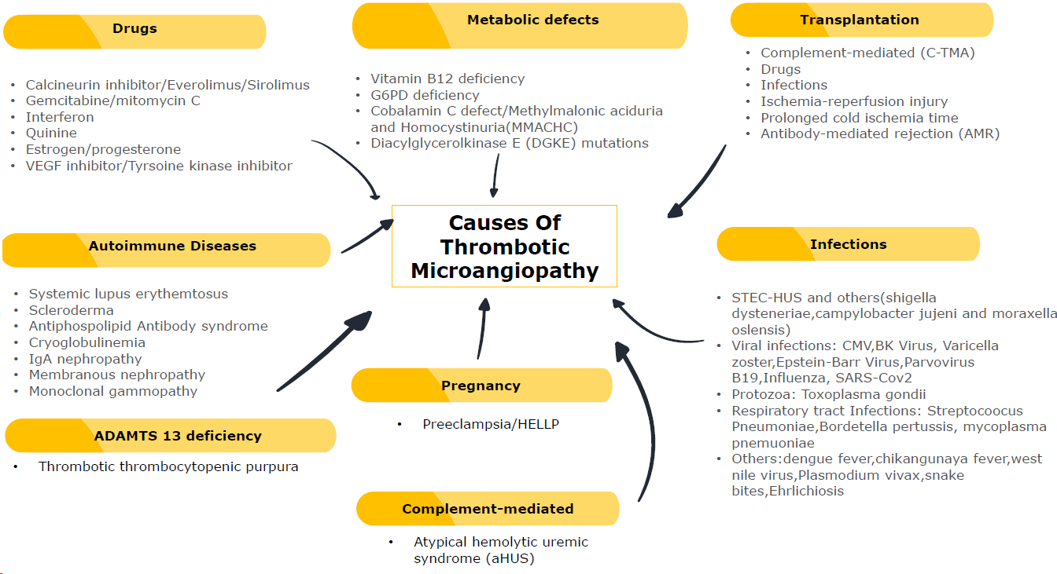
Figure 1 Common causes of thrombotic microangiopathies.
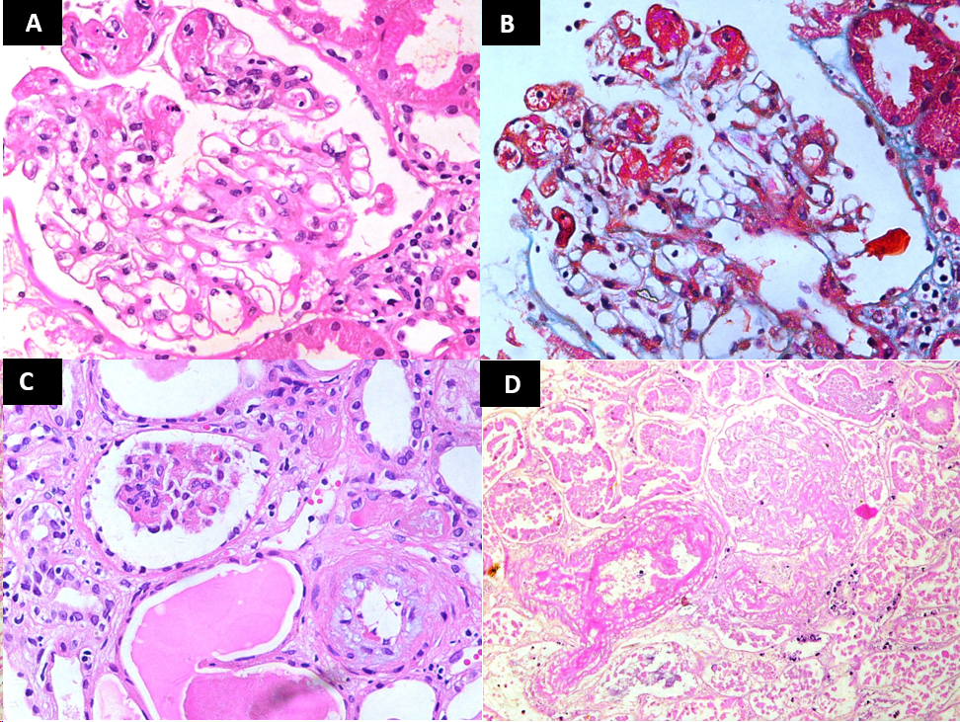
Figure 2 Glomerular lesions in thrombotic microangiopathies. A: High-power view showing a glomerulus containing fibrin thrombi in dilated capillaries at 9 to 12’O clock position (H&E, × 400); B: The same glomerulus on trichrome staining showing fibrin thrombi staining red with this stain (Masson’s Trichrome, × 400); C: Medium-power view showing one ischemic glomerulus and an arteriole exhibiting mucinous intimal thickening (H&E, × 200); D: Medium-power view showing completely infarcted glomerulus and an adjacent infarcted arteriole containing intraluminal fibrin thrombus. (H&E, × 200).
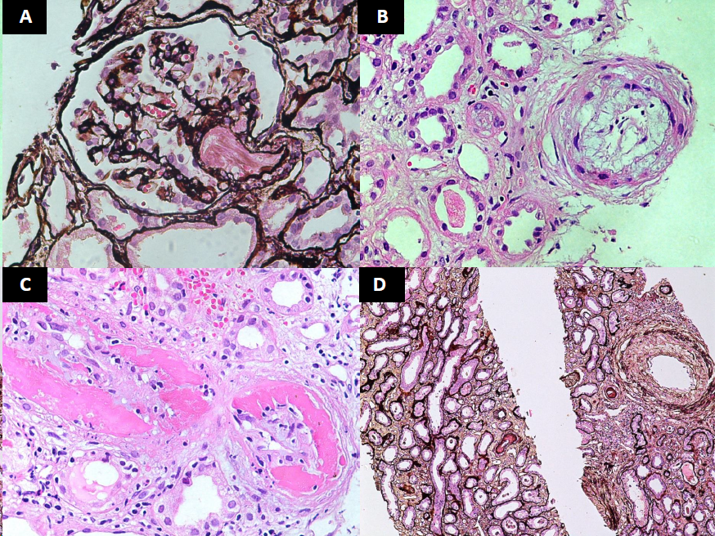
Figure 3 Vascular lesions in thrombotic microangiopathies. A: Medium-power view showing a glomerulus with an arteriole containing fibrin thrombi in acute phase of thrombotic microangiopathies (TMAs) (H&E, × 200); B: High-power view showing an arteriole with endothelial swelling and complete occlusion of the lumen. An adjacent small artery shows marked mucinous thickening of the intima with narrowing of the lumen (H&E, × 400); C: High-power view showing a small artery with fibrinoid necrosis of the vessel wall and intimal proliferation (H&E, × 400); D: Medium-power view showing fibrointimal thickening of an interlobular size artery in chronic phase of TMA. Mild tubular atrophy is seen in the background (Silver stain, × 200).
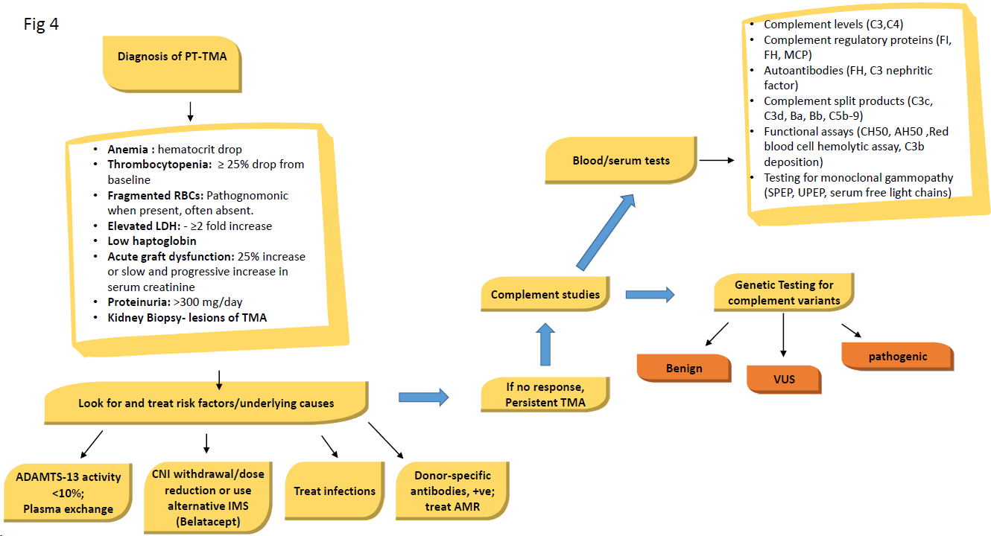

Figure 4 An algorithmic approach to diagnosis, classification and treatment of posttransplant thrombotic microangiopathy. ADAMTS13: A disintegrin-like and metalloprotease with thrombospondin type 1 motif, 13; AMR: Antibody-mediated rejection; IMS: Immunosuppression; LDH: Lactate dehydrogenase; MCP: Membrane cofactor protein; PT-TMA: Posttransplant thrombotic microangiopathy; SPEP: Serum protein electrophoresis; TMA: Thrombotic microangiopathy; UPEP: Urine protein electrophoresis; VUS: Variant of unknown significance.

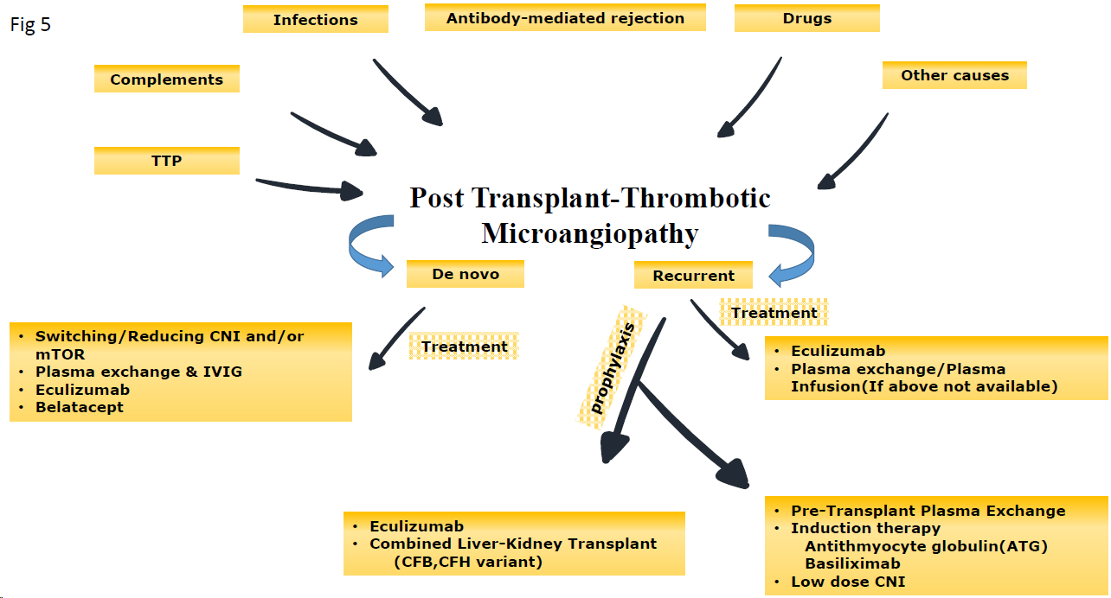

Figure 5 Summary of the main etiologic agents and types of posttransplant thrombotic microangiopathy and their treatment and preventive strategies. CFB: Complement factor B; CFH: Complement factor H; CNI: Calcineurin inhibitor; IVIG: Intravenous immunoglobulin; mTOR: Mammalian target of rapamycin; TTP: Thrombotic thrombocytopenic purpura.

Table 1 Etiology and classification of thrombotic microangiopathies
Primary TMAs
Shiga toxin-producing E. Coli-associated HUS
Thrombotic thrombocytopenic purpura
Atypical HUS or complement-mediated
Secondary TMAs
Infections including viral, fungal, and bacterial
Drugs including immunosuppressants and chemotherapeutic agents
Autoimmune diseases
Malignant hypertension
Malignancy
Metabolic defects
Pregnancy
Transplantation, both hematopoietic stem cell transplantation and solid organ transplantation
Disseminated intravascular coagulation
Radiation
TMAs: Thrombotic microangiopathies.
Table 2 Etiology of post-transplant thrombotic microangiopathies
Recurrent TMA, rare (5%-10% of cases)
Mutations in complement regulatory factor genes [e.g., factor H, factor I, membrane cofactor protein, etc.]
Mutations in complement genes (e.g., C3)
TMA associated with autoantibodies (anti-factor H antibodies, anti-ADAMTS13 antibodies, antiphospholipid antibodies)
TMA associated with autoimmune diseases (scleroderma and systemic lupus erythematosus)
De-novo TMA, common (90%-95% of cases)
Associated with the type of donor and organ procurement procedure, e.g. Ischemia reperfusion injury
Drugs
I: Calcineurin inhibitors-associated TMA
II: Mammalian target of rapamycin inhibitors-associated TMA
Antibody-mediated rejection associated TMA
Infection-associated TMA
I: Viral, e.g. hepatitis C virus, parvovirus B19, and cytomegalovirus)
II: Fungal
III: Bacterial
Other rare causes, such as malignancy, other drugs, and pregnancy
ADAMTS13, a disintegrin-like and metalloprotease with thrombospondin type 1 motif, 13; TMA: Thrombotic microangiopathie.
Table 3 Morphological features of thrombotic microangiopathies
Active lesions
1 Glomerular lesions (Light microscopy):
Intraluminal thrombi
Endothelial swelling or denudation
Endothelial swelling or denudation
Subendothelial space widening (bloodless glomeruli)
Mesangiolysis
Microaneurysms
2 Arteriolar lesions:
Intraluminal thrombi
Endothelial swelling or denudation
Intramural fibrin
Fragmented red blood cells
3 Arterial lesions:
Intraluminal thrombi
Intimal edema
Myxoid intimal swelling
Myocyte necrosis
Intramural fibrin
Fragmentation of red blood cells
Chronic lesions
1 Glomerular lesions (Light microscopy):
Double contours of peripheral capillary walls, with variable mesangial interposition
2 Arteriolar lesions:
Hyaline deposits
3 Arterial lesions:
Fibrous intimal thickening with concentric lamination (onion-skining)

