Name of Journal: World Journal of Clinical Cases
Manuscript NO: 41498
Manuscript Type: CASE REPORT

Tegafur deteriorates established cardiovascular atherosclerosis in colon cancer: A case report and review of the literature

Zhang SC et al. Tegafur deteriorates established cardiovascular atherosclerosis

Shi-Chang Zhang, Meng-Yao Yu, Lei Xi, Jie-Xin Zhang

Shi-Chang Zhang, Meng-Yao Yu, Jie-Xin Zhang, Department of Laboratory Medicine, the First Affiliated Hospital of Nanjing Medical University, Nanjing 210029, Jiangsu Province, China

Lei Xi, Department of Pathology, the First Affiliated Hospital of Nanjing Medical University, Nanjing 210029, Jiangsu Province, China

ORCID number: Shi-Chang Zhang (0000-0002-6587-2518); Meng-Yao Yu (0000-0001-8707-355X); Lei Xi (0000-0003-2181-4970); Jie-Xin Zhang (0000-0003-1407-7562).

Author contributions: Yu MY and Xi L participated in data collection; Zhang JX and Zhang SC conceived and coordinated the study; all authors participated in manuscript writing.

Supported by National Natural Science Foundation of China, No. 81501817 and No. 81671836; Natural Science Youth Foundation of Jiangsu Province, No. BK20151029; and the Key Laboratory for Laboratory Medicine of Jiangsu Province of China, No. ZDXKB2016005.

Informed consent statement: Informed consent was obtained from the patient.

Conflict-of-interest statement: We declare that we do not have any commercial or associative interest that represents a conflict of interest in connection with the work submitted.

CARE Checklist (2016) statement: The authors have read the CARE Checklist (2016), and the manuscript was prepared and revised according to the CARE Checklist (2016).

Open-Access: This article is an open-access article which was selected by an in-house editor and fully peer-reviewed by external reviewers. It is distributed in accordance with the Creative Commons Attribution Non Commercial (CC BY-NC 4.0) license, which permits others to distribute, remix, adapt, build upon this work non-commercially, and license their derivative works on different terms, provided the original work is properly cited and the use is non-commercial. See: http://creativecommons.org/licenses/by-nc/4.0/

Manuscript source: Unsolicited manuscript

Corresponding author: Jie-Xin Zhang, MD, PhD, Senior Researcher, Department of Laboratory Medicine, the First Affiliated Hospital of Nanjing Medical University, 300 Guangzhou Road, Nanjing 210029, Jiangsu Province, China. jiexinzhang@njmu.edu.cn
Telephone: +86-25-68103450

Received: August 10, 2018
Peer-review started: August 10, 2018
First decision: October 5, 2018
Revised: November 2, 2018
Accepted: November 7, 2018
Article in press: November 7, 2018
Published online: January 6, 2019

Abstract
BACKGROUND
Cardiac toxic effect of tegafur (S-1) is extremely rare, and there has been no report on this issue so far.

CASE SUMMARY
We herein report a typical case of single S-1 administration after radical operation for colon cancer. The patient had no background or medical history of acute coronary syndrome (ACS), and only aortic and coronary atherosclerosis was revealed by computed tomography (CT) before surgery. He complained of sternum pain during the fifth cycle of S-1 treatment. Electrocardiogram (ECG) and serum cardiac marker cardiac troponin T (cTnT) strongly suggested ACS, which was possibly caused by S-1 cardiotoxicity.

CONCLUSION
Monitoring protocols based on ECG, CT, and cTnT should be performed in real time to evaluate cardiac function during S-1 administration.

Key words: S-1; Acute coronary syndrome; Computed tomography; Electrocardiogram; Cardiac troponin T; Case report

© The Author(s) 2019. Published by Baishideng Publishing Group Inc. All rights reserved.

Core tip: Cardiac toxic effect of tegafur (S-1) is extremely rare, and there has been no report on this issue so far. We herein report a typical case and review the literature. The case might contribute to improving our understanding of the pharmacology and mechanism of S-1 in treating colon cancer. This report also emphasizes the group of cancer patients who have already been diagnosed with cardiovascular atherosclerosis and serves as a reminder to gastroenterologists that delicate monitoring protocols should be carried out in real time to evaluate the cardiac function of S-1-onging patients.

Citation: Zhang SC, Yu MY, Xi L, Zhang JX. Tegafur deteriorates established cardiovascular atherosclerosis in colon cancer: A case report and review of the literature. World J Clin Cases 2019; 7(1): 89-94
URL: https://www.wjgnet.com/2307-8960/full/v7/i1/89.htm
DOI: https://dx.doi.org/10.12998/wjcc.v7.i1.89
INTRODUCTION
Colon cancer is a common malignancy originating from the digestive tracts. Its worldwide incidence is increasing year by year, and it ranks third among gastric and intestinal tumors nowadays^{[1]}. Surgical operation is the cure, and chemotherapy is considered as a general adjuvant therapy to reduce recurrence and improve survival rate postoperatively. Tegafur/gimeracil/oteracil (S-1) is a new generation oral fluorouracil drug against gastric and colorectal cancer. Clinical data indicate that myelosuppression, gastrointestinal reaction, peripheral neurotoxicity, and liver damage are the main dose limiting toxicities. Reports on its cardiac injury are rare. In this case, non-ST segment elevation acute coronary syndrome (NSTE-ACS) was confirmed by electrocardiography (ECG) as well as the serum cardiac marker cardiac troponin T (cTnT) in a colon cancer patient during the fifth cycle of single S-1 chemotherapy.

CASE PRESENTATION
Chief complaints
Recurrent abdominal pain for half a month.

History of present illness
An 87-year-old male patient was admitted to our hospital on May 1, 2017 for recurrent abdominal pain with anal exhaust and defecation cessation for half a month.

History of past illness
He had a history of right inguinal herniorrhaphy 20 years ago and he denied histories of trauma, smoking or drinking, hyperlipemia, or chronic diseases such as hypertension and diabetes.

Physical examination
Upon physical examination, a 2 cm solid mass was found in his right lower abdomen.

Laboratory testing
Fecal occult blood test was positive. Albumin was 31.1 g/L, indicating low albumin. Serum CEA was 93.00 ng/mL (normal range: <5 ng/mL) and CA199 was 113.7 U/mL (normal range: <39 U/mL).

Imaging examination
Echocardiographic examination revealed mild tricuspid and aortic regurgitation insufficiency (Figure 1). Chest and abdomen computed tomography (CT) showed a soft tissue shadow in the ileocecal junction and adjacent ileum that was surrounded by multiple swollen lymph nodes, which was highly indicative of a tumor lesion (Figure 2A). Aortic and coronary atherosclerosis was also detected (Figure 2B). Colonoscopy further confirmed an ileocecal cauliflower-like space-occupying lesion (Figure 3A), followed by a pathological diagnosis of adenocarcinoma (Figure 3B).

FINAL DIAGNOSIS
Ileocecal adenocarcinoma and ACS.

TREATMENT
The patient underwent radical resection on May 4, 2017 and began S-1 capsule administration at one month after the operation.

OUTCOME AND FOLLOW-UP
The patient periodically went back to our hospital for review. He had no documented complaints of discomfort and showed no obvious adverse reaction until the fifth cycle of single S-1 chemotherapy on October 28, 2017. He developed retrosternal pain. ECG showed extensive ST-T segment depression along with inversed T wave (Figure 4). A serial of cardiac markers were continuously detected during the onset (Table 1), among which serum cTnT and pro-brain natriuretic peptide levels were extremely elevated. In retrospect of CT scan of the heart and after consultation with cardiologists, the patient was diagnosed with NSTE-ACS. Considering D-dimer was elevated after the outbreak of ACS (1.66 mg/L; normal range: <0.55 mg/L), antiplatelet and anticoagulant protocols were applied to stabilize plaque. Improvement of myocardial metabolism and nutritional support were also applied.

DISSCUSION
Pharmacological effect of S-1
Adjuvant chemotherapy, such as 5-fluorouracil (5-FU), has been proven to reduce the high proportion of recurrence and metastasis of colon cancer, which are still the main cause of death after surgical resection. However, every coin has two sides. The common side effects of 5-FU are myelosuppression, diarrhea, mucositis, and hand-foot syndrome. In recent years, S-1 has become a new trend of anticancer first-line drug due to its better tolerance and fewer toxicity than 5-FU. It is a synergetic and modified agent of 5-FU consisting of the active ingredient tegafur (FT) and other two biological regulators, gimeracil (CDHP) and oteracil potassium (Oxo)^{[2]}. As a pro-5-FU, FT preserves bioavailability and can be converted into 5-FU through oral uptake, thus interfering DNA, RNA, and protein synthesis in tumor cells. The regulator CDHP inhibits the catabolism of 5-FU released from FT under the action of dihydropyrimidine dehydrogenase. Therefore, it contributes adequate concentration and therapeutic effect of 5-FU in peripheral blood and tumor tissue, which is similar to that of continuous intravenous infusion of 5-FU. Oxo, another regulator of S-1, concentrates in gastrointestinal tissue after oral administration. Oxo blocks 5-FU phosphorylation and reduces local toxicity^{[3]}.

Cardiac toxic effect of 5-FU
The patient in our case had confirmed aortic and coronary atherosclerosis by CT examination before surgery. Considering no other obvious triggers within 4 months except single S-1 administration, ACS onset was considered to be related to cardiotoxicity of S-1. According to some reports, cardiotoxicity is of less frequency but more lethal during 5-FU treatment, with a classical manifestation of angina-like chest pain. The exact pathophysiological mechanism of cardiotoxicity of 5-FU has not yet been fully elucidated. One hypothesis is that 5-FU and its metabolites (e.g., fluoroacetate) induce coronary vasospasm. This has been demonstrated in both animal models and human vascular samples during 5-FU infusion^{[4,5]}. Another theory is that 5-FU is catabolized to alpha-fluoro-beta alanine and subsequently to fluoroacetate, which is known to be highly cardiotoxic and neurotoxic^{[6]}. The original records on the side effects of tegafur date back to the last century. However, whether cardiotoxicity of 5-FU also applies to S-1 is barely documented.

CT, ECG, and cTnT in S-1 monitoring
Coronary CT angiography (CCTA) provides both detailed information on the cavity and wall of the coronary artery and the dynamic signal of blood flow in it, emphasizing its important diagnostic value for ACS. Its high-resolution images can exhibit the main branch stenosis of the coronary artery. In addition, CCTA is also applied for morphological evaluation of atherosclerotic plaque in the main coronary artery as well as its main branches^{[7]}.
ECG is a first-line diagnostic technique for patients with chest pain. It is of great clinical significance in reducing disability and mortality of ACS by early diagnosis and in patients' better prognosis. ECG is more operable than the interventional examination and coronary angiography in ACS diagnosis. The characteristic of NSTE-ACS, ST-T alternation, such as depressed ST without ST elevation, is one of the most important indicators^{[8]}.
cTnT is a structural protein of cardiac myocytes. When cardiac cells are injured, increased membrane permeability occurs, followed by cell apoptosis or necrosis. The cytoplasmic and structural cTnT will be released into the blood. Therefore, it is considered to be the “gold standard” for diagnosing myocardial injury, especially myocardial infraction, due to its rapid increase in blood to achieve the detection sensitivity^{[9]}.
Individual susceptibility to cardiotoxicity is unpredictable when taking S-1. For those who have already been diagnosed with cardiovascular atherosclerosis and are highly likely to have a lethal strike, we recommend that delicate monitor protocols, based on ECG, CT and cTnT, should be carried out in real time to evaluate the cardiac function of S-1-onging patients. As such, high-risk patients may truly benefit from S-1 treatment since it may improve their prognosis for myocardial infarction prevention.

CONCLUSION
Individual susceptibility to cardiotoxicity is unpredictable in patients with gastric and colorectal cancer when they take S-1. Cardiotoxicity of S-1 should be considered in patients with cardiovascular atherosclerosis during anticancer therapy. Monitoring protocols based on ECG, CT, and cTnT should be carried out in real time to evaluate cardiac function during S-1 administration.

REFERENCES
1 García-Alfonso P, Grande E, Polo E, Afonso R, Reina JJ, Jorge M, Campos JM, Martínez V, Angeles C, Montagut C. The role of antiangiogenic agents in the treatment of patients with advanced colorectal cancer according to K-RAS status. Angiogenesis 2014; 17: 805-821 [PMID: 24793846 DOI: 10.1007/s10456-014-9433-6]
2 Benson AB 3rd. S-1: another oral agent for patients with colorectal cancer. Lancet Oncol 2013; 14: 1244-1245 [PMID: 24225156 DOI: 10.1016/S1470-2045(13)70533-3]
3 Kobayakawa M, Kojima Y. Tegafur/gimeracil/oteracil (S-1) approved for the treatment of advanced gastric cancer in adults when given in combination with cisplatin: a review comparing it with other fluoropyrimidine-based therapies. Onco Targets Ther 2011; 4: 193-201 [PMID: 22162925 DOI: 10.2147/OTT.S19059]
4 Deboever G, Hiltrop N, Cool M, Lambrecht G. Alternative treatment options in colorectal cancer patients with 5-fluorouracil- or capecitabine-induced cardiotoxicity. Clin Colorectal Cancer 2013; 12: 8-14 [PMID: 23102544 DOI: 10.1016/j.clcc.2012.09.003]
5 Südhoff T, Enderle MD, Pahlke M, Petz C, Teschendorf C, Graeven U, Schmiegel W. 5-Fluorouracil induces arterial vasocontractions. Ann Oncol 2004; 15: 661-664 [PMID: 15033676 DOI: 10.1093/annonc/mdh150]
6 Leong LEX, Khan S, Davis CK, Denman SE, McSweeney CS. Fluoroacetate in plants - a review of its distribution, toxicity to livestock and microbial detoxification. J Anim Sci Biotechnol 2017; 8: 55 [PMID: 28674607 DOI: 10.1186/s40104-017-0180-6]
7 Lubbers MM, Dedic A, Kurata A, Dijkshoorn M, Schaap J, Lammers J, Lamfers EJ, Rensing BJ, Braam RL, Nathoe HM, Post JC, Rood PP, Schultz CJ, Moelker A, Ouhlous M, van Dalen BM, Boersma E, Nieman K. Round-the-clock performance of coronary CT angiography for suspected acute coronary syndrome: Results from the BEACON trial. Eur Radiol 2018; 28: 2169-2175 [PMID: 29247351 DOI: 10.1007/s00330-017-5082-7]
8 Mueller C. Biomarkers and acute coronary syndromes: an update. Eur Heart J 2014; 35: 552-556 [PMID: 24357507 DOI: 10.1093/eurheartj/eht530]
9 Thygesen K, Alpert JS, White HD; Joint ESC/ACCF/AHA/WHF Task Force for the Redefinition of Myocardial Infarction. Universal definition of myocardial infarction. Eur Heart J 2007; 28: 2525-2538 [PMID: 17951287 DOI: 10.1093/eurheartj/ehm355]

P-Reviewer: Ueda H S-Editor: Ji FF L-Editor: Wang TQ E-Editor: Bian YN

Specialty type: Medicine, research and experimental
Country of origin: China
Peer-review report classification
Grade A (Excellent): 0
Grade B (Very good): B
Grade C (Good): 0
Grade D (Fair): 0
Grade E (Poor): 0
Table 1 Serum cardiac markers of the patient during acute coronary syndrome onset
Date | cTnI | cTnT (ng/L) | CK-MB (U/L) | Mb (µg/L) | PRO-BNP (pg/mL) | PCT (ng/mL)
28/10 | - | 146.2 | 43.0 | 230 | ∕ | ∕
29/10 | - | 1256 | 50 | 54 | 1077 | 0.059
01/11 | - | 1102 | ∕ | ∕ | ∕ | ∕
06/11 | ± | 507.3 | ∕ | ∕ | ∕ | ∕
cTnI: Cardiac troponin I; cTnT: Cardiac troponin T; CK-MB: Creatine kinase-MB; Mb: Myoglobin; PRO-BNP: Pro-brain natriuretic peptide; PCT: Procalcitonin.

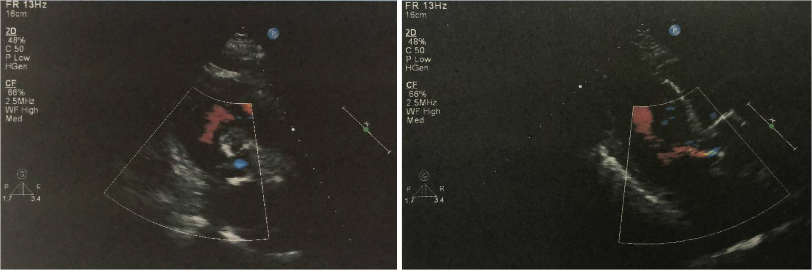
Figure 1 Echocardiographic examination on October 28, 2017.

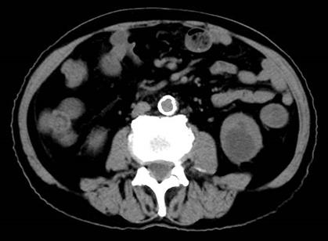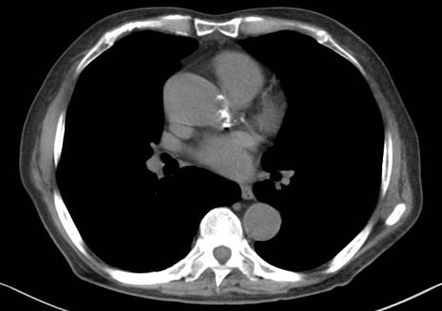
A
B
Figure 2 Pre-surgery computed tomography examination. A: A soft tissue shadow of the ileocecal junction and adjacent ileum surrounded by multiple swollen lymph nodes; B: Aortic and coronary atherosclerosis.

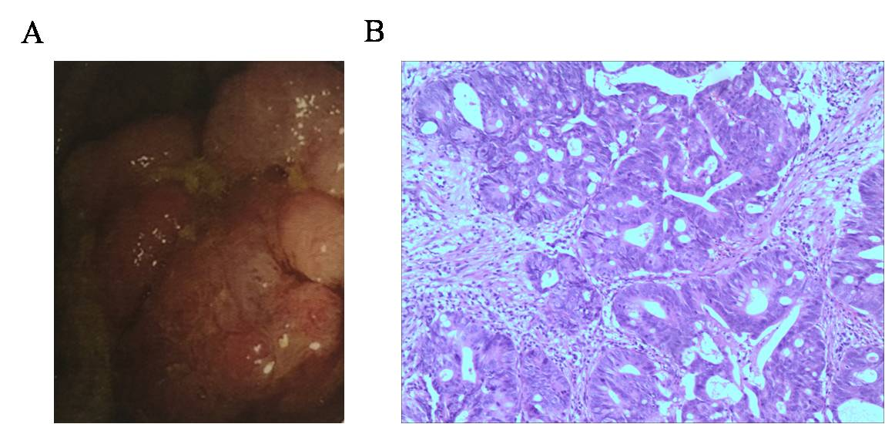
Figure 3 Diagnosis of a space-occupying ileocecal lesion. A: Colonoscopic examination; B: H&E staining showed adenocarcinoma (magnification, ×100).

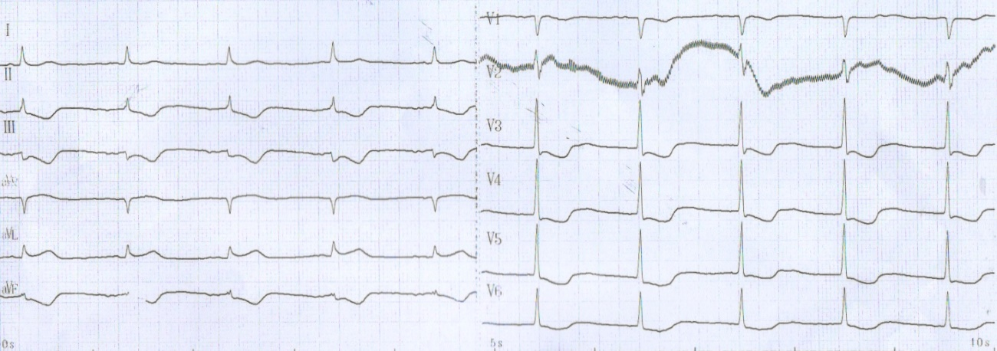
Figure 4 Electrocardiogram results on October 28, 2017.

