Name of journal: World Journal of Gastroenterology
ESPS Manuscript NO: 9717
Columns: MINIREVIEWS

Epithelial cysts of spleen: A minireview

Ingle SB et al. Primary splenic epithelial cysts

Sachin B Ingle, Chitra R Hinge (Ingle), Swapna Patrike

Sachin B Ingle, department of Pathology, MIMSR Medical College, Latur, Maharashtra 4132512, India

Chitra R Hinge (Ingle), department of Physiology, MIMSR Medical College, Latur, Maharashtra 4132512, India

Swapna Patrike, department of Pathology, MIMSR Medical College, Latur, Maharashtra 4132512, India

Author contributions: Ingle SB and Patrike S prepared the manuscript; Ingle SB and Hinge (Ingle) CR critically revised the intellectual content and gave final approval of manuscript.

Correspondence to: Sachin B Ingle, Associate Professor, Department of Pathology, MIMSR Medical College, Ambajogai Road, Latur, Maharashtra 413512, India. dr.sachiningle@gmail.com
Telephone: +91-2382-227424 Fax: +91-2382-228939

Received: February 28, 2013 Revised May 20, 2014
Accepted:

Published online:

Abstract
Primary splenic epithelial cyst is an unusual event in everyday surgical practice with about 800 cases reported until date as per English literature. Splenic cyst may be parasitic or non-parasitic in origin. The nonparasitic cysts are either primary or secondary. Primary cysts are also called as true, congenital, epidermoid or epithelial cyst. Primary splenic cysts account for 10% of all benign non-parasitic splenic cysts and are the most frequent type of splenic cysts in children. Usually, splenic cysts are asymptomatic and can be found incidentally during imaging techniques or on laprotomy. The symptoms are related to size of cyst. When they assume large sizes, they may present with fullness in left abdomen, local or referred pain, symptoms due to compression of adjacent structures (like nausea, vomiting, flatulence, diarrhoea) rarely as thrombocytopenia and occasionally may be presented with complications such as infection, rupture and/or haemorrhage. The preoperative diagnosis of primary splenic cyst can be ascertained by ultrasonography (USG) examination, computed tomography or magnetic resonance imaging, although wide use of USG today has led to an increase in incidence of splenic cyst by 1%. However, careful histopathological evaluation along with immunostaining for presence of epithelial lining is mandatory to arrive at the diagnosis. The treatment has changed drastically from total splenectomy in the past to splenic preservation methods recently.

© 2014 Baishideng Publishing Group Inc. All rights reserved.

Key words: Epithelial cyst; Spleen; Diagnosis; Splenectomy; Laproscopy

Core tip: Accurate pre-operative diagnosis of primary epithelial cysts is difficult; the occurrence of a cystic lesion either unilocular or multilocular in the absence of previous trauma, infection or exposure to hydatid disease may help to arrive at the diagnosis. However, careful histopathological evaluation along with immunostaining is important to arrive at correct diagnosis. The treatment has changed drastically from total splenectomy in the past to splenic preservation methods recently. The rationale behind conservative management is to preserve the splenic function in order to avoid untoward complications related to historical treatment.

Ingle SB, Hinge (Ingle) CR, Patrike S. Epithelial cysts of spleen: A minireview. World J Gastroenterol 2014; In press

INTRODUCTION
Primary splenic cysts are unusual and found as an incidental finding in surgical practice. As per the existing literature, the first case was confirmed in 1929, by Andral, the classification of these lesions has evolved into the present system^{[1]}.

CLASSIFICATION
The splenic cysts have been classified based on their lining, etiology, pathogenesis, etc. (1) According to Martin splenic cysts are classified as (a) Type 1 cysts are true cysts having lining epithelium; and (b) Type 2 cysts are false cysts without lining epithelium^{[2,3]}. The pseudo cysts are usually posttraumatic, due to failure of organization of hematomas located beneath the capsule or in the splenic parenchyma and rarely it may occur in splenic abscess or splenic infarction^{[1,4,5]}; (2) Depending on the causative agent it can be of two types: (a) Parasitic cysts and (b) Non-parasitic cysts. Parasitic cysts are usually seen in endemic areas and are caused mainly by Echinococcus granulosus infestation^{[1,6,7]}; and (3)A new classification based on the true pathogenesis of cyst divides non-parasitic splenic cysts as congenital, neoplastic, traumatic, and degenerative^{[8]}. Primary splenic cyst constitutes 10% of all nonparasitic cysts of spleen. These cysts are predominently seen in paediatric and adolescent age groups^{[2,9]}. Usually they are asymptomatic and found incidentally on ultrasound examination of abdomen^{[2]}. The clinical significance is attributed mainly because of their potential to rupture, to infect or to bleed, and due to the potential of a serious differential diagnosis of a neoplastic lesion in the left hypochondrium^{[10]}.
Recently, treatment of choice is open partial splenectomy as it preserves the splenic functions and there is no recurrence of the lesion due to complete removal^{[11]}. Histopathological evaluation along with immunohistochemistry is the mainstay to confirm the subtype of splenic cyst and to rule out the rare possibility of malignant transformation in the pluripotent epithelial lining^{[12]}.

EPIDEMIOLOGY
Primary splenic epithelial cyst is a rare condition with incidence of 0.07% as reported as per review of 42327 autopsies^{[13-16]}. Primary splenic cysts are seen mostly in childhood, adolescents and young adults^{[13]}. Congenital type is common in girls^{[17,18]}. Non-parasitic splenic cysts are common in Europe & North America, while the parasitic cysts are common in Africa and Central America^{[19]}. The prevalence rate of splenic cysts has been increased now a day due to increased use of non-invasive modes of diagnosis i.e. ultrasonography (USG) and computed tomography (CT) scan^{[20]}.

PATHOPHYSIOLOGY
The pathogenesis of primary splenic cysts is not clear. In view of this, many hypotheses were proposed.

Mesothelial invagination theory
In case of congenital cysts, it is postulated that during development there is invasion of mesothelial lining along with capsule. As the lining is having pluripotent nature, its is having propensity to undergo metaplasia and secretion of fluid by the lining epithelium leading to formation of cyst^{[1,5]}.
The congenital cyst lining is postulated to arise from invasion of peritoneum along with its mesothelial lining after rupture of splenic capsule or due to trapping of mesothelial cells in splenic sulci.

Lymph space theory
According to this theory the cysts may arise from the normal lymph spaces in the spleen^{[16]}.

Endodermal inclusion theory
Endodermal inclusion theory proposes that these epithelial splenic cysts develop by true metaplasia of a heterotopic endodermal inclusion within the spleen^{[21-23]}. Due to pleuripotent nature of the mesothelium, there seems to be metaplasia in the lining leading to formation of cysts with various types of epithelial lining i.e. squamous, columnar etc^{[12]}. According to some studies the epidermoid nature is due to teratomatous differentiation or due to inclusion of fetal squamous lining instead of metaplasia.

CLINICAL FEATURES
Age
These cysts are predominantly seen in the second and third decades, however, can be seen in paediatric age group^{[24]}.

Sex
They are common in females as compared to males^{[18]}.

Signs and symptoms
Usually the smaller cyst are symptomless. A painless mass in left hypochondriac region is the main presentation in 30%-40% cases. There may be localized pain or referred pain due to mass effect^{[25]}. Occasionally the patients may present with thrombocytopenia^{[1,26]}. The initial symptoms are mainly due to pressure effect i.e. nausea, belching pain in abdomen^{[25]}. Pleuritic pain and persistent cough are also the presenting features^{[27]}. Occasionally they present with complications, like infection, rupture and haemorrhage^{[25,28]}. On physical examination, there reveal left hypochondriac mass. The routine haematological and biochemical investigations are within normal limits.

Tumor markers
The serum tumour markers, carcinoembryonic antigen (CEA) and carbohydrate antigen 19-9 (CA 19-9) may be raised and so checked^{[29]}.

DIAGNOSIS
Clinical diagnosis
Most of the primary cysts are clinically silent and are diagnosed incidentally on ultrasonography. Now a day, the prevalence is increased because of the increased use of non-invasive imaging techniques i.e. USG and CT^{[30]}.
Whenever, there is a lump in left hypochondriac region. The clinician should exclude other causes of splenomegaly i.e. infectious mononucleosis, fever of unknown origin, haemolytic anaemia, chronic leukaemias, collagen vascular disease, and liver diseases. Serological markers play key role in such circumstances^{[31]}.

USG
Ultrasonography is a good non-invasive tool for screening and confirming the cystic nature of the mass^{[2]}. Ultrasound can differentiate solid and cystic lesions in most cases^{[32]}. Characteristically, on USG the cyst appears as an anechoic mass with thin walled lesion with septations or irregular walls. There are calcific foci in case of complex cysts. Calcifications are useful to differentiate cysts from other causes of splenomegaly^{[27,30,10]}.

CT and magnetic resonance imaging
CT and magnetic resonance imaging (MRI) may give guidelines, with regard to the morphology of the cyst, the nature of the fluid, the exact location in the organ and its relationship with the adjacent structures^{[10,27,30]}. On MRI,with T1-weighted images, the cyst is hypointense while on T2, it is hypereintense, with intensity of signal equal to water without reinforcement after contrast injection. However, the signal intensity may be elevated according to contents in the cyst e.g. signal intensity on T1 can be increased in case of hemorrhagic cyst^{[33]}.

Accurate clinical diagnosis
Accurate clinical diagnosis of primary epithelial cysts is difficult; the occurrence of a unilocular cyst in the absence of previous trauma, infection or exposure to hydatid disease may help to arrive at the diagnosis^{[1]}. The diagnosis of pseudocyst should be suspected in cases with history of trauma, elder age along with evidence of hematoma in the organ parenchyma and calcification in the cyst wall. The diagnosis of hydatid cyst is done by detailed clinical history, the evidence of calcification in the wall, presence of daughter cysts with multiple organ involvement^{[34,35]}.

Other techniques
Other techniques such as 99m Technetium sulphur colloid scintigraphy and 67-Gallium citrate are also proved the diagnostic utility^{[2]}. The inner cyst wall is immunoreactive to anti-CA 19-9 antibodies^{[36]}. Serum levels of the markers may be low as compared to actual elevations within the cystic cavity.
Angiography is helpful in differentiating a splenic cyst, which is usually avascular lesion, while the malignant tumours (lymphoma, sarcoma), which usually have disarranged vascular pattern^{[27,13]}.
However, definite diagnosis is possible only after splenectomy when epithelial lining is confirmed on histopathology along with immunohistochemistry. Primary epithelial cysts are usually solitary, but can be multiple. Cases have also been described in accessory spleens^{[37,38]}.
The cysts are either unilocular/multilocular with occasional calcific foci. Grossly, here is an example of a unilocular cyst with smooth glistening inner wall surface (Figure 1).
A case of multilocular primary epithelial cyst of spleen in a postmenopausal women presented as splenomegaly was reported (Figure 2)^{[12]}.
Histologically, the primary splenic cysts have epithelial lining i.e. flattened, low cuboidal, low columnar or squamous type and unilayered or multilayered with benign nuclear features^{[1]}. Epidermoid cysts have stratified squamous epithelium with a fibrocollagenous cyst wall (Figure 3). Immunohistochemically, the epithelial cells are positive for pan-cytokeratin and negative for CD240 (lymphatic epithelial marker) and CD34 (endothelial cell marker). Here is an example of Primary splenic cyst lined with cuboidal to flattened epithelial lining (Figure 4).
The differential diagnoses for a cysts in spleen include parasitic echinococcal disease, congenital cyst, post traumatic pseudo-cyst , infarction, infection, pyogenic splenic abscess, pancreatic pseudo-cyst, metastatic disease, and cystic neoplasms like haemangioma/lymphangioma (diffuse lymphangiomatosis of spleen)(Figure 5).

TREATMENT
Previously, splenectomy was the treatment of choice for splenic cysts. Recently, the approach is changed towards conservative surgery in view of overwhelming sepsis after spenectomy leading to raised mortality. The splenic cysts with a diameter more than 4-5 cm should treat surgically^{[11]}. Traditionally the cysts has been treated either by partial or total splenectomy. However, there are chances of overwhelming sepsis after splenectomy. In the modern era of laparoscopic surgery, more interest in conservative surgery like percutaneous aspiration, sclerosis is documented to prevent post splenectomy complications. Marsupialisation is very much effective in smaller cysts.
There are different types of surgical modalities according to the clinical situation.
Today, there is different conservative treatment modalities i.e. percutaneous drainage, partial splenectomy with a stapler or harmonic scalpel, total cystectomy, marsupialisation or, cyst unroofing, laparoscopic puncture and creation of a cyst peritoneal window is also an effective conservative treatment modality by laparoscopic approach. The aim of partial splenectomy is to retain the immunological protection of patient by preserving more than 25% of the splenic parenchyma, which is the optimum splenic tissue to preserve immunologic efficiency without increasing the risk of recurrence^{[28]}.
Any type of conservative surgical treatment modality is having little value in cases e.g. very large cyst in hilum of spleen, intrasplenic cyst almost surrounded by splenic parenchyma, with dense vascular adhesions to surrounding structures or in case of multiple cysts. In such circumstances, splenectomy either by open approach or by laparoscopic approach is the treatment of choice.

PROGNOSIS
The clinical importance of splenic cysts is due to their potential to rupture, to be infected or to bleed. Cyst with diameter > 5 cm are more likely to rupture resulting in life threatening haemoperitoneum. Two rare cases of patients with epithelial splenic cysts as an incidental finding during emergency laprotomy for splenic rupture were reported^{[39]}. The most common infection is from bacteria of salmonella group^{[13]}. A prepubertal girl (12-year-old) presented with a large congenital splenic cyst complicated by Salmonella organisms was documented^{[18]}. Pregnancy associated splenic cysts are extremely rare and as per existing literature only five cases were described^{[40]}. A case of squamous cell carcinoma in a case of epidermoid cyst was reported in a pregnant woman^{[4]}.

REFERENCES
- Ingle SB, Hinge CR , Jatal SN. An interesting case of primary epithelial
cyst of spleen. Indian J Pathol Microbiol 2013; 56: 181-182 [PMID: 24056665 DOI: 10.4103/0377-4929.118700]
2 Garg M, Kataria SP, Sethi D, Mathur SK. Epidermoid cyst of spleen mimicking splenic lymphangioma. Adv Biomed Res 2013; 2: 49 [PMID: 24516849 DOI: 10.4103/2277-9175.114190.]
3 MARTIN JW. Congenital splenic cysts. Am J Surg 1958; 96: 302-308 [PMID: 13559574]
4 Schwarts SI. The spleen. In: Schwartz SI, Harold E, editors. Maingot’s Abdominal Operations. 9th edition. USA: Appleton & Lange 1990: 80.
5 Daga G, Mittal V, Singh RJ, Sood N. Epithelial cyst of the spleen. J Indian
Assoc Pediatr Surg 2011; 16: 18-20 [PMID: 2143084 DOI: 10.4103/0971-9261.74516 3]
6 Avital S, Kashtan H. A large epithelial splenic cyst. N Engl J Med
2003; 349: 2173-2174 [PMID: 14645653]
7 Kalinova K. Giant pseudocyst of the spleen: A case report and review of the literature. J Indian Assoc Pediatr Surg 2005; 10: 176-178.
8 Morgenstern L. Nonparasitic splenic cysts: pathogenesis, classification, and treatment. J Am Coll Surg 2002; 194: 306-314 [PMID: 11893134]
9 Belekar D, Desai A, Dewoolkar A, Dewoolkar V, Bhutala U. Splenic epithelial cyst: A rare entity. Int J Surg 2010; 22: 1-18.
10 Hansen MB, Moller AC. Splenic cysts. Surg Laparosc Endosc Percutan Tech 2004; 14: 316-322 [PMID: 15599294]
11 Szczepanik AB, Meissner AJ. Partial splenectomy in the management of nonparasitic splenic cysts. World J Surg 2009; 33: 852-856 [PMID: 19172349 DOI: 10.1007/s00268-008-9868-2]
12 Manoj MG, Misra P, Kakkar S. Multilocular epithelial cyst of spleen: a rare occurrence. Indian J Pathol Microbiol 2012; 55: 602-604 [PMID: 23455826 DOI: 10.4103/0377-4929.107850]
13 Macheras A, Misiakos EP, Liakakos T , Mpistarakis D , Fotiadis C, Karatzas G.
Non-parasitic splenic cysts: a report of three cases. World J Gastroenterol 2005; 11: 6884-6887 [PMID: 16425403]
14. Doolas A, Nolte M, McDonald OG, Economou SG. Splenic cysts. J Surg Oncol 1978; 10: 369-387 [PMID: 732326]
15 Geraghty M, Khan IZ, Conlon KC. Large primary splenic cyst: A laparoscopic technique. J Minim Access Surg 2009; 5: 14-16 [PMID: 19547686]
16 Robbins FG, Yellin AE, Lingua RW, Craig JR, Turrill FL, Mikkelsen WP. Splenic epidermoid cysts. Ann Surg 1978; 187: 231-235 [PMID: 637577]
17 Hilmes MA, Strouse PJ. The paediatric spleen. Semin Ultrasound CT
MR 2007; 28: 3-11 [PMID: 17366703]
18 Karia N, Lakhoo K. Complicated congenital splenic cyst: saved by a splenunculus. Afr J Paediatr Surg 2011; 8: 98-100 [PMID: 21478599 DOI: 10.4103/0189-6725.79068]
19 Sellers GJ, Starker PM. Laparoscopic treatment of a benign splenic cyst. Surg Endosc 1997; 11: 766-768 [PMID: 9214329]
20 Wu HM, Kortbeek JB. Management of splenic pseudocysts following trauma: a retrospective case series. Am J Surg 2006; 191: 631-634 [PMID:16647350]
21 Kundal VK, Gajdhar M, Kundal R, Sharma C, Agrawal D, Meena A. Giant Epithelial Non-Parasitic Splenic Cyst. J Case Rep 2013; 3: 106-109
22 Harding HE. A large inclusion cyst in a spleen. J Path 1933; 36: 485 [DOI: 10.1002/path.1700360312]
23 Touloukian RJ, Maharaj A, Ghoussoub R, Reyes M. Partial decapsulation of splenic epithelial cysts: studies on etiology and outcome. J Pediatr Surg 1997; 32: 272-274 [PMID: 9044136]
24 Sakamoto Y, Yunotani S, Edakuni G, Mori M, Iyama A, Miyazaki K. Laparoscopic splenectomy for a giant splenic epidermoid cyst: report of a case. Surg Today 1999; 29: 1268-1272 [PMID: 10639710]
25 Trompetas V, Panagopoulos E, Priovolou-Papaevangelou M, Ramantanis G. Giant benign true cyst of the spleen with high serum level of CA 19-9. Eur J Gastroenterol Hepatol 2002; 14: 85-88 [PMID: 11782581]
26 Tsakraklides V, Hadley TW. Epidermoid cysts of the spleen. A report
of five cases. Arch Pathol 1973; 96: 251-254 [PMID: 4743891]
27 Labruzzo C, Haritopoulos KN, El Tayar AR, Hakim NS. Posttraumatic cyst of the spleen: a case report and review of the literature. Int Surg 2002; 87: 152-156 [PMID: 12403089]
28 Till H, Schaarschmidt K. Partial laparoscopic decapsulation of congenital splenic cysts. A medium-term evaluation proves the efficiency in children. Surg Endosc 2004; 18: 626-628 [PMID: 15026897]
29 Walz MK, Metz KA, Sastry M, Eigler FW, Leder LD. Benign mesothelial splenic cyst may cause high serum concentration of CA 19-9. Eur J Surg 1994; 160: 389-391 [PMID: 7948360]
30 Robertson F, Leander P, Ekberg O. Radiology of the spleen. Eur Radiol 2001; 11: 80-95 [PMID: 11194923]
31 Knudson P, Coon W, Schnitzer B, Liepman M. Splenomegaly without an apparent cause. Surg Gynecol Obstet 1982; 155: 705-708 [PMID: 7135177]
32 Siniluoto TM, Päivänsalo MJ, Lähde ST, Alavaikko MJ, Lohela PK, Typpö AB, Suramo IJ. Nonparasitic splenic cysts. Ultrasonographic features and follow-up. Acta Radiol 1994; 35: 447-451 [PMID: 8086251]
33 Ramani M, Reinhold C, Semelka RC, Siegelman ES, Liang L, Ascher SM, Brown JJ, Eisen RN, Bret PM. Splenic hemangiomas and hamartomas: MR imaging characteristics of 28 lesions. Radiology 1997; 202: 166-172 [PMID: 8988207]
34 Fernández-Ruiz M, Guerra-Vales JM, Enguita-Valls AB, Vila-Santos J, García-Borda FJ, Morales-Gutiérrez C. Splenic hydatid cyst, a rare location of extrahepatic echinococcosis: Report of six cases. Eur J Intern Med 2008; 19: e51-e53 [PMID:19013364 DOI:10.1016/j.ejim.2008.02.003.]
35 Polat P, Kantarci M, Alper F, Suma S, Koruyucu MB, Okur A. Hydatid
disease from head to toe. Radiographics 2003; 23: 475-494. quiz 536-537 [PMID: 12640161]
36 Madia C, Lumachi F, Veroux M, Fiamingo P, Gringeri E, Brolese A, Zanus G, Cillo U, D'Amico DF. Giant splenic epithelial cyst with elevated serum markers CEA and CA 19-9 levels: an incidental association? Anticancer Res 2003; 23: 773-776 [PMID: 12680182]
37 Morohoshi T, Hamamoto T, Kunimura T, Yoshida E, Kanda M, Funo K, Nagayama T, Maeda M, Araki S. Epidermoid cyst derived from an accessory spleen in the pancreas. A case report with literature survey. Acta Pathol Jpn 1991; 41: 916-921 [PMID: 1785350]
38 Tateyama H, Tada T, Murase T, Fujitake S, Eimoto T. Lymphoepithelial cyst and epidermoid cyst of the accessory spleen in the pancreas. Mod Pathol 1998; 11: 1171-1177 [PMID: 9872647]
39 Fragandreas G, Papadopoulos S, Gerogiannis I, Spyridis C, Tsantilas D, Venizelos I, Gerasimidis T. Epithelial splenic cysts and life-threatening splenic rupture. Chirurgia (Bucur) 2011; 106: 519-522 [PMID: 21991879]
40 Rotas M, Ossowski R, Lutchman G, Levgur M. Pregnancy complicated with a giant splenic cyst: a case report and review of the literature. Arch Gynecol Obstet 2007; 275: 301-305 [PMID: 16937120]
P-Reviewers: Kamocki Z Liu PP Murakami M, Schrittwieser R S-Editor: Ding Y L-Editor: E-Editor:

Figure 1 Huge primary splenic cyst with glistening smooth inner wall.
Figure 2 Multiloculated primary splenic cyst.
Figure 3 Epidermoid cyst of spleen (HE, ×10). HE: Hematoxylin and eosin stain.
Figure 4 Primary splenic cyst lined cuboidal to flattened epithelial lining (HE, ×10). HE: Hematoxylin and eosin stain.
Figure 5 Diffuse lymphangiomatosis of spleen (HE, ×10). HE: Hematoxylin and eosin stain.

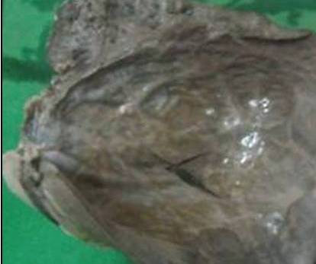
Figure 1 Huge primary splenic cyst with glistening smooth inner wall.

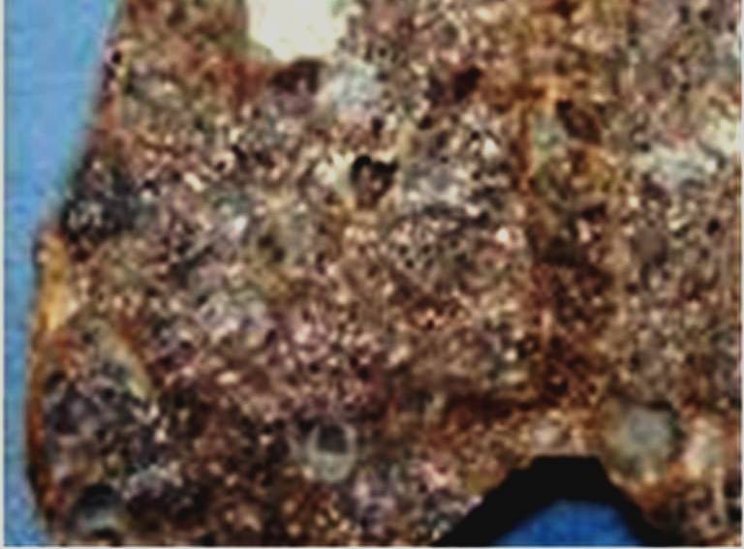
Figure 2 Multiloculated primary splenic cyst.

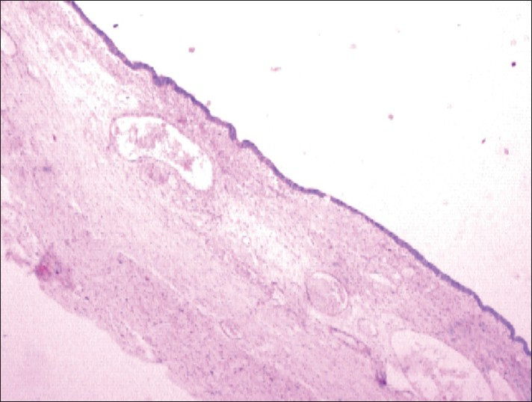
Figure 3 Epidermoid cyst of spleen (HE, ×10). HE: Hematoxylin and eosin stain.

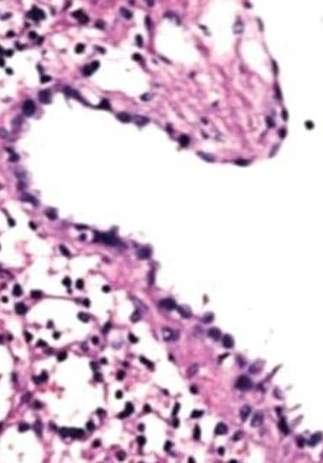
Figure 4 Primary splenic cyst lined cuboidal to flattened epithelial lining (HE, ×10). HE: Hematoxylin and eosin stain.

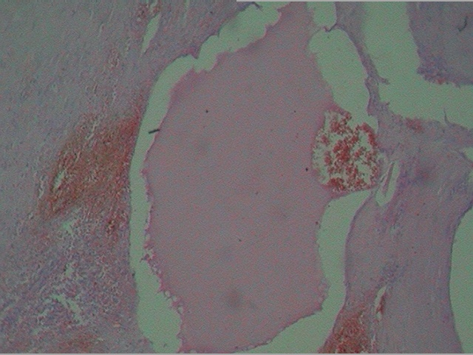
Figure 5 Diffuse lymphangiomatosis of spleen (HE, ×10). HE: Hematoxylin and eosin stain.

