Name of Journal: World Journal of Gastrointestinal Surgery
Manuscript NO: 86473
Manuscript Type: SYSTEMATIC REVIEWS

Comparative effectiveness of several adjuvant therapies after hepatectomy for hepatocellular carcinoma patients with microvascular invasion

Pei YX et al. Adjuvant therapies for HCC with MVI

Yin-Xuan Pei, Chen-Guang Su, Zheng Liao, Wei-Wei Li, Zi-Xiang Wang, Jin-Long Liu

Yin-Xuan Pei, Chen-Guang Su, Zheng Liao, Wei-Wei Li, Zi-Xiang Wang, Jin-Long Liu, Department of Hepatobiliary Surgery, The Affiliated Hospital of Chengde Medical University, Chengde 067000, Hebei Province, China

Author contributions: Pei YX and Liu JL contributed to the conception and design of the study; Pei YX and Su CG conducted the literature search and extracted the data; Liao Z and Wang ZX assessed methodological quality of included studies; Liao Z was involved in the resolution of all the arguments; Pei YX, Su CG, and Liao Z conducted the data analysis; Pei YX wrote the manuscript; and all authors have read and approve the final manuscript.

Corresponding author: Jin-Long Liu, MD, Chief Doctor, Department of Hepatobiliary Surgery, The Affiliated Hospital of Chengde Medical University, No. 36 Nanyingzi Street, Shuangqiao District, Chengde 067000, Hebei Province, China. liujl800813@163.com

Received: October 11, 2023
Revised: December 24, 2023
Accepted: January 18, 2024
Published online: February 27, 2024

Abstract
BACKGROUND
For resectable hepatocellular carcinoma (HCC), radical hepatectomy is commonly used as a curative treatment. However, postoperative recurrence significantly diminishes the overall survival (OS) of HCC patients, especially with microvascular invasion (MVI) as an independent high-risk factor for recurrence. While some studies suggest that postoperative adjuvant therapy may decrease the risk of recurrence following liver resection in HCC patients, the specific role of adjuvant therapies in those with MVI remains unclear.

AIM
To conduct a network meta-analysis (NMA) to evaluate the efficacy of various adjuvant therapies and determine the optimal adjuvant regimen.

METHODS
A systematic literature search was conducted on PubMed, EMBASE, and Web of Science until April 6, 2023. Studies comparing different adjuvant therapies or comparing adjuvant therapy with hepatectomy alone were included. Hazard ratios (HRs) with 95% confidence intervals were used to combine data on recurrence free survival and OS in both pairwise meta-analyses and NMA.

RESULTS
Fourteen eligible trials (2268 patients) reporting five different therapies were included. In terms of reducing the risk of recurrence, radiotherapy (RT) [HR = 0.34 (0.23, 0.5); surface under the cumulative ranking curve (SUCRA) = 97.7%] was found to be the most effective adjuvant therapy, followed by hepatic artery infusion chemotherapy [HR = 0.52 (0.35, 0.76); SUCRA = 65.1%]. Regarding OS improvement, RT [HR: 0.35 (0.2, 0.61); SUCRA = 93.1%] demonstrated the highest effectiveness, followed by sorafenib [HR = 0.48 (0.32, 0.69); SUCRA = 70.9%].

CONCLUSION
Adjuvant therapy following hepatectomy may reduce the risk of recurrence and provide a survival benefit for HCC patients with MVI. RT appears to be the most effective adjuvant regimen.

Key Words: Hepatocellular carcinoma; Adjuvant therapy; Network meta-analysis; Transarterial chemoembolization; Hepatic artery infusion chemotherapy; Radiotherapy; Sorafenib

©The Author(s) 2024. Published by Baishideng Publishing Group Inc. All rights reserved.

Citation: Pei YX, Su CG, Liao Z, Li WW, Wang ZX, Liu JL. Comparative effectiveness of several adjuvant therapies after hepatectomy for hepatocellular carcinoma patients with microvascular invasion. World J Gastrointest Surg 2024; 16(2): 554-570
URL: https://www.wjgnet.com/1948-9366/full/v16/i2/554.htm
DOI: https://dx.doi.org/10.4240/wjgs.v16.i2.554

Core Tip: This study represents the inaugural network meta-analysis examining the efficacy of postoperative adjuvant therapies in individuals with hepatocellular carcinoma featuring microvascular invasion who underwent curative hepatectomy. Comparing four distinct postoperative adjuvant strategies-transarterial chemoembolization, sorafenib, hepatic artery infusion chemotherapy, and radiotherapy (RT)-we assessed their impact on recurrence free survival and overall survival (OS). The outcomes unveiled that RT emerges as the most effective adjuvant therapy, significantly reducing recurrence risk and extending OS.

INTRODUCTION
Hepatocellular carcinoma (HCC) is the sixth most common malignant tumor in the world and ranks third in terms of worldwide malignant tumor mortality rates in 2020^{[1]}. Curative treatments for HCC include ablation, radical hepatectomy, and liver transplantation. However, ablation is suitable only for early-stage HCC patients, who represent a small percentage of the overall HCC population. Although liver transplantation serves as the optimal treatment for HCC patients, the scarcity of donor organs restricts the availability of this procedure. Therefore, hepatectomy is the most commonly employed curative treatment for resectable HCC. Unfortunately, the 5-year recurrence rate for patients who undergoing hepatectomy ranges from 50% to 70%^{[2,3]}.
Recurrence of HCC is associated with several risk factors^{[4]}, including single nodule > 5 cm, vascular invasion, and multiple nodules. Among these factors, microvascular invasion (MVI) is an independent risk factor for recurrence. MVI is defined as the presence of cancer cells in the lumen of endothelium-lined vessels, typically in the small branches of the portal and hepatic veins of the paracancerous liver tissue, visible only under the microscope^{[5]}. Previous studies have shown that among HCC patients who underwent hepatectomy, those with MVI had a higher risk of recurrence and shorter overall survival (OS) than those without MVI^{[6]}.
Several studies have indicated that adjuvant therapy following curative hepatectomy can prevent recurrence and improve OS in HCC patients with MVI. These postoperative adjuvant therapies include transarterial chemoembolization (TACE)^{[7]}, sorafenib^{[8]}, hepatic artery infusion chemotherapy (HAIC)^{[9]}, and radiotherapy (RT)^{[10]}. However, the existing studies mostly compare individual adjuvant therapy with hepatectomy alone. Direct or indirect comparisons between the various adjuvant therapies are lacking. Therefore, we performed the network meta-analysis (NMA) to compare the relative efficacy of each adjuvant therapy to determine the optimal treatment.

MATERIALS AND METHODS
Our systematic review and NMA were reported according to the PRISMA extension statement for NMA^{[11]}. The protocol was registered on PROSPERO (CRD42023398381).

Search strategy
In this NMA, relevant studies were systematically searched for in PubMed, EMBASE, and the Web of Science up to April 6, 2023, using the terms “hepatocellular carcinoma”, “hepatoma”, “hepatectomy”, “postoperative”, “adjuvant”, and “microvascular invasion”. Detailed search strategies are presented in Table 1. In addition, references listed in published articles that may be relevant to this NMA were manually searched.

Study selection
Included studies were required to meet the following criteria: (1) HCC patients of any age, sex, or race with MVI who had undergone a curative hepatectomy; (2) The intervention including any post-operative adjuvant therapies for hepatectomy; (3) The outcome reporting recurrence free survival (RFS) or OS; and (4) Randomized controlled trials (RCTs), retrospective studies, or cohort studies. And, the exclusion criteria were as follows: (1) Studies with mostly the same population (the most recent or most detailed study was adopted); (2) Single-arm studies; (3) Unavailable outcome; and (4) Reviews, conference, abstracts, letters, case reports, and animal experiments. The titles and abstracts of all articles were browsed and screened separately by two authors, and the full texts of potentially eligible studies were reviewed to select the eligible articles. Any disagreements were resolved through discussion with a third author.

Data extraction
The relevant data were extracted by two authors independently from the included studies and filled into a predesigned data form. The data collected included: (1) The first author, year of publication, study design, sample sizes, and the treatment; (2) The patient’s age and gender and tumor-related information; (3) The hazard ratio (HR) and 95% confidence interval (95%CI) for OS or RFS. Any disagreements were resolved through discussions with a third investigator.

Risk of bias and quality assessment
The Cochrane risk of bias assessment tool^{[12]} was used to evaluate the methodological quality of the selected RCTs. The Newcastle-Ottawa Scale (NOS)^{[13]} was used to evaluate the methodological quality of cohort and retrospective studies. The scale is grouped into three parts: Selection (4 points), comparability (2 points), and outcome (3 points), for a maximum of 9 points. Zero to 3 points indicate high risk of bias, 4 to 6 points indicate moderate risk of bias, and 7 to 9 points indicate low risk of bias.

Statistical analysis
RFS and OS were used to compare the effectiveness of different postoperative adjuvant therapies, and the outcomes were reported at HR and 95%CI. When included studies did not directly report HRs, they were estimated using Tierney’s or Parmar’s method^{[14,15]}.
Pairwise meta-analysis was conducted using R version 4.1.2 (Foundation for Statistical Computing, Vienna, Austria) with R package “meta” (version 5.1-1). The outcomes were pooled with a random-effect model. Statistical heterogeneity was assessed using I² test. The Bayesian NMA was performed using R version 4.1.2 and JAGS 4.3.0 with R package “gemtc” (version 1.0-1) and “rjags” (version 4-13). Network diagrams were constructed to show direct comparisons between different interventions. Four independent Markov chains were set to fit the model. For every outcome, 50000 sample iterations per chain were generated after 20000 burn-ins and one step-size interval to obtain a posterior distribution. Fixed or random effects models were chosen according to the Deviance Information Criterion (DIC). The model’s convergence was assessed with Brooks-Gelman-Rubin diagnostics, traces, and density plots. We estimated global inconsistency by comparing the fit of the consistency model to that of the inconsistency model. And local inconsistency was assessed by comparing direct and indirect evidence estimates using a node-splitting approach^{[16]} (P value < 0.05 suggests the existence of inconsistency in the NMA). Cumulative probability ranking charts were used to report the probability ranking of different adjuvant therapies. Furthermore, we calculated the surface under the cumulative ranking curve (SUCRA) values to evaluate the interventions that rank the best. The SUCRA values ranged from 0-1, with higher SUCRA values for interventions implying better treatment effectiveness. In addition, the comparison-adjusted funnel plots and Egger’s tests were used to assess the publication biases using R package “netmeta”. P-value < 0.05 indicated a statistically significant result.

RESULTS
Study characteristics and bias assessment
Using a pre-defined search strategy, 620 studies were identified from 3 online databases. After removing duplicates and reading titles and abstracts, 33 relevant studies were considered for full-text reading. Finally, 14 eligible studies were included in the NMA^{[7-10,17-26]} (Figure 1). Among the included studies, three were RCTs^{[7,9,20]}, 10 were retrospective cohort studies^{[8,10,17-19,21-23,25,26]}, and one was prospective cohort studies^{[24]}. These studies comprised a total of 2268 patients and investigated five different treatment arms, namely sorafenib, HAIC, RT, TACE, and hepatectomy alone. The patient distribution across the treatment arms was as follows: 171 patients in the sorafenib arm, 172 patients in the HAIC arm, 113 patients in the RT arm, 655 patients in the TACE arm, and 1157 patients in the hepatectomy alone arm. Except for one study comparing the efficacy of RT with TACE^{[21]}, all other studies compared the efficacy of postoperative adjuvant therapy with hepatectomy alone. Specifically, three studies utilized sorafenib as an intervention^{[8,17,18]}, two studies used HAIC^{[9,19]}, three studies employed RT^{[10,20,21]}, and six studies focused on TACE^{[7,22-26]}. The included studies were published between 2016 and 2022, with sample sizes ranging from 49 patients^{[18]} to 328 patients^{[22]}. Further information regarding the characteristics of the included studies can be found in Table 2. All cohort and retrospective studies scored above six on the NOS, indicating medium to high quality (Table 3). In terms of the Cochrane Risk of Bias Assessment Tool, all RCTs were deemed to have a low risk of bias (Figure 2).

Pairwise meta-analysis
In the pairwise meta-analysis, all studies reported both RFS and OS. The detailed forest plots illustrating the results are presented in Figure 3A for RFS and Figure 3B for OS. Regarding for RFS, compared to hepatectomy alone, sorafenib (HR = 0.53, 95%CI: 0.31-0.93), HAIC (HR = 0.52, 95%CI: 0.38-0.71), RT (HR = 0.36, 95%CI: 0.22-0.59), TACE (HR = 0.69, 95%CI: 0.60-0.78) were all associated with a reduced risk of recurrence. Notably, RT demonstrated superiority over TACE (HR = 0.45, 95%CI: 0.26-0.76) in terms of reducing recurrence risk.
In terms of improving OS, sorafenib (HR = 0.48, 95%CI: 0.35-0.66), HAIC (HR = 0.58, 95%CI: 0.42-0.81), and TACE (HR = 0.64, 95%CI: 0.54-0.75) were significantly more effective than hepatectomy alone. The effect of RT was comparable to that of TACE (HR = 0.67, 95%CI: 0.33-1.35). However, RT only showed a tendency to improve OS compared to hepatectomy alone (HR = 0.23, 95%CI: 0.05-1.05).

NMA
Figure 4 depict the comparison networks for RFS and OS, respectively. The width of the edges indicates the number of studies comparing the two treatments, while the size of the nodes represents the number of arms corresponding to each treatment method in the included studies. The model converges well after 50000 iterations, and the results were considered stable (Figure 5).
Regarding reducing the risk of recurrence (Figures 6A and 7), sorafenib (HR = 0.56, 95%CI: 0.4-0.77), HAIC (HR = 0.52, 95%CI: 0.35-0.76), RT (HR = 0.34 95%CI: 0.23-0.5), and TACE (HR = 0.69 95%CI: 0.59-0.81) were all significantly more effective than hepatectomy alone. Furthermore, RT demonstrated superiority over TACE [HR = 0.49 (0.32, 0.73)]. The ranking results are presented in Figure 8 with RT (SUCRA = 97.7%) having the highest likelihood of ranking first for RFS, followed by HAIC (SUCRA = 65.1%), sorafenib (SUCRA = 57.1%), and TACE (SUCRA = 30.0%).
For improving OS (Figures 6B and 7), patients who underwent RT (HR = 0.35, 95%CI: 0.2-0.61), HAIC (HR = 0.59, 95%CI: 0.38-0.92), sorafenib (HR = 0.48, 95%CI: 0.32-0.69), or TACE (HR = 0.62, 95%CI: 0.49-0.76) experienced a significantly greater survival benefit compared to those who underwent hepatectomy alone. Notably, RT demonstrated superior efficacy compared to TACE (HR = 0.57, 95%CI: 0.33-0.99). Among these interventions, RT (SUCRA = 93.1%) ranked the highest in terms of improving OS, followed by sorafenib (SUCRA = 70.9%), HAIC (SUCRA = 47.0%), and TACE (SUCRA = 38.8%).

Transitivity assessment, inconsistency, and publication bias
Upon reviewing the populations, interventions, and outcomes of the included studies, we observed that they exhibited consistency or high similarity. Therefore, this NMA adhered to the transitivity assumption. To assess the model fit, we compared the DIC values between the consistent and inconsistent models (Table 4). Encouragingly, the consistent model exhibited similar or superior fit compared to the inconsistent model, indicating favorable global consistency in this NMA. Additionally, the node-splitting approach revealed consistency between the direct and indirect evidence, further supporting the absence of local inconsistency (Figure 9). As shown in Figure 10, the funnel plot and Egger’s tests suggested no significant publication bias existed among the included studies in terms of RFS (P = 0.88) or OS (P = 0.40).

DISCUSSION
High recurrence rates significantly impact the OS of HCC patients who undergo hepatectomy. MVI is an oncological characteristic independently associated with recurrence^{[27]}. However, the role of adjuvant therapy has not been elucidated in these patients. To the best of our knowledge, this is the first NMA aimed at evaluating the effectiveness of postoperative adjuvant therapy in HCC patients with MVI who have undergone curative hepatectomy.
Our study found that all postoperative adjuvant therapies had a positive effect compared to curative hepatectomy alone. Among the various therapies evaluated, RT emerged as the most effective in reducing the risk of recurrence, followed by HAIC. In terms of improving OS, RT was found to be the most effective, followed by sorafenib. However, postoperative adjuvant TACE showed the least benefit for HCC patients with MVI. Our analysis of direct or indirect paired comparisons of RFS or OS revealed that, except for RT being significantly superior to TACE, there were no significant differences among the other adjuvant therapies.
Recurrence of HCC after radical resection primarily occurs due to the presence of residual microscopic lesions that are not detectable on imaging^{[28]}. MVI can be considered as a residual microscopic lesion. Several classifications of MVI have been proposed^{[29,30]}. The latest classification system^{[29]} categorizes MVI into four classes based on the appearance and burden of MVI: M0 (no MVI), M1 (non-invasion type, < 5 vessels), M2 (invasion type < 5 vessels, or non-invasion type > 5 vessels), and M3 (invasion type, > 5 vessels). Regardless of the classification, the OS and RFS gradually decreased with increasing MVI stages. Unlike macrovascular invasion, which can be identified through preoperative imaging, MVI can only be confirmed through postoperative pathology. The positivity rate of pathological MVI after hepatectomy can be as high as 51%^{[31]}. Recently, several models predicting postoperative MVI have been reported^{[30-32]}, demonstrating moderate to high accuracy. When the possibility of postoperative MVI is considered high, taking an expanded margin may reduce the rate of postoperative MVI. However, complete avoidance of postoperative MVI is challenging, necessitating further consideration of therapeutic management for MVI-positive patients.
In recent years, the concept of adjuvant therapy following hepatectomy has gained prominence, aiming to improve OS for resectable HCC. Various adjuvant therapy strategies have been reported, such as interferon^{[32]}, TACE^{[33]}, HAIC^{[34]}, targeted therapy^{[8,35]}, immunotherapy^{[36]}, RT^{[37]}, and Huaier^{[38]}. However, current guidelines offer inconsistent recommendations regarding the use of adjuvant therapy in HCC after hepatectomy^{[39-42]}. Only the Asian Pacific Association for the Study of the Liver recommends adjuvant therapy for HCC patients with intermediate or high-risk of recurrence^{[42]}, while other guidelines do not endorse this recommendation at present. It is important to note that most of these guidelines were formulated several years ago. Recent multiple meta-analyses have demonstrated the survival benefits of postoperative adjuvant therapy for resected HCC patients^{[43-45]}. A previously published NMA compared the efficacy of eight postoperative adjuvant therapies in HCC patients who underwent hepatectomy^{[46]}. The results suggested that adjuvant therapies provided survival benefits over surgery alone and HAIC and internal RT were likely to be the two most effective adjuvant regimens. However, the NMA did not further analyze the subgroup of patients, even that NMA included the patients with low risk of recurrence. It is unclear what adjuvant therapy would be most beneficial for the MVI-positive patients, and clarifying this issue is the goal and strength of our NMA.
TACE is the most commonly used adjuvant therapy, and its effectiveness in HCC patients with MVI has been documented^{[44,47]}. However, our NMA results suggested that TACE had the least benefit compared to other adjuvant therapies. This could be attributed to the technical limitations of TACE and the characteristics of MVI. MVI cannot be clearly stained during hepatic arterial angiography, resulting in potential target vessels that may be overlooked. Additionally, the hypoxic microenvironment induced by embolization can upregulate hypoxia-inducible factors that may promote tumor progression^{[48-50]}. In contrast, HAIC does not induce a hypoxic environment, and the high dose of intravascular chemotherapeutic agents administered over a prolonged period can directly and effectively kill tumor cells. In addition, the chemotherapy regimen of HAIC is worth exploring. The oxaliplatin-based FOLFOX regimen is now the most popular regimen, and its higher effectiveness compared to previous single-agent regimens makes HAIC possible for HCC patients^{[51]}. Alternatively, sorafenib may be a preferable choice compared to HAIC due to its comparable survival benefits and greater convenience with less discomfort.
In recent years, post-resection treatment of HCC has seen increased focus on RT. Advances in new RT techniques, such as intensity-modulated RT, three-dimensional conformal RT, and stereotactic body RT, have facilitated the precise delivery of high doses of radiation to the tumor site while preserving normal liver tissue. The core principle of RT involves direct or indirect damage to cancer cells’ DNA through radiation, thereby inducing cell death. Several studies have revealed that residual microscopic lesions commonly develop around the primary tumor after hepatectomy^{[52-54]}. In adjuvant RT protocols, the clinical target volume primarily encompasses the marginal parenchyma, extending 1-3 cm around the tumor bed. Furthermore, unlike TACE or HAIC, RT remains unaffected by blood flow. These characteristics ensure the effective eradication of residual cancer cells after hepatectomy. Additionally, recent research has demonstrated that RT can stimulate remodeling of the tumor immune microenvironment through stromal cells, thereby augmenting its anti-tumor effects^{[55]}.
Our study’s findings regarding HCC with MVI align with prior research^{[56]}, suggesting that post-hepatectomy RT significantly enhances OS and reduces recurrence risks in HCC patients. Moreover, postoperative adjuvant RT might confer benefits to other patient cohorts. A recent meta-analysis indicated that in the population with portal vein tumor thrombosis (PVTT), postoperative adjuvant RT resulted in lower recurrence rates and prolonged OS compared to surgery alone^{[57]}. However, it’s important to note the absence of observed survival benefits from adjuvant RT in patients with PVTT types III and IV^{[58]}. For specific HCC sites, such as those adjacent to major blood vessels, achieving R0 hepatectomy becomes challenging, often resorting to narrow-margin hepatectomy (< 1 cm). Patients undergoing narrow-margin hepatectomy typically exhibit poorer prognoses compared to those with R0 hepatectomy^{[59,60]}. Nevertheless, adjuvant RT demonstrates a survival benefit comparable to R0 hepatectomy and decreases recurrence risks in narrow-margin hepatectomy cases^{[61]}. Overall, apart from the MVI population, specific PVTT and narrow-margin populations could also benefit from postoperative adjuvant RT. Further studies are anticipated to delineate other patient cohorts suitable for postoperative RT.
There were a few limitations to our study. Due to the lack of RCTs, our NMA mainly relied on cohort studies. However, observational studies can better reflect real-world clinical practice compared to RCTs, thereby enhancing the generalizability of the evidence. Additionally, in a small number of studies, HRs for OS or RFS were not directly provided, and we estimated them indirectly using Tierney’s method. Given the relatively small number of studies included in our analysis, caution is advised in interpreting our results. Nevertheless, we believe our findings will offer valuable insights for future, more expansive studies. Furthermore, the studies available to us have solely focused on individual adjuvant therapies. However, the impact and safety of combined adjuvant therapies for HCC patients post-hepatectomy remain unknown. This intriguing avenue warrants further exploration in future research endeavors.

CONCLUSION
Our NMA suggests that adjuvant therapy, particularly RT, holds promise in reducing the risk of recurrence and improving survival outcomes for HCC patients with MVI after hepatectomy. These findings provide valuable evidence for clinicians when making treatment decisions for this patient population. Future well-designed RCTs with larger sample sizes are warranted to confirm these results and further explore the optimal adjuvant treatment strategies for HCC patients with MVI.

ARTICLE HIGHLIGHTS
Research background
For resectable hepatocellular carcinoma (HCC), radical hepatectomy is commonly used as a curative treatment. Unfortunately, the 5-year recurrence rate for patients who undergoing hepatectomy ranges from 50% to 70%. Postoperative recurrence significantly diminishes the overall survival (OS) of HCC patients, especially with microvascular invasion (MVI) as an independent high-risk factor for recurrence. While some studies suggest that postoperative adjuvant therapy may decrease the risk of recurrence following liver resection in HCC patients, the specific role of adjuvant therapies in those with MVI remains unclear.

Research motivation
In HCC patient with MVI, various postoperative adjuvant therapies such as transarterial chemoembolization (TACE), hepatic artery infusion chemotherapy (HAIC), sorafenib, and radiotherapy (RT) have been reported. However, the most effective adjuvant therapy among these remains unknown.

Research objectives
The study aimed at assessing the effectiveness of different adjuvant therapies and identifying the most effective adjuvant regimen.

Research methods
A systematic literature search was conducted on PubMed, EMBASE, and Web of Science until April 6, 2023. Studies comparing different adjuvant therapies or comparing adjuvant therapy with hepatectomy alone were included. Paired meta-analysis and network meta-analysis were conducted to compare the efficacy of various adjuvant therapies. Cumulative probability ranking charts were used to report the probability ranking of different adjuvant therapies. Furthermore, we calculated the surface under the cumulative ranking curve (SUCRA) values to evaluate the interventions that rank the best. In addition, the comparison-adjusted funnel plots and Egger’s tests were used to assess the publication biases.

Research results
Fourteen eligible trials (2268 patients) reporting five different therapies (TACE, HAIC, sorafenib, and RT) were included. In terms of reducing the risk of recurrence, RT was found to be the most effective adjuvant therapy, followed by HAIC. Regarding OS improvement, RT demonstrated the highest effectiveness, followed by sorafenib.

Research conclusions
In summary, adjuvant therapy following hepatectomy may reduce the risk of recurrence and provide a survival benefit for HCC patients with MVI. RT appears to be the most effective adjuvant regimen.

Research perspectives
Future studies should focus on the efficacy and safety of combinations of multiple adjuvant therapies.

REFERENCES
1 Sung H, Ferlay J, Siegel RL, Laversanne M, Soerjomataram I, Jemal A, Bray F. Global Cancer Statistics 2020: GLOBOCAN Estimates of Incidence and Mortality Worldwide for 36 Cancers in 185 Countries. CA Cancer J Clin 2021; 71: 209-249 [PMID: 33538338 DOI: 10.3322/caac.21660]
2 Moazzam Z, Lima HA, Alaimo L, Endo Y, Shaikh CF, Ratti F, Marques HP, Soubrane O, Lam V, Poultsides GA, Popescu I, Alexandrescu S, Martel G, Guglielmi A, Hugh T, Aldrighetti L, Endo I, Pawlik TM. Impact of tumor burden score on timing and patterns of recurrence after curative-intent resection of hepatocellular carcinoma. Surgery 2022; 172: 1448-1455 [PMID: 36031442 DOI: 10.1016/j.surg.2022.07.019]
3 Ishizawa T, Hasegawa K, Aoki T, Takahashi M, Inoue Y, Sano K, Imamura H, Sugawara Y, Kokudo N, Makuuchi M. Neither multiple tumors nor portal hypertension are surgical contraindications for hepatocellular carcinoma. Gastroenterology 2008; 134: 1908-1916 [PMID: 18549877 DOI: 10.1053/j.gastro.2008.02.091]
4 Xu XF, Xing H, Han J, Li ZL, Lau WY, Zhou YH, Gu WM, Wang H, Chen TH, Zeng YY, Li C, Wu MC, Shen F, Yang T. Risk Factors, Patterns, and Outcomes of Late Recurrence After Liver Resection for Hepatocellular Carcinoma: A Multicenter Study From China. JAMA Surg 2019; 154: 209-217 [PMID: 30422241 DOI: 10.1001/jamasurg.2018.4334]
5 Roayaie S, Blume IN, Thung SN, Guido M, Fiel MI, Hiotis S, Labow DM, Llovet JM, Schwartz ME. A system of classifying microvascular invasion to predict outcome after resection in patients with hepatocellular carcinoma. Gastroenterology 2009; 137: 850-855 [PMID: 19524573 DOI: 10.1053/j.gastro.2009.06.003]
6 Lim KC, Chow PK, Allen JC, Chia GS, Lim M, Cheow PC, Chung AY, Ooi LL, Tan SB. Microvascular invasion is a better predictor of tumor recurrence and overall survival following surgical resection for hepatocellular carcinoma compared to the Milan criteria. Ann Surg 2011; 254: 108-113 [PMID: 21527845 DOI: 10.1097/SLA.0b013e31821ad884]
7 Wei W, Jian PE, Li SH, Guo ZX, Zhang YF, Ling YH, Lin XJ, Xu L, Shi M, Zheng L, Chen MS, Guo RP. Adjuvant transcatheter arterial chemoembolization after curative resection for hepatocellular carcinoma patients with solitary tumor and microvascular invasion: a randomized clinical trial of efficacy and safety. Cancer Commun (Lond) 2018; 38: 61 [PMID: 30305149 DOI: 10.1186/s40880-018-0331-y]
8 Li Q, Song T. Association Between Adjuvant Sorafenib and the Prognosis of Patients With Hepatocellular Carcinoma at a High Risk of Recurrence After Radical Resection. Front Oncol 2021; 11: 633033 [PMID: 34631511 DOI: 10.3389/fonc.2021.633033]
9 Li SH, Mei J, Cheng Y, Li Q, Wang QX, Fang CK, Lei QC, Huang HK, Cao MR, Luo R, Deng JD, Jiang YC, Zhao RC, Lu LH, Zou JW, Deng M, Lin WP, Guan RG, Wen YH, Li JB, Zheng L, Guo ZX, Ling YH, Chen HW, Zhong C, Wei W, Guo RP. Postoperative Adjuvant Hepatic Arterial Infusion Chemotherapy With FOLFOX in Hepatocellular Carcinoma With Microvascular Invasion: A Multicenter, Phase III, Randomized Study. J Clin Oncol 2023; 41: 1898-1908 [PMID: 36525610 DOI: 10.1200/JCO.22.01142]
10 Wang L, Wang W, Rong W, Li Z, Wu F, Liu Y, Zheng Y, Zhang K, Siqin T, Liu M, Chen B, Wu J. Postoperative adjuvant treatment strategy for hepatocellular carcinoma with microvascular invasion: a non-randomized interventional clinical study. BMC Cancer 2020; 20: 614 [PMID: 32611327 DOI: 10.1186/s12885-020-07087-7]
11 Hutton B, Salanti G, Caldwell DM, Chaimani A, Schmid CH, Cameron C, Ioannidis JP, Straus S, Thorlund K, Jansen JP, Mulrow C, Catalá-López F, Gøtzsche PC, Dickersin K, Boutron I, Altman DG, Moher D. The PRISMA extension statement for reporting of systematic reviews incorporating network meta-analyses of health care interventions: checklist and explanations. Ann Intern Med 2015; 162: 777-784 [PMID: 26030634 DOI: 10.7326/M14-2385]
12 Higgins JP, Altman DG, Gøtzsche PC, Jüni P, Moher D, Oxman AD, Savovic J, Schulz KF, Weeks L, Sterne JA; Cochrane Bias Methods Group; Cochrane Statistical Methods Group. The Cochrane Collaboration's tool for assessing risk of bias in randomised trials. BMJ 2011; 343: d5928 [PMID: 22008217 DOI: 10.1136/bmj.d5928]
13 Wells GA, Wells G, Shea B, O’connell D, Peterson J, Welch V, Losos M, Tugwell PJCE, Ga SW, Zello GA, Petersen JA. The Newcastle-Ottawa Scale (Nos) for Assessing the Quality of Nonrandomised Studies in Meta-Analyses. Ottawa Hospital Research Institute. 2014
14 Tierney JF, Stewart LA, Ghersi D, Burdett S, Sydes MR. Practical methods for incorporating summary time-to-event data into meta-analysis. Trials 2007; 8: 16 [PMID: 17555582 DOI: 10.1186/1745-6215-8-16]
15 Parmar MK, Torri V, Stewart L. Extracting summary statistics to perform meta-analyses of the published literature for survival endpoints. Stat Med 1998; 17: 2815-2834 [PMID: 9921604 DOI: 10.1002/(sici)1097-0258(19981230)17:24<2815::aid-sim110>3.0.co;2-8]
16 van Valkenhoef G, Dias S, Ades AE, Welton NJ. Automated generation of node-splitting models for assessment of inconsistency in network meta-analysis. Res Synth Methods 2016; 7: 80-93 [PMID: 26461181 DOI: 10.1002/jrsm.1167]
17 Zhang XP, Chai ZT, Gao YZ, Chen ZH, Wang K, Shi J, Guo WX, Zhou TF, Ding J, Cong WM, Xie D, Lau WY, Cheng SQ. Postoperative adjuvant sorafenib improves survival outcomes in hepatocellular carcinoma patients with microvascular invasion after R0 liver resection: a propensity score matching analysis. HPB (Oxford) 2019; 21: 1687-1696 [PMID: 31153833 DOI: 10.1016/j.hpb.2019.04.014]
18 Huang Y, Zhang Z, Zhou Y, Yang J, Hu K, Wang Z. Should we apply sorafenib in hepatocellular carcinoma patients with microvascular invasion after curative hepatectomy? Onco Targets Ther 2019; 12: 541-548 [PMID: 30666133 DOI: 10.2147/OTT.S187357]
19 Hsiao JH, Tsai CC, Liang TJ, Chiang CL, Liang HL, Chen IS, Chen YC, Chang PM, Chou NH, Wang BW. Adjuvant hepatic arterial infusion chemotherapy is beneficial for selective patients with Hepatocellular carcinoma undergoing surgical treatment. Int J Surg 2017; 45: 35-41 [PMID: 28728985 DOI: 10.1016/j.ijsu.2017.07.071]
20 Shi C, Li Y, Geng L, Shen W, Sui C, Dai B, Lu J, Pan M, Yang J. Adjuvant stereotactic body radiotherapy after marginal resection for hepatocellular carcinoma with microvascular invasion: A randomised controlled trial. Eur J Cancer 2022; 166: 176-184 [PMID: 35303509 DOI: 10.1016/j.ejca.2022.02.012]
21 Wang L, Chen B, Li Z, Yao X, Liu M, Rong W, Wu F, Lin S, Liu Y, Zheng Y, Li Y, Wang W, Wu J. Optimal postoperative adjuvant treatment strategy for HBV-related hepatocellular carcinoma with microvascular invasion: a propensity score analysis. Onco Targets Ther 2019; 12: 1237-1247 [PMID: 30863091 DOI: 10.2147/OTT.S179247]
22 Qiu Y, Yang Y, Wang T, Shen S, Wang W. Efficacy of Postoperative Adjuvant Transcatheter Arterial Chemoembolization in Hepatocellular Carcinoma Patients With Microscopic Portal Vein Invasion. Front Oncol 2022; 12: 831614 [PMID: 35795039 DOI: 10.3389/fonc.2022.831614]
23 Wang YY, Wang LJ, Xu D, Liu M, Wang HW, Wang K, Zhu X, Xing BC. Postoperative adjuvant transcatheter arterial chemoembolization should be considered selectively in patients who have hepatocellular carcinoma with microvascular invasion. HPB (Oxford) 2019; 21: 425-433 [PMID: 30249510 DOI: 10.1016/j.hpb.2018.08.001]
24 Qi YP, Zhong JH, Liang ZY, Zhang J, Chen B, Chen CZ, Li LQ, Xiang BD. Adjuvant transarterial chemoembolization for patients with hepatocellular carcinoma involving microvascular invasion. Am J Surg 2019; 217: 739-744 [PMID: 30103903 DOI: 10.1016/j.amjsurg.2018.07.054]
25 Wang H, Du PC, Wu MC, Cong WM. Postoperative adjuvant transarterial chemoembolization for multinodular hepatocellular carcinoma within the Barcelona Clinic Liver Cancer early stage and microvascular invasion. Hepatobiliary Surg Nutr 2018; 7: 418-428 [PMID: 30652086 DOI: 10.21037/hbsn.2018.09.05]
26 Sun JJ, Wang K, Zhang CZ, Guo WX, Shi J, Cong WM, Wu MC, Lau WY, Cheng SQ. Postoperative Adjuvant Transcatheter Arterial Chemoembolization After R0 Hepatectomy Improves Outcomes of Patients Who have Hepatocellular Carcinoma with Microvascular Invasion. Ann Surg Oncol 2016; 23: 1344-1351 [PMID: 26714945 DOI: 10.1245/s10434-015-5008-z]
27 Pinyol R, Montal R, Bassaganyas L, Sia D, Takayama T, Chau GY, Mazzaferro V, Roayaie S, Lee HC, Kokudo N, Zhang Z, Torrecilla S, Moeini A, Rodriguez-Carunchio L, Gane E, Verslype C, Croitoru AE, Cillo U, de la Mata M, Lupo L, Strasser S, Park JW, Camps J, Solé M, Thung SN, Villanueva A, Pena C, Meinhardt G, Bruix J, Llovet JM. Molecular predictors of prevention of recurrence in HCC with sorafenib as adjuvant treatment and prognostic factors in the phase 3 STORM trial. Gut 2019; 68: 1065-1075 [PMID: 30108162 DOI: 10.1136/gutjnl-2018-316408]
28 Llovet JM, Bruix J. Novel advancements in the management of hepatocellular carcinoma in 2008. J Hepatol 2008; 48 Suppl 1: S20-S37 [PMID: 18304676 DOI: 10.1016/j.jhep.2008.01.022]
29 Feng LH, Dong H, Lau WY, Yu H, Zhu YY, Zhao Y, Lin YX, Chen J, Wu MC, Cong WM. Novel microvascular invasion-based prognostic nomograms to predict survival outcomes in patients after R0 resection for hepatocellular carcinoma. J Cancer Res Clin Oncol 2017; 143: 293-303 [PMID: 27743138 DOI: 10.1007/s00432-016-2286-1]
30 Sumie S, Nakashima O, Okuda K, Kuromatsu R, Kawaguchi A, Nakano M, Satani M, Yamada S, Okamura S, Hori M, Kakuma T, Torimura T, Sata M. The significance of classifying microvascular invasion in patients with hepatocellular carcinoma. Ann Surg Oncol 2014; 21: 1002-1009 [PMID: 24254204 DOI: 10.1245/s10434-013-3376-9]
31 Kluger MD, Salceda JA, Laurent A, Tayar C, Duvoux C, Decaens T, Luciani A, Van Nhieu JT, Azoulay D, Cherqui D. Liver resection for hepatocellular carcinoma in 313 Western patients: tumor biology and underlying liver rather than tumor size drive prognosis. J Hepatol 2015; 62: 1131-1140 [PMID: 25529622 DOI: 10.1016/j.jhep.2014.12.018]
32 Chen LT, Chen MF, Li LA, Lee PH, Jeng LB, Lin DY, Wu CC, Mok KT, Chen CL, Lee WC, Chau GY, Chen YS, Lui WY, Hsiao CF, Whang-Peng J, Chen PJ; Disease Committee of Adjuvant Therapy for Postoperative Hepatocellular Carcinoma, Taiwan Cooperative Oncology Group, National Health Research Institutes, Zhunan, Taiwan. Long-term results of a randomized, observation-controlled, phase III trial of adjuvant interferon Alfa-2b in hepatocellular carcinoma after curative resection. Ann Surg 2012; 255: 8-17 [PMID: 22104564 DOI: 10.1097/SLA.0b013e3182363ff9]
33 Li KY, Zhang SM, Shi CX, Tang KL, Huang JZ. Effect of prophylactic transcatheter arterial chemoembolization on hepatocellular carcinoma with microvascular invasion after R0 resection. A case-control study. Sao Paulo Med J 2020; 138: 60-63 [PMID: 32321107 DOI: 10.1590/1516-3180.2019.0042.R1.05072019]
34 Hamada T, Yano K, Wada T, Imamura N, Hiyoshi M, Kondo K, Nanashima A. Increased Survival Benefit of Adjuvant Intra-arterial Infusion Chemotherapy in HCC Patients with Portal Vein Infiltration after Hepatectomy. World J Surg 2020; 44: 2770-2776 [PMID: 32318792 DOI: 10.1007/s00268-020-05527-w]
35 Bai S, Hu L, Liu J, Sun M, Sun Y, Xue F. Prognostic Nomograms Combined Adjuvant Lenvatinib for Hepatitis B Virus-related Hepatocellular Carcinoma With Microvascular Invasion After Radical Resection. Front Oncol 2022; 12: 919824 [PMID: 35898866 DOI: 10.3389/fonc.2022.919824]
36 Hui D, Qiang L, Jian W, Ti Z, Da-Lu K. A randomized, controlled trial of postoperative adjuvant cytokine-induced killer cells immunotherapy after radical resection of hepatocellular carcinoma. Dig Liver Dis 2009; 41: 36-41 [PMID: 18818130 DOI: 10.1016/j.dld.2008.04.007]
37 Gou XX, Shi HY, Li C, Chen ZL, Ouyang W, Sun LY, Diao YK, Wang MD, Yao LQ, Gu LH, Pawlik TM, Lau WY, Shen F, Xue J, Yang T. Association of Adjuvant Radiation Therapy With Long-Term Overall and Recurrence-Free Survival After Hepatectomy for Hepatocellular Carcinoma: A Multicenter Propensity-Matched Study. Int J Radiat Oncol Biol Phys 2022; 114: 238-249 [PMID: 35643251 DOI: 10.1016/j.ijrobp.2022.05.020]
38 Chen Q, Shu C, Laurence AD, Chen Y, Peng BG, Zhen ZJ, Cai JQ, Ding YT, Li LQ, Zhang YB, Zheng QC, Xu GL, Li B, Zhou WP, Cai SW, Wang XY, Wen H, Peng XY, Zhang XW, Dai CL, Bie P, Xing BC, Fu ZR, Liu LX, Mu Y, Zhang L, Zhang QS, Jiang B, Qian HX, Wang YJ, Liu JF, Qin XH, Li Q, Yin P, Zhang ZW, Chen XP. Effect of Huaier granule on recurrence after curative resection of HCC: a multicentre, randomised clinical trial. Gut 2018; 67: 2006-2016 [PMID: 29802174 DOI: 10.1136/gutjnl-2018-315983]
39 Su GL, Altayar O, O'Shea R, Shah R, Estfan B, Wenzell C, Sultan S, Falck-Ytter Y. AGA Clinical Practice Guideline on Systemic Therapy for Hepatocellular Carcinoma. Gastroenterology 2022; 162: 920-934 [PMID: 35210014 DOI: 10.1053/j.gastro.2021.12.276]
40 Marrero JA, Kulik LM, Sirlin CB, Zhu AX, Finn RS, Abecassis MM, Roberts LR, Heimbach JK. Diagnosis, Staging, and Management of Hepatocellular Carcinoma: 2018 Practice Guidance by the American Association for the Study of Liver Diseases. Hepatology 2018; 68: 723-750 [PMID: 29624699 DOI: 10.1002/hep.29913]
41 European Association for the Study of the Liver. EASL Clinical Practice Guidelines: Management of hepatocellular carcinoma. J Hepatol 2018; 69: 182-236 [PMID: 29628281 DOI: 10.1016/j.jhep.2018.03.019]
42 Omata M, Cheng AL, Kokudo N, Kudo M, Lee JM, Jia J, Tateishi R, Han KH, Chawla YK, Shiina S, Jafri W, Payawal DA, Ohki T, Ogasawara S, Chen PJ, Lesmana CRA, Lesmana LA, Gani RA, Obi S, Dokmeci AK, Sarin SK. Asia-Pacific clinical practice guidelines on the management of hepatocellular carcinoma: a 2017 update. Hepatol Int 2017; 11: 317-370 [PMID: 28620797 DOI: 10.1007/s12072-017-9799-9]
43 Ke Q, Wang L, Wu W, Huang X, Li L, Liu J, Guo W. Meta-Analysis of Postoperative Adjuvant Hepatic Artery Infusion Chemotherapy Versus Surgical Resection Alone for Hepatocellular Carcinoma. Front Oncol 2021; 11: 720079 [PMID: 35004268 DOI: 10.3389/fonc.2021.720079]
44 Esagian SM, Kakos CD, Giorgakis E, Burdine L, Barreto JC, Mavros MN. Adjuvant Transarterial Chemoembolization Following Curative-Intent Hepatectomy Versus Hepatectomy Alone for Hepatocellular Carcinoma: A Systematic Review and Meta-Analysis of Randomized Controlled Trials. Cancers (Basel) 2021; 13 [PMID: 34203692 DOI: 10.3390/cancers13122984]
45 Huang S, Li D, Zhuang L, Sun L, Wu J. A meta-analysis of the efficacy and safety of adjuvant sorafenib for hepatocellular carcinoma after resection. World J Surg Oncol 2021; 19: 168 [PMID: 34112190 DOI: 10.1186/s12957-021-02280-9]
46 Liu Y, Wang Y, Guo X, He Y, Zhou J, Lv Q, Huang X, Li X. Comparative Effectiveness of Adjuvant Treatment for Resected Hepatocellular Carcinoma: A Systematic Review and Network Meta-Analysis. Front Oncol 2021; 11: 709278 [PMID: 34540675 DOI: 10.3389/fonc.2021.709278]
47 Shen A, Liu M, Zheng D, Chen Q, Wu Z. Adjuvant transarterial chemoembolization after curative hepatectomy for hepatocellular carcinoma with microvascular invasion: A systematic review and meta-analysis. Clin Res Hepatol Gastroenterol 2020; 44: 142-154 [PMID: 31303533 DOI: 10.1016/j.clinre.2019.06.012]
48 Morse MA, Sun W, Kim R, He AR, Abada PB, Mynderse M, Finn RS. The Role of Angiogenesis in Hepatocellular Carcinoma. Clin Cancer Res 2019; 25: 912-920 [PMID: 30274981 DOI: 10.1158/1078-0432.CCR-18-1254]
49 Al Tameemi W, Dale TP, Al-Jumaily RMK, Forsyth NR. Hypoxia-Modified Cancer Cell Metabolism. Front Cell Dev Biol 2019; 7: 4 [PMID: 30761299 DOI: 10.3389/fcell.2019.00004]
50 Sergio A, Cristofori C, Cardin R, Pivetta G, Ragazzi R, Baldan A, Girardi L, Cillo U, Burra P, Giacomin A, Farinati F. Transcatheter arterial chemoembolization (TACE) in hepatocellular carcinoma (HCC): the role of angiogenesis and invasiveness. Am J Gastroenterol 2008; 103: 914-921 [PMID: 18177453 DOI: 10.1111/j.1572-0241.2007.01712.x]
51 Obi S, Sato S, Kawai T. Current Status of Hepatic Arterial Infusion Chemotherapy. Liver Cancer 2015; 4: 188-199 [PMID: 26674592 DOI: 10.1159/000367746]
52 Wang W, Feng X, Zhang T, Jin J, Wang S, Liu Y, Song Y, Liu X, Yu Z, Li Y. Prospective evaluation of microscopic extension using whole-mount preparation in patients with hepatocellular carcinoma: Definition of clinical target volume for radiotherapy. Radiat Oncol 2010; 5: 73 [PMID: 20731853 DOI: 10.1186/1748-717X-5-73]
53 Zhou XP, Quan ZW, Cong WM, Yang N, Zhang HB, Zhang SH, Yang GS. Micrometastasis in surrounding liver and the minimal length of resection margin of primary liver cancer. World J Gastroenterol 2007; 13: 4498-4503 [PMID: 17724808 DOI: 10.3748/wjg.v13.i33.4498]
54 Shi M, Zhang CQ, Zhang YQ, Liang XM, Li JQ. Micrometastases of solitary hepatocellular carcinoma and appropriate resection margin. World J Surg 2004; 28: 376-381 [PMID: 15022021 DOI: 10.1007/s00268-003-7308-x]
55 Berg TJ, Pietras A. Radiotherapy-induced remodeling of the tumor microenvironment by stromal cells. Semin Cancer Biol 2022; 86: 846-856 [PMID: 35143991 DOI: 10.1016/j.semcancer.2022.02.011]
56 Wang L, Qiu L, Ke Q, Ji H, Wu J. Systematic review of adjuvant external beam radiotherapy for hepatocellular carcinoma following radical hepatectomy. Radiother Oncol 2022; 175: 101-111 [PMID: 35998838 DOI: 10.1016/j.radonc.2022.08.019]
57 Sun H, Ma B, Sun N, Bai H, Li X, Zhang C. Survival benefit of perioperative locoregional adjuvant treatment for hepatocellular carcinoma with portal vein tumor thrombosis: A systematic review and Bayesian network meta-analysis. Crit Rev Oncol Hematol 2023; 189: 104083 [PMID: 37536447 DOI: 10.1016/j.critrevonc.2023.104083]
58 Sun J, Yang L, Shi J, Liu C, Zhang X, Chai Z, Lau WY, Meng Y, Cheng SQ. Postoperative adjuvant IMRT for patients with HCC and portal vein tumor thrombus: An open-label randomized controlled trial. Radiother Oncol 2019; 140: 20-25 [PMID: 31176205 DOI: 10.1016/j.radonc.2019.05.006]
59 Shi M, Guo RP, Lin XJ, Zhang YQ, Chen MS, Zhang CQ, Lau WY, Li JQ. Partial hepatectomy with wide versus narrow resection margin for solitary hepatocellular carcinoma: a prospective randomized trial. Ann Surg 2007; 245: 36-43 [PMID: 17197963 DOI: 10.1097/01.sla.0000231758.07868.71]
60 Chau GY, Lui WY, Tsay SH, King KL, Loong CC, Chiu JH, Wu CW, P'eng FK. Prognostic significance of surgical margin in hepatocellular carcinoma resection: an analysis of 165 Childs' A patients. J Surg Oncol 1997; 66: 122-126 [PMID: 9354168 DOI: 10.1002/(sici)1096-9098(199710)66:2<122::aid-jso9>3.0.co;2-f]
61 Yu W, Wang W, Rong W, Wang L, Xu Q, Wu F, Liu L, Wu J. Adjuvant radiotherapy in centrally located hepatocellular carcinomas after hepatectomy with narrow margin (<1 cm): a prospective randomized study. J Am Coll Surg 2014; 218: 381-392 [PMID: 24559953 DOI: 10.1016/j.jamcollsurg.2013.11.030]

Footnotes
Conflict-of-interest statement: All the authors report no relevant conflicts of interest for this article.

PRISMA 2009 Checklist statement: The authors have read the PRISMA 2009 Checklist, and the manuscript was prepared and revised according to the PRISMA 2009 Checklist.

Open-Access: This article is an open-access article that was selected by an in-house editor and fully peer-reviewed by external reviewers. It is distributed in accordance with the Creative Commons Attribution NonCommercial (CC BY-NC 4.0) license, which permits others to distribute, remix, adapt, build upon this work non-commercially, and license their derivative works on different terms, provided the original work is properly cited and the use is non-commercial. See: https://creativecommons.org/Licenses/by-nc/4.0/

Provenance and peer review: Unsolicited article; Externally peer reviewed.
Peer-review model: Single blind

Peer-review started: October 11, 2023
First decision: December 8, 2023
Article in press: January 18, 2024

Specialty type: Gastroenterology and hepatology
Country/Territory of origin: China
Peer-review report’s scientific quality classification
Grade A (Excellent): A
Grade B (Very good): B, B
Grade C (Good): C
Grade D (Fair): 0
Grade E (Poor): 0

P-Reviewer: Chen S, Japan; El-Serafi I, United Arab Emirates; Sahin TT, Turkey S-Editor: Wang JJ L-Editor: A P-Editor: Zhao YQ

Figure Legends
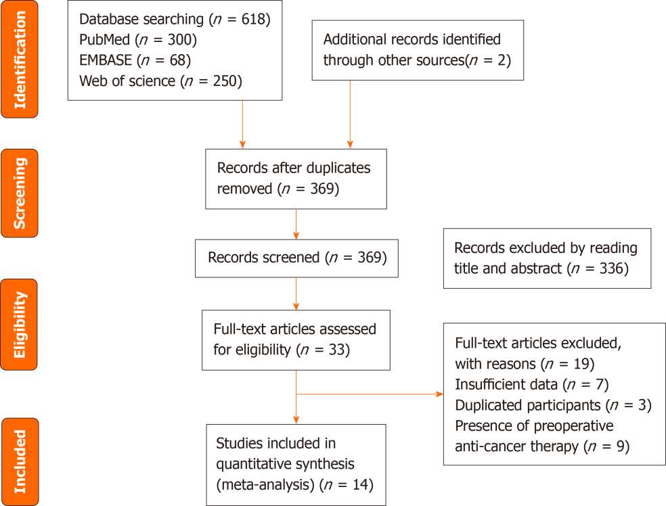
Figure 1 PRISMA flowchart for selection of the studies.

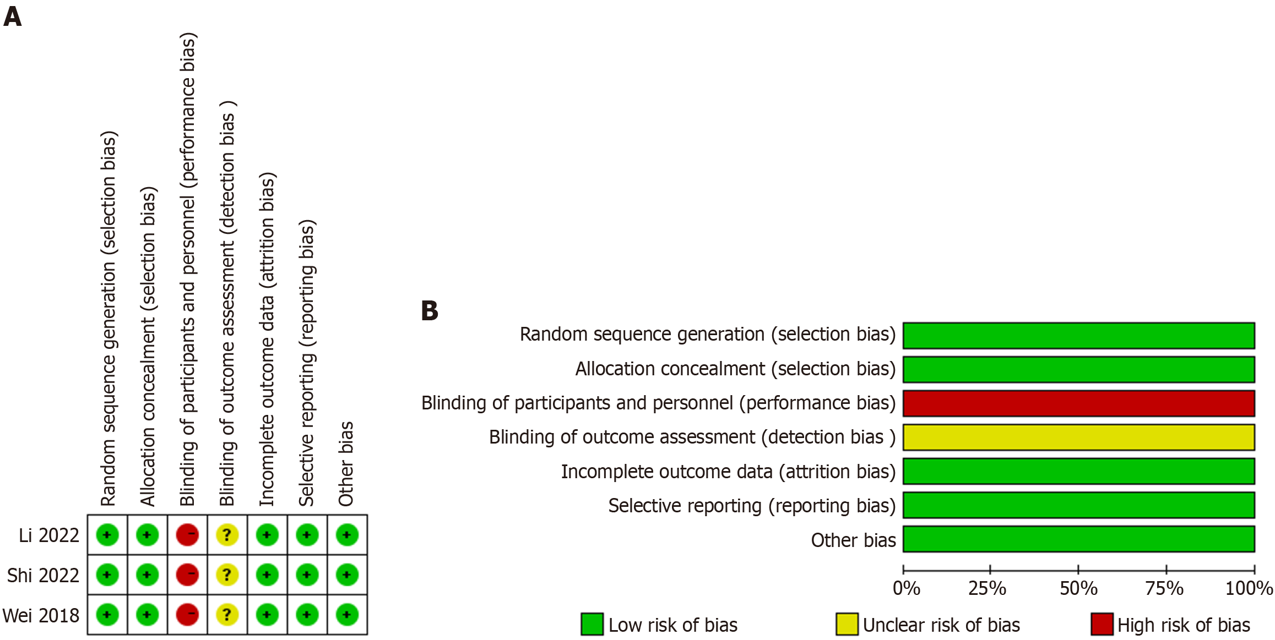
Figure 2 Risk-of-bias assessments for prospective clinical trials included in the meta-analysis. A: Risk-of-bias summary; B: Risk-of-bias graph. +: Low risk of bias; ?: Unclear risk of bias; -: High risk of bias.

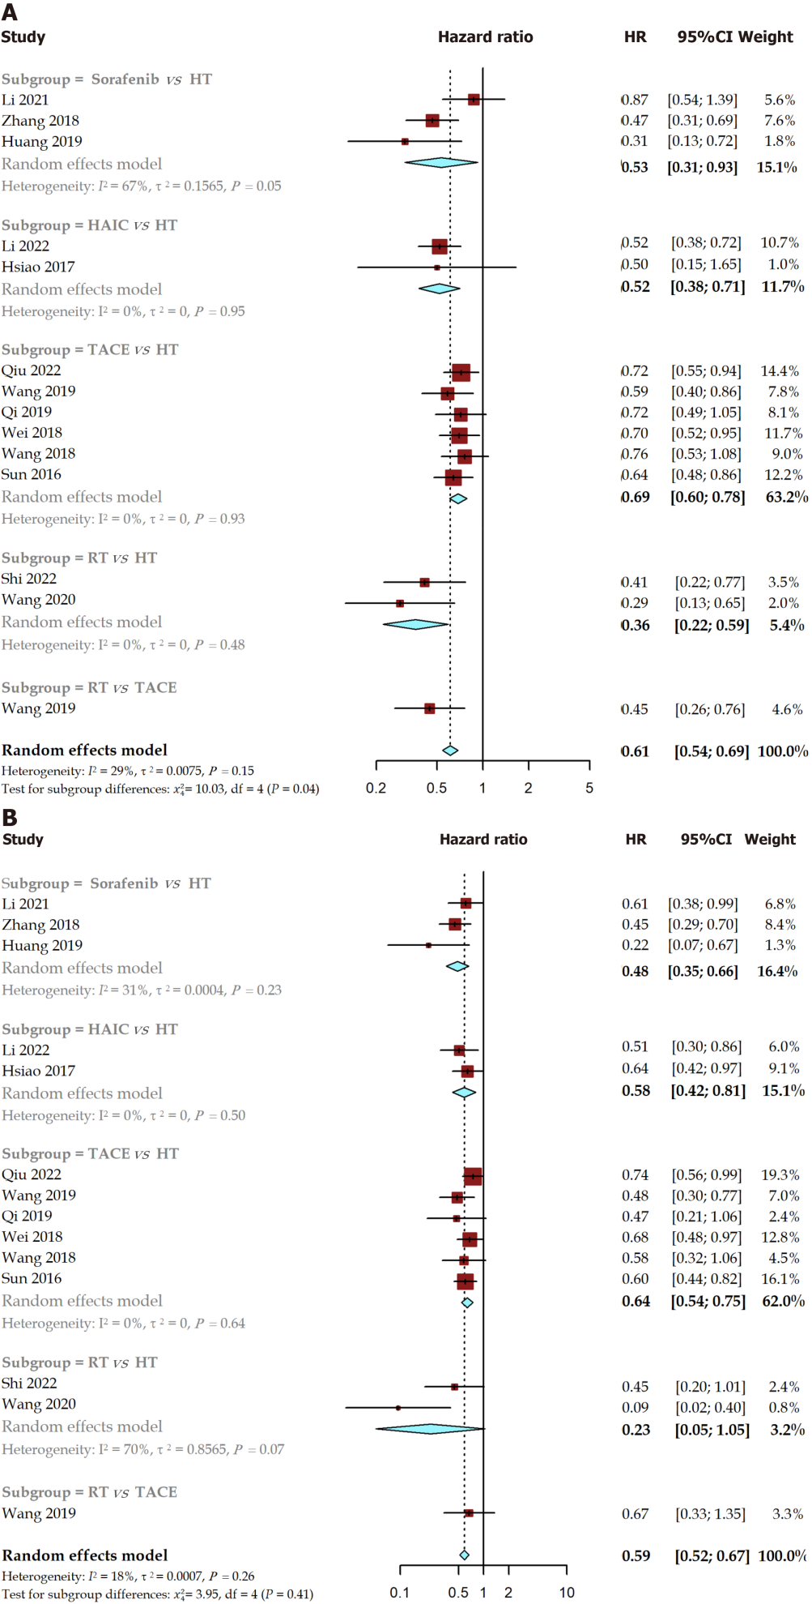
Figure 3 Forest plot of recurrence free survival and overall survival for pairwise meta-analysis. A: Recurrence free survival; B: Overall survival. HT: Hepatectomy; HAIC: Hepatic artery infusion chemotherapy; RT: Radiotherapy; TACE: Transarterial chemoembolization; HR: Hazard ratio; CI: Confidence interval.

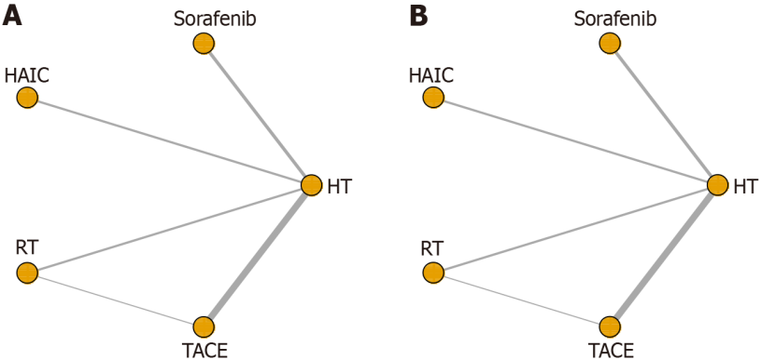
Figure 4 Network diagram of eligible comparisons for recurrence free survival and overall survival. A: Recurrence free survival; B: Overall survival. HT: Hepatectomy; HAIC: Hepatic artery infusion chemotherapy; RT: Radiotherapy; TACE: Transarterial chemoembolization.

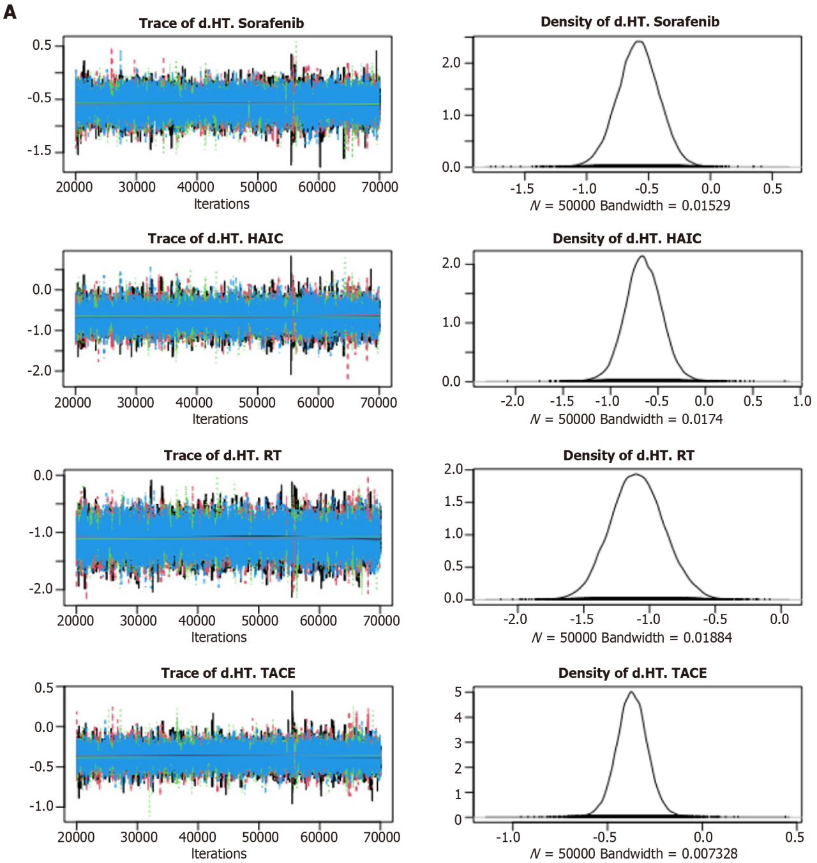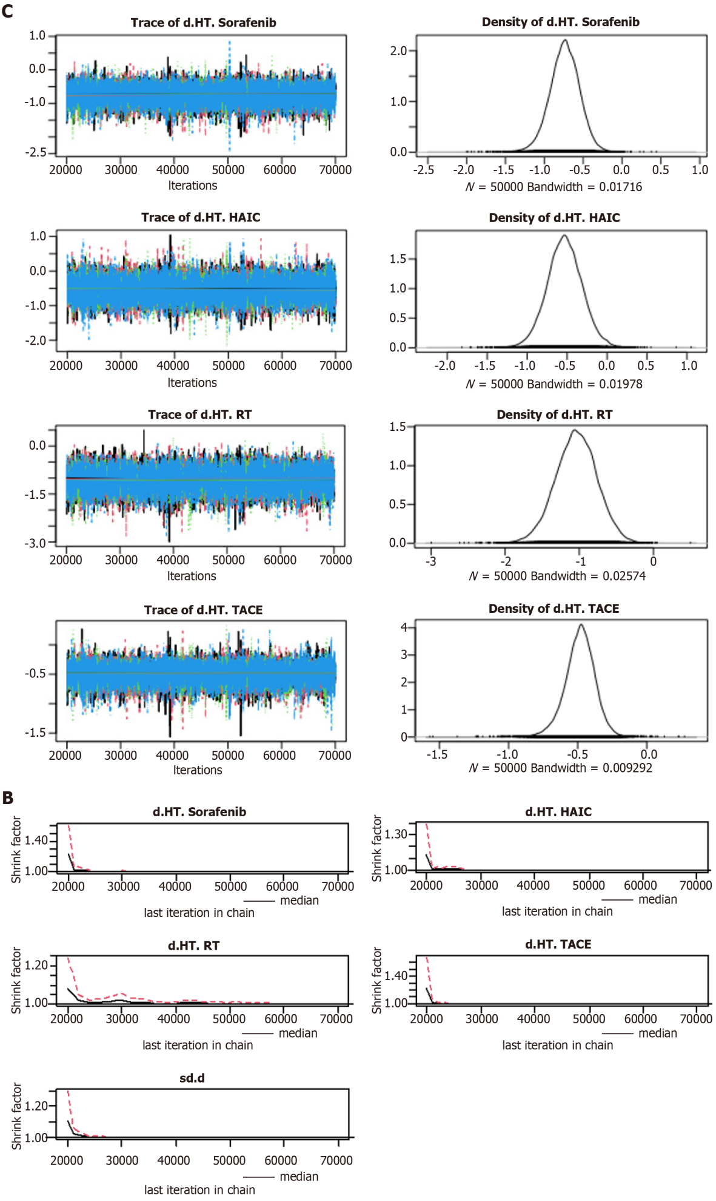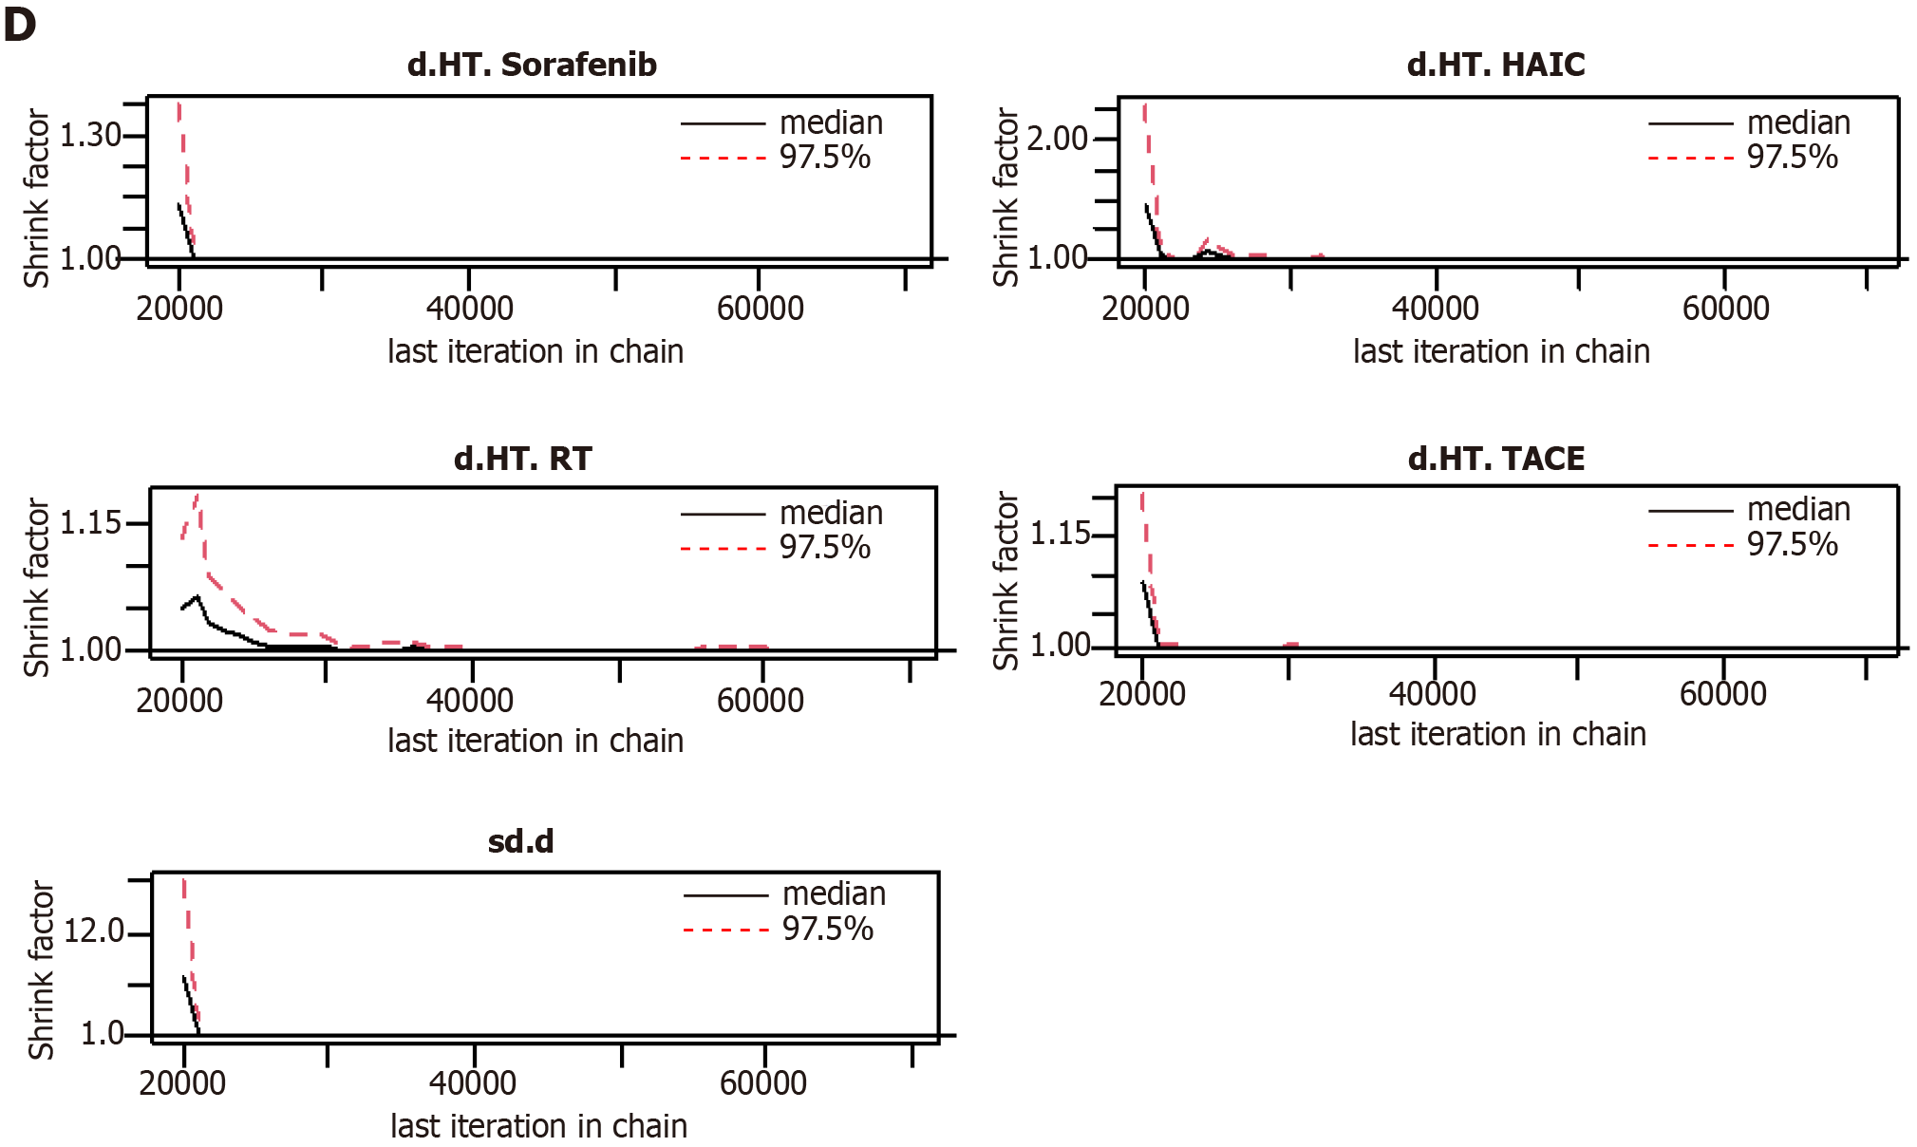
Figure 5 Convergence of the three chains established by trace and the Brooks-Gelman-Rubin diagnostic for recurrence free survival and overall survival. A and B: Recurrence free survival; C and D: Overall survival. HT: Hepatectomy; HAIC: Hepatic artery infusion chemotherapy; RT: Radiotherapy; TACE: Transarterial chemoembolization.
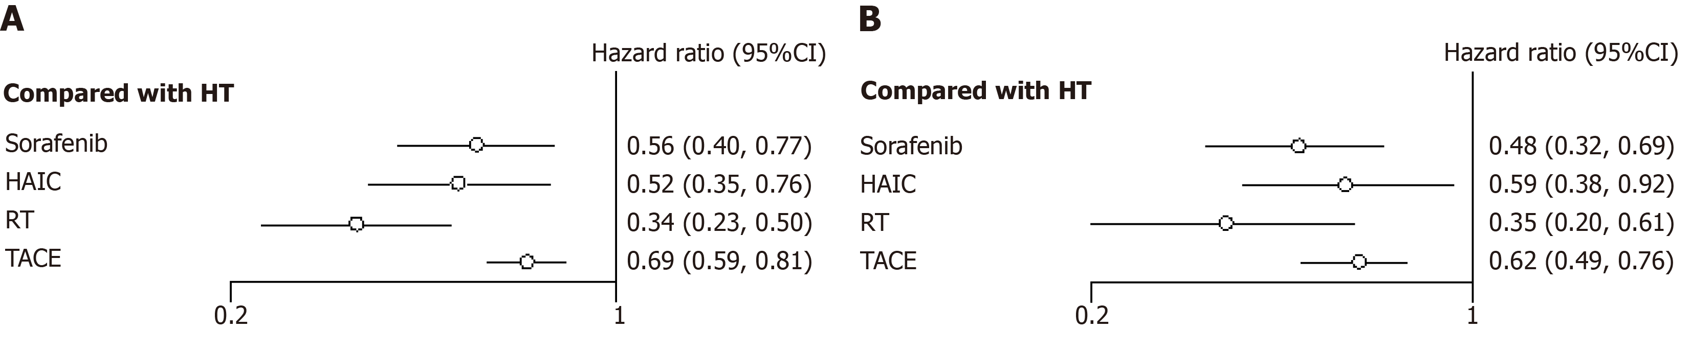
Figure 6 Hazard ratio along with 95% confidence interval for recurrence free survival and overall survival for each adjuvant therapy compared with hepatectomy. A: Recurrence free survival; B: Overall survival. HT: Hepatectomy; HAIC: Hepatic artery infusion chemotherapy; RT: Radiotherapy; TACE: Transarterial chemoembolization; CI: Confidence interval.

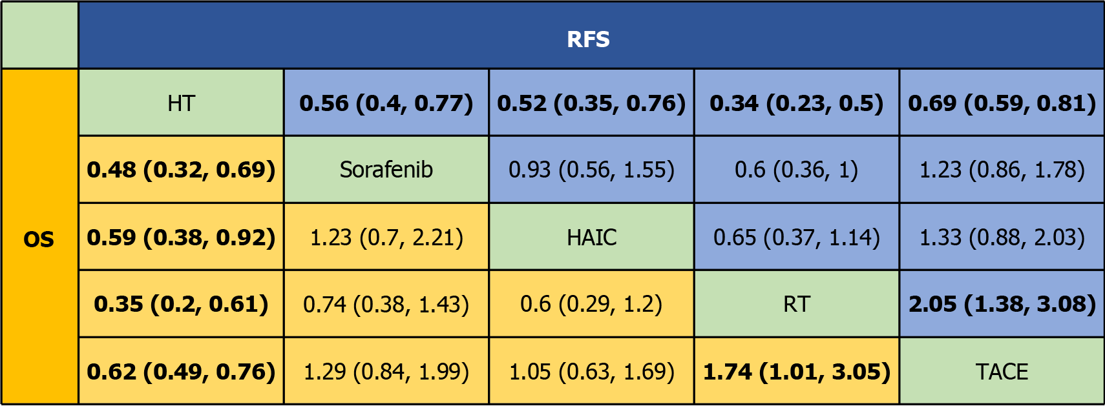
Figure 7 Pooled estimates of the network meta-analysis. HT: Hepatectomy; HAIC: Hepatic artery infusion chemotherapy; RT: Radiotherapy; TACE: Transarterial chemoembolization; RFS: Recurrence free survival; OS: Overall survival.

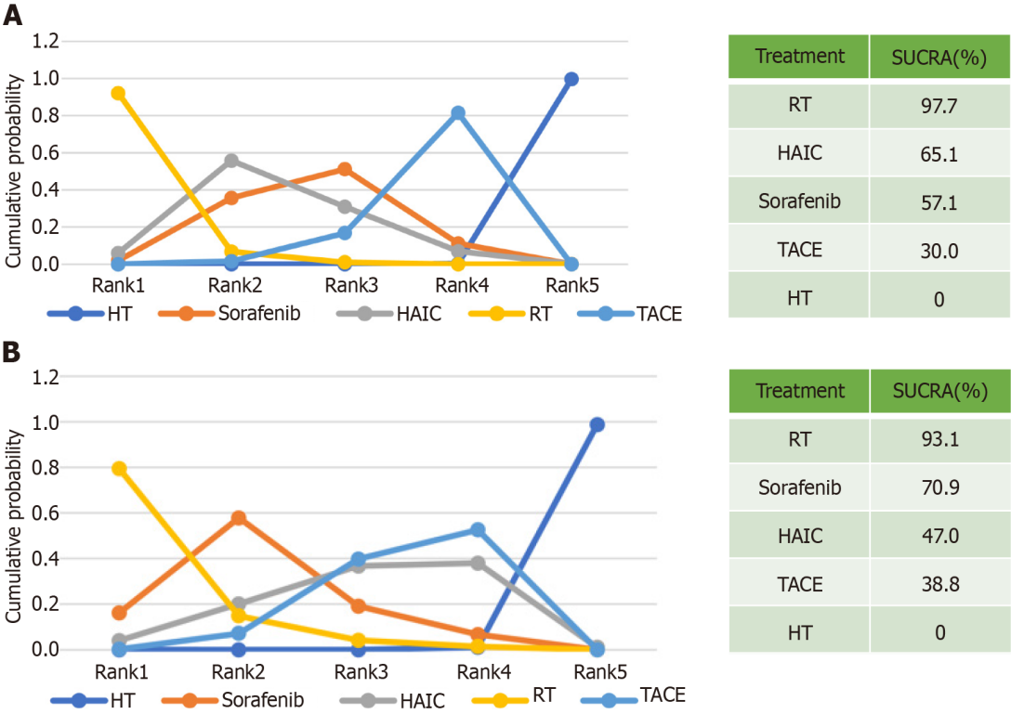
Figure 8 Cumulative ranking plot and surface under the cumulative ranking curve values for recurrence free survival and overall survival. A: Recurrence free survival; B: Overall survival. HT: Hepatectomy; HAIC: Hepatic artery infusion chemotherapy; RT: Radiotherapy; TACE: Transarterial chemoembolization; SUCRA: Surface under the cumulative ranking curve.

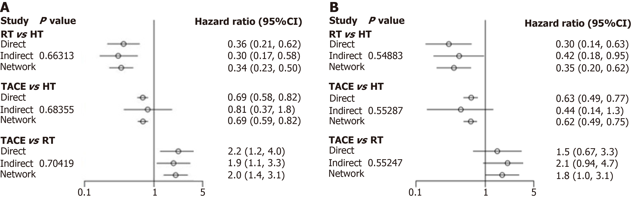
Figure 9 The node-splitting approach demonstrated consistency between the direct and indirect evidence for recurrence free survival and overall survival. A: Recurrence free survival; B: Overall survival. HT: Hepatectomy; RT: Radiotherapy; TACE: Transarterial chemoembolization; CI: Confidence interval.

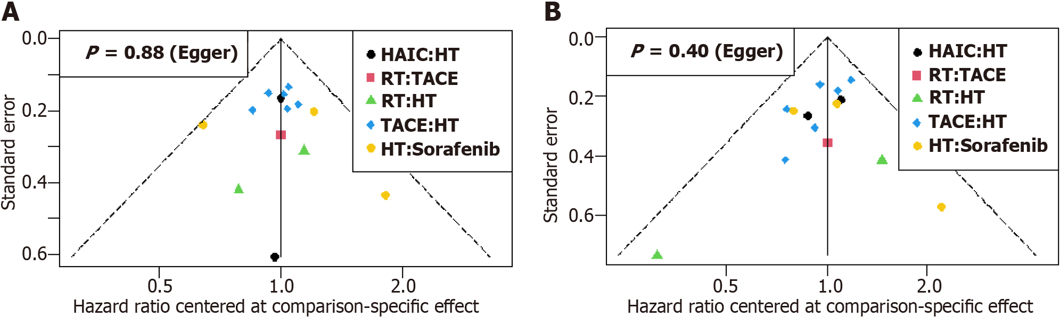
Figure 10 Funnel plot and Egger’s tests for the included studies in terms of recurrence free survival and overall survival. A: Recurrence free survival; B: Overall survival. HT: Hepatectomy; HAIC: Hepatic artery infusion chemotherapy; RT: Radiotherapy; TACE: Transarterial chemoembolization.

Table 1 Literature search criteria
Database | Literature search criteria | Number of literatures
PubMed | ((microvascular invasion) OR MVI) AND ((“Carcinoma, Hepatocellular”[Mesh]) OR (hepatocellular carcinoma[Title/Abstract]) OR (liver cancer[Title/Abstract]) OR (hepatoma[Title/Abstract])) AND (resection[Title/Abstract] OR hepatectomy[Title/Abstract]) AND (post-operative[Title/Abstract] OR postoperative[Title/Abstract] OR adjuvant[Title/Abstract] OR prevent[Title/Abstract]) | 300
Web of Science | (TS = (hepatocellular carcinoma)) AND ((AB = (resection OR hepatectomy)) OR TI = (resection OR hepatectomy)) AND ((TI = (post-operative OR postoperative OR adjuvant OR prevent)) OR AB = (post-operative OR postoperative OR adjuvant OR prevent)) AND ((TI = (microvascular invasion)) OR AB = (microvascular invasion)) | 250
EMBASE | ‘hepatocellular carcinoma’/exp AND (‘resection’/exp OR ‘hepatectomy’/exp) AND (‘adjuvant’/exp OR ‘postoperative’ OR ‘post-operative’ OR prevent:ti OR prevention:ti) AND ‘microvascular invasion’/exp | 68

Table 2 The baseline characteristics of included studies
Ref. | Design | Enrollment period | Treatment | Sample size (n) | Male  (n) | Age (yr) | Tumor size (cm) | Multiple nodules (n) | HBV (n) | Child-Pugh, A/B (n)
Li et al^{[8]}, 2021 | Retrospective cohort, PSM | August 2009 to August 2017 | Sorafenib | 42 | 34/8 | 54.2 ± 1.4 | 6.2 ± 0.6 | 29 | NA | 42
 |  |  | HT alone | 42 | 35/7 | 54.6 ± 1.7 | 7.2 ± 0.8 | 25 | NA | 42
Zhang et al^{[17]}, 2019 | Retrospective cohort, PSM | 2009 to 2016 | Sorafenib | 113 | 97/16 | 49.0 (43.0-56.0) | 5.9 (4.0-9.0) | 17 | 102 | 111/2
 |  |  | HT alone | 113 | 98/15 | 48.0 (40.0-57.0) | 5.42 (3.8-9.1) | 21 | 98 | 112/1
Huang et al^{[18]}, 2019 | Retrospective cohort | January 2009 to December 2016 | Sorafenib | 16 | 12 | 52.25 ± 11.94 | NA | 2 | 12 | 16/0
 |  |  | HT alone | 33 | 30 | 51.52 ± 11.87 | NA | 3 | 26 | 31/2
Li et al^{[9]}, 2023 | RCT | June 2016 to August 2021 | HAIC | 143 | 122 | 51 (25-75) | 5.5 (1.8-30.0) | 43 | 125 | 142/1
 |  |  | HT alone | 143 | 126 | 54 (27-75 | 5.4 (1.5-16.0) | 27 | 51 | 141/2
Hsiao et al^{[19]}, 2017 | Retrospective cohort | 2006 to 2014 | HAIC | 29 | NA | NA | NA | NA | NA | NA
 |  |  | HT alone | 41 | NA | NA | NA | NA | NA | NA
Shi et al^{[20]}, 2022 | RCT | August 2015 to December 2016 | RT | 38 | 33 | 56.42 ± 10.44 | 4.87 ± 2.03 | NA | 36 | NA
 |  |  | HT alone | 38 | 32 | 55.74 ± 10.19 | 4.88 ± 2.46 | NA | 36 | NA
Wang et al^{[10]}, 2020 | Retrospective cohort | July 2015 to December 2018 | RT | 29 | 24 | 55.90 ± 8.05 | 4.75 ± 2.15 | 2 | 29 | 29/0
 |  |  | HT alone | 30 | 25 | 56.57 ± 9.43 | 4.50 ± 2.98 | 2 | 30 | 30/0
Wang et al^{[21]}, 2019 | Retrospective cohort, PSM | July 2008 to December 2016 | RT | 46 | 43 | 50.98 ± 10.53 | 5.39 ± 2.74 | 4 | 38 | 46/0
 |  |  | TACE | 46 | 37 | 51.52 ± 11.40 | 5.50 ± 3.07 | 5 | 36 | 46/0
Qiu et al^{[22]}, 2022 | Retrospective cohort, PSM | April 2014 to July 2019 | TACE | 164 | 138 | 51 ± 12 | 4.7 ± 2.9 | 43 | 135 | 162/2
 |  |  | HT alone | 164 | 145 | 52 ± 12 | 5.0 ± 2.9 | 52 | 136 | 162/2
Wang et al^{[23]}, 2019 | Retrospective cohort, PSM | September 2004 to December 2015 | TAEC | 57 | 47 | 55 ± 11 | 6 (2-14) | 11 | 47/2 | 54/3
 |  |  | HT alone | 57 | 51 | 56 ± 10 | 6 (2-18) | 11 | 47/6 | 54/3
Qi et al^{[24]}, 2019 | Prospective cohort | January 2012 to December 2014 | TACE | 91 | 78 | NA | NA | 23 | 77 | 54/37
 |  |  | HT alone | 109 | 93 | NA | NA | 25 | 96 | 76/33
Wei et al^{[7]}, 2018 | RCT | June 2009 to December 2012 | TACE | 116 | 106 | 44.0 (18-75) | 5 | 0 | 94/NA | 116/0
 |  |  | HT alone | 118 | 106 | 48.5 (18-74) | 5 | 0 | 101/NA | 116/2
Wang et al^{[25]}, 2018 | Retrospective cohort | January 2010 to December 2014 | TACE | 44 | 42 | 52.07 ± 7.24 | 3.84 ± 1.27 | 44 | NA | 41/1
 |  |  | HT alone | 84 | 76 | 54.49 ± 10.18 | 3.83 ± 1.09 | 84 | NA | 82/2
Sun et al^{[26]}, 2016 | Retrospective cohort | January 2004 to June 2013 | TACE | 137 | 120 | 48.88 ± 0.87 | 6.51 ± 0.27 | 11 | 121 | 135/2
 |  |  | HT alone | 185 | 167 | 49.91 ± 0.72 | 6.99 ± 0.29 | 17 | 163 | 182/3
PSM: Propensity score matching; RCT: Randomized controlled trial; HT: Hepatectomy; HAIC: Hepatic artery infusion chemotherapy; RT: Radiotherapy; TACE: Transarterial chemoembolization; NA: Not available; HBV: Hepatitis B virus.

Table 3 Methodological quality assessment for cohort studies using the Newcastle-Ottawa Scale
Ref. | Selection |  |  |  | Comparability | Exposure |  |  | Quality Score
 | Representativeness of the exposed cohort | Selection of the non-exposed cohort | Ascertainment of exposure | Demonstration that outcome of interest was not present at start of study | Comparability of cohorts on the basis of the design or analysis | Assessment of outcome | Was follow-up long enough for outcomes to occur | Adequacy of follow up of cohorts
Li et al^{[8]}, 2021 | 1 | 1 | 1 |  | 2 | 1 | 1 |  | 7
Zhang 2019 | 1 | 1 | 1 | 1 | 2 | 1 | 1 |  | 8
Huang et al^{[18]}, 2019 | 1 | 1 | 1 |  | 2 | 1 | 1 | 1 | 8
Hsiao et al^{[19]}, 2017 | 1 | 1 | 1 | 1 | 1 | 1 | 1 |  | 7
Wang et al^{[10]}, 2020 | 1 | 1 | 1 |  | 2 | 1 | 1 |  | 7
Wang et al^{[21]}, 2019 | 1 | 1 | 1 |  | 1 | 1 | 1 |  | 6
Qiu et al^{[22]}, 2022 | 1 | 1 | 1 |  | 1 | 1 | 1 | 1 | 7
Wang et al^{[23]}, 2019 | 1 | 1 | 1 |  | 2 | 1 | 1 |  | 7
Qi et al^{[24]}, 2019 | 1 | 1 | 1 |  | 2 | 1 | 1 |  | 7
Wang et al^{[25]}, 2018 | 1 | 1 | 1 |  | 1 | 1 | 1 | 1 | 7
Sun et al^{[26]}, 2016 | 1 | 1 | 1 |  | 1 | 1 | 1 |  | 6

Table 4 Comparisons of the fit of consistency and inconsistency
Model | Recurrence free survival | Overall survival
Consistency | 18.00 | 20.25
Inconsistency | 19.79 | 21.82

Published by Baishideng Publishing Group Inc
7041 Koll Center Parkway, Suite 160, Pleasanton, CA 94566, USA
Telephone: +1-925-3991568
E-mail: office@baishideng.com
Help Desk: https://www.f6publishing.com/helpdesk
https://www.wjgnet.com

© 2024 Baishideng Publishing Group Inc. All rights reserved.

