Name of Journal: World Journal of Clinical Cases
Manuscript NO: 49456
Manuscript Type: OPINION REVIEWS

Effective use of the Japan Narrow Band Imaging Expert Team classification based on diagnostic performance and confidence level

Hirata D et al. Effective use of the JNET classification

Daizen Hirata, Hiroshi Kashida, Mineo Iwatate, Tomomasa Tochio, Akira Teramoto, Yasushi Sano, Masatoshi Kudo

Daizen Hirata, Mineo Iwatate, Tomomasa Tochio, Akira Teramoto, Yasushi Sano, Gastrointestinal Center and Institute of Minimally-invasive Endoscopic Care, Sano Hospital, Kobe 6550031, Japan

Daizen Hirata, Hiroshi Kashida, Masatoshi Kudo, Department of Gastroenterology and Hepatology, Kindai University, Osaka 5895811, Japan

ORCID number: Daizen Hirata (0000-0001-7255-6129); Hiroshi Kashida (0000-0002-7186-600X); Mineo Iwatate (0000-0003-3782-3687); Tomomasa Tochio (0000-0003-3082-3721); Akira Teramoto (0000-0003-4031-3012); Yasushi Sano (0000-0002-3352-5757); Masatoshi Kudo (0000-0002-4102-3474).

Author contributions: Hirata D, Kashida H, Sano Y and Kudo M designed the research; Hirata D, Iwatate M, Tochio T, Teramoto A and Sano Y performed the research; Hirata D and Iwatate M performed the literature review; Hirata D and Iwatate M analyzed the data; Hirata D wrote the paper; Kashida H and Kudo M contributed critical revision and editing.

Supported by no dedicated source of funding

Conflict-of-interest statement: No potential conflicts of interest.

Data sharing statement: No additional data are available.

Open-Access: This is an open-access article that was selected by an in-house editor and fully peer-reviewed by external reviewers. It is distributed in accordance with the Creative Commons Attribution Non Commercial (CC BY-NC 4.0) license, which permits others to distribute, remix, adapt, build upon this work non-commercially, and license their derivative works on different terms, provided the original work is properly cited and the use is non-commercial. See: http://creativecommons.org/licenses/by-nc/4.0/

Manuscript source: Invited manuscript

Corresponding author: Daizen Hirata, MD, Doctor, Gastrointestinal Center and Institute of Minimally-invasive Endoscopic Care, Sano Hospital, 2-5-1 Shimizugaoka, Tarumi-ku, Kobe 6550031, Japan. daizenhirata@gmail.com
Telephone: +81-78-7851000
Fax: +81-78-7850077

Received: June 4, 2019
Peer-review started: June 4, 2019
First decision: July 21, 2019
Revised: August 18, 2019
Accepted: August 27, 2019
Article in press:
Published online:
Abstract
Five years have passed since the Japan Narrow Band Imaging Expert Team classification was proposed in 2014. However, the diagnostic performance of this classification has not yet been established. We conducted a retrospective study and a systematic search of MEDLINE. There were three retrospective single center studies about the diagnostic performance of this classification. In order to clarify this issue, we reviewed our study and three previous studies. This review revealed the diagnostic performance in regard to three important differentiations: (1) neoplasia from non-neoplasia; (2) malignant neoplasia from benign neoplasia; and (3) deep submucosal invasive cancer from other neoplasia. The sensitivity in differentiating neoplasia from non-neoplasia was 98.1%-99.8%. The specificity in differentiating malignant neoplasia from benign neoplasia was 84.7%-98.2%. The specificity in the differentiation of deep submucosal invasive cancer from other neoplasia was 99.8%-100.0%. This classification would enable endoscopists to identify almost all neoplasia, to appropriately determine whether to perform en bloc resection and to avoid unnecessary surgery. This article is the first review about the diagnostic performance of the Japan Narrow Band Imaging Expert Team classification. Previous reports about the diagnostic performance have all been retrospective single center studies. A large-scale prospective multicenter evaluation study is needed for further validation.

Key words: Japan Narrow Band Imaging Expert Team; Classification; Magnifying endoscopy; Narrow-band imaging; Validation; Diagnostic performance; Colonoscopy; Colorectal neoplasms

© The Author(s) 2019. Published by Baishideng Publishing Group Inc. All rights reserved.

Core tip: This is the first review of the Japan Narrow Band Imaging Expert Team classification regarding the diagnostic performance. There are three important differentiations: neoplasia from non-neoplasia, malignant neoplasia from benign neoplasia and deep submucosal invasive cancer from other neoplasia. The sensitivity in differentiating neoplasia from non-neoplasia was 98.1%-99.8%. The specificity in differentiating malignant neoplasia from benign neoplasia was 84.7%-98.2%. The specificity in differentiating deep submucosal invasive cancer from other neoplasia was 99.8%-100.0%. This classification will enable endoscopists to identify almost all neoplasia, to appropriately determine whether to perform en bloc resection and to avoid unnecessary surgery.

Hirata D, Kashida H, Iwatate M, Tochio T, Teramoto A, Sano Y, Kudo M. Effective use of the Japan Narrow Band Imaging Expert Team classification based on diagnostic performance and confidence level. World J Clin Cases 2019; In press

INTRODUCTION
The Sano classification was proposed as the first Narrow Band Imaging (NBI) classification in 2006^{[1]}. Following this, three classifications were proposed in Japan^{[2-4]}. Colon Tumor NBI Interest Group proposed the Narrow Band Imaging International Colorectal Endoscopic (NICE) classification in 2009 (Figure 1). The NICE classification is easily applicable and can be used without magnification. However, previous validation studies revealed two problems with the NICE classification. One was that the confidence rate was reported to be only 50%-75%^{[5,6]} though the diagnostic performance was acceptable in cases with high confidence. This means that the number of polyps that can be diagnosed by the NICE classification is not high enough. The other problem was that endoscopists could not differentiate malignant neoplasia [high grade intramucosal neoplasia (HGIN) and invasive cancer] from benign neoplasia [low grade intramucosal neoplasia (LGIN)] using the NICE classification. This differentiation is clinically valuable for deciding treatment options because the invasion depth of malignant neoplasia should be evaluated by the specimen obtained en bloc by endoscopic mucosal resection (EMR) or endoscopic submucosal dissection.
In 2014, the Japan Narrow Band Imaging Expert Team (JNET) classification was published and showed the NBI diagnosis with magnification had the potential to increase the confidence rate and enable endoscopists to differentiate malignant neoplasia from benign neoplasia^{[7,8]}.
The JNET classification consists of four categories: JNET type 1, type 2A, type 2B and type 3. Each type represents the histological features of the polyps, and they are categorized by focusing on two specific features: the vessel pattern and the surface pattern (Figure 2). JNET type 1 refers to hyperplastic polyps and sessile serrated polyps. Type 2A refers to LGIN and type 2B corresponds to HGIN or shallow submucosal invasive cancer (S-SMC). Type 3 refers to deep submucosal invasive cancer (D-SMC).
The aim of this review is to reveal the diagnostic performance and the confidence level of the JNET classification. Because there were no previous studies concerning the diagnostic performance and the confidence level of the JNET classification, we analyzed them based on the study data compiled at Sano hospital.
In this review we evaluate the diagnostic performance of the JNET classification and its confidence level (high or low) based on data from the study conducted at Sano Hospital from March 2015 to September 2018, and also those from the systematic review carried out in MEDLINE from January 2014 through March 2019.

OUR STUDY
We investigated the diagnostic performance of the JNET classification including its confidence level (high or low) at Sano Hospital from March 2015 to September 2018. In this study, all colorectal polyps were diagnosed using the JNET classification before endoscopic resection or surgery. NBI magnifying observation was performed by five experts and three trainees. “High-confidence diagnosis” is defined as a diagnosis that the endoscopist has confidence of more than 90% probability. Both the endoscopic diagnosis and confidence level were recorded in real time during the colonoscopy, and the histopathological diagnosis was reported by an expert pathologist. We evaluated the relationship between the JNET type, its confidence level and the histopathological diagnosis for all polyps as the primary endpoint. The diagnostic performance and the high confidence rate were analyzed based on this data. We evaluated the diagnostic performance in differentiating “neoplasia (type 2A) from non-neoplasia (type 1),” “malignant neoplasia (types 2B and 3) from benign neoplasia (type 2A),” and “D-SMC (type 3) from other neoplasia (types 2A and 2B).”

LITERATURE SEARCH
For the purpose of this review, a systematic search was carried out in MEDLINE from January 2014 through March 2019. Keywords included “the Japan NBI Expert Team” or “JNET classification” by two endoscopists. Non-English articles were excluded. Fourteen articles were selected. Non-original articles were also excluded. The full texts of 12 original articles were reviewed. Articles about the diagnostic performance were included. Articles about other modalities and other issues such as study protocol and treatment were excluded. Finally, three original articles were selected and included in this study (Figure 3)^{[9-11]}.

DIAGNOSTIC PERFORMANCE WITH ITS CONFIDENCE LEVEL IN OUR STUDY
The authors examined 6138 colorectal polyps that were diagnosed using the JNET classification before endoscopic resection or surgery from March 2015 to September 2018. The histopathological diagnosis of the 6138 polyps were 979 hyperplastic polyps, 244 sessile serrated polyps, 4642 LGIN, 214 HGIN or S-SMC and 59 D-SMC. The total number of polyps diagnosed with high confidence was 5624. The high confidence rate was 91.6%. The relationship between the JNET classification (with or without confidence level) and the histopathological diagnosis is shown in Table 1. Rate of correspondence between each JNET type and the histopathological diagnosis was 85.4%.

PREVIOUS REPORTS ABOUT THE DIAGNOSTIC PERFORMANCE OF THE JNET CLASSIFICATION
Three articles about the diagnostic performance were reviewed in this study. These articles and our study are summarized in Table 2^{[9-11]}.
Sumimoto et al^{[9]} conducted a retrospective analysis of 2933 colorectal lesions (136 hyperplastic polyps/sessile serrated polyps, 1926 LGIN, 571 HGIN, 87 S-SMC and 213 D-SMC). The accuracy of types 1, 2A, 2B and 3 were 99.3%, 77.1%, 78.1% and 96.6%, respectively.
Komeda et al^{[10]} performed a retrospective image evaluation study in 199 colorectal lesions (14 hyperplastic polyps/sessile serrated polyps, 127 LGIN, 22 HGIN, 19 S-SMC and 17 D-SMC). The accuracy of types 1, 2A, 2B and 3 were 98.5%, 90.9%, 87.4% and 94.0%, respectively. They also analyzed the relationship between the macroscopic type and the diagnostic performance. They concluded that the JNET classification was useful for the diagnosis of hyperplastic polyps, sessile serrated polyps, LGIN, HGIN and D-SMC but not S-SMC.
Minoda et al^{[11]} conducted a retrospective image evaluation study of 40 colorectal lesions involving 22 doctors (11 experts and 11 non-gastrointestinal trainees). The average diagnostic accuracy was 76.6% for the experts and 61.4% for the trainees, though the relationship between the JNET classification and the histopathological diagnosis was not disclosed. They concluded that the JNET classification was useful for differentiating malignant polyps from benign ones for every doctor. They also revealed orientation and training were necessary to use this system adequately even for experienced colonoscopists.

THE DIAGNOSTIC PERFORMANCE OF THE JNET CLASSIFICATION
The diagnostic performance is important in determining the treatment strategy. The three differentiations are: neoplasia (type 2A) vs non-neoplasia (type 1), malignant neoplasia (types 2B and 3) vs benign neoplasia (type 2A) and D-SMC (type 3) vs other neoplasia (types 2A and 2B). The details of each diagnostic performance are shown in Tables 3-5. We analyzed the diagnostic performance for each differentiation in our study and the previous reports. Minoda et al^{[11]} was excluded in these analyses because necessary details and relationships were not disclosed.

Neoplasia (type 2A) versus non-neoplasia (type 1)
The diagnostic performance in differentiating neoplasia (type 2A) from non-neoplasia (type 1) is directly associated with the necessity of endoscopic treatment. Type 2A polyps should be resected by polypectomy. However, it is usually not necessary to resect type 1 polyps. The sensitivity, the accuracy and the negative predictive value were 98.1%-99.8%, 88.8%-99.0% and 88.9%-99.1%, respectively. According to this classification, endoscopists can identify almost all neoplasia.
In high confidence cases, counting 93.1% among all polyps, they were high enough to enable “Detect InSpect ChAractrise Resect and Discard strategy” according to “Preservation and incorporation of valuable endoscopic innovations initiative” from the American Society For Gastrointestinal Endoscopy^{[12,13]}.

Malignant neoplasia (types 2B and 3) versus benign neoplasia (type 2A)
The diagnostic performance in differentiating malignant neoplasia from benign neoplasia is associated with the necessity of en bloc resection. While type 2A polyps can be treated by piecemeal EMR or polypectomy, type 2B polyps should be resected en bloc to obtain a precise histologic diagnosis from the specimen. The accuracy, specificity and negative predictive value of this diagnosis are 80.7%-96.1%, 84.7%-98.2% and 87.0%-97.7%, respectively. This is considered beneficial in diagnosing polyps as malignant neoplasm. By using the JNET classification, endoscopists can appropriately determine whether to perform en bloc resection.

D-SMC (type 3) versus other neoplasia (types 2A and 2B)
The diagnostic performance in differentiating D-SMC from other neoplasia is associated with the necessity of surgical resection. As for this distinction, the specificity was extremely high being 99.8%-100.0%. The JNET classification enables endoscopists to avoid unnecessary surgery for non-invasive neoplasia. In our study, the unnecessary surgeries were only two cases. On the other hand, 10.6%-23.9% of type 2B lesions were D-SMCs, and 0.0%-5.1% of type 3 lesions were S-SMCs. Additional magnifying chromoendoscopy is recommended in cases where it is difficult to differentiate between S-SMC and D-SMC.

DISCUSSION
This is the first review concerning the diagnostic performance of the JNET classification taking account of the confidence level. Based on this review, we propose treatment strategy for colorectal localized lesions using the JNET classification with its confidence level (Figure 4).
Type 1 polyps generally do not need resection except for sessile serrated polyps^{[14]}. Type 2A polyps shall be resected by polypectomy or EMR. Utsumi et al^{[15]} reported that additional chromoendoscopy in type 1 and 2A polyps with low confidence prediction did not improve accuracy enough. Therefore, additional chromoendoscopy is considered to be unnecessary in order to differentiate type 2A from type 1.
Whereas type 2A polyps can be resected by piecemeal EMR, type 2B polyps should be resected en bloc by EMR or endoscopic submucosal dissection to obtain a precise histologic diagnosis concerning the invasion depth and determining endoscopic curability. Our review revealed the usefulness of the JNET classification, in that it accurately differentiated malignant polyps (types 2B and 3) from benign (type 2A). It should be noted that 37.3%-70.6% of D-SMC showed type 2B findings. Magnifying chromoendoscopy is recommended before high-risk endoscopic resection for D-SMC in type 2B polyps, if it is available. Type 3 lesions were diagnosed to be D-SMC with more than 99% specificity in our review, and therefore they are indicated for surgical resection.
The JNET classification is considered to have as high of diagnostic performance as the NICE classification. However, there have been no studies directly comparing the JNET classification with the NICE classification. For comparison with the NICE classification, we evaluated the diagnostic performance with high confidence prediction and the high confidence rate in regard to two differentiations; “Neoplasia vs non-neoplasia” and “D-SMC vs other neoplasia” (Table 6). In both differentiations, the high confidence rate in the JNET classification was significantly higher than that of the NICE classification. It may demonstrate that the JNET classification is clearer and easier to use than the NICE classification for the endoscopists. Magnifying observation may increase the high confidence rate of endoscopic diagnosis.
The JNET classification is compatible with the NICE classification in that both classifications are divided into three major categories (type 1, 2 and 3) corresponding to the similar histopathology. The NICE type 2 corresponds approximately to the JNET type 2A and type 2B. Due to this similarity, endoscopists using the NICE classification should be able to use the JNET classification easily. A video article explaining typical examples and key points will help endoscopists to adopt the JNET classification^{[16]}.
The limitation in this review is that there were only three articles about the diagnostic performance of the JNET classification. The previous studies were all retrospective single center studies. A large-scale prospective multicenter validation study of the JNET classification is awaited in the future. A comparative trial between the JNET classification and the NICE classification would also be beneficial.
We predict that the JNET classification will provide endoscopists with a useful treatment strategy based on precise histopathological predictions and a higher confidence level for optical diagnosis.

CONCLUSION
The JNET classification enables endoscopists to identify almost all neoplasia, to appropriately determine whether to perform en bloc resection and to avoid unnecessary surgery.

REFERENCES
1 Sano Y, Horimatsu T, Fu KI, Katagiri A, Muto M, Ishikawa H. Magnifying observation of microvascular architecture of colorectal lesions using a narrow band imaging system. Dig Endosc 2006; 18 Suppl 1: S44-S51 [DOI: 10.1111/j.1443-1661.2006.00621.x]
2 Wada Y, Kudo SE, Kashida H, Ikehara N, Inoue H, Yamamura F, Ohtsuka K, Hamatani S. Diagnosis of colorectal lesions with the magnifying narrow-band imaging system. Gastrointest Endosc 2009; 70: 522-531 [PMID: 19576581 DOI: 10.1016/j.gie.2009.01.040]
3 Nikami T, Saito S, Tajiri H, Ikegami M. The evaluation of histological atypia and depth of invasion of colorectal lesions using magnified endoscopy with narrow-band imaging. Gastroenterol Endosc 2009; 51: 10-19 [DOI: 10.11280/gee.51.10]
4 Hirata M, Tanaka S, Oka S, Kaneko I, Yoshida S, Yoshihara M, Chayama K. Magnifying endoscopy with narrow band imaging for diagnosis of colorectal tumors. Gastrointest Endosc 2007; 65: 988-995 [PMID: 17324407 DOI: 10.1016/j.gie.2006.07.046]
5 Hewett DG, Kaltenbach T, Sano Y, Tanaka S, Saunders BP, Ponchon T, Soetikno R, Rex DK. Validation of a simple classification system for endoscopic diagnosis of small colorectal polyps using narrow-band imaging. Gastroenterology 2012; 143: 599-607.e1 [PMID: 22609383 DOI: 10.1053/j.gastro.2012.05.006]
6 Hayashi N, Tanaka S, Hewett DG, Kaltenbach TR, Sano Y, Ponchon T, Saunders BP, Rex DK, Soetikno RM. Endoscopic prediction of deep submucosal invasive carcinoma: validation of the narrow-band imaging international colorectal endoscopic (NICE) classification. Gastrointest Endosc 2013; 78: 625-632 [PMID: 23910062 DOI: 10.1016/j.gie.2013.04.185]
7 Sano Y, Tanaka S, Kudo SE, Saito S, Matsuda T, Wada Y, Fujii T, Ikematsu H, Uraoka T, Kobayashi N, Nakamura H, Hotta K, Horimatsu T, Sakamoto N, Fu KI, Tsuruta O, Kawano H, Kashida H, Takeuchi Y, Machida H, Kusaka T, Yoshida N, Hirata I, Terai T, Yamano HO, Kaneko K, Nakajima T, Sakamoto T, Yamaguchi Y, Tamai N, Nakano N, Hayashi N, Oka S, Iwatate M, Ishikawa H, Murakami Y, Yoshida S, Saito Y. Narrow-band imaging (NBI) magnifying endoscopic classification of colorectal tumors proposed by the Japan NBI Expert Team. Dig Endosc 2016; 28: 526-533 [PMID: 26927367 DOI: 10.1111/den.12644]
8 Iwatate M, Sano Y, Tanaka S, Kudo SE, Saito S, Matsuda T, Wada Y, Fujii T, Ikematsu H, Uraoka T, Kobayashi N, Nakamura H, Hotta K, Horimatsu T, Sakamoto N, Fu KI, Tsuruta O, Kawano H, Kashida H, Takeuchi Y, Machida H, Kusaka T, Yoshida N, Hirata I, Terai T, Yamano HO, Nakajima T, Sakamoto T, Yamaguchi Y, Tamai N, Nakano N, Hayashi N, Oka S, Ishikawa H, Murakami Y, Yoshida S, Saito Y; Japan NBI Expert Team (JNET). Validation study for development of the Japan NBI Expert Team classification of colorectal lesions. Dig Endosc 2018; 30: 642-651 [PMID: 29603399 DOI: 10.1111/den.13065]
9 Sumimoto K, Tanaka S, Shigita K, Hirano D, Tamaru Y, Ninomiya Y, Asayama N, Hayashi N, Oka S, Arihiro K, Yoshihara M, Chayama K. Clinical impact and characteristics of the narrow-band imaging magnifying endoscopic classification of colorectal tumors proposed by the Japan NBI Expert Team. Gastrointest Endosc 2017; 85: 816-821 [PMID: 27460392 DOI: 10.1016/j.gie.2016.07.035]
10 Komeda Y, Kashida H, Sakurai T, Asakuma Y, Tribonias G, Nagai T, Kono M, Minaga K, Takenaka M, Arizumi T, Hagiwara S, Matsui S, Watanabe T, Nishida N, Chikugo T, Chiba Y, Kudo M. Magnifying Narrow Band Imaging (NBI) for the Diagnosis of Localized Colorectal Lesions Using the Japan NBI Expert Team (JNET) Classification. Oncology 2017; 93 Suppl 1: 49-54 [PMID: 29258091 DOI: 10.1159/000481230]
11 Minoda Y, Ogino H, Chinen T, Ihara E, Haraguchi K, Akiho H, Takizawa N, Aso A, Tomita Y, Esaki M, Komori K, Otsuka Y, Iwasa T, Ogawa Y. Objective validity of the Japan Narrow-Band Imaging Expert Team classification system for the differential diagnosis of colorectal polyps. Dig Endosc 2019 [PMID: 30861599 DOI: 10.1111/den.13393]
12 Ignjatovic A, East JE, Suzuki N, Vance M, Guenther T, Saunders BP. Optical diagnosis of small colorectal polyps at routine colonoscopy (Detect InSpect ChAracterise Resect and Discard; DISCARD trial): a prospective cohort study. Lancet Oncol 2009; 10: 1171-1178 [PMID: 19910250 DOI: 10.1016/S1470-2045(09)70329-8]
13 Rex DK, Kahi C, O'Brien M, Levin TR, Pohl H, Rastogi A, Burgart L, Imperiale T, Ladabaum U, Cohen J, Lieberman DA. The American Society for Gastrointestinal Endoscopy PIVI (Preservation and Incorporation of Valuable Endoscopic Innovations) on real-time endoscopic assessment of the histology of diminutive colorectal polyps. Gastrointest Endosc 2011; 73: 419-422 [PMID: 21353837 DOI: 10.1016/j.gie.2011.01.023]
14 Sano W, Sano Y, Iwatate M, Hasuike N, Hattori S, Kosaka H, Ikumoto T, Kotaka M, Fujimori T. Prospective evaluation of the proportion of sessile serrated adenoma/polyps in endoscopically diagnosed colorectal polyps with hyperplastic features. Endosc Int Open 2015; 3: E354-E358 [PMID: 26357681 DOI: 10.1055/s-0034-1391948]
15 Utsumi T, Iwatate M, Sunakawa H, Teramoto A, Hirata D, Hattori S, Sano W, Hasuike N, Ichikawa K, Fujimori T, Sano Y. Additional chromoendoscopy for colorectal lesions initially diagnosed with low confidence by magnifying narrow-band imaging: Can it improve diagnostic accuracy? Dig Endosc 2018; 30 Suppl 1: 45-50 [PMID: 29658652 DOI: 10.1111/den.13055]
16 Sano Y, Hirata D, Saito Y. Japan NBI Expert Team classification: Narrow-band imaging magnifying endoscopic classification of colorectal tumors. Dig Endosc 2018; 30: 543-545 [PMID: 29656581 DOI: 10.1111/den.13072]

P-Reviewer: Eyraud D
S-Editor: Tang JZ L-Editor: Filipodia E-Editor:
Specialty type: Medicine, research and experimental
Country of origin: Japan
Peer-review report classification
Grade A (Excellent): 0
Grade B (Very good): B
Grade C (Good): 0
Grade D (Fair): 0
Grade E (Poor): 0

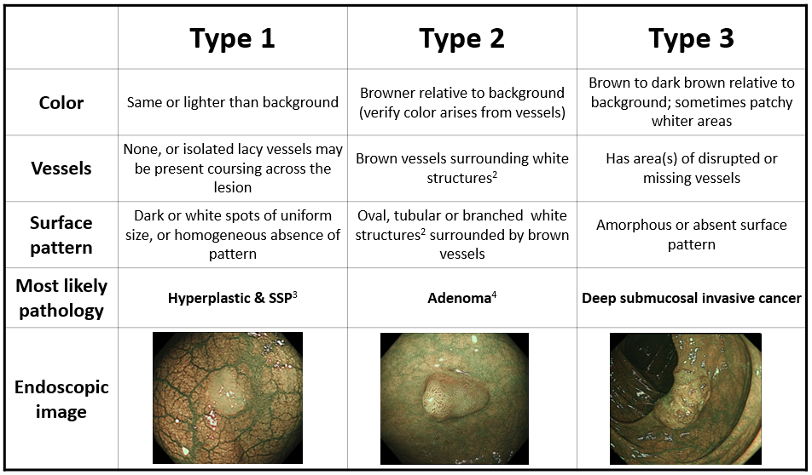
Figure 1 Narrow Band Imaging International Colorectal Endoscopic classification¹. ¹Can be applied using colonoscopes with/without optical (zoom) magnification. ²These structures (regular or irregular) may represent the pits and the epithelium of the crypt opening. ³In the WHO classification, sessile serrated polyp and sessile serrated adenoma are synonymous. ⁴Type 2 consists of Vienna classification types 3, 4 and superficial 5 (all adenomas with either low or high grade dysplasia or with superficial submucosal carcinoma). The presence of high grade dysplasia or superficial submucosal carcinoma may be suggested by an irregular vessel or surface pattern and is often associated with atypical morphology. SSP: Sessile serrated polyp.
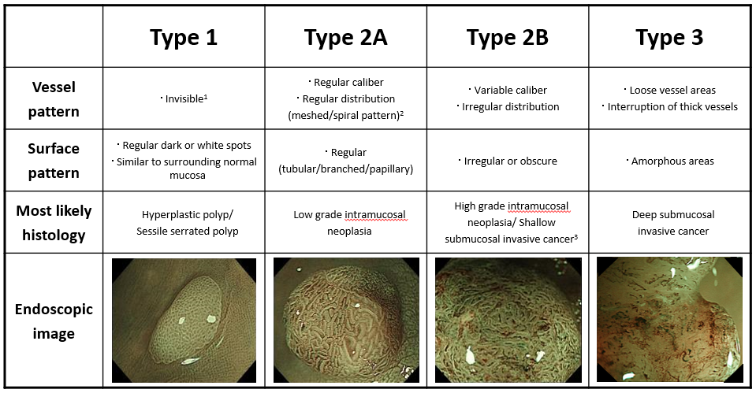
Figure 2 The Japan Narrow Band Imaging Expert Team classification. ¹If visible, the caliber in the lesion is similar to surrounding normal mucosa. ²Micro-vessels are often distributed in a punctate pattern and well-ordered reticular or spiral vessels may not be observed in depressed lesions. ³Deep submucosal invasive cancer may be included.

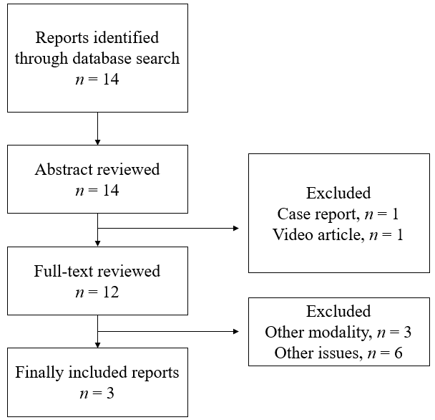
Figure 3 Flow diagram of study selection.

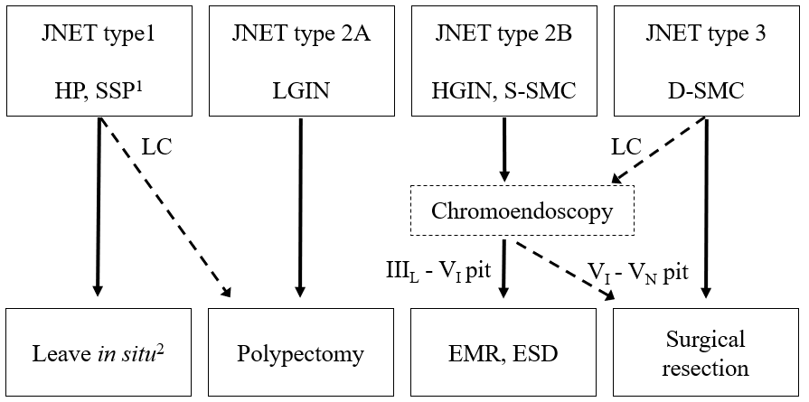
Figure 4 Treatment strategy of colorectal lesions using the Japan Narrow Band Imaging Expert Team classification. ¹Any polyps suspected of SSPs should be resected by endoscopic treatment. ²Hyperplastic polyps less than 5 mm in size are commonly left in situ. HP: Hyperplastic polyp; SSP: Sessile serrated polyp; LGIN: Low grade intramucosal neoplasia; HGIN: High grade intramucosal neoplasia; S-SMC: Shallow submucosal invasive cancer; D-SMC: Deep submucosal invasive cancer; LC: Low confidence.

Table 1 The relationship between the Japan Narrow Band Imaging Expert Team classification and the histopathological diagnosis at Sano Hospital
OA (HC), n | HP, SSP | LGIN | HGIN, S-SMC | D-SMC
Type 1 | 653 (564) | 90 (48) | 0 | 0
Type 2A | 570 (440) | 4459 (4289) | 119 (118) | 0
Type 2B | 0 | 93 (42) | 93 (65) | 22 (21)
Type 3 | 0 | 0 | 2 (2) | 37 (35)
OA: overall cases; HC: High confidence cases; HP: Hyperplastic polyp; SSP: Sessile serrated polyp; LGIN: Low grade intramucosal neoplasia; HGIN: High grade intramucosal neoplasia; S-SMC: Shallow submucosal invasive cancer; D-SMC: Deep submucosal invasive cancer.

Table 2 Reports about diagnostic performance of the Japan Narrow Band Imaging Expert Team Classification
First author | Cases, n | Participants | Study design
Sumimoto et al^{[9]} | 2933 | 3 experts | A retrospective analysis | in vivo | Single center
Komeda et al^{[10]} | 199 | 3 experts | A retrospective analysis | in vitro | Single center
Minoda et al^{[11]} | 40 | 11 experts and 11 non-GI trainees | A retrospective analysis | in vitro | Single center
Our study | 6138 | 5 experts and 3 trainees | A retrospective analysis | in vivo | Single center

Table 3 Neoplasia (type 2A) versus non-neoplasia (type 1)
First author | Sumimoto | Komeda | Our study
Accuracy, % | 99.0 | 98.0 | 88.8
Sensitivity, % | 99.8 | 99.3 | 98.1
Specificity, % | 87.5 | 85.7 | 53.3
PPV, % | 99.1 | 98.5 | 88.9
NPV, % | 97.5 | 92.3 | 87.9
PPV: Positive predictive value; NPV: Negative predictive value.

Table 4 Malignant neoplasia (types 2B and 3) versus benign neoplasia (type 2A)
First author | Sumimoto | Komeda | Our study
Accuracy, % | 80.7 | 91.9 | 96.1
Sensitivity, % | 71.9 | 81.0 | 56.4
Specificity, % | 84.7 | 96.9 | 98.2
PPV, % | 67.8 | 92.2 | 62.3
NPV, % | 87.0 | 91.9 | 97.7
PPV: Positive predictive value; NPV: Negative predictive value.

Table 5 Deep submucosal invasive cancer (type 3) versus other neoplasia (types 2A and 2B)
First author | Sumimoto | Komeda | Our study
Accuracy, % | 96.4 | 93.5 | 99.6
Sensitivity, % | 55.4 | 29.4 | 62.7
Specificity, % | 99.8 | 100.0 | 100.0
PPV, % | 95.2 | 100.0 | 94.9
NPV, % | 96.4 | 93.4 | 99.6
PPV: Positive predictive value; NPV: Negative predictive value.

Table 6 Comparison with Narrow Band Imaging International Colorectal Endoscopic classification
Diagnosis | Neoplasia vs non-neoplasia¹ |  | Deep submucosal invasive cancer vs other neoplasia²
Classification | JNET | NICE^{[5]} | JNET | NICE^{[6]}
Overall, n | 5891 | 236 | 4825 | 400
Accuracy, % | 91.3 | 89 | 96.8 | 90
Sensitivity, % | 99.0 | 98 | 51.0 | 92
Specificity, % | 56.2 | 69 | 99.1 | 88
PPV, % | 91.2 | 87 | 74.5 | 88
NPV, % | 92.2 | 95 | 97.6 | 92
High confidence rate, % | 93.1 | 75 | 92.9 | 50
¹JNET type 1 vs types 2A and 2B and NICE type 1 vs type 2. ²JNET types 2A and 2B vs type 3 and NICE type 2 vs type 3. PPV: Positive predictive value; NPV: Negative predictive value; JNET: Japan Narrow Band Imaging Expert Team; NICE: Narrow Band Imaging International Colorectal Endoscopic.

