Name of journal: World Journal of Gastroenterology
ESPS Manuscript NO: 8325
Columns: PROSPECTIVE STUDY

Adjuvant therapy sparing in rectal cancer achieving complete response after chemo-radiation

García-Albéniz X et al. Adjuvant therapy sparing in rectal cancer

Xabier García-Albéniz, Rosa Gallego, Ralf Dieter Hofheinz, Gloria Fernández-Esparrach, Juan Ramón Ayuso-Colella, Josep Antoni Bombí, Carles Conill, Miriam Cuatrecasas, Salvadora Delgado, Angels Ginés, Rosa Miquel, Mario Pagés, Estela Pineda, Verónica Pereira, Aarón Sosa, Oscar Reig, Iván Victoria, Luis Feliz, Antonio María de Lacy, Antoni Castells, Iris Burkholder, Andreas Hochhaus, Joan Maurel

Xabier García-Albéniz, Department of Epidemiology, Harvard School of Public Health, Boston, MA 02115, United States

Rosa Gallego, Estela Pineda, Verónica Pereira, Aarón Sosa, Oscar Reig, Iván Victoria, Luis Feliz, Joan Maurel, Department of Medical Oncology, Hospital Clínic, ICMDiM, IDIBAPS, CIBEREHD, University of Barcelona, 08007 Barcelona, Spain

Ralf Dieter Hofheinz, Interdisciplinary Tumor Center Mannheim (ITM) and III Medical Clinic, University Hospital Mannheim, University of Heidelberg, 69117 Mannheim, Germany

Gloria Fernández-Esparrach, Angels Ginés, Endoscopy Unit, Department of Gastroenterology, Hospital Clínic, ICMDiM, IDIBAPS, CIBEREHD, University of Barcelona, 08007 Barcelona, Spain

Juan Ramón Ayuso-Colella, Mario Pagés, Departments of Radiology, Hospital Clínic, ICMDiM, IDIBAPS, CIBEREHD, University of Barcelona, 08007 Barcelona, Spain

Josep Antoni Bombí, Miriam Cuatrecasas, Rosa Miquel, Department of Pathology, Hospital Clínic, ICMDiM, IDIBAPS, CIBEREHD, University of Barcelona, 08007 Barcelona, Spain

Carles Conill, Department of Radiation Oncology, Hospital Clínic, ICMDiM, IDIBAPS, CIBEREHD, University of Barcelona, 08007 Barcelona, Spain

Salvadora Delgado, Antonio María de Lacy, Department of Gastrointestinal Surgery, Hospital Clínic, ICMDiM, IDIBAPS, CIBEREHD, University of Barcelona, 08007 Barcelona, Spain

Antoni Castells, Department of Gastroenterology, Hospital Clínic, ICMDiM, IDIBAPS, CIBEREHD, University of Barcelona, 08007 Barcelona, Spain

Iris Burkholder, Department of Nursing and Health, University of Applied Sciences of the Saarland, Saarbruecken, Germany

Andreas Hochhaus, Department for Hematology and Oncology, Clinic for Internal Medicine II, Jena University Hospital, 07743 Jena, Germany

Author contributions: Maurel J and Castells A designed research; García-Albéniz X, Gallego R, Maurel J performed research; Hofheinz RD, Ayuso-Colella JR, Bombí JA, Conill C, Cuatrecasas M, Delgado S, Ginés A, Miquel R, Pagés M, María de Lacy A, Castells A, Burkholder I, Hochhaus A, Maurel J contributed new reagents or analytic tools; García-Albéniz X analyzed data; García-Albéniz X and Maurel J wrote the paper; all the authors critically reviewed the manuscript drafts and approved the final manuscript.

Supported by an “Ajut Josep Font” (Hospital Clinic, Barcelona) and an ASISA fellowship to Xabier García-Albéniz

Correspondence to: Xabier García-Albéniz, MD, ScM, Department of Epidemiology, Harvard School of Public Health, 677 Huntington Avenue, MA 02115, United States. xabi@post.harvard.edu

Telephone: +1-617-4321539 Fax: +1-617-4321539
Received: December 24, 2013 Revised: February 27, 2014
Accepted: July 15, 2014

Published online:

Abstract
AIM: To evaluate the long-term results of patients with ypT0N0 after conventional chemoradiotherapy and laparoscopic mesorectal excision without adjuvant therapy.

METHODS: Patients staged cT3-T4 by endoscopic ultrasound or magnetic resonance imaging received neoadjuvant 5-fluorouracil in continuous infusion for five weeks and concomitant radiotherapy. Laparoscopic surgery was planned after five-eight weeks. Patients ypT0N0 were not treated with adjuvant therapy according to the protocol. Patients ypT1-2N0 or ypT3-4 or N+ were offered 5-fluorouracil-based adjuvant treatment on an individual basis. An external cohort was used as a reference for the findings.

RESULTS: One hundred and seventy six patients were treated with induction chemoradiotherapy (CRT) and 170 underwent total mesorectal excision. ypT0N0 was achieved in 26/170 patients (15%). After median follow-up of 58.3 mo, patients with ypT0N0 had a five-year disease-free survival and overall survival rate of 96% (95%CI: 77-99) and 100%, respectively. We provide evidence about the natural history of patients with localized rectal cancer achieving a complete response after preoperative chemoradiation. The inherent good prognosis of these patients will have implication on clinical trial design and care of patients.

CONCLUSION: Withholding adjuvant chemotherapy after complete response following standard neoadjuvant CRT and laparoscopic mesorectal excision might be safe within an experienced multidisciplinary team.

© 2014 Baishideng Publishing Group Inc. All rights reserved.

Key words: Gastrointestinal diseases; Irritable bowel syndrome; Exercise; Follow-up; Physical activity

Core tip: In our first study we proved increased physical activity for 12 wk to improve irritable bowel syndrome (IBS) symptoms. In this follow-up study we showed that increased physical activity improve IBS symptoms, as well as different aspects of the disease specific quality of life, fatigue, depression and anxiety on the long term. The study strengthens the evidence for the positive effects of physical activity in IBS and defends the place of physical activity as an effective and durable treatment option for IBS.

García-Albéniz X, Gallego R, Hofheinz RD, Fernández-Esparrach G, Ayuso-Colella JR, Bombí JA, Conill C, Cuatrecasas M, Delgado S, Ginés A, Miquel R, Pagés M, Pineda E, Pereira V, Sosa A, Reig O, Victoria I, Feliz L, María de Lacy A, Castells A, Burkholder I, Hochhaus A, Maurel J. Adjuvant therapy sparing in rectal cancer achieving complete response after chemo-radiation. World J Gastroenterol 2014; In press

INTRODUCTION
Randomized clinical trials (RCT) have shown better local control, lower toxicity and higher compliance with preoperative chemoradiotherapy (CRT) or radiotherapy (RT) than postoperative adjuvant CRT, either for all^{[1]} or for selected high-risk patients^{[2]}. Only one study has shown an improvement in disease-free survival (DFS) with the preoperative CRT strategy. However, these results should be interpreted with caution since the analysis was carried out in only 267 of the initially planned 900 patients^{[3]}. In addition, pre-surgery CRT was better than pre-surgery RT alone in terms of local recurrences in both resectable^{[4–6]} and non-resectable patients^{[7]}. No benefit in DFS or overall survival (OS) was seen when comparing CRT with RT in resectable tumors. However, a significant benefit was obtained in time to treatment failure and cancer specific survival favoring CRT in non-resectable patients^{[7]}.
Although the strategy of pre-surgical CRT is well established, the benefit of adjuvant therapy after neoadjuvant CRT and total mesorectal excision (TME) is not supported by randomized clinical trials. Nevertheless, the National Comprehensive Cancer Network guidelines recommended postoperative chemotherapy for all patients undergoing preoperative CRT, regardless of surgical pathology results^{[8]}, and the European Society for Medical Oncology has recommended a similar strategy to colon cancer (high-risk stage II and stage III)^{[9]}. Interestingly, a recent review by Bujko et al^{[10]} questioned the value of adjuvant therapy, specifically in the subset of ypT0-2N0 patients. Although patients with complete pathological remission (ypT0N0) fare well in multiple series^{[11,12]}, there is uncertainty as to whether this is due to the induction (CRT), the adjuvant or to both therapies.
The aim of this single-institution prospective study was to evaluate DFS and OS when adjuvant chemotherapy was omitted in patients with ypT0N0 after conventional CRT and laparoscopic TME in a tertiary-care setting. An external cohort of patients drawn from a randomized clinical trial^{[13]} was used to compare the findings.

MATERIALS AND METHODS
Patients
From November 2000 to November 2008, all patients with a biopsy-proven adenocarcinoma of the rectum admitted to the Colorectal Cancer Unit at our hospital were evaluated for inclusion in the prospective cohort. Exclusion criteria for CRT treatment in the study were: (1) early stage (cT1-2N0); (2) cT3Nx located above the line crossing the promontorium and the acetabulum in a lateral projection of the barium enema; (3) elderly patients with frailty criteria or over age 85 years; (4) patients unfit for CRT or with previous pelvic radiotherapy; (5) patient refusal to participate; and (6) metastatic disease. The study protocol was approved by the Ethics Committee of the Hospital Clínic of Barcelona, Spain.

Pre-operative staging and treatment
Staging was performed in all cases by endoscopic ultrasound (EUS), abdominal spiral computed tomography (CT), barium enema, chest X-ray and, after February 2006, pelvic magnetic resonance imaging (MRI) Patients received neoadjuvant chemotherapy 225 mg/m²/d 5-fluorouracil (5-FU) in continuous infusion for five weeks, with concurrent radiotherapy (45 Gy).

Surgical procedure and pathology evaluation
Surgery was performed by two surgeons (AML and SD have both performed approxiamtely 50 laparoscopic rectal surgeries yearly since 1997) and included abdominoperineal resection and low anterior resection by laparoscopy. All resections were performed according to TME principles between five-eight weeks after completion of CRT.
Patients were considered as having achieved “complete response” if ypT0N0 (no residual tumor and mesorectal lymph nodes negative for metastases). Specimens were reviewed by Josep Antoni Bombí, Miriam Cuatrecasas and Rosa Miquel following standard protocols and standard H/E staining, blinded to patient outcome. Patients were considered as having achieved “intermediate response” if ypT1-2N0. Patients with ypT3-4 specimens or with the presence of pathological lymph node involvement (ypN1) were considered as “poor responders”.

Post-operative strategy and follow-up
Patients with residual disease (intermediate and non-responders) were offered adjuvant chemotherapy with 5-FU 3 g/m² in 48 h continuous infusion plus folinic acid 200 mg/m² every two weeks for six cycles. Patients showing complete pathological response were not offered adjuvant chemotherapy after surgery (“wait and see” approach).
Follow-up consisted of periodic visits to the surgery or/and oncology outpatient clinics. Controls were scheduled every three months during the first two years, and every six months thereafter for the following three years. Patients were visited yearly after the fifth year. General laboratory work-up with carcinoembryonic antigen (CEA) levels was obtained and physical examination performed during all visits. Abdominal and pelvic CT scans were scheduled every six months for two years and annually after the second year of follow-up. Chest radiograph was performed annually and colonoscopy was carried out every three years in all patients. When recurrence was suspected, histological confirmation was attempted whenever possible.

External reference
Given that the results of our single-institution non-randomized cohort may reflect a selection of patients rather than the effect of a therapeutic approach, a second cohort of patients following a similar treatment program was taken from a RCT (NCT01500993) as a reference to evaluate the results. The NCT01500993 study is a non-inferiority clinical trial comparing capecitabine vs fluorouracil in chemoradiotherapy for locally advanced rectal cancer^{[13]}. From this trial we selected those patients for whom the same therapeutic strategy had been applied as for the main cohort: neoadjuvant chemoradiotherapy followed by surgery and adjuvant chemotherapy (both CRT and adjuvant chemotherapy could be capecitabine- or fluorouracil-based), and for whom information was available regarding the degree of pathological response achieved after chemoradiotherapy. Details on dosing and schedules can be found in the main publication^{[13]}. With the exception of two covariates (days in hospital and type of surgery in terms of open vs laparoscopy), the same information was available from this cohort.

Statistical analysis
Medians were compared using Wilcoxon score test and proportions were compared with chi-square test. Logistic regression was used to evaluate pre-surgery determinants of achieving a complete response. DFS was defined as the time from diagnosis until local and/or distant recurrence or death for any cause, whichever occurred first. OS was defined as time from diagnosis to death from any cause. Administrative censoring was established on December 1st, 2011. Kaplan-Meier curves were used to plot survival and compute five-year DFS and OS. Cox proportional hazards regression with Efron method for ties was used to perform the survival analysis. Multivariate analysis was built using those variables with a P-value < 0.10 in the univariate analysis. Radial margin involvement was excluded from the multivariate analysis given its collinearity with the exposure of interest by definition. Continuous variables were entered as such in the models. The proportional hazards assumption was verified by plotting the cumulative martingale residuals and assessing for significance. All P-values were two-sided. SAS V9.3 (SAS Institute, Cary, NC) was used for the analysis.

RESULTS
Patient characteristics and response to CRT
From November 2000 to November 2008, 435 patients were evaluated for inclusion. A total of 201 patients underwent pre-operative CRT. Reasons for exclusion are shown in Figure 1. Twenty-five patients were included in two clinical trials^{[14,15]} and were not analyzed in the current cohort, and six patients did not have radical surgery after CRT. Therefore, 170 patients constituted the basis of this analysis (Figure 1). Median age was 67 years (range: 40-85 years) and 68% were male. Fully laparoscopic approach was intended in 161 (95%) patients, of whom 17 were switched to open surgery (11%). The type of resection performed was low-anterior resection in 119 (70%) patients and abdomino-perineal resection in 35 (21%) patients. In the surgical specimens of 81 (48%) patients, 12 or more lymph nodes could be identified. Median follow-up was 58.3 mo (range: 3.8-129.8 mo).
Radial margin assessment was carried out in 147 patients (89%). Patients with ypT0N0 were considered by definition as R0 independently of radial margin assessment. R0 resection was performed in 132 of 147 (89%) assessed patients. Complete pathological response was obtained in 26 patients (15%). Forty-seven (28%) patients achieved an intermediate response. The median number of retrieved lymph nodes was 11 (1-33). Absence of involvement of lymph nodes (ypN0) was found in 130 specimens (76%).
Significant differences were found in the levels of CEA at diagnosis among patients with different types of response (Table 1). Regarding post-surgery variables, there were also significant differences in days in hospital and involvement of the radial margin (negative by definition in ypT0N0 patients, Table 1). Age-, sex- and pre-surgery staging- and pre-surgery hemoglobin-adjusted analysis identified CEA as the sole predictor of complete response achievement (used as a continuous variable, OR = 0.82, 95%CI: 0.68-0.99, P = 0.0362).

DFS and OS
None of the ypT0N0 (complete responder) patients (n = 26) received adjuvant chemotherapy according to the study protocol. In the group with intermediate response, 11 patients received adjuvant chemotherapy (23%). In contrast, 47 patients of the poor-responder group had adjuvant chemotherapy (48%), a significant difference compared with the responding group (P < 0.001).
Recurrences were observed in 46 patients (27%). In the group of poor responders there were 42 (43%) relapses (30 only distant, nine only local and two local and distant relapse). In the group of intermediate responders there were two distant relapses and one local relapse (6% relapse). One (4%) of 26 patients with complete response developed metastases and none presented local recurrence (Figures 2 and 3). The patient with complete response developed isolated liver metastasis 15 mo after primary resection, which was salvaged with a right hepatectomy. Systemic recurrence occurred most frequently in the liver (11%), followed by the lung (10%), peritoneum (4%) and lymph nodes (3%). Figure 2 shows the cumulative hazards of local and distant relapse. Local relapses are seen late in follow-up in both the intermediate and poor responder groups. The rates of local relapses are different between groups (P = 0.0112). The cumulative hazard of distant relapse rises steadily in the group of poor responders and stabilizes after 43 mo of follow-up. Three distant relapses are seen in the group of good or intermediate responders in the first 25 mo of follow-up.
Four patients (5%) in the groups of complete and intermediate responders died (due to causes not related to rectal cancer) vs eight (8%) patients in the poor responders group. At a median follow-up of 58.3 mo, five-year DFS was 96% (95%CI: 89-100), 93% (95%CI: 86-100) and 54% (95%CI: 44-65) in the group with complete response, intermediate response and poor response, respectively (P < 0.0001, Figure 3A). Five-year OS was 100%, 93% (95%CI: 86-100) and 67% (95%CI: 58-78) in the group with complete response, intermediate response and poor response, respectively (P = 0.0002, Figure 3B).
In the multivariate analysis, type of response was the main predictive factor for DFS. Taking the poor responders as the reference category (since it is the most frequent type of response), patients with complete response had HR for DFS of 0.07 (95%CI: 0.01-0.54) and patients with an intermediate response has HR for DFS of 0.16 (95%CI: 0.06-0.46). Baseline CEA level and days of admission following surgery were also predictive for DFS (Table 2). Patients with intermediate response also presented better OS in the multivariate analysis when compared with patients with poor response, with a HR of 0.30 (95%CI: 0.11-0.78, Table 3).

External reference cohort
One hundred and forty five patients were evaluated from the NCT01500993 study. Seventy-three and 72 patients were treated with fluorouracil- or capecitabine- based regimes, respectively. There were no relevant differences from the main cohort in terms of age, pre-surgery hemoglobin, CEA and clinical staging.
The proportion of patients achieving a complete response was lower in the external reference cohort (10%), and the proportion of patients with a poor response was slightly higher, 62%. A multivariate analysis of age, gender, CEA, clinical stage and pre-surgery hemoglobin did not identify any of these factors as predictors of response. Of note, in both cohorts clinical stage was unrelated to the type of response achieved (χ², P = 0.36 for the main cohort and P = 0.61 for the external reference cohort).
Three patients did not receive adjuvant chemotherapy, one in the complete responder group and two in the poor responder group. This is the principal difference from the main cohort, where complete responders were not treated with adjuvant chemotherapy. Median follow up was 43.7 mo (range: 0.5-63.7 mo). No patient with complete or intermediate response suffered a local relapse during the study follow-up. Three-year local relapse-free survival was 90% (87% in the main cohort, Figure 2). Rate of distant relapse was also different by type of response achieved, with a three-year distant relapse-free survival of 93%, 84% and 68% for complete, intermediate and poor responders, respectively (P = 0.043, Figure 2). In the main cohort these percentages are 97%, 96% and 67% (P < 0.0001, Figure 2).
The degree of response to CRT and CEA level were predictors of DFS (Table 2) and degree of response to CRT and pre-surgery clinical stage were predictors of OS (Table 3). There were three deaths in the group of complete responders in the external reference cohort. One patient died due to distant spread of the disease, another due to myocardial infarction without evidence of relapse and a third due to septic shock following elective surgery of the primary tumor. Three-year OS was 86%, 90% and 75% in the group of complete, intermediate and poor responders, respectively (P = 0.037, Figure 3). The magnitude of the prediction of OS by degree of response was similar to the main cohort (HR 0.32, 95%CI: 0.13-0.83, for intermediate responders compared to poor responders, Table 3). The magnitude of the prediction of DFS by degree of response, although statistically significant, was lower (Table 3). Both DFS and OS were worse by type of response achieved in the external reference cohort compared with the main cohort (Figure 3).

DISCUSSION
This is the largest prospective rectal cancer cohort used to date to evaluate withholding of adjuvant therapy for complete pathological responders after standard CRT and laparoscopic resection. Our long-term oncologic results appear to be comparable with those obtained in our external reference cohort and with previous studies^{[16–18]}.
We provide evidence supporting the observation that patients achieving ypT0N0 fare extremely well, despite adjuvant treatment not being administered. Complete responders in the main cohort presented even better DFS and OS than those ypT0N0 patients in the external reference cohort, where adjuvant chemotherapy was recommended. Important baseline prognostic factors (i.e., age, clinical stage, CEA, hemoglobin) do not seem to differ between both cohorts. The main cohort represents an unselected population, whereas the external reference cohort was taken from a clinical trial; trials usually include fitter patients.
The most widely used and reproducible system for evaluation of CRT efficacy is down-staging. Although different down-staging classifications have being proposed^{[18–20]}, the most commonly used separates ypT0-2N0 vs ypT3-4 or N+. As most patients treated with pre-op CRT are staged with EUS or MRI as cT3, and T3 (involvement of mesorectum) is optimally defined with both techniques^{[21]}, it seems reasonable to use this down-staging classification. Other advantages are that it is widely reproducible among pathologists and includes pathologic nodal information. Several studies have confirmed the prognostic value of this specific down-staging^{[16,20,22,23]}. We have also observed differences in DFS and OS in both the main and external reference cohorts. In the main cohort, the degree of pathological response was more discriminative that in the external reference cohort and prognosis was better in each strata. This could be due to random variability or to better pathological assessment in the main cohort. Better classification of the patients would encompass a stage migration and improvement of the prognosis in every stratum. Other reasons for differences in the percentage of complete pathological responses is that time from termination of CRT and surgery in the external reference cohort was usually four weeks, whereas in the main cohort it was five to eight weeks.
Although methodologically complex, oncologists should pursue the identification of dynamic strategies of treatment for rectal cancer where initial response to CRT could guide subsequent adjuvant therapies and surveillance policies. This can be achieved either by high-quality observational data and proper analytic methods^{[24]} or with randomized clinical trials. Clinical trials studying adjuvant chemotherapy should consider that pathological down-staging after neo-adjuvant CRT separates patients with different prognosis and endorses proper stratification (e.g., ypT1-2N0 vs ypT3-4 or N+). The timing and magnitude of risk of local and distant recurrence shown here may also help to guide post-surgery surveillance strategies in these patients. Our results suggest that local relapse surveillance can be more flexible in patients with good response since the risk is very low.
Adjuvant chemotherapy following neoadjuvant CRT has not been proven beneficial in randomized clinical trials^{[4,25]}, although an unplanned sub-analysis of an EORTC trial has suggested a benefit in ypT0-2 patients^{[26]}. An important limitation of this study is that only a subset (78%) of the originally randomized patients was included, which introduces the risk of a selection bias^{[27]} not solved by the original randomization, turning the study into an observational one and thus subject to bias due to unmeasured confounders. Only one prospective clinical trial (SCRIPT) is currently evaluating the value of adjuvant therapy with a control arm without therapy. The other trial (CHRONICLE) was closed before schedule due to low accrual.
Although we suggest that patients with ypT0N0 should not be treated with adjuvant chemotherapy, this statement should be taken with caution for two reasons: First, the results are based on a single third-level oncologic institution, where expert radiologists, surgeons, gastroenterologist and oncologists coordinate to provide state-of-the art oncologic care and surveillance to patients, and these results may lack the external validation required for extrapolation to other institutions. Second, our study has a limited number of patients. However, our study has a long follow-up, is the first to evaluate the natural history of patients after CRT without adjuvant therapy and included all patients with > cT3, mid and low rectal tumors younger than 85 years evaluated in this period, reflecting a non-selected population of patients.
In conclusion, we have shown that the natural behavior of ypT0N0 patients is optimal when treated in a tertiary care center and that adjuvant chemotherapy could be of low therapeutic value. Our results suggest that withholding adjuvant chemotherapy from those patients achieving ypT0N0 after standard neoadjuvant CRT and TME, if treated by an experienced multidisciplinary team, might be a reasonable option.

ACKNOWLEDGEMENTS
We thank Katherine Williams for her English editorial assistance.

COMMENTS
Background
Preoperative chemoradiation is the standard of care for localized rectal cancer. The role of further adjuvant chemotherapy for those patients achieving a complete response is a grey area.

Research frontiers
Current lines of research in rectal cancer aim to tailor treatment to the least invasive possible approach while maintaining the best possible outcomes. Patient selection is key in this process. Elements that may help inform patient selection include genetics, pathway analysis, tumor stage/localization together with patients' comorbidities and overall health status. Evaluation of the response of the tumor to therapy as performed in the neoadjuvant setting can act as an additional tool for patient selection.

Innovations and breakthroughs
Authors provide evidence about the natural history of patients with localized rectal cancer achieving a complete response after preoperative chemoradiation. The inherent good prognosis of these patients will have implication on clinical trial design and care of patients.

Applications
Their results provide equipoise for a clinical trial that might consider the absence of adjuvant treatment for those patients achieving a patholotical complete response after chemoradiation as a control arm. They also provide comfort to those patients and physicians that decide withholding adjuvant chemotherapy in such scenario.

Terminology
Laparoscopic resection: minimally invasive surgery using small incision in the abdomen. Total mesorectal excision: excision of the fat and fascia surrounding the rectum along with the rectum itself en bloc. Chemoradiotherapy: Combination of radiotherapy and chemotherapy to enhance the effects of the first. In rectal cancer, administered preoperatively improves the local control. Pathological complete response: absence of malignant cells in the pathological specimen after having received chemoradiotherapy.

Peer review
The manuscript is a retrospective database analysis of rectal cancer patients who received neoadjuvant treatment. Those, who experienced complete remission, were not given adjuvant tretament and showed a very good outcome. A validation cohort is provided. In general, the study is well performed, the manuscript well written and easy to follow.

REFERENCES
1 Sauer R, Becker H, Hohenberger W, Rödel C, Wittekind C, Fietkau R, Martus P, Tschmelitsch J, Hager E, Hess CF, Karstens JH, Liersch T, Schmidberger H, Raab R. Preoperative versus postoperative chemoradiotherapy for rectal cancer. N Engl J Med 2004; 351: 1731-1740 [PMID: 15496622 DOI: 10.1056/NEJMoa040694]
2 Sebag-Montefiore D, Stephens RJ, Steele R, Monson J, Grieve R, Khanna S, Quirke P, Couture J, de Metz C, Myint AS, Bessell E, Griffiths G, Thompson LC, Parmar M. Preoperative radiotherapy versus selective postoperative chemoradiotherapy in patients with rectal cancer (MRC CR07 and NCIC-CTG C016): a multicentre, randomised trial. Lancet 2009; 373: 811-820 [PMID: 19269519 DOI: 10.1016/S0140-6736(09)60484-0]
3 Roh MS, Colangelo LH, O'Connell MJ, Yothers G, Deutsch M, Allegra CJ, Kahlenberg MS, Baez-Diaz L, Ursiny CS, Petrelli NJ, Wolmark N. Preoperative multimodality therapy improves disease-free survival in patients with carcinoma of the rectum: NSABP R-03. J Clin Oncol 2009; 27: 5124-5130 [PMID: 19770376 DOI: 10.1200/JCO.2009.22.0467]
4 Bosset JF, Collette L, Calais G, Mineur L, Maingon P, Radosevic-Jelic L, Daban A, Bardet E, Beny A, Ollier JC. Chemotherapy with preoperative radiotherapy in rectal cancer. N Engl J Med 2006; 355: 1114-1123 [PMID: 16971718 DOI: 10.1056/NEJMoa060829]
5 Gérard JP, Conroy T, Bonnetain F, Bouché O, Chapet O, Closon-Dejardin MT, Untereiner M, Leduc B, Francois E, Maurel J, Seitz JF, Buecher B, Mackiewicz R, Ducreux M, Bedenne L. Preoperative radiotherapy with or without concurrent fluorouracil and leucovorin in T3-4 rectal cancers: results of FFCD 9203. J Clin Oncol 2006; 24: 4620-4625 [PMID: 17008704 DOI: 10.1200/JCO.2006.06.7629]
6 Bujko K, Nowacki MP, Nasierowska-Guttmejer A, Michalski W, Bebenek M, Kryj M. Long-term results of a randomized trial comparing preoperative short-course radiotherapy with preoperative conventionally fractionated chemoradiation for rectal cancer. Br J Surg 2006; 93: 1215-1223 [PMID: 16983741 DOI: 10.1002/bjs.5506]
7 Braendengen M, Tveit KM, Berglund A, Birkemeyer E, Frykholm G, Påhlman L, Wiig JN, Byström P, Bujko K, Glimelius B. Randomized phase III study comparing preoperative radiotherapy with chemoradiotherapy in nonresectable rectal cancer. J Clin Oncol 2008; 26: 3687-3694 [PMID: 18669453 DOI: 10.1200/JCO.2007.15.3858]
8 NCCN. Rectal cancer. NCCN Clinical Practical Guidelines in Oncology 2012[Internet]. 2012; Available from: http://www.nccn.org.professionals/physician_gls/PDF/rectal.pdf
9 Glimelius B, Tiret E, Cervantes A, Arnold D. Rectal cancer: ESMO Clinical Practice Guidelines for diagnosis, treatment and follow-up. Ann Oncol 2013; 24 Suppl 6: vi81-vi88 [PMID: 24078665 DOI: 10.1093/annonc/mdt240]
10 Bujko K, Glynne-Jones R, Bujko M. Does adjuvant fluoropyrimidine-based chemotherapy provide a benefit for patients with resected rectal cancer who have already received neoadjuvant radiochemotherapy? A systematic review of randomised trials. Ann Oncol 2010; 21: 1743-1750 [PMID: 20231300 DOI: 10.1093/annonc/mdq054]
11 Capirci C, Valentini V, Cionini L, De Paoli A, Rodel C, Glynne-Jones R, Coco C, Romano M, Mantello G, Palazzi S, Mattia FO, Friso ML, Genovesi D, Vidali C, Gambacorta MA, Buffoli A, Lupattelli M, Favretto MS, La Torre G. Prognostic value of pathologic complete response after neoadjuvant therapy in locally advanced rectal cancer: long-term analysis of 566 ypCR patients. Int J Radiat Oncol Biol Phys 2008; 72: 99-107 [PMID: 18407433 DOI: 10.1016/j.ijrobp.2007.12.019]
12 Maas M, Nelemans PJ, Valentini V, Das P, Rödel C, Kuo LJ, Calvo FA, García-Aguilar J, Glynne-Jones R, Haustermans K, Mohiuddin M, Pucciarelli S, Small W, Suárez J, Theodoropoulos G, Biondo S, Beets-Tan RG, Beets GL. Long-term outcome in patients with a pathological complete response after chemoradiation for rectal cancer: a pooled analysis of individual patient data. Lancet Oncol 2010; 11: 835-844 [PMID: 20692872 DOI: 10.1016/S1470-2045(10)70172-8]
13 Hofheinz RD, Wenz F, Post S, Matzdorff A, Laechelt S, Hartmann JT, Müller L, Link H, Moehler M, Kettner E, Fritz E, Hieber U, Lindemann HW, Grunewald M, Kremers S, Constantin C, Hipp M, Hartung G, Gencer D, Kienle P, Burkholder I, Hochhaus A. Chemoradiotherapy with capecitabine versus fluorouracil for locally advanced rectal cancer: a randomised, multicentre, non-inferiority, phase 3 trial. Lancet Oncol 2012; 13: 579-588 [PMID: 22503032 DOI: 10.1016/S1470-2045(12)70116-X]
14 Ugidos L, Delgado S, Conill C, Ginés A, Gallego R, Ayuso JR, Miquel R, Tosca M, de Lacy A, Castells A, Maurel J. Phase I trial of neoadjuvant chemoradiotherapy (CRT) with capecitabine and weekly irinotecan followed by laparoscopic total mesorectal excision (LTME) in rectal cancer patients. Invest New Drugs 2009; 27: 262-268 [PMID: 18923810 DOI: 10.1007/s10637-008-9192-6]
15 Fernández-Martos C, Pericay C, Aparicio J, Salud A, Safont M, Massuti B, Vera R, Escudero P, Maurel J, Marcuello E, Mengual JL, Saigi E, Estevan R, Mira M, Polo S, Hernandez A, Gallen M, Arias F, Serra J, Alonso V. Phase II, randomized study of concomitant chemoradiotherapy followed by surgery and adjuvant capecitabine plus oxaliplatin (CAPOX) compared with induction CAPOX followed by concomitant chemoradiotherapy and surgery in magnetic resonance imaging-defined, locally advanced rectal cancer: Grupo cancer de recto 3 study. J Clin Oncol 2010; 28: 859-865 [PMID: 20065174 DOI: 10.1200/JCO.2009.25.8541]
16 Valentini V, van Stiphout RG, Lammering G, Gambacorta MA, Barba MC, Bebenek M, Bonnetain F, Bosset JF, Bujko K, Cionini L, Gerard JP, Rödel C, Sainato A, Sauer R, Minsky BD, Collette L, Lambin P. Nomograms for predicting local recurrence, distant metastases, and overall survival for patients with locally advanced rectal cancer on the basis of European randomized clinical trials. J Clin Oncol 2011; 29: 3163-3172 [PMID: 21747092 DOI: 10.1200/JCO.2010.33.1595]
17 Park IJ, You YN, Agarwal A, Skibber JM, Rodriguez-Bigas MA, Eng C, Feig BW, Das P, Krishnan S, Crane CH, Hu CY, Chang GJ. Neoadjuvant treatment response as an early response indicator for patients with rectal cancer. J Clin Oncol 2012; 30: 1770-1776 [PMID: 22493423 DOI: 10.1200/JCO.2011.39.7901]
18 Lee JH, Kim SH, Kim JG, Cho HM, Shim BY. Preoperative chemoradiotherapy (CRT) followed by laparoscopic surgery for rectal cancer: predictors of the tumor response and the long-term oncologic outcomes. Int J Radiat Oncol Biol Phys 2011; 81: 431-438 [PMID: 20732756 DOI: 10.1016/j.ijrobp.2010.05.019]
19 Wolthuis AM, Penninckx F, Haustermans K, Ectors N, Van Cutsem E, D'Hoore A. Outcome standards for an organ preservation strategy in stage II and III rectal adenocarcinoma after neoadjuvant chemoradiation. Ann Surg Oncol 2011; 18: 684-690 [PMID: 20842458 DOI: 10.1245/s10434-010-1324-5]
20 Kaminsky-Forrett MC, Conroy T, Luporsi E, Peiffert D, Lapeyre M, Boissel P, Guillemin F, Bey P. Prognostic implications of downstaging following preoperative radiation therapy for operable T3-T4 rectal cancer. Int J Radiat Oncol Biol Phys 1998; 42: 935-941 [PMID: 9869213]
21 Fernández-Esparrach G, Ayuso-Colella JR, Sendino O, Pagés M, Cuatrecasas M, Pellisé M, Maurel J, Ayuso-Colella C, González-Suárez B, Llach J, Castells A, Ginès A. EUS and magnetic resonance imaging in the staging of rectal cancer: a prospective and comparative study. Gastrointest Endosc 2011; 74: 347-354 [PMID: 21802588 DOI: 10.1016/j.gie.2011.03.1257]
22 Janjan NA, Crane CN, Feig BW, Cleary K, Dubrow R, Curley SA, Ellis LM, Vauthey J, Lenzi R, Lynch P, Wolff R, Brown T, Pazdur R, Abbruzzese J, Hoff PM, Allen P, Brown B, Skibber J. Prospective trial of preoperative concomitant boost radiotherapy with continuous infusion 5-fluorouracil for locally advanced rectal cancer. Int J Radiat Oncol Biol Phys 2000; 47: 713-718 [PMID: 10837955]
23 Mohiuddin M, Hayne M, Regine WF, Hanna N, Hagihara PF, McGrath P, Marks GM. Prognostic significance of postchemoradiation stage following preoperative chemotherapy and radiation for advanced/recurrent rectal cancers. Int J Radiat Oncol Biol Phys 2000; 48: 1075-1080 [PMID: 11072165]
24 Hernán MA, Lanoy E, Costagliola D, Robins JM. Comparison of dynamic treatment regimes via inverse probability weighting. Basic Clin Pharmacol Toxicol 2006; 98: 237-242 [PMID: 16611197 DOI: 10.1111/j.1742-7843.2006.pto_329.x]
25 Bosset JF, Calais G, Mineur L, Maingon P, Stojanovic-Rundic S, Bensadoun RJ, Bardet E, Beny A, Ollier JC, Bolla M, Marchal D, Van Laethem JL, Klein V, Giralt J, Clavère P, Glanzmann C, Cellier P, Collette L. Fluorouracil-based adjuvant chemotherapy after preoperative chemoradiotherapy in rectal cancer: long-term results of the EORTC 22921 randomised study. Lancet Oncol 2014; 15: 184-190 [PMID: 24440473 DOI: 10.1016/S1470-2045(13)70599-0]
26 Collette L, Bosset JF, den Dulk M, Nguyen F, Mineur L, Maingon P, Radosevic-Jelic L, Piérart M, Calais G. Patients with curative resection of cT3-4 rectal cancer after preoperative radiotherapy or radiochemotherapy: does anybody benefit from adjuvant fluorouracil-based chemotherapy? A trial of the European Organisation for Research and Treatment of Cancer Radiation Oncology Group. J Clin Oncol 2007; 25: 4379-4386 [PMID: 17906203 DOI: 10.1200/JCO.2007.11.9685]
27 Hernán MA, Hernández-Díaz S, Robins JM. A structural approach to selection bias. Epidemiology 2004; 15: 615-625 [PMID: 15308962]

P-Reviewers: Carboni F, Langner C, Steele SR, Wang JY S-Editor: Gou SX
L-Editor: E-Editor:

Figure 1 Patient flow chart of the main cohort. CRT: Chemoradiotherapy; CT: Chemotherapy; TEM: Transanal endoscopic microsurgery; PE: Pulmonary embolism.

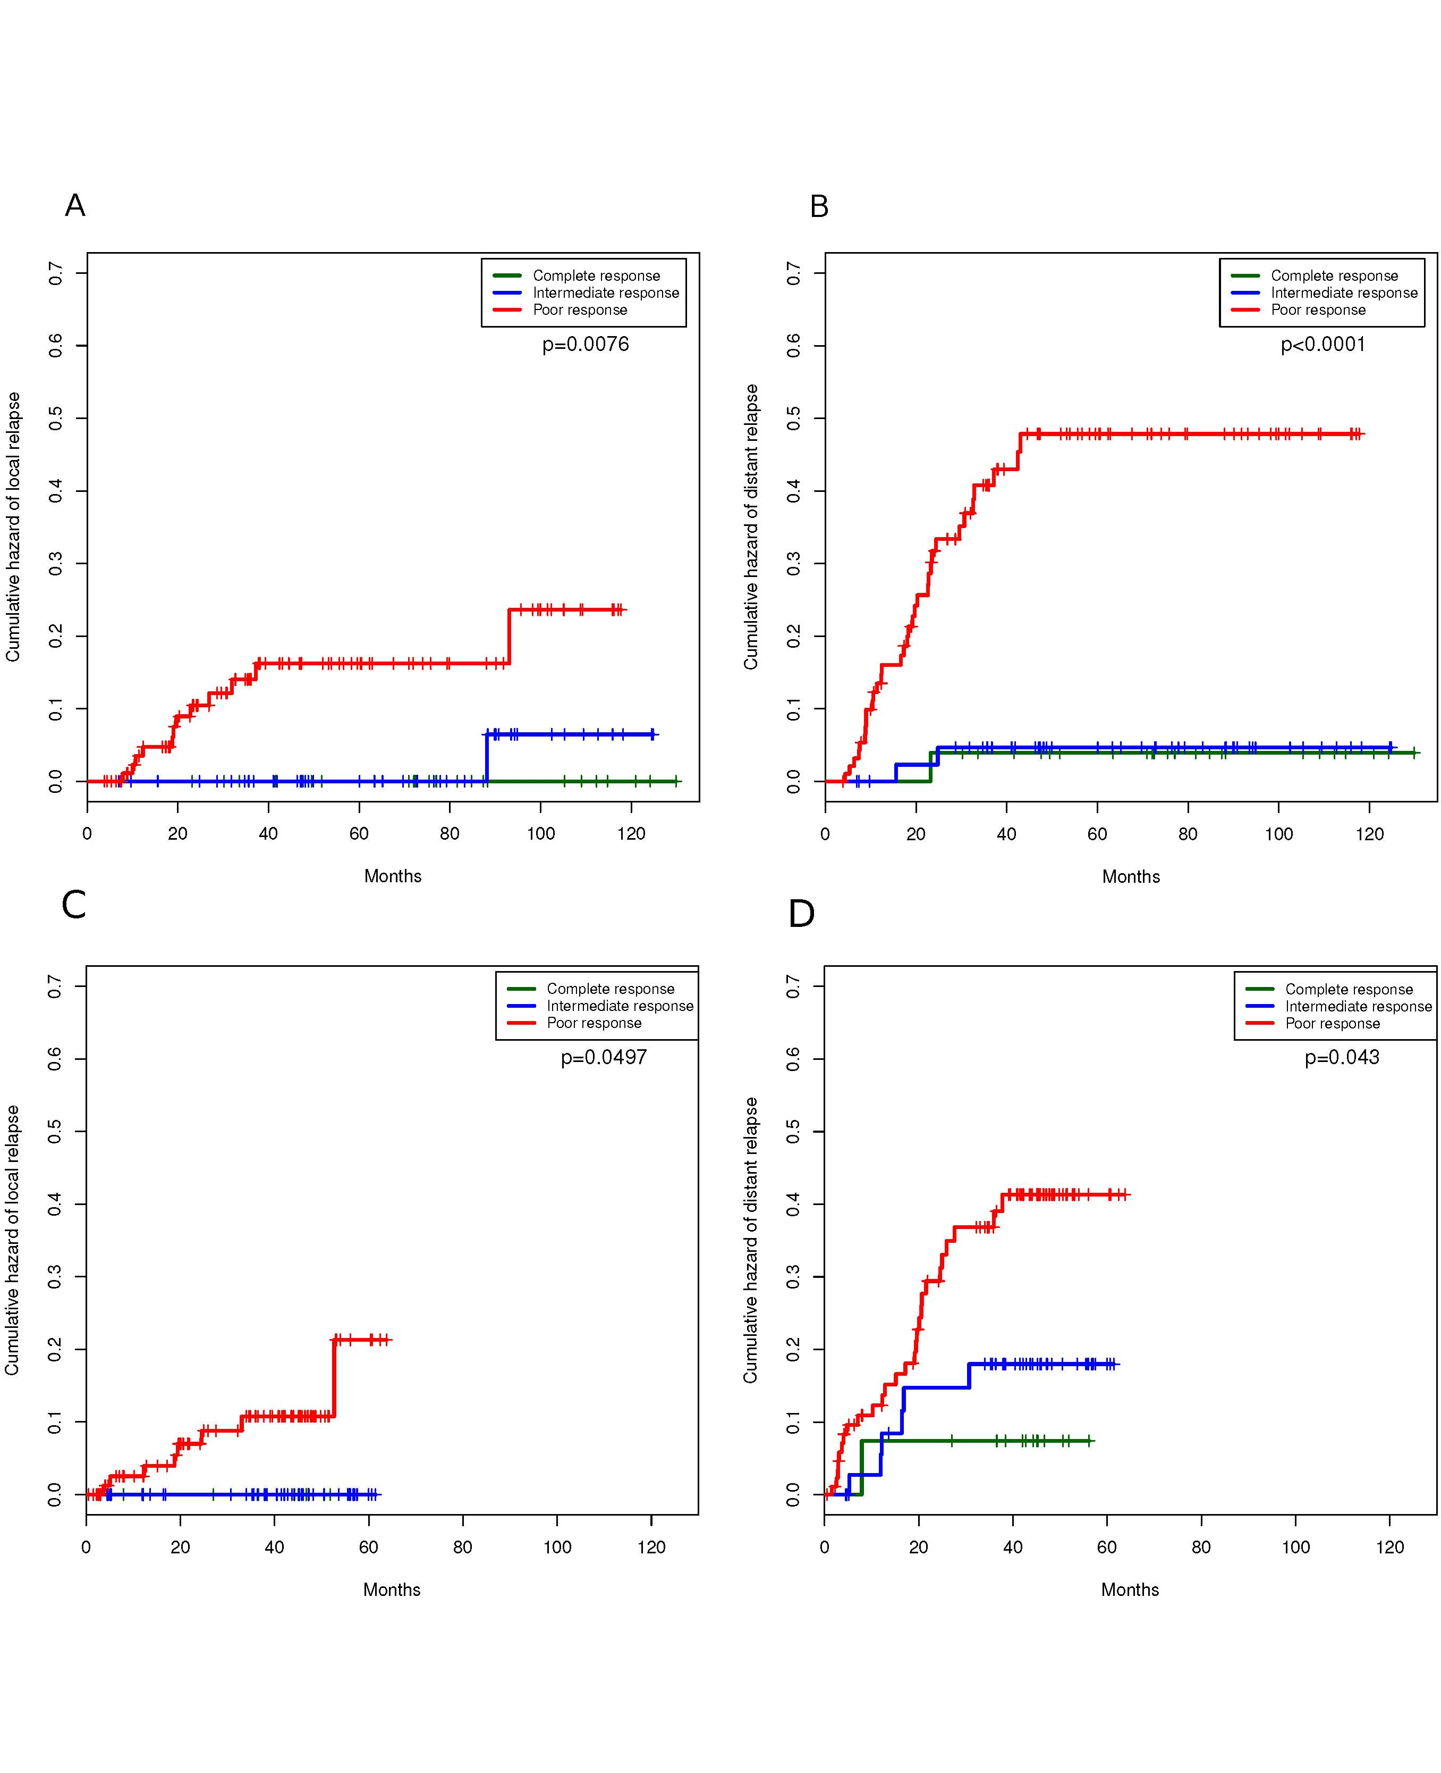
Figure 2 Cumulative hazards estimates. A: Local relapse in the main cohort; B: Distant relapse in the main cohort; C: Local relapse in the external reference cohort; D: Distant relapse in the external reference cohort (Note: in Figure 2C complete and intermediate responders overlap).
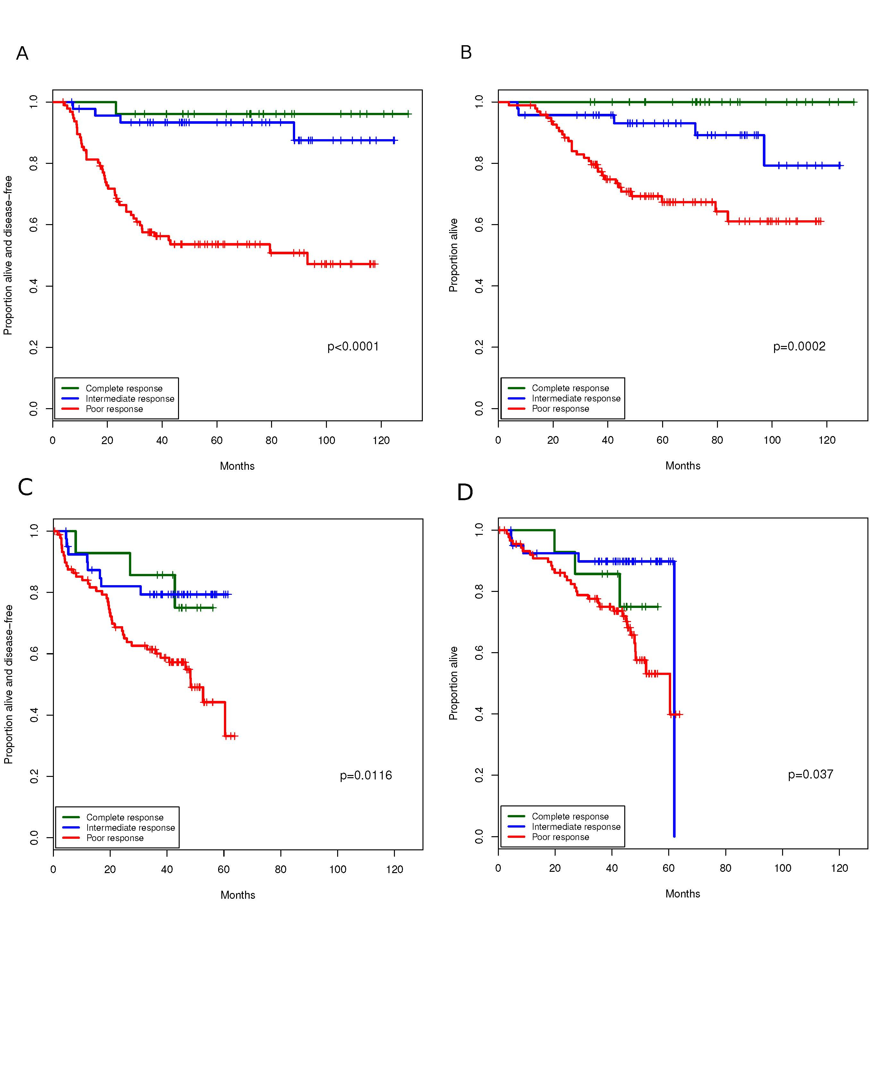
Figure 3 Kaplan Meier estimates. A: Disease-free survival in the main cohort; B: Overall survival in the main cohort; C: Disease-free survival in the external reference cohort; D: Overall survival in the external reference cohort.

Table 1 Descriptive baseline statistics by type of response achieved n (%)
Variable | Complete responseª  (n = 26) | Intermediate response^{b}  (n = 47) | Poor response^{c}  (n = 97) | P value
Median patient age (range) | 65.5 (39.9-84.9) | 65.7 (42.9-84.0) | 65.5 (41.3-83.5) | 0.8407
Female patients | 11 (42) | 14 (30) | 29 (30) | 0.4551
CEA μg/L^{d} |  |  |  | 0.0122
< 3.6 | 21 (81) | 26 (55) | 47 (49)
3.6 to < 20.9 | 5 (19) | 20 (43) | 41 (42)
> 20.9 | 0 | 0 | 9 (9)
Median pre-surgery Hemoglobin, g/dL (range) | 13.1 (9.2-16.0) | 14.0 (7.9-18.2) | 13.4 (7.6-18.4) | 0.0580
Clinical stage |  |  |  | 0.1325
cT2N0 | 0 | 2¹ (4) | 0 (0)
cT2N1 | 0 | 3 (6) | 3 (3)
cT3N0 | 11 (42) | 21 (45) | 38 (39)
cT3N1 | 14 (54) | 14 (30) | 38 (39)
cT4N0 | 1 (4) | 0 (0) | 2 (2)
cT4N1 | 0 | 0 | 3 (3)
Severe stenosis precluding staging | 0 | 7 (15) | 13 (13)
Median distance from tumor to anal margin, cm (range) | 7.0 (2.0-12.0) | 5.0 (1.0-15.0) | 8.0 (1.0-15.0) | 0.0697
Previous abdominal surgery | 14 (54) | 16 (34) | 39 (40) | 0.2546
Type of surgery |  |  |  | 0.5368
AAP or miles intervention | 4 (15) | 8 (17) | 23 (24)
Low-anterior resection | 21 (81) | 33 (70) | 65 (67)
Other | 1 (4) | 6 (13) | 9 (9)
Laparoscopic vs open surgery |  |  |  | 0.1748
Fully laparoscopic | 25 (96) | 42 (89) | 77 (79)
Intraoperative conversion to open surgery | 1 (4) | 4 (9) | 12 (12)
Open surgery from the beginning | 0 | 1 (2) | 8 (8)
Median days in hospital (range) | 5.0 (3.0-16.0) | 6.5 (4-55) | 7 (2-145) | 0.0164
Median number of lymph nodes resected (range) | 11 (1-27) | 10 (1-33) | 12 (1-29) | 0.3768
Patients with 12 or more lymph nodes resected | 12 (46) | 20 (43) | 49 (51) | 0.66
Involvement of radial margin |  |  |  | < 0.0001
No | 26 (100) | 44 (94) | 62 (64)
Yes | 0 | 0 | 15 (16)
Not assessed | 0 | 3 (6) | 20 (21)
¹Although staging of cT2N0 was considered an exclusion criterion, these tumors were located in the low rectum and we considered that, despite staged cT2N0, the risk of local relapse without neoadjuvant chemo-radiotherapy was too high. ªypT0N0; ^{b}ypT1-2N0; ^{c}ypT3-4N1-2; ^{d}This variable has one missing value. These categories are equal-widths in the logarithmic scale. IQR: Interquartile range; CEA: Carcinoembryonic antigen.

Table 2 Multivariate analysis of disease-free survival
 | Main cohort |  | External reference cohort
 | HR (95%CI) | P-value | HR (95%CI) | P-value
Type of response after CRT
ypT0N0 | 0.07 (0.01-0.54) | 0.010 | 0.51 (0.15-1.7) | 0.27
ypT1-2N0 | 0.16 (0.06-0.46) | 0.0007 | 0.41 (0.18-0.94) | 0.036
ypT3-4/N1-2 | Reference |  | Reference
CEA | 1.02 (1.01-1.03) | 0.0010 | 1.02 (1.01-1.03) | 0.0072
Pre-surgery clinical stage
T2-3N0 | Reference |  | Reference
T4 and/or N1 | 1.19 (0.82-1.73) | 0.35 | 1.66 (0.85-3.26) | 0.14
Days of admission following surgery¹ | 1.02 (1.01-1.02) | 0.0019
¹This variable was not available in the external reference cohort. CRT: Chemoradiotherapy; CEA: Carcinoembryonic antigen; EUS: Ultrasound endoscopy. Model is also adjusted by a quadratic term of CEA.

Table 3 Multivariate analysis of overall survival
 | Main cohort |  | External reference cohort
 | HR (95%CI) | P-value | HR (95%CI) | P-value
Chemotherapy¹ | 1.09 (0.55-2.16) | 0.81
Type of response after CRT
ypT0N0 | NE |  | 0.61 (0.19-2.02) | 0.42
ypT1-2N0 | 0.30 (0.11-0.78) | 0.014 | 0.32 (0.13-0.83) | 0.019
ypT3-4/N1-2 | Reference |  | Reference
CEA | 1.00 (0.97-1.03) | 0.78
Pre-surgery clinical stage
T2-3N0 |  |  | Reference
T4 and/or N1 |  |  | 1.89 (0.95-3.76) | 0.069
¹This factor was not evaluated in the external reference cohort because all patients were scheduled to receive chemotherapy. CRT: Chemoradiotherapy; CEA: Carcinoembryonic antigen; NE: Not estimable because there are no deaths in this category. Model is also adjusted by a square term of CEA.

