Name of Journal: World Journal of Gastroenterology
Manuscript NO: 82927
Manuscript Type: ORIGINAL ARTICLE

Observational Study
Pre-transjugular-intrahepatic-portosystemic-shunt measurement of hepatic venous pressure gradient and its clinical application: A comparison study

Wang XX et al. TIPS for patients with HVPG ≥ 16 mmHg

Xi-Xuan Wang, Xiao-Chun Yin, Li-Hong Gu, Hui-Wen Guo, Yang Cheng, Yan Liu, Jiang-Qiang Xiao, Yi Wang, Wei Zhang, Xiao-Ping Zou, Lei Wang, Ming Zhang, Yu-Zheng Zhu-Ge, Feng Zhang

Xi-Xuan Wang, Xiao-Chun Yin, Li-Hong Gu, Yang Cheng, Yan Liu, Jiang-Qiang Xiao, Yi Wang, Wei Zhang, Xiao-Ping Zou, Lei Wang, Ming Zhang, Yu-Zheng Zhu-Ge, Feng Zhang, Department of Gastroenterology, Affiliated Drum Tower Hospital of Nanjing University Medical School, Nanjing 210000, Jiangsu Province, China

Xi-Xuan Wang, Yu-Zheng Zhu-Ge, Medical School, Southeast University, Nanjing 210000, Jiangsu Province, China

Hui-Wen Guo, Department of Gastroenterology, The Affiliated Jiangning Hospital of Nanjing Medical University, Nanjing 210000, Jiangsu Province, China

Author contributions: Wang XX and Yin XC contributed equally to this work; Zhang F, Zhu-Ge YZ, Wang XX contributed to the conceptualization; Wang XX, Yin XC, Gu LH, Guo HW, Cheng Y, Liu Y contributed to the data curation; Zhang F, Zhu-Ge YZ, Wang XX contributed to the formal analysis; Zhang F acquired the funding; Wang XX, Yin XC, Gu LH, Guo HW, Cheng Y, Liu Y contributed to the investigation; Zhang F, Zhu-Ge YZ, Zhang M, Xiao JQ, Wang Y, Zhang W contributed to the methodology; Zhang F, Zhu-Ge YZ, Zhang M administered the project; Wang L, Zou XP contributed to the resources; Wang L, Zou XP utilized the software; Zhang F, Zhu-Ge YZ, Zhang M contributed to the supervision; Wang XX, Yin XC, Gu LH, Guo HW contributed to the validation; Wang XX, Yin XC contributed to the visualization; Wang XX wrote the original draft; Zhang F, Zhu-Ge YZ reviewed and edited the draft; all authors have read and approve the final manuscript.

Supported by the National Natural Science Foundation of China, No. 81900552; Nanjing Health Science, Technology Development Special Fund Project-Key project, No. ZKX19015; Outstanding Youth Fund project, No. JQX20005; Funding for Clinical Trials from the Affiliated Drum Tower Hospital, Medical School of Nanjing University, No. 2022-LCYJ-MS-13.

Corresponding author: Feng Zhang, MD, Doctor, Professor, Department of Gastroenterology, Affiliated Drum Tower Hospital of Nanjing University Medical School, No. 321 Zhongshan Road, Nanjing 210000, Jiangsu Province, China. fzdndx@126.com

Received: January 3, 2023
Revised: March 15, 2023
Accepted: May 17, 2023
Published online: June 14, 2023

Abstract
BACKGROUND
It is controversial whether transjugular intrahepatic portosystemic shunt (TIPS) placement can improve long-term survival.

AIM
To assess whether TIPS placement improves survival in patients with hepatic-venous-pressure-gradient (HVPG) ≥ 16 mmHg, based on HVPG-related risk stratification.

METHODS
Consecutive variceal bleeding patients treated with endoscopic therapy+nonselective β-blockers (NSBBs) or covered TIPS placement were retrospectively enrolled between January 2013 and December 2019. HVPG measurements were performed before therapy. The primary outcome was transplant-free survival; secondary endpoints were rebleeding and overt hepatic encephalopathy (OHE).

RESULTS
A total of 184 patients were analyzed (mean age, 55.27 years ± 13.86, 107 males; 102 in the EVL+NSBB group, 82 in the covered TIPS group). Based on the HVPG-guided risk stratification, 70 patients had HVPG < 16 mmHg, and 114 patients had HVPG ≥ 16 mmHg. The median follow-up time of the cohort was 49.5 mo. There was no significant difference in transplant-free survival between the two treatment groups overall (hazard ratio [HR], 0.61; 95% confidence interval [CI]: 0.35, 1.05; P = 0.07). In the high-HVPG tier, transplant-free survival was higher in the TIPS group (HR, 0.44; 95%CI: 0.23, 0.85; P = 0.004). In the low-HVPG tier, transplant-free survival after the two treatments was similar (HR, 0.86; 95%CI: 0.33, 0.23; P = 0.74). Covered TIPS placement decreased the rate of rebleeding independent of the HVPG tier (P < 0.001). The difference in OHE between the two groups was not statistically significant (P = 0.09; P = 0.48).

CONCLUSION
TIPS placement can effectively improve transplant-free survival when the HVPG is greater than 16 mmHg.

Key Words: Hepatic venous pressure gradient; Transjugular intrahepatic portosystemic shunts; Cirrhosis; Variceal rebleeding; Survival

©The Author(s) 2023. Published by Baishideng Publishing Group Inc. All rights reserved.

Citation: Wang XX, Yin XC, Gu LH, Guo HW, Cheng Y, Liu Y, Xiao JQ, Wang Y, Zhang W, Zou XP, Wang L, Zhang M, Zhu-Ge YZ, Zhang F. Pre-transjugular-intrahepatic-portosystemic-shunt measurement of hepatic venous pressure gradient and its clinical application: A comparison study. World J Gastroenterol 2023; 29(22): 3519-3533
URL: https://www.wjgnet.com/1007-9327/full/v29/i22/3519.htm
DOI: https://dx.doi.org/10.3748/wjg.v29.i22.3519

Core Tip: Hepatic venous pressure gradient helps clinicians to assess the prognosis of decompensated cirrhotic patients. The study included 184 patients showed that hepatic-venous-pressure-gradient (HVPG) before therapy as a risk stratification provides prognostic value. Treatment can be given with greater confidence with the management of patients by HVPG.

INTRODUCTION
As a result of portal hypertension related to cirrhosis, variceal bleeding (VB) has been the leading cause of death in cirrhotic patients^{[1]}. More than 50% of cirrhotic patients who undergo the recommended hemostatic treatments are readmitted due to rebleeding within a year. Among them, the mortality rate is nearly 33%^{[2]}. In view of the high rebleeding rate, further therapy to prevent rebleeding, which is defined as secondary prophylaxis, should be performed for patients surviving acute VB. Nonselective beta-blockers (NSBBs) can decrease the portal venous pressure by reducing the cardiac output and splanchnic vasodilation. In addition, to render varices ischemic and necrotic, some endoscopic treatments for VB have been developed. It is advocated that endoscopic variceal ligation (EVL), combined with NSBBs, should be the first line of therapy for the secondary prevention of VB, while transjugular intrahepatic portosystemic shunt (TIPS) placement should be performed in rebleeding patients and preemptive TIPS placement should only be performed for high-risk patients^{[3,4]}. TIPS placement is a fluoroscopy-guided procedure in which a conduit is built between the systemic and portal venous systems with the intent of decreasing the portal pressure^{[5]}. A study with a median follow-up of 16 mo concluded that early TIPS placement could reduce treatment failure and mortality among high-risk patients^{[6]}. Preemptive treatment could also improve the survival of patients with acute-on-chronic liver failure and acute VB, as suggested in a European observational study^{[7]}. However, diversion of the portal flow could also lead to hepatic encephalopathy (HE) resulting from hepatic hypoperfusion and liver failure^{[6,8]}. Holster et al^{[5]} noted that TIPS placement was associated with higher rates of early HE (within one year). Thus, it is not clear whether TIPS placement offers a survival benefit.
The hepatic venous pressure gradient (HVPG) has been shown to have prognostic value in both compensated and decompensated cirrhosis^{[3,4,9]}. In patients with HVPG ≥ 16 mmHg, the mortality rate of acute variceal hemorrhage is increased^{[10]}. Moreover, HVPG ≥ 20 mmHg has been a clinically effective predictor of early rebleeding^{[11]}. In our previous study^{[12]}, which had a 1-year follow-up period, we concluded that covered TIPS placement was more effective than standard therapy in preventing rebleeding but that it did not improve survival.
On the basis of our earlier findings, we compared TIPS placement with EVL+NSBBs to assess whether TIPS placement improves survival in cirrhotic patients with VB based on HVPG-related risk stratification over a long-term period to obtain more precise individual treatments and better treatment effects.

MATERIALS AND METHODS
Study design and patients
The study protocol was approved by the ethics committees of the Nanjing Drum Tower Hospital (Nanjing, Jiangsu Province, China). We retrospectively screened clinically stable cirrhotic patients with VB who were admitted to the Department of Gastroenterology of Nanjing Drum Tower Hospital from January 2013 to December 2019 in the prospectively maintained database (Figure 1). The included patients were diagnosed with liver cirrhosis by clinical, radiologic, and endoscopic examinations^{[13]}, and signed the informed consent form. The HVPG measurement was performed before therapy. Based on the HVPG-guided risk stratification (with the HVPG as a scale variable), patients with HVPG ≥ 16 mmHg were considered high-HVPG patients, and those with 10 mmHg ≤ HVPG < 16 mmHg were considered low-HVPG patients. The exclusion criteria of the study were as follows: (1) Non-standardized sequential endoscopic therapy; (2) previous secondary preventive intervention; (3) concomitant malignant tumors; (4) failure of sequential endoscopic therapy, i.e., rebleeding before the eradication of varices; (5) severe heart failure (New York Heart Association stage IV), respiratory failure (PaO₂ < 60 mmHg) or severe kidney dysfunction (stage 5 chronic kidney disease); (6) pregnancy or lactation; and (7) missing follow-up data.
Finally, we included 184 patients in our study. All patients signed the informed consent form. Data for 83 of the 184 patients have been previously reported^{[12]}. The prior article examined the effect of covered TIPS placement vs EVL+β-blockers in patients with HVPG ≥ 16 mmHg after 1 year, whereas in this study, which included all patients with HVPG ≥ 10 mmHg, we report the long-term outcomes after covered TIPS placement.

HVPG measurement
All included patients underwent preoperative examinations to rule out contraindications followed by HVPG measurements, which were performed under local anesthesia after 6-8 h of fasting (Figure 2). Briefly, the external zero reference point was set at the midaxillary line of the patient. Puncture through the right internal jugular vein was performed. In the TIPS group, a Cobra catheter (RUPS-100, COOK, Bloomington, IN, United States) was introduced into the right or middle hepatic vein, and hepatic venography was performed first to confirm whether stenosis or an obvious lateral shunt was present in the surrounding area. Measurements indicating large shunts were considered meaningless, while measurements indicating small or no shunts were considered meaningful. A 5.5-7 F balloon-tipped catheter (Edwards Lifesciences, Irvine, CA, United States) was guided into the hepatic vein. The free hepatic venous pressure (FHVP) was read after the pressure value stabilized. Air was injected to dilate the balloon to fully block hepatic vein blood flow. The wedged hepatic venous pressure (WHVP) was read after the pressure value stabilized for at least 40 s. The WHVP, FHVP, and inferior vena cava pressure were measured three times. Differences among the WHVP or FHVP measurements should not exceed 1 mmHg. The average of the 3 measurements was taken. After the pressure measurements were completed, a contrast agent was injected to confirm whether the obstruction was complete and whether hepatic vein-to-vein communications were present. The HVPG was calculated according to the following formula: HVPG=WHVP-FHVP.

Therapy
After the HVPG measurements were acquired, the details of the two therapies were explained to the patients, including the procedures, adverse reactions, cost, and so on. Doctors provided professional medical advice based on the patient’s performance status, past bleeding history, vascular conditions, and HVPG, among other factors. The final treatment was selected by the patients.
Endoscopic therapy and NSBB usage were the same as described in our previous article^{[12]}; specific details are provided in the Supplementary Methods.
Eighty-two patients underwent covered TIPS placement (Figure 2). Briefly, the process of TIPS placement was the same as described in our previous article^{[12]}; specific details are provided in the Supplementary Methods. All operations were completed by a professional gastroenterology interventional therapy team to avoid surgical complications as much as possible.
Etiological treatment was followed throughout the study.

Follow-up and endpoints
Outpatient follow-up was performed 1, 3, 6 and 12 mo after treatment and once a year thereafter. Follow-up examinations included postoperative history collection, routine blood tests and abdominal ultrasound. Any patients with complications during the follow-up period were admitted to the hospital for active treatment.
The primary endpoint of the study was the transplant-free survival time. The secondary endpoints were (1) Rebleeding and (2) the development of overt HE (OHE) diagnosed according to the American Association for the Study of Liver Diseases guidelines^{[14]}. The patients were followed up until November 2021 or until death or liver transplantation. Two physicians regularly reviewed the data to detect errors. Two physicians assessed the accuracy of the data. After verification of the collected clinical variables in our study, statistical analysis was performed.

Statistical analysis
Our long-term observational study followed the Strengthening the Reporting of Observational Studies in Epidemiology guidelines^{[15]}. Data are described as frequencies and percentages, means and standard deviations, or medians and interquartile ranges, as appropriate. Baseline characteristics were compared using Fisher’s exact test for categorical variables, t test for continuous variables, and the Wilcoxon rank-sum test for ordinal and continuous variables. Survival was estimated using the cumulative incidence function. Kaplan–Meier curves were used to illustrate the cumulative rates of survival and variceal rebleeding, and differences were assessed by the log-rank test. Associations of the risk factors with mortality were assessed by univariate and multivariate Cox proportional hazards regression models, and forward regression analysis was used to select the variables included in the multivariate model. All analyses were performed using GraphPad software (version 9.0), Statistical Package for Social Sciences (version 22.0) and R studio (version 4.0.1), and a level of significance was established at the two-sided 5% level.

RESULTS
According to the inclusion and exclusion criteria, 184 patients were analyzed. Based on the HVPG-guided risk stratification, 70 patients were in the low-HVPG tier, and 114 were in the high-HVPG tier. The patient characteristics are shown in Table 1. The median follow-up time was 49.5 mo. Patients who were lost to follow-up were excluded. The average time from registering to the end of research was not significantly different between the two groups. There were some differences in the baseline characteristics, which reflected the more severe conditions of the patients undergoing covered TIPS placement.

Transplant-free survival
In general, the mortality rate was not significantly different between the two therapies in the whole cohort of patients who were admitted with VB (P = 0.07) (Figure 3A). In the low-HVPG tier, few differences were observed between the two groups (P = 0.74) (Figure 3B). Interestingly, in the high-HVPG tier, covered TIPS placement markedly improved survival. In patients with HVPG ≥ 16 mmHg, 14 (24.1%) patients in the TIPS group and 19 (33.9%) in the EVL+NSBB group died during the follow-up period; 3 (5.4%) patients in the TIPS group and 3 (5.2%) in the EVL+NSBB group underwent liver transplantation. The transplant-free survival rate was higher in the TIPS group (hazard ratio [HR], 0.44; 95% confidence interval [CI]: 0.23, 0.85; P = 0.004) (Figure 3C). Similar trends were found among patients without a shunt in the hepatic vein (Supplementary Figure 1).
A subgroup analysis was performed according to etiology. For cirrhotic patients with viral hepatitis and alcoholic hepatitis, the difference in transplant-free survival was negligible (HR, 0.53; 95%CI: 0.26, 1.06; P = 0.07) (Figure 3D). Among these patients, TIPS placement did not improve transplant-free survival in the low-HVPG tier (HR, 0.91; 95%CI: 0.23, 3.61; P = 0.89) (Figure 3E) but did improve transplant-free survival in the high-HVPG tier (HR, 0.41; 95%CI: 0.18, 0.94; P = 0.04) (Figure 3F). For cirrhotic patients who had etiologies unrelated to viral and alcoholic hepatitis, TIPS placement did not confer a significant transplant-free survival benefit, as shown in Supplementary Figure 1.
Subgroup analysis was performed according to the endoscopic appearance of varices, whether there were cardiofundal varices or type 2 isolated gastric varices (IGV)^{[16]}. Among patients suffering only from esophagogastric varices and/or type 1 gastroesophageal varices (GOV1), during the follow-up period, TIPS placement showed a significant transplant-free survival advantage in the high-HVPG tier (HR, 0.29; 95%CI: 0.11, 0.71; P = 0.007) (Supplementary Figure 1), while there was no significant difference between the two groups (HR, 0.75; 95%CI: 0.22, 2.54; P = 0.64) (Supplementary Figure 1). Among 57 patients with GOV2 and/or IGV, TIPS placement did not improve survival, as shown in Supplementary Figure 1.
In the univariate analysis, baseline age, total bilirubin (Tbil), aspartate aminotransferase, HVPG tier and therapy were included as candidate variables for the multivariate model. The final multivariate Cox regression model showed that age (HR, 1.03 per year of age; 95%CI: 1.02, 1.07), Tbil (HR, 1.03 per mol/L of Tbil; 95%CI: 1.00, 1.06), HVPG tier (HR, 2.01 compared with low-HVPG tier; 95%CI: 1.04, 3.89), and therapy (HR, 0.45 compared with EVL+NSBBs; 95%CI: 0.25, 0.81) were independent risk factors for mortality (Table 2).
Uncontrolled rebleeding, HE and multiple organ dysfunction syndrome were the most common causes of death (Table 3).

Rebleeding
In the whole cohort, covered TIPS placement significantly reduced rebleeding, as previous studies^{[17]} have reported (P < 0.001) in both the low-HVPG and high-HVPG tiers (Figure 4). The same trends were found for the patients without stents and in the subgroup analyses (Supplementary Figure 2). TIPS placement definitely reduced rebleeding, even when ignoring the etiology and endoscopic appearance. The causes of rebleeding are shown in Table 4.

OHE
Thirteen patients (16.30%) experienced OHE, including 12 (13.33%) patients in the EVL+NSBB group and 18 (28.12%) in the covered TIPS group (Table 5). The occurrence of OHE was consistently similar between the two groups over the long term, while a significant difference was observed in the occurrence of OHE at 1 year (2.90% vs 10.98%, P = 0.02).

Jaundice and hyperbilirubinemia
Changes in Tbil after therapy occurred in 184 patients (EVL+NSBB group vs covered TIPS group, 102 vs 82) at baseline, 156 patients at the 1-year follow-up (92 vs 74), and 141 patients at the 2-year follow-up (77 vs 64). The TBIL values for 181 patients were registered at the end of follow-up.
Among the included patients (n = 184), excluding those without complete follow-up examinations (n = 43), the changes in the actual values and in the P values after Bonferroni correction at each point are shown in Figure 5A and B. TIPS placement did not induce hyperbilirubinemia (Tbil > 34 μmol/L^{[18]}) in the low-HVPG tier (Figure 5C and D), while in the high-HVPG tier, more patients who underwent TIPS placement experienced hyperbilirubinemia (Figure 5E and F), as shown in Table 5.

Ascites
Changes in the depth of ascites after therapy were obtained, as described for Tbil.
The average of the actual values and the P values after Bonferroni correction at each point are shown in Figure 6 and Table 5. In our research, the depth of ascites in the patients after covered TIPS placement decreased, while after endoscopy therapy with NSBBs, it did not, which agreed with the previously reported findings^{[19]}.

Hypercreatinemia, hyponatremia and hepatorenal syndrome
The changes in serum creatine and Na⁺ after therapy were the same as the changes in Tbil.
TIPS placement had no effects on hypercreatinemia (creatine > 110 μmol/L for males, > 100 μmol/L for females) or hyponatremia (Na⁺ < 135 mmol/L) compared with EVL+NSBBs (Supplemental Figure 3), ignoring the HVPG.

Changes in the model for end-stage liver disease score
Changes in the model for end-stage liver disease score after therapy were determined the same as described for changes in the Tbil level^{[20]}.
In the whole cohort, the scores gradually increased over follow-up after both of the therapies (Figure 7A and B). The patients treated with EVL+NSBBs in the low-HVPG tier showed increased scores after the second year (Figure 7C), while those treated with covered TIPS placement did not. the scores of patients in the high-HVPG tier increased earlier (Figure 7E and F).

Shunt dysfunction
In our study, stent loss occurred in 12 of 82 patients, including 3 (12.50%) in the low-HVPG tier and 9 (16.07%) in the high-HVPG tier. Stent dysfunction was discovered in 6 (66.67%) patients in the high-HVPG tier due to rebleeding or ascites, while stent dysfunction was discovered in patients in the low-HVPG tier during regular follow-up.

DISCUSSION
It would be extremely helpful to be able to distinguish patients with a high risk of uncontrolled rebleeding. Risk stratification is pivotal for secondary prophylaxis in VB. A recent expert consensus has suggested that HVPG-guided treatment is a reasonable clinical strategy^{[4]}. A study in 2015 concluded that HVPG measurement was useful for making decisions in selecting therapies for secondary prophylaxis^{[21]}. However, the HVPG cutoff for risk stratification has not been clearly demonstrated. In 1991, a study demonstrated that the lowest pressure associated with continued bleeding or rebleeding was 16 mmHg^{[22]}. Furthermore, Villanueva et al^{[23]} pointed out that HVPG > 16 mmHg was a predictor of treatment failure. The latest expert consensus is that early TIPS placement reduces treatment failure in patients with HVPG ≥ 20 mmHg^{[4]}. There is established evidence for an HVPG-stratified approach to treatment among compensated cirrhotic patients but very limited data for decompensated patients. On the basis of earlier findings^{[12]}, at the beginning of our study and according to the present guidelines, the included patients were divided into 2 groups: the high-HVPG (≥ 16 mmHg) and low-HVPG (10 mmHg ≤ HVPG < 16 mmHg) groups. Consequently, if there were no contraindications, TIPS placement improved survival in patients with HVPG ≥ 16 mmHg (HR, 0.4385; 95%CI: 0.2255-0.8525; P = 0.0037), even though patients who underwent TIPS placement had worse baseline clinical indicators.
A previous study could not conclude whether there were any beneficial effects of TIPS placement on transplant-free survival in all patients. Notably, the median follow-up in all previous studies was shorter than 24 mo, while our median follow-up was 49.5 mo. In our study, the survival benefit can be viewed in the long term. Moreover, the main causes of death were significantly different. Rebleeding in patients treated with covered TIPS placement, which was generally due to stent dysfunction, was controlled in most patients, providing an opportunity for further therapy, while rebleeding in some patients treated with EVL+NSBBs was turbulent.
Our study of HVPG-guided treatment indicated that patients with high HVPG values have a high risk of rebleeding despite treatment with EVL+NSBBs, and in patients with HVPG ≥ 16 mmHg, percutaneous transhepatic variceal embolization or TIPS placement may be a favorable alternative to EVL+NSBBs.
Considering the high rate of OHE in patients treated with covered TIPS placement mentioned in previous research^{[8,24]}, we opted for the placement of small-diameter (8 mm) stents, which can provide adequate bleeding prophylaxis and decrease the OHE rate. Regarding the patients in the low-HVPG tier, there was a trend of growth in the rate of OHE among patients treated with covered TIPS placement, and these results are in accordance with earlier findings. Covered TIPS placement did not increase the rate of OHE among patients in the high-HVPG tier. The differences in encephalopathy between the two treatment groups were the largest in the first year, and this result is in accordance with that of a previous study^{[6]}. A Chinese study proposed that the HVPG is a risk factor for liver failure after TIPS placement^{[24]}. Therefore, we assessed hyperbilirubinemia after therapy. Our results were in accordance with those of a previous study^{[24]}.
Based on the HVPG-guided risk stratification, patients with a high HVPG were more likely to benefit from TIPS placement in our study. For patients with a low HVPG, the significant reduction in rebleeding did not improve survival outcomes due to the complications of TIPS placement. Furthermore, HVPG-guided risk stratification may be applied in the evaluation of OHE and hyperbilirubinemia syndrome after TIPS: patients with a high HVPG have a higher probability of OHE and hyperbilirubinemia than those with a low HVPG. Rebleeding and ascites might occur earlier in patients with a high HVPG who underwent TIPS placement and developed stent dysfunction, but this needs further study. Further research is needed to evaluate whether HVPG-guided risk stratification should be performed before splenectomy.
Notably, our results cannot be extrapolated to older patients or patients with occlusive portal vein thrombosis or hepatocellular carcinoma, as these populations were not included in our study. Additionally, in our study, the numbers of patients with IGV and/or GOV2 were not sufficient, which contributed to the fact that the differences between the two therapies were not significant; as such, the findings could not confirm previous research^{[25]}. Due to the nature of single-center observational studies, an inherent risk of selection bias is inevitable. Another potential bias may be the lower-than-expected attention to the clinical symptoms in patients. Furthermore, selection bias could not be ignored because the therapy was ultimately chosen by the patient. Even with these limitations, this study produced robust data. Further randomized controlled trials need to be performed to prove the benefit of covered TIPS placement in the secondary prevention of VB.

CONCLUSION
In conclusion, covered TIPS placement increases long-term transplant-free survival in patients with HVPG ≥ 16 mmHg who are admitted with VB, but this advantage may not be observed in patients with 10 mmHg ≤ HVPG < 16 mmHg. More appropriate management and treatment of cirrhotic patients may be achieved by stratification according to HVPG measurements obtained before therapy.

ARTICLE HIGHLIGHTS
Research background
It is controversial whether transjugular intrahepatic portosystemic shunt (TIPS) placement can improve long-term survival.

Research motivation
To clarify the feasibility of hepatic venous pressure gradient (HVPG) as a risk stratification strategy for patients with decompensated cirrhosis.

Research objectives
To assess whether TIPS placement improves survival in patients with HVPG ≥ 16 mmHg based on HVPG-related risk stratification.

Research methods
Consecutive variceal bleeding patients treated with endoscopic variceal ligation (EVL)+nonselective β-blockers (NSBBs) or covered TIPS placement were retrospectively enrolled between January 2013 and December 2019. HVPG measurements were performed before therapy. The primary outcome was transplant-free survival; secondary endpoints were rebleeding and overt hepatic encephalopathy (OHE).

Research results
A total of 184 patients were analyzed (mean age, 55.27 years ± 13.86, 107 males; 102 in the EVL+NSBB group, 82 in the covered TIPS group). Based on the HVPG-guided risk stratification, 70 patients had HVPG < 16 mmHg, and 114 patients had HVPG ≥ 16 mmHg. The median follow-up time of the cohort was 49.5 mo. There was no significant difference in transplant-free survival between the two treatment groups overall (hazard ratio [HR], 0.61; 95% confidence interval [CI]: 0.35, 1.05; P = 0.07). In the high-HVPG tier, transplant-free survival was higher in the TIPS group (HR, 0.44; 95%CI: 0.23, 0.85; P = 0.004). In the low-HVPG tier, transplant-free survival after the two treatments was similar (HR, 0.86; 95%CI: 0.33, 0.23; P = 0.74). Covered TIPS placement decreased the rate of rebleeding independent of the HVPG tier (P < 0.001). The difference in OHE between the two groups was not statistically significant (P = 0.09; P = 0.48).

Research conclusions
TIPS placement can effectively improve transplant-free survival when the HVPG is greater.

Research perspectives
Further randomized controlled trials need to be performed to prove the benefit of covered TIPS placement in the secondary prevention of decompensated cirrhosis.

ACKNOWLEDGEMENTS
The authors would like to thank several researchers from Nanjing Medical University, Nanjing University, Jiangsu University and Southeast University for their help in data collection for the DCDT COHORT STUDY since 2012, Nurse Qin Yin from the Department of Gastroenterology of Nanjing Drum Tower Hospital for help in patient follow-up, Dr. Hao Han and Prof. Jian Yang from the Department of Ultrasound Imaging of Nanjing Drum Tower Hospital for their help in collecting abdominal ultrasound images, Dr. Hao Zhang from the Department of Internal Medicine of Nanjing Drum Tower Hospital for his guidance on visualization, and Dr. Taishun Li from the Department of Biomedicine Statistics of Nanjing Drum Tower Hospital for providing statistical suggestions.

REFERENCES
1 Carbonell N, Pauwels A, Serfaty L, Fourdan O, Lévy VG, Poupon R. Improved survival after variceal bleeding in patients with cirrhosis over the past two decades. Hepatology 2004; 40: 652-659 [PMID: 15349904 DOI: 10.1002/hep.20339]
2 Garcia-Tsao G, Bosch J. Management of varices and variceal hemorrhage in cirrhosis. N Engl J Med 2010; 362: 823-832 [PMID: 20200386 DOI: 10.1056/NEJMra0901512]
3 Garcia-Tsao G, Abraldes JG, Berzigotti A, Bosch J. Portal hypertensive bleeding in cirrhosis: Risk stratification, diagnosis, and management: 2016 practice guidance by the American Association for the study of liver diseases. Hepatology 2017; 65: 310-335 [PMID: 27786365 DOI: 10.1002/hep.28906]
4 de Franchis R, Bosch J, Garcia-Tsao G, Reiberger T, Ripoll C; Baveno VII Faculty. Baveno VII - Renewing consensus in portal hypertension. J Hepatol 2022; 76: 959-974 [PMID: 35120736 DOI: 10.1016/j.jhep.2021.12.022]
5 Holster IL, Tjwa ET, Moelker A, Wils A, Hansen BE, Vermeijden JR, Scholten P, van Hoek B, Nicolai JJ, Kuipers EJ, Pattynama PM, van Buuren HR. Covered transjugular intrahepatic portosystemic shunt vs endoscopic therapy + β-blocker for prevention of variceal rebleeding. Hepatology 2016; 63: 581-589 [PMID: 26517576 DOI: 10.1002/hep.28318]
6 García-Pagán JC, Caca K, Bureau C, Laleman W, Appenrodt B, Luca A, Abraldes JG, Nevens F, Vinel JP, Mössner J, Bosch J; Early TIPS (Transjugular Intrahepatic Portosystemic Shunt) Cooperative Study Group. Early use of TIPS in patients with cirrhosis and variceal bleeding. N Engl J Med 2010; 362: 2370-2379 [PMID: 20573925 DOI: 10.1056/NEJMoa0910102]
7 Trebicka J, Gu W, Ibáñez-Samaniego L, Hernández-Gea V, Pitarch C, Garcia E, Procopet B, Giráldez Á, Amitrano L, Villanueva C, Thabut D, Silva-Junior G, Martinez J, Genescà J, Bureau C, Llop E, Laleman W, Palazon JM, Castellote J, Rodrigues S, Gluud L, Ferreira CN, Barcelo R, Cañete N, Rodríguez M, Ferlitsch A, Mundi JL, Gronbaek H, Hernández-Guerra M, Sassatelli R, Dell'Era A, Senzolo M, Abraldes JG, Romero-Gómez M, Zipprich A, Casas M, Masnou H, Primignani M, Weiss E, Catalina MV, Erasmus HP, Uschner FE, Schulz M, Brol MJ, Praktiknjo M, Chang J, Krag A, Nevens F, Calleja JL, Robic MA, Conejo I, Albillos A, Rudler M, Alvarado E, Guardascione MA, Tantau M, Bosch J, Torres F, Pavesi M, Garcia-Pagán JC, Jansen C, Bañares R; International Variceal Bleeding Observational Study Group and Baveno Cooperation. Rebleeding and mortality risk are increased by ACLF but reduced by pre-emptive TIPS. J Hepatol 2020; 73: 1082-1091 [PMID: 32339602 DOI: 10.1016/j.jhep.2020.04.024]
8 Sauerbruch T, Mengel M, Dollinger M, Zipprich A, Rössle M, Panther E, Wiest R, Caca K, Hoffmeister A, Lutz H, Schoo R, Lorenzen H, Trebicka J, Appenrodt B, Schepke M, Fimmers R; German Study Group for Prophylaxis of Variceal Rebleeding. Prevention of Rebleeding From Esophageal Varices in Patients With Cirrhosis Receiving Small-Diameter Stents Versus Hemodynamically Controlled Medical Therapy. Gastroenterology 2015; 149: 660-8.e1 [PMID: 25989386 DOI: 10.1053/j.gastro.2015.05.011]
9 Merkel C, Bolognesi M, Sacerdoti D, Bombonato G, Bellini B, Bighin R, Gatta A. The hemodynamic response to medical treatment of portal hypertension as a predictor of clinical effectiveness in the primary prophylaxis of variceal bleeding in cirrhosis. Hepatology 2000; 32: 930-934 [PMID: 11050041 DOI: 10.1053/jhep.2000.19322]
10 Lesmana CRA, Raharjo M, Gani RA. Managing liver cirrhotic complications: Overview of esophageal and gastric varices. Clin Mol Hepatol 2020; 26: 444-460 [PMID: 33053928 DOI: 10.3350/cmh.2020.0022]
11 Monescillo A, Martínez-Lagares F, Ruiz-del-Arbol L, Sierra A, Guevara C, Jiménez E, Marrero JM, Buceta E, Sánchez J, Castellot A, Peñate M, Cruz A, Peña E. Influence of portal hypertension and its early decompression by TIPS placement on the outcome of variceal bleeding. Hepatology 2004; 40: 793-801 [PMID: 15382120 DOI: 10.1002/hep.20386]
12 Guo H, Zhang F, Yin X, Zhang M, Xiao J, Wang Y, Zhang B, Zhang W, Zou X, Zhuge Y. Endoscopic therapy + β-blocker vs. covered transjugular intrahepatic portosystemic shunt for prevention of variceal rebleeding in cirrhotic patients with hepatic venous pressure gradient ≥16 mmHg. Eur J Gastroenterol Hepatol 2021; 33: 1427-1435 [PMID: 32868650 DOI: 10.1097/MEG.0000000000001872]
13 Tajiri T, Yoshida H, Obara K, Onji M, Kage M, Kitano S, Kokudo N, Kokubu S, Sakaida I, Sata M, Tajiri H, Tsukada K, Nonami T, Hashizume M, Hirota S, Murashima N, Moriyasu F, Saigenji K, Makuuchi H, Oho K, Yoshida T, Suzuki H, Hasumi A, Okita K, Futagawa S, Idezuki Y. General rules for recording endoscopic findings of esophagogastric varices (2nd edition). Dig Endosc 2010; 22: 1-9 [PMID: 20078657 DOI: 10.1111/j.1443-1661.2009.00929.x]
14 Vilstrup H, Amodio P, Bajaj J, Cordoba J, Ferenci P, Mullen KD, Weissenborn K, Wong P. Hepatic encephalopathy in chronic liver disease: 2014 Practice Guideline by the American Association for the Study of Liver Diseases and the European Association for the Study of the Liver. Hepatology 2014; 60: 715-735 [PMID: 25042402 DOI: 10.1002/hep.27210]
15 von Elm E, Altman DG, Egger M, Pocock SJ, Gøtzsche PC, Vandenbroucke JP; STROBE Initiative. The Strengthening the Reporting of Observational Studies in Epidemiology (STROBE) Statement: guidelines for reporting observational studies. Int J Surg 2014; 12: 1495-1499 [PMID: 25046131 DOI: 10.1016/j.ijsu.2014.07.013]
16 Sarin SK, Lahoti D. Management of gastric varices. Baillieres Clin Gastroenterol 1992; 6: 527-548 [PMID: 1421599 DOI: 10.1016/0950-3528(92)90037-f]
17 Jalan R, Forrest EH, Stanley AJ, Redhead DN, Forbes J, Dillon JF, MacGilchrist AJ, Finlayson ND, Hayes PC. A randomized trial comparing transjugular intrahepatic portosystemic stent-shunt with variceal band ligation in the prevention of rebleeding from esophageal varices. Hepatology 1997; 26: 1115-1122 [PMID: 9362350 DOI: 10.1002/hep.510260505]
18 Sullivan JI, Rockey DC. Diagnosis and evaluation of hyperbilirubinemia. Curr Opin Gastroenterol 2017; 33: 164-170 [PMID: 28333690 DOI: 10.1097/MOG.0000000000000354]
19 Inadomi J, Cello JP, Koch J. Ultrasonographic determination of ascitic volume. Hepatology 1996; 24: 549-551 [PMID: 8781322 DOI: 10.1002/hep.510240314]
20 Kamath PS, Wiesner RH, Malinchoc M, Kremers W, Therneau TM, Kosberg CL, D'Amico G, Dickson ER, Kim WR. A model to predict survival in patients with end-stage liver disease. Hepatology 2001; 33: 464-470 [PMID: 11172350 DOI: 10.1053/jhep.2001.22172]
21 Zhang M, Wang G, Zhao L, Wu Z, Zhang W, Zhang C. Second prophylaxis of variceal bleeding in cirrhotic patients with a high HVPG. Scand J Gastroenterol 2016; 51: 1502-1506 [PMID: 27379704 DOI: 10.1080/00365521.2016.1193218]
22 Ready JB, Robertson AD, Goff JS, Rector WG Jr. Assessment of the risk of bleeding from esophageal varices by continuous monitoring of portal pressure. Gastroenterology 1991; 100: 1403-1410 [PMID: 2013385]
23 Villanueva C, Piqueras M, Aracil C, Gómez C, López-Balaguer JM, Gonzalez B, Gallego A, Torras X, Soriano G, Sáinz S, Benito S, Balanzó J. A randomized controlled trial comparing ligation and sclerotherapy as emergency endoscopic treatment added to somatostatin in acute variceal bleeding. J Hepatol 2006; 45: 560-567 [PMID: 16904224 DOI: 10.1016/j.jhep.2006.05.016]
24 Yao Y, Satapathy SK, Fernandes ESM, Ramírez-Fernández O, Vitale A, Chen Z. Hepatic venous pressure gradient (HVPG) predicts liver failure after transjugular intrahepatic portal shunt: a retrospective cohort study. Ann Transl Med 2022; 10: 1122 [PMID: 36388791 DOI: 10.21037/atm-22-4737]
25 Stanley AJ, Jalan R, Ireland HM, Redhead DN, Bouchier IA, Hayes PC. A comparison between gastric and oesophageal variceal haemorrhage treated with transjugular intrahepatic portosystemic stent shunt (TIPSS). Aliment Pharmacol Ther 1997; 11: 171-176 [PMID: 9042990 DOI: 10.1046/j.1365-2036.1997.106277000.x]

Footnotes
Institutional review board statement: The study was reviewed and approved for publication by our institutional (Nanjing Drum Tower Hospital) reviewer.

Informed consent statement: All study participants or their legal guardian provided informed written consent for personal and medical data collection prior to study enrollment.

Conflict-of-interest statement: No authors have conflicts of interest related to the manuscript.

Data sharing statement: The original anonymous dataset is available upon request from the corresponding author at fzdndx@126.com.

STROBE statement: The authors have read the STROBE Statement—checklist of items, and the manuscript was prepared and revised according to the STROBE Statement—checklist of items.

Open-Access: This article is an open-access article that was selected by an in-house editor and fully peer-reviewed by external reviewers. It is distributed in accordance with the Creative Commons Attribution NonCommercial (CC BY-NC 4.0) license, which permits others to distribute, remix, adapt, build upon this work non-commercially, and license their derivative works on different terms, provided the original work is properly cited and the use is non-commercial. See: https://creativecommons.org/Licenses/by-nc/4.0/

Provenance and peer review: Unsolicited article; Externally peer reviewed.
Peer-review model: Single blind

Peer-review started: January 3, 2023
First decision: March 8, 2023
Article in press: May 17, 2023

Specialty type: Gastroenterology and hepatology
Country/Territory of origin: China
Peer-review report’s scientific quality classification
Grade A (Excellent): 0
Grade B (Very good): B, B
Grade C (Good): C, C
Grade D (Fair): 0
Grade E (Poor): 0

P-Reviewer: Papadopoulos VP, Greece; Shalimar, India; Torres US, Brazil S-Editor: Chang KL L-Editor: A P-Editor: Cai YX

Figure Legends
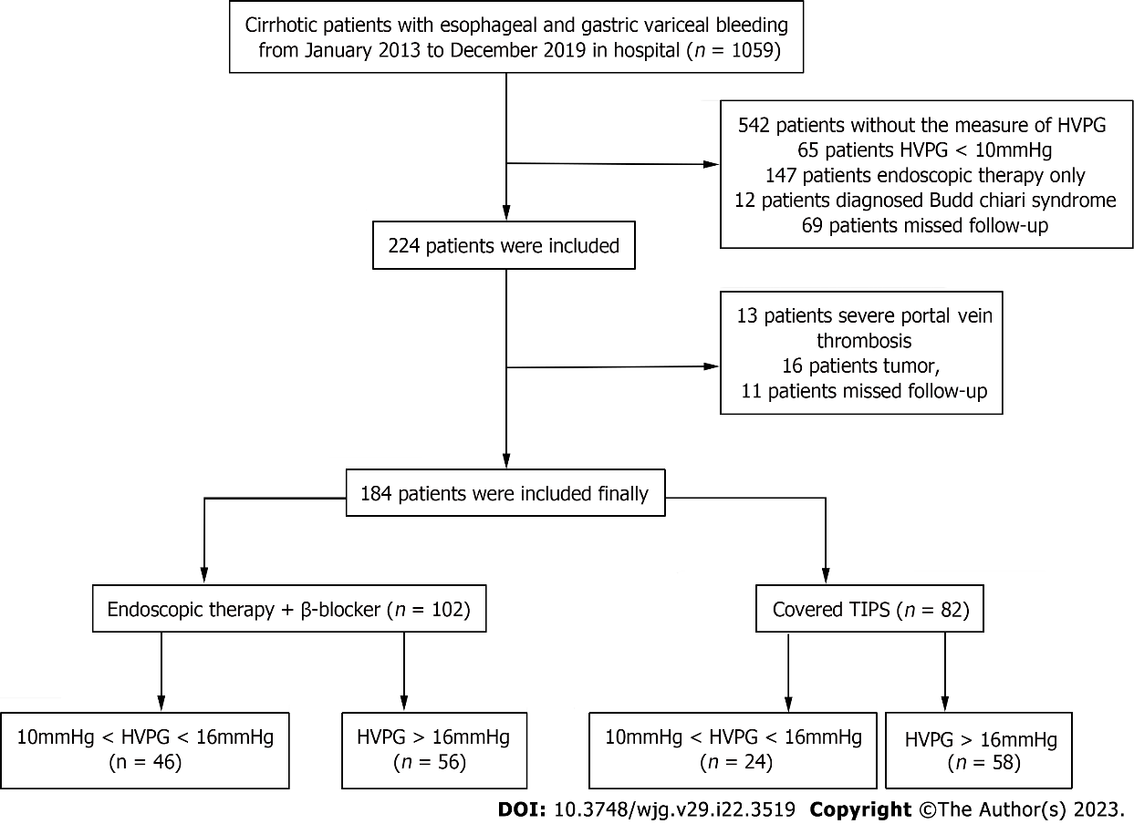
Figure 1 Flow chart of the patients involved. HVPG: Hepatic venous pressure gradient; TIPS: Transjugular intrahepatic portosystemic shunt.

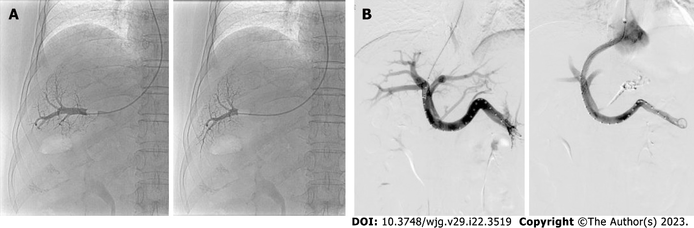
Figure 2 Images taken in hepatic venous pressure gradient measurement and transjugular intrahepatic portosystemic shunts. A: A 68-year-old male received endoscopic therapy with non-selective β-blockers, whose hepatic venous pressure gradient (HVPG) is 16mmHg; B: A 57-year-old female received covered transjugular intrahepatic portosystemic shunts, whose HVPG is 19.6 mmHg.

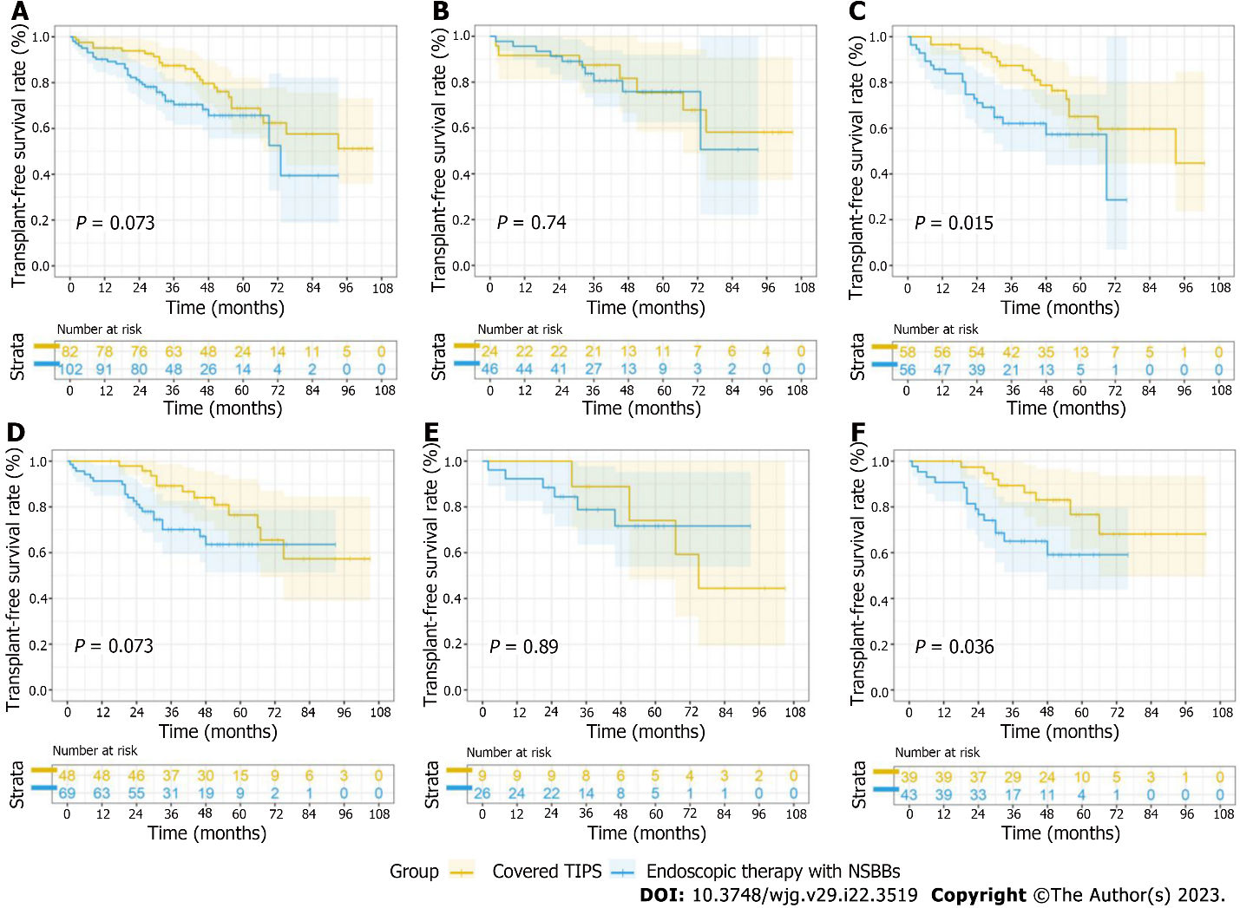
Figure 3 Comparison of transplant-free survival rates between the patients with endoscopic therapy+non-selective β-blockers and covered transjugular intrahepatic portosystemic shunts during the whole follow-up period. A: The total cohort; B: Patients on low-hepatic venous pressure gradient (HVPG) tier; C: Patients on high-HVPG tier; D: Patients with viral cirrhosis or alcoholic cirrhosis; E: Patients with viral cirrhosis or alcoholic cirrhosis on low-HVPG tier; F: Patients with viral cirrhosis or alcoholic cirrhosis on high-HVPG tier; TIPS: Transjugular intrahepatic portosystemic shunt; NSBBs: Non-selective β-blockers.

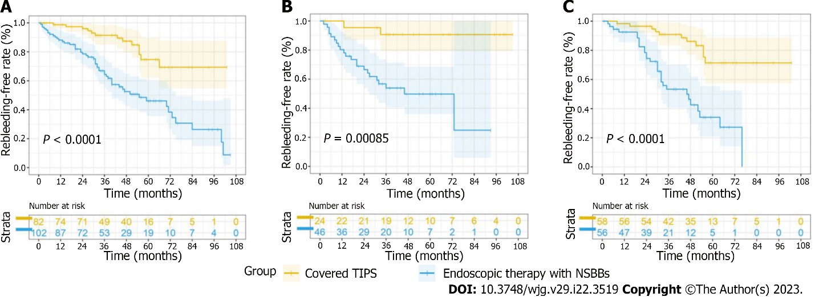
Figure 4 Comparison of the rebleeding-free rate between the patients with endoscopic therapy+non-selective β-blockers and covered transjugular intrahepatic portosystemic shunts. A: The total cohort; B: Patients on low-hepatic venous pressure gradient (HVPG) tier; C: Patients on high-HVPG tier; TIPS: Transjugular intrahepatic portosystemic shunt; NSBBs: Non-selective β-blockers.

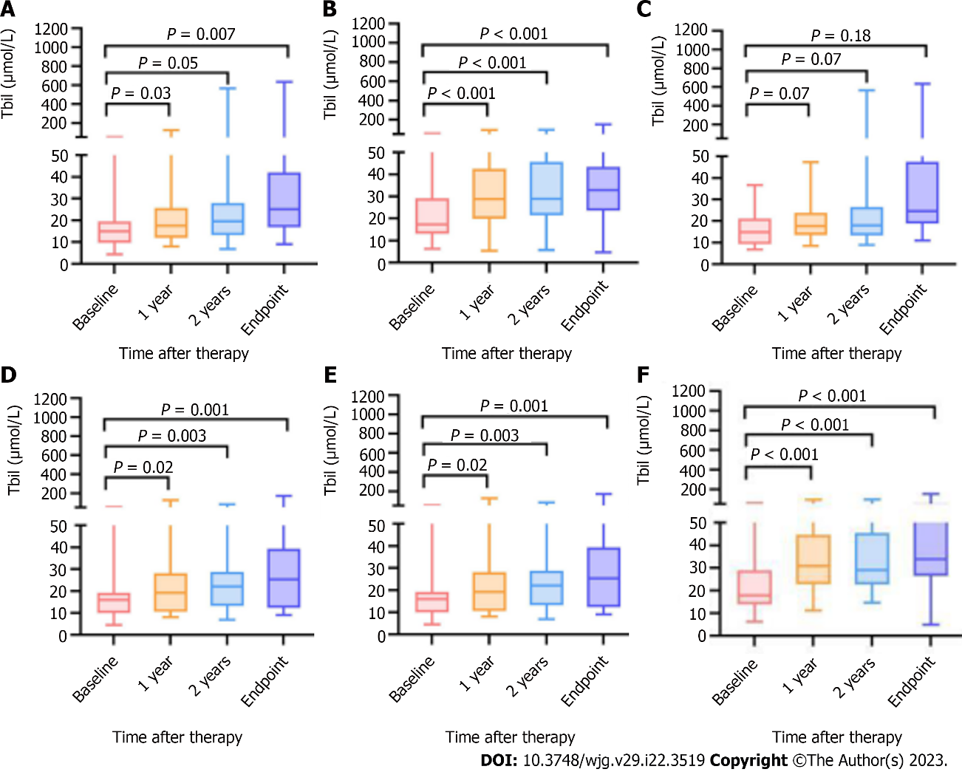
Figure 5 Changes in total bilirubin after therapy at baseline, 1-year follow-up, 2-year follow-up and the endpoint of follow-up. A: Patients received endoscopy therapy + non-selective β-blockers (NSBBs); B: Patients received covered transjugular intrahepatic portosystemic shunt (TIPS); C: Patients received endoscopy therapy + NSBBs in the low-hepatic venous pressure gradient (HVPG) tier; D: Patients received covered TIPS in the low-HVPG tier; E: Patients received endoscopy therapy + NSBBs in the high-HVPG tier; F: Patients received covered TIPS in the high-HVPG tier.

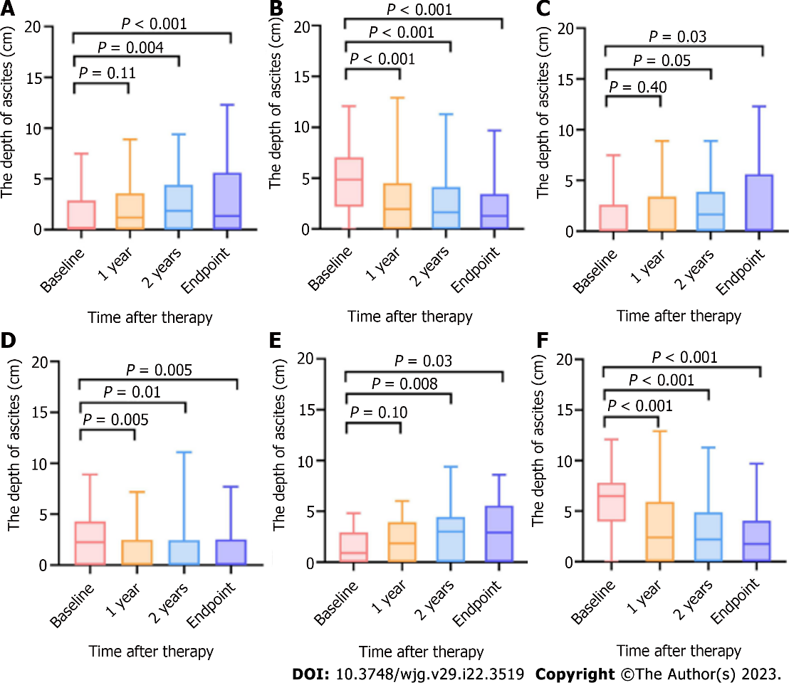
Figure 6 Changes in the depths of ascites after therapy at baseline, 1-year follow-up, 2-year follow-up and the endpoint of follow-up. A: Patients received endoscopy therapy + non-selective β-blockers (NSBBs); B: Patients received covered transjugular intrahepatic portosystemic shunt (TIPS); C: Patients received endoscopy therapy + NSBBs in the low-hepatic venous pressure gradient (HVPG) tier; D: Patients received covered TIPS in the low-HVPG tier; E: Patients received endoscopy therapy + NSBBs in the high-HVPG tier; F: Patients received covered TIPS in the high-HVPG tier.

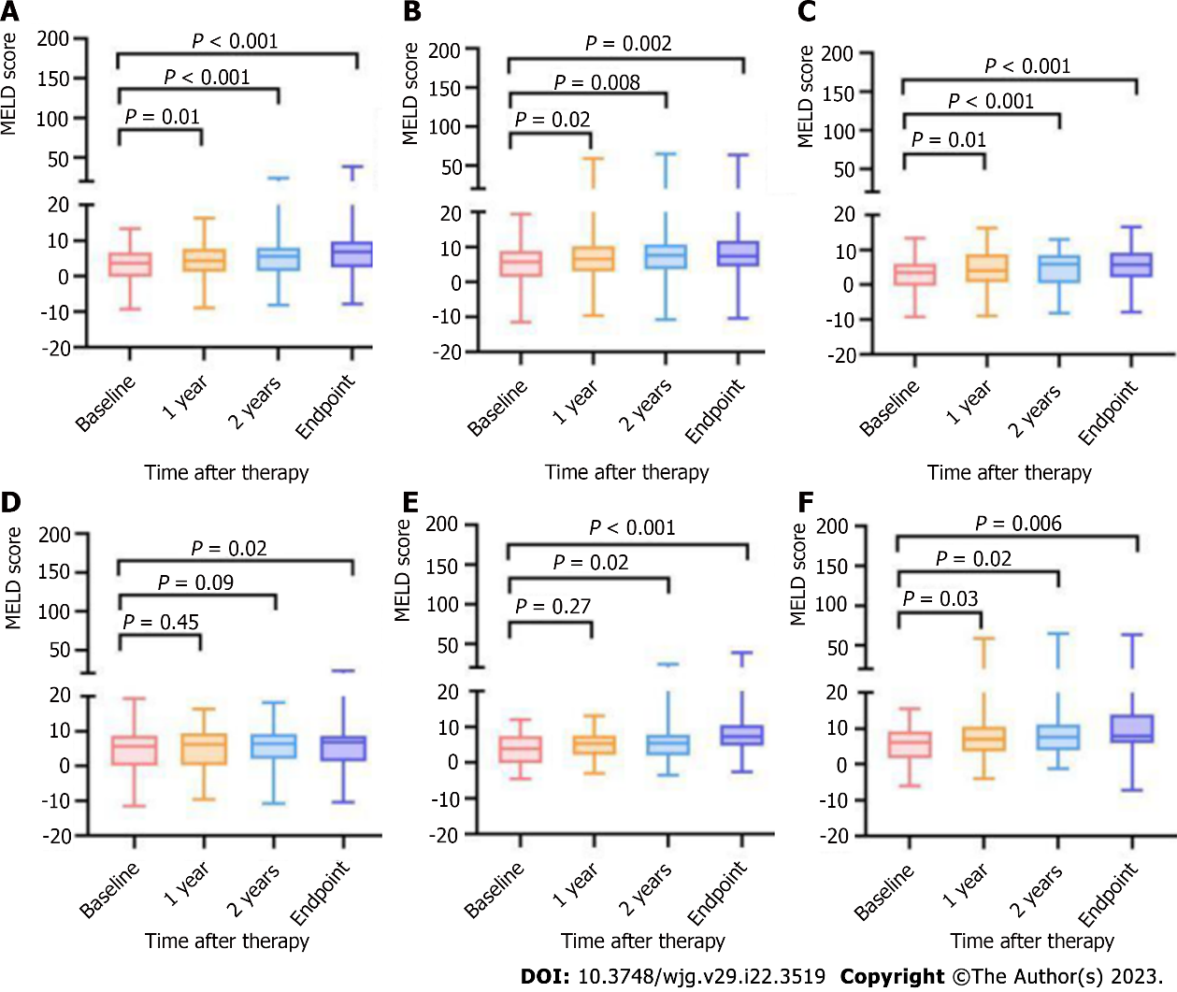
Figure 7 Changes in the model for end-stage liver disease scores after therapy at baseline, 1-year follow-up, 2-year follow-up and the endpoint of follow-up. A: Patients received endoscopy therapy+non-selective β-blockers (NSBBs); B: Patients received covered transjugular intrahepatic portosystemic shunt (TIPS); C: Patients received endoscopy therapy + NSBBs in the low-hepatic venous pressure gradient (HVPG) tier; D: Patients received covered TIPS in the low-HVPG tier; E: Patients received endoscopy therapy + NSBBs in the high-HVPG tier; F: Patients received covered TIPS in the high-HVPG tier.

Table 1 Baseline characteristics
Parameter | 10 mmHg ≤ HVPG < 16 mmHg (n = 70) |  |  |  |  | HVPG ≥ 16 mmHg (n = 114)
 | Total | Endoscopic therapy + NSBBs (n = 46) | Covered TIPS (n = 24) | P value | Total | Endoscopic therapy + NSBBs (n = 56) | Covered TIPS (n = 58) | P value
Mean age (yr) | 55.27 ± 13.86 | 55.74 ± 13.44 | 54.38 ± 14.87 | 0.7 | 58.12 ± 11.22 | 57.30 ± 10.89 | 58.91 ± 11.57 | 0.45
Sex
Male/female | 39/31 | 28/18 | 11/13 | 0.31 | 68/46 | 34/22 | 34/24 | 0.85
Previous bleeding history
0/1-2/> 3 | 41/26/3 | 31/15/0 | 10/11/3 | 0.02 | 77/26/11 | 41/10/5 | 36/16/6 | 0.41
Virus/alcoholic/immune/others | 29/6/16/19 | 23/3/10/10 | 6/3/6/9 | 0.21 | 74/8/15/17 | 40/3/4/9 | 34/5/11/8 | 0.23
PLT (× 10^9/L) | 69.80 ± 41.48 | 67.56 ± 34.80 | 74.00 ± 52.37 | 0.54 | 73.3 ± 52.60 | 67.71 ± 38.00 | 78.6 ± 63.32 | 0.27
ALT (U/L) | 28.24 ± 20.56 | 30.10 ± 22.65 | 23.94 ± 14.22 | 0.28 | 29.97 ± 21.50 | 30.5 ± 21.56 | 29.47 ± 21.63 | 0.80
AST (U/L) | 33.09 ± 19.42 | 34.87 ± 21.50 | 29.11 ± 13.27 | 0.27 | 36.26 ± 23.93 | 34.72 ± 17.89 | 37.75 ± 28.67 | 0.51
Tbil (μmol/L) | 21.60 ± 13.80 | 21.76 ± 18.16 | 21.28 ± 12.20 | 0.94 | 20.69 ± 13.19 | 18.61 ± 11.60 | 22.6 9± 14.37 | 0.10
Creatinine (μmol/L) | 64.79 ± 29.51 | 62.23 ± 18.36 | 70.91 ± 46.74 | 0.30 | 62.78 ± 17.31 | 62.89 ± 17.31 | 62.67 ± 17.48 | 0.95
Albumin (g/L) | 35.05 ± 4.31 | 36.27 ± 3.89 | 32.71 ± 4.18 | < 0.01 | 34.06 ± 5.11 | 34.98 ± 4.71 | 33.16 ± 5.37 | 0.06
Prothrombin time (s) | 14.24 ± 2.33 | 14.05 ± 2.16 | 14.67 ± 2.69 | 0.35 | 14.89 ± 2.24 | 14.14 ± 1.84 | 15.59 ± 2.37 | < 0.001
INR | 1.24 ± 0.20 | 1.22 ± 0.19 | 1.27 ± 0.23 | 0.4 | 1.28 ± 0.19 | 1.23 ± 0.16 | 1.34 ± 0.21 | < 0.001
Child–Pugh scores | 6.26 ± 1.15 | 6.02 ± 1.13 | 6.71 ± 1.08 | 0.02 | 6.89 ± 1.37 | 6.46 ± 1.21 | 7.31 ± 1.40 | < 0.001
Child–Pugh stage (A/B/C) | 46/23/1 | 35/10/1 | 11/13/0 | 0.02 | 50/59/5 | 31/24/1 | 19/35/4 | 0.03
MELD score | 16 ± 5.82 | 15 ± 5.83 | 17 ± 5.59 | 0.12 | 16 ± 4.95 | 16 ± 4.37 | 17 ± 5.44 | 0.27
Ascites (yes/no) | 35/35 | 27/19 | 8/16 | 0.12 | 24/90 | 19/36 | 5/54 | < 0.001
Shunt (yes/no) | 10/60 | 6/40 | 4/20 | 0.73 | 9/105 | 6/50 | 3/55 | 0.27
Baseline HVPG (mmHg) | 13.04 ± 1.75 | 12.88 ± 1.78 | 13.35 ± 1.69 | 0.30 | 21.17 ± 4.40 | 18.82 ± 2.45 | 23.44 ± 4.68 | < 0.001
Baseline WHVP (mmHg) | 21.32 ± 3.98 | 21.37 ± 3.96 | 21.23 ± 4.13 | 0.90 | 29.14 ± 5.24 | 26.79 ± 4.01 | 31.41 ± 5.31 | < 0.001
Baseline FHVP (mmHg) | 8.42 ± 3.11 | 8.71 ± 3.05 | 7.88 ± 3.24 | 0.30 | 7.98 ± 3.26 | 7.96 ± 3.07 | 8.01 ± 3.47 | 0.93
Baseline IVCP (mmHg) | 7.58 ± 3.15 | 7.75 ± 3.10 | 7.25 ± 3.30 | 0.53 | 7.12 ± 3.18 | 7.20 ± 3.07 | 7.05 ± 3.30 | 0.81
Baseline RAP (mmHg) | 6.24 ± 3.05 | 6.34 ± 3.05 | 6.06 ± 3.11 | 0.72 | 5.68 ± 3.10 | 5.70 ± 3.10 | 5.66 ± 3.12 | 0.94
Severity of varicosity
(Mild/Moderate/Severe) | 11/23/36 | 7/13/26 | 4/10/10 | 0.46 | 17/30/67 | 11/13/32 | 6/17/35 | 0.35
EV/GOV1/GOV2 /or IGV (no/yes) | 47/25/16/3 | 31/16/9/1 | 16/9/7/2 | 0.66 | 63/31/29/9 | 31/12/14/4 | 32/19/15/5 | 0.80
Numbers of endoscopic therapy (times) | - | 2.21 ± 1.32 | - | - | - | 2.36 ± 1.19 | - | -
Pre-TIPS PPG (mmHg) | - | - | 28.69 ± 5.67 | - | - | - | 32.18 ± 5.90 | -
post-TIPS PPG (mmHg) | - | - | 18.79 ± 5.23 | - | - | - | 21.69 ± 5.99 | -
Interventions required due to stent dysfunction | - | - | 3 | - | - | - | 9 | -
Registration time to research ending (mo) | 65.14 ± 19.83 | 62.47 ± 15.82 | 70.29 ± 25.46 | 0.18 | 55.94 ± 19.90 | 52.91 ± 17.33 | 58.86 ± 21.86 | 0.11
Median follow-up time (mo) | 56 | 56 | 58.5 | - | 49.5 | 45 | 51.5 | -
HVPG: Hepatic venous pressure gradient; NSBBs: Non-selective β-blockers; TIPS: Transjugular intrahepatic portosystemic shunts; PLT: Platelets; ALT: Alanine aminotransferase; AST: Aspartate aminotransferase; Tbil: Total bilirubin; INR: International normalized ratio; MELD: The model for end-stage liver disease; WHVP: Wedged hepatic venous pressure; FHVP: Free hepatic venous pressure; IVCP: Inferior vena cava pressure; RAP: Right atrium pressure; EV: Esophageal varices; GOV: Gastroesophageal varices; IGV: Isolated gastric varices; PPG: Portal pressure gradient.

Table 2 Cox regression evaluation of factors associated with mortality
Univariate Analysis |  | Multivariate Analysis
Hazard Ratio | P value | Hazard Ratio | P value
1.03 (1.01, 1.06) | 0.04 | 1.03 (1.01, 1.06） | 0.02
1.01 (1.01, 1.02) | 0.01 | - | -
1.01 (1.00, 1.02) | 0.03 | 1.03 (1.00, 1.06) | 0.01
1.63 (0.92, 2.89) | 0.09 | 2.01 (1.04, 3.89) | 0.04
0.610 (0.35, 1.05) | 0.07 | 0.447 (0.25, 0.81) | 0.01
AST: Aspartate aminotransferase; Tbil: Total bilirubin; HVPG: Hepatic venous pressure gradient; NSBBs: Non-selective β-blockers; TIPS: Transjugular intrahepatic portosystemic shunts.

Table 3 Distribution of the causes of endpoint
 |  | Uncontrolled rebleeding | OHE | MODS | Liver transplantation | Nonliver related death
HVPG ≥ 16 mmHg (n = 114) | Endoscopic therapy + NSBBs (n = 56) | 10 | 6 | 3 | 3 | 0
 | Covered TIPS (n = 58) | 0 | 10 | 2 | 3 | 2
10 mmHg ≤ HVPG < 16 mmHg (n = 70) | Endoscopic therapy + NSBBs (n = 46) | 5 | 0 | 1 | 2 | 2
 | Covered TIPS (n=24) | 0 | 3 | 0 | 4 | 0
HVPG: Hepatic venous pressure gradient; NSBBs: Non-selective β-blockers; TIPS: Transjugular intrahepatic portosystemic shunts; OHE: Overt hepatic encephalopathy; MODS: Multiple organ dysfunction syndrome.

Table 4 Distribution of the causes of rebleeding
 |  | EGVB | Ectopic variceal bleeding | Ulcer bleeding | Portal hypertensive gastropathy | Venous invasion of HCC | Hematobilia
HVPG ≥ 16 mmHg (n = 114) | Endoscopic therapy + NSBBs (n = 56) | 24 | 0 | 3 | 1 | 1 | 0
 | Covered TIPS (n = 58) | 9 | 0 | 1 | 0 | 0 | 1
10 mmHg ≤ HVPG < 16 mmHg (n = 70) | Endoscopic therapy + NSBBs (n = 46) | 16 | 1 | 3 | 1 | 0 | 1
 | Covered TIPS (n = 24) | 3 | 0 | 0 | 0 | 0 | 0
HVPG: Hepatic venous pressure gradient; NSBBs: Non-selective β-blockers; TIPS: Transjugular intrahepatic portosystemic shunts; EGVB: Esophageal and gastric varices bleeding; HCC: Hepatocellular carcinoma.

Table 5 Rates of complications in the endoscopic therapy+nonselective β-blockers and covered transjugular intrahepatic portosystemic shunt groups
Complications | 10 mmHg ≤ HVPG < 16 mmHg (n = 70) |  |  |  | HVPG ≥ 16 mmHg (n = 114)
 | Total | Endoscopic therapy + NSBBs (n = 46) | Covered TIPS (n = 24) | P value | Total | Endoscopic therapy + NSBBs (n = 56) | Covered TIPS (n = 58) | P value
OHE during follow-up (yes/no) | 2/68 | 0/46 | 2/22 | 0.11 | 10/104 | 3/53 | 9/49 | 0.049
Jaundice during follow-up (yes/no) | 22/48 | 14/32 | 8/16 | 0.79 | 46/68 | 17/39 | 29/29 | 0.04
Ascites during follow-up (yes/no) | 29/41 | 18/28 | 11/13 | 0.62 | 75/39 | 38/18 | 37/21 | 0.70
Hypercreatinemia during follow-up(yes/no) | 10/60 | 5/41 | 5/19 | 0.29 | 13/101 | 6/50 | 7/51 | 1.00
Hyponatremia during follow-up (yes/no) | 11/59 | 9/37 | 2/22 | 0.31 | 8/106 | 4/52 | 4/54 | 1.00
OHE in 1 year (yes/no) | 8/62 | 3/43 | 5/19 | 0.09 | 22/92 | 9/47 | 13/45 | 0.48
Jaundice in 1 year(yes/no) | 11/59 | 5/41 | 6/18 | 0.17 | 29/85 | 8/48 | 21/37 | 0.01
Ascites in 1 year (yes/no) | 34/36 | 23/23 | 11/13 | 0.80 | 74/40 | 35/21 | 39/19 | 0.70
Hypercreatinemia in 1 year (yes/no) | 5/65 | 2/44 | 3/21 | 0.33 | 4/110 | 3/53 | 1/57 | 0.36
Hyponatremia in 1 year (yes/no) | 7/63 | 5/41 | 2/22 | 1.00 | 20/94 | 12/44 | 8/50 | 0.33
HVPG: Hepatic venous pressure gradient; NSBBs: Non-selective β-blockers; TIPS: Transjugular intrahepatic portosystemic shunts; OHE: Overt hepatic encephalopathy. Non-selective β-blockers; TIPS: Transjugular intrahepatic portosystemic shunts; OHE: Overt hepatic encephalopathy.

Published by Baishideng Publishing Group Inc
7041 Koll Center Parkway, Suite 160, Pleasanton, CA 94566, USA
Telephone: +1-925-3991568
E-mail: bpgoffice@wjgnet.com
Help Desk: https://www.f6publishing.com/helpdesk
https://www.wjgnet.com

© 2023 Baishideng Publishing Group Inc. All rights reserved.

