Name of journal: World Journal of Gastrointestinal Surgery
ESPS Manuscript NO: 12512
Columns: CASE REPORT

Hepatic portal venous gas after endoscopy in a patient with anastomotic obstruction

Sadatomo A et al. Hepatic portal venous gas after endoscopy

Ai Sadatomo, Koji Koinuma, Rihito Kanamaru, Yasuyuki Miyakura, Hisanaga Horie, Alan T Lefor, Yoshikazu Yasuda

Ai Sadatomo, Koji Koinuma, Rihito Kanamaru, Yasuyuki Miyakura, Hisanaga Horie, Alan T Lefor, Yoshikazu Yasuda, Department of Surgery, Jichi Medical University, Shimotsuke, Tochigi 329-0498, Japan

Author contributions: All authors contributed to this manuscript.

Ethics approval: This study was approved by the Institutional Review Board of Jichi Medical School for ethical issues.

Informed consent: The patient provided informed written consent prior to submit the manuscript.

Conflict-of-interest: We certify that there is no conflict of interest with any financial organization regarding the material discussed in the manuscript.

Open-Access: This article is an open-access article which was selected by an in-house editor and fully peer-reviewed by external reviewers. It is distributed in accordance with the Creative Commons Attribution Non Commercial (CC BY-NC 4.0) license, which permits others to distribute, remix, adapt, build upon this work non-commercially, and license their derivative works on different terms, provided the original work is properly cited and the use is non-commercial. See: http://creativecommons.org/licenses/by-nc/4.0/

Correspondence to: Ai Sadatomo, MD, Graduate Student, Department of Surgery, Department of Surgery, Jichi Medical University, 3311 Yakushiji, Shimotsuke, Tochigi 329-0498, Japan. r0626as@jichi.ac.jp

Telephone: +81-285-587371
Fax: +81-285-443234

Received: July 12, 2014
Peer-review started: July 13, 2014
First decision: September 28, 2014
Revised: December 16, 2014
Accepted: Janurary 9, 2015
Article in press:
Published online:

Abstract
A 72-year-old male underwent a laparoscopic low anterior resection for advanced rectal cancer. A diverting loop ileostomy was constructed due to an anastomotic leak five days postoperatively. Nine months later, colonoscopy performed through the stoma showed complete anastomotic obstruction. The mucosa of the proximal sigmoid colon was atrophic and whitish. Ten days after the colonoscopy, the patient presented in shock with abdominal pain. Abdominal computed tomography scan showed hepatic portal venous gas (HPVG) and a dilated left colon. HPVG induced by obstructive colitis was diagnosed and a transverse colostomy performed emergently. His subsequent hospital course was unremarkable. Rectal anastomosis with diverting ileostomy is often performed in patients with low rectal cancers. In patients with anastomotic obstruction or severe stenosis, colonoscopy through diverting stoma should be avoided. Emergent operation to decompress the obstructed proximal colon is necessary in patients with a blind intestinal loop accompanied by HPVG.

Key words: Portal venous gas; Colonoscopy; Anastomotic obstruction; Bacterial translocation; Abdominal computed tomography

© The Author(s) 2015. Published by Baishideng Publishing Group Inc. All rights reserved.

Core tip: A rare case of hepatic portal venous gas (HPVG) is reported. Endoscopy through ileostomy leaded the formation of HPVG induced by obstructive colitis. The anastomosis of rectum was totally obstructed after rectum cancer operation. For nine months, the mucosa of ascending to sigmoid colon has changed atrophy for disuse. The patient’s condition improved after emergent operation of transverse colostomy. In patients with anastomotic obstruction or severe stenosis, colonoscopy through diverting stoma should be avoided.

Sadatomo A, Koinuma K, Kanamaru R, Miyakura Y, Horie H, Lefor AT, Yasuda Y. Hepatic portal venous gas after endoscopy in a patient with anastomotic obstruction. World J Gastrointest Surg 2015; In press

INTRODUCTION
Hepatic portal venous gas (HPVG) is a rare radiological sign associated with a wide range of abdominal abnormalities, ranging from benign to life-threatening conditions. Factors leading to gas in the portal vein include mucosal damage caused by necrosis, bowel obstruction, and sepsis^{[1]}. We report a case of HPVG following endoscopy performed through an ileostomy. The patient had severe anastomotic stenosis after low rectal cancer resection leading to a functional blind loop.

CASE REPORT
The patient is a 72-year-old man who underwent laparoscopic low anterior resection of rectal cancer nine months prior to presentation. Five days after the rectal resection with primary anastomosis, he underwent construction of a diverting ileostomy because of an anastomotic leak. The remainder of the hospital course was uneventful after the second operation. Histopathology showed a moderately-differentiated adenocarcinoma with metastases to regional lymph nodes (T3N1M0). Adjuvant chemotherapy including tegafur-uracil (UFT) and leucovorin (UZEL) was administered for six months.
Colonoscopy performed per anus, eight months after resection, revealed severe stenosis at the rectal anastomosis. The pinhole lumen was covered by hard granulation tissue, and the endoscope could not pass through the hole. Following this, colonoscopy was performed through the ileostomy to examine the proximal colon, which confirmed that the anastomosis was completely obstructed and the proximal sigmoid colon mucosa was atrophic and whitish, consistent with chronic ischemic mucosal damage (Figure 1). The procedure was performed in 63 min. The patient complained of mild abdominal pain during the colonoscopy, but the pain improved soon after the examination. Six days after the colonoscopy, he visited his local physician with complaints of appetite loss and slight fever. He was diagnosed with acute enteritis based on laboratory data consistent with inflammation, and treated with oral antibiotics and an intestinal remedy.
Ten days after the colonoscopy, he visited our hospital with a temperature of 40 °C, blood pressure of 83/49 mmHg, and pulse of 100/min. Physical examination showed mild tenderness in the lower part of the abdomen with no sign of peritonitis. Laboratory data showed a white blood cell count of 8900/ mm³, C-reactive protein of 18.1 mg/dL, metabolic acidosis (PH 7.374, anion gap of 12), and lactate dehydrogenase level of 1.1 mmol/L. Abdominal CT scan showed a large amount of HPVG. The transverse, descending and sigmoid colon were dilated with no free air or ascites (Figure 2).
We believe that HPVG was caused by obstructive colitis and septic shock following colonoscopy. An emergency laparotomy was performed, which revealed that the transverse colon was edematous and purple violet (Figure 3). A transverse colostomy was constructed. Stool culture revealed presence of Pseudomonas aeruginosa. The postoperative course was uneventful and he was discharged on the seventh postoperative day. Four months later, ileostomy closure was performed.

DISCUSSION
HPVG was first described by Wolfe and Evens in infants^{[2]} and has been associated with serious underlying diseases and a high mortality rate. HPVG has been reported to be associated with many conditions, such as necrotizing enterocolitis, bowel ischemia, Crohn’s disease, ulcerative colitis, graft-vs-host disease, bowel obstruction and iatrogenic complications^{[3]}. HPVG has been associated with procedures including endoscopy^{[4,5]}, laparoscopy, endoscopic retrograde cholangiopancreatography^{[6]}, esophageal variceal band ligation and percutaneous endoscopic gastrostomy tube placement^{[7]}.
The diagnosis of HPVG is often made by abdominal CT scans with high sensitivity. It is possible to detect even a small amount of HPVG, leading to the early diagnosis of HPVG. HPVG is not necessarily an indication for surgery, and the prognosis depends on the underlying disease. Satya et al^{[7]} reported that the mortality rate of HPVG was 25% to 35%. HPVG associated with bowel necrosis and ischemia usually has a high risk of mortality, so urgent laparotomy is recommended for such patients. Patients with a more equivocal clinical presentation might be treated non-operatively with intensive monitoring^{[8]}. In the present patient, clinical findings indicated that the patient was in septic shock and emergent operation was needed.
Factors that predispose to the development of HPVG include: (1) mucosal damage; (2) bowel distention; and (3) sepsis^{[1]}. Two or three of these conditions often coexist in many patients. Mucosal damage may be secondary to necrotic bowel, ulcerative colitis, or ulcer disease. Intraluminal gas can enter the capillary veins easily through a damaged mucosal barrier. Intraluminal pressures are increased by enema or colonoscopy. An intra-abdominal abscess can contain gas-forming organisms leading to HPVG. In this patient, anastomotic leakage and subsequent stenosis was likely caused by impaired blood flow to the left colon. The colonic mucosa became atrophic because of the absence of fecal passage for over nine months. A closed loop from the ileocecal valve to the site of the anastomotic stricture became a functional blind loop and intraluminal pressures were increased by the colonoscopy. Although no bacterial blood cultures were obtained, we suggest that HPVG and sepsis were caused by bacterial translocation.
A rectal anastomosis with diverting ileostomy is performed in many patients with distal rectal cancer. In the case of anastomotic obstruction or severe stenosis, the colon proximal to the anastomosis may become a closed loop. Colonoscopy through the ileostomy should be avoided. Emergent surgery to decompress the obstructed bowel is necessary in such patients with a blind loop accompanied by HPVG.

COMMENTS
Case characteristics
Seventy-two years old man presented in shock with abdominal pain and high fevers ten days after colonoscopy through ileostomy.

Clinical diagnosis
Physical examination showed mild tenderness in the lower part of the abdomen with no sign of peritonitis.

Differential diagnosis
Sepsis, gastrointestinal perforation.

Laboratory diagnosis
White blood cells: 8900/ mm³; C-reactive protein: 18.1 mg/dL; metabolic acidosis (PH 7.374, anion gap of 12).

Imaging diagnosis
Abdominal computerized tomography scan showed a large amount of hepatic portal venous gas (HPVG) and dilated transverse, descending and sigmoid colon.

Treatment
Emergent operation of transverse colostomy was done.

Related reports
Some cases of iatrogenic HPVG were reported in English literature and they are named in author’s references. This is the first case report of HPVG induced by colonoscopy through ileostomy.

Experiences and lessons
In the case of anastomotic obstruction or severe stenosis, colonoscopy through ileostomy should be avoided.

Peer review
It is interesting.

REFERENCES
1 Liebman PR, Patten MT, Manny J, Benfield JR, Hechtman HB. Hepatic--portal venous gas in adults: etiology, pathophysiology and clinical significance. Ann Surg 1978; 187: 281-287 [PMID: 637584 DOI: 10.3748/wjg.15.3585]
2 Wolfe JN, Evans WA. Gas in the portal veins of the liver in infants; a roentgenographic demonstration with postmortem anatomical correlation. Am J Roentgenol Radium Ther Nucl Med 1955; 74: 486-488 [PMID: 13249015]
3 Abboud B, El Hachem J, Yazbeck T, Doumit C. Hepatic portal venous gas: physiopathology, etiology, prognosis and treatment. World J Gastroenterol 2009; 15: 3585-3590 [PMID: 19653334]
4 Kuo SM, Chang WK, Yu CY, Hsieh CB. Silent hepatic portal venous gas following upper gastrointestinal endoscopy. Endoscopy 2009; 41 Suppl 2: E121-E122 [PMID: 19544258 DOI: 10.1055/s-0029-1214657]
5 Rao S, Tkacz JN, Farraye FA. Portal venous gas after colonoscopy in two patients with Crohn's disease. Gastrointest Endosc 2013; 77: 316-318 [PMID: 23317698 DOI: 10.1016/j.gie.2012.09.024]
6 Bobba RK, Arsura EL. Hepatic portal and mesenteric vein gas as a late complication of percutaneous endoscopic gastrostomy tube placement in an elderly patient. Dig Dis Sci 2005; 50: 411-414 [PMID: 15745110 DOI: 10.1007/s10620-005-1620-2]
7 Allaparthi SB, Anand CP. Acute gastric dilatation: a transient cause of hepatic portal venous gas-case report and review of the literature. Case Rep Gastrointest Med 2013; 2013: 723160 [PMID: 23819076 DOI: 10.1155/2013/723160]
8 Nelson AL, Millington TM, Sahani D, Chung RT, Bauer C, Hertl M, Warshaw AL, Conrad C. Hepatic portal venous gas: the ABCs of management. Arch Surg 2009; 144: 575-81; discussion 581 [PMID: 19528392 DOI: 10.1001/archsurg.2009.88]

P-Reviewer: Nayci A S-Editor: Ji FF L-Editor: E-Editor:

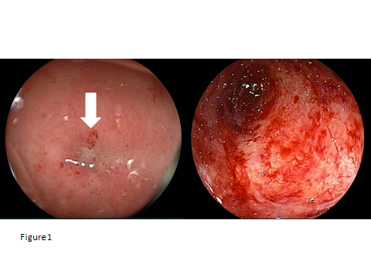
Figure 1 Colonoscopy through the ileostomy showed a tight stricture of the sigmoid colon at the anastomotic site (arrow). The mucosa of the sigmoid colon was severely atrophic (right panel).

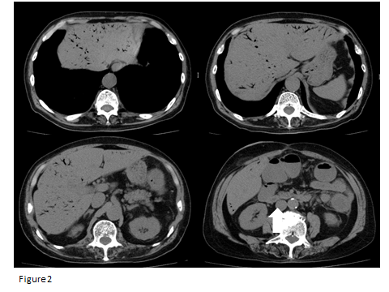

Figure 2 Computed tomography scan of the abdomen showed a marked amount of air throughout the portal venous system. The transverse colon was dilated (arrow).

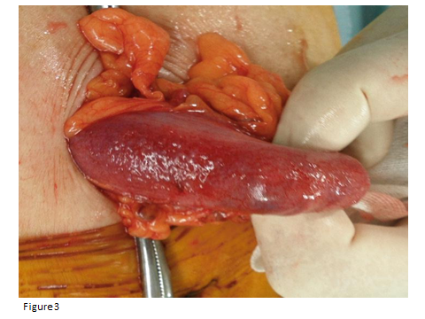
Figure 3 Intraoperative findings. The transverse colon was edematous.

