Name of Journal: World Journal of Clinical Oncology
ESPS Manuscript NO: 23088
Manuscript Type: Letters to the Editor

Awareness about early cancer lump is painless could decrease breast cancer mortality in developing countries

Garg P. ECLIPs awareness can decrease cancer mortality

Pankaj Garg

Pankaj Garg, Department of Surgery, Indus Super Specialty Hospital, Punjab 141001, India

Author contributions: Garg P conceived the idea, designed the study, drafted the manuscript, revised the manuscript and submitted the manuscript.

Conflict of interest statement: The author has no conflict of interest to report.

Open-Access: This article is an open-access article which was selected by an in-house editor and fully peer-reviewed by external reviewers. It is distributed in accordance with the Creative Commons Attribution Non Commercial (CC BY-NC 4.0) license, which permits others to distribute, remix, adapt, build upon this work non-commercially, and license their derivative works on different terms, provided the original work is properly cited and the use is non-commercial. See: http://creativecommons.org/licenses/by-nc/4.0/

Correspondence to: Dr. Pankaj Garg, MBBS, MS, FIAGES, Department of Surgery, Indus Super Specialty Hospital, Phase 1, Sector 55, Mohali, Punjab 141001, India. drgargpankaj@yahoo.com
Telephone: +91-950-1011000
Fax: +91-172-2594556

Received: October 20, 2015
Peer-review started: October 21, 2015
First decision: February 2, 2016
Revised: February 10, 2016
Accepted: March 22, 2016
Article in press:
Published online:

Abstract
There are several factors which delay patients’ reporting late to healthcare facility even after detecting the breast lump (patient delay). Amongst these, one of the important factors in low- and middle-income countries (LMICs) is lack of awareness that early cancer lump is painless (ECLIPs). Pain is often taken as a danger sign and presence of a painless lump is often not taken seriously. The studies have shown that up to 98% of women in low-income countries are unaware that a painless lump could be a warning sign of early breast cancer. This fact is significant because this could be one of the prime reasons for the women having discovered a painless lump in the breast, accidentally or by BSE, presume it to be harmless and don’t report early to health care facility. Therefore, creating awareness about ECLIPs could be an effective strategy to reduce mortality due to breast cancer in low-income countries. Moreover, unlike modifying risk factors which requires long term behavior modification, creating awareness about ECLIPs is easy and cost effective.

Key words: Breast; Cancer; Screening; Lump; Pain; Painless

© The Author(s) 2016. Published by Baishideng Publishing Group Inc. All rights reserved.

Core tip: Breast cancer mortality is quite high in low- and middle-income countries (LMICs) despite low incidence levels in these countries. One of the major reasons for this is late presentation of patients to clinicians in LMICs. The late presentation can be due to either inability to detect lump early or late realization that the detected lump can be cancerous. For the latter, lack of awareness that early cancer lump is painless (ECLIPs) is one major reason. Moreover creating awareness about ECLIPs is easy and cost effective. Therefore ECLIPs awareness should be part of breast cancer national programs in LMICs.

Garg P. Awareness about early cancer lump is painless could decrease breast cancer mortality in developing countries. World J Clin Oncol 2016; In press

TO THE EDITOR

I read with great interest the article titled “Lay perceptions of breast cancer in Western Kenya”. The article highlights the dismal level of awareness about breast cancer causes and symptoms in low- and middle-income countries (LMICs)^{[1]}. Primary as well as secondary prevention can play an important part to decrease mortality due to breast cancer. In this context, an important aspect of secondary prevention [awareness about the fact that early breast cancer lump is painless (ECLIPs)] assumes quite importance in LMICs where the level of education is quite low.

The incidence of breast cancer in low-income countries is three to four times lower as compared to the developed countries (25.8 vs 95 per 100000)^{[2]}. But the pressing issue in low-income countries is high mortality despite low incidence (12.7 vs 17.1 per 100000)^{[2]}. The main reasons for this are delay in detecting a lump, delay in availing treatment even after detecting a breast lump (patient delay), and inadequate specialized healthcare facilities (hospital delay and inadequate treatment).
The strategies to tackle this are modifying risk factors (to reduce incidence), regular screening (to detect early), decrease patient delay, and provide better treatment facilities (Figure 1).
Modifying risk factors require behavior modification which is difficult and take much longer time. Regular screening by mammography, and clinical breast examination (CBE) and provision of better healthcare facilities is hindered by logistical constraints^{[3]}. Breast self-examination (BSE), though cheap, has sensitivity of only 12%-14%, has no positive effect compared to those who are not performing it and it also leads to false positives ^{[4]}.
Amongst the patient delay factors, one of the important factors is lack of awareness about ECLIPs^{[5]}. In low-income countries, due to high prevalence of illiteracy, pain is usually taken as a danger sign and presence of a painless lump is often not taken seriously and is ignored^{[5]}. In these countries, up to 75% of women perceived breast pain as a symptom of breast cancer^{[6]} and up to 98% of women were unaware that a painless lump could be the first warning sign of a breast cancer^{[7]}. This fact is significant because this could be one of the prime reasons for the women having discovered a painless lump in the breast, accidentally or by any other screening method, presume it to be harmless and don’t report early to health care facility. Therefore, creating awareness about ECLIPs could be an effective strategy to reduce mortality due to breast cancer in LMICs. Moreover, creating awareness about ECLIPs is easier. It is a single small fact which can easily reach large populations if highlighted properly at various platforms including media. This step (by decreasing patient delay) would also increase the efficacy of screening. Therefore ECLIPs awareness is a logical, easy, and cost effective strategy to decrease breast cancer mortality in LMICs and should be a part of national cancer management strategies in these countries.

REFERENCES
1 Naanyu V, Asirwa CF, Wachira J, Busakhala N, Kisuya J, Otieno G, Keter A, Mwangi A, Omenge OE, Inui T. Lay perceptions of breast cancer in Western Kenya. World J Clin Oncol 2015; 6: 147-155 [PMID: 26468451 DOI: 10.5306/wjco.v6.i5.147]
2 Ferlay J, Soerjomataram I, Dikshit R, Eser S, Mathers C, Rebelo M, Parkin DM, Forman D, Bray F. Cancer incidence and mortality worldwide: sources, methods and major patterns in GLOBOCAN 2012. Int J Cancer 2015; 136: E359-E386 [PMID: 25220842 DOI: 10.1002/ijc.29210]
3 Bray F, Jemal A, Torre LA, Forman D, Vineis P. Long-term Realism and Cost-effectiveness: Primary Prevention in Combatting Cancer and Associated Inequalities Worldwide. J Natl Cancer Inst 2015; 107: djv273 [PMID: 26424777 DOI: 10.1093/jnci/djv273]
4 Ma I, Dueck A, Gray R, Wasif N, Giurescu M, Lorans R, Pizzitola V, Pockaj B. Clinical and self breast examination remain important in the era of modern screening. Ann Surg Oncol 2012; 19: 1484-1490 [PMID: 22160521 DOI: 10.1245/s10434-011-2162-9]
5 Garg P, Bansal M, Garg M, Arora B. Creating awareness about the painless nature of early breast cancer lump is important in low-income countries. Breast J 2010; 16: 101-102 [PMID: 19825004 DOI: 10.1111/j.1524-4741.2009.00847.x]
6 Odusanya OO, Tayo OO. Breast cancer knowledge, attitudes and practice among nurses in Lagos, Nigeria. Acta Oncol 2001; 40: 844-848 [PMID: 11859984 DOI: 10.1080/02841860152703472]
7 Oluwatosin OA, Oladepo O. Knowledge of breast cancer and its early detection measures among rural women in Akinyele Local Government Area, Ibadan, Nigeria. BMC Cancer 2006; 6: 271 [PMID: 17125524 DOI: 10.1186/1471-2407-6-271]

P-Reviewer: Cihan YB, Javanbakht J, Shao R S-Editor: Qiu S L-Editor: E-Editor:

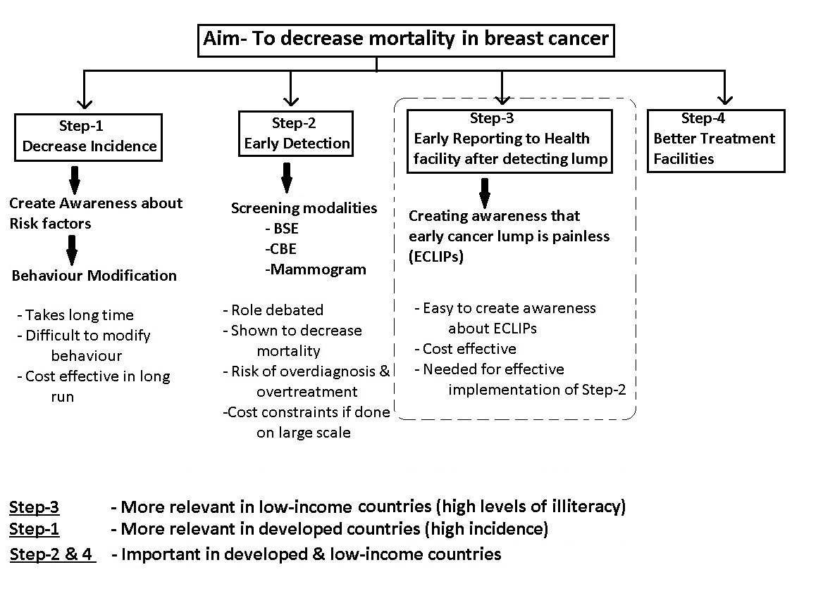
Figure 1 Role of awareness about early cancer lump is painless in overall management of breast cancer.

