Name of Journal: World Journal of Gastroenterology
Manuscript NO: 86286
Manuscript Type: ORIGINAL ARTICLE

Retrospective Cohort Study
Comparison of fecal calprotectin levels and endoscopic scores for predicting relapse in patients with ulcerative colitis in remission

Ishida N et al. FC, endoscopic scores predict UC relapse

Natsuki Ishida, Tatsuhiro Ito, Kenichi Takahashi, Yusuke Asai, Takahiro Miyazu, Tomohiro Higuchi, Satoshi Tamura, Shinya Tani, Mihoko Yamade, Moriya Iwaizumi, Yasushi Hamaya, Satoshi Osawa, Ken Sugimoto

Natsuki Ishida, Tomohiro Higuchi, Satoshi Osawa, Department of Endoscopic and Photodynamic Medicine, Hamamatsu University of School of Medicine, Hamamatsu 431-3192, Japan

Tatsuhiro Ito, Kenichi Takahashi, Yusuke Asai, Takahiro Miyazu, Satoshi Tamura, Shinya Tani, Mihoko Yamade, Yasushi Hamaya, Ken Sugimoto, First Department of Medicine, Hamamatsu University of School of Medicine, Hamamatsu 431-3192, Japan

Moriya Iwaizumi, Department of Laboratory Medicine, Hamamatsu University of School of Medicine, Hamamatsu 431-3192, Japan

Author contributions: Ishida N made the concept of this study; Ishida N and Sugimoto K designed the study; Ishida N, Ito T, Takahashi K, Asai Y, Miyazu T, Higuchi T, Tamura S and Tani S collected the data; Yamade M, Iwaizumi M, and Hamaya Y analyzed the data; Ishida N and Sugimoto K wrote the article; and Hamaya Y and Osawa S provided critical insights regarding article preparation.

Corresponding author: Ken Sugimoto, MD, PhD, Professor, First Department of Medicine, Hamamatsu University of School of Medicine, No. 1-20-1 Handayama, Hamamatsu 431-3192, Japan. sugimken@hama-med.ac.jp

Received: June 10, 2023
Revised: August 24, 2023
Accepted: November 29, 2023
Published online: December 21, 2023

Abstract
BACKGROUND
Although the usefulness of endoscopic scores, such as the Mayo Endoscopic Subscore (MES), Ulcerative Colitis Endoscopic Index of Severity (UCEIS), and Ulcerative Colitis Colonoscopic Index of Severity (UCCIS), and biomarkers such as fecal calprotectin (FC) for predicting relapse in ulcerative colitis (UC) has been reported, few studies have included endoscopic scores for evaluating the entire colon.

AIM
To compare the usefulness of FC value and MES, UCEIS, and UCCIS for predicting relapse in patients with UC in clinical remission.

METHODS
In total, 75 patients with UC in clinical and endoscopic remission who visited our institution between February 2019 and March 2022 were enrolled. The diagnosis of UC was confirmed based on the clinical presentation, endoscopic findings, and histology, according to the current established criteria for UC. Fecal samples were collected the day before or after the colonoscopy for measurement of FC. Endoscopic evaluations were performed using MES, UCEIS, and UCCIS. The primary outcome measure of this study was the assessment of the association between relapse within 12 mo and MES, UCEIS, UCCIS, and FC. The secondary outcome was the comparison between endoscopic scores and biomarkers in enrolled patients with UC with mucosal healing.

RESULTS
FC and UCCIS showed a significant correlation with UCEIS (r = 0.537, P < 0.001 and r = 0.957, P < 0.001, respectively). Receiver-operating characteristic analysis for predicting MES 0 showed that the area under the curve of UCCIS was significantly higher than that of FC (P < 0.01). During the 1-year observation period, 18 (24%) patients experienced a relapse, and both the FC and UCCIS of the relapse group were significantly higher than that of the remission group. The cut-off values for predicting relapse were set at FC = 323 mg/kg and UCCIS = 10.2. The area under the curve of the receiver-operating characteristic analysis for predicting relapse did not show a significant difference between FC and UCCIS. The accuracy of the endoscopic scores and biomarkers in predicting relapse was 86.7% for UCCIS, 85.3% for UCEIS, 76.0% for FC, and 73.3% for MES.

CONCLUSION
The three endoscopic scores and FC may predict UC relapse during clinical remission. Among these scores, UCEIS may be the most useful in terms of ease of evaluation and accuracy.

Key Words: Ulcerative colitis; Mayo Endoscopic Subscore; Ulcerative Colitis Endoscopic Index of Severity; Ulcerative Colitis Colonoscopic Index of Severity; Fecal calprotectin; Relapse

©The Author(s) 2023. Published by Baishideng Publishing Group Inc. All rights reserved.

Citation: Ishida N, Ito T, Takahashi K, Asai Y, Miyazu T, Higuchi T, Tamura S, Tani S, Yamade M, Iwaizumi M, Hamaya Y, Osawa S, Sugimoto K. Comparison of fecal calprotectin levels and endoscopic scores for predicting relapse in patients with ulcerative colitis in remission. World J Gastroenterol 2023; 29(47): 6111-6121
URL: https://www.wjgnet.com/1007-9327/full/v29/i47/6111.htm
DOI: https://dx.doi.org/10.3748/wjg.v29.i47.6111

Core Tip: We evaluated the usefulness of fecal calprotectin and endoscopic scores, including the Mayo Endoscopic Subscore, Ulcerative Colitis Endoscopic Index of Severity (UCEIS), and Ulcerative Colitis Colonoscopic Index of Severity, in patients with ulcerative colitis (UC) in remission. All three endoscopic scores and fecal calprotectin are useful for predicting relapse in UC. The UCEIS is easy to evaluate and appears to be highly accurate in predicting relapse.

INTRODUCTION
With the advances in treatment options for ulcerative colitis (UC), achieving mucosal healing has become a key therapeutic goal^{[1]}. Mucosal healing is evaluated using endoscopic scores, such as the Mayo Endoscopic Subscore (MES) and Ulcerative Colitis Endoscopic Index of Severity (UCEIS)^{[2,3]}. Although endoscopic examination is the most direct method for the evaluation of mucosal healing, frequent endoscopic examinations are not recommended owing to the associated costs and potential risks, along with the physical burden and psychological stress on the patient. Consequently, biomarkers are used as a method of evaluating mucosal status as an alternative to endoscopic examination^{[4]}. Biomarkers such as fecal calprotectin (FC), immunological fecal occult blood test, and leucine-rich alpha-2 glycoprotein have been reported to be useful in UC^{[5-12]}. Particularly, FC has shown a significant correlation with endoscopic scores and reflects mucosal activity in UC^{[5,6]}. In addition, FC is widely used in clinical practice and often employed as a marker in large-scale clinical trials of new therapeutic agents to determine their therapeutic efficacy^{[13-15]}.
The endoscopic score can predict the prognosis of UC, with higher scores indicating higher rates of subsequent hospitalizations and surgeries^{[16-18]}. A previous report on patients with UC with mucosal healing showing an MES of 1 or less showed that the subsequent relapse rate was significantly higher in the MES 1 group than in the MES 0 group^{[19]}. Thus, while the endoscopic score has been shown to contribute to the prediction of subsequent relapse, biomarkers have also been identified as effective predictors^{[20-25]}. Particularly, there are many reports on the prediction of relapse in UC using FC^{[20-24]}.
As previously mentioned, biomarkers reflect the endoscopic scores and contribute to the subsequent prediction of prognosis. In this study, we analyzed the relative efficacy of endoscopic scores against that of biomarkers in predicting relapse. Considering the possibility that this analysis may require a more detailed endoscopic score than just MES and UCEIS, we also incorporated the Ulcerative Colitis Colonoscopic Index of Severity (UCCIS), which provides a comprehensive assessment of the overall colorectal score^{[26,27]}.

MATERIALS AND METHODS
Patients and disease assessments
In total, 75 patients with UC in clinical remission who visited the Hamamatsu University School of Medicine between February 2019 and March 2022 were enrolled. These patients were diagnosed with UC based on their clinical presentation, endoscopic findings, and histology according to the current established criteria for UC^{[28]}. Patients diagnosed with enteritis, including Crohn’s disease and inflammatory bowel disease unclassified, were excluded.
In this study, the clinical activity of UC was evaluated using the clinical activity index (CAI) according to Rachmilewitz^{[29]}. Endoscopic scores for UC were assessed using MES, UCEIS, and UCCIS^{[2,3,26]}. MES was evaluated according to the following criteria: 0, normal or inactive disease; 1, mild disease with erythema, decreased vascular pattern, and mild friability; 2, moderate disease with marked erythema, absence of vascular patterns, friability, and erosions; and 3, severe disease with spontaneous bleeding and ulceration^{[2]}. The UCEIS score was evaluated by calculating the sum of three descriptors: vascular pattern (score 0-2), erosions and ulcers (score 0-3), and bleeding (score 0-3)^{[3]}. The UCCIS score was assessed using the following descriptors in the five segments of the ascending colon, transverse colon, descending colon, sigmoid colon, and rectum: vascular pattern (score 0-2), granularity (score 0-2), erosions and ulcers (score 0-4), and bleeding/friability (score 0-2). These descriptor scores were then applied to the following formula: UCCIS = 3.1 × sum (vascular pattern across five segments) + 3.6 × sum (granularity across five segments) + 3.5 × sum (ulceration across five segments) + 2.5 × sum (bleeding/friability across five segments)^{[26]}. Clinical remission was defined as CAI 4 or less, and mucosal healing was defined as MES 0 or MES 1. Patients who met these criteria were included in this study.

Biomarker measurement
Fecal samples were collected in plastic tubes for FC measurement and stored at -20 ℃ until shipment to the laboratory (SRL Inc., Tokyo, Japan). The measurements were performed using a Phadia 250 Immunoassay Analyzer (HITACHI Ltd., Tokyo, Japan) and Elia A Calprotectin 2 reagent (Phadia GmbH, Freiburg, Germany) using fluorescence enzyme immunoassay principles. As colonoscopic preparation could influence the results of FC, fecal samples were collected the day before or after the colonoscopy.

Study design
This retrospective, single-center observational study aimed to evaluate whether MES, UCEIS, UCCIS, and FC serve as predictors of clinical relapse. The primary outcome measure was the assessment of the association between relapse within 12 mo and MES, UCEIS, UCCIS, and FC. The secondary outcome was the comparison between endoscopic scores and biomarkers in the enrolled patients with UC with mucosal healing.
Patients enrolled in this study made outpatient visits at intervals of 3 or more months. These patients were outpatients for more than 12 mo or until relapse. Clinical relapse was defined as an increase in CAI above baseline due to the worsening of diarrhea and abdominal pain or frequent or bloody stools requiring modification or addition of treatment. Changes in treatment were made at the discretion of each attending physician.

Statistical analysis
Statistical analyses were performed using IBM SPSS Statistics for Windows, version 24 (IBM Corp., Armonk, N.Y., United States) and EZR (Saitama Medical Center, Jichi Medical University, Saitama, Japan)^{[30]}. Differences were assessed using the Mann-Whitney U test or Student’s t-test. Correlations were analyzed using Spearman's correlation coefficient. Receiver-operating characteristic (ROC) analysis was performed for endoscopy score and relapse prediction. The cumulative non-failure rate was evaluated using Kaplan-Meier analysis with the log-rank test. P < 0.05 was considered statistically significant.

Ethical statement
The study protocol was reviewed and approved by the ethics committee of Hamamatsu University School of Medicine (No. 20-322). This study was conducted in accordance with the Good Clinical Practice principles in adherence to the Declaration of Helsinki.

RESULTS
Patient characteristics
In total, 75 patients with UC were enrolled in this study. The baseline patient characteristics are shown in Table 1. The median patient age and disease duration were 49 years and 8 years, respectively. A total of 43 patients had an MES of 0, and 32 had an MES of 1. UCEIS scores ranged from 0 to 3, and the median UCCIS and FC values were 0 and 174 mg/kg, respectively.

Association between FC and endoscopic score
First, the association between endoscopic score and FC was assessed in enrolled patients with UC with MES 0 and 1. FC and UCCIS were significantly higher in the MES 1 group than in the MES 0 group (P < 0.001 and P < 0.001, respectively; Figure 1A and B). Both FC and UCCIS showed a significant correlation with UCEIS (r = 0.537, P < 0.001 and r = 0.957, P < 0.001, respectively; Figure 1C and D). A significant correlation was also observed between FC and UCCIS (r = 0.506, P < 0.001; Figure 1E). ROC analysis to predict MES 0 showed cut-off values of FC 385 mg/kg and UCCIS 6.6, with an area under the curve (AUC) of 0.858 [95% confidence interval (CI): 0.770-0.946] and 0.987 (95%CI: 0.969-1.000; Table 2). The AUC of UCCIS was significantly higher than that of FC (P < 0.001; Figure 2).

Association between FC and endoscopic scores, and clinical relapse
In total, 18 (24.0%) patients experienced clinical relapse during the 1-year follow-up period. The baseline FC and UCCIS values were significantly higher in the relapse group than in the remission group (P < 0.001 and P < 0.001, respectively; Figure 3A and B). In the ROC analysis for predicting clinical relapse, the cut-off value for FC was 323 mg/kg, and the AUC was 0.813 (95%CI: 0.698-0.927; Figure 3C). The cut-off value for UCCIS was 10.2, and the AUC was 0.823 (95%CI: 0.697-0.949), with no significant difference (Figure 3C).

Kaplan-Meier analysis of remission rate grouped by cut-off value
Kaplan-Meier analysis was used to assess the remission maintenance rate by grouping by each endoscopic score and cut-off value. When the endoscopic score was grouped by MES 0 and 1 and UCEIS ≤ 1 and ≥ 2, a significant difference was observed in the log-rank test (P < 0.001 and P < 0.001, respectively; Figure 4A and B). The analysis also revealed significant differences between the FC < 323 and FC ≥ 323 groups and UCCIS < 10.2 and UCCIS ≥ 10.2 groups using the log-rank test (P < 0.001 and P < 0.001, respectively; Figure 4C and D). Regarding the accuracy of relapse prediction, UCCIS had the highest accuracy at 86.7%, followed by UCEIS at 85.3% (Table 3). The accuracies of FC and MES were 76.0% and 73.3%, respectively.

DISCUSSION
This study showed that FC, MES, UCEIS, and UCCIS are useful for predicting relapse in patients with UC in clinical remission. Endoscopic and biomarker assessment must be used in current clinical practice for UC, in which achievement of mucosal healing is the goal of treatment because endoscopic scores and biomarkers have been reported to contribute to subsequent prognosis in patients with UC^{[16-25]}. MES, a simple endoscopic score, is often used in large-scale clinical trials and real-world clinical practice. Although the simplicity of MES makes it easy to use, it cannot be used for detailed scoring^{[2]}. On the other hand, UCEIS, which evaluates vascular, bleeding, and erosion/ulcer patterns, is capable of providing a more detailed evaluation compared to MES^{[3]}. However, the assessment of MES and UCEIS is performed on the most active lesions, located in the sigmoid colon or rectum, thus only assessing localized areas. There are several reports on endoscopic scores that evaluate the activity of the entire colon. UCCIS, like UCEIS, is calculated by scoring each item and substituting those scores into the formula^{[26]}. Although UCCIS evaluates the entire colon, its complexity of scoring poses considerable challenges.
Biomarkers quantify activity and enable detailed evaluation of inflammation^{[21]}. In Japan, endoscopic examination and biomarker measurements cannot be performed in the same month. As previously mentioned, each endoscopic score and biomarker has its own advantages and disadvantages. To the best of our knowledge, no studies have yet compared the abilities of MES, UCEIS, UCCIS, and FC, a representative biomarker, to predict relapse.
In this study, we investigated the prediction of relapse and evaluated the relationship between FC, UCEIS, and UCCIS in patients with a mucosal healing score of MES 1 or less. A few reports on biomarkers have evaluated the association between biomarkers and endoscopic scores in the entire severity range of MES, from 0 to 3. Guardiola et al^{[31]} reported that FC is useful for evaluating UC activity, including histological evaluation, in patients with UC who are in clinical and endoscopic remission. Previously, we reported a significant correlation between FC and UCCIS in UC with an MES ≤ 1 (r = 0.653, P < 0.001)^{[32]}. In that study, FC showed a significant correlation with UCEIS and UCCIS, indicating that FC is a sensitive biomarker that reflects endoscopic activity even among patients who have achieved mucosal healing.
Regarding the prediction of relapse, which is the main purpose of this study, it was found that FC, MES, UCEIS, and UCCIS are all useful for predicting relapse within 1 year. Several reports on the prediction of recurrence using endoscopic scores have shown that MES 1 was associated with a significantly higher risk of relapse compared to MES 0 and MES 1^{[19]}. We have also previously shown the usefulness of MES for relapse prediction in the analysis that examined the relapse prediction ability of fecal occult blood test^{[33]}. Conversely, Yamamoto et al^{[34]} reported that a similar analysis did not show a significant difference in predicting 1-year relapse, suggesting that the relapse prediction ability of MES is controversial. Arai et al^{[35]} examined relapse prediction using UCEIS and reported that UCEIS is useful in mid- to long-term relapse prediction. We previously reported recurrence prediction using UCCIS, and the analysis was performed over a long-term observation period of 2 years and 5 years^{[36]}.
The cut-off of UCEIS in this study was set at 2, and the analysis was performed accordingly. This was because other UCEIS scores were also grouped and analyzed; however, the analysis grouped by scores of 2 or more and 1 or less showed the most accurate results. Arai et al^{[35]} also reported that grouping based on a UCEIS cut-off of 2 or higher and 1 or lower was useful, and the cut-off value of UCEIS 2 was considered to be valid. Moreover, we did not perform multivariate analysis because UCEIS and UCCIS have a strong correlation close to 1, and including both these variables would have rendered the statistical analysis inconsequential. Instead, we examined the sensitivity, specificity, positive predictive values, negative predictive values, and accuracy. Regarding accuracy, both UCEIS and UCCIS exhibited an accuracy of 80% or more and were considered to be useful scores for predicting relapse. However, the UCCIS is an extremely complicated scoring system in which four items are evaluated across five colonic segments, and the scores are substituted into a formula. Therefore, it is not realistic to use this score in clinical practice. Hence, the UCEIS emerges as a preferable endoscopic scoring system in predicting relapse, owing to its accuracy and ease of use in clinical practice. Intensifying treatment based on the UCEIS score in real-world clinical practice could help prevent relapse; hence, further prospective studies in this regard are desired.
The strength of this study is that endoscopic examination and biomarker measurements were performed simultaneously. However, currently, biomarkers and endoscopic measurements cannot be performed together in clinical practice. Nevertheless, several limitations to this study must be acknowledged. First, it was a single-center retrospective analysis conducted in a small number of patients. Second, our results were not compared with other biomarkers, such as leucine-rich alpha-2 glycoprotein; histological findings were also not considered. Third, biomarker and endoscopic evaluations were not performed at the time of relapse.

CONCLUSION
In conclusion, MES, UCEIS, UCCIS, and FC were useful for predicting relapse in patients with UC in clinical remission. Among the three endoscopic scores evaluated, UCEIS may be the most useful in terms of ease of evaluation and predictive accuracy.

ARTICLE HIGHLIGHTS
Research background
The goal of ulcerative colitis (UC) treatment is to achieve mucosal healing, for which endoscopic evaluation is recommended. To avoid endoscopy, fecal calprotectin (FC), which may be an alternative biomarker for UC, was reported to be useful in evaluating patients. Although endoscopic scores and FC, in addition to traditional biomarkers and the Mayo Endoscopic Subscore (MES), are useful for predicting relapse in patients with UC in remission, no studies have compared the predictive abilities of the Ulcerative Colitis Endoscopic Index of Severity (UCEIS) and the Ulcerative Colitis Colonoscopic Index of Severity (UCCIS), which assesses the entire colon.

Research motivation
To evaluate whether FC and MES, UCEIS, and UCCIS are useful for predicting relapse in patients with UC in clinical remission.

Research objectives
Overall, 75 patients with UC in clinical remission, with a clinical activity index (CAI) according to Rachmilewitz score was ≤ 4, underwent colonoscopic examination and FC measurements.

Research methods
We assessed whether the enrolled patients experienced UC relapse within 12 mo after endoscopic examination and FC measurement. Clinical relapse was defined as an increase in CAI above baseline due to worsening of diarrhea and abdominal pain or frequent or bloody stools, requiring modification or addition of treatment. We also evaluated the association between endoscopic scores and FC.

Research results
Cut-off values and areas under the curve (AUC) for FC and UCCIS in the receiver-operating characteristic analysis to predict clinical relapse were 323 mg/kg, 0.813 [95% confidence interval (CI)]: 0.698-0.927], and 10.2, for FC, AUC, and UCCIS, respectively.
The AUC was 0.823 (95%CI: 0.697-0.949). Univariate analysis was performed using these cut-off values (FC < 323 mg/kg vs ≥ 323 mg/kg; UCCIS < 10.2 vs ≥ 10.2; MES 0 vs 1; and UCEIS ≤ 1 vs ≥ 2). The accuracy of relapse prediction was the highest with UCCIS, followed by UCIES, FC, and MES.

Research conclusions
MES, UCEIS, UCCIS, and FC were useful for predicting relapse in patients with UC in clinical remission.

Research perspectives
UCCIS comprehensively evaluates the endoscopic activity of UC, helping to predict its relapse. However, its complexity poses a challenge. Among the three endoscopic scores, UCEIS may be the most useful in terms of ease of evaluation and accuracy.

ACKNOWLEDGEMENTS
We would like to express our appreciation to the staff of the gastroenterology ward, outpatient clinic, and the departments of laboratory medicine and endoscopic and photodynamic medicine at Hamamatsu University School of Medicine.
REFERENCES
1 Peyrin-Biroulet L, Sandborn W, Sands BE, Reinisch W, Bemelman W, Bryant RV, D'Haens G, Dotan I, Dubinsky M, Feagan B, Fiorino G, Gearry R, Krishnareddy S, Lakatos PL, Loftus EV Jr, Marteau P, Munkholm P, Murdoch TB, Ordás I, Panaccione R, Riddell RH, Ruel J, Rubin DT, Samaan M, Siegel CA, Silverberg MS, Stoker J, Schreiber S, Travis S, Van Assche G, Danese S, Panes J, Bouguen G, O'Donnell S, Pariente B, Winer S, Hanauer S, Colombel JF. Selecting Therapeutic Targets in Inflammatory Bowel Disease (STRIDE): Determining Therapeutic Goals for Treat-to-Target. Am J Gastroenterol 2015; 110: 1324-1338 [PMID: 26303131 DOI: 10.1038/ajg.2015.233]
2 Schroeder KW, Tremaine WJ, Ilstrup DM. Coated oral 5-aminosalicylic acid therapy for mildly to moderately active ulcerative colitis. A randomized study. N Engl J Med 1987; 317: 1625-1629 [PMID: 3317057 DOI: 10.1056/NEJM198712243172603]
3 D'Haens G, Sandborn WJ, Feagan BG, Geboes K, Hanauer SB, Irvine EJ, Lémann M, Marteau P, Rutgeerts P, Schölmerich J, Sutherland LR. A review of activity indices and efficacy end points for clinical trials of medical therapy in adults with ulcerative colitis. Gastroenterology 2007; 132: 763-786 [PMID: 17258735 DOI: 10.1053/j.gastro.2006.12.038]
4 Sands BE. Biomarkers of Inflammation in Inflammatory Bowel Disease. Gastroenterology 2015; 149: 1275-1285.e2 [PMID: 26166315 DOI: 10.1053/j.gastro.2015.07.003]
5 Schoepfer AM, Beglinger C, Straumann A, Trummler M, Renzulli P, Seibold F. Ulcerative colitis: correlation of the Rachmilewitz endoscopic activity index with fecal calprotectin, clinical activity, C-reactive protein, and blood leukocytes. Inflamm Bowel Dis 2009; 15: 1851-1858 [PMID: 19462421 DOI: 10.1002/ibd.20986]
6 Lin WC, Wong JM, Tung CC, Lin CP, Chou JW, Wang HY, Shieh MJ, Chang CH, Liu HH, Wei SC; Taiwan Society of Inflammatory Bowel Disease Multicenter Study. Fecal calprotectin correlated with endoscopic remission for Asian inflammatory bowel disease patients. World J Gastroenterol 2015; 21: 13566-13573 [PMID: 26730169 DOI: 10.3748/wjg.v21.i48.13566]
7 Nakarai A, Kato J, Hiraoka S, Kuriyama M, Akita M, Hirakawa T, Okada H, Yamamoto K. Evaluation of mucosal healing of ulcerative colitis by a quantitative fecal immunochemical test. Am J Gastroenterol 2013; 108: 83-89 [PMID: 23007005 DOI: 10.1038/ajg.2012.315]
8 Nakarai A, Kato J, Hiraoka S, Takashima S, Takei D, Inokuchi T, Sugihara Y, Takahara M, Harada K, Okada H. Ulcerative colitis patients in clinical remission demonstrate correlations between fecal immunochemical test results, mucosal healing, and risk of relapse. World J Gastroenterol 2016; 22: 5079-5087 [PMID: 27275100 DOI: 10.3748/wjg.v22.i21.5079]
9 Takashima S, Kato J, Hiraoka S, Nakarai A, Takei D, Inokuchi T, Sugihara Y, Takahara M, Harada K, Okada H, Tanaka T, Yamamoto K. Evaluation of Mucosal Healing in Ulcerative Colitis by Fecal Calprotectin Vs. Fecal Immunochemical Test. Am J Gastroenterol 2015; 110: 873-880 [PMID: 25823769 DOI: 10.1038/ajg.2015.66]
10 Shinzaki S, Matsuoka K, Iijima H, Mizuno S, Serada S, Fujimoto M, Arai N, Koyama N, Morii E, Watanabe M, Hibi T, Kanai T, Takehara T, Naka T. Leucine-rich Alpha-2 Glycoprotein is a Serum Biomarker of Mucosal Healing in Ulcerative Colitis. J Crohns Colitis 2017; 11: 84-91 [PMID: 27466171 DOI: 10.1093/ecco-jcc/jjw132]
11 Yasutomi E, Inokuchi T, Hiraoka S, Takei K, Igawa S, Yamamoto S, Ohmori M, Oka S, Yamasaki Y, Kinugasa H, Takahara M, Harada K, Furukawa M, Itoshima K, Okada K, Otsuka F, Tanaka T, Mitsuhashi T, Kato J, Okada H. Leucine-rich alpha-2 glycoprotein as a marker of mucosal healing in inflammatory bowel disease. Sci Rep 2021; 11: 11086 [PMID: 34045529 DOI: 10.1038/s41598-021-90441-x]
12 Shimoyama T, Yamamoto T, Yoshiyama S, Nishikawa R, Umegae S. Leucine-Rich Alpha-2 Glycoprotein Is a Reliable Serum Biomarker for Evaluating Clinical and Endoscopic Disease Activity in Inflammatory Bowel Disease. Inflamm Bowel Dis 2023; 29: 1399-1408 [PMID: 36334015 DOI: 10.1093/ibd/izac230]
13 Reinisch W, Bressler B, Curtis R, Parikh A, Yang H, Rosario M, Røseth A, Danese S, Feagan B, Sands BE, Ginsburg P, Dassopoulos T, Lewis J, Xu J, Wyant T. Fecal Calprotectin Responses Following Induction Therapy With Vedolizumab in Moderate to Severe Ulcerative Colitis: A Post Hoc Analysis of GEMINI 1. Inflamm Bowel Dis 2019; 25: 803-810 [PMID: 30295811 DOI: 10.1093/ibd/izy304]
14 Danese S, Sands BE, Abreu MT, O'Brien CD, Bravatà I, Nazar M, Miao Y, Wang Y, Rowbotham D, Leong RWL, Arasaradnam RP, Afif W, Marano C. Early Symptomatic Improvement After Ustekinumab Therapy in Patients With Ulcerative Colitis: 16-Week Data From the UNIFI Trial. Clin Gastroenterol Hepatol 2022; 20: 2858-2867.e5 [PMID: 35276329 DOI: 10.1016/j.cgh.2022.02.050]
15 Loftus EV Jr, Colombel JF, Takeuchi K, Gao X, Panaccione R, Danese S, Dubinsky M, Schreiber S, Ilo D, Finney-Hayward T, Zhou W, Phillips C, Gonzalez YS, Shu L, Yao X, Zhou Q, Vermeire S. Upadacitinib Therapy Reduces Ulcerative Colitis Symptoms as Early as Day 1 of Induction Treatment. Clin Gastroenterol Hepatol 2023; 21: 2347-2358.e6 [PMID: 36464141 DOI: 10.1016/j.cgh.2022.11.029]
16 Colombel JF, Rutgeerts P, Reinisch W, Esser D, Wang Y, Lang Y, Marano CW, Strauss R, Oddens BJ, Feagan BG, Hanauer SB, Lichtenstein GR, Present D, Sands BE, Sandborn WJ. Early mucosal healing with infliximab is associated with improved long-term clinical outcomes in ulcerative colitis. Gastroenterology 2011; 141: 1194-1201 [PMID: 21723220 DOI: 10.1053/j.gastro.2011.06.054]
17 Xie T, Zhang T, Ding C, Dai X, Li Y, Guo Z, Wei Y, Gong J, Zhu W, Li J. Ulcerative Colitis Endoscopic Index of Severity (UCEIS) vs Mayo Endoscopic Score (MES) in guiding the need for colectomy in patients with acute severe colitis. Gastroenterol Rep (Oxf) 2018; 6: 38-44 [PMID: 29479441 DOI: 10.1093/gastro/gox016]
18 Corte C, Fernandopulle N, Catuneanu AM, Burger D, Cesarini M, White L, Keshav S, Travis S. Association between the ulcerative colitis endoscopic index of severity (UCEIS) and outcomes in acute severe ulcerative colitis. J Crohns Colitis 2015; 9: 376-381 [PMID: 25770163 DOI: 10.1093/ecco-jcc/jjv047]
19 Barreiro-de Acosta M, Vallejo N, de la Iglesia D, Uribarri L, Bastón I, Ferreiro-Iglesias R, Lorenzo A, Domínguez-Muñoz JE. Evaluation of the Risk of Relapse in Ulcerative Colitis According to the Degree of Mucosal Healing (Mayo 0 vs 1): A Longitudinal Cohort Study. J Crohns Colitis 2016; 10: 13-19 [PMID: 26351390 DOI: 10.1093/ecco-jcc/jjv158]
20 Fiorino G, Danese S, Peyrin-Biroulet L, Sans M, Bonelli F, Calleri M, Zierold C, Pollastro R, Moretti F, Malesci A. LIAISON(®) Calprotectin for the prediction of relapse in quiescent ulcerative colitis: The EuReCa study. United European Gastroenterol J 2022; 10: 836-843 [PMID: 35789124 DOI: 10.1002/ueg2.12268]
21 Urushikubo J, Yanai S, Nakamura S, Kawasaki K, Akasaka R, Sato K, Toya Y, Asakura K, Gonai T, Sugai T, Matsumoto T. Practical fecal calprotectin cut-off value for Japanese patients with ulcerative colitis. World J Gastroenterol 2018; 24: 4384-4392 [PMID: 30344422 DOI: 10.3748/wjg.v24.i38.4384]
22 Scaioli E, Digby RJ, Belluzzi A. Different Cutoff Levels of Fecal Calprotectin to Predict Clinical Relapse in Ulcerative Colitis. Inflamm Bowel Dis 2016; 22: E26 [PMID: 27271496 DOI: 10.1097/MIB.0000000000000839]
23 Theede K, Holck S, Ibsen P, Kallemose T, Nordgaard-Lassen I, Nielsen AM. Fecal Calprotectin Predicts Relapse and Histological Mucosal Healing in Ulcerative Colitis. Inflamm Bowel Dis 2016; 22: 1042-1048 [PMID: 26919460 DOI: 10.1097/MIB.0000000000000736]
24 Nakarai A, Hiraoka S, Takahashi S, Inaba T, Higashi R, Mizuno M, Takashima S, Inokuchi T, Sugihara Y, Takahara M, Harada K, Kato J, Okada H. Simultaneous Measurements of Faecal Calprotectin and the Faecal Immunochemical Test in Quiescent Ulcerative Colitis Patients Can Stratify Risk of Relapse. J Crohns Colitis 2018; 12: 71-76 [PMID: 28961792 DOI: 10.1093/ecco-jcc/jjx118]
25 Hiraoka S, Kato J, Nakarai A, Takashima S, Inokuchi T, Takei D, Sugihara Y, Takahara M, Harada K, Okada H. Consecutive Measurements by Faecal Immunochemical Test in Quiescent Ulcerative Colitis Patients Can Detect Clinical Relapse. J Crohns Colitis 2016; 10: 687-694 [PMID: 26802083 DOI: 10.1093/ecco-jcc/jjw025]
26 Neumann H, Neurath MF. Ulcerative colitis: UCCIS--a reproducible tool to assess mucosal healing. Nat Rev Gastroenterol Hepatol 2012; 9: 692-694 [PMID: 23070368 DOI: 10.1038/nrgastro.2012.198]
27 Samuel S, Bruining DH, Loftus EV Jr, Thia KT, Schroeder KW, Tremaine WJ, Faubion WA, Kane SV, Pardi DS, de Groen PC, Harmsen WS, Zinsmeister AR, Sandborn WJ. Validation of the ulcerative colitis colonoscopic index of severity and its correlation with disease activity measures. Clin Gastroenterol Hepatol 2013; 11: 49-54.e1 [PMID: 22902762 DOI: 10.1016/j.cgh.2012.08.003]
28 Magro F, Gionchetti P, Eliakim R, Ardizzone S, Armuzzi A, Barreiro-de Acosta M, Burisch J, Gecse KB, Hart AL, Hindryckx P, Langner C, Limdi JK, Pellino G, Zagórowicz E, Raine T, Harbord M, Rieder F; European Crohn’s and Colitis Organisation [ECCO]. Third European Evidence-based Consensus on Diagnosis and Management of Ulcerative Colitis. Part 1: Definitions, Diagnosis, Extra-intestinal Manifestations, Pregnancy, Cancer Surveillance, Surgery, and Ileo-anal Pouch Disorders. J Crohns Colitis 2017; 11: 649-670 [PMID: 28158501 DOI: 10.1093/ecco-jcc/jjx008]
29 Rachmilewitz D. Coated mesalazine (5-aminosalicylic acid) vs sulphasalazine in the treatment of active ulcerative colitis: a randomised trial. BMJ 1989; 298: 82-86 [PMID: 2563951 DOI: 10.1136/bmj.298.6666.82]
30 Kanda Y. Investigation of the freely available easy-to-use software 'EZR' for medical statistics. Bone Marrow Transplant 2013; 48: 452-458 [PMID: 23208313 DOI: 10.1038/bmt.2012.244]
31 Guardiola J, Lobatón T, Rodríguez-Alonso L, Ruiz-Cerulla A, Arajol C, Loayza C, Sanjuan X, Sánchez E, Rodríguez-Moranta F. Fecal level of calprotectin identifies histologic inflammation in patients with ulcerative colitis in clinical and endoscopic remission. Clin Gastroenterol Hepatol 2014; 12: 1865-1870 [PMID: 24993368 DOI: 10.1016/j.cgh.2014.06.020]
32 Ishida N, Higuchi T, Miyazu T, Tamura S, Tani S, Yamade M, Iwaizumi M, Hamaya Y, Osawa S, Furuta T, Sugimoto K. C-reactive protein is superior to fecal biomarkers for evaluating colon-wide active inflammation in ulcerative colitis. Sci Rep 2021; 11: 12431 [PMID: 34127687 DOI: 10.1038/s41598-021-90558-z]
33 Ishida N, Matsuura T, Asai Y, Miyazu T, Tamura S, Tani S, Yamade M, Iwaizumi M, Hamaya Y, Osawa S, Furuta T, Sugimoto K. Predicting Ulcerative Colitis Relapse in Clinical Remission With Fecal Immunochemical Occult Blood Test or Prostaglandin E-Major Urinary Metabolite. Clin Transl Gastroenterol 2022; 13: e00501 [PMID: 35616320 DOI: 10.14309/ctg.0000000000000501]
34 Yamamoto T, Shimoyama T, Umegae S, Matsumoto K. Endoscopic score vs. fecal biomarkers for predicting relapse in patients with ulcerative colitis after clinical remission and mucosal healing. Clin Transl Gastroenterol 2018; 9: 136 [PMID: 29491393 DOI: 10.1038/s41424-018-0006-7]
35 Arai M, Naganuma M, Sugimoto S, Kiyohara H, Ono K, Mori K, Saigusa K, Nanki K, Mutaguchi M, Mizuno S, Bessho R, Nakazato Y, Hosoe N, Matsuoka K, Inoue N, Ogata H, Iwao Y, Kanai T. The Ulcerative Colitis Endoscopic Index of Severity is Useful to Predict Medium- to Long-Term Prognosis in Ulcerative Colitis Patients with Clinical Remission. J Crohns Colitis 2016; 10: 1303-1309 [PMID: 27194529 DOI: 10.1093/ecco-jcc/jjw104]
36 Ishida N, Onoue S, Miyazu T, Tamura S, Tani S, Yamade M, Iwaizumi M, Hamaya Y, Osawa S, Furuta T, Sugimoto K. Further research on the clinical relevance of the ulcerative colitis colonoscopic index of severity for predicting 5-year relapse. Int J Colorectal Dis 2021; 36: 2661-2670 [PMID: 34409500 DOI: 10.1007/s00384-021-04009-2]

Footnotes
Institutional review board statement: The study was reviewed and approved for publication by our Institutional Reviewer.

Informed consent statement: Informed consent from patients was obtained in the form of an opt-out form on the hospital website.

Conflict-of-interest statement: The authors have no conflicts of interest related to the manuscript.

Data sharing statement: No additional data are available.

STROBE statement: The authors have read the STROBE Statement-checklist of items, and the manuscript was prepared and revised according to the STROBE Statement-checklist of items.

Open-Access: This article is an open-access article that was selected by an in-house editor and fully peer-reviewed by external reviewers. It is distributed in accordance with the Creative Commons Attribution NonCommercial (CC BY-NC 4.0) license, which permits others to distribute, remix, adapt, build upon this work non-commercially, and license their derivative works on different terms, provided the original work is properly cited and the use is non-commercial. See: https://creativecommons.org/Licenses/by-nc/4.0/

Provenance and peer review: Unsolicited article; Externally peer reviewed.

Peer-review model: Single blind

Peer-review started: June 10, 2023
First decision: August 8, 2023
Article in press: November 29, 2023

Specialty type: Gastroenterology and hepatology
Country/Territory of origin: Japan
Peer-review report’s scientific quality classification
Grade A (Excellent): 0
Grade B (Very good): 0
Grade C (Good): C, C
Grade D (Fair): 0
Grade E (Poor): 0

P-Reviewer: Rocha R, Brazil; Teramoto-Matsubara OT, Mexico S-Editor: Qu XL L-Editor: Filipodia P-Editor: Xu ZH
Figure Legends
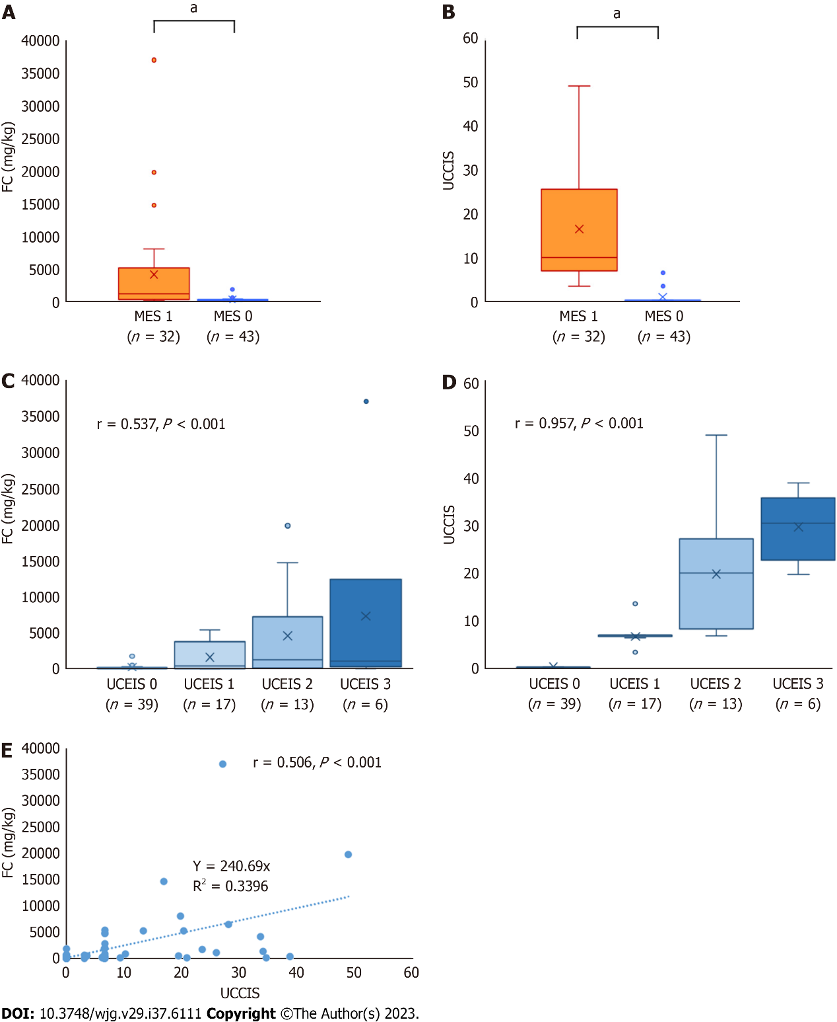
Figure 1 Association between fecal calprotectin and endoscopic scores. A: Differences in fecal calprotectin (FC) levels between Mayo Endoscopic Subscore (MES) groups; B: Differences in the Ulcerative Colitis Colonic Index of Severity (UCCIS); C: Correlation with the Ulcerative Colitis Endoscopic Index of Severity; D: Relationship between FC and UCCIS; E: Correlation between FC and UCCIS. ªP < 0.001.

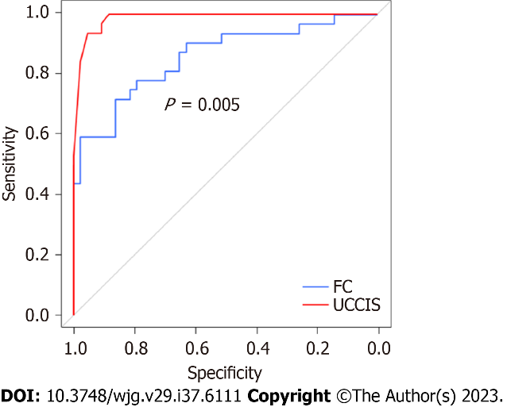
Figure 2 Receiver-operating characteristic analysis of fecal calprotectin and Ulcerative Colitis Colonic Index of Severity for predicting Mayo Endoscopic Subscore 0. FC: Fecal calprotectin; UCCIS: Ulcerative Colitis Colonic Index of Severity.

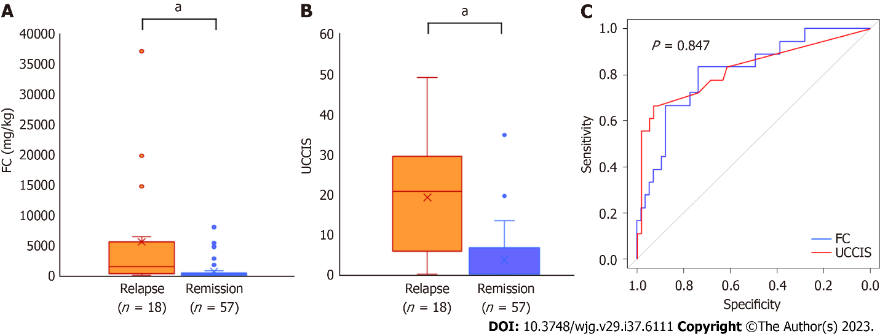
Figure 3 Differences between fecal calprotectin and Ulcerative Colitis Colonic Index of Severity in terms of predicting relapse and the receiver-operating characteristic analysis for predicting relapse. A: Difference in fecal calprotectin (FC) levels between the relapse and remission groups; B: Difference in Ulcerative Colitis Colonic Index of Severity (UCCIS) between the relapse and remission groups; C: Receiver-operating characteristic analysis of FC and UCCIS for predicting relapse within 1 year. ªP < 0.001. FC: Fecal calprotectin; UCCIS: Ulcerative colitis colonic index of severity.

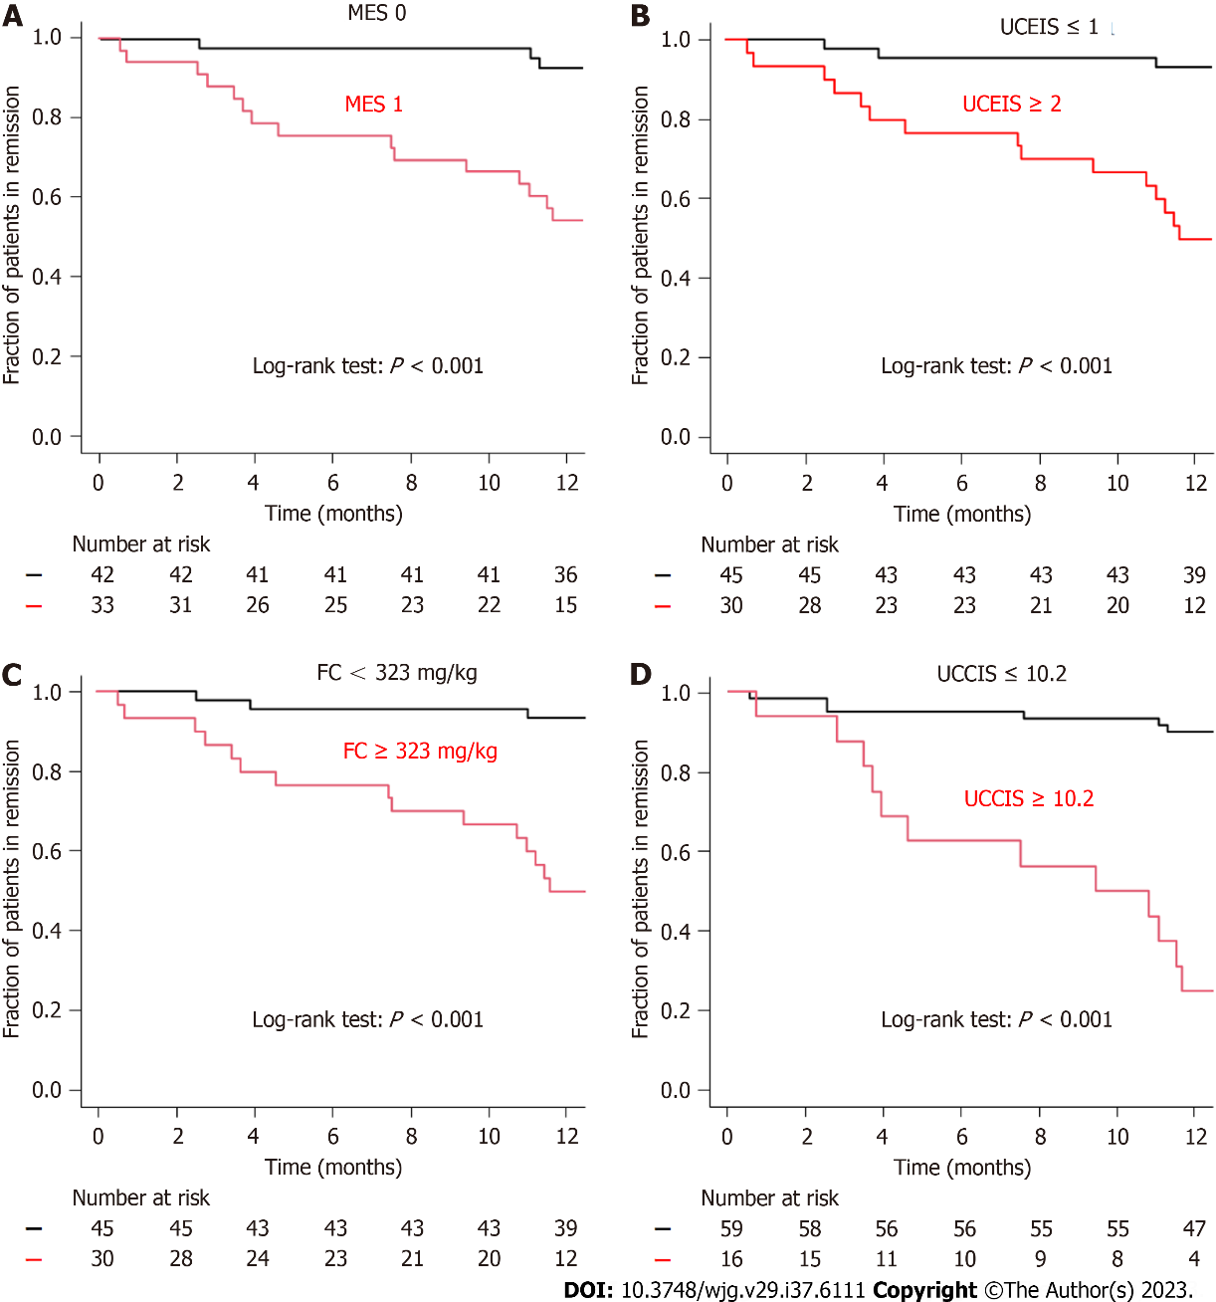
Figure 4 Kaplan-Meier analysis of relapse-free rates. A: Mayo Endoscopic Subscore; B: Ulcerative Colitis Endoscopic Index of Severity; C: Fecal calprotectin levels; D: Ulcerative Colitis Colonic Index of Severity. FC: Fecal calprotectin; MES: Mayo endoscopic subscore; UCCIS: Ulcerative colitis colonic index of severity; UCEIS: Ulcerative colitis endoscopic index of severity.

Table 1 Baseline patient characteristics
Characteristic | All, n = 75
Age in yr, median [IQR] | 49 [36, 62]
Male/Female, n (%) | 45 (60.0)/30 (40.0)
Disease duration in yr, median [IQR] | 8 [5, 13]
Disease extent, n (%)
Extensive colitis | 45 (60.0)
Left-sided colitis | 24 (32.0)
Proctitis | 6 (8.0)
CAI by the Rachmilewitz index, median [IQR] | 0 [0, 1]
MES, n (%)
MES 0 | 43 (57.3)
MES 1 | 32 (42.7)
UCEIS, n (%)
UCEIS 0 | 39 (52.0)
UCEIS 1 | 17 (22.7)
UCEIS 2 | 13 (17.3)
UCEIS 3 | 6 (8.0)
UCCIS, median [IQR] | 0 [0, 6.7]
FC in mg/kg, median [IQR] | 174 [43, 810]
Medication used during the study, n (%)
Oral 5-ASA | 48 (64.0)
Suppository steroids | 2 (2.7)
Systemic steroids | 9 (12.0)
Immunomodulators | 23 (30.7)
Biologics | 30 (40.0)
5-ASA: 5-aminosalicylic acid; CAI: Clinical activity index; FC: Fecal calprotectin; IQR: Interquartile range; MES: Mayo Endoscopic Subscore; UCCIS: Ulcerative Colitis Colonoscopic Index of Severity; UCEIS: Ulcerative Colitis Endoscopic Index of Severity.

Table 2 Receiver-operating characteristic analysis of fecal calprotectin and Ulcerative Colitis Colonic Index of Severity for predicting Mayo Endoscopic Subscore 0
Factor | FC | UCCIS
Cut-off value | 385 | 6.6
AUC (95%CI) | 0.858 (0.770-0.946) | 0.987 (0.969-1.000)
PPV | 0.793 | 0.992
NPV | 0.804 | 0.994
Sensitivity | 0.719 | 0.992
Specificity | 0.804 | 0.985
Accuracy | 0.800 | 0.947
AUC: Area under the curve; CI: Confidence interval; FC: Fecal calprotectin; NPV: Negative predictive value; PPV: Positive predictive value; UCCIS: Ulcerative Colitis Colonoscopic Index of Severity.

Table 3 Comparison of accuracy of relapse prediction between fecal calprotectin levels, Ulcerative Colitis Colonoscopic Index of Severity, Mayo Endoscopic Subscore, and Ulcerative Colitis Endoscopic Index of Severity
Factor | Sensitivity | Specificity | PPV | NPV | Accuracy
FC ≥ 323 | 0.500 | 0.933 | 0.833 | 0.737 | 0.760
UCCIS ≥ 10.2 | 0.750 | 0.898 | 0.667 | 0.930 | 0.867
MES 1 | 0.833 | 0.702 | 0.469 | 0.930 | 0.733
UCEIS ≥ 2 | 0.722 | 0.895 | 0.684 | 0.911 | 0.853
FC: Fecal calprotectin; MES: Mayo Endoscopic Subscore; NPV: Negative predictive value; PPV: Positive predictive value; UCCIS: Ulcerative Colitis Colonoscopic Index of Severity; UCEIS: Ulcerative Colitis Endoscopic Index of Severity.

Published by Baishideng Publishing Group Inc
7041 Koll Center Parkway, Suite 160, Pleasanton, CA 94566, USA
Telephone: +1-925-3991568
E-mail: bpgoffice@wjgnet.com
Help Desk: https://www.f6publishing.com/helpdesk
https://www.wjgnet.com

© 2023 Baishideng Publishing Group Inc. All rights reserved.

