Appendix
Figure 1) PET-CT Scan with ¹⁸F-FDG, showing a metabolic active nodule in the middle part of the left thyroid nodule of approximately 10 mm in size, without any clear correlate in the low dose CT of the PETCT. There is no depiction of the incidental 3 mm papillary microcarcinoma of the left thyroid lobe close to the isthmus, neither is the 6 mm MTC of the right thyroid lobe visualized.
Figure 2) thryroid gland, after in toto surgical removal.
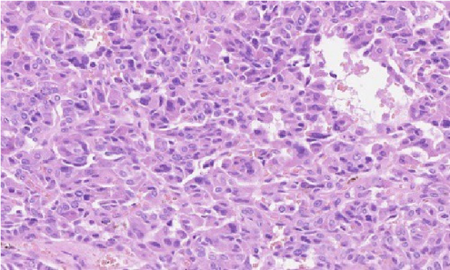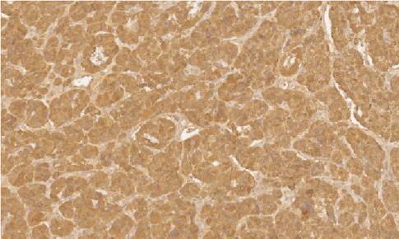

Figure 3) HE medullary thyroid cancer Figure 4) medullary thyroid cancer, IHC, calcitonin

