Name of Journal: World Journal of Clinical Cases
Manuscript NO: 61185
Manuscript Type: CASE REPORT

Acute spontaneous thoracic epidural hematoma associated with intraspinal lymphangioma: A case report

Chia KJ et al. Lymphangioma related intraspinal EDH

Kai-Jay Chia, Li-Han Lin, Ming-Tse Sung, Tsung-Ming Su, Jin-Fu Huang, Hsiang-Lin Lee, Wen-Wei Sung, Tsung-Han Lee

Kai-Jay Chia, Tsung-Ming Su, Jin-Fu Huang, Tsung-Han Lee, Division of Neurosurgery, Department of Surgery, Kaohsiung Chang Gung Memorial Hospital and Chang Gung University College of Medicine, Kaohsiung 83301, Taiwan

Li-Han Lin, Department of Radiology, Kaohsiung Chang Gung Memorial Hospital and Chang Gung University College of Medicine, Kaohsiung 83301, Taiwan

Ming-Tse Sung, Department of Pathology, Kaohsiung Chang Gung Memorial Hospital and Chang Gung University College of Medicine, Kaohsiung 83301, Taiwan

Hsiang-Lin Lee, Department of Surgery, Chung Shan Medical University Hospital, Taichung 40201, Taiwan

Wen-Wei Sung, Department of Urology, Chung Shan Medical University Hospital, Taichung 40201, Taiwan

Author contributions: Chia KJ and Lee TH played a major role in the acquisition of data; Lin LH, Sung MT, Su TM, Huang JF and Lee HL interpreted the patient data; Chia KJ and Lee TH contributed in writing the manuscript; Lin LH, Sung MT, Sung WW and Lee TH revised the manuscript for intellectual content; all authors read and approved the final manuscript.

Corresponding author: Tsung-Han Lee, MD, PhD, Neurosurgeon, Division of Neurosurgery, Department of Surgery, Kaohsiung Chang Gung Memorial Hospital, No. 123 Dapi Road, Niaosong District, Kaohsiung 83301, Taiwan. tsunghan927@gmail.com

Received: December 3, 2020
Revised: January 24, 2021
Accepted: March 20, 2021
Published online: May 16, 2021

Abstract
BACKGROUND
Spontaneous spinal epidural hematoma is a rare neurosurgical emergency.

CASE SUMMARY
A 53-year-old healthy woman suffered from complete paraplegia in both legs and loss of all sensation below the xiphoid process. She was diagnosed as acute spontaneous thoracic epidural hematoma caused by an intraspinal lymphangioma. The primary lab survey showed all within normal limits. Presence of a posteriorly epidural space-occupying lesion at the T4-T8 level of the spinal canal was confirmed on magnetic resonance imaging. A decompressive laminectomy was performed from the T4 to T7 levels at the sixth hour following abrupt onset of complete paraplegia. The lesion was confirmed as lymphangioma. This patient recovered well within one month.

CONCLUSION
This study reports a case of acute spontaneous thoracic epidural hematoma caused by an intraspinal lymphangioma with well recovery after surgical intervention.

Key Words: Lymphangioma; Epidural hematoma; Intraspinal; Paraplegia; Decompressive laminectomy; Case report

©The Author(s) 2021. Published by Baishideng Publishing Group Inc. All rights reserved.

Citation: Chia KJ, Lin LH, Sung MT, Su TM, Huang JF, Lee HL, Sung WW, Lee TH. Acute spontaneous thoracic epidural hematoma associated with intraspinal lymphangioma: A case report. World J Clin Cases 2021; 9(14): 3411-3417
URL: https://www.wjgnet.com/2307-8960/full/v9/i14/3411.htm
DOI: https://dx.doi.org/10.12998/wjcc.v9.i14.3411

Core Tip: This case suffered from acute spontaneous thoracic epidural hematoma caused by an intraspinal lymphangioma presenting with complete paraplegia in both legs and loss of all sensation below the xiphoid process. A posteriorly epidural space-occupying lesion at the T4-T8 level of the spinal canal was relieved via decompressive laminectomy in time and the symptoms recovered well within one month.
INTRODUCTION
Lymphangiomas that present as spinal soft tissue tumors in the epidural space are extremely uncommon^{[1-5]}. However, these spontaneous spinal epidural hematomas can be a rare cause of spinal cord compression, accounting for less than 1% of spinal space-occupying lesions^{[6]}. In this report, we present probably the first reported case of an acute spontaneous thoracic epidural hematoma caused by an intraspinal lymphangioma in a 53-year-old female patient.

CASE PRESENTATION
Chief complaints
A 53-year-old healthy woman was admitted to our emergency room with complete paraplegia in both legs and loss of all sensation below the xiphoid process (T5 level).

History of present illness
One day before admission, she had taken a walk with her husband along the dam in Kaohsiung. While walking at that time, she was only wearing a backpack and did not do any specific stretching exercises. After the walk, the patient felt a slight discomfort over her back. By noon on the next day, she complained of tightness over her bilateral chest wall, around the level of the xiphoid process. She denied straining, lifting, crying, sneezing, or coughing in the past three days. On arrival at the emergency room, 27 h after the walk, the muscle power in her lower extremities was 0/5 strength bilaterally, and she experienced no sensation below the xiphoid process. She also had difficulty in voiding her bladder. Vital signs at presentation were body temperature (BT): 36.6 ℃, respiratory rate (RR): 17/min, pulse rate (PR): 82/min and blood pressure (BP): 156/82 mmHg. A neurological examination revealed increased deep tendon reflexes over the right and left knees and ankles.
The patient was not receiving any anticoagulation therapy, and laboratory test results, including a complete blood count, chemistry panel, and coagulation profile, were all within normal limits.

History of past illness
The patient denied related past illness or any history of anticoagulation therapy.

Personal and family history
The patient denied related personal and family history.

Physical examination
Vital signs at presentation were BT: 36.6 ℃, RR: 17/min, PR: 82/min and BP: 156/82 mmHg. A neurological examination revealed increased deep tendon reflexes over the right and left knees and ankles.

Laboratory examinations
Laboratory test results, including a complete blood count, chemistry panel, and coagulation profile, were all within normal limits (platelets: 206000/μL, PT: 10.1 s, INR: 0.96, and APTT: 28.2 s). Microscopic examination of the intrathoracic abnormally dilated vascularities showed a proliferation of varying sized and focally dilated vascular channels filled with blood and lymphatic substance (Figure 1). The pathologic diagnosis was lymphangioma.

Imaging examinations
Magnetic resonance imaging (MRI) of the thoracic spine, performed one hour after abrupt onset of complete paraplegia, revealed the presence of a posteriorly epidural space-occupying lesion (7.6 mm × 18 mm × 85 mm in size) at the T4-T8 level of the spinal canal. The lesion caused obliteration of the cerebrospinal fluid (CSF) signal at the T6-T7 level thecal sac, with mildly thin peripheral enhancement (Figure 2). The scanned field showed neither a definite signal intensity changes in the spinal cord nor a significant bone marrow signal change in the vertebral body.

FINAL DIAGNOSIS
Based on magnetic resonance imaging, intraoperative findings, and pathological examination, acute thoracic epidural hematoma associated with intraspinal lymphangioma was diagnosed.

TREATMENT
At the sixth hour following abrupt onset of complete paraplegia, a decompressive laminectomy was performed from the T4 to T7 levels. This procedure exposed an acute epidural hematoma in the T4-T7 region, predominantly at T6-T7 (Figure 3). During the surgery, numerous epidural vessels, with some abnormally dilated vascularities, were found at the T4 to upper T6 levels (Figure 4).

OUTCOME AND FOLLOW-UP
Postoperative spinal angiography performed at 3 d following the thoracic spinal surgery showed the artery of Adamkiewicz arising from the right T10 radiculomedullary artery (Figure 5). No gross fistula channel or aneurysmal dilatation arising from radiculopial or radiculomedullary arteries was observed at the T5 to T11 levels.
A follow-up MRI of the thoracic spine performed 7 d postoperatively revealed no residual gross epidural hematoma and no remaining spinal cord compression except for a faint T2 hyperintense signal at the T6-T8 level spinal cord (Figure 6). On the seventh postoperative day, the patient experienced substantial recovery of the muscle power in both legs (grade 4). The sensation of proprioception, pain, pin-prick, and vibration also returned to normal. At discharge (1 mo after the operation), she regained complete sphincteric control.

DISCUSSION
Nontraumatic spinal epidural hematoma was first described by Jackson in 1869^{[7]}. Spontaneous spinal epidural hematoma (SSEH) is a rare disease entity that is usually associated with underlying hematological disorders or other predisposing conditions^{[8]}. Notably, lymphangiomas presenting as a spinal soft tissue tumor in the epidural space are so extremely rare^{[1-5]} that SSEH caused by intraspinal lymphangioma has never been reported previously in the literature. To our knowledge, the case described herein is probably the first reported acute spontaneous spinal epidural hemorrhage resulting from an intraspinal lymphangioma.
Lymphangiomas are congenital lymphatic malformations that are usually discovered in early childhood. They have no racial or gender predilection^{[9]}. In up to 10% of patients, the malformations may not be discovered until adulthood, with only a few cases appearing as late as the fifth decade of life. Frequently, a lymphangioma manifests as an asymptomatic soft or semi-firm mass. Although these lesions tend to surround and sometimes invade normal anatomic structures, they have no malignant potential^{[10]}. However, lymphangiomas presenting as a spinal soft tissue tumor in the epidural space are extremely rare^{[1-5]}. Surgical excision is the treatment of choice, and recurrence rates as high as 15% have been reported^{[11]}.
SSEH is a rare, but disabling or even fatal, condition. The annual incidence of SSEH has been estimated at 0.1 per 100000^{[12]}. The male/female ratio is 1.5:1, and most cases occur between the ages of 50 and 80 years^{[13]}. The etiology is unknown, but predisposing factors can include hypertension, anticoagulant therapy, increased venous pressure (straining, sneezing, lifting, or whooping cough), pregnancy or labor, and vascular malformation^{[14]}. The causative hematomas most frequently occur at the lower cervical and thoracolumbar spinal levels in adults. Early diagnosis and prompt management improve the prognosis and outcome, but SSEH still remains a clinical challenge. Physicians encountering spinal soft tissue tumors should understand the typical symptoms and should consider SSEH as one of the differential diagnoses.
Currently, MRI is the main investigative tool for spinal soft tissue tumors, and it allows a prompt diagnosis of a spinal epidural hematoma. On MRI, the hematoma appears as an isointense area on the spinal cord on T1-weighted images obtained within the first 24 h. After 36 h, it appears as a hyperintense or mixed signal intensity area on the spinal cord on T2-weighted images^{[15]}. In addition to specific signal changes, contrast enhancement pattern and morphological findings on MR images can differentiate acute SSEH from spinal epidural neoplastic mass^{[16]}. Pan et al^{[17]} reported that, from the clinical viewpoint, most patients with spinal epidural hematomas undergo some degree of irreversible cord injury by the time the hematoma is resorbed. The prognosis of SSEH correlates with the size and level of hematoma, preoperative neurological status of the patient, and the time interval between the onset of symptoms and surgery^{[18,19]}. Therefore, immediate surgical decompression remains the primary consideration in the management of patients with progressive neurological deficits.

CONCLUSION
Acute spontaneous spinal epidural hematoma caused by an intraspinal lymphangioma is a very rare occurrence. Neurosurgeons should consider the possibility of SSEH when their patients show neurologic symptoms related to the spinal cord or root compression. In the event of a thoracic epidural hematoma, prompt surgical intervention is mandatory in order to achieve neurologic recovery.

REFERENCES
1 Chu M, Li G, Wei L, Lin Y, Qi J, Wang C, Zhao S. A rare case of cavernous lymphangioma in the epidural space of the cervicothoracic spine. Spine (Phila Pa 1976) 2007; 32: E48-E51 [PMID: 17202881 DOI: 10.1097/01.brs.0000250992.55556.fe]
2 Aslan K, Bekci T, Gunbey HP, Incesu L, Turgut E. A rare cause of backache: epidural lymphangioma of the cervicothoracic spine. Spine J 2015; 15: 1900 [PMID: 25912507 DOI: 10.1016/j.spinee.2015.04.022]
3 Fattahi A, Taheri M, Majdi M. Lymphangioma of the Thoracic Spine with Epidural Compression: A Case Report. Iran J Med Sci 2019; 44: 172-175 [PMID: 30936605]
4 Ha BY, Park JB, Kim YM, Lyo IU. Lymphangioma in the epidural space of the thoracic spine. J Korean Neurosurg Soc 2010; 47: 403-405 [PMID: 20539805 DOI: 10.3340/jkns.2010.47.5.403]
5 Jiang YG, Xiang J, Zhang L. Intraspinal lymphangioma: 2 case reports and literature review. Surg Neurol 2006; 66: 430-436; discussion 436 [PMID: 17015133 DOI: 10.1016/j.surneu.2005.12.038]
6 Alexiadou-Rudolf C, Ernestus RI, Nanassis K, Lanfermann H, Klug N. Acute nontraumatic spinal epidural hematomas. An important differential diagnosis in spinal emergencies. Spine (Phila Pa 1976) 1998; 23: 1810-1813 [PMID: 9728384 DOI: 10.1097/00007632-199808150-00018]
7 Jackson R. Case of spinal apoplexy. Lancet 1869; 94: 5-6 [DOI: 10.1016/S0140-6736(02)67624-X]
8 Kreppel D, Antoniadis G, Seeling W. Spinal hematoma: a literature survey with meta-analysis of 613 patients. Neurosurg Rev 2003; 26: 1-49 [PMID: 12520314 DOI: 10.1007/s10143-002-0224-y]
9 Ersoy AO, Oztas E, Saridogan E, Ozler S, Danisman N. An Unusual Origin of Fetal Lymphangioma Filling Right Axilla. J Clin Diagn Res 2016; 10: QD09-QD11 [PMID: 27134953 DOI: 10.7860/JCDR/2016/18516.7513]
10 Zadvinskis DP, Benson MT, Kerr HH, Mancuso AA, Cacciarelli AA, Madrazo BL, Mafee MF, Dalen K. Congenital malformations of the cervicothoracic lymphatic system: embryology and pathogenesis. Radiographics 1992; 12: 1175-1189 [PMID: 1439020 DOI: 10.1148/radiographics.12.6.1439020]
11 Glasson MJ, Taylor SF. Cervical, cervicomediastinal and intrathoracic lymphangioma. Prog Pediatr Surg 1991; 27: 62-83 [PMID: 1907390 DOI: 10.1007/978-3-642-87767-4_5]
12 Groen RJ. Non-operative treatment of spontaneous spinal epidural hematomas: a review of the literature and a comparison with operative cases. Acta Neurochir (Wien) 2004; 146: 103-110 [PMID: 14963742 DOI: 10.1007/s00701-003-0160-9]
13 Foo D, Rossier AB. Preoperative neurological status in predicting surgical outcome of spinal epidural hematomas. Surg Neurol 1981; 15: 389-401 [PMID: 9760981 DOI: 10.1016/0090-3019(81)90178-6]
14 Liao CC, Lee ST, Hsu WC, Chen LR, Lui TN, Lee SC. Experience in the surgical management of spontaneous spinal epidural hematoma. J Neurosurg 2004; 100: 38-45 [PMID: 14748572 DOI: 10.3171/spi.2004.100.1.0038]
15 Fukui MB, Swarnkar AS, Williams RL. Acute spontaneous spinal epidural hematomas. AJNR Am J Neuroradiol 1999; 20: 1365-1372 [PMID: 10472999]
16 Chang FC, Lirng JF, Chen SS, Luo CB, Guo WY, Teng MM, Chang CY. Contrast enhancement patterns of acute spinal epidural hematomas: a report of two cases. AJNR Am J Neuroradiol 2003; 24: 366-369 [PMID: 12637283]
17 Pan G, Kulkarni M, MacDougall DJ, Miner ME. Traumatic epidural hematoma of the cervical spine: diagnosis with magnetic resonance imaging. Case report. J Neurosurg 1988; 68: 798-801 [PMID: 3357037 DOI: 10.3171/jns.1988.68.5.0798]
18 Liu Z, Jiao Q, Xu J, Wang X, Li S, You C. Spontaneous spinal epidural hematoma: analysis of 23 cases. Surg Neurol 2008; 69: 253-260 [PMID: 17900669 DOI: 10.1016/j.surneu.2007.02.019]
19 Schoonjans AS, De Dooy J, Kenis S, Menovsky T, Verhulst S, Hellinckx J, Van Ingelghem I, Parizel PM, Jorens PG, Ceulemans B. Spontaneous spinal epidural hematoma in infancy: review of the literature and the "seventh" case report. Eur J Paediatr Neurol 2013; 17: 537-542 [PMID: 23786707 DOI: 10.1016/j.ejpn.2013.05.012]

Footnotes
Informed consent statement: The patient has provided informed consent for publication of the case.

Conflict-of-interest statement: The authors declare that they have no conflict of interest.

CARE Checklist (2016) statement: The authors have read the CARE Checklist (2016), and the manuscript was prepared and revised according to the CARE Checklist (2016).

Open-Access: This article is an open-access article that was selected by an in-house editor and fully peer-reviewed by external reviewers. It is distributed in accordance with the Creative Commons Attribution NonCommercial (CC BY-NC 4.0) license, which permits others to distribute, remix, adapt, build upon this work non-commercially, and license their derivative works on different terms, provided the original work is properly cited and the use is non-commercial. See: http://creativecommons.org/Licenses/by-nc/4.0/

Manuscript source: Unsolicited manuscript

Peer-review started: December 3, 2020
First decision: January 10, 2021
Article in press: March 20, 2021

Specialty type: Clinical neurology
Country/Territory of origin: Taiwan
Peer-review report’s scientific quality classification
Grade A (Excellent): 0
Grade B (Very good): B, B
Grade C (Good): 0
Grade D (Fair): 0
Grade E (Poor): 0

P-Reviewer: Anghelescu A, Bains L S-Editor: Zhang H L-Editor: A P-Editor: Yuan YY
Figure Legends
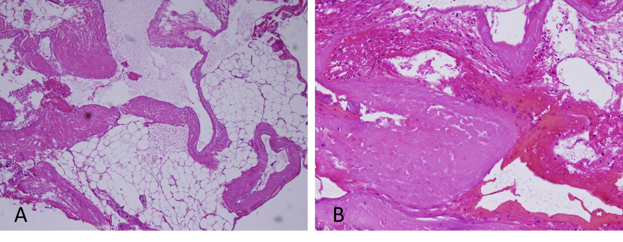
Figure 1 Hematoxylin and eosin staining. A: Proliferation of irregular thick wall vascular channels lined by flat endothelial cells with clear lymphatic fluid in the lumens [hematoxylin and eosin (H&E), 40 ×]; B: Some of the proliferative vessels are filled with blood, instead of lymphatic substance (H&E, 100 ×).

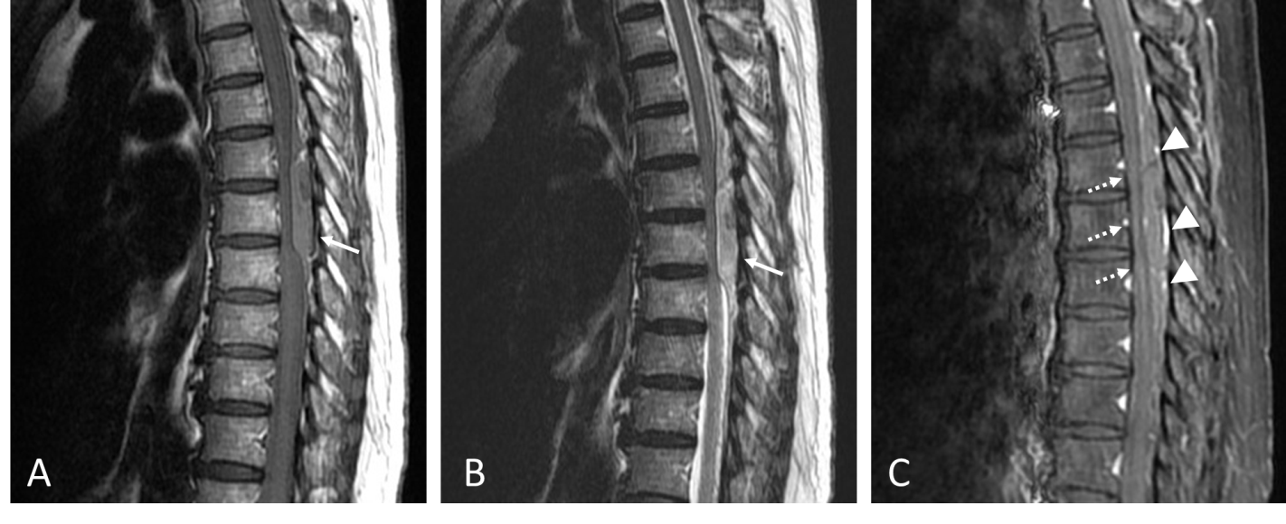
Figure 2 Preoperative spinal magnetic resonance imaging demonstrating an intraspinal epidural hematoma at the T4 to the T8 levels (arrows). A: Sagittal T1-weighted image (T1WI); B: Sagittal T2-weighted image; C: Sagittal T1WI with enhancement showing mildly thin peripheral enhancement (arrowheads) and the spinal cord is compressed and flattened (dashed thin arrows).

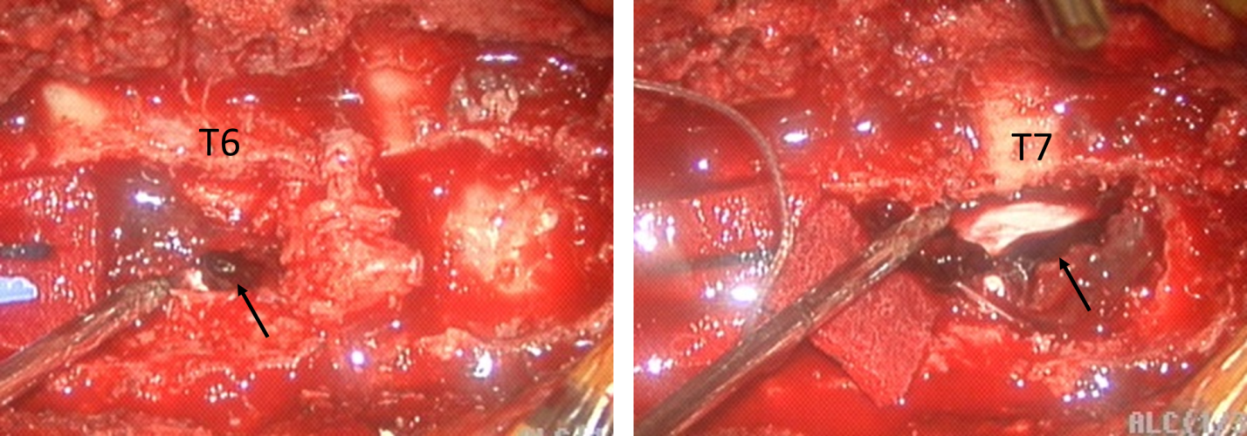
Figure 3 Dark reddish blood (arrows) in the epidural space was exposed after a laminectomy.

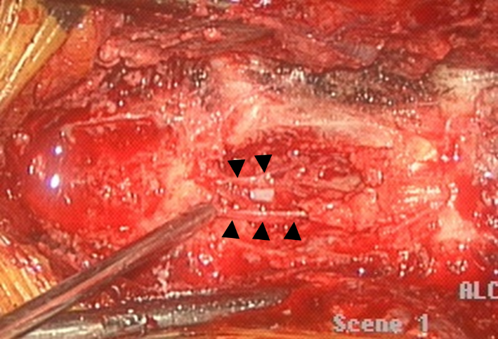
Figure 4 After a laminectomy of T5, numerous epidural vessels (arrowheads) were found.
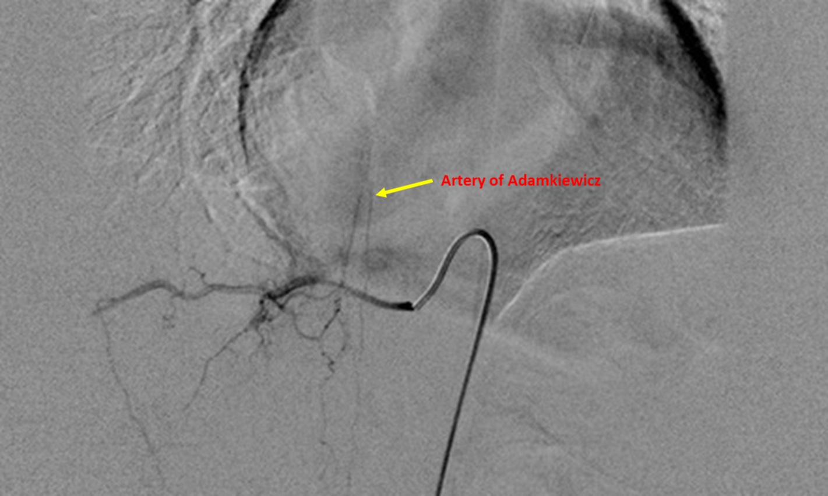
Figure 5 Postoperative spinal angiography shows the artery of Adamkiewicz arising from the right radiculomedullary artery at T10 level.
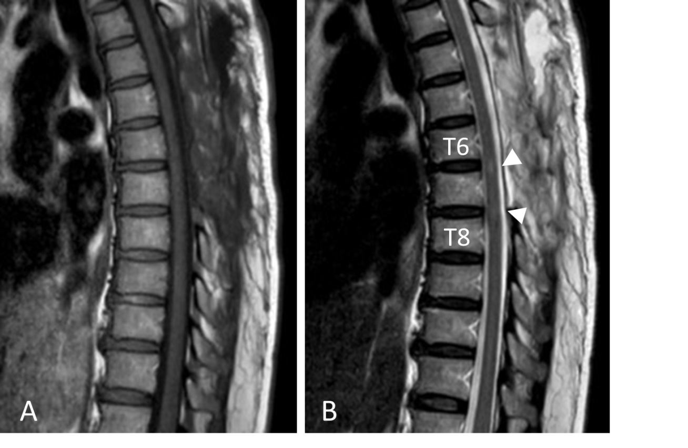
Figure 6 Postoperative spinal magnetic resonance imaging revealing a faint T2 hyperintense intramedullary signal at the T6-T8 levels (arrow heads) with no residual epidural hematoma and no remaining spinal cord compression. A: Sagittal T1-weighted image; B: Sagittal T2-weighted image.

Published by Baishideng Publishing Group Inc
7041 Koll Center Parkway, Suite 160, Pleasanton, CA 94566, USA
Telephone: +1-925-3991568
E-mail: bpgoffice@wjgnet.com
Help Desk: https://www.f6publishing.com/helpdesk
https://www.wjgnet.com

© 2021 Baishideng Publishing Group Inc. All rights reserved.

