Name of Journal: World Journal of Orthopedics
Manuscript NO: 39273
Manuscript Type: CASE REPORT

Anterior transolecranon dislocation of the elbow in a child: A case report

Bouaziz W et al. Elbow anterior transolecranon dislocation

Wajdi Bouaziz, Ahmed Racem Guidara, Ahmed Trabelsi, Tarek Bardaa, Mourad Hammami, Zoubaier Ellouz, Hassib Keskes

Wajdi Bouaziz, Ahmed Racem Guidara, Ahmed Trabelsi, Tarek Bardaa, Zoubaier Ellouz, Hassib Keskes, Department of Orthopaedic Surgery and Traumatology, Habib Bourguiba University Hospital, Sfax 3000, Tunisia
Mourad Hammami, Department of Orthopaedic Surgery and Traumatology, Tataouine Regional Hospital, Sfax 3263, Tunisia

ORCID number: Wajdi Bouaziz (0000-0002-0839-8127); Ahmed Racem Guidara (0000-0002-1406-9872); Ahmed Trabelsi (0000-0001-9587-2319); Tarak Bardaa (0000-0002-8075-6849); Mourad Hammami (0000-0001-7210-9361); Zoubaier Ellouz (0000-0003-3211-9850); Hassib Keskes (0000-0003-2231-760X).

Author contributions: All the authors contributed in outlining the manuscript, gathering the data, and writing the manuscript.

Informed consent statement: The patient’s mother provided written informed consent authorizing the use and disclosure of her son’s protected health information.

Conflict-of-interest statement: None of the authors have any financial or other conflicts of interest that may bias the current study.

CARE Checklist (2013) statement: The authors have read the CARE Checklist (2013), and the manuscript was prepared and revised according to the CARE Checklist (2013).

Open-Access: This article is an open-access article which was selected by an in-house editor and fully peer-reviewed by external reviewers. It is distributed in accordance with the Creative Commons Attribution Non Commercial (CC BY-NC 4.0) license, which permits others to distribute, remix, adapt, build upon this work non-commercially, and license their derivative works on different terms, provided the original work is properly cited and the use is non-commercial. See: http://creativecommons.org/licenses/by-nc/4.0/

Manuscript source: Unsolicited manuscript

Correspondence to: Ahmed Racem Guidara, MD, Doctor, Surgeon, Department of Orthopaedic Surgery and Traumatology, Habib Bourguiba University Hospital, El Ain Street, Sfax 3000, Tunisia. rassimou@live.fr
Telephone: +216-22-650267

Received: May 4, 2018
Peer-review started: May 5, 2018
First decision: June 6, 2018
Revised: June 15, 2018
Accepted: June 28, 2018
Article in press:
Published online:

Abstract
Anterior transolecranon dislocation of the elbow is rarely observed in children, reported in only a small series. The present case involves an anterior transolecranon dislocation of the left elbow joint in a 7-year-old child, which was surgically treated. Two attempts of closed reduction failed because the radial head had buttonholed via the joint capsule. After its release, open reduction was easily performed; osteosynthesis of the olecranon was not performed. Remarkably, good result was obtained, despite a mild flexion deformity at the last follow-up.
This case report aims to highlight this treatment method, which may be considered for such an uncommon injury.

Key words: Elbow; Children; Anterior dislocation; Open reduction; Olecranon osteosynthesis

© The Author(s) 2018. Published by Baishideng Publishing Group Inc. All rights reserved.

Core tip: Anterior transolecranon dislocation is rarely observed in children and rarely reported in the literature. This case shows that the management of this injury can be difficult, requiring surgery with or without osteosynthesis of the olecranon.

Bouaziz W, Guidara AR, Trabelsi A, Bardaa T, Hammami M, Ellouz Z, Keskes H. Anterior transolecranon dislocation of the elbow in a child: A case report. World J Orthop 2018; In press

INTRODUCTION
Although anterior transolecranon dislocation of the elbow is not uncommon in adults, it is rarely seen in children^{[1]}. Limited published recommendations for the management of these lesions in children are available. Closed reduction is possible in most elbow dislocations. We report a rare case of irreducible anterior transolecranon fracture dislocation of the left elbow joint in a 7-year-old child who was surgically treated.

CASE REPORT
A 7-year-old boy was admitted to the emergency department of the Habib Bourguiba University Hospital, Tunisia, for direct left elbow trauma sustained in a fall 2 h earlier while playing with his friends on the street. The patient presented with severe pain, swelling, and deformity of the elbow, with functional disability of the left upper limb. The neurovascular status of the limb was intact, range of motion was restricted by pain, and the fingers were mobile and sensitive. In addition, the radial pulse was palpable and equal to that of the contralateral side. X-rays of the elbow revealed anterior and lateral transolecranon dislocation (Figure 1). The child was transferred to the operating room and placed in the decubitus position, with his arm on a hand table. Closed reduction was attempted twice under general anesthesia and using an X-ray image intensifier. Maneuver was conducted as recommended in a previous report by Winslow^{[2]}; however, both attempts were unsuccessful. Therefore, the patient was surgically treated.
A lateral approach to expose the elbow joint found that the olecranon and radial head were anteriorly dislocated, and the annular ligament was torn. The closed reduction attempts failed because the radial head was buttonholed through the torn anterior capsule of the elbow joint. Subsequently, the radial head was released, and the joint was reduced under direct vision (Figure 2). Reduction was perfect, as verified by an X-ray image intensifier. Because the joint was found to be stable following reduction, internal fixation of the olecranon fracture was not performed. Using a splint, the reduced joint was externally immobilized for four weeks (Figure 3). Recovery was uncomplicated. Eventually, the patient was discharged after wound inspection on the third postoperative day. The splint was removed a month later, with the initiation of healing of the olecranon revealed on X-ray by incomplete densification of the fracture (Figure 4). Although the patient had complete flexion of the elbow joint, extension was incomplete (Figure 5). He was referred for rehabilitation and assisted active range of motion exercises. After three months, the patient recovered good range of motion. He showed only 10° of sequellar extension lag, complete range of pronation, and supination movements, and was able to perform all daily activities. His quickDASH score was 4.54. Plain radiographs indicated healing of the olecranon fracture (Figure 6).

DISCUSSION
By far, posterior elbow dislocations are the most common dislocations among children, and these are an effect of indirect forces transmitted to the elbow following a fall on the outstretched hand^{[3,4]}. Till date, a few number of anterior transolecranon dislocations of the elbow has been reported^{[5]}.
Anterior dislocations of the elbow among children were often associated with fractures around the elbow, and some cases included neurovascular injury^{[6,7]}. Closed reduction has commonly been performed, except in cases involving soft-tissue interposition or buttonholing of the radial head through the capsule that have prevented it^{[8,9]}. Closed reduction was attempted in this case, but it failed because of buttonholing of the radial head through the capsule of the joint, which was discovered during surgery, along with a torn annular ligament. Similar cases of close reduction failure because of buttonholing of the anterior capsule have been reported in Japan by Takaso et al^{[8]} and in the United States by Aversano et al^{[10]}. The anatomic pathology of anterior transolecranon fracture dislocation described by Tiemdjo et al^{[11]} and as shown in Table 1, includes 4 types, each with a proposed treatment. This classification has prognostic and therapeutic values.
No clear conclusions regarding the surgical approach and technique to reduce and stabilize the dislocated elbow joint can be drawn from the available published reports. We selected the lateral approach for better visualization of the articular surface of the joint and chiefly for direct control of the radial head. Reduction of the dislocated joint was easy to perform following the release of the buttonholed radial head. In most reports, surgical reduction was followed by osteosynthesis of the olecranon. We selected simple immobilization of the elbow until consolidation because stable reduction of the olecranon was achieved. Contrary to what was recommended Tiemdjo et al^{[11]}, we did not perform osteosynthesis to limit damages of the growth plate and avoid clutter by the material, which may probably perturb the range of motion later. In addition, no other further intervention was required to remove the osteosynthesis material. Postoperative stability was maintained by a splint with a 75°-80° flexed elbow to obtain less tension of the olecranon. The result was considered good, despite the sequellar mild flexion deformity. An enhanced reduction is associated with better result. Osteosynthesis of the olecranon could improve results only if a perfect reduction was achieved. The reduction in this patient was good and stable. Therefore, immobilization did not allow immediate rehabilitation. This explains the mild flexion deformity at the last follow-up. Accordingly, accelerated functional treatment and rehabilitation following surgery are recommended, as long periods of immobilization are not beneficial^{[12]}. In this patient, splint removal after only four weeks following the surgery allowed relatively early mobilization.
In conclusion, this uncommon case of anterior transolecranon dislocation could not be successfully managed using simple closed reduction. Open reduction without osteosynthesis of the olecranon had an excellent result at the last follow-up. This indicates that perfect reduction must be the main goal of any approach and that osteosynthesis is not the only way to recover anterior function of the elbow.

ARTICLE HIGHLIGHTS
Case characteristics
Anterior transolecranon dislocation of the elbow is rarely observed in children and is reported in only a small series of cases. This case report aimed to highlight that osteosynthesis is not essential in such an uncommon injury.

Clinical diagnosis
Anterior transolecranon dislocation.

Differential diagnosis
Simple elbow dislocation.

Imaging diagnosis
Plain radiographs revealed anterior dislocated elbow with olecranon fracture.

Treatment
Open reduction without osteosynthesis.

Related reports
Only few cases of anterior transolecranon dislocation in children have been reported in the literature. We think that our case may be the first one reported in the African continent.

Experiences and lessons
This case will contribute to improvements in our understanding of the management of anterior transolecranon dislocation in children. The main lesson learned was that osteosynthesis is not essential for the management of such fractures.

ACKNOWLEDGEMENTS
We thank the boy’s parents for allowing us to share his details and thank Dr. Wajdi Bouaziz for advice and for performing the surgery.

REFERENCES
1 Guitton TG, Albers RG, Ring D. Anterior olecranon fracture-dislocations of the elbow in children. A report of four cases. J Bone Joint Surg Am 2009; 91: 1487-1490 [PMID: 19487529 DOI: 10.2106/JBJS.H.00855]
2 Winslow R. A case of complete anterior dislocation of both bones of the forearm at the elbow. Surg Gynecol Obstet 1913; 16: 570-571
3 Altuntas AO, Balakumar J, Howells RJ, Graham HK. Posterior divergent dislocation of the elbow in children and adolescents: a report of three cases and review of the literature. J Pediatr Orthop 2005; 25: 317-321 [PMID: 15832146 DOI: 0.1097/01.bpo.0000153877.20561.8a]
4 Kaziz H, Naouar N, Osman W, Ayeche M. Outcomes of Paediatric Elbow Dislocations. Malays Orthop J 2016; 10: 44-49 [PMID: 28435546 DOI: 10.5704/MOJ.1603.008]
5 Ring D, Jupiter JB, Sanders RW, Mast J, Simpson NS. Transolecranon fracture-dislocation of the elbow. J Orthop Trauma 1997; 11: 545-550 [PMID: 9415859 DOI: 0.1097/00005131-199711000-00001]
6 Lasanianos N, Garnavos C. An unusual case of elbow dislocation. Orthopedics 2008; 31: 806 [PMID: 19292413 DOI: 0.3928/01477447-20080801-10]
7 Fadili M, Wichou M, Haddoun AR, Harfaoui A, Dkhissi M, Zryouil B. [Anterior luxation of the elbow. A case report]. Tunis Med 2001; 79: 251-252 [PMID: 11515487]
8 Takase K, Mizuochi J. Irreducible dislocation of the radial head with undisplaced olecranon fracture in a child: a case report. J Pediatr Orthop B 2011; 20: 345-348 [PMID: 21460738 DOI: 10.1097/BPB.0b013e32834534cb]
9 Takami H, Takahashi S, Ando M. Irreducible isolated dislocation of the radial head. Clin Orthop Relat Res 1997; (345): 168-170 [PMID: 9418635 DOI: 0.1097/00003086-199712000-00023]
10 Aversano F, Kepler CK, Blanco JS, Green DW. Rare cause of block to reduction after radial head dislocation in children. J Orthop Trauma 2011; 25: e38-e41 [PMID: 21399463 DOI: 10.1097/BOT.0b013e3181dc245d]
11 Tiemdjo H, Kinkpe C, Coulibaly NF, Sane A, Ndiaye A, Seye SI. [Anterior transolecranon fracture-dislocations of the elbow in children: A case report and review of the literature]. Arch Pediatr 2015; 22: 737-740 [PMID: 26047739 DOI: 10.1016/j.arcped.2015.03.022]
12 Riel KA, Bernett P. [Simple elbow dislocation. Comparison of long-term results after immobilization and functional treatment]. Unfallchirurg 1993; 96: 529-533 [PMID: 8235672]

P-Reviewer: Canavese F, Massoud EIE S-Editor: Ji FF L-Editor: E-Editor:

Specialty type: Orthopedics
Country of origin: Tunisia
Peer-review report classification
Grade A (Excellent): 0
Grade B (Very good): 0
Grade C (Good): C
Grade D (Fair): D
Grade E (Poor): 0

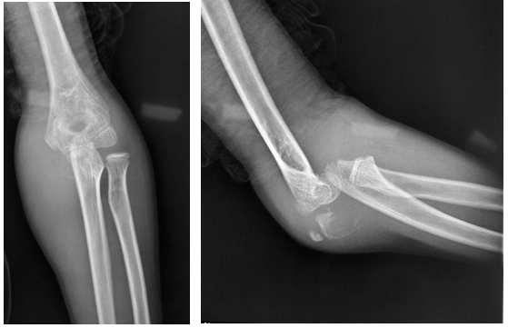
Figure 1 Preoperative radiographs showing anterior trans olecranon dislocation of the elbow.

Figure 2 Open radial head release and reduction of the radio humeral joint using a lateral approach.

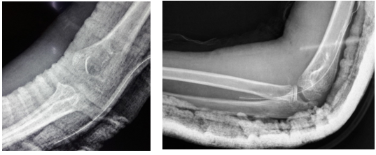
Figure 3 Immediate post-operative X-rays showing good reduction of the elbow joint.

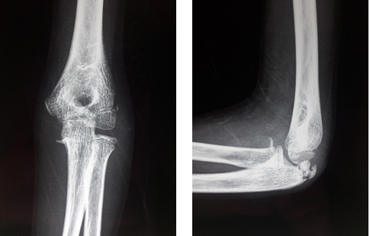

Figure 4 Four week post-operative X-rays showing the initiation of healing of the olecranon.

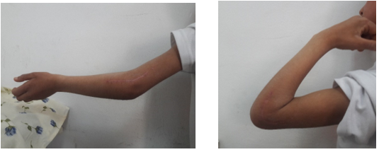

Figure 5 Incomplete extension of the elbow after 4 wk.

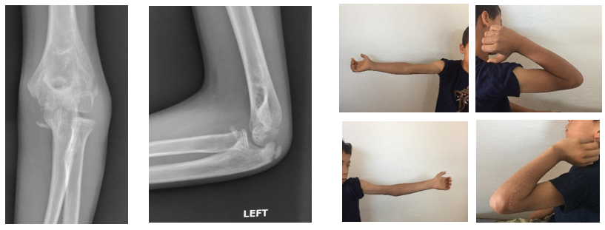
Figure 6 Healing of the olecranon and good motion after rehabilitation.

Table 1 Tiemdjo classification and proposed therapeutic indications of anterior trans-olecranon fractures-dislocations in children
Classification | Description | Treatment
Type 1 | Epiphyseal splinting or proximal fracture of the olecranon  If the periosteum is intact | Reduction + Tension-band Wiring  Reduction + Plaster
Type 2 | Transverse fracture | Reduction +  Tension-band Wiring
Type 3 | Oblique fracture | Reduction + Screwed plate
Type 4 | Olecranon fracture + associated injury (radius, humerus) | Reduction + Osteosynthesis of the olecranon fracture and the associated injury

