Name of Journal: World Journal of Clinical Cases
Manuscript NO: 69748
Manuscript Type: CASE REPORT

Carbon ion radiotherapy for synchronous choroidal melanoma and lung cancer: A case report

Zhang YS et al. CIRT for melanoma and lung cancer

Yan-Shan Zhang, Ting-Chao Hu, Yan-Cheng Ye, Jin-Hua Han, Xiao-Jun Li, Yi-He Zhang, Wei-Zuo Chen, Hong-Yu Chai, Xin Pan, Xin Wang, Yu-Ling Yang

Yan-Shan Zhang, Ting-Chao Hu, Yan-Cheng Ye, Xiao-Jun Li, Yi-He Zhang, Wei-Zuo Chen, Hong-Yu Chai, Xin Pan, Xin Wang, Yu-Ling Yang, Heavy Ion Center, Wuwei Cancer Hospital, Wuwei 733000, Gansu Province, China

Jin-Hua Han, Department of Ophthalmology, Wuwei Cancer Hospital, Wuwei 733000, Gansu Province, China

Author contributions: Zhang YS and Hu TC designed the experiment; Ye YC drafted the manuscript; Han JH, Li XJ and Zhang YH collected the data; Chen WZ and Chai HY analyzed and interpreted the data; Pan X, Wang X and Yang YL wrote the article.

Supported by Key R&D plan of Science and Technology Program of Gansu Province, China, No. 19YF3FH001.

Corresponding author: Yan-Cheng Ye, PhD, Chief Doctor, Heavy Ion Center, Wuwei Cancer Hospital, No. 31 Sanitary Alley, Haizang Road, Wuwei 733000, Gansu Province, China. zlyyyyc@163.com

Received: August 12, 2021
Revised: September 8, 2021
Accepted: September 30, 2021
Published online: November 26, 2021

Abstract
BACKGROUND
Despite being the most common intraocular malignancy among adults, choroidal melanoma is a rare cancer type, even more so when accompanied by lung cancer. We report a patient with synchronous choroid melanoma and lung cancer treated with carbon ion radiotherapy (CIRT).

CASE SUMMARY
A 41-year-old woman was transferred to our center with a diagnosis of choroidal melanoma in her right eye. During the examination, we found a right lung tumor that was histologically diagnosed as lung cancer. The patient was treated with CIRT for both malignant neoplasms. The CIRT dose was 70 photon equivalent doses (GyE) in five fractions for the right eye choroidal melanoma and 72 GyE in 16 fractions for the right lung cancer. At 3 mo after CIRT, the choroidal melanoma completely disappeared, as did the right lung cancer 7 mo after; the patient was in complete remission.

CONCLUSION
CIRT may be an effective treatment for double primary lung cancer and choroid melanoma.

Key Words: Melanoma; Lung neoplasms; Heavy ion radiotherapy; Neoplasms; Choroid neoplasms; Case report

©The Author(s) 2021. Published by Baishideng Publishing Group Inc. All rights reserved.

Citation: Zhang YS, Hu TC, Ye YC, Han JH, Li XJ, Zhang YH, Chen WZ, Chai HY, Pan X, Wang X, Yang YL. Carbon ion radiotherapy for synchronous choroidal melanoma and lung cancer: A case report. World J Clin Cases 2021; 9(33): 10374-10381
URL: https://www.wjgnet.com/2307-8960/full/v9/i33/10374.htm
DOI: https://dx.doi.org/10.12998/wjcc.v9.i33.10374

Core Tip: Simultaneous choroidal melanoma and lung cancer are extremely rare. This report details a case of a 41-year-old woman with right-side choroidal melanoma and lung cancer treated with carbon ion radiotherapy. Seven months after treatment, the patient was in complete remission.

INTRODUCTION
Uveal melanoma is the most common primary ocular malignancy among adults^{[1]} and is treated with conventional surgery or various radiotherapy techniques^{[2,3]}. The most common radiotherapy modalities are plaque brachytherapy and proton radiotherapy (PRT)^{[4-6]}. However, carbon ion beams conform to the prescribed dose better than proton beams because of a sharper lateral falloff. Carbon ion beams are also biologically advantageous over PRT in treating relatively resistant tumors. Therefore, carbon ion radiotherapy (CIRT) was hypothesized to have similar or better clinical outcomes than PRT for choroidal melanoma. The National Institute of Radiological Sciences (NIRS) in Japan started using CIRT for uveal melanoma in 2001, and, as anticipated, CIRT was safe and effective^{[7]}. CIRT is also effective with acceptable toxicity for early-stage and locally advanced non-small cell lung cancer. Moreover, it is equally safe and effective for elderly patients or patients with severe comorbidities who cannot receive surgery or chemoradiotherapy^{[8-10]}.
We present a case of concurrent choroidal melanoma and lung cancer that was successfully treated with CIRT. This report follows the CARE Guidelines: Consensus-based Clinical Case Reporting Guideline Development^{[11]}.

CASE PRESENTATION
Chief complaints
A 41-year-old woman was referred to the Wuwei Heavy Ion Center in June 2020 with choroidal melanoma of her right eye.

History of present illness
The right eye melanoma was histologically confirmed via fine-needle aspiration biopsy at an eye hospital. Written informed consent was obtained from the patient for publication.

Laboratory examinations
The immunohistochemical profile was C-erbB-2 (-), CK7 (+), Ki-67 (index = 25 %), Napsin A (+), P63 (-), and TTF-1 (+).

Imaging examinations
Computed tomography (CT) and magnetic resonance imaging (MRI) demonstrated that the tumor was located on the cranial side of the right eye. The patient presented with right eye malaise with gradual diminution of vision in the right eye over a period of 2 mo. After being transferred to our center, the patient's vision rapidly worsened, and she became completely blind in 15 d.
The patient underwent MRI at our hospital (3.0T; Siemens), which identified a lesion behind the right eye bulb from abnormal T1- and T2-weighted signals and high intensity on diffusion-weighted images (Figure 1). Ophthalmoscopy of the right eye showed a solid dark-gray mass in the posterior segment of the choroid with intense brown pigmentation occupying the posterior third of the vitreous chamber and mild retinal detachment at the peripheral choroidal mass rim. The mass was dome-shaped, 11.1 mm × 12.1 mm in size, and occupied a third of the posterior segment of the right eye (Figure 2). During the examination, a tumor in the lower lobe of the right lung was also observed. A multidisciplinary team discussion concluded that double primary neoplasms, ocular metastasis of lung cancer, and ocular melanoma with lung metastasis were possibilities. Subsequently, the patient underwent a lung biopsy, which indicated infiltrating acinar adenocarcinoma.

FINAL DIAGNOSIS
The final histologically confirmed diagnoses were: (1) choroidal melanoma of the right eye, cT2N0M0 [per the American Joint Committee on Cancer (AJCC) 8th edition]; and (2) right-sided lung cancer, infiltrating acinar adenocarcinoma, cT3N0M0, IIb (per the AJCC 8th edition), KPS: 90. CIRT for lung and eye cancer was planned after discussion with the patient and family.

TREATMENT
First, we treated the right eye tumor. The patient was immobilized in a supine position with a bite block device (trUpoint ARCH; CIVCO, Orange City, IA, United States) (Figure 3). A set of 1-mm thick CT images was obtained using a CT simulator. Gross tumor volume (GTV) was determined using CT images and referencing the ophthalmoscopy and MRI findings. Clinical target volume (CTV) was the GTV plus 1 mm, and planning target volume (PTV) was the CTV plus a 1.0-mm margin. CIRT was performed with the anterior and right lateral portals. The total prescribed dose was 70.0 photon equivalent doses (GyE) in 5 fractions (Fx; 2 Fxs from the anterior portal and 3 Fxs from the right lateral portal) once daily, five times per week (Monday to Friday). Carbon ion doses were expressed in GyE, defined as the physical dose multiplied by the relative biological effectiveness (RBE) of the carbon ions, which was assumed to be 3.0^{[12]}.
After completing CIRT for choroidal melanoma, we continued with treating the right-sided lung cancer. The patient was immobilized in the prone position using a customized vacuum cushion and chest thermoplastic mask. CT images were obtained using four-dimensional CT (4DCT) with 3-mm thick images. GTV was delineated based on the 4DCT images, CTV was defined as GTV plus 5 mm, ITV was defined as CTV plus the tumor motion on the 4DCT images, and PTV was expanded by 5 mm based on ITV. The CIRT plan delivered 72 GyE to the target volume in 16 Fx using the broad-beam method once daily, five times per week (Monday to Friday).
CIRT was planned using the carbon ion plan (ciPlan, version 1.0; IMP, Lanzhou, China). Treatment planning included a biologic treatment plan optimization procedure using the carbon ion Treat Plan (ciTreat) (version 1.0, IMP) treatment planning software system that considers local RBE values calculated by the ciPlan software based on the mixed beam model.
Efficacy evaluation was performed based on the Response Evaluation Criteria in Solid Tumours version 1.1 guidelines. The Common Terminology Criteria for Adverse Events (CTCAE) version 5.0 guidelines were used to evaluate adverse events. The Radiation Therapy Oncology Group (RTOG) acute radiation injury classification criteria were used to evaluate radiation damage. During and after CIRT, there were only grade 1 adverse events and no grade ≥ 2 RTOG acute effects.

OUTCOME AND FOLLOW-UP
Ophthalmic examination before CIRT revealed complete loss of vision in the right eye. One month after CIRT, the patient’s right eye began to perceive light and continued to gradually improve. Table 1 presents findings of the ophthalmic examination. After 3 CIRT Fxs, mild right eye edema occurred. Upon CIRT completion, MRI demonstrated that the melanoma increased, with obvious retinal detachment (Figure 4A). One month after CIRT, the choroid tumor was smaller, and the retinal detachment was resolved (Figure 4B). Three months after CIRT, the right eye choroid tumor disappeared completely, achieving complete remission (CR) (Figure 5). The patient’s right eye vision slowly returned (Table 1).
Before CIRT, the lung cancer size was 4.7 cm × 5.2 cm. After CIRT, it regressed to 4.2 cm × 3.5 cm after 1 mo, 3.6 cm × 2.5 cm after 3 mo, and completely disappeared after 7 mo, with only a small area of pulmonary fibrosis, also achieving CR (Figure 6). The CTCAE evaluation showed grade 1 radiation dermatitis and right eye edema.
We recommended that the patient receive chemotherapy and immunotherapy because of the high risk of metastasis from the two lesions. However, out of economic consideration, the patient refused further treatment and expressed that they and their family were content with the results, which already exceeded their expectations. The patient felt very satisfied with the CIRT treatment. Seven months after completing CIRT, the patient’s right eye vision was still weak, but no other treatment-related side effects were observed, and the patient felt good.

DISCUSSION
A middle vascular pigmented layer, including the iris, ciliary body, and choroid, comprises the uvea of the eye^{[13]}, and uveal tract melanomas are anterior or posterior tract lesions. Anterior tract melanomas involve the iris, and posterior tract melanomas involve the ciliary body and the choroid layer. Malignant uvea melanomas are more common in the choroid and ciliary body than in the iris.
Melanomas are highly malignant cancers^{[14]}. There are several histological subgroups with various degrees of aggressive behavior and systemic metastases risk. Cytogenetic features, such as chromosome 3 monosomy and the mutations in the GNAQ and BAP1 genes, are also related to higher aggressiveness and systemic spread. Recently, PALB2 and MLH1 germline mutations were associated with a hereditary predisposition to the risk of uveal melanoma, and several other genes also have potential associations with uveal melanomas^{[15]}. The clinical presentation of uveal melanoma relies on the mass location within the uveal tissue, size, pigmentation, associated bleeding, retinal detachment, inflammation, and extrascleral extension. Most patients experience decreased visual acuity and blurred vision^{[1]}. Although there are many cutting-edge treatment techniques, visual prognosis is usually poor, and many patients develop functional blindness in the affected eye. Further, metastasis to the liver and other organs is a primary cause of death despite recent advances in medical therapy^{[16]}.
Most patients with uveal melanoma undergo enucleation. Globally, a relatively small population of patients receive some form of radiotherapy. The most common radiotherapy modalities for uveal melanoma are plaque brachytherapy and PRT. Brachytherapy is effective for small-to-medium-sized uveal melanomas with thicknesses of less than 7 mm, whereas PRT is used when the uveal melanoma is larger or closer to the optic disc or fovea, taking advantage of the Bragg peak and biological profile. Newer techniques, such as stereotactic radiosurgery with CyberKnife, achieve similar local control rates with eye retention to PRT but have a poorer post-treatment visual prognosis^{[17]}. Carbon ion beams have unique physical and biological properties that make high-precision, high linear energy transfer (LET) radiotherapy^{[12]}. For choroidal melanoma, high-dose radiation with excellent dose conformity is necessary for optimal results, similar to PRT and plaque brachytherapy. Therefore, we expected that CIRT was suitable for treating this tumor. Moreover, the high LET characteristics of carbon ions make it an effective treatment that is likely to achieve comparable tumor control with a lower dose than PRT. NIRS results have demonstrated that for choroidal melanoma, CIRT is at least comparable to PRT^{[18,19]}.
Multiple primary malignant neoplasms indicate the simultaneous presence of two or more primary malignancies of different histological types in the same patient, which can affect multiple tissues and organs^{[20]}. Currently, the most accepted criteria for diagnosing primary malignant tumors are that each tumor should be histologically confirmed as malignant, occur in different parts or organs, differ regarding the histological, cytological, and morphological features and immunohistochemical phenotypes, and the possibility that one tumor is the metastasis of another must be completely excluded clinically, radiologically, and pathologically^{[21]}.

CONCLUSION
We report a case of synchronous lung cancer and choroid melanoma. Both lesions were treated with CIRT, resulting in their complete resolution. The patient is currently experiencing relapse-free survival 7 mo after completing CIRT. The treatment outcome suggests that CIRT is an effective option for synchronous double primary lung cancer and choroid melanoma, and favorable results are likely.

REFERENCES
1 Singh AD, Bergman L, Seregard S. Uveal melanoma: epidemiologic aspects. Ophthalmol Clin North Am 2005; 18: 75-84, viii [PMID: 15763193 DOI: 10.1016/j.ohc.2004.07.002]
2 Shields JA, Shields CL. Management of posterior uveal melanoma: past, present, and future: the 2014 Charles L. Schepens lecture. Ophthalmology 2015; 122: 414-428 [PMID: 25439609 DOI: 10.1016/j.ophtha.2014.08.046]
3 Macdonald EC, Cauchi P, Kemp EG. Proton beam therapy for the treatment of uveal melanoma in Scotland. Br J Ophthalmol 2011; 95: 1691-1695 [PMID: 21216794 DOI: 10.1136/bjo.2010.195594]
4 Damato B, Kacperek A, Errington D, Heimann H. Proton beam radiotherapy of uveal melanoma. Saudi J Ophthalmol 2013; 27: 151-157 [PMID: 24227980 DOI: 10.1016/j.sjopt.2013.06.014]
5 Rivard MJ, Melhus CS, Sioshansi S, Morr J. The impact of prescription depth, dose rate, plaque size, and source loading on the central axis using 103Pd, 125I, and 131Cs. Brachytherapy 2008; 7: 327-335 [PMID: 18782684 DOI: 10.1016/j.brachy.2008.05.002]
6 Reichstein D, Karan K. Plaque brachytherapy for posterior uveal melanoma in 2018: improved techniques and expanded indications. Curr Opin Ophthalmol 2018; 29: 191-198 [PMID: 29538180 DOI: 10.1097/ICU.0000000000000468]
7 Tsujii H, Kamada T, Shirai T, Noda K, Tsuji H, Karasawa K. Carbon-Ion Radiotherapy: Principles, Practices, and Treatment Planning. Springer Japan, 2014: 163-168 [DOI: 10.1007/978-4-431-54457-9]
8 Takahashi W, Nakajima M, Yamamoto N, Yamashita H, Nakagawa K, Miyamoto T, Tsuji H, Kamada T, Fujisawa T. A prospective nonrandomized phase I/II study of carbon ion radiotherapy in a favorable subset of locally advanced non-small cell lung cancer (NSCLC). Cancer 2015; 121: 1321-1327 [PMID: 25641119 DOI: 10.1002/cncr.29195]
9 Hayashi K, Yamamoto N, Nakajima M, Nomoto A, Tsuji H, Ogawa K, Kamada T. Clinical outcomes of carbon-ion radiotherapy for locally advanced non-small-cell lung cancer. Cancer Sci 2019; 110: 734-741 [PMID: 30467928 DOI: 10.1111/cas.13890]
10 Karube M, Yamamoto N, Shioyama Y, Saito J, Matsunobu A, Okimoto T, Ohno T, Tsuji H, Nakano T, Kamada T. Carbon-ion radiotherapy for patients with advanced stage non-small-cell lung cancer at multicenters. J Radiat Res 2017; 58: 761-764 [PMID: 28992088 DOI: 10.1093/jrr/rrx037]
11 Gagnier JJ, Kienle G, Altman DG, Moher D, Sox H, Riley D; CARE Group. The CARE guidelines: consensus-based clinical case reporting guideline development. BMJ Case Rep 2013; 2013 [PMID: 24155002 DOI: 10.1136/bcr-2013-201554]
12 Koto M, Ikawa H, Kaneko T, Hagiwara Y, Hayashi K, Tsuji H. Long-term outcomes of skull base chordoma treated with high-dose carbon-ion radiotherapy. Head Neck 2020; 42: 2607-2613 [PMID: 32472716 DOI: 10.1002/hed.26307]
13 Chattopadhyay C, Kim DW, Gombos DS, Oba J, Qin Y, Williams MD, Esmaeli B, Grimm EA, Wargo JA, Woodman SE, Patel SP. Uveal melanoma: From diagnosis to treatment and the science in between. Cancer 2016; 122: 2299-2312 [PMID: 26991400 DOI: 10.1002/cncr.29727]
14 Shukla S, Acharya S, Dulani M. Choroid Melanoma - A Rare Case Report. J Clin Diagn Res 2015; 9: ED09-ED10 [PMID: 26155486 DOI: 10.7860/JCDR/2015/13227.5959]
15 Lucena E, Goldemberg DC, Thuler LCS, de Melo AC. Epidemiology of uveal melanoma in Brazil. Int J Retina Vitreous 2020; 6: 51 [PMID: 33292764 DOI: 10.1186/s40942-020-00261-w]
16 Furdova A, Slezak P, Chorvath M, Waczulikova I, Sramka M, Kralik G. No differences in outcome between radical surgical treatment (enucleation) and stereotactic radiosurgery in patients with posterior uveal melanoma. Neoplasma 2010; 57: 377-381 [PMID: 20429631]
17 Thornton S, Coupland SE, Heimann H, Hussain R, Groenewald C, Kacperek A, Damato B, Taktak A, Eleuteri A, Kalirai H. Effects of plaque brachytherapy and proton beam radiotherapy on prognostic testing: a comparison of uveal melanoma genotyped by microsatellite analysis. Br J Ophthalmol 2020; 104: 1462-1466 [PMID: 32024655 DOI: 10.1136/bjophthalmol-2019-315363]
18 Hirasawa N, Tsuji H, Ishikawa H, Koyama-Ito H, Kamada T, Mizoe JE, Ito Y, Naganawa S, Ohnishi Y, Tsujii H. Risk factors for neovascular glaucoma after carbon ion radiotherapy of choroidal melanoma using dose-volume histogram analysis. Int J Radiat Oncol Biol Phys 2007; 67: 538-543 [PMID: 17141971 DOI: 10.1016/j.ijrobp.2006.08.080]
19 Toyama S, Tsuji H, Mizoguchi N, Nomiya T, Kamada T, Tokumaru S, Mizota A, Ohnishi Y, Tsujii H; Working Group for Ophthalmologic Tumors. Long-term results of carbon ion radiation therapy for locally advanced or unfavorably located choroidal melanoma: usefulness of CT-based 2-port orthogonal therapy for reducing the incidence of neovascular glaucoma. Int J Radiat Oncol Biol Phys 2013; 86: 270-276 [PMID: 23414768 DOI: 10.1016/j.ijrobp.2012.12.022]
20 Jemal A, Bray F, Center MM, Ferlay J, Ward E, Forman D. Global cancer statistics. CA Cancer J Clin 2011; 61: 69-90 [PMID: 21296855 DOI: 10.3322/caac.20107]
21 Fernández-Ruiz M, Guerra-Vales JM, Castelbón-Fernández FJ, Llenas-García J, Caurcel-Díaz L, Colina-Ruizdelgado F. Multiple primary malignancies in Spanish patients with hepatocellular carcinoma: analysis of a hospital-based tumor registry. J Gastroenterol Hepatol 2009; 24: 1424-1430 [PMID: 19486257 DOI: 10.1111/j.1440-1746.2009.05793.x]

Footnotes
Informed consent statement: Informed written consent was obtained from the patient.

Conflict-of-interest statement: No conflict of interest.

CARE Checklist (2016) statement: The authors have read the CARE Checklist (2016), and the manuscript was prepared and revised according to the CARE Checklist (2016).

Open-Access: This article is an open-access article that was selected by an in-house editor and fully peer-reviewed by external reviewers. It is distributed in accordance with the Creative Commons Attribution NonCommercial (CC BY-NC 4.0) license, which permits others to distribute, remix, adapt, build upon this work non-commercially, and license their derivative works on different terms, provided the original work is properly cited and the use is non-commercial. See: https://creativecommons.org/Licenses/by-nc/4.0/

Provenance and peer review: Unsolicited article; Externally peer reviewed.

Peer-review started: August 12, 2021
First decision: September 2, 2021
Article in press: September 30, 2021

Specialty type: Oncology
Country/Territory of origin: China
Peer-review report’s scientific quality classification
Grade A (Excellent): 0
Grade B (Very good): 0
Grade C (Good): C
Grade D (Fair): 0
Grade E (Poor): 0

P-Reviewer: Pandit PN S-Editor: Wang JL L-Editor: Filipodia P-Editor: Wang JL

Figure Legends
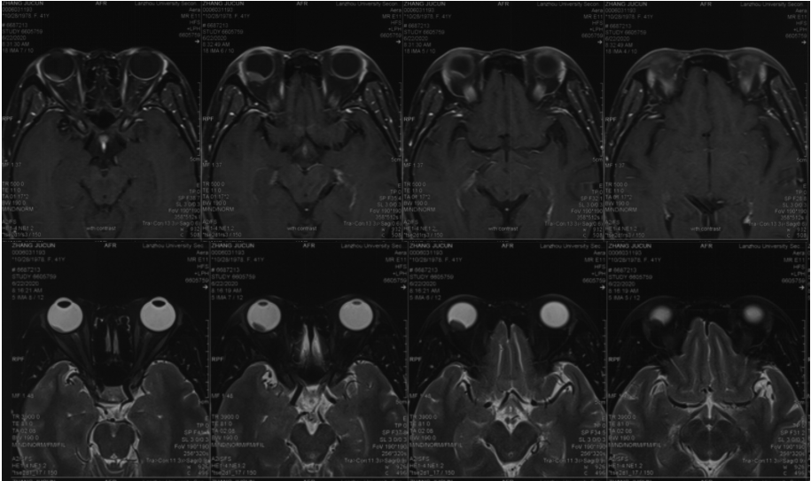
Figure 1 Magnetic resonance imaging of the right eye showed an abnormal signal shadow behind the right eye bulb, short T1 and T2 signals, and high diffusion-weighted imaging signals.

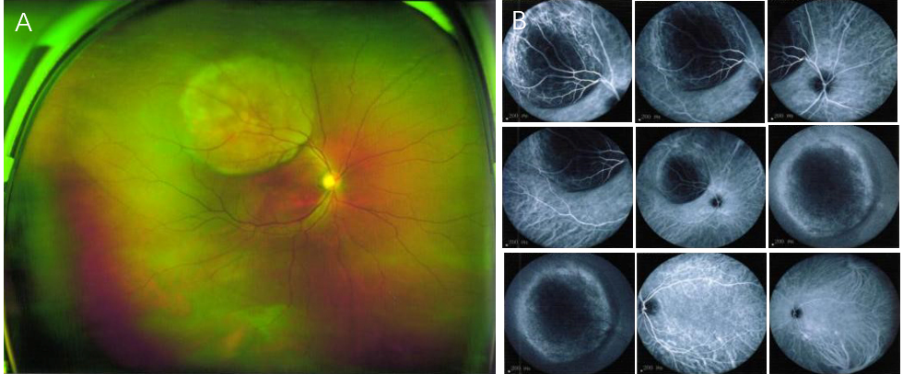
Figure 2 Ophthalmoscopy of the right eye. A, B: Solid dark gray mass in the posterior segment (choroid) with intense brown pigmentation, occupying posterior third of the vitreous chamber along with mild retinal detachment observed at the peripheral rim of the nodular choroidal mass. The mass size of 11.11 mm × 12.1 mm.

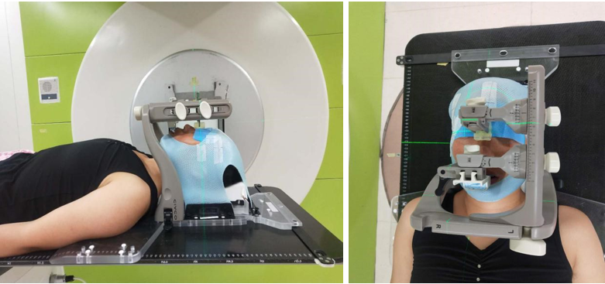
Figure 3 Head immobilization with trUpoint.

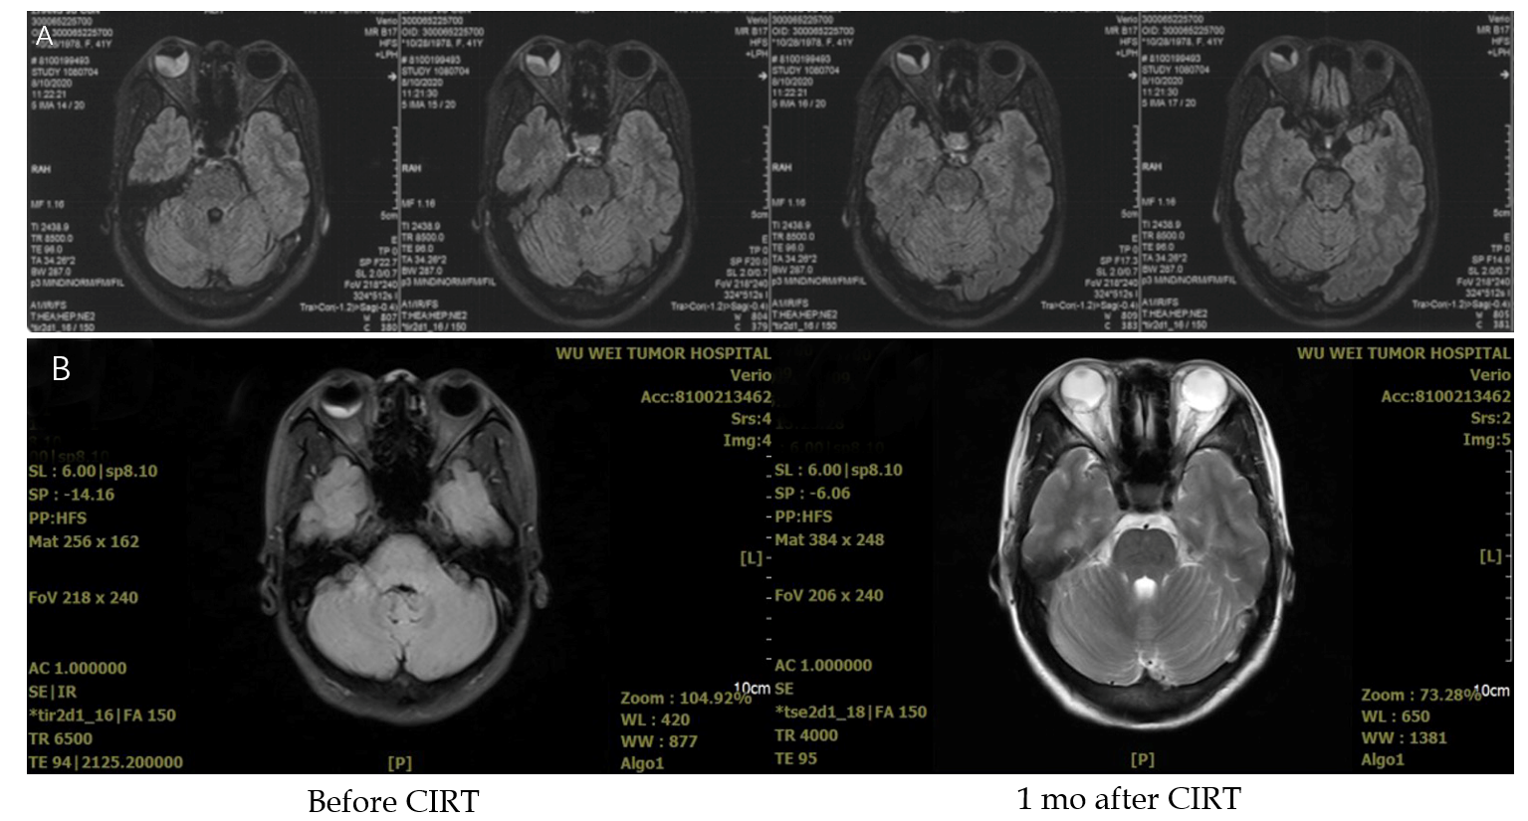
Figure 4 Images after 5 fractions of carbon ion radiotherapy, and 1 mo after carbon ion radiotherapy. A: The tumor is bigger, retinal detachment was obvious; B: The choroidal tumor of right eye was smaller and retinal detachment was improved. CIRT: Carbon ion radiotherapy.

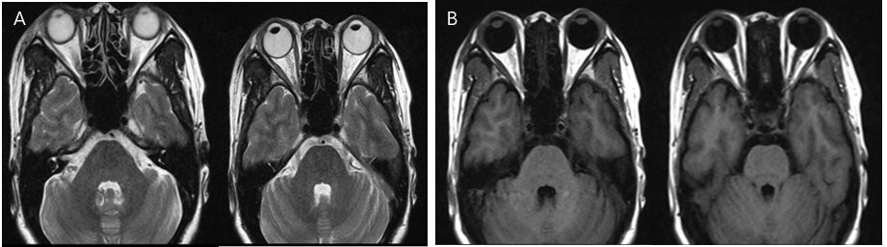
Figure 5 Choroidal tumor of the right eye disappeared completely 3 mo after carbon ion radiotherapy. A: T2W magnetic resonance imaging (MRI); B: T1W MRI.

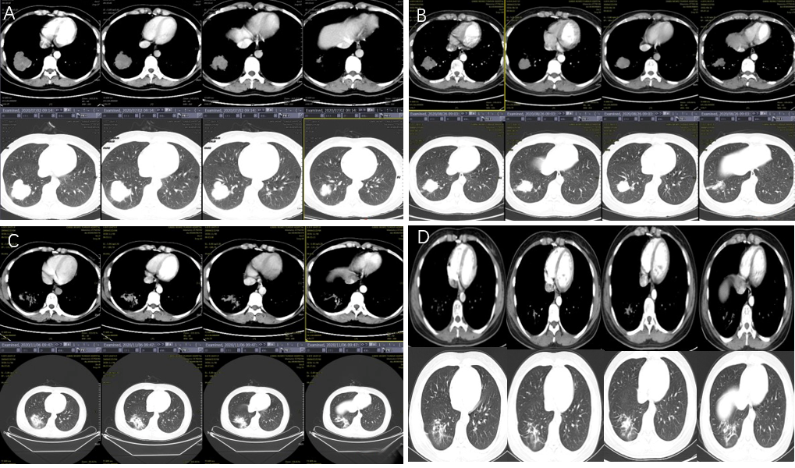
Figure 6 Images of lung tumor. A: Size of the lung tumor before carbon ion radiotherapy (CIRT) was 4.7 cm × 5.2 cm; B: Size of the lung tumor 1 mo after CIRT was 4.2 cm × 3.5 cm; C: At 3 mo after CIRT, the right lung tumor size was 3.6 cm × 2.5 cm; D: At 7 mo, the lung tumor disappeared completely, only showing a little pulmonary fibrosis.

Table 1 Ophthalmic examination
 | Right |  | Left
 | VOD | IOP, mmHg | VOS | IOP, mmHg
Before CIRT | HM/30 cm | 9.8 | 1.0 | 16.4
1 mo after CIRT | Light perception | 13.9 | 1.0 | 18.8
2 mo after CIRT | Hand motions | 11.0 | 0.8 | 18.2
4 mo after CIRT | 0.02 | 14.0 | 1.0 | 15.2
6 mo after CIRT | 0.04 | 13.0 | 1.0 | 16.0
CIRT: Carbon ion radiotherapy; VOD: Vision right eye; VOS: Vision left eye; IOP: Intraocular pressure.

Published by Baishideng Publishing Group Inc
7041 Koll Center Parkway, Suite 160, Pleasanton, CA 94566, USA
Telephone: +1-925-3991568
E-mail: bpgoffice@wjgnet.com
Help Desk: https://www.f6publishing.com/helpdesk
https://www.wjgnet.com

© 2021 Baishideng Publishing Group Inc. All rights reserved.

