Name of Journal: World Journal of Gastrointestinal Oncology
ESPS Manuscript NO: 20751
Manuscript Type: MINIREVIEWS

Role of histone deacetylases in pancreas: Implications for pathogenesis and therapy

Klieser E et al. Histone deacetylases in pancreas

Eckhard Klieser, Stefan Swierczynski, Christian Mayr, Johanna Schmidt, Daniel Neureiter, Tobias Kiesslich, Romana Illig

Eckhard Klieser, Johanna Schmidt, Daniel Neureiter, Romana Illig, Institute of Pathology, Paracelsus Medical University, Salzburger Landeskliniken (SALK), 5020 Salzburg, Austria

Stefan Swierczynski, Department of Surgery, Paracelsus Medical University, Salzburger Landeskliniken (SALK), 5020 Salzburg, Austria

Christian Mayr, Tobias Kiesslich, Department of Internal Medicine I, Paracelsus Medical University, Salzburger Landeskliniken (SALK), 5020 Salzburg, Austria

Christian Mayr, Tobias Kiesslich, Laboratory for Tumour Biology and Experimental Therapies (TREAT), Institute of Physiology and Pathophysiology, Paracelsus Medical University, 5020 Salzburg, Austria

Author contributions: Neureiter D and Illig R outlined the manuscript; Klieser E, Swierczynski S, Mayr C, Neureiter D and Kiesslich T researched the literature and contributed individual chapters of the manuscript; Mayr C and Kiesslich T designed the figures; Schmidt J did proofreading and contributed to textual revision of the manuscript.

Conflict-of-interest statement: The authors declared no conflict of interest.

Open-Access: This article is an open-access article which was selected by an in-house editor and fully peer-reviewed by external reviewers. It is distributed in accordance with the Creative Commons Attribution Non Commercial (CC BY-NC 4.0) license, which permits others to distribute, remix, adapt, build upon this work non-commercially, and license their derivative works on different terms, provided the original work is properly cited and the use is non-commercial. See: http://creativecommons.org/licenses/by-nc/4.0/

Correspondence to: Dr. Daniel Neureiter, MA, Associate Professor, Institute of Pathology, Paracelsus Medical University, Salzburger Landeskliniken (SALK), Müllner Haupstrasse 48, Salzburg 5020, Austria. d.neureiter@salk.at
Telephone: +43-662-44824701

Received: June 19, 2015
Peer-review started: June 21, 2015
First decision: August 14, 2015
Revised: September 3, 2015
Accepted: October 20, 2015
Article in press:
Published online:
Abstract
In the last years, our knowledge of the pathogenesis in acute and chronic pancreatitis (AP/CP) as well as in pancreatic cancerogenesis has significantly diversified. Nevertheless, the medicinal therapeutic options are still limited and therapeutic success and patient outcome are poor. Epigenetic deregulation of gene expression is known to contribute to development and progression of AP and CP as well as of pancreatic cancer. Therefore, the selective inhibition of aberrantly active epigenetic regulators can be an effective option for future therapies. Histone deacetylsases (HDACs) are enzymes that remove an acetyl group from histone tails, thereby causing chromatin compaction and repression of transcription. In this review we present an overview of the currently available literature addressing the role of HDACs in the pancreas and in pancreatic diseases. In pancreatic cancerogenesis, HDACs play a role in the important process of epithelial-mesenchymal-transition, ubiquitin-proteasome pathway and, hypoxia-inducible-factor-1-angiogenesis. Finally, we focus on HDACs as potential therapeutic targets by summarizing currently available histone deacetylase inhibitors.

Key words: Pancreatitis; Pancreatic cancer; Epigenetics; Histone deacetylase; Histone deacetylase inhibitor

© The Author(s) 2015. Published by Baishideng Publishing Group Inc. All rights reserved.

Core tip: Histone deacetylases (HDACs) are epigenetic regulators that play an essential role in organ development and tissue homeostasis. Aberrant HDAC activity contributes to the development of several diseases, including acute and chronic pancreatitis as well as pancreatic cancer. In acute and chronic pancreatitis the inhibition of HDACs exerts significant positive effects of cytokine- and nuclear factor-κB transmitted inflammation and tissue damage paralleled by reduced oxidative stress. HDACs are expressed in pancreatic cancer and were functionally linked to key processes of tumor progression (epithelial-mesenchymal-transition, the ubiquitin-proteasome pathway and angiogenesis), indicating a pleiotropic effect of HDACs in pancreatic cancerogenesis. Treatment of pancreatic cancer cells in vitro with HDACs inhibitors alone and/or in combination with conventional cancer agents resulted in diverse beneficial effects, including inhibition of proliferation and cell cycle as well as apoptosis. Therefore, inhibition of HDACs might be a promising strategy for treatment of pancreatic cancer.

Klieser E, Swierczynski S, Mayr C, Schmidt J, Neureiter D, Kiesslich D, Illig R. Role of histone deacetylases in pancreas: Implications for pathogenesis and therapy. World J Gastrointest Oncol 2015; In press
INTRODUCTION
The pancreas plays a key role in human physiology by its essential functions in gastrointestinal enzymatic digestion and endocrine glucose-dependent regulation of systemic energy metabolism via two main functions located in the histo-anatomical endocrine (islets of Langerhans) and exocrine (acinar - ductal) compartment of the pancreas (Figure 1)^{[1]}. The endocrine compartment releases hormones into the blood stream, thereby controlling blood glucose concentration, whereas the exocrine part produces and secrets digestive hydrolytic enzymes into the duodenum. These important physiological tasks of the pancreas become clinically evident, when an acute or chronic inflammatory process like pancreatitis as well as progressive carcinogenesis and subsequently necessary intensive surgery of pancreatic cancer lead to organ destruction and disturbance of the functional integrity of the pancreas (Figure 1)^{[2-4]}. As medicinal therapeutic options of pancreatitis and pancreas cancer are limited and mostly not associated with enhanced therapeutic success until now, the need for new approaches (such as epigenetic interactions) is still urgent in order to improve the quality of live and the outcome of patients with pancreatitis and pancreas cancer^{[5,6]}. In this review we give an overview of the role of epigenetic regulation by histone (de-)acetylation in pancreatic inflammation as well as in development of pancreatic tumors. We will further discuss the potential of histone deacetylases inhibitors (HDACis) as therapeutic approaches for treatment of these pancreatic diseases.
Epigenetic regulation of gene expression is a fundamental mechanism of eukaryotic organisms to ensure that only a subset of genes is actively expressed, thereby enabling the development of organs, specific tissues and their specialized physiologic functions. The term epigenetics describes all heritable changes in gene expression which act independently of the primary structure of the DNA, i.e., the DNA sequence. The two major mechanisms of epigenetics are methylation of DNA and post-translational modification of histone tails^{[7]}. Histones are proteins that package the DNA in structural units called nucleosomes. There are five major classes of histones: H1, H2A, H2B, H3 and H4. H1 are linker histones, whereas two of each of the other four histone classes build the octameric core of the nucleosome^{[8]}. In general, DNA methylation is associated with gene silencing, whereas the effect of histone modifications is dependent on the modification itself, the position of the modification and other surrounding histone modifications^{[7,9]}.
The two currently best known histone modifications are histone methylation and acetylation, of which methylation can lead to both, transcriptional activation and repression. Acetylation of histone tails, on the other hand mostly enhances gene expression^{[8]}. This can be explained by the fact that the addition of an acetyl group causes a neutralization of the positive charge of the histone, thereby loosening the contact between DNA and histones and facilitating accessibility of the DNA to transcription-promoting proteins^{[8]}. In contrast, the reverse process, called deacetylation, causes compaction of chromatin and repression of transcription^{[10]}. Deacetylation is performed by a group of enzymes, the histone deacetlyases (HDACs), which can be further classified into four groups HDACs I-IV (for details of the different HDAC groups see^{[10,11]}). HDACs play a crucial role in proper development of organs by epigenetic repression of certain genes. However, aberrant activity of HDACs also contributes to development of various human malignancies^{[10]}.

HDAC EXPRESSION IN PANCREATITIS
In the last years, intense efforts have been undertaken to gain more detailed insights into the role of HDACs in inflammation and their possible pathogenic involvement in chronic and destructive diseases. As reviewed in detail by others^{[12-14]}, HDACs are centrally involved in inflammatory processes in numerous chronic and organ-destructive diseases such as inflammatory bowel disease, chronic respiratory conditions, rheumatoid arthritis and juvenile idiopathic arthritis, allergic diseases and atherosclerosis^{[12-14]}. Here, HDACs influence the antigen presentation, expression of inflammatory mediators and anti-viral responses either directly or indirectly, for instance via class II, major histocompatibility complex, transactivator (CIITT), Interleukin (IL)-10, nuclear factor (NF)-κB, metastatic tumor antigen (MTA)1 or signal transducer and activator of transcription (STAT)^{[14,15]}. To summarize the functional role of HDACs during pancreatic inflammation and pancreatitis, a recapitulation of relevant inflammatory pathways on cellular and molecular levels involved in acute or chronic pancreatitis (AP, CP) is given in short (reviewed in detail in^{[16-18]}) - in Figures 1 and 2: in the acute phase (AP), neutrophils, followed by monocytes and macrophages, represent the key inflammatory cells secreting the major cytokines and inflammatory mediators. These include, amongst others, tumor necrosis factor (TNF)-α, IL-1β, IL-6, monocyte chemotactic protein (MCP)-1 and platelet activating factor (PAF; being also produced in part by acinar cells)^{[19]}. For development of CP, activation of pancreatic stellate cells as well as infiltrating myeloid cells and particularly macrophages are important on cellular level, whereby nuclear factor-κB (NF-κB) plays a relevant role on molecular level initiating and promoting fibrosis and scarring of the pancreatic tissue, which results ultimately in loss of exocrine and endocrine functions of the pancreas^{[20,21]}. Additionally, detailed investigations of immune cells revealed that T-cell-subsets play a central role in the pathogenesis of CP by increased counts of CD4+ and CD8+ central memory T-cell subsets (especially CCR7+) which additionally show enhanced IL-10-based response activity towards pancreatitis-associated antigens (mediated via CD4⁺CD25^{high}FoxP3⁺CD127⁻)^{[22,23]}.
The following selected experimental approaches showed an association between inflammatory members and HDACs during pathogenesis of AP and CP, using in-vitro and in-vivo-analysis with HDAC inhibitors.
In 2007, the group of Larsen et al^{[24]} investigated the possibly protective effect of HDAC inhibition on beta cells after cytokine-induced toxicity. They cultivated the INS-1 beta cell line and intact rat islets treated with the HDACis suberoylanilide hydroxamic acid (SAHA) or trichostatin A (TSA) in the absence or presence of IL-1β and interferon (IFN)-γ. Based on insulin secretion, nitric oxide (NO) formation, inducible NO synthase (iNOS) levels and NF-κB activity as well as viability and apoptosis, the authors could show that HDAC inhibition leads to cytokine-mediated decrease in insulin secretion, paralleled by reduced iNOS levels, NO formation and apoptosis. Furthermore, the IL-1β-induced phosphorylation of the inhibitor protein kappa Bα (IκBα) was inhibited by HDACis. The authors concluded that application of HDACis had a preventive effect on cytokine-induced beta cell apoptosis and impaired beta cell function associated with a down-regulation of NF-κB trans-activating activity.
In 2014, the group of Hartman et al^{[25]} analyzed the role of HDAC in trypsin activation, inflammation, and tissue damage in severe acute pancreatitis. After induction of pancreatitis with taurocholic acid in C57Bl/6 mice, the effect of pretreatment with the HDAC inhibitor TSA on serum levels of amylase and IL-6 was determined as well as the pancreatic levels of macrophage inflammatory protein-2 (MIP-2), tissue morphology and myeloperoxidase activity, pro-inflammatory mediators, and trypsin activation in the pancreas and lungs. Using this experimental setting, the authors could demonstrate that pretreatment with TSA results in a significant decrease in amylase levels and a reduction of systemic IL-6 and pulmonary myeloperoxidase activity, as well as the taurocholate-induced gene expression of cyclooxygenase-2, MIP-2, MCP -1, IL-6, and IL-1β in the pancreas. These findings suggest that HDACs are involved in the pathogenetic process of AP such as inflammation and tissue damage.
Recently, the group of Kanika et al^{[26]} studied the effect of HDAC inhibition on inflammation and fibrogenesis in L-Arginine(Arg)-induced pancreatitis and -associated fibrosis in Wistar rats. Looking at biochemical estimations, histological alterations, DNA damage, and the expression of various proteins, post-treatment with sodium butyrate (SB) decreased L-Arg-induced oxidative and nitrosative stress, DNA damage, histological alterations, and fibrosis. Interestingly, post-treatment with SB significantly decreased the expression of α-smooth muscle actin, IL-1β iNOS, and 3-nitrotyrosine. Overall, the authors concluded that post-treatment with SB could alleviate L-Arg-induced pancreatic damage and fibrosis in rats^{[26]}.
These findings are summarized in Figure 2: taken together, the pre- or post-treatment of AP and CP with the three different HDAC inhibitory substances SAHA, TSA and SB resulted in a significant decrease of inflammatory mediators in AP and CP with reduced disease progression compared to untreated controls. Interestingly, none of the mentioned experimental trials have carried out a sub-analysis of the HDAC classes and their members which could selectively be involved in this specific disease model. This approach could lead to the development of high selective HDAC-inhibitors to reduce systemic effects of pan-HDACis, because individual members of HDAC classes are specifically involved in the modulation of immune response in acute and chronic inflammatory diseases (reviewed in detail in^{[14]}).

HDAC EXPRESSION IN PANCREATIC TUMORS
The development from normal to cancerous cells is driven by complex modifications. Alternative pathways like epigenetic alterations become more and more interesting than progression models for mutations of different proto-oncogenes or tumor suppressor genes. One alternative way is the modification of histones by histone deacetylation. By removing acetyl groups from nucleosomes, histones, and non-histone proteins, HDACs do restrict the availability to access transcription factors or repressors^{[27]}, implicating that over-expression of HDACs can lead to aberrant gene expression and carcinogenesis^{[28]}.
Ductal adenocarcinoma of the pancreas, or simply called pancreatic cancer (PC), ranks among the most lethal of all malignancies in humans. In general, little is known about the role of HDACs in neoplasms derived from pancreatic endocrine and acinar cells; therefore the following paragraphs focus mainly on PC.
Recent studies revealed that under conditions of pancreatitis, adult exocrine acinar cells can differentiate and gain metaplastic ductal characteristics. This differentiation is also known as acinar-to-ductal metaplasia (ADM) and in mouse models, ADM is a precursor lesion of PC^{[29,30]}. Wauters et al^{[31]} investigated the role of Sirtuine 1 (SIRT1) and its inhibition by Leptomycin B and nicotinamide in a mouse model and human pancreatic exocrine cell culture experiments. Localized in the nucleus of normal exocrine acinar cells, SIRT1 is inhibited by the protein deleted in breast cancer 1 (DBC1). In ADM, the co-localization of SIRT1 and DBC1 is disrupted and SIRT1 translocates into the cytoplasm, ending up in SIRT1-driven effects like cell differentiation and certain roles during multistage carcinogenesis^{[32-34]}. The Wnt/β-Catenin pathway plays an important role in embryonic acinar cell differentiation and Prolferation. Wauters et al^{[31]} discovered that in pancreatic acini, SIRT1 is a regulator of the Wnt/β-catenin signialing pathway and SIRT1 inhibition resulted in maintenance of Wnt/β-Catenin signaling. In conlusion, Murtaugh et al^{[35]} propose that in normal pancreas, DBC1 balances SIRT1 activity and acinar cells remain differentiated. In 2007, Nakagawa et al^{[36]} investigated the expression profile of class I HDACs in human cancer tissues. Amongst others, they stained 20 PC samples with class I HDAC antibodies. Immunoreactivity was observable for HDAC1 in 17 PC (85%), for HDAC2 in 18 PC (90%), for HDAC3 in 20 PC (100%) and for HDAC 8 in 18 PC (90%) samples.
Lehmann et al^{[37]} discovered a significant correlation between class I HDAC expression and an increased nuclear translocation of RelA/p65. RelA/p65 is a member of the NFκB family transcription factors and a key regulator in pancreatic carcinogenesis. The NFκB family is involved in the regulation of many genes which participate in functions like cell survival, proliferation, differentiation, and inflammation^{[38]}. In addition, Weichert et al^{[39]} pointed out that high expression rates of RelA/p65 are correlated with the activation of the NFκB pathway in PC. Furthermore, they linked their results on class I HDAC expression to higher tumor grades and poor prognosis.
It has been also reported that HDAC2 plays a role in therapeutic resistance in PC, since inhibition of HDAC2 leads to up-regulation of the BH3-only protein NOXA. This in turn makes PC cells vulnerable to etoposide-induced (topoisomerase II inhibitor) apoptosis as well as tumor necrosis factor-related apoptosis-inducing ligand (TRAIL)-induced apoptosis^{[40,41]}.
In addition, Marshall et al^{[42]} discovered a relation between oncoproteins of the Myc family and HDAC2 up-regulation. In PC, the c-Myc oncogene is highly expressed, whereas CCNG2 is under-expressed. CCNG2 is known to stop cell cycle progression by inducing G1/S phase cell cycle arrest. Marshall et al^{[43]} showed that trichostatin A, a pan-HDACI, is able to improve CCNG2 expression and significantly elevates CCNG2 protein expression. On the contrary, they showed that transcriptional repression of CCNG2 contributes to N-Myc and HDAC2-induced cell proliferation. This suggests a potential benefit by using HDACIs in the treatment of PC as well.
In growing solid tumors, like PC, tumor cells experience specific microenvironmental conditions - in particular, a decreased oxygen level, called hypoxia^{[44]}. Hypoxia in the microenvironment of tumors can lead to radio/chemo-resistance and metastasis^{[45-47]}. Cellular response to hypoxia is controlled by many intracellular accumulating transcription factors, of which Hypoxia-inducible-factor-1 (HIF-1) plays an important role in the events induced by hypoxia^{[44]}. HIF-1 is composed by the HIF-1α and HIF-1β subunits^{[48]}. Denslow et al^{[49]}, Liu et al^{[50]} and Miyake et al^{[51]} showed that the expression of HDAC1 positively correlates with the expression of HIF-1α and metastasis-associated protein 1 (MTA1) in PC and that the expression of HIF-1α is possibly regulated through HDAC1/MTA1 subunits of the Nucleosome Remodeling Deacetylase (NuRD) complex, a HDAC containing repressor complex of proteins with the capability of ATP-dependent chromatin remodeling (Figure 3). As these changes are associated with poor prognosis, the inhibition of HDAC1 seems to be a promising therapeutic target^{[51]}.
In recent studies, HDACs have been connected with epithelial-mesenchymal transition (EMT), a process that contributes to PC progression^{[52]}. EMT is described as a turning of tumor cells from an epithelial into a mesenchymal phenotype, thereby becoming more invasive - a process which can lead to the development of metastases^{[53]}. E-cadherin regulates metastasis of PC and is suppressed by a Snail/HDAC1/HDAC2 repressor complex. Similar to HIF-1, gene expression of Snail is upregulated by hypoxia^{[54]}. Von Burstin et al^{[55]} showed that down-regulation of E-cadherin is associated with disorganization and loss of cell-cell adhesion in EMT and that inhibition of histone deacetylation seems to be one possibility to intervene E-cadherin down-regulation in PC. In cancer cells, E-Cadherin is repressed by transcription repressors like Snail and Zinc finger E-box-binding homeobox 1 (ZEB1) which regulate the recruitment of HDAC1 and HDAC2 to the E-Cadherin promotor (Figure 3)^{[56]}.
The ubiquitin-proteasome pathway regulates the degradation of intracellular proteins, including proteins which are involved in cell cycle regulation and differentiation. In order to survive, tumor cells are more dependent on the ubiquitin-proteasome pathway than healthy cells, because tumor cells show more accumulation of mis- or unfolded proteins than other cells^{[57]} - see also Figure 4. Aldana-Masangkay et al^{[58]} detected that HDAC6 is able to bind ubiquinated proteins and to activate the proteasome pathway. In consequence, HDAC6 protects tumor cells from apoptosis by helping to reduce the intercellular amount of mis-or unfolded proteins. As shown by Rodriguez-Gonzalez et al^{[57]} HDAC6 inhibitors break up aggressomes, an aggregation of misfolded proteins, in PC. Furthermore, combination of HDAC6 and proteasome inhibitors increases proteasome-induced apoptosis in cancer cells (Figure 4)^{[59]}. Frankland-Searby et al^{[60]} found that patients with a solid tumor like PC benefit from a combination of bortezomib (proteasome inhibitor) and a specific HDAC6 inhibitor.
The nerve growth factor IB, also known as Nur77, affects proliferation as well as apoptosis. Nur77 gene encodes an orphan nuclear receptor that positively regulates antigen-induced apoptosis of thymocytes^{[59]}. HDAC7 was shown to be a key regulator in the negative selection of thymocytes and ensures down-regulation of the Nur77 gene^{[61]}. Recently, Ouaissi et al^{[62]} determined the expression pattern of Nur77 gene simultaneously with the expression pattern of genes encoding for HDACs and SIRTs in PC. They recognized an overexpression of HDAC7 and HDAC2 as well as Nur77 in a significantly high percentage of PC compared to benign tumors and chronic pancreatitis. Although the function of Nur77 seems to be divergent and therefore further studies are needed to clarify the involvement of the HDAC7/HDAC2/Nur77 axis in the pathogenesis of PC, those findings suggest new approaches in the design of anti-PC therapy^{[62]}.
In summary, especially class I and II HDACs influence events involved in pancreatic cancerogenesis. Significant correlations of the NFκB-family member RelA/p65 and class I HDACs imply possible effects on functions like cell survival, proliferation, differentiation, and inflammation, which all play a role in cancerogenesis^{[37,38]}. Primarily class I HDACs show importance in the regulation of apoptosis and cell cycle in mainly three different ways: (1) inhibition of HDACs (HDAC2 and 7) induces up-regulation of BH-3 only protein NOXA, CCNG2 gene expression and Nur77^{[41,43,61]}; (2) moreover, HDACs are involved in EMT of PC tumor cells via the Snail/HDAC1/HDAC2 complex that suppresses E-Cadherin expression; and (3) in the oxygenation of PC microenvironment by regulating the expression HIF-1α through HDAC1/MTA1^{[51,55]}. All these findings suggest that HDAC inhibitors (HDACi) would interfere with cancerogenesis in PC on different points and are therefore a highly promising tool in anti-PC therapy.

HDAC-INHIBITORS: FROM THE BENCH TO THE BED
The development of histone deacetylase inhibitors (HDACis) as therapeutics for chronic diseases and cancer arose from the functional understanding of the underlying dys-regulation of HDACs. The acetylation status of histones is controlled by the opposing actions of two enzyme classes, the histone acetyltransferases (HATs), which transfer acetyl groups to lysine residues within the N-terminal tails of core histones, and the histone deacetylases (HDACs) which remove the acetyl groups^{[63]}. Histone hyperacetylation is associated with transcriptional activity. The rate of regulation and affection through HDACis lies by 20 % of all known genes, whereof almost one half is down-regulated and the other half is up-regulated^{[64]}.
The family of HDACis includes naturally occurring and synthetically generated compounds which target the HDAC enzyme family. These compounds vary in their chemical structure, their biological activity, and their specificity. There are two HDACis - vorinostat (Zolinza®) and romidepsin (Istodax®) - which have received approval from the United States Food and Drug Administration (FDA) for treatment of cutaneous T-cell lymphoma (CTCL). Romidepsin also got approved for the treatment of peripheral T-cell lymphoma (PTCL)^{[65,66]}.
The HDACis can be grouped by their structure into hydroxamic acid, cyclic peptide, bibenzimide, and short-chain fatty acid group (Table 1). The group of hydroxamates (vorinostat, givinostat, abexinostat, panobinostat, belinostat, and trachostatinA) exerts nonspecific HDAC inhibition by affecting all classes of HDACs^{[67,68]}.
The group of cyclic peptides includes compounds like depsipeptide (romidespin) and trapoxin. The benziamides include entinostat and mocetinostat. The hydroxamates, cyclic peptides and benziamides have potent inhibition properties in the nanomolar range. HDAC isotype-selective inhibitors like tubacin, mocetinostat and PC-34501 inhibit HDAC6; in addition HDAC1 and 8 are also becoming available^{[69,70]}.
It is a current topic of discussion whether to choose a broad-spectrum HDACi or a class specific HDACi. Furthermore, there are emerging hypotheses about the combination of HDACis with other signaling compounds like miRNA inhibition, in order to obtain better inhibition outputs^{[6]}.
The response to HDACis is complex and involves transcriptional effects as well as non-transcriptional effects in the cell: Marks et al^{[71]} summarized the multimodal effects through HDACis including apoptosis, cell-cycle arrest, necrosis, autophagy, differentiation, and migration. Lee and Marks reviewed that normal cells are up to ten times more resistant to HDACi-induced cell death than transformed cells. As an example, they described that vorinostat induced DNA double strand breaks (DSB) in normal and transformed cells in the cell culture, but normal cells were able to repair the DSB without almost any loss in viability.
In pancreatic cell lines, HDACis were shown to be potent anticancer drugs as single compounds but also as adjuvant drugs when combined with DNA-damaging agents, ionizing radiation or other approaches such as silencing through small interfering RNA^{[72,73]}. Vincent et al^{[74]} showed that Drosophila Eyes Absent Homologue-2 (EYA2) is silenced in the majority of PC and investigated the role of epigenetic mechanisms of EYA2 gene silencing in pancreatic cancers. Knockdown of EYA2 increased cell proliferation in pancreatic cancer cell lines. Silencing of EYA2 expression in pancreatic cancer cell lines correlated with histone deacetylation and was reversible with HDACis.
Peulen et al^{[75]} described that HDAC inhibition in human pancreas cell lines with chemical inhibitors (SAHA, MS-275 and celecoxib) significantly impaired proliferation of a human pancreatic cell line (BxPC-3 cells) in-vitro.
Yee et al^{[76]} showed in human pancreatic adenocarcinoma cells that the combination of the HDACi suberoylanilide hydroxamic acid (SAHA) and ML-60218 (inhibitor of RNA polymerase III) led to suppression of colony formation and proliferation, cell cycle arrest, and apoptotic cell death. The enhanced cytotoxicity was accompanied by up-regulation of the pro-apoptotic regulator BAX and the cyclin-dependent kinase inhibitor p21 (CDKN1A).
Mhedi et al^{[77]} examined human pancreatic cancer cell lines (Panc-1, BxPC-3, SOJ-6) and an immortalized epithelial cell line of a normal human pancreatic duct (HPDE/E6E7): a significant variation in HDACs and SIRTs protein expression levels was seen among individual cell samples. The in-vivo results showed that panobinostat (LBH589) exhibited a tumor reduction efficacy similar to the chemotherapeutic drug gemcitabine. In line with its in-vitro activity, panobinostat also achieved a significant reduction of tumor growth in a BxPC-3 pancreatic tumor cell line subcutaneous xenograft mouse model^{[77]}.
In a xenograft model of pancreatic cancer, Lee et al^{[78]} tested the effects of combined (vorinostat) SAHA and bortezomib treatment with or without gemcitabine on cell growth, apoptosis and expression of related proteins. The triple combination of vorinostat, bortezomib, and gemcitabine resulted in the strongest antitumor effects in-vitro.
Currently, there are 7 clinical trials concerning HDACis in PC^{[79]}. In general, there are more than 80 clinical trials investigating more than eleven different HDACis in solid and hematological malignancies, either as mono-therapies or in combination with other antitumor agents^{[63]}.

Vorinostat
The FDA approval for vorinostat was given after two phase II clinical trials in CTCL patients. Vorinostat showed similar effects as standard therapy in CTCL patients, but with a higher relief from pruritus. It was well tolerated with some adverse effects like diarrhea, fatigue and nausea. The response rates in solid cancer like breast, colorectal or lung cancer were poor. The use as a single agent has been unsuccessful, but the combination with conventional cancer agents seemed to be highly beneficial^{[78,80,81]}.

Depsipeptide
The bicyclic peptide is connected with potent cytotoxic effects in-vitro and in-vivo. Depsipetide was tested in a range of clinical trials (phase I/II/III) in colorectal, renal, breast neoplasms as well as hematological malignancies; and showed limited activity as monotherapy in acute myeloid leukemia and myelodysplastic syndrome^{[82,83]}.

CONCLUSION
The pancreas plays a key role in the exocrine and endocrine functional integrity of the organism which is severely affected by processes like acute or chronic inflammation as well as cancerogenesis. It is clear today that epigenetic regulators, such as HDACs are involved in development and progression of pancreatic diseases as shown during the last years in diverse in-vitro and in-vivo models. In this review, we investigated current literature to comprehensively summarize the role of HDACs in AP and CP as well as in PC. HDACs are overly expressed in PC and are associated with EMT, angiogenesis, and consequently with poor prognosis. HDACis were shown to have multifariously anti-tumor effects in PC, especially in combination with standard chemotherapeutics. Based on the data presented in this review, targeting HDACs can be a promising therapeutic option for treatment of PC and should be prospectively assessed in future clinical trials.
REFERENCES
1 Chandra R, Liddle RA. Recent advances in the regulation of pancreatic secretion. Curr Opin Gastroenterol 2014; 30: 490-494 [PMID: 25003603 DOI: 10.1097/MOG.0000000000000099]
2 Binker MG, Cosen-Binker LI. Acute pancreatitis: the stress factor. World J Gastroenterol 2014; 20: 5801-5807 [PMID: 24914340 DOI: 10.3748/wjg.v20.i19.5801]
3 Maeda H, Hanazaki K. Pancreatogenic diabetes after pancreatic resection. Pancreatology 2011; 11: 268-276 [PMID: 21734430 DOI: 10.1159/000328785]
4 Ohtsuka T, Tanaka M, Miyazaki K. Gastrointestinal function and quality of life after pylorus-preserving pancreatoduodenectomy. J Hepatobiliary Pancreat Surg 2006; 13: 218-224 [PMID: 16708298 DOI: 10.1007/s00534-005-1067-z]
5 Neureiter D, Jäger T, Ocker M, Kiesslich T. Epigenetics and pancreatic cancer: pathophysiology and novel treatment aspects. World J Gastroenterol 2014; 20: 7830-7848 [PMID: 24976721 DOI: 10.3748/wjg.v20.i24.7830]
6 Swierczynski S, Klieser E, Illig R, Alinger-Scharinger B, Kiesslich T, Neureiter D. Histone deacetylation meets miRNA: epigenetics and post-transcriptional regulation in cancer and chronic diseases. Expert Opin Biol Ther 2015; 15: 651-664 [PMID: 25766312 DOI: 10.1517/14712598.2015.1025047]
7 Egger G, Liang G, Aparicio A, Jones PA. Epigenetics in human disease and prospects for epigenetic therapy. Nature 2004; 429: 457-463 [PMID: 15164071 DOI: 10.1038/nature02625]
8 Strahl BD, Allis CD. The language of covalent histone modifications. Nature 2000; 403: 41-45 [PMID: 10638745 DOI: 10.1038/47412]
9 Jenuwein T, Allis CD. Translating the histone code. Science 2001; 293: 1074-1080 [PMID: 11498575 DOI: 10.1126/science.1063127]
10 Tang J, Yan H, Zhuang S. Histone deacetylases as targets for treatment of multiple diseases. Clin Sci (Lond) 2013; 124: 651-662 [PMID: 23414309 DOI: 10.1042/CS20120504]
11 Haumaitre C, Lenoir O, Scharfmann R. Directing cell differentiation with small-molecule histone deacetylase inhibitors: the example of promoting pancreatic endocrine cells. Cell Cycle 2009; 8: 536-544 [PMID: 19197155]
12 Woan KV, Sahakian E, Sotomayor EM, Seto E, Villagra A. Modulation of antigen-presenting cells by HDAC inhibitors: implications in autoimmunity and cancer. Immunol Cell Biol 2012; 90: 55-65 [PMID: 22105512 DOI: 10.1038/icb.2011.96]
13 Dekker FJ, van den Bosch T, Martin NI. Small molecule inhibitors of histone acetyltransferases and deacetylases are potential drugs for inflammatory diseases. Drug Discov Today 2014; 19: 654-660 [PMID: 24269836 DOI: 10.1016/j.drudis.2013.11.012]
14 Shakespear MR, Halili MA, Irvine KM, Fairlie DP, Sweet MJ. Histone deacetylases as regulators of inflammation and immunity. Trends Immunol 2011; 32: 335-343 [PMID: 21570914 DOI: 10.1016/j.it.2011.04.001]
15 Suárez-Álvarez B, Baragaño Raneros A, Ortega F, López-Larrea C. Epigenetic modulation of the immune function: a potential target for tolerance. Epigenetics 2013; 8: 694-702 [PMID: 23803720 DOI: 10.4161/epi.25201]
16 Thrower E, Husain S, Gorelick F. Molecular basis for pancreatitis. Curr Opin Gastroenterol 2008; 24: 580-585 [PMID: 19122498 DOI: 10.1097/MOG.0b013e32830b10e6]
17 Zheng L, Xue J, Jaffee EM, Habtezion A. Role of immune cells and immune-based therapies in pancreatitis and pancreatic ductal adenocarcinoma. Gastroenterology 2013; 144: 1230-1240 [PMID: 23622132 DOI: 10.1053/j.gastro.2012.12.042]
18 Gukovsky I, Li N, Todoric J, Gukovskaya A, Karin M. Inflammation, autophagy, and obesity: common features in the pathogenesis of pancreatitis and pancreatic cancer. Gastroenterology 2013; 144: 1199-209.e4 [PMID: 23622129 DOI: 10.1053/j.gastro.2013.02.007]
19 Makhija R, Kingsnorth AN. Cytokine storm in acute pancreatitis. J Hepatobiliary Pancreat Surg 2002; 9: 401-410 [PMID: 12483260 DOI: 10.1007/s005340200049]
20 Omary MB, Lugea A, Lowe AW, Pandol SJ. The pancreatic stellate cell: a star on the rise in pancreatic diseases. J Clin Invest 2007; 117: 50-59 [PMID: 17200706 DOI: 10.1172/JCI30082]
21 Treiber M, Neuhöfer P, Anetsberger E, Einwächter H, Lesina M, Rickmann M, Liang S, Kehl T, Nakhai H, Schmid RM, Algül H. Myeloid, but not pancreatic, RelA/p65 is required for fibrosis in a mouse model of chronic pancreatitis. Gastroenterology 2011; 141: 1473-1485, 1485.e1-e7 [PMID: 21763242 DOI: 10.1053/j.gastro.2011.06.087]
22 Schmitz-Winnenthal H, Pietsch DH, Schimmack S, Bonertz A, Udonta F, Ge Y, Galindo L, Specht S, Volk C, Zgraggen K, Koch M, Büchler MW, Weitz J, Beckhove P. Chronic pancreatitis is associated with disease-specific regulatory T-cell responses. Gastroenterology 2010; 138: 1178-1188 [PMID: 19931255 DOI: 10.1053/j.gastro.2009.11.011]
23 Grundsten M, Liu GZ, Permert J, Hjelmstrom P, Tsai JA. Increased central memory T cells in patients with chronic pancreatitis. Pancreatology 2005; 5: 177-182 [PMID: 15849488 DOI: 10.1159/000085269]
24 Larsen L, Tonnesen M, Ronn SG, Størling J, Jørgensen S, Mascagni P, Dinarello CA, Billestrup N, Mandrup-Poulsen T. Inhibition of histone deacetylases prevents cytokine-induced toxicity in beta cells. Diabetologia 2007; 50: 779-789 [PMID: 17265033 DOI: 10.1007/s00125-006-0562-3]
25 Hartman H, Wetterholm E, Thorlacius H, Regnér S. Histone deacetylase regulates trypsin activation, inflammation, and tissue damage in acute pancreatitis in mice. Dig Dis Sci 2015; 60: 1284-1289 [PMID: 25492506 DOI: 10.1007/s10620-014-3474-y]
26 Kanika G, Khan S, Jena G. Sodium Butyrate Ameliorates l-Arginine-Induced Pancreatitis and Associated Fibrosis in Wistar Rat: Role of Inflammation and Nitrosative Stress. J Biochem Mol Toxicol 2015; 29: 349-359 [PMID: 25774002 DOI: 10.1002/jbt.21698]
27 Haberland M, Montgomery RL, Olson EN. The many roles of histone deacetylases in development and physiology: implications for disease and therapy. Nat Rev Genet 2009; 10: 32-42 [PMID: 19065135 DOI: 10.1038/nrg2485]
28 Kouzarides T. Histone acetylases and deacetylases in cell proliferation. Curr Opin Genet Dev 1999; 9: 40-48 [PMID: 10072350]
29 Rooman I, Real FX. Pancreatic ductal adenocarcinoma and acinar cells: a matter of differentiation and development? Gut 2012; 61: 449-458 [PMID: 21730103 DOI: 10.1136/gut.2010.235804]
30 Pérez-Mancera PA, Guerra C, Barbacid M, Tuveson DA. What we have learned about pancreatic cancer from mouse models. Gastroenterology 2012; 142: 1079-1092 [PMID: 22406637 DOI: 10.1053/j.gastro.2012.03.002]
31 Wauters E, Sanchez-Arévalo Lobo VJ, Pinho AV, Mawson A, Herranz D, Wu J, Cowley MJ, Colvin EK, Njicop EN, Sutherland RL, Liu T, Serrano M, Bouwens L, Real FX, Biankin AV, Rooman I. Sirtuin-1 regulates acinar-to-ductal metaplasia and supports cancer cell viability in pancreatic cancer. Cancer Res 2013; 73: 2357-2367 [PMID: 23370328 DOI: 10.1158/0008-5472.CAN-12-3359]
32 Strobel O, Dor Y, Alsina J, Stirman A, Lauwers G, Trainor A, Castillo CF, Warshaw AL, Thayer SP. In vivo lineage tracing defines the role of acinar-to-ductal transdifferentiation in inflammatory ductal metaplasia. Gastroenterology 2007; 133: 1999-2009 [PMID: 18054571 DOI: 10.1053/j.gastro.2007.09.009]
33 Nin V, Escande C, Chini CC, Giri S, Camacho-Pereira J, Matalonga J, Lou Z, Chini EN. Role of deleted in breast cancer 1 (DBC1) protein in SIRT1 deacetylase activation induced by protein kinase A and AMP-activated protein kinase. J Biol Chem 2012; 287: 23489-23501 [PMID: 22553202 DOI: 10.1074/jbc.M112.365874]
34 Song NY, Surh YJ. Janus-faced role of SIRT1 in tumorigenesis. Ann N Y Acad Sci 2012; 1271: 10-19 [PMID: 23050959 DOI: 10.1111/j.1749-6632.2012.06762.x]
35 Murtaugh LC, Law AC, Dor Y, Melton DA. Beta-catenin is essential for pancreatic acinar but not islet development. Development 2005; 132: 4663-4674 [PMID: 16192304 DOI: 10.1242/dev.02063]
36 Nakagawa M, Oda Y, Eguchi T, Aishima S, Yao T, Hosoi F, Basaki Y, Ono M, Kuwano M, Tanaka M, Tsuneyoshi M. Expression profile of class I histone deacetylases in human cancer tissues. Oncol Rep 2007; 18: 769-774 [PMID: 17786334]
37 Lehmann A, Denkert C, Budczies J, Buckendahl AC, Darb-Esfahani S, Noske A, Müller BM, Bahra M, Neuhaus P, Dietel M, Kristiansen G, Weichert W. High class I HDAC activity and expression are associated with RelA/p65 activation in pancreatic cancer in vitro and in vivo. BMC Cancer 2009; 9: 395 [PMID: 19912635 DOI: 10.1186/1471-2407-9-395]
38 van Essen D, Engist B, Natoli G, Saccani S. Two modes of transcriptional activation at native promoters by NF-kappaB p65. PLoS Biol 2009; 7: e73 [PMID: 19338389 DOI: 10.1371/journal.pbio.1000073]
39 Weichert W, Boehm M, Gekeler V, Bahra M, Langrehr J, Neuhaus P, Denkert C, Imre G, Weller C, Hofmann HP, Niesporek S, Jacob J, Dietel M, Scheidereit C, Kristiansen G. High expression of RelA/p65 is associated with activation of nuclear factor-kappaB-dependent signaling in pancreatic cancer and marks a patient population with poor prognosis. Br J Cancer 2007; 97: 523-530 [PMID: 17622249 DOI: 10.1038/sj.bjc.6603878]
40 Fritsche P, Seidler B, Schüler S, Schnieke A, Göttlicher M, Schmid RM, Saur D, Schneider G. HDAC2 mediates therapeutic resistance of pancreatic cancer cells via the BH3-only protein NOXA. Gut 2009; 58: 1399-1409 [PMID: 19528037 DOI: 10.1136/gut.2009.180711]
41 Schüler S, Fritsche P, Diersch S, Arlt A, Schmid RM, Saur D, Schneider G. HDAC2 attenuates TRAIL-induced apoptosis of pancreatic cancer cells. Mol Cancer 2010; 9: 80 [PMID: 20398369 DOI: 10.1186/1476-4598-9-80]
42 Bennin DA, Don AS, Brake T, McKenzie JL, Rosenbaum H, Ortiz L, DePaoli-Roach AA, Horne MC. Cyclin G2 associates with protein phosphatase 2A catalytic and regulatory B' subunits in active complexes and induces nuclear aberrations and a G1/S phase cell cycle arrest. J Biol Chem 2002; 277: 27449-27467 [PMID: 11956189 DOI: 10.1074/jbc.M111693200]
43 Marshall GM, Gherardi S, Xu N, Neiron Z, Trahair T, Scarlett CJ, Chang DK, Liu PY, Jankowski K, Iraci N, Haber M, Norris MD, Keating J, Sekyere E, Jonquieres G, Stossi F, Katzenellenbogen BS, Biankin AV, Perini G, Liu T. Transcriptional upregulation of histone deacetylase 2 promotes Myc-induced oncogenic effects. Oncogene 2010; 29: 5957-5968 [PMID: 20697349 DOI: 10.1038/onc.2010.332]
44 Nurwidya F, Takahashi F, Minakata K, Murakami A, Takahashi K. From tumor hypoxia to cancer progression: the implications of hypoxia-inducible factor-1 expression in cancers. Anat Cell Biol 2012; 45: 73-78 [PMID: 22822460 DOI: 10.5115/acb.2012.45.2.73]
45 Xing F, Okuda H, Watabe M, Kobayashi A, Pai SK, Liu W, Pandey PR, Fukuda K, Hirota S, Sugai T, Wakabayshi G, Koeda K, Kashiwaba M, Suzuki K, Chiba T, Endo M, Mo YY, Watabe K. Hypoxia-induced Jagged2 promotes breast cancer metastasis and self-renewal of cancer stem-like cells. Oncogene 2011; 30: 4075-4086 [PMID: 21499308 DOI: 10.1038/onc.2011.122]
46 Raval RR, Lau KW, Tran MG, Sowter HM, Mandriota SJ, Li JL, Pugh CW, Maxwell PH, Harris AL, Ratcliffe PJ. Contrasting properties of hypoxia-inducible factor 1 (HIF-1) and HIF-2 in von Hippel-Lindau-associated renal cell carcinoma. Mol Cell Biol 2005; 25: 5675-5686 [PMID: 15964822 DOI: 10.1128/MCB.25.13.5675-5686.2005]
47 Huang LE, Bindra RS, Glazer PM, Harris AL. Hypoxia-induced genetic instability--a calculated mechanism underlying tumor progression. J Mol Med (Berl) 2007; 85: 139-148 [PMID: 17180667 DOI: 10.1007/s00109-006-0133-6]
48 Semenza GL. Hydroxylation of HIF-1: oxygen sensing at the molecular level. Physiology (Bethesda) 2004; 19: 176-182 [PMID: 15304631 DOI: 10.1152/physiol.00001.2004]
49 Denslow SA, Wade PA. The human Mi-2/NuRD complex and gene regulation. Oncogene 2007; 26: 5433-5438 [PMID: 17694084 DOI: 10.1038/sj.onc.1210611]
50 Liu Y, Long Y, Xing Z, Zhang D. C-Jun recruits the NSL complex to regulate its target gene expression by modulating H4K16 acetylation and promoting the release of the repressive NuRD complex. Oncotarget 2015; 6: 14497-14506 [PMID: 25971333]
51 Miyake K, Yoshizumi T, Imura S, Sugimoto K, Batmunkh E, Kanemura H, Morine Y, Shimada M. Expression of hypoxia-inducible factor-1alpha, histone deacetylase 1, and metastasis-associated protein 1 in pancreatic carcinoma: correlation with poor prognosis with possible regulation. Pancreas 2008; 36: e1-e9 [PMID: 18362831 DOI: 10.1097/MPA.0b013e31815f2c2a]
52 Krantz SB, Shields MA, Dangi-Garimella S, Munshi HG, Bentrem DJ. Contribution of epithelial-to-mesenchymal transition and cancer stem cells to pancreatic cancer progression. J Surg Res 2012; 173: 105-112 [PMID: 22099597 DOI: 10.1016/j.jss.2011.09.020]
53 Yang J, Weinberg RA. Epithelial-mesenchymal transition: at the crossroads of development and tumor metastasis. Dev Cell 2008; 14: 818-829 [PMID: 18539112 DOI: 10.1016/j.devcel.2008.05.009]
54 Barrallo-Gimeno A, Nieto MA. The Snail genes as inducers of cell movement and survival: implications in development and cancer. Development 2005; 132: 3151-3161 [PMID: 15983400 DOI: 10.1242/dev.01907]
55 von Burstin J, Eser S, Paul MC, Seidler B, Brandl M, Messer M, von Werder A, Schmidt A, Mages J, Pagel P, Schnieke A, Schmid RM, Schneider G, Saur D. E-cadherin regulates metastasis of pancreatic cancer in vivo and is suppressed by a SNAIL/HDAC1/HDAC2 repressor complex. Gastroenterology 2009; 137: 361-371, 371.e1-371.e5 [PMID: 19362090 DOI: 10.1053/j.gastro.2009.04.004]
56 Aghdassi A, Sendler M, Guenther A, Mayerle J, Behn CO, Heidecke CD, Friess H, Büchler M, Evert M, Lerch MM, Weiss FU. Recruitment of histone deacetylases HDAC1 and HDAC2 by the transcriptional repressor ZEB1 downregulates E-cadherin expression in pancreatic cancer. Gut 2012; 61: 439-448 [PMID: 22147512 DOI: 10.1136/gutjnl-2011-300060]
57 Rodriguez-Gonzalez A, Lin T, Ikeda AK, Simms-Waldrip T, Fu C, Sakamoto KM. Role of the aggresome pathway in cancer: targeting histone deacetylase 6-dependent protein degradation. Cancer Res 2008; 68: 2557-2560 [PMID: 18413721 DOI: 10.1158/0008-5472.CAN-07-5989]
58 Aldana-Masangkay GI, Sakamoto KM. The role of HDAC6 in cancer. J Biomed Biotechnol 2011; 2011: 875824 [PMID: 21076528 DOI: 10.1155/2011/875824]
59 Wu Q, Li Y, Liu R, Agadir A, Lee MO, Liu Y, Zhang X. Modulation of retinoic acid sensitivity in lung cancer cells through dynamic balance of orphan receptors nur77 and COUP-TF and their heterodimerization. EMBO J 1997; 16: 1656-1669 [PMID: 9130711 DOI: 10.1093/emboj/16.7.1656]
60 Frankland-Searby S, Bhaumik SR. The 26S proteasome complex: an attractive target for cancer therapy. Biochim Biophys Acta 2012; 1825: 64-76 [PMID: 22037302 DOI: 10.1016/j.bbcan.2011.10.003]
61 Dequiedt F, Kasler H, Fischle W, Kiermer V, Weinstein M, Herndier BG, Verdin E. HDAC7, a thymus-specific class II histone deacetylase, regulates Nur77 transcription and TCR-mediated apoptosis. Immunity 2003; 18: 687-698 [PMID: 12753745]
62 Ouaïssi M, Silvy F, Loncle C, Ferraz da Silva D, Martins Abreu C, Martinez E, Berthézene P, Cadra S, Le Treut YP, Hardwigsen J, Sastre B, Sielezneff I, Benkoel L, Delgrande J, Ouaissi A, Iovanna J, Lombardo D, Mas E. Further characterization of HDAC and SIRT gene expression patterns in pancreatic cancer and their relation to disease outcome. PLoS One 2014; 9: e108520 [PMID: 25275504 DOI: 10.1371/journal.pone.0108520]
63 Ververis K, Hiong A, Karagiannis TC, Licciardi PV. Histone deacetylase inhibitors (HDACIs): multitargeted anticancer agents. Biologics 2013; 7: 47-60 [PMID: 23459471 DOI: 10.2147/BTT.S29965]
64 Minucci S, Pelicci PG. Histone deacetylase inhibitors and the promise of epigenetic (and more) treatments for cancer. Nat Rev Cancer 2006; 6: 38-51 [PMID: 16397526 DOI: 10.1038/nrc1779]
65 Marks PA, Breslow R. Dimethyl sulfoxide to vorinostat: development of this histone deacetylase inhibitor as an anticancer drug. Nat Biotechnol 2007; 25: 84-90 [PMID: 17211407 DOI: 10.1038/nbt1272]
66 Campas-Moya C. Romidepsin for the treatment of cutaneous T-cell lymphoma. Drugs Today (Barc) 2009; 45: 787-795 [PMID: 20126671 DOI: 10.1358/dot.2009.45.11.1437052]
67 Marks PA. The clinical development of histone deacetylase inhibitors as targeted anticancer drugs. Expert Opin Investig Drugs 2010; 19: 1049-1066 [PMID: 20687783 DOI: 10.1517/13543784.2010.510514]
68 Schneider-Stock R, Ocker M. Epigenetic therapy in cancer: molecular background and clinical development of histone deacetylase and DNA methyltransferase inhibitors. IDrugs 2007; 10: 557-561 [PMID: 17665331]
69 Parmigiani RB, Xu WS, Venta-Perez G, Erdjument-Bromage H, Yaneva M, Tempst P, Marks PA. HDAC6 is a specific deacetylase of peroxiredoxins and is involved in redox regulation. Proc Natl Acad Sci U S A 2008; 105: 9633-9638 [PMID: 18606987 DOI: 10.1073/pnas.0803749105]
70 Tang W, Luo T, Greenberg EF, Bradner JE, Schreiber SL. Discovery of histone deacetylase 8 selective inhibitors. Bioorg Med Chem Lett 2011; 21: 2601-2605 [PMID: 21334896 DOI: 10.1016/j.bmcl.2011.01.134]
71 Lee JH, Marks PA. Histone deacetylase inhibitors in the therapy of cancer: much to learn. Epigenomics 2010; 2: 723-725 [PMID: 22122077 DOI: 10.2217/epi.10.59]
72 Fogg PC, O'Neill JS, Dobrzycki T, Calvert S, Lord EC, McIntosh RL, Elliott CJ, Sweeney ST, Hastings MH, Chawla S. Class IIa histone deacetylases are conserved regulators of circadian function. J Biol Chem 2014; 289: 34341-34348 [PMID: 25271152 DOI: 10.1074/jbc.M114.606392]
73 Neureiter D, Zopf S, Leu T, Dietze O, Hauser-Kronberger C, Hahn EG, Herold C, Ocker M. Apoptosis, proliferation and differentiation patterns are influenced by Zebularine and SAHA in pancreatic cancer models. Scand J Gastroenterol 2007; 42: 103-116 [PMID: 17190770 DOI: 10.1080/00365520600874198]
74 Vincent A, Hong SM, Hu C, Omura N, Young A, Kim H, Yu J, Knight S, Ayars M, Griffith M, Van Seuningen I, Maitra A, Goggins M. Epigenetic silencing of EYA2 in pancreatic adenocarcinomas promotes tumor growth. Oncotarget 2014; 5: 2575-2587 [PMID: 24810906]
75 Peulen O, Gonzalez A, Peixoto P, Turtoi A, Mottet D, Delvenne P, Castronovo V. The anti-tumor effect of HDAC inhibition in a human pancreas cancer model is significantly improved by the simultaneous inhibition of cyclooxygenase 2. PLoS One 2013; 8: e75102 [PMID: 24040391 DOI: 10.1371/journal.pone.0075102]
76 Yee NS, Zhou W, Chun SG, Liang IC, Yee RK. Targeting developmental regulators of zebrafish exocrine pancreas as a therapeutic approach in human pancreatic cancer. Biol Open 2012; 1: 295-307 [PMID: 23213420 DOI: 10.1242/bio.2012539]
77 Mehdi O, Françoise S, Sofia CL, Urs G, Kevin Z, Bernard S, Igor S, Anabela CD, Dominique L, Eric M, Ali O. HDAC gene expression in pancreatic tumor cell lines following treatment with the HDAC inhibitors panobinostat (LBH589) and trichostatine (TSA). Pancreatology 2011; 12: 146-155 [PMID: 22487525 DOI: 10.1016/j.pan.2012.02.013]
78 Lee JK, Ryu JK, Yang KY, Woo SM, Park JK, Yoon WJ, Lee SH, Jeong KS, Kim YT, Yoon YB. Effects and mechanisms of the combination of suberoylanilide hydroxamic acid and bortezomib on the anticancer property of gemcitabine in pancreatic cancer. Pancreas 2011; 40: 966-973 [PMID: 21487323 DOI: 10.1097/MPA.0b013e3182156d5a]
79 Proteasome Inhibitor NPI-0052 and Vorinostat in Patients With Non-small Cell Lung Cancer, Pancreatic Cancer, Melanoma or Lymphoma. [accessed 2014 Aug]. Available from: URL: https://clinicaltrials.gov/ct2/show/NCT00667082?term=Pancreas+and+HDAC&rank=1
80 Olsen EA, Kim YH, Kuzel TM, Pacheco TR, Foss FM, Parker S, Frankel SR, Chen C, Ricker JL, Arduino JM, Duvic M. Phase IIb multicenter trial of vorinostat in patients with persistent, progressive, or treatment refractory cutaneous T-cell lymphoma. J Clin Oncol 2007; 25: 3109-3115 [PMID: 17577020 DOI: 10.1200/JCO.2006.10.2434]
81 Duvic M, Talpur R, Ni X, Zhang C, Hazarika P, Kelly C, Chiao JH, Reilly JF, Ricker JL, Richon VM, Frankel SR. Phase 2 trial of oral vorinostat (suberoylanilide hydroxamic acid, SAHA) for refractory cutaneous T-cell lymphoma (CTCL). Blood 2007; 109: 31-39 [PMID: 16960145 DOI: 10.1182/blood-2006-06-025999]
82 Sandor V, Bakke S, Robey RW, Kang MH, Blagosklonny MV, Bender J, Brooks R, Piekarz RL, Tucker E, Figg WD, Chan KK, Goldspiel B, Fojo AT, Balcerzak SP, Bates SE. Phase I trial of the histone deacetylase inhibitor, depsipeptide (FR901228, NSC 630176), in patients with refractory neoplasms. Clin Cancer Res 2002; 8: 718-728 [PMID: 11895901]
83 Byrd JC, Marcucci G, Parthun MR, Xiao JJ, Klisovic RB, Moran M, Lin TS, Liu S, Sklenar AR, Davis ME, Lucas DM, Fischer B, Shank R, Tejaswi SL, Binkley P, Wright J, Chan KK, Grever MR. A phase 1 and pharmacodynamic study of depsipeptide (FK228) in chronic lymphocytic leukemia and acute myeloid leukemia. Blood 2005; 105: 959-967 [PMID: 15466934 DOI: 10.1182/blood-2004-05-1693]
84 Deorukhkar A, Shentu S, Park HC, Diagaradjane P, Puduvalli V, Aggarwal B, Guha S, Krishnan S. Inhibition of radiation-induced DNA repair and prosurvival pathways contributes to vorinostat-mediated radiosensitization of pancreatic cancer cells. Pancreas 2010; 39: 1277-1283 [PMID: 20531243 DOI: 10.1097/MPA.0b013e3181dd63e1]
85 Lewis EC, Blaabjerg L, Størling J, Ronn SG, Mascagni P, Dinarello CA, Mandrup-Poulsen T. The oral histone deacetylase inhibitor ITF2357 reduces cytokines and protects islet β cells in vivo and in vitro. Mol Med 2011; 17: 369-377 [PMID: 21193899 DOI: 10.2119/molmed.2010.00152]
86 Sung V, Richard N, Brady H, Maier A, Kelter G, Heise C. Histone deacetylase inhibitor MGCD0103 synergizes with gemcitabine in human pancreatic cells. Cancer Sci 2011; 102: 1201-1207 [PMID: 21375679 DOI: 10.1111/j.1349-7006.2011.01921.x]
87 Huang S, Zhu M, Wu W, Rashid A, Liang Y, Hou L, Ning Q, Luo X. Valproate pretreatment protects pancreatic β-cells from palmitate-induced ER stress and apoptosis by inhibiting glycogen synthase kinase-3β. J Biomed Sci 2014; 21: 38 [PMID: 24884462 DOI: 10.1186/1423-0127-21-38]
88 Tian J, Dang H, Chen Z, Guan A, Jin Y, Atkinson MA, Kaufman DL. γ-Aminobutyric acid regulates both the survival and replication of human β-cells. Diabetes 2013; 62: 3760-3765 [PMID: 23995958 DOI: 10.2337/db13-0931]
P-Reviewer: Kleeff J S-Editor: Tian YL
L-Editor: E-Editor:

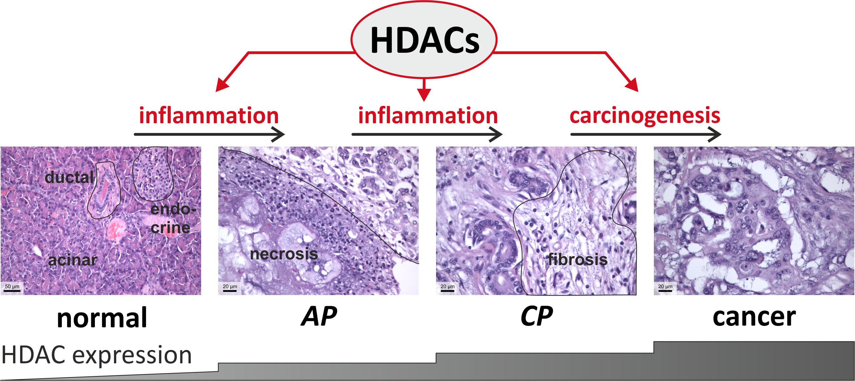
Figure 1 Histone deacetylases (HDACs) and histopathological correlates in the transition from normal to acute/chronic pancreatitis (AP, CP) and pancreatic cancer. The trend to increased expression (based on pharmacological inhibition studies) of HDACs from normal to pancreatic cancer tissue is shown in the lower part of the figure. In pancreatic cancer, up-regulation of HDAC-1,-2,-3,-7,-8 could be demonstrated - see text for details - probably offering approaches for personalized therapies based on specific HDAC inhibition.

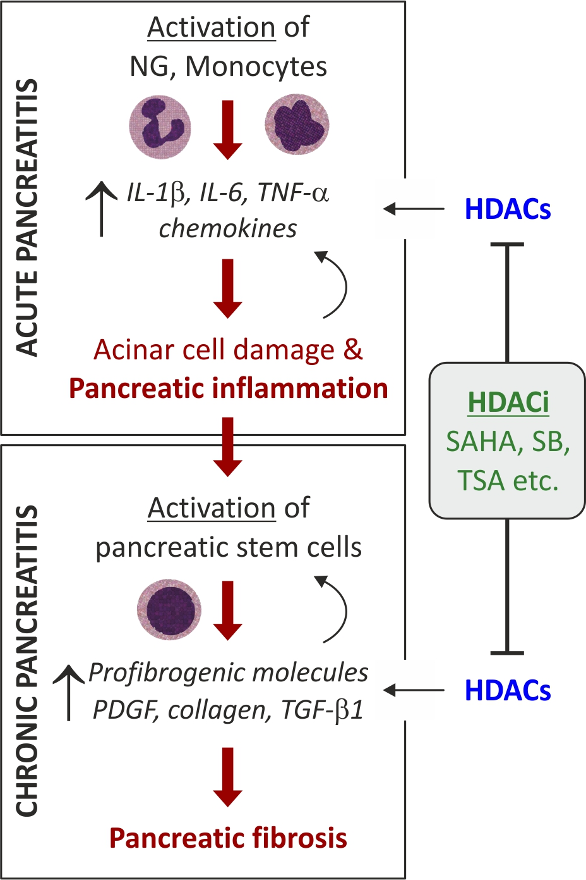
Figure 2 Histone deacetylases (HDACs) in acute and chronic pancreatitis (AP, CP). HDACs induce key pro-inflammatory mediators in AP and chronic pancreatitis (CP) leading to destruction of pancreatic tissue with necrosis in case of AP and fibrosis/atrophy in case of CP. Inhibition of HDACs by histone deacetylases inhibitors (HDACis) was shown to significantly antagonist these effects in vitro and in vivo^{[24-26]}. IL: Interleukin; TNFα: Tumor necrosis factor α; TGF-β1: Transforming growth factor β1.

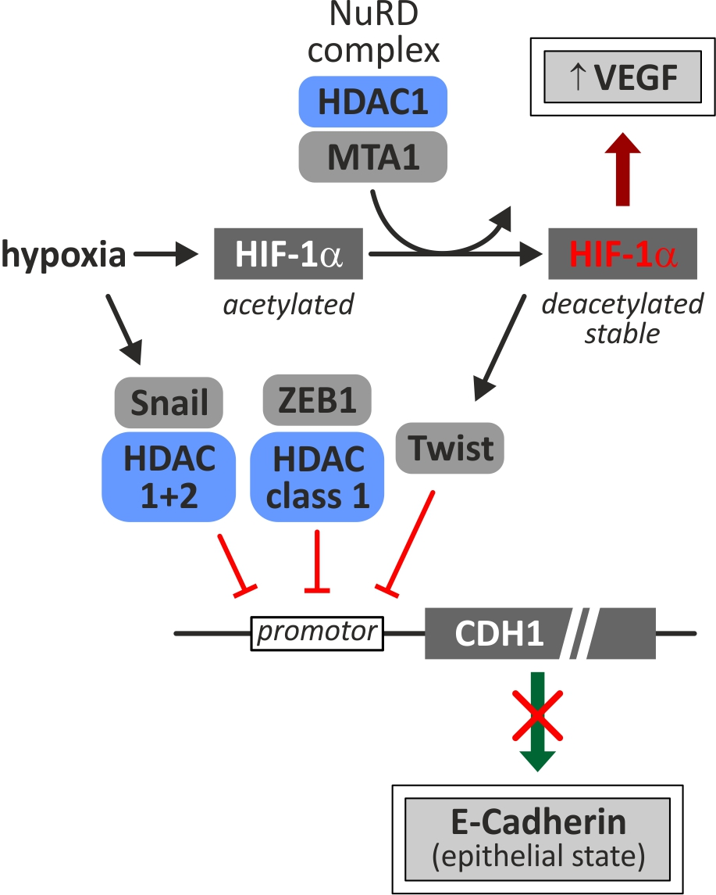
Figure 3 HDAC involvements in HIF1-mediated response to hypoxia. As suggested by Miyake et al^{[51]}, HIF-1α is possibly regulated and stabilized by two subunits of the NuRD complex: HDAC1/MTA1. Stabilized HIF-1α induces neo-angiogenesis by up-regulation of VEGF and, furthermore, contributes to EMT via Twist and subsequent inhibition of E-Cadherin expression (CDH1). Expression of E-Cadherin can be additionally repressed by complexes of either HDAC class I with ZEB1 or HDAC1 and 2 with Snail at the CDH1 promoter^{[56]}. HDAC: Histone deacetylases; HIF1: Hypoxia inducible factor-1; MTA1: Metastasis-associated protein 1; VEGF: Vascular endothelial growth factor; EMT: Epithelial-mesenchymal transition; ZEB1: Zinc finger E-box-binding homeobox 1.

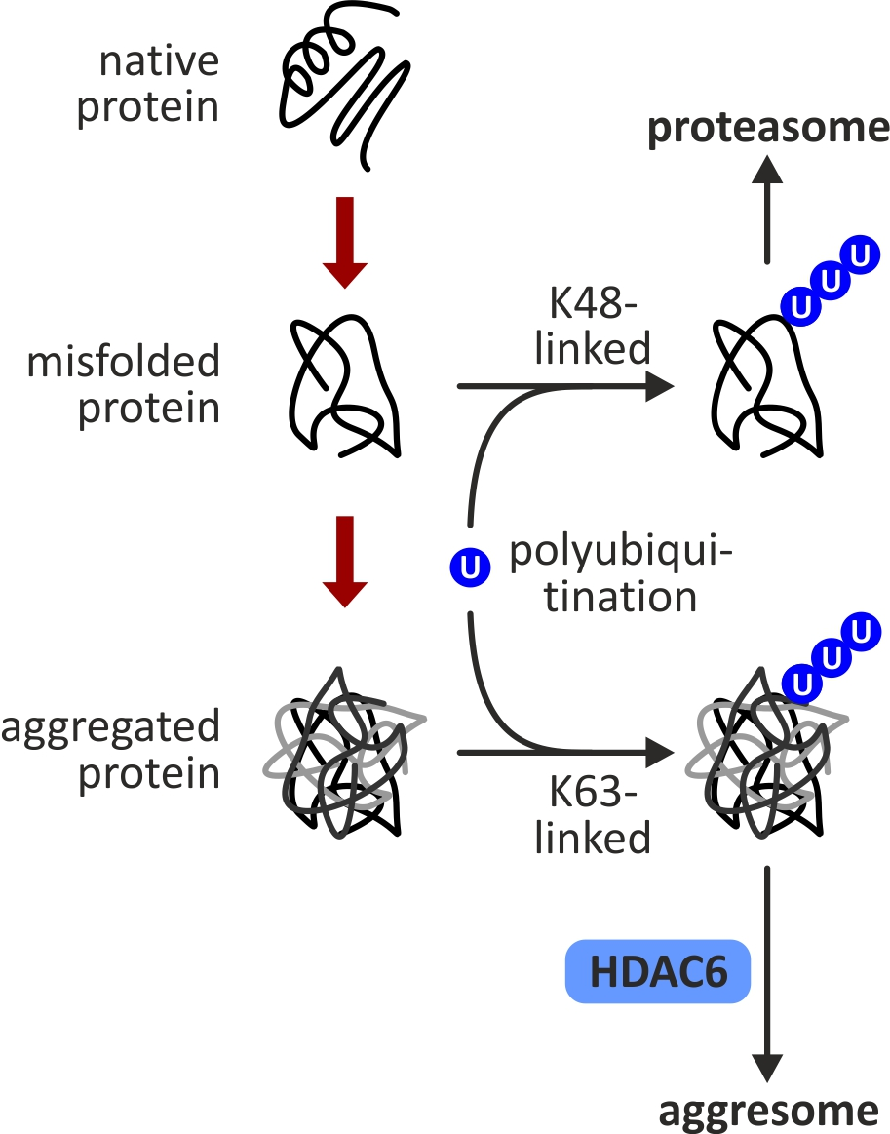
Figure 4 Role of histone deacetylase 6 (HDAC6) in protein turnover. HDAC6 facilitates un-/misfolded protein degradation by recruiting ubiquinated proteins to the aggresome or proteasome thus protecting tumor cells from apoptosis - see text for details^{[58]}.

Table1 Overview of histone deacetylase inhibitors based on their structure, class specificity; current clinical trials and suggested therapeutic effects^{[63,77 84-88]}
Structure class | HDAC class specificity | HDAC inhibitor | Clinical trials | Effects
Hydroxamic acid | I, II, IV | Trichostatin A | - | -
 |  | Quisinostat | Phase I | -
 |  | Vorinostat | FDA approved (2006), phase II, III | Vorinostat significantly sensitized pancreatic cancer cells for radiotherapy
 |  | Panobinostat | Phase II, III | Panobinostat induced the death of pancreatic tumor cell by apoptosis.
 |  | Resminostat | Phase I, II | -
 |  | Abexinostat |  | -
 |  | Belinostat |  | -
 | I, II | Givinostat |  | The orally active HDAC inhibitor ITF2357 (givinostat) favors β-cell survival during inflammatory conditions
Cyclic peptide | I | Depsipeptide | FDA approved (2009), phase I, II | -
Benzamides | I | Entinostat | Phase II | -
 | HDAC1 | Mocetinostat | Phase I, II | Mocetinostat + gemcitabine might be an effective treatment for gemcitabine-refractory pancreatic cancer
Fatty acid | I, II  I, II | Valporic acid | Phase I, II, III | Valporic acid may protect β-cells from palmitate-induced apoptosis and ER stress via GSK-3β inhibition, independent of ATF4/CHOP pathway.
 |  | Butyrate | Phase II | Butyrate regulates both the survival and replication of human β-cells
HDAC: Histone deacetlyase; FDA: Food and Drug Administration.

