Name of Journal: World Journal of Orthopedics
Manuscript NO: 40534
Manuscript Type: MINIREVIEWS

Intra-operative computed tomography guided navigation for pediatric pelvic instrumentation: A technique guide

Anari JB et al. Navigation in pediatric pelvic instrumentation

Jason B Anari, Patrick J Cahill, John M Flynn, David A Spiegel, Keith D Baldwin

Jason B Anari, Patrick J Cahill, John M Flynn, David A Spiegel, Keith D Baldwin, Department of Orthopaedic Surgery, Children’s Hospital of Philadelphia, Philadelphia, PA 19104, United States

ORCID number: Jason B Anari (0000-0002-2190-6333); Patrick J Cahill (000-0002-7129-1007); John M Flynn (0000-0003-0643-0506); David A Spiegel (0000-0001-6417-7735); Keith D Baldwin (0000-0002-2333-9061).

Author contributions: Anari JB contributed to primary manuscript preparation; Cahill PJ, Flynn JM and Spiegel DA contributed to manuscript review, contributed patients; Baldwin KD contributed to secondary manuscript preparation, contributed patients.

Conflict-of-interest statement: The authors have no conflicts-of-interest to disclose that are pertinent to this article.

Open-Access: This article is an open-access article which was selected by an in-house editor and fully peer-reviewed by external reviewers. It is distributed in accordance with the Creative Commons Attribution Non Commercial (CC BY-NC 4.0) license, which permits others to distribute, remix, adapt, build upon this work non-commercially, and license their derivative works on different terms, provided the original work is properly cited and the use is non-commercial. See: http://creativecommons.org/licenses/by-nc/4.0/

Manuscript source: Invited manuscript

Correspondence to: Keith D Baldwin, MD, Assistant Professor, Department of Orthopaedic Surgery, Children’s Hospital of Philadelphia, 3401 Civic Center Blvd, Philadelphia, PA 19104, United States. baldwink@email.chop.edu
Telephone: +1-856-4040635
Fax: +1-215-5907861

Received: July 2, 2018
Peer-review started: July 2, 2018
First decision: July 19, 2018
Revised: July 29, 2018
Accepted: August 4, 2018
Article in press:
Published online:

Abstract
Pelvic instrumentation for neuromuscular scoliosis has been part of neuromuscular scoliosis surgery since the era of the Luque Galveston construct. Unit Rod (Medtronic Sofamor-Danek, Nashville, TN) instrumentation brought with it the concept of cantilever correction by placing the implants in the pelvis and then gradually bringing the rod to the spine by sequentially tightening the sublaminar wires, with the goal of creating a level pelvis over a straight spine. More recently surgeons have utilized pedicle screw constructs in which the corrective strategies have varied. Challenges with pelvic fixation using iliac screws linked to the spinal rod have led to the development of the S2-alar-iliac technique (S2AI) in which the spinal rod connects to the pelvic screw. The screw is placed in the S2 ala, cross the sacro-iliac joint and into the ilium through a large column of supra-acetabular bone. This column is the same area used for anterior inferior iliac spine external fixation frames used in trauma surgery. S2AI screw placement can be technically difficult and can require experienced radiology technologists to provide the appropriate views. Additionally, although the technique was originally described being placed via freehand technique with intra-operative flouroscopy, the freehand technique suffers from the anatomic anomalies present in the pelvis in neuromuscular scoliosis. As such, we prefer to place them using intra-operative navigation for all pediatric spinal deformity cases. Below in detail we report our intra-operative technique and an illustrative case example.

Key words: Pediatric; Spinal deformity; Image guidance; Posterior instrumentation; Technique

© The Author(s) 2018. Published by Baishideng Publishing Group Inc. All rights reserved.

Core tip: S2-alar-iliac technique (S2AI) screws are used commonly in 2018 in posterior spinal fusion surgery when a fusion to the pelvis is indicated. The benefits of this instrumentation choice are well known; and now with 3D technology surgeons can safely place S2AI screws reproducibly even in aberrant pediatric anatomy.

Anari JB, Cahill PJ, Flynn JM, Spiegel DA, Baldwin KD. Intra-operative computed tomography guided navigation for pediatric pelvic instrumentation: A technique guide. World J Orthop 2018; In press

INTRODUCTION
Neuromuscular scoliosis is a common cause of spinal deformity, and nonambulatory patients commonly have a thoracolumbar or lumbar curve associated with pelvic obliquity (Figure 1). While corrective strategies have varied, the initial approach using the Luque-Galveston technique involved extension of the spinal rod into the posterior ilium/pelvis. The corrective strategy in the unit rod occurred by first placing the pelvic limbs of the fixation in the pelvis, and then gradually bringing the rod to the spine by applying cantilever forces and sequentially tightening sublaminar wires to bring the spine to the rod^{[1]}. Problems including prominence of the implants, loosening of the pelvic limbs within the pelvis (“windshield wipering”), and rod fracture. The unit rod is a pre-contoured rod which was developed to avert the need for intraoperative rod contouring, and the technique for correction was the same. Subsequent variations in lumbo-pelvic fixation have included iliac screws, which are placed into the posterior iliac crest and attached to the spinal rod via connectors. Some authors have placed duel screws into the ilium, while others have advocated for screws in both the first sacral vertebra and the ilium. Challenges with this fixation include implant prominence and failure of the implant at the junction between either the screw and the connector or the connector and the rod.
In 2007, Sponseller introduced the S2-alar-iliac technique (S2AI) in which the pelvic screw is placed from the sacrum into the pelvis. The screw head is low profile and connects directly with the spinal rod^{[2]}. While initial reports documented safety and placement in both pediatric and adult spinal deformity patients, much of the recent literature regarding safety of placement using the S2AI technique has been published in adults^{[3-6]}. Shillingford et al^{[3]} report a free hand technique without intra-operative imaging that has a cortical breech rate of 7% posteriorly and 1% anteriorly. Anterior perforation into the pelvis or inferior perforation into the sciatic notch can have catastrophic result given the neurovascular and visceral structures found in such locations^{[3]}. There may also be variations in anatomy, for example the relationship between the iliac wings and the pelvis. In the setting of considerable pelvic obliquity, the patient may bear weight on the downside iliac wing, and one may observe asymmetry in the relationship between the iliac wings and the pelvis such as adduction of one iliac wing with abduction of the other.
We have utilized computed tomography (CT) image navigation for placement of pedicle screws at our institution for more than 10 years, and we have extended this practice to the placement of S2AI screws^{[7]}. Here we describe our technique for CT guided pediatric pelvic fixation using the S2AI technique.

TECHNIQUE
The patient is placed in the prone position on an open Jackson table and a subperiosteal exposure from the upper instrumented vertebrae to S2 is performed. Adequate exposure on the sacrum includes visualization of both the S1 and S2 neural foramina. An anchor point is picked proximally in the lumbar or thoracic spine that is sturdy enough to hold a reference array (4 tines at a minimum) and simultaneously remain out of the surgeon’s working space while placing instrumentation. Our preferred location is the lower thoracic spine (T11/12) as this is usually far enough away to be out of the working field but not too far from the insertion point to alter the information acquired by the CT scan. Patient lordosis must be taken into account as significant differences in trajectory may lead to interference of the guidance probe with the sensor array.
Once the exposure is complete and the array in a stable location a low dose CT scan (2.25 mSv) is performed from the top of the femoral heads to the lower lumbar spine region (O-Arm Medtronic Sofamor-Danek, Nashville, TN). Following completion of the CT scan the navigation probe (Figure 2) is connected to the array by docking the probe in the array’s recess. Once confirmation of coupling occurs 3D anatomy from the CT scan is confirmed by placing the probe over a lumbar spinous process correlating the imaging seen on the screen with the patient. The surgeon, who stands on the patient’s left places the right sided S2AI screw and switches sides for the left sided screw. The typical entry point insertion for the S2AI screws are just lateral to the lateral edge of the S1 and S2 foramina midway between the two (Figure 3), although minor variations may be required depending on the local anatomy. Once this point is identified using the probe a 4 mm acorn burr is used to create a pilot hole for the pedicle probe approximately 3 mm in depth. The navigation probe is replaced in the pilot hole to confirm trajectory in both the axial and sagittal planes. Normal anatomy puts the S2AI trajectory at approximately 40º lateral in the axial plane and 20º-40º caudal in the sagittal plane^{[2,8]}. Once surgeon has trajectory memorized the straight gearshift is passed through the sacrum into the sacroiliac joint and into the ilium (Figure 4). In rare cases the proper trajectory may require that the screw be placed directly into the ilium and not through the sacrum.
On the navigation screen depth and trajectory can be checked anytime with gearshift removal and placement of navigation probe. The authors prefer to place gearshift to the desired screw depth, dilate the tract, and then place the navigation probe down the tract to ensure circumferential bone and a floor alongside a guide wire (Figure 5). A ball tip probe then palpates the walls of the tract, and the channel is tapped to a diameter 0.5 mm less than the desired screw diameter, over the guide wire. The walls of the tract are palpated one last time before the cannulated screw is placed over the guide wire. Lastly the navigation probe is placed down the cannulated screw to palpate a floor as well as ensure the trajectory taken by the screw (Figure 6). Final position of the S2AI screws align with the cephalad instrumentation facilitating rod insertion. Figure 7 depicts a patient with neuromuscular scoliosis and pelvic obliquity who had S2AI instrumentation placed during an instrumented posterior fusion.

DISCUSSION
The extension of spinal instrumentation and fusion across the lumbosacral junction and into the pelvis is required in a number of clinical scenarios in both children and adults. In the pediatric population this is most commonly to address pelvic obliquity in the neuromuscular population, while in adults a common indication is to achieve rigid distal anchors for correcting sagittal imbalance in the setting of osteoporotic bone and to enhance the chances of arthrodesis across the lumbosacral junction^{[9-12]}. Each situation offers varying complexity with regard to the insertion of implants, for example in pediatric patients in which there may be variations in the relationship between the iliac wings and the sacrum. We have also observed that the isthmus may be quite narrow in some pediatric patients, and the navigation allows us to identify this and choose the optimal sized screw, which is important given the literature suggestion screw diameter < 8 mm are at an increased risk of implant complications^{[13]}.
We have utilized a CT guided approach for more than 10 years and have been satisfied with our ability to safely place the implants, and this approach also serves as a valuable training tool for our residents and fellows who are being exposed to the challenge of lumbo-pelvic fixation. Reports concerning both free hand instrumentation and navigation assisted instrumentation are available^{[14-16]}. The discussions include a comparison of cost, radiation safety for patient/surgeon/staff, reliance on technology, and associated risks with the learning curve^{[17-19]}. At our institution the intra-operative CT dose is extremely low and all faculty are prepared to place without image guidance if the technology fails intra-operatively^{[20]}.

REFERENCES
1 Herkowitz HN, Garfin SR, Eismont FJ, Bell GR, Balderson RA. Rothman-Simeone the Spine. 6th edition. Philadelphia: Elsevier Saunders, 2011
2 Chang TL, Sponseller PD, Kebaish KM, Fishman EK. Low profile pelvic fixation: anatomic parameters for sacral alar-iliac fixation versus traditional iliac fixation. Spine (Phila Pa 1976) 2009; 34: 436-440 [PMID: 19247163 DOI: 10.1097/BRS.0b013e318194128c]
3 Shillingford JN, Laratta JL, Tan LA, Sarpong NO, Lin JD, Fischer CR, Lehman RA Jr, Kim YJ, Lenke LG. The Free-Hand Technique for S2-Alar-Iliac Screw Placement: A Safe and Effective Method for Sacropelvic Fixation in Adult Spinal Deformity. J Bone Joint Surg Am 2018; 100: 334-342 [PMID: 29462037 DOI: 10.2106/JBJS.17.00052]
4 Hu X, Lieberman IH. Robotic-guided sacro-pelvic fixation using S2 alar-iliac screws: feasibility and accuracy. Eur Spine J 2017; 26: 720-725 [PMID: 27272491 DOI: 10.1007/s00586-016-4639-5]
5 Shillingford JN, Laratta JL, Park PJ, Lombardi JM, Tuchman A, Saifi CS, Lehman RA, Lenke LG. Human versus Robot: A Propensity-Matched Analysis of the Accuracy of Free Hand versus Robotic Guidance for Placement of S2 Alar-Iliac (S2AI) Screws. Spine (Phila Pa 1976) 2018 [PMID: 29672421 DOI: 10.1097/BRS.0000000000002694]
6 Laratta JL, Shillingford JN, Lombardi JM, Alrabaa RG, Benkli B, Fischer C, Lenke LG, Lehman RA. Accuracy of S2 Alar-Iliac Screw Placement Under Robotic Guidance. Spine Deform 2018; 6: 130-136 [PMID: 29413734 DOI: 10.1016/j.jspd.2017.08.009]
7 Ughwanogho E, Patel NM, Baldwin KD, Sampson NR, Flynn JM. Computed tomography-guided navigation of thoracic pedicle screws for adolescent idiopathic scoliosis results in more accurate placement and less screw removal. Spine (Phila Pa 1976) 2012; 37: E473-E478 [PMID: 22020579 DOI: 10.1097/BRS.0b013e318238bbd9]
8 Zhu F, Bao HD, Yuan S, Wang B, Qiao J, Zhu ZZ, Liu Z, Ding YT, Qiu Y. Posterior second sacral alar iliac screw insertion: anatomic study in a Chinese population. Eur Spine J 2013; 22: 1683-1689 [PMID: 23508334 DOI: 10.1007/s00586-013-2734-4]
9 O'Brien JP, Dwyer AP, Hodgson AR. Paralytic pelvic obliquity. Its prognosis and management and the development of a technique for full correction of the deformity. J Bone Joint Surg Am 1975; 57: 626-631 [PMID: 1150703 DOI: 10.2106/00004623-197557050-00007]
10 Hayer SD, Rabago DP, Amaza IP, Kille T, Coe CL, Zgierska A, Zakletskaia L, Mundt MP, Krahn D, Obasi CN, Molander RC. Effectiveness of nasal irrigation for chronic rhinosinusitis and fatigue in patients with Gulf War illness: protocol for a randomized controlled trial. Contemp Clin Trials 2015; 41: 219-226 [PMID: 25625809 DOI: 10.1016/j.cct.2015.01.008]
11 Lee MC, Jarvis C, Solomito MJ, Thomson JD. Comparison of S2-Alar and traditional iliac screw pelvic fixation for pediatric neuromuscular deformity. Spine J 2018; 18: 648-654 [PMID: 28870838 DOI: 10.1016/j.spinee.2017.08.253]
12 Sponseller PD, Zimmerman RM, Ko PS, Pull Ter Gunne AF, Mohamed AS, Chang TL, Kebaish KM. Low profile pelvic fixation with the sacral alar iliac technique in the pediatric population improves results at two-year minimum follow-up. Spine (Phila Pa 1976) 2010; 35: 1887-1892 [PMID: 20802390 DOI: 10.1097/BRS.0b013e3181e03881]
13 Jain A, Kebaish KM, Sponseller PD. Sacral-Alar-Iliac Fixation in Pediatric Deformity: Radiographic Outcomes and Complications. Spine Deform 2016; 4: 225-229 [PMID: 27927507 DOI: 10.1016/j.jspd.2015.11.005]
14 Kim YJ, Lenke LG, Bridwell KH, Cho YS, Riew KD. Free hand pedicle screw placement in the thoracic spine: is it safe? Spine (Phila Pa 1976) 2004; 29: 333-42; discussion 342 [PMID: 14752359 DOI: 10.1097/01.BRS.0000109983.12113.9B]
15 Du JP, Fan Y, Wu QN, Wang DH, Zhang J, Hao DJ. Accuracy of Pedicle Screw Insertion Among 3 Image-Guided Navigation Systems: Systematic Review and Meta-Analysis. World Neurosurg 2018; 109: 24-30 [PMID: 28917704 DOI: 10.1016/j.wneu.2017.07.154]
16 Mason A, Paulsen R, Babuska JM, Rajpal S, Burneikiene S, Nelson EL, Villavicencio AT. The accuracy of pedicle screw placement using intraoperative image guidance systems. J Neurosurg Spine 2014; 20: 196-203 [PMID: 24358998 DOI: 10.3171/2013.11.SPINE13413]
17 Hu X, Lieberman IH. What is the learning curve for robotic-assisted pedicle screw placement in spine surgery? Clin Orthop Relat Res 2014; 472: 1839-1844 [PMID: 24048889 DOI: 10.1007/s11999-013-3291-1]
18 Yoshihara H, Paulino CB. Radiation Exposure to the Surgeons and Patients in Fluoroscopic-guided Segmental Pedicle Screw Placement for Pediatric Scoliosis. Spine (Phila Pa 1976) 2018 [PMID: 29762341 DOI: 10.1097/BRS.0000000000002718]
19 Ghasem A, Sharma A, Greif DN, Alam M, Maaieh MA. The Arrival of Robotics in Spine Surgery: A Review of the Literature. Spine (Phila Pa 1976) 2018 [PMID: 29672420 DOI: 10.1097/BRS.0000000000002695]
20 Sarwahi V, Payares M, Wendolowski S, Maguire K, Thornhill B, Lo Y, Amaral TD. Low-Dose Radiation 3D Intraoperative Imaging: How Low Can We Go? An O-Arm, CT Scan, Cadaveric Study. Spine (Phila Pa 1976) 2017; 42: E1311-E1317 [PMID: 28296816 DOI: 10.1097/BRS.0000000000002154]

P-Reviewer: Kung WM, Pavone V S-Editor: Ji FF L-Editor: E-Editor:

Specialty type: Orthopedics
Country of origin: United States
Peer-review report classification
Grade A (Excellent): 0
Grade B (Very good): 0
Grade C (Good): C, C
Grade D (Fair): 0
Grade E (Poor): 0

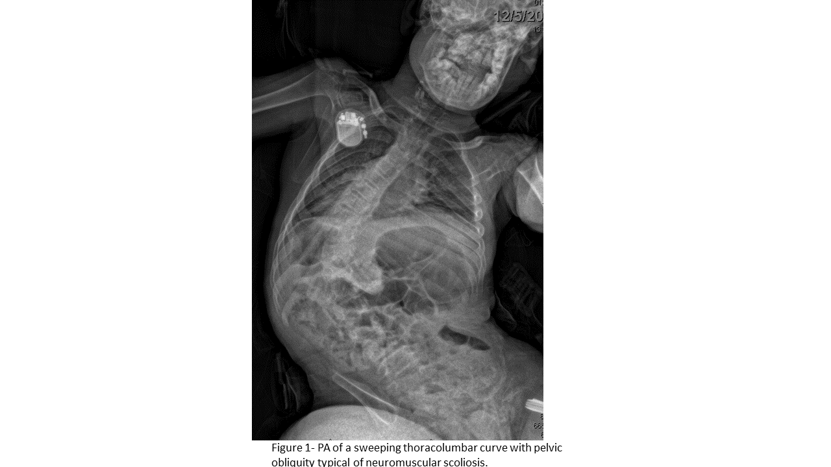
Figure 1 Poster-oanterior of a sweeping thoracolumbar curve with pelvic obliquity typical of neuromuscular scoliosis.

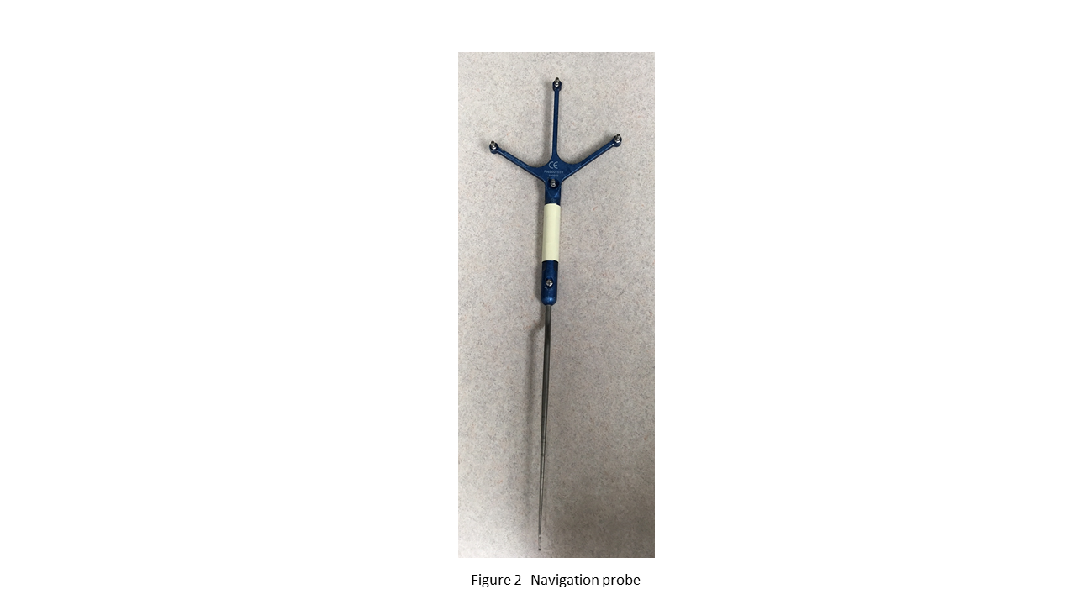
Figure 2 Navigation probe.

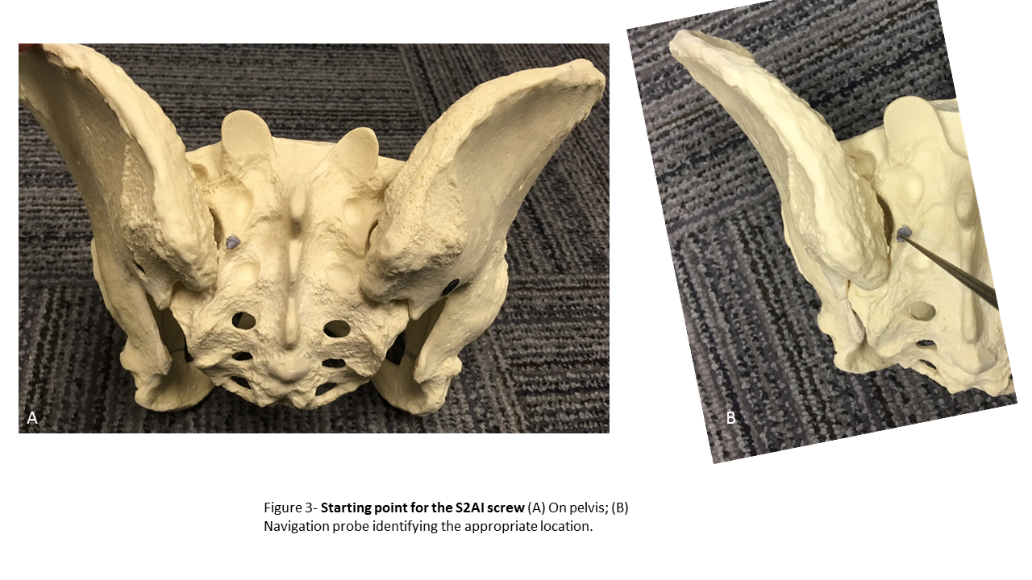
Figure 3 Starting point for the S2-alar-iliac technique screw. A: On pelvis; B: Navigation probe identifying the appropriate location.

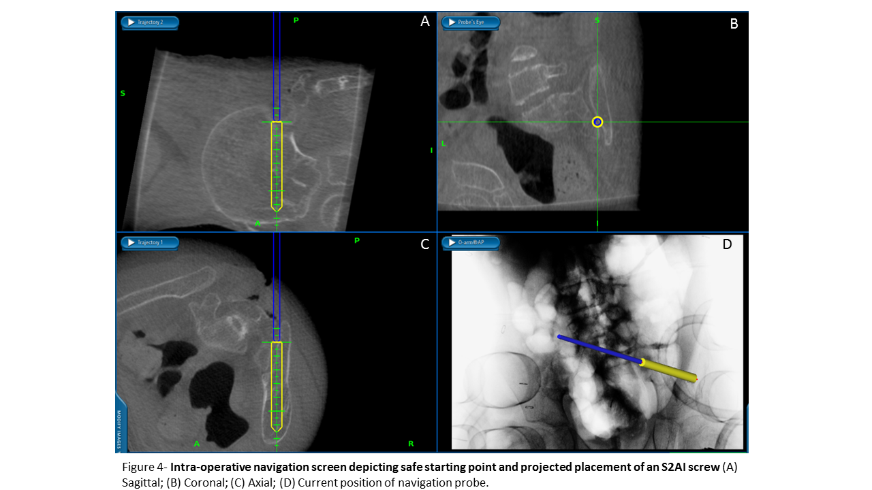
Figure 4 Intra-operative navigation screen depicting safe starting point and projected placement of an S2-alar-iliac technique screw. A: Sagittal; B: Coronal; C: Axial; D: Current position of navigation probe.

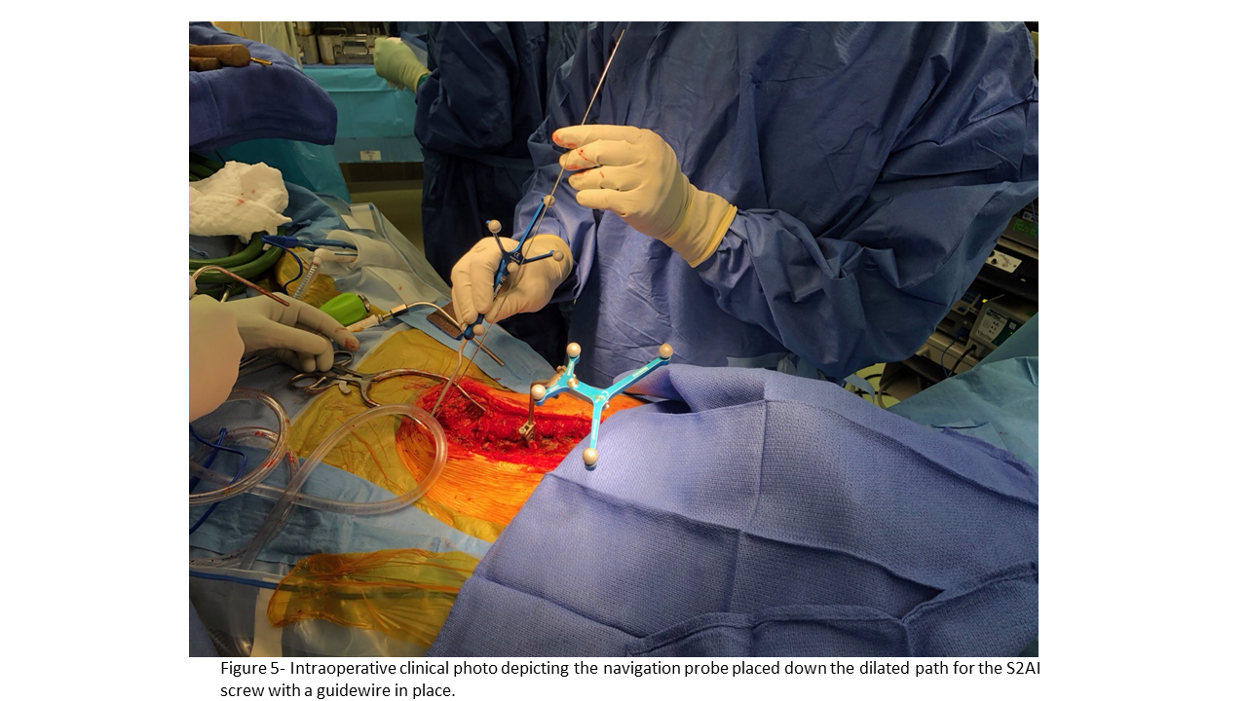

Figure 5 Intraoperative clinical photo depicting the navigation probe placed down the dilated path for the S2-alar-iliac technique screw with a guidewire in place.

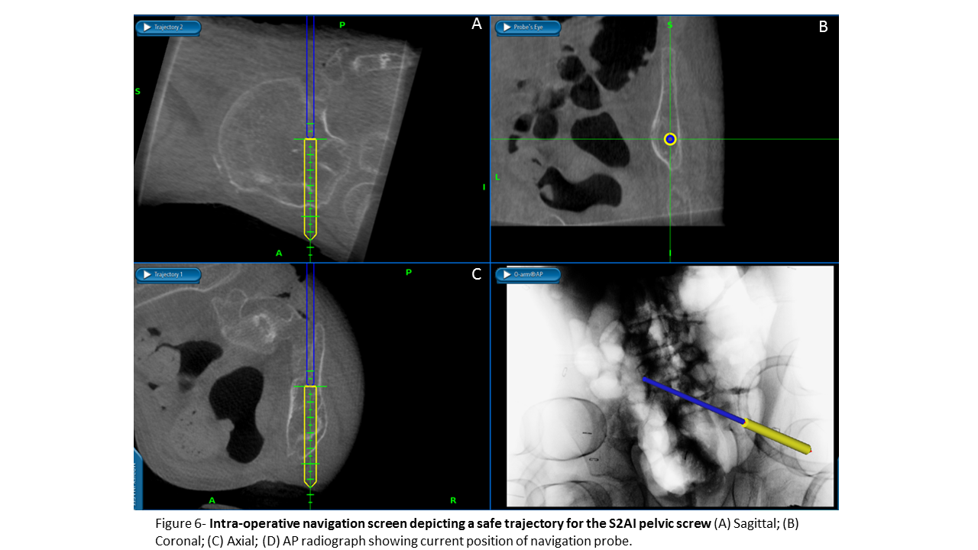
Figure 6 Intra-operative navigation screens depicting a safe trajectory for the S2-alar-iliac technique pelvic screw. A: Sagittal; B: Coronal; C: Axial; D: Anterior-posterior radiograph showing current position of navigation probe.

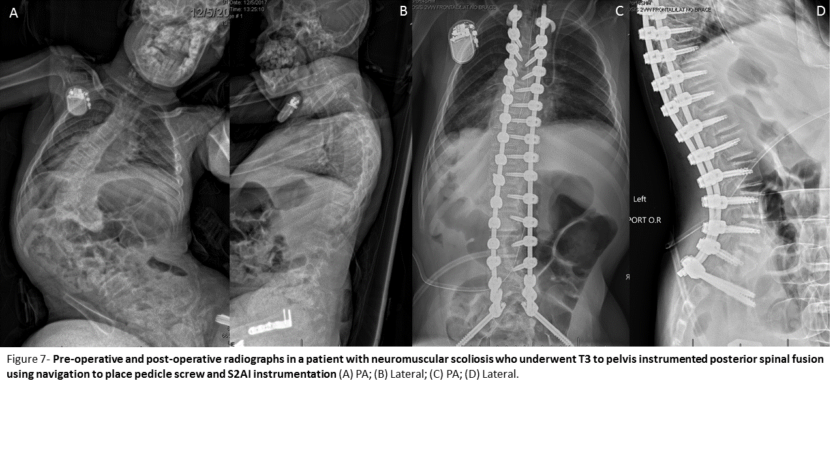
Figure 7 Pre-operative and post-operative radiographs in a patient with neuromuscular scoliosis who underwent T3 to pelvis instrumented posterior spinal fusion using navigation to place pedicle screw and S2-alar-iliac technique instrumentation. A: Poster-oanterior; B: Lateral; C: Anter-oposterior; D: Lateral.

