Name of Journal: World Journal of Clinical Cases
Manuscript NO: 77957
Manuscript Type: ORIGINAL ARTICLE

Retrospective Study
Development and validation of a prognostic nomogram for decompensated liver cirrhosis

Zhang W et al. A nomogram for DLC patients

Wang Zhang, Yue Zhang, Qi Liu, Yuan Nie, Xuan Zhu

Wang Zhang, Yue Zhang, Qi Liu, Yuan Nie, Xuan Zhu, Department of Gastroenterology, Jiangxi Clinical Research Center for Gastroenterology, The First Affiliated Hospital of Nanchang University, Nanchang 330006, Jiangxi Province, China

Author contributions: Zhang W and Zhang Y contributed equally to this study; Zhang W designed and wrote the original draft; Zhang Y collected the data and wrote the original draft; Liu Q analyzed the data; Nie Y and Zhu X critically revised the manuscript; All authors have read and approve the final manuscript.

Supported by the National Natural Science Foundation of China, No. 81960120; the “Gan-Po Talent 555” Project of Jiangxi Province, No. GCZ (2012)-1; the Jiangxi Clinical Research Center for Gastroenterology, No. 20201ZDG02007.

Corresponding author: Xuan Zhu, MD, Professor, Department of Gastroenterology, Jiangxi Clinical Research Center for Gastroenterology, The First Affiliated Hospital of Nanchang University, No.17, Yongwaizhengjie Road, Donghu District, Nanchang 330006, Jiangxi Province, China. waiyongtg@163.com

Received: May 30, 2022
Revised: August 31, 2022
Accepted: September 9, 2022
Published online: October 16, 2022

Abstract
BACKGROUND
Decompensated liver cirrhosis (DLC) is a stage in the progression of liver cirrhosis and has a high mortality.

AIM
To establish and validate a novel and simple-to-use predictive nomogram for evaluating the prognosis of DLC patients.

METHODS
A total of 493 patients with confirmed DLC were enrolled from The First Affiliated Hospital of Nanchang University (Nanchang, Jiangxi Province, China) between December 2013 and August 2019. The patients were divided into two groups: a derivation group (n = 329) and a validation group (n = 164). Univariate and multivariate Cox regression analyses were performed to assess prognostic factors. The performance of the nomogram was determined by its calibration, discrimination, and clinical usefulness.

RESULTS
Age, mechanical ventilation application, model for end-stage liver disease (MELD) score, mean arterial blood pressure, and arterial oxygen partial pressure/inhaled oxygen concentration were used to construct the model. The C-indexes of the nomogram in the derivation and validation groups were 0.780 (95%CI: 0.670-0.889) and 0.792 (95%CI: 0.698-0.886), respectively. The calibration curve exhibited good consistency with the actual observation curve in both sets. In addition, decision curve analysis indicated that our nomogram was useful in clinical practice.

CONCLUSION
A simple-to-use novel nomogram based on a large Asian cohort was established and validated and exhibited improved performance compared with the Child-Turcotte-Pugh and MELD scores. For patients with DLC, the proposed nomogram may be helpful in guiding clinicians in treatment allocation and may assist in prognosis prediction.

Key Words: Decompensated liver cirrhosis; Nomogram; Prognosis; Child-Turcotte-Pugh score; MELD score

©The Author(s) 2022. Published by Baishideng Publishing Group Inc. All rights reserved.

Citation: Zhang W, Zhang Y, Liu Q, Nie Y, Zhu X. Development and validation of a prognostic nomogram for decompensated liver cirrhosis. World J Clin Cases 2022; 10(29): 10467-10477
URL: https://www.wjgnet.com/2307-8960/full/v10/i29/10467.htm
DOI: https://dx.doi.org/10.12998/wjcc.v10.i29.10467

Core Tip: The overall survival of decompensated liver cirrhosis (DLC) has been one of the main concerns of patients and clinicians. In this research, we established a simple and effective nomogram including age, application of mechanical ventilation, model for end-stage liver disease (MELD) score, mean arterial blood pressure and arterial oxygen partial pressure/inhaled oxygen concentration. This nomogram had better prognostic value than the Child-Turcotte-Pugh and MELD scores. Moreover, the nomogram was validated in the internal cohort, and it may be helpful in guiding clinicians in treatment allocation and in predicting the prognosis of DLC.

INTRODUCTION
Decompensated cirrhosis (DLC) is characterized by the development of cirrhosis-related complications, such as ascites, gastroesophageal variceal bleeding, hepatic encephalopathy (HE), and severe jaundice^{[1]}. Less than 1% of patients with acute DLC do not have any evidence of systemic inflammation^{[2]}. Patients with DLC have a dismal prognosis, with a median survival of approximately 2 years^{[3]}. Variceal bleeding is one of the most feared complications in patients with cirrhosis due to its deleterious impact on prognosis. Severe hemorrhage may cause ischemic hepatitis, which causes the release of inflammatory stimuli and may precipitate acute-on-chronic liver failure (ACLF)^{[4]}. The course of DLC is often abruptly accelerated by the development of ACLF, which has a high short-term mortality^{[5]}. Therefore, early recognition and timely treatment are significantly important to improving survival in DLC patients. A previous study confirmed that the Child-Turcotte-Pugh (CTP) score and model for end-stage liver disease (MELD) score were predictors of mortality in DLC patients^{[6,7]}; However, many studies have revealed the poor predictive performance of these two scores when compared with other scores or biomarkers^{[8,9]}.
Nomograms are easy to use and can facilitate management-related decision making. Nomograms are widely applied as statistical prognostic models in medicine and could offer more individualized and accurate predictions than other models for numerous illnesses^{[10,11]}. The purpose of this study was to determine the risk factors for short-term death from DLC and to construct a clinically useful nomogram to estimate individual prognosis.

MATERIALS AND METHODS
Study populations
Patients were consecutively recruited from the Department of Gastroenterology, the First Affiliated Hospital of Nanchang University (Nanchang, Jiangxi Province, China), between December 2013 and August 2019. The inclusion criteria were as follows: (1) age ≥ 18 years; (2) diagnosis of cirrhosis (on account of previous hepatic pathology or clinical signs, imaging examinations, or laboratory and endoscopic presentation results); and (3) presence of acute decompensated events, including HE, gastroesophageal varices hemorrhage, development of large ascites, spontaneous bacterial peritonitis (SBP), hepatorenal syndrome, and any combination of these. Patients with the following were excluded: (1) primary liver carcinoma or other malignant tumors; (2) concurrent pregnancy; (3) infection with human immunodeficiency virus; (4) liver operations such as liver transplantation; and (5) loss to follow-up. The Ethics Committee of The First Affiliated Hospital of Nanchang University approved this study protocol (No. 2013-1202). Three hundred twenty-nine patients who were enrolled between December 2013 and September 2016 were assigned to the derivation cohort, and the other 164 patients were assigned to the validation cohort between October 2016 and August 2019 (approximate ratio of 2:1). This study follows the transparent reporting of a multivariable prediction model for individual prognosis or diagnosis reporting guidelines for the development and validation of prediction models (Supplementary Table 1).

Data collection
Demographic information, laboratory tests, and clinical features were collected from electronic medical records. All laboratory tests were performed within 24 h after admission. The primary outcome was defined as death at the 28-d, 3-mo and 6-mo follow-up durations. The CTP score was computed according to ascites, prothrombin time (PT), serum bilirubin, albumin, and HE^{[6]}. The MELD score was calculated as follows: MELD =9.6 × ln[serum creatinine (mg/dL)] + 3.8 × ln[total bilirubin (mg/dL)] + 11.2 × ln[PT (international normalized ratio, INR)] + 6.43 × (etiology: 0 if cholestatic or alcoholic, 1 otherwise)^{[7]}.

Treatment
For all patients, after the diagnosis of DLC was determined, standard medical therapies were used, such as endoscopic hemostasis therapy, antiviral treatment, liver-protecting therapy, albumin and plasma transfusion and prevention of complications such as HE and SBP.

Statistical analysis
Statistical analyses were performed with Statistical Product and Service Solutions (SPSS) software version 24.0 (SPSS Inc., Chicago, IL, United States). Continuous variables are expressed as the mean ± SD and were compared using an unpaired, 2-tailed t test or the Mann‒Whitney test. Categorical variables were compared using the chi-squared test or Fisher’s exact test. Univariate risk factors that reached P < 0.2 were subjected to Cox regression analysis. The Age, mechanical ventilation application, MELD score, mean arterial blood pressure (MAP) and arterial oxygen partial pressure (PaO₂)/inhaled oxygen concentration (FiO₂) were used to construct the model. The final Cox regression model for fitness of the data and proportional hazards assumption was checked by the Schoenfeld residual test (the global test). The test revealed that the assumption was met with a P-value of the global test = 0.28.
The nomogram based on the results of previous Cox regression analyses was established using R version 3.3.2 (http://www.r-project.org/). The discrimination of the models was assessed according to the concordance index (C-index); the larger the C-index was, the more accurate the prognostic ability of the nomogram. The net reclassification index (NRI) quantifies the improvement in the predictive accuracy of the nomogram compared with the CTP and MELD scores. The integrated discrimination improvement index (IDI) evaluates different tangent lines that can be used to assess the overall improvement of the model and was calculated to assess the improvement of the nomogram compared with the CTP and MELD scores. In addition, NRI > 0 indicates that the new model is more accurate than the old model for prediction. The same is true for the IDI. Calibration curves were also drawn to evaluate the concordance between the predicted and observed probabilities. Decision curve analysis (DCA) was conducted to assess the clinical usefulness of the predictive nomogram by quantifying the net benefits at different threshold probabilities in both cohorts. In the present study, the R packages used included survival, survminer, rms, nricens, predictABEL, Hmisc, devtools, and ggDCA. All tests were two-sided, and differences were considered statistically significant when P < 0.05.

RESULTS
Baseline characteristics of the included patients
In total, 329 and 164 patients were included for analysis in the derivation and internal validation cohorts, respectively, and a flow diagram detailing the screening process is shown in Figure 1. The baseline characteristics of both cohorts are shown in Table 1. In the derivation and internal validation cohorts, the age ranges were 21-86 years (mean ± SD: 53.76 ± 11.64 years) and 31-91 years (mean ± SD: 57.38 ± 11.89 years), respectively. In the derivation and internal validation sets, the patients were predominantly men (253/329, 76.9% vs 116/164, 70.7%), the main etiology was hepatitis B virus (HBV) in 66.9% and 58.5% of patients, respectively, and the primary hospitalization reason was variceal bleeding (45.60% and 46.34%, respectively). When comparing the demographic and clinical characteristics between the derivation and validation sets, we found that the derivation set had shorter hospital stays (8.40 ± 5.88) and fewer patients with vasopressor use (88/329, 26.75%) and mechanical ventilation (MV) application (18/329, 5.47%) (P < 0.05). Moreover, the validation set had higher alanine aminotransferase (ALT), alkaline phosphatase (ALP), creatinine, and INR levels and higher CTP and MELD scores (P < 0.05). The validation set had higher 28-d, 3-mo and 6-mo risks of death than the derivation set (P < 0.05).

Univariate and multivariate analyses
Univariate analysis showed that age, use of vasopressors, MV application, ALT, aspartate aminotransferase, γ-glutamyl transpeptidase, ALP, white blood cell count, MAP, PaO₂/FiO₂, CTP score and MELD score were significantly associated with the prognosis of DLC patients in the derivation set (P < 0.05, Table 2). Variables with significant differences by univariate analysis were subjected to multivariate Cox regression analyses. The results showed that only age, MV application and MELD score were independent risk factors for outcomes (HR: 1.028, 95%CI: 1.007-1.050; HR: 4.200, 95%CI: 1.975-8.932; HR: 1.080, 95%CI: 1.030-1.132, respectively), while MAP and PaO₂/FiO₂ were independent protective factors for mortality (HR: 0.979, 95%CI: 0.960-0.998; HR: 0.998, 95%CI: 0.995-1.000, respectively) (Table 2).

Construction of a prognostic nomogram
Based on the results of multivariable Cox regression analyses, a nomogram including age, MV application, MAP, oxygenation index (OI; PaO₂/FiO₂) and MELD score was established to predict 28-d, 3-mo and 6-mo mortality (Figure 2). By assigning a weighted score to each of the independent prognostic parameters and using that value in the total point scale axis, the total score could be easily computed to assign the probability of survival for individual patients. For instance, a DLC patient aged 45 (15 points) with MV application (36 points), a MAP of 100 (25 points), an OI of 400 (21 points), and a MELD score of 15 (37.5 points) had a total of 134.5 points for a predicted 28-d, 3-mo, and 6-mo survival probability of 72%, 55% and 48%, respectively.

Performance of the model and clinical usefulness
We assessed the discriminative ability of our final model by using the C-index, and the C-index of the nomogram was 0.780 (95%CI: 0.670-0.889) in the derivation cohort, showing superior predictive performance to that of the CTP score (0.708, 95%CI: 0.596-0.820) or the MELD score (0.735, 95%CI: 0.609-0.860). The NRI and IDI were also determined to compare the efficiency between the nomogram and the two scores (Table 3). In the derivation cohort, when compared with the CTP score, the NRI values for 28-d, 3-mo, and 6-mo mortality were 0.419 (95%CI: 0.192-0.606), 0.355 (95%CI: 0.134-0.488) and 0.319 (95%CI: 0.081-0.481), respectively, and the IDI values for 28-d, 3-mo, and 6-mo mortality were 0.262 (95%CI: 0.181-0.394), 0.193 (95%CI: 0.118-0.285) and 0.178 (95%CI: 0.098-0.270), respectively. When compared with the MELD score, the NRI values for 28-d, 3-mo, and 6-mo mortality were 0.395 (95%CI: 0.214-0.548), 0.305 (95%CI: 0.080-0.417) and 0.281 (95%CI: 0.077-0.402), respectively, and the IDI values for 28-d, 3-mo, and 6-mo mortality were 0.133 (95%CI: 0.070-0.247), 0.081 (95%CI: 0.026-0.151) and 0.064 (95%CI: 0.023-0.133), respectively. The calibration curve of the nomogram is shown in Figure 3A-C, and the calibration plot revealed an adequate fit of the nomogram for predicting the risk of death. As shown in Figure 4A-C, the DCA showed that across the entire range of threshold probability, using the nomogram model to predict 28-d, 3-mo, and 6-mo survival adds more net benefit in clinical decision making.

Internal validation of the prognostic nomogram
The established model was internally validated by using the bootstrap validation method. When the established nomogram was used in the validation set, the C-index of the nomogram was 0.792 (95%CI: 0.698-0.886), with better predictive value than the CTP score (0.714, 95%CI: 0.602-0.826) and the MELD score (0.695, 95%CI: 0.575-0.815), indicating that the nomogram is suitable for estimating the outcome of DLC patients. In addition, the NRI and IDI values of the validation set also indicated that the present nomogram had improved accuracy compared to the CTP and MELD scores for predicting mortality (Table 3). Furthermore, the promising performance of the nomogram was also identified by calibration curve and decision curve analyses (Figures 3D-F and 4D-F).

DISCUSSION
In the present study, an easy-to-use novel nomogram was constructed to assess the prognosis of DLC patients. The proposed nomogram was derived from clinical and laboratory data to improve its clinical generality and applicability. This nomogram had superior predictive ability and clinical usefulness compared to the current prognostic score models, including the CTP and MELD scores. In addition, we adopted the internal validation cohort to reduce the influence of patients of different ages and other factors on the results.
In our derivation and validation cohorts, HBV was the predominant etiology among the DLC patients, which was in line with that in a previous study^{[12]}, indicating that HBV infection is a critical global health threat, particularly in Asia. Furthermore, the results showed that 150 (45.60%) and 76 (46.34%) patients were hospitalized for variceal bleeding in the derivation and validation sets, respectively. Variceal hemorrhage is a severe complication of portal hypertension in patients with cirrhosis and is associated with significant mortality^{[13]}. Patients with variceal bleeding may develop other complications of cirrhosis and are at increased risk of developing circulatory dysfunction and bacterial infections that may lead to ACLF^{[4]}, which has high short-term mortality.
The CTP and MELD scores are commonly used to predict adverse outcomes in DLC patients. However, CTP is a subjective variable, including the presence or absence of HE and ascites^{[6]}. The MELD score contains three indicators, namely, creatinine, INR, and bilirubin, but it lacks indicators of organ failure and may have a lower prognostication accuracy^{[14]}. The proposed nomogram included age, MV application, MELD score, MAP, and OI. A previous study indicated that age was closely related to patient prognosis and that old age was a crucial factor for poor prognosis in cirrhosis^{[15]}. MV is required for patients who develop acute respiratory failure, and it was identified as an independent factor related to intensive care unit (ICU) mortality in cirrhotic patients or patients with liver cirrhosis^{[16]}. The results of a prospective cohort study that enrolled 592 cirrhotic patients admitted to the ICU revealed that patients who required MV had a poor prognosis, which was associated with organ failure^{[17]}. The MELD score is based on three readily available biochemical variables: creatinine, serum bilirubin, and INR. It has been confirmed as a highly reliable predictor of short- and mid-term mortality in patients with cirrhosis awaiting liver transplantation^{[18]}. However, the MELD score does not consider other conditions that are related to poor prognosis, such as organ failure, especially in critically ill patients. MAP is a reliable marker of circulatory function in ICU patients, particularly in patients with hemodynamic instability^{[19]}. In this setting, circulatory dysfunction is the key feature of DLC^{[20]}. A previous study showed that higher MAP values were related to acute kidney injury recovery in patients with DLC^{[21]}. Patidar et al^{[22]} evaluated the associations between MAP and poor ICU outcomes in critically ill cirrhotic patients and found that the risk of mortality intensely increased in patients whose MAP was below a threshold of 65 mmHg. The OI is PaO₂ divided by FiO₂ and is widely to assess acute respiratory distress syndrome (ARDS); the normal range is 400-500 mmHg^{[23]}. Campbell et al^{[24]} suggested that the OI is an independent predictor of ICU mortality in patients with cirrhosis and validated prognostic scoring tools for predicting ICU mortality.
In fact, the developed nomogram had superior discrimination power (C-index of 0.780) compared with using the CTP or MELD score alone. Moreover, a slightly higher C-index (0.792) was observed while performing internal validation in another set of cirrhotic patients. Based on the calibration plots, good calibration was observed. As indicated by the positive NRI and IDI, this nomogram is more accurate in predicting mortality than the CTP and MELD scores. In addition, according to DCA, the nomogram provided better clinical benefits than the conventional scores. Overall, the rationale of the selected variables was confirmed.
Nevertheless, our study has several limitations. First, this was a retrospective study; therefore, some potential bias may exist. Second, patients were enrolled from a single center. Third, the model only underwent internal validation. In the future, a prospective study is needed to validate the sensitivity and specificity of the nomogram.

CONCLUSION
In summary, we developed and validated a nomogram for predicting the survival probability of DLC patients. This simple nomogram had an adequate calibration and discrimination ability and good clinical utility. This nomogram may be helpful for promoting the early diagnosis and prevention of DLC.

ARTICLE HIGHLIGHTS
Research background
Decompensated liver cirrhosis (DLC) has high mortality, and there are some limitations when applying the common prognostic scores. Nomograms are widely used as prognostic models for many diseases.

Research motivation
Due to the worse prognosis, the overall survival of DLC has attracted much attention from clinicians. Thus, it is necessary to develop a prognostic model to evaluate the outcome of DLC patients.

Research objectives
To develop and validate a novel and simple-to-use prognostic nomogram to assess the prognosis of DLC patients.

Research methods
A total of 493 DLC patients were included in this study and divided into a derivation group (n = 329) and a validation group (n = 164). According to the results of univariate and multivariate Cox regression analyses, a nomogram model was developed to predict the prognosis of DLC.

Research results
The nomogram was developed based on age, mechanical ventilation application, model for end-stage liver disease (MELD) score, mean arterial blood pressure and PaO₂/FiO₂. The C-indexes, calibration curves and decision curve analysis revealed that the nomogram model is a valid tool.

Research conclusions
We constructed a nomogram model that could accurately predict the prognosis of DLC patients and showed better prognostic performance than the CTP and MELD scores.

Research perspectives
This research established a nomogram that could predict prognosis in DLC patients. In addition, the nomogram was precisely evaluated by internal validation, which may be helpful to clinicians in clinical decision making.

ACKNOWLEDGEMENTS
We would like to thanks the National Natural Science Foundation of China (grant number: 81960120), the “Gan-Po Talent 555” Project of Jiangxi Province (GCZ (2012)-1) and the Jiangxi Clinical Research Center for Gastroenterology (20201ZDG02007).

REFERENCES
1 D'Amico G, Garcia-Tsao G, Pagliaro L. Natural history and prognostic indicators of survival in cirrhosis: a systematic review of 118 studies. J Hepatol 2006; 44: 217-231 [PMID: 16298014 DOI: 10.1016/j.jhep.2005.10.013]
2 Arroyo V, Angeli P, Moreau R, Jalan R, Clària J, Trebicka J, Fernández J, Gustot T, Caraceni P, Bernardi M; investigators from the EASL-CLIF Consortium, Grifols Chair and European Foundation for the Study of Chronic Liver Failure (EF-Clif). The systemic inflammation hypothesis: Towards a new paradigm of acute decompensation and multiorgan failure in cirrhosis. J Hepatol 2021; 74: 670-685 [PMID: 33301825 DOI: 10.1016/j.jhep.2020.11.048]
3 Bernardi M, Caraceni P. Novel perspectives in the management of decompensated cirrhosis. Nat Rev Gastroenterol Hepatol 2018; 15: 753-764 [PMID: 30026556 DOI: 10.1038/s41575-018-0045-2]
4 Arroyo V, Moreau R, Jalan R. Acute-on-Chronic Liver Failure. N Engl J Med 2020; 382: 2137-2145 [PMID: 32459924 DOI: 10.1056/NEJMra1914900]
5 Moreau R, Jalan R, Gines P, Pavesi M, Angeli P, Cordoba J, Durand F, Gustot T, Saliba F, Domenicali M, Gerbes A, Wendon J, Alessandria C, Laleman W, Zeuzem S, Trebicka J, Bernardi M, Arroyo V; CANONIC Study Investigators of the EASL–CLIF Consortium. Acute-on-chronic liver failure is a distinct syndrome that develops in patients with acute decompensation of cirrhosis. Gastroenterology 2013; 144: 1426-1437, 1437.e1-1437.e9 [PMID: 23474284 DOI: 10.1053/j.gastro.2013.02.042]
6 Pugh RN, Murray-Lyon IM, Dawson JL, Pietroni MC, Williams R. Transection of the oesophagus for bleeding oesophageal varices. Br J Surg 1973; 60: 646-649 [PMID: 4541913 DOI: 10.1002/bjs.1800600817]
7 Kamath PS, Wiesner RH, Malinchoc M, Kremers W, Therneau TM, Kosberg CL, D'Amico G, Dickson ER, Kim WR. A model to predict survival in patients with end-stage liver disease. Hepatology 2001; 33: 464-470 [PMID: 11172350 DOI: 10.1053/jhep.2001.22172]
8 Li FC, Fan YC, Li YK, Wang K. Plasma diamine oxidase level predicts 6-month readmission for patients with hepatitis B virus-related decompensated cirrhosis. Virol J 2019; 16: 115 [PMID: 31533748 DOI: 10.1186/s12985-019-1219-4]
9 Yao Y, Yang D, Huang Y, Dong M. Predictive value of insulin-like growth factor 1-Child-Turcotte-Pugh score for mortality in patients with decompensated cirrhosis. Clin Chim Acta 2020; 505: 141-147 [PMID: 32119835 DOI: 10.1016/j.cca.2020.02.031]
10 Touijer K, Scardino PT. Nomograms for staging, prognosis, and predicting treatment outcomes. Cancer 2009; 115: 3107-3111 [PMID: 19544538 DOI: 10.1002/cncr.24352]
11 Sternberg CN. Are nomograms better than currently available stage groupings for bladder cancer? J Clin Oncol 2006; 24: 3819-3820 [PMID: 16864852 DOI: 10.1200/JCO.2006.07.1290]
12 Yuen MF, Yuan HJ, Wong DK, Yuen JC, Wong WM, Chan AO, Wong BC, Lai KC, Lai CL. Prognostic determinants for chronic hepatitis B in Asians: therapeutic implications. Gut 2005; 54: 1610-1614 [PMID: 15871997 DOI: 10.1136/gut.2005.065136]
13 Baiges A, Hernández-Gea V, Bosch J. Pharmacologic prevention of variceal bleeding and rebleeding. Hepatol Int 2018; 12: 68-80 [PMID: 29210030 DOI: 10.1007/s12072-017-9833-y]
14 Baldin C, Piedade J, Guimarães L, Victor L, Duarte J, Veiga Z, Alcântara C, Fernandes F, Pereira JL, Pereira G. CLIF-C AD Score Predicts Development of Acute Decompensations and Survival in Hospitalized Cirrhotic Patients. Dig Dis Sci 2021; 66: 4525-4535 [PMID: 33389350 DOI: 10.1007/s10620-020-06791-5]
15 Schiødt FV, Chung RT, Schilsky ML, Hay JE, Christensen E, Lee WM; Acute Liver Failure Study Group. Outcome of acute liver failure in the elderly. Liver Transpl 2009; 15: 1481-1487 [PMID: 19877205 DOI: 10.1002/lt.21865]
16 Levesque E, Hoti E, Azoulay D, Ichaï P, Habouchi H, Castaing D, Samuel D, Saliba F. Prospective evaluation of the prognostic scores for cirrhotic patients admitted to an intensive care unit. J Hepatol 2012; 56: 95-102 [PMID: 21835136 DOI: 10.1016/j.jhep.2011.06.024]
17 Levesque E, Saliba F, Ichaï P, Samuel D. Outcome of patients with cirrhosis requiring mechanical ventilation in ICU. J Hepatol 2014; 60: 570-578 [PMID: 24280294 DOI: 10.1016/j.jhep.2013.11.012]
18 Kamath PS, Kim WR; Advanced Liver Disease Study Group. The model for end-stage liver disease (MELD). Hepatology 2007; 45: 797-805 [PMID: 17326206 DOI: 10.1002/hep.21563]
19 Cesari M, Frigo AC, Tonon M, Angeli P. Cardiovascular predictors of death in patients with cirrhosis. Hepatology 2018; 68: 215-223 [PMID: 28902431 DOI: 10.1002/hep.29520]
20 Schrier RW, Arroyo V, Bernardi M, Epstein M, Henriksen JH, Rodés J. Peripheral arterial vasodilation hypothesis: a proposal for the initiation of renal sodium and water retention in cirrhosis. Hepatology 1988; 8: 1151-1157 [PMID: 2971015 DOI: 10.1002/hep.1840080532]
21 Velez JC, Nietert PJ. Therapeutic response to vasoconstrictors in hepatorenal syndrome parallels increase in mean arterial pressure: a pooled analysis of clinical trials. Am J Kidney Dis 2011; 58: 928-938 [PMID: 21962618 DOI: 10.1053/j.ajkd.2011.07.017]
22 Patidar KR, Peng JL, Pike F, Orman ES, Glick M, Kettler CD, Nephew LD, Desai AP, Nair K, Khan BA, Buckley CA, Machado RF, Chalasani NP, Ghabril MS. Associations Between Mean Arterial Pressure and Poor ICU Outcomes in Critically Ill Patients With Cirrhosis: Is 65 The Sweet Spot? Crit Care Med 2020; 48: e753-e760 [PMID: 32618694 DOI: 10.1097/CCM.0000000000004442]
23 Bein T, Grasso S, Moerer O, Quintel M, Guerin C, Deja M, Brondani A, Mehta S. The standard of care of patients with ARDS: ventilatory settings and rescue therapies for refractory hypoxemia. Intensive Care Med 2016; 42: 699-711 [PMID: 27040102 DOI: 10.1007/s00134-016-4325-4]
24 Campbell J, McPeake J, Shaw M, Puxty A, Forrest E, Soulsby C, Emerson P, Thomson SJ, Rahman TM, Quasim T, Kinsella J. Validation and analysis of prognostic scoring systems for critically ill patients with cirrhosis admitted to ICU. Crit Care 2015; 19: 364 [PMID: 26462911 DOI: 10.1186/s13054-015-1070-y]

Footnotes
Institutional review board statement: Study protocol was approved by the ethics committee of First Affiliated Hospital of Nanchang University (No.2013-1202). The study was performed in accordance with the Declaration of Helsinki.

Conflict-of-interest statement: The authors declare that there are no conflicts of interest.

Data sharing statement: The data that support the findings of this study are available from the corresponding author, Zhu X, upon reasonable request.

Open-Access: This article is an open-access article that was selected by an in-house editor and fully peer-reviewed by external reviewers. It is distributed in accordance with the Creative Commons Attribution NonCommercial (CC BY-NC 4.0) license, which permits others to distribute, remix, adapt, build upon this work non-commercially, and license their derivative works on different terms, provided the original work is properly cited and the use is non-commercial. See: https://creativecommons.org/Licenses/by-nc/4.0/

Provenance and peer review: Unsolicited article; Externally peer reviewed.
Peer-review model: Single blind

Peer-review started: May 30, 2022
First decision: August 21, 2022
Article in press: September 9, 2022

Specialty type: Gastroenterology and Hepatology
Country/Territory of origin: China
Peer-review report’s scientific quality classification
Grade A (Excellent): 0
Grade B (Very good): B
Grade C (Good): C
Grade D (Fair): 0
Grade E (Poor): 0

P-Reviewer: Rodrigues AT, Brazil; Song MJ, South Korea S-Editor: Chang KL L-Editor: A P-Editor: Chang KL

Figure Legends
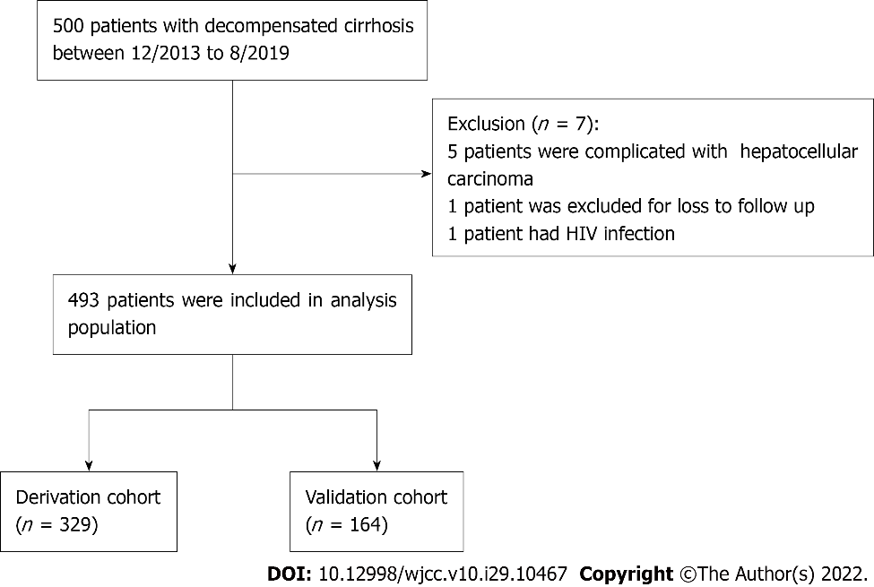
Figure 1 Flow diagram for selecting decompensated liver cirrhosis patients. HIV: Human immunodeficiency virus.

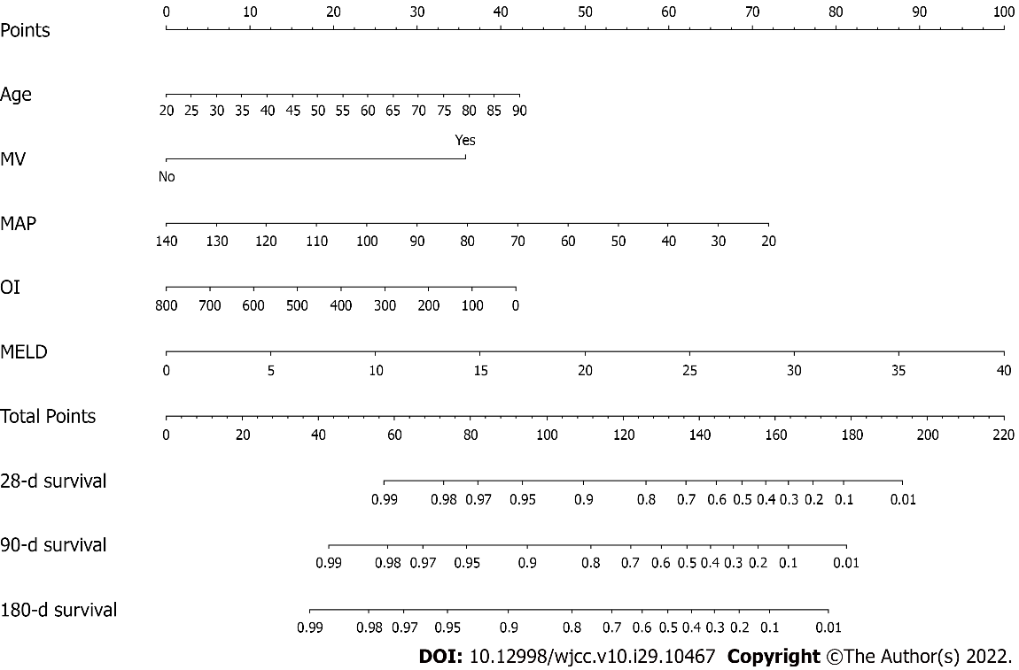
Figure 2 The nomogram for predicting 28-d, 3-mo and 6-mo survival probabilities of patients with decompensated liver cirrhosis. MV: Mechanical ventilation; MAP: mean arterial blood pressure; OI: Oxygenation index; MELD: Model for end-stage liver disease.

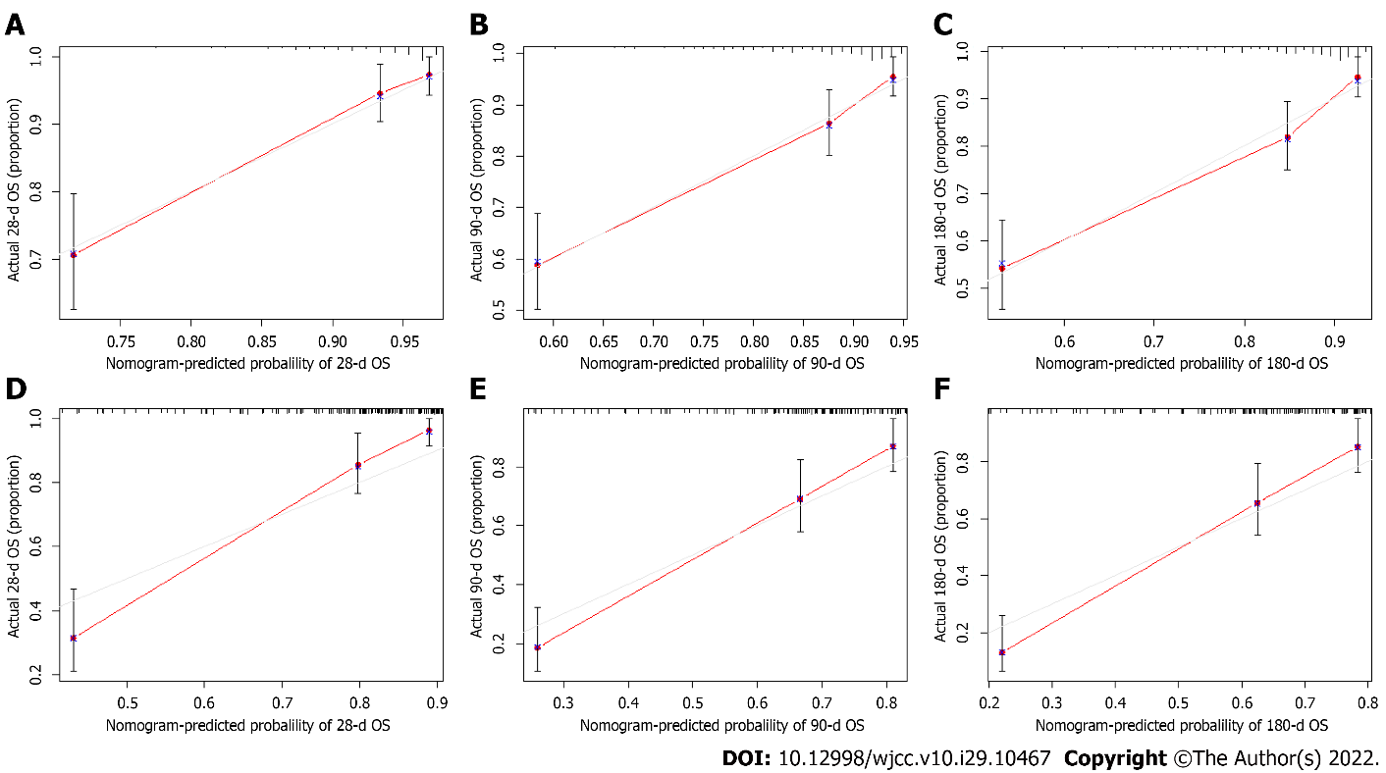
Figure 3 The calibration curves of the nomogram for 28-d, 3-mo and 6-mo survival probabilities. A: Twenty-eight-day survival in the derivation group; B: Three-month survival in the derivation group; C: Six-month survival in the derivation group; D: Twenty-eight-day survival in the validation group; E: Three-month survival in the validation group; F: Six-month survival in the validation group.

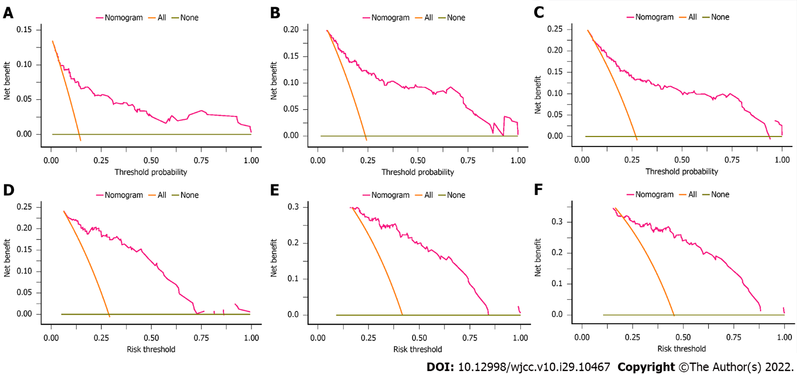
Figure 4 Decision curve analysis of the nomogram for the survival prediction of patients with decompensated liver cirrhosis. A: Twenty-eight-day survival in the derivation group; B: Three-month survival in the derivation group; C: Six-month survival in the derivation group; D: Twenty-eight-day survival in the validation group; E: Three-month survival in the validation group; F: Six-month survival in the validation group.
Table 1 Participant characteristics
 | Derivation cohort (n = 329) | Internal validation cohort (n = 164) | P
Age (yr), mean ± SD | 53.76 ± 11.64 | 57.38 ± 11.89 | 0.001ª
Male sex, n (%) | 253 (76.90) | 116 (70.70) | 0.137
Hospitalization period (d), mean ± SD | 8.40 ± 5.88 | 9.49 ± 4.69 | 0.026ª
Liver cirrhosis etiology, n (%)
HBV | 220 (66.90) | 96 (58.50) | 0.07
HCV | 13 (3.95) | 6 (3.66) | 0.87
Alcoholic liver disease | 52 (15.80) | 30 (18.29) | 0.49
Schistosomiasis cirrhosis | 14 (4.25) | 8 (4.88) | 0.75
Primary biliary cirrhosis | 3 (0.90) | 5 (3.05) | 0.08
Cryptogenic cirrhosis | 27 (8.21) | 18 (11.00) | 0.31
Hospitalization reason, n (%)
Variceal bleeding | 150 (45.60) | 76 (46.34) | 0.875
Hepatic encephalopathy | 86 (26.14) | 43 (26.22) | 0.985
Infection | 45 (13.68) | 21 (12.80) | 0.789
Ascites | 28 (8.50) | 13 (7.93) | 0.825
Hepatorenal syndrome | 20 (6.08) | 11 (6.71) | 0.787
Vasopressors | 88 (26.75) | 79 (48.17) | < 0.001ª
HBeAg (+) | 35 (10.64) | 15 (9.15) | 0.605
Mechanical ventilation | 18 (5.47) | 36 (21.95) | < 0.001ª
Biochemical parameters
ALT, IU/L | 22.00 (16.00-40.75) | 29.00 (20.00-52.50) | < 0.001ª
AST, IU/L | 44.00 (31.00-90.50) | 39.00 (28.00-74.00) | 0.085
GGT, IU/L | 27.00 (15.00-74.50) | 29.00 (14.00-79.50) | 0.982
ALP, IU/L | 73.70 (55.00-112.00) | 82.50 (56.25-138.75) | 0.037ª
Serum sodium, mmol/L | 138.10 (135.00-141.00) | 137.85 (134.03-140.98) | 0.329
Creatinine, μmol/L | 72.70 (59.35-93.20) | 79.70 (63.55-115.00) | 0.006ª
INR | 1.32 (1.21-1.54) | 1.45 (1.24-1.74) | < 0.001ª
Bilirubin, μmol/L | 24.70 (15.80-42.80) | 26.85 (16.03-58.25) | 0.157
WBC, 10 × 9/L | 6.39 (3.94-9.61) | 6.81 (4.11-11.13) | 0.11
Platelet, 10 × 9/L | 74.50 (47.50-111.50) | 73.80 (39.00-109.50) | 0.245
PT, s | 15.00 (13.80-17.20) | 15.90 (13.40-19.20) | 0.086
MAP, mmHg | 83.00 (77.67-89.33) | 82.17 (78.00-87.67) | 0.472
PO₂/FiO₂ | 402.86 ± 118.57 | 388.28 ± 137.36 | 0.266
Albumin, g/L | 28.41 ± 7.87 | 27.64 ± 6.18 | 0.256
CTP score | 8 (7-10) | 9 (7-11) | 0.001ª
MELD score | 9.44 (5.96-13.52) | 12.20 (7.77-16.67) | < 0.001ª
Mortality, n (%)
28 d | 41 (12.46) | 47 (28.66） | < 0.001ª
3 mo | 65 (19.76) | 69 (42.07) | < 0.001ª
6 mo | 75 (22.80) | 73 (44.51) | < 0.001ª
ªSignificant P value.
HBV: Hepatitis B virus; HCV: Hepatitis B virus; HBeAg: Hepatitis Be antigen; ALT: Alanine aminotransferase; AST: Aspartate aminotransferase; GGT: Gamma-glutamyl transferase; ALP: Alkaline phosphatase; INR: International normalized ratio; WBC: White blood cell; PT: Prothrombin time; MAP: Mean arterial blood pressure; PO₂/FiO₂: Arterial oxygen partial pressure/inhaled oxygen concentration; CTP score: Child-Turcotte-Pugh score; MELD score: model for end-stage liver disease score.

Table 2 Univariate and multivariate Cox regression analyses in decompensated liver cirrhosis patients from the derivation cohort (n = 329)
 | Univariate analysis |  | Multivariate analysis
 | HR (95% CI) | P value | HR (95% CI) | P value
Age | 1.021 (1.001-1.040) | 0.037ª | 1.028 (1.007-1.050) | 0.009ª
Male sex | 1.133 (0.653-1.967) | 0.657
Vasopressors
No | Reference
Yes | 1.643 (1.027-2.628) | 0.038ª
HBeAg
negative | Reference
positive | 0.692 (0.301-1.594) | 0.387
Mechanical ventilation
No | Reference
Yes | 9.916 (5.486-17.922) | < 0.001ª | 4.200 (1.975-8.932) | < 0.001ª
ALT | 1.001 (1.000-1.002) | < 0.001ª
AST | 1.001 (1.000-1.001) | < 0.001ª
GGT | 1.001 (1.000-1.002) | 0.090ª
ALP | 1.002 (1.001-1.003) | < 0.001ª
Serum sodium | 1.003 (0.982-1.026) | 0.761
WBC | 1.052 (1.030-1.073) | < 0.001ª
Platelet | 1.002 (0.999-1.004) | 0.259
MAP | 0.976 (0.967-0.996) | 0.019ª | 0.979 (0.960-0.998) | 0.031ª
PO₂/FiO₂ | 0.996 (0.994-0.998) | < 0.001ª | 0.998 (0.995-1.000) | 0.038ª
CTP score | 1.332 (1.214-1.462) | < 0.001ª
MELD score | 1.142 (1.107-1.178) | < 0.001ª | 1.080 (1.030-1.132) | 0.002ª
ªSignificant P value.
HBeAg: Hepatitis Be antigen; ALT: Alanine aminotransferase; AST: Aspartate aminotransferase; GGT: Gamma-glutamyl transferase; ALP: Alkaline phosphatase; WBC: White blood cell; MAP: Mean arterial blood pressure; PO₂/FiO₂: Arterial oxygen partial pressure/inhaled oxygen concentration; CTP score: Child-Turcotte-Pugh score; MELD score: model for end-stage liver disease score.

Table 3 The validation of the nomogram versus two scores by net reclassification index and integrated discrimination improvement index
Index | Derivation cohort |  |  | Validation cohort
 | Estimate | 95% CI | P value | Estimate | 95% CI | P value
NRI versus CTP
For 28-d mortality | 0.419 | 0.192-0.606 | < 0.001ª | 0.395 | 0.061-0.662 | 0.020ª
For 3-mo mortality | 0.355 | 0.134-0.488 | 0.007ª | 0.241 | 0.005-0.490 | 0.040ª
For 6-mo mortality | 0.319 | 0.081-0.481 | < 0.001ª | 0.227 | 0.120-0.480 | < 0.001ª
NRI vs MELD
For 28-d mortality | 0.395 | 0.214-0.548 | < 0.001ª | 0.578 | 0.364-0.740 | < 0.001ª
For 3-mo mortality | 0.305 | 0.080-0.417 | 0.013ª | 0.388 | 0.233-0.547 | < 0.001ª
For 6-mo mortality | 0.281 | 0.077-0.402 | 0.007ª | 0.358 | 0.249-0.527 | < 0.001ª
IDI vs CTP
For 28-d mortality | 0.262 | 0.181-0.394 | < 0.001ª | 0.253 | 0.095-0.426 | < 0.001ª
For 3-mo mortality | 0.193 | 0.118-0.285 | < 0.001ª | 0.167 | 0.040-0.308 | 0.020ª
For 6-mo mortality | 0.178 | 0.098-0.270 | < 0.001ª | 0.152 | 0.013-0.294 | < 0.001ª
IDI vs MELD
For 28-d mortality | 0.133 | 0.070-0.247 | < 0.001ª | 0.322 | 0.195-0.473 | < 0.001ª
For 3-mo mortality | 0.081 | 0.026-0.151 | < 0.001ª | 0.220 | 0.122-0.343 | < 0.001ª
For 6-mo mortality | 0.064 | 0.023-0.133 | < 0.001ª | 0.212 | 0.132-0.298 | < 0.001ª
ªSignificant P value.
NRI: Net reclassification index; CTP: Child-Turcotte-Pugh; MELD: Model for end-stage liver disease; IDI: Integrated discrimination improvement index.

Published by Baishideng Publishing Group Inc
7041 Koll Center Parkway, Suite 160, Pleasanton, CA 94566, USA
Telephone: +1-925-3991568
E-mail: bpgoffice@wjgnet.com
Help Desk: https://www.f6publishing.com/helpdesk
https://www.wjgnet.com

© 2022 Baishideng Publishing Group Inc. All rights reserved.

