Name of journal: World Journal of Stem Cells
ESPS Manuscript NO: 12927
Columns: REVIEW

Mesenchymal stem cells: Emerging mechanisms of immunomodulation and therapy

Glenn JD et al. Mesenchymal stem cells and immunomodulation

Justin D Glenn, Katharine A Whartenby

Justin D Glenn, Katharine A Whartenby, Departments of Neurology and Oncology, Johns Hopkins School of Medicine, Baltimore, Maryland, MD 21287, United States

Author contributions: Both authors contributed to this paper.

Correspondence to: Katharine A Whartenby, PhD, Departments of Neurology and Oncology, Johns Hopkins School of Medicine, 601 N. Wolfe Street, Baltimore, Maryland, MD 21287, United States. whartenby@jhmi.edu

Telephone: +1-410-5023290 Fax: +1-443-2874062

Received: July 29, 2014 Revised: September 9, 2014
Accepted: September 16, 2014

Published online:

Abstract
Mesenchymal stem cells (MSCs) are a pleiotropic population of cells that are self-renewing and capable of differentiating into canonical cells of the mesenchyme, including adipocytes, chondrocytes, and osteocytes. They employ multi-faceted approaches to maintain bone marrow niche homeostasis and promote wound healing during injury. Biomedical research has long sought to exploit their pleiotropic properties as a basis for cell therapy for a variety of diseases and to facilitate hematopoietic stem cell establishment and stromal reconstruction in bone marrow transplantation. Early results demonstrated their usage as safe, since and there was little host response to these cells. The discovery of their immunosuppressive functions ushered in a new interest in MSCs as a promising therapeutic tool to suppress inflammation and down-regulate pathogenic immune responses in graft-versus-host and autoimmune diseases such as multiple sclerosis, autoimmune diabetes, and rheumatoid arthritis. MSCs produce a large number of soluble and membrane-bound factors, some of which inhibit immune responses. However, the full range of MSC-mediated immune-modulation remains incompletely understood, as emerging reports also reveal that MSCs can adopt an immunogenic phenotype, stimulate immune cells, and yield seemingly contradictory results in experimental animal models of inflammatory disease. The present review describes the large body of literature that has been accumulated on the fascinating biology of MSCs and their complex effects on immune responses.

© 2014 Baishideng Publishing Group Inc. All rights reserved.

Key words: Mesenchymal stem cell; Immunosuppression; Immunogenic; Autoimmunity; Cell-based therapy

Core tip: Mesenchymal stem cells (MSCs) comprise a mixture of different stromal cell types that display remarkable pleiotropic properties, including those of anti-apoptosis, angiogenesis, growth factor production, anti-fibrosis, and chemo-attraction. It is because of these diverse biological properties that these cells have been intensively studied in the hopes of their utilization as a platform of cellular therapy in disease settings. Early experimental and preclinical studies focused on their stem cell renewal, differentiation, and regenerative properties for potential use in degenerative diseases of mesenchymal origin. Afterwards, MSCs were found to increase the success of bone marrow transplantation, reduce rejection of engrafted tissues, and display remarkable anti-inflammatory properties. Currently, much work centers on the immune-modulatory facets of MSCs, especially in reducing inflammation and suppressing immune cell function in preclinical injury and autoimmune disease settings. However, emerging reports suggest a multifunctional quality to MSC immune-modulation. This review dissects MSC manipulation of immune responses, which result in either immunosuppression or immuno-stimulation.

Glenn JD, Whartenby KA. Mesenchymal stem cells: Emerging mechanisms of immunomodulation and therapy. World J Stem Cells 2014; In press

INTRODUCTION
MSCs were originally discovered in the 1950s as the longest surviving cells of human and mouse bone marrow monolayer cell cultures^{[1,2]}. Friedenstein and colleagues later noted that these fibroblastic cells were very rare in the bone marrow^{[3]}. Over time in culture, these sparse colony-forming units divided prolifically and gave rise to expanded populations of fibroblastic clones. These spindle-shaped, fibroblastic cells were plastic adherent and were named MSCs as they could be induced in vitro and in vivo to differentiate into adipocytes, chondrocytes, connective stromal cells, and osteocytes- cells which all comprise the mesenchyme (Figure 1). MSC differentiation into parenchymal cells of the mesenchyme has become one of the principal criteria of establishing their identity. Additional, though controversial, reports indicate that MSCs may also be induced to transdifferentiate into cells of the endoderm (lung cells, muscle cells, and gut epithelial cells) and the ectoderm (epithelia and neurons)^{[4,5]}.
The pleiotropic nature of MSCs has presented a challenge in their identification. Their functional characteristics of self-renewal and ability to differentiate along with some widely accepted markers together form a profile to help identify them. There is consensus that MSCs, though heterogeneous, share some common features: they are uniformly negative for the expression of key hematopoietic cell markers, including CD34, CD45, CD11b, CD11c, CD14, CD19, CD79α, CD86, and MHC class II molecules. They express CD90, CD105, CD44, CD73, CD9, and very low levels of CD80. The International Society for Cellular Therapy has designated this expression pattern as the minimal criteria for human MSC discretion, but marker expression panels for MSCs continue to be updated over time^{[6,7]}.
Though MSCs were first isolated from the bone marrow, they have since been harvested from the stroma of multiple organs and tissues, including adipose, tonsils, umbilical cord, skin, and dental pulp^{[8-13]}. MSCs derived from the marrow continue to be the most frequently studied. The cellular and tissue origins of MSCs have been elusive, but in one landmark study, Crisan and colleagues suggested a pericytic origin for MSCs. Pericytes are perivascular cells that inhabit multiple organ systems^{[14]}. This group identified pericytes on the basis of CD146, NG2, and PDGF-Rβ expression from human skeletal muscle, pancreas, adipose tissue, and placenta. They found that these cells expressed markers typical of MSCs and could be differentiated in culture to become myocytes, osteocytes, chondrocytes, and adipocytes. Though the study did not directly track the possible in vivo transition of pericytes to MSCs, they identified pericytes as potential progenitor cells to non-bone marrow-derived MSCs.

THE PHYSIOLOGY OF MSCS
MSCs strategically form niches in perivascular spaces in almost every region of the body. It is thought that such localization allows them to detect local and distant tissue damage, as in wound infliction, and respond by migration to these sites and promoting tissue repair and healing (Figure 2)^{[15]}. While myriad studies show that exogenously administered MSCs migrate to healthy organs or to injured sites for inflammation suppression and wound healing, there has been sparse data to actually demonstrate in vivo mobilization of endogenous MSCs to sites of injury or participation in the wound healing process^{[15,16]}, due in part to lack of unique markers expressed by MSCs.
One of the most insightful reports to address this issue utilizes a natural transplantation model of feto-maternal microchimerism, in which chimeric MSCs take up residence in maternal bone marrow in every pregnancy^{[17,18]}. Importantly, this study reported that collagen-I-promoter-driven, GFP⁺ MSCs derived from transgenic fetuses homed to wounds inflicted on mothers in as early as 24 h post-infliction^{[18]}. These cells were still detected 7 d post-infliction, exhibited a fibroblastic appearance, and were marked by vimentin expression, which is indicative of extracellular matrix synthesis and tissue repair. These data implicate endogenous MSCs as capable of travel from the bone marrow to wound sites for healing purposes.
Beyond their role in tissue repair and wound healing, MSCs of the perivascular niche in the bone marrow construct and maintain the hematopoietic stem cell (HSC) microenvironment (Figure 2). MSCs have been demonstrated to migrate and situate in the bone marrow compartment in NOD-SCID mice and differentiate into pericytes, myofibroblasts, endothelia, stromal cells, osteocytes, and osteoblasts^{[19]}. In bone marrow sinusoids, CD146⁺ MSCs are thought to create the structural framework of the hematopoietic microenvironment, as they are capable of generating this environment at heterotopic sites, along with the establishment of subendothelial cells, upon transfer to miniature bone organs^{[20]}. These subendothelial cells are important producers of angiopoeitin-1, which is known to contribute to HSC sustenance. MSCs in the vicinity that express Nestin are spatially associated with HSCs and may be the primary cells controlling their homeostasis^{[21]}. Nestin⁺ MSCs produce high levels of HSC-maintenance factors, including CXCL-12, c-kit ligand, angiopoietin-1, IL-7, vascular cell adhesion molecule-1 (VCAM-1), and osteopontin. When HSC mobilization out of marrow is required, these MSCs down-regulate HSC maintenance genes. In response to parathyroid hormone treatment, which promotes osteoblast differentiation and HSC expansion, Nestin⁺ MSCs proliferate and become primed towards osteoblastogenesis. When purified HSCs are transferred to lethally irradiated mice, they only efficiently home to bone marrow that is populated with Nestin⁺ MSCs. In addition, osteoblasts derived from Nestin⁺ MSCs form the endosteal niche that lines the surface of the trabecular bone^{[20,22]}. This niche, in concert with that formed by perivascular MSCs, regulates HSC survival, proliferation, and quiescent maintenance in the G₀ state^{[22]}.

MSCS AND IMMUNOSUPPRESSION
Interest in Immuno-modulatory properties of MSCs
A key method by which MSCs and their stromal derivatives guard the HSC microenvironment is by protecting the niche from inflammatory insults, which could cause inadvertent HSC differentiation and reserve depletion. MSC-derived fibroblasts, which also populate the HSC niche, may exert an anti-inflammatory effect by eliminating survival factors for immune cells, such as T cells, and re-calibrating chemokine gradients, as has been studied in the context of fibroblast dysfunction in the chronic autoimmune disease rheumatoid arthritis^{[23]}. This could promote T cell apoptosis and re-direction out of the initial site of inflammation to allow for tissue repair^{[23,24]}. In addition, MSCs and their derivatives from multiple normal sites within the body, including chrondrocytes and fibroblasts from synovial joints, lungs, and skin, suppressed activated T cell proliferation and their cytokine production^{[22,25]}. MSCs may even influence T cell proliferation indirectly, as splenic stromal cells can induce nitric oxide (NO)-producing dendritic cell (DC) generation in a fibronectin-dependent fashion; these immune-regulatory DCs suppress T cell proliferation^{[24,26]}. Moreover, it is well-established that wound inflictions trigger MSC migration and suppression of inflammation to permit the proliferation of tissue-resident stromal cells, production of reconstructive molecules of the ECM, and wound healing^{[15,16]}.

Mechanisms of MSC suppression of innate immune cells
The discovery of anti-inflammatory properties of MSCs led to investigation of their use as immunosuppressive agents. Innate immune cells have important roles in tissue homeostasis and are the first line of defense against invading pathogens such as viruses and bacteria. Cells of this system respond to pathogens rapidly and do so in a relatively non-specific manner, generally responding to pathogens as a class as opposed to pathogen subtypes and strains. These cells express a multitude of pattern recognition receptors to which they can detect pathogen-associated molecular patterns and respond accordingly (Figure 3).
Macrophages, specifically of the M1 subset, are specialized phagocytes that engulf and digest dead cells and invading microbes such as bacteria. M1 macrophages produce pro-inflammatory cytokines and the anti-microbial molecule nitric oxide (NO), in response to interferon alone or in combination with detection of microbial stimuli such as lipopolysaccharide^{[27,28]}. However, in the presence of interleukin-4 (IL-4) and IL-13, macrophages differentiate into an alternative, immunosuppressive M2 subset, which is characterized by IL-10 production and decreased expression of IL-12 and tumor necrosis factor-α (TNF-α)^{[27,28]}. Early work demonstrated that human MSCs antagonize the M1 phenotype and promote M2 polarization, as characterized by increased CD206 expression, increased IL-10 production and phagocytosis, and decreased pro-inflammatory cytokine and NO production^{[29]}. In transwell cultures, MSCs have also been shown to skew macrophages towards the M2 lineage, which indicates the involvement of soluble, MSC-derived factors that contribute to the polarization^{[27]}. In addition, MSCs reduce the expression of CD86 and MHCII on macrophages, thus diminishing their stimulatory potency^{[30]}. In an excisional wound repair model in mice, human gingiva-derived MSCs were shown to migrate to the wound site and polarize M2 for wound repair^{[31]}. One proposed mechanism is that multiple soluble factors are produced for MSCs to elicit M2 polarization. Prostaglandin E2 (PGE2) was found to be constitutively produced by human MSCs at levels able to suppress IL-6 and TNF-α expression in activated macrophages^{[30]}. In addition, neutralizing antibodies to IL-6 and granulocyte macrophage-colony stimulating factor (GM-CSF) showed that these cytokines synergistically promote human gingiva-derived MSC-mediated promotion of the M2 phenotype in macrophages^{[31]}.
In addition to macrophages, neutrophils are important phagocytes of the innate immune system. In response to detection of microbial molecules, neutrophils produce a large quantity of microbicidal oxidative products in the so-called oxidative respiratory burst^{[32]}. Respiratory bursts are also closely associated with neutrophil apoptosis^{[33]}. MSCs inhibit neutrophil apoptosis, even under IL-8-mediated activation conditions, via MSC-derived IL-6^{[34,35]}. It is thought that MSCs may enact this effect to preserve the non-dividing neutrophil pool found in bone marrow sinusoids. MSCs also prevent respiratory bursts from neutrophils, an effect which aligns with MSC immunosuppression, but had no effect on neutrophil phagocytosis, matrix, adhesion, or chemotaxis^{[34]}.
Mast cells contribute heavily to allergic responses, especially through the release of pro-inflammatory cytokines and histamine-containing granules. Co-culture studies revealed that MSCs suppressed the ability of mast cells to degranulate and produce TNF-α^{[36]}. In a passive cutaneous anaphylaxis in vivo model, MSCs also reduced inflammation promoted by mast cells. In these experiments, MSC-mediated immunosuppression was dependent on up-regulation of cyclo-oxygenase-2 in MSCs and their production of PGE2, which suppressed mast cells via EP4 receptor ligation^{[36]}.
Natural killer cells (NKs) are innate immune cells that, in addition to producing pro-inflammatory cytokines, are cytotoxic toward intracellular pathogen infected and cancer cells. NK cytotoxicity is regulated by both inhibitory and activating receptors, in addition to target cell MHC expression levels and antibody-dependent cell cytotoxicity. Studies showed that MSCs inhibited NK proliferation activation^{[37,38]} and reduced the expression of NK activating receptors, including 2B4 and NKG2D^{[37]}. MSCs also reduced pro-inflammatory cytokine production by NKs. Furthermore, freshly isolated NKs were not cytotoxic towards MSCs, but acquired cytotoxicity after 4-d cultures with IL-15. Neutralization of PGE2 and transforming growth factor-β (TGF-β), both thought to contribute to MSC immunosuppression, overrode MSC-mediated suppression of NK proliferation. Indoleamine-2,3-dioxygenase expression by MSCs has also been found to inhibit NK^{[38]}. Taken together, these studies indicate that the inhibitory effects of MSCs on NKs may depend on NK culture duration, NK activation state, and time after which MSCs are added to NK cultures.
Dendritic cells (DCs) bridge the innate and adaptive immune systems as they function both as cytokine producers and potent antigen-presenting cells. DCs take up antigen and during maturation and activation up-regulate MHCs, increase the expression of co-stimulatory molecules (i.e., CD40, CD80, CD83 and CD86), and migrate to secondary lymphoid organs and present antigen to T cells for the generation of a primary adaptive immune response. During T cell-priming, DCs also produce a medley of cytokines that affect downstream T cell effector function. MSCs have been shown to affect most of these processes: MSCs inhibit DC endocytosis, up-regulation of MHC, CD40, CD80, CD83, and CD86 during differentiation and prevent further increase of CD40, CD83, and CD86 expression during maturation^{[39,40]}. They also interfered with DC capacity to produce IL-12 and activate allogeneic T cells^{[39,40]}. Furthermore, MSCs also block the generation of dermal DCs from CD34-derived CD14⁺CD1a⁻ precursors and those derived from immature monocytes^{[40]}. Monocytes cultured under DC-differentiating conditions in the presence of MSCs fail to proliferate and remain at the G₀ state^{[41]}. MSC treatment inhibited in vivo, DC maturation, cytokine secretion, and migration to lymph nodes^{[42]}, which results in insufficient T-cell priming in the lymph nodes. As in previous cellular contexts, diverse molecular contributions are thought to mediate MSC-modulation of DCs. For example, IL-6 has been shown to at least partially contribute to MSC-mediated inhibition of DC differentiation from bone marrow progenitors^{[43]}, and PGE2 from MSCs has been shown to convert mature CD11c⁺B220⁻DCs into a regulatory subset^{[44]}.

Mechanisms of MSC suppression of adaptive immune cells
Cells of the adaptive immune system, particularly B and T lymphocytes, are composed of billions of unique clones that, as opposed to innate immune cells, recognize highly specific molecules (usually peptides). Each clone expands upon antigen recognition and reaches an effector state in order to eliminate the pathogen present (Figure 4).
B cells are specialized in producing antibodies, which play multiple roles in directly neutralizing pathogens, promoting opsonization for neutralization and phagocytic intake, and activation of other immune cells. Naïve B cells are activated by B-cell receptor (BCR) ligation, CD40/CD40L binding, and Toll-like receptor (TLR) binding of microbial products^{[45]}. In response to activation, B cells proliferate and differentiate into plasma cells, which produce antibodies. Studies have reported that MSCs inhibit B cell proliferation by arrest at the G₀/G₁ check point, without induction of apoptosis^{[45-47]}. In addition, an MSCs reduced production of IgG, IgM, and IgA during in vitro co-culture of B cells^{[46]}. MSCs also suppressed chemokine receptor expression on B cells^{[46]}. In vivo, MSCs have also been shown to suppress B cell function. In an MRL/Lpr model of systemic lupus erythematosus^{[48]}, a single MSC injection along with cyclophosphamide reduced dsDNA auto-antibodies^{[49]}. In the context of transplantation, MSC injections led to a reduction of allo-specific antibodies and promoted long-term graft acceptance^{[50,51]}. In a proteolipid protein (PLP)-mediated form of experimental autoimmune encephalomyelitis (EAE), a murine form of multiple sclerosis^{[52]}, mice given MSCs exhibited an inhibition of PLP-specific antibodies^{[53]}. Cell-cell contact and soluble factors synthesized by MSCs are thought to suppress B cell function. Programmed death-1 (PD-1)/PD ligand-1 (PD-L1) ligation have been shown to enact B cell suppression by MSCs, with soluble factors largely remaining unidentified^{[45,54]}.
T cells of adaptive immune systems are divided into CD4+ and CD8+ lineages, both which can be sub-grouped into different effector subsets. Upon activation through unique T-cell receptors (TCRs) and co-stimulation by APCs such as DCs, T cells rapidly proliferate and differentiate into effector cells. Effector CD4+ T cells develop as IFNγ-producing T_{H}1 cells, IL-4- and IL-13-producing T_{H}2 cells, IL-10-producing Treg, and IL-17-producing T_{H}17. CD8+ T cells are mainly considered as cytotoxic T lymphocytes (CTLs) and produce cytotoxic granules that kill infected and cancerous cells; however, they can differentiate into many of the same effector subtypes as their CD4+ T cell counterparts.
MSCs inhibit T cell proliferation, regardless of stimulus type, by arrest at the G₀/G₁ cell cycle phase^{[55-57]}. This inhibition is also MHC-independent, as both autologous and allogeneic MSCs exert this same anti-proliferative effect. T cells inhibited by MSCs also exhibit increased survival and less apoptosis, but this state can be partially reverted via IL-2^{[55]}. One study showed that MSCs repressed T cell proliferation via up-regulation of inducible nitric oxide synthase (iNOS), which produces the NO which produces such effect^{[58]}. MSCs also modulated cytokine production of T cells. It was reported that these cells suppressed IFNγ production from T_{H}1, promoted IL-4 secretion from T_{H}2, and increased the proportion of Treg present in culture^{[59]}. MSCs produce immune-modulatory molecules such as hepatocyte growth factor (HGF), TGF-B, and PGE2, which may enact these cellular effects^{[55]}. MSCs have also been reported to inhibit T_{H}17 development through various means, including inhibition with the effector molecules PGE2, a truncated peptide of C-C chemokine ligand-2 (CCL-2), 1L-10, and PD-1/PD-L1 ligation^{[52,60-63]}. Importantly, MSCs must be pre-exposed to a combination of effector cytokines, including IFNγ and TNFα or IL-1β, in order to efficiently suppress T cell function^{[58]}. Moreover, MSCs have been shown to suppress the cytotoxicity of CTLs, presumably by a soluble factor^{[64]}. When administered viral peptides and tumor antigens, the cells suppress CTL killing and were not recognized as targets of infection or foreign cells, despite enhanced MHC-I expression post-IFNγ treatment^{[22,65,66]}.
In vivo, MSCs have been extensively used in pre-clinical experimental disease settings involving pathogenic T cells. Some of the earliest reports show MSC-mediated amelioration of EAE induced by the peptide, myelin oligodendrocyte glycoprotein (MOG) 35-55, which preferentially induces a neuro-inflammatory disease mediated by T_{H}1 and T_{H}17 cells^{[52,57]}. In this setting, the polarization of these cells was inhibited in vivo, and MSC-derived HGF alone suppressed EAE while also promoting a beneficial neurotropic effect^{[52,57,67]}. MSCs suppressed skin-graft rejection in monkeys, which was associated with T cell suppression of proliferation^{[68]}. In a model of streptozotocin-induced autoimmune diabetes, MSCs inhibited T-cell mediated destruction of insulin-secreting β-cells in the pancreas^{[69]}. MSCs also suppressed proliferation of auto-reactive T cells in collagen-induced arthritis, in addition to decreasing TNF-α production and supporting the generation of Treg cells^{[70]}. These studies demonstrate immense potential for the use of MSCs in modulating the immune response in inflammatory settings for therapeutic benefit, especially of autoimmune diseases.

MSCS AND IMMUNOGENICITY
Although the majority of investigations of MSC effects on immune cell function and pre-clinical immunogenic and inflammatory conditions have indicated immunosuppression, other studies have shown immunostimulatory properties, which are discussed next.

Microbial molecule detection
In vivo, MSCs are present in virtually all tissues of the body and express multiple receptor types that permit detection of changes in tissue homeostasis. Differential TLR stimulation of MSCs has been shown to influence the downstream effect of MSCs on immune responses (Figure 5)^{[71]}. Stimulation of TLR3 with poly (I:C), which mimics viral double-stranded RNA detection, in MSCs causes them to polarize towards an anti-inflammatory phenotype (MSC2 phenotype) characterized by increased production of the immune-regulatory factors IDO and PGE2 and of RANTES and IP-10. However, when MSCs are stimulated with LPS, a TLR4 agonist, they develop a pro-inflammatory MSC1 phenotype in which they up-regulate the pro-inflammatory cytokines IL-6 and IL-8. MSC1, but not un-primed or MSC2, support PBMC activation and proliferation. In opposition to the previous findings, Romieu-Mourez et al^{[72]} found that stimulation of either TLR3 or TLR4 lead to the production of the pro-inflammatory cytokines IL-6, IL-8 IL-1, and the chemokine CCL-5; however, such differences may be due to differences in stimulation protocols, especially for MSC exposure time differences to TLR agonists^{[72]}. When MSCs are co-cultured with naïve and transitional B cells in the presence of IL-2 and the TLR9 agonist CpG 2006 (viral/ bacterial PAMP mimic), B cell survival, differentiation, and antibody production are enhanced^{[73]}. Though the effect was cell-contact dependent, the MSCs produced increased IL-6 in co-culture, which is known to increase B cell proliferation. In vivo, MSCs are also postulated to not only support the viability of naïve, but also more differentiated, B cell subsets in the bone marrow^{[73]}.
The rationale for the different MSC polarization types in response to different microbial stimuli detection remains unknown. MSCs are thought to exhibit a homoeostatic default immunosuppressive phenotype for the purposes of inhibiting inappropriate HSC differentiation and potential depletion of HSC reserves in the bone marrow. However, outside of the bone marrow, they may adopt the pro-inflammatory MSC1 phenotype to aid in the formation of an immune response in tissues during early tissue damage and/or pathogen invasion. It is interesting to note that tissue necrosis and damage leads to the release of intracellular danger-associated molecular patterns (DAMPs) such as heat shock proteins, high mobility group proteins, and degraded ECM molecules, which trigger stimulation of innate immune cells through TLR4 and TLR2 ligation for resolution of tissue damage^{[74]}. It is possible that TLR4 stimulation of MSCs, whether derived from PAMP or DAMP, could still lead to the same pro-inflammatory outcome due to the apparent necessity of generating an inflammatory environment for the recruitment and activation of immune cells to respond to either tissue damage and/or pathogen invasion. In contrast, the MSC2 phenotype could be adopted for the down-regulation of immune responses to limit inflammatory damage to tissues and permit EMC reconstruction and healing.

Cytokine milieu
MSCs are pleiotropic cells that are highly sensitive to different microenvironments, especially those containing cytokines. Importantly, cytokines exert immune-suppressive or immunogenic effects on cells and tissues dependent on multiple variables, including cytokine identities, combinations, and concentrations (Figure 6).
In continuation of the differential TLR stimulation on MSC polarization, the downstream effects of TLR stimulation in MSCs can be affected by prior cytokine priming. Initial priming of human MSCs with either IFN-α or IFN-γ synergizes with downstream TLR3 or TLR4 stimulation to enhance the production of pro-inflammatory cytokines by MSCs^{[72]}. The concentration of inflammatory cytokines has also been postulated to regulate MSC polarization. IFN-γ and IL-1 or TNF-α induction of iNOS and NO production have been demonstrated as an effector mechanism MSCs used for inhibition of T cell proliferation. However, under closer scrutiny, it was discovered that their concentrations must be relatively high, for low/insufficient levels of these cytokines failed to up-regulate iNOS to adequate levels for T cell functional suppression, and led to an induction of T cell responses^{[75]}. In this scenario, MSCs still retained upregulation of the T-cell activity enhancing chemokines such as CCL2, CCL5, CXCL9, and CXCL10. When iNOS-/-MSCs were injected into normal C57BL/6 mice and challenged with a suboptimal dose of OVA for induction of a delayed type hypersensitivity (DTH) response, swelling occurred in injected footpads of mice^{[75]}. However, when these mutant MSCs were injected into CCR5 -/-CXCR3-/- mice, they could not promote the DTH response, highlighting the importance of chemokine ligation on T cells as an immune-enhancing effect of MSCs in the absence of iNOS induction. Thus high pro-inflammatory cytokine concentrations are thought to promote an MSC2 phenotype while an MSC1 phenotype may result from low level of such cytokines^{[76]}.
As a testament to the importance of the cytokine milieu on influencing MSC function, we recently showed that MSCs differentially affected the generation of different effector CD8+ T cell subsets^{[77]}. In this study, we found that MSCs had little effect on the functions of IL-2 and IL-12-generated CTLs, increased cytokine production and cytotoxicity of non-polarized, activated CD8+ T cells, and potently suppressed IL-17A-producing, Tc17 development. IFNγ-producing CD8+ T cells were also cytotoxic towards MSCs, which was associated with heavily increased MHC-I expression on MSCs. These effects were associated with the early enhancement of IL-2 production, which is known to promote CTLs but antagonize the IL-17-producing program. In a the MOG₃₇₋₅₀ model of EAE, which is mediated by pathogenic CD8+ T cells, MSCs exacerbated the disease and increased the CD8+ T cell presence in the brains of diseased mice. Here, the MSCs appeared to alter the activation program of the developing T cells, but the precise mechanisms of MSC-induced IL-2 production and downstream effector function remain undefined.
In another report of MSC modulation of neuro-inflammatory autoimmune disease, MSCs were found to ameliorate mild MOG-induced EAE, but worsen the severe form, with intracerebroventricular (ICT) injection into mice^{[78]}. In almost two-thirds of severe-EAE animals, these MSCs migrated into the parenchyma and formed masses characterized by focal inflammation, demyelination, axon loss, and collagen and fibronectin deposits. Importantly, these MSCs do encounter an inflammatory environment when injected ICT, and may undergo a polarization similar to the aforementioned MSC1 type, which could be dependent on the cytokine and molecular milieu.
In addition to the pro-inflammatory cytokines mentioned above, production and detection of IL-6 also acted as a switch for MSCs during immune response^{[76]}. This molecule, which is constitutively produced by MSCs, polarized macrophages towards the M2 type upon cell-cell contact^{[79]}. This polarization was also dependent upon MSC production of IDO and PGE2. However, in the absence of IL-6, MSCs induced polarization of macrophages towards the M1 phenotype, which is characterized by IFNγ, TNF-α, and CD40L expression^{[76]}. In contrast , a positive correlation with IL-6 in vivo production and MSC administration in mice exhibiting collagen-induced arthritis was reported to worsen this disease^{[80]}. The molecular milieu that governs the production of IL-6 from MSCs in the context of macrophage polarization has not been determined, but may involve pre-exposure to certain cytokine combinations that influence MSCs in a concentration-dependent manner, as an in the case of iNOS. The in vivo milieu must also be taken into account, for increased IL-6 production could theoretically enhance inflammation by promoting effector immune cell differentiation, as in the case of IL-17A-producing T cells.

Immune cell differentiation state
Upon activation through cell-specific receptor signaling, immune cells undergo successive stages of differentiation towards a terminal phenotype characterized by optimal effector function, usually before subsequent apoptosis or transition into memory status. The specific stage of an immune cell’s differentiation may render it susceptible or refractory to any MSC action (Figure 7).
NK cells are generally in a resting state, but upon IL-2 activation, proliferate and differentiate into activated cytolytic and cytokine-producing cells capable of efficient lysis of target cells. MSCs robustly prevented resting NK cell activation and proliferation, but were only partially capable of suppressing this process on NK cells that have been pre-exposed to IL-2^{[38]}. Moreover, the extent of MSC suppression of NK cell proliferation in the latter case was ratio dependent, with decreasing suppression with increasing NK:MSC ratio. IL-2-pre-exposed, but not resting, NK cells also efficiently lysed autologous and allogeneic MSCs, and exhibited increased IFNγ production with MSC co-culture. Interestingly, IFNγ-pre-exposed MSCs had a better capacity of inhibiting pre-activated NK cell activity, presumably due to increased MHC-I expression on MSCs in response to inflammatory cytokine signaling, which negatively affects NK cell function.
Under the arm of adaptive immunity, MSCs have been extensively shown to suppress T_{H}17 and Tc17 development, but less work has addressed MSC effects on memory T cells. Hsu and colleagues showed that MSCs specifically enhanced IL-17 expression in CD4+CD45RO+ memory T cells, but not in any other populations of CD4+ or CD8+ T cells^{[81]}. These T_{H}17 subsequently enhanced neutrophil function. It is thought that, since these memory T cells rapidly react to a pathogen challenge in vivo, they could interact with MSCs at peripheral sites to enhance their function and increase the T cell response for efficient pathogen elimination. Thus immune cell activation state is an important factor in influencing outcome with MSC interactions.

THERAPEUTIC CONSIDERATIONS AND CONCLUSION
Initial pre-clinical animal models of inflammatory conditions suggested that MSCs exerted a beneficial effect for a range of diseases and ushered in their potential use in controlling human diseases, especially autoimmune disease (Table 1). However, additional studies also indicate an exacerbation of disease symptoms, thus raising points to consider regarding the safe use of these cells in humans^{[82,83]}. Importantly, MSCs represent a highly heterogeneous and pleiotropic population of stem cells. The intrinsic variability in the cellular make-up may influence multiple properties of how MSCs affect immune cell function and disease. Therefore, an intensified focus on further characterizing the subtypes of MSCs is desperately needed. The heterogeneity in the isolation, culturing, and expansion of MSC populations are known to affect the phenotype of MSCs^{[84]}. For potential clinical use, a more thorough standardization for isolating and culturing these cells is needed along with the ability to project the specific immune-modulatory effects of a given MSC population depending on its subtype make-up.
When injected systemically, MSCs accumulate in the lungs and capillary beds of other tissues, which could decrease the number of MSCs migrating to target areas for treatment. Several lines of genetic and chemical engineering research are already working to improve cell delivery^{[82]}. There still remains a dearth of information on the long-term engraftment of MSCs in target organs, which is important in light of their initial lung entrapment. Importantly, more research is necessary for a better understanding of the fate of injected MSCs, to determine whether they maintain their primary phenotype or differentiate, depending on the molecular milieu and microenvironment encountered.
The use of MSCs for immune-modulation represents an exciting new step in cellular therapy. However, a number of considerations and further characterizations of the precise nature of these cells will improve their future use in a number of different settings. The conditions of culture can greatly impact the phenotypes of the cells, which is a consideration of in vitro culture of cells for therapy. As the MSCs respond to their environments, a more difficult variable to control will be the in vivo setting in which they are introduced; cells introduced into an inflammatory environment may respond differently from those introduced into a suppressive environment, for example.
Thus, future studies that further address these questions and are geared toward a more precise characterization of MSC populations and how they respond to these different pathological settings may help promote safe and effective clinical utility of these cells.

REFERENCES
1 Berman L, Stulberg CS, Ruddle FH. Long-term tissue culture of human bone marrow. I. Report of isolation of a strain of cells resembling epithelial cells from bone marrow of a patient with carcinoma of the lung. Blood 1955; 10: 896-911 [PMID: 13250035]
2 Mcculloch EA, Parker RC. Continuous cultivation of cells of hemic origin. Proc Can Cancer Conf 1957; 2: 152-167 [PMID: 13437168]
3 Friedenstein AJ, Chailakhjan RK, Lalykina KS. The development of fibroblast colonies in monolayer cultures of guinea-pig bone marrow and spleen cells. Cell Tissue Kinet 1970; 3: 393-403 [PMID: 5523063]
4 Kopen GC, Prockop DJ, Phinney DG. Marrow stromal cells migrate throughout forebrain and cerebellum, and they differentiate into astrocytes after injection into neonatal mouse brains. Proc Natl Acad Sci U S A 1999; 96: 10711-10716 [PMID: 10485891 DOI: 10.1073/pnas.96.19.10711]
5 Pittenger MF, Mackay AM, Beck SC, Jaiswal RK, Douglas R, Mosca JD, Moorman MA, Simonetti DW, Craig S, Marshak DR. Multilineage potential of adult human mesenchymal stem cells. Science 1999; 284: 143-147 [PMID: 10102814 DOI: 10.1126/science.284.5411.143]
6 Boxall SA, Jones E. Markers for characterization of bone marrow multipotential stromal cells. Stem Cells Int 2012; 2012: 975871 [PMID: 22666272 DOI: 10.1155/2012/975871]
7 Dominici M, Le Blanc K, Mueller I, Slaper-Cortenbach I, Marini F, Krause D, Deans R, Keating A, Prockop Dj, Horwitz E. Minimal criteria for defining multipotent mesenchymal stromal cells. The International Society for Cellular Therapy position statement. Cytotherapy 2006; 8: 315-317 [PMID: 16923606 DOI: 10.1080/14653240600855905]
8 Lai D, Wang F, Dong Z, Zhang Q. Skin-derived mesenchymal stem cells help restore function to ovaries in a premature ovarian failure mouse model. PLoS One 2014; 9: e98749 [PMID: 24879098 DOI: 10.1371/journal.pone.0098749]
9 Yan K, Zhang R, Chen L, Chen F, Liu Y, Peng L, Sun H, Huang W, Lv B, Li F, Cai Y, Tang Y, Zou Y, Du M, Qin L, Zhang H, Jiang X. Nitric oxide-mediated immunosuppressive effect of human amniotic membrane-derived mesenchymal stem cells on the viability and migration of microglia. Brain Res 2014; : [PMID: 24909791 DOI: 10.1016/j.brainres.2014.05.041]
10 Li D, Chai J, Shen C, Han Y, Sun T. Human umbilical cord-derived mesenchymal stem cells differentiate into epidermal-like cells using a novel co-culture technique. Cytotechnology 2014; 66: 699-708 [PMID: 24952026 DOI: 10.1007/s10616-013-9569-z]
11 Ryu KH, Kim SY, Kim YR, Woo SY, Sung SH, Kim HS, Jung SC, Jo I, Park JW. Tonsil-derived mesenchymal stem cells alleviate concanavalin A-induced acute liver injury. Exp Cell Res 2014; 326: 143-154 [PMID: 24954408 DOI: 10.1016/j.yexcr.2014.06.007]
12 Shi Y, Su J, Roberts AI, Shou P, Rabson AB, Ren G. How mesenchymal stem cells interact with tissue immune responses. Trends Immunol 2012; 33: 136-143 [PMID: 22227317]
13 Huang GT, Gronthos S, Shi S. Mesenchymal stem cells derived from dental tissues vs. those from other sources: their biology and role in regenerative medicine. J Dent Res 2009; 88: 792-806 [PMID: 19767575 DOI: 10.1177/0022034509340867]
14 Crisan M, Yap S, Casteilla L, Chen CW, Corselli M, Park TS, Andriolo G, Sun B, Zheng B, Zhang L, Norotte C, Teng PN, Traas J, Schugar R, Deasy BM, Badylak S, Buhring HJ, Giacobino JP, Lazzari L, Huard J, Péault B. A perivascular origin for mesenchymal stem cells in multiple human organs. Cell Stem Cell 2008; 3: 301-313 [PMID: 18786417 DOI: 10.1016/j.stem.2008.07.003]
15 Kolf CM, Cho E, Tuan RS. Mesenchymal stromal cells. Biology of adult mesenchymal stem cells: regulation of niche, self-renewal and differentiation. Arthritis Res Ther 2007; 9: 204 [PMID: 17316462 DOI: 10.1186/ar2116]
16 Shi Y, Hu G, Su J, Li W, Chen Q, Shou P, Xu C, Chen X, Huang Y, Zhu Z, Huang X, Han X, Xie N, Ren G. Mesenchymal stem cells: a new strategy for immunosuppression and tissue repair. Cell Res 2010; 20: 510-518 [PMID: 20368733 DOI: 10.1038/cr.2010.44]
17 O'Donoghue K, Chan J, de la Fuente J, Kennea N, Sandison A, Anderson JR, Roberts IA, Fisk NM. Microchimerism in female bone marrow and bone decades after fetal mesenchymal stem-cell trafficking in pregnancy. Lancet 2004; 364: 179-182 [PMID: 15246731 DOI: 10.1016/S0140-6736(04)16631-2]
18 Seppanen E, Roy E, Ellis R, Bou-Gharios G, Fisk NM, Khosrotehrani K. Distant mesenchymal progenitors contribute to skin wound healing and produce collagen: evidence from a murine fetal microchimerism model. PLoS One 2013; 8: e62662 [PMID: 23650524 DOI: 10.1371/journal.pone.0062662]
19 Muguruma Y, Yahata T, Miyatake H, Sato T, Uno T, Itoh J, Kato S, Ito M, Hotta T, Ando K. Reconstitution of the functional human hematopoietic microenvironment derived from human mesenchymal stem cells in the murine bone marrow compartment. Blood 2006; 107: 1878-1887 [PMID: 16282345 DOI: 10.1182/blood-2005-06-2211]
20 Sacchetti B, Funari A, Michienzi S, Di Cesare S, Piersanti S, Saggio I, Tagliafico E, Ferrari S, Robey PG, Riminucci M, Bianco P. Self-renewing osteoprogenitors in bone marrow sinusoids can organize a hematopoietic microenvironment. Cell 2007; 131: 324-336 [PMID: 17956733 DOI: 10.1016/j.cell.2007.08.025]
21 Méndez-Ferrer S, Michurina TV, Ferraro F, Mazloom AR, Macarthur BD, Lira SA, Scadden DT, Ma'ayan A, Enikolopov GN, Frenette PS. Mesenchymal and haematopoietic stem cells form a unique bone marrow niche. Nature 2010; 466: 829-834 [PMID: 20703299 DOI: 10.1038/nature09262]
22 Uccelli A, Moretta L, Pistoia V. Mesenchymal stem cells in health and disease. Nat Rev Immunol 2008; 8: 726-736 [PMID: 19172693 DOI: 10.1038/nri2395]
23 Buckley CD, Pilling D, Lord JM, Akbar AN, Scheel-Toellner D, Salmon M. Fibroblasts regulate the switch from acute resolving to chronic persistent inflammation. Trends Immunol 2001; 22: 199-204 [PMID: 11274925 DOI: 10.1016/S1471-4906(01)01863-4]
24 Flavell SJ, Hou TZ, Lax S, Filer AD, Salmon M, Buckley CD. Fibroblasts as novel therapeutic targets in chronic inflammation. Br J Pharmacol 2008; 153 Suppl 1: S241-S246 [PMID: 17965753 DOI: 10.1038/sj.bjp.0707487]
25 Jones S, Horwood N, Cope A, Dazzi F. The antiproliferative effect of mesenchymal stem cells is a fundamental property shared by all stromal cells. J Immunol 2007; 179: 2824-2831 [PMID: 17709496 DOI: 10.4049/jimmunol.179.5.2824]
26 Zhang M, Tang H, Guo Z, An H, Zhu X, Song W, Guo J, Huang X, Chen T, Wang J, Cao X. Splenic stroma drives mature dendritic cells to differentiate into regulatory dendritic cells. Nat Immunol 2004; 5: 1124-1133 [PMID: 15475957 DOI: 10.1038/ni1130]
27 Cho DI, Kim MR, Jeong HY, Jeong HC, Jeong MH, Yoon SH, Kim YS, Ahn Y. Mesenchymal stem cells reciprocally regulate the M1/M2 balance in mouse bone marrow-derived macrophages. Exp Mol Med 2014; 46: e70 [PMID: 24406319 DOI: 10.1038/emm.2013.135]
28 Spaggiari GM, Moretta L. Cellular and molecular interactions of mesenchymal stem cells in innate immunity. Immunol Cell Biol 2013; 91: 27-31 [PMID: 23146943 DOI: 10.1038/icb.2012.62]
29 Kim J, Hematti P. Mesenchymal stem cell-educated macrophages: a novel type of alternatively activated macrophages. Exp Hematol 2009; 37: 1445-1453 [PMID: 19772890 DOI: 10.1016/j.exphem.2009.09.004]
30 Maggini J, Mirkin G, Bognanni I, Holmberg J, Piazzón IM, Nepomnaschy I, Costa H, Cañones C, Raiden S, Vermeulen M, Geffner JR. Mouse bone marrow-derived mesenchymal stromal cells turn activated macrophages into a regulatory-like profile. PLoS One 2010; 5: e9252 [PMID: 20169081 DOI: 10.1371/journal.pone.0009252]
31 Zhang QZ, Su WR, Shi SH, Wilder-Smith P, Xiang AP, Wong A, Nguyen AL, Kwon CW, Le AD. Human gingiva-derived mesenchymal stem cells elicit polarization of m2 macrophages and enhance cutaneous wound healing. Stem Cells 2010; 28: 1856-1868 [PMID: 20734355]
32 Witko-Sarsat V, Rieu P, Descamps-Latscha B, Lesavre P, Halbwachs-Mecarelli L. Neutrophils: molecules, functions and pathophysiological aspects. Lab Invest 2000; 80: 617-653 [PMID: 10830774 DOI: 10.1038/labinvest.3780067]
33 Watson RW. Redox regulation of neutrophil apoptosis. Antioxid Redox Signal 2002; 4: 97-104 [PMID: 11970847 DOI: 10.1089/152308602753625898]
34 Raffaghello L, Bianchi G, Bertolotto M, Montecucco F, Busca A, Dallegri F, Ottonello L, Pistoia V. Human mesenchymal stem cells inhibit neutrophil apoptosis: a model for neutrophil preservation in the bone marrow niche. Stem Cells 2008; 26: 151-162 [PMID: 17932421 DOI: 10.1634/stemcells.2007-0416]
35 Maqbool M, Vidyadaran S, George E, Ramasamy R. Human mesenchymal stem cells protect neutrophils from serum-deprived cell death. Cell Biol Int 2011; 35: 1247-1251 [PMID: 21649586 DOI: 10.1042/CBI20110070]
36 Brown JM, Nemeth K, Kushnir-Sukhov NM, Metcalfe DD, Mezey E. Bone marrow stromal cells inhibit mast cell function via a COX2-dependent mechanism. Clin Exp Allergy 2011; 41: 526-534 [PMID: 21255158 DOI: 10.1111/j.1365-2222.2010.03685.x]
37 Sotiropoulou PA, Perez SA, Gritzapis AD, Baxevanis CN, Papamichail M. Interactions between human mesenchymal stem cells and natural killer cells. Stem Cells 2006; 24: 74-85 [PMID: 16099998 DOI: 10.1634/stemcells.2004-0359]
38 Spaggiari GM, Capobianco A, Becchetti S, Mingari MC, Moretta L. Mesenchymal stem cell-natural killer cell interactions: evidence that activated NK cells are capable of killing MSCs, whereas MSCs can inhibit IL-2-induced NK-cell proliferation. Blood 2006; 107: 1484-1490 [PMID: 16239427 DOI: 10.1182/blood-2005-07-2775]
39 Zhang W, Ge W, Li C, You S, Liao L, Han Q, Deng W, Zhao RC. Effects of mesenchymal stem cells on differentiation, maturation, and function of human monocyte-derived dendritic cells. Stem Cells Dev 2004; 13: 263-271 [PMID: 15186722 DOI: 10.1089/154732804323099190]
40 Nauta AJ, Kruisselbrink AB, Lurvink E, Willemze R, Fibbe WE. Mesenchymal stem cells inhibit generation and function of both CD34+-derived and monocyte-derived dendritic cells. J Immunol 2006; 177: 2080-2087 [PMID: 16887966 DOI: 10.4049/jimmunol.177.4.2080]
41 Ramasamy R, Fazekasova H, Lam EW, Soeiro I, Lombardi G, Dazzi F. Mesenchymal stem cells inhibit dendritic cell differentiation and function by preventing entry into the cell cycle. Transplantation 2007; 83: 71-76 [PMID: 17220794 DOI: 10.1097/01.tp.0000244572.24780.54]
42 Chiesa S, Morbelli S, Morando S, Massollo M, Marini C, Bertoni A, Frassoni F, Bartolomé ST, Sambuceti G, Traggiai E, Uccelli A. Mesenchymal stem cells impair in vivo T-cell priming by dendritic cells. Proc Natl Acad Sci U S A 2011; 108: 17384-17389 [PMID: 21960443 DOI: 10.1073/pnas.1103650108]
43 Djouad F, Charbonnier LM, Bouffi C, Louis-Plence P, Bony C, Apparailly F, Cantos C, Jorgensen C, Noël D. Mesenchymal stem cells inhibit the differentiation of dendritic cells through an interleukin-6-dependent mechanism. Stem Cells 2007; 25: 2025-2032 [PMID: 17510220 DOI: 10.1634/stemcells.2006-0548]
44 Zhang Y, Cai W, Huang Q, Gu Y, Shi Y, Huang J, Zhao F, Liu Q, Wei X, Jin M, Wu C, Xie Q, Zhang Y, Wan B, Zhang Y. Mesenchymal stem cells alleviate bacteria-induced liver injury in mice by inducing regulatory dendritic cells. Hepatology 2014; 59: 671-682 [PMID: 23929707 DOI: 10.1002/hep.26670]
45 Franquesa M, Hoogduijn MJ, Bestard O, Grinyó JM. Immunomodulatory effect of mesenchymal stem cells on B cells. Front Immunol 2012; 3: 212 [PMID: 22833744 DOI: 10.3389/fimmu.2012.00212]
46 Corcione A, Benvenuto F, Ferretti E, Giunti D, Cappiello V, Cazzanti F, Risso M, Gualandi F, Mancardi GL, Pistoia V, Uccelli A. Human mesenchymal stem cells modulate B-cell functions. Blood 2006; 107: 367-372 [PMID: 16141348 DOI: 10.1182/blood-2005-07-2657]
47 Tabera S, Pérez-Simón JA, Díez-Campelo M, Sánchez-Abarca LI, Blanco B, López A, Benito A, Ocio E, Sánchez-Guijo FM, Cañizo C, San Miguel JF. The effect of mesenchymal stem cells on the viability, proliferation and differentiation of B-lymphocytes. Haematologica 2008; 93: 1301-1309 [PMID: 18641017 DOI: 10.3324/haematol.12857]
48 Inoue S, Popp FC, Koehl GE, Piso P, Schlitt HJ, Geissler EK, Dahlke MH. Immunomodulatory effects of mesenchymal stem cells in a rat organ transplant model. Transplantation 2006; 81: 1589-1595 [PMID: 16770249 DOI: 10.1097/01.tp.0000209919.90630.7b]
49 Zhou K, Zhang H, Jin O, Feng X, Yao G, Hou Y, Sun L. Transplantation of human bone marrow mesenchymal stem cell ameliorates the autoimmune pathogenesis in MRL/lpr mice. Cell Mol Immunol 2008; 5: 417-424 [PMID: 19118507 DOI: 10.1038/cmi.2008.52]
50 Franquesa M, Herrero E, Torras J, Ripoll E, Flaquer M, Gomà M, Lloberas N, Anegon I, Cruzado JM, Grinyó JM, Herrero-Fresneda I. Mesenchymal stem cell therapy prevents interstitial fibrosis and tubular atrophy in a rat kidney allograft model. Stem Cells Dev 2012; 21: 3125-3135 [PMID: 22494435 DOI: 10.1089/scd.2012.0096]
51 Ge W, Jiang J, Baroja ML, Arp J, Zassoko R, Liu W, Bartholomew A, Garcia B, Wang H. Infusion of mesenchymal stem cells and rapamycin synergize to attenuate alloimmune responses and promote cardiac allograft tolerance. Am J Transplant 2009; 9: 1760-1772 [PMID: 19563344 DOI: 10.1111/j.1600-6143.2009.02721.x]
52 Rafei M, Campeau PM, Aguilar-Mahecha A, Buchanan M, Williams P, Birman E, Yuan S, Young YK, Boivin MN, Forner K, Basik M, Galipeau J. Mesenchymal stromal cells ameliorate experimental autoimmune encephalomyelitis by inhibiting CD4 Th17 T cells in a CC chemokine ligand 2-dependent manner. J Immunol 2009; 182: 5994-6002 [PMID: 19414750 DOI: 10.4049/jimmunol.0803962]
53 Gerdoni E, Gallo B, Casazza S, Musio S, Bonanni I, Pedemonte E, Mantegazza R, Frassoni F, Mancardi G, Pedotti R, Uccelli A. Mesenchymal stem cells effectively modulate pathogenic immune response in experimental autoimmune encephalomyelitis. Ann Neurol 2007; 61: 219-227 [PMID: 17387730 DOI: 10.1002/ana.21076]
54 Augello A, Tasso R, Negrini SM, Amateis A, Indiveri F, Cancedda R, Pennesi G. Bone marrow mesenchymal progenitor cells inhibit lymphocyte proliferation by activation of the programmed death 1 pathway. Eur J Immunol 2005; 35: 1482-1490 [PMID: 15827960 DOI: 10.1002/eji.200425405]
55 Di Nicola M, Carlo-Stella C, Magni M, Milanesi M, Longoni PD, Matteucci P, Grisanti S, Gianni AM. Human bone marrow stromal cells suppress T-lymphocyte proliferation induced by cellular or nonspecific mitogenic stimuli. Blood 2002; 99: 3838-3843 [PMID: 11986244 DOI: 10.1182/blood.V99.10.3838]
56 Glennie S, Soeiro I, Dyson PJ, Lam EW, Dazzi F. Bone marrow mesenchymal stem cells induce division arrest anergy of activated T cells. Blood 2005; 105: 2821-2827 [PMID: 15591115 DOI: 10.1182/blood-2004-09-3696]
57 Zappia E, Casazza S, Pedemonte E, Benvenuto F, Bonanni I, Gerdoni E, Giunti D, Ceravolo A, Cazzanti F, Frassoni F, Mancardi G, Uccelli A. Mesenchymal stem cells ameliorate experimental autoimmune encephalomyelitis inducing T-cell anergy. Blood 2005; 106: 1755-1761 [PMID: 15905186 DOI: 10.1182/blood-2005-04-1496]
58 Ren G, Zhang L, Zhao X, Xu G, Zhang Y, Roberts AI, Zhao RC, Shi Y. Mesenchymal stem cell-mediated immunosuppression occurs via concerted action of chemokines and nitric oxide. Cell Stem Cell 2008; 2: 141-150 [PMID: 18371435 DOI: 10.1016/j.stem.2007.11.014]
59 Aggarwal S, Pittenger MF. Human mesenchymal stem cells modulate allogeneic immune cell responses. Blood 2005; 105: 1815-1822 [PMID: 15494428 DOI: 10.1182/blood-2004-04-1559]
60 Qu X, Liu X, Cheng K, Yang R, Zhao RC. Mesenchymal stem cells inhibit Th17 cell differentiation by IL-10 secretion. Exp Hematol 2012; 40: 761-770 [PMID: 22634392 DOI: 10.1016/j.exphem.2012.05.006]
61 Luz-Crawford P, Noël D, Fernandez X, Khoury M, Figueroa F, Carrión F, Jorgensen C, Djouad F. Mesenchymal stem cells repress Th17 molecular program through the PD-1 pathway. PLoS One 2012; 7: e45272 [PMID: 23028899 DOI: 10.1371/journal.pone.0045272]
62 Ghannam S, Pène J, Moquet-Torcy G, Jorgensen C, Yssel H. Mesenchymal stem cells inhibit human Th17 cell differentiation and function and induce a T regulatory cell phenotype. J Immunol 2010; 185: 302-312 [PMID: 20511548 DOI: 10.4049/jimmunol.0902007]
63 Duffy MM, Pindjakova J, Hanley SA, McCarthy C, Weidhofer GA, Sweeney EM, English K, Shaw G, Murphy JM, Barry FP, Mahon BP, Belton O, Ceredig R, Griffin MD. Mesenchymal stem cell inhibition of T-helper 17 cell- differentiation is triggered by cell-cell contact and mediated by prostaglandin E2 via the EP4 receptor. Eur J Immunol 2011; 41: 2840-2851 [PMID: 21710489 DOI: 10.1002/eji.201141499]
64 Rasmusson I, Ringdén O, Sundberg B, Le Blanc K. Mesenchymal stem cells inhibit the formation of cytotoxic T lymphocytes, but not activated cytotoxic T lymphocytes or natural killer cells. Transplantation 2003; 76: 1208-1213 [PMID: 14578755 DOI: 10.1097/01.TP.0000082540.43730.80]
65 Rasmusson I, Uhlin M, Le Blanc K, Levitsky V. Mesenchymal stem cells fail to trigger effector functions of cytotoxic T lymphocytes. J Leukoc Biol 2007; 82: 887-893 [PMID: 17609339 DOI: 10.1189/jlb.0307140]
66 Morandi F, Raffaghello L, Bianchi G, Meloni F, Salis A, Millo E, Ferrone S, Barnaba V, Pistoia V. Immunogenicity of human mesenchymal stem cells in HLA-class I-restricted T-cell responses against viral or tumor-associated antigens. Stem Cells 2008; 26: 1275-1287 [PMID: 18292209 DOI: 10.1634/stemcells.2007-0878]
67 Bai L, Lennon DP, Caplan AI, DeChant A, Hecker J, Kranso J, Zaremba A, Miller RH. Hepatocyte growth factor mediates mesenchymal stem cell–induced recovery in multiple sclerosis models. Nat Neurosci 2012; 15: 862-870 [PMID: 22610068 DOI: 10.1038/nn.3109]
68 Bartholomew A, Sturgeon C, Siatskas M, Ferrer K, McIntosh K, Patil S, Hardy W, Devine S, Ucker D, Deans R, Moseley A, Hoffman R. Mesenchymal stem cells suppress lymphocyte proliferation in vitro and prolong skin graft survival in vivo. Exp Hematol 2002; 30: 42-48 [PMID: 11823036 DOI: 10.1016/S0301-472X(01)00769-X]
69 Urbán VS, Kiss J, Kovács J, Gócza E, Vas V, Monostori E, Uher F. Mesenchymal stem cells cooperate with bone marrow cells in therapy of diabetes. Stem Cells 2008; 26: 244-253 [PMID: 17932424 DOI: 10.1634/stemcells.2007-0267]
70 Augello A, Tasso R, Negrini SM, Cancedda R, Pennesi G. Cell therapy using allogeneic bone marrow mesenchymal stem cells prevents tissue damage in collagen-induced arthritis. Arthritis Rheum 2007; 56: 1175-1186 [PMID: 17393437 DOI: 10.1002/art.22511]
71 Waterman RS, Tomchuck SL, Henkle SL, Betancourt AM. A new mesenchymal stem cell (MSC) paradigm: polarization into a pro-inflammatory MSC1 or an Immunosuppressive MSC2 phenotype. PLoS One 2010; 5: e10088 [PMID: 20436665 DOI: 10.1371/journal.pone.0010088]
72 Romieu-Mourez R, François M, Boivin MN, Bouchentouf M, Spaner DE, Galipeau J. Cytokine modulation of TLR expression and activation in mesenchymal stromal cells leads to a proinflammatory phenotype. J Immunol 2009; 182: 7963-7973 [PMID: 19494321 DOI: 10.4049/jimmunol.0803864]
73 Traggiai E, Volpi S, Schena F, Gattorno M, Ferlito F, Moretta L, Martini A. Bone marrow-derived mesenchymal stem cells induce both polyclonal expansion and differentiation of B cells isolated from healthy donors and systemic lupus erythematosus patients. Stem Cells 2008; 26: 562-569 [PMID: 18024418 DOI: 10.1634/stemcells.2007-0528]
74 Miyake K. Innate immune sensing of pathogens and danger signals by cell surface Toll-like receptors. Semin Immunol 2007; 19: 3-10 [PMID: 17275324 DOI: 10.1016/j.smim.2006.12.002]
75 Li W, Ren G, Huang Y, Su J, Han Y, Li J, Chen X, Cao K, Chen Q, Shou P, Zhang L, Yuan ZR, Roberts AI, Shi S, Le AD, Shi Y. Mesenchymal stem cells: a double-edged sword in regulating immune responses. Cell Death Differ 2012; 19: 1505-1513 [PMID: 22421969 DOI: 10.1038/cdd.2012.26]
76 Bernardo ME, Fibbe WE. Mesenchymal stromal cells: sensors and switchers of inflammation. Cell Stem Cell 2013; 13: 392-402 [PMID: 24094322 DOI: 10.1016/j.stem.2013.09.006]
77 Glenn JD, Smith MD, Calabresi PA, Whartenby KA. Mesenchymal stem cells differentially modulate effector CD8+ T cell subsets and exacerbate experimental autoimmune encephalomyelitis. Stem Cells 2014 [PMID: 24911892 DOI: 10.1002/stem.1755]
78 Grigoriadis N, Lourbopoulos A, Lagoudaki R, Frischer JM, Polyzoidou E, Touloumi O, Simeonidou C, Deretzi G, Kountouras J, Spandou E, Kotta K, Karkavelas G, Tascos N, Lassmann H. Variable behavior and complications of autologous bone marrow mesenchymal stem cells transplanted in experimental autoimmune encephalomyelitis. Exp Neurol 2011; 230: 78-89 [PMID: 21440544 DOI: 10.1016/j.expneurol.2011.02.021]
79 Eggenhofer E, Hoogduijn MJ. Mesenchymal stem cell-educated macrophages. Transplant Res 2012; 1: 12 [PMID: 23369493 DOI: 10.1186/2047-1440-1-12]
80 Chen B, Hu J, Liao L, Sun Z, Han Q, Song Z, Zhao RC. Flk-1+ mesenchymal stem cells aggravate collagen-induced arthritis by up-regulating interleukin-6. Clin Exp Immunol 2010; 159: 292-302 [PMID: 20002448 DOI: 10.1111/j.1365-2249.2009.04069.x]
81 Hsu SC, Wang LT, Yao CL, Lai HY, Chan KY, Liu BS, Chong P, Lee OK, Chen HW. Mesenchymal stem cells promote neutrophil activation by inducing IL-17 production in CD4+ CD45RO+ T cells. Immunobiology 2013; 218: 90-95 [PMID: 22464815 DOI: 10.1016/j.imbio.2012.02.007]
82 Ankrum J, Karp JM. Mesenchymal stem cell therapy: Two steps forward, one step back. Trends Mol Med 2010; 16: 203-209 [PMID: 20335067 DOI: 10.1016/j.molmed.2010.02.005]
83 Kishk NA, Abokrysha NT, Gabr H. Possible induction of acute disseminated encephalomyelitis (ADEM)-like demyelinating illness by intrathecal mesenchymal stem cell injection. J Clin Neurosci 2013; 20: 310-312 [PMID: 23157845 DOI: 10.1016/j.jocn.2012.04.013]
84 Karp JM, Leng Teo GS. Mesenchymal stem cell homing: the devil is in the details. Cell Stem Cell 2009; 4: 206-216 [PMID: 19265660 DOI: 10.1016/j.stem.2009.02.001]
85 Nauta AJ, Westerhuis G, Kruisselbrink AB, Lurvink EG, Willemze R, Fibbe WE. Donor-derived mesenchymal stem cells are immunogenic in an allogeneic host and stimulate donor graft rejection in a nonmyeloablative setting. Blood 2006; 108: 2114-2120 [PMID: 16690970 DOI: 10.1182/blood-2005-11-011650]
86 Sudres M, Norol F, Trenado A, Grégoire S, Charlotte F, Levacher B, Lataillade JJ, Bourin P, Holy X, Vernant JP, Klatzmann D, Cohen JL. Bone marrow mesenchymal stem cells suppress lymphocyte proliferation in vitro but fail to prevent graft-versus-host disease in mice. J Immunol 2006; 176: 7761-7767 [PMID: 16751424 DOI: 10.4049/jimmunol.176.12.7761]
87 Ortiz LA, Dutreil M, Fattman C, Pandey AC, Torres G, Go K, Phinney DG. Interleukin 1 receptor antagonist mediates the antiinflammatory and antifibrotic effect of mesenchymal stem cells during lung injury. Proc Natl Acad Sci U S A 2007; 104: 11002-11007 [PMID: 17569781 DOI: 10.1073/pnas.0704421104]
88 Gupta N, Su X, Popov B, Lee JW, Serikov V, Matthay MA. Intrapulmonary delivery of bone marrow-derived mesenchymal stem cells improves survival and attenuates endotoxin-induced acute lung injury in mice. J Immunol 2007; 179: 1855-1863 [PMID: 17641052 DOI: 10.4049/jimmunol.179.3.1855]
89 Djouad F, Plence P, Bony C, Tropel P, Apparailly F, Sany J, Noël D, Jorgensen C. Immunosuppressive effect of mesenchymal stem cells favors tumor growth in allogeneic animals. Blood 2003; 102: 3837-3844 [PMID: 12881305 DOI: 10.1182/blood-2003-04-1193]
90 Sajic M, Hunt DP, Lee W, Compston DA, Schweimer JV, Gregson NA, Chandran S, Smith KJ. Mesenchymal stem cells lack efficacy in the treatment of experimental autoimmune neuritis despite in vitro inhibition of T-cell proliferation. PLoS One 2012; 7: e30708 [PMID: 22359549 DOI: 10.1371/journal.pone.0030708]
91 Djouad F, Fritz V, Apparailly F, Louis-Plence P, Bony C, Sany J, Jorgensen C, Noël D. Reversal of the immunosuppressive properties of mesenchymal stem cells by tumor necrosis factor alpha in collagen-induced arthritis. Arthritis Rheum 2005; 52: 1595-1603 [PMID: 15880818 DOI: 10.1002/art.21012]
92 Sun L, Akiyama K, Zhang H, Yamaza T, Hou Y, Zhao S, Xu T, Le A, Shi S. Mesenchymal stem cell transplantation reverses multiorgan dysfunction in systemic lupus erythematosus mice and humans. Stem Cells 2009; 27: 1421-1432 [PMID: 19489103 DOI: 10.1002/stem.68]
93 Fiorina P, Jurewicz M, Augello A, Vergani A, Dada S, La Rosa S, Selig M, Godwin J, Law K, Placidi C, Smith RN, Capella C, Rodig S, Adra CN, Atkinson M, Sayegh MH, Abdi R. Immunomodulatory function of bone marrow-derived mesenchymal stem cells in experimental autoimmune type 1 diabetes. J Immunol 2009; 183: 993-1004 [PMID: 19561093 DOI: 10.4049/jimmunol.0900803]
94 Sánchez L, Gutierrez-Aranda I, Ligero G, Rubio R, Muñoz-López M, García-Pérez JL, Ramos V, Real PJ, Bueno C, Rodríguez R, Delgado M, Menendez P. Enrichment of human ESC-derived multipotent mesenchymal stem cells with immunosuppressive and anti-inflammatory properties capable to protect against experimental inflammatory bowel disease. Stem Cells 2011; 29: 251-262 [PMID: 21732483 DOI: 10.1002/stem.569]

P-Reviewer: Gharaee-Kermani M, Hwang SM S-Editor: Ji FF L-Editor: E-Editor:

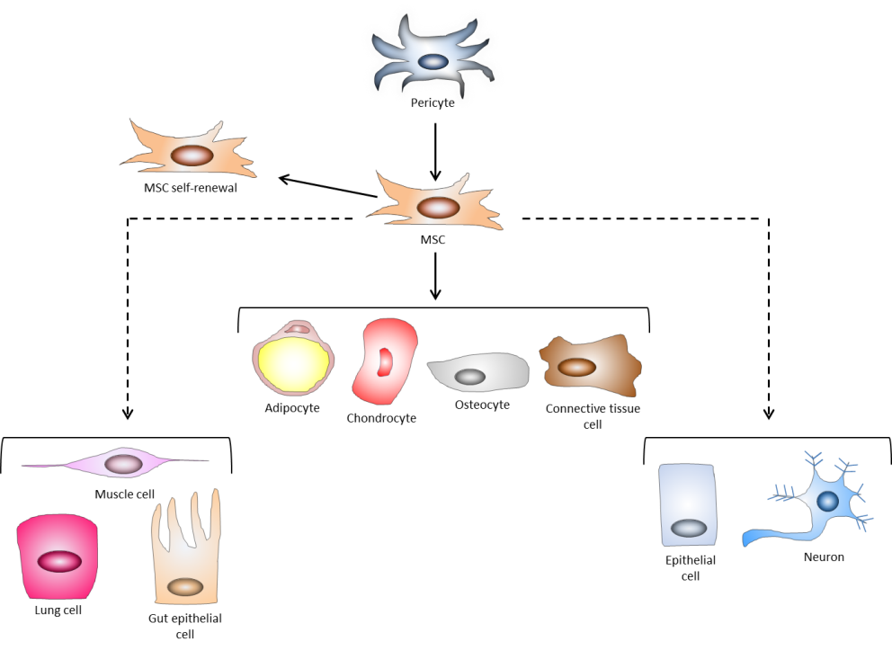

Figure 1 Basic properties of mesenchymal stem cells. Mesenchymal stem cells (MSCs) are a heterogeneous population of stromal cells thought to be derived from pericytes. These cells are defined by self-renewal and the ability to differentiate into the mesodermal cells (solid lines): adipocytes, chondrocytes, osteocytes, and connective tissue cells. Though controversial (dotted lines), they may also transdifferentiate into cells of the endoderm (lung, muscle, and gut epithelial cells) and of the ectoderm (neurons and epithelial cells). Adapted from ref. [22].

self-renewal/ proliferation

G0 quiescence
CD146⁺
MSC

Nestin⁺
MSC

Mobilization
±
MSC
HSC
HSC

Osteoblast
sinusoid
Sinusoid
epithelium
Endosteal niche
Vascular niche

Mobilization to
wound site

Bone marrow
Skin wound site

MSC
Vascular
endothelium
Inflammation
Vimentin
(ECM synthesis, tissue repair)
Wound injury

Perivascular
MSC
Mobilization ?

Figure 2 The biology of mesenchymal stem cells. In the bone marrow, mesenchymal stem cells (MSCs) aid in constructing the endosteal niche and regulate the homeostasis of HSCs. MSCs maintain HSCs in a state of quiescence defined by self-renewal and proliferation without differentiation. CD146⁺ MSCs in the vascular niche also maintain HSC homeostasis and, along with Nestin⁺ MSCs regulate the mobilization of HSC into the vascular system. In response to inflammatory cues and chemokine gradients, MSCs mobilize out of the bone marrow and to peripheral sites of injury, where they suppress inflammation to facilitate wound healing. MSCs contribute to tissue reconstruction with the production and deposition of vimentin. In is incompletely understood whether perivascular MSCs may also migrate to sites of injury to contribute to wound healing. Adapted from ref. [22].

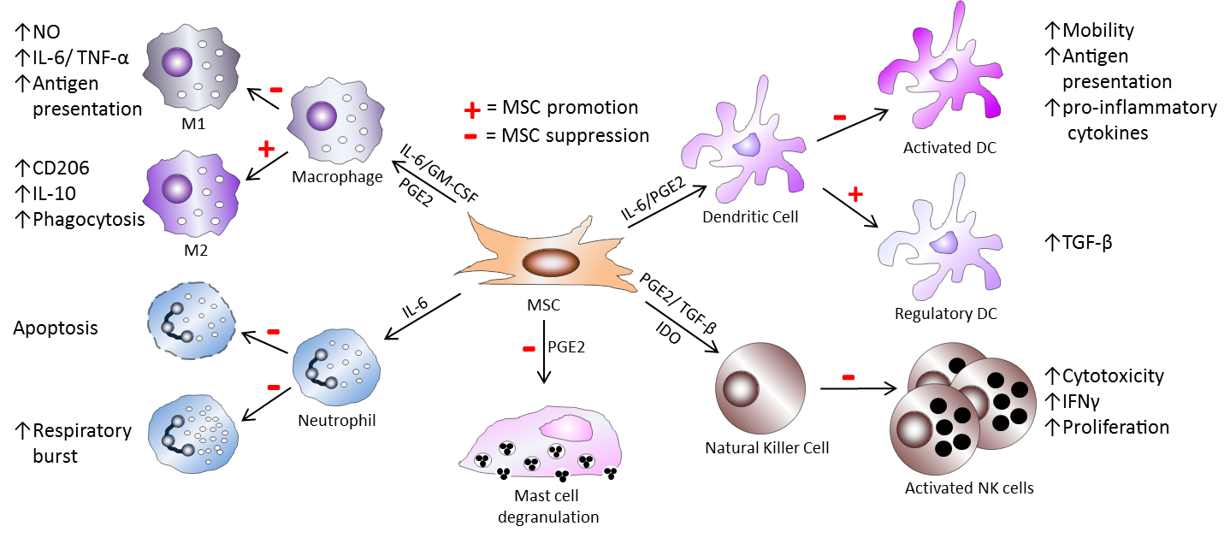
Figure 3 Mesenchymal stem cell immunosuppression of innate immune cells. Mesenchymal stem cells (MSCs) utilize diverse molecular mechanisms to suppress innate immune cells. MSCs suppress macrophage polarization to M1, though favors M2 polarization. MSCs inhibit mast cell degranulation of histamine-containing granules and inhibit NK cell and DC activation, differentiation, and effector functions. MSC-derived PGE2 contributes to all of these effects. MSC-produced IL-6 suppresses neutrophil apoptosis and respiratory burst and also contributes to inhibition of DC function. In the presence of IL-6 and GM-CSF, MSCs also affect macrophage function, while TGF-β and IDO suppress NK cell function. In addition, MSCs also favor the generation of regulatory DCs.

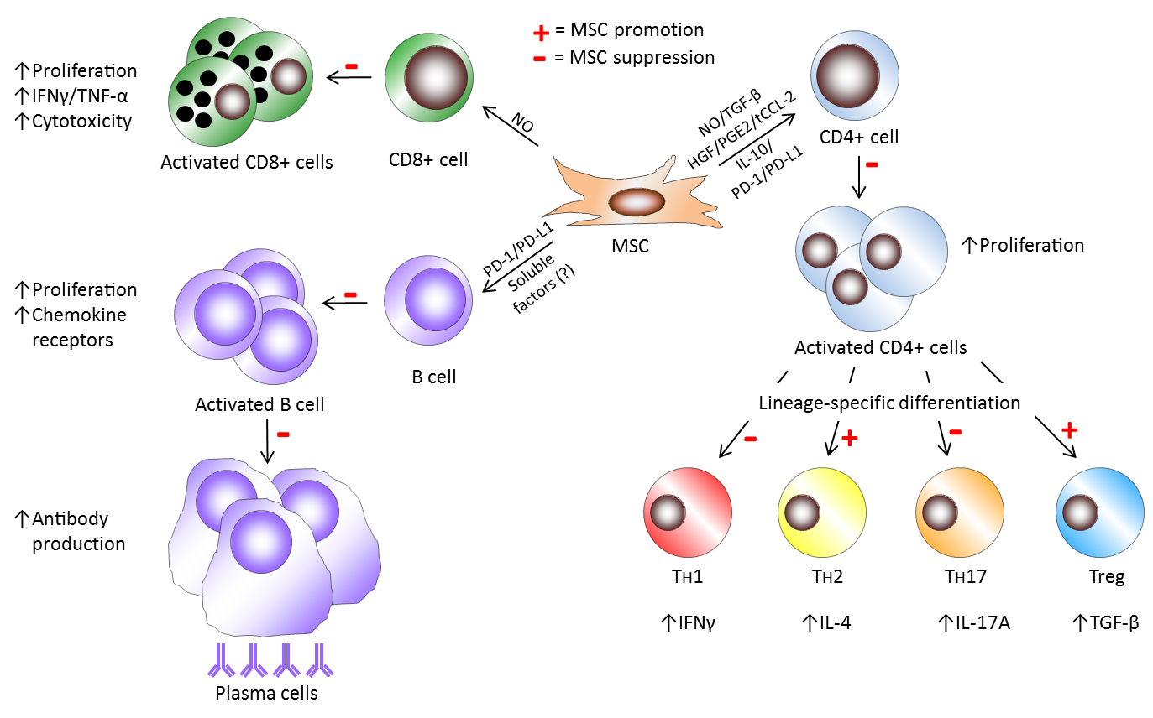
Figure 4 Mesenchymal stem cell immunosuppression of adaptive immune cells. In the context of B cells, mesenchymal stem cells (MSCs) inhibit various facets of B cells activity, including activation, proliferation, chemokine receptor expression, and differentiation to becoming antibody-secreting plasma cells. Unknown soluble factors and PD-1/PD-L1 ligation mediate these effects of MSCs on B cells. MSC have been shown to induce NO in response to inflammatory cytokine detection to suppress CD8+ T cell proliferation, cytokine production, and cytotoxicity. In response to activation in specific cytokine milieus, CD4+ T cells can differentiate into numerous effector populations. MSCs produce soluble factors (NO, TGF-B, HGF, PGE2, truncated CCL-2, and IL-10) and membrane-bound molecules (PD-1 ligation) to achieve suppression of CD4+ T cell proliferation and the polarization of CD4+ T cells towards T_{H}1 and T_{H}17 cells. MSCs favor the development of T_{H}2 and anti-inflammatory Treg populations.

Figure 5 Differential TLR stimulation affects mesenchymal stem cell immune-modulation. Mesenchymal stem cells (MSCs) are situated throughout the body as sentinels in virtually all organs and the perivasculature and are equipped with pattern-recognition receptors, including Toll-like receptorS (TLRS), to detect DAMPs from dying cells and PAMPs from pathogens. In response to TLR3 signaling, MSCs maintain an anti-inflammatory MSC2 phenotype, marked by induction of IDO, PGE2, RANTES, and IP-10 (in addition to IL-1 and CCL-5). However, in response to signaling through TLR3, MSC adopt the pro-inflammatory MSC1 phenotype and up-regulate IL-6 and IL-8, in addition to IL-1 and CCL-5. In the presence of IL-2 in combination with TLR9 signaling, MSCs have been shown to also produce IL-6, which promotes B cells survival, proliferation, and differentiation, though MSC-derived IL-6 has not been demonstrated to directly exert these effects on B cells.

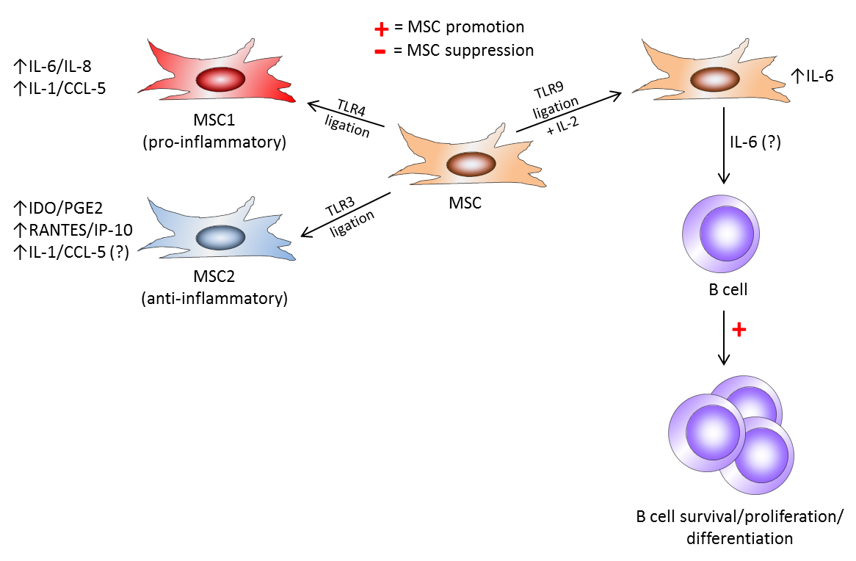

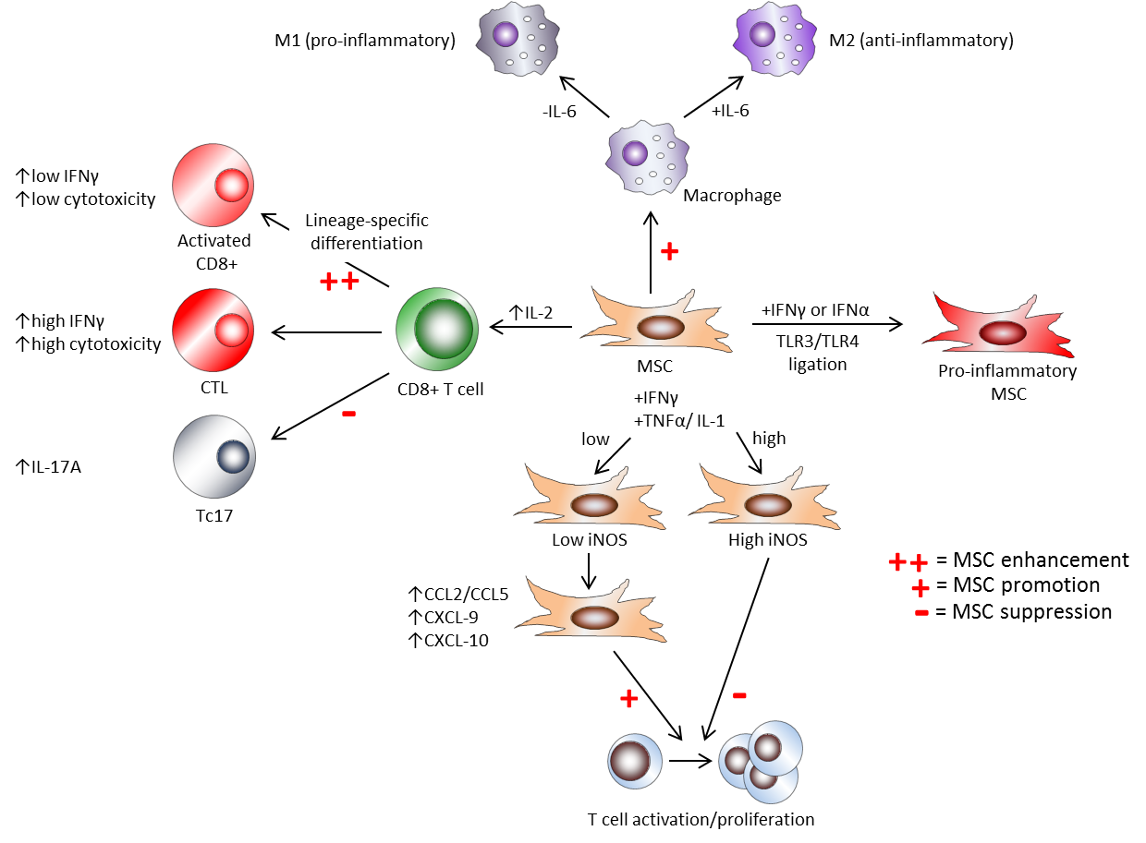
Figure 6 Effects of cytokine milieu on mesenchymal stem cell immune-modulation. Mesenchymal stem cell (MSC) modulation of immune responses is strongly affected by the makeup of cytokine milieus. Toll-like receptor (TLR) ligation in conjunction with interferon signaling drives MSCs down a pro-inflammatory route. While high concentrations of the pro-inflammatory cytokines IFNγ and either tumor necrosis factor-α (TNF-α) or IL-1 have been shown to induce iNOS and NO in MSCs to mediate suppression of T cell proliferation, low concentrations of these factors fail to fully induce iNOS, and instead enhance T cell proliferation, presumably via cytokine-induced chemokines. Furthermore, MSCs differentially affect the polarization of effector CD8+ T cell subsets: through enhanced early IL-2 expression induced by MSCs, activated CD8+ T cells exhibit increased IFNγ expression and cytotoxicity, while fully differentiated cytotoxic T lymphocytes (CTLs) are largely unaffected by MSC action. In contrast, MSCs potently suppress Tc17 development. Moreover, IL-6 signaling acts as a switch for MSC immune-modulation of macrophages. In the presence of IL-6, MSCs retain promotion of M2, but favor M1 polarization in the absence of this cytokine.

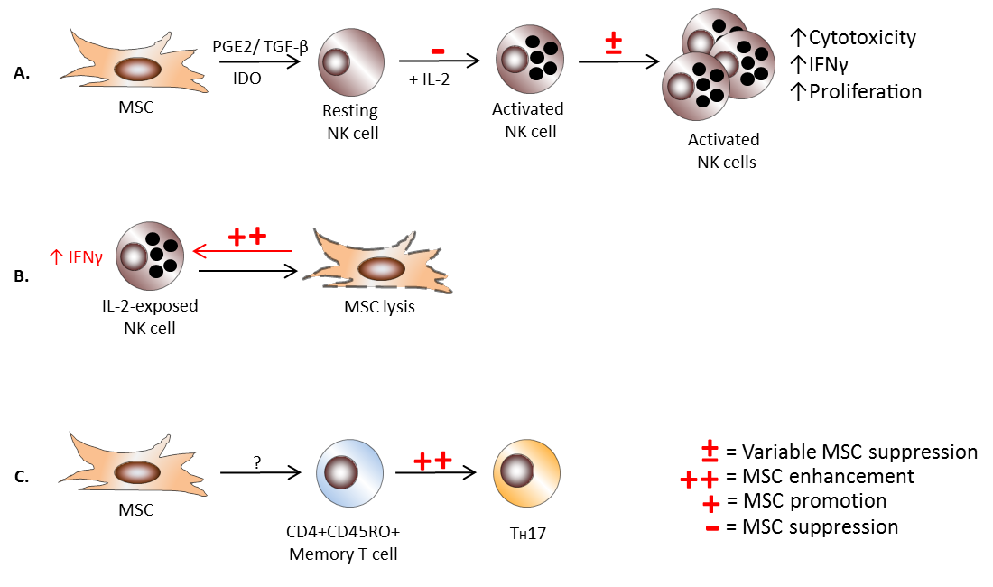
Figure 7 Effects of immune cell activation state on mesenchymal stem cell immune-modulation. The differentiation state of immune cells can render them susceptible or refractory to mesenchymal stem cell (MSC) action. Though MSCs efficiently inhibit the activation and downstream cytotoxicity of resting NK cells, they exert variable suppression on IL-2-activated NK cells, which is partially ratio dependent (A). MSCs themselves may become targets of activated NK cells for lysis, and enhance NK cell production of IFNγ in the process (B). Interestingly, MSCs promote T_{H}17 differentiation from CD4+CD45RO+ memory T cells, but no other CD4+ or CD8+ T cell population (C).

Table 1 Effects of mesenchymal stem cells on preclinical disease models
Disease | Species | Route of  administration | Effect | MSC mechanism of action | Ref.
Skin-graft rejection | Monkey | Systemic | Prolonged skin graft survival | Inhibition of T cell proliferation | [68]
Skin-graft rejection | Mouse | Systemic | Increased rejection | Induction of memory T cell response | [85]
Skin-graft rejection | Mouse | Systemic | Increased rejection | Potential increased T cell alloreactivity | [48]
Graft-v-Host  disease | Mouse | Systemic | Disease prevention | Cytokine-induced iNOS to inhibit T cell proliferation | [58]
Graft-v-Host  disease | Mouse | Systemic | No clinical benefit | Lack of suppression of donor T cell proliferation | [86]
Skin wound | Mouse | Systemic | Wound healing | M2 polarization , decreased inflammation, increased IL-10 | [31]
Acute lung injury | Mouse | Systemic | Protected lungs from injury | Blockade of TNFα and IL-1 production | [87]
Acute lung injury | Mouse | Local | Decreased severity | Down-regulation of inflammation, increased IL-10 | [88]
Melanoma | Mouse | Local | Increased tumor growth | Inhibition of tumor-specific  T cell response | [89]
MOG₃₅₋₅₅ EAE | Mouse | Systemic | Disease amelioration | Inhibition of CD4+ T cell proliferation | [57]
MOG₃₅₋₅₅ EAE  (severe) | Mouse | Local | Disease worsening | Focal cell mass formation and increased inflammation | [78]
MOG₃₇₋₅₀ EAE | Mouse | Systemic | Disease worsening | Increased pro-inflammatory CD8+ T cell frequency in CNS | [77]
Experimental autoimmune neuritis | Mouse | Systemic | No clinical benefit | unknown | [90]
Rheumatoid arthritis | Mouse | Systemic | Prevention | Reduced T cell proliferation, decreased inflammation, Treg induction | [70]
Rheumatoid arthritis | Mouse | Systemic | No clinical benefit | Accentuation of T_{H}1 response | [91]
Systemic lupus erythematosus | Mouse | Systemic | Multi-organ dysfunction reversal | Suppression of T_{H}17 and induction of Treg | [92]
Type-I-diabetes | Mouse | Systemic | Delayed onset | Promotion of T_{H}2 response | [93]
Inflammatory bowel disease | Mouse | Systemic | Prevention | Decreased neutrophil infiltration | [94]
MSC: Mesenchymal stem cell; MOG: Myelin oligodendrocyte glycoprotein; EAE: Experimental autoimmune encephalomyelitis; TNF-α: Tumor necrosis factor-α.

