Name of Journal: World Journal of Gastrointestinal Oncology
Manuscript NO: 60289
Manuscript Type: CASE REPORT

Rare common bile duct metastasis of breast cancer: A case report and literature review

Tang J et al. Bile duct metastases from breast cancer

Jie Tang, Guang-Xi Zhao, Shuang-Shuang Deng, Ming Xu

Jie Tang, Guang-Xi Zhao, Department of Gastroenterology, Shanghai East Hospital, Tongji University School of Medicine, Shanghai 200120, China

Shuang-Shuang Deng, Department of Pathology, Shanghai East Hospital, Tongji University School of Medicine, Shanghai 200120, China

Ming Xu, Department of Gastroenterology, Pudong New Area People's Hospital, Shanghai University of Medicine & Health Sciences, Shanghai 201200, China

Author contributions: Tang J and Zhao GX reviewed the patient information and wrote the manuscript; Deng SS reviewed the pathologic findings and wrote the manuscript; Xu M designed, reviewed, and wrote the manuscript; All authors have read and approved the final manuscript.

Supported by Top-level Clinical Discipline Project of Shanghai Pudong, No. PWYgf2018-04.

Corresponding author: Ming Xu, MD, Chief Physician, Department of Gastroenterology, Pudong New Area People's Hospital, Shanghai University of Medicine & Health Sciences, No. 490 Chuanhuan South Road, Pudong New Area, Shanghai 201200, China. xm73dr@163.com

Received: November 6, 2020
Revised: December 11, 2020
Accepted: December 26, 2020
Published online: February 15, 2021

Abstract
BACKGROUND
Breast cancer is the most common tumor in women, and about one-third of cases develop metastatic disease. However, metastatic breast cancer rarely invades the common bile duct (CBD) directly without involving the liver, and involvement of the gastrointestinal tract is rare. Cases of such metastases pose a particular diagnostic challenge.

CASE SUMMARY
A 55-year-old female presented to the Department of Gastroenterology with complaint of a 2 mo history of right upper abdominal pain accompanied by pain in the right back, aggravated after eating greasy diet. The patient had received a diagnosis of breast cancer 3 years prior. Physical examination showed obvious superficial protuberant erythema on the left neck and chest skin, with slight tenderness and burning sensation. Endoscopic retrograde cholangiopancreatography showed an obstruction at the end of the CBD. Histopathology of the CBD and symptomatic skin biopsies showed positivity for cytokeratin 7 and trans-acting T-cell-specific transcription factor breast cancer biomarkers. A cancer embolus was also found in the skin vasculature. Accordingly, the diagnosis of breast cancer metastases to the skin and biliary ducts was made. A plastic biliary sent was placed, which relieved the right upper abdominal pain and protected against unnecessary hepatectomy surgery.

CONCLUSION
Although rare, biliary metastasis should be considered in patients with bile duct stenosis and a history of breast cancer.

Key Words: Breast cancer; Common bile duct; Metastases; Plastic stent; Prognosis; Case report

©The Author(s) 2021. Published by Baishideng Publishing Group Inc. All rights reserved.

Citation: Tang J, Zhao GX, Deng SS, Xu M. Rare common bile duct metastasis of breast cancer: A case report and literature review. World J Gastrointest Oncol 2021; 13(2): 147-156
URL: https://www.wjgnet.com/1948-5204/full/v13/i2/147.htm
DOI: https://dx.doi.org/10.4251/wjgo.v13.i2.147

Core Tip: Breast cancer is the most common tumor in women, and about one-third of cases develop metastatic disease. However, metastatic breast cancer rarely invades the common bile duct (CBD) directly without involving the liver, and involvement of the gastrointestinal tract is rare. We report a case of CBD metastasis from breast cancer that was diagnosed according to findings from endoscopic retrograde cholangiopancreatography imaging and histopathology of CBD and symptomatic skin biopsies. This case highlights the importance of making an accurate diagnosis before undertaking an operative approach. Although CBD metastasis of breast cancer is rare, it should not be completely ignored.

INTRODUCTION
Breast cancer is the most common tumor in women^{[1]} and about one-third of cases will progress to metastatic disease^{[2]}, which is the leading cause of cancer-related death^{[3]}. Only 5%-10% of newly diagnosed breast cancer patients present with distant metastasis; more troubling, the risk of developing metastatic disease is high among patients with localized primary disease following successful primary tumor resection and adjuvant therapy^{[4-6]}. It is estimated that up to 30% of node-negative breast cancer patients will develop metastatic disease, despite receiving standard treatment^{[4-6]}.
Breast cancer metastasis includes contiguous, lymphatic, and hematogenous forms of spread^{[7]}. While hematogenous spread of breast cancer can target any site in the human body, the most common sites are bone, lung, lymph nodes, liver, and brain^{[7]}. Metastasis to the digestive system, kidney, and retroperitoneal organs is rare, and to the biliary system is remarkably rare^{[8-10]}. Widespread liver metastases can compress or infiltrate the bile duct, which may lead to obstructive jaundice, while a direct metastatic involvement of the extrahepatic bile duct in the absence of hepatic lesions is exceptional^{[8-10]}.
We describe, herein, a special case of secondary tumor of the common bile duct (CBD) from a primary breast cancer tumor that had been treated by operation 3 years earlier. Our review of the literature highlighted that this diagnosis may be difficult and controversial in rare sites. For early diagnosis, endoscopy and detailed pathological analysis are necessary, which may help prevent unnecessary surgical intervention.

CASE PRESENTATION
Chief complaints
A 55-year-old female presented to the Department of Gastroenterology (Shanghai East Hospital, Shanghai, China) with complaint of right upper abdominal pain lasting over a 2 mo period that was accompanied by pain in the right back and aggravated after eating greasy diet.

History of present illness
The patient’s symptoms started 2 mo prior, with recurrent episodes of right upper abdominal pain.

History of past illness
The patient had been diagnosed with breast cancer 3 years prior but had an unremarkable medical history otherwise.

Physical examination
Physical examination revealed mild tenderness in the right upper quadrant of the abdomen. Superficial protuberant erythema with clear margins were observed on the left neck and chest; the patient indicated a burning sensation and slight tenderness associated with the erythema.

Laboratory examinations
Laboratory tests upon admission showed elevated gamma-glutamyl transpeptidase (238 IU/L; normal range: 10-60 IU/L) but normal level of alkaline phosphatase (67 IU/L) and negative findings for inflammatory biomarkers. All blood tumor markers (alpha-fetoprotein: 2.01 ng/mL; carcinoembryonic antigen: 1.71 ng/mL; cancer antigen-125: 12.1 U/mL; cancer antigen-199: 9.26 U/mL; and cancer antigen-135: 14.3 U/mL) were within normal ranges.

Imaging examinations
Magnetic resonance cholangiopancreatography revealed enlarged head of the pancreas, narrowed CBD within the pancreas head, and slightly dilated upper bile ducts (Figure 1). Ultrasound gastroscopy revealed changes indicative of chronic pancreatitis, widening of the bile duct wall, and immunoglobulin G (IgG)4-related cholangitis (Figure 2). Subsequent laboratory tests, however, showed the IgG-4 level to be within the normal range, excluding the possibility of IgG4-related cholangitis.
Abdominal enhanced magnetic resonance imaging showed that the wall of the CBD was thickened and became obviously enhanced with contrast agent. The coronal view showed dilation of the upper segment of the CBD, with rough tissue wall and narrowing of the lower segment. Nodular thickening was also seen (localized) in the lower segment of the CBD (Figure 3). Endoscopic retrograde cholangiopancreatography (ERCP) showed an obstruction at the end of the CBD. Biopsies were taken from the affected tissues (CBD end and symptomatic skin lesions; Figure 4). Bone scan showed metastases in the left third rib and the eighth vertebral body (Figure 5).

Further diagnostic work-up
Histopathology results for the biopsied CBD and skin of left neck and chest were: Cytokeratin 7 (+); trans-acting T-cell-specific transcription factor (+); estrogen receptor (ER) (-); progesterone receptor (PR) (-); and human epidermal growth factor receptor-2 (HER2) (-). Morphological characteristics were assessed, and a cancer embolus was found in the skin vasculature (Figure 6).

FINAL DIAGNOSIS
Metastases of breast cancer to the skin and biliary ducts.

TREATMENT
After undergoing ERCP placement of a plastic stent for systemic chemotherapy, the patient was referred to an oncologist who ordered a treatment course of gemcitabine (1000 mg, administered on day 1 and day 8) and cisplatin (30 mg, administered on day 1 to day 3).

OUTCOME AND FOLLOW-UP
The patient eventually died of multiple organ failure caused by severe infection after systemic chemotherapy.

DISCUSSION
Invasive breast carcinoma of no special type is the most common histological type of breast cancer, accounting for 75%-80% of all invasive breast cancer cases. Gastrointestinal tract involvement is rare, accounting for only about 10% of all cases, but usually occurs in invasive lobular carcinoma^{[11]}. Through literature review, we found reports of 30 cases of metastatic breast cancer involving the bile ducts, including 7 cases involving CBD^{[11-16]}, 20 cases involving extrahepatic duct^{[9,17-21]} or lymph nodes extending directly into bile ducts^{[12,22]} and ampulla of Vater, and 3 cases classified as uncertain^{[23]} (Table 1). In these cases, the time interval between the diagnosis of breast cancer and the secondary tumor was as long as 21 years and as short as 2 years. Preoperative diagnosis was achieved in only 4 cases, and the others were treated surgically. Rego et al^{[15]} reported on 2 patients with abnormal ampulla and distal CBD stenosis detected by ERCP, with a diagnosis of breast metastasis confirmed by immunohistochemistry before surgical treatment. Budimir et al^{[11]}reported on another case in which ERCP detected CBD stenosis, after which brush aspiration was performed for subsequent cytological analysis. Finally, Cochrane et al^{[16]} reported on a case in which endoscopic ultrasound revealed a mass in the mid-portion of the CBD, with fine-needle aspiration biopsy demonstrating metastatic breast cancer.
Patients with metastatic breast cancer involving the bile ducts may experience abdominal discomfort, upper gastrointestinal bleeding, jaundice and related symptoms, such as pruritus or alterations in stool and urine^{[24]}; these nonspecific clinical symptoms, being similar to the presentation of primary tumors, complicate the diagnostic process. Moreover, in most cases, there is a long interval between the diagnosis of the primary tumor and the development of metastatic tumors affecting biliary tract function, which poses a further challenge to suspicion of a relationship between the historical breast cancer event and the presenting biliary disease^{[13,15,25,26]}. Endoscopic diagnosis may be difficult, due to implantation of the metastatic cells in the submucosa. Coletta et al^{[21]} reported that breast cancer metastasis could target the extrahepatic bile duct without involvement of the lumen or duct mucosa. ERCP sensitivity ranges from 25% to 50% for masses near the hepatic hilum, and negative finding for biopsied tissues is estimated to occur in > 30% of cases^{[24]}. Thus, the combination of ultrasound-guided biopsy and immunohistochemical analysis plays a key role in the diagnosis of this rare type of secondary tumor.
Early identification and surgical resection of cholangiocarcinoma have been shown to improve the 5-year overall survival^{[2]}. In the case of primary malignant bile duct tumors, clinicians are likely to recommend surgery, but for patients with metastatic breast cancer, surgery is generally not considered clinically beneficial^{[27]}. Treatments for metastatic breast cancer are guided by multiple factors, most importantly the expression status of ER, PR and HER2, treatment history, and prognostic indicators (i.e. short disease-free interval, presence of visceral metastases, performance status, and degree of symptoms)^{[28]}. For example, patients with hormone receptor-positive status are expected to benefit from hormone therapy, whereas those with HER2-positive disease are treated with targeted agents (trastuzumab and lapatinib) in conjunction with chemotherapy. In contrast, treatments of patients with triple-negative breast cancer only depend on cytotoxic chemotherapy^{[28]}.
Discordant ER, PR, or HER2 expression status between primary tumors and metastases has been reported^{[29]}. In addition, the conversion to negative receptor status is, on average, higher than that of positive conversion (24% vs 14% for ER; 46% vs 15% for PR; 13% vs 5% for HER2)^{[30]}. Two explanations have been put forth for this observation. The first involves technical issues that result in poor reproducibility of immunohistochemistry techniques. The second involves tumor heterogeneity (i.e. subpopulations of cells within the primary tumor and its metastases, having distinct genotypes and phenotypes and possibly different biological behaviors)^{[31]}. Receptor status of breast cancer may indicate both the prognosis and risk of recurrence; for example, ER-positive tumors display protracted metastasis latency periods and frequently metastasize to the bone^{[32-35]}. In our case, CBD metastasis of breast cancer occurred 3 years after surgical treatment, with multiple bone metastases in addition. Expression of the nuclear protein Ki-67 has been shown to correlate with the proliferative rate of tumor cells and this biomarker is used clinically as an independent prognostic biomarker in primary breast cancer, especially among patients with ER (+) tumors^{[36,37]}. Therefore, a biopsy of suspected breast cancer metastases would be necessary to determine the appropriate management of the disease.
In general, patients with pancreaticobiliary malignancies, metastatic disease and external biliary compression by lymph nodes should be implanted with plastic or self-expanding metal stents to both relieve related jaundice and abdominal pain symptoms and to improve the overall prognosis^{[11]}. Surgical bypass or biliary stenting is reported to extend survival to over 1 year, in comparison to un-intervened cases of liver metastases, for whom mean survival is only about 1 mo^{[11]}.Although many previous reports have indicated the superiority of a metal stent for malignant distal biliary obstruction^{[38]}, we generally prefer to use plastic stents to relieve symptoms before pathological diagnosis is obtained. Thus, only after our patient underwent ERCP placement of a plastic stent was she referred to the oncology department for systemic chemotherapy.

CONCLUSION
In conclusion, we report a special breast cancer case of direct metastasis to the CBD. Although this situation is rare, the possibility of biliary metastasis should be considered in the differential diagnosis of the bile duct stenosis for patients with a history of breast cancer, to avoid unnecessary hepatectomy. The differential diagnosis of cholangiocarcinoma is very important, with advanced endoscopic techniques and pathological diagnosis playing an important role in such.

REFERENCES
1 Tao Z, Shi A, Lu C, Song T, Zhang Z, Zhao J. Breast Cancer: Epidemiology and Etiology. Cell Biochem Biophys 2015; 72: 333-338 [PMID: 25543329 DOI: 10.1007/s12013-014-0459-6]
2 Wong K, Henderson IC. Management of metastatic breast cancer. World J Surg 1994; 18: 98-111 [PMID: 7910993 DOI: 10.1007/BF00348199]
3 Kimbung S, Loman N, Hedenfalk I. Clinical and molecular complexity of breast cancer metastases. Semin Cancer Biol 2015; 35: 85-95 [PMID: 26319607 DOI: 10.1016/j.semcancer.2015.08.009]
4 Cardoso F, Costa A, Norton L, Cameron D, Cufer T, Fallowfield L, Francis P, Gligorov J, Kyriakides S, Lin N, Pagani O, Senkus E, Thomssen C, Aapro M, Bergh J, Di Leo A, El Saghir N, Ganz PA, Gelmon K, Goldhirsch A, Harbeck N, Houssami N, Hudis C, Kaufman B, Leadbeater M, Mayer M, Rodger A, Rugo H, Sacchini V, Sledge G, van't Veer L, Viale G, Krop I, Winer E. 1st International consensus guidelines for advanced breast cancer (ABC 1). Breast 2012; 21: 242-252 [PMID: 22425534 DOI: 10.1016/j.breast.2012.03.003]
5 Gupta GP, Massagué J. Cancer metastasis: building a framework. Cell 2006; 127: 679-695 [PMID: 17110329 DOI: 10.1016/j.cell.2006.11.001]
6 Early Breast Cancer Trialists' Collaborative Group (EBCTCG), Peto R, Davies C, Godwin J, Gray R, Pan HC, Clarke M, Cutter D, Darby S, McGale P, Taylor C, Wang YC, Bergh J, Di Leo A, Albain K, Swain S, Piccart M, Pritchard K. Comparisons between different polychemotherapy regimens for early breast cancer: meta-analyses of long-term outcome among 100,000 women in 123 randomised trials. Lancet 2012; 379: 432-444 [PMID: 22152853 DOI: 10.1016/S0140-6736(11)61625-5]
7 Giestas S, Lopes S, Souto P, Agostinho C, Camacho E, Cipriano M, Sofia C. Ampullary Metastasis From Breast Cancer: A Rare Cause of Obstructive Jaundice. GE Port J Gastroenterol 2016; 23: 300-303 [PMID: 28868483 DOI: 10.1016/j.jpge.2016.03.001]
8 Stellato TA, Zollinger RM Jr, Shuck JM. Metastatic malignant biliary obstruction. Am Surg 1987; 53: 385-388 [PMID: 3605855]
9 Franco D, Martin B, Smadja C, Szekely AM, Rougier P. Biliary metastases of breast carcinoma. The case for resection. Cancer 1987; 60: 96-99 [PMID: 2438031 DOI: 10.1002/1097-0142(19870701)60:1<96::aid-cncr2820600117>3.0.co;2-s]
10 Taal BG, den Hartog Jager FC, Steinmetz R, Peterse H. The spectrum of gastrointestinal metastases of breast carcinoma: II. The colon and rectum. Gastrointest Endosc 1992; 38: 136-141 [PMID: 1568609 DOI: 10.1016/s0016-5107(92)70378-2]
11 Budimir I, Sabol Pusic M, Nikolic M, Dorosulic Z, Ljubicic N, Stajduhar E, Mise I, Vazdar L, Sarcevic B. Obstructive Jaundice as an Uncommon Manifestation of Metastatic Breast Cancer. World J Oncol 2015; 6: 297-300 [PMID: 29147419 DOI: 10.14740/wjon762w]
12 Popp JW Jr, Schapiro RH, Warshaw AL. Extrahepatic biliary obstruction caused by metastatic breast carcinoma. Ann Intern Med 1979; 91: 568-571 [PMID: 484956 DOI: 10.7326/0003-4819-91-4-568]
13 Titus AS, Baron TH, Listinsky CM, Vickers SM. Solitary breast metastasis to the ampulla and distal common bile duct. Am Surg 1997; 63: 512-515 [PMID: 9168764]
14 Stoeckler F, Hagmüller E, Rumpelt HJ, Weickert U. A rare cause of distal bile duct stenosis. J Gastrointest Cancer 2007; 38: 157-159 [PMID: 19089672 DOI: 10.1007/s12029-008-9029-8]
15 Rego RF, Atiq M, Velchala N, Nevin D, McElreath DP, McKnight WD, Aduli F. Ampullary metastasis from breast cancer: an unusual finding. Endoscopy 2009; 41 Suppl 2: E278-E279 [PMID: 19866428 DOI: 10.1055/s-0029-1215071]
16 Cochrane J, Schlepp G. Metastatic Breast Cancer to the Common Bile Duct Presenting as Obstructive Jaundice. Case Rep Gastroenterol 2015; 9: 278-284 [PMID: 26351417 DOI: 10.1159/000438744]
17 Kopelson G, Chu AM, Doucette JA, Gunderson LL. Extra-hepatic biliary tract metastases from breast cancer. Int J Radiat Oncol Biol Phys 1980; 6: 497-504 [PMID: 7390931 DOI: 10.1016/0360-3016(80)90066-8]
18 Pappo I, Feigin E, Uziely B, Amir G. Biliary and pancreatic metastases of breast carcinoma: is surgical palliation indicated? J Surg Oncol 1991; 46: 211-214 [PMID: 1707119 DOI: 10.1002/jso.2930460318]
19 Feliu Villaró F, Luengo Rodríguez de Ledesma L, Gómez Sugrañés JR, Castellote Caixal M, Ros López S, García Rubio B. [Obstructive jaundice due to the intraluminal biliary metastasis of a breast carcinoma]. Rev Esp Enferm Dig 1995; 87: 482-483 [PMID: 7612377]
20 Papo M, Fernandez J, Quer JC, Sirvent JJ, Richart C. Metastatic breast carcinoma presenting as obstructive jaundice. Am J Gastroenterol 1996; 91: 2240-2241 [PMID: 8855761]
21 Coletta M, Montalti R, Pistelli M, Vincenzi P, Mocchegiani F, Vivarelli M. Metastatic breast cancer mimicking a hilar cholangiocarcinoma: case report and review of the literature. World J Surg Oncol 2014; 12: 384 [PMID: 25515643 DOI: 10.1186/1477-7819-12-384]
22 Engel JJ, Trujillo Y, Spellberg M. Metastatic carcinoma of the breast: a cause of obstructive jaundice. Gastroenterology 1980; 78: 132-135 [PMID: 6153071]
23 Rabin MS, Richter IA. Metastatic breast carcinoma presenting as obstructive jaundice. A report of 3 cases. S Afr Med J 1979; 55: 388-390 [PMID: 432736]
24 Sarocchi F, Gilg MM, Schreiber F, Langner C. Secondary tumours of the ampulla of Vater: Case report and review of the literature. Mol Clin Oncol 2018; 8: 274-280 [PMID: 29435287 DOI: 10.3892/mco.2017.1535]
25 Ferrari AB, Pulcini G, Gheza F, Vinco A, Manenti S, Cervi E, Villanacci V, Cervi G. Duodenal metastasis from male breast cancer: a case report and review of the literature. J Med Case Rep 2009; 3: 8331 [PMID: 19830225 DOI: 10.4076/1752-1947-3-8331]
26 Bastos T, Souza TF, Otoch JP, Grecco E, Àvila F, Artifon EL. Metastasis of breast cancer to major duodenal papilla. Rev Gastroenterol Peru 2014; 34: 149-150 [PMID: 25028907]
27 Abid A, Moffa C, Monga DK. Breast cancer metastasis to the GI tract may mimic primary gastric cancer. J Clin Oncol 2013; 31: e106-e107 [PMID: 23319694 DOI: 10.1200/JCO.2012.44.6393]
28 Smith NZ. Treating metastatic breast cancer with systemic chemotherapies: current trends and future perspectives. Clin J Oncol Nurs 2012; 16: E33-E43 [PMID: 22459535 DOI: 10.1188/12.CJON.E33-E43]
29 Vignot S, Besse B, André F, Spano JP, Soria JC. Discrepancies between primary tumor and metastasis: a literature review on clinically established biomarkers. Crit Rev Oncol Hematol 2012; 84: 301-313 [PMID: 22710198 DOI: 10.1016/j.critrevonc.2012.05.002]
30 Aurilio G, Monfardini L, Rizzo S, Sciandivasci A, Preda L, Bagnardi V, Disalvatore D, Pruneri G, Munzone E, Della Vigna P, Renne G, Bellomi M, Curigliano G, Goldhirsch A, Nolè F. Discordant hormone receptor and human epidermal growth factor receptor 2 status in bone metastases compared to primary breast cancer. Acta Oncol 2013; 52: 1649-1656 [PMID: 23327413 DOI: 10.3109/0284186X.2012.754990]
31 Fisher R, Pusztai L, Swanton C. Cancer heterogeneity: implications for targeted therapeutics. Br J Cancer 2013; 108: 479-485 [PMID: 23299535 DOI: 10.1038/bjc.2012.581]
32 Smid M, Wang Y, Zhang Y, Sieuwerts AM, Yu J, Klijn JG, Foekens JA, Martens JW. Subtypes of breast cancer show preferential site of relapse. Cancer Res 2008; 68: 3108-3114 [PMID: 18451135 DOI: 10.1158/0008-5472.CAN-07-5644]
33 Soni A, Ren Z, Hameed O, Chanda D, Morgan CJ, Siegal GP, Wei S. Breast cancer subtypes predispose the site of distant metastases. Am J Clin Pathol 2015; 143: 471-478 [PMID: 25779997 DOI: 10.1309/AJCPYO5FSV3UPEXS]
34 Largillier R, Ferrero JM, Doyen J, Barriere J, Namer M, Mari V, Courdi A, Hannoun-Levi JM, Ettore F, Birtwisle-Peyrottes I, Balu-Maestro C, Marcy PY, Raoust I, Lallement M, Chamorey E. Prognostic factors in 1,038 women with metastatic breast cancer. Ann Oncol 2008; 19: 2012-2019 [PMID: 18641006 DOI: 10.1093/annonc/mdn424]
35 Kennecke H, Yerushalmi R, Woods R, Cheang MC, Voduc D, Speers CH, Nielsen TO, Gelmon K. Metastatic behavior of breast cancer subtypes. J Clin Oncol 2010; 28: 3271-3277 [PMID: 20498394 DOI: 10.1200/JCO.2009.25.9820]
36 Dowsett M, Nielsen TO, A'Hern R, Bartlett J, Coombes RC, Cuzick J, Ellis M, Henry NL, Hugh JC, Lively T, McShane L, Paik S, Penault-Llorca F, Prudkin L, Regan M, Salter J, Sotiriou C, Smith IE, Viale G, Zujewski JA, Hayes DF; International Ki-67 in Breast Cancer Working Group. Assessment of Ki67 in breast cancer: recommendations from the International Ki67 in Breast Cancer working group. J Natl Cancer Inst 2011; 103: 1656-1664 [PMID: 21960707 DOI: 10.1093/jnci/djr393]
37 Cheang MC, Chia SK, Voduc D, Gao D, Leung S, Snider J, Watson M, Davies S, Bernard PS, Parker JS, Perou CM, Ellis MJ, Nielsen TO. Ki67 index, HER2 status, and prognosis of patients with luminal B breast cancer. J Natl Cancer Inst 2009; 101: 736-750 [PMID: 19436038 DOI: 10.1093/jnci/djp082]
38 Fernandez Y Viesca M, Arvanitakis M. Early Diagnosis And Management Of Malignant Distal Biliary Obstruction: A Review On Current Recommendations And Guidelines. Clin Exp Gastroenterol 2019; 12: 415-432 [PMID: 31807048 DOI: 10.2147/CEG.S195714]

Footnotes
Informed consent statement: Informed written consent was obtained from the patient for publication of this report and any accompanying images.

Conflict-of-interest statement: The authors declare that they have no conflicts of interest.

CARE Checklist (2016) statement: The authors have read the CARE Checklist (2016), and the manuscript was prepared and revised according to the CARE Checklist (2016).

Open-Access: This article is an open-access article that was selected by an in-house editor and fully peer-reviewed by external reviewers. It is distributed in accordance with the Creative Commons Attribution NonCommercial (CC BY-NC 4.0) license, which permits others to distribute, remix, adapt, build upon this work non-commercially, and license their derivative works on different terms, provided the original work is properly cited and the use is non-commercial. See: http://creativecommons.org/Licenses/by-nc/4.0/

Manuscript source: Unsolicited manuscript

Peer-review started: November 6, 2020
First decision: November 30, 2020
Article in press: December 26, 2020

Specialty type: Oncology
Country/Territory of origin: China
Peer-review report’s scientific quality classification
Grade A (Excellent): 0
Grade B (Very good): B, B
Grade C (Good): 0
Grade D (Fair): 0
Grade E (Poor): 0

P-Reviewer: Kimura K S-Editor: Fan JR L-Editor: Filipodia P-Editor: Li JH

Figure Legends
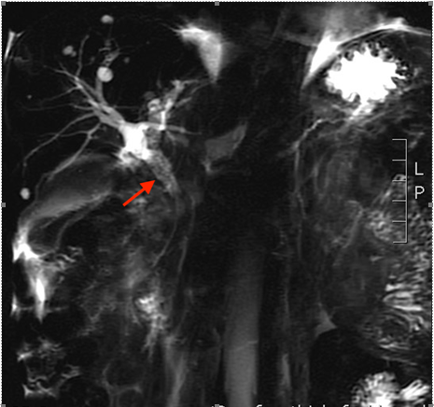
Figure 1 Magnetic resonance cholangiopancreatography. Findings of dilatation of the common bile duct, stenosis of the distal common bile duct, and density shadow of soft tissue are indicated by an arrow.

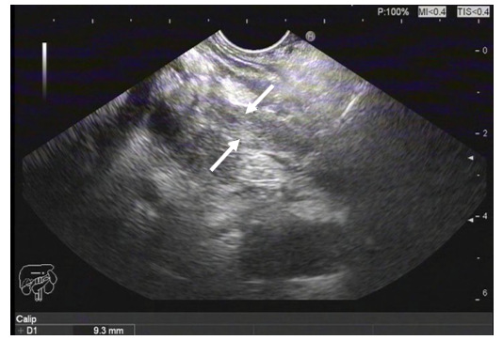
Figure 2 Endoscopy findings. Ultrasound gastroscopy revealed widening of the bile duct wall (arrows).
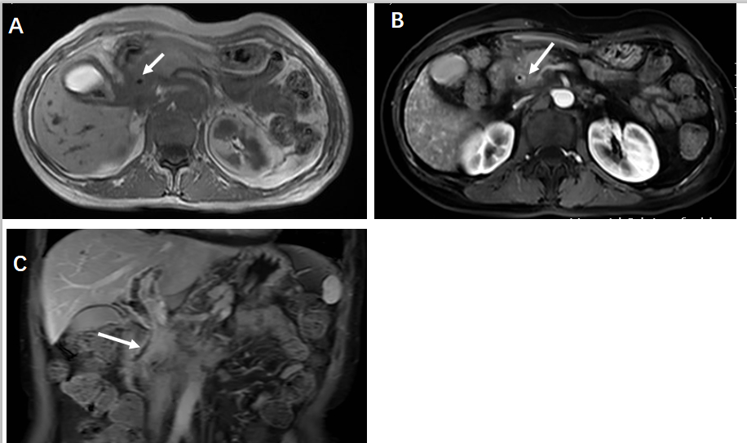
Figure 3 Magnetic resonance imaging of the abdomen. A and B: The wall of the common bile duct was thickened (arrows) and became obviously enhanced with contrast agent; C: Local nodular thickening was seen in the lower segment of the common bile duct (arrow).
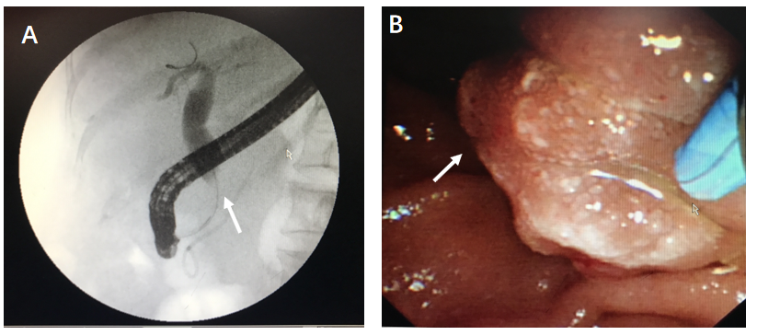
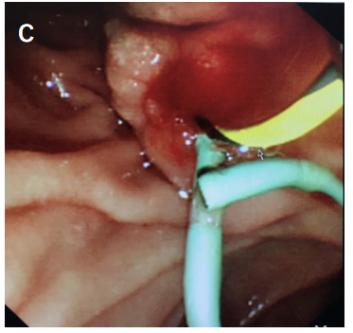
Figure 4 Endoscopy findings. A: Endoscopic retrograde cholangiopancreatography showed dilatation of the common bile duct and stenosis of the distal common bile duct (arrow); B: Edema of the ampulla; C: Implanted plastic stent.

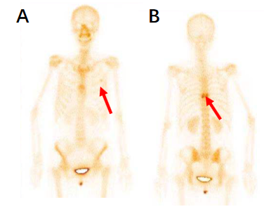
Figure 5 Bone scan findings. A: Metastasized tumors in the left third rib; B: Metastasized tumors in the eighth vertebral body.
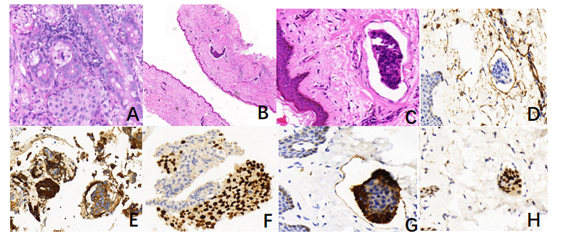
Figure 6 Histopathology of biopsies of the common bile duct and the skin of left neck and chest. A: Cancer cells were found to have infiltrated the glandular duct of the common bile duct (CBD); B and C: Low-power magnifications (B: 2´, C: 40´) demonstrating cancer embolus in the vasculature of the skin; D: Positive immunohistochemistry (IHC) staining for CD34 in the cancer embolus areas; E and F: Strong positive IHC staining for cytokeratin (CK) 7 and trans-acting T-cell-specific transcription factor (GATA-3) in the CBD; G: Strong positive IHC staining for CK7 in the skin of left neck and chest; H: Strong positive IHC staining for GATA3 in the skin of left neck and chest.
Table 1 Reported cases of bile duct metastasis of breast cancer
Ref. | Cases, n | Location of secondary tumor | Therapy | Time interval between diagnosis of primary tumor and metastasis
Popp et al^{[12]}, 1979 | 1 | CBD | Surgical bypass plus chemotherapy | Average 40 mo
Titus et al^{[13]}, 1997 | 1 | Distal bile duct | Pancreaticoduodenectomy | Undetermined
Stoeckler et al^{[14]}, 2007 | 1 | Distal bile duct | Pancreaticoduodenectomy | Undetermined
Rego et al^{[15]}, 2009 | 2 | Ampulla of Vater and CBD | Surgery and palliative chemotherapy | 2 yr
Cochrane et al^{[16]}, 2015 | 1 | CBD | Aplastic stent placed, chemotherapy and endocrine therapy | 21 yr
Budimir et al^{[11]}, 2015 | 1 | CBD | Metal stent implantation and aromatase inhibitors | 6 yr
Popp et al^{[12]}, 1979 | 6 | Extrahepatic lymph nodes | Radical and palliative surgery, transhepatic drainage, radiation, chemotherapy | Average 40 mo
Kopelson et al^{[17]}, 1980 | 6 | Extrahepatic duct | Radical and palliative surgery, radiation, chemotherapy | Undetermined
Engel et al^{[22]}, 1980 | 2 | Extrahepatic duct, lymph nodes | Biliary tract resection and choledochojejunostomy | Undetermined
Franco et al^{[9]}, 1987 | 2 | Proximal bile duct, bifurcation | Bile duct resection, double choledochojejunostomy | 6 and 8 yr respectively
Pappo et al^{[18]}, 1991 | 1 | Extrahepatic, intra and extraluminal | Bile duct resection, choledochojejunostomy, cholecystectomy | 2 yr
Feliu Villaró et al^{[19]}, 1995 | 1 | Extrahepatic intraluminal | Undetermined | Undetermined
Papo et al^{[20]}, 1996 | 1 | Extrahepatic intraluminal | Biliary tract resection and choledochojejunostomy | Undetermined
Coletta et al^{[21]}, 2014 | 1 | Extrahepatic bile ducts | Cholecystectomy, extrahepatic biliary resection, and double hepaticojejunostomy | 13 yr
Rabin et al^{[23]}, 1979 | 3 | Undetermined | Undetermined | Undetermined
CBD: Common bile duct.

Published by Baishideng Publishing Group Inc
7041 Koll Center Parkway, Suite 160, Pleasanton, CA 94566, USA
Telephone: +1-925-3991568
E-mail: bpgoffice@wjgnet.com
Help Desk: https://www.f6publishing.com/helpdesk
https://www.wjgnet.com

© 2021 Baishideng Publishing Group Inc. All rights reserved.

