....
Ill
UNIVERSITYof MARYLAND
SCHOOL OF MEDICINE
Patricia Langenberg, Ph.D. Professor and Vice-Chair

Department of Epidemiology & Public Health
660 W. Redwood Street, Room 102A Baltimore, MD 21201
410 706 3251

July 24, 2014

Biostatistician Report

t Patricia Langenberg certify that I hold a doctoral degree in Mathematics and Statistics. I have more than 35 years of experience in the design, analysis and interpretation of the type of data used in the manuscript submitted to the World Journal of Psychiatry, "Light Treatment for Seasonal Affective Disorder, A Comparison Study..."

The statistical methods used in the data analysis in this manuscript meet the standard required for publication in a peer-reviewed journal. I take responsibility for the analysis and interpretation of the data presented in the manuscript.

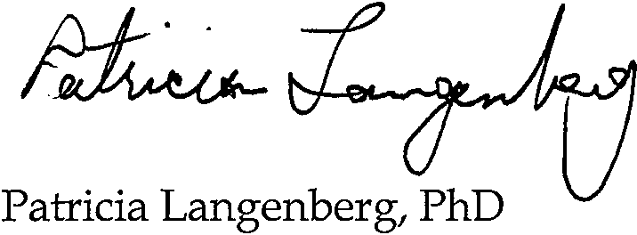Sincerely,

Biostatistician

Teodor T. Postolache, MD Corresponding author
Date: July 24, 2014

Date: July 24, 2014

DENTISTRY • LAW • MEDICINE • NURSING • PHARMACY • SOCIAL WORK • GRADUATE STUDIES

