Name of Journal: World Journal of Pharmacology
ESPS Manuscript NO: 28497
Manuscript Type: Minireviews

Long-term potentiation in autonomic ganglia: Potential role in cardiovascular disorders

Alkadhi KA. Ganglionic LTP and cardiovascular disorders

Karim A Alkadhi

Karim A Alkadhi, Department of Pharmacological and Pharmaceutical Sciences, College of Pharmacy, University of Houston, Houston, TX 77204, United States

Author contributions: Alkadhi KA contributed all to this paper.

Conflict-of-interest statement: Alkadhi KA declares no conflict of interest related to this publication.

Open-Access: This article is an open-access article which was selected by an in-house editor and fully peer-reviewed by external reviewers. It is distributed in accordance with the Creative Commons Attribution Non Commercial (CC BY-NC 4.0) license, which permits others to distribute, remix, adapt, build upon this work non-commercially, and license their derivative works on different terms, provided the original work is properly cited and the use is non-commercial. See: http://creativecommons.org/licenses/by-nc/4.0/

Manuscript source: Invited manuscript

Correspondence to: Karim A Alkadhi, PhD, Professor, Department of Pharmacological and Pharmaceutical Sciences, College of Pharmacy, University of Houston, SR-2, Cullen Blvd, Houston, TX 77204, United States. kalkadhi@uh.edu
Telephone: +1-713-7431212
Fax: +1-713-7431229

Received: April 22, 2016
Peer-review started: April 28, 2016
First decision: May 13, 2016
Revised: July 7, 2016
Accepted: July 11, 2016
Article in press:
Published online:

Abstract
Ganglionic long-term potentiation (gLTP) is an activity-dependent, enduring enhancement of ganglionic transmission. This phenomenon may be induced in autonomic ganglia of an organism under certain conditions where repetitive impulses surge from the central nervous system (CNS) to the periphery. Chronic stress, repetitive epileptic seizure or chronic use of CNS stimulants could induce gLTP, which would result in a long lasting heightening of sympathetic tone to the cardiovascular system causing hypertension and disturbed cardiac rhythm that may lead to sudden cardiac death. These conditions are briefly reviewed in this article.

Key words: Electrophysiology; Ganglionic long-term potentiation; Central nervous system stimulants; Epilepsy; Sudden unexpected death in epilepsy; Sudden cardiac death

© The Author(s) 2016. Published by Baishideng Publishing Group Inc. All rights reserved.

Core tip: Heightened activity of the central nervous system (CNS) caused by epilepsy, chronic stress and CNS stimulants could provide strong preganglionic stimulation of autonomic ganglia, which may trigger expression of ganglionic long-term potentiation (gLTP). Expression of gLTP can result in cardiovascular dysfunction that may lead to morbidity and even mortality.

Alkadhi KA. Long-term potentiation in autonomic ganglia: Potential role in cardiovascular disorders. World J Pharmacol 2016; In press

INTRODUCTION
Before Bliss and Lomo^{[1]} coined the term “long-term potentiation (LTP)” in the hippocampus to describe activity-dependent long-lasting potentiation, similar activity-induced enhancement of synaptic transmission was described in the mammalian sympathetic ganglia^{[2,3]}. However, it was nearly two decades before ganglionic LTP (gLTP) was characterized in mammalian and amphibian sympathetic ganglia^{[4-13]} as well as avian parasympathetic ciliary ganglion^{[14]} (Table 1). Later, my laboratory identified serotonin as the neurotransmitter necessary for induction and maintenance of gLTP in the rat superior cervical ganglion^{[15]}.
The expression of gLTP is due to a series of events resulting from both the postsynaptic and presynaptic regions, and including activation of enzymes, modulators and second messengers. Whereas LTP of the central nervous system (CNS) is regarded as a cellular mechanism of memory; the function of gLTP is uncertain. It is clear that hyperactivity of the CNS, as in the case of chronic stress or recurrent epileptic seizures, may provide the high frequency stimulation (HFS) necessary to induce the expression of LTP in autonomic ganglia, which may cause deleterious alterations in the cardiovascular system function.
gLTP is induced by repetitive HFS (20 Hz) of preganglionic nerve. Upon cessation of HFS of the preganglionic nerve of rat superior cervical ganglion, test stimuli (0.017 Hz) evoke initial highly potentiated ganglionic responses (compound action potentials), lasting up to 4 min, called post-tetanic potentiation^{[15-17]}. This is followed by steady lesser-potentiated action potentials lasting up to 3 h, indicating an increase in synaptic strength^{[15,18-20]}.
Published work from this laboratory determined that initiation of gLTP entails both HFS of the preganglionic nerve and stimulation of 5-HT₃ receptors by serotonin originating from certain cells within the superior cervical ganglion of rat^{[15]}. Activation of 5-HT₃ receptors is necessary for both initiation and expression of gLTP^{[15]}. Extracellular recording revealed that, in ganglia that have expressed gLTP, serotonin 5-HT₃ receptor agonists and blockers, in concentrations comparable to pharmacological doses in clinical settings, have profound effects on the magnitude of gLTP^{[15]} (Table 2), even though the same agents produced no significant effect on basal transmission in ganglia from control rat^{[15]}. Thus, we have established gLTP as the first serotonin-dependent LTP ever reported in a mammalian species^{[21,22]}.
The 5-HT₃ receptor is a ligand-gated receptor-channel complex, and a member of the superfamily that also includes the nACh receptor^{[23]}. It is known that activation of the presynaptic 5-HT₃ receptor causes upsurges in calcium concentration inside rat brain nerve terminals^{[24]}. The role of 5-HT₃ receptor in the induction and maintenance of gLTP is presently unclear. Perhaps the activation of 5-HT₃ channel-receptor complex at the nerve terminals in ganglia causes localized entry of calcium ions increasing its intracellular concentration to a level adequate for activation of downstream signaling molecules, including protein kinase C (PKC), calmodulin and calcium-calmodulin kinase II (CaMKII), which are essential for expressing gLTP^{[25]}.

IN VITRO INDUCTION OF GLTP
Ganglionic long-term potentiation can be induced by HFS (20 Hz for 20 s) of the preganglionic sympathetic nerve. This frequency is within the maximum range of in vivo firing frequency of preganglionic neurons^{[26]}. The response may be measured in vitro by intracellular or extracellular recording techniques^{[6]}. Furthermore, gLTP has been evoked and recorded in situ from ganglia of anesthetized animals^{[7,8,27]}.
The LTP of the hippocampal CA1 region and gLTP are similar in various aspects. For example, both are saturable in that when fully expressed, another HFS will not cause additional augmentation of synaptic transmission^{[28]}. Experiments in rat sympathetic ganglia suggest similar molecular mechanisms for the expression of gLTP and hippocampal LTP^{[29]}. Both require a ligand-gated ion channel; here is where hippocampal LTP and gLTP differ: Whereas area CA1 hippocampal LTP requires activation of glutamate NMDA receptor, gLTP requires activation of serotonin 5-HT₃ receptor. Similar to NMDA receptor, 5-HT₃ receptor is very permeable to Ca²⁺, which is exceedingly important for launching the molecular cascades responsible for expression of LTP. Strong evidence from this laboratory reveals the involvement of a variety of signaling molecules (e.g., CaMKII, PKC, calmodulin, calcineurin, etc.) in the expression of both hippocampal LTP and gLTP^{[30,31]}.
The involvement of endogenous serotonin is indicated by absence of HFS-induced gLTP in ganglia of animals treated with reserpine (3 mg/kg) to remove serotonin. However, when these ganglia were treated with serotonin or m-CPBG (a 5-HT₃-receptor agonist), HFS invariably induced expression of gLTP (Table 2)^{[15]}.

IN VIVO EXPRESSION OF GLTP
An expected outcome from in vivo manifestation of gLTP in ganglia is a long-lasting enhancement of sympathetic tone that outflows to the cardiovascular system. Work from this laboratory has established the consequences of in vivo induction of gLTP in sympathetic ganglia on blood pressure^{[29,32,33]}. We hypothesize that CNS repetitive activity causes similar outflow to preganglionic nerves, which together with endogenous serotonin may trigger expression of gLTP of sympathetic ganglia. Expression of gLTP produces prolonged and steady increase of sympathetic tone to the cardiovascular resulting in hypertension and disturbed cardiac rhythm (Figure 1).
We hypothesized that chronic psychosocial stress can induce in vivo expression of gLTP in sympathetic ganglia, which results in a constant rise in sympathetic tone thus contributing to or initiating a rise of blood pressure. We tested this hypothesis in four animal models of hypertension; aged rats, spontaneously hypertensive rat (SHR), obese Zucker rat and the psychosocial stress model^{[28,33-35]}. We investigated the existence of gLTP in ganglia from these models. For example, in psychosocially stressed hypertensive rats, treatment with tropisetron (ICS; a 5-HT3 receptor antagonist) resulted in normalizing blood pressure of these rats (Figure 2; [29]). Parallel outcomes were obtained in SHR and obese Zucker rat^{[29,32]}. This strongly indicated that the hypertension seen in these animals was, at least partly, due to expression of gLTP.
To further ascertain the existence of gLTP in ganglia isolated from these animal models we showed that “basal” transmission in these ganglia was markedly potentiated (Figure 3A) and that this potentiation was blocked when ganglia were treated with 5-HT3 receptor antagonists^{[29,32,33,35]} (Figure 3B). In another series of experiments, we hypothesized that in vitro HFS will not induce gLTP in ganglia isolated from hypertensive old rats if, in fact, gLTP has been expressed already in these ganglia in vivo. Whereas HFS produced strong gLTP in ganglia isolated from normotensive adult rats, no gLTP was seen in ganglia from old rats^{[28,35]} (Figure 3C). It is worthy to note that in these series, to ascertain the specificity of 5-HT₃ receptor we used three different selective antagonists; bemesetron, tropisetron and ondansetron (Zofran), all were equally effective in blocking gLTP^{[28,33-35]}.

POTENTIAL INDUCTION OF GLTP IN BRAIN ILLNESSES AND BY DRUGS
Any procedure that can induce continuous intense flow of impulses from the brain to autonomic ganglia could cause a sustained increase of sympathetic tone to the cardiovascular system, may lead to or contribute to disorders of the system^{[28-30,32,33,36]} (Figure 1). The expression of gLTP in autonomic ganglia that may cause hypertension and cardiac arrhythmias can be a serious risk factor for morbidity and mortality. Evidence that associates expression of gLTP with hypertension has been determined for chronic psychosocial stress^{[28-30,32,33,36]}. Other possible inducers of gLTP are discussed in the following sections.

POSTTRAUMATIC STRESS DISORDER
This serious type of stress results from experiencing harsh distressing occurrences for example witnessing injuries or death, exposure to natural disasters, or experiencing a life-threatening accident. Posttraumatic stress disorder (PTSD) is an incapacitating and potentially chronic disorder characterized by substantial illness. Although similar in some features to chronic stress, PTSD has distinctive pathology^{[37]}. In the first few years following the traumatic event, some PTSD patients may recover, but up to 40% remain chronically symptomatic for years^{[38]}. The major brain areas implicated in the manifestation of PTSD are the prefrontal cortex, amygdala, and hippocampus^{[39]}. During a traumatic event the amygdala sends intensifying impulses to various areas of the brain including prefrontal cortex, hypothalamus, hippocampus and brain stem nuclei. During the course of PTSD, intensified brain activity has been described. For example, PTSD patients showed augmented spontaneous activity in the amygdala and frontal cortex^{[40]}. Moreover, PTSD is linked to increased sympathetic activity represented by elevated blood pressure increased heart rate, and/or increased adrenergic transmitter release^{[41]}. This increase in sympathetic activity could be due to expression of gLTP in autonomic ganglia. However, whether gLTP is present in ganglia during the progression of PTSD and whether cardiovascular disorders are due to gLTP in autonomic ganglia remain to be explored in animal models of PTSD.

EPILEPSY
The excessive and abnormal cortical brain activity in epilepsy is transmitted through the brain stem to the rest of the body and can usually cause various types of seizures. Strong stimulation of the sympathetic nervous system often accompany seizures and can cause hypertension, dispersed injury of myocytes, and increased predisposition to ventricular arrhythmias^{[42,43]}. Several areas in the brain are involved in the cardiovascular effect of epileptic seizures such as the hypothalamus and medulla oblongata, particularly nuclei of the nucleus tractus solitarius, and area postrema, which are closely engaged in regulation of cardiovascular function^{[44-46]}. Therefore, enhanced activity of these areas is communicated to autonomic ganglia and may provide the required repetitive activity that triggers the expression of gLTP in these ganglia. The expression of gLTP results in long-term enhancement of sympathetic tone to the cardiovascular system, causing hypertension and neurogenic cardiac arrhythmias, which can be major risk factors for sudden unexpected death in epilepsy, a dangerous clinical difficulty for certain epileptic patients, especially those with chronic, inadequately controlled seizures.

NICOTINE
Epileptiform brain activity was recorded in the brains of young rats treated with nicotine^{[47]}. In humans, chronic use of tobacco products is known to cause enhanced cholinergic activity in the brain^{[48-50]}. Nicotine can also augment peripheral sympathetic activity through activation of postganglionic nicotinic acetylcholine receptors^{[51,52]}. Moreover, nicotine can release epinephrine from the adrenal medulla into the blood^{[53,54]}. Thus, nicotine causes stimulation of the cardiovascular system that increases heart rate and causes hypertension by action on both peripheral and central sites^{[53]}. Hence, since epileptic patients are more likely to be chronic tobacco users^{[55]}, such chronic use of nicotine may result in the expression of gLTP in ganglia or enhancement of the impacts of already expressed gLTP in epileptic tobacco users, thus intensify the risk for cardiovascular dysfunction that may cause sudden death^{[56]}.

CAFFEINE
Caffeine, a competitive inhibitor of adenosine receptors, is the most extensively used CNS stimulant because it is consumed in a variety of hot and cold drinks, as well as many prescription and over-the-counter medications. Neuroimaging studies reports show that by acting on brain cortex, caffeine enhances attention and mental arousal^{[57-59]}. However, there is no convincing evidence that the usual doses of caffeine increase the risk of heart attack, sudden cardiac death, or disruption of cardiac rhythm. Nonetheless, a new caffeine source are the so called “energy drinks”, which contain uncommonly hefty doses of caffeine. Consumption of such energy drinks may lead to platelet and endothelial dysfunction, which can cause myocardial infarction and other cardiovascular disorders in healthy young adults^{[60-62]} (for review see^{[63]}). Through stimulation of the CNS, heavy frequent intake of caffeine-containing drinks may trigger gLTP in sympathetic ganglia, which could be responsible for the reported cardiovascular disturbances. The danger may be even greater when such consumption of large doses of caffeine is coupled with heavy use of tobacco products.

AMPHETAMINES AND COCAINE
The amphetamines work mainly by modifying the catecholamine system in the pleasure center of the brain^{[64]}. They increase levels of major catecholamines such as dopamine and norepinephrine in a dose-dependent manner^{[65-67]}. A case-control study has linked the use of one of the most commonly used CNS stimulant, methylphenidate (Ritalin), to sudden death in children and teenagers^{[68]}.
Cocaine inhibits the monoamine reuptake mechanism in central and peripheral sympathetic nerve terminals in humans^{[69-71]} with end effects similar to those seen with amphetamines. This however, may not be the sole CNS effect of cocaine inasmuch as other reuptake inhibitors do not have cocaine-like effects. The abuse of cocaine is correlated with cardiovascular dysfunction including hypertension, ventricular dysrhythmia, acute myocardial infarction, and left ventricular hypertrophy. Therefore, the chronic use of CNS stimulants such as amphetamine and cocaine may trigger expression of gLTP, which may lead to morbidity and/or sudden death.

CONCLUSION
Abnormal strong brain activity as in epileptic seizures cause intense activation of ganglionic neurons, which can induce gLTP in sympathetic ganglia leading to long-term heightened sympathetic tone to the cardiovascular system with the ensuing rise in blood pressure and disturbed heart rhythm. Abnormal CNS activity can result from severe brain injuries, ongoing psychological stress, epilepsy, and regular abuse of CNS stimulating substances. Even though these disorders can cause disturbances of the function of the cardiovascular system, their possible link to gLTP has not been studied, except in chronic psychosocial stress. Therefore, it is necessary to determine such links in order to develop therapeutic plans to avoid serious consequences such as sudden cardiac death.

REFERENCES
1 Bliss TV, Lomo T. Long-lasting potentiation of synaptic transmission in the dentate area of the anaesthetized rabbit following stimulation of the perforant path. J Physiol 1973; 232: 331-356 [PMID: 4727084 DOI: 10.1113/jphysiol.1973.sp010273]
2 Volle RL. Enhancement of neuromuscular responses to acetylcholine and succinylcholine following repetitive stimulation of the motor nerve. Arch Int Pharmacodyn Ther 1966; 160: 284-293 [PMID: 5954031]
3 Dunant Y, Dolivo M. Plasticity of synaptic functions in the exised sympathetic ganglion of the rat. Brain Res 1968; 10: 271-273 [PMID: 5683552 DOI: 10.1016/0006-8993(68)90134-0]
4 Brown TH, McAfee DA. Long-term synaptic potentiation in the superior cervical ganglion. Science 1982; 215: 1411-1413 [PMID: 6278593 DOI: 10.1126/science.6278593]
5 Briggs CA, McAfee DA, McCaman RE. Long-term potentiation of synaptic acetylcholine release in the superior cervical ganglion of the rat. J Physiol 1985; 363: 181-190 [PMID: 2991505 DOI: 10.1113/jphysiol.1985.sp015703]
6 Briggs CA, McAfee DA. Long-term potentiation at nicotinic synapses in the rat superior cervical ganglion. J Physiol 1988; 404: 129-144 [PMID: 2855347 DOI: 10.1113/jphysiol.1988.sp017282]
7 Alonso-deFlorida F, Morales MA, Minzoni AA. Modulated long-term potentiation in the cat superior cervical ganglion in vivo. Brain Res 1991; 544: 203-210 [PMID: 2039938 DOI: 10.1016/0006-8993(91)90055-Z]
8 Bachoo M, Polosa C. Preganglionic axons from the third thoracic spinal segment fail to induce long-term potentiation in the superior cervical ganglion of the cat. Can J Physiol Pharmacol 1992; 70 Suppl: S27-S31 [PMID: 1338296 DOI: 10.1139/y92-240]
9 Weinreich D, Undem BJ, Taylor G, Barry MF. Antigen-induced long-term potentiation of nicotinic synaptic transmission in the superior cervical ganglion of the guinea pig. J Neurophysiol 1995; 73: 2004-2016 [PMID: 7623097]
10 Minota S, Kumamoto E, Kitakoga O, Kuba K. Long-term potentiation induced by a sustained rise in the intraterminal Ca2+ in bull-frog sympathetic ganglia. J Physiol 1991; 435: 421-438 [PMID: 1685189 DOI: 10.1113/jphysiol.1991.sp018517]
11 Koyano K, Kuba K, Minota S. Long-term potentiation of transmitter release induced by repetitive presynaptic activities in bull-frog sympathetic ganglia. J Physiol 1985; 359: 219-233 [PMID: 2860240 DOI: 10.1113/jphysiol.1985.sp015582]
12 Kumamoto E, Kuba K. Sustained rise in ACh sensitivity of a sympathetic ganglion cell induced by postsynaptic electrical activities. Nature 1983; 305: 145-146 [PMID: 6604228 DOI: 10.1038/305145a0]
13 Kumamoto E, Kuba K. Mechanism of long-term potentiation of transmitter release induced by adrenaline in bullfrog sympathetic ganglia. J Gen Physiol 1986; 87: 775-793 [PMID: 2873199 DOI: 10.1085/jgp.87.5.775]
14 Scott TR, Bennett MR. The effect of ions and second messengers on long-term potentiation of chemical transmission in avian ciliary ganglia. Br J Pharmacol 1993; 110: 461-469 [PMID: 8220908 DOI: 10.1111/j.1476-5381.1993.tb13833.x]
15 Alkadhi KA, Salgado-Commissariat D, Hogan YH, Akpaudo SB. Induction and maintenance of ganglionic long-term potentiation require activation of 5-hydroxytryptamine (5-HT3) receptors. J Physiol 1996; 496 (Pt 2): 479-489 [PMID: 8910231 DOI: 10.1113/jphysiol.1996.sp021700]
16 Martin AR, Pilar G. Presynaptic and post-synaptic events during post-tetanic potentiation and facilitation in the avian ciliary ganglion. J Physiol 1964; 175: 17-30 [PMID: 14241155 DOI: 10.1113/jphysiol.1964.sp007500]
17 Magleby KL, Zengel JE. A quantitative description of tetanic and post-tetanic potentiation of transmitter release at the frog neuromuscular junction. J Physiol 1975; 245: 183-208 [PMID: 165286 DOI: 10.1113/jphysiol.1975.sp010840]
18 Bennett MR. Nitric oxide release and long term potentiation at synapses in autonomic ganglia. Gen Pharmacol 1994; 25: 1541-1551 [PMID: 7721027 DOI: 10.1016/0306-3623(94)90353-0]
19 Brain KL, Bennett MR. Calcium in the nerve terminals of chick ciliary ganglia during facilitation, augmentation and potentiation. J Physiol 1995; 489 (Pt 3): 637-648 [PMID: 8788930 DOI: 10.1113/jphysiol.1995.sp021079]
20 Lin YQ, Bennett MR. Nitric oxide modulation of quantal secretion in chick ciliary ganglia. J Physiol 1994; 481 (Pt 2): 385-394 [PMID: 7537816 DOI: 10.1113/jphysiol.1994.sp020447]
21 Madison DV, Schuman EM. LTP, post or pre? A look at the evidence for the locus of long-term potentiation. New Biol 1991; 3: 549-557 [PMID: 1680385]
22 Johnston D, Williams S, Jaffe D, Gray R. NMDA-receptor-independent long-term potentiation. Annu Rev Physiol 1992; 54: 489-505 [PMID: 1314043 DOI: 10.1146/annurev.ph.54.030192.002421]
23 Derkach V, Surprenant A, North RA. 5-HT3 receptors are membrane ion channels. Nature 1989; 339: 706-709 [PMID: 2472553 DOI: 10.1038/339706a0]
24 Nichols RA, Mollard P. Direct observation of serotonin 5-HT3 receptor-induced increases in calcium levels in individual brain nerve terminals. J Neurochem 1996; 67: 581-592 [PMID: 8764583 DOI: 10.1046/j.1471-4159.1996.67020581.x]
25 Alzoubi KH, Bedawi AS, Aleisa AM, Alkadhi KA. Hypothyroidism impairs long-term potentiation in sympathetic ganglia: electrophysiologic and molecular studies. J Neurosci Res 2004; 78: 393-402 [PMID: 15389831 DOI: 10.1002/jnr.20268]
26 Coote JH, Westbury DR. Intracellular recordings from sympathetic preganglionic neurones. Neurosci Lett 1979; 15: 171-175 [PMID: 530526 DOI: 10.1016/0304-3940(79)96108-1]
27 Bachoo M, Heppner T, Fiekers J, Polosa C. A role for protein kinase C in long term potentiation of nicotinic transmission in the superior cervical ganglion of the rat. Brain Res 1992; 585: 299-302 [PMID: 1324771 DOI: 10.1016/0006-8993(92)91223-2]
28 Alkadhi KA, Alzoubi KH, Aleisa AM, Tanner FL, Nimer AS. Psychosocial stress-induced hypertension results from in vivo expression of long-term potentiation in rat sympathetic ganglia. Neurobiol Dis 2005; 20: 849-857 [PMID: 16005635 DOI: 10.1016/j.nbd.2005.05.020]
29 Alkadhi KA, Alzoubi KH, Aleisa AM. Plasticity of synaptic transmission in autonomic ganglia. Prog Neurobiol 2005; 75: 83-108 [PMID: 15784301 DOI: 10.1016/j.pneurobio.2005.02.002]
30 Alzoubi KH, Aleisa AM, Alkadhi KA. Expression of gLTP in sympathetic ganglia of obese Zucker rats in vivo: molecular evidence. J Mol Neurosci 2008; 35: 297-306 [PMID: 18563301 DOI: 10.1007/s12031-008-9110-6]
31 Gerges NZ, Alzoubi KH, Alkadhi KA. Role of phosphorylated CaMKII and calcineurin in the differential effect of hypothyroidism on LTP of CA1 and dentate gyrus. Hippocampus 2005; 15: 480-490 [PMID: 15714506 DOI: 10.1002/hipo.20073]
32 Gerges NZ, Aleisa AM, Alhaider AA, Alkadhi KA. Reduction of elevated arterial blood pressure in obese Zucker rats by inhibition of ganglionic long-term potentiation. Neuropharmacology 2002; 43: 1070-1076 [PMID: 12504912 DOI: 10.1016/S0028-3908(02)00283-6]
33 Alkadhi KA, Otoom SA, Tanner FL, Sockwell D, Hogan YH. Inhibition of ganglionic long-term potentiation decreases blood pressure in spontaneously hypertensive rats. Exp Biol Med (Maywood) 2001; 226: 1024-1030 [PMID: 11743138]
34 Gerges NZ, Aleisa AM, Schwarz LA, Alkadhi KA. Chronic psychosocial stress decreases calcineurin in the dentate gyrus: a possible mechanism for preservation of early ltp. Neuroscience 2003; 117: 869-874 [PMID: 12654339 DOI: 10.1016/S0306-4522(02)00766-2]
35 Alzoubi KH, Aleisa AM, Alkadhi KA. In vivo expression of ganglionic long-term potentiation in superior cervical ganglia from hypertensive aged rats. Neurobiol Aging 2010; 31: 805-812 [PMID: 18649973 DOI: 10.1016/j.neurobiolaging.2008.06.007]
36 Alkadhi K, Alzoubi K. Role of long-term potentiation of sympathetic ganglia (gLTP) in hypertension. Clin Exp Hypertens 2007; 29: 267-286 [PMID: 17653963 DOI: 10.1080/10641960701500356]
37 Vieweg WV, Julius DA, Fernandez A, Beatty-Brooks M, Hettema JM, Pandurangi AK. Posttraumatic stress disorder: clinical features, pathophysiology, and treatment. Am J Med 2006; 119: 383-390 [PMID: 16651048 DOI: 10.1016/j.amjmed.2005.09.027]
38 Kessler RC, Sonnega A, Bromet E, Hughes M, Nelson CB. Posttraumatic stress disorder in the National Comorbidity Survey. Arch Gen Psychiatry 1995; 52: 1048-1060 [PMID: 7492257 DOI: 10.1001/archpsyc.1995.03950240066012]
39 Brunello N, Davidson JR, Deahl M, Kessler RC, Mendlewicz J, Racagni G, Shalev AY, Zohar J. Posttraumatic stress disorder: diagnosis and epidemiology, comorbidity and social consequences, biology and treatment. Neuropsychobiology 2001; 43: 150-162 [PMID: 11287794]
40 Yan X, Brown AD, Lazar M, Cressman VL, Henn-Haase C, Neylan TC, Shalev A, Wolkowitz OM, Hamilton SP, Yehuda R, Sodickson DK, Weiner MW, Marmar CR. Spontaneous brain activity in combat related PTSD. Neurosci Lett 2013; 547: 1-5 [PMID: 23643995 DOI: 10.1016/j.neulet.2013.04.032]
41 Morris MC, Rao U. Psychobiology of PTSD in the acute aftermath of trauma: Integrating research on coping, HPA function and sympathetic nervous system activity. Asian J Psychiatr 2013; 6: 3-21 [PMID: 23380312 DOI: 10.1016/j.ajp.2012.07.012]
42 Ishiguro Y, Morgan JP. Effect of endogenous catecholamine on myocardial stunning in a simulated ischemia model. Fundam Clin Pharmacol 2001; 15: 111-116 [PMID: 11468020]
43 Shimizu M, Kagawa A, Takano T, Masai H, Miwa Y. Neurogenic stunned myocardium associated with status epileptics and postictal catecholamine surge. Intern Med 2008; 47: 269-273 [PMID: 18277028]
44 Colice GL. Neurogenic pulmonary edema. Clin Chest Med 1985; 6: 473-489 [PMID: 3907948]
45 Stauffer AZ, Dodd-o J, Lathers CM. The relationship of the lock-step phenomenon and precipitous changes in mean arterial blood pressure. Electroencephalogr Clin Neurophysiol 1989; 72: 340-345 [PMID: 2467800 DOI: 10.1016/0013-4694(89)90070-9]
46 Davison DL, Terek M, Chawla LS. Neurogenic pulmonary edema. Crit Care 2012; 16: 212 [PMID: 22429697 DOI: 10.1186/cc11226]
47 Hralová M, Marešová D, Riljak V. Effect of the single-dose of nicotine-administration on the brain bioelectrical activity and on behaviour in immature 12-day-old rats. Prague Med Rep 2010; 111: 182-190 [PMID: 20946718]
48 Rose JE, Behm FM, Salley AN, Bates JE, Coleman RE, Hawk TC, Turkington TG. Regional brain activity correlates of nicotine dependence. Neuropsychopharmacology 2007; 32: 2441-2452 [PMID: 17356570 DOI: 10.1038/sj.npp.1301379]
49 Gloria R, Angelos L, Schaefer HS, Davis JM, Majeskie M, Richmond BS, Curtin JJ, Davidson RJ, Baker TB. An fMRI investigation of the impact of withdrawal on regional brain activity during nicotine anticipation. Psychophysiology 2009; 46: 681-693 [PMID: 19490513 DOI: 10.1111/j.1469-8986.2009.00823.x]
50 Beaver JD, Long CJ, Cole DM, Durcan MJ, Bannon LC, Mishra RG, Matthews PM. The effects of nicotine replacement on cognitive brain activity during smoking withdrawal studied with simultaneous fMRI/EEG. Neuropsychopharmacology 2011; 36: 1792-1800 [PMID: 21544072 DOI: 10.1038/npp.2011.53]
51 Haass M, Kübler W. Nicotine and sympathetic neurotransmission. Cardiovasc Drugs Ther 1997; 10: 657-665 [PMID: 9110108 DOI: 10.1007/BF00053022]
52 Adamopoulos D, van de Borne P, Argacha JF. New insights into the sympathetic, endothelial and coronary effects of nicotine. Clin Exp Pharmacol Physiol 2008; 35: 458-463 [PMID: 18307741 DOI: 10.1111/j.1440-1681.2008.04896.x]
53 Hill P, Wynder EL. Smoking and cardiovascular disease. Effect of nicotine on the serum epinephrine and corticoids. Am Heart J 1974; 87: 491-496 [PMID: 4817106 DOI: 10.1016/0002-8703(74)90174-4]
54 Grunberg NE, Popp KA, Bowen DJ, Nespor SM, Winders SE, Eury SE. Effects of chronic nicotine administration on insulin, glucose, epinephrine, and norepinephrine. Life Sci 1988; 42: 161-170 [PMID: 3275854 DOI: 10.1016/0024-3205(88)90679-0]
55 Ferguson PL, Chiprich J, Smith G, Dong B, Wannamaker BB, Kobau R, Thurman DJ, Selassie AW. Prevalence of self-reported epilepsy, health care access, and health behaviors among adults in South Carolina. Epilepsy Behav 2008; 13: 529-534 [PMID: 18585962 DOI: 10.1016/j.yebeh.2008.05.005]
56 Rong L, Frontera AT, Benbadis SR. Tobacco smoking, epilepsy, and seizures. Epilepsy Behav 2014; 31: 210-218 [PMID: 24441294 DOI: 10.1016/j.yebeh.2013.11.022]
57 Koppelstaetter F, Poeppel TD, Siedentopf CM, Ischebeck A, Kolbitsch C, Mottaghy FM, Felber SR, Jaschke WR, Krause BJ. Caffeine and cognition in functional magnetic resonance imaging. J Alzheimers Dis 2010; 20 Suppl 1: S71-S84 [PMID: 20182040]
58 Koppelstaetter F, Poeppel TD, Siedentopf CM, Ischebeck A, Verius M, Haala I, Mottaghy FM, Rhomberg P, Golaszewski S, Gotwald T, Lorenz IH, Kolbitsch C, Felber S, Krause BJ. Does caffeine modulate verbal working memory processes? An fMRI study. Neuroimage 2008; 39: 492-499 [PMID: 17936643 DOI: 10.1016/j.neuroimage.2007.08.037]
59 Park CA, Kang CK, Son YD, Choi EJ, Kim SH, Oh ST, Kim YB, Park CW, Cho ZH. The effects of caffeine ingestion on cortical areas: functional imaging study. Magn Reson Imaging 2014; 32: 366-371 [PMID: 24512799 DOI: 10.1016/j.mri.2013.12.018]
60 Worthley MI, Prabhu A, De Sciscio P, Schultz C, Sanders P, Willoughby SR. Detrimental effects of energy drink consumption on platelet and endothelial function. Am J Med 2010; 123: 184-187 [PMID: 20103032 DOI: 10.1016/j.amjmed.2009.09.013]
61 Thyagarajan B, Alagusundaramoorthy SS, Agrawal A. Atrial Fibrillation Due to Over The Counter Stimulant Drugs in A Young Adult. J Clin Diagn Res 2015; 9: OD05-OD07 [PMID: 26435989 DOI: 10.7860/jcdr/2015/13483.6330]
62 Ibrahim NK, Iftikhar R. Energy drinks: Getting wings but at what health cost? Pak J Med Sci 2014; 30: 1415-1419 [PMID: 25674149 DOI: 10.12669/pjms.306.5396]
63 Lippi G, Cervellin G, Sanchis-Gomar F. Energy Drinks and Myocardial Ischemia: A Review of Case Reports. Cardiovasc Toxicol 2016; 16: 207-212 [PMID: 26320007 DOI: 10.1007/s12012-015-9339-6]
64 Bidwell LC, McClernon FJ, Kollins SH. Cognitive enhancers for the treatment of ADHD. Pharmacol Biochem Behav 2011; 99: 262-274 [PMID: 21596055 DOI: 10.1016/j.pbb.2011.05.002]
65 Miller GM. The emerging role of trace amine-associated receptor 1 in the functional regulation of monoamine transporters and dopaminergic activity. J Neurochem 2011; 116: 164-176 [PMID: 21073468 DOI: 10.1111/j.1471-4159.2010.07109.x]
66 Mikkelsen E, Lake CR, Brown GL, Ziegler MG, Ebert MH. The hyperactive child syndrome: peripheral sympathetic nervous system function and the effect of d-amphetamine. Psychiatry Res 1981; 4: 157-169 [PMID: 6939007 DOI: 10.1016/0165-1781(81)90019-6]
67 Eiden LE, Weihe E. VMAT2: a dynamic regulator of brain monoaminergic neuronal function interacting with drugs of abuse. Ann N Y Acad Sci 2011; 1216: 86-98 [PMID: 21272013 DOI: 10.1111/j.1749-6632.2010.05906.x]
68 Gould MS, Walsh BT, Munfakh JL, Kleinman M, Duan N, Olfson M, Greenhill L, Cooper T. Sudden death and use of stimulant medications in youths. Am J Psychiatry 2009; 166: 992-1001 [PMID: 19528194 DOI: 10.1176/appi.ajp.2009.09040472]
69 Melon PG, Boyd CJ, McVey S, Mangner TJ, Wieland DM, Schwaiger M. Effects of active chronic cocaine use on cardiac sympathetic neuronal function assessed by carbon-11-hydroxyephedrine. J Nucl Med 1997; 38: 451-456 [PMID: 9074537]
70 Vongpatanasin W, Mansour Y, Chavoshan B, Arbique D, Victor RG. Cocaine stimulates the human cardiovascular system via a central mechanism of action. Circulation 1999; 100: 497-502 [PMID: 10430763 DOI: 10.1161/01.CIR.100.5.497]
71 Lange RA, Hillis LD. Cardiovascular complications of cocaine use. N Engl J Med 2001; 345: 351-358 [PMID: 11484693 DOI: 10.1056/NEJM200108023450507]

P- Reviewer: Takahashi H, Unger M S- Editor: Gong XM
L- Editor: E- Editor:

Table 1 Summery of studies reporting ganglionic long-term potentiation of the nicotinic pathway in various animal species

Animal species | Specific ganglia | Ref.
Rat | superior cervical ganglion | Brown and McAfee^{[4]} Briggs and McAfee^{[6]}  Alkadhi et al^{[15]}  Alzoubi et al^{[25]}  Alkadhi et al^{[28]}  Alkadhi et al^{[29]}  Alkadhi and Alzoubi^{[36]} Alzoubi et al^{[30]}
Cat | superior cervical, lumbar and stellate ganglia | Alonso-deFlorida et al^{[7]} Bachoo and Polosa^{[8]}
guinea pig | superior cervical ganglion | Weinreich et al^{[9]}
chick | parasympathetic ciliary ganglion | Scott and Bennett^{[14]}
bullfrog | sympathetic ganglia | Koyano et al^{[11]}  Kumamoto and Kuba^{[13]} Minota et al^{[10]}
Adapted from Alkadhi K, Alzoubi K. In: Sudden Death in Epilepsy: Forensic and Clinical Issues (Chapter 26). CRC Press, 2011: 395-426.

Table 2 Effects of various 5-HT3 receptor agonists and antagonists on compound action potential during ganglionic long-term potentiation induced in vitro by high frequency repetitive stimulation
Serotonergic drugs | Mode of action | Compound AP
Serotonin (10-20 μmol/L) | Agonist | Increased
Fluoxetine (10 μmol/L) | SSRI | Increased
m-CPBG, (1 μmol/L) | Receptor agonist | Increased
Tropisetron (5 μmol/L) | Receptor antagonist | Reduced
Ondansetron (5 μmol/L) | Receptor antagonist | Reduced
MDL 72222 (0.5 μmol/L) | Receptor antagonist | Reduced
Reserpine pretreatment (3 mg/kg) | 5-HT depletion | No gLTP
m-CPBG (1μmol/L) + reserpine | Receptor agonist | Increased

The same drugs produced no significant effect on basal synaptic transmission in control ganglia (adapted from^{[15,25,29,30,32,33,36]}). SSRI: Selective serotonin reuptake inhibitor; AP: Action potential.

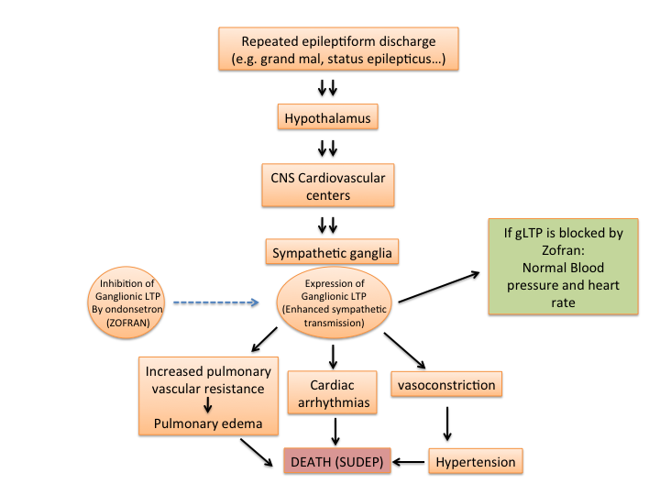

Figure 1 The hypothesis: In the whole animal, epileptic seizures provide the repetitive stimulation required for the expression of ganglionic long-term potentiation in sympathetic ganglia, resulting in increased peripheral resistance, hypertension and cardiopulmonary dysregulation leading to sudden death. Blocking serotonin 5-HT₃ receptor with antagonist (Zofran©) in ganglia has been shown to obviate the effect of gLTP. gLTP: Ganglionic long-term potentiation; CNS: Central nervous system; SUDEP: Sudden unexpected death in epilepsy.

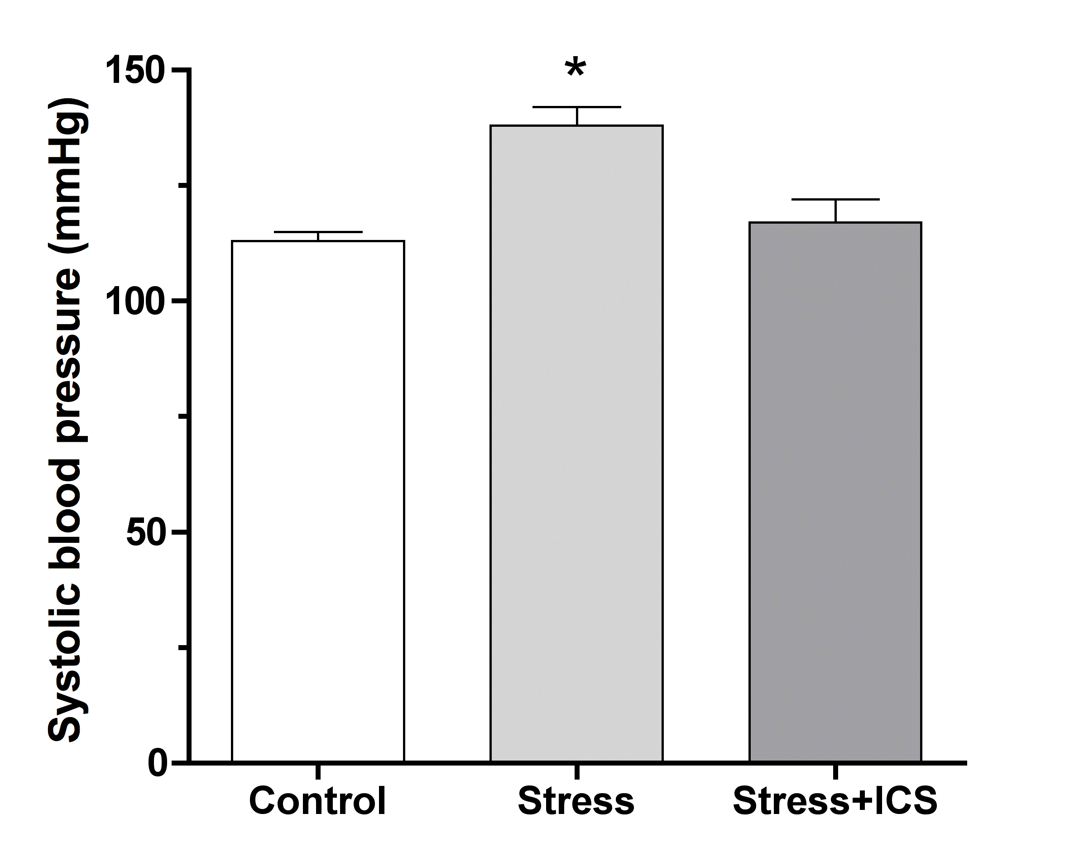

Figure 2 Tropisetron (ICS) normalizes established stress hypertension in psychosocially stressed male rats without affecting blood pressure in control (unstressed) rats measured at day 30 of continuous stress. Blood pressure was measured by tail-cuff plethysmography. Similar results were obtained from female rats. Each point in each group is the mean ± SD from 5 male or female rats. (*) indicates significant difference from other groups (Adapted from Ref.^{[29]}).

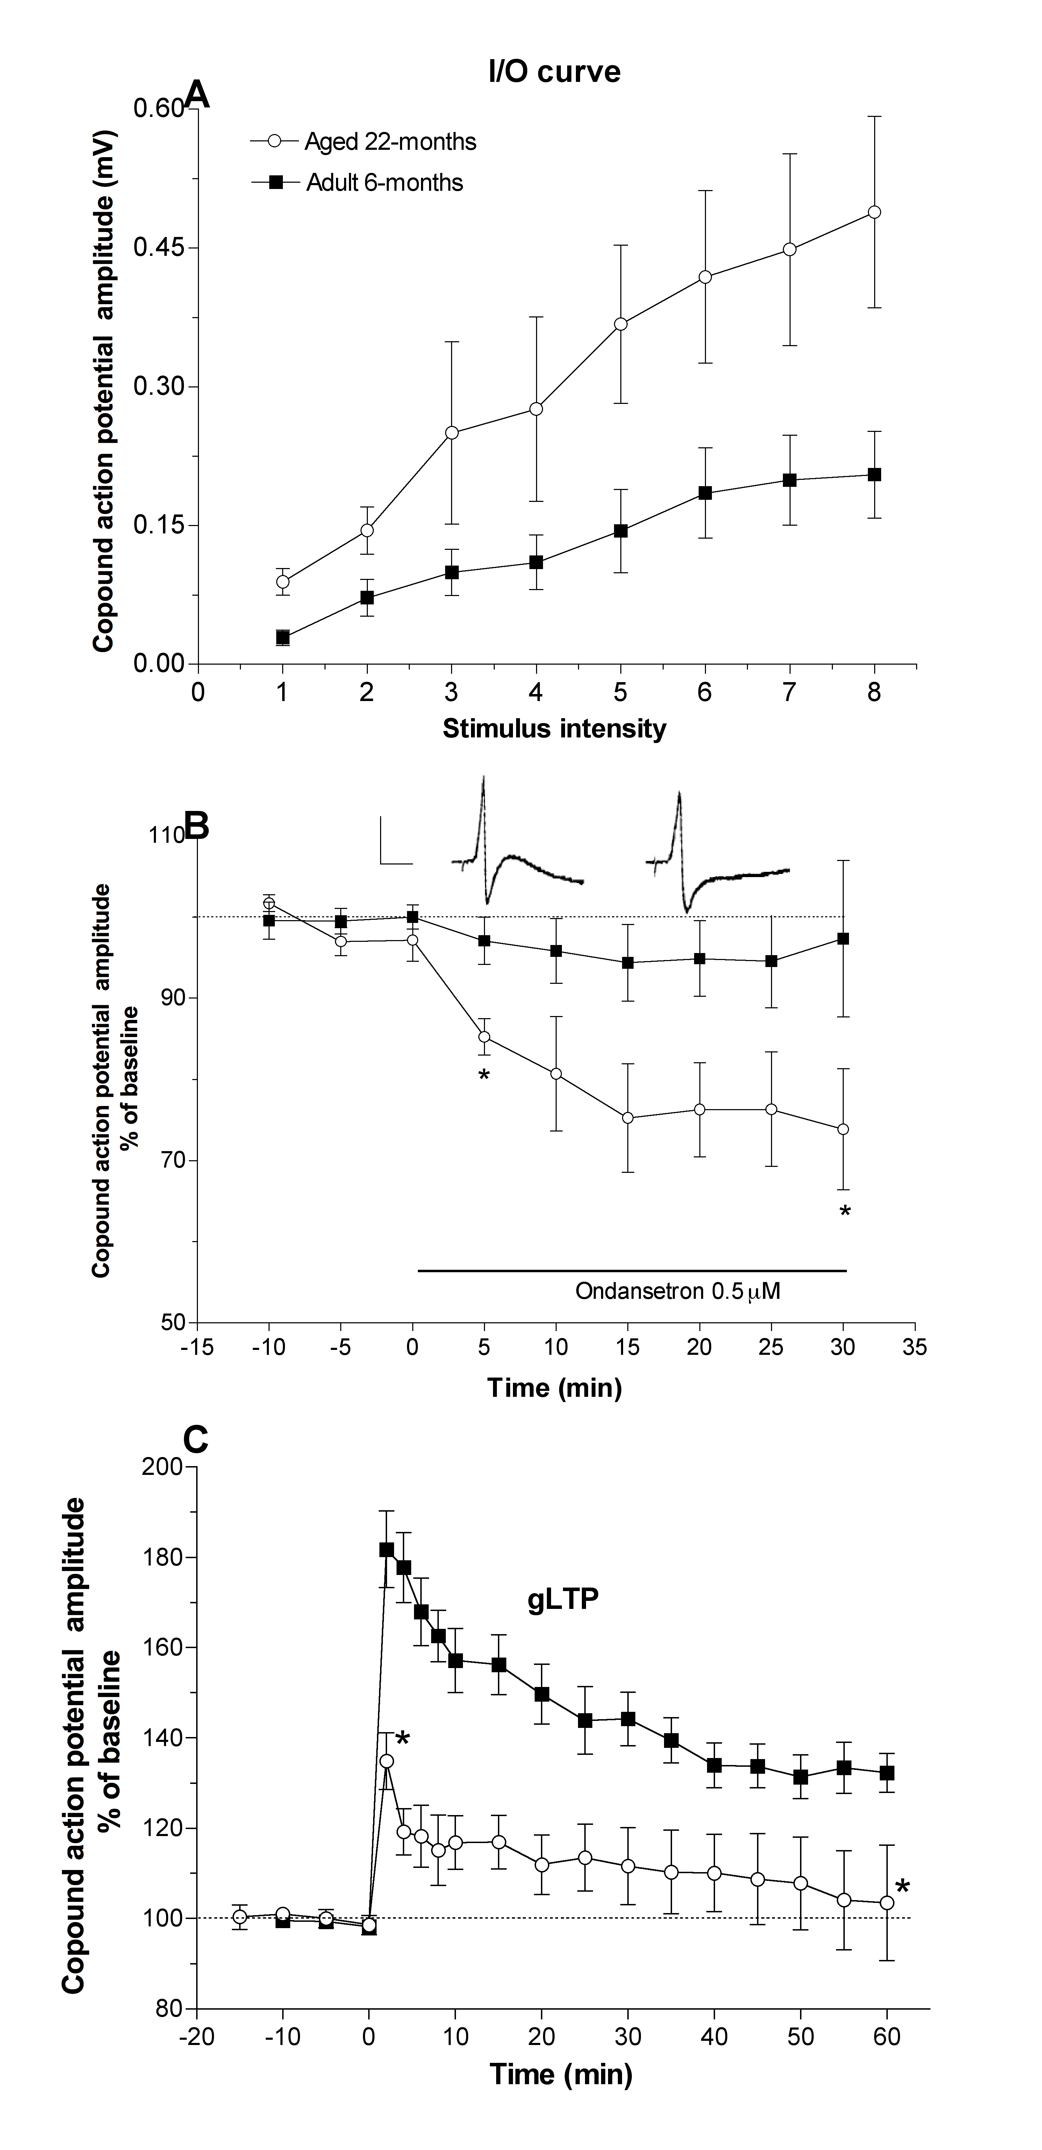
Figure 3 Expression of ganglionic long-term potentiation in sympathetic superior cervical ganglia in aged (22 mo) hypertensive rats. A: Input/output curve (I/O) of aged animal ganglia compared to adult (6 mo) ganglia, indicating enhanced synaptic activity in the aged animal ganglia. Stimulus intensity numbers along the X-axis are arbitrary values, where 1 is the minimal and 8 the maximal response [compound action potential (CAP) amplitude in mV]. Each point from aged rats is significantly different from matching points of adult rats, and is the mean ± SEM from 5-7 ganglia; B: Inhibition of “baseline” ganglionic transmission in aged rats by a 5-HT3 receptor antagonist ondansetron (Zofran) as an indication of expression of gLTP in vivo. Zofran (0.5 µmol/L, solid horizontal line) decreased CAP baseline of ganglia isolated from aged but not of those isolated from adult rats. All points between the two asterisks are significantly different (P < 0.05) from corresponding point for adult rats. Each point in each series is the mean ± SEM from 5-7 ganglia. Inset: CAPs of aged rats before and after application of drug; calibration 0.5 mV/20 ms; C: High frequency stimulation (HFS: 20 Hz/20 s, at 0 time) of the preganglionic nerves evoked robust gLTP in ganglia excised from adult rats. Identical protocol in ganglia from aged rats produced no gLTP. Each point represents the mean ± SEM from 5 ganglia. Adapted from Ref^{[35]}. gLTP: Ganglionic long-term potentiation.

